## Chapter 33 ZONING [1]

[ARTICLE I. - IN GENERAL](../level3/PTIIICOOR_CH33ZO_ARTIINGE.docx)

[ARTICLE II. - BUILDING CONTENT, SETBACKS AND AREA OF SITES](../level3/PTIIICOOR_CH33ZO_ARTIIBUCOSEARSI.docx)

[ARTICLE III. - HEIGHT OF BUILDINGS](../level3/PTIIICOOR_CH33ZO_ARTIIIHEBU.docx)

[ARTICLE IV. - TOWERS, POLES AND MASTS](../level3/PTIIICOOR_CH33ZO_ARTIVTOPOMA.docx)

[ARTICLE V. - AWNINGS, CANOPIES AND TENTS](../level3/PTIIICOOR_CH33ZO_ARTVAWCATE.docx)

[ARTICLE VI. - SIGNS](../level3/PTIIICOOR_CH33ZO_ARTVISI.docx)

[ARTICLE VII. - OFF-STREET PARKING](../level3/PTIIICOOR_CH33ZO_ARTVIIOREPA.docx)

[ARTICLE VIII. - RIGHT-OF-WAY PLAN AND MINIMUM WIDTH](../level3/PTIIICOOR_CH33ZO_ARTVIIIRI-WPLMIWI.docx)

[ARTICLE IX. - STREET NAMES AND NUMBERS](../level3/PTIIICOOR_CH33ZO_ARTIXSTNANU.docx)

[ARTICLE X. - ALCOHOLIC BEVERAGES](../level3/PTIIICOOR_CH33ZO_ARTXALBE.docx)

[ARTICLE XA. - EDUCATIONAL AND CHILD CARE FACILITIES, NONPUBLIC](../level3/PTIIICOOR_CH33ZO_ARTXAEDCHCAFANO.docx)

[ARTICLE XI. - PUBLIC CHARTER SCHOOL FACILITIES](../level3/PTIIICOOR_CH33ZO_ARTXIPUCHSCFA.docx)

[ARTICLE XIA. - VILLA DEVELOPMENT DISTRICT](../level3/PTIIICOOR_CH33ZO_ARTXIAVIDEDI.docx)

[ARTICLE XII. - MOBILE HOMES AND MOBILE HOME PARKS](../level3/PTIIICOOR_CH33ZO_ARTXIIMOHOMOHOPA.docx)

[ARTICLE XIIA. - WORKFORCE HOUSING DEVELOPMENT PROGRAM](../level3/PTIIICOOR_CH33ZO_ARTXIIAWOHODEPR.docx)

[ARTICLE XIII. - GU, INTERIM DISTRICT](../level3/PTIIICOOR_CH33ZO_ARTXIIIGUINDI.docx)

[ARTICLE XIV. - RU-1, SINGLE-FAMILY RESIDENTIAL DISTRICT](../level3/PTIIICOOR_CH33ZO_ARTXIVSIMIREDI.docx)

[ARTICLE XIVA. - RU-1Z, ZERO LOT LINE DEVELOPMENT SINGLE-FAMILY RESIDENTIAL DISTRICT](../level3/PTIIICOOR_CH33ZO_ARTXIVAZELOLIDESIMIREDI.docx)

[ARTICLE XIVB. - RU-1M(a), MODIFIED SINGLE-FAMILY RESIDENTIAL DISTRICT](../level3/PTIIICOOR_CH33ZO_ARTXIVBMOSIMIREDI.docx)

[ARTICLE XIVC. - RU-1M(b), MODIFIED SINGLE-FAMILY RESIDENTIAL DISTRICT](../level3/PTIIICOOR_CH33ZO_ARTXIVCBMOSIMIREDI.docx)

[ARTICLE XV. - RU-2, TWO-FAMILY RESIDENTIAL DISTRICT](../level3/PTIIICOOR_CH33ZO_ARTXVTMIREDI.docx)

[ARTICLE XVA. - RU-TH, TOWNHOUSE DISTRICT](../level3/PTIIICOOR_CH33ZO_ARTXVATODI.docx)

[ARTICLE XVB. - RU-RH, ROWHOUSE DISTRICT](../level3/PTIIICOOR_CH33ZO_ARTXVBRODI.docx)

[ARTICLE XVI. - RU-3, FOUR UNIT APARTMENT HOUSE DISTRICT](../level3/PTIIICOOR_CH33ZO_ARTXVIFOUNAPHODI.docx)

[ARTICLE XVIA. - RU-3M, MINIMUM APARTMENT HOUSE DISTRICT](../level3/PTIIICOOR_CH33ZO_ARTXVIAMIAPHODI.docx)

[ARTICLE XVII. - RU-3B, BUNGALOW COURT DISTRICT](../level3/PTIIICOOR_CH33ZO_ARTXVIIBUCODI.docx)

[ARTICLE XVIIA. - RU-4L, LIMITED APARTMENT HOUSE DISTRICT](../level3/PTIIICOOR_CH33ZO_ARTXVIIALIAPHODI.docx)

[ARTICLE XVIIB. - RU-4M, MODIFIED APARTMENT HOUSE DISTRICT](../level3/PTIIICOOR_CH33ZO_ARTXVIIBMOAPHODI.docx)

[ARTICLE XVIII. - RU-4, HIGH DENSITY APARTMENT HOUSE DISTRICT](../level3/PTIIICOOR_CH33ZO_ARTXVIIIHIDEAPHODI.docx)

[ARTICLE XIX. - RU-4A, HOTEL APARTMENT HOUSE DISTRICT](../level3/PTIIICOOR_CH33ZO_ARTXIXHOAPHODI.docx)

[ARTICLE XIXA. - RU-5, RESIDENTIAL—SEMI-PROFESSIONAL OFFICE DISTRICT](../level3/PTIIICOOR_CH33ZO_ARTXIXAREEOFOFDI.docx)

[ARTICLE XIXB. - RU-5A, SEMI-PROFESSIONAL OFFICE DISTRICT](../level3/PTIIICOOR_CH33ZO_ARTXIXBSEOFOFDI.docx)

[ARTICLE XX. - EU-M, ESTATE MODIFIED DISTRICT](../level3/PTIIICOOR_CH33ZO_ARTXXESMODI.docx)

[ARTICLE XXA. - EU-S, ESTATE USE SUBURBAN](../level3/PTIIICOOR_CH33ZO_ARTXXAESUSSU.docx)

[ARTICLE XXI. - EU-1 SINGLE-FAMILY ONE ACRE ESTATE DISTRICT](../level3/PTIIICOOR_CH33ZO_ARTXXISIMIONACESDI.docx)

[ARTICLE XXII. - EU-1C, SINGLE-FAMILY TWO AND ONE-HALF ACRE ESTATE DISTRICT](../level3/PTIIICOOR_CH33ZO_ARTXXIISIMITWOLFACESDI.docx)

[ARTICLE XXIII. - EU-2, SINGLE-FAMILY FIVE ACRE ESTATE DISTRICT](../level3/PTIIICOOR_CH33ZO_ARTXXIIISIMIFIACESDI.docx)

[ARTICLE XXIV. - BU-1, NEIGHBORHOOD BUSINESS DISTRICT](../level3/PTIIICOOR_CH33ZO_ARTXXIVNEBUDI.docx)

[ARTICLE XXV. - BU-1A, LIMITED BUSINESS DISTRICT](../level3/PTIIICOOR_CH33ZO_ARTXXVLIBUDI.docx)

[ARTICLE XXVI. - BU-2, SPECIAL BUSINESS DISTRICT](../level3/PTIIICOOR_CH33ZO_ARTXXVISPBUDI.docx)

[ARTICLE XXVII. - BU-3 LIBERAL BUSINESS DISTRICT](../level3/PTIIICOOR_CH33ZO_ARTXXVIILIBUDI.docx)

[ARTICLE XXVIII. - ADDITIONAL BUSINESS INDUSTRIAL AND OFFICE DISTRICT REGULATIONS](../level3/PTIIICOOR_CH33ZO_ARTXXVIIIADBUINOFDIRE.docx)

[ARTICLE XXIX. - IU-1, INDUSTRIAL, LIGHT MANUFACTURING DISTRICT](../level3/PTIIICOOR_CH33ZO_ARTXXIXINLIMADI.docx)

[ARTICLE XXX. - IU-2 INDUSTRIAL, HEAVY MANUFACTURING DISTRICT](../level3/PTIIICOOR_CH33ZO_ARTXXXINHEMADI.docx)

[ARTICLE XXXI. - IU-3, INDUSTRIAL, UNLIMITEDMANUFACTURING DISTRICT](../level3/PTIIICOOR_CH33ZO_ARTXXXIINUNMADI.docx)

[ARTICLE XXXII. - IU-C, INDUSTRIAL DISTRICT, CONDITIONAL](../level3/PTIIICOOR_CH33ZO_ARTXXXIIINDICO.docx)

[ARTICLE XXXIIA. - BIRD ROAD DESIGN AND INDUSTRIAL DISTRICT](../level3/PTIIICOOR_CH33ZO_ARTXXXIIABIRODEINDI.docx)

[ARTICLE XXXIII. - AU, AGRICULTURAL DISTRICT](../level3/PTIIICOOR_CH33ZO_ARTXXXIIIAUAGDI.docx)

[ARTICLE XXXIIIA. - CLUSTERED DEVELOPMENTS](../level3/PTIIICOOR_CH33ZO_ARTXXXIIIACLDE.docx)

[ARTICLE XXXIIIB. - PLANNED DEVELOPMENT](../level3/PTIIICOOR_CH33ZO_ARTXXXIIIBPLDE.docx)

[ARTICLE XXXIIIC. - GP, GOVERNMENTAL PROPERTY](../level3/PTIIICOOR_CH33ZO_ARTXXXIIICGPGOPR.docx)

[ARTICLE XXXIIID. - PLANNED AREA DEVELOPMENT DISTRICT (PAD)](../level3/PTIIICOOR_CH33ZO_ARTXXXIIIDPLARDEDIPA.docx)

[ARTICLE XXXIIIE. - OFFICE PARK DISTRICT (OPD)](../level3/PTIIICOOR_CH33ZO_ARTXXXIIIEOFPADIOP.docx)

[ARTICLE XXXIIIF. - ZERO LOT LINE DEVELOPMENTS (ZLL)](../level3/PTIIICOOR_CH33ZO_ARTXXXIIIFZELOLIDEZL.docx)

[ARTICLE XXXIIIG. - RESERVED](../level3/PTIIICOOR_CH33ZO_ARTXXXIIIGRE.docx)

[ARTICLE XXXIIIH. - TRADITIONAL NEIGHBORHOOD DEVELOPMENT (TND) DISTRICT](../level3/PTIIICOOR_CH33ZO_ARTXXXIIIHTRNEDETNDI.docx)

[ARTICLE XXXIII(I). - DOWNTOWN KENDALL URBAN CENTER DISTRICT](../level3/PTIIICOOR_CH33ZO_ARTXXXIII_I_DOKEURCEDI.docx)

[ARTICLE XXXIII(J). - NARANJA COMMUNITY URBAN CENTER DISTRICT](../level3/PTIIICOOR_CH33ZO_ARTXXXIII_J_NACOURCEDI.docx)

[ARTICLE XXXIII(K). - STANDARD URBAN CENTER DISTRICT REGULATIONS](../level3/PTIIICOOR_CH33ZO_ARTXXXIII_K_STURCEDIRE.docx)

[ARTICLE XXXIII(L). - GOULDS COMMUNITY URBAN CENTER DISTRICT](../level3/PTIIICOOR_CH33ZO_ARTXXXIII_L_GOCOURCEDI.docx)

[ARTICLE XXXIII(M). - PRINCETON COMMUNITY CENTER URBAN DISTRICT](../level3/PTIIICOOR_CH33ZO_ARTXXXIII_M_PRCOCEURDI.docx)

[ARTICLE XXXIII(N). - PERRINE COMMUNITY URBAN CENTER DISTRICT (PECUCD)](../level3/PTIIICOOR_CH33ZO_ARTXXXIII_N_PECOURCEDIPE.docx)

[ARTICLE XXXIII(O). - OJUS URBAN AREA DISTRICT](../level3/PTIIICOOR_CH33ZO_ARTXXXIII_O_OJURARDI.docx)

[ARTICLE XXXIII(P). - CUTLER RIDGE METROPOLITAN URBAN CENTER DISTRICT (CRMUCD)](../level3/PTIIICOOR_CH33ZO_ARTXXXIII_P_CURIMEURCEDICR.docx)

[ARTICLE XXXIII(Q). - LEISURE CITY COMMUNITY URBAN CENTER DISTRICT (LCUC)](../level3/PTIIICOOR_CH33ZO_ARTXXXIII_Q_LECOURCEDILC.docx)

[ARTICLE XXXIII(R). - MODEL CITY URBAN CENTER DISTRICT (MCUCD)](../level3/PTIIICOOR_CH33ZO_ARTXXXIII_R_MOURCEDIMC.docx)

[ARTICLE XXXIII(S). - NORTH CENTRAL URBAN AREA DISTRICT (NCUAD)](../level3/PTIIICOOR_CH33ZO_ARTXXXIII_NOCEURARDINC.docx)

[ARTICLE XXXIII(T). - PALMER LAKE METROPOLITAN URBAN CENTER DISTRICT (PLMUC)](../level3/PTIIICOOR_CH33ZO_ARTXXXIII_T_PALAMEURCEDIPL.docx)

[ARTICLE XXXIV. - FEES](../level3/PTIIICOOR_CH33ZO_ARTXXXIVFE.docx)

[ARTICLE XXXV. - HOMESTEAD AIR FORCE BASE ZONING](../level3/PTIIICOOR_CH33ZO_ARTXXXVHOAIFOBAZO.docx)

[ARTICLE XXXVI. - ZONING PROCEDURE](../level3/PTIIICOOR_CH33ZO_ARTXXXVIZOPR.docx)

[ARTICLE XXXVII. - MIAMI INTERNATIONAL AIRPORT (WILCOX FIELD) ZONING](../level3/PTIIICOOR_CH33ZO_ARTXXXVIIMIINAIWIFIZO.docx)

[ARTICLE XXXVIII. - OPA LOCKA AIRPORT ZONING](../level3/PTIIICOOR_CH33ZO_ARTXXXVIIIOPLOAIZO.docx)

[ARTICLE XXXIX. - HOMESTEAD GENERAL AVIATION AIRPORT ZONING](../level3/PTIIICOOR_CH33ZO_ARTXXXIXHOGEAVAIZO.docx)

[ARTICLE XL. - KENDALL TAMIAMI EXECUTIVE AIRPORT ZONING](../level3/PTIIICOOR_CH33ZO_ARTXLKETAEXAIZO.docx)

[ARTICLE XLI. - ROCKMINING OVERLAY ZONING AREA (ROZA)](../level3/PTIIICOOR_CH33ZO_ARTXLIROOVZOARRO.docx)

FOOTNOTE(S):

--- (**1**) ---

Annotations—AO 4-63A; CAO's 77-28, 84-18. (Back)

**Charter reference—** Authority of County to establish and enforce zoning regulations, § 1.01(A)(12). (Back)

**Cross reference—** Procedure for adoption and adoption of master plans, area studies, etc., § 2-111 et seq.; vessel mooring code, § 7-31 et seq.; code enforcement, Ch. 8CC; dumps and landfill sites, Ch. 11B; development within coastal flood hazard districts, Ch. 11C; historical preservation, Ch. 16A; improvement districts, Ch. 18; landscaping, Ch. 18A; planning generally, Ch. 23A; environmental protection, Ch. 24; environmentally endangered lands program, Ch. 24A; subdivisions, Ch. 28; urban renewal, Ch. 30A; developments, in incorporated areas creating County impact, Ch. 33A; areas of critical environmental concern, Ch. 33B; zoning overlay § 33B-1 et seq.; Fixed-Guideway Rapid Transit System—Development Zone, Ch. 33C. (Back)

**State Law reference—** Local Government Comprehensive Planning and Land Development Regulation Act, F.S. § 163.3161 et seq. (Back)

### ARTICLE I. IN GENERAL

Sec. 33-1. Definitions.

Sec. 33-2. Districts enumerated.

Sec. 33-3. District boundary maps.

Sec. 33-4. Offensive color, design, smoke, noise, etc.; nuisances, moves and locations to be approved; location on lands subject to flooding.

Sec. 33-4.1. Outdoor lighting.

Sec. 33-4.2. Maintenance of buildings, non-dwelling structures and fences.

Sec. 33-5. Architectural style and color.

Sec. 33-6. Permits not to be issued for violations.

Sec. 33-7. Minimum lot areas and yards.

Sec. 33-8. Certificate of use.

Sec. 33-8.1. Zoning Improvement Permit (ZIP).

Sec. 33-9. Permit to move building; bond.

Sec. 33-10. Buildings on through lots.

Sec. 33-11. Fences, walls, bus shelters and hedges.

Sec. 33-12. Fences and safety barriers for swimming pools.

Sec. 33-13. Unusual uses.

Sec. 33-13.1. Notification of County Commissioner of Licensing of group home.

Sec. 33-14. Box lunches, distribution.

Sec. 33-14.1. Mobile sales and mobile food service operations.

Sec. 33-15. Junkyards; repair of automobiles in residential districts.

Sec. 33-15.1. Reserved.

Sec. 33-16. Excavations; public hearing required; exceptions.

Sec. 33-16.01. Administrative approval and permitting for filling of certain lake excavations and rock pits.

Sec. 33-16.1. Privately owned artificial lake slope provisions.

Sec. 33-16.2. Existing accessory structures and landscaping on certain privately owned artificial lakes.

Sec. 33-17. Buildings for public assemblage—In districts other than business or industrial.

Sec. 33-18. Religious facilities and schools in RU-5A, BU and IU districts.

Sec. 33-19. Donation collection bins prohibited; exceptions.

Sec. 33-19.1. Display of vehicles for sale.

Sec. 33-20. Accessory buildings; utility sheds and pergolas; swimming pools; fallout shelters; boat storage; portable mini-storage units.

Sec. 33-20.1. Permanently installed generators.

Sec. 33-20.1.1. Prima facie evidence of illegal multiple use or illegal subdivision of a residence.

Sec. 33-21. Rifle and pistol ranges.

Sec. 33-22. Reserved.

Sec. 33-23. Cemeteries, mausoleums and crematories.

Sec. 33-24. Easements not to be adversely affected by permits.

Sec. 33-25. Houseboats.

Sec. 33-25.1 Home office.

Sec. 33-26. Hospitals, private or special.

Sec. 33-27. Airports.

Sec. 33-28. Reserved.

Sec. 33-29. Reserved.

Sec. 33-30. Telephone booths, public.

Sec. 33-31. Unity of title requirements for residential developments.

Sec. 33-32. Limitations and restrictions on use of metal covering for buildings and additions.

Sec. 33-33. Public hearing.

Sec. 33-34. Existing uses.

Sec. 33-35. Nonconforming uses.

Sec. 33-35.1. Hurricane relief regarding existing and nonconforming residential uses.

Sec. 33-36. Variances and conditional permits.

Sec. 33-36.1. Administrative adjustment procedure.

Sec. 33-36.2. Administrative Modification or Elimination of Conditions of Prior Administrative Approvals.

Sec. 33-37. Exceptions to chapter.

Sec. 33-38. Stop work orders.

Sec. 33-38.1. Resisting or obstructing enforcement.

Sec. 33-39. Penalty for violation of chapter.

Sec. 33-39.1. Civil liability; penalties; attorneys' fees.

Sec. 33-39.2. Enforcement; procedure.

Sec. 33-39.2.1. Team Metro: Delegation of enforcement power and duties.

Sec. 33-39.3. Consent agreements.

Sec. 33-1. Definitions.

For the purpose of this chapter, the following definitions for terms used herein shall apply to all sections of this chapter unless the context clearly indicates otherwise:

(1) *Accessory building.* A secondary residence, garage, or other building or structure on a lot or parcel subordinate to and not forming an integral part of the main or principal building but pertaining to the use of the main building. An accessory building may include servant's quarters unless prohibited by existing deed restrictions. Also see *Guesthouse.*

(1.1) *Accessory wireless equipment building.* Any building/cabinet, shelter, or structure associated with a Wireless Supported Service Facility constructed for the primary purpose of housing the electronics, mechanical equipment, backup power, power generators and other free standing equipment associated with the operation of the facility.

(1.2) *Adult Day Care Center.* As defined in Chapter 429, Florida Statutes, an Adult Day Care Center shall include a facility that provides, for a part of a day, care services to three or more persons who are 18 years of age or older, who are not related to the owner or operator by blood or marriage, and who require such services. Said care services may include, but are not limited to, providing a protective and noninstitutional setting with therapeutic programs of social and health activities and services; leisure activities; self-care training; rest; nutritional services; and respite care. Care services shall not include regular physician visits or treatment programs for alcohol or substance abuse addiction or impairment. On-site supportive and optional services provided at an adult day care center may include, but are not limited to, speech, occupational, and physical therapy; legal consultation; consumer education; and referrals for follow-up services. Overnight stay or overnight care is not permitted. A valid Certificate of Use shall be obtained and renewed annually. Adult day care centers shall be licensed in accordance with Chapter 429, Florida Statues, and proof of such license shall be provided to the County prior to issuance of a certificate of use.

(2) *Advertising signs.* A surface whereon advertising matter is set in public view, including reference to any use of premises whereon it is displayed or posted.

(2.1) *Aged person* means any person age sixty (60) or over who is currently a resident of the State and who, because of a functional impairment, requires personal assistance with the activities of daily living but does not require nursing home or institutional care.

(3) *Alcoholic beverages.* The term "alcoholic beverages" shall be as defined by Section 561.01(4), Florida Statutes.

(4) *Alley.* A narrow thoroughfare dedicated or used for public passageway up to twenty-five (25) feet in width, upon which usually abut the rear of the premises, or upon which service entrances or buildings abut, and not generally used as a thoroughfare by both pedestrians and vehicles, which is not used for general traffic, and is not otherwise officially designed as a street.

(4.1) *Allied health care clinical college/university.* Any private college or university whose curriculum is devoted exclusively to subjects in the allied health care fields and which may include an accessory clinic where clinical services are provided by students under the supervision of a licensed health care professional as part of the academic training.

(5) *Alteration.* Any change in the arrangement of a building, including any work affecting the structural parts of a building or any change in wiring, plumbing or heating systems.

(5.1) *Amusement center.* Any indoor place or enclosure which contains three (3) or more amusement devices of any description, including, but not limited to, pinball amusement games, computer amusement games and/or games of chance for the public amusement, patronage or recreation.

(5.2) *Antennas.* Any apparatus designed for the transmitting and/or receiving of electromagnetic waves, which includes but is not limited to telephonic, radio or television communications. Types of Antennas included, but are not limited to, whip antennas, panel, and/or Cylinder Type Antennas.

(5.3) *Antennas (cylinder type).* Antennas which are fully housed within cylindrical design canisters.

(5.4) *Antenna support structure.* A facility that is constructed and designed primarily for the support of Antennas, which include the following types:

(i) *Guyed tower.* A tower that is supported in whole or in part by guy wires and ground anchors or other means of support in addition to the superstructure of the tower itself;

(ii) *Lattice tower.* A tower that consists of vertical and horizontal supports and crossed metal braces, which is usually triangular or square in a cross section;

(iii) *Monopole.* A tower of a single pole design; and

(iv) *Camouflaged structure.* A structure designed to support antenna and designed to blend into the existing surroundings.

(6) *Apartment.* A room or a suite of rooms within an apartment house, arranged, intended or designed to be used as a home or residence of one (1) family with kitchen facilities for the exclusive use of the one (1) family.

(6.1) *Apartment building.* A building which is used or intended to be used as a home or residence for three (3) or more families living in separate apartments, in which the yard areas, hallways, stairways, balconies and other common areas and facilities are shared by families living in the apartment units.

(7) *Apartment garage.* A building designed and intended to be used for the housing of vehicles belonging to the occupants of an apartment building on the same premises, in connection with living quarters and having a square foot area not more than sufficient to house a number of automobiles not exceeding the number of apartments contained in the principal building.

(8) *Apartment hotel.* Any public lodging establishment which otherwise meets the definition of a hotel, but which also has units with kitchen equipment and housekeeping facilities.

(9) *Arterial highway.* Highways enumerated in [Section 33-133](../level3/PTIIICOOR_CH33ZO_ARTVIIIRI-WPLMIWI.docx#PTIIICOOR_CH33ZO_ARTVIIIRI-WPLMIWI_S33-133RI-WPLMIWISTWA)

(9.1) *Arts Foundation.* A facility containing offices, lecture and seminar rooms, exhibition areas, as well as artists' work studios, all of which is operated by a non-profit organization dedicated to the promotion of the visual arts and artists through the exhibition and presentation of the foundation's artists' works.

(9.2) *Automobile gas stations/mini marts.* Buildings and premises used for the supply and retail sale of motor fuels as well as the ancillary sale of convenience goods. Both full service and self-service dispensing of motor fuels are permitted.

(10) *Bar or saloon.* Any place devoted primarily to the selling or dispensing and drinking of malt, vinous or other alcoholic beverages or any place where any sign is exhibited or displayed indicating that alcoholic beverages are obtainable within or thereon and where such beverages are consumed on the premises.

(11) *Barbecue pit or building.* An open or enclosed pit or fireplace or an open on enclosed building used primarily for cooking meats in the "barbecue style."

(12) *Barbecue stand.* A refreshment place where space is provided or allowance is made for automobiles to gather for the primary purpose of serving the occupants barbecued meats.

(12.1) *Basement.* That portion of a building between floor and ceiling which is so located that one-half (½) or more of the clear height from floor to ceiling is below-grade.

(12.2) *Bed and breakfast establishment.* A bed and breakfast establishment is an owner-occupied single-family dwelling offering transient accommodations and meals for paying guests.

(13) *Beer.* The word "beer" shall be as defined in Section 563.01, Florida Statutes.

(14) *Block.* A block shall be deemed to be all that property frontage along one (1) highway lying between the two nearest intersecting or intercepting streets and railroad right-of-way or waterway, golf course, campus, park or similar open space.

(14.1) *Brewery (farm related).* An establishment, located wholly on a farm, for the manufacture of malt liquors, such as beer and ale, using grains produced in other regions and other ingredients produced primarily on the farm or in the State of Florida.

(15) *Boundary of district.* The center line of a street or right-of-way or the center line of the alleyway, between the rear or side property lines or, where no alley or passageway exists, the rear or side property lines of all lots bordering on any district limits or any district boundary shown on the maps adopted by [Section 33-3](../level3/PTIIICOOR_CH33ZO_ARTIINGE.docx#PTIIICOOR_CH33ZO_ARTIINGE_S33-3DIBOMA)

(16) *Building.* A building is any structure having a roof entirely separated from any other structure by space or by walls in which there are no communicating doors or windows or any similar opening and erected for the purpose of providing support or shelter for persons, animals, things or property of any kind.

(17) *Building height.* The height of a building with a gabled or hip roof shall be the vertical distance measured from the average elevation of the finished building site to the top of the roof of the uppermost story. The height of a building with a flat or nearly flat roof shall be measured from the footing as stated above to the highest point of the roof (but not the parapet orcoping shall be used). A flat roof shall be considered a roof that has a slope of less than seven (7) degrees with the horizontal.

(18) *Building line.* The extreme overall dimensions of a building as staked on the ground, including all area covered by any vertical projection to the ground of overhang of walls, roof or any other part of a structure, whichever is nearest to the property line, will be considered as the building line.

(19) *Building site.* The ground area of a building or buildings together with all open spaces surrounded by said building or buildings.

(20) *Bungalow court.* A bungalow court is a group of three (3) or more family units on one (1) or more adjoining lots, having separate outside entrances on the ground floor level for each single-family dwelling, including all open spaces required by this chapter; and all maintained under one (1) ownership.

(21) *Bungalow villas.* A bungalow villa is a group of ten (10) or more one-story dwelling units containing not more than two (2) single-family units per structure, located on one (1) or more adjoining lots and having separate outside entrances on the ground floor level for each single-family dwelling, designed to provide accommodations for transient or overnight guests. Structures may be designed for full residential use including cooking and similar facilities, and must be maintained under one (1) ownership.

(22) *Business.* See *Place of business.*

(23) *Cabaret.* The term shall mean a place of business other than a "night club" located in a hotel or motel having fifty (50) or more guest rooms, where liquor, beer or wine is sold, given away or consumed on the premises, and where music or other entertainment is permitted or provided for the guest of said hotel or motel only.

(24) *Cafeteria.* A place where food is obtained by self-service and eaten on the premises.

(25) *Center line, highway.* A line running parallel with the highway right-of-way which is half the distance between the extreme edges of the official right-of-way width as shown on a map approved by the Department of Public Works.

(26) *Certified survey.* A survey, sketch, plan, map or other exhibit is said to be certified when a written statement regarding its accuracy or conformity to specified standards is signed by the specified professional engineer, registered surveyor, architect or other legally recognized person.

(27) *Church or religious facility.* A church, synagogue or other structure in which worship services pertaining to a particular system of beliefs are held. Wherever the term "church" is used in this chapter the term "religious facility" shall also apply.

(28) *Club, pressing.* A pressing, cleaning or laundry agency where no gasoline or explosive of any kind is used.

(29) *Club, private.* An organization or association of persons for some common purpose, such as but not limited to a fraternal, social, educational or recreational purpose, but not including clubs organized primarily for profit or to render a service which is customarily carried on as a business. Such organizations and associations must be incorporated under the Laws of Florida as a nonprofit corporation and such corporation's major purpose shall not be for the purpose of serving alcoholic beverages to its members or others.

(30) *Commercial districts.* Either business, industrial or arts and crafts districts.

(30.01) *Commercial vehicle storage.* The parking and storage for a fee of operable, non-disabled, licensed commercial motor vehicles as defined in section 320.01, Florida Statutes, construction equipment, agricultural equipment, and incidental temporary parking of operable, non-disabled, licensed passenger automobiles to serve such allowable uses on the same parcel (but not to include stand-alone automobile parking and storage uses such as car rental facilities).

(30.02) *Common use amenity.* Feature provided for the common and exclusive enjoyment of residents within a residential site plan, including, without limitation, a recreational or entertainment facility, swimming pool, outdoor recreational area or facility, passive park, or water body set aside as park area.

(30.1) *Community residential home.* A dwelling unit licensed to serve clients of the State of Florida Department of Health and Rehabilitative Services, which provides a living environment for seven (7) to fourteen (14) unrelated residents who operate as the functional equivalent of a family. Supervisory and supportive staff as may be necessary to meet the physical, emotional, and social needs of the resident clients shall be excluded from said count.

(30.2) *Commuter college/university.* Any private college or university campus which is intended primarily to meet the needs of part-time and working students, which is located within a shopping center or office park, and which meets the following criteria: i) the campus is designed without any residential dormitories, athletic facilities, performance venues, and other facilities which are typically provided in college campuses to service full-time students, and ii) the square footage of all college and university campuses within the shopping center or office park consists of no more than 150,000 square feet of total building space or ten (10) percent of the square footage of the shopping center or office park, whichever is lower. A cafeteria/food court and school store selling new and used books and sundries for the convenience of students shall be considered as an ancillary use in connection with commuter college/university facilities provided that the square footage of such uses does not exceed ten (10) percent of the total square footage of the facility.

(31) *Conditional permit.* A permit issued subject to revision or cancellation by the issuing department under the terms of this chapter.

(31.1) *Construction debris materials recovery transfer facility.* The term construction debris materials recovery transfer facility shall mean a solid waste management facility that provides for the processing of construction and demolition debris and the extraction of recyclable materials therefrom.

(32) *Convention hall.* An assembly or meeting place for delegates for action on particular matters such as political, fraternal, veterans affairs and the like.

(33) *Court.* An open, unoccupied, unobstructed space, except for trees, shrubs and foundations, statuary, other than a yard, on the same lot as a building.

(34) *Court, bungalow.* See *Bungalow court.*

(35) *Court, inner.* A court surrounded by a structure and not extending to a street or alley or to a front, side or rear yard.

(36) *Court, outer.* A court extending to a street or alley or to a front or rear yard.

(37) *Cubic content.* The cubic content of a building is its bulk volume exclusive of the volume below grade. In ascertaining the cubic content of gabled buildings, the height shall be measured from the top of footings (which measurement shall not be below the average elevation of the building site) to a point halfway between the plate and ridge. For a flat roof the highest point of the roof (but not the parapet or coping) shall be used. In determining cubic content, only one-half (½) credit shall be given for attached, open porches and porte-cocheres; only two-thirds credit shall be given attached, enclosed garages. No credit shall be given for attached, screened enclosures when roof is of screen.

The cubic content required by this chapter and the zoning maps is hereby changed to a square footage requirement by dividing the cubic content requirement by ten (10). After the effective date of this ordinance [Ord. No. 72-20], minimum building sizes will be established on property which is rezoned by the application of minimum square footage figures rather than that of cubic content, and such figures shall be depicted on the zoning maps on a square footage basis. In ascertaining the square footage of a building, the gross horizontal floor area of the floor, or several floors between the exterior faces of the exterior walls of such building shall be included, with only two-thirds credit being given for attached garages and one-half (½) credit being given for attached open porches and porte-cocheres. No credit shall be given for screened enclosures when roof is of screen, nor shall credit be given for detached accessory buildings.

(37.1) *Department.* Unless otherwise specified within this chapter, department shall mean the Department of Planning and Zoning.

(37.1.1) *Dependent child* means:

(a) A child who has been found by the court:

(1) To have been abandoned, abused, or neglected by his parents or other custodians;

(2) To have been surrendered to the department of a licensed child placing agency for purpose of adoption;

(3) To have been voluntarily placed with a licensed child-caring agency, a licensed child-placing agency, or the Department of Health and Rehabilitative Services, whereupon, pursuant to State requirements, a performance agreement has expired and the parent(s) have failed to substantially comply with the requirements of the agreement;

(4) To have been voluntarily placed with a licensed child-placing agency for the purposes of subsequent adoption and a natural parent or parents have signed a consent pursuant to Florida Rules of Juvenile Procedure; or

(5) To be at substantial risk of imminent abuse or neglect by the parent(s) or the custodian; or

(b) A child for whom there is no pending investigation by the State of Florida Department of Health and Rehabilitative Services into an allegation or suspicion of abuse, neglect or abandonment; no pending referral alleging the child is delinquent; or no current supervision by the Department of Health and Rehabilitative Services for an adjudication of dependency or delinquency; provided that the child has also been found by the court:

(1) To have persistently run away from his parents or legal custodians despite reasonable efforts of the child, the parents or legal custodians, and appropriate agencies to remedy the conditions contributing to the behavior. Reasonable efforts shall include voluntary participation by the child's parents or legal custodians and the child in family mediation, services and treatment offered by the State of Florida Department of Health and Rehabilitative Services;

(2) To be habitually truant from school, while subject to compulsory school attendance, despite reasonable efforts to remedy the situation and through voluntary participation by the child's parents or legal custodians and by the child in family mediation, services and treatment offered by the State of Florida Department of Health and Rehabilitative Services; or

(3) To have persistently disobeyed the reasonable and lawful demands of his parents or legal custodians and to be beyond their control despite efforts by the child's parents or legal custodians and appropriate agencies to remedy the conditions contributing to the behavior. Reasonable efforts may include such things as good faith participation in family or individual counseling.

(38) *Depth of lot.* The depth of a lot is the depth between its mean front street line and its mean rear line.

(38.1) *Development disability* means a disorder or syndrome which is attributable to intellectual disability, cerebral palsy, autism, epilepsy, or spina bifida and which constitutes a substantial handicap that can reasonably be expected to continue indefinitely.

(39) *Director.* The word "Director" shall mean the Director of the Department of Planning and Zoning or designee, unless the context clearly indicates otherwise.

(39.1) *Distillery (farm related).* A facility located wholly on a farm designed for the distillation of grains and fruits produced primarily on the farm or in the State of Florida.

(40) *Dog kennel.* The following uses shall constitute a dog kennel:

(i) The keeping of any dog or dogs, regardless of number, for sale, breeding, boarding or treatment purposes, except by a hobby breeder as defined by [Chapter 5](../level2/PTIIICOOR_CH5ANFO.docx#PTIIICOOR_CH5ANFO) of this Code or in a dog hospital, dog beauty parlor, pet care center or pet shop, as permitted by law; or

(ii) The keeping of dogs, six (6) months of age or older, on premises used for residential purposes, in excess of the following numbers:

(a) Four (4) dogs on property that is less than 1 acre in gross area in any RU, EU, AU, or GU district, or in any individual residence unit in a multifamily RU district;

(b) Six (6) dogs on property that is at least 1 acre but less than 2 acres in gross area in an RU-1 or RU-2 district or in any EU, AU, or GU district; and

(c) Eight (8) dogs on property that is 2 acres or more in gross area in an RU-1 or RU-2 district or in any EU, AU, or GU district; or

(iii) The keeping of more than four (4) guard dogs on vacant property or on property used for business or industrial purposes.

(40.1) *Domestic violence* means any assault, battery, sexual assault, sexual battery or any criminal offense resulting in physical injury or death of one (1) family or household member by another who is or was residing in the same single dwelling unit.

(40.2) *Domestic violence center* means a facility that provides shelter, counseling and referral services to victims of domestic violence.

(41) *Dwelling, one family.* A private residence building used or intended to be used as a home or residence in which all living rooms are accessible to each other from within the building and in which the use and management of all sleeping quarters, all appliances for sanitation, cooking, ventilating, heating or lighting are designed for the use of one (1) family only.

(42) *Dwelling, duplex.* A residence building designed for, or used as the separate homes or residences of two (2) separate and distinct families, but having the appearance of a single-family dwelling house. Each individual unit in the duplex shall comply with the definition for a one (1) family dwelling.

(42.1) *Electrical power plant* means any electrical generating facility of twenty (20) megawatts or more using any process or fuel and includes associated facilities except those electrical generating facilities the regulation and certification of which are expressly preempted by Chapter 403, Florida Statutes.

(43) *Estate.* Any residential site comprising an area of one (1) acre or more shall come within the meaning of the word "estate," as provided herein under Districts EU-1, EU-1C and EU-2.

(44) *Family.* One (1) person, or group of two (2) or more persons living together and interrelated by blood, marriage or legal adoption, occupying a dwelling unit designed as a single-family use, as a separate housekeeping unit with a single set of kitchen facilities. The persons thus constituting a family may also include gratuitous guests and domestic servants.

(45) *Filling station.* See *Gas station.*

(45.1) *Floor area ratio.* The floor area of the building or buildings on any lot divided by the area of the lot.

(46) *Frontage.* Distance measured along a highway right-of-way.

(46.1) *Fruit and vegetable stand.* Any portable establishment for the retail sale of locally grown fresh fruit and vegetables and food products derived from such fruit and vegetables.

(47) *Garage, community.* A structure or series of structures under one (1) roof, and under one (1) ownership, for the storage of vehicles by three (3) or more owners or occupants of property in the vicinity, where said structure has no public shop or mechanical services in connection therewith.

(48) *Garage, mechanical.* See *Garage, public.*

(49) *Garage, private.* A structure not larger than five hundred (500) square feet in area for the private use solely for the owner or occupant of the principal building on a lot or of his family or domestic employees for the storage of noncommercial motor vehicles, and which has no public shop or mechanical service in connection therewith.

(50) *Garage, public.* A structure for the storage, care, repair, or refinishing of motor vehicles, or a structure containing a public shop, or where automobile mechanical service is provided.

(51) *Gas station.* A structure designed or used for the retail sale or supply of fuels, lubricants, air, water and other operating commodities for motor vehicles and including the customary space and facilities for the installation of such commodities on or in such vehicles but not including space or facilities for the storage, painting, repair, refinishing, bodywork or other servicing of motor vehicles.

(51.1) *Governmental center.* A site or tract of land where three (3) or more departments or divisions of a government are located.

(52) *Grade.* The established grade of premises, whether vacant or improved, is the highest elevation of the sidewalk at the property line as fixed by the County.

(53) *Gridiron system.* A rectangular system of street and blocks.

(53.1) *Group home.* A dwelling unit licensed by the State of Florida Department of Health and Rehabilitative Services which is licensed to serve resident clients and which provides a living environment for not more than six (6) unrelated residents who operate as a functional equivalent of a family. Supervisory and supportive staff as may be necessary to meet the physical, emotional, and social needs of the resident clients shall be excluded in said count.

(54) *Guesthouse.* A single-family building in the rear yard area of a residence which is not occupied year around, but which is used as temporary residence, only. Such a building shall conform to the requirements for accessory buildings, except that a sink, bathtub and cooking facilities may be provided. Only nonpaying and personal guests of the occupant of the principal residence shall occupy a guesthouse. Year around occupancy shall not be permitted by the same guest, nor shall the owner occupy the guesthouse and rent the principal residence.

(55) *Height of building.* See *Building height.*

(56) *Highway.* Any public thoroughfare wider than twenty-five (25) feet including streets, which affords primary access to abutting property, and any thoroughfare of less width which is not classed as any alley. Also see definition of arterial highway.

(57) *Home office.* An office designed for and operated as a home occupation/office location in a dwelling unit, and carried on by a person residing in the dwelling unit involving only written correspondence, telephones, computers, or other common office equipment, and which is clearly ancillary and secondary to the use of the dwelling for residential purposes. A home office shall preclude any business operation which requires or permits customers or patrons to visit the dwelling. The incidental taking of office work home and completing same, by a person having a business address other than the residence, shall not constitute the establishment of a home office and shall continue to be permitted in conjunction with a residential use without regard to the provisions of [Section 33-25.1](../level3/PTIIICOOR_CH33ZO_ARTIINGE.docx#PTIIICOOR_CH33ZO_ARTIINGE_S33-25.1HOOF) of this code. It is further provided that an office use ancillary to a permitted, bona fide agricultural use shall not constitute a home office.

(58) *Hotel.* A building in which lodging, or boarding and lodging, are provided as the more or less temporary residence of individuals who are lodged therein and in which ingress and egress to and from all rooms are made through an inside lobby supervised by a person in charge at all times. As such, it is open to the public in contradistinction to a boarding, lodging house or an apartment building. Keys to the rooms and mail for the occupant of the hotel are received and generally kept by the attendant at the desk in the lobby. Daily linen service and other normal and customary hotel services shall be offered to the individuals lodged therein. No more than five (5) percent of the individual hotel units shall be occupied for more than six (6) months. Kitchen facilities in individual units may be offered.

(58.1) *Immediate vicinity* means the area in which a specified parcel of land is located that is physically, functionally or geographically identifiable as a distinct realm, place or neighborhood, or the area within a radius of not more than five hundred (500) feet from the specified parcel of land, whichever is smaller.

(59) *Intoxicating liquors.* For the purpose of this chapter, "intoxicating liquors" shall be as defined in Section 561.01(8), Florida Statutes.

(60) *Junk.* Old and dilapidated automobiles, trucks, tractors and other such vehicles and parts thereof, wagons and other kinds of vehicles and parts thereof, scrap, building material, scrap contractor's equipment, tanks, casks, cans, barrels, boxes, drums, piping, bottles, glass, old iron, machinery, rags, paper, excelsior, hair, mattresses, beds or bedding or any other kind of scrap or waste material which is stored, kept, handled or displayed within the County limits. Also see *Trash.*

(60.1) *Abandoned property.* Wrecked or derelict property having no value other than nominal salvage value, if any, which has been left abandoned and unprotected from the elements and shall include wrecked, inoperative, or partially dismantled motor vehicles, trailers, boats, machinery, refrigerators, washing machines, plumbing fixtures, furniture, and any other similar article which has no value other than nominal salvage value, if any, and which has been left abandoned and unprotected from the elements.

(60.2) *Light truck* shall mean a truck having a net vehicle weight not to exceed five thousand (5,000) pounds.

(61) *Lot.* Parcel of land shown on a recorded plat or on the official County zoning maps or any piece of land described by a legally recorded deed.

(62) *Lot, corner lot.* Any lot situated at the junction of and abutting on two (2) or more intersections or intercepting streets or public highways. If the angle of intersection of the direction lines of two (2) highways is more than one hundred thirty-five (135) degrees, the lot fronting on said intersection is not a corner lot.

(63) *Lot, interior.* Any lot which is not a corner lot.

(64) *Lot, key.* A "key" lot is a lot so divided as to have its side lines coincide with the rear lot lines of adjacent lots on either or both of the sides of the aforesaid "key" lots.

(65) *Lot lines, front.* In the case of a lot abutting upon only one (1) street, the front lot line is the line separating such lot from such street. In the case of a corner lot that part of the lot having the narrowest frontage on any street shall be considered the front lot line. In the case of any other lot, one (1) such line shall be elected to be the front lot line for the purpose of this chapter, provided it is so designated by the building plans which meet the approval of the Director. Also see *Right-of-way.*

(66) *Lot lines, rear.* The rear lot line is that boundary which is opposite and most distant from the front lot line. In the case of a lot pointed at the rear, or any odd-shaped lot, the rear lot line shall be determined by the Director.

(67) *Lot lines, side.* A side lot line is any lot boundary line not a front lot line or a rear lot line. A side lot line separating a lot from a street is an exterior side lot line. A side lot line separating a lot from another lot or lots is an interior side lot line.

(68) *Lot, through.* Any lot having frontage on two parallel or approximately parallel streets or other thoroughfares, except platted lots required to maintain a decorative wall as defined in [Section 28-1](../level2/PTIIICOOR_CH28SU.docx#PTIIICOOR_CH28SU_S28-1DE)(k) along the rear property line as required by the plat.

(69) *Mapped streets.* A mapped street is any approved street shown on an official map or the projection of any existing street through an unsubdivided parcel of land, whether the street is dedicated, or in existence or not. For the purpose of this definition, all five acre fractional lines shall be deemed the center lines of mapped streets, unless the same are waived by the Director of the Building and Zoning Department and the Director of Public Works.

(69.01) *Medical Allied Training Facility.* Any facility with a minimum floor area of 20,000 square feet, licensed by the Commission for Independent Education of the Florida Department of Education, to train students for careers as medical equipment technicians or as medical support personnel.

(69.05) *Medical observation dormitory.* A facility at which research and testing for pharmaceutical and pharmaceutical device companies occurs pursuant to a clinical investigation as defined by 21 CFR § 312.3(b), Code of Federal Regulations. Such investigation is governed by extensive U.S. Food and Drug Administration regulations and involves the overnight stay of human subjects, either healthy volunteers or clinically stable representatives of subpopulations which may ultimately use the tested pharmaceuticals. The facility may include laboratories, dormitory rooms, kitchens, observation rooms and recreation rooms. The scope of services rendered is to consist solely of performing research studies, and does not include other therapy rendered for the benefit of a patient or diagnostic services.

(69.1) *Mentally ill* means an impairment of the emotional processes, of the ability to exercise conscious control of one's actions, or of the ability to perceive reality or to understand, which impairment substantially interferes with a person's ability to meet the ordinary demands of living, regardless of etiology; except that, for the purposes of this definition, the term does not include intellectual disability or developmental disability, simple intoxication, or conditions manifested only by antisocial behavior or drug addiction.

(70) *Mobile home (trailer).* A non-self-propelled vehicle or conveyance, permanently equipped to travel upon the public highways, that is used either temporarily or permanently as a residence or living quarters. Such mobile home may be affixed to the ground in accordance with the provisions for tie-down of [Chapter 19A](../level2/PTIIICOOR_CH19AMOHO.docx#PTIIICOOR_CH19AMOHO) of the Code of Miami-Dade County, Florida, and other similar additional tie-downs, but shall not otherwise be permanently secured to a foundation.

(70.1) *Manufactured home.* A mobile home fabricated on or after June 15, 1976, in an off-site manufacturing facility for installation or assembly at the building site, with each section bearing a seal certifying that it is built in compliance with the federal Manufactured Home Construction and Safety Standard Act.

(70.2) *Mobile Food Service Operation.* The preparation/cooking, serving and/or sale of food conducted from a portable stand, vehicle or trailer. Each such stand, vehicle or trailer shall be considered a mobile food service operation. Mobile food service operations must obtain all required licenses from the State of Florida prior to operating in Miami-Dade County.

(70.3) *Mobile Sales Operations.* Sales of products, limited to flowers, plants and produce, that are conducted from a portable stand, vehicle or trailer. Each such portable stand, vehicle or trailer shall be considered a mobile sales operation.

(70.4) *Mobile Operations,* as referred in this chapter, shall mean mobile food service operations and mobile sales operations. The distribution of box lunches in compliance with [Section 33-14](../level3/PTIIICOOR_CH33ZO_ARTIINGE.docx#PTIIICOOR_CH33ZO_ARTIINGE_S33-14BOLUDI) shall not constitute a mobile operation.

(71) *Motel.* A building or a group of two (2) or more buildings designed to provide sleeping accommodations for transient or overnight guests. Each building shall contain a minimum of ten (10) residential units or rooms which shall generally have direct, private openings to a street, drive, court, patio, or the like.

(71.1) *Multiple-family housing development or project.* Three or more single-family buildings, or more than one (1) two-family building or more than one (1) multiple family building on a building site, or any combination thereof.

(72) *Neighborhood.* The area, included in one (1) predominant type of use, such as residential neighborhood, together with the area having values ardently affected by any usage in that area.

(73) *Neighborhood store.* A retail establishment which supplies household requirements to the immediately surrounding residential neighborhood, such as a delicatessen, grocery, drug-sundry, tobacco stores, etc.

(74) *New subdivision.* A subdivision of land into lots, parcels or tracts, excluding any subdivision included under "old" subdivision.

(75) *Night club.* Any place of business located within any building or establishment under one (1) roof and on one (1) floor, established and operated for the purpose of supplying entertainment or music, or both, and providing meals and refreshments prepared on the premises, having a seating capacity of not less than forty (40) people at tables; having an aggregate floor space of not less than two thousand two hundred (2,200) square feet, and providing a dance floor containing not less than three hundred eight (308) square feet; such floor space providing for dancing to be free from chairs, tables or other obstructions at all times.

(76) *Nonconforming use.* Use of any property or premises in any manner which does not comply with the regulations provided for the district in which the property or premises provided for the district in which the property or premises are situated, if such use was originally legally established.

(77) *Official right-of-way.* This term shall be interpreted to mean the zoned right-of-way width as established in this chapter.

(78) *Old subdivisions.* A subdivision on which the plat has been officially accepted and recorded prior to August 2, 1938, and which has not been reverted to acreage, tracts or blocks.

(78.1) *A physically handicapped or disabled person* shall mean a person who has a physical or mental impairment which substantially limits one (1) or more major life activities or who has a record of having, or is regarded as having, such physical or mental impairment.

(78.2) *Pet Care Centers.* The term "pet care center" shall mean a business establishment, operating during daytime hours only, that provides supervised care for cats or dogs in an air conditioned indoor facility for the purpose of the animal's general well-being including supervised interaction with other animals, feeding and grooming services. A pet care center shall not include breeding services.

(78.3) *Pergola.* A freestanding structure usually consisting of parallel colonnades supporting an open roof of girders and cross rafters. A pergola is built as an outdoor sitting area with lattice or open slat roof for partial shade. Structures with a thatch-type roof, including, but not limited to, tiki huts, shall not constitute a pergola.

(79) *Pigeon loft, noncommercial.* The maintenance of not more than twenty (20) carrier or racing pigeons for the purpose of engaging in the hobby of racing pigeons for sport.

(80) *Pit.* A hole in the ground, such as a rock quarry or other excavation.

(81) *Place of business.* Any vehicle, building, structure, yard, area, lot, premises, or part thereof, or any other place in or on which one (1) or more persons engage in a gainful occupation.

(81.1) *Planning Division.* The words "Planning Division" shall mean the Planning Division of the Department of Planning and Zoning.

(82) *Point of sale.* The boundary of the room and the necessary parts of the building in which products are sold.

(83) *Poultry market.* A commercial establishment or place where live poultry is kept and offered for sale.

(84) Reserved.

(85) *Principal building.* The building situated or to be placed nearest the front property line and the use of which conforms to the primary use permitted by the zone classification in which it is located.

(86) *Repairs.* Restoration of portions of a building to its condition as before decay, wear or damage, but not including alteration of the shape or size of any portion.

(86.1) *Resident client* shall include an aged person, a physically disabled or handicapped person, developmentally disabled person, dependent child, or a nondangerous mentally ill person.

(87) *Residential.* The term "residential" or "residence" is applied herein to any lot, plot, parcel, tract, area or piece of land or any building used exclusively for family dwelling purposes or intended to be used, including concomitant uses specified herein.

(88) *Restaurant.* A building, room or rooms, not operated as a dining room in connection with a hotel, where food is prepared and served to a group of families, a club or to the public and for consumption on the premises.

(89) *Resubdivision.* Any change in the shape or size of any lot, tract or parcel of land previously platted for the purpose, whether immediate or future, of sale, rent, lease, building development, anchorage or other use. Any change in the shape or size of any lot, tract or parcel of land previously approved for building purposes whether immediate or future and regardless whether or not the same is vacant or improved in whole or in part, for sale, rent, lease, building development, anchorage or other use.

(90) *Right-of-way line.* The outside boundaries of a highway right-of-way, whether such right-of-way be established by usage, dedication or by the official right-of-way map.

(91) *Rooming house.* A residential building used, or intended to be used, as a place where sleeping or housekeeping accommodations are furnished or provided for pay to less than five (5) transient or permanent guests or tenants and in which less than five (5) and more than three (3) rooms are used for the accommodation of such guests or tenants, but which does not maintain a public dining room or cafe in the same building, nor in any building in connection therewith.

(92) *Screen enclosure.* A frame erected of metal or wood spaced and constructed in accordance with Ordinance No. 57-22, [2] South Florida Building Code, as from time to time amended, which framing and overhead supports are only covered with insect screening of metal, fiberglass or other approved insect screening material when such screening possesses at least fifty (50) percent open area per square inch, provided that such framing and overhead supports are solely for the purpose of supporting such screening and shall not have the effect of appearance of a roof or a wall, building siding or louvered structure.

(92.05) *Sector(s).* A group of antennas, excluding cylinder types, not to exceed four (4).

(92.1) *Seed drying facility.* A bin or other enclosed structure used to remove moisture from seed so that deterioration from insects, mold, and enzymic activity will be negligible. Such bin or structure may house respiration and heating equipment and other associated control devices such as thermostats, air inlets, recirculators, stirrers and other similar devices.

(93) *Servants' quarters.* A secondary residential building occupied by an employee of the principal residential building and conforming to the restrictions of this chapter, including those for accessory buildings.

(94) *Service bar.* The term service bar shall mean a liquor, beer or wine or other alcoholic, vinous or malt beverage bar or counter used in connection with the operation of a bona fide restaurant, situated in the kitchen or some room where guests are not allowed to enter and not situated within the room or that portion of the restaurant wherein food is served to guests; at which bar or counter drinks are prepared solely for the purpose of service to and consumption by the guests of the restaurant, and from which bar and counter drinks are dispensed solely for consumption by the guests of the restaurant seated at tables within the room or portion of the restaurant wherein food is served to the guests. No service of drinks or food is permitted to guests or patrons at the service bar.

(95) *Service station.* See *Gas station.*

(96) *Setback.* The minimum horizontal distance between the street, rear or side lines of the lot and the front, rear or side lines of the building. When two (2) or more lots under one (1) ownership are used, the exterior property line so grouped shall be used in determining offsets.

(97) *Site.* Area of premises to be covered by a structure.

(97.1) *Sponsoring agency* shall mean an agency or unit of government, a profit or nonprofit agency, or any person or organization which intends to establish or operate a group home or a community residential home.

(98) *Store.* A building in which commodities are sold at retail or wholesale. Also, see *Neighborhood store.*

(99) *Story:*

(a) That portion of a building included between the uppermost surface of any floor and the uppermost surface of the floor or roof next above.

(b) That portion of a building between floor and ceiling which is so located that more than half of the clear height from floor to ceiling is above grade.

(c) In any residential building in which the area of the upper floor does not exceed two-thirds of the area of the floor immediately below it, such upper floor shall not be considered a story.

(d) That portion of a building in a high flood hazard district below the elevation of the regulatory flood level and below the lowest habitable floor, and constructed in accordance with [Chapter 11C](../level2/PTIIICOOR_CH11CDEWIFLHADI.docx#PTIIICOOR_CH11CDEWIFLHADI) (Development Within Coastal Flood Hazard Districts) of the Code of Miami-Dade County shall not be considered a story.

(100) *Street.* See *Highway.*

(101) *Structural alterations.* Any change in the shape or size of any portion of a building or of the supporting members of a building or structure such as walls, columns, beams, arches, girders, floor joists or roof joists.

(102) *Structure.* Anything constructed or erected the use of which requires rigid location on the ground, or attachment to something having a permanent location on the ground, including buildings, walls, fences, signs, light standards, towers, tanks, etc.

(103) *Subdivision.* A division of a lot, tract or parcel of land or water into two (2) or more lots, plats, sites or other subdivisions of land or water for the purpose, whether immediate or future, of sale, rent, lease, building development, anchorage, right-of-way dedication or other use.

(104) *Tearoom.* A room in a building for use in serving light meals and nonalcoholic beverages.

(104.1) *Telecommunications hub.* A facility designed and constructed primarily to house computer servers, communications routers, switches and similar machinery or equipment for directing or facilitating communications traffic.

(105) *Tent.* Any structure or enclosure, the roof or one-half (½) or more of the sides of which are of silk, cotton, canvas or any light material, either attached to a building or structure or unattached.

(105.1) *Testing laboratory or plant.* A testing laboratory shall mean a plant which tests materials, products, methods and systems in accordance with established standards or procedures.

(106) *Tourist cottage.* A single-family dwelling used as one (1) of the units of a tourist park.

(107) *Tourist park.* Any lot or plot of ground upon which three (3) or more single-family camp cottages or two (2) or more trailers are located and maintained for the accommodation of transients, where a charge is or is not made.

(107.1) *Trade school.* A technical trade school, such as but not limited to, aviation technology, computer technology, construction trades, electronics, health and beauty services, office and business skills and similar vocational trades.

(108) *Trailer.* A non-self-propelled vehicle or conveyance permanently equipped to travel upon the public highways, that is used either temporarily or permanently as a residence or living quarters. Such mobile home may be affixed to the ground in accordance with the provisions for tie-down of [Chapter 19A](../level2/PTIIICOOR_CH19AMOHO.docx#PTIIICOOR_CH19AMOHO) of the Code of Miami-Dade County, Florida, and other similar additional tie-downs, but shall not otherwise be permanently secured to a foundation.

(109) *Trailer camps.* See *Tourist park.*

(110) *Trailer park.* See *Tourist park.*

(110.1) *Reserved.*

(111) *Trash.* Cuttings from vegetation, refuse, paper, bottles, rags. Also see *Junk.*

(112) *Unincorporated areas.* Any land in the County not lying within the boundaries of a duly incorporated village, town, municipality or other such governmental unit.

(112.05) *Urban Development Boundary (UDB).* The boundary line delineated on the Land Use Plan Map of the Miami-Dade County Comprehensive Development Master Plan or successor County comprehensive plan, distinguishing where development may occur from areas where it should not occur.

(112.1) *Utility shed.* An accessory detached storage building.

(113) *Vehicle.* A conveyance for persons or materials.

(113.1) *Vehicle Retail Showroom:* Retail showroom for sale of vehicles.

(113.2) *Warehouse, membership.* A use designed and operated for warehousing and sale of merchandise at retail and wholesale prices to members.

(114) *Waterfront.* Any site shall be considered as waterfront premises provided any or all of its lot lines abut on or are contiguous to any body of water, including creek, canal, bay, ocean, river or any other body of water, natural or artificial, not including a swimming pool, whether said lot line is front, rear or side.

(115) *Wine.* The word "wine" shall be as defined in Section 461.01(4), Florida Statutes.

(115.01) *Winery (farm related).* An agricultural processing facility used for fermenting and processing fruit into wine made from locally grown produce and where such wine products may be tasted and sold. As used in this section "locally grown produce" shall mean produce grown in Miami-Dade County.

(115.1) *Wireless supported services.* Wireless services including, but not limited to, Personal Wireless Services (as defined in 47 U.S.C. § 322(c)(7)(C)(I)), as amended from time to time, and any other services which are provided via the transmitting and/or receiving of electromagnetic waves and also including telephonic, radio, and television communications.

(115.2) *Wireless supported service facility.* Antennas, antenna support structures and accessory wireless equipment building or any combination thereof utilized for or in connection with the provision of wireless supported services.

(116) *Yard.* An open space on the same lot with a building, said space being unoccupied and unobstructed from the ground upward, except as otherwise permitted herein.

(117) *Yard, rear.* The yard area lying to the rear of the principal building.

(118) *Yard, side.* The year area lying to the sides of the principal building.

(119) *Zoning Official.* The Zoning Official shall be the Assistant Director for Zoning of the Department of Planning and Zoning.

(Ord. No. 57-19, § 4, 10-22-57; Ord. No. 58-41, § 1, 10-21-58; Ord. No. 59-48, § 1, 12-22-59; Ord. No. 63-11, § 1, 4-2-63; Ord. No. 64-34, § 1, 7-21-64; Ord. No. 66-62, § 1, 12-6-66; Ord. No. 68-1, § 1, 1-9-68; Ord. No. 69-60, §§ 1, 2, 9-17-69; Ord. No. 71-41, § 1, 5-18-71; Ord. No. 71-93, § 1, 11-30-71; Ord. No. 72-20, § 1, 3-21-72; Ord. No. 73-3, §§ 1—4, 1-19-73; Ord. No. 73-65, § 2, 7-17-73; Ord. No. 73-68, § 1, 7-17-73; Ord. No. 75-110, §§ 1, 2, 12-2-75; Ord. No. 76-1, §§ 1, 2, 1-6-76; Ord. No. 76-5, § 1, 1-20-76; Ord. No. 77-29, § 1, 5-3-77; Ord. No. 80-6, § 1, 2-5-80; Ord. No. 81-26, § 1, 3-17-81; Ord. No. 81-40, § 1, 4-21-81; Ord. No. 89-45, § 1, 5-23-89; Ord. No. 89-46, § 1, 5-23-89; Ord. No. 90-107, § 1, 9-25-90; Ord. No. 90-118, § 3, 11-6-90; Ord. No. 91-51, § 1, 5-7-91; Ord. No. 92-13, § 1, 3-3-92; Ord. No. 92-48, § 1, 6-2-92; Ord. No. 92-81, § 1, 7-21-92; Ord. No. 95-123, § 1, 7-11-95; Ord. No. 95-215, § 1, 12-5-95; Ord. No. 95-219, § 1, 12-5-95; Ord. No. 96-81, §§ 1, 2, 6-4-96; Ord. No. 97-12, § 1, 2-25-97; Ord. No. 97-19, § 1, 2-25-97; Ord. No. 97-208, § 1, 11-18-97; Ord. No. 98-125, § 21, 9-3-98; Ord. No. 01-02, § 1, 1-23-01; Ord. No. 01-99, § 1, 6-5-01; Ord. No. 01-131, § 1, 9-13-01; Ord. No. 02-46, § 1, 4-9-02; Ord. No. 02-88, § 1, 6-6-02; Ord. No. 02-231, § 1, 11-19-02; Ord. No. 03-213, § 1, 10-7-03; Ord. No. 04-56, § 1, 3-16-04; Ord. No. 04-60, § 1, 3-16-04; Ord. No. 04-118, § 1, 6-8-04; Ord. No. 04-215, § 1, 12-2-04; Ord. No. 08-11, § 1, 1-22-08; Ord. No. 09-102, § 1, 11-17-09; Ord. No. 10-08, § 1, 2-2-10; Ord. No. 10-19, § 1, 3-2-10; Ord. No. 10-20, § 1, 3-2-10; Ord. No. 10-22, § 1, 3-2-10; Ord. No. 10-58, § 1, 9-21-10; Ord. No. 10-73, § 1, 11-4-10; Ord. No. 11-04, § 1, 2-1-11; Ord. No. 11-32, § 1, 5-17-11; Ord. No. 11-92, § 1, 11-15-11; Ord. No. 12-49, § 1, 7-3-12; Ord. No. 12-96, § 1, 11-8-12; Ord. No. 13-42, § 1, 5-7-13; Ord. No. 13-76, § 1, 9-4-13; Ord. No. 13-82, § 1, 9-17-13; Ord. No. 13-83, § 6, 9-17-13)

Sec. 33-2. Districts enumerated.

For the purpose of this chapter, all the unincorporated area of the County is hereby divided into the following districts:

GU—Interim District

RU-1—Single-family Residential District

RU-1M(a)—Modified Single-Family Residential District

RU-1M(b)—Modified Single-Family Residential District

RU-2—Two-family Residential District

RU-3—Four-unit Apartment District

RU-3B—Bungalow Court District

RU-4L—Limited Apartment House District

RU-3M—Minimum Apartment House District

RU-4M—Modified Apartment House District

RU-4—High Density Apartment House District

RU-4A—Hotel Apartment House District

RU-5—Residential—Semi-professional Office District

RU-5A—Semi-professional Office District

RU-TH—Townhouse District

RU-RH—Rowhouse District

EU-M—Estates modified, single-family, minimum lot area 15,000 square feet

EU-S—Estate use, suburban

EU-1—Estates, residential, 1 acre or more in area

EU-1C—Estates, residential, 2½ acres or more in area

EU-2—Estates, residential, 5 acres or more in area

BU-1—Business Districts, neighborhood

BU-1A—Business Districts, limited

BU-2—Business Districts, special

BU-3—Business Districts, liberal

IU-1—Industrial Districts, light manufacturing

IU-2—Industrial Districts, heavy manufacturing

IU-3—Industrial Districts, unlimited manufacturing

IU-C—Industrial District, conditional

TND—Traditional Neighborhood Development District

AU—Agricultural District

GP—Governmental property

PAD—Planned Area Development

OPD—Office Park District

ULU—Utility lines underground

PLMUC—Palmer Lake Metropolitan Urban Center

(Ord. No. 57-19, § 2, 10-22-57; Ord. No. 58-40, § 1, 10-7-58; Ord. No. 60-8, § 3, 2-9-60; Ord. No. 64-4, § 1, 2-4-64; Ord. No. 64-18, § 1, 5-5-64; Ord. No. 72-41, § 1, 7-27-72; Ord. No. 76-36, § 1, 4-20-76; Ord. No. 76-106, 12-7-76; Ord. No. 77-64, § 1, 9-20-77; Ord. No. 95-135, § 3, 7-25-95; Ord. No. 06-96, § 2, 6-20-06; Ord. No. 13-43, § 13, 5-7-13)

Sec. 33-3. District boundary maps.

The boundaries of the various districts (zone classification districts) are shown upon the zoning maps on file in the Department and such maps shall be known as the district boundary maps. Changes in the boundaries of districts shall be made in accordance with appropriate laws and such changes shall be shown on the district boundary maps.

(Ord. No. 59-48, § 3, 12-22-59; Ord. No. 95-215, § 1, 12-5-95)

**Cross reference—** Definition of district, § 33-1(15).

Sec. 33-4. Offensive color, design, smoke, noise, etc.; nuisances, moves and locations to be approved; location on lands subject to flooding.

Nothing shall be allowed on the premises in any district which would in any way be offensive or obnoxious by reason of color, design, or the emission of odors, liquids, gases, dust, smoke, vibration or noise. Nor shall anything be placed, constructed or maintained that would in any way constitute an eyesore or nuisance to adjacent property owners, residents, or to the community. No structure shall be erected, altered, structurally altered or moved except by methods and on locations as approved by the Director.

(Ord. No. 57-19, § 5(A), 10-22-57; Ord. No. 64-25, § 1, 7-7-64; Ord. No. 73-65, § 1, 7-17-73; Ord. No. 92-150, § 2, 12-1-92; Ord. No. 95-215, § 1, 12-5-95)

Sec. 33-4.1. Outdoor lighting.

Lights for area lighting of outdoor areas, such as, but not limited to, tennis courts, golf courses, sporting areas or grounds, parking lots or areas, amusement or entertainment areas, and outside lighting for security purposes, shall not be permitted except under the following conditions:

(a) Detailed plans shall be submitted to the Department showing the location, height, type of lights, shades, deflectors and beam directions.

(b) The Department may issue a permit for such lighting if, after a review of the detailed plans therefor and after consideration of the adjacent area and neighborhood and its use and future development, the proposed lighting will be so located, oriented, adjusted and shielded that the lighting will be deflected, shaded and focused away from such adjacent property and will not be or become a nuisance to such adjacent property, and will not create a traffic hazard on adjacent streets by reason of glare or the like.

(c) Upon a determination by the Department that the proposed lighting will not conform to the provisions of this subsection or as to the negative effect such lighting may have on the adjacent area and neighborhood or traffic, after considering the detailed plan and such area and neighborhood, the Department shall not issue a permit for the same, and no such lighting shall be permitted until approved after public hearing.

(d) In addition, outdoor lighting for recreational and offstreet area parking purposes, or for any other purpose in the RU, EU, AU and GU Zones shall be designed so that any overspill of lighting onto adjacent properties shall not exceed one-half (½) footcandle (vertical) and shall not exceed one-half (½) footcandle (horizontal) illumination on adjacent properties or structures. An outdoor lighting installation shall not be placed in permanent use until a letter of compliance from a registered engineer or architect or the duly authorized representative of such engineer or architect is provided stating that the installation has been field checked and meets the requirements as set forth above. The requirements of this subparagraph shall apply to any night lighting in BU and IU Zones abutting an RU, EU, AU, or GU Zone.

(e) It is not intended here to regulate permitted sign lights and it is not the intent to modify, amend or repeal any portion of the South Florida Building Code.

(Ord. No. 63-47, § 1, 11-5-63; Ord. No. 75-73, § 1, 9-17-75; Ord. No. 79-114, § 2, 12-4-79; Ord. No. 95-215, § 1, 12-5-95)

Sec. 33-4.2. Maintenance of buildings, non-dwelling structures and fences.

Every building, every accessory structure used for non-dwelling purposes, including, but not limited to, garages, carports, cabanas, storage buildings, and every fence shall comply with the following requirements:

(a) Every foundation, exterior and interior wall, roof, floor, ceiling, window and exterior door shall be structurally sound and maintained in good repair.

(b) Every accessory structure shall be kept in a reasonably clean and sanitary condition free from rodents, insects and vermin.

(c) The roof of every accessory structure shall be well drained of rainwater.

(d) All exterior surfaces subject to deterioration shall be properly maintained and protected from the elements by paint and other approved protective coating, applied in a workmanlike fashion.

(Ord. No. 97-11, § 1, 2-25-97)

Sec. 33-5. Architectural style and color.

All buildings constructed shall be of an architectural style and color which will harmonize with the premises and with other buildings in the same neighborhood. All questions raised on this subject shall be referred to the appropriate zoning board for recommendation.

(Ord. No. 57-19, § 5(B), 10-22-57)

Sec. 33-6. Permits not to be issued for violations.

No permits shall be issued for work that would violate any provision of this chapter, or any recorded restriction which runs with the land that are accepted in connection with a public hearing or required by the County pursuant to the Community Zoning Appeals Board or County Commission resolutions.

(Ord. No. 57-19, § 5(C), 10-22-57; Ord. No. 69-59, § 1, 9-17-69; Ord. No. 98-125, § 21, 9-3-98; Ord. No. 13-16, § 1, 2-5-13)

Sec. 33-7. Minimum lot areas and yards.

(a) *Septic tanks in rear yards.* Unless the plumbing system of the residential building on such lot is connected to a sanitary sewer other than septic tank with field drains, every lot used for residential purposes in any district shall have a rear yard with an area of at least twenty-five (25) percent of the total lot area, provided that sufficient rear lot area required to care for a septic tank drain field shall not be occupied by an accessory building or other structure.

(b) *Lot frontage in RU Districts; lot area exceptions for certain lots recorded prior to August 2, 1938.* No building shall be erected or used as a residence in any RU District unless it is erected on a lot having the minimum frontage and square feet of land area required by the applicable zoning classification, unless the lesser frontage and square foot area thereof was caused by a conveyance or device of record prior to August 2, 1938, or by a platting of an unrevoked subdivision recorded prior to August 2, 1938, in which case the same may only be used:

(1) For single-family residential use, providing the same complies with the following conditions and restrictions:

a. The lot is zoned RU-1, RU-2, RU-3 or RU-3B, and

b. The lot is not less than fifty (50) feet in width, and has a total square foot area of not less than five thousand (5,000) square feet, or is a combination of two (2) or more lots totaling the same in width and in square foot area, or

c. The lot is not less than thirty-five (35) feet in width, and has a total square foot area of not less than three thousand seven hundred fifty (3,750) square feet; provided it is at least the same width and depth as the other lots in use in the same subdivision; and provided further, the residence does not exceed one (1) story and does not cover more than thirty (30) percent of the total lot area. Two (2) or more lots may be combined to provide such a lot, subject to the same provisions.

(2) For duplex use (two-family residential dwelling), providing the same complies with the following conditions:

a. The lot is zoned RU-2, RU-3, or RU-3B, and

b. The lot is not less than (40) feet in width and contains at least five thousand five hundred fifty (5,550) square feet of lot area. Two or more lots may be combined to provide such a lot, subject to the same provisions.

(c) *Business lots in new subdivisions.* Lots in all new subdivisions which are to be zoned for business shall have a width of not less than fifty (50) feet except on corners where two (2) highways intersect. Corner lots shall have a frontage of not less than seventy-five (75) feet on each highway and not less than seven thousand five hundred (7,500) square feet of area. Lots having an area of less than seven thousand five hundred (7,500) square feet shall be plat and deed restricted against residential use.

(d) *Subdivision of land.* No lot or portion thereof shall be separated for a new use which would reduce the lot area or width required for an existing use below the minimum required by this chapter. Nor shall a lot or portion thereof be separated below the minimum standards required by the applicable zone classification.

(e) *Resubdividing or refacing of lots.* No land contained in a platted subdivision, whether or not the same is described by lot, tract or parcel, or has reverted to acreage, shall be resubdivided or refaced if, in the opinion of the Director, the same would be incompatible with or detrimental to the surrounding area or neighborhood. In making his determination he shall take into consideration the effect such would have on such area and neighborhood when considering the following:

(1) Whether or not through lots would be established, and their effect on adjacent property;

(2) Whether or not the character of the neighborhood would be changed;

(3) Whether or not the width or area of the lots would be less than those existing;

(4) Whether or not the front, side, or rear yards, or setbacks would be compatible with the remaining area or neighborhood, or change the yards or setbacks on immediately adjacent property;

(5) Whether or not such would detrimentally increase the density of population or traffic.

If the said Director is in doubt, he will not permit such resubdivision or refacing unless the same is approved after public hearing.

(Ord. No. 57-19, § 5(D), 10-22-57; Ord. No. 63-55, § 1, 11-26-63; Ord. No. 64-12, § 1, 4-21-64; Ord. No. 91-119, § 1, 10-1-91; Ord. No. 95-135, § 4, 7-25-95; Ord. No. 95-215, § 1, 12-5-95; Ord. No. 06-126, § 1, 9-12-06)

**Cross reference—** Table of minimum width, area of lot, maximum lot coverage and minimum building sizes, § 33-49.

Sec. 33-8. Certificate of use.

(a) No structure, other than a single-family residence or duplex, shall be used or any existing use enlarged, or any new use made of any land, body of water, or structure, without first obtaining a certificate of use (C.U.) therefor from the Department. Said certificate of use shall be required for each individual business and each multi-family building located within unincorporated Miami-Dade County.

(b) In the event there is a question as to the legality of a use, the Director may require inspections, affidavits and such other information he may deem appropriate or necessary to establish the legality of the use, before a certificate of use will be issued. Additionally, the Department shall have the right to periodically inspect premises at any reasonable time to ensure the existence of a current and valid C.U., and to ensure compliance with the terms and conditions under which a C.U. was issued.

(c) The person or entity listed upon a Certificate of Title issued pursuant to Chapter 45, Florida Statutes as the purchaser of a single-family residence, condominium unit, townhouse or duplex shall obtain a C.U. from the Department prior to offering said residence for sale, transfer or other alienation. The C.U. required by this subsection (c) shall be for the purpose of determining whether or not the residence in question complies with all building codes and zoning codes applicable to the residence and to provide a disclosure of those findings. The Director shall require disclosure by requiring an inspection of the property by personnel authorized to conduct such inspections by the Director and to subsequently record in the public records of Miami-Dade County the inspection report. Said report shall include a good faith estimate of the cost to repair or remedy all code violations disclosed by the inspection. The Director shall prescribe the form of the inspection report and disclosure to ensure compliance with the intent of this section. Upon the recording of the inspection report and estimate in the public records of Miami-Dade County, the Director is authorized to issue the C.U. required by this subsection (c). The Director shall refer any County Code violations disclosed in the report to the proper County Department for enforcement action. County Departments are authorized to collect fees for inspections and other administrative costs and/or for the issuance of the C.U., as maybe applicable, and as established in the Departments' approved schedule of fees.

Except for C.U.s required by code or zoning resolution to be renewed annually, and except for C.U.s issued on a temporary basis, certificates of use shall remain valid for an unlimited time unless revoked for cause. The C.U. is only valid for the specific address, business name, corporate name and type of business for which it was issued. A new C.U. shall be required for any changes in; use, name, ownership, expansion of square footage occupied, the inclusion of additional uses, or when changes to the structure have been approved by final building inspection.

No certificate of use shall be utilized in a manner contrary to the regulations contained in this chapter.

(Ord. No. 57-19, § 5(E), 10-22-57; Ord. No. 95-215, § 1, 12-5-95; Ord. No. 02-114, § 1, 6-18-02; Ord. No. 08-133, § 1, 12-2-08)

**Cross reference—** Authority of Zoning Director to stop work pending investigation of materials, work and use, § 33-38.

Sec. 33-8.1. Zoning Improvement Permit (ZIP).

Certain buildings, structures, improvements and installations are exempted by the Florida Building Code from building permit issuance, but must otherwise comply with the minimum requirements of this chapter. Therefore, such buildings, structures, improvements and installations shall be subject to review under the Zoning Improvement Permit (ZIP) standards contained in this section, as well as the regulations of the underlying zoning district.

The following buildings, structures, improvements and installations shall require a ZIP from the Department of Planning and Zoning:

Above ground pools that contain water over 24 inches deep;

Agricultural/farm buildings and non-habitable structures on bona fide farms;

Canopy carports, canopy and other fabric covered framework installed on residential properties;

Chickee huts constructed by Miccosukee or Seminole Indians;

Chain link fences, picket fences, ornamental iron fences and other fences installed on residential property that are deemed non-wind resistant; provided, however, any pool safety barrier fence and any fence with concrete columns shall require a building permit; Decorative reflective pools and fishponds that contain water less than 24 inches deep, that contain less than 250 square feet in area, and contain less than 2,250 gallons in volume;

Decorative garden-type water fountains;

Parking lot refurbishing - resurfacing, re-striping or seal coating, and paving and drainage of existing parking lots;

Portable mini-storage unit, subject to the conditions and limitations of [Section 33-20](../level3/PTIIICOOR_CH33ZO_ARTIINGE.docx#PTIIICOOR_CH33ZO_ARTIINGE_S33-20ACBUUTSHPESWPOFASHBOSTPOMIORUN)(i);

Signs - balloon type;

Signs - painted wall type;

Signs - stick on letter type.

The director of the Department shall have the authority to require ZIP review for other buildings, structures, improvements and installations that are newly created or come about by changes in the state or local building codes.

In the event any portion of the subject property is contiguous to or across the street from a municipal boundary, applicant shall submit a boundary survey performed in accordance with Chapter 61G17-6.0031, Florida Administration Code.

The submittal of plans shall be necessary to fully advise and acquaint the issuing Department with the location and use of the buildings, structures, improvements and installations, and such plans must accompany the application for a ZIP. The respective Directors of the Department of Public Works, Department of Environmental Resources Management, Miami-Dade County Fire Rescue Department and Department of Planning & Zoning shall review the submitted plans only to the extent of their respective jurisdiction under the Code of Miami-Dade County In the event there is a question as to the legality of a use, the Director may require affidavits and such other information as may be deemed appropriate or necessary to establish the legality of the use, before a ZIP permit is issued.

(Ord. No. 03-186, § 1, 9-9-03; Ord. No. 05-191, § 1, 11-1-05)

Sec. 33-9. Permit to move building; bond.

(a) No building or structure shall be moved from one (1) lot or premises to another, unless such building or structure shall thereupon be made to conform with all the provisions of this chapter relative to building or structures hereafter erected upon the lot or premises to which such buildings or structures shall have been moved.

(b) The Director is hereby authorized to require any person applying to obtain a permit to move a building or structure from one (1) lot or premises to another, to post a bond, either in cash or surety company bond, meeting with the approval of the Director in a sum not to exceed two thousand five hundred dollars ($2,500.00), deposited with the Clerk of the County Commission, if a cash bond, or if a surety bond, payable to the County, conditioned upon the applicant's compliance in all respects with the building and zoning codes pertaining to the area on which such a building shall have been moved.

(c) A building shall not be moved on, across or along a public highway without a permit being obtained from the Department and the Department of Public Works. A building to be moved shall be routed over highways and bridges as directed by the Director of Public Works.

(Ord. No. 57-19, §§ 5(F), 28(C), 10-22-57; Ord. No. 95-215, § 1, 12-5-95)

Sec. 33-10. Buildings on through lots.

Where a lot extends through from one (1) street to another, the setback requirement for each such street shall be complied with and any building shall have dual facing. Lots which have a decorative wall as defined in [Section 28-1](../level2/PTIIICOOR_CH28SU.docx#PTIIICOOR_CH28SU_S28-1DE)(k) along the rear property line as required by plat shall not be considered through lots.

(Ord. No. 57-19, § 5(G), 10-22-57; Ord. No. 92-13, § 2, 3-3-92)

Sec. 33-11. Fences, walls, bus shelters and hedges.

(a) *Permits; conformance to requirements; erection on property lines.* Permits shall be required for all walls and fences, and except as may be approved as a result of public hearings, walls, fences, which obscure or obstruct vision, and hedges shall be restricted to the height, location and type as indicated hereinafter, and except when a higher wall, fence or hedge is required as a visual screening buffer at the rear of double frontage lots under [Chapter 28](../level2/PTIIICOOR_CH28SU.docx#PTIIICOOR_CH28SU) of this Code. Except as hereinafter restricted, all walls, fences and hedges may be placed on the property lines. This section, however, shall not be construed to permit such walls, fences and hedges to extend beyond the official right-of-way lines or property lines.

(b) *Exterior finish of walls and fences.* All walls and fences shall be maintained in good, clean and finished condition. A fence with a finished and unfinished side shall be erected so that the unfinished side and supporting members face inward toward the interior of the property. Furthermore, all fences shall have the finished side facing the neighboring property or street (outward). A continuous wall or fence that is owned by multiple property owners or held in common ownership shall be of uniform construction and materials and its exterior shall also be maintained in good, clean and finished condition for the entire length of said wall or fence. Each side of a CBS wall shall be completely finished with stucco and paint. Each side of a decorative masonry wall shall be completely painted; however, walls comprised of decorative brick and natural stone may be left unpainted provided the cement and grout are finished on both sides. If a wall is to be placed on a shared property line, consent for access must be obtained from the adjoining property owner(s) prior to finishing the opposite side of the wall. If such consent cannot be obtained, the property owner erecting the wail must present proof that a request for access approval was mailed to every adjacent property owner, by certified mail, return receipt requested, to the mailing address(es) as listed in the most current Miami-Dade County tax roll, and the mailing was returned undeliverable or the adjacent property owner(s) failed to respond to the request within thirty (30) days after receipt. Upon such a showing, the property owner erecting the wall shall not be required to finish the opposite side of the wall.

(c) *Height at intersection.* Fences, walls, bus shelters or hedges shall not exceed two and one-half (2.5) feet in height within the safe sight distance triangle, as defined below. The height of fences, walls, bus shelters and hedges shall not exceed two and one-half (2.5) feet in height within ten (10) feet of the edge of driveway leading to a public right-of-way.

The safe sight distance triangle area shall not contain obstructions to cross-visibility at a height of two and one-half (2.5) feet or more above pavement; potential obstructions include, but are not limited to, structures, grass, ground covers, shrubs, vines, hedges, trees, rocks, walls and fences. The following table represents minimum criteria for determining the required area of cross-visibility:

*Safe Sight Distance Triangle Table*

|  |  |  |
| --- | --- | --- |
|  | Required Visibility | |
| Functional Classification of Through Street | Left (ft.)* | Right (ft.)* | Depth on Minor Street (ft.)** |
| Local | 0 | 0 | 0 |
| (50 foot or less right-of-way) | (triangle lies within public right-of-way) | | |
| Collector | 190 | 40 | 7 |
| (60 foot—70 foot right-of-way) |  |  |  |
| Arterial | 260 | 40 | 7 |
| (80 foot or over right-of-way) |  |  |  |

 * Visibility distances measured from center line of minor street, along right-of-way line of through street.

** Depth visibility on minor street measured from right-of-way line of through street, along center line of minor street (public or private street).

Table interpretations and waivers of the above requirements shall be made in writing by the Director of the Public Works Department.

(d) *Measuring height of wall, fence or hedge.* The height of a wall, hedge or fence shall be the vertical distance measured from the average elevation of the finished building site to the top of the wall, hedge or fence. The average elevation shall be measured along both sides of the wall, hedge or fence line. Virgin land may not be increased or decreased to affect the permitted (or required) height of a wall, hedge or fence unless the entire building site is graded to even out the level of the site or to increase it to the required Miami-Dade County flood criteria elevation. Average elevation shall be determined by taking elevations along both sides of the wall, hedge or fence line, at five-foot intervals and totaling the same and then dividing the total by the number of stations at which the elevations were taken.

(e) *Height between different districts.* Notwithstanding any provisions in this chapter to the contrary, where an RU District abuts another district, a fence, wall or hedge on the RU property may be erected, or maintained on the common property line of the height permitted in the abutting district.

(f) *Fences for tennis courts; fences and walls for other recreational uses.* Fences for tennis courts may be erected up to fourteen (14) feet in height if such fence conforms to accessory use setbacks. Fences and/or walls in connection with other permitted recreational uses, such as baseball backstops, handball courts, and the like, shall be permitted of a height necessary for the particular use if required accessory use setbacks are observed.

(g) *Wire fences, barbed wire and electricity charged fences.* Wire fences shall be permitted in all districts except where otherwise prohibited by this chapter. Barbed wire fences and fences charged with electricity shall be permitted only in the AU Zoning District, except as may be approved after public hearing and except:

(i) Barbed wire fences shall be permitted in the BU and IU Zones where such barbed wire is placed on an angle extension of not more than sixteen (16) inches on top of walls or fences at least six (6) feet in height. This extension shall contain no more than three (3) strands of barbed wire and shall not extend over official rights-of-way or over property under different ownership.

(ii) Electrically charged secondary wire fences that are pulsating shall be permitted in IU Districts where such fences conform with the requirements of [Section 33-11](../level3/PTIIICOOR_CH33ZO_ARTIINGE.docx#PTIIICOOR_CH33ZO_ARTIINGE_S33-11FEWABUSHHE)(k).

(h) *Heights in RU and EU-M Districts.* In the RU and EU-M Districts, the height of any fence or wall shall not exceed six (6) feet. In the RU and EU-M Districts, the height of any hedge shall not exceed seven (7) feet. In the RU-5 and RU-5A Districts, fences, walls and hedges shall conform to these regulations, except as may otherwise specifically be required by the District regulations.

(i) *Height in other EU, AU and GU Districts.* In EU Districts other than EU-M, and in AU and GU Districts, the height of any fence or wall shall not exceed six (6) feet when located within the required front or side street setback areas; In EU Districts other than EU-M, and in AU and GU Districts, the height of any hedge shall not exceed seven (7) feet when located within the required front or side street setback areas. At other points in such districts, fences, walls or hedges shall not exceed eight (8) feet in height. The Director may authorize hedges of a greater height for windbreaks for groves when necessary to protect same.

(j) *Height in BU and IU Districts.* In the BU and IU Districts, the height of any wire fence shall not exceed eight (8) feet when located within the required front or side street setback areas; when located between the building line and other property lines, not to exceed eight (8) feet in height. Walls and hedges, when located within the required front or side street setback areas shall not exceed four (4) feet in height; when located between the building line and other property lines, walls and hedges shall not exceed eight (8) feet in height. It is provided, however, that electrically charged secondary wire fences in IU Districts shall not exceed ten (10) feet or two (2) feet above the height of primary perimeter fence, whichever is lower.

(k) *IU Districts, fence in lieu of wall.* In IU Districts, a wire fence or combination wire fence and electrically charged secondary wire fence that is pulsating shall be permitted in lieu of a masonry wall as required in the IU Districts under the following conditions:

(1) That the property concerned is zoned industrial and the adjacent property, either abutting on or across the street from where the fence is to be erected is zoned industrial.

(2) The storage within such fences be limited to vehicles, equipment and new materials.

(3) That all required parking be excluded from the fenced-in area, unless otherwise approved by the Director.

(4) Where abutting property is other than industrial, or where the property on the street opposite the industrial site concerned is zoned other than industrial, a concrete wall will be erected as otherwise provided for in this chapter.

(5) Electrically charged secondary wire fences shall be completely surrounded by a non-electrical fence or wall located between the electrically charged wire fence and the perimeter of the property; and

(6) The height of the electrically charged secondary wire fence shall not exceed ten (10) feet or two (2) feet above the height of a non-electrical perimeter fence, whichever is lower; and

(7) Electrically charged wire fences shall be clearly identified with warning signs that read: "Warning - Electric Fence". Such warning signs in three languages, English, Spanish and Creole, shall be posted on the electrically charged fence at least five (5) feet above finished grade and spaced no greater than sixty (60) feet apart; and

(8) A Building permit shall be required prior to installing an electrically pulsating charged wire fence. Said fence must meet all applicable life-safety codes.

It is provided, however, that the limitations set forth in this section for electrically charged fences shall not apply to United States Military Bases.

(Ord. No. 69-62, § 1, 9-17-69; Ord. No. 70-20, § 1, 3-11-70; Ord. No. 80-127, § 1, 11-4-80; Ord. No. 82-31, § 1, 4-20-82; Ord. No. 85-31, § 2, 5-7-85; Ord. No. 89-109, § 1, 11-7-89: Ord. No. 95-25, § 1, 2-7-95; Ord. No. 95-199, § 1, 11-7-95; Ord. No. 03-159, § 1, 7-8-03; Ord. No. 05-77, § 1, 4-19-05; Ord. No. 10-87, § 1, 12-7-10; Ord. No. 11-57, § 1, 8-2-11; Ord. No. 11-68, § 1, 9-20-11; Ord. No. R-13-09, § 1, 2-5-13)

**Cross reference—** Wall around junkyards, § 33-15.

Sec. 33-12. Fences and safety barriers for swimming pools.

(a) *Required for final inspection of pool.* No final inspection and approval for a swimming pool shall be given by the Department, unless there has been erected a safety barrier as hereinafter provided. No pool shall be filled with water unless a final inspection has been made and approved, except for testing purposes as may be approved by the Department of Planning and Zoning.

(b) *Types permitted.* The safety barrier shall take the form of a screened-in patio, a wooden fence, a wire fence, a rock wall, a concrete block wall or other materials, so as to enable the owner to blend the same with the style of architecture planned or in existence on the property.

(c) *Height.* The minimum height of the safety barrier shall be not less than four (4) feet.

(d) *Location of barrier.* The safety barrier shall be erected either around the swimming pool or around the premises or a portion thereof on which the swimming pool is erected. In either event, it shall enclose the area entirely, prohibiting unrestrained admittance to the enclosed area. Pools located in enclosed structures or on the roofs of buildings shall not require the installation of barriers as required herein.

(e) *Gates.* Gates shall be of the spring lock type, so that they shall automatically be in a closed and fastened position at all times. Gates shall also be equipped with a safe lock and shall be locked when the swimming pool is not in use.

(f) *Permits.* Before any work is commenced, permits shall be secured for all swimming pools and for the safety barriers. Plans shall contain all details necessary to show compliance with the terms and conditions of this chapter. No swimming pool permit shall be issued unless simultaneously therewith a permit is secured for the erection of the required safety barrier, provided however, that in lieu of the permit for a safety barrier, a written statement from the owner certifying that he understands and agrees that the pool cannot be used or filled with water until a permit has been obtained for an approved safety barrier and such barrier erected, inspected and approved will be acceptable. This certification, however, will not eliminate the need for obtaining a permit and erecting an approved barrier prior to final inspection and use of the pool. If the premises are already enclosed, as hereinbefore provided, permit for the safety barrier shall not be required, if, upon inspection of the premises, the existing barrier and gates are proven to be satisfactory.

(g) *Wooden fences.* In the wooden type fence, the boards, pickets, louvers, or other such members, shall be spaced, constructed, and erected, so as to make the fence nonclimbable and impenetrable.

(h) *Walls.* Walls, whether of the rock or block type, shall be so erected to make them nonclimbable.

(i) *Wire fences.* Wire fences shall be the two (2) inch chain link or diamond weave nonclimbable type, or of an approved equal, with top rail, they shall be of a heavy, galvanized material.

(j) *Refusal of permit.* It shall be within the discretion of the Director to refuse approval of an barrier which, in his opinion, does not furnish the safety requirements of this section, i.e., that is high enough and so constructed to keep the children of preschool age from getting over or through it.

(k) *Maintenance.* It shall be the responsibility of the owner and/or occupant of the premises upon which the swimming pool is hereafter erected to maintain and keep in proper and safe condition the safety barrier required and erected in accordance with this chapter.

(Ord. No. 57-19, § 5, (CC), 10-22-57; Ord. No. 64-53, § 1, 10-23-64; Ord. No. 74-33, §§ 1, 2, 5-7-74; Ord. No. 95-215, § 1, 12-5-95; Ord. No. 98-125, § 21, 9-3-98)

**Cross reference—** Operation of public swimming pools, Ch. 27; location of swimming pools on lot, § 33-20(c).

Sec. 33-13. Unusual uses.

(a) *Prohibited in residential district.* Any use of premises in a residential district which conflicts with normal and expected use in the district is prohibited.

(b) *Teaching music; raising poultry.* The teaching of music for profit, the raising of poultry for sale, and other occupations which are operated as a business shall not be permitted in any district where such use obviously is in conflict with the prescribed and expected uses therein.

(c) *Reserved.*

(d) *Cultural arts* shall be classified as a business or industry for the purpose of this chapter, except as taught in a building located as specified in section on buildings of public assemblage.

(e) *Unusual and new uses.* Unless approved upon public hearing, the following unusual uses or uses similar thereto shall not be permitted in any district save and except in those districts that permit such uses without a public hearing: Airport; airplane crop dusting field; all zoning applications by State and municipal entities and agencies; amusement rides and enterprises; amusement center (except in BU-1A Zone in which such use is permitted); archery ranges; art galleries and museums (educational and philanthropic) in districts more restrictive than RU-4; auction sales; auto, truck, machinery salvage yards; bathing beach; boat salvage; bombing field, canal excavation, where not a part of C. & S. F. F. C. D. and County secondary canal system; carnivals, circuses; convalescent homes; day camp, day nursery in zone more restrictive than RU-3; dog kennel, in district more restrictive than BU-3 or IU-1, dog training track; electric substation; electric power plant; frog farm; garbage and waste dumps; gas distribution system and plant; golf course except in RU-1 and other Districts where the same is a permitted use; golf course clubhouse and incidental uses in all districts more restrictive than the BU-1 District; golf driving range; gypsy camp; heliports; homes of the aged (except group homes and community residential homes where same is a permitted use); homes for dependent children (except group homes and community residential homes where same is a permitted use); hospitals (not animal hospital) in district more restrictive than RU-4; incinerators; Indian village; institutions for handicapped persons (except group homes and community residential homes where same is a permitted use), including, but not limited to, incidental related facilities such as workshops, sales of products fabricated therein, residential quarters, educational training facilities; infirmary, commissary, or any one (1) or combination of such related incidental facilities; junkyard; kindergarten in zones more restrictive than RU-3; lake excavation and asphalt plant, concrete batching plant, concrete block plant, prestressed and precast concrete products plant, rock crushing and screening plant ancillary thereto or in connection with lake excavation(s), excluding those uses expressly allowed in the "Rockmining Overlay Zoning Area" as defined in [Section 33-152](../level3/PTIIICOOR_CH33ZO_ARTXIPUCHSCFA.docx#PTIIICOOR_CH33ZO_ARTXIPUCHSCFA_S33-152APPUDE); landing field; movie (open air) except as provided in BU-1A Zone; nightclub in BU-2 or more liberal districts; nursing homes; oil and gas well drilling and essential, incidental uses thereto, such as minimum storage facilities; in AU and GU Districts subject to conformance to all applicable Florida State statutes and rules and regulations of the State Board of Conservation and other applicable state rules and regulations; outdoor display; outdoor paint testing laboratory; outdoor patios and table service in connection with restaurants in zones more restrictive than BU-1 and IU-1; palmist and psychic readers; parking (noncommercial parking in zones more restrictive than in which the use it serves is located); pistol ranges; pony rings; private club in RU-3B and RU-3 and more restrictive districts, including, but not limited to, AU and GU Districts; private playgrounds and recreational area; except for those allowed pursuant to [Section 33-199](../level3/PTIIICOOR_CH33ZO_ARTXIVSIMIREDI.docx#PTIIICOOR_CH33ZO_ARTXIVSIMIREDI_S33-199USER); public and private utility facilities such as electricity, gas, water, telephone, telegraph, cable TV., and including work centers (repair and storage areas for trucks, heavy equipment, pipe, meters, valves, cable, poles) as accessory uses, and including sewage treatment plants and lift stations and water treatment plants and pumping stations, excluding temporary package water and sewage treatment plants approved by the Environmental Quality Control Board and until December 31, 2008, excluding any telecommunications antenna owned and operated by a telecommunications company providing services to the public for hire attached to any pole or H-frame or lattice structure owned by a utility which is used in and is part of the utility's network for the provision of electric services, provided that (a) equipment appurtenant to the antenna is maintained on the utility pole or structure, (b) the utility pole or structure does not exceed 125 feet in height above ground unless the utility pole or structure is located in an easement or right-of-way which is greater than fifty (50) feet in width or, if less than fifty (50) feet in width, such easement or right-of-way is adjacent to and parallel with road right-of-way which is one hundred (100) feet or greater in width, and (c) the antenna was attached to the utility pole or structure prior to January 1, 1997; race tracks; retirement villages, including as an accessory use commercial facilities of the BU-1 type; rifle range; rock pits (filling of); rock quarries; shopping center promotional activities; skeet range; subdivision entrance gates and entrance features not conforming to regulations; testing laboratory or plant; tourist attractions; radio and TV transmitting stations; trailer as watchman's quarters; trailers or tourist camp; trap range; water tank and tower; water treatment plant; water use facilities; Wireless Supported Service Facilities except as provided for in [Section 33-63.2](../level3/PTIIICOOR_CH33ZO_ARTIVTOPOMA.docx#PTIIICOOR_CH33ZO_ARTIVTOPOMA_S33-63.2WISUSEFA) and [33-63.3](../level3/PTIIICOOR_CH33ZO_ARTIVTOPOMA.docx#PTIIICOOR_CH33ZO_ARTIVTOPOMA_S33-63.3CA); wood burning barbecue (commercial); zoo (except in public park).

A complex of buildings used or intended to be used as one (1) private home and residence containing the usual sleeping quarters, cooking, living, sanitary, ventilating, lighting and heating facilities where there is but one (1) kitchen and dining facility, both contained in the same building, although other residential rooms may be in separate buildings but so planned and situated as to be used only as a residence by one (1) family and not as separate rental units, may be permitted if approved after public hearing; and if so approved, an exception may be granted to the requirements for the spacing between the buildings of the complex, and to the setbacks from the property lines where the same abuts a waterway, body of water, park, playground, golf course, railroad right-of-way and similar open spaces.

New uses: That are those uses or enterprises similar to those enumerated in the Business (BU) or Industrial (IU) Districts will be permitted in the BU or IU Districts which permits one (1) or more similar uses; provided the Director finds that such new use is not more objectionable than the enumerated uses in such district, is similar thereto and will be compatible therewith. No use that is enumerated in any BU or IU District will be permitted in a more restrictive district.

A public hearing for the following unusual uses or uses similar thereto within coastal or freshwater wetlands, as defined in [Section 24-3](../level4/PTIIICOOR_CH24ENPRBIBAENDEAQPACOARBIBAENENTRFUENENLAPR_ARTIINGE_DIV1GEPR.docx#PTIIICOOR_CH24ENPRBIBAENDEAQPACOARBIBAENENTRFUENENLAPR_ARTIINGE_DIV1GEPR_S24-3RURE) of the Code of Miami-Dade County, shall be held by the Community Zoning Appeals Board and shall include a simultaneous public hearing for class I or class IV permit applications as provided pursuant to Section 24-58.2 of the Code of Miami-Dade County:

(1) Canal excavation;

(2) Lake excavation, including the following ancillary uses (if requested): Concrete batching plant, concrete block plant, prestressed and precast concrete products plant, rock crushing and screening plant ancillary thereto or in connection therewith;

(3) Rock pits (filling of);

(4) Rock quarries and other lake excavations.

The permit applicant may, at his or her option, obtain a public hearing before the Community Zoning Appeals Board for amendments or modifications to the following previously approved unusual uses or uses similar thereto, said public hearing to be held simultaneously to the public hearing required for a class I or class IV permit application, as provided pursuant to Section 24-58.2 of the Code of Miami-Dade County:

(1) Canal excavation;

(2) Lake excavation, including the following ancillary uses (if requested): Concrete batching plant, concrete block plant, prestressed and precast concrete products plant, rock crushing and screening plant ancillary thereto or in connection therewith;

(3) Rock pits (filling of);

(4) Rock quarries and other lake excavations.

(f) *Exception for sewer lift stations and pumping stations.* Notwithstanding the requirements of [Section 33-13](../level3/PTIIICOOR_CH33ZO_ARTIINGE.docx#PTIIICOOR_CH33ZO_ARTIINGE_S33-13UNUS)(e) or any other sections of this Chapter, sewer lift stations and pumping stations, including generators in connection with such stations and any other structures necessary to their operation, shall not be considered an unusual use requiring a public hearing in any zoning district where:

(1) Stations and accessory structures including generators in connection with such stations are required by the Miami-Dade County Water and Sewer Department or other service providers as a condition of service;

(2) Stations and accessory structures including generators in connection with such stations are located and required to serve development(s) within the Urban Development Boundary (UDB) as indicated on the Comprehensive Development Master Land Use Plan Map (LUP);

(3) A landscape plan for such stations has been submitted to and approved by the Director; indicating hedges (a) a minimum of three (3) feet in height when measured immediately after planting; and (b) planted and maintained to form a visual screen around the site within one (1) year after the time of planting, except that openings shall be required for providing adequate ingress, egress, and maintenance to the site for the purpose of maintaining said stations and accessory structures; and

(4) All fencing is to be provided on site in accordance with the requirements of [Section 33-11](../level3/PTIIICOOR_CH33ZO_ARTIINGE.docx#PTIIICOOR_CH33ZO_ARTIINGE_S33-11FEWABUSHHE)(g).

Additionally, where the requirements of this subsection have been met, lift stations and pumping stations, including generators and any other structures necessary to their operation, may be placed upon a site without regard to lot width, lot area, lot coverage or setback requirements established in this Chapter for the applicable zoning district.

(g) *Circuses or carnivals* may be operated on GU and AU properties which are located within the Urban Development Boundary, and in BU-2 and all IU Districts, and on properties having a current certificate of use for church or school use without a public hearing as prescribed in the above paragraph, provided:

(1) Written waivers of objection for the specific use and length of time that the carnival or circus will remain in the location are obtained from fifty (50) percent of all property owners within two hundred fifty (250) feet.

(2) Written waivers of objection are obtained from forty (40) percent of homeowners and residential building owners and residential tenants within five hundred (500) feet and subsequent investigation by the Director does not determine other objections, and provided further that no such use shall be for more than fifteen (15) days.

(3) Carnival and circus use on school, church or shopping center premises shall be limited to four (4) events per calendar year. The first two of such events shall not be subject to the restrictions listed in (g)(1) and (g)(2), provided that no such event shall be for more than fifteen (15) days.

(4) The necessity for waivers of objection as enumerated in (f)(1) and (2) above shall be waived by the Director on developed shopping center sites containing not less than sixty (60) acres where the rides, tents and booths associated with the event are set back a minimum of five hundred (500) feet from any residential structure, providing subsequent investigation by the Director does not determine any objections related to health, safety, or welfare.

(h) *Mobile Food Service Operations Special Event (MOFSE).* Special event consisting of a concentration of Mobile Food Service Operations shall be permitted without a public hearing provided:

(1) The MOFSE shall:

(a) Be limited to one (1) MOFSE per week not to exceed three consecutive days at a given site.

(b) Be permitted to operate in properties in commercial, industrial, urban center districts, GU (where trended for industrial or commercial use) zoning districts and in residential zoning districts on properties having a current Certificate of Use and occupancy as a museum, hospital, school, government facility or church.

(c) Operate no later than 10:00 p.m. on weekdays, midnight on weekends, and 1:00 a.m. on weekends in industrial areas where there are no residential areas within one thousand (1,000) feet. Up to four days per year, a MOFSE may operate until midnight on a weekday, provided that it occurs on a holiday, and provided that these four dates are included as part of the schedule of events provided in the application and are indicated on the Certificate of Use.

(d) Not permit the sale of alcoholic beverages.

(e) Obtain a building permit from the Building and Neighborhood Compliance Department in the event of erection of temporary structures or stages.

(2) A Certificate of Use shall be obtained for each MOFSE site on an annual basis.

(a) A Certificate of Use (CU) package for MOFSE sites shall be obtained, completed and submitted to the Department of Planning and Zoning. The completed package shall include all of the following:

(1) Notarized letter from property owner of record authorizing the MOFSE described in the application package and designating a MOFSE Coordinator and an alternate.

(2) Written waivers of objection from eighty (80) percent of the owners or residents of residentially zoned properties within one thousand (1,000) feet. The Director shall not count unoccupied properties in calculating the eighty (80) percent.

(3) Schedule of events.

(4) Notification and sign-off from Miami-Dade Police Department.

(5) A traffic safety and security plan.

(6) Narrative from applicant describing the hours of operations, estimated public attendance, and description of any other amenities provided.

(7) Copies of State licenses of each of the individual Mobile Food Service Operations participating.

(8) The maximum number of individual Mobile Food Service Operations which may be present at the MOFSE. This maximum number shall be indicated on the Certificate of Use.

(9) Site plan or survey indicating the following, which shall consider the MOFSE's estimated public attendees and the maximum number of individual Mobile Food Service Operations:

(a) General placement of the individual Mobile Food Service Operations.

(b) Location of refuse facilities, if not hauled away by the individual Mobile Food Service Operations.

(c) Location of sanitation facilities.

(d) Location of on-site and off-site parking areas.

(e) Lighting fixtures, if applicable.

(f) Rights-of-way, internal circulation and ingress and egress.

(g) Class A (temporary signs) shall meet the requirements for special event signage. Location, number and size shall be indicated on the site plan.

(b) If it is found that the MOFSE is operating in manner not consistent with the representations made in the application package provided to the Department or that the MOFSE coordinator fails to comply with the provisions of [Section 33-13](../level3/PTIIICOOR_CH33ZO_ARTIINGE.docx#PTIIICOOR_CH33ZO_ARTIINGE_S33-13UNUS)(h)(3), the Director shall have the authority to revoke the CU immediately.

(3) MOFSE Coordinator. The designated MOFSE Coordinator or alternate shall:

(a) Assist in the placement/positioning of individual Mobile Food Service Operations in a MOFSE.

(b) Maintain for inspection at MOFSE site all pertinent documentation provided by the individual Mobile Food Service Operations such as proof of licensing and insurance.

(c) Assure compliance with hours, clean-up and other CU requirements.

(4) MOFSE located at County parks, sports stadiums or racetracks during events shall be exempt from the requirements of this section but must otherwise comply with all other applicable requirements in this Code.

(Ord. No. 57-19, § 5(I), 10-22-57; Ord. No. 60-15, 4-26-60; Ord. No. 62-22, § 2, 5-15-62; Ord. No. 63-8, § 1, 3-12-63; Ord. No. 63-11, § 2, 4-2-63; Ord. No. 64-11, § 1, 4-7-64; Ord. No. 64-58, § 1, 11-17-64; Ord. No. 65-6, § 1, 1-26-65; Ord. No. 65-12, § 1, 2-16-65; Ord. No. 65-13, § 1, 3-16-65; Ord. No. 65-23, § 1, 4-6-65; Ord. No. 66-65, § 1, 12-20-66; Ord. No. 68-1, § 2, 1-9-68; Ord. No. 68-18, § 1, 4-16-68; Ord. No. 71-41, § 2, 5-18-71; Ord. No. 76-5, § 2, 1-20-76; Ord. No. 76-37, § 1, 4-20-76; Ord. No. 77-43, § 1, 6-21-77; Ord. No. 83-70, § 14, 9-6-83; Ord. No. 87-4, § 1, 2-3-87; Ord. No. 88-83, § 1, 10-4-88; Ord. No. 89-45, § 2, 5-23-89; Ord. No. 89-46, § 2, 5-23-89; Ord. No. 90-107, § 2, 9-25-90; Ord. No. 91-51, § 5, 5-7-91; Ord. No. 91-93, § 1, 9-16-91; Ord. No. 95-219, § 1, 12-5-95; Ord. No. 96-127, § 4, 9-4-96; Ord. No. 98-173, § 1, 12-1-98; Ord. No. 99-122, § 1, 9-21-99; Ord. No. 00-101, § 1, 7-25-00; Ord. No. 01-02, § 5, 1-23-01; Ord. No. 01-16, § 1, 1-23-01; Ord. No. 04-163, § 1, 9-9-04; Ord. No. 08-11, § 2, 1-22-08; Ord. No. 09-47, § 1, 6-2-09; Ord. No. 11-32, § 2, 5-17-11; Ord. No. 12-108, § 1, 12-4-12; Ord. No. 12-111, § 1, 12-18-12)

Sec. 33-13.1. Notification of County Commissioner of Licensing of group home.

Within five (5) days after receipt from the sponsoring agency or the Florida Department of Health and Rehabilitative Services (HRS), the Director shall notify in writing the County Commissioner in whose district a group home has been received that such home is licensed by HRS.

(Ord. No. 96-60, § 1, 5-7-96)

**Editor's note—**

Ord. No. 96-60, adopted May 7, 1996, amended the [Chapter 33](../level2/PTIIICOOR_CH33ZO.docx#PTIIICOOR_CH33ZO) of the Code by the addition of provisions which have been designated at the discretion of the editor as [§ 33-13.1](../level3/PTIIICOOR_CH33ZO_ARTIINGE.docx#PTIIICOOR_CH33ZO_ARTIINGE_S33-13.1NOCOCOLIGRHO)

Sec. 33-14. Box lunches, distribution.

No person shall distribute box lunches in the unincorporated areas of the County until such person has obtained all required permits from the County and the State of Florida.

The distribution of box lunches shall be subject to the following restrictions:

(1) A box lunch operation shall only be permitted to stop temporarily on private property and only when actively serving customers. Once all transactions are complete, the box lunch operation must vacate the premises. No selling to be conducted on, or from, the public right-of-way and such sales to be made only from private property on which is located the use whose employees desire the service, and then only with the consent of the owner of such private property. (In the event active construction prevents access to private property, a temporary stop may be made on right-of-way.)

(2) The uses to be served to be confined to industrial and manufacturing plants, including commercial uses such as garages and the like, and such uses also to include the servicing of building projects under active construction.

(3) Owners of the box lunch business to be responsible for the action of their drivers and salesmen, and that such drivers and salesmen to do everything possible to prevent and eliminate the scattering of food, cups, napkins, etc., at their stops.

(4) That such business shall have a properly authorized and licensed place of business.

(5) That if any time following the issuance of such permit it shall appear to the Director that the holder of same has willfully violated the above restrictions, such permit shall be canceled with approval of the County Commission.

(Ord. No. 57-19, § 38, 10-22-57; Ord. No. 13-42, § 2, 5-7-13)

Sec. 33-14.1. Mobile sales and mobile food service operations.

(A) Notwithstanding any provisions of this chapter to the contrary, mobile sales operations, as defined in [Section 33-1](../level3/PTIIICOOR_CH33ZO_ARTIINGE.docx#PTIIICOOR_CH33ZO_ARTIINGE_S33-1DE)(70.3), and mobile food service operations, as defined in [Section 33-1](../level3/PTIIICOOR_CH33ZO_ARTIINGE.docx#PTIIICOOR_CH33ZO_ARTIINGE_S33-1DE)(70.2) of this Code (collectively defined as mobile operations under [Section 33-1](../level3/PTIIICOOR_CH33ZO_ARTIINGE.docx#PTIIICOOR_CH33ZO_ARTIINGE_S33-1DE)(70.4)) are permissible on private property subject to the following conditions:

(1) Mobile operations are permissible only in the following zoning districts: BU, IU, urban center, urban area, and GU (where trended for industrial, or business use). Mobile operations are also permissible in residential zoning districts on properties having a current certificate of use and occupancy as a museum, hospital, school or church provided such use does not operate more frequently than once per week and no longer than three consecutive days.

(2) Mobile operations may only be conducted from 7:00 a.m. to 10:00 p.m. on weekdays and from 7:00 a.m. to 11:00 p.m. on weekends.

(3) Mobile operations shall not be located in any driveway aisles, no parking zones, landscaped area, loading areas, or parking lanes, nor may mobile operations impede the on-site circulation of motor vehicles.

(4) Mobile operations shall not be located in required parking spaces unless the number of spaces exceeds the minimum amount required for other uses on the property. The utilization of an off-street parking space for the operation of a mobile operation must not cause the site to become deficient in required off-street parking.

(5) Mobile operations shall not be located on the public right-of-way.

(6) Mobile operations are permissible on vacant, unimproved property only when approved as a special event pursuant to [Section 33-13](../level3/PTIIICOOR_CH33ZO_ARTIINGE.docx#PTIIICOOR_CH33ZO_ARTIINGE_S33-13UNUS)(h) of this Code.

(7) Mobile operations shall be located a minimum of 20 feet from the property line of an existing residential use, except that mobile operations may be located at a minimum of 10 feet from the property line if the residential use is separated by a six (6) foot high masonry wall.

(8) The total space dedicated to the mobile operation and vending area shall not exceed an area of six hundred (600) square feet,

(9) Alcoholic beverage sales and use of sound amplification devices are prohibited.

(10) Electric service connection to an on-site approved outlet is permitted provided that no wiring or cables are run beyond the vending area or pose any danger to the patrons. For purposes of this requirement, the vending area includes the space taken up by: a portable stand, vehicle, or trailer; signs; equipment; products; and any tents, tarpaulins, canopies, or awnings.

(11) A Certificate of Use (CU) must be obtained by the property owner to permit mobile operations on the site. A site plan or survey shall be submitted indicating the following:

(a) Location of the individual mobile operations and associated vending area. Mobile operations shall be located so as to minimize the impacts on adjacent residential uses.

(b) Location of improvements on the site.

(c) Location of on-site parking areas.

(d) Rights-of-way, internal circulation and ingress and egress.

(12) Signage associated with the mobile operation shall be confined to the mobile operation and authorized vending area. Signage attached to the mobile unit shall be permitted. Detached signage shall be limited to one sign not exceeding nine (9) square feet.

(13) The number of mobile operations permissible on a site at any one time shall be limited as follows:

(a) One (1) mobile operation may be permitted on each site which contains a minimum of 10,000 square feet of net lot area.

(b) An additional mobile operation may be permitted for each additional 50,000 square feet of net lot area, up to a maximum of three (3) mobile operations per site.

(c) Mobile operations in excess of these thresholds may only be permitted as a special event pursuant to Sections [33-13](../level3/PTIIICOOR_CH33ZO_ARTIINGE.docx#PTIIICOOR_CH33ZO_ARTIINGE_S33-13UNUS)(g) and [33-13](../level3/PTIIICOOR_CH33ZO_ARTIINGE.docx#PTIIICOOR_CH33ZO_ARTIINGE_S33-13UNUS)(h) of this Code.

(B) If it is found that a mobile operation is operating in manner not consistent with the representations made in the application package provided to the Department, the Director shall have the authority to revoke the CU of the property owner immediately.

(C) Except as otherwise provided in this Code, it is unlawful to conduct mobile operations in any outdoor location without first obtaining a CU in accordance with the provisions of this Section.

(D) The operator of a mobile operation must be able to produce for inspection: a copy of a letter or other written communication from the property owner or representative that authorizes the mobile operation and, for mobile food service operators, a copy of the applicant's required State license for food service establishments.

(E) Mobile operations located at County parks, sports stadiums or racetracks during events shall be exempt from the requirements of this section but must otherwise comply with all other applicable requirements in this Code.

(Ord. No. 11-92, § 2, 11-15-11; Ord. No. 13-42, § 3, 5-7-13)

Sec. 33-15. Junkyards; repair of automobiles in residential districts.

(a) No junkyard shall be permitted in a residential district. No junkyard shall be established or enlarged without a permit from the Department, and the permit shall not be issued unless the same has been approved by the appropriate zoning board, after public hearing.

(1) Junkyards shall be surrounded by a solid wall eight (8) feet high, and this wall shall be of C.B.S. construction and painted and maintained in order to present a good appearance.

In lieu of a C.B.S. wall, an eight-foot-high cyclone-wire type fence with top rail may be substituted, such wire fence to be interwoven with wooden, metal or plastic strips to create a solid screening site barrier. If wire fencing is used, a two-foot concrete (on footing) or heavy sheet metal curb (imbedded at least two (2) feet in the ground) shall be placed immediately adjacent to and inside such fence to prevent runoff of oil, transmission fluid and other contaminants onto adjacent properties or into adjacent waterways that may result from junking operations.

Whether a C.B.S. or interwoven cyclone-wire fence is used, all gates shall be of the cyclone-wire type, interwoven with wooden, metal or plastic slats in order to screen the interior of the yard when the gates are closed.

(2) In addition, whether a fence or wall encloses the junkyard, an appropriate hedge made up of native tree or plant species such as southern red cedar or other species approved by the Department shall be planted outside the walls or fences, such tree or plant species to be not less than four (4) feet in height at time of planting, five (5) feet on the center and two and one-half (2½) feet from the wall or hedge. In no event shall the junk or scrap be piled higher than the wall or fence unless the hedge around the entire site grows above the wall or fence and forms a solid screen; in that event the scrap or junk may be piled up to the height of the hedge.

(3) All existing junk and scrap yards shall be made to comply to all of the foregoing requirements within a period of two (2) years from the effective date of the ordinance from which this section derives and if not so made to comply, they shall be removed and the use discontinued.

(b) In residential zoning districts, a property owner or tenant on improved property having a principal building may repair or otherwise put into operative condition an automobile of his property, only if all of the following requirements are met:

(1) The property owner or tenant owns the automobile being repaired;

(2) The repair activity takes places only during daylight hours;

(3) While under repair the automobile shall not be parked in front of the principal building on the property unless the side yard and/or the rear yard are not accessible; and

(4) The work undertaken at the premises to repair or otherwise put the automobile into operative condition shall be limited to minor repairs only. The term "minor repair" includes any work which is completed within seventy-two (72) hours including, but not limited to, change of tires, replacement of batteries, change of oil, replacement of brakes and engine tune-up. Any other work, including work wherein the vehicle engine or transmission is removed or lifted from the vehicle for repair or replacement, or the vehicle is placed on blocks with the tires removed, is prohibited.

(Ord. No. 57-19, § 5(K), 10-22-57; Ord. No. 66-42, § 1, 9-20-66; Ord. No. 72-95, § 1, 12-19-72; Ord. No. 82-68, § 3, 7-20-82; Ord. No. 91-14, § 1, 2-5-91; Ord. No. 95-215, § 1, 12-5-95; Ord. No. 03-160, § 2, 7-8-03)

**Cross reference—** Definition of junk, § 33-1(60); additional provisions requiring public hearing for establishment of junkyard, § 33-13(e).

Sec. 33-15.1. Reserved.

**Editor's note—**

Ord. No. 03-160, § 3, adopted July 8, 2003, repealed [section 33-15.1](../level3/PTIIICOOR_CH33ZO_ARTIINGE.docx#PTIIICOOR_CH33ZO_ARTIINGE_S33-15.1RE) in its entirety. Former [section 33-15.1](../level3/PTIIICOOR_CH33ZO_ARTIINGE.docx#PTIIICOOR_CH33ZO_ARTIINGE_S33-15.1RE) pertained to abandoned property and derived from Ord. No. 77-29, § 2, adopted May 3, 1977; Ord. No. 79-51, §§ 1, 2, adopted June 19, 1979; Ord. No. 94-207, § 2, adopted Nov. 1, 1994; Ord. No. 95-215, § 1, adopted Dec. 5, 1995.

Sec. 33-16. Excavations; public hearing required; exceptions.

(a) *Public hearing required for certain excavations; exception.* No excavations below the level of any street, highway or right-of-way shall be made except upon approval after public hearing; provided, no public hearing is required for excavations for the following purposes:

(1) The foundation of a building or any structure to be constructed immediately after such excavations. All excavations shall be refilled after construction of such foundation in a manner which will prevent accumulation of stagnant water or other hazard.

(2) Swimming pools.

(3) Water hazard in a bona fide golf course.

(4) Canals which are part of Miami-Dade County or South Florida Water Management District canal system.

(5) Reflecting ponds and water features with a maximum depth of six (6) feet of water so long as said amenities are completely lined with impervious material, a horizontal five-foot safety shelf is provided around the perimeter of the reflecting pond or water feature at an elevation where not more than eighteen (18) inches of water is provided on the shelf area and so long as backsloping or a perimeter berm is provided to prevent overland storm water runoff from entering the water body.

(6) Lake excavations west of the salt barrier line shall also be allowed without a public hearing in all districts within the developable boundaries of the adopted metropolitan development pattern map of the Comprehensive Development Master Plan as may be amended from time to time. Public hearings will be required in all areas east of the salt barrier line. Applicants may choose to go to public hearing for lake excavation approval even if same is not required; provided, however, that if an unusual use is requested, applicants shall proceed in accordance with [Section 33-13](../level3/PTIIICOOR_CH33ZO_ARTIINGE.docx#PTIIICOOR_CH33ZO_ARTIINGE_S33-13UNUS). In order to receive a waiver from the public hearing requirement, applicants must submit complete excavation plans to the Department. The Department shall review lake excavation plans for compliance with the requirements noted below. All plans shall be reviewed and approved or denied by the Department within fifteen (15) days from the date of submission. Applicants shall have the right to extend the fifteen-day period upon timely request made in writing to the Department. Staff shall have the right to extend the fifteen-day period by written notice to the applicant that additional information is needed to process the plan. Denials shall be in writing and shall specifically set forth the grounds for denial. If the plan is disapproved by the Department on the grounds of requirement (6)b, (6)j, (6)l, or (6)r below, the applicant may appeal to the Community Zoning Appeals Board in accordance with procedure established for appeals of administrative decision in [Section 33-311](../level3/PTIIICOOR_CH33ZO_ARTXXXVIZOPR.docx#PTIIICOOR_CH33ZO_ARTXXXVIZOPR_S33-311COZOAPBOUTDU)(c). Disapprovals on all other grounds listed below may be appealed to the Community Zoning Appeals Board as unusual use requests in accordance with procedure established in [Section 33-13](../level3/PTIIICOOR_CH33ZO_ARTIINGE.docx#PTIIICOOR_CH33ZO_ARTIINGE_S33-13UNUS)

In order to waive the public hearing requirement for a lake excavation, the excavation must be designed and excavated in accordance with the following conditions and requirements:

a. Final plans shall be substantially in compliance with those submitted and approved for the administrative site plan review for the proposed lake excavation. The grading, leveling, sloping of the banks and perimeter restoration shall be on a progressive basis as the project develops and the excavation progresses. In accordance with this requirement, the applicant will submit final as-built surveys prepared and sealed by a Florida-licensed surveyor and/or professional engineer upon completion of the excavation, or upon request of either the Director or the Director of Environmental Resources Management when it appears that the excavation is proceeding contrary to approved plans. The property shall be staked and posted to meet with the approval of the Director and the Director of Environmental Resources Management; said stakes shall be maintained in proper position so that the limits of excavation, slopes and grade levels may be easily determined and posts shall warn the public concerning possible hazards. Upon completion of the project, the property shall be restored and left in an acceptable condition meeting the approval of the Director of Environmental Resources Management and the Director.

b. If in the opinion of the Director the excavation is hazardous to the surrounding area, the hazardous area will be fenced in, or otherwise protected, by the applicant as directed by the Director.

c. During the entire operation explosives shall not be used.

d. The applicant shall be permitted to operate between the hours of 7:00 a.m. and 5:00 p.m. on weekdays; Saturday and Sunday operation and/or other hours of operation than 7:00 a.m. to 5:00 p.m., may be permitted by the Director only if the same does not become objectionable, in his opinion, to the surrounding area.

e. The time for the completion of the project including excavation, grading, etc., shall be determined by the Director and the work shall be carried on continuously and expeditiously so that the excavation will be completed within the allocated time.

f. If the operation is discontinued, abandoned, falls behind schedule, or time expires, the existing excavation shall immediately be sloped to conform to the approved slope.

g. In order to insure compliance with all terms and conditions imposed, a cash or surety bond or substantially equivalent instrument meeting with the approval of the Director shall be posted with the Department, payable to Miami-Dade County, in an amount as may be determined and established by the Director. Said instrument shall be in such form that the same may be recorded in the public records of Miami-Dade County and said instrument shall be executed by the property owner and any and all parties who may have an interest in the land, such as mortgagees, etc. The bond amount will be based on the volume of cut required to create the approved slope configuration.

h. The title of the property in question shall not be transferred without the approval of the Director unless the excavation of the subject property has been completed and/or unless the bond has been released.

i. The excavation use permit shall be renewable annually by the Department. Permits will be canceled only when the work is found to be in violation of any of the conditions or requirements of this section and/or when it is detrimental and/or incompatible with the surrounding neighborhood.

j. Prior to administrative site plan review, a report on soil borings taken on-site shall be submitted for review to the Department of Environmental Resources Management to determine if excavation to the requested depth may result in the displacement of layers of soft material (e.g., sand) and cause sinking of nearby properties. In addition, if hard rock is not encountered during excavation, the Department of Environmental Resources Management may require the vertical cut to be modified in such a manner that a stable side slope will be sustained.

k. The depth of the lake excavation shall not be less than ten (10) feet below mean low water elevation (W.C.2.4). The maximum depth of the excavation shall be limited to that depth computed to contain water of two hundred fifty (250) ppm chlorides as projected to the year 2000. Penetration of the aquiclude, as determined by the Director of the Department of Environmental Resources Management, is prohibited.

l. An earth berm, or alternative structure as approved by the Director of the Department of Environmental Resources Management, shall be constructed around the perimeter of all lakes to prevent overland storm water runoff from entering the lake. The berm shall be constructed adjacent to the lake top of slope on the landward side. Said berm shall extend one (1) foot above the D.C.F.C. elevation. The landward slope of the berm shall have a gradient not steeper than one (1) foot vertical to four (4) feet horizontal. The lakeward slope shall not be steeper than the required lake slope. Berming and backsloping treatments shall be constructed in a manner acceptable to the Director of the Department of Environmental Resources Management.

m. The maximum permissible slope shall be in one (1) of the following manners:

1. Lakes adjacent to arterial roadways (slope option available in every case): Beginning at top of slope (D.C.F.C. elevation), a slope dropping one (1) foot vertical to seven (7) feet horizontal extending lakeward to a point where five (5) feet of water depth is provided below the mean low water elevation (W.C.2.4.); thence begin deep cut with a slope as material permits (Note: A twenty-foot minimum offset, measured from lake top of slope to the zoned right-of-way per [Section 33-133](../level3/PTIIICOOR_CH33ZO_ARTVIIIRI-WPLMIWI.docx#PTIIICOOR_CH33ZO_ARTVIIIRI-WPLMIWI_S33-133RI-WPLMIWISTWA), shall be provided when the lake is adjacent to an arterial roadway. The offset and berm (see [Section 33-16](../level3/PTIIICOOR_CH33ZO_ARTIINGE.docx#PTIIICOOR_CH33ZO_ARTIINGE_S33-16EXPUHEREEX)(a)(6)(l)) may be deleted where curb and gutter roadway is provided. Where the water area lies outside of a horizontal roadway curve, the necessary shoulder safety requirements shall be provided in accordance with the requirements of the public works manual). Drainage structures, other than approved outfall pipes, are not permitted within the lake slope area.

2. Lake(s) adjacent to roadways other than arterial roadways:

(a) Option 1., above, or

(b) Beginning at top of slope (D.C.F.C. elevation), a slope dropping one (1) foot vertical to four (4) feet horizontal shall be provided extending lakeward to a point where three (3) feet of water depth is provided below the mean low water elevation (W.C.2.4.), followed by an eight-foot horizontal shelf; thence begin a deep cut with a slope as material permits. (Note: Berm (see [Section 33-16](../level3/PTIIICOOR_CH33ZO_ARTIINGE.docx#PTIIICOOR_CH33ZO_ARTIINGE_S33-16EXPUHEREEX)(a)(6)(l)) may be deleted where a curb and gutter roadway is provided. Where the water area lies outside of a horizontal roadway curve, the necessary shoulder safety requirements shall be provided in accordance with the requirements of the public works manual).

3. Lake(s) with common or public access to the lake shore and not adjacent to roadways:

(a) Options 1., and 2., above, or

(b) Beginning at top of slope (D.C.F.C. elevation), a slope dropping one (1) foot vertical to three (3) feet horizontal with slope protection as required by the Director of the Department of Environmental Resources Management shall be provided extending lakeward to a point where three (3) feet of water depth is provided below the mean low water elevation (W.C.2.4.) followed by a five-foot horizontal shelf; thence, begin a deep cut with a slope as material permits.

4. Lake(s) without common or public access to the lake shore and not adjacent to roadways:

(a) Options 1, 2, and 3, above, or

(b) Beginning at top of slope (D.C.F.C. elevation), a slope dropping one (1) foot vertical to one (1) foot horizontal with slope protection as required by the Director of the Department of Environmental Resources Management shall be provided extending lakeward to a point where three (3) feet of water depth is provided below the mean low water elevation (W.C.2.4.) followed by a five-foot horizontal shelf; thence, begin a deep cut with a slope as material permits.

n. No positive drainage of storm water from roads or any other source will be allowed to enter the excavation except as the result of issuance of a class II permit by the Department of Environmental Resources Management. Retention of pollutants is one (1) criterion for issuance of a class II permit.

o. There shall be no direct connection between a lake excavation and a drainage canal. A system to permit overflows from lakes to canals for flood control purposes is allowable.

p. No portion of the proposed lake excavation area shall fall within the thirty-day cone of influence of any public water supply wellfield as defined in Section 24-12.1. Between the thirty- and two-hundred-ten-day cones of influence of any public water supply wellfield, lake excavations will be permitted to a maximum water depth of forty (40) feet below mean low water elevation (W.C.2.4.).

q. That the dedication of rights-of-way shall be made in accordance with [Section 33-133](../level3/PTIIICOOR_CH33ZO_ARTVIIIRI-WPLMIWI.docx#PTIIICOOR_CH33ZO_ARTVIIIRI-WPLMIWI_S33-133RI-WPLMIWISTWA) of the Code of Miami-Dade County unless the Director of Public Works deems such are not necessary or requires a lesser amount. Improvements shall be made to such rights-of-way in order to comply with and in accordance with the requirements of the manual of public works construction, as may be deemed lacking, desirable and necessary by the Public Works Director.

A public hearing shall not be waived for any excavation requiring a class I or class IV standard form permit pursuant to Section 24-58.1(1)(a), (c) and (d) and for short form class I or class IV permits for which a public hearing has been requested pursuant to Section 24-58.2(I)(B).

r. In all zoning districts that have open space requirements, development plans submitted for review and approval which contain a lake(s) shall have at least thirty (30) percent of the dry land open space requirements satisfied on land immediately adjacent to the lake(s) perimeter. In districts with no open space requirements, roads, parks or other open areas servicing the development shall be placed adjacent to the lake(s) in a manner that provides aesthetic benefits to the development.

(b) *Definitions.* For the purposes of this section, D.C.F.C. shall be defined as Miami-Dade County flood control elevation. W.C.2.4 shall be defined as "water control" page 2.4 in the public works manual of Miami-Dade County, which includes a detailed drawing of the mean low water elevation points throughout Miami-Dade County.

(Ord. No. 57-19, § 5(L), 10-22-57; Ord. No. 62-22, § 1, 5-15-62; Ord. No. 66-43, § 1, 9-20-66; Ord. No. 83-4, §§ 1, 2, 2-1-83; Ord. No. 83-70, § 15, 9-6-83; Ord. No. 95-215, § 1, 12-5-95; Ord. No. 96-127, § 5, 9-4-96; Ord. No. 97-27, § 1, 4-8-97)

**Cross reference—** Safety procedures for excavations, § 21-44; additional provisions requiring public hearing for establishment of rock quarries, § 33-13(e).

Sec. 33-16.01. Administrative approval and permitting for filling of certain lake excavations and rock pits.

(I) *Excavation Fill Plan Approval Required.* It shall be unlawful for any person to place fill into a lawfully existing lake excavation or rock pit without the prior written approval of the Director of an Excavation Fill Plan and a valid Excavation Fill Permit issued in accordance with the requirements set forth herein, except as such fill project may be approved at public hearing pursuant to [Section 33-311](../level3/PTIIICOOR_CH33ZO_ARTXXXVIZOPR.docx#PTIIICOOR_CH33ZO_ARTXXXVIZOPR_S33-311COZOAPBOUTDU) of this code. Such written approval shall expire within (i) eighteen (18) months from the date of the Director's administrative approval unless commencement of the fill project has occurred or (ii) upon abandonment of the fill project as defined in this Section.

Notwithstanding the provisions of [Section 33-13](../level3/PTIIICOOR_CH33ZO_ARTIINGE.docx#PTIIICOOR_CH33ZO_ARTIINGE_S33-13UNUS)(e) of this Code pertaining to the filling of a lake excavation or rock pit, the Director shall consider and approve an application for a plan for the filling of a lawful existing lake excavation or rock pit ("excavation fill plan") when it is demonstrated that the application satisfies the requirements provided herein and does not contravene the standards or criteria set forth in [Chapter 24](../level2/PTIIICOOR_CH24ENPRBIBAENDEAQPACOARBIBAENENTRFUENENLAPR.docx#PTIIICOOR_CH24ENPRBIBAENDEAQPACOARBIBAENENTRFUENENLAPR) of this Code. It is provided, however, that nothing contained in this section shall preclude an applicant from applying for public hearing approval to fill an excavation or rock pit pursuant to [Section 33-311](../level3/PTIIICOOR_CH33ZO_ARTXXXVIZOPR.docx#PTIIICOOR_CH33ZO_ARTXXXVIZOPR_S33-311COZOAPBOUTDU) of this Code. In approving an application under this section in whole or in part, the Director shall impose such conditions as necessary and appropriate to minimize the risk to public safety, health and welfare.

A. For purposes of this section the following terms shall apply:

(1) "fill project" shall include all aspects of the filling of a lake excavation or rock pit and all ancillary activity related to the filling, including, but not limited to, the transportation of fill to the excavation, the unloading, testing, sorting and removal from the excavation and application site of any fill material transported to the excavation that is not considered clean fill, the placement of the remaining clean fill into the excavation, and any required lake sloping;

(2) "phased fill project" shall be defined as a fill project conducted in separate phases as approved by the Director, where the combined filling of all phases consists of no more than forty (40) gross acres of the area of the lake excavation or rock pit, measured waterward of the top of slope;

(3) "commencement of the fill project" shall mean the date of original Certificate of Use issuance;

(4) "abandonment of the fill project" shall mean a six-month suspension of filling activity as defined by the above term "fill project".

B. Excavation Fill Plan Application Requirements and Standards.

(1) The application shall be for a fill project including a total of no more than forty (40) gross acres of the area of a lawful existing lake excavation or rock pit, measured waterward from the top of slope. No application shall be considered pursuant to this section for a fill project where the total acreage approved by the Director for a single lake excavation or rock pit would exceed forty (40) gross acres, whether approved in a single application or through multiple separate applications.

(2) The application shall seek approval of a fill project that will require no more than three (3) years to complete.

(3) The application shall not request approval to fill an excavation or rock pit regulated by a declaration of restrictive covenants that by its terms can be modified or eliminated only at public hearing.

(4) No portion of the lake excavation or rock pit proposed to be filled shall be on a parcel of land located (a) east of the salt barrier line pursuant to [Section 7-1](../level3/PTIIICOOR_CH7BODOWA_ARTIINGE.docx#PTIIICOOR_CH7BODOWA_ARTIINGE_S7-1WACODI)(b) of this code, (b) outside the Urban Development Boundary of the adopted Miami-Dade Comprehensive Development Master Plan (CDMP) Land Use Plan Map as may be amended from time to time, (c) within a designated coastal wetland or jurisdictional freshwater wetland as defined in [Chapter 24](../level2/PTIIICOOR_CH24ENPRBIBAENDEAQPACOARBIBAENENTRFUENENLAPR.docx#PTIIICOOR_CH24ENPRBIBAENDEAQPACOARBIBAENENTRFUENENLAPR) of this Code, or d) within a wellfield protection area established pursuant to [Chapter 24](../level2/PTIIICOOR_CH24ENPRBIBAENDEAQPACOARBIBAENENTRFUENENLAPR.docx#PTIIICOOR_CH24ENPRBIBAENDEAQPACOARBIBAENENTRFUENENLAPR) of the Code.

(5) The fill project shall be located entirely on a parcel of land (a) within an IU (Industrial) zoning district, or (b) within a GU (Interim) zoning district and designated industrial and office on the CDMP Land Use Plan Map.

(6) No portion of the requested fill project shall be located within a ½ mile radius of (a) the nearest property line of any parcel of land with a lawfully existing dwelling unit, except watchman's quarters, or (b) any RU, EU or AU zoned property or property designated for Residential Communities in the CDMP and on the CDMP Land Use Plan Map. Such distance shall be measured from the closest point of the proposed filling activity to the nearest RU, EU or AU district boundary line and to the nearest property line of any parcel of land with a lawfully existing non-conforming dwelling unit in any other zoning district. For purposes of establishing such distances, the applicant for such filling approval shall furnish a certified survey from a registered surveyor, which shall indicate such ½-mile distance. Notwithstanding the provisions of this paragraph, a fill project proposed for less than six (6) months and no more than five (5) gross acres waterward of the top of slope shall not be subject to such distance requirements.

(7) The application shall provide that any remaining slopes not requested to be modified shall be in accordance with previously approved excavation plans or in accordance with the sloping requirements pursuant to [Section 33-16](../level3/PTIIICOOR_CH33ZO_ARTIINGE.docx#PTIIICOOR_CH33ZO_ARTIINGE_S33-16EXPUHEREEX)(a)(6)(m) of this Code.

(8) The fill project shall be so designed and operated so as not to create noise, vibration, dust and traffic impacts beyond that which might be otherwise expected of an allowable industrial use in an IU zoning district.

(9) The application shall contain an off-site traffic route plan. The off-site truck route immediately abutting the fill project shall only utilize section line roads or major access roads, including major roadways (three or more lanes) and frontage roadways serving limited access expressways, providing such roadways do not abut residentially zoned or CDMP Land Use Plan Map designated park or residential areas.

(10) The fill project shall not contravene an express prohibition contained in a prior zoning resolution.

(11) The fill project is so designed as not to create a material risk of groundwater contamination or other adverse environmental impact, nuisance, water pollution, or ground pollution as defined in [Chapter 24](../level2/PTIIICOOR_CH24ENPRBIBAENDEAQPACOARBIBAENENTRFUENENLAPR.docx#PTIIICOOR_CH24ENPRBIBAENDEAQPACOARBIBAENENTRFUENENLAPR) of the Code.

(12) If a lake excavation or rock pit is proposed to be filled in phases, a phase plan shall be submitted with the initial excavation fill plan and permit application. The plan and supporting documents shall delineate the area to be filled in each phase and the time frame projected to close out each phase of the fill project.

(13) No application shall seek to fill and no administrative approval shall be granted to fill a lake excavation or rock pit utilized as part of a stormwater management plan established by a zoning resolution, plat or restrictive covenant.

(II) *Excavation Fill Permit Approval and Bond Requirements.*

A. *Permit Requirements.* After approval of an excavation fill plan for a lake excavation or rock pit, the Director shall consider and approve an application for a permit and shall issue a permit to fill such lake excavation or rock pit, where it is demonstrated that the following requirements have been met. In approving an application under this subsection in whole or in part, the Director shall impose such conditions as necessary and appropriate to minimize the risk to public safety, health and welfare, including, but not limited to, requirements for posting and fencing of the property.

(1) The plans submitted with the permit application shall be substantially in compliance with the approved excavation fill plan. The permit application plans shall include a copy of the approved excavation fill plan and at least three (3) sets of the proposed fill project permit plans, sealed by a Florida-licensed surveyor and/or professional engineer.

(2) The applicant shall record a notice of authorization on a form prescribed by the Director of the excavation fill plan approved by the Director and the Director of the Department of Environmental Resources Management (DERM Director) for the fill project in the public records of Miami-Dade County prior to the issuance of a Certificate of Use (CU) authorizing commencement of the fill project.

(3) The applicant shall submit a detailed written disclosure of the fill project specifying the equipment and methods to be utilized during the fill project, including every aspect of the trucking, dumping, sorting and filling process.

(4) The applicant shall obtain a fill project CU permit, and shall promptly renew the same semi-annually with the Department, upon compliance with all terms and conditions, the same subject to cancellation upon violation of any of the conditions. Failure to commence the fill project within six months of the date of the original CU issuance shall result in an abandonment of the fill project.

(5) Prior to each CU renewal, the applicant shall submit a status report indicating the percentage of fill project completion and the estimated time of the fill project's final completion.

(6) If an excavation will be filled in phases, a phase plan shall be submitted with the initial excavation fill plan and permit plan application. The plan and supporting documents shall delineate the area to be filled in each phase and the time frame projected to close out each phase of the fill project.

(B) *Bond Requirements.* In addition to any bond required by DERM, the property owner and any and all parties who may have a legal beneficial or equitable interest in the land shall execute a bond agreement with the Department of Planning and Zoning prior to issuance of a CU for a fill project. Such bond agreement shall stipulate that in order to insure compliance with all terms and conditions associated with the fill project permit approval, a cash or surety bond or substantially equivalent instrument meeting with the approval of the Director shall be posted by the applicant with the Department, payable to Miami-Dade County, in an amount as may be determined and established by the Director and the DERM Director. Said instrument shall be in such form that the same may be recorded in the public records of Miami-Dade County. The bond amount will be based on the volume of cut required to conform any remaining excavation to the approved slope configuration, as well as a minimum flat rate bond amount of $50,000 to remove any unauthorized fill material. The bond agreement terms and conditions shall include, but shall not be limited to, the following:

(1) that no portion of the property subject to the approved excavation fill plan and permit shall be transferred without the approval of the Director, unless the filling of the subject excavation has been completed in accordance with the excavation fill plan and permit for the fill project and unless the bond has been released;

(2) that only such clean fill material as allowed by [Chapter 24](../level2/PTIIICOOR_CH24ENPRBIBAENDEAQPACOARBIBAENENTRFUENENLAPR.docx#PTIIICOOR_CH24ENPRBIBAENDEAQPACOARBIBAENENTRFUENENLAPR) of this Code and approved in writing by the Department of Environmental Resources Management, as set forth herein, shall be used in the fill project;

(3) that no fill material or unacceptable fill to be removed shall be permitted to be stored on property abutting the fill project site or within the adjacent rights-of-way at any time during the fill project;

(4) that any unacceptable fill material shall be stored in containers; shall not be permitted to remain on the project site for more than thirty (30) days; and shall not exceed a volume of forty (40) cubic yards

(5) that neither the clean fill material piles, nor the unacceptable fill material piles, nor the piles awaiting sorting shall be permitted to exceed a height of 10 feet above the applicable flood elevations for the property.

(6) that the applicant shall be permitted to operate no longer than between the hours of 8:00 a.m. and 5:00 p.m. on weekdays;

(7) that the deadline date for the completion of the fill project, including final closure and completion of all tasks set forth in the approved plans and permit shall be determined by the Director and established in the permit. All authorized work shall be carried on continuously and expeditiously so that the filling will be completed within the allocated time, but in no event for any more than three (3) years from issuance of the CU permit;

(8) that if the fill project is discontinued, abandoned, falls behind schedule or time expires under the permit, the remaining excavation shall immediately be sloped to conform with the previously approved excavation plans and all equipment and concomitant uses shall be removed from the premises, unless an application to extend the time is filed with the Department prior to expiration of the approval and provided that good cause is demonstrated as to the delay in completing the filling of the excavation. In no event shall such extension allow the fill project to continue beyond three (3) years after issuance of permit;

(9) that the grading, leveling, sloping of the banks and perimeter restoration shall be on a progressive basis during the fill project. In accordance with this requirement, the applicant shall submit "as-built" surveys prepared and sealed by a Florida-licensed surveyor and/or professional engineer annually and at final completion of the fill operation or upon request of either the Director or the DERM Director when it is determined by the Director or the DERM Director that the filling is proceeding contrary to approved plans or in violation of the conditions of the approved excavation fill plan or the permit plan;

(10) that the property shall be suitably posted to meet with the approval of the Director and the DERM Director; said postings shall denote the fill project and shall warn the public concerning the possible hazards prior to commencement and for the duration of the fill project;

(11) that the applicant shall obtain all permits required by this Code and comply with all permit requirements and all applicable conditions of the Department of Environmental Resources Management as well as the Public Works Department for the duration of the fill project;

(12) that upon completion of the fill project, the property shall be restored and left in an acceptable condition meeting the approval of the Director and the DERM Director;

(13) that the final slope(s) of the remaining excavation shall be in accord with the previously approved excavation plan or in accord with the slope requirements of [Section 33-16](../level3/PTIIICOOR_CH33ZO_ARTIINGE.docx#PTIIICOOR_CH33ZO_ARTIINGE_S33-16EXPUHEREEX)(a)(6)(m) of this Code, unless otherwise approved by the Director in accordance with a contiguous excavation fill plan application for an allowable phased fill project;

(14) that the final depth of any remaining excavation shall be in accord with [Section 33-16](../level3/PTIIICOOR_CH33ZO_ARTIINGE.docx#PTIIICOOR_CH33ZO_ARTIINGE_S33-16EXPUHEREEX)(a)(6)(k) or in accord with previously approved plans for the excavation;

(15) that the fill project shall meet all stormwater management requirements of the Code of Miami-Dade County and the filled excavation or portion of excavation filled shall not exceed the applicable flood elevations for the property;

(16) that upon completion of a partial fill project, the site shall contain an earth berm or alternative structure in accord with the requirements of [Section 33-16](../level3/PTIIICOOR_CH33ZO_ARTIINGE.docx#PTIIICOOR_CH33ZO_ARTIINGE_S33-16EXPUHEREEX)(a)(6)(1) or in accord with the previously approved plans if said plans had contained such a feature;

(17) that to the extent possible, the property shall be staked and said stakes shall be maintained in proper position so that the limits of the filling, slopes and grade levels may be easily determined.

(Ord. No. 03-114, § 1, 5-6-03)

**Cross reference—** Removal of abandoned vehicles and equipment by aviation department, § 25-8.6.

**State law reference—** Lost or abandoned property, F.S. Ch. 705.

Sec. 33-16.1. Privately owned artificial lake slope provisions.

(a) This section shall govern the placement of accessory improvements and landscaping which are hereby deemed not to modify the established slope of privately owned artificial lakes. This section shall not apply to the placement of accessory improvements landward of the top of the slope of such artificial lakes, which structures are permitted as accessory uses under other Sections of this Code.

(b) For purposes of this section, "privately owned artificial lake" shall mean only a privately owned artificial lake not connected to any jurisdictional wetlands or to any other surface water body.

(c) For purposes of this section, "water's edge" shall be defined as the average low ground water elevation.

(d) The placement of the following accessory improvements and landscaping shall be permitted waterward of the top of slope on a residential lot, parcel or tract, subject to the following conditions:

(1) Docks shall either be floated or be placed on pilings at right angles to the shoreline, except as otherwise provided herein.

(2) All docks on a single lot, parcel or tract collectively shall not exceed thirty (30) percent of the subject lot's width as measured at the top of the slope per Miami-Dade County Flood Criteria (D.C.F.C.) elevation; provided, however, a dock that is placed parallel to the lot and that does not extend more than six (6) feet beyond the water's edge may be built to the side setback lines.

(3) No dock shall project further into the artificial lake more than one-half (½) the length of the lot's shoreline frontage as measured at the water's edge, or twenty (20) percent of the lake width at its widest point, whichever is smaller. In no event shall a dock exceed fifty (50) feet in length. For purposes of this section, the length shall be the perpendicular dimension measured from the water's edge to the farthest point of the dock extending into the lake.

(4) In no event shall a dock be placed closer than one hundred (100) feet to the opposite shore's top of slope (D.C.F.C. elevation).

(5) A dock or a deck not exceeding eighteen (18) inches above D.C.F.C. elevation may be placed with a zero (0) foot side setback. A dock or a deck exceeding eighteen (18) inches above D.C.F.C. elevation shall conform to accessory building side setback requirements.

(6) Only one (1) dock shall be permitted for each principal building on the subject lot, parcel or tract.

(7) Rocks and landscaping waterward of the top of slope but landward of the water's edge are allowed.

(8) Rip-rap and interlocking block waterward of the top of slope and extending to a point one (1) foot below the water's edge are allowed.

(9) Open sided structures shall be permitted waterward of the top of slope but landward of the water's edge, subject to compliance with accessory building setback and lot coverage requirements of the zoning district in which the structure is located; provided, however, the rear setback requirement shall be zero (0) feet. In no event shall an open sided structure that is placed waterward of the top of slope exceed fifteen (15) feet in height nor shall it exceed two hundred twenty-five (225) square feet in area. Only one (1) such open sided structure shall be permitted for each principal building on the subject lot, parcel or tract. Open sided structures other than railings on docks and decks shall not be permitted, unless approved as a nonuse variance at a public hearing.

(10) Steps and decks on pilings or on similar spatially separated upright supports shall be permitted waterward of the top of slope and landward of the water's edge.

(11) Boat ramps shall be permitted providing no filling of the slope area occurs.

(12) Filling waterward of the top of slope shall be prohibited.

Structures other than those listed above are prohibited from placement within the area waterward of the top of slope.

(Ord. No. 96-93, § 1, 6-18-96)

Sec. 33-16.2. Existing accessory structures and landscaping on certain privately owned artificial lakes.

The foregoing recitations are adopted and incorporated herein by reference.

Notwithstanding any other provision of this chapter to the contrary, any accessory structure or landscaping in those subdivisions located in Section 10, Township 52 South, Range 40 East shall be deemed to be in compliance with this chapter, provided that the accessory structure or landscaping meets all of the following requirements:

(a) The accessory structure or landscaping is accessory to a lawful single-family residential use that abuts a privately owned artificial lake that is connected to another surface water body; and

(b) The accessory structure or landscaping is located in part or in whole waterward of the top of slope; and

(c) The accessory structure or landscaping was complete prior to the effective date of this section; and

(d) A building permit for the accessory structure has been applied for on or before April 20, 2000, and once issued shall not be renewed more than twice.

(Ord. No. 98-45, § 1, 4-21-98)

Sec. 33-17. Buildings for public assemblage—In districts other than business or industrial.

All building or other structures or any part thereof, intended for public assemblage, wherein provisions are made for fifty (50) or more persons to assemble in one (1) room or such structure as an auditorium, church, club, hospital, sanitarium, school, theater, night club, amusement park structure and similar structures, excluding hotels, motels and apartments shall be located or placed only in business or industrial districts, as herein provided, and shall comply with the following:

(1) No building for public assemblage shall be located closer than twenty-five (25) feet to any property line which abuts on a public highway or alley, or closer than fifty (50) feet of any property line abutting a lot under different ownership than that on which the structure is to be placed, or closer than seventy-five (75) feet to an existing residential building.

(2) A separate lot used to provide setback requirements shall not be occupied by another building, if it would reduce the clear space required.

(3) In EU-1 and EU-2 Districts, where the setback from the front building line is greater than the minimum specified by this section, buildings for public assemblage shall set back at least the minimum distance required, namely, fifty (50) feet from the front property line.

(4) No building for public assemblage in EU-M, EU-1 and EU-2 Districts shall be closer than seventy-five (75) feet to any property line abutting a lot under ownership other than that on which the structure is to be placed.

(5) Reserved.

(6) Reserved.

(7) Ample parking facilities for buildings for public assemblage shall be provided off the highway right-of-way. Parking facilities for a church, school, or other buildings used for noncommercial purposes in a residential district may be permitted in the same district with said church, school or other buildings used for noncommercial purposes, provided no parking lot or special parking area is closer than twenty-five (25) feet to any property under different ownership which is zoned RU or EU unless the parking area is separated from such lot by a wall or hedge approved by the Director.

(8) Philanthropic and eleemosynary institutions shall be classed as buildings for public assemblage, but if any building or its use is operated for profit, it shall be permitted only in districts where such business or industry is permitted.

(Ord. No. 57-19, § 5(M)(1), 10-22-57; Ord. No. 02-255, § 1, 12-3-02)

**Cross reference—** Wilful or malicious bombing or threats of bombings of public buildings, § 21-1 et seq.

Sec. 33-18. Religious facilities and schools in RU-5A, BU and IU districts.

(a) Buildings used for public assemblage as defined in [Section 33-17](../level3/PTIIICOOR_CH33ZO_ARTIINGE.docx#PTIIICOOR_CH33ZO_ARTIINGE_S33-17BUPUASNDIOTBUIN), where located in RU-5A, BU or IU Districts may be permitted with the same yard requirements and setbacks as required of the office, business or industrial buildings legally allowed in these districts.

(b) With the exception of religious facilities no building for public assemblage shall be permitted in IU-2 and IU-3 Districts unless directly connected with legally established industrial use.

(c) Churches in RU-1, RU-2, EU-M, EU-1, EU-1C, EU-2, AU and GU Districts will be permitted only upon approval after public hearing; schools in GU, EU-2, EU-1C, EU-1, EU-S, EU-M, RU-1, RU-2, RU-1(M)(a), RU-1(M)(b), RU-TH, RU-5, RU-5A, PAD, IU-2, IU-3 and IU-C will be permitted only upon approval after public hearing, and shall be subject to compliance with the requirements of sections [33-151.11](../level3/PTIIICOOR_CH33ZO_ARTXAEDCHCAFANO.docx#PTIIICOOR_CH33ZO_ARTXAEDCHCAFANO_S33-151.11APDE) through [33-151.22](../level3/PTIIICOOR_CH33ZO_ARTXAEDCHCAFANO.docx#PTIIICOOR_CH33ZO_ARTXAEDCHCAFANO_S33-151.22EN) of this code.

(d) Duly constituted "missions" are permitted under the same conditions and in the same zoning districts that churches are permitted. For the purposes of this section, a "mission" shall mean any body, association, or organization for doing religious and charitable work, devoted entirely to the moral, religious and social improvement of those in need of such missionary work and assistance, which does not constitute a church but is sponsored by a duly constituted church.

(Ord. No. 57-19, § 5(M)(2), 10-22-57; Ord. No. 59-18, § 1, 6-23-59; Ord. No. 61-33, § 1, 7-19-61; Ord. No. 77-60, § 1, 9-6-77; Ord. No. 95-123, § 1, 7-11-95; Ord. No. 02-46, § 2, 4-9-02; Ord. No. 02-103, § 1, 6-18-02; Ord. No. 02-255, § 1, 12-3-02; Ord. No. 04-118, § 3, 6-8-04; Ord. No. 07-178, § 1, 12-4-07)

Sec. 33-19. Donation collection bins prohibited; exceptions.

(a) *Donation collection bins prohibited.* It shall be unlawful to deposit, store, keep or maintain or to permit to be deposited, stored, kept or maintained a donation collection bin in or on any lot, parcel or tract of land or body of water in any zoning district unless it is enclosed within a building, or except as provided in this section. A donation collection bin is hereby defined as a receptacle designed with a door, slot or other opening and which is intended to accept and store donated items.

(b) *Exceptions.* The following shall be exempted from the provision of subsection (a) above:

(1) Nonmotorized vehicles which comply with the following criteria:

(i) The nonmotorized vehicles must be operated by an organization which has been incorporated as a not-for-profit organization under the laws of the State of Florida for a charitable purpose and which has been declared exempt from the payment of federal income taxes by the United States Internal Revenue Service;

(ii) Personnel directly employed by or volunteers for the not-for-profit organization must be present at the non-motorized vehicles at least five days a week (except holidays) to accept donations;

(iii) The monetary proceeds resulting from the sale of donations collected at a nonmotorized vehicle must be used in accordance with the organization's charitable purpose pursuant to [Section 33-19](../level3/PTIIICOOR_CH33ZO_ARTIINGE.docx#PTIIICOOR_CH33ZO_ARTIINGE_S33-19DOCOBIPREX)(a)(i) to benefit persons within the boundaries of Miami-Dade County or outside of Miami-Dade County to provide emergency relief for victims of natural, man-made or economic disasters;

(iv) The operation of the nonmotorized vehicles, the collection and distribution of donations and proceeds thereof must be conducted by said not-for-profit organization and not by a licensee, subcontractor or agent of the not-for-profit organization; and

(v) The nonmotorized vehicles shall be located on sites in accordance with the requirements of [Section 33-238](../level3/PTIIICOOR_CH33ZO_ARTXXIVNEBUDI.docx#PTIIICOOR_CH33ZO_ARTXXIVNEBUDI_S33-238USPE)(5); provided further that said nonmotorized vehicles shall operate in a safe manner, be neat in appearance, well maintained, free of graffiti, fully painted and shall be buffered from adjacent properties by on-site landscaping, walls or similar screening; and

(vi) For each nonmotorized vehicle said not-for-profit organization shall submit a declaration of use in a form meeting with the approval of the Director in connection with the issuance of an annually renewable certificate of use and occupancy. Said declaration of use shall specify compliance with the foregoing conditions.

Nonmotorized vehicles which comply with the foregoing criteria are not required to be shown on-site plans which are required by the Code to be submitted for approval at public hearing or by administrative site plan review.

(2) Permanently placed donation collection bins which comply with the following criteria:

(i) The donation collection bins are contained wholly upon improved property owned and operated by an organization which has been incorporated as a not-for-profit organization under the laws of the State of Florida for a charitable purpose and which has been declared exempt from the payment of federal income taxes by the United States Internal Revenue Service.

(ii) The monetary proceeds resulting from the donations collected at said donation collection bins must be used in accordance with the organization's charitable purpose to benefit persons within the boundaries of Miami-Dade County or outside of Miami-Dade County to provide emergency relief for victims of natural, man-made or economic disasters. The collection and distribution of donations and proceeds thereof must be conducted by the not-for-profit organization owning and operating the donation collection bins and not by a licensee, subcontractor or agent of said not-for-profit organization; provided, however, that this subsection shall not prevent the not-for-profit organization from contracting with a licensed common carrier to transport donated goods to a disaster site for distribution of same to victims of the disaster;

(iii) The donation collection bins shall be permanently affixed to the property and shall have been approved by the Building Official as meeting the requirements for wind resistance established by the Florida Building Code;

(iv) The donation collection bins shall be buffered from view from any location off of the property of said charity and shall not be closer than 75 feet from any property line. Each donation collection bin shall require a permit from the Department prior to placement on the property. No donation collection bin shall have a floor area in excess of 20 square feet and shall not exceed a height of 7 feet. Donation collection bins must be shown on site plans which are required by the Code to be submitted for approval at public hearing or by administrative site plan review. Said bins shall not be required to comply with the windborne debris impact standards of the Florida Building Code. Electrical connections to the bins shall be prohibited; and

(v) For each donation collection bin said not-for-profit organization shall submit a declaration of use in a form meeting with the approval of the Director in connection with the issuance of an annually renewable certificate of use and occupancy. Said declaration of use shall specify compliance with the foregoing conditions.

(3) Temporarily placed donation collection bins, which comply with the following criteria:

(i) The donation collection bins are contained wholly upon improved property owned and operated by an organization which has been incorporated as a not-for-profit organization under the laws of the State of Florida for a charitable purpose and which has been declared exempt from the payment of federal income taxes by the United States Internal Revenue Service;

(ii) No more than one such donation collection bin may be located on such site of one acre or less; for properties over one acre, no more than one bin per acre up to a maximum of 5 bins per site;

(iii) Such donation collection bin must have wheels affixed to the bottom of the bin or be readily transportable;

(iv) Such collection bin shall display prominently the name of and contact information for the not-for-profit organization responsible for the bin;

(v) The monetary proceeds resulting from the donations collected at said donation collection bin must be used in accordance with the organization's charitable purpose to benefit persons within the boundaries of Miami-Dade County or outside of Miami-Dade County to provide emergency relief for victims of natural, man-made, or economic disasters. The collection and distribution of donations and proceeds thereof must be conducted by the not-for-profit organization owning and operating the donation collection bins and not by a licensee, subcontractor, or agent of said not-for-profit organization; provided, however, that this subsection shall not prevent the not-for-profit organization from contracting with a licensed common carrier to transport donated goods to a disaster site for distribution of same to victims of the disaster;

(vi) Each donation collection bin shall require a permit from the Department prior to placement on the property. Each bin shall be located no closer than 20 feet from any property line. No donation collection bin shall have a floor area in excess of 20 square feet and shall not exceed a height of 7 feet. Donation collection bins that comply with the criteria set forth in this subsection (3) are not required to be shown on site plans which are required by the Code to be submitted for approval at public hearing or by administrative site plan review. Electrical connections to the bins shall be prohibited;

(vii) Such collection bin shall be maintained in a safe, clean, neat, and presentable manner, free of graffiti, and shall be in a usable condition at all times;

(viii) No major repairs or overhaul work on such collection bin shall be made or performed on the site, (or any other work performed thereon which would constitute a nuisance under existing ordinances);

(ix) Such collection bin shall not be used for living or sleeping quarters or for housekeeping or storage purposes and shall not have attached thereto any service connection lines;

(x) When located outdoors, such collection bin shall be tied down to the land upon which it is located;

(xi) Such collection bin shall be secured indoors for the duration of the following National Weather Service Advisories, Watches, and Warnings for Miami-Dade County: Wind Advisory; Severe Thunderstorm Watch; High Wind Watch; Tornado Watch; High Wind Warning; Severe Thunderstorm Warning; Tornado Warning; Tropical Storm Warning; Hurricane Watch; and Hurricane Warning; and

(xii) For each such bin, said not-for-profit organization shall submit a declaration of use in a form meeting with the approval of the Director in connection with the issuance of the temporary permit. Said declaration of use shall specify compliance with the foregoing conditions. The temporary permit shall specify the duration of the use. Notwithstanding any ordinance, resolution, or administrative order to the contrary, no fee shall be charged for the issuance of a certificate of use for a temporarily placed collection donation bin.

(c) *Designation of enforcement officer.* The Director shall designate an enforcement officer who shall be responsible for the removal of illegal donation collection boxes.

(d) *Notification.* Whenever the enforcement officer ascertains that an illegal donation collection bin is present on any property within unincorporated Miami-Dade County, the officer shall cause a notice to be placed on such bin in substantially the following form:

NOTICE

This donation collection bin is unlawfully upon property known as (setting forth brief description of location) and must be removed within seventy-two (72) hours from the time of this notice. Failure to remove the bin shall result in the removal and destruction of the bin by order of Miami-Dade County.

Dated this: (setting forth the date, time of posting of the notice)

Signed: (setting forth name, with the address and telephone number of the enforcement officer). Such notice shall be not less than eight (8) inches by ten (10) inches and shall be sufficiently weatherproof to withstand normal exposure to the elements.

(e) *Removal of donation collection bin.* If at the end of seventy-two (72) hours after posting of such notice, the donation collection bin has not been removed from the property, the enforcement officer shall cause the bin to be removed.

(f) *Assistance of Miami-Dade Police Department.* If the enforcement officer is unable to successfully remove a donation collection bin subject to seizure under this section, the enforcement officer or his designated representatives may secure the assistance of the Miami-Dade Police Department to effect the removal of said bin.

(g) *Obstructing an enforcement officer in the performance of duties.* Whoever opposes, obstructs or resists the enforcement officer in the discharge of duties as provided in this section, upon conviction, shall be guilty of a misdemeanor of the second degree and shall be subject to punishment as provided by law.

(h) *Destruction of donation collection bin.* Whenever a donation collection bin remains unclaimed as provided in subsection (d) above, it shall be destroyed by order of Miami-Dade County. The contents of the bin may be destroyed or donated to charity.

(i) *Recovery of costs.* All costs incurred pursuant to this section shall be paid by the owner of the donation collection bin. The enforcement officer may institute a suit to recover such expenses against the bin owner.

(j) *Responsibility for compliance.* The owner of the donation collection bin and the tenant and/or owner of the property on which the bin is maintained shall be responsible for compliance with this chapter.

(Ord. No. 94-117, § 1, 6-9-94; Ord. No. 95-197, § 1, 11-7-95; Ord. No. 95-215, § 1, 12-5-95; Ord. No. 99-99, § 1, 9-9-99; Ord. No. 09-75, § 1, 9-1-09; Ord. No. 13-17, § 1, 2-5-13)

Sec. 33-19.1. Display of vehicles for sale.

(a) No vehicle or boat shall be displayed for sale in a residential district unless affixed to the vehicle is a valid state license plate issued for the vehicle, except that a vehicle affixed with a lost tag may be displayed for a period not to exceed ten (10) days. A vehicle with a lost tag shall have the vehicle registration affixed to the rear window so as to be easily readable by law enforcement and code enforcement officials. As used in this section, the term "vehicle" shall include an automobile, motorcycle, truck, or recreational vehicle, a utility trailer, or a trailer for transporting off-highway vehicles or boats.

(b) In residential districts no more than one (1) vehicle may be displayed for sale at any one (1) time on any one (1) premise and no more than two (2) vehicles may be displayed for sale at any one (1) premise for any one (1) calendar year, and the display shall only be permitted at the current address of the registered owner of the vehicle offered for sale on the subject premises.

(c) No more than one sign shall be placed on the vehicle offered for sale. Such sign shall not exceed 8 inches by 12 inches.

(d) All violations of this section shall be punishable by a fine of one hundred dollars ($100.00) for the first vehicle on a first offense and five hundred dollars ($500.00) per vehicle for each additional vehicle and any repeat violation of this section. The County may lien the vehicle and any real property owned by the violator in Miami-Dade County until all fines, enforcement costs, and administrative costs are paid by the violator. Any vehicle in violation of this section shall be towed if not removed immediately by the owner. (Vehicle owners will be responsible for all fines, towing fees, storage fees, and any administrative and enforcement fees that result from the enforcement of this section.)

(Ord. No. 95-211, § 3, 11-21-95; Ord. No. 98-36, § 1, 3-31-98; Ord. No. 01-85, § 1, 5-8-01; Ord. No. 05-190, § 1, 11-3-05)

Sec. 33-20. Accessory buildings; utility sheds and pergolas; swimming pools; fallout shelters; boat storage; portable mini-storage units.

(a) *Temporary.* Temporary accessory buildings, tents, out-buildings, and other similar structures are prohibited for residential use whether on a temporary or permanent basis. Permanent accessory buildings, at the discretion of the Director, may be constructed and used as a temporary residence prior to erection of permanent or main residence under conditions herein specified and a portion of a main residence, at the discretion of the Director, may be used and occupied as a temporary residence under the same and following conditions:

(1) Where application is made and permit is issued for a permanent residential structure on the site to be used for a temporary residence.

(2) Sanitary facilities approved by the Director and Health Department are provided.

(3) Waivers of objection are secured from all residents and property owners within a radius of seventy-five (75) feet of the proposed building site as described on the application for building permit, unless upon sufficient proof, it is clearly shown that upon diligent search, the applicant was unable to ascertain the name and whereabouts of the owner of property within the radius specified.

(4) That the applicant execute a cash escrow agreement in a sum not less than one hundred dollars ($100.00) (at the discretion of the Director) guaranteeing reasonable progress in the construction of a permanent residential structure and its completion within the time specified in the permit and according to its terms.

(5) Where reasonable progress is made and justifiable reasons shown, satisfactory to the Director, he may grant an additional maximum of ninety (90) days for compliance with the terms of the agreement and building permit.

(6) The cash escrow agreement will be released and escrow refunded upon completion of the main residence and in the case where an accessory building has been used for the temporary residential purposes, where said accessory is converted to its proper use as permitted under applicable district.

The foregoing provisions shall not be construed to mean that residential uses, either on a temporary or permanent basis, will be permitted in IU-2 or IU-3 Districts.

(b) *Permanent.* Accessory buildings, structures or uses shall not be closer than seventy-five (75) feet to the front property line except where it is desired to place them closer than seventy-five (75) feet to the front property line; each side line offset distance required for such lot shall be increased by the number of feet less than seventy-five (75) feet above referred to, provided such setback from the front property line is at least fifteen (15) feet greater than the setback for a principal building in the same block and said front line setback is not less than fifty (50) feet. No permit shall be issued for an accessory building for any use unless the principal building exists on front of lot, or unless a permit is obtained simultaneously for both buildings and construction progress concurrently. Accessory buildings shall not occupy a greater percent of the rear yard area than the following:

|  |  |
| --- | --- |
| *District* | *Percent* |
| EU-M | 20 |
| RU-1 | 30 |
| RU-2 | 30 |
| EU-1 | 5 |
| EU-2 | 2 |
| BU & IU | 30 |

Where less than twenty-five (25) percent of the lot is available for rear yard the above percentage available for accessory buildings shall be correspondingly reduced. On lots occupied by apartments, hotels, stores, clubs or other buildings at least one and one-half (1½) square feet of open yard area shall be provided for each lineal foot of septic tank drain tile.

(1) Utility sheds and pergolas larger than one hundred (100) square feet shall comply with the accessory building setbacks contained in [Section 33-50](../level3/PTIIICOOR_CH33ZO_ARTIIBUCOSEARSI.docx#PTIIICOOR_CH33ZO_ARTIIBUCOSEARSI_S33-50TASELIREESDI). Utility sheds and pergolas, not larger than one hundred (100) square feet, not exceeding ten (10) feet in height and incidental to an existing single-family or townhouse residential use shall be setback as follows:

|  |  |
| --- | --- |
|  | Feet |
| Front | 55 |
| Rear | 5; or 2(2) |
| Interior side | 5; or 2(2) |
| Spacing from house | 10 |
| Side street | 10 |

(1) Utility sheds and pergolas in townhouse developments shall be regulated by [Section 33-202.3](../level3/PTIIICOOR_CH33ZO_ARTXVATODI.docx#PTIIICOOR_CH33ZO_ARTXVATODI_S33-202.3USPE)(2)(q).

(2) Rear and interior side setbacks may be reduced to two (2) feet provided an affidavit is submitted indicating consent from the owner of the property that directly abuts the property boundary where the reduction is requested.

(3) Where applicable, all utility sheds shall be in compliance with the Florida Building Code or be approved by the State of Florida and shall be subject to easement restrictions pursuant to Sections [33-24](../level3/PTIIICOOR_CH33ZO_ARTIINGE.docx#PTIIICOOR_CH33ZO_ARTIINGE_S33-24EANOBEADAFPE) and [33-284.43](../level3/PTIIICOOR_CH33ZO_ARTXXXIIIFZELOLIDEZL.docx#PTIIICOOR_CH33ZO_ARTXXXIIIFZELOLIDEZL_S33-284.43DEPA)(k).

(c) *Swimming pools.* Swimming pools in all districts shall be constructed no closer than five (5) feet to any building foundation, unless both the design and construction are approved by the Director as safe and will not possibly result in a weakening of or damage to the building foundation. In no event shall said pools be closer than eighteen (18) inches to any wall or any enclosure. Screen enclosures, enclosing swimming pools or other approved uses, where attached to the principal building, shall be permitted no closer to the front property line than the principal building; and if so attached, such enclosures shall not be considered as a part of such residence or building, but shall be considered as an accessory building for purposes of lot coverage only. Swimming pools, whether or not enclosed within screen enclosures, that are not attached to the principal building, and other permitted detached screen enclosures, shall be considered as accessory uses and shall be setback at least seventy-five (75) feet from the front property line. In addition to the above and foregoing, the following setbacks shall apply:

(1) Minimum setback distances for swimming pools in any RU Districts shall be ten (10) feet from any interior side property line, twenty (20) feet from a side street property line, and seven and one-half (7½) feet from a rear property line, except that where the pool is accessory to other than one- or two-family residential use, the minimum setback distance from a side street property line shall be five (5) feet greater than required for the principal building.

(2) Screen enclosures enclosing swimming pools or other approved uses in all RU Districts shall be setback a minimum distance of seven and one-half (7½) feet from any interior side property line, fifteen (15) feet from any side street property line and six (6) feet from the rear property line, except that the minimum setback distance from a side street property line for a screen enclosure accessory to other than one- or two-family residential use, shall be the same as required for the principal building.

(3) Minimum setback distances for swimming pools in EU-M and EU-S Districts shall be twenty (20) feet from any interior side property line, thirty (30) feet from any side street property line and seven and one-half (7½) feet from a rear property line.

(4) Screen enclosures enclosing swimming pools or other approved uses in EU-M and EU-S Districts shall be setback a minimum distance of fifteen (15) feet from any interior side property line, twenty-five (25) feet from any side street property line and six (6) feet from a rear property line.

(d) *Fallout or bomb shelters.* A fallout or bomb shelter shall be permitted to be constructed within five (5) feet of the rear property line and without regard for the spacing requirement applicable to buildings located on the same premises if such shelter is attached to an existing building or accessory to an existing building, in all districts; provided, that it shall otherwise conform to all other setback requirements prescribed for the principal building and further provided, that such shelter shall be designed and constructed in accordance with the provisions of the South Florida Building Code, and in accordance with the minimum specifications and requirements as prescribed in the pamphlets published by the Office of Civil and Defense Mobilization designated as Fallout Shelter Surveys; Guide for Architects and Engineers, MP-10-2 National Plan Appendix Services, May 1960; Family Fallout Shelters of Wood, NP-21, December 1960; The Family Fallout Shelter, MP-15, June, 1959; and Clay Masonry Family Fallout Shelters, MP-18, February 1960, which pamphlets are hereby adopted as a part hereof by reference.

(e) *Boat storage.* Boats of less than thirty (30) feet in length, not more than one hundred and two (102) inches in width and thirteen (13) feet six (6) inches in height above grade, may be stored or temporarily parked in the RU, EU, AU and GU Zoning Districts on lots developed with a residential structure subject to the following conditions:

(1) Sites with less than one-half (0.5) acre of lot area shall be permitted to store up to one (1) boat. The place of storage shall be to the rear of the front building line of the residential structure. Where the boat storage area is located between the residence and a side street property line, the boat shall be visually buffered by a minimum six-foot high privacy fence, masonry wall, or trees or shrubs maintained to a minimum height of six feet. The front building line referred to shall be that portion furthest from the street.

(2) Sites containing a minimum of one-half (0.5) acre of lot area shall be permitted to store up to two (2) boats. Sites containing a minimum of five (5) acres of lot area shall be permitted to store up to three (3) boats. The place of storage shall be to the rear of the front building line of the residential structure, and such front building line shall be that portion furthest from the street. Where two or more boats are located on a site, the boat storage area shall meet the rear and side setback requirements for the principal structure and be visually buffered from the adjacent property and right-of-way by a minimum six-foot high privacy fence, masonry wall or trees or shrubs maintained to a minimum height of six feet, provided however, if a permit was approved for a five-foot high privacy fence or masonry wall prior to the effective date of this ordinance and thereafter constructed, such a fence or wall shall be acceptable in lieu of one that is six-feet high.

(3) Up to two (2) personal watercrafts not exceeding five (5) feet in width by twelve (12) feet in length may be stored or parked in lieu of a boat authorized by this section. Such watercraft shall be visually buffered in accordance with [Section 33-20](../level3/PTIIICOOR_CH33ZO_ARTIINGE.docx#PTIIICOOR_CH33ZO_ARTIINGE_S33-20ACBUUTSHPESWPOFASHBOSTPOMIORUN)(e)(2) or (3), as applicable.

(4) Boats and place of storage or temporary parking shall be kept in a clean, neat and presentable condition.

(5) No major repairs or overhaul work shall be made or performed on the premises.

(6) The boats shall not be used for living or sleeping quarters, and shall be placed on and secured to a transporting trailer.

(7) The temporary parking of a boat in front of the front building line or in front of the side street building line for no more than 2 hours in any 24-hour period, while the boat is hitched to an operable motor vehicle with a valid permanent license tag, for the purposes of loading and unloading equipment and supplies shall be permitted, but under no circumstances shall a boat be parked in the public right-of-way, including the swale area of a right-of-way.

(8) Commercial boat parking shall be prohibited. All boats stored on the property must be registered to the property owner or authorized residential tenant.

(f) *Recreational and camping equipment.* Recreational and camping equipment in the form of travel and camping trailer, truck trailer and motor travel home, designed and used as temporary living quarters for recreation, camping or travel use may be parked in the open on sites containing a single-family or duplex residence, subject to the following conditions:

(1) No more than one (1) such equipment shall be parked on such site.

(2) Such parking shall be limited to such equipment owned or leased by the occupant-owner or occupant-lessee of the site concerned, or owned or leased by a bona fide out-of-Miami-Dade County house guest of the occupant-owner or occupant-lessee of the site concerned, with the parking of such equipment by guest not to exceed fourteen (14) days.

(3) The location for such parked equipment shall be in the rear yard or in the side yard to the rear of a line established by the front building line furthest from the street and set back to at least the rear building line wherever possible, but in no event in front of such front building line. Such equipment shall be setback from side property lines at least a distance equivalent to the required side setback for the principal building and shall be set back from the rear property line at least ten (10) feet.

(4) Such equipment and the area of parking shall be maintained in a clean, neat and presentable manner and the equipment shall be in a usable condition at all times.

(5) Such equipment shall, at all times, have attached a current vehicle registration license plate.

(6) No major repairs or overhaul work on such equipment shall be made or performed on the site, (or any other work performed thereon which would constitute a nuisance under existing ordinances).

(7) When parked on the site, such equipment shall not be used for living or sleeping quarters, or for housekeeping or storage purposes and shall not have attached thereto any service connections lines, except as may periodically be required to maintain the equipment and appliances.

(8) Such equipment shall not exceed the maximum length, width, height and weight permitted under applicable provisions of the motor vehicle laws of the State of Florida; provided, however, the maximum length shall not exceed thirty (30) feet and the maximum height shall not exceed ten (10) feet.

(9) Such equipment shall be so secured so that it will not be a hazard or menace during high winds or hurricane.

(10) A seller (dealer or individual) offering for sale such new or used equipment, must furnish and attach to such equipment a true copy of this subsection.

(g) *Recreational and camping equipment as temporary watchman's quarters in AU district.* Recreational and camping equipment in the form of travel and camping trailer, truck trailer and motor travel home, designed and used as temporary watchman's quarters for security purposes, may be parked in the open on sites in the AU district, subject to the following conditions:

(1) No more than one (1) such equipment shall be parked on such site.

(2) Such parking shall be limited to those sites containing a minimum of five (5) gross acres, located outside the Urban Development Boundary as shown on the Comprehensive Development Master Plan Land Use Plan Map.

(3) Such equipment shall be parked for security purposes and shall be accessory to an actively farmed agricultural crop, with the parking of such equipment by the watchman not to exceed nine (9) months maximum at any occurrence.

(4) The location for such parked equipment shall be a minimum of one hundred (100) feet from any property line.

(5) Such equipment and the area of parking shall be maintained in a clean, neat and presentable manner and the equipment shall be in a usable condition at all times.

(6) Such equipment shall, at all times, have attached a current vehicle registration license plate.

(7) Such equipment shall not exceed the maximum length, width, height and weight permitted under applicable provisions of the motor vehicle laws of the State of Florida.

(8) A permit shall be obtained prior to each occurrence for the parking of such equipment.

(9) All applicable requirements shall be complied with for the disposal of sewage.

(h) *Outdoor boat and RV storage area on private residential condominium association, homeowner's association or multi-family tenant community property.* The term "boat" as used in this subsection shall include every description of watercraft or airboat used or capable of being used as a means of transportation on water. The term "RV" shall mean recreational and camping equipment in the form of travel and camping trailer, swamp buggy and other off-road vehicles and motor travel home.

*Conditions and limitations.* An outdoor storage area designated for residents' parking of boats and RV's shall be permitted, subject to compliance with the following:

(1) The private storage area is an accessory use for a residential condominium, homeowner's association or multi-family tenant association and shall be located on the residential condominium, homeowner's association or multi-family tenant association property.

(2) Each boat and RV stored in the designated area shall be registered to a resident of the subject condominium, homeowner's or tenant's association community. In no event shall non-residents' recreational vehicles or boats be parked in the storage area. Each boat shall be secured to a transporting trailer in compliance with all applicable regulations.

(3) The area devoted to storage shall be setback a minimum of 25 feet from all property lines; said 25-foot setback area to be maintained as an open landscaped area and shall be free of walls and/or fences. In no event shall the storage area count toward required landscaped open space; providing, however, the 25-foot landscaped setback area may be computed toward required open landscaped space.

(4) The storage area shall be enclosed by (1) a five-foot decorative masonry wall or (2) a five-foot high chain link fence with hedges a minimum of three feet in height when measured immediately after planting and maintained to form a visual screen around the site within one year after the time of planting, except that gated openings shall be permitted for ingress and egress.

(5) The storage area shall not be included in maximum lot coverage.

(6) The storage area shall either be paved or shall be hard-surfaced and shall comply with the requirements of the Department of Environmental Resources Management as well as the Florida Building Code.

(7) Boats placed in the storage area shall be restricted to the following dimensions as measured pursuant to [Section 33-20](../level3/PTIIICOOR_CH33ZO_ARTIINGE.docx#PTIIICOOR_CH33ZO_ARTIINGE_S33-20ACBUUTSHPESWPOFASHBOSTPOMIORUN)(e):

(a) thirty (30) feet in overall length

(b) eight feet six inches (8'6") in width

(c) thirteen (13) feet six (6) inches in height.

(8) RV's placed in the storage area shall not exceed thirty (30) feet in length, eight feet six inches (8'6") in width nor exceed ten (10) feet in height.

(9) The boats, RV's and place of storage shall be kept in a clean, neat condition.

(10) Where required under Florida Statute, all RV's, boats and trailers for transporting same shall have and display a current Florida registration or license plate.

(11) No major repairs or overhaul work shall be made or performed on the premises; and no flushing of outdrive or outboard motors shall be permitted from sunset to sunrise.

(12) Neither the boats nor the RV's shall be used for living or sleeping quarters while parked in the storage area.

(13) Common open space on residential condominium property may be utilized for such a storage area, all subject to the conditions enumerated herein.

(14) Maintenance of the storage area shall either be provided through (i) a multi-purpose special taxing district, (ii) through the associations execution of a declaration of restrictions, or (iii) other maintenance provisions acceptable to Miami-Dade County in recordable form approved by the County Attorney, accepting responsibility for the maintenance of the storage area and ensuring continued compliance with the conditions enumerated herein.

*Administrative review required.* Such storage area(s) shall be shown on plans submitted for site plan approval or plat approval, whichever is required by code to occur first, and the storage area shall be subject to review for compliance with the conditions enumerated in this subsection; or such proposed storage area(s) for previously developed (existing) communities containing required common open space shall be reviewed for substantial compliance, and an application for substantial compliance determination may be considered in substantial compliance with previously approved plans if the proposed storage area is shown in a location that had previously been indicated as common open space, provided the storage area complies with all the conditions contained in this subsection. Substitution of a storage area for previously approved recreational amenities, such as but not limited to tennis and racketball court(s) and similar recreational amenties may be permitted upon a showing that the majority of the property owners or tenants in the community approve same.

(i) *Portable mini-storage unit.* For the purpose of this section, the term portable mini-storage unit shall mean a portable container designed for the storage of personal property that is placed on a homeowner's lot, parcel or tract and is designed to be delivered to and/or removed from the homeowner's site by a truck or other street-legal vehicle.

One temporary portable mini-storage unit may be placed on a fee simple lot, parcel or tract containing a single-family residence, subject to the following conditions and limitations:

(1) The homeowner:

(a) Has a valid building permit for the major remodeling of, or for a significant addition to, or for damage repair to the single-family residence on the lot, parcel, or tract whereon the portable mini-storage unit is requested to be placed; or

(b) Is conducting work involving interior improvements that do not require a building permit; or

(c) Is using the portable mini-storage unit to move personal items or furnishings to another location; and

(2) The portable mini-storage unit, shall not exceed 8 feet in width, 16 feet in length, and 8 feet in height; and

(3) The portable mini-storage unit shall be placed at ground level, shall be setback a minimum of ten (10) feet from the front property line and a minimum of five (5) feet from all other property lines, and shall comply with the safe sight distance triangle regulations; and

(4) In no instance shall hazardous material be placed in the portable mini-storage unit; and

(5) The property owner shall apply for and obtain a Zoning Improvement Permit (ZIP) pursuant to [Section 33-8.1](../level3/PTIIICOOR_CH33ZO_ARTIINGE.docx#PTIIICOOR_CH33ZO_ARTIINGE_S33-8.1ZOIMPEZI) for a portable mini-storage unit that will be kept on the lot/parcel for more than 15 days.

(6) The ZIP for the portable mini-storage unit shall be a conditional permit and shall be issued for a period not to exceed 90 days.

(7) No mechanical, plumbing or electrical installations or connections are made to the portable mini-storage unit.

(8) The portable mini-storage unit shall have clearly posted on the exterior of the unit, the name, current phone number and address of the company providing the portable mini-storage unit, a copy of the current ZIP permit issued for the mini-storage unit, and the date the portable mini-storage unit was placed at the site.

(9) The conditional ZIP approval may be revoked by the Director at any time should the homeowner's utilization of such temporary portable mini-storage unit result in unsafe or unsanitary conditions on the site or upon violation of any of the conditions or limitations stated herein.

(Ord. No. 57-19, § 5(O), 10-22-57; Ord. No. 58-34, § 1, 9-9-58; Ord. No. 59-48, § 4, 12-22-59; Ord. No. 61-36, § 1, 9-5-61; Ord. No. 62-5, § 1, 2-6-62; Ord. No. 63-16, § 2, 5-7-63; Ord. No. 68-39, § 1, 6-18-68; Ord. No. 75-3, § 1, 1-7-75; Ord. No. 79-19, § 1, 3-6-79; Ord. No. 96-2, § 1, 1-9-96; Ord. No. 97-19, § 2, 2-25-97; Ord. No. 03-135, § 1, 6-3-03; Ord. No. 03-183, § 1, 9-9-03; Ord. No. 04-58, § 1, 3-16-04; Ord. No. 05-191, § 2, 11-1-05; Ord. No. 12-93, § 1, 11-8-12; Ord. No. 12-96, § 2, 11-8-12; Ord. No. 13-33, § 1, 4-2-13; Ord. No. 13-80, § 1, 9-4-13)

**Cross reference—** Fences and safety barriers for swimming pools, § 33-12.

Sec. 33-20.1. Permanently installed generators.

A permanent generator installation shall be permitted as an ancillary use in all zoning districts, subject to the following conditions:

(a) *Setbacks for permanent generators.* In those zoning districts permitting accessory buildings, compliance with accessory building rear, interior side and side street setbacks shall be required for a permanent generator. The front setback shall be behind the front building line of the principal building. There shall be no spacing requirements from the principal building to the generator.

In those zoning districts not permitting accessory buildings, the permanent generator shall comply with principal building setbacks, except that there shall be no spacing requirement from the principal building to the generator.

(b) *Setback exception for certain residential districts.* Permanently installed generators fueled by propane gas or natural gas not exceeding five (5) feet in height from finished grade to the top of the generator shall be permitted as an accessory use in conjunction with a permitted residential use in accordance with the following setback requirements:

(1) Front—behind the front building line

(2) Rear—five (5) feet

(3) Interior side—three (3) feet in RU districts; five (5) feet in EU, AU and GU districts

(4) Side street—behind the side street building line, unless completely screened from view by a wall or hedge. In no event shall a permanently installed generator be placed closer than ten (10) feet to the side street property line.

(5) Spacing—there shall be no spacing requirement between the principal building and the permanently installed generator.

(c) *Number permitted in residential districts.* A maximum of one permanent generator shall be permitted as an ancillary use to a single-family residence, duplex unit or townhouse unit. A maximum of one generator per structure shall be permitted for multi-family developments, with the exception of condominium units, which shall be permitted one permanent generator per condominium unit.

(d) In all residential districts, a permanent generator shall be screened from view by a wall or hedge.

(e) A permanent generator installation shall not be counted as part of maximum lot coverage, maximum floor area ratio, or parking requirement calculations. Permanent generator installations on improved properties may encroach into the required landscaped open areas.

(f) There shall be no variance from the provisions of this section.

(Ord. No. 06-83, § 1, 6-6-06)

Sec. 33-20.1.1. Prima facie evidence of illegal multiple use or illegal subdivision of a residence.

(a) It shall be presumed that a multi-family use has been established when one (1) or more of the following conditions are observed:

(1) There are two (2) or more electrical, water gas or other types of utility meters, or mailboxes on the premises.

(2) There is evidence of a liquid propane (LP) gas tank installed in an unauthorized detached structure on the premises.

(3) There is more than one (1) cooking area in the primary structure.

(4) All living areas in the dwelling are not interconnected.

(5) Multiple paved numbered parking spaces.

(6) An unauthorized detached building with air conditioning, interior cooking areas or utility meters.

(7) There is more than one (1) different house address unit number posted on the premises.

(8) An advertisement indicating the availability of more than one (1) living unit on the premises.

(9) An unpermitted exterior door.

(b) For duplex or triplex structures, the terms "structure" and "dwelling" as used herein shall apply as to each unit.

(c) The presumption may be rebutted by the submission of a current floor plan prepared by an engineer or architect, surveying the residence and accessory structures and showing all rooms are interconnected as a single-family dwelling accompanied by a notarized affidavit from the property owner attesting that the residence or accessory structure is being maintained for single-family occupancy and/or substantiated by an interior inspection of the dwelling by a compliance officer. If the compliance officer is able to enter the interior of the property and verify its use as a single-family dwelling, the property owner is exempt from the above submission.

(d) Nothing contained in this section shall prevent the enforcement actions authorized by the Code of Miami-Dade County, Florida independent of this section.

(Ord. No. 99-22, § 1, 3-4-99)

Sec. 33-21. Rifle and pistol ranges.

Rifle and pistol ranges and trap shooting or skeet fields may be permitted only upon application to the appropriate zoning board and after public hearing before the board. If the application is granted a permit shall be obtained from the Director prior to the establishment of either a rifle or pistol range, trap shooting or skeet fields.

(Ord. No. 57-19, § 5(Q), 10-22-57)

**Cross reference—** Permit from Miami-Dade Police Department for shooting gallery, § 21-31; additional provisions for public hearings for unusual uses such as archery, rifle, pistol, trap and skeet ranges, § 33-13(e).

Sec. 33-22. Reserved.

**Editor's note—**

Ord. No. 03-160, § 4, adopted July 8, 2003, repealed [section 33-22](../level3/PTIIICOOR_CH33ZO_ARTIINGE.docx#PTIIICOOR_CH33ZO_ARTIINGE_S33-22RE) in its entirety. Former [section 33-22](../level3/PTIIICOOR_CH33ZO_ARTIINGE.docx#PTIIICOOR_CH33ZO_ARTIINGE_S33-22RE) pertained to garbage disposal and derived from Ord. No. 57-19, § 5(R), adopted Oct. 22, 1957.

Sec. 33-23. Cemeteries, mausoleums and crematories.

No premises shall be used or occupied for the purpose of a cemetery, mausoleum or crematory, in any district established by this chapter, excepting in GU and AU Districts, and then only upon approval after public hearing.

No land for which a plat has not been recorded shall be used for any burials. The dead shall not be buried or placed closer than fifty (50) feet to any highway right-of-way which is seventy (70) feet or more in width nor closer than twenty-five (25) feet to any highway, the right-of-way width of which is less than seventy (70) feet nor closer than twenty-five (25) feet to any other property line.

(Ord. No. 57-19, § 5(S), 10-22-57)

Sec. 33-24. Easements not to be adversely affected by permits.

(a) Where real property is encumbered by one (1) or more easements for drainage purposes, canal maintenance, water, sewage and gas, telephone or power lines, fire lanes, or the like and the easement is of record, by deed, survey, plat, zoning map or otherwise, and is of notice to the Department, no permit shall be issued unless the applicant therefor secures from the easement owner a written statement that the proposed use, building or structures, if installed in the proposed manner, will not interfere with the owner's reasonable use of the easement.

(b) The written statement required by Subsection (a) above shall be submitted to the Department as part of the application for the permit.

(Ord. No. 76-53, § 1, 6-15-76; Ord. No. 95-215, § 1, 12-5-95)

Sec. 33-25. Houseboats.

No houseboat which is not propelled by its own power shall be permitted to fasten to a dock, anchor to land or to remain in any of the waterways without a special conditional permit, application for which shall be made to the Director.

(Ord. No. 57-19, § 5(U), 10-22-57)

Sec. 33-25.1 Home office.

(A) A home office shall be permitted as an ancillary use to all lawful residential uses subject to the following limitations:

1. The area of the dwelling unit devoted to a home office shall not exceed two hundred (200) square feet of the living area of the dwelling unit, including garages.

2. The home office shall not be conducted in any accessory building or other structure detached from the residence except that a home office may be allowed in the habitable space on the second floor of a detached garage on a rowhouse lot in the RU-RH district.

3. The home office use must be conducted by a member of the household residing in the dwelling unit, and no person shall be employed at any time in connection with the home office use who is not a member of the household residing in the dwelling unit except that a disabled individual may employ a personal care attendant as necessary to accommodate a home use office on the site by such individual.

4. No sign relating to the home office may be posted or displayed on the site and no vehicle with any sign displaying the home office use or home office residential address, which might serve to indicate that the dwelling unit is being used for a home office, may be located on the site.

5. No customer, vendee, client or other patron shall be served in person on the site, nor shall the home office use be conducted in any way which would necessitate the presence of suppliers or patrons on the site, with the exception of deliveries customary to residential use.

6. There shall be no display, manufacturing, distribution, or repair of any type of materials, merchandise or other products on the premises. Storage of such items shall be confined to the home office area.

7. There shall be no change in the outside residential character of the building or premises as a result of the conduct of such home office use, or any visible evidence thereof.

8. More than one (1) home office may be permitted at any one (1) time in a dwelling unit, provided that each such home office complies with each of the aforestated requirements and further provided that the combined total square footage of all home office uses in the dwelling unit does not exceed the provisions of (1) above.

9. An annually renewable certificate of use and occupancy shall be obtained for any home office.

(B) No variances shall be granted through provisions of other applicable regulations which will in any way conflict with or vary the provisions of this section.

(Ord. No. 97-208, § 2, 11-18-97; Ord. No. 06-96, § 3, 6-20-06)

Sec. 33-26. Hospitals, private or special.

Private or public institutions or homes, including hospitals, for the care and treatment of persons who are mentally ill, must be placed at least three hundred (300) feet from any adjoining property line and not closer than one hundred (100) feet from any official right-of-way line, and are prohibited in all districts unless approved as the result of a public hearing; provided, however, that in districts in which group homes and community residential homes are a permitted use, these setback requirements shall not apply to such homes.

(Ord. No. 57-19, § 5(V), 10-22-57; Ord. No. 81-26, § 2, 3-17-81; Ord. No. 91-51, § 6, 5-7-91)

Sec. 33-27. Airports.

All airports and landing fields shall require approval as a result of a public hearing.

Before any application for permit to build, construct, or operate any airport or landing field in the County shall be granted, the Director, before issuing such permit, shall be satisfied that all federal and State requirements for the construction and operation of such airport or landing field have been met and shall give written notice to the Director of the Port Authority of the filing of such application and secure his approval before issuing the permit.

(Ord. No. 57-19, § 5(Y), 10-22-57)

Sec. 33-28. Reserved.

**Editor's note—**

Ord. No. 03-160, § 5, adopted July 8, 2003, repealed [section 33-28](../level3/PTIIICOOR_CH33ZO_ARTIINGE.docx#PTIIICOOR_CH33ZO_ARTIINGE_S33-28RE) in its entirety. Former [section 33-28](../level3/PTIIICOOR_CH33ZO_ARTIINGE.docx#PTIIICOOR_CH33ZO_ARTIINGE_S33-28RE) pertained to flammable rubbish and derived from Ord. No. 57-19, § 5(Z)(1), adopted Oct. 22, 1957.

Sec. 33-29. Reserved.

**Editor's note—**

Ord. No. 03-160, § 6, adopted July 8, 2003, repealed [section 33-29](../level3/PTIIICOOR_CH33ZO_ARTIINGE.docx#PTIIICOOR_CH33ZO_ARTIINGE_S33-29RE) in its entirety. Former [section 33-29](../level3/PTIIICOOR_CH33ZO_ARTIINGE.docx#PTIIICOOR_CH33ZO_ARTIINGE_S33-29RE) pertained to construction materials on premises before permit issued; removal of materials, and derived from Ord. No. 57-19, § 5(Z), adopted Oct. 22, 1957.

Sec. 33-30. Telephone booths, public.

(a) *Residential and agricultural districts.* In all residential, agricultural and GU Interim Districts, temporary permits may be issued for the installation of public telephone booths for a one-year period of time subject to an extension of time for justifiable reason. Such permits shall be subject to cancellation when, in the opinion of the Director, sufficient telephone service has been brought into the area, or when the use creates a traffic hazard or a nuisance.

Certificates of use and occupancy must be secured for each public telephone booth erected. The application for said certificate must be accompanied by a location sketch, and with written approval of property owners in the form of a waiver of objection from the abutting property owners within one hundred fifty (150) feet on each side of the location site, and from the corresponding, abutting property owner on the opposite side of the street from the site location in question. A fee, as provided by Administrative Order No. 4-40, as amended from time to time, shall be paid for each certificate issued.

Location of the booth must be approved by the Director, and if a right-of-way is concerned, must be approved by the Director of Public Works.

Each booth shall be properly fastened to the ground so that it shall not become a wind hazard.

All booths shall be properly maintained and painted so that they shall not become unsightly or an eyesore.

The conventional type of strip telephone signs will be permitted providing they are placed on the booth in the usual and conventional manner. Signs shall not be erected independent of the booth structure.

(b) *Business and industrial districts.* In all commercial and industrial districts, the booths shall be permitted on a permanent basis so long as they do not constitute a traffic hazard or a nuisance.

Certificates of use and occupancy must be secured for each booth erected; the application for said certificate must be accompanied by a local sketch. A fee, as provided by Administrative Order No. 4-40, as amended from time to time, shall be paid for each certificate issued.

The booth must be erected on private property, conform to regular setback requirements and the location must be approved by the Director.

Construction and maintenance requirements shall be the same as for the residential areas.

In addition to the usual booth signs, the standard public telephone plaque signs shall be permitted. The location of signs shall meet the approval of the Director.

(Ord. No. 57-19, § 5(AA), 10-22-57; Ord. No. 78-52, § 2, 7-18-78)

Sec. 33-31. Unity of title requirements for residential developments.

(1) In order to assure that proposed developments are developed in substantial compliance with proffered plans, or in compliance with plans approved by public hearing, the Director may, when he deems it necessary in order to preserve the integrity of a development, require a property owner to file a unity of title, or other similar agreement or covenant, on a form approved for legal sufficiency by the County Attorney.

(2) (a)  
Maintenance of common areas and facilities.

1. A homeowners' association, or similar association, shall be created for the entire development (total property) as a master association which shall provide for the maintenance of all common areas, roadways, cross-easements and other amenities common to the entire parcel of land. This does not preclude individual associations for each phase in regard to maintenance of buildings and other common areas so long as said associations, or the members thereof, are made members of the master association, or,

2. The property owner shall execute and record among the public records a covenant running with the land for the entire property providing for the maintenance of all common areas, roadways, cross-easements and other amenities common to the entire parcel of land. This does not preclude individual associations for each phase in regard to maintenance of buildings and other common areas.

(b) Each phase of development, when standing independently or in conjunction with existing developed contiguous phases, shall meet all zoning requirements. This subsection shall not be subject to a request for a variance.

(c) Recordable documents establishing reciprocal rights or cross-easements for satisfaction of zoning requirements (including water and sewer lines, common parking areas, streets, driveways, entrances and exits, etc.).

(3) The recordation of separate mortgages on each phase subsequent to the recordation of a unity of title or other similar agreement or covenant shall not be deemed as a breach of the agreement, nor shall sales of individual units in the development.

(4) The provisions of this section shall not render structures approved pursuant to these provisions as nonconforming in nature. Subsequent changes more restrictive in nature in the Code relating to the underlying zoning on the property shall render the uses nonconforming in nature.

(Ord. No. 81-63, § 1, 6-2-81)

Sec. 33-32. Limitations and restrictions on use of metal covering for buildings and additions.

The limitations and restrictions on the use of metal covering for buildings and additions are as follows:

(a) That such metal buildings, their components and their use shall conform in every respect with all applicable provisions of the South Florida Building Code.

(b) That metal sandwich-type panel units, which are approved as conforming to the standards of the South Florida Building Code shall be permitted for construction of all buildings in all zoning districts; provided, the exterior metal walls shall have a noncorrosive surface with a secondary finish, shop or field applied, or integral finish which will not reflect more than sixty (60) percent of the incident light.

(c) That approved architecturally shaped metal structural sheets may be used for exterior wall and roof covering of buildings in BU and IU Districts and for nonresidential use buildings in the AU District and for nonresidential accessory use buildings in the RU and EU Districts, provided the same, and the use thereof are approved as conforming with all requirements of the South Florida Building Code and the proviso portion of Subsection (b) above.

(d) Nonstructural aluminum exterior wall lap siding with baked enamel or other approved finish, which is approved as complying with standards of the South Florida Building Code, shall be permitted as veneer siding in all zoning districts.

(e) This section is not intended to amend, repeal, modify or supersede Article V, [Chapter 33](../level2/PTIIICOOR_CH33ZO.docx#PTIIICOOR_CH33ZO) or [Section 33-246](../level3/PTIIICOOR_CH33ZO_ARTXXVLIBUDI.docx#PTIIICOOR_CH33ZO_ARTXXVLIBUDI_S33-246PU)(23) of this Code or to prevent the use of metal shingles as roofing, if such shingles are approved as complying with the standards of the South Florida Building Code. It is intended, however, that the provisions of this section shall supersede all reference in [Chapter 33](../level2/PTIIICOOR_CH33ZO.docx#PTIIICOOR_CH33ZO) of the Code of Miami-Dade County to requirements for masonry construction, and that type of construction shall be governed by the provisions of this section and the South Florida Building Code.

(Ord. No. 57-19, § 28, 10-22-57; Ord. No. 61-14, § 1, 4-11-61; Ord. No. 65-22, § 2, 4-6-65)

Sec. 33-33. Public hearing.

Whenever a public hearing is required by this chapter before a particular variance or use may be made, expanded or continued in or on any land, body of water or structure, appropriate application shall be made therefor and hearing thereon held in accordance with the applicable law and if it is determined that the variance should be granted under law applicable thereto or the use would not be detrimental to, incompatible or in conflict with the general plan or development of the area concerned the application may be granted subject to all reasonable restrictions and conditions deemed necessary to be imposed, including provisions for revocation thereof.

(Ord. No. 57-19, § 37, 10-22-57; Ord. No. 59-9, § 2, 4-28-59)

Sec. 33-34. Existing uses.

(a) Nothing contained in this chapter shall be deemed or construed to prohibit a continuation of the particular lawful use or uses of any land, building, structure, improvement or premises legally existing in the respective districts at the time this chapter becomes effective; provided, however, that if any such existing lawful use is changed to a different use after the date of the adoption of this chapter [3] such different use shall conform to the provisions of this chapter regulating the particular district in which said premises are situated.

(b) If any legally existing use or occupancy of a building or premises conflicts with any requirement of this chapter or any of its amendments, such building shall not be moved, structurally altered or added to, except after approval after public hearing.

(c) All future buildings, structures, repairs, alterations or other improvements shall comply with all district requirements contained herein and such structural provisions of the building code and other regulations as have been incorporated herein and made a part hereof, including any building on which construction was suspended at the time this chapter* was adopted and any building for which foundations were not completed at said time.

(d) If, after the adoption of this chapter* the aggregate cost of the repairs or alterations, during the ensuing ten-year period, exceeds fifty (50) percent of its current value, any building not conforming in use and occupancy with the provisions of this chapter shall be arranged or altered to conform as to use and occupancy with the requirements of this chapter and its subsequent amendments; provided, however, that this paragraph shall apply only to such buildings as were so used or occupied legally prior to August 2, 1938.

(Ord. No. 57-19, § 34, 10-22-57)

Sec. 33-35. Nonconforming uses.

(a) A nonconforming use shall not be extended in any direction nor shall such use be replaced by another use not specifically permitted in the district concerned.

(b) No building or premises wherein or whereon a nonconforming use is discontinued for a period of at least six (6) months, or is superseded by a use permitted under the provisions of this chapter in the district in which said building or premises are situated, shall again be devoted to any use prohibited by this chapter in the district.

(c) Any building which does not conform in use, occupancy or construction, or in some other way, with the provisions of this chapter (said structure, use of occupancy having existed prior to the adoption of these regulations) which becomes damaged as to roof and/or structure to an extent of fifty (50) percent or more of its reasonable market value at the time, by fire, flood, explosion, wind, war, riot or any other act of God or man, shall not be reconstructed or used or occupied as before said damage, but, if damage to an extent of less than fifty (50) percent of the reasonable market value at the time of the damage, the building may be reconstructed or used as before, provided such reconstruction is completed or such use is started within six (6) months of the date of such damage.

(d) When a nonconforming building is vacated, the Director may attach, or have attached, a notice to the effect that new occupancy shall require conformance to this chapter, but the absence of such notice shall not relieve the owner of full compliance with this chapter.

(e) Where any premises, whereon a building containing a nonconforming use is located, is partially acquired by an official public body for a public purpose, the use shall be permitted to continue on remaining portion of the premises under the following conditions:

(1) Where part of the structure is taken, an amount equal to that portion required may be added to the remaining structure.

(2) If the entire structure is acquired, a new structure may be erected on the remaining portion of the premises, if such premises conform to the requirements of this chapter, providing said new structure does not exceed in size the original structure that was taken.

(3) If such existing structure does not warrant remodeling or relocating, then a new structure may be erected on the remaining portion of the premises, providing the same does not exceed in size the original structure and providing that the new structure can be erected on the site in accordance with applicable zoning regulations.

(4) If the existing structure is such that it can be relocated on the portion of premises remaining, then the same can be relocated providing it complies with applicable zoning and building regulations.

(5) Where a new structure is erected for several uses and it is desired to reestablish a nonconforming use, the same shall be permitted providing the area to be devoted to the nonconforming use shall not exceed the original area devoted to the nonconforming use.

(f) In the event a nonconforming use is created by resolution pursuant to an application filed by the Director, an application requesting a nonuse variance or special exception pursuant to [Section 33-304](../level3/PTIIICOOR_CH33ZO_ARTXXXVIZOPR.docx#PTIIICOOR_CH33ZO_ARTXXXVIZOPR_S33-304AP) of the Code which furthers the original purpose and intent of the nonconforming use may be filed at no fee to the applicant. The application filed under this subsection must be filed within twelve (12) months of the date the zoning resolution is transmitted to the Clerk of the Commission and shall only apply to those nonuse variances and special exceptions which are necessitated by a change of zoning and that would not have been required under the prior zoning district.

(Ord. No. 57-19, § 35, 10-22-57; Ord. No. 79-54, § 1, 7-3-79; Ord. No. 95-215, § 1, 12-5-95)

**Cross reference—** Definition of nonconforming use, § 33-1(76).

Sec. 33-35.1. Hurricane relief regarding existing and nonconforming residential uses.

Notwithstanding any other provisions of [Chapter 33](../level2/PTIIICOOR_CH33ZO.docx#PTIIICOOR_CH33ZO) to the contrary, including, but not limited to, Sections [33-34](../level3/PTIIICOOR_CH33ZO_ARTIINGE.docx#PTIIICOOR_CH33ZO_ARTIINGE_S33-34EXUS) and [33-35](../level3/PTIIICOOR_CH33ZO_ARTIINGE.docx#PTIIICOOR_CH33ZO_ARTIINGE_S33-35NOUS), all legal, nonconforming residential uses and legal existing residential uses (including, but not limited to, mobile homes and manufactured housing) which existed on August 23, 1992, shall be permitted to rebuild in compliance with all plans approved and of record as of August 23, 1992 or in accordance with any use and number of units permitted by a certificate of occupancy then in existence. It is provided however that no structure or portion thereof shall be rebuilt in a zoned road right-of-way except in a zoned right-of-way adjacent to a five-acre fractional line waived by the Director and the Director of the Public Works Department, prior to August 23, 1992. All rebuilding shall be in compliance, and conformity, with all other provisions of the Code of Miami-Dade County other than [Chapter 33](../level2/PTIIICOOR_CH33ZO.docx#PTIIICOOR_CH33ZO). All building permits shall be applied for no later than August 30, 1993. The authorization provided in this section shall terminate on August 31, 1993.

(Ord. No. 92-143, § 1, 11-17-92; Ord. No. 95-215, § 1, 12-5-95)

Sec. 33-36. Variances and conditional permits.

The Director, as herein provided, shall have the power to grant variances in the application of any provision of this chapter, where no adjoining property rights are interfered with, under the conditions stated in this section, and to issue conditional permits therefor for the following purposes. Each conditional permit shall state a time limit for the fulfillment of the condition governing its issue and shall be revokable where said conditions are not met, and a reasonable bond may be required to assure fulfillment of such conditions.

(a) *Pending zoning changes.* Use of a lot or lots in any subdivision pending the amendment of district boundaries within said subdivision in accordance with recommendations of the Director, provided a map of such subdivision has been approved by the Director subsequent to the passage of this Code and is duly recorded in the Office of the Clerk of the Circuit Court of Miami-Dade County.

(b) *In GU, Interim District.* Use of land in undeveloped sections of the GU Interim District, before placing structures thereon or making other new uses therefor, provided:

(1) Such uses are consistent with and not in contravention with the requirements of this chapter and the present and probable future uses of the neighborhood, and

(2) That where the area of land involved is less than five (5) acres the area and shape of said land shall be such as would be acceptable for platting, and

(3) Application is made at the same time, in a form acceptable to the Director, to establish boundaries for a suitable district to cover the area where a new use or change of use is intended, and

(4) A plat shall be submitted and tentative approval of the Director obtained thereon for any use involving three (3) or more buildings to be used for residential or commercial purposes other than farming, and

(5) That for land to be used for a structure or use connected with farming, the area, setback and other requirements of this chapter shall be complied with, and a plat will not be required.

(c) *Temporary field offices.* Use of a lot or lots for temporary field sales or construction office during specified periods of time, provided map of said subdivision has been approved by the Director. Plans for any such temporary building or buildings shall also require approval of the Director.

(d) *Property split by district boundary.* Extension of a district when its boundary splits a privately owned lot.

(e) *Setbacks; lot area.* Variation, the purpose of which is to conform to front line requirements of the rest of the block; to allow a reduction in the minimum lot area requirements or setback where the shape of the building lot or location of existing nearby buildings justifies such variance.

(f) *Pending survey to verify distances.* Issuance of a permit conditional upon the owner's submitting a certified survey to verify distances shown on the plans filed with the application.

(g) *Special uses.* Other special types of special usage, such as temporary stands, landing fields, public buildings or structures for temporary use, temporary refuse dumps, etc. For other special or unusual uses permitted herein, where any question exists regarding the possibility of said special or unusual use conflicting with or encroaching upon other legally existing uses in any district.

(Ord. No. 57-19, § 38, 10-22-57)

Sec. 33-36.1. Administrative adjustment procedure.

(a) *Purpose.* The purpose of this section is to provide a procedure for certain residential property owners to obtain minor administrative adjustments to the setback, lot coverage and building spacing requirements specified in the underlying zoning district regulations, provided that the specified standards of this section are met. These standards provide for substantially the same patterns of site development as the underlying district regulations.

(b) *Applicability.* Notwithstanding any other provisions of this chapter to the contrary, the Director shall, by administrative decision, approve applications for limited adjustments from setback, lot coverage and building spacing requirements for single-family residence, duplex, townhouse and accessory residential uses located in RU and EU districts, and for single-family residential and accessory residential uses in the AU or GU districts.

(c) *Limitations and exclusions.* Applications for administrative adjustment shall be subject to the following limitations and exclusions:

(1) Administrative adjustment approvals shall be limited to those lots within an area where at least seventy-five (75) percent of the lots in the immediate vicinity, as defined in [section 33-1](../level3/PTIIICOOR_CH33ZO_ARTIINGE.docx#PTIIICOOR_CH33ZO_ARTIINGE_S33-1DE)(58.1), have already been developed or platted.

(2) A setback shall not be adjusted below twenty-five (25) percent of that required by the underlying district regulations.

(3) Lot coverage for a principal and/or accessory structure shall not be increased by more than ten (10) percent of that required by the underlying district regulations.

(4) Spacing between structures on the same lot may be reduced; provided, however, in no event shall such spacing be less than 5 feet.

(5) Unless specifically permitted by the underlying zoning regulations, no accessory building shall be placed in front of the front building line of the principal building.

(6) Under this section, no application shall be made for nor shall approval be granted for an adjustment to canopy carport regulations.

(d) *Application.* The application for administrative adjustment shall be made by the owner of the property on a form prescribed by the Department. For the purposes of this section the term "owner" shall mean the person who owns and resides at, or owns and intends to reside at, the subject premises. The term "owner" shall also include qualified developers participating in "The Infill Housing Initiative" pursuant to Article VII, [Chapter 17](../level2/PTIIICOOR_CH17HO.docx#PTIIICOOR_CH17HO) of this code. A declaration of restrictive covenants in recordable form and approved by the Director shall be submitted by such qualified developer, together with the application for administrative adjustment. Such declaration of restrictive covenants shall certify that the subject property shall be sold in accordance with "The Infill Housing Initiative." The application shall include (i) a certified land survey, performed in accordance with Florida Administrative Code, dated within one year proceeding the filing date of the administrative adjustment application, providing such survey reflects all current conditions of the subject property; (ii) accurately dimensioned plans showing the location of the proposed construction in relation to the existing structure(s) and the general location and use of existing structures on property adjacent to the subject property; (iii) additional plans as may be required by the Director; and (iv) a letter of intent explaining the reason and justification for the proposed administrative adjustment. It is provided however, that such survey shall not be required to depict municipal boundaries as required by [Section 33-304](../level3/PTIIICOOR_CH33ZO_ARTXXXVIZOPR.docx#PTIIICOOR_CH33ZO_ARTXXXVIZOPR_S33-304AP)(a).

Except as otherwise provided in this subsection, the application shall be accompanied by the signed consent of all contiguous property owners, including those located across the street(s) from the subject site, shall be submitted by the applicant on a form prescribed by the Director, and on the site plan submitted for consideration. Said consent shall not be required when a separating public right-of-way measures 70 feet or greater, nor shall consents be required when a body of water completely separates the subject parcel from another parcel.

If the applicant for an administrative adjustment is unable to obtain either the signed consent or objection of a neighboring property owner, the signed consent of that owner shall not be required when the following conditions have been met:

(a) Written notice of the request for administrative adjustment is provided to the neighboring property owner. Such notice shall be deemed sufficient if it accurately describes the adjustment requested, if it informs the neighboring property owner of the consequences of a failure to respond, and if such notice is sent first class mail, return receipt requested, to the property owner of record, as reflected on the Miami-Dade County Property Appraiser's tax roll, as updated; and

(b) The applicant for the administrative adjustment shall present proof acceptable to the Department that a notice meeting the requirements of (a), above, has been sent, and that one of the following two events has occurred:

(i) After 90 days from receipt of notice, as indicated on the return receipt, the neighboring property owner has failed to respond; or

(ii) The United States Postal Service has returned the notice as undeliverable.

(e) *Inspection.* Upon receipt of the application for an administrative adjustment, the Director, prior to making a decision, may have a staff member inspect the site of the subject property and the surrounding properties to determine what impact, if any, the proposed administrative adjustment will have on the adjoining lots.

(f) *Review standards.* The following standards shall be applied in considering an administrative adjustment:

(1) No more than two sides of the encroaching construction shall be considered for a setback adjustment (all prior setback variances, administrative adjustments and alternative site development options shall count toward this limitation); and

(2) No prior setback, lot coverage or building spacing variance(s), administrative adjustment(s) or alternative site development option(s) shall be further changed by administrative adjustment; and

(3) The architectural design, scale, mass, and building materials of any proposed structure or addition shall be aesthetically harmonious with that of other existing or proposed structures or buildings on the property; and

(4) The plan shall clearly illustrate water runoff solution(s) for the encroaching construction area; and

(5) The property owner shall certify in writing that any and all easement areas as shown on the recorded plat remain unencumbered by the encroaching construction, unless a release of interest by the easement holder(s) is obtained and submitted prior to permit issuance; and

(6) The applicant provide written certification from a registered architect or engineer that the existing encroaching construction complies, or can be made to comply with all applicable construction codes, including, but not limited to, the Florida Building Code, the applicable Fire Prevention Code and other zoning regulations; and

(7) Any reduction in the spacing requirement between a principal building and an accessory building or structure on the same lot shall not result in a situation that causes maintenance difficulty or an unsightly appearance; and

(8) The proposed accessory building or structure is a normal and customary accessory residential use; and

(9) The property owner certifies in writing that the type and placement of any proposed outdoor lighting fixtures shall comply with the Code of Miami-Dade County and the Florida Building Code.

(10) Notwithstanding the foregoing, no proposed administrative adjustment shall be approved where the Director determines that the proposed construction or addition:

(i) Will not be in harmony with the general appearance and character of the subject block face or the block face across the street from the subject property or will result in a significant diminution of value of the adjacent property; or

(ii) Will be detrimental to the public welfare in that it will have substantial negative impact on public safety due to unsafe traffic movements, heightened pedestrian- vehicular conflicts, or heightened risk of fire; or

(iii) Creates materially greater adverse privacy impacts on adjacent residences than that permitted by the underlying district regulations.

(f) *Conditions and safeguards.* In granting an administrative adjustment, the Director may prescribe conditions and safeguards deemed necessary to protect the interests served by the underlying zoning district regulations, including, but not limited to:

(1) Landscape materials, walls, and fences as required buffering.

(2) Modification of the orientation or deletion of any openings.

(3) Modification of site arrangements.

(4) Modification of plans.

(g) *Public notice, effective date and permit issuance.* Upon receipt of all necessary information including a staff report, the Director shall review the information and render a decision, either approving, approving modified or denying the administrative adjustment request. A copy of said decision shall be published in a newspaper of general circulation. No approvals or modifications shall be effective, nor shall any building permits be issued, until it has been determined that no timely appeal of the Director's decision as provided in subsection (h) herein has been filed with the Department. If a timely appeal of the administrative adjustment is filed, no approvals or modifications shall be effective, nor shall any building permit be issued, until final disposition of the appeal, including judicial review.

(h) The applicant, or any aggrieved property owner in the area, may appeal the decision of the Director to the appropriate Community Zoning Appeals Board in the manner provided for appeals of administrative decisions (Section [33-311](../level3/PTIIICOOR_CH33ZO_ARTXXXVIZOPR.docx#PTIIICOOR_CH33ZO_ARTXXXVIZOPR_S33-311COZOAPBOUTDU) of the Code). In the event an appeal is made by an aggrieved property owner in the area, the Director may stop or suspend any construction authorized by the adjustment, until a decision has been made on the appeal. In the event the Director should determine that the suspension of the construction could cause imminent peril to life or property he or she may permit the construction to continue upon such conditions and limitations, including the furnishing of an appropriate bond, as may be deemed proper under the circumstances.

(i) *Recording.* The decision of the Director shall be recorded on the official zoning maps of Miami-Dade County.

(Ord. No. 77-12, § 1, 2-15-77; Ord. No. 78-15, § 1, 3-21-78; Ord. No. 83-12, § 1, 3-1-83; Ord. No. 95-215, § 1, 12-5-95; Ord. No. 98-60, § 1, 5-5-98; Ord. No. 98-125, § 21, 9-3-98; Ord. No. 98-174, § 1, 12-3-98; Ord. No. 02-231, § 2, 11-19-02; Ord. No. 07-34, § 1, 2-6-07)

Sec. 33-36.2. Administrative Modification or Elimination of Conditions of Prior Administrative Approvals.

The Director shall approve an application to modify or eliminate a condition of an administrative site plan approval, an administrative approval of a subdivision entrance feature, or any part of any such condition, upon demonstration pursuant to the applicable standards set forth in [section 33-310.1](../level3/PTIIICOOR_CH33ZO_ARTXXXVIZOPR.docx#PTIIICOOR_CH33ZO_ARTXXXVIZOPR_S33-310.1ADMOELCORECO) that the proposed modification or elimination will result in substantial compliance with the requirements of a previously approved administrative action, will correct a clerical or scrivener's error, or is no longer required because the administrative approval has been entirely and voluntarily abandoned.

(Ord. No. 03-93, § 1, 4-22-03)

Sec. 33-37. Exceptions to chapter.

(a) Where the dimensions of any residential lot are less than prescribed by this chapter for its particular district and it is not possible to acquire sufficient adjoining land to increase the size of said lot to the dimensions required hereby, a permit shall be issued only after approval by public hearing.

(b) No use or occupancy of any land or structure, other than as provided in [Section 33-36](../level3/PTIIICOOR_CH33ZO_ARTIINGE.docx#PTIIICOOR_CH33ZO_ARTIINGE_S33-36VACOPE) and elsewhere herein, shall be permitted in any district established hereby; nor shall any deviation from any restriction established herein as to size of lot, distance of building from nearest right-of-way line of the highway or street, alley or other thoroughfare, or property line distance, or from any other restriction or regulation provided herein, be permitted, except as provided herein, until after a public hearing.

(Ord. No. 57-19, § 36, 10-22-57)

Sec. 33-38. Stop work orders.

For the purpose of inspection, the Director and his authorized representatives shall have free access to materials and work at all times and either or both shall have the power to stop work pending investigation as to materials, work, grades, use and other provisions of this chapter.

The Director is authorized, where he deems it necessary, to request the execution of any agreement for recording.

(Ord. No. 57-19, § 14, 10-22-57)

Sec. 33-38.1. Resisting or obstructing enforcement.

It shall be unlawful to resist, obstruct or oppose the Director or his designated representative or enforcement officer in the discharge of his duties under this chapter.

(Ord. No. 89-118, § 1, 11-21-89)

Sec. 33-39. Penalty for violation of chapter.

Any person who shall violate a provision of this chapter, or fails to comply therewith, or with any of the requirements thereof, shall upon conviction thereof in the County Court, be punished by a fine not to exceed five hundred dollars ($500.00) or by imprisonment in the County Jail for not more than sixty (60) days, or by both such fine and imprisonment. Any person who violates or fails to comply with this chapter shall also be subject to fines in accordance with [Chapter 8CC](../level2/PTIIICOOR_CH8CCCOEN.docx#PTIIICOOR_CH8CCCOEN) of this Code. Each day of violation or noncompliance shall constitute a separate offense.

(Ord. No. 58-21, § 1, 6-10-58; Ord. No. 80-83, § 1, 7-15-80; Ord. No. 89-118, § 2, 11-21-89)

Sec. 33-39.1. Civil liability; penalties; attorneys' fees.

(a) Any person who violates a provision of this chapter or any lawful rule, regulation or written order promulgated under this chapter is subject to injunction or other equitable relief to enforce compliance with or prohibit the violation of this chapter. Further, such person is liable for any damage to Miami-Dade County caused by such violation, and for the reasonable costs and expenses incurred by Miami-Dade County in enforcing the provisions of this chapter, including, but not limited to, the costs of enforcement inspections, preparation of enforcement reports, photographs, title searches, postage and other demonstrable administrative costs for enforcement and collection. All such sums shall become immediately due and payable upon expenditure by the County and shall become delinquent if not paid within thirty (30) days after receipt by the violator of the Department's bill itemizing the enforcement costs incurred in enforcing the provisions of this chapter (the "due date"). All such delinquent sums shall bear interest at the rate of twelve (12) percent per annum.

(b) In addition to the foregoing, any person who violates a provision of this chapter or any lawful rule, regulation or written order promulgated under this chapter is subject to the judicial imposition of a civil penalty for each offense of an amount not to exceed five thousand dollars ($5,000.00) per offense. In assessing the penalty, the court may receive evidence in mitigation. Each day during any portion of which a violation occurs constitutes a separate offense.

(c) Upon the rendition of a judgment or decree by any of the courts of this State against any person and in favor of the Director or the County in any action to enforce compliance with or prohibit the violation of the provisions of this chapter, the court shall adjudge or decree against that person and in favor of the Director or the County a reasonable sum as fees or compensation for the attorney acting on behalf of the Director or the County in the suit in which recovery is had. Such fees or compensation shall be included in the judgment or decree rendered in the case. This provision shall apply to all civil actions filed after the effective date of this ordinance. Cessation of the violation of any of the provisions of this chapter prior rendition of a judgment or prior to execution of a negotiated settlement, but after an action has been filed by the Director or the County to enforce the provisions of this chapter, shall be deemed for the purposes of this section the functional equivalent of a confession of judgment or verdict in favor of the Director or the County, for which attorney's fees shall be awarded as set forth in this section.

(d) Nothing in this section shall be construed to permit or require the Director to bring an action on behalf of any private person.

(Ord. No. 89-118, § 3, 11-21-89)

Sec. 33-39.2. Enforcement; procedure.

The Director is hereby authorized to institute actions on behalf of the County in any court of competent jurisdiction in this State to seek enforcement of this chapter and all remedies for violation thereof.

(Ord. No. 89-118, § 4, 11-21-89)

Sec. 33-39.2.1. Team Metro: Delegation of enforcement power and duties.

Unless otherwise provided by ordinance, the Director of the Department of Planning and Zoning shall delegate his enforcement powers and duties to the Director of Team Metro for the expressed purpose of enforcing the regulations of this Chapter as specified in [Section 2-969](../level3/PTIIICOOR_CH2AD_ARTLXXIAOFCIASOUTEME.docx#PTIIICOOR_CH2AD_ARTLXXIAOFCIASOUTEME_S2-969EN) or in an administrative order of the County Manager.

(Ord. No. 96-86, § 4, 6-4-96; Ord. No. 98-125, § 21, 9-3-98)

Sec. 33-39.3. Consent agreements.

The Director or his designee may, in the discretion of the Director or designee, terminate an investigation or an action commenced under the provisions of this chapter upon execution of a written consent agreement between the Director or his designee and the persons who are the subject of the investigation or action. The consent agreement shall provide written assurance of voluntary compliance with all the applicable provisions of this chapter by such persons. The consent agreement may in addition provide for the following: Mitigation of injuries accruing on account of the violation investigated or sued upon; compensatory damages; punitive damages; civil penalties; costs and expenses of enforcement; attorneys' fees; and remedial or corrective action. Except as expressly and specifically provided in the executed written consent agreement, an executed written consent agreement shall neither be evidence of a prior violation of this chapter nor shall such agreement be deemed to impose any limitation or action by the Director or the County in enforcing any of the provisions of this chapter, nor shall the agreement constitute a waiver of or limitation upon the enforcement of any federal, State or local law or ordinance. Each violation of any of the terms of an executed written consent agreement shall constitute a separate violation under this chapter by the persons who executed the agreement and by their respective officers, directors, agents, servants, employees, attorneys, heirs, successors and assigns, and by any persons in active concert or participation with any of the foregoing persons and who have received actual notice of the consent agreement. Each day during any portion of which each such violation occurs constitutes a separate offense under this chapter.

(Ord. No. 89-118, § 5, 11-21-89)

FOOTNOTE(S):

--- (**2**) ---

**Editor's note—** Codified as Section 8-1 et seq. of this Code. The South Florida Building Code is not contained in this volume. (Back)

--- (**3**) ---

**Editor's note—** Ord. No. 57-19, from which this chapter is derived was enacted on October 22, 1957. (Back)

### ARTICLE II. BUILDING CONTENT, SETBACKS AND AREA OF SITES [4]

Sec. 33-40. Cubic content of buildings.

Sec. 33-41. Setbacks—Application of tables.

Sec. 33-42. Same—Survey required when property line in doubt.

Sec. 33-43. Use of more restrictive dimensions; compliance with special setback lines.

Sec. 33-44. Measuring setback from right-of-way lines.

Sec. 33-45. Maximum setbacks in certain districts.

Sec. 33-46. Permits to issue for lots on public road only.

Sec. 33-47. Front street setbacks for commercial uses in BU and IU Districts; pump islands at service stations; light poles.

Sec. 33-48. Reserved.

Sec. 33-49. Table of minimum widths, area of lots; maximum lot coverage, and minimum building sizes.

Sec. 33-50. Table of setback lines in residential and estate districts.

Sec. 33-51. Setbacks in business and industrial districts.

Sec. 33-40. Cubic content of buildings.

The minimum standards established for cubic content of buildings by tables in this article in each district are applicable unless:

(1) A greater cubic content has previously been established by usage or otherwise in a specific neighborhood, subdivision or area.

(2) In order to provide compatibility with the adjacent or surrounding or nearby area or areas a greater cubic content is established when any land, body of water or structure is rezoned or when a special permit or a variance is granted.

(3) A greater cubic content is required by deed, or plat restriction or by covenant running with the land.

(4) A greater cubic content is shown on an official district map or otherwise provided by this or any other ordinance.

(5) Such building or buildings are in bungalow courts, in which event individual buildings therein shall not be less than two-thirds (2/3) of the size established as the minimum for the block or subdivision; and provided that the size of any bungalow within fifty (50) feet of a street or road right-of-way is not less than the size required for other residential buildings in the neighborhood.

(Ord. No. 57-19, § 30(A), 10-22-57)

Sec. 33-41. Setbacks—Application of tables.

The minimum lot area and dimensions of sites and setbacks shown by tables in this article shall apply to the districts indicated.

Front building lines for all structures shall be set back from the nearest highway right-of-way according to sections on official right-of-way plan and minimum widths and tables in this article. The setback from all side and rear property lines shall be not less than ten (10) percent of the average width of the lot, provided such setback is not less than five (5) feet, but in no case shall such setback requirements exceed seven and one-half (7½) feet, except where greater distance is required for a specified district by tables in this article and for corner lots.

(Ord. No. 57-19, § 30(B), 10-22-57)

**Cross reference—** Definition of setback, § 33-1(96); location of building for public assemblage in EU-M, EU-1 and EU-2 Districts, § 33-17(4).

Sec. 33-42. Same—Survey required when property line in doubt.

Applications for permit to erect, move or alter a structure which is to be located within ten (10) feet of any property line, or which is to be located within twenty-five (25) feet of any existing or proposed highway right-of-way, or where there is any doubt in the minds of the Director and the Director of the Public Works Department about the location of a property line, shall be accompanied by a certified map from a survey of the premises prepared by a land surveyor, registered in the State, and markers showing the boundary corners, corresponding to the survey, shall be left undisturbed until a certificate of occupancy is issued.

(Ord. No. 57-19, § 30(B)(1), 10-22-57; Ord. No. 95-215, § 1, 12-5-95)

Sec. 33-43. Use of more restrictive dimensions; compliance with special setback lines.

(a) In the case of two (2) or more districts abutting in one (1) block, the yard dimensions which are the greater for the districts in that block shall prevail.

(b) Where special setback lines, other than those provided in this article, are established by the Director for any purpose, such as for odd shaped lots, for waterfront sites (including canals, bays, etc.) or other reasons specified herein, all buildings erected, moved or added to thereafter shall conform to said special setback lines established by any amendment hereto, regardless of the standards provided in this article, or chapter.

(c) No person, firm, corporation, or public agency shall excavate or construct or reconstruct any building or structure including, but not limited to, dwelling house, hotel, motel, apartment building, seawall, revetment, or other structure incidental to or related to such structure, including, but not limited to, such attendant structures or facilities as a patio, swimming pool or garage, within fifty-five (55) feet of the line of mean high water, but not closer than fifty-five (55) feet from the applicable erosion control line whenever same has been established under Chapter 161, Florida Statutes, at any riparian coastal location fronting the Atlantic Ocean shoreline of Miami-Dade County, exclusive however of bays, inlets, rivers, canals, bayous, creeks, passes, vegetation type non-sandy shores, and the like, said line of mean high water being hereby defined as the natural ground contour that is one and six-tenths (1.6) feet above mean sea level, as provided by the national 1929 datum. Whenever any building or buildings are to be erected closer than one hundred (100) feet to the line of mean high water, fifty (50) percent of the width of said building (measured roughly from north to south along said line) shall be set back a minimum distance of one hundred (100) feet from the line of mean high water; and a seawall or revetment shall be constructed so that there is an essentially unbroken and continuous barrier to storm wave action, formed by the combination of building walls and seawalls or revetments. Except for such seawalls or revetments no structure of any kind shall be erected within the area of additional setback established in this paragraph.

(1) In order that there be no doubt that the required setback is not violated, all applications for permits for any excavations to be made, or for any building or structures to be erected, within one hundred fifty (150) feet of the line of mean high water or applicable erosion control line, whichever controls, shall be accompanied by a certified survey made by a surveyor or engineer registered in the State of Florida, showing property lines, the line of mean high water, erosion control line if established and applicable, and pertinent ground elevations and beach profiles normal to the shoreline based on the mean sea level provided by the national 1929 datum. Said permit application shall be made to the Department. The permit shall be issued, provided that the Director of the Public Works Department finds that the excavation, or building or structure to be erected, complies with the setback requirement.

(2) A waiver to the setback requirements may be granted by the Director whenever the Director of the Public Works Department of Miami-Dade County certifies that the application for waiver clearly and unequivocally complies with the guidelines hereinafter provided.

(3) The application from any riparian property owner shall include such facts and circumstances and engineering data concerning shoreline stability and storm tides related to shoreline topography as are adequate for making an engineering determination as to the justification for said waiver; and if in the immediate contiguous or adjacent area of the proposed structure a number of existing substantial structures have established a reasonably continuous and uniform construction line closer to the line of mean high water or to an applicable erosion control line than provided herein, said proposed structure may be permitted along such existing line or along a transition line to meet said existing structures if such alignment of the proposed structure will minimize beach erosion; provided, however, that all said waivers shall be further processed in accord with Section 161.052 and 161.053, Florida Statutes.

(4) The provisions of this section shall not apply to structures intended for shore protection purposes which are regulated by Section 161.041, Florida Statutes, nor shall they apply to structures existing or under construction on January 19, 1973. Reconstruction and repairs of an existing building damaged more than fifty (50) percent of the current value of the existing building will not be permitted except in conformance with this ordinance and other applicable regulation.

(5) The provisions of Subsection (c) hereof are applicable in the unincorporated areas of the County.

(Ord. No. 57-19, § 30(B)(2), (3), 10-22-57; Ord. No. 73-4, § 1, 1-9-73; Ord. No. 74-67, §§ 1, 2, 9-3-74; Ord. No. 95-215, § 1, 12-5-95)

Sec. 33-44. Measuring setback from right-of-way lines.

All setback distances from property lines which abut an existing or officially established highway right-of-way shall be measured from the limits of the official right-of-way lines, including those established by this chapter, regardless of whether or not such full official right-of-way width has been dedicated.

(Ord. No. 57-19, § 30(B)(4), 10-22-57)

Sec. 33-45. Maximum setbacks in certain districts.

The front setback distance of the building line of the principal building in an EU-M, RU-1 and RU-2 District shall not exceed fifty (50) feet, provided, however, such maximum front setback may be adjusted by the Director where peculiar conditions exist and where compliance with this regulation would impose an unnecessary hardship on the property owner, and a greater front setback would not be detrimental to the adjacent property owner and would comply with the spirit and intent of the regulations; among other things, peculiar conditions which can be considered would be such as, buildings or structures in the area with greater front setbacks than regularly permitted, unusually deep lots, lakefront lots, use of property across the street in variance with usual permitted uses in the district, such as school, church, cemetery, park or the like.

(Ord. No. 57-19, § 30(B)(5), 10-22-57; Ord. No. 67-49, § 1, 7-11-67; Ord. No. 95-215, § 1, 12-5-95)

Sec. 33-46. Permits to issue for lots on public road only.

No permit shall be issued for a building or use on a lot, plot, tract, or parcel in any district until that portion of the applicant's lot, plot, tract, or parcel lying within the required official zoned right-of-way has been dedicated to the public for road purposes, and standard pavement improvements have been made, bonded for or an improvement agreement signed prior to building permit issuances except as otherwise provided in Sections [33-133](../level3/PTIIICOOR_CH33ZO_ARTVIIIRI-WPLMIWI.docx#PTIIICOOR_CH33ZO_ARTVIIIRI-WPLMIWI_S33-133RI-WPLMIWISTWA)(C), (D) and (E) herein. Any deviation from this section shall require a non-use variance pursuant to the provisions of [Section 33-311](../level3/PTIIICOOR_CH33ZO_ARTXXXVIZOPR.docx#PTIIICOOR_CH33ZO_ARTXXXVIZOPR_S33-311COZOAPBOUTDU) of the Code.

Any lot, plot, tract or parcel under single ownership is exempt from the provisions of this section where that lot, plot, tract, or parcel (a) is located outside the Urban Development Boundary (as shown on the Comprehensive Development Master Plan); (b) is to be used only for agricultural or residential purposes; and (c) is not located adjacent to a zoned section line road.

Where a site plan for a multiple-family housing development, apartment development, or apartment hotel development containing frontage on a public or dedicated road and containing interior private streets or roads within the development has been submitted to and approved by the Department, it shall be exempt from the provisions of this section, except that if full right-of-way dedications or improvements as required by the Public Works Department are lacking, the same shall be provided or a non-use variance obtained.

(Ord. No. 57-19, § 30(B)(6), 10-22-57; Ord. No. 69-50, § 1, 9-3-69; Ord. No. 80-71, § 2, 7-1-80; Ord. No. 81-106, § 1, 9-17-81; Ord. No. 82-69, § 1, 7-20-82; Ord. No. 94-28, § 1, 2-1-94; Ord. No. 95-215, § 1, 12-5-95)

Sec. 33-47. Front street setbacks for commercial uses in BU and IU Districts; pump islands at service stations; light poles.

(a) Front setback and yard area requirements for commercial structures in Business (BU) and Industrial (IU) Districts shall be twenty (20) feet, provided that front setback of pump islands for gasoline service stations shall be only fifteen (15) feet, and provided, further, that light standards (poles) shall meet the setback requirements for class B detached signs.

(b) Detached, freestanding canopies to cover pump islands at gasoline service stations shall be permitted, provided:

(1) That the nearest edge of the detached canopy to the front property line (measured to the official right-of-way line) is at least seventeen (17) feet therefrom.

(2) That the nearest edge of the detached canopy to the side street property line (measured to the official right-of-way line) is at least twelve (12) feet therefrom.

(3) No minimum setback or spacing need be provided between the inner edge of the canopy and the gasoline service station building.

(Ord. No. 57-19, § 30, 10-22-57; Ord. No. 64-63, § 1, 12-1-64)

Sec. 33-48. Reserved.

**Editor's note—**

Ord. No. 90-118, § 2, adopted Nov. 6, 1990, repealed [§ 33-48](../level3/PTIIICOOR_CH33ZO_ARTIIBUCOSEARSI.docx#PTIIICOOR_CH33ZO_ARTIIBUCOSEARSI_S33-48RE), relative to setbacks for auto sales or vacant lots, which derived from Ord. No. 57-19, [§ 30](../level2/PTIIICOOR_CH30TRMOVE.docx#PTIIICOOR_CH30TRMOVE)(C)(2), adopted Oct. 22, 1957.

Sec. 33-49. Table of minimum widths, area of lots; maximum lot coverage, and minimum building sizes.

The minimum width and area of lots, the maximum lot coverage, and minimum building sizes shall be in effect for the districts enumerated in the following table:

|  |  |  |  |  |  |
| --- | --- | --- | --- | --- | --- |
| *District* | *Families* | *Min. Width* | *Min. Lot*  *Area*  *(Sq. Ft.)* | *Max. Lot*  *Coverage*  *(% of Lot Area)* | *Min. Bldg.*  *Size*  *(Cu. Ft.)* |
| RU-1 | 1 | New sub.-75′ | 7,500 | 35% for subdivisions platted on or before March 8, 2002; 40% for subdivisions platted after March 8, 2002 | 8,500 |
|  |  | Old sub.-50′ | 5,000 | 35% | 8,500 |
| RU-1M(a) | 1 | 50′ | 5,000 | 40% for subdivisions platted on or before March 8, 2002; 45% for subdivisions platted after March 8, 2002 | 8,500 |
| RU-1M(b) | 1 | 60′ | 6,000 | 40% for subdivisions platted on or before March 8, 2002; 45% for subdivisions platted after March 8, 2002 | 8,500 |
| RU-1Z | 1 | New sub.-45′ | 4,500 | 50% | 8,500 |
|  |  | Old sub.* |  |  |  |
| *as approved by public hearing or administrative site plan review | | | | |  |
| RU-2 | 1 | New sub.-75′ | 7,500 | 35% | 8,500 |
|  |  | Old sub.-None | 3,750 | 30% | 8,500 |
|  | 2 singles | New sub.-75′ | 7,500 | 30% | 8,500 front res. |
|  |  |  |  |  | 5,000 rear res. |
|  |  | Old sub.-50′ | 5,550 | 30% | 8,500 front res. |
|  |  |  |  |  | 3,000 rear res. |
|  | duplex | New sub.-75′ | 7,500 | 30% | 8,500 |
|  |  | Old sub.-50′ | 5,550 | 30% | 8,500 |
| RU-3 | 1 | Same as single-family residence in RU-2 District. |  |  |  |
|  | 2 singles | Same as two single-family residences in RU-2 District. |  |  |  |
|  | duplex | Same as duplex in RU-2 District. |  |  |  |
|  | 3 or 4 unit | 75′ | 7,500 | 40% | 7,500 |
|  | Multi-family housing development | 100' | 2 acres net lot area | 30% |  |
| RU-3B | 1 | Same as single-family residence in RU-2 District. |  |  |  |
|  | 2 singles | Same as two single-family residences in RU-2 District. |  |  |  |
|  | duplex | Same as duplex in RU-2 District. |  |  |  |
|  | 3 or 4 unit | Same as 3 or 4 unit in RU-3 District. |  |  |  |
|  | bungalow | 100′ | 2000 per fam. | 40% | See RU-3B |
|  | court |  | 10,000 min. |  |  |
| RU-4 | 1 or 2 singles | Same as 1 or 2 single-family residences in RU-2 District. |  |  |  |
|  | duplex | Same as duplex in RU-2 District. |  |  |  |
|  | 3 or 4 unit | Same as 3 or 4 unit in RU-2 District. |  |  |  |
|  | 5 or more units | 100′ | 500 per fam. 10,000 min. | See RU-4 |  |
| RU-4A | 1 or 2 singles | Same as 1 or 2 single-family residences in RU-2 District. |  |  |  |
|  | duplex | Same as duplex in RU-2 District. |  |  |  |
|  | 3 or 4 unit | Same as 3 or 4 unit in RU-2 District. |  |  |  |
|  | 5 or more units | 100′ | 500 per fam. 10,000 min. | See RU-4 |  |
|  | bungalow villa | See RU-4A |  |  |  |
| EU-M | 1 | Prior to 5-9-57 100′ | 15,000 | 30% | 12,500 |
|  |  | New sub.-120′ (Min. depth 115′) | 15,000 | 30% | 12,500 |
| EU-S | 1 | 125′ (Min. depth 135′) | 25,000 (inc. r/w) | 30% | 15,000 |
| EU-1 | 1 | Prior to 4-17-51 100′ | 1 ac. (inc. r/w) | 15% | 15,000 |
|  |  | New sub.-125′ | 1 ac. (inc. r/w) | 15% | 15,000 |
| EU-1C | 1 | 150′ | 2½ ac. (inc. r/w) | 15% | 17,500 |
| EU-2 | 1 | 200′ | 5 ac. (inc. r/w) | 15% | 17,500 |
| AU | 1 | Prior to 2-13-51 100′ | 10,000 | 25% | 7,500 |
|  |  | New sub.-200′ | 5 ac. (inc. r/w) | 15% | 7,500 |

_____

|  |  |  |  |
| --- | --- | --- | --- |
| *BU Districts* |  | *Minimum lot*  *frontage* | *Minimum lot*  *area* |
| BU use | Old sub. | 50′ | 5000 sq. ft. |
|  | New sub. | 50′, 75′ corner | 5000 sq. ft., 7500 sq. ft. |
| RU or BU & RU use | Old sub. & New sub. | 1, 2, 3 or 4 residential units—75′ | 1, 2, 3 or 4 residential units—7500 sq. ft. |
|  |  | 5 or more residential units—100′ See Note 3 | 5 or more residential units—10,000 sq. ft. See Note 3 |
| *IU Districts* | | | |
| BU or IU use | Old sub. | 50′ | 5000 sq. ft. |
|  | New sub. | 75′ | 7500 sq. ft. |
| *KU Districts* | Same as RU-1 Districts | | |

_____

NOTE 1. Percentage of lot coverage allowed applied to principal structure. Lot coverage for accessory buildings such as guest houses, secondary residences, etc., shall be as provided in other applicable Sections.

Lot coverage requirements shall in no way affect existing setback or spacing requirements, or the requirements that residential uses must conform to residential setbacks when established in business or industrial districts.

NOTE 2. Unless otherwise stated, figures in this column are for single-family residential use. Duplex structure shall be one and one-half (1½) times minimum cubic content. Three (3) or four (4) units shall be twice the minimum cubic content.

NOTE 3. Where a lot is to be used exclusively for commercial purposes, the number of store units shall not be dependent on any square foot area requirements; however, where it is desired to combine a residential use of any type with a commercial use, necessary lot area shall first be provided for the residential use and, if there is any surplus area, the commercial use will be permitted, providing all setback, spacing, parking, and other requirements are met.

NOTE 4. Unless otherwise stated herein or shown on the district maps, the cubic content specified shall refer to a one (1) story, single-family dwelling. Proportional increases in size or value shall be required for two (2) story or more than one (1) family use.

NOTE 5. Minimum width of lots in new subdivisions in the RU-1Z, RU-1, RU-1M(a), RU-1M(b), EU-M, EU-S and EU-1 Districts may be decreased from the amount required under the following conditions:

(a) The decrease shall be applicable to lots containing a portion of their frontage along the curvilinear streets and cul-de-sacs.

(b) The minimum lot frontage as defined elsewhere for the various zoning districts must be provided at the minimum building setback line of curvilinear lots.

(c) That the minimum frontage requirement at street right-of-way line and radius requirements of exterior street right-of-way line along curvilinear streets and cul-de-sacs shall meet the following requirements:

|  |  |
| --- | --- |
| *Zoning District* | *Minimum*  *Frontage*  *(feet)* |
| RU-1Z | [31](../level2/PTIIICOOR_CH31VEHI.docx#PTIIICOOR_CH31VEHI) |
| RU-1 | 50 |
| RU-1M(a) | 33 |
| RU-1M(b) | 40 |
| EU-M | 80 |
| EU-S | 85 |
| EU-1 | 85 |

(d) Lot area must comply with all other minimum zoning requirements.

(e) The design of the streets where the lot frontage occurs must conform to standards of the Public Works Department.

(Ord. No. 57-19, § 29(C), (D), 10-22-57; Ord. No. 59-43, § 2, 11-24-59; Ord. No. 61-2, 1-17-61; Ord. No. 63-28, § 1, 7-9-63; Ord. No. 64-19, § 1, 5-5-64; Ord. No. 68-22, § 1, 4-16-68; Ord. No. 72-59, § 1, 9-19-72; Ord. No. 82-30, § 1, 4-20-82; Ord. No. 94-201, § 1, 11-1-94; Ord. No. 95-135, § 5, 7-25-95; Ord. No. 02-32, § 1, 2-26-02; Ord. No. 03-132, § 2, 6-3-03; Ord. No. 05-189, § 1, 11-3-05)

Sec. 33-50. Table of setback lines in residential and estate districts.

The minimum setback distances and spacing requirements in residential and estate districts shall be as follows:

|  |  |  |  |  |  |
| --- | --- | --- | --- | --- | --- |
| *District/Families* | *Front*  *(Ft.)* | *Rear*  *(Ft.)* | *Between Buildings*  *(Ft.)* | *Interior Side*  *(Ft.)* | *Side Street*  *(Ft.)* |
| RU-1: One | 25 for subdivisions platted on or before March 8, 2002; for subdivisions platted after March 8, 2002, 15 for 50% of the lineal footage of the width of the house and 25 for balance; except 20 for attached garages | 25 for subdivisions platted on or before March 8, 2002; for subdivisions platted after March 8, 2002, 15 for 50% of the lineal footage of the width of the house and 25 for balance | — | 10% lot width min.—5′ max.—7½′ | 15 |
| Acc. bldg. | 75 | 5 | 10 | same as RU-1 res. | equal to front setback requirements for principal structure on key lot, plus 5′; 20′ where there is no key lot. |
| Canopy carport | 5 | 5 | — | 2 | 5 |
| RU-1M(a): | 25 for subdivisions platted on or before March 8, 2002; for subdivisions platted after March 8, 2002, 15 for 50% of the lineal footage of the width of the house and 25 for balance; except 20 for attached garages | 25 for subdivisions platted on or before March 8, 2002; for subdivisions platted after March 8, 2002, 15 for 50% of the lineal footage of the width of the house and 25 for balance | — | 5 | 10 |
| Acc. bldg. | 75 | 5 | 10 | 5 | 15 |
| Canopy carport | 5 | 5 | — | 2 | 5 |
| RU-1M(b): | 25 for subdivisions platted on or before March 8, 2002; for subdivisions platted after March 8, 2002, 15 for 50% of the lineal footage of the width of the house and 25 for balance; except 20 for attached garages | 25 for subdivisions platted on or before March 8, 2002; for subdivisions platted after March 8, 2002, 15 for 50% of the lineal footage of the width of the house and 25 for balance | — | 6 | 10 |
| Acc. bldg. | 75 | 5 | 10 | 6 | 15 |
| Canopy carport | 5 | 5 | — | 2 | 5 |
| RU-2: One |  |  | —same as RU-1 res.— | |  |
| Two singles: Front |  |  | —same as RU-1 res.— | |  |
| Rear |  |  | —same as RU-1 acc. bldg.— | |  |
| Duplex |  |  | —same as RU-1 res.— | |  |
| Acc. bldg. |  |  | —same as RU-1 acc. bldg.— | |  |
| Canopy carport | 5 | 5 | — | 2 | 5 |
| RU-3: One |  |  | —same as RU-1 res.— | |  |
| Two singles |  |  | —same as two singles in RU-2— | |  |
| Duplex |  |  | —same as RU-1 res.— | |  |
| Three or four | 25 | 25 | — | 15 | 25 |
| Acc. bldg. | 75 | 5 | 10 | 7½ | 30 |
| Canopy carport | 5 | 5 | — | 2 | 5 |
| RU-3B: One |  |  | —same as RU-1 res.— | |  |
| Two singles |  |  | —same as two singles in RU-2— | |  |
| Duplex |  |  | —same as RU-1 res.— | |  |
| Three or four |  |  | —same as 3 or 4 unit in RU-3— | |  |
| Bungalow court |  |  | —see RU-3B— | |  |
| Acc. bldg., 1 to 4 units | 75 | 5 | 10 | 7½ | 30 |
| RU-4 & RU-4A: One |  |  | —same as RU-1 res.— | |  |
| Two singles |  |  | —same as two singles in RU-2— | |  |
| Duplex |  |  | —same as RU-1 res.— | |  |
| Three or four |  |  | —same as 3 or 4 units in RU-3— | |  |
| Five or more |  |  | —see RU-4 and RU-4A— | |  |
| Acc. bldg. | 75 | 5 | 10 | 7½ | 30 |
| EU-M: One | 25 | 25 | — | 15 | 25 |
| Acc. bldg. | 75 | 7½ | 10 | 20 | 30 |
| Canopy carport | 5 | 5 | — | 2 | 5 |
| EU-S: One | 35 | 25 | — | 15 | 25 |
| Acc. bldg. | 75 | 7½ | 10 | 20 | 30 |
| Canopy carport | 13 | 5 | — | 2 | 5 |
| EU-1: One | 50 | 25 | — | 15 | 25 |
| Acc. bldg. |  |  | —same as EU-M accessory buildings— | |  |
| Canopy carport | 28 | 5 | — | 2 | 5 |
| EU-1C |  |  | —same as EU-1— | |  |
| EU-2 |  |  | —same as EU-1—principal building and entrance lodge same as principal building in EU-1—all other buildings not closer than 85′ to the highway right-of-way | |  |
| Canopy carport | 28 | 5 | — | 2 | 5 |
| AU |  |  | —same as EU-1 unless otherwise specified in AU District— | |  |

NOTE 1. Refer to [Section 33-20](../level3/PTIIICOOR_CH33ZO_ARTIINGE.docx#PTIIICOOR_CH33ZO_ARTIINGE_S33-20ACBUUTSHPESWPOFASHBOSTPOMIORUN)(b)(l) for additional utility shed setback regulations. Sheds in townhouse developments shall be regulated by [Section 33-202.3](../level3/PTIIICOOR_CH33ZO_ARTXVATODI.docx#PTIIICOOR_CH33ZO_ARTXVATODI_S33-202.3USPE)(2)(q).

(Ord. No. 57-19, § 30(E), 10-22-57; Ord. No. 59-43, § 3, 11-24-59; Ord. No. 76-82, § 1, 9-21-76; Ord. No. 79-19, § 3, 3-6-79; Ord. No. 95-135, § 6, 7-25-95; Ord. No. 97-19, § 3, 2-25-97; Ord. No. 01-77, § 1, 4-24-01; Ord. No. 02-32, § 2, 2-26-02; Ord. No. 03-132, § 2, 6-3-03; Ord. No. 13-33, § 2, 4-2-13)

Sec. 33-51. Setbacks in business and industrial districts.

The minimum setback distances and spacing requirements in all business districts and in IU-1, IU-2 and IU-3 Industrial Districts (see [Section 33-273](../level3/PTIIICOOR_CH33ZO_ARTXXXIIINDICO.docx#PTIIICOOR_CH33ZO_ARTXXXIIINDICO_S33-273SE) for IU-C setback requirements) shall be as follows:

*Front*—Twenty (20) feet.

*Side street*—Fifteen (15) feet, except where an RU, EU or GU lot abuts a business or industrial lot, then the side street setback shall be twenty-five (25) feet on any part of the commercial structure located within twenty-five (25) feet of the residential district boundary provided, however, if an abutting GU lot is depicted as "Industrial & Office" on the adopted Land Use Plan map of the Comprehensive Development Master Plan and no building permit has been issued for a residence at the time of the approval of the building permit for the business or industrial use, the setback shall be fifteen (15) feet from the side street property line.

*Interior side*—Zero (0) feet where the adjacent property is BU or IU Districts and where the use of the building is limited exclusively to business or industrial use. The wall along the side property line shall be constructed in accordance with the Florida Building Code.

Five (5) feet where any openings are provided in the wall of the proposed structure, adjacent to the interior side property lot line.

Ten (10) feet for such portions of the business structure as are devoted to residential use.

Fifteen (15) feet where the adjacent property is zoned RU or EU or GU. It is provided, however, that where an abutting GU lot is depicted as "Industrial & Office" on the adopted Land Use Plan map of the Comprehensive Development Master Plan and no building permit has been issued for a residence at the time of the approval of the building permit for the business or industrial use, in such instances the setback shall be:

Zero (0) feet where the wall along the interior side property line is unpierced and constructed in accordance with the Florida Building Code; or

Five (5) feet where any openings are provided in the wall of the proposed structure, adjacent to the interior side property lot line.

*Rear*—Twenty (20) feet from residential district boundary, except that credit shall be given for full width of dedicated alleys in computing this setback.

Five (5) feet from business or industrial district boundary, where any openings are provided in wall of proposed structure, adjacent to rear lot line.

Zero (0) feet from business or industrial district boundary where no openings are proposed in wall of proposed structure, adjacent to rear lot line.

Same setbacks shall apply for accessory buildings as apply to principal structures.

*Between buildings*—Twenty (20) feet.

Structures containing residential uses or mixed residential-business uses shall comply with residential setbacks (for the entire building) as may be required for the residential use in the residential district.

(Ord. No. 57-19, § 3, 10-22-57; Ord. No. 58-4, § 1, 2-13-58; Ord. No. 64-19, § 4, 5-5-64; Ord. No. 80-89, § 1, 9-2-80; Ord. No. 83-39, § 1, 6-7-83; Ord. No. 02-255, § 3, 12-3-02; Ord. No. 03-41, § 1, 3-11-03)

FOOTNOTE(S):

--- (**4**) ---

**Cross reference—** Definition of building line, § 33-1(18); definition of building site, § 33-1(19); minimum lot areas and yards, § 33-7; buildings on through lots, § 33-10; yard requirements and setbacks for buildings for public assemblage in BU and IU Districts, § 33-18; measuring setback lines, § 33-137. (Back)

### ARTICLE III. HEIGHT OF BUILDINGS [5]

Sec. 33-52. Maximum height in all districts; exceptions.

Sec. 33-53. Cornice height in specific districts.

Sec. 33-54. Reserved.

Sec. 33-55. Certain structures exempt.

Sec. 33-56. Compliance with FAA rules.

Sec. 33-57. Setback when height exceeds limit.

Sec. 33-58. Height of building limited to width of street in certain districts.

Sec. 33-59. Reserved.

Sec. 33-52. Maximum height in all districts; exceptions.

Except where a greater height may be approved as a result of a public hearing, the maximum height of a building shall be thirty-five (35) feet, two (2) stories, except as specified in each district and as specified elsewhere in the Code. No accessory building, garage or servants' quarter in RU and EU-M Districts shall exceed one (1) story in height unless the principal residence on the lot is two (2) stories in height and there are two (2) or more two-story residences on other lots in the block.

(Ord. No. 57-19, § 29(A), 10-22-57; Ord. No. 64-19, § 2, 5-5-64; Ord. No. 69-50, § 2, 9-3-69; Ord. No. 74-20, § 1, 4-16-74; Ord. No. 82-13, § 1, 3-2-82; Ord. No. 95-135, § 7, 7-25-95)

**Cross reference—** Height of buildings for public assemblage, § 33-17(6).

Sec. 33-53. Cornice height in specific districts.

The minimum cornice height of buildings in EU-M and RU-1 Districts shall be fifteen (15) feet above the sidewalk or, in lieu of a sidewalk, the average elevation of the plot covered by the structure elevation adjacent to the lot on which said building is placed, in the following Districts: EU-M, RU-1, RU-2 and RU-3.

(Ord. No. 57-19, § 29(B), 10-2-57)

Sec. 33-54. Reserved.

Sec. 33-55. Certain structures exempt.

(a) The provisions of this article regarding building height shall not apply to: airplane beacons, belfries, chimneys, church spires/steeples, conveyors, cooling towers, cupolas, domes, elevator bulkheads and shafts and enclosures for mechanical equipment shall not be considered a part of a building for height calculations, fire towers, flag poles, monuments, parapet wall extending not more than five (5) feet above the limited height of the building on which it rests, radio and television towers, roof structures used only for ornamental purposes providing they do not exceed ten (10) percent of the roof area on which they stand, smokestacks, stage towers or scenery lofts, tanks, bins and silos used for purpose of storing grain or feed products such as silage in connection with agricultural production, water towers, and structures used in connection with screening of Antennas.

(b) The provisions of this article III regarding building height shall not apply to active and passive recreational facilities which may be provided on the roof of a building, provided that the enclosed portion of such facilities shall not exceed sixty (60) percent of the total area of such roof, and provided that the same does not exceed one (1) story or twenty (20) feet in height.

(Ord. No. 57-19, § 29(D), 10-22-57; Ord. No. 69-28, § 1, 4-15-69; Ord. No. 73-5, § 1, 1-9-73; Ord. No. 87-8, § 3, 3-3-87; Ord. No. 01-02, § 4, 1-23-01)

Sec. 33-56. Compliance with FAA rules.

All buildings, structures and improvements to be constructed shall conform to and comply with the prevailing criteria and requirements of the Federal Aviation Administration and the Miami-Dade County Airport Zoning Regulations where applicable, regulations contrary thereto contained herein notwithstanding. The Director shall process applications for permits through the County Port Authority and Federal Aviation Administration whenever he deems it advisable.

(Ord. No. 57-19, § 29(E), 10-22-57; Ord. No. 69-42, § 1, 7-16-69)

Sec. 33-57. Setback when height exceeds limit.

Any portion of a building in the BU-2, BU-3, IU-1, IU-2 and IU-3 Districts which is between thirty-five (35) and forty (40) feet in height shall be setback at least twenty-five (25) feet from the lot line adjacent to any street or thoroughfare. Thereafter one (1) additional foot of setback shall be provided for each five (5) feet of additional height.

(Ord. No. 57-19, § 29(F), 10-22-57; Ord. No. 82-13, § 1, 3-2-82)

Sec. 33-58. Height of building limited to width of street in certain districts.

No building in IU-C, IU-1, IU-2 or IU-3 Districts shall be of a height greater than the width of the widest street upon which such building abuts, except after application is made and permit issued as a result of public hearing.

(Ord. No. 57-19, § 29(G), 10-22-57; Ord. No. 82-13, § 1, 3-2-82)

Sec. 33-59. Reserved.

**Editor's note—**

Ord. No. 02-255, § 4, adopted Dec. 3, 2002, repealed [section 33-59](../level3/PTIIICOOR_CH33ZO_ARTIIIHEBU.docx#PTIIICOOR_CH33ZO_ARTIIIHEBU_S33-59RE) in its entirety. Former [section 33-59](../level3/PTIIICOOR_CH33ZO_ARTIIIHEBU.docx#PTIIICOOR_CH33ZO_ARTIIIHEBU_S33-59RE) pertained to fire resistive construction of building over fifty-five feet and derived from Ord. No. 57-19, [§ 29](../level2/PTIIICOOR_CH29TA.docx#PTIIICOOR_CH29TA)(H), adopted Oct. 22, 1957.

FOOTNOTE(S):

--- (**5**) ---

**Cross reference—** Definition of building height, § 33-1(17); towers, poles and masts, § 33-60 et seq. (Back)

### ARTICLE IV. TOWERS, POLES AND MASTS [6]

Sec. 33-60. Compliance with article.

Sec. 33-61. Plans and specifications to accompany application for permit.

Sec. 33-62. Height and Setback.

Sec. 33-62.1. Reserved.

Sec. 33-63. Antennas for amateur radio stations.

Sec. 33-63.1. Satellite dish antennas.

Sec. 33-63.2 Wireless supported service facilities.

Sec. 33-63.3. Co-location.

Sec. 33-60. Compliance with article.

(a) Before erection of a water tower, standpipe, windmill, tower or mast for any purpose, over ten (10) feet in height above the roof of a structure or over twenty (20) feet in height if erected on natural ground, the requirements of this article and the construction requirements of the South Florida Building Code shall be observed. All towers, poles, and masts requiring notice to the Federal Aviation Administration (FAA) as prescribed in Federal Aviation Regulations (FAR) Part 77, shall be lighted as specifically recommended by the FAA in the determination rendered to the proponent's notice of proposed construction. In addition, for all towers, poles, and masts not requiring notice to the FAA which are one hundred fifty (150) feet or higher above grade in height, one (1) flashing red beacon safety light will be required for each one hundred fifty (150) feet in height. The peak effective intensity of said lights should not be less than one thousand five hundred (1,500) candles (in red) when measured at any horizontal angle. The flashing mechanism should not permit more than forty (40) nor less than twenty (20) flashes per minute. The beacons shall conform to Federal Aviation Administration type L-866 (red) or Military Specification L-6273. All existing towers, poles, and masts, which are one hundred fifty (150) feet or higher above grade shall be made to conform with those requirements by May 1, 1989. This section shall be applicable and enforceable in the incorporated and unincorporated areas of Miami-Dade County.

(b) Until December 31, 2008, telecommunications antennas owned and operated by a telecommunications company providing services to the public for hire attached to any pole or H-frame or lattice structure owned by a utility which is used in and is part of the utility's network for the provision of electric services, shall be permitted in any zoning district, provided that (a) equipment appurtenant to the antenna is maintained on the utility pole or structure, (b) the utility pole or structure does not exceed one hundred twenty-five (125) feet in height above ground unless the utility pole or structure is located in an easement or right-of-way which is greater than fifty (50) feet in width or, if less than fifty (50) feet in width, such easement or right-of-way is adjacent to and parallel with road right-of-way which is one hundred (100) feet or greater in width, and (c) the antenna was attached to the utility pole or structure prior to January 1, 1997.

(Ord. No. 57-19, § 28(B), 10-22-57; Ord. No. 88-2, § 1, 1-19-88; Ord. No. 88-125, § 1, 12-20-88; Ord. No. 98-173, § 2, 12-1-98)

Sec. 33-61. Plans and specifications to accompany application for permit.

Plans and specifications for the structures provided in [Section 33-60](../level3/PTIIICOOR_CH33ZO_ARTIVTOPOMA.docx#PTIIICOOR_CH33ZO_ARTIVTOPOMA_S33-60COAR) shall be submitted to the Director showing all dimensions, size and kind of members, footings, guy wires; location, depth and type of guy anchors and footings, type and weight of antenna, apparatus or structures to be attached to or supported by the structure, and application made for permit.

(Ord. No. 57-19, § 28(B)(1), 10-22-57)

Sec. 33-62. Height and Setback.

No part of any tower, pole or mast shall be higher than ninety (90) percent of the horizontal distance from its foundation at ground elevation to the nearest point on adjacent property under another ownership or to the nearest edge of a highway right-of-way. It is provided, however, that in the BU-3 or IU zoning districts, the following structures 150 feet or less in height above ground elevation shall not be subject to the required setback: (a) radio towers where incidental to a business or industrial use on the premises, or (b) wireless supported service facilities whether a principal or incidental use; provided, however, that such installation under (a) or (b) shall conform to the provisions of all airport zoning regulations contained herein.

(Ord. No. 57-19, § 28(B)(2), 10-22-57; Ord. No. 66-3, § 1, 2-1-66; Ord. No. 02-153, § 1, 9-12-02)

Sec. 33-62.1. Reserved.

**Editor's note—**

Ord. No. 95-95, § 1, adopted June 6, 1995, repealed former [§ 33-62.1](../level3/PTIIICOOR_CH33ZO_ARTIVTOPOMA.docx#PTIIICOOR_CH33ZO_ARTIVTOPOMA_S33-62.1RE), relative to communication poles, which derived from Ord. No. 93-53, § 1, adopted May 20, 1993.

Sec. 33-63. Antennas for amateur radio stations.

Poles, masts and towers for supporting antenna used in the operation of amateur radio stations licensed by the Federal Communications Commission shall be excepted from the above regulations and shall be governed by the following requirements:

(a) *Location on property.* All such poles, masts and towers shall be placed no closer than five (5) feet to an official right-of-way line or to property under different ownership, or closer than one (1) foot to an easement. If beam (array) type of antenna installed, no element or part of such beam type array antenna shall extend closer than five (5) feet to an official right-of-way line and/or the property under different ownership or closer than one (1) foot to an easement.

(b) *Compliance with electrical codes and federal regulations.* All such installations shall conform to the requirements of the National Electrical Code and the F.C.C. regulations, Part 12, Section 12.60 governing amateur radio services. National Electrical Code installation must maintain a minimum of eight (8) feet clearance from power lines over two hundred fifty (250) volts and all high voltage primary lines, and this includes the beam elements or any part thereof.

(c) *Permits.* Permits shall be required for installation of any poles, masts or towers over twenty (20) feet above the roof of any structure to which they may be attached, and for any installation over thirty-five (35) feet in height when erected on natural ground. Where permits are required, they shall be obtained from the Department; and applications for permits shall be accompanied by plans and specifications, three (3) copies, showing all dimensions, size and kind of members, footings and guy wires, if any; locations, depth and type of guy anchors and footings, if any, and showing the type and weight of antenna, apparatus or structure to be attached to or supported by the structure.

(d) *Poles, type.* Poles shall be of the approved creosoted type or treated or painted with a chemical preservative and an outer coat of oil base paint before installation (Color to match surrounding development).

(e) *Holes.* Recommended sizes and depths of holes for various type poles subject to good engineering standards:

|  |  |  |
| --- | --- | --- |
| *Pole*  *Height*  *Above*  *Ground* | *Hole Depth*  *in Firm*  *Ground* | *Hole Depth*  *in Rock*  *Ground* |
| 16 ft. | 3½ ft. | 3 ft. |
| 20 ft. | 4 ft. | 3 ft. |
| 25 ft. | 5 ft. | 3 ft. |
| 35 ft. | 6 ft. | 4 ft. |
| 50 ft. | 7 ft. | 4½ ft. |

If the earth is damp or soggy, the depth of hole is to be increased by one (1) foot.

If the pole is guyed in accordance with American Standards Association standards, the depth of hole as listed in Code can be decreased by one (1) foot. If carrying a beam, poles must be properly guyed, as is the case where pulling effect of wire antenna or weight of other installations will require guying.

(f) *Masts.* Masts constructed of wood (2″ x 2″ or 4″ x 4″ for either the "A" frame type construction or straight masts) shall be properly chemically treated, painted with an outside coat of oil base paint and be properly guyed both at the top and middle in at least three (3) different directions, approximately one hundred twenty (120) degrees apart, or otherwise suitably guyed. Masts to support a beam, whether of wood or metal pipe, must comply with all the regulations applicable in regard to location, guying, etc., and the maximum allowable weight of antenna, rotator and components shall not exceed one hundred fifty (150) pounds.

(g) *Towers.* Towers of steel, iron or aluminum, whether of the rigid nondemountable type or the rigid, demountable type with the crank-up, crank-down and either the hinged base or swivel crank-over features shall carry no more weight on the top than specified by the manufacturers' specifications.

(h) *Waiver of objection for certain structures; servicing; removal.* All poles, masts or towers, and other structures used for antennas under this section, which exceed thirty-five (35) feet in height above grade elevation, or which exceed twenty (20) feet in height above the roof of any structure shall be subject to the following requirements:

If the top of such poles, masts or towers are higher above their foundation, or the foundation of the structure on which they are erected, than ninety (90) percent of the horizontal distance from its base or projected base to the nearest point on adjacent property under different ownership or to the nearest edge of an official right-of-way, then no permit shall be issued for such installation unless a waiver is obtained from each and every owner of adjacent property that the structure could fall upon.

In calculating the height of demountable type towers, the top of the lower rigid section shall be considered the top for the purpose of this subsection.

Beam array antenna shall be so mounted so as to provide easy servicing and easy access for removal at approach of hurricanes, or provide for the lowering of such beam.

(Ord. No. 57-19, § 28(B)(3), 10-22-57; Ord. No. 95-215, § 1, 12-5-95)

Sec. 33-63.1. Satellite dish antennas.

The standards of this section pertain to privately owned satellite dish antennas and are intended to enable clear television reception for the private use and enjoyment of the dish owner. The standards for commercial telecommunications facilities and antennas associated therewith are enumerated in [Section 33-63.2](../level3/PTIIICOOR_CH33ZO_ARTIVTOPOMA.docx#PTIIICOOR_CH33ZO_ARTIVTOPOMA_S33-63.2WISUSEFA).

(a) *Definition.* A Satellite dish antenna (SDA) shall be defined as a device incorporating a reflective surface that is solid, open mesh, or bar configured and is in the shape of a shallow parabolic dish, cone, horn, or cornucopia. Such device is used to transmit and/or receive radio or electromagnetic waves between terrestrially and/or orbitally based uses. This definition is meant to include but not be limited to what are commonly referred to as satellite earth stations and satellite microwave antennas.

(b) *Measuring an SDA.* The diameter of an SDA shall be measured to the outermost part of the SDA. The height of an SDA shall be measured from natural grade to the top of the SDA fastened in a vertical position. The setback of an SDA shall be measured from the property line to the nearest portion of the SDA fastened in a horizontal position.

(c) *Permits and exceptions.* Unless preempted by Federal Law, no SDA shall be erected unless a building permit is first obtained from the Building Department. Under current Federal Law no permit is necessary for SDA's measuring less than one (1) meter (39.37 inches) in diameter when placed as an accessory use to any single-family residence, duplex or townhouse unit, or less than two (2) meters (78.74 inches) in diameter when placed as an accessory use to any permitted business, industrial, office or multi-family use.

(d) The trend determination regulations specified in [Section 33-196](../level3/PTIIICOOR_CH33ZO_ARTXIIIGUINDI.docx#PTIIICOOR_CH33ZO_ARTXIIIGUINDI_S33-196STDEZOREBEAPGUPR) for the GU (Interim) District shall govern the standards to be utilized in the placement of SDA's within the GU District.

(e) As an accessory use to any single-family residence, duplex or townhouse, one (1) ground-mounted SDA is permitted per dwelling unit subject to all the following conditions:

(1) No installation shall exceed fifteen (15) feet in height.

(2) SDA's must be located behind the front and side street building line of the principal building and a minimum of seventy-five (75) feet from the front property line. SDA's are to be setback from the interior side property lines a minimum of seven and one-half (7½) feet in RU Districts and twenty (20) feet in the EU, AU and GU Districts. The minimum rear setback is seven and one-half (7½) feet.

(f) As an accessory use to any single-family residence, duplex or townhouse, one (1) roof-mounted or wall-mounted SDA is permitted per dwelling unit in lieu of a ground mounted SDA, subject to all the following conditions:

(1) A certified engineer's report reflects that clear reception of all satellite transmissions is not possible with a ground mounted SDA under paragraph (e) above;

(2) The SDA shall be mounted on the rear or interior side wall of the principal building or on the roof to the rear of the actual front building line;

(3) The SDA shall not exceed ten (10) feet in diameter;

(4) The height of the proposed installation shall not exceed the maximum height restriction imposed upon principal uses within the underlying zoning district.

(g) As an accessory use to any business, office or multi-family use, ground-mounted SDA's are permitted subject to all the following conditions:

(1) The ground mounted SDA shall not exceed sixteen (16) feet in diameter;

(2) All installations shall comply with the principal building setback requirements specified within the underlying zoning district. The ground mounted SDA shall be located behind the actual front and side street building line;

(3) No ground mounted SDA shall project beyond the height of the tallest principal building on the lot on which it is erected.

(h) As an accessory use to any business, office or multi-family use, roof or wall-mounted SDA's are permitted, in lieu of ground-mounted antennas, subject to all the following conditions:

(1) The SDA shall not exceed sixteen (16) feet in diameter;

(2) Each SDA must be mounted on the roof to the rear of the front building line or on the rear or non-street side wall of the principal building;

(3) The height of the SDA shall not exceed seventeen (17) feet above the height of the principal building on which it is placed.

(i) SDA's are permitted as an accessory use in any Industrial District (IU) subject to compliance with the principal building setback requirements within the underlying zoning district. In Industrial Districts (IU) abutting or across the street from a residential district, SDA's must also comply with all conditions of paragraphs (g) and (h) above.

(j) Signage of any type is prohibited on SDA's.

(k) Nothwithstanding the provisions contained in this section to the contrary, the Director shall have the discretion to administratively modify setback requirements when it can be demonstrated through a certified engineer's report that compliance with such setback requirements would hinder clear reception of signals. In such instances, the Director:

(1) May require that the SDA be buffered with landscaping or screened from view, providing such buffering or screening does not interfere with clear reception;

(2) Shall ensure that the modification is within the spirit and intent of this section; and

(3) To the extent possible shall ensure that the SDA installation is compatible with the appearance and character of the neighborhood.

(Ord. No. 87-8, § 2, 3-3-87; Ord. No. 95-215, § 1, 12-5-95; Ord. No. 02-10, § 1, 1-29-02)

Sec. 33-63.2 Wireless supported service facilities.

(a) *Permitted Districts and Criteria for Antennas.*

(1) *Permitted Districts.* Antennas used as part of a Wireless Supported Service Facility which are mounted on existing Structures shall be permitted in the following zoning districts subject to the criteria outlined below.

(A) In hotels, motels, and apartment hotels in an RU-4A district; in all RU-5, RU-5A, OPD, in all business and industrial districts.

(B) On multi-family residential buildings in an RU-4L, RU-4M, RU-4 and RU-4A district.

(C) In any district on any structure lawfully being used for any of the following purposes, where the site is located at the intersection of section-line roads, a transition area, or abutting a major roadway as depicted on the Land Use Plan Map of the Comprehensive Development Master Plan, or section center: public or private/nonpublic educational facilities on a site of 10 or more gross acres, hospitals, race tracks, stadiums, or public or private utilities.

(2) *Criteria.* Antennas may be located on existing Structures with a height of thirty (30) feet or greater, so long as the Antennas do not extend (i) more than thirteen (13) feet above the highest point of the roof of a building as measured in accordance with the provisions of [Section 33-1](../level3/PTIIICOOR_CH33ZO_ARTIINGE.docx#PTIIICOOR_CH33ZO_ARTIINGE_S33-1DE)(17) or (ii) the highest point on the Structure as measured from the average elevation of the finished building site to the top of the structure.

(A) Except for Cylinder Type Antennas, Antennas shall be screened from view or wall mounted and shall not exceed nine (9) Sectors.

(B) Where wall mounted, Antennas shall not extend above the wall where located and shall be painted to match the supporting Structure. Wall mounted Antennas shall be limited to one (1) Sector per building elevation.

(C) Wall mounted Antennas not exceeding the height of the wall where located and painted to match the supporting Structure will be allowed on rooftop elevator bulkheads, rooftop enclosures for mechanical equipment, and rooftop Accessory Wireless Equipment Buildings in addition to (b)(2)(i), above, but shall be limited to one (1) Sector per elevation on the particular rooftop structure where they are placed.

(D) Where roof mounted:

1. Requests to install roof mounted Antennas shall be accompanied by a line of sight analysis for each building elevation. The line of sight analysis shall be as provided for in the sketches shown below as Figures 33-63.2(b)(2)iii and iv. In conducting such analysis, the width of the right-of-way shall be equal to the width of the right-of-way fronting the particular elevation.

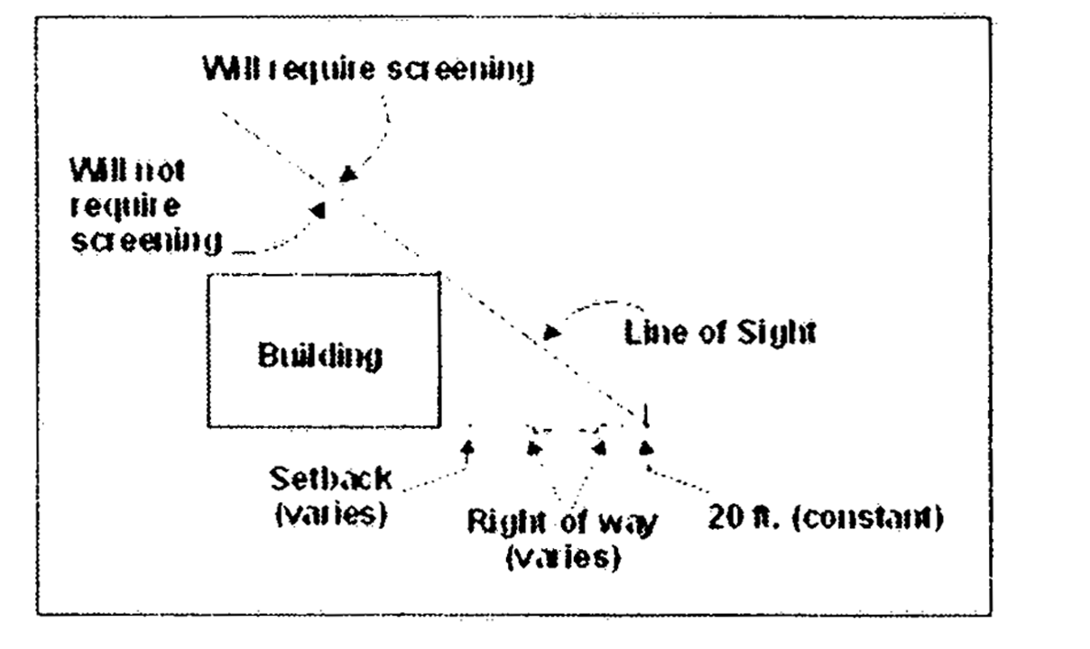

**Figure 33-63.2(b)(2)iii**

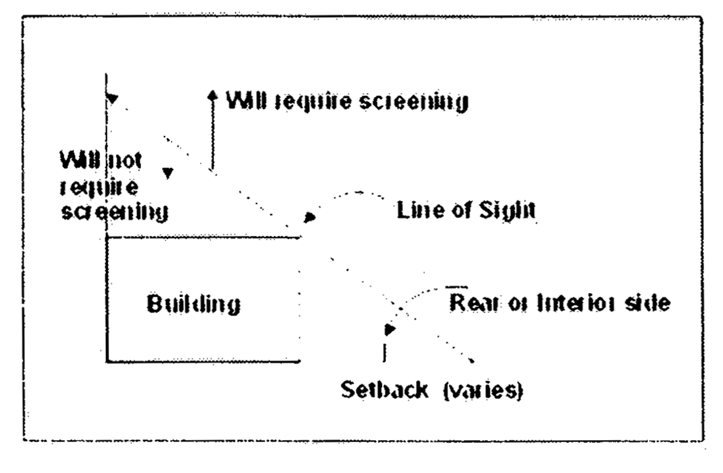

**Figure 33-63.2(b)(2)iv**

2. Any Antennas or portion thereof above the line of sight will require screening. All required screening used in conjunction with such rooftop installations shall be architecturally compatible and harmonious in color and materials with the supporting structures and any existing or approved screening on the structure. Screening materials at corners shall be the same length and height on all corners.

(i) An initial antenna installation within 13 feet of the corner of a structure shall require screening along the rooflines of both sides of the corner to a distance of 13 feet.

(ii) An initial antenna installation more than 13 feet from the corner of a structure, or the installation of any antenna subsequent to a prior antenna installation, shall provide screening along the entire rooflines from which the line of sight analysis shows that the antenna can be seen.

3. Cylinder Type Antennas shall be limited to three (3) per Structure and shall be painted to match the Structure.

4. No sign shall be allowed on an Antenna.

5. No signals, lights, or illumination shall be permitted on an Antenna, unless required by any applicable federal, state or local rule, regulation or law.

6. Accessory Wireless Equipment Buildings used in conjunction with Antennas, if located on the ground, shall comply with the minimum principal building setback requirements of the zoning district in which they are located. Self-standing, non sheltered equipment cabinet(s) used in conjunction with Antennas, if located on the ground shall be deemed mechanical equipment similar to air conditioning units and shall be limited to a height not to exceed eight (8) feet and an area not to exceed eighty (80) square feet. There shall be no minimum spacing between Accessory Wireless Equipment Buildings and the building located on the property.

(c) *Permitted Districts and Criteria for Antenna Support Structures.*

(1) *Permitted Districts.* Wireless Supported Service Facilities including Antenna Support Structures of one hundred (100) feet or less in height used in connection with a Wireless Supported Service Facility shall be permitted in the BU-3 and in all Industrial Districts. For Antenna Support Structures greater than one hundred (100) feet in height in the BU-3 and in the Industrial Districts, and for all Antenna Support Structures, except Antenna Support Structures for broadcast radio and television, in the RU-3M, RU-4L, RU-4M, RU-4, RU4A, RU-5, RU5-A, AU, GU with an agricultural trend determination, BU-1, BU-1A, BU-2, OPD, TND and PAD zoning districts, a public hearing is required pursuant to [Section 33-311](../level3/PTIIICOOR_CH33ZO_ARTXXXVIZOPR.docx#PTIIICOOR_CH33ZO_ARTXXXVIZOPR_S33-311COZOAPBOUTDU)(A)(18) and this section.

(2) *Criteria.*

(A) Signage.

(1.) No advertising signs, including commercial advertising, logo, political signs, flyers, flags or banners, whether or not posted temporarily, shall be permitted on any part of the antenna support structures or antenna with the exception of the following:

a. Warning, danger or other sign designed to maintain public safety;

b. Any federal, state or municipal flags located on such facilities designed to look like a flagpole; or

c. Permitted signage associated with the principle use on the property where the principle use incorporates a camouflaged antenna support structure.

(B) Zoning District. Antenna Support Structures considered for approval under [section 33-311](../level3/PTIIICOOR_CH33ZO_ARTXXXVIZOPR.docx#PTIIICOOR_CH33ZO_ARTXXXVIZOPR_S33-311COZOAPBOUTDU)(A)(18) of this code shall meet each of the following requirements, as applicable, except as alternative development options may be approved pursuant to [section 33-311](../level3/PTIIICOOR_CH33ZO_ARTXXXVIZOPR.docx#PTIIICOOR_CH33ZO_ARTXXXVIZOPR_S33-311COZOAPBOUTDU)(A)(18)(b).

1. In the BU-1, BU-1A, RU-5, and RU-5A zoning districts:

a) A stealth or camouflaged Antenna Support Structure shall be designed to resemble a natural object or a man-made structure (i.e. tree, bell tower, clock tower, church steeple, flag pole, etc.), shall be located on a minimum one (1) gross acre parent tract and

1) shall be a camouflaged artificial tree or flagpole not exceeding 150 feet in height; or

2) shall be designed to serve a purpose other than supporting antennas (i.e., lighting of sports facilities, transmission of electrical and/or telephone lines, flag poles); or

3) shall be designed to be harmonious with the architectural elements of the surrounding structures, such as bulk, massing and scale of surrounding properties; or be designed to blend and be harmonious with the principal structure on the property on which the Antenna Support Structure is proposed to be constructed and installed.

b) A non-camouflaged Antenna Support Structure shall not exceed 125 feet in height and shall be located on a minimum one (1) gross acre parent tract.

2. In the AU zoning district and the GU zoning district with an agricultural trend determination:

a. non-camouflaged Antenna Support Structures shall be located on a minimum five (5) gross acre parent tract, and

b. no Antenna Support Structures shall exceed 200 feet in height.

3. In all RU-3M, RU-4L, RU-4M, RU-4, and RU-4A zoning districts non-camouflaged Antenna Support Structures shall not exceed 150 feet in height, and shall not exceed 125 feet in height if located on a parcel where the immediate vicinity contains any existing single-family or duplex residential dwelling or is zoned for single-family or duplex dwellings.

4. In all BU-3, IU-1, IU-2, IU-3, and IU-C zoning districts, a non-camouflaged Antenna Support Structure shall not exceed 200 feet in height.

5. In all OPD and BU-2 zoning districts, a non-camouflaged Antenna Support Structure shall not exceed 200 feet in height.

6. On properties zoned PAD or TND, location and design criteria for Antenna Support Structures and related equipment buildings shall be controlled as part of the conditions of approval of the PAD or TND agreement and any amendments thereto, in accordance with the applicable requirements of [section 33-284.24](../level3/PTIIICOOR_CH33ZO_ARTXXXIIIDPLARDEDIPA.docx#PTIIICOOR_CH33ZO_ARTXXXIIIDPLARDEDIPA_S33-284.24PUIN) or [section 33-284.46](../level3/PTIIICOOR_CH33ZO_ARTXXXIIIHTRNEDETNDI.docx#PTIIICOOR_CH33ZO_ARTXXXIIIHTRNEDETNDI_S33-284.46PUIN) and section 33-246.47 of this code.

[3] No signals, lights, or illumination shall be permitted on the Antenna Support Structure or the Antennas, unless required by any applicable federal, state or local rule, regulation or law.

[4] Accessory Wireless Equipment Buildings used in conjunction with Antenna Support Structures and Antennas, if located on the ground, shall comply with the minimum principal building setback requirements of the zoning district in which they are located. Self-standing, non sheltered equipment cabinet(s) used in conjunction with Antenna Support Structures or Antennas, if located on the ground shall be deemed mechanical equipment similar to air conditioning units and shall be limited to a height not to exceed eight (8) feet and an area not to exceed eighty (80) square feet. There shall be no minimum spacing between Accessory Wireless Equipment Buildings and the building located on the property.

(Ord. No. 01-02, § 2, 1-23-01; Ord. No. 01-157, § 1, 9-25-01; Ord. No. 02-153, § 2, 9-12-02; Ord. No. 03-163, § 1, 7-8-03)

Sec. 33-63.3. Co-location.

To encourage co-location and the use of sites, which already have Wireless Supported Service Facilities, additions to such facilities may occur as follows:

(a) The addition of Antennas, cables, and/or Accessory Wireless Equipment Building to an existing Wireless Supported Service Facility shall be permitted in any district regardless of whether the Wireless Supported Service Facility is legally conforming or non-conforming and regardless of any limitations placed by any Resolution approving the Wireless Supported Service Facility.

(Ord. No. 01-02, § 3, 1-23-01)

FOOTNOTE(S):

--- (**6**) ---

**Cross reference—** Height of buildings not applicable to church steeples, spires, domes, etc., § 33-55. (Back)

### ARTICLE V. AWNINGS, CANOPIES AND TENTS

Sec. 33-64. Definitions.

Sec. 33-65. Permit required.

Sec. 33-66. Reserved.

Sec. 33-67. Construction.

Sec. 33-68. Inspections.

Sec. 33-69. Awnings in residential districts, maximum projection.

Sec. 33-70. Awnings in business and industrial districts; maximum projection.

Sec. 33-71. Use of cloth, canvas canopies in residential districts, excepting canopy carports.

Sec. 33-72. Reserved.

Sec. 33-73. Canopies at entrances to buildings.

Sec. 33-74. Canvas cabanas.

Sec. 33-75. Canopy carports in certain residential districts.

Sec. 33-76. Detached screened outdoor living quarters in EU Districts.

Sec. 33-77. Use of canopies in business and industrial districts.

Sec. 33-78. Awning or storm shutter on building where compliance with setback impossible.

Sec. 33-79. Tents.

Sec. 33-80. Use of awnings, canopies and tents in AU and GU Districts.

Sec. 33-81. Reserved.

Sec. 33-64. Definitions.

(a) *Awning.* A detachable covering, intended to provide protection against sun or weather, supported by a rigid frame. Awnings may be installed so as to remain in a fixed position or be installed in a manner permitting raising and lowering or shifting to function as a shutter to close entirely the protected opening. An awning must be supported entirely from the walls of the building to which it is attached or cantilevered.

(b) *Canopy.* A covering, intended to provide protection against the sun or weather, which is mounted on a rigid metal frame, and is supported in full or in part by posts attached to the ground, a deck or a concrete slab. Attached canopies shall be supported, in part, by the wall of a permanent structure. "Freestanding" shall refer to canopies supported entirely by posts.

(c) *Tent.* A portable shelter comprised of canvas or other cloth supported by a rigid frame or by poles, stakes and ropes, or both, and not attached to any building.

(d) *Cabanas (Canvas).* A tent used on the beach, as accessory to hotel, motel or hotel-apartment use.

(e) *Canopy Carport.* A vehicle shelter which is mounted on a rigid frame and supported by posts attached to the ground.

(Ord. No. 57-19, § 5(FF)(A), 10-22-57; Ord. No. 10-38, § 1, 6-3-10)

Sec. 33-65. Permit required.

A permit must be obtained from the Department for all awnings, canopies and canopy carports to be installed in residential, business and industrial districts. Other installations covered by this article, though not requiring permits, shall comply with this article and all other applicable rules, regulations and codes. Such plans and drawings as may be deemed necessary to fully advise and acquaint the issuing Department with the location, construction and material of the installation, must accompany the application for permit.

(Ord. No. 57-19, § 5(FF)(B)(1), 10-22-57; Ord. No. 95-215, § 1, 12-5-95; Ord. No. 10-38, § 2, 6-3-10)

Sec. 33-66. Reserved.

**Editor's note—**

Paragraph F of Section 5FF, of Ord. No. 57-19, from which this section was derived, was repealed by Section 1 of Ord. No. 60-2 enacted on January 19, 1960. The section levied fees for the permits required in [Section 33-65](../level3/PTIIICOOR_CH33ZO_ARTVAWCATE.docx#PTIIICOOR_CH33ZO_ARTVAWCATE_S33-65PERE). Permit fees are provided for in [Section 33-285](../level3/PTIIICOOR_CH33ZO_ARTXXXIVFE.docx#PTIIICOOR_CH33ZO_ARTXXXIVFE_S33-285SCFE)

Sec. 33-67. Construction.

All installations covered by this article, whether requiring permits or not, shall comply with this chapter and all applicable construction codes and regulations.

Canvas shall not be used for structures or appurtenances thereto other than listed in [this] article.

(Ord. No. 57-19, § 5(FF)(B)(2), (4), 10-22-57)

Sec. 33-68. Inspections.

All installations covered by this article requiring permits shall be subject to inspection and the permittee shall call the issuing Department for an inspection after the installation has been completed.

(Ord. No. 57-19, § 5(FF)(B)(3), 10-22-57)

Sec. 33-69. Awnings in residential districts, maximum projection.

In all residential districts, awnings comprised of wood, metal, canvas or other similar cloth material shall be permitted for the purpose of providing protection from the elements for doors, windows or other openings. Such awnings shall not project more than five (5) feet six (6) inches from the building wall nor extend closer than one (1) foot to any interior side property line.

(Ord. No. 57-19, § 5(FF)(B)(5), 10-22-57; Ord. No. 62-14, § 1, 3-6-62; Ord. No. 10-38, § 3, 6-3-10)

Sec. 33-70. Awnings in business and industrial districts; maximum projection.

In all business and industrial districts, (including those districts requiring masonry construction), awnings comprised of wood, metal, canvas (or other similar cloth material) shall be permitted for the purpose of providing protection from the elements of doors, windows and other openings. Such awning shall not extend more than nine (9) feet from the building wall nor extend closer than two and one-half (2½) feet to the interior side property lines when projected from side walls, or closer than two and one-half (2½) feet to the rear property line, nor closer than seven (7) feet to any official right-of-way line. In no event shall such awning be used to shelter any merchandise, equipment, display or to be used for any commercial, industrial or storage purpose.

(Ord. No. 57-19, § 5(FF)(B)(6), 10-22-57; Ord. No. 10-38, § 4, 6-3-10)

Sec. 33-71. Use of cloth, canvas canopies in residential districts, excepting canopy carports.

(a) Canopies comprised of a covering made of cloth, canvas, or other similar material shall be permitted within the side and rear yards in all residential districts subject to the regulations of this section. Canopies shall have a maximum height of ten feet as measured from grade to the lowest horizontal element of the frame structure with the total height of the structure not exceeding 15 feet. Canopies may encroach into the rear and side setback but shall not be located closer than ten feet to the rear property line and five feet to the interior side property line. On a side street, the canopy shall meet the principal building setback. In no event shall the area protected by the canopy be enclosed or screened in any manner. See [section 33-75](../level3/PTIIICOOR_CH33ZO_ARTVAWCATE.docx#PTIIICOOR_CH33ZO_ARTVAWCATE_S33-75CACACEREDI) for regulations related to canopy carports.

(b) In addition to the requirements of [section 33-71](../level3/PTIIICOOR_CH33ZO_ARTVAWCATE.docx#PTIIICOOR_CH33ZO_ARTVAWCATE_S33-71USCLCACAREDIEXCACA)(a), an attached canopy comprised of cloth, canvas or other similar material shall project a maximum of 15 feet from the primary structure.

(c) In addition to the requirements of [Section 33-71](../level3/PTIIICOOR_CH33ZO_ARTVAWCATE.docx#PTIIICOOR_CH33ZO_ARTVAWCATE_S33-71USCLCACAREDIEXCACA)(a), freestanding canopies comprised of cloth, canvas or other similar material shall not exceed 12 feet by 24 feet in size. Freestanding canopies exceeding the maximum size requirement may be permitted for authorized special events but shall not remain on the site for a period exceeding 30 days.

(d) If the canopy has aluminum, shingle, or other solid roof, it shall be considered to be part of the principal structure and subject to all setbacks and height restrictions for principal structures.

(e) The canopy shall be erected in such manner that it shall be removed during hurricanes.

(Ord. No. 57-19, § 5(FF)(B)(7), 10-22-57; Ord. No. 70-35, § 1, 4-29-70; Ord. No. 70-67, § 1, 9-15-70; Ord. No. 10-38, § 5, 6-3-10)

Sec. 33-72. Reserved.

**Editor's note—**

Section 6 of Ord. No. 10-38, adopted June 3, 2010, deleted [§ 33-72](../level3/PTIIICOOR_CH33ZO_ARTVAWCATE.docx#PTIIICOOR_CH33ZO_ARTVAWCATE_S33-72RE), which pertained to canopy shutters, and derived from Ord. No. 57-19, adopted Oct. 22, 1957.

Sec. 33-73. Canopies at entrances to buildings.

In all RU-4, RU-4A and all business and industrial districts, canvas or metal canopies shall be permitted to extend from the entrance door of the principal structure concerned to the official right-of-way line for the purpose of providing shelter or covered walkway for guests or customers. Where a sidewalk and curb exist, the canopy may extend to within eighteen (18) inches of the curbline provided permission in writing is first secured from the Director of Public Works and/or State Road Department. In no event shall such canopy be screened or enclosed in any manner. Such installations must provide an unobstructed clear space between the grade and the bottom of the valance of at least six and one-half (6½) feet.

(Ord. No. 57-19, § 5(FF)(B)(8), 10-22-57)

Sec. 33-74. Canvas cabanas.

In all RU-4 and RU-4A Districts, canvas cabanas shall be permitted where such use is incidental and accessory to a private club, hotel, apartment-hotel, or motel use, and where limited to the use of the guests of such establishments only. Cabanas shall not be used for overnight sleeping quarters or contain cooking facilities. Such cabanas shall comply with all applicable accessory building setback and spacing regulations and with lot coverage requirements. Canvas cabanas shall also be permitted as an incidental use in connection with publicly or privately owned and operated parks.

(Ord. No. 57-19, § 5(FF)(B)(9), 10-22-57)

Sec. 33-75. Canopy carports in certain residential districts.

In certain residential districts as shown in [Section 33-50](../level3/PTIIICOOR_CH33ZO_ARTIIBUCOSEARSI.docx#PTIIICOOR_CH33ZO_ARTIIBUCOSEARSI_S33-50TASELIREESDI), attached or detached fabric, fiberglass or metal canopy carports shall be permitted. Such canopies shall comply with the setback requirements pursuant to [Section 33-50](../level3/PTIIICOOR_CH33ZO_ARTIIBUCOSEARSI.docx#PTIIICOOR_CH33ZO_ARTIIBUCOSEARSI_S33-50TASELIREESDI) and with lot coverage requirements. The canopy carport shall not exceed ten (10) feet in height as measured from grade to the horizontal element of the frame structure. When placed in the front setback area, the canopy carport shall be no greater than one-half (½) the width of the residence. No more than one (1) such canopy carport shall be provided for each dwelling unit on the premises concerned.

(Ord. No. 57-19, § 5(FF)(B)(10), 10-22-57; Ord. No. 70-35, § 2, 4-29-70; Ord. No. 70-67, § 2, 9-15-70; Ord. No. 01-77, § 2, 4-24-01)

Sec. 33-76. Detached screened outdoor living quarters in EU Districts.

In EU Districts, detached metal and screened outdoor living quarters are permitted under the following conditions:

(a) That the use of said structure be restricted to recreational utility purposes.

(b) That the structure be made to comply with all requirements of the building code.

(c) That no plumbing be permitted in said structures.

(Ord. No. 57-19, § 5(FF)(B)(11), 10-22-57)

Sec. 33-77. Use of canopies in business and industrial districts.

(a) In business and industrial districts where sales from open lots are specifically permitted by applicable regulations, and the use does not require the erection of any building, one (1) canvas or metal canopy not to exceed 288 square feet may be erected for each fifty (50) feet of lot frontage (on one (1) street only). In no event shall the area protected by the canopy be enclosed or screened in any manner. The canopy shall be erected in such manner that it shall be removed during hurricanes. The standard setbacks for structures in the particular districts concerned shall apply.

(b) In business and industrial districts the erection of an approved permanent metal canopy shall be permitted not to exceed thirty (30) feet in depth and the length equivalent to the width of the lot, subject to all principal building setbacks being complied with.

(Ord. No. 57-19, § 5(FF)(B)(12), 10-22-57; Ord. No. 70-12, § 1, 2-18-70; Ord. No. 10-38, § 7, 6-3-10)

Sec. 33-78. Awning or storm shutter on building where compliance with setback impossible.

Where it is not possible to comply with setback requirements from official right-of-way lines because of the location of the existing building, the erection of the awning or storm shutter is hereby permitted on a temporary basis on said building closer to the official right-of-way than heretofore permitted, under the following conditions:

(1) That said awning or shutter does not extend more than nine (9) feet from the building wall.

(2) That proper and safe vertical clearance is provided.

(3) That written approval is secured from the Department of Public Works, and State Road Department (where State road is involved).

(4) That where the awning or shutter extends over dedicated right-of-way and a curb and sidewalk exist, the awning or shutter shall come no closer than eighteen (18) inches to the curbline. If a curb and sidewalk do not exist, no extension shall be made over dedicated right-of-way.

(5) That where the awning or shutter extends over official right-of-way, which has not been dedicated, the awning or shutter shall come no closer than eighteen (18) inches to the dedicated right-of-way line.

(6) An agreement shall be executed and recorded and signed by the property owner and tenant if other than an owner occupant, to remove the awning or shutter when deemed necessary by the Department because of widening of the adjacent right-of-way.

(7) That proper permits shall be secured from the Department.

(Ord. No. 57-19, § 5(FF)(C), 10-22-57; Ord. No. 95-215, § 1, 12-5-95)

Sec. 33-79. Tents.

The use and erection of tents shall be prohibited except for temporary use as shelter in connection with camping trips, outings for youth organizations, and other similar uses or where specifically permitted elsewhere in this chapter.

(Ord. No. 57-19, § 5(FF)(D), 10-22-57)

Sec. 33-80. Use of awnings, canopies and tents in AU and GU Districts.

In AU and GU Districts, the use of canvas or metal structures and installations covered by this article shall be governed by the character of the neighborhood and use involved, and corresponding regulations shall apply.

(Ord. No. 57-19, § 5(FF)(E), 10-22-57)

Sec. 33-81. Reserved.

**Editor's note—**

Section 8 of Ord. No. 10-38, adopted June 3, 2010, deleted [§ 33-81](../level3/PTIIICOOR_CH33ZO_ARTVAWCATE.docx#PTIIICOOR_CH33ZO_ARTVAWCATE_S33-81RE), which pertained to signs identifying erector, and derived from Ord. No. 57-19, adopted Oct. 22, 1957.

### ARTICLE VI. SIGNS [7]

[DIVISION 1. - TITLE, APPLICABILITY, PURPOSE AND DEFINITIONS](../level4/PTIIICOOR_CH33ZO_ARTVISI_DIV1TIAPPUDE.docx)

[DIVISION 2. - GENERAL PROVISIONS](../level4/PTIIICOOR_CH33ZO_ARTVISI_DIV2GEPR.docx)

[DIVISION 3. - SIGN STANDARDS REQUIREMENTS AND CHARTS](../level4/PTIIICOOR_CH33ZO_ARTVISI_DIV3SISTRECH.docx)

[DIVISION 4. - ENTRANCE FEATURES](../level4/PTIIICOOR_CH33ZO_ARTVISI_DIV4ENFE.docx)

[DIVISION 5. - COMMERCIAL SIGNS ON EXPRESSWAY RIGHT-OF-WAY](../level4/PTIIICOOR_CH33ZO_ARTVISI_DIV5COSIEXRI-W.docx)

[DIVISION 6. - COMMERCIAL SIGNS ON RAPID TRANSIT SYSTEM RIGHT-OF-WAY](../level4/PTIIICOOR_CH33ZO_ARTVISI_DIV6COSIRATRSYRI-W.docx)

[DIVISION 7. - BUSWAY RIGHT-OF-WAY](../level4/PTIIICOOR_CH33ZO_ARTVISI_DIV7BURI-W.docx)

FOOTNOTE(S):

--- (**7**) ---

**Editor's note—** Ord. No. 85-59, § 1, adopted July 18, 1985, repealed §§ 33-82—33-121.9, which comprised Divs. 1—4 of Art. VI. Section 2 of Ord. No. 85-59 set out new Divs. 1—4. The repealed provisions derived from the ordinances set out in the chart below: (Back)

|  |  |  |  |
| --- | --- | --- | --- |
| **Ord. No.** | **Date** | **Ord. No.** | **Date** |
| 57-19 | 10-22-57 | 68-11 | 2-21-68 |
| 59-45 | 12-8-59 | 69-55 | 9-17-69 |
| 61-15 | 4-11-61 | 69-89 | 12-3-69 |
| 61-21 | 5-16-61 | 70-13 | 2-18-70 |
| 62-25 | 6-19-62 | 72-90 | 12-5-72 |
| 62-39 | 9-25-62 | 77-45 | 7- 5-77 |
| 64-14 | 4-21-64 | 78-13 | 3-21-78 |
| 64-45 | 9-15-64 | 78-52 | 7-18-78 |
| 65-15 | 3-16-65 | 83-45 | 6-21-83 |

#### DIVISION 1. TITLE, APPLICABILITY, PURPOSE AND DEFINITIONS [8]

Sec. 33-82. Short title and applicability.

Sec. 33-83. Purpose.

Sec. 33-84. Definitions.

Sec. 33-82. Short title and applicability.

(a) This article shall be known as the "Sign Code of Miami-Dade County, Florida" and shall be applicable in the unincorporated areas of Miami-Dade County, and specifically in the incorporated areas of Miami-Dade County. When the provisions of this article are applicable to a municipality, the municipality shall be responsible for enforcement.

(b) If property in the unincorporated area fronting a street right-of-way forms a common boundary with a municipality, and if the zoning classifications on both sides of the boundary are comparable, the property in the unincorporated area shall comply with the provisions of the municipal ordinance, provided the municipality has a sign ordinance with stricter standards than this article. In such event Miami-Dade County shall apply and enforce the provisions of the municipal ordinance in the unincorporated areas of the County. No variance from this section shall be permitted without the prior express consent of the affected municipality.

(Ord. No. 85-59, § 2, 7-18-85; Ord. No. 96-163, § 1, 11-12-96)

Sec. 33-83. Purpose.

(a) The purpose of this chapter [article] is to permit signs that will not, because of size, location, method of construction and installation, or manner of display:

(1) Endanger the public safety; or

(2) Create distractions that may jeopardize pedestrian or vehicular traffic safety; or

(3) Mislead, confuse, or obstruct the vision of people seeking to locate or identify uses or premises; or

(4) Destroy or impair aesthetic or visual qualities of Miami-Dade County which is so essential to tourism and the general welfare; and

(b) The purpose of this article is also to permit, regulate and encourage the use of signs with a scale, graphic character, and type of lighting compatible with buildings and uses in the area, so as to support and complement land use objectives as set forth in the Comprehensive Development Master Plan.

(c) The purpose of this article is also to protect noncommercial speech such that any sign authorized herein may contain, in lieu of any other message or copy, any lawful noncommercial message, so long as such sign complies with the size, height, area and other requirements of this article.

(Ord. No. 85-59, § 2, 7-18-85; Ord. No. 07-61, § 1, 4-26-07)

Sec. 33-84. Definitions.

For the purposes of this article the following words and phrases are hereby defined as provided in this section, unless the context clearly indicates otherwise. Where there is a question as to the correct classification or definition of a sign, the Director shall place said sign in the strictest category and/or classification.

(a) *Sign:* Any display of characters, letters, logos, illustrations or any ornamentation designed or used as an advertisement, announcement, or to indicate direction.

Use of merchandise, products, vehicles, equipment, inflated balloons, or the like as an attention attractor or advertising device, with or without a printed or written message or advertisement, shall be considered a sign.

(b) *Attraction board:* A sign or portion of a sign on which copy is changed periodically, advertising special sales, bargains, etc. Said attraction board may be incorporated into the sign permitted.

(c) *Awning, canopy, roller curtain or umbrella sign:* Any sign painted, stamped, perforated, or stitched on the surface area of an awning, canopy, roller curtain or umbrella.

(d) *Cantilever:* That portion of a building, projecting horizontally, whether it be on the same plane as the roof line or not.

(e) *Cantilever sign:* Any sign which is mounted on a cantilever. No cantilever sign may extend beyond the cantilever.

(f) *Class A (temporary signs):* Any sign(s) to be erected on a temporary basis, such as signs advertising the sale or rental of the premises on which located; signs advertising a subdivision of property; signs advertising construction actually being done on the premises on which the sign is located; signs advertising future construction to be done on the premises on which located, and special events, such as carnivals, concerts, public meetings, sporting events, political campaigns or events of a similar nature.

(g) *Class B (point of sale sign):* Any sign advertising or designating the use, occupant of the premises, or merchandise and products sold on the premises, shall be deemed to be a point of sale sign (class B) and shall be located on the same premises whereon such is situated or the products sold.

(h) *Class C (commercial advertising signs):* Any sign which is used for any purpose other than that of advertising to the public the legal or exact firm name of business or other activity carried on the premises, or for advertising any service or product or products actually and actively being offered for sale on the premises, or which is designed and displayed solely to offer for sale or rent the premises, or to advertise construction being done, or proposed to be done, on the premises, or to advertise special events, shall constitute a class C sign.

Class C signs may be in the form of a billboard, bulletin board, mural, or poster board, or may be affixed flat to a building or painted thereon.

(i) *Detached sign:* Any sign not attached to or painted on a building, but which is affixed and permanently attached to the ground. Permanently attached as used herein shall mean that the supporting structure of the sign is attached to the ground by a concrete foundation.

(j) *Director:* The Director or his qualified agent.

(k) *Directional sign:* A sign which guides or directs the public and contains no advertising. The name of the facility (such as store name), which the sign is giving direction to, may be included when specified conditions in the ordinance are complied with.

(l) *Entrance features:* Any combination of decorative structures and landscape elements located at the entrance to a development, which identifies or draws attention to the development and/or exercises control of ingress and egress to the development. An entrance feature may include, although not necessarily be limited to, ornamental walls, fences, identifying lettering, logos, works of art, and other decorative structures, earthworks, water bodies, fountains, trees, plantings, and other landscape elements, as well as gatehouses, either singly or in any combination thereof.

(m) *Flat sign:* Any sign attached to and erected parallel to the face of, or erected or painted on the outside wall of any building, and supported throughout its length by such wall or building.

(n) *Marquee:* A covered structure projecting from, and supported by the building with independent roof and drainage provisions, and which is erected over a doorway or entranceway as protection against the weather.

(o) *Marquee sign:* Any sign attached to or hung from a marquee.

(p) *Portable sign:* Any sign not attached to or painted on a building and not affixed or permanently attached to the ground.

(q) *Projecting sign:* Any sign which is an independent structure, which is attached to the building wall, and which extends at any angle from the face of the wall. No projecting sign shall extend above the roof or parapet wall in any residential district.

(r) *Pylon:* A vertical extension of a building, constructed integrally and concurrently with the building, or in connection with a major remodeling or alteration of a building. To classify as a pylon for sign purposes, the pylon structure must be an integral part of the building structure, extending to ground level. In business and industrial districts only, the material and construction may vary from the materials and type of construction of the exterior walls of the building, but same must be approved by the Director. In all cases, the pylon shall have the appearance of a solid structure.

(s) *Pylon sign:* A flat sign attached to or painted on the face of a pylon. The outer edge of the sign shall not extend beyond the pylon nor above the roof line.

(t) *Roof sign:* Any sign which is painted on, fastened to, or supported by the roof or erected over the roof.

(u) *Semaphore:* Any sign consisting of two (2) dual-face signs extending horizontally from a light standard. Such sign projecting from opposite sides of such light standard, and such signs must be located in the parking lot of a shopping center to identify the location of parking areas. No advertising is permitted on the sign.

(v) *Shopping center:* An area zoned for business is a shopping center where at least two hundred fifty (250) feet of street frontage has been zoned for commercial purposes under one (1) application and under one (1) ownership, and where it contains at least two (2) tiers of in-front parking, contains two (2) or more retail uses, and is subject to site plan or plot use approval as a condition of the applicable resolution or ordinance.

(w) *Wall:* For sign purposes, that portion of the building's exterior, horizontal surface on the same plane, regardless of vertical or horizontal indentations, and including the surface of parapets and pylons projecting from the building. For sign purposes, there shall be considered to be only four (4) planes to any building and it shall be the prerogative of the Director to determine which portion of odd-shaped buildings, such as buildings of hexagon or octagon design, to which flat signs may be affixed, with such location to be so determined as to prevent a grouping of signs which can be viewed from one (1) direction.

(x) *Wall sign:* Any sign painted on or attached to and erected parallel to the face of, or erected and confined within the limits of, the outside wall of any building and supported by such wall or building and which displays only one (1) advertising surface.

(y) *City of Miami Urban Core* shall mean the geographic area commencing at Biscayne Bay and the North side of NE 18th Street; thence West along the North side of NE 18th Street to the East side of NE 2nd Avenue; thence North along the East side of NE 2nd Avenue to the South side of NE 36th Street; thence East along the South side of NE 36 Street to the West side of Biscayne Boulevard; thence North along the west side of Biscayne Boulevard to the North side of I-195; thence West along the North side of I-195 to the East side of N. Federal Highway; thence North along the East side of N. Federal Highway to the North side of NE 39th Street; thence West along the North side of NE 39th Street to East side of NE 2nd Avenue; thence North along the East side of NE 2nd Avenue to North side of NE 40th Street; thence West along the North side of NE 40th Street to West side of N. Miami Avenue; to its intersection with the South limited access right-of-way line of the I-195 Eastbound exit ramp; thence West along said South limited access right-of-way line to its intersection with the South side of NW 37th Street; thence West along the South side of NW 37th Street to the East side of NW 1st Avenue; thence South along the East side of NW 1st Avenue to the North side of NW 36th Street; thence East along the North side of NW 36th Street to the West side of N. Miami Avenue; thence South along the West side of N. Miami Avenue to the North side of NW 25th Street; thence West along the North side of NW 25th Street to the East side of the theoretical extension thereto of NW 1st Court; thence North along the East side of the theoretical extension of NW 1st Court to the North side of NW 27th Street; thence West along the North side of NW 27th Street to the West side of NW 2nd Avenue; thence South along the West side of NW 2nd Avenue to the South side of NW 19th Street; thence East along the South side of NW 19th Street to the West side of NW 1st Avenue; thence South along the West side of NW 1st Avenue to the North side of NW 16th Street; thence West along the North side of NW 16th Street to the West side of NW 3rd Avenue; thence South along the West side of NW 3rd Avenue to the North Side of the Dolphin Expressway; thence West along the North side of the Dolphin Expressway to the East side of I-95; thence North along the East side of I-95 to North side of NW 20th Street; thence West along the North side of NW 20th Street to the West side of NW 14th Avenue; thence South along the West side of NW 14th Avenue to the South side of the Dolphin Expressway; thence East along the South side of the Dolphin Expressway to the East bank of the Wagner Creek Canal; thence South 300 feet along the East bank of the Wagner Creek Canal; thence East running parallel 300 feet to the South of the Dolphin Expressway to the West side of NW 7th Avenue; thence North along the West side of NW 7th Avenue to the South side of the Dolphin Expressway; thence East along the South side of the Dolphin Expressway to the West side of I-95; thence South along the West side of I-95 to the North side of NW 5th Street; thence West along the North side of NW 5th Street to the West side of NW 6th Avenue; thence South on the West side of NW 6th Avenue to the West side of NW North River Drive; thence South along the West side of NW North River Drive to the North side of West Flagler Street; thence East along the North side of West Flagler Street to the West side of I-95; thence South along the West side I-95 to the South side of SW 8th Street; thence East along the South side of SW 8th Street to the East side of S. Miami Avenue; thence North along the East side of S. Miami Avenue to the South side of the Miami River; thence East along the South side of the Miami River to the East side of Brickell Avenue; thence North along the East side of Brickell Avenue to the North side of the Miami River; thence East along the North side of the Miami River to Biscayne Bay; thence North along the Biscayne Bay shoreline to the point of beginning, as shown on the City of Miami Urban Core map shown below.

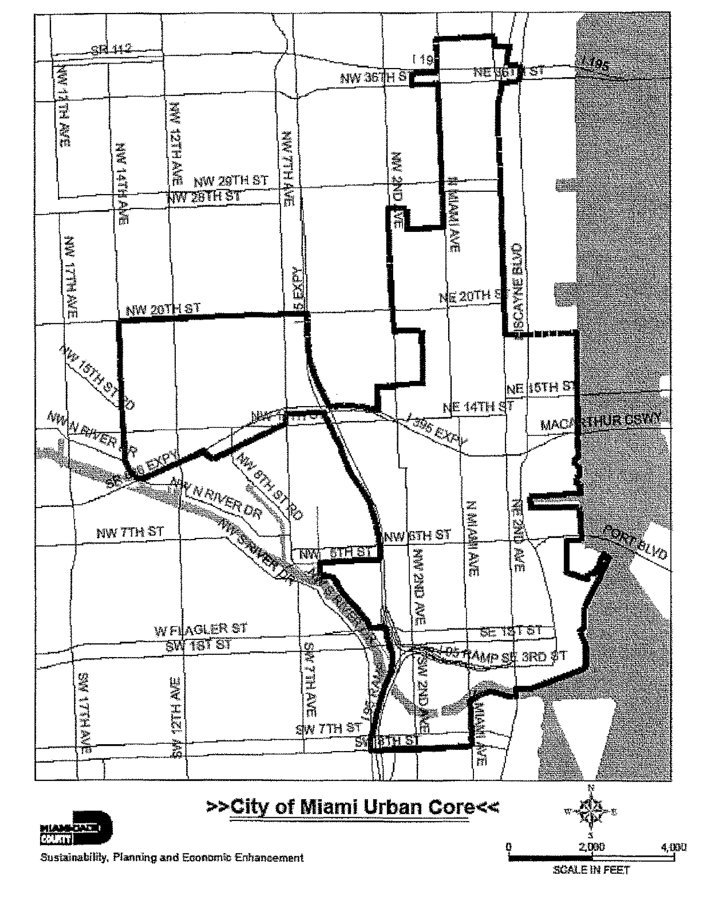

(z) *Mural.* Any Class C wall sign painted on, or affixed or secured flat to the facade of a building.

(aa) *Blank wall.* A blank wall means the wall of a building that is free of windows, balconies, railings, articulated facade, decorative grills or gratings, or other architectural elements. Walls constructed on rooftops or as part of a parapet shall not be considered blank walls for the purposes of this article.

(Ord. No. 85-59, § 2, 7-18-85; Ord. No. 95-215, § 1, 12-5-95; Ord. No. 07-61, § 2, 4-26-07; Ord. No. 07-91, § 1(2), 7-10-07; Ord. No. 10-71, § 1, 10-19-10; Ord. No. 12-09, § 1, 3-6-12)

FOOTNOTE(S):

--- (**8**) ---

**Editor's note—** As originally enacted, Div. 1 was entitled "Definitions and Requirements," and began with § 33-84. To preserve Code format, the editor has moved Div. 1 to begin with § 33-82 and has slightly altered the title. No substantive changes were made editorially. (Back)

#### DIVISION 2. GENERAL PROVISIONS

Sec. 33-85. Interpretation.

Sec. 33-86. Permits required.

Sec. 33-87. Compliance with codes.

Sec. 33-88. Qualification and certification of erector.

Sec. 33-89. Fees required.

Sec. 33-90. Time limitation of permits.

Sec. 33-91. Identification of permit holder on sign.

Sec. 33-92. Responsibility for sign.

Sec. 33-93. Inspection.

Sec. 33-94. Signs permitted without a sign permit.

Sec. 33-95. Prohibited signs.

Sec. 33-96. Illumination.

Sec. 33-96.1. Automatic electric changing signs.

Sec. 33-97. Maintenance of signs.

Sec. 33-85. Interpretation.

Only those signs that are specially authorized by this sign code shall be permitted. Those that are not listed or authorized shall be deemed prohibited. It is provided, however, that any sign authorized herein may contain, in lieu of any other message or copy, any lawful noncommercial message, so long as such sign complies with the size, height, area and other requirements of this article.

(Ord. No. 85-59, § 2, 7-18-85; Ord. No. 07-61, § 3, 4-26-07)

Sec. 33-86. Permits required.

(a) *Applications and permits.* No sign, unless excepted by this article, shall be erected, constructed, posted, painted, altered, maintained, or relocated, except as provided in this article and until a permit has been issued by the Department. Before any permit is issued, an application for such permit shall be filed together with three (3) sets of drawings and/or specifications (one (1) to be returned to the applicant) as may be necessary to fully advise and acquaint the issuing department with the location, method of construction, type of materials, manner of illumination, method of erection, securing or fastening, number and type of signs applied for, and advertisement to be carried. All signs which are electrically illuminated by neon or any other means shall require a separate electric permit and inspection.

(b) *Consent of property owner.* No sign shall be placed on any property unless the applicant has the written consent of the owner and lessee, if any, of the property.

(c) *Calculating number of signs.* A single sign containing advertisement on each side shall be counted as one (1) sign. Every other sign shall be counted as a separate sign for each face thereof. Excepting class C signs, "V" type signs will be considered as one (1) sign if the spread of the "V" at the open end is not greater than the length of its narrowest side.

(d) *Calculating sign size.* The area of a sign shall include borders and framing. Heights shall be measured to the top extremity of the sign and distances to the farthest point. The square footage in a circular rotating or revolving sign shall be determined by multiplying one-half (½) of the circumference by the height of the rotating sign, except in the case of the flat rotating sign, the area will be determined by the square footage of one (1) side of such sign. The Director shall have the discretion of determining the area of any sign which is irregular in shape, and in such cases will be guided by calculations as made by a licensed, registered engineer when same are shown on the drawing.

(e) *Review of the application.* The Department shall complete its review of a sign permit application for the unincorporated area within 30 calendar days after filing, and shall render a decision either for approval or denial within that time. Failure by the Department to render a decision within 30 calendar days shall be deemed a denial, appealable as provided herein. If the permit is denied based upon grounds set forth in this article, the applicant may file an appeal to the appropriate Community Zoning Appeals Board. Such appeal shall be heard at the next regular meeting of such board after notice pursuant to the requirements of [Section 33-310](../level3/PTIIICOOR_CH33ZO_ARTXXXVIZOPR.docx#PTIIICOOR_CH33ZO_ARTXXXVIZOPR_S33-310NOHEPRACCOZOAPBOBOCOCO)(c) of this code. Further appeal shall be as authorized pursuant to the Florida rules of court. It is provided that the procedures for the review of a sign permit application pursuant to this section shall be limited to the Department of Planning and Zoning and shall not apply to other county departments' review of a sign permit application pursuant to the Florida Building Code.

(f) *Restrictions on Certain Class C Sign Permits.*

(1) No permit shall be issued for a mural on property where a civil violation notice pursuant to [Chapter 8CC](../level2/PTIIICOOR_CH8CCCOEN.docx#PTIIICOOR_CH8CCCOEN) of this code has been issued for an unauthorized mural until such civil violation notice has been resolved.

(2) No permit shall be issued for a mural to an erector or affiliate of such erector who has been issued a civil violation notice pursuant to [Chapter 8CC](../level2/PTIIICOOR_CH8CCCOEN.docx#PTIIICOOR_CH8CCCOEN) of this code for erecting an unauthorized mural until such civil violation notice has been resolved.

(3) No permit shall be issued to a property owner or owner of a mural or affiliate thereof who has been issued a civil violation notice pursuant to [Chapter 8CC](../level2/PTIIICOOR_CH8CCCOEN.docx#PTIIICOOR_CH8CCCOEN) of this code for erecting an unauthorized mural, until such civil violation notice has been resolved.

(4) No permit shall be issued for an existing mural in violation of this article if authorization for such mural was obtained from a municipality.

(5) No permit for a mural shall be issued to an owner, erector or affiliate thereof, if such owner, erector or affiliate has an existing agreement with a municipality purporting to allow the establishment or continuation of a mural upon payment of fines, penalties or other payments to the municipality, if such mural is not in compliance with the requirements of this article.

(6) For purposes of this subsection, the term "affiliate" shall mean (i) a person, corporation, partnership or other business organization ("entity"), directly controlling, controlled by, or under common control with, another entity, or (ii) any entity owning or controlling ten percent or more of the ownership interest of another entity.

(Ord. No. 85-59, § 2, 7-18-85; Ord. No. 95-215, § 1, 12-5-95; Ord. No. 07-61, § 4, 4-26-07)

Sec. 33-87. Compliance with codes.

(1) [*Required.*] All signs shall conform to the requirements of the building, electrical, and other applicable technical codes, except as may be otherwise provided herein.

(2) *Advertising conflicting with zoning rules.* No sign shall be erected or used to advertise any use or matter which would conflict with the regulations for the district in which it is located or be in conflict with the use permitted under the certificate of use or occupancy for the property.

(Ord. No. 85-59, § 2, 7-18-85)

Sec. 33-88. Qualification and certification of erector.

Where the erection of any sign requires compliance with any Miami-Dade County technical code, the erector of the sign shall qualify with the respective examining board.

(Ord. No. 85-59, § 2, 7-18-85)

Sec. 33-89. Fees required.

No sign, where a permit is necessary shall be exhibited unless the required permit fees are paid.

(Ord. No. 85-59, § 2, 7-18-85)

Sec. 33-90. Time limitation of permits.

All signs shall be erected on or before the expiration of ninety (90) days from the date of issuance of the permit. If the sign is not erected within said ninety (90) days, the permit shall become null and void, and a new permit required; provided, however, that the Director may extend such permit for a period of ninety (90) days from the date of the expiration of the permit if written application for such extension is received and approved by the Director prior to the expiration date of the initial permit and provided that the proposed sign complies with all requirements in effect at the date of such renewal.

(Ord. No. 85-59, § 2, 7-18-85)

Sec. 33-91. Identification of permit holder on sign.

Each sign requiring a permit shall carry the permit number and the name of the person or firm placing the sign on the premises; such marking shall be permanently attached and clearly visible from the ground.

(Ord. No. 85-59, § 2, 7-18-85)

Sec. 33-92. Responsibility for sign.

The owner and/or tenant of the premises, and the owner and/or erector of the sign shall be held responsible for any violation of this chapter; provided, however, that when the sign has been erected in accordance with this chapter, the sign company shall be relieved of further responsibility after final approval of the sign.

(Ord. No. 85-59, § 2, 7-18-85)

Sec. 33-93. Inspection.

No sign shall be approved for use, unless the same shall have been inspected by the Department issuing the permit, and no sign shall be erected or used unless it complies with all the requirements of this chapter and applicable technical codes. The holder of a permit for a sign shall request inspections of a sign as follows:

(1) Foundation inspection (this shall include method of fastening to building or other approved structure).

(2) Shop inspection (electrical and/or structural where indicated on the permit and/or approved plan).

(3) Final inspection (this shall include structural framing, electrical work identification of permit number and erector of sign, etc.).

(4) Any additional inspections which may be specified on the permit and/or approved plans.

(Ord. No. 85-59, § 2, 7-18-85)

Sec. 33-94. Signs permitted without a sign permit.

(a) Class A temporary signs not exceeding six (6) square feet in area, not electrically illuminated will not require a sign permit, but must otherwise comply with this article and applicable technical codes.

(b) Traffic signs, provisional warnings and signs indicating danger, are exempt from this chapter. Such exempted signs shall not contain any commercial advertisement.

(c) Awning, canopy, roller curtain, or umbrella sign or signs shall be limited to eight-inch letters in height, and shall not exceed a total coverage of twenty-four (24) square feet. Any such sign shall be limited to the identification of the occupant and/or use of the property. No sign permit shall be required for the awning, canopy, roller curtain or umbrella sign, but the same shall comply with applicable technical codes.

(d) Disabled or handicapped parking signs. Signs required by State law or County ordinance for parking spaces reserved for disabled or handicapped persons shall not require a sign permit.

(e) Signs not exceeding one and one-half (1½) square feet in area and bearing only property street numbers, post box numbers, or name of occupant of premises.

(f) Flags and insignia of any government, except when displayed in connection with commercial promotion.

(g) Legal notices, identification, information, or directional signs erected by or on behalf of governmental bodies.

(h) Integral decorative and architectural features of buildings except letters, logos, trademarks, moving parts or moving lights.

(i) Signs within enclosed buildings or structures which are so located that they are not visible from public or private streets or adjacent properties such as signs in interior areas of malls, commercial buildings, ball parks, stadiums and similar structures or uses, providing said signs are erected in such a manner as not to be hazardous. If illuminated, the necessary electrical permits shall be obtained.

(j) Temporary holiday decorations provided said decorations carry no advertising matter and further provided that such decoration is not up more than sixty (60) days for a single holiday and is removed within seven (7) days after the holiday ends.

(k) "Danger," "No Parking," "Post No Bills," "Bad Dog," and similar warning signs, provided such signs do not exceed an area of one (1) and one-half (1.5) square feet.

(l) Banners and other decorative materials in conjunction with an event conducted pursuant to a dedication or a grand opening, are permitted without a sign permit. Such banners and decorative materials are not to be posted more than thirty (30) days preceding the event, and are to be removed within seven (7) days following the grand opening day of the event.

(m) Signs required by law.

(n) Signs which are incorporated within bus passenger benches and shelters in compliance with Sections [33-121.14](../level4/PTIIICOOR_CH33ZO_ARTVISI_DIV5COSIEXRI-W.docx#PTIIICOOR_CH33ZO_ARTVISI_DIV5COSIEXRI-W_S33-121.14NOSI) and [33-121.17](../level4/PTIIICOOR_CH33ZO_ARTVISI_DIV5COSIEXRI-W.docx#PTIIICOOR_CH33ZO_ARTVISI_DIV5COSIEXRI-W_S33-121.17RECL)(b).

(o) Baby stroller parking signs. Signs required for parking spaces reserved for persons transporting young children and strollers shall not require a sign permit.

(p) "No Trespassing" signs, provided such signs do not exceed an area of three (3) square feet.

(q) The Director of the Miami-Dade County Park and Recreation Department, or designee, shall be permitted to post banners promoting park activities, special events and sponsorships relating to same, provided (i) such banners are posted on the Miami-Dade County park property where the activity or special event will occur; (ii) that each banner shall be limited in size to no more than thirty (30) square feet; (iii) that the banner shall not be posted more than sixty (60) days preceding the activity or event and shall be removed within seven (7) days following the activity or event. Banners complying with the conditions specified in this subsection shall be permitted without a sign permit.

(Ord. No. 85-59, § 2, 7-18-85; Ord. No. 90-24, § 1, 3-20-90; Ord. No. 96-161, § 1, 11-12-96; Ord. No. 96-162, § 1, 11-12-96; Ord. No. 06-35, § 1, 3-7-06)

Sec. 33-95. Prohibited signs.

(a) No sign shall be so located as to constitute a danger to public safety.

(b) No sign shall exhibit thereon any lewd or lascivious matter.

(c) No sign shall be attached to trees, utility poles or any other unapproved supporting structure.

(d) Roof signs are prohibited in all the districts.

(e) No signs shall be erected or painted on fence and wall enclosures in residential districts. Fence and wall signs shall be prohibited in the residential districts. These restrictions do not apply to Class B signs in the AU district.

(f) In both the incorporated and unincorporated areas of the County even if not classified as a sign, blinking or flashing lights, streamer lights, pennants, banners, streamers, and all fluttering, spinning or other type of attention attractors or advertising devices are prohibited except for national flags, flags of bona fide civic, charitable, fraternal and welfare organizations and further except during recognized holiday periods such attention-attractors that pertain to such holiday periods may be displayed on a temporary basis during such periods. The flags permitted by this subsection shall not be used in mass in order to circumvent this subsection by using said flags primarily as an advertising device.

(g) No revolving or rotating sign shall be permitted or erected except as a class B (point of sale) sign in the BU and IU Districts. Such signs shall be illuminated by internal lighting only.

(h) Any signs which are not traffic signs as defined in [Section 33-94](../level4/PTIIICOOR_CH33ZO_ARTVISI_DIV2GEPR.docx#PTIIICOOR_CH33ZO_ARTVISI_DIV2GEPR_S33-94SIPEWISIPE)(b) which use the word "stop" or "danger" or present or imply the need or requirement of stopping, or which are copies or imitations of official signs. Red, green or amber (or any color combination thereof) revolving or flashing light giving the impression of a police or caution light is a prohibited sign, whether on a sign or on an independent structure.

(i) Unless specifically permitted by this chapter or other law, portable signs shall be prohibited, including those that are tied down with metal straps, chaining, or otherwise temporarily anchored to an existing structure or other similar method of anchoring.

(j) Signs painted or affixed in any manner to any vehicle, trailer or pickup truck, van or similar transportable device and which is used to advertise a place of business or activity as viewed from a public road shall be prohibited. This shall not be interpreted to prohibit identification of commercial vehicles provided such vehicles are operational and moved and used daily for delivery or service purposes and are not used, or intended for use, as portable signs. This sign shall also not be interpreted to apply to buses, taxicabs, and similar common carrier vehicles which are licensed or certified by Miami-Dade County or other governmental agency.

(Ord. No. 85-59, § 2, 7-18-85; Ord. No. 10-90, § 1, 12-7-10)

Sec. 33-96. Illumination.

Except as provided in [Section 33-96.1](../level4/PTIIICOOR_CH33ZO_ARTVISI_DIV2GEPR.docx#PTIIICOOR_CH33ZO_ARTVISI_DIV2GEPR_S33-96.1AUELCHSI), signs illuminated by flashing, moving, intermittent, chasing or rotating lights are prohibited. Signs may be illuminated by exposed bulbs, fluorescent tubes, interior lighting, or by indirect lighting from any external source. Indirect lighting, such as floodlights, shall not shine directly on adjacent property, motorists or pedestrians. Illumination shall be such that it will provide reasonable illumination and eliminate glare and intensity which might pose safety hazards to drivers and pedestrians. Revolving and rotating signs shall be illuminated by internal lighting only.

(Ord. No. 85-59, § 2, 7-18-85; Ord. No. 94-99, § 1, 5-17-94)

Sec. 33-96.1. Automatic electric changing signs.

Subject to the following mandatory conditions, Automatic Electric Changing Signs ("ACS"), shall be permitted in BU and IU districts, seaports, airports, sports stadiums, racetracks, and other similar uses as follows:

(a) This provision shall apply to Class B (Point of Sale) signs only.

(b) An ACS shall conform to all sign size, placement, setback, and quantity limitations as provided elsewhere in this chapter and shall comply with all building code requirements.

(c) Incandescent lamps/bulbs in excess of 9 watts are prohibited in an ACS. Incandescent lamps/bulbs in an ACS shall not be exposed but shall be covered by a translucent lenses or filters.

(d) An ACS shall be equipped with an automatic operational night dimming device.

(e) The following operating modes are prohibited:

(1) Flash — the condition created by displaying the same message intermittently by turning it on and off, on and off, with rapidity, or any other delivery mode that creates a flashing effect.

(2) Zoom — the look or condition created by expanding a message from a central point to its full size.

(3) Any signs which use the word "stop" or "danger" or imply the need or requirement of stopping, or which are copies or imitations of official signs.

(4) Red, green or amber (or any color combination thereof) revolving or flashing light giving the impression of a police or caution light shall be prohibited.

(f) A minimum of ten (10) acres gross improved land area shall be required for the placement of an ACS.

(g) With the exception of airports or seaports, the subject ACS shall be located only on a major or minor roadway as depicted on the adopted Comprehensive Development Master Plan Land Use Plan map.

(h) A detached ACS shall be surrounded by a minimum of twenty-five (25) square feet of landscaped area. A plan indicating such landscape area shall be submitted to the Director at the time of building permit application.

(i) The content of the ACS shall be limited solely to the promotion of products or services offered on the premises. The only fixed message shall be the name of the company possessing a valid Certificate of Use and Occupancy for the subject premises.

(j) The applicant for an ACS shall file of record a declaration of use, on a form prescribed and approved by the Director, which will govern the operation of the ACS and contain penalties for abatement and removal of the ACS for violations of the declaration of use and the provisions herein.

(Ord. No. 94-99, § 2, 5-17-94; Ord. No. 95-215, § 1, 12-5-95)

Sec. 33-97. Maintenance of signs.

(a) [*Required.*] All signs shall be properly maintained in a safe and legible condition at all times. In the event that a use having a sign is discontinued for a period of forty-five (45) days, all signs identifying the use are to be removed from the site or in the case of a painted sign, painted out. Sign removal shall be the responsibility of the owner of the property.

(b) *Latticework, painting, etc.* Where the rear of any sign is visible from a street, waterway, park or residence, or from a EU, RU, or BU District, the exposed structural members of such sign shall be either concealed by painted latticework, slats or be suitably painted or decorated, and such back screening shall be designed, painted and maintained to the satisfaction of the Director.

(c) *Cutting weeds.* The owner of each sign not attached to a building shall be responsible for keeping the weeds cut on his property within a radius of fifty (50) feet or to the nearest highway or waterway.

(d) *Removal of dilapidated signs.* The Director may cause to be removed any sign which shows neglect or becomes dilapidated or where the area around such sign is not maintained as provided herein after due notice has been given. The owner of the sign and/or the property shall be financially responsible for the removal of the sign.

(Ord. No. 85-59, § 2, 7-18-85)

#### DIVISION 3. SIGN STANDARDS REQUIREMENTS AND CHARTS

Sec. 33-98. Generally.

Sec. 33-99. Class A temporary signs.

Sec. 33-100. Permanent point of sale signs for GU, EU, RU-1, RU-2, and RU-TH Districts.

Sec. 33-100.1. Permanent point of sale signs for AU.

Sec. 33-101. Permanent point of sale signs in the RU-3, RU-3B and RU-3M Districts.

Sec. 33-102. Permanent point of sale signs in the RU-4L and RU-4M Districts.

Sec. 33-103. Permanent point of sale signs in the RU-4 and RU-4A Districts.

Sec. 33-104. Permanent point of sale signs for the RU-5 and RU-5A Districts.

Sec. 33-105. Permanent point of sale signs for shopping centers.

Sec. 33-106. Permanent point of sale signs in the BU and IU Districts.

Sec. 33-107. Class C commercial signs.

Sec. 33-108. Permanent point of sale signs for mobile home parks.

Sec. 33-109. Point of sale signs for the Office Park District.

Sec. 33-110. Permanent point of sale signs for Planned Area Development Zone.

Sec. 33-111. Directional signs.

Sec. 33-98. Generally.

The following charts indicate the physical standards and requirements applicable to signs and the districts in which they are permitted. The following standards are subject to other applicable technical code requirements.

(Ord. No. 85-59, § 2, 7-18-85)

Sec. 33-99. Class A temporary signs.

Type of signs permitted: Real estate; subdivision; construction; future construction; special events; balloons.

|  |  |  |  |  |  |  |
| --- | --- | --- | --- | --- | --- | --- |
| Type of Signs | Size | Number | Setback and Spacing | Illumination | Maximum Height | Special Conditions |
| Real estate | Real estate signs in an AU/GU District (not of a residential character) and all BU and IU Zones shall be limited to 40 square feet Real estate signs in AU and GU Districts (of a residential character) and RU EU District shall be limited to 4 square feet | 1 sign only | Real estate signs shall be no closer than 5 feet to an official r.o.w. line unless attached to an existing building 15 feet to an interior side property line or centered on a lot between interior side property lines | Permitted See general provision on illumination | Real estate signs shall not exceed 10 feet measured from grade to top of sign | No permit required for signs that are no larger than 6 square feet and which are not electrically illuminated Real estate signs shall only be permitted on premises advertised for rent or for sale No class A temporary sign shall be maintained on the premises for a period to exceed 90 days, unless justifiable reason is shown to the satisfaction of the Director and approval is secured upon proper application. Upon the expiration of the approved period, the sign shall be removed from the premises |
| Subdivision signs | Maximum of 256 square feet per sign but total square footage for all signs shall not exceed 512 square feet | 3 per subdivision | Not closer than 15 feet to official r.o.w. Not closer than 15 feet to property under a different ownership | Same as real estate signs | Shall not exceed 22 feet from ground to top of sign | Same as real estate signs |
| Construction signs | Maximum of 256 square feet for a detached sign When construction signs are painted on an approved construction shed, there is no size limitation | 1 general sign and 1 for each trade provided the total sign area does not exceed 256 square feet | 15 feet from official r.o.w. 15 feet to property under different ownership or centered between interior property lines | Same as real estate signs | Same as subdivision signs | Same as real estate signs |
| Future construction signs | Maximum of 40 square feet in BU and IU District 24 square feet in AU, GU, EU and RU Districts | 1 sign | Same as subdivision signs | Same as real estate signs | Shall not exceed 22 feet from ground level to top of sign | Same as real estate signs |
| Special events signs include carnivals, concerts, public meetings, sports events, political campaigns, and other uses of a similar nature | 22 inches by 28 inches except as to site of use which shall be governed by applicable district regulations | Signs shall be unlimited in number as to off-site locations and limited to number as permitted in the zoning district for on-site locations (point of sale signs) | 5 feet from official r.o.w. and 5 feet from property under different ownership, except for site of use which shall be governed by applicable district regulations | Same as real estate signs | Not applicable | Special events signs shall be removed within 30 days after the special event or last election which candidate or issue was on the ballot Promoters, sponsors and candidates shall be responsible for compliance with the provisions this section and shall remove signs promoting or endorsing their respective special events or candidacies when such signs are displayed or used in violation of this section. Additionally, any private owner who fails to remove an unlawful special events sign from his or her property shall be deemed in violation of this section. Above provisions of this section which require the removal of signs shall be applicable to both the unincorporated and incorporated areas of Miami-Dade County, Florida |
| Balloons | Maximum of 32 feet in height and 25 feet in width | 1 sign for each property | 5 feet from official r.o.w. and property lines | Permitted until 11:00 p.m. | See provision on size | No balloon sign shall be maintained on the premises except for four (4) times each calendar year, for no more than once each calendar quarter. Balloons can be maintained on the premises up to a maximum of seventeen (17) days during any one (1) calendar quarter. Balloons may only be used in BU and IU Districts. Such signs are limited to identification of the occupant and/or use of the property. Balloons suspended in air may not be elevated to a height greater than thirty-two (32) feet above the rooftop of the building in which the advertised use or occupant is located. Rooftop installations are permitted with the consent of the property owner. Balloon signs will be permitted for special events with prior approval of the County Manager or his designee and will be allowed for forty-eight (48) hours before the special event and must be removed within forty-eight (48) hours after the close of the special event. Such time may be extended for one (1) business day, if necessary, when the 48 hours after the close of the special event falls on a weekend or holiday. Prior to receiving any permit under this section each person erecting balloon signs shall post and maintain a two thousand five hundred dollars ($2,500.00) cash bond, which shall remain in effect so long as such person continues to erect balloon signs in Miami-Dade County. If any such person erects a balloon sign and fails to remove it in accordance with this section, the Director shall provide such person 48 hours' prior written notice of intent to forfeit the bond. Such notice shall be sufficient if delivered to the address provided by the person applying for the permit to erect a balloon sign. If the person does not cure the violation within 48 |
|  |  |  |  |  |  | hours after delivery of the Director's notice, the bond shall be forfeited. If a person's bond is forfeited and such person fails to post a new bond, all existing permits issued under this section shall be forfeited and all balloon signs shall be removed. |

(Ord. No. 85-59, § 2, 7-18-85; Ord. No. 90-24, § 2, 3-20-90; Ord. No. 90-58, § 1, 6-19-90; Ord. No. 90-105, § 1, 9-25-90; Ord. No. 04-207, § 1, 12-2-04)

Sec. 33-100. Permanent point of sale signs for GU, EU, RU-1, RU-2, and RU-TH Districts.

Type of signs permitted: Detached; flat; awning, canopy, roller curtain, umbrella; projecting.

|  |  |  |  |  |  |  |
| --- | --- | --- | --- | --- | --- | --- |
| *Type of Signs* | *Size* | *Number2* | *Setbacks*  *and*  *Spacing* | *Illumination* | *Maximum*  *Height* | *Special*  *Conditions* |
| Detached | 1.5 square feet | Only 1 sign permitted of a type to be selected by applicant | 15 feet from r.o.w. line 5′ to interior property line | See general section on illumination Lighting permitted if does not conflict with adjacent property | 20 feet from grade to top of sign | No permit, if sign is not illuminated and sign is 1.5 square feet or less |
| Flat1 (wall and cantilever) | Same as detached | See detached above | Not applicable | Same as detached | Not applicable | Same as above |
| Awning, canopy, roller curtain and umbrella signs | Same as detached | See detached above | Same as detached | No illumination permitted | Not applicable | No permit required Letters attached or painted to fabric shall be limited to 8 inches in height and such signs shall be limited to the identification of the occupant and/or use of the property |
| Projecting | Same as detached | See detached above | Same as detached | Same as detached | 9 feet from established grade to bottom of sign | Same as detached sign Near edge of sign shall be no more than 18″ from building wall |

Nonconforming use(s) in a residential district is permitted a flat sign only of the same size as if the use was established on a property in a district zoned permitting the use concerned.

Churches, schools and universities when located in these districts shall be permitted 1 sign not to exceed 24 square feet.

(Ord. No. 85-59, § 2, 7-18-85; Ord. No. 96-162, § 2, 11-12-96)

Sec. 33-100.1. Permanent point of sale signs for AU.

Type of signs permitted: Detached; fiat; awning, canopy, roller curtain, umbrella; projecting; portable, directional.

|  |  |  |  |  |  |  |
| --- | --- | --- | --- | --- | --- | --- |
| *Type of Signs* | *Size3* | *Number1* | *Setbacks*  *and*  *Spacing* | *Illumination* | *Maximum*  *Height* | *Special*  *Conditions2* |
| Detached | 32 square feet (primary frontage sign, one sign only) 24.0 square feet (secondary frontage and additional sign) | Only 1 sign permitted per frontage of a type to be selected by applicant. Where the primary frontage exceeds 660 linear feet, a second sign shall be permitted. A minimum spacing of 100 feet is required between detached signs. | 5 feet from dedicated r.o.w. line or 15 feet from edge of pavement, whichever is greater | See general section on illumination Lighting permitted if does not conflict with adjacent property | 20 feet from grade to top of sign | Permit required |
| Flat (wall and cantilever) | Same as detached | Same as detached | Not applicable | Same as detached | Not applicable | Same as above |
| Awning, canopy, roller curtain and umbrella signs | Same as detached | Same as detached | Same as detached | No illumination permitted | Not applicable | Same as above |
| Projecting | Same as detached | Same as detached | Same as detached | Same as detached | 9 feet from established grade to bottom of sign | Same as detached sign Near edge of sign shall be no more than 18″ from building wall |
| Portable signs | 9 square feet | One sign permitted per entrance | Same as detached | No illumination permitted | 3.5 feet from grade | Signs shall not be left out between sunset and sunrise. Zoning Improvement Permit required |

Churches, schools and universities when located in this district shall be permitted one (1) sign not to exceed twenty-four (24) square feet.

In addition to signage permitted in this section, up to five (5) signs related to a bona fide on-site agricultural use are allowed without a permit. Such signs shall not exceed six (6) square feet per sign and shall not be electrically illuminated.

Directional signage shall meet all provisions of [section 33-111](../level4/PTIIICOOR_CH33ZO_ARTVISI_DIV3SISTRECH.docx#PTIIICOOR_CH33ZO_ARTVISI_DIV3SISTRECH_S33-111DISI) except that sign area is permitted up to six (6) square feet per sign.

(Ord. No. 96-162, § 3, 11-12-96; Ord. No. 10-90, § 2, 12-7-10)

Sec. 33-101. Permanent point of sale signs in the RU-3, RU-3B and RU-3M Districts.

Type of signs permitted: Detached; flat; awning, canopy, roller curtain, umbrella; projecting; marquee.

|  |  |  |  |  |  |  |
| --- | --- | --- | --- | --- | --- | --- |
| *Type of Signs*  *Permitted* | *Size* | *Number* | *Setbacks*  *and*  *Spacing* | *Illumination* | *Maximum*  *Height* | *Special*  *Conditions* |
| Detached | RU-3 permitted 6 square feet except for churches, schools and universities which are permitted 24 square feet RU-3B and RU-3M permitted 24 square feet | Only 1 sign of a type as selected by applicant An additional office sign of not more than 1.5 square feet is permitted | 15 feet from r.o.w. 15 feet from r.o.w. 5 feet from interior side property | Illumination permitted; see general provision on illumination | 20 feet from grade to top of sign |  |
| Flat (wall and cantilever) | Same as detached | See detached above | Not applicable | Same as above | Cantilever signs shall not extend vertically above the roof line or parapet wall, whichever is higher |  |
| Awning, canopy, roller curtain and umbrella signs | Same as detached | See detached above | 15 feet from r.o.w. 5 feet to interior side property line | No illumination permitted | Not applicable | No permit required Letters attached or painted to fabric shall be limited to the identification of the occupant and/or use of the property |
| Projecting | Same as detached | See detached above | Same as detached | Same as detached | 9 feet from grade to bottom of sign |  |
| Marquee | Same as detached | See detached above | Same as detached | Same as detached | Not applicable |  |

(Ord. No. 85-59, § 2, 7-18-85)

Sec. 33-102. Permanent point of sale signs in the RU-4L and RU-4M Districts.

Type of signs permitted: Detached; flat; marquee; awning, canopy, roller curtain, umbrella; projecting; pylon.

|  |  |  |  |  |  |  |
| --- | --- | --- | --- | --- | --- | --- |
| *Type of*  *Signs* | *Size* | *Number* | *Setbacks*  *and*  *Spacing* | *Illumination* | *Maximum Height* | *Special Conditions* |
| Detached | 24 square feet for detached sign | Only 2 signs of a type as may be selected by applicant An additional office sign no more than 1.5 square feet is permitted | 15 feet from r.o.w. line 5 feet to interior side property line | Illumination permitted; see general provision on illumination | 20 feet from grade to top of sign |  |
| Flat (wall and cantilever) | 40 square feet for a building not exceeding 15 feet in height; thereafter, .4 square feet for each foot of building height above 15 feet measured to the lowest point of the sign on the building | See detached | Not applicable | Same as detached | Cantilever signs shall not extend vertically above the roof line or parapet wall |  |
| Marquee | 40 square feet | See detached above | Same as detached | Same as detached | Not applicable |  |
| Awning, canopy, roller curtain and umbrella signs | 24 square feet | See detached above | Same as detached | No illumination | Not applicable | No permit required Letters attached or painted to fabric shall be limited to 8 inches in height and such signs shall be limited to the identification of the occupant and/or use of the property |
| Projecting | 24 square feet | See detached above | Same as detached | Same as detached | Not applicable |  |
| Pylon | 40 square feet | See detached above | Not applicable | Same as detached | Not applicable | See definition for pylon sign |

(Ord. No. 85-59, § 2, 7-18-85)

Sec. 33-103. Permanent point of sale signs in the RU-4 and RU-4A Districts.

Type of signs permitted: Detached; marquee; flat; awning, canopy, roller curtain, umbrella; projecting; pylon.

|  |  |  |  |  |  |  |
| --- | --- | --- | --- | --- | --- | --- |
| *Type of*  *Signs* | *Size* | *Number* | *Setbacks*  *and*  *Spacing* | *Illumination* | *Maximum*  *Height* | *Special*  *Conditions* |
| Detached | 24 square feet per detached sign | Only 2 signs of a type selected by applicant | 15 feet from r.o.w. 5 feet from interior side property line 10 feet between signs | Illumination permitted; see general provision on illumination | 20 feet from grade to top of sign | See notes at end of chart for these districts |
| Marquee | Total of 40 square feet | See detached above | 15 feet from r.o.w. 5 feet from interior side property line | Same as detached | Not applicable | Same as detached |
| Flat (wall and cantilever) | 40 square feet for a building not exceeding 15 feet in height; thereafter, .8 square feet for each foot of building height above 15 feet measured to the lowest point of the sign on the building | See detached above | Not applicable | Same as detached | Cantilever signs shall not extend vertically above the roof line or parapet wall | Same as detached |
| Awning, canopy, roller curtain and umbrella sign | 24 square feet | See detached above | Same as detached | No illumination | Not applicable | No permit required |
| Projecting | 24 square feet | See detached above | Not applicable | Same as detached | Not applicable | Same as detached |
| Pylon | 40 square feet | See detached above | Not applicable | Same as detached | Not applicable | Same as detached |

*Notes:* The following notes apply generally to signs in the RU-4 and RU-4A Districts.

Hotels, motels and apartment hotels may use signs to advertise cocktail lounge, swimming pool, cabanas, coffee shop and other facilities approved and available on the premises providing the sign indicates that the use is available and restricted to their patrons only. The advertisement of these incidental uses must be incorporated in the sign, advertising the name of the hotel, apartment hotel or motel. The lettering advertising the incidental facilities and uses shall be the same size as the restriction notifying the public that the use is available for patrons only, and in no event shall either exceed 4 inches in height.

Hotels and motels in addition to all other signs authorized for their use shall be permitted 1 additional sign for the sole purpose of advertising and displaying credit club membership or association insignia, provided such sign or display shall be of a box type with glass or plastic sides with inner illumination, constructed in accordance with existing sign regulations and electrical code requirements, and shall contain an overall area not in excess of 25 square feet, with lettering not to exceed 12 inches in height; provided further, that such signs or displays may only advertise or display the proprietor's membership in credit clubs or other association, or such club or association insignia but the same may in addition thereto include the identification of the hotel or motel so advertising (these signs are permitted in addition to the 2 signs permitted above).

An additional office sign of no more than 1.5 square feet is permitted.

(Ord. No. 85-59, § 2, 7-18-85)

Sec. 33-104. Permanent point of sale signs for the RU-5 and RU-5A Districts.

Type of sign permitted: Only flat (wall or cantilever) sign.

|  |  |  |  |  |  |  |
| --- | --- | --- | --- | --- | --- | --- |
| *Type of*  *Signs* | *Size* | *Number* | *Setbacks*  *and*  *Spacing* | *Illumination* | *Maximum*  *Height* | *Special*  *Conditions* |
| Flat (wall and cantilever) | 12 square feet | 1 for each street frontage | Not applicable | Illumination permitted; see general provision on illumination | Not applicable | Sign shall be mounted on building wall or on a cantilever parallel with the wall |

(Ord. No. 85-59, § 2, 7-18-85)

Sec. 33-105. Permanent point of sale signs for shopping centers.

Type of signs permitted: Detached; attraction board; flat; pylon; awning, canopy, roller curtain, umbrella; semaphore.

|  |  |  |  |  |  |  |
| --- | --- | --- | --- | --- | --- | --- |
| *Type of*  *Signs* | *Size* | *Number* | *Setbacks*  *and*  *Spacing* | *Illumination* | *Maximum*  *Height* | *Special*  *Conditions\** |
| Detached | Up to 40 square feet for first 50 feet of frontage plus .75 square feet for each additional foot of frontage to a maximum sign size of 300 square feet | 1 sign only if shopping center has less than 500 feet of lineal street frontage; a shopping center with 500 or more lineal street frontage is permitted either 1 300-square-foot sign or 2 200-square-foot signs; shopping centers on a corner lot are permitted an additional 40-square-foot sign on a side street | Setback for all street r.o.w.'s is 7 feet for a sign not exceeding 40 square feet; thereafter .8125 feet of additional setback for each 10 square feet of sign (calculated to the nearest ½ foot) Interior side setback is a minimum of 3½ feet for a sign not exceeding 40 square feet; thereafter the interior side setback shall be increased by 10 percent of the calculated street frontage up to 100 lineal feet and by 20 percent of the calculated street frontage where the same exceeds 100 lineal feet but does not exceed 200 lineal feet; then increases by 30 percent of the calculated street frontage above the 200 lineal feet Minimum space between detached signs shall be 20 feet | Illumination permitted; see general provision on illumination | 30 feet from grade to top of sign | Sign shall be used only to identify the shopping center and/or as a directory of tenants in the shopping center |
| Flat (wall and cantilever) | 10 percent of the wall area for a building that does not exceed 15 feet in height, then 1.5 percent increase for each foot of building height above grade measured to the bottom of the sign | Only 2 signs of a type selected by applicant | Not applicable | Same as detached | Not applicable | Signs permitted only for individual tenants shopping center must be placed flat against building or on a cantilever or pylon |
| Awning, canopy, roller curtain and umbrella signs | 24 square feet | Same as flat | 7 feet from r.o.w. | Illumination permitted; see general provision on illumination | Not applicable | No permit required |
| Semaphore signs | Maximum of 4 square feet per side face | Number approved by the Director in his approval of the plot use plan for the shopping center Only 2 dual-faced signs may be attached to any 1 standard or pole | Location determined by the Director in his approval of the plat use plan for shopping centers Signs must observe setback requirements applicable to other detached signs | Signs must be attached to light standards in parking lots and shall not contain any illumination save and except as provided by the overhead electrical lights supported by the standard or pole | Minimum of 9 feet from the parking lot paved surface to bottom of sign No more than 30 feet from parking lot paved surface to top of sign | Permitted only in shopping centers in BU-1A and more liberal districts The property of the shopping center and its parking lot area must be under one (1) ownership and abutting and immediately adjacent to one (1) another; the electrical light standard and/or pole supporting such signs shall be sufficient to support the signs without the possibility of injury to person and property |

*Service stations in a shopping center are permitted the same type and number of signs that are permitted a service station in a BU (Business) District and shall comply with all regulations applicable to it in the BU District.

(Ord. No. 85-59, § 2, 7-18-85; Ord. No. 95-215, § 1, 12-5-95; Ord. No. 99-83, § 1, 7-13-99)

Sec. 33-106. Permanent point of sale signs in the BU and IU Districts.

Type of signs permitted: Detached; marquee; flat; awning, canopy, roller curtain, umbrella; projecting; pylon. (Not applicable to shopping centers; see definition for shopping centers.)

|  |  |  |  |  |  |  |
| --- | --- | --- | --- | --- | --- | --- |
| *Type of*  *Signs* | *Size* | *Number* | *Setbacks*  *and*  *Spacing* | *Illumination* | *Maximum*  *Height* | *Special*  *Conditions* |
| Detached | 40 square feet maximum for first 50 feet of initial street frontage plus .75 square foot for each additional foot of street frontage to a maximum sign size of 300 square feet | See special conditions | Setback for all street r.o.w.'s is 7 feet for a sign not exceeding 40 square feet; thereafter .8125 foot of additional setback for each 10 square feet of sign calculated to the nearest½ foot; maximum required setback need not be greater than 20 feet. Interior side setback is a minimum of 3½ feet for a sign not exceeding 40 square feet; thereafter the interior side setback shall be increased by 10 percent of the calculated street frontage up to 100 lineal feet and by 20 percent of the calculated street frontage where the same exceeds 100 lineal feet but does not exceed 200 lineal feet; then increases by 30 percent where the calculated street frontage is above the 200 lineal feet Minimum space between detached signs shall be 10 feet Pole signs erected in connection with service stations may disregard the interior side setbacks, provided that they do not overhang on property of different ownership and the clear distance between the bottom of the sign and the established grade elevation of the property is at least 8 feet | See general section on illumination | 30 feet from grade to top of sign | Type and number of point of sale signs permitted for a single individual business on a lot will be based on the following formula: *Lot frontage     Signs  (feet)     allowed*  0—75     2 signs but no detached  76—150     3 signs, one (1) of which may  be detached  151 +     4 signs, one (1) of which may  be detached  In addition, a corner lot with minimum dimensions of 300 feet by 300 feet will be allowed 4 signs, 2 of which may be detached signs provided that the second sign is no greater than ½ the size allowed the first sign and provided the separation between the 2 signs is at least equal to 50 percent of the total amount of frontage on both streets or roadways Where multiple businesses are located on a given lot, each business use shall be permitted a wall sign only |
| Marquee | 40 square feet | Same as detached | 15 feet from r.o.w. 5 feet from interior side property line | Same as detached | Same as detached | Same as detached In addition, for purpose of counting signs, each face of a marquee shall count as an individual sign |
| Flat (wall and cantilever) | 10 percent of the wall area for a building that does not exceed 15 feet in height; then 1.5 percent increase for each foot of building height above the 15 feet measured to bottom of the sign | Same as detached | Not applicable | Same as detached | Not applicable |  |
| Awning, canopy, roller curtain and umbrella signs | 24 square feet | Same as detached | Same as detached | Same as detached | Not applicable | No permit required 8″ letter height |
| Projecting | 40 square feet | Same as detached | 7 feet from r.o.w. No closer than 5 feet to interior side property line | Same as detached | Not applicable | Same as detached |
| Pylon | Approved sign surface area shall be 20 percent of the wall area from which the pylon extends or projects Pylon size shall be limited to a maximum of 50 percent of the approved sign surface area | Same as detached | Same as detached | Same as detached | Not applicable | In Business and Industrial Districts only, the material and construction may vary from the materials and type of construction of the exterior walls of the building but same must be approved by the Director. In all cases, the pylon shall have the appearance of a solid structure |

(Ord. No. 85-59, § 2, 7-18-85; Ord. No. 85-81, § 1, 10-1-85; Ord. No. 95-215, § 1, 12-5-95)

Sec. 33-107. Class C commercial signs.

Type of signs permitted: Billboard; bulletin board; poster board; mural in locations specified herein.

|  |  |  |  |  |  |  |
| --- | --- | --- | --- | --- | --- | --- |
| *Type of*  *Signs* | *Size* | *Number* | *Setback*  *and*  *Spacing* | *Illumination* | *Maximum*  *Height* | *Special*  *Conditions* |
| Detached | Maximum size of 14 feet by 48 feet (672 square feet) plus embellishment providing overall size of sign does not exceed 750 square feet | No more than 2 signs shall be placed in a group except when such signs are less than 48 feet long and form a triangle | 20 feet to official r.o.w. line 5 feet to interior side property line 15 feet from any lot on which there is a residential building (regardless of the zoning classification of such lot) 30 feet to any EU or RU District boundary, except where the face of the sign fronts or orients toward the EU or RU District, then the spacing shall be 300 feet. No closer to r.o.w. than the nearest existing substantial building fronting on the same side of the street and within 100 feet of such sign. Except when flat against a legally existing building the sign shall not be placed: 1.  Within 100 feet of the point of beginning of the change of direction on the side toward which the direction of a highway changes 2.  In the inside of a curve. 3.  No sign shall be erected closer than 100 feet to any church, school, cemetery, public park, public reservation, public playground, State or national forest 4.  In the BU-1A, 2, 3, IU-1, IU-2 and IU-3 Zones, no class C sign shall be erected closer than 600 feet to another class C sign on the same side of the street measured along the center line of the same roadway or street, except that cantilever back-to-back signs shall be considered as 1 sign for the purposes of spacing and except when such signs are on opposite ends of the same building, the restriction shall not apply as between the signs on opposite ends of the same building, providing such signs otherwise conform to spacing requirements from other class C signs in the area | No illumination shall be installed on any class C sign which may conflict with adjacent uses or be objectionable to residential areas and uses Also see general provisions on illumination | 30 feet from normal or average grade to top of sign | When grouped, all signs shall be placed at an angle to form a single "V" or placed back-to-back and not be placed in a straight line Plans submitted for a permit shall show location and setback of all buildings within 100 feet of the proposed sign location |
| Wall | Same as detached, except in BU-1A and BU-2 Districts, wall signs shall conform to class B point of sale wall signs | No more than 2 in group | Same as detached | Same as detached | Shall not extend above the roof or parapet of the building | None |

*Zones/districts permitting use.* Class C commercial advertising signs shall be permitted in the following zones: (a) In BU-3, IU-1, IU-2 and IU-3 Zones. (b) In BU-1A and BU-2 Zones subject to the following conditions: (1) Cantilever construction. Detached class C signs in these zones must be of cantilever type construction (double-faced sign, both faces of the same size, secured back to back on the same set of vertical supports with no supporting bracing) with a minimum of 5 feet clearance between grade and bottom of board surface. Second face of sign will not be required if the rear of sign is properly and adequately concealed or hidden. (2) Sites for signs. Sites for location of each detached class C sign in these zones must conform to the same minimum lot requirements as to size and frontage as required for erection of commercial buildings, and such sites cannot be improved with buildings or other structures.

In a BU-1A or BU-2 Zone, any class C signs erected on a site shall be immediately removed from such site at the time the first building permit is issued for permanent building to be erected thereon if the sign is within 300 feet of the proposed building.

If a building exists on property, no permits for erection of class C signs thereon shall be issued if the sign is within 300 feet of an existing building.

In addition, unless approved as result of a public hearing, no class C signs shall be erected on any property zoned BU-1A, BU-2, BU-3, IU-1, IU-2 or IU-3 unless the street frontage on the opposite side of the street is zoned commercial or industrial.

*Landscaping requirements.* Landscaping shall be required where appropriate, as determined by the Director.

*Murals.* Notwithstanding the Class C sign limitations contained in this section, mural signs located within the City of Miami Urban Core shall be permitted, subject to the following conditions:

 (1) Prior to permit issuance, the City of Miami Zoning Administrator shall refer all mural sign permit applications to the Director of the Miami-Dade County Department of Planning and Zoning to determine compliance with this article, including, but not limited to, Divisions 5 and 6 of this article (Commercial Signs on Expressway Right-of-Way and Commercial Signs on Rapid Transit System Right-of-Way).

 (2) The City of Miami Zoning Administrator shall prepare a statement indicating that the proposed mural sign complies with all applicable City of Miami regulations, and that the applicant has demonstrated that it is not a party to an existing agreement with a municipality purporting to allow the establishment or continuation of a mural upon payment of fines, penalties or other payments to the municipality, if such mural is not in compliance with the requirements of this article. Such statement shall be submitted to the Director of the Department of Planning and Zoning, together with the city-approved mural application, related plans, and Miami-Dade County application review fee.

 (3) No more than 45 mural signs shall be permitted at any one time within the entire City of Miami Urban Core.

 (4) No mural sign shall be placed closer than 200 feet to any single-family residential zoning district boundary or 100 feet from any nonconforming single-family or duplex residential use.

 (5) Mural sign shall be placed only on blank walls as defined in the article. It is provided, however, that a mural may be permitted to cover windows if the material covering the windows is (i) composed of adhesive-backed perforated vinyl transparent to the occupants of the building, (ii) does not prevent opening of windows intended to be opened, and (iii) does not prevent ingress or egress.

 (6) No mural sign shall be placed closer than 300 feet to another mural sign oriented toward the same street. The 300-foot spacing requirement shall be measured in a straight line from the closest edge of the mural sign on one building to the closest edge of the mural sign on the other building. It is provided, however, that such spacing requirement shall not be applicable within the City of Miami Park West Entertainment District as defined in the Code of the City of Miami, Florida, on the effective date of this ordinance.

 (7) A mural sign shall be permitted to cover the entire blank portion of a wall of a building.

 (8) No more than 2 mural signs shall be placed on any one building, and any two such mural signs shall be placed on opposite or adjacent walls of the building.

 (9) Mural signs may be illuminated only in accordance with the provisions of Sections [33-96](../level4/PTIIICOOR_CH33ZO_ARTVISI_DIV2GEPR.docx#PTIIICOOR_CH33ZO_ARTVISI_DIV2GEPR_S33-96IL) and [33-107](../level4/PTIIICOOR_CH33ZO_ARTVISI_DIV3SISTRECH.docx#PTIIICOOR_CH33ZO_ARTVISI_DIV3SISTRECH_S33-107CLCCOSI). Illumination of mural signs shall be limited to the hours of 6 p.m. to midnight.

 (10) No permit for a mural shall be issued less than 45 days from the effective date of this ordinance. In the event that on the 45th day after the effective date the initial number of requests for mural permits exceeds the maximum number of murals authorized by this ordinance, the City of Miami Zoning Administrator shall determine the award of mural permits by a procedure established by the City of Miami.

*Maintenance.* In addition to the general maintenance requirements for this section, the owner and/or the erector of the sign shall be responsible for maintaining any landscaping required by this article and the signs concerned in good condition and appearance. Ground mounted Class C sign sites shall be maintained free from trash or debris. Failure to do so shall constitute cause for cancellation of the permit and removal of the sign, if owner and/or erector fails to correct same within 15 days after written notice of nonconformance. Written notice shall be provided to both the property owner and, if known, the erector of the sign.

*Zone/district exemption.* Notwithstanding the Class C limitations herein, Miami International Airport (Wilcox Field) as defined by [Section 33-332](../level3/PTIIICOOR_CH33ZO_ARTXXXVIIMIINAIWIFIZO.docx#PTIIICOOR_CH33ZO_ARTXXXVIIMIINAIWIFIZO_S33-332DE)(1), shall be exempt from all Class C limitations for all wall-mounted Class C signs, including landscaping and maintenance requirements. It is further provided that no Class C sign permit shall be granted to any Class C sign applicant, owner, or erector who is subject to any unresolved notice of violation or citation for violation of any provision of the Miami-Dade County sign code.

(Ord. No. 85-59, § 2, 7-18-85; Ord. No. 05-187, § 2, 10-18-05; Ord. No. 07-61, § 5, 4-26-07; Ord. No. 07-91, § 2(5), 3(5), 7-10-07; Ord. No. 08-80, § 1, 7-1-08; Ord. No. 10-71, § 2, 10-19-10)

Sec. 33-108. Permanent point of sale signs for mobile home parks.

Type of signs permitted: Flat (wall); entrance feature.

|  |  |  |  |  |  |  |
| --- | --- | --- | --- | --- | --- | --- |
| *Type of*  *Sign* | *Size* | *Number* | *Setbacks*  *and*  *Spacing* | *Illumination* | *Maximum*  *Height* | *Special*  *Conditions* |
| Flat (wall) | Maximum 24 square feet | Not applicable | Not applicable | Illumination permitted; see general provision on illumination | Not applicable | No free-standing or roof signs shall be permitted in a mobile home park. Wall signs on the commercial and service buildings, for purposes of identification to those within the park only, shall be no larger than 24 square feet. |
| Entrance feature | Determined by public hearing approving the mobile home park | 1 | Determined by public hearing approval of site plan for the mobile home park | Same as flat |  | An entrance feature which harmonizes with the landscaped buffer shall be required at the entrance and shall contain a sign to identify the park. This item shall be required as a part of the site plan, including details as to size and location of the entrance feature and size of sign to be placed thereon, all of which shall be shown on an elevation sketch to accompany the site use plan and be subject to approval at the public hearing held to consider the plan |

(Ord. No. 85-59, § 2, 7-18-85)

Sec. 33-109. Point of sale signs for the Office Park District.

Type of signs permitted: Detached; flat; entrance feature.

|  |  |  |  |  |  |  |
| --- | --- | --- | --- | --- | --- | --- |
| *Type of*  *Signs* | *Size* | *Number* | *Setbacks*  *and*  *Spacing* | *Illumination* | *Maximum*  *Height* | *Special*  *Conditions* |
| Detached | 50 square feet | 1 detached or flat wall sign per principal building; must be located adjacent to principal building being identified | 20 feet from official r.o.w. line, edge of pavement of private drives, and any property lines | See general provision on illumination | 10 feet from grade to top of sign | The flat or detached sign may only identify the building or occupants therein |
| Flat (wall) | Same as detached | See detached | Not applicable | Same as detached | Not applicable | Same as detached |
| Entrance feature | Determined by administrative approval of entrance features | 1 only | Site plan review | Same as detached | Not applicable | Signage to identify the office park complex shall be integrated into entrance feature design and be permitted upon entrance feature approval |

(Ord. No. 85-59, § 2, 7-18-85)

Sec. 33-110. Permanent point of sale signs for Planned Area Development Zone.

Type of signs permitted: See special conditions.

|  |  |  |  |  |  |  |
| --- | --- | --- | --- | --- | --- | --- |
| *Type of*  *Signs* | *Size* | *Number* | *Setbacks*  *and*  *Spacing* | *Illumination* | *Maximum*  *Height* | *Special*  *Conditions* |
| See special conditions | See special conditions | See special conditions | See special conditions | See special conditions | See special conditions | Residential signs in accordance with requirements which best reflect the residential use the PAD as determined by site plan review Detached signs and signs visible from public roads, for permitted retail convenience facilities, are prohibited All other uses as permitted in the PAD shall conform to the applicable zoning district requirements for sign regulations. See [Section 33-284.27](../level3/PTIIICOOR_CH33ZO_ARTXXXIIIDPLARDEDIPA.docx#PTIIICOOR_CH33ZO_ARTXXXIIIDPLARDEDIPA_S33-284.27DEPA) |

(Ord. No. 85-59, § 2, 7-18-85)

Sec. 33-111. Directional signs.

Permitted only in connection with the specified uses. Limited directional signs also permitted in all districts for any use.*

|  |  |  |  |  |  |  |  |  |
| --- | --- | --- | --- | --- | --- | --- | --- | --- |
|  |  |  |  |  |  |  | Special Conditions | |
| *Use* | *Type of*  *Sign* | *Sign*  *Size* | *Number* | *Setbacks* | *Locations* | *Maximum*  *Illumination* | *Minimum*  *Site Height* | *Other*  *Requirements* | *Conditions* |
| Airport | Detached only | Maximum 30 square feet | Depends on site plan approval. The number of signs shall be determined for each facility by site plan review by the Department and of the facility, the type and number of structures to be identified, and the need for the sign at the given location | Signs shall be located on private property and no sign shall be closer than 75 feet to a public r.o.w. Other sign setbacks and spacing will be determined as part of the site plan review process | Directional signs shall be located at points of entry to the facility from the public road(s) provided that signs may be located elsewhere and/or in addition to entries based on need as determined by the site plan review process | No neon lighting permitted; also see other requirements under general provisions for illumination Lighting should be in character with overall design of the project as determined by site plan review | The maximum height of a directional sign shall be 10 feet to top of sign with a minimum clearance of 4 feet from the bottom of sign to grade; provided, however, that signs that are affixed to the ground need not provide the 4-foot clearance | Directional signs are permitted only at airports having a minimum site of 80 acres net land area | At least 2 buildings on the site |
| Colleges | Same as airport | Maximum 18 square feet | Same as airport | Same as airport | Same as airport | Same as airport | Same as airport | Minimum 30 acres net | Same as airport |
| Hospitals | Same as airport | Same as colleges | Same as airport | Same as airport | Same as airport | Same as airport | Same as airport | Minimum 10 acres net | Same as airport |
| Housing development | Same as airport | Same as colleges | Same as airport | Same as airport | Same as airport | Same as airport | Same as airport | Minimum 10 acres net | Same as airport |
| Industrial parks | Same as airport | Same as colleges | Same as airport | Same as airport | Same as airport | Same as airport | Same as airport | Minimum 10 acres net | Same as airport |
| Office parks | Same as airport | Same as colleges | Same as airport | Same as airport | Same as airport | Same as airport | Same as airport | Minimum 10 acres net | Same as airport |
| Shopping centers | Same as airport | Same as colleges | Same as airport | Same as airport | Same as airport | Same as airport | Same as airport | Minimum 30 acres net Minimum of 400,000 square feet of gross leasable floor area and at least 2 full line department stores as lead tenants. Sign permits shall be issued only to the owner of a shopping center. Only major tenants with a minimum of 75,000 square feet gross leasable floor area may be identified on said sign | |

\**Note:*Directional signs, to direct traffic flow and locate entrances and exists, shall be permitted in all zoning districts in connection with any permitted use provided they do not exceed 3 square feet in area and do not exceed 4 feet in height above grade; and providing they are shown and approved on site plans which indicate sign size, location, copy, etc. Logos, names, and advertising are not permitted on such signs.

(Ord. No. 85-59, § 2, 7-18-85; Ord. No. 95-215, § 1, 12-5-95)

#### DIVISION 4. ENTRANCE FEATURES

Sec. 33-112. Permitted features described.

Sec. 33-113. Penalty; injunctive remedy.

Secs. 33-114—33-121.9. Reserved.

Sec. 33-112. Permitted features described.

Notwithstanding any other provision of this article, entrance features in compliance with each of the standards enumerated below shall be permitted:

(a) Entrance features that are placed on private property shall be continually and properly maintained by the owners. To assure the proper maintenance of entrance features:

(1) An executed covenant, stating that all structures shall be maintained in good condition and repair and that all landscaping shall likewise be so maintained, shall be delivered to the Department for review and, upon approval, shall be duly recorded prior to the issuance of any permits.

(b) Entrance features may be placed within public rights-of-way provided:

(1) Prior approval is granted by the Miami-Dade County Public Works Department; and

(2) A bond is submitted to the Public Works Department in an amount to cover the removal of said features if deemed necessary at a later date by the Public Works Department. The bond shall have an initial ten-year life and shall be renewed for five-year periods thereafter; and

(3) An executed covenant, stating that all structures shall be maintained in good condition and repair and that all landscaping shall likewise be so maintained, shall be delivered to Miami-Dade County Public Works Department for review and, upon approval, shall be duly recorded prior to the issuance of any permits.

(c) Entrance features shall be placed so as not to encroach upon utility lines or traffic control devices whether such lines or devices be located overhead or underground; and where a conflict is indeed encountered, the developer or designated property owner shall be responsible for the removal or relocation of the said features or a part thereof.

(d) Entrance features shall be placed so as not to cause a visual obstruction and thereby create a traffic hazard, and should the use of illumination be incorporated in said features, such illumination shall be placed so as to be unobtrusive to moving traffic lanes or adjacent properties.

(e) The character and scale of entrance features shall be of a design such that said features are complementary to the identified development and compatible with the immediate neighborhood insofar as its overall impact is concerned.

(f) All structures within entrance features shall meet all standards of the South Florida Building Code and any other applicable standards, and all water bodies with depths greater than eighteen (18) inches shall meet all applicable standards of this chapter, applicable to reflecting pools and water features, standards.

(g) Applications for permits for entrance features shall be made by the fee owner of the property in question and shall be submitted to the Department. Applications shall include an accurately dimensioned plot use plan identifying all structures and landscaping incorporated in said features and identifying all setbacks and elevations of the same.

(h) Upon receipt of all necessary information, the County's plat division shall review the same, and in turn, the joint directors of the County's plat division shall review the information, including staff's report, and render a decision either approving, modifying, or denying the request. A copy of said decision shall be published in a newspaper of general circulation. All approvals or modifications shall not be effective until fifteen (15) days after the directors' decision is published in a newspaper of general circulation. The decision of the directors shall be recorded on the official zoning maps of Miami-Dade County.

(i) The applicant, or any aggrieved property owner in the area, may appeal the decision of the joint directors to the Community Zoning Appeals Board, in the manner provided for appeals of administrative decision (Section [33-311](../level3/PTIIICOOR_CH33ZO_ARTXXXVIZOPR.docx#PTIIICOOR_CH33ZO_ARTXXXVIZOPR_S33-311COZOAPBOUTDU)(c)(2) of the Code of Miami-Dade County).

(Ord. No. 85-59, § 2, 7-18-85; Ord. No. 89-4, § 1, 1-17-89; Ord. No. 95-215, § 1, 12-5-95; Ord. No. 98-125, § 21, 9-3-98)

Sec. 33-113. Penalty; injunctive remedy.

Any person violating any of the provisions of this division shall be punished by a fine not to exceed five hundred dollars ($500.00) or by imprisonment in the County Jail for a period not to exceed sixty (60) days, or by both such fine and imprisonment, in the discretion of the County Court. Each day's violation shall be considered a separate violation. Any continuing violations of the provisions of this article may be enjoined and restrained by injunctive order of the Circuit Court in appropriate proceedings instituted for such purpose.

(Ord. No. 85-59, § 2, 7-18-85)

Secs. 33-114—33-121.9. Reserved.

#### DIVISION 5. COMMERCIAL SIGNS ON EXPRESSWAY RIGHT-OF-WAY

Sec. 33-121.10. Definitions.

Sec. 33-121.11. Applicability.

Sec. 33-121.12. Signs prohibited in protected areas.

Sec. 33-121.13. Exceptions.

Sec. 33-121.14. Nonconforming signs.

Sec. 33-121.15. Variances.

Sec. 33-121.16. Penalty.

Sec. 33-121.17. Repeal clause.

Secs. 33-121.18, 33-121.19. Reserved.

Sec. 33-121.10. Definitions.

(a) "Expressway" shall mean limited access rights-of-way and facilities and related approaches, viaducts, bridges and interchange facilities and service roads and any portion of the interstate highway system, now existing or as may be later constructed or designated.

(b) "Applicable regulations" shall mean any pertinent zoning, building or other regulations in effect in the incorporated or unincorporated areas of Miami-Dade County or the State of Florida.

(c) "Protected areas" shall mean all property in Miami-Dade County within six hundred (600) feet of the right-of-way of any expressway right-of-way provided that directional signs and semaphore signs may be located on any portion of a shopping center which is approved as a development of regional impact pursuant to section 380.06, Florida Statutes, or which has received a binding letter of vested rights from the State of Florida issued prior to January 1, 1980, exempting it from development of regional impact review. Any such signs shall be subject to the requirements of Article VI of this Chapter, but the provisions of [section 33-121.15](../level4/PTIIICOOR_CH33ZO_ARTVISI_DIV5COSIEXRI-W.docx#PTIIICOOR_CH33ZO_ARTVISI_DIV5COSIEXRI-W_S33-121.15VA) shall not apply.

(d) "Sign" shall mean any display of characters, letters, illustrations or any ornamentation designed or used as an advertisement, announcement or to indicate direction.

(e) "Erect" shall mean to construct, build, rebuild (if more than fifty (50) percent of the structural members involved), relocate raise, assemble, place, affix, attach, paint, draw, or in any other manner bring into being or establish.

(f) "Temporary sign" shall mean signs to be erected on a temporary basis, such as signs advertising the sale or rental of the premises on which located; signs advertising a subdivision of property; signs advertising construction actually being done on premises on which the sign is located; signs advertising future construction to be done on the premises on which located and special events, such as public meetings, sporting events, political campaigns or events of a similar nature.

(g) "Point of sale sign" shall mean any sign advertising or designating the use, occupant of the premises, or merchandise or products sold on the premises.

(h) "Outdoor advertising sign" shall mean any sign which is used for any purpose other than that of advertising to the public the legal or exact firm name or type of business conducted on the premises, or of products or merchandise sold on the premises; or which is designed and displayed to offer for sale or rent the premises on which displayed, or the subdivision of such premises, or present or future construction or development of such premises, or advertising special events, shall constitute an outdoor advertising sign.

(Ord. No. 63-26, § 1, 7-2-63; Ord. No. 83-53, § 1, 7-5-83; Ord. No. 85-36, § 1, 6-6-85; Ord. No. 00-32, § 1, 5-9-00)

Sec. 33-121.11. Applicability.

This division shall apply to both the incorporated and unincorporated area, except that, notwithstanding [Section 33-82](../level4/PTIIICOOR_CH33ZO_ARTVISI_DIV1TIAPPUDE.docx#PTIIICOOR_CH33ZO_ARTVISI_DIV1TIAPPUDE_S33-82SHTIAP) of this Code, this division shall not apply in those municipalities that by ordinance have opted out of this division and have established their own regulations of signs in proximity to expressways. A copy of each municipal ordinance establishing regulations differing from this division shall be filed with the Director within fifteen (15) days after adoption by the municipality. It is further provided that any municipality that has not opted out of this division may establish and enforce more restrictive regulations as such municipality may deem necessary.

(Ord. No. 63-26, § 2, 7-2-63; Ord. No. 83-53, § 2, 7-5-83; Ord. No. 85-36, § 2, 6-6-85; Ord. No. 07-84, § 1, 6-26-07)

Sec. 33-121.12. Signs prohibited in protected areas.

It shall be unlawful hereafter for any person, firm or corporation, or any other legal entity to erect, permit or maintain any sign in protected areas, except as provided for hereinafter.

(Ord. No. 63-26, § 3, 7-2-63)

**Cross reference—** Commercial signs prohibited along expressways, § 21-23.1.

Sec. 33-121.13. Exceptions.

Erection of the following signs shall be permitted in protected areas, subject to the conditions and limitations listed herein and further, subject to other applicable regulations where such regulations are more restrictive or more definitive than the provisions of this division and are not inconsistent therewith:

(a) *Temporary signs* which are located and oriented to serve streets other than an expressway, and are located at least one hundred (100) feet from the expressway right-of-way, except that such signs may serve and be oriented to an expressway if the property concerned abuts the expressway right-of-way and is not served by a parallel expressway service road or is abutting the expressway right-of-way and has direct, permanent legal access to the expressway. In no event shall any temporary sign be larger than one hundred twenty (120) square feet.

(b) *Point of sale signs* which are located on and oriented to the frontage on the street which provides actual and direct access to the front or principal entrance of the place of business; however, on corner lots a second detached point of sale sign will be permitted provided that the same is not larger than forty (40) square feet, is located on and oriented to the street frontage of the street other than the one (1) serving the principal entrance of the place of business. "Oriented," in connection with point of sale signs shall mean, in the case of detached signs, placed at a ninety (90) degree angle to the street being serviced; in the case of roof signs, parallel to and fronting such street and within the front twenty-five (25) percent of the building concerned; and in the case of pylon signs, within the front twenty (20) percent of the building concerned. Wall signs within two hundred (200) feet of an expressway shall be confined to the wall of the building containing the principal entrance, except that a wall sign may be placed on one (1) other wall of such building and shall be limited to ten (10) percent of such other wall area. In no event shall any detached point of sale sign be erected within the protected area which is greater in height than twenty-five (25) feet above the average grade of the premises concerned, and no point of sale roof sign shall be erected which is greater in height above the roof than ten (10) feet.

(c) *Outdoor advertising signs* shall not be erected for the purpose of serving any expressway, and outdoor advertising signs in protected areas shall be erected and oriented to serve only streets other than expressways, subject to the following conditions:

(1) That in no event shall any outdoor advertising sign be erected or placed closer than two hundred (200) feet to the right-of-way lines of any expressway.

(2) That outdoor advertising signs shall be erected and placed only in business or commercial (not including industrial) zoning districts which permit outdoor advertising under the applicable zoning regulations of the County or municipality having jurisdiction.

(3) That no outdoor advertising sign shall be erected that is larger than fifteen (15) feet in width and fifty (50) feet in length, whether single or multiple boards.

(4) That no detached outdoor advertising sign shall be erected which is more than twenty-five (25) feet above the average existing grade of the site on which such sign is erected, or the flood criteria elevation (if property is filled to such elevation) whichever is the greater; nor shall an outdoor advertising roof sign be erected which is more than twenty (20) feet above the roof.

(5) That no advertising signs shall be erected or placed within three hundred (300) feet of another outdoor advertising sign, such distance to be measured in all directions from the outermost edges of such sign.

(6) That no outdoor advertising sign shall be erected or placed within one hundred (100) feet of any church, school, cemetery, public park, public reservation, public playground, State or national forest.

(7) That outdoor advertising signs shall be erected and placed at right angles to the street which they are serving and shall be located within the front seventy (70) feet of the lot or tract on which erected.

(8) That no outdoor advertising signs shall be erected or placed on a street dead-ended by the expressway, between the expressway and the first street running parallel to the expressway and on the same side of the dead-end street, even though such distance may be greater than two hundred (200) feet.

(9) That outdoor advertising signs shall be erected and placed only on property conforming in size and frontage to the requirements of the zoning district in which located, and detached outdoor advertising signs shall not be erected on property already containing a use or structure.

(10) That detached outdoor advertising sign structures shall be of the so-called cantilever type construction (double-faced sign, both faces of the same size, secured back to back on vertical supports with no supporting bracing).

(d) Any sign which fails to conform with the provisions of this division but is not visible from any expressway due to an intervening obstruction.

(Ord. No. 63-26, § 4, 7-2-63; Ord. No. 64-32, § 1, 7-21-64; Ord. No. 68-15, § 1, 3-5-68; Ord. No. 69-75, § 1, 10-22-69)

Sec. 33-121.14. Nonconforming signs.

(a) Signs which have been erected prior to the effective date [9] of this division may continue to be maintained until March 1, 1968. Thereafter, unless such signs conform to the provisions of this division, they shall be removed: If a nonconforming spacing situation can be eliminated by the removal of one (1) sign, the sign which has been erected for the longest period of time shall have priority.

(b) Any sign legally erected, permitted, or maintained subsequent to July 11, 1963, which is not in violation of this division but upon the opening for public use of an expressway or applicable portion thereof becomes nonconforming, the same may continue to be maintained for a period of five (5) years from the day of such opening provided on or before the expiration of the five (5) year period, the nonconforming sign must be removed; provided, any sign which is exempt from the provisions of this division pursuant to Subsection (d) of [Section 33-121.13](../level4/PTIIICOOR_CH33ZO_ARTVISI_DIV5COSIEXRI-W.docx#PTIIICOOR_CH33ZO_ARTVISI_DIV5COSIEXRI-W_S33-121.13EX) hereof, but subsequently becomes nonconforming due to the elimination of the obstruction preventing its visibility from an expressway, must be removed within five (5) years from the time of the elimination of such obstruction; further provided, after the effective date of this amendment any sign erected, permitted or maintained after a future expressway right-of-way has been designated by the recording of an expressway right-of-way map in the public records of Miami-Dade County, Florida, which becomes nonconforming due to the completion of such expressway shall be removed within thirty (30) days after such expressway or applicable portion thereof is opened for public use.

(c) If approved as a result of a public hearing by the appropriate Community Zoning Appeals Board, a nonconforming sign may be replaced or modernized provided the board size and height is not increased.

(Ord. No. 63-26, § 5, 7-2-63; Ord. No. 70-94, § 1, 12-15-70; Ord. No. 98-59, § 1, 5-5-98)

Sec. 33-121.15. Variances.

No variances shall be granted through provisions of applicable regulations which will in any way conflict with or vary the provisions of this division.

(Ord. No. 63-26, § 6, 7-2-63)

Sec. 33-121.16. Penalty.

Any person violating any of the provisions of this division shall be punished by a fine not to exceed five hundred dollars ($500.00) or by imprisonment in the County Jail for a period not to exceed sixty (60) days, or by both such fine and imprisonment, in the discretion of the County Court. Any continuing violations of the provisions of this division may be enjoined and restrained by injunctive order of the Circuit Court in appropriate proceedings instituted for such purpose.

(Ord. No. 63-26, § 1, 7-2-63)

Sec. 33-121.17. Repeal clause.

(a) All County and municipal ordinances, County and municipal resolutions, municipal charters, special laws applying only to Miami-Dade County or any municipality in Miami-Dade County, or any general laws which the Board of County Commissioners is authorized by the Constitution to supersede, nullify, modify or amend, or any part of such ordinance, resolution, charter or law, in conflict with any provision of this division, is hereby repealed.

(b) Provisions of this division shall not apply to signs authorized by the City of Miami pursuant to City of Miami Ordinance No. 9993 only when said ordinance has been amended by the City of Miami in accordance with the City of Miami Resolution No. 85-540.

(Ord. No. 63-26, § 8, 7-2-63; Ord. No. 83-53, § 3, 7-5-83; Ord. No. 85-36, § 3, 6-6-85)

Secs. 33-121.18, 33-121.19. Reserved.

FOOTNOTE(S):

--- (**9**) ---

**Editor's note—** Ord. No. 63-26, from which this division is derived, was adopted on July 2, 1963, and became effective ten (10) days after its enactment. (Back)

#### DIVISION 6. COMMERCIAL SIGNS ON RAPID TRANSIT SYSTEM RIGHT-OF-WAY

Sec. 33-121.20. Definitions.

Sec. 33-121.21. Applicability.

Sec. 33-121.22. Signs prohibited in protected areas.

Sec. 33-121.23. Exceptions to sign prohibition.

Sec. 33-121.24. Nonconforming signs.

Sec. 33-121.25. Variances.

Sec. 33-121.26. Penalty; injunctive remedy.

Sec. 33-121.27. Repeal clause.

Sec. 33-121.20. Definitions.

(a) *Rapid Transit System right-of-way* shall mean an official map designating outside boundaries for the Fixed-Guideway Rapid Transit System for Miami-Dade County, Florida, which may from time to time be amended. The Rapid Transit System right-of-way map shall be so designated and recorded and on file in the public records of Miami-Dade County, Florida.

(b) *Applicable regulations* shall mean any pertinent zoning, building or other regulations in effect in the incorporated or unincorporated areas of Miami-Dade County or the State of Florida.

(c) *Protected areas* shall mean all property in Miami-Dade County within three hundred (300) feet of the right-of-way of any Rapid Transit System right-of-way.

(d) *Sign* shall mean any display of characters, letters, illustrations or any ornamentation designed or used as an advertisement, announcement or to indicate direction.

(e) *Erect* shall mean to construct, build, rebuild (if more than fifty (50) percent of the structural members involved), relocate, raise, assemble, place, affix, attach, paint, draw, or in any other manner bring into being or establish.

(f) *Temporary sign* shall mean signs to be erected on a temporary basis, such as signs advertising the sale or rental of the premises on which located; signs advertising a subdivision of property; signs advertising construction actually being done on premises on which the sign is located; signs advertising future construction to be done on the premises on which located and special events, such as public meetings, sporting events, political campaigns or events of a similar nature.

(g) *Point of sale sign* shall mean any sign advertising or designating the use, occupant of the premises, or merchandise or products sold on the premises.

(h) *Outdoor advertising sign* shall mean any sign which is used for any purpose other than that of advertising to the public the legal or exact firm name or type of business conducted on the premises, or of products or merchandise sold on the premises; or which is designed and displayed to offer for sale or rent the premises on which displayed, or the subdivision of such premises, or present or future construction or development of such premises, or advertising special events, and which shall constitute an outdoor advertising sign. Outdoor advertising sign shall not include a sign which is erected inside a building for the purpose of serving the persons within the building.

(Ord. No. 78-74, § 3, 10-17-78; Ord. No. 83-85, § 1, 9-20-83)

Sec. 33-121.21. Applicability.

This division shall apply to both the incorporated and unincorporated area. Any municipality may establish and enforce equivalent or more restrictive regulations, as such municipality may deem necessary.

(Ord. No. 78-74, § 3, 10-17-78)

Sec. 33-121.22. Signs prohibited in protected areas.

It shall be unlawful hereafter for any person, firm or corporation, or any other legal entity, to erect, permit or maintain any sign in protected areas, except as provided for hereinafter.

(Ord. No. 78-74, § 3, 10-17-78)

Sec. 33-121.23. Exceptions to sign prohibition.

Erection of the following signs shall be permitted in protected areas, subject to the conditions and limitations listed herein and further, subject to other applicable regulations where such regulations are more restrictive or more definitive than the provisions of this division and are not inconsistent therewith:

(a) Temporary signs which are located and oriented to serve streets other than a Rapid Transit System, and are located at least one hundred (100) feet from the Rapid Transit System right-of-way, except that such signs may serve and be oriented to a Rapid Transit System if the property concerned abuts the Rapid Transit System right-of-way and is not served by a parallel Rapid Transit System service road or is abutting the Rapid Transit System right-of-way and has direct, permanent legal access to the Rapid Transit System. In no event shall any temporary sign be larger than one hundred twenty (120) square feet.

(b) Point of sale signs which are located on and oriented to the frontage on the street which provides actual and direct access to the front of principal entrance of the place of business; however, on corner lots a second detached point-of-sale sign will be permitted provided that the same is not larger than forty (40) square feet, is located on and oriented to the street frontage of the street other than the one (1) serving the principal entrance of the place of business. "Oriented," in connection with point-of-sale signs, shall mean, in the case of detached signs, placed at a ninety-degree angle to the street being served; in the case of roof signs, parallel to and fronting such street and within the front twenty-five (25) percent of the building concerned; and in the case of pylon signs, within the front twenty (20) percent of the building concerned. Wall signs within two hundred (200) feet of a Rapid Transit System shall be confined to the wall of the building containing the principal entrance, except that a wall sign may be placed on one (1) other wall of such building and shall be limited to ten (10) percent of such other wall area. In no event shall any detached point of sale sign be erected within the protected area which is greater in height than twenty-five (25) feet above the average grade of the premises concerned, and no point of sale roof sign shall be erected which is greater in height above the roof than ten (10) feet.

(c) Outdoor advertising signs shall not be erected for the purpose of serving any Rapid Transit System, and outdoor advertising signs in protected areas shall be erected and oriented to serve only streets other than Rapid Transit Systems, subject to the following conditions:

(1) That in no event shall any outdoor advertising sign be erected or placed closer than three hundred (300) feet to the right-of-way lines of any Rapid Transit System.

(2) That outdoor advertising signs shall be erected and placed only in business and commercial (not including industrial) zoning districts which permit outdoor advertising under the applicable zoning regulations of the County or municipality having jurisdiction.

(3) That no outdoor advertising sign shall be erected that is larger than fifteen (15) feet in width and fifty (50) feet in length, whether single or multiple boards.

(4) That no detached outdoor advertising sign shall be erected which is more than twenty-five (25) feet above the average existing grade of the site on which such sign is erected or the flood criteria elevation (if property is filled to such elevation), whichever is the greater; nor shall an outdoor advertising roof sign be erected which is more than twenty (20) feet above the roof.

(5) That no advertising signs shall be erected or placed within three hundred (300) feet of another outdoor advertising sign, such distance to be measured in all directions from the outermost edges of such sign.

(6) That no outdoor advertising sign shall be erected or placed within one hundred (100) feet of any church, school, cemetery, public park, public reservation, public playground, State or national forest.

(7) That outdoor advertising signs shall be erected and placed at right angles to the street which they are serving and shall be located within the front seventy (70) feet of the lot or tract on which erected.

(8) That no outdoor advertising signs shall be erected or placed on a street dead-ended by the Rapid Transit System, between the Rapid Transit System and the first street running parallel to the Rapid Transit System and on the same side of the dead-end street, even though such distance may be greater than three hundred (300) feet.

(9) That outdoor advertising signs shall be erected and placed only on property conforming in size and frontage to the requirements of the zoning district in which located, and detached outdoor advertising signs shall not be erected on property already containing a use or structure.

(10) That detached outdoor advertising sign structures shall be of the so-called cantilever-type construction (double-faced sign, both faces of the same size, secured back to back on vertical supports with no supporting bracing).

(d) Any sign which fails to conform with the provisions of this division but is not visible from any Rapid Transit System due to an intervening obstruction.

(Ord. No. 78-74, § 3, 10-17-78)

Sec. 33-121.24. Nonconforming signs.

(a) Signs which have been erected prior to the effective date of this division may continue to be maintained until January 1, 1984. Thereafter, unless such signs conform to the provisions of this division, they shall be removed. If a nonconforming spacing situation can be eliminated by the removal of one (1) sign, the sign which has been erected for the longest period of time shall have priority.

(b) [If] any sign [be] legally erected, permitted or maintained subsequent to the effective date of this division, which is not in violation of this division but upon the opening for public use of a Rapid Transit System or applicable portion thereof becomes nonconforming, the same may continue to be maintained for a period of three (3) years from the day of such opening, provided on or before the expiration of the three-year period, the nonconforming sign must be removed; provided any sign which is exempt from the provisions of this division pursuant to (d) of [Section 33-121.23](../level4/PTIIICOOR_CH33ZO_ARTVISI_DIV6COSIRATRSYRI-W.docx#PTIIICOOR_CH33ZO_ARTVISI_DIV6COSIRATRSYRI-W_S33-121.23EXSIPR) hereof, but subsequently becomes nonconforming due to the elimination of the obstruction preventing its visibility from a Rapid Transit System, must be removed within three (3) years from the time of the elimination of such obstruction; further provided, after the effective date of this amendment any sign erected, permitted or maintained after a future Rapid Transit System right-of-way has been designated by the recording of a Rapid Transit System right-of-way map in the public records of Miami-Dade County, Florida, which becomes nonconforming due to the completion of such Rapid Transit System shall be removed within thirty (30) days after such Rapid Transit System or applicable portion thereof is opened for public use.

(Ord. No. 78-74, § 3, 10-17-78)

Sec. 33-121.25. Variances.

No variance shall be granted through provisions of applicable regulations which will in any way conflict with or vary the provisions of this article.

(Ord. No. 78-74, § 3, 10-17-78)

Sec. 33-121.26. Penalty; injunctive remedy.

Any person violating any of the provisions of this division shall be punished by a fine not to exceed five hundred dollars ($500.00) or by imprisonment in the County Jail for a period not to exceed sixty (60) days, or by both such fine and imprisonment, in the discretion of the County Court. Any continuing violations of the provisions of this division may be enjoined and restrained by injunctive order of the Circuit Court in appropriate proceedings instituted for such purpose.

(Ord. No. 78-74, § 3, 10-17-78)

Sec. 33-121.27. Repeal clause.

All County and municipal ordinances, County and municipal resolutions, municipal charters, special laws applying only to Miami-Dade County or any municipality in Miami-Dade County, or any general laws which the Board of County Commissioners is authorized by the Constitution to supersede, nullify, modify or amend, or any part of such ordinance, resolution, charter or law, in conflict with any provision of this division, is hereby repealed.

(Ord. No. 78-74, § 3, 10-17-78)

#### DIVISION 7. BUSWAY RIGHT-OF-WAY

Sec. 33-121.28. Definitions.

Sec. 33-121.29. Signs prohibited in protected areas.

Sec. 33-121.30. Nonconforming signs.

Sec. 33-121.31. Variances.

Sec. 33-121.28. Definitions.

(a) *Busway right of way map* shall mean an official map designating outside boundaries for the Miami-Dade Transit Busway for Miami-Dade County, Florida, which shall be certified by the Clerk of the Board as the official busway zoning right-of-way map, and which shall be maintained on file in the records of the Department of Planning and Zoning. The busway zoning map may from time to time be altered, enlarged, amended or deleted by ordinance.

(b) *Applicable regulations* shall mean any pertinent zoning or building ordinance or other legislation regulating the use of signs in the incorporated or unincorporated areas of Miami-Dade County.

(c) *Busway protected areas* shall mean all property in Miami-Dade County within three hundred (300) feet of the busway right-of-way.

(d) *Sign* shall mean any display of characters, letters, illustrations or any ornamentation designed or used as an advertisement, announcement or to indicate direction.

(e) *Erect* shall mean to construct, build, rebuild (if more than 50% of the support structure is involved), relocate, raise, assemble, place, affix, attach, paint, draw, or in any other manner bring into being or establish a sign.

(Ord. No. 05-202, § 1, 11-3-05)

Sec. 33-121.29. Signs prohibited in protected areas.

It shall be unlawful to erect, permit or maintain any Class C (outdoor advertising) sign in protected areas.

(Ord. No. 05-202, § 1, 11-3-05)

Sec. 33-121.30. Nonconforming signs.

Signs which have been lawfully erected prior to the effective date of this division may continue to be maintained as provided in [Section 33-35](../level3/PTIIICOOR_CH33ZO_ARTIINGE.docx#PTIIICOOR_CH33ZO_ARTIINGE_S33-35NOUS) of this chapter.

(Ord. No. 05-202, § 1, 11-3-05)

Sec. 33-121.31. Variances.

Relief from the requirements of this section shall only be permitted pursuant to the requirements in [Section 33-311](../level3/PTIIICOOR_CH33ZO_ARTXXXVIZOPR.docx#PTIIICOOR_CH33ZO_ARTXXXVIZOPR_S33-311COZOAPBOUTDU)(A)(4)(a) of the Code of Miami-Dade County.

(Ord. No. 05-202, § 1, 11-3-05)

### ARTICLE VII. OFF-STREET PARKING

Sec. 33-122. Required; definitions of parking space.

Sec. 33-122.1. Exceptions from parking lot configuration.

Sec. 33-122.2. Parking spaces for persons transporting young children and strollers.

Sec. 33-122.3. Requirement of bicycle racks or other means of storage.

Sec. 33-122.4. Reserved.

Sec. 33-123. Approval of plan before issuance of permits.

Sec. 33-124. Standards.

Sec. 33-124.1. Parking of commercial vehicles in residential or agricultural zones.

Sec. 33-125. Parking area on application for building permit.

Sec. 33-126. Surface of parking areas.

Sec. 33-127. Districts where parking area permitted between setback line and right-of-way.

Sec. 33-128. Location on same lot as use; exceptions.

Sec. 33-129. Application of provisions to change of uses.

Sec. 33-130. Between business structure and public park.

Sec. 33-131. Using parking areas for commercial parking lot.

Sec. 33-132. Marking parking spaces; backing out into street; improvement of frontage.

Sec. 33-122. Required; definitions of parking space.

Permanently maintained off-street parking for vehicles shall be provided in connection with any building or premises used or designed to be used for the purposes set forth in this article. Parking spaces on private roadways shall not be credited towards required parking. For the purpose of this article, each parking space shall be a minimum of eight and one-half (8.5) by eighteen (18) feet with the following exceptions:

(1) Where parking spaces for the handicapped are to be provided, they shall be a minimum of eighteen (18) feet long and the width and quality shall be in accordance with the South Florida Building Code.

Parking stall and aisle dimensions shall conform to the charts entitled "Minimum Parking Stall Dimension" and "Striping Detail" hereby incorporated as part of this section.

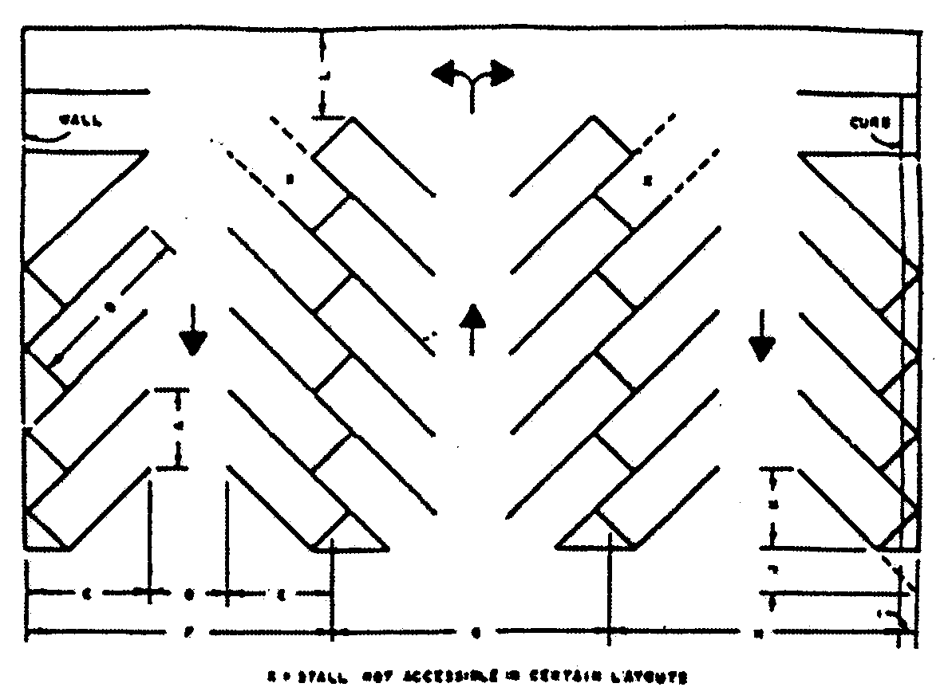

MINIMUM PARKING STALL DIMENSIONS (IN FEET)  
AT VARIOUS ANGLES

|  |  |  |  |  |
| --- | --- | --- | --- | --- |
| Dimension | Symbol |  | (8.5′ × 18′) | |
|  |  | 45° | 60° | 75° | 90° |
| Stall width, parallel to aisle | A | 12.0 | 9.8 | 8.8 | 8.5 |
| Stall length of line | B | 26.5 | 22.9 | 20.3 | 18.0 |
| Stall depth to wall | C | 18.7 | 19.8 | 19.6 | 18.0 |
| Aisle width between stall lines | D | 12.0 | 17.0 | 21.0 | 22.0 |
| Stall depth, interlock | E | 15.7 | 17.7 | 18.5 | 18.0 |
| Module, wall to interlock | F | 46.5 | 54.6 | 59.1 | 58.0 |
| Module, interlocking | G | 43.5 | 52.4 | 58.0 | 58.0 |
| Module, interlock to curb face | H | 44.7 | 52.4 | 56.7 | 55.5 |
| Bumper overhang (typical) | I | 1.8 | 2.2 | 2.4 | 2.5 |
| Offset | J | 6.0 | 2.5 | 0.6 | 0.0 |
| Setback | K | 12.7 | 9.0 | 4.7 | 0.0 |
| Driveways | L | ** | ** | ** | ** |

For parallel parking minimum widths and length are 8.0′ × 23.0′.

** Driveways where there is no parking on either side shall be a minimum of twenty (20) feet in width for two-way traffic and fourteen (14) feet for one-way traffic. Access drives between the paved portion of the right-of-way and the property line shall comply with the Miami-Dade County public works manual.

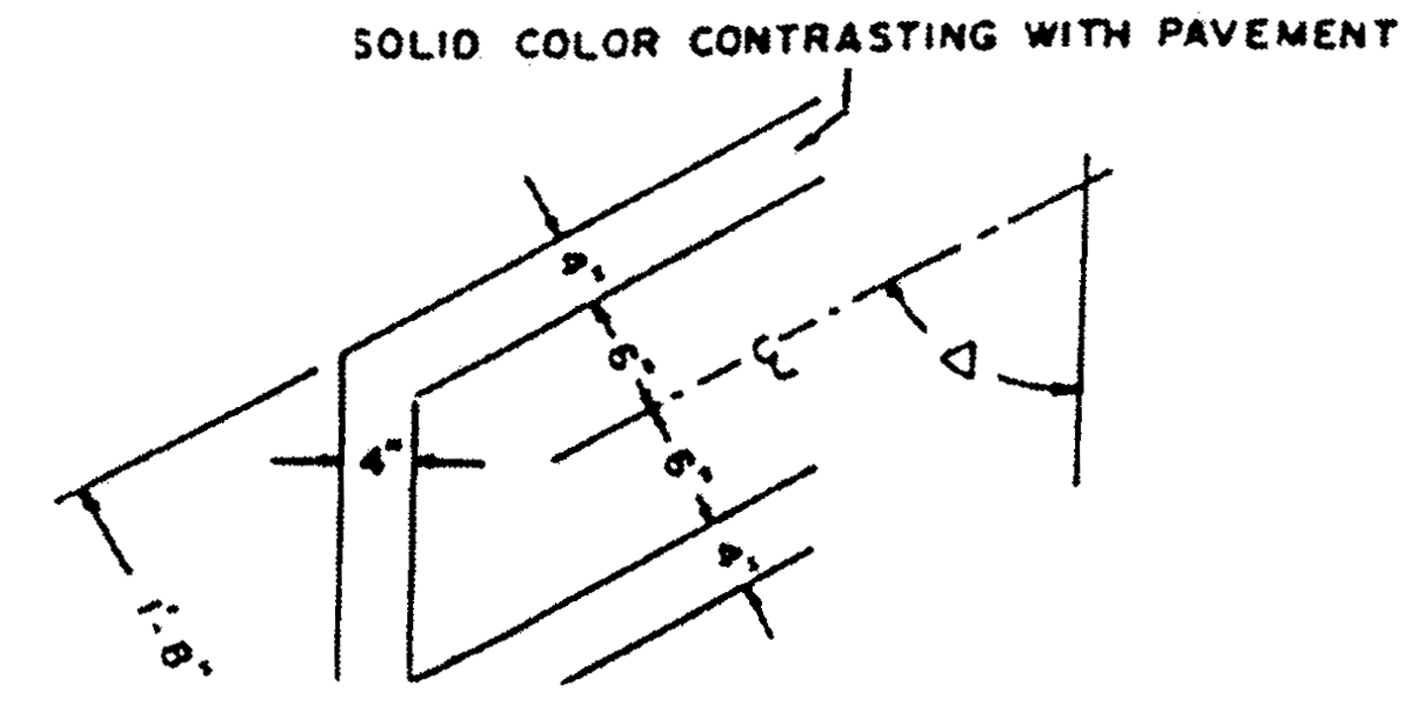

For all occupancies other than residential, the parking spaces shall be marked with double striping on each side of the space to identify and facilitate their use. All striping shall be of a color (typically white) contrasting with the pavement. Dimension requirements, as noted elsewhere, shall be measured to the center point of the double stripe, as shown on the "Striping Detail" hereby incorporated as part of this section. Notwithstanding the above provisions and striping details, where striping is required for residential users, not less than a single four-inch stripe shall be provided, with parking stall dimensions to be measured to the center line of the strip. In all instances, adequate interior driveways and ingress and egress driveways shall be provided to connect all parking spaces with a public right-of-way or alley. Where a parking space heads into and abuts a walkway, the paved eighteen-foot length shall be provided a wheel stop or curb at sixteen (16) feet in order to prevent extension of the vehicle over any portion of the provided walkway width. Required and surplus parking shall comply with these provisions and such parking shall not be placed in dedicated or official rights-of-way.

(Ord. No. 57-19, § 5(BB), 10-22-57; Ord. No. 69-71, § 1, 10-8-69; Ord. No. 80-116, § 1, 10-21-80; Ord. No. 83-40, § 1, 6-7-83; Ord. No. 85-19, § 1, 4-2-85; Ord. No. 91-36, § 1, 3-19-91)

Sec. 33-122.1. Exceptions from parking lot configuration.

Notwithstanding provisions of this ordinance to the contrary, buildings which have received a certificate of use and occupancy prior to the effective date of this ordinance may utilize the following standards for expansion providing that: (1) the expansion does not exceed ten (10) percent of the on-site building square footage existing as of the effective date of this ordinance, and (2) a covenant suitable for recording is submitted establishing the calculations and conditions upon which the additional square footage has been permitted. However, the area of building expansion must comply to the ration of parking space to square footage requirements contained elsewhere in this article.

(1) Standard size parking stalls shall measure nine (9) feet by nineteen (19) feet and have a clear back up of twenty-four (24) feet.

(2) Compact stalls shall measure seven and one-half (7.5) feet by fifteen (15) feet with a clear back up of twenty (20) feet. The percentage of compact spaces in any individual parking facility shall not exceed thirty-five (35) percent for facilities of twenty-five (25) to fifty (50) spaces; forty (40) percent for facilities of fifty-one (51) to two hundred fifty (250) spaces; and forty-five (45) percent for facilities of two hundred fifty-one (251) or more spaces. Said spaces shall be clearly designated "compact cars only."

(Ord. No. 91-36, § 1, 3-19-91)

Sec. 33-122.2. Parking spaces for persons transporting young children and strollers.

Parking spaces specifically designed for persons transporting young children under the age of three (3) and strollers, shall be required for all uses other than single-family, duplex, townhouse or multifamily; provided, however, industrial zoned properties shall not be required to comply with this section. Such baby stroller parking spaces shall be provided as follows:

(a) *Quality of specially designated parking spaces:*

|  |  |
| --- | --- |
| Total Parking Spaces in Lot | Required Number of Spaces |
| Up to 100 | 0 |
| 101 to 500 | 2 |
| 501 to 1,000 | 3 |
| Over 1,000 | One (1) additional space for each 500 parking spaces over 1,000 |

(b) *Location of parking spaces.* Such spaces shall be located as closely as possible to parking spaces designated for the physically handicapped and/or disabled persons; provided however, parking spaces designated for the physically handicapped and/or disabled persons shall take precedence. Where no parking spaces designated for the physically handicapped and/or disabled persons have been provided, parking spaces for persons transporting young children and strollers shall be located on the shortest accessible route of travel from adjacent parking to an accessible entrance.

(c) *Signage and markings.* All parking spaces for persons transporting young children and strollers shall be prominently outlined with green paint and posted with an approved permanent above-ground sign which shall conform to the figure entitled "Baby Stroller Parking Sign" hereby incorporated in this section. The bottom of the sign must be at least five (5) feet above grade when attached to a building, or seven (7) feet above grade for a detached sign.

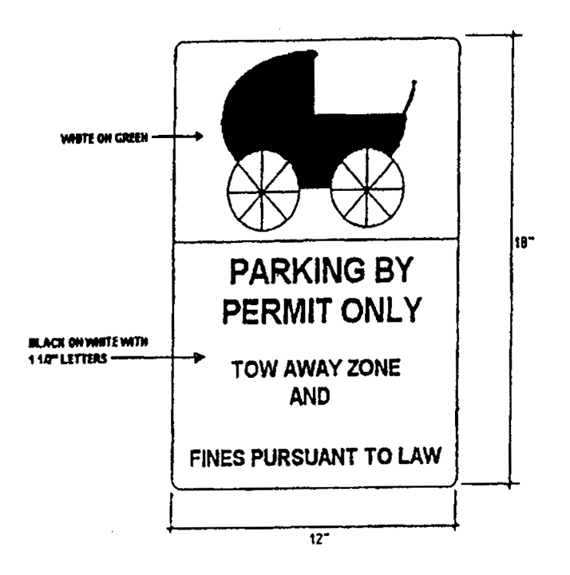

All property owners who are required by this section to provide parking spaces for persons transporting young children and strollers shall provide such parking spaces within two (2) years from the effective date of the ordinance from which this section derives (Ordinance No. 94-104). In no event shall the number of parking spaces for the physically handicapped and/or disabled be reduced below the quantity required by the South Florida Building Code.

(Ord. No. 94-104, § 1, 6-7-94; Ord. No. 96-161, § 2, 11-12-96; Ord. No. 98-108, § 3, 7-21-98)

Sec. 33-122.3. Requirement of bicycle racks or other means of storage.

Racks or other means of storage that can secure at least four (4) bicycles shall be required for all park, shopping center, office and restaurant uses with parking lots, as follows:

(a) Quantity of bicycle parking spaces required:

|  |  |
| --- | --- |
| Total Parking Spaces in Lot | Required Number of Bicycle Parking Spaces: |
| 25 to 50 | 4 |
| 51 to 100 | 8 |
| 101 to 500 | 12 |
| 501 to 1000 | 16 |
| over 1000 | four (4) additional spaces for each 500 parking spaces over 1000. |

(b) Other uses. All other uses, other than airport or seaport terminals, single-family, duplex or townhouse which are exempt, shall provide racks or other means of storage as provided herein only where their total parking lot has one hundred one (101) or more spaces.

(c) Location and design of bicycle parking spaces; requirements.

(1) The bicycle parking spaces shall be located near the entrances to the building.

(2) At buildings and shopping centers that have multiple parking lots, the bicycle parking spaces should be installed near the entrances to the buildings served by the lots.

(3) The bicycle parking spaces should be in a highly visible, well lighted location that provides enough clear space to facilitate easy use and does not impede pedestrian traffic or handicap accessibility.

(4) The parking spaces may not be placed in the County maintained right-of-way.

(5) The design of the bicycle rack should permit the locking of the frame and at least one (1) wheel with a standard size "U" lock and accommodate the typical range of bicycle sizes.

(6) The bicycle rack must resist removal, resist rust, corrosion and vandalism, and must be properly maintained.

(d) Other forms of storage. At the owner's option, bicycle parking may also be installed in the form of storage rooms, lockers or cages.

(e) Signage and markings. All bicycle parking spaces shall be posted with a permanent and properly maintained above-ground sign which shall conform to the figure entitled "Secured Bicycle Parking" hereby incorporated in this section. The bottom of the sign must be at least five (5) feet above grade when attached to a building, which may not be installed in the County maintained right-of-way. No permit shall be required for such signs.

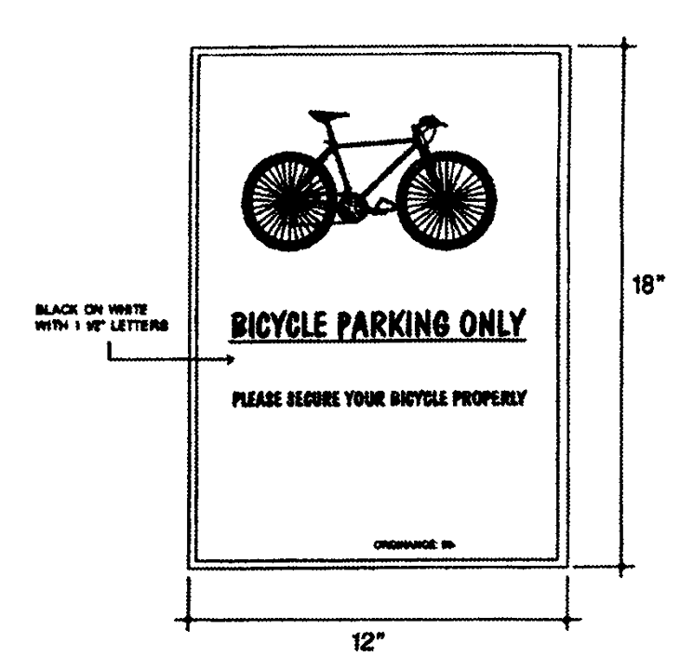

**Bicycle Parking Sign**

(f) Application to existing uses. All property owners of existing establishments that are required by this section to provide bicycle parking spaces shall comply within one (1) year from the effective date of the ordinance from which this section derives and shall be responsible to maintain such facilities. Existing multifamily uses are exempt from this subsection.

(Ord. No. 99-81, § 1, 7-13-99; Ord. No. 00-107, § 1, 9-7-00)

Sec. 33-122.4. Reserved.

**Editor's note—**

Ord. No. 03-160, § 7, adopted July 8, 2003, repealed [section 33-122.4](../level3/PTIIICOOR_CH33ZO_ARTVIIOREPA.docx#PTIIICOOR_CH33ZO_ARTVIIOREPA_S33-122.4RE) in its entirety. Former [section 33-122.4](../level3/PTIIICOOR_CH33ZO_ARTVIIOREPA.docx#PTIIICOOR_CH33ZO_ARTVIIOREPA_S33-122.4RE) pertained to litter containers and derived from Ord. No. 00-47, § 1, adopted April 11, 2000.

Sec. 33-123. Approval of plan before issuance of permits.

Prior to the issuance of any building, paving, grading and leveling or other permits, a suitable sketch must be presented to the Department indicating the parking layout drainage on the premises and indicating all driveways extending beyond the property line into the public right-of-way. The drainage plan for the premises shall meet with the approval of the Department of Public Works. The driveway plan must meet with the approval of the Director and the Director of the Public Works Department on all roads and in approving or rejecting the plan, the Directors shall determine that their decision is in the interest of public safety and welfare, taking into consideration the volume of traffic to be generated, its pattern and conflict with the adjacent road traffic; the number of driveways proposed and their proximity to others in the area; location and proximity of median cuts; visual clearances or obstructions at the driveways; angle and location of driveway and its intersection with the road; elevation of the driveway in reference to the road, and any other factors that may affect the safety and welfare of the public. In addition all driveways extending into State roads shall meet with the approval of the State and Department.

(Ord. No. 57-19, § 5(BB), 10-22-57; Ord. No. 68-32, § 1, 5-21-68; Ord. No. 95-215, § 1, 12-5-95)

Sec. 33-124. Standards.

Off-street parking shall be provided in accordance with the following minimum standards:

(a) *Dwellings:*

(1) Single-family dwellings not specifically referenced elsewhere in this section shall be provided two (2) parking spaces. Paving of said spaces shall not be required.

(2) Two-, three- and four-unit dwellings shall be provided two (2) parking spaces per unit.

(3) Townhouses shall be provided a minimum of two (2) off-street parking spaces per townhouse unit. Such parking spaces may be provided on the lot of the townhouses or in a commonly owned and maintained off-street parking bay or facility; provided, that no parking space shall be more than one hundred fifty (150) feet, by the most direct pedestrian route, from the door of the townhouse to the parking space it is intended to serve.

Each townhouse site shall have its own off-street parking area and driveway thereto where on-site off-street parking is to be provided. In addition to the above required residents off-street parking spaces, a minimum of twenty-five hundredths (0.25) visitors parking spaces per townhouse shall be provided in a convenient commonly owned and maintained off-street parking bay or facility. Individual garages shall not be credited towards the parking requirement.

(4) Cluster communities shall have two and one-quarter (2.25) parking spaces provided for each dwelling unit either on the individually owned lot(s) or on common property. Tandem parking is permitted only on individual lots and in the driveways connecting such lots with the adjacent roads provided said driveways are for the exclusive use of each individual lot; however, tandem parking shall be limited to no more than one (1) such tandem parking space for each individual lot. Individual garages shall not be credited towards the parking requirement.

(5) Zero lot line communities shall have a minimum of two (2) off-street parking spaces provided on each platted lot.

In addition, zero lot line communities shall provide one (1) guest parking space for every four (4) dwelling units for all projects, except for those developed on public streets.

Tandem parking is permitted only on individual lots and in the driveways connecting such lots with the adjacent roads; provided, said driveways are for the exclusive use of each individual lot; however, tandem parking shall be limited to no more than one (1) such tandem parking space for each individual lot. Individual garages shall not be credited towards the parking requirement.

(6) Five (5) or more unit apartment buildings or apartment hotels:

One and one-half (1.50) parking spaces for each guest room, efficiency, or one (1) bedroom unit.

One and three-quarters (1.75) parking spaces for each two-bedroom unit.

Two (2.0) parking spaces for each three- or more bedroom unit.

(7) A minimum of two (2) off-street parking spaces shall be provided for each mobile home space, both such parking spaces may be on the mobile home space, and each of the same shall be hard surfaced, or one (1) or both parking spaces may be in a common parking court, such courts, where provided, to be installed throughout the park to conveniently serve the inhabitants in different areas of the park, and such courts shall be hard surfaced.

(b) *Hotels, rooming houses.* At least one (1) parking space for each of the first forty (40) individual guest rooms or suites; one (1) additional parking space for every two (2) guest rooms or suites thereafter. Public meeting rooms in hotels shall be further controlled as to parking by Subsection (e) of this section and by Subsection (k) where the meeting room does not contain permanent seats; and restaurants by Subsections (i) and (j). In addition, one (1) parking space shall be provided for each four (4) employees.

(c) *Motels, tourist courts, bed and breakfast establishments, and transient accommodations.* One (1) parking space for each individual sleeping room or bedroom.

(d) *Churches.* At least one (1) parking space for each one hundred (100) square feet or fractional part thereof of the seating area in the main auditorium (sanctuary), including adjacent areas which may be used as part of the auditorium.

(e) *Reserved.*

(f) *Hospitals.* At least one (1) parking space for each of the first three hundred (300) beds and one (1) additional parking space for every two (2) additional beds thereafter for patients contained in such building, plus one (1) parking space for each three (3) employees and resident staff members.

(g) *Sanitariums, convalescent homes, homes for the aged and similar institutions.* At least one (1) parking space for each two (2) beds for patients contained in such buildings, plus one (1) parking space for each two (2) employees.

(h) *Commercial:*

(1) Retail—Food or grocery stores, drug and sundry stores, department stores, membership warehouses, retail stores, retail stores similar to the foregoing, banks, post offices, mortuaries, funeral homes, waiting rooms stations for common carriers and shopping centers shall be provided parking at a rate of one (1) parking space for each and every two hundred fifty (250) square feet of the gross floor area or fractional part thereof. All retail uses within enclosed malls in excess of three hundred thousand (300,000) square feet shall provide parking at the rate of one (1) parking space for each and every three hundred and fifty (350) square feet of the gross floor area or fractional part thereof, excluding theaters, restaurants and food courts which shall provide parking as delineated in this section.

(2) Auto dealership showrooms, garage and gas station bay areas, and similar uses shall be provided three (3) parking spaces for the first twenty-five hundred (2,500) square feet of floor area, or fractional part thereof, and one (1) parking space for each additional five hundred (500) square feet of gross floor area, or fractional part thereof, plus three (3) parking spaces for each five thousand (5,000) square feet, or fractional part thereof, of open lot area. Office and retail parts areas shall be provided parking spaces as otherwise contained in this article. Customer and employee parking shall be labeled as such.

(3) Furniture showrooms shall be provided three (3) parking spaces for the first twenty-five hundred (2,500) square feet of gross floor area, or fractional part thereof, and one (1) parking space for each additional five hundred (500) square feet of gross floor area or fractional part thereof. When such a use is located within any BU District, the site plan submitted to the Department shall illustrate future parking spaces based on a calculation of one (1) parking space for each two hundred fifty (250) square feet of gross floor area or fractional part thereof, which shall be provided in the event the furniture use is discontinued. The lot area reserved for future parking spaces shall remain unencumbered with any structures and shall be landscaped. However, this landscaped area shall not be credited toward the minimum required open space. Prior to the issuance of a Certificate of Use and Occupancy for any use other than a furniture store, the property owner must provide the required number of parking spaces for the intended use as provided elsewhere in the article.

(3.1) Home improvement centers, including all storage/sales areas, shall have parking provided at a rate of one parking space for each two hundred fifty (250) square feet of gross floor area or fractional part thereof.

(4) Plant nurseries shall have parking provided at a rate of eight (8) spaces for the first acre, or fractional part thereof, and one (1) parking space for each two (2) acres thereafter up to ten (10) acres. One (1) additional parking space shall be provided for each five (5) acres or portion thereof thereafter.

(5) Packing plants shall have parking provided at a rate of one (1) parking space for each one thousand (1,000) square feet of gross floor area, or fractional part thereof.

(6) Open lot commercial uses such as, but not limited to, used care lots, storage yards and recreational vehicle sales lots shall be provided five (5) off-street parking spaces for the first five thousand (5,000) square feet of net lot area, or fractional part thereof and one (1) parking space for each additional five hundred (500) square feet of net lot area so used. These spaces shall be reserved for customer and employee parking only, and shall be labeled as such.

(7) Automobile gas stations/mini marts shall be provided one (1) parking space for each two hundred fifty square feet (250) of gross floor area or fractional part thereof, with a minimum of three (3) spaces which shall be designed so as not to interfere with the dispensing operation.

(8) Wholesale showrooms in the industrial districts shall be provided one (1) parking space for each six hundred (600) square feet of showroom area, or fractional part thereof.

(9) All commercial uses not identified in Subsections (1) through (7) above shall be provided three (3) parking spaces for the first twenty-five hundred (2,500) square feet of gross floor area, or fractional part thereof, and one (1) parking space for each and every additional five hundred (500) square feet of gross floor area, or fractional part thereof.

(i) *Restaurants, lounges, nightclubs, or similar places dispensing food, drink or refreshments.*

(1) Table service establishments shall be provided one (1) parking space for each fifty (50) square feet of floor area, or fractional part thereof devoted to patron use.

(2) Take-out establishments shall be provided one (1) parking space for each two hundred fifty (250) square feet of gross floor area, or fractional part thereof.

(j) *Adult Day Care Center,* shall be provided with one (1) parking space for each five hundred (500) square feet of gross floor area, or equal to the combined total of personnel and transportation vehicles whichever is greater.

(k) *Recreational and entertainment use:*

(1) Art galleries, amusement centers, cultural centers, libraries and museums shall be provided one (1) parking space for each two hundred fifty (250) square feet of gross floor area, or fractional part thereof.

(2) Banquet halls, bingo halls, convention halls and private clubs shall be provided one (1) parking space for each one hundred (100) square feet of patron area, or fractional part thereof.

(3) Bowling alleys, skating rinks, and indoor gun ranges shall be provided one (1) parking space per two hundred fifty (250) square feet of gross floor area, or fractional part thereof. Office, retail, restaurant and other areas in conjunction therewith shall have parking spaces provided as otherwise contained in this article.

(4) Dance, karate, and aerobics schools, and health/exercise studios shall be provided one (1) parking space for each one hundred (100) square feet of classroom area, or fractional part thereof. Office, retail, and restaurant areas in conjunction therewith shall have parking spaces provided as otherwise contained in this article.

(5) Golf courses shall be provided three (3) parking spaces per hole plus three (3) additional spaces. Office, retail, restaurant and other areas in conjunction therewith shall have parking provided as otherwise contained in this article.

(6) Live-aboard marinas shall be provided one (1) parking space per boat slip.

(7) Non-live-aboard marinas shall be provided one (1) parking space for each two (2) boat slips.

(8) Boats stored in racks shall be provided one (1) parking space for each three (3) boat racks.

(9) Stadiums and basketball gymnasiums shall be provided at least one (1) parking space for each four (4) seats.

(10) Commercial tennis and racquetball clubs shall be provided four (4) parking spaces per court. Office, retail, and restaurant areas in conjunction therewith shall have parking provided as otherwise contained in this article.

(11) Theaters, including move theaters, and general auditoriums shall be provided one (1) parking space for each one hundred (100) square feet of auditorium seating area or fractional part thereof.

(12) Open lot recreational use parking requirements shall be determined by the Director and such requirements shall be based on the number of people that can reasonably be expected to be on such premises at one (1) time. Said determination shall be calculated on a basis of one (1) parking space for each four (4) persons.

(l) *Schools.*

(1) Day nurseries, kindergarten and elementary schools: Total parking spaces shall equal the combined total of personnel and transportation vehicles.

(2) Junior high [schools]: Total parking spaces shall equal one and one-quarter (1¼) times the combined total of personnel and transportation vehicles.

(3) High schools, trade schools and colleges: One (1) parking space per two hundred (200) square feet of classroom area, including laboratories, libraries and administrative areas. Housing facilities on college campuses must provide off-street parking of two (2) spaces for each three (3) sleeping rooms. Other such uses, such as restaurants, auditoriums, theaters, etc., shall provide parking as required in this section for such uses. In addition, in connection with the foregoing schools, one (1) parking space shall be required for each four (4) employees, excluding teachers.

 In connection with the foregoing school use, parking required for church use may be credited toward parking requirements for school use, where the same are operated by the same ownership and on the same property.

 The applicant shall submit information substantiating the personnel and vehicle figures used for computing the above parking requirements.

(m) *Office, professional building or similar uses.* One (1) parking space for each three hundred (300) square feet of gross floor area of such building or fractional part thereof.

(n) *Industrial.*

(1) For a warehouse building, one (1) parking space shall be provided for each one thousand (1,000) square feet of gross floor area in the building up to ten thousand (10,000) square feet and then one (1) space for each two thousand (2,000) square feet of gross warehouse floor area thereafter. Office, retail and wholesale showroom areas provided in conjunction with the industrial use shall have parking spaces provided for such areas as otherwise contained in this article. Regardless of the intended mix of use, a minimum of two (2) parking spaces shall be provided for each bay in the building. In determining the number of bays, the Director shall take into account the possibility of partitioning the building into multiple units, the number and location of bathrooms, the number and location of overhead or other door openings, the layout of electrical circuits and air conditioning units, etc. In determining the number of spaces to be provided, the formula requiring the greatest number of parking spaces shall be applied.

(2) Where open lot or walled-in uses only are involved, such as salvage yards, batching plants, precast or prestressed concrete products, or the like, two (2) parking spaces for each five thousand (5,000) square feet of lot area shall be provided, or one (1) space for each two (2) employees shall be provided, whichever requires the greater number of parking spaces. Such parking spaces shall be located no farther than one thousand five hundred (1,500) feet from the industrial use in question. Such noncontiguous property to be used for parking must be located in BU-1A, BU-2, BU-3 or an industrial district.

(3) For a telecommunications hub, one (1) parking space for each two thousand (2,000) square feet of gross floor area shall be provided. Office areas provided in conjunction with the industrial use shall have parking spaces provided for such areas as otherwise contained in this article. In the event of a subsequent change in use from a telecommunications hub to a permitted, alternative use, the alternative use shall conform to the parking standards otherwise contained in this article. A variance to reduce the number of required parking spaces shall not be granted solely on the basis of a proposed change in use from an existing telecommunications hub to an alternative use.

The ownership of the parking area shall be the same as that of the individual site which it is to serve. Before any permit for industrial use may be obtained, which under this chapter requires additional and separate parking areas, the owner of the industrial site shall cause to be recorded an agreement to the effect that the ownership of the industrial site and of the separate parking area shall remain the same until the regulations are amended eliminating the need for such separate parking area.

Prior to the issuance of a building permit for the erection of a new structure or building, or for an addition thereto, either of which is to be used for industrial purposes, or prior to the issuance of a certificate of use and occupancy for a different use of an existing industrial structure or building, the applicant shall complete and execute a form prescribed by the Director which shall, among other things, provide the necessary information upon which the required off-street parking may be determined; and the applicant shall therein acknowledge that such information is submitted for such determination; and in the event of a change in use or additional use is contemplated, such additional off-street parking as may be required by this chapter, if any, must be furnished prior to such use change or additional use.

(o) *Housing for low and/or moderate income for older persons and/or persons with disabilities.*

(1) For any publicly owned or non-profit apartment building exceeding four (4) units providing housing for elderly persons or persons with disabilities that is developed and financially assisted under the United States Housing Act of 1937, fifty hundredths (0.50) parking space shall be provided for each dwelling unit in the apartment building.

(2) For any other apartment building exceeding four (4) units providing low and/or moderate income housing for older persons as defined by the Fair Housing Act, 42 U.S.C. § 3607, one (1) parking space shall be provided for each dwelling unit in the apartment building.

(3) Provisions of [Chapter 33](../level2/PTIIICOOR_CH33ZO.docx#PTIIICOOR_CH33ZO) of the Code of Miami-Dade County concerned with the requirements for lot coverage and open space shall remain enforced under this section. The lot area not used as a result of the decrease in parking spaces as required under [Section 33-124](../level3/PTIIICOOR_CH33ZO_ARTVIIOREPA.docx#PTIIICOOR_CH33ZO_ARTVIIOREPA_S33-124ST)(a) shall remain as open space and shall be landscaped or used for recreational purposes. Said open space shall be in addition to the open space requirements of the Code. The site plan submitted to the Department shall illustrate future parking spaces if the present parking requirements are inadequate pursuant to subdivision (4) herein.

(4) If it is determined by the Department at the time of annual renewal of certificate of occupancy that the parking reduction permitted pursuant to subsections (1) or (2) above does not allow adequate parking for the apartment building, the owner must increase the number of parking spaces to fulfill the needs as determined by the Director.

(p) *Self-service storage facilities.*

(1) Self-service storage facilities shall be defined as fully enclosed spaces used for warehousing which contain individual storage units with floor area no greater than four hundred (400) square feet and an interior height not to exceed twelve (12) feet. No wholesale or retail sales are permitted.

(2) In self-service storage facilities, off-street parking shall be provided on the following basis: One (1) parking space per five thousand (5,000) square feet of building area for the first twenty thousand (20,000) square feet of building; one (1) parking space per ten thousand (10,000) square feet (or fraction thereof) of building area thereafter; and one (1) parking space for the manager's apartment, where provided. One (1) parking space per four hundred (400) square feet of gross office area (or fraction thereof) shall also be provided. In the application of these regulations, a minimum number of five (5) off-street parking spaces shall be provided for any self-service storage facility regardless of size.

(Ord. No. 57-19, § 5(BB)(1)(3), 10-22-57; Ord. No. 61-27, § 1, 6-27-61; Ord. No. 62-23, § 1, 6-5-62; Ord. No. 64-13, § 1, 4-21-64; Ord. No. 64-31, § 1, 7-21-64; Ord. No. 69-71, § 2, 10-8-69; Ord. No. 77-10, § 1, 2-15-77; Ord. No. 77-61, § 1, 9-6-77; Ord. No. 83-14, § 1, 3-15-83; Ord. No. 83-57, § 1, 7-5-83; Ord. No. 83-116, § 1, 12-20-83; Ord. No. 91-36, § 1, 3-19-91; Ord. No. 94-165, § 1, 9-13-94; Ord. No. 95-215, § 1, 12-5-95; Ord. No. 95-218, § 1, 12-5-95; Ord. No. 98-5, § 1, 1-13-98; Ord. No. 01-99, § 2, 6-5-01; Ord. No. 03-80, § 1, 4-8-03; Ord. No. 03-117, § 1, 5-6-03; Ord. No. 08-78, § 1, 7-1-08; Ord. No. 10-20, § 2, 3-2-10; Ord. No. 11-04, § 2, 2-1-11; Ord. No. 13-76, § 2, 9-4-13)

**Cross reference—** Off-street parking for buildings for public assemblage, § 33-17(7).

Sec. 33-124.1. Parking of commercial vehicles in residential or agricultural zones.

(a) The following are hereby defined as commercial vehicles for the purpose of this section:

*Category 1.* A vehicle that is a taxicab, a limousine under twenty (20) feet in length or any passenger vehicle truck or van with a maximum height of eight (8) feet from the ground marked with a sign, letters, identification numbers or emblem advertising or associating it in any way with a commercial enterprise other than those which identify the vehicle maker or dealer. A sport utility vehicle marked with a sign, letters, identification numbers or emblem advertising or associating it in any way with a commercial enterprise, other than those which identify the vehicle maker or dealer, shall be considered as a Category 1 vehicle. For purposes of this section, a passenger vehicle bearing an emblem or lettering of a government entity shall also be considered as a Category 1 vehicle.

*Category 2.* A vehicle eight (8) feet or less in height that displays externally stored or mounted equipment either in a fixed or temporary manner which is visible of a commercial activity are visible including, but not limited to, food vending equipment, ladders, paint cans, lawn care equipment or fixtures and brackets necessary to carry such items. Trailers or utility trailers less than 20 feet in length which are enclosed or of an unenclosed design shall also be included as Category 2 vehicles.

*Category 3.* A vehicle, other than a recreational vehicle as defined in [section 33-20](../level3/PTIIICOOR_CH33ZO_ARTIINGE.docx#PTIIICOOR_CH33ZO_ARTIINGE_S33-20ACBUUTSHPESWPOFASHBOSTPOMIORUN)(f), exceeding twenty (20) feet in length or more than eight (8) feet in height from the ground including, but not limited to, tow trucks, dump trucks, construction or earth moving vehicles or equipment and semi-tractors and trailers.

(b) Storage or parking of certain commercial vehicles is allowed on private property in residential zones as follows:

1. In agriculturally zoned areas (AU) where a bona fide agricultural use, as defined in [Section 19-3](../level2/PTIIICOOR_CH19REPROWMEAC.docx#PTIIICOOR_CH19REPROWMEAC_S19-3DE)(B) of this Code, exists on private property, parking or storage of commercial vehicles used for agricultural purposes or in the transport of agricultural products is allowed as otherwise provided in this chapter.

2. In residentially zoned districts, only two Category 1 vehicles may be parked at a residence.

3. In residentially zoned districts, only one Category 2 vehicle may be stored or parked provided that it is kept within an enclosed garage or behind the front building line within a completely enclosed, opaque fence, screening wall or landscaping 6 feet in height at least ten (10) feet from the rear property line. If a Category 2 vehicle is so stored or parked, then only one Category 1 vehicle may also be stored or parked at such residence.

4. For residential properties of four (4) or more units, the parking allowances provided for herein shall be applied as to each unit.

5. Storage or parking of Category 3 vehicles are prohibited in all residentially zoned districts.

6. The temporary parking of a Category 2 or 3 vehicle in front of the building line or in front of the buffer screen shall only be permitted for the purpose of loading or unloading of materials or persons or engaged in providing a commercial service at the premises or for the purpose of the driver to make a temporary convenience stop at the residence. However, a temporary or convenience stop shall be limited to no more than one hour in any 24-hour period.

(c) Parking of certain commercial vehicles on the right-of-way is prohibited in residential zones as follows:

1. In areas zoned residential districts, it shall be unlawful for Category 2 or 3, vehicles, as herein defined, to be otherwise parked on the public right-of-way, unless actively engaged in the loading or unloading of materials or persons or engaged in providing a commercial service. Examples of providing commercial services include, but are not limited to, removal of disabled vehicles from private or public property presence at a construction site, delivery of goods, repair of household appliances and cleaning of household furniture.

(d) Violations of these provisions are punishable as follows:

1. Any violation of this section is punishable by a civil fine of five-hundred dollars ($500.00). Upon a repeat violation of subsection [33-124.1](../level3/PTIIICOOR_CH33ZO_ARTVIIOREPA.docx#PTIIICOOR_CH33ZO_ARTVIIOREPA_S33-124.1PACOVEREAGZO)(c), in addition to civil penalties, such vehicle may be towed or immobilized until all outstanding violations and enforcement costs have been paid. After 35 days of storage or immobilization, such vehicle may be disposed of pursuant to the provisions contained in Section 713.585, Florida Statutes. Any enforcement officer is hereby authorized to secure the assistance of the Miami-Dade Police Department to effect enforcement of these provisions.

2. Whoever opposes, obstructs or resists an enforcement officer in the discharge of duties as provided in this section, upon conviction, shall be guilty of a misdemeanor of the second degree and shall be subject to punishment as provided by law.

(Ord. No. 99-16, § 2, 2-2-99; Ord. No. 05-75, § 1, 4-19-05)

Sec. 33-125. Parking area on application for building permit.

Applications for building or use permits shall indicate the area to be used for parking and permits shall be issued stating that such area shall be so reserved and developed. Recordable restrictions so reserving such area may be required at the discretion of the Director. Such area reserved for parking area will be marked on the zoning maps and no permits for additional use of such area shall be issued. Area reserved for parking in connection with any use shall be under the same ownership as that of the use itself.

(Ord. No. 57-19, § 5(BB)(2), 10-22-57)

Sec. 33-126. Surface of parking areas.

(1) In the AU, RU-1, RU-2 and RU-3 Districts the area reserved for off-street parking shall be either graveled, mulched or hard-surfaced. In all other zones it shall be hard-surfaced. Where the parking area is hard-surfaced, the same shall consist of a good rolled rock base, well tamped and topped with oil and sand or with asphalt or surfaced with concrete. Occupancy of a given structure or premises shall be prohibited until the required parking area has been improved, inspected and approved.

(2) In all other districts, all off-street parking areas shall be surfaced with a minimum of a rolled six-inch rock base and a one-inch durable weatherproof asphaltic pavement. The occupancy or use of a given structure or premises shall be prohibited until the required off-street parking area has been improved, inspected and approved.

(3) All required off-street parking areas shall be properly drained so that no nuisance will be caused to adjacent or nearby properties. All construction shall comply with design standards as established by all applicable laws, ordinances and regulations.

(4) All required off-street parking areas shall be maintained in good repair and shall be kept in a reasonably clean and sanitary condition free from rodents, insects and vermin.

(Ord. No. 57-19, § 5(BB)(4), 10-22-57; Ord. No. 94-161, § 1, 9-13-94; Ord. No. 97-11, § 2, 2-25-97)

Sec. 33-127. Districts where parking area permitted between setback line and right-of-way.

No parking areas including driveways except for minimum ingress and egress drives in the RU, EU, AU, GU and RU-5 (with the exception of RU-5A), Districts shall be located closer than twenty-five (25) feet to an official right-of-way except parking areas for single-family, two-family, three- and four-unit apartment uses.

In the RU-1 and RU-2 Districts and single-family, two-family, three-unit apartment and four-unit apartment users in the RU-3 District, front, side, and side street setback areas may be used for off-street parking if said area is of sufficient depth to permit the parking of vehicles. Parking in the BU Districts shall be permitted between the required setback line and the official right-of-way line, providing a continuous, extensively planted greenbelt of not less than five (5) feet shall be placed along all property lines abutting said official right-of-way line. Parking in the IU-1, IU-2, IU-3 Districts shall be permitted between the required setback line and the official right-of-way line providing that greenbelt requirements as provided elsewhere in this chapter are satisfied. In no event may parking areas located in the setback areas be sheltered or enclosed in any manner.

(Ord. No. 57-19, § 5(BB)(5), 10-22-57; Ord. No. 64-19, § 3, 5-5-64; Ord. No. 68-29, § 1, 5-21-68; Ord. No. 91-36, § 1, 3-19-91)

Sec. 33-128. Location on same lot as use; exceptions.

(a) Off-street parking areas shall be located on the same lot, parcel or premises as the use to be served; provided, if the use to be served is a business or commercial use, the parking area therefor may be on a lot or parcel of land that is in an IU or BU District and is within three hundred feet (300′) from the site of such business or commercial use to be served; provided such business or commercial use shall immediately terminate in the event such parking area therefor is not available and all those having any right, title or interest in and to such business or commercial use property site shall execute and place on the public records of this County a covenant approved by the Director that such business or commercial use shall cease and terminate upon the elimination of such parking area, and that no business or commercial use shall be made of such property until the required parking area is available and provided.

(b) Off-street parking areas shall be located on the same lot, parcel or premises as the use to be served; provided, if the use to be served is an apartment building, the parking area therefor may be located on a lot or parcel of land that is in the same apartment district which permits the use, or more liberal apartment or business district and within three hundred feet (300′) from the site of such apartment structure to be served, said distance to be measured by the normal and legal way a pedestrian would travel; provided such apartment use shall immediately terminate in the event such parking area therefor is not available and all parties having any right, title or interest in and to such apartment shall execute and place on the public records of this County a covenant approved by the Director that such apartment use shall cease and terminate upon the elimination of such parking area, and that no apartment or other use shall be made of such property until the required parking area is available and provided.

(Ord. No. 57-19, § 5(BB)(6), 10-22-57; Ord. No. 62-23, § 2, 6-5-62; Ord. No. 70-18, § 1, 3-11-70)

Sec. 33-129. Application of provisions to change of uses.

This article shall apply to changes of uses as well as the establishment of new uses.

(Ord. No. 57-19, § 5(BB)(7), 10-22-57)

Sec. 33-130. Between business structure and public park.

Where a business is adjacent to a park, neither the driveway nor the parking area shall be located between the business structure and the public park.

(Ord. No. 57-19, § 5(BB)(8), 10-22-57)

Sec. 33-131. Using parking areas for commercial parking lot.

No area designated as a parking area in connection with any designated use or uses shall be operated as a commercial parking lot.

(Ord. No. 57-19, § 5(BB)(9), 10-22-57)

Sec. 33-132. Marking parking spaces; backing out into street; improvement of frontage.

For all uses other than single-family, duplex or townhouse, the parking area shall be marked by painted lines, as otherwise provided in this chapter, indicating the individual parking spaces or stalls. In all districts, the parking area shall be so arranged that there is no backout into an adjacent private or public street, excepting only lots used for single-family or duplex use. The frontage along the entire parking area adjacent to the private or public street shall be curbed, walled or landscaped, except at entrances, exits, or drainage outlets approved by the Director and the Department of Public Works.

(Ord. No. 57-19, § 5(BB)(10), 10-22-57; Ord. No. 91-36, § 1, 3-19-91)

### ARTICLE VIII. RIGHT-OF-WAY PLAN AND MINIMUM WIDTH

Sec. 33-133. Right-of-way plan and minimum width of streets and ways.

Sec. 33-134. Permit to vary width of street and setback.

Sec. 33-135. Building line for NW 7th Avenue.

Sec. 33-136. Placing building near section line; construction on or in right-of-way.

Sec. 33-137. Measuring setback lines.

Sec. 33-133. Right-of-way plan and minimum width of streets and ways.

The minimum right-of-way widths for streets, roads and public ways for the unincorporated area of the County shall be as follows:

(A) NORTH AND SOUTH HIGHWAYS (Avenues).

*North-South East Highways (Avenues).*

*Feet*

(1) North Miami Avenue from 79 St. North to Memorial Hwy. (Griffing Blvd.) (unincorporated areas) .....100

From State Road #9 to Miami-Dade County North Line .....70

(2) North Miami Avenue from Memorial Hwy. (Griffing Blvd.) to State Road. #9 (unincorporated areas) .....100

(3) NE 2 Ave. from North limits of Miami Shores North to State Rd. #9 (unincorporated areas) .....70

(4) W. Dixie Hwy. from NE 2 Ave. to 174 St. (unincorporated area), except—See No. 5 below .....70

(5) W. Dixie Hwy. from NE 119 St. to NE 121 St. .....70

(6) W. Dixie Hwy. from NE 174 St. North to County Line (unincorporated areas) .....66

(7) NE 6 Ave. North limits of Miami Shores North to Griffing Blvd. .....70

(8) NE 2 Ave. (Griffing Blvd.) (Memorial Hwy. NW 2 Ave.) from NE 6 Ave. North to Golden Glades Dr. .....70

(9) (a)  
State Rd. #5 from NE 36 St. to South limits of North Miami Beach (unincorporated areas) .....100

(b) State Rd. #5 from North limits of North Miami Beach to North County Line (unincorporated areas) .....116

(c) State Rd. #5 from South limits of South Miami, South to Tennessee Rd. (unincorporated areas) .....116

(10) State Rd. #5 from South limits of Florida City to South County Line (See State Dept. of Transportation r/w Map Project #5239-5240) .....100 to  
350

(11) State Rd. #5 from Tennessee Rd. in Sec. 8-57-39 South to the North limits of Homestead .....116

(12) Ingraham Hwy. (State Rd. #27) from Longview Rd. to Cape Sable .....125

(13) Ingraham Hwy. (SW 217 Ave.) from Mowry Dr. South to State Rd. #27 .....125

(14) Longview Dr. from Mowry Dr. South to State Rd. #27 .....125

(15) Old Cutler Rd. through U.S. Dept. of Agriculture property in Sec. 24-55-40 to Chapman Field at Mitchell Dr. and Old Cutler Rd. (Ingraham Hwy.) from Coral Reef Dr. South to Silver Palm Dr. .....100

(16) Card Sound Road from U.S. #1 (in [Sec. 30](../level2/PTIIICOOR_CH30TRMOVE.docx#PTIIICOOR_CH30TRMOVE), Twp. 57S, Rge. 39E going Se/ly to the Monroe County Line (being the East line of [Sec. 13](../level2/PTIIICOOR_CH13EX.docx#PTIIICOOR_CH13EX), Twp. 59S, Rge. 39E). Said right-of-way traversing the following Sections: 30 and 31, Twp. 575, Rge. 39E; 5, 6, 8, 16, 17, 21, 22, 27, 34 and 35, Twp. 58S, Rge. 39E; 2, 11, 12 and 13, Twp. 59S, Rge. 39E). Said right-of-way to be measured 55′ each side from the centerline of existing pavement .....110

(17) State Rd. A1A Bakers Haulover North to County Line .....100

(18) Rickenbacker Causeway Rd. from South end of Crandon Park South to Cape Florida Lighthouse .....120

(19) Bayshore Dr. (Biscayne Key) from Cape Florida Lighthouse North to waterway and then East to North and South Highway .....100

(20) Reserved [10]

(21) Seaboard Throughway from Galloway Road to Krome Avenue .....125

 On portions of Sections 28, 32 and [33](../level2/PTIIICOOR_CH33ZO.docx#PTIIICOOR_CH33ZO) in Township 54 South, Range 40 East, Sections 5, 7, 8 and 18 in Township 55 South, Range 40 East, Sections 13, 23, 24, 26, 27, [33](../level2/PTIIICOOR_CH33ZO.docx#PTIIICOOR_CH33ZO) and 34 in Township 55 South, Range 39 East, and Sections 4, 5, 7, 8, and 18 in Township 56 South, Range 39 East, bounded on the northwesterly side of the Seaboard Airline Railway southeasterly right-of-way line and on the southeasterly side by a line parallel to the Seaboard Airline Railway southeasterly right-of-way line, and one hundred twenty-five (125) feet southeasterly therefrom as measured on a perpendicular from the southeasterly Seaboard Airline Railway right-of-way line.

*North-South West Highways (Avenues).*

(22) State Rd. No. 7 Golden Glades Dr. north to County Line .....100

(23) NW 7th Ave. (State Rd. No. 7) from NW 79th St. to south limits of North Miami and from north limits of North Miami to Golden Glades Dr. Cloverleaf .....100

(24) NW 7th Ave. from Golden Glades Dr. extended north to County Line .....70

(25) State Hwy. No. 9 from 27th Ave. north to north County Line (See State Dept. of Transportation r/w Project No. 8724-203) .....200 to 300

(26) NW 12th Ave.—Extension from NW 71st St. north to south limits of North Miami and north limits of North Miami to Opa Locka Blvd. .....100

(27) NW 17th Ave.—From NW 71st St., north to Opa Locka Blvd. .....100

(28) NW 22nd Ave.—From NW 38th St., north to Miami-Dade County north line .....100

(29) NW 27th Ave.—From NW 36th St. to Miami-Dade County north line .....100

(30) West side of NW 27th Ave.—From 36th St., south to center line of 20th St. .....50

(31) NW 37th Ave.—From NW 20th St. to County Line (unincorporated area) .....70

(32) NW 47th Ave. (Bougainvillea Ave.)—From Gratigny Road to Opa Locka Blvd. .....70

(33) LeJeune Road from the north Miami-Dade County Line to the north boundary of the City of Opa Locka (NW 151st Street) .....100

LeJeune Road from NW 36th Street to NW 20th Street .....100

LeJeune Road from Tamiami Trail to 75 feet south of SW 16th Terrace (unincorporated) .....70

(34) Red Rd. (State Rd. No. 819) from SW 74th Street, north to NW 183rd Street (unincorporated areas) .....100

 Said 100-foot right-of-way to be measured equidistant from the section lines except in that portion from NW 183rd Street to the North County Line where the right-of-way shall be established as follows:

East 100 feet of the west 130 feet of Section 6, Township 52 South, Range 41 East; east 100 feet of the west 130 feet of the south 1,256 feet of [Section 31](../level2/PTIIICOOR_CH31VEHI.docx#PTIIICOOR_CH31VEHI), Township 51 South, Range 41 East; the east 100 feet of west 145 feet of [Section 31](../level2/PTIIICOOR_CH31VEHI.docx#PTIIICOOR_CH31VEHI), Township 51 South, Range 41 East, less the south 1265 feet thereof.

(34.1) Red Rd.(State Rd. No. 819) from Old Cutler Road north to SW 74th Street (unincorporated areas) .....70

(34. 2) SW 62nd Ave. from Coral Way (SW 24th St.) south to SW 30th St. (unincorporated areas) .....50

(35) Ludlam Road from International Airport South to State Rd. No. 5 (unincorporated areas) .....70

(36) Ludlam Road from Mitchell Road south to Coral Reef Dr. .....100

(37) (a)  
Ludlam Road from Mitchell Road north to 160 feet south of North Kendall Drive .....70

(b) Ludlam Road from 160 feet south of North Kendall Drive to 150 feet north of SW 85th Street .....80

 The 80 feet to be measured 40 feet on each side of the following centerline:

 Beginning at a point on the W line of northwest quarter of Section 1-55-40, said point being 200 feet S of the NW corner of said Section 1 and being the point of curvature of a circular curve; thence run northerly and northeasterly along the arc of a circular curve to the right, said curve being tangent to the West line of the northwest quarter of said Section 1 and having a radius of 818.51 feet through a central angle of 54 degrees 01 minutes 53 seconds for an arc distance of 771.88 feet to the point of tangency; thence run northeasterly along a line tangent to the last-described curve for a distance of 100 feet to the point of curvature of a circular curve to the left; thence run northeasterly and northerly along the arc of said circular curve to the left having a radius of 818.51 feet through a central angle of 53 degrees 48 minutes 33 seconds for an arc distance of 768.70 feet to the point of tangency with the E line of the southeast quarter of Section 35-54-40, said point of tangency being 1178.54 feet N of the SE corner of said Section 35 and being the end of the center line herein described .....80

(c) Ludlum Road from 150 feet north of SW 85th Street to State Road No. 5 (US No. 1) .....70

(38) Milam Road (NW 72nd Avenue) from Tamiami Canal (Miami city limits) to NW 74th Street (Town of Medley limits) .....100

(Ord. No. 63-37, § 1, 9-10-63)

(39) Palmetto Rd. from NW 90th St. to Tamiami Trail .....300

(40) Palmetto Rd. (From Tamiami Trail south to Coral Way (SW 25th St.) 125 feet all on west side of Canal) .....125

(41) Palmetto Rd. (From Coral Way south to Bird Rd. 62½ feet on the west side of section line, 62½ feet on east side of section line) .....125

(42) Palmetto Road from Bird Rd. south to Kendall Road—35 feet on the west side of the section line and 90 feet on the east side of the section line .....125

 From Kendall Road to SW 98th Street, 40 feet on either side of the following described center line:

 Beginning at the NW corner of the northwest quarter of Section 2-55-40; thence, run South along the West line of said northwest quarter of Section 2 for 2250 feet; thence deflecting 12 degrees 20 minutes to the left run southeasterly along a straight line for 1050 feet more or less to the point of intersection with the S line of the northwest quarter, northwest quarter, southwest quarter, of Section 2, said point being the end of the center line herein described .....80

(42a) NW 112 Avenue from NW 106th Street to NW 122 Street, Miami-Dade County, Florida, provided continuation of the existing use, or substantially similar future use, of the lands abutting the right-of-way on the effective date of this ordinance (June 28, 2002). Right-of-way plan and minimum width requirements for this half-section line roadway shall revert to 70 feet after a change in use or a determination by the Director that the current use has been abandoned .....0

(43) (a)  
W. 117th Avenue from NW corner of Section 30-52-40 south to NW corner of Section 7-54-40 .....0

(b) SW 117th Avenue from NW corner of Section 18-54-40 south to SW corner of Section 18-54-40; this portion of SW 117 Avenue extends from Coral Way (SW 24 St.) to Bird Drive (SW 40 St.) and more particularly described as the east 80 feet of the West 134 feet of Section 18-54-40 .....80

(c) SW 117th Avenue from SW corner of Section 18-54-40 south to State Road No. 5 .....125

(44) Burr Road (127 Ave.)—US No. 1 to Homestead Army Airbase .....100

(45) South Allapattah Road (State Road #909) from North Canal Drive north to State Road #5 .....100

(46) (a)  
NW 137 Avenue from State Road #25 (Okeechobee Road) to Flagler Street .....110

(b) SW 137 Avenue (Lindgren Road) from Flagler Street to State Road #5 (US #1) .....110

(46.1) SW 157 Avenue from theoretical SW 112 Street to SW 120 Street .....80

Said 80-foot right-of-way shall be measured westward of the westerly line of the 140 foot wide Black Creek Canal (C-1W) right-of-way as constructed in the SE ¼ of Section 8, Township 55 South, Range 39 East and shall transition Northerly through said SE ¼ of said Section 8 to meet the existing alignment for SW 157th Avenue at theoretical SW 112th Street, on the north side of said Black Creek Canal (C-1W). Said transition shall meet with the approval of the Directors of the Departments of Planning and Zoning and Public Works.

(46.2) SW 157 Avenue from SW 120 Street to SW 136 Street .....80

Said 80-foot right-of-way shall be measured westward of the westerly line of the 150 foot wide Black Creek Canal (C-1W) right-of-way as constructed across [Section 17](../level2/PTIIICOOR_CH17HO.docx#PTIIICOOR_CH17HO), Township 55 South, Range 39 East.

(47) Krome Avenue from north limits of Homestead north to intersection of Krome Avenue and SAL right-of-way .....125

(48) (a)  
Krome Avenue .....180

 Krome Avenue (177 Avenue) [180-foot right-of-way]: The east 180 feet of Sections 12, 13, 24, 25 and 36 in Township 54 South, Range 38 East; the east 90 feet of the south ¼ of Section 1, Township 55 South, Range 38 East; the east 90 feet of Sections 12, 13, 24, 25 and 36 in Township 55 South, Range 38 East; the east 90 feet of Sections 1 and 12 in Township 56 South, Range 38 East; the east 90 feet of that portion of [Section 13](../level2/PTIIICOOR_CH13EX.docx#PTIIICOOR_CH13EX) in Township 56 South, Range 38 East, lying north of Seaboard Coastline Railroad; the west 90 feet of the south ¼ of Section 6, Township 55 South, Range 39 East; the west 90 feet of Sections 7, 18, 19, 30 and 31, Township 55 South, Range 39 East; the west 90 feet of Sections 6 and 7, Township 56 South, Range 39 East; the west 90 feet of that portion of [Section 18](../level2/PTIIICOOR_CH18IMSPRPDI.docx#PTIIICOOR_CH18IMSPRPDI), Township 56 South, Range 39 East lying north of Seaboard Coastline Railroad; less that portion lying within the right-of-way as shown on the State of Florida right-of-way map for Krome Avenue as recorded in Plat Book 83 at page 22 of the Public Records of Miami-Dade County, Florida.

(b) Krome Avenue .....300

Krome Avenue (177 Avenue) [300-foot right-of-way]: The 300-foot right-of-way as shown on the State of Florida right-of-way map for Krome Avenue as recorded in Plat Book 83 at page 22 of the Public Records of Miami-Dade County, Florida.

(49) SW 192 Avenue (Tower Road) from Coconut Palm Drive (SW 248 Street) to Palm Drive (SW 344 Street) .....86

The east 43 feet of the west ½ of each of the following sections: Sections 26 and 35 of Township 56 South, Range 38 East; Sections 2, 11, 14 and 23 of Township 57 South, Range 38 East; and the west 43 feet of the east ½ of each of the following sections; Sections 26 and 35 of Township 56 South, Range 38 East; Sections 2, 11, 14 and 23 of Township 57 South, Range 38 East.

(B) EAST AND WEST STREETS

*East-West North Streets.*

(1) West Flagler Street from Snapper Creek Canal Road to west limits of Miami .....100

(2) NW 25 Street from NW 72 Avenue to NW 107 Avenue .....80

The centerline of this 80-foot official right-of-way shall be located along the south line of the north 40 feet of the northwest ¼ of Section 35, Township 53 South, Range 40 East for the portion between NW 72 Avenue and the Palmetto Bypass.

 The centerline of this 80-foot official right-of-way shall be located along the south line of the north 100 feet of Sections 32, 33 and 34, Township 53 South, Range 40 East, for that portion between Palmetto Bypass and NW 107 Avenue.

(2a) NW 25 Street from NW 107 Avenue to NW 117 Avenue .....70

The centerline of this 70 foot official right-of-way shall be located along the south line of the north 95 feet of [Section 31](../level2/PTIIICOOR_CH31VEHI.docx#PTIIICOOR_CH31VEHI), Township 53 South, Range 40 East, for the portion between NW 107 Avenue and NW 117 Avenue.

(3) NW 36 Street from 37 Avenue west to Milam Road .....100

(4) NW 36 Street Extension and NW 41 Street, from NW 117 Avenue to NW 79 Avenue .....110

The centerline of this 110-foot official right-of-way shall be as follows: Begin at the northwest corner of [Section 30](../level2/PTIIICOOR_CH30TRMOVE.docx#PTIIICOOR_CH30TRMOVE), Township 53 South, Range 40 East; thence run north 89° 52′ 01″ east along the north line of the northwest ¼ of [Section 30](../level2/PTIIICOOR_CH30TRMOVE.docx#PTIIICOOR_CH30TRMOVE) for 2631.75 feet to the northeast corner of the northwest ¼ of [Section 30](../level2/PTIIICOOR_CH30TRMOVE.docx#PTIIICOOR_CH30TRMOVE); thence run north 89° 52′ 11″ east along the north line of the northeast ¼ of [Section 30](../level2/PTIIICOOR_CH30TRMOVE.docx#PTIIICOOR_CH30TRMOVE) for 2639.41 feet to the northeast corner of [Section 30](../level2/PTIIICOOR_CH30TRMOVE.docx#PTIIICOOR_CH30TRMOVE); thence run north 89° 58′ 49″ east along the north line of the northwest ¼ of [Section 29](../level2/PTIIICOOR_CH29TA.docx#PTIIICOOR_CH29TA), Township 53 South, Range 40 East for 2633.66 feet to the northeast corner of the NW ¼ of [Sec. 29](../level2/PTIIICOOR_CH29TA.docx#PTIIICOOR_CH29TA); thence run North 89° 59′ 39″ East along the North line of the NE ¼ of [Sec. 29](../level2/PTIIICOOR_CH29TA.docx#PTIIICOOR_CH29TA) for 2640.70′ to the NE corner of [Sec. 29](../level2/PTIIICOOR_CH29TA.docx#PTIIICOOR_CH29TA); thence run North 89° 51′ 57″ East along the North line of the NW ¼ of [Sec. 28](../level2/PTIIICOOR_CH28SU.docx#PTIIICOOR_CH28SU), Twp. 53S, Rge. 40E for 2640.10′ to the NE corner of the NW ¼ of [Sec. 28](../level2/PTIIICOOR_CH28SU.docx#PTIIICOOR_CH28SU); then run North 89° 51′ 07″ East along the North line of the NE ¼ of [Sec. 28](../level2/PTIIICOOR_CH28SU.docx#PTIIICOOR_CH28SU) for 966.04′ to the point of curvature of a circular curve to the right; thence run southeasterly along the arc of said circular curve to the right having a radius of 1909.86′ through a central angle of 30° 30′ 51″ for an arc distance of 1017.14′; then run South 59° 38′ 02″ East along a line which is tangent to the previously described curve for 264.83′ to the point of curvature of a circular curve to the left; thence run southeasterly along the arc of said circular curve to the left having a radius of 1909.86′ through a central angle of 30° 00′ 00″ for an arc distance of 1000′ to the point of tangency with the South line of Tract 31 in [Sec. 27](../level2/PTIIICOOR_CH27SWPOPU.docx#PTIIICOOR_CH27SWPOPU), Twp. 53S, Rge. 40E, Florida Fruit Land Company Subdivision #1 (Plat Book 2, Pge. 17); thence run South 89° 38′ 02″ East along the South line of Tracts 31 and 18 in [Sec. 27](../level2/PTIIICOOR_CH27SWPOPU.docx#PTIIICOOR_CH27SWPOPU) of said plat, Florida Fruit Land Company Subdivision #1 for 2187.32′ to the point of intersection with the East line of the NW¼ of [Sec. 27](../level2/PTIIICOOR_CH27SWPOPU.docx#PTIIICOOR_CH27SWPOPU); thence run South 89° 38′ 43″ East along the South line of Tract 15 of [Sec. 27](../level2/PTIIICOOR_CH27SWPOPU.docx#PTIIICOOR_CH27SWPOPU), Florida Fruit Land Company Subdivision #1, for 378.35′ to the point of curvature of a circular curve to the right; thence run southeasterly along the arc of said circular curve to the right having a radius of 1145.92′ through a central angle of 15° 33′ 37″ for an arc distance of 311.21′; then run South 74° 05′ 06″ East along a line which is tangent to the previously described curve for 335.06′ to the point of curvature of a circular curve to the left; thence run southeasterly along the arc of said circular curve to the left having a radius of 1145.92′ through a central angle of 16° 14′ 59″ for an arc distance of 325′ to the point of intersection with the East line of the NW ¼, NE ¼ of [Sec. 27](../level2/PTIIICOOR_CH27SWPOPU.docx#PTIIICOOR_CH27SWPOPU) and the end of the herein described center line, said point of intersection being 832.18′ Southerly of the NE corner of the NW ¼, NE ¼ of [Sec. 27](../level2/PTIIICOOR_CH27SWPOPU.docx#PTIIICOOR_CH27SWPOPU) as measured along the East line of the NW ¼, NE¼ of [Sec. 27](../level2/PTIIICOOR_CH27SWPOPU.docx#PTIIICOOR_CH27SWPOPU); said center line being further described and shown on a right-of-way map recorded in Plat Book 81 at Page 24 of the Public Records of Miami-Dade County, Florida.

(5) NW 54 St. from West limits of Miami to Okeechobee Rd. .....100

(6) NW 71 St. .....70

(6.1) NW 74 Street from Palmetto Expressway (State Road No. 826) to NW 107th Avenue .....126

(7) NW 79 St. (State Rd. #828) from West limits of Miami to East limits of Hialeah .....100

(8) NW 91 St. from NW 7 Ave. to NW 12 Ave. .....70

(9) NW 95 St. from West limits of Miami Shores to NW 37 Avenue (unincorporated areas) .....70

(10) NW 103 St. from Federal Hwy. #1 to East limits of Hialeah, except as noted below. .....100

Note: NW 103 St. from NW 36 Ct. to NW 37 Ave. .....150

(10a) NW 114 Street from NW 107th Avenue to NW 117 Avenue (Homestead Extension of the Florida Turnpike), Miami-Dade County, Florida, provided continuation of the existing use, or substantially similar future use, of the lands abutting the right-of-way on the effective date of this ordinance (June 28, 2002). Right-of-way plan and minimum width requirements for this half-section line roadway shall revert to 70 feet after a change in use or a determination by the Director that the current use has been abandoned .....0

(11) Gratigny Rd. (NW and NE 119 St.) from NW 27 Ave. East to West Dixie Highway .....100

Gratigny Rd. West of NW of NW 27 Ave. .....70

(12) NW 135 St. from West limits of Opa Locka West continuing into Atlantic Rd. as far as Okeechobee Rd. .....100

(13) Opa Locka Blvd. from the East limits of Opa Locka East through Nichols Sub. swinging South to 135 St. at NW 2 Ave. .....80

(14) NW 138 St. (All South of Section lines). (135 St. jogs to 139 Street West of Red Road) .....100

(15) Golden Glades Dr. (Sunny Isles Rd.—State Rd. #826) from State Rd. A1A West to Okeechobee Rd. (unincorporated areas) .....100

 Except from St. Rd. A1A to US #1, the same width as established on State Dept. of Transportation r/w Project #5155, State Rd. #826 as shown in Plat Book 38, Page 73, PB 44, Page 3, and as shown of Bella Vista Sub., 2nd Rev. Plat, Plat Book 50, Page 76.

(16) (a)  
Miami Gardens Rd. US #1 to Red Rd. (NW 57 Ave.) .....100

(b) Miami Gardens Rd. (NW 186 St.) from Red Rd. (NW 57 Ave.) to St. Rd. #25 (Okeechobee Rd.) .....100

(17) Ives Dairy Rd. between St. Rd. #9 to NE 14 Ave. .....70

(18) Miami-Dade County north line (215 St.) .....100

*East-West South Streets.*

(19) Tamiami Trail (SW 8 St.) from the center line from Ludlam Road (SW 67 Ave.) to the center line of SW 74 Ave. .....100

 And from SW 74 Ave. to Palmetto Road (SW 77 Ave.) as previously dedicated and indicated on the amended plat of Miami Gateway Sub. (PB 28, Pg. 6), except as modified by acquisition of right-of-way for Palmetto Bypass, as shown on Florida D.O.T. right-of-way map recorded in PB 68, Pg. 7, and from Palmetto Road (SW 77 Ave.) to SW 82 Ave. as follows: All that part of the northwest quarter of the northeast quarter of Section 10, Township 54 South, Range 40 East, which lies north of a line that is 125 feet south of and parallel to the base line survey as shown on the Florida State Department of Transportation right-of-way map recorded in PB 72, Pg. 85 of the Public Records of Miami-Dade County, Florida, and west of SW 82 Ave. to the County line as the same is shown on the Florida State Department of Transportation right-of-way map on file with the Miami-Dade County Public Works Department known as Section 8711, Project 669C and Section 8712, Project 669B.

(20) (a)  
Coral Way (SW 24 St.) from Red Road (SW 57 Ave.) to Snapper Creek Canal .....100

(b) Coral Way (SW 24 St.) from SW 117 Ave. to SW 157 Ave. .....100

 Said right-of-way to be measured as follows: That portion of Sections 9 through 16 inclusive, Township 54 South, Range 39 East lying within a uniform strip of land 100 feet wide, 50 feet on each side of as measured at right angles and radially to the following described center line: Begin at the SW corner of Section 7-54-40; thence run westerly along a line parallel to the south line of Section 12-54-39 for a distance of 1144.53 feet to the point of curvature of a circular curve to the left; thence run southwesterly along the arc of said circular curve to the left having a radius of 1145.92 feet through a central angle of 40 degrees 43 minutes 44 seconds for an arc distance of 814.58 feet to a point of tangency; thence run south 49 degrees 16 minutes 16 seconds west along a line tangent to the last described curve for a distance 200 feet to the point of curvature of a circular curve to the right; thence run southwesterly along the arc of said circular curve to the right having a radius of 1145.92 feet through a central angle of 40 degrees 43 minutes 44 seconds for an arc distance of 814.58 feet to a point of tangency on the south line of Section 12-54-39, said point being 150 feet west of the SE corner of the southwest quarter of Section 12-54-39; thence run westerly along the south line of the southwest quarter of said [Section 12](../level2/PTIIICOOR_CH12EL.docx#PTIIICOOR_CH12EL) to the SW corner of said [Section 12](../level2/PTIIICOOR_CH12EL.docx#PTIIICOOR_CH12EL); thence run westerly along the south line of said [Section 11](../level2/PTIIICOOR_CH11CO.docx#PTIIICOOR_CH11CO) to the SW corner of said [Section 11](../level2/PTIIICOOR_CH11CO.docx#PTIIICOOR_CH11CO); thence run westerly along the south line of said Section 10 to the SW corner of said Section 10; thence run westerly along the south line of said Section 9 to the SW corner of said Section 9, said SW corner of said Section 9 being the end of the herein described center line.

(21) (a)  
Bird Drive (SW 40 St.) from State Road No. 5 (unincorporated areas) to Snapper Creek Canal .....100

(b) Bird Drive (SW 42 St.) from a point 125 feet West of the center line of SW 125 Avenue to SW 177 Ave. .....110

 Said 110 feet to be measured as follows: The south 110 feet of the west 660.58 feet of [Section 13](../level2/PTIIICOOR_CH13EX.docx#PTIIICOOR_CH13EX) and the south 110 feet of Sections 14 through 18 inclusive, all in Township 54 South, Range 39 East.

(22) (a)  
Miller Drive (SW 56 St.) from State Road No. 5 to Snapper Creek Canal (unincorporated areas) .....100

(b) Miller Drive (SW 56 St.) from SW 117 Avenue to SW 157 Avenue .....100

 Said right-of-way to be measured as follows: A uniform strip of land 100 feet in width, lying 50 feet on each side of the following described center line: Begin at the NW corner of Section 30-54-40; thence run south 89 degrees 42 minutes 15 seconds west along the westerly extension of the north line of said [Section 30](../level2/PTIIICOOR_CH30TRMOVE.docx#PTIIICOOR_CH30TRMOVE) for a distance of 150 feet to the point of curvature of a circular curve to the right; thence run westerly along the arc of said circular curve to the right having a radius of 954.93 feet through a central angle of 23 degrees 11 minutes 13 seconds for an arc distance of 386.45 feet to the point of tangency with a line; thence run north 67 degrees 06 minutes 32 seconds west along the line that is tangent to the last-described curve for a distance of 200 feet to the point of curvature of a circular curve to the left; thence run westerly along the arc of said circular curve to the left having a radius of 954.93 feet through a central angle of 22 degrees 53 minutes 14 seconds for an arc distance of 381.45 feet to the point of tangency with the north line of Section 25-54-39; thence run westerly along the north line of Sections 25, 26, 27 and 28 all in Township 54 South, Range 39 East to the NW corner of said [Section 28](../level2/PTIIICOOR_CH28SU.docx#PTIIICOOR_CH28SU) and the end of the hereinafter described center line.

(23) (a) Sunset Drive (SW 72 St.) from Old Cutler Road (unincorporated areas) to Snapper Creek Canal Road .....100

(b) Sunset Drive (SW 72 St.) from SW 118 Avenue to SW 157 Ave. .....100

(24) SW 104 Street from the SAL Railroad to SW 117 Ave. .....110

(25) North Kendall Dr. (SW 88 St.) from Palmetto Bypass (S.R. 826) to Krome Ave. (SW 117 Ave.) .....110

(26) Chapman Field Dr. .....70

(27) Mitchell Dr. from Chapman Field west to Ludlam Rd. .....100

(28) (a) Coral Reef Drive (SW 152 Street) from Ludlam Road to West Old Cutler Road .....110

(a.1)  
Hainlin Mill Drive (SW 216 Street) from Biscayne Bay bulkhead line to SW 177 Ave., except as noted below .....110

Note: SW 216 Street from State Road No. 5 (US No. 1) to SW 127 Avenue .....80

(b)  
Coral Reef Drive (SW 152 St.) from Krome (177) Ave. to US No. 1 .....110

(29) Silver Palm Dr. from Old Cutler Rd. west to State Road No. 5 .....100

(30) Moody Drive from SW 107 Avenue to US No. 1 .....100

(31) Mowry Drive from east limits of Homestead to South Allapattah Drive .....100

(32) Mowry Drive from west limits of Homestead to Longview Road .....125

(33) Mowry Drive from Longview Road west to Ingraham Highway .....125

(34) Biscayne Drive from U.S. No. 1 west to Krome Avenue .....100

(C) Except as may provided in Sections [33-133](../level3/PTIIICOOR_CH33ZO_ARTVIIIRI-WPLMIWI.docx#PTIIICOOR_CH33ZO_ARTVIIIRI-WPLMIWI_S33-133RI-WPLMIWISTWA)(A) and (B) hereof, on all section lines, eighty (80) feet shall be the minimum right-of-way width, and on all other half-section (also known as quarter-section) lines, seventy (70) feet shall be the minimum official right-of-way width. The provisions of this subsection shall not apply to those properties described in [Section 33B-13](../level4/PTIIICOOR_CH33BARCRENCO_ARTIIEAEV_DIV1GE.docx#PTIIICOOR_CH33BARCRENCO_ARTIIEAEV_DIV1GE_S33B-13DEAR)(a) herein with the exceptions of S.W. 136 Street from S.W. 187 Avenue to S.W. 209 Avenue; S.W. 168 Street from Levee L-31N to S.W. 237 Avenue; S.W. 237 Avenue from S.W. 168 Street to S.W. 160 Street; Ingraham Highway (formerly S.R. 27); and that portion of N.W. 87 Avenue from N.W. 197 Terrace north to the north County line. Furthermore the provisions of this subsection shall not apply to that portion of S.W. 122 Avenue which lies within the S.E. ¼ of the S.W. ¼ of Section 36, Township 54, Range 39; nor shall the provisions of this subsection apply to that portion of the South 40 feet of N.W. 106 Street which lies between N.W. 112 Avenue and N.W. 117 Avenue or that portion of N.W. 122 Avenue south of N.W. 25 Street to theoretical N.W. 21 Terrace; nor shall the provisions of this subsection apply to that portion of S.W. 102 Avenue which lies between Black Creek Canal and SW 232 Street; nor to the portion of Red Road (57 Avenue), north of Old Cutler Road to S.W. 74 Street (unincorporated area) nor shall the provisions of this subsection apply to that portion of N.E. 191 Street which lies between N.E. 24 Avenue and N.E. 25 Avenue.

(D) On all interior subdivision streets, forty-seven (47) feet shall be the official minimum right-of-way width, except as further modified by [Chapter 28](../level2/PTIIICOOR_CH28SU.docx#PTIIICOOR_CH28SU) of this Code. The provisions of this subsection shall not apply to those properties described in [Section 33B-13](../level4/PTIIICOOR_CH33BARCRENCO_ARTIIEAEV_DIV1GE.docx#PTIIICOOR_CH33BARCRENCO_ARTIIEAEV_DIV1GE_S33B-13DEAR)(a) herein with the exception of S.W. 136 Street from S.W. 187 Avenue to S.W. 209 Avenue; S.W. 168 Street from Levee L-31N to S.W. 237 Avenue; S.W. 237 Avenue from S.W. 168 Street to S.W. 160 Street; and Ingraham Highway (formerly S.R. 27). Furthermore, the provisions of this subsection shall not apply to that portion of S.W. 123 Avenue which lies within the South ¾ of the S.E. ¼ of the S.W. ¼ of Section 36-54-39, or to that portion of S.W. 124 Avenue which lies within the North 5.00 feet of the South ¾ of the S.E. ¼ of the S.W. ¼ of Section 36, Township 54, Range 39.

(E) All five-acre fractional lines shall be deemed interior subdivision streets unless otherwise provided in this chapter, or unless waived by the Director and the Director of the Public Works Department. The provisions of this subsection shall not apply to those properties described in [Section 33B-13](../level4/PTIIICOOR_CH33BARCRENCO_ARTIIEAEV_DIV1GE.docx#PTIIICOOR_CH33BARCRENCO_ARTIIEAEV_DIV1GE_S33B-13DEAR)(a) herein with the exception of S.W. 136 Street from S.W. 187 Avenue to S.W. 209 Avenue; S.W. 168 Street from Levee L-31N to S.W. 237 Avenue; S.W. 237 Avenue from S.W. 168 Street to S.W. 160 Street; and Ingraham Highway (formerly S.R. 27).

(F) On all alleys, twenty (20) feet shall be the official minimum width. The center line of all streets, roads and highways shall be approved and (or established by the Director of Public Works; in all cases where the right-of-way does not follow a fractional line, the location of the right-of-way shall be determined by the Director of Public Works.

(Ord. No. 57-19, § 31(A), 10-22-57; Ord. No. 58-14, §§ 1, 2, 5-1-58; Ord. No. 60-13, § 1, 3-24-60; Ord. No. 61-46, § 1, 11-21-61; Ord. No. 62-13, § 1, 3-6-62; Ord. No. 63-5, § 1, 2-12-63; Ord. No. 63-10, § 1, 3-26-63; Ord. No. 63-37, § 2, 9-10-63; Ord. No. 63-54, § 1, 11-26-63; Ord. No. 64-62, § 1, 12-1-64; Ord. No. 65-22, § 1, 4-6-65; Ord. No. 65-42, § 1, 5-18-65; Ord. No. 65-49, § 1, 7-27-65; Ord. No. 65-67, § 1, 10-5-65; Ord. No. 65-69, §§ 1—3, 11-9-65; Ord. No. 68-9, § 1, 2-21-68; Ord. No. 68-10, § 1, 2-21-68; Ord. No. 68-46, §§ 1, 2, 8-20-68; Ord. No. 68-47, § 1, 8-20-68; Ord. No. 70-63, § 1, 9-1-70; Ord. No. 72-34, §§ 1, 2, 6-20-72; Ord. No. 77-73, § 1, 10-4-77; Ord. No. 82-60, § 2, 7-20-82; Ord. No. 86-12, § 1, 2-18-86; Ord. No. 91-144, § 1, 12-17-91; Ord. No. 92-151, § 1, 12-15-92; Ord. No. 95-215, § 1, 12-5-95; Ord. No. 96-149, § 1, 10-8-96; Ord. No. 97-108, § 1, 7-8-97; Ord. No. 99-06, § 1, 1-21-99; Ord. No. 01-167, § 1, 10-23-01; Ord. No. 02-106, §§ 1, 2, 6-18-02; Ord. No. 02-249, § 1, 12-3-02; Ord. No. 03-77, § 1, 4-8-03; Ord. No. 03-136, § 1, 6-3-03; Ord. No. 03-212, § 1, 10-7-03; Ord. No. 04-209, § 1, 12-2-04; Ord. No. 05-144, § 8, 7-7-05; Ord. No. 05-186, § 1, 10-18-05; Ord. No. 06-96, § 4, 6-20-06; Ord. No. 07-95, § 1, 7-10-07; Ord. No. 08-99, § 1, 9-2-08)

Sec. 33-134. Permit to vary width of street and setback.

No permit shall be issued for the placing of any building or other structure along aforedescribed one hundred (100) feet arterial highways which would permit any portion of said building or structure to be closer to the centerline of any such arterial highway, as defined in [Section 33-1](../level3/PTIIICOOR_CH33ZO_ARTIINGE.docx#PTIIICOOR_CH33ZO_ARTIINGE_S33-1DE), than fifty (50) feet plus the required front building line setback distance unless the County Commission establishes a right-of-way greater than one hundred (100) feet for any such highway, in which case, the setback of the building line nearest the highway shall be measured from the nearest edge of the official r/w width; except that the Director may issue a conditional permit for the construction of the buildings with the front building line setback conforming to established use of sixty (60) percent of the safe, permanent and legally existing structures on either side of a highway in any block and within one hundred (100) feet of the proposed site of the new structure, upon the applicant for said permit entering into a written agreement with the County, agreeing that in the event of the subsequent widening of such arterial highway through purchase or condemnation, said applicant will thereupon move that part of the structure projecting beyond the official front building line aforementioned at his own expense, and further agreeing that in the event of a condemnation suit said applicant waives any damage insofar as the taking of that part of the improvement upon the original building site which lies between the official front building line beyond the designated highway r/w, which agreement shall be so executed as to entitle it for record.

(Ord. No. 57-19, § 31(B), 10-22-57)

Sec. 33-135. Building line for NW 7th Avenue.

The official building line for NW 7th Avenue between NW 95th Street and NW 103rd Street shall be the same as the official r/w line.

(Ord. No. 57-19, § 31(B), 10-22-57)

Sec. 33-136. Placing building near section line; construction on or in right-of-way.

No permit shall be issued for the placing of any structure closer than forty (40) feet to any section line or closer than thirty-five (35) feet to any half section line plus, in either event, the building setback required by this chapter, except where greater or less distances are required by [Section 33-133](../level3/PTIIICOOR_CH33ZO_ARTVIIIRI-WPLMIWI.docx#PTIIICOOR_CH33ZO_ARTVIIIRI-WPLMIWI_S33-133RI-WPLMIWISTWA) or [33-134](../level3/PTIIICOOR_CH33ZO_ARTVIIIRI-WPLMIWI.docx#PTIIICOOR_CH33ZO_ARTVIIIRI-WPLMIWI_S33-134PEVAWISTSE). No building or structure shall be permitted on, or in, a right-of-way as described in [Section 33-133](../level3/PTIIICOOR_CH33ZO_ARTVIIIRI-WPLMIWI.docx#PTIIICOOR_CH33ZO_ARTVIIIRI-WPLMIWI_S33-133RI-WPLMIWISTWA), except that drip irrigation pump houses ("pump houses") may be permitted to be constructed in such rights-of-way providing prior written approval is obtained from the director of the Public Works Department pursuant to [Section 28-18](../level2/PTIIICOOR_CH28SU.docx#PTIIICOOR_CH28SU_S28-18ENST) of the Code of Miami-Dade County, Florida, and further providing that a building permit is secured for such pump house placement. Additionally, wire fences without barbed wire may be permitted to be constructed on or in rights-of-way, as described in [Section 33-133](../level3/PTIIICOOR_CH33ZO_ARTVIIIRI-WPLMIWI.docx#PTIIICOOR_CH33ZO_ARTVIIIRI-WPLMIWI_S33-133RI-WPLMIWISTWA), provided that written approval is obtained from the director of the Public Works Department pursuant to [Section 28-18](../level2/PTIIICOOR_CH28SU.docx#PTIIICOOR_CH28SU_S28-18ENST), and further provided that a building permit is secured for such fence placement. Masonry walls, wood fences, or wire fences may be permitted to be constructed on or in a right-of-way as described in [Section 33-133](../level3/PTIIICOOR_CH33ZO_ARTVIIIRI-WPLMIWI.docx#PTIIICOOR_CH33ZO_ARTVIIIRI-WPLMIWI_S33-133RI-WPLMIWISTWA) if approved as a non-use variance pursuant to the provisions of Sections [28-18](../level2/PTIIICOOR_CH28SU.docx#PTIIICOOR_CH28SU_S28-18ENST)(c)(1) and (2) and [33-311](../level3/PTIIICOOR_CH33ZO_ARTXXXVIZOPR.docx#PTIIICOOR_CH33ZO_ARTXXXVIZOPR_S33-311COZOAPBOUTDU) of the Code.

(Ord. No. 57-19, § 31(C), 10-22-57; Ord. No. 92-94, § 1, 9-15-92; Ord. No. 94-29, § 2, 2-1-94; Ord. No. 94-50, § 2, 3-17-94)

Sec. 33-137. Measuring setback lines.

All building and structure setbacks from roads, streets, highways, etc., as prescribed elsewhere in this chapter, shall be measured from the official right-of-way line adjacent to the property (where full dedication has not been made) and where dedication is greater than the minimum required, the setback for buildings and structures shall be measured from the dedicated line.

(Ord. No. 57-19, § 31(D), 10-22-57)

FOOTNOTE(S):

--- (**10**) ---

**Editor's note—** Ord. No. 65-27, § 1, enacted April 20, 1965, repealed item (20). The number has been reserved to maintain continuity. (Back)

### ARTICLE IX. STREET NAMES AND NUMBERS

Sec. 33-138. Definitions.

Sec. 33-139. Names and numbers to comply with article; authority of Department.

Sec. 33-140. Sectional divisions.

Sec. 33-141. Names of avenues.

Sec. 33-142. Names of streets.

Sec. 33-143. Names of terraces.

Sec. 33-144. Name of lanes.

Sec. 33-145. Names of courts.

Sec. 33-146. Names of places.

Sec. 33-147. Numbering buildings.

Sec. 33-148. Street naming and numbering plat.

Sec. 33-149. Duty of owners of buildings.

Sec. 33-138. Definitions.

The following words and phrases are hereby defined as provided in this section, when used in this article:

(1) *Through streets.* All thoroughfares making a continuous intersection across and extending for one (1) or more squares on both sides of Flagler Street and of Miami Avenue shall be deemed a through street.

(2) *Square.* The side of a block lying between two (2) through streets shall be deemed a square.

(3) *Streets.* All through streets running east and west shall be designated as streets.

(4) *Avenues.* All through streets running north and south shall be designated as avenues.

(5) *Courts.* All thoroughfares not deemed through streets located and running next parallel to an avenue shall be designated as courts.

(6) *Places.* All thoroughfares not deemed through streets located and running next parallel to a court shall be designated as places.

(7) *Terraces.* All thoroughfares not deemed through streets located and running next parallel to a street shall be designated as terraces.

(8) *Lanes.* All thoroughfares not deemed through streets located and running next parallel to a terrace shall be designated as lanes.

(9) *Roads.* All thoroughfares running diagonally and not a continuation of a north and south or east or west thoroughfare shall be designated as roads.

(10) *Number unit.* Each twelve and one-half (12½) feet of every lot shall be deemed a number unit.

(11) *Base thoroughfares.* Those certain streets herein named Miami Avenue and Flagler Street shall be deemed the base thoroughfare from which all street names and house numbers shall have their numerical beginning, running northerly, southerly, easterly and westerly.

(Ord. No. 57-19, § 32(B), 10-22-57)

Sec. 33-139. Names and numbers to comply with article; authority of Department.

(a) (1) The primary name of all public and private streets and avenues shall be named in accordance with the established numerical naming as hereinafter provided, a secondary name may be added to the established numerical naming as hereinafter provided, and all buildings shall be numbered as hereinafter provided.

(2) The Director of the Public Works Department and the Director may authorize exceptions to the established numerical naming of public and private streets and avenues as hereinafter provided.

(b) The Department is hereby authorized to designate house numbers for buildings erected in the unincorporated area of the County, in accordance with this article.

(Ord. No. 57-19, § 32(A), 10-22-57; Ord. No. 86-38, § 1, 5-20-86; Ord. No. 95-215, § 1, 12-5-95)

Sec. 33-140. Sectional divisions.

(a) The base thoroughfares shall be deemed to divide the County into four (4) sections, northeast, northwest, southeast and southwest.

(b) That portion of the County lying north of Flagler Street and east of Miami Avenue shall be indicated as the northeast, and all thoroughfares in said section shall add the letters NE to their names and designation.

(c) That portion of the County lying north of Flagler Street and west of Miami Avenue shall be indicated as the northwest and all thoroughfares in said section shall add the letters NW to their names and designation.

(d) That portion of the County lying south of Flagler Street and east of Miami Avenue shall be indicated as the southeast and all thoroughfares in said section shall add the letters SE to their names and designation.

(e) That portion of the County lying south of Flagler Street and west of Miami Avenue shall be indicated as the southwest and all thoroughfares in said section shall add the letters SW to their names and designation.

(Ord. No. 57-19, § 32(C), 10-22-57)

Sec. 33-141. Names of avenues.

Avenues as herein defined shall derive their names as follows:

(a) Each avenue lying east of the base thoroughfare Miami Avenue shall bear the numerical name indicating the number of squares easterly that it may be removed from said base thoroughfare.

(b) Each avenue lying west of the base thoroughfare Miami Avenue shall bear the numerical name indicating the number of squares westerly that it may be removed from said base thoroughfare.

(Ord. No. 57-19, § 32(D), 10-22-57)

Sec. 33-142. Names of streets.

Streets as herein defined shall derive their names as follows:

(a) Each street lying north of the base thoroughfare Flagler Street shall bear the numerical name indicating the number of squares that such street may be removed from said base thoroughfare.

(b) Each street lying south of the base thoroughfare Flagler Street shall bear the numerical name indicating the number of squares that such street may be removed from said base thoroughfare.

(Ord. No. 57-19, § 32(E), 10-22-57)

Sec. 33-143. Names of terraces.

Terraces, as herein defined, shall derive their names as follows:

(a) Each terrace lying north of the base thoroughfare Flagler Street shall derive its name from the next southerly street.

(b) Each terrace lying south of the base thoroughfare Flagler Street shall drive its name from the next northerly street.

(Ord. No. 57-19, § 32(F), 10-22-57)

Sec. 33-144. Name of lanes.

Lanes, as herein defined, shall derive their names as follows:

(a) Each lane lying north of the base thoroughfare Flagler Street shall drive its name from the next southerly street.

(b) Each lane lying south of the base thoroughfare Flagler Street shall derive its name from the next northerly street.

(Ord. No. 57-19, § 32(E), 10-22-57)

Sec. 33-145. Names of courts.

Courts as herein defined, shall drive their names as follows:

(a) Each court lying east of the base thoroughfare Miami Avenue shall derive its name from the next westerly avenue.

(b) Each court lying west of the base thoroughfare Miami Avenue shall derive its name from the next easterly avenue.

(Ord. No. 57-19, § 32(H), 10-22-57)

Sec. 33-146. Names of places.

Places as herein defined shall derive their names as follows:

(a) Each place lying east of the base thoroughfare Miami Avenue shall derive its name from the next westerly avenue.

(b) Each place lying west of the base thoroughfare Miami Avenue shall derive its name from the next easterly avenue.

(Ord. No. 57-19, § 32(I), 10-22-57)

Sec. 33-147. Numbering buildings.

The numbering of all buildings shall be in conformity with the following system:

(a) All numbering of number units shall begin from base thoroughfare; the north and east sides of the streets having the odd number and the south and west sides having the even numbers.

(b) The numbers of each number unit in a square shall increase in arithmetical progression of two (2) as the number units recede from the base thoroughfare.

(c) The numbers of the number units in the first squares adjoining a base thoroughfare shall begin with one (1) on the north and east sides and two (2) on the south and west sides and progress arithmetically by two's for each successive number unit space from the base thoroughfare, to the next street or avenue.

(d) The numbering of number units in each square shall begin with that one hundred (100) number indicating the number of squares it may be removed from the base thoroughfare, and numbers shall advance by one hundreds only by squares as herein defined.

(Ord. No. 57-19, § 32(J), 10-22-57)

Sec. 33-148. Street naming and numbering plat.

(a) The Director of Public Works is hereby directed to make without delay special maps or plats of the County covering all additions or subdivisions recorded or generally known and available within the County limits; designating the names of streets and number units by the numbers as herein provided.

(b) The said maps or plats shall be known as the street naming and numbering plat and be kept open to the public for reference in the Department.

(c) Hereafter all buildings, houses, portions of land and lots adjacent to or abutting upon streets, avenues, places, terraces, courts, lanes and roads of the County shall be known and designated by the numbers indicated on said plats referred to in this section.

(Ord. No. 57-19, § 32(K), 10-22-57; Ord. No. 95-215, § 1, 12-5-95)

Sec. 33-149. Duty of owners of buildings.

(a) It shall be the duty of the owner of any building facing, abutting, opening or having its main entrance from any right-of-way in the County to have affixed to such building suitable numbers composed of figures not less than three (3) inches in height, and/or panel upon glass or some metallic substance, in accordance with the plats referred to in [Section 33-148](../level3/PTIIICOOR_CH33ZO_ARTIXSTNANU.docx#PTIIICOOR_CH33ZO_ARTIXSTNANU_S33-148STNANUPL)(a) hereof.

(b) All buildings constructed, erected or removed after January 31, 1941 shall upon completion of their construction, erection or removal be numbered by the owner thereof as per [Section 33-148](../level3/PTIIICOOR_CH33ZO_ARTIXSTNANU.docx#PTIIICOOR_CH33ZO_ARTIXSTNANU_S33-148STNANUPL) hereof.

(c) It shall be the duty of the owner to maintain numbers of his buildings as herein provided in good condition and in a conspicuous place where same can be seen and read from the street.

(d) The word "owner" as used in this article shall include owners of the fee, lessee and "agent in charge."

(Ord. No. 57-19, § 32(L), 10-22-57)

### ARTICLE X. ALCOHOLIC BEVERAGES [11]

Sec. 33-150. Location of establishments.

Sec. 33-151. Hours and days of sale.

Secs. 33-151.1—33-151.10. Reserved.

Sec. 33-150. Location of establishments.

(A) *Distance from other establishments.* Unless approved as a special exception (Section [33-311](../level3/PTIIICOOR_CH33ZO_ARTXXXVIZOPR.docx#PTIIICOOR_CH33ZO_ARTXXXVIZOPR_S33-311COZOAPBOUTDU)(A)(3)), no premises shall be used for the sale of any alcoholic beverages, as defined herein, to be consumed on or off the premises where the structure or place of business intended for such use is located less than fifteen hundred (1,500) feet from a place of business having an existing, unabandoned, legally established (and not one (1) of the uses excepted from the spacing requirements hereinafter provided) alcoholic beverage use which permits consumption on or off the premises. The fifteen hundred (1,500) feet distance requirements shall be measured by following a straight line from the nearest portion of the structure of the place of business.

(B) *Distance from church or school.* Unless approved as a special exception (Section [33-311](../level3/PTIIICOOR_CH33ZO_ARTXXXVIZOPR.docx#PTIIICOOR_CH33ZO_ARTXXXVIZOPR_S33-311COZOAPBOUTDU)(A)(3)), no premises shall be used for the sale of alcoholic beverages to be consumed on or off the premises where the structure or place of business intended for such use is located less than twenty-five hundred (2,500) feet from a church or public school. The twenty-five-hundred-foot distance requirement shall be measured and computed as follows:

(1) From a church, the distance shall be measured by following a straight line from the front door of the proposed place of business to the nearest point of the church structure, and

(2) From a public school, the distance shall be measured by following a straight line from the front door of the proposed place of business to the nearest point of the school grounds.

(C) *Compliance prerequisite to issuance of licenses, permits and certificates.* No certificate of use or occupancy, license, building or other permit shall be issued to any person, firm, or corporation for the sale of alcoholic beverages to be consumed on or off the premises where the proposed place of business does not conform to the requirements of Subsections (A) and (B) above.

(D) *Nonconforming uses; definition of abandonment.* The uses referred to in Subsections (A) and (B) above that are in violation of the provisions thereof, and that were in existence on or before June 14, 1956, shall be deemed to be nonconforming and as such may continue until there is an abandonment thereof, provided that such nonconforming uses have been established and proven to the satisfaction of the Department on or before October 1, 1956, and not thereafter. After October 1, 1956, the right to establish a use not conforming with the requirements of Subsections (A) and (B) shall have expired and shall not thereafter be recognized. Any uses, created and established in a legal manner, which may thereafter become nonconforming, may continue until there is an abandonment. Once a nonconforming use is abandoned it cannot be re-established unless it can conform to the requirements of this chapter.

Abandonment shall consist of a change of use or of a suspension of active business with the public for a period of not less than three (3) months, or prior to the end of the period, on a written declaration of abandonment by the tenant and owner of the premises if under lease, and if not, by the owner.

(E) *Exceptions to spacing and distance requirements.* The restrictions and spacing requirements set forth in Subsections (A) and (B) above shall not apply:

(1) To private clubs, provided such clubs conform to all the requirements of a private club as stated in Chapter 561 of the Florida Statutes and other applicable State laws, and providing that there are no signs of any type exhibited or displayed or other indications that can be seen from the exterior of the clubhouse, building or structure that alcoholic beverages are served. Before a certificate of use and occupancy to serve alcoholic beverages will be issued, the applicant must submit necessary data to prove that it is eligible for the use and complies with Chapter 561 of the Florida Statutes or other applicable State laws; provided, anything to the contrary notwithstanding, these requirements must be complied with, even though the club intends to serve only beer and/or wine.

(2) ESTABLISHMENTS IN RU-4, RU-4A DISTRICTS. To cocktail lounges, bars and cabarets located in RU-4 or RU-4A Districts and which conform to the requirements of said districts, or such other cocktail lounges, bars and cabarets in other liberal districts as may comply with the RU-4 or RU-4A requirements.

(3) RESTAURANTS IN BU-1, BU-1A DISTRICTS. To dining rooms or restaurants located in the BU-1 or BU-1A Districts which comply with the requirements of such districts and serve cooked, full course meals, daily prepared on the premises, or such other dining rooms or restaurants in other more liberal districts complying with the requirements of the BU-1 or BU-1A District and which serve cooked, full course meals, daily prepared on the premises, providing that only a service bar is used and the sale of alcoholic beverages are sold only to persons seated at tables.

(4) CERTAIN COCKTAIL LOUNGE-BARS IN RESTAURANTS. To cocktail lounge-bars as an accessory use in restaurants located in any IU or BU-1A or more liberal BU District, provided the restaurant occupies no less than four thousand (4,000) square feet of gross floor space, and has accommodations for service of two hundred (200) or more patrons at tables, and provided that the restaurant prepares and serves fully cooked meals daily and contains full kitchen facilities, meaning commercial grade burners, ovens, range hood(s) and refrigeration units of such size and quantity to accommodate the occupancy content of the restaurant, and provided that the restaurant shall be prohibited from advertising itself as a bar, cocktail lounge-bar, saloon, nightclub or similar type of establishment; and further provided that once the restaurant use is terminated, the cocktail lounge use will automatically terminate. The cocktail lounge-bar in the restaurant structure shall not have separate outside patron entrances, provided, hwoever, a fire door exit shall be permitted, when the same is equipped with panic-type hardware and locks and is maintained in a locked position except in emergencies; and provided the cocktail lounge-bar shall be so located that there is no indication from the outside of the structure that the cocktail loungebar is within the structure, and provided that the accessory cocktail lounge-bar is no larger that fifteen (15) percent of the gross square footage of the restaurant, and provided that the alcoholic beverages are served for on-premises consumption only; and further provided that the operating hours for the cocktail lounge-bar shall not extend beyond the permitted hours of operation for the restaurant.

(5) BEER AND WINE FOR OFF-PREMISES CONSUMPTION. To the sale of beer and wine as a grocery item for consumption off the premises, from grocery stores, meat markets, and automobile gas stations/mini marts within the hours adopted and prescribed by the County Commission.

(6) CONVENTION HALLS IN BU-1A DISTRICTS. To convention halls located in BU-1A, or more liberal business and industrial districts, which meet the following requirements: (a) Where the hall is part of the operation of a hotel or motel and directly under its management. (b) Where the square footage area of the convention hall is at least ten thousand (10,000) square feet. (c) Where the seating capacity of the hall is in excess of five hundred (500) persons. (d) Where the sign advertising the cocktail lounge or bar use is of same or similar type as is permitted for motels in the RU-4 Districts, that is, the advertisement is incorporated into the sign proper for the convention hall.

(7) BEER AND WINE IN BOWLING ALLEYS. To beer and wine bars in bowling alleys:

(a) Where there are no signs of any type exhibited or displayed, or other indications, that can be seen from the outside of the structure concerned, that beer or wine or other malt and vinous beverages are being served, and

(b) When such bowling alleys are in a fully air conditioned building having at least ten thousand (10,000) square feet of floor space under one (1) roof and under one (1) ownership of title, and

(c) Where the building contains at least six (6) alleys usable for bowling, and where the bowling alley has facilities for the service of food and beverages in an area separate from the alleys themselves and contains at least two thousand (2,000) square feet of usable floor space, including the bar and other facilities for the service of food and beverages and has accommodations for at least sixty (60) patrons at tables, and

(d) Provided that such building be not less than five hundred (500) feet from a school or church measured as provided hereinabove.

(8) NIGHT CLUBS IN CERTAIN HOTELS AND MOTELS. To night clubs and cabarets where the same are located in a hotel, motel, or apartment hotel and under the same roof, which contains at least two hundred (200) guest rooms or apartment units under the same roof, provided the exterior of any such building shall not have store fronts or give the appearance of commercial or mercantile activity as viewed from the highways. In the event the use contains windows which may be seen from the highway, said windows shall be of fixed, obscure glass. Such night club or cabaret shall be entered only through lobby, and no additional entrance shall be permitted. An additional entrance or door shall be permitted when the same opens into a courtyard or patio (away from street side) which is enclosed and which is not visible from the street. A fire door or exit shall be permitted, provided that the same is equipped with panic-type hardware and locks and is maintained in a locked position except in emergency.

(9) PACKAGE STORES IN SHOPPING CENTERS IN BU-1A DISTRICT. Package stores in shopping centers in a BU-1A (limited business) or more liberal district containing a net ground building area of not less than five (5) acres including dedicated rights-of-way under one (1) ownership with an improved building area of not less than forty-one thousand (41,000) square feet of floor area thereon, and with an improved and developed parking area of not less than two hundred twenty-one (221) vehicles. Only one (1) such package store will be permitted in the shopping center. Said package store shall be at least two thousand five hundred (2,500) feet from any church, school and at least five hundred (500) feet from any other licensed alcoholic beverage establishment measured as otherwise provided in this section.

(10) COCKTAIL LOUNGES IN GOLF COURSE CLUBHOUSES AND BEER IN ANCILLARY REFRESHMENT STANDS LOCATED ON SAID GOLF COURSE. To cocktail lounges in golf course clubhouses and beer in ancillary refreshment stands located on said course, whether governmentally or privately owned provided a bona fide regular, standard golf course is maintained and consists of at least nine (9) holes, with clubhouse, locker rooms and attendant golf facilities and comprising in all at least one hundred (100) acres of land. Failure of such club to maintain the golf course, clubhouse and golf facilities shall ipso facto terminate the privilege of the cocktail lounge and sale of beer from the refreshment stands.

(11) EXCURSION, SIGHTSEEING OR TOUR BOATS. To excursion, sightseeing or tour boats, providing the operators thereof obtain a State beverage license for such boats, the same being designated as their place of business, upon compliance with all the laws relating to vendors operating places of business where consumption on the premises is permitted; provided that such excursion, sightseeing or tour boats contain all the necessary equipment and supplies in order to, and do, serve full course meals regularly, and have accommodations at all times for the service of two hundred (200) or more patrons at tables and occupying more than four thousand (4,000) square feet of space.

(12) TENNIS CLUBS AND INDOOR RACQUETBALL CLUBS. To any chartered or incorporated club owning or leasing and maintaining any bona fide tennis club or four-wall indoor racquetball club consisting of not less than ten (10) regulation-size tennis courts or ten (10) regulation-size four-wall indoor racquetball courts, or a combination of tennis courts and four-wall indoor racquetball courts numbering fifteen (15), with clubhouse facilities, pro shop, locker rooms, and attendant tennis or racquetball facilities, all located on a contiguous tract of land owned or leased by such club and providing that there are no signs of any type exhibited or displayed or other indications that can be seen from the exterior of the clubhouse, building or structure that alcoholic beverages are served.

(13) NOT-FOR-PROFIT THEATERS WITH LIVE PERFORMANCES. To any State-chartered not-for-profit legal entity organized principally for the purpose of operating a theater with live stage performances and with not fewer than one hundred (100) seats. Sales of alcoholic beverages shall be permitted only for consumption on the premises and only to patrons during any regularly scheduled live theater performance. No sit-down bar shall be permitted.

(14) Winery (farm related) as defined in [Section 33-1](../level3/PTIIICOOR_CH33ZO_ARTIINGE.docx#PTIIICOOR_CH33ZO_ARTIINGE_S33-1DE) (115.01).

(F) *Prerequisites to use of premises as exception.* For the purpose of this chapter, the right to use premises for the sale of beer, wine or liquor for consumption on, or off, such premises shall be established at such time as a building permit is issued, the application for which states that such use is to be established, and provided that the structure for which the building permit was issued is completed, and an occupancy permit issued for such use within the time prescribed for the completion of said structure under these regulations. In cases where the use is to be established in an existing structure, such use will be considered as existing at such time as the occupancy permit for such use has been issued, provided the use has been established within the time prescribed in the permit.

(G) *Sketch indicating location.* For the purpose of establishing the distance between alcoholic beverage uses, and between such uses and churches or public schools, the applicant for such use shall furnish a certified sketch of survey from a registered engineer or surveyor. Such sketch shall indicate the distance between the proposed place of business and any existing alcoholic beverage establishment within 2,000 feet, and any church or school within 3,000 feet. Each sketch shall indicate all such distances and routes. In case of dispute, the measurement scaled by the Director shall govern.

(H) *Entertainment in night clubs and cabarets; hearing on night club use.* Except in night clubs and cabarets, band or orchestra music or dancing or entertainment shall be prohibited in all bars, gardens, saloons, package stores or similar establishments dispensing of alcoholic beverages. Night club use shall be prohibited unless the same is approved after a public hearing.

(I) *Transfer of nonconforming use.* Upon good and justifiable cause proven to the satisfaction of the Zoning Board, a legally existing nonconforming alcoholic beverage use may be transferred to another nonconforming but properly zoned site in the same general neighborhood, not to exceed three hundred (300) feet from the sold site, upon approval of the appropriate Zoning Board after a public hearing.

(J) *Expansion of nonconforming use.* Legally existing alcoholic beverage made nonconforming by reason of the regulations establishing distance restrictions between such uses, or any of them, or between any such uses and churches or schools, shall not be expanded unless and until such expansion shall have been approved by the appropriate Zoning Board for good and justifiable cause after a public hearing. "Expansion" as used herein, shall include the enlargement of space for such use and uses incidental thereto, the extension of a beer and wine bar to include intoxicating liquor, and the extension of a bar use to a night club use.

Nothing herein, however, shall be deemed an attempt to modify any prohibition or make less restrictive any requirement by the laws of the State of Florida.

(K) *Certificate void after thirty (30) days if premises not established.* All alcoholic beverage uses must be established on the premises within thirty (30) days of the date of the issuance of a certificate of use and occupancy, otherwise said certificate of use and occupancy shall be null and void.

(L) *Compliance prerequisite to issuance of license.* Anything to the contrary notwithstanding, no liquor license of any type may be used in a manner contrary to this chapter. The Tax Collector shall issue no license unless a current certificate of use or occupancy in the applicant's name accompanies the application. The license as issued shall note thereon any special limitations or restrictions applicable due to the zoning on the property.

(M) *Additional alcoholic beverage uses.* Any provision of this chapter to the contrary notwithstanding, the service or sale of alcoholic beverages as herein listed will be permitted:

(1) BOWLING ALLEYS. Beer and wine only as provided for in [Section 33-150](../level3/PTIIICOOR_CH33ZO_ARTXALBE.docx#PTIIICOOR_CH33ZO_ARTXALBE_S33-150LOES)(E)(7) and [Section 33-151](../level3/PTIIICOOR_CH33ZO_ARTXALBE.docx#PTIIICOOR_CH33ZO_ARTXALBE_S33-151HODASA)(h).

(2) CHARTER BOATS. Beer only as provided for in [Section 33-151](../level3/PTIIICOOR_CH33ZO_ARTXALBE.docx#PTIIICOOR_CH33ZO_ARTXALBE_S33-151HODASA)(d).

(3) CONVENTION HALLS. Liquor, beer and wine as provided for in [Section 33-150](../level3/PTIIICOOR_CH33ZO_ARTXALBE.docx#PTIIICOOR_CH33ZO_ARTXALBE_S33-150LOES)(E)(6).

(4) EXCURSION, SIGHTSEEING OR TOUR BOATS. Liquor, beer and wine, subject to conditions as provided for in [Section 33-150](../level3/PTIIICOOR_CH33ZO_ARTXALBE.docx#PTIIICOOR_CH33ZO_ARTXALBE_S33-150LOES)(E)(11) and [Section 33-151](../level3/PTIIICOOR_CH33ZO_ARTXALBE.docx#PTIIICOOR_CH33ZO_ARTXALBE_S33-151HODASA)(n).

(5) GOLF COURSES. Lounges in club houses and ancillary golf course refreshment stands as provided for in [Section 33-150](../level3/PTIIICOOR_CH33ZO_ARTXALBE.docx#PTIIICOOR_CH33ZO_ARTXALBE_S33-150LOES)(E)(10) and [Section 33-151](../level3/PTIIICOOR_CH33ZO_ARTXALBE.docx#PTIIICOOR_CH33ZO_ARTXALBE_S33-151HODASA)(o).

(6) COUNTY PARKS.

(a) Beer, take out only, no consumption on the premises at bait and tackle installations at marinas.

(b) Liquor, beer and wine use in restaurants.

(c) Beer, package sales only at camp grounds.

(d) Beer only at concession stands.

(7) COUNTY-OWNED AIRPORTS. Liquor, beer, malt liquor and wine in restaurants, bars, lounges, concessions, concession stands and package stores at County-owned airports.

(8) PRIVATE CLUBS. As provided for in [Section 33-150](../level3/PTIIICOOR_CH33ZO_ARTXALBE.docx#PTIIICOOR_CH33ZO_ARTXALBE_S33-150LOES)(E)(1), and as defined in these regulations.

(Ord. No. 57-19, § 5(J), 10-22-57; Ord. No. 58-6, § 1, 2-20-58; Ord. No. 60-46, § 1, 12-6-60; Ord. No. 63-11, § 3, 4-2-63; Ord. No. 70-19, § 1, 3-11-70; Ord. No. 71-1, §§ 1, 2, 1-6-71; Ord. No. 75-110, §§ 3, 4, 2-2-75; Ord. No. 77-53, § 1, 7-19-77; Ord. No. 78-21, § 1, 4-4-78; Ord. No. 78-51, § 1, 7-18-78; Ord. No. 80-10, §§ 1, 2, 2-19-80; Ord. No. 81-58, § 1, 5-19-81; Ord. No. 91-30, § 1, 3-5-91; Ord. No. 95-215, § 1, 12-5-95; Ord. No. 02-176, § 1, 10-8-02; Ord. No. 04-215, § 3, 12-2-04; Ord. No. 13-76, § 3, 9-4-13)

**Cross reference—** Solicitation of drinks by hosts, waitresses, entertainers and other prohibited, § 21-21.

Sec. 33-151. Hours and days of sale.

No alcoholic beverages shall be sold or served within the unincorporated areas of Miami-Dade County except at such hours and on such days and by such vendors as set forth below:

(a) *Establishments for package sales only.* Vendors holding a license from the State beverage department for the sale of alcoholic beverages for consumption off the premises only, shall make no sale of alcoholic beverages on Sundays, and shall make no sale of alcoholic beverages during weekdays except between the hours of 8:00 a.m. and 10:00 p.m.; provided, however, that vendors operating stores primarily for the sale of products other than alcoholic beverages (excepting such stores as are nonconforming under the zoning regulations) may make sales of beer in sealed containers for consumption off the premises during such hours as their stores legally remain open for the sale of other goods; provided further, however, that nothing in the foregoing proviso shall be deemed to modify any of the provisions of the zoning regulations as heretofore or hereafter adopted. Vendors in bait and tackle installations and camp grounds holding a State license from the beverage department for the sale of beer in sealed containers, for consumption off the premises, shall make no sale of beverages except between the hours of 5:00 a.m. and 7:00 p.m.

(b) *Marinas, piers and fishing camps.* Vendors in marinas, piers and fishing camps holding a license from the State beverage department for the sale of alcoholic beverages shall make no sale of such alcoholic beverages on week days except between the hours of 8:00 a.m. and 1:00 a.m. of the following day, and between the hours of 5:00 p.m. on Sunday and 1:00 a.m. of the following Monday; provided, however, that such vendors may make sales of beer only for consumption on the premises between the hours of 10:00 a.m. on Sunday and 1:00 a.m. of the following Monday, and for consumption off the premises between the hours of 6:00 a.m. on any day and 1:00 a.m. of the following day.

(c) *Private clubs.* Vendors holding a license from the State beverage department for the sale of alcoholic beverages for consumption on the premises in private clubs shall make no sale of such alcoholic beverages except between the hours of 8:00 a.m. and 1:00 a.m. of the following day, and shall make no sale of beer on Sundays except between the hours of 10:00 a.m. and 1:00 a.m. on the following Monday; and shall make no sale of any other alcoholic beverages on Sundays, except between the hours of 5:00 p.m. and 1:00 a.m. on the following Monday.

(d) *Charter boats.* Vendors holding a license from the State beverage department for the sale of beer for consumption on charter boats shall make no sale of beer on weekdays except between the hours of 8:00 a.m. and 1:00 a.m. of the following day, and shall make no sale of beer on Sundays except between the hours of 10:00 a.m. and 1:00 a.m. on the following Monday. No such sales shall be made by any charter boat until after having put out to sea.

(e) *Hotels and motels.* Vendors holding a license from the State beverage department for the sale of alcoholic beverages for consumption on the premises in hotels and motels which are restricted by the zoning regulations to making such sales to guests only, shall make no sales of such alcoholic beverages except between the hours of 8:00 a.m. and 1:00 a.m. on the following day on weekdays, and shall make no sale of beer on Sundays, except between the hours of 10:00 a.m. and 1:00 a.m. on the following Monday; and shall make no sale of any other alcoholic beverages on Sundays except between the hours of 5:00 p.m. and 1:00 a.m. on the following Monday. In hotels and motels where package sales are restricted to guests only under the zoning regulations, no such sales shall be made except between the hours of 8:00 a.m. and 10:00 p.m. on weekdays, and between the hours of 5:00 p.m. on Sunday and 1:00 a.m. on the following Monday. In hotels and motels located in a proper business zone and conforming to the zoning regulations permitting unrestricted sales of alcoholic beverages, no sales shall be made except during the times permitted under Subsection (h) hereof.

"Premises", as used in this section, shall be confined to the bar and/or cocktail lounge located in the particular hotel or motel.

(f) *Cabarets.* For the purpose of this section, the term "cabaret" shall mean a place of business other than a "night club" located in a hotel or a motel having fifty (50) or more guest rooms, where liquor, beer or wine is sold, given away or consumed on the premises and where music or other entertainment is permitted or provided for the guests of said hotel or motel only, which place of business is duly licensed as a "cabaret", shall make no sales of such alcoholic beverages except between the hours of 8:00 a.m. and 3:00 a.m. on the following day on weekdays and shall make no sale of said alcoholic beverages on Sundays except between the hours of 5:00 p.m. and 3:00 a.m. on the following Monday.

(g) *Restaurants.* Vendors holding a license from the State beverage department for the sale of alcoholic beverages for consumption on the premises in restaurants, which are restricted by the zoning regulations to making such sales with the service of food only, shall make no sales of such alcoholic beverages on weekdays except between the hours of 8:00 a.m. and 1:00 a.m. on the following day, and shall make no sales of beer on Sundays except between the hours of 10:00 a.m. and 1:00 a.m. on the following Monday; and shall make no sales of other alcoholic beverages on Sundays except between the hours of 1:00 p.m. and 1:00 a.m. on the following Monday. Sales of alcoholic beverages for consumption off the premises shall not be permitted. Vendors in restaurants located in a proper business zone and conforming to the zoning regulations permitting unrestricted sales only during the times permitted under Subsection (h) hereof.

(h) *Bars and cocktail lounges.* Vendors having a license from the State beverage department for the sale of alcoholic beverages for consumption on the premises in those bars and cocktail lounges that are not restricted by the zoning regulations to guests only, or to service with food, or the like, shall make no sales of such alcoholic beverages on weekdays except between the hours of 8:00 a.m. and 1:00 a.m. of the following day; and shall make no sales of beer on Sundays except between the hours of 10:00 a.m. and 1:00 a.m. of the following Monday; and shall make no sales of any other alcoholic beverages on Sunday except between the hours of 5:00 p.m. and 1:00 a.m. of the following Monday; sales of beer for consumption off the premises shall not be made on weekdays except between the hours of 8:00 a.m. and 1:00 a.m. of the following day; and shall not be made on Sundays except between the hours of 10:00 a.m. and 1:00 a.m. of the following Monday. Sale of other alcoholic beverages for consumption off the premises shall not be made on weekdays except between the hours of 8:00 a.m. and 10:00 p.m.; and shall not be made on Sundays.

(i) *Night clubs.* For the purpose of this section, the term "night club" is defined as any place of business located within any building or establishment under one (1) roof and on one (1) floor, wherein entertainment or music or both are regularly supplied, and providing meals and refreshments prepared on the premises, and having a seating capacity of not less than forty (40) people at tables; having an aggregate floor space of not less than two thousand two hundred (2,200) square feet; and providing a dance floor containing not less than three hundred eight (308) square feet, such floor space provided for dancing to be free from chairs, tables or other obstructions at all times. Upon written application to the Board of County Commissioners and upon paying of the Board of County Commissioners the sum of five hundred dollars ($500.00), any person holding a license under the State beverage department for sale of alcoholic beverages on the premises, and which place of business so conducted by such vendor classified as a night club, as above defined, shall be issued a special permit to operate as a night club. Such special permit shall be paid for on or before the first of October and shall expire the first of the succeeding October; provided that any person beginning business after the first of October may obtain a special permit upon the payment of the annual fee of five hundred dollars ($500.00), and such permit shall expire on the first of the succeeding October; provided further that any person beginning such business on or after the first of April of any year may procure a special permit expiring the first of October of the same year on the payment of one-half (½) the fee herein required for the annual special permit. Such special permit shall be posted at a conspicuous place in the place where such night club operates.

Any night club, as above defined, which holds a night club license from this Board and which holds a license from the State beverage department for the sale of alcoholic beverages on the premises, shall be permitted to remain open, and sell alcoholic beverages for consumption on the premises from 8:00 a.m. to 4:50 a.m. of the following day during week days, and on Sundays to remain open and sell beer for consumption on the premises from 10:00 a.m. to 4:50 a.m. of the following Monday; and to remain open and sell other alcoholic beverages on Sunday for the consumption on the premises from 5:00 p.m. to 4:50 a.m. of the following Monday; and except that where the alcoholic beverages are served with meals at tables, the same may be served from 1:00 p.m. on Sunday to 4:50 a.m. on the following Monday. It is specifically provided, however, that each and every night club that may operate in the unincorporated areas of Miami-Dade County in accordance with this section shall close its doors and have all its patrons off its premises by not later than 5:00 a.m. of each day.

(j) *Miami International Airport and County-owned airports.* Vendors authorized by the Board of County Commissioners to sell alcoholic beverages upon the property and premises of the Miami International Airport or County-owned airports, and holding appropriate licenses from the State of Florida, Department of Business Regulation, Division of Beverage for the sale of alcoholic beverages for consumption on the premises, shall make no sale of such alcoholic beverages except between the hours of 8:00 a.m. and 4:50 a.m. the following day. Authorized vendors holding appropriate licenses from the State of Florida, Department of Business Regulation, Division of Beverage for the sale of alcoholic beverages for consumption off the premises only shall make no sale of alcoholic beverages except between the hours of 8:00 a.m. and 10:00 p.m.

(k) *Motels and hotels in North Miami Beach service area.* Anything in this section to the contrary notwithstanding, hotels and motels located in that portion of the "North Miami Beach service area" bounded on the north by the County line, on the west by the Intracoastal Waterway, on the east by the Atlantic Ocean, and on the south by Bakers Haulover Park, shall be entitled to make sales of alcoholic beverages and package sales to guests on Sunday commencing at 1:00 p.m., and continuing until 1:00 a.m. on the following Monday.

(l) *Additional interpretations.* Wherever in this section it is provided that weekday sales of alcoholic beverages are permitted between any certain hour and a stated time on the following day, the term "following day" shall be deemed to include Sunday.

(m) *Package sales on Christmas Eve and New Year's Eve and on Sundays during the month of December.* All vendors in the unincorporated areas of Miami-Dade County holding valid, current licenses from the State beverage department for the sale of alcoholic beverages for consumption off the premises (establishments for package sales only) may make sales and keep their places of business open until 12:00 midnight on Christmas Eve (December 24th) and New Year's Eve (December 31st), and between the hours of 8:00 a.m. and 10:00 p.m. on Sundays during the month of December, the provisions of Subsection (a) of this section to the contrary notwithstanding.

(n) *Excursion, sightseeing or tour boats.* Vendors holding a license from the State beverage department for the sale of beer, wine and liquor for consumption on excursion, sightseeing or tour boats shall make no sale of such beer, wine and liquor on week days except between the hours of 8:00 a.m. and 1:00 a.m. of the following day, and shall make no sale of such beer, wine and liquor on Sundays except between the hours of 10:00 a.m. and 1:00 a.m. on the following Monday. No such sales shall be made by any excursion, sightseeing or tour boats while moored at docks or wharves. The term "charter boats" as it is commonly used and as it is used in Subsection [33-151](../level3/PTIIICOOR_CH33ZO_ARTXALBE.docx#PTIIICOOR_CH33ZO_ARTXALBE_S33-151HODASA)(d) is expressly excluded from the operation of this subsection.

(o) *Golf course clubhouse and ancillary refreshments stands.* Vendors holding a license from the State beverage department for the sale of alcoholic beverages for consumption on the premises in lounges in golf course clubhouses shall make no sales of such alcoholic beverages on weekdays except between the hours of 8:00 a.m. and 1:00 a.m. on the following day, and shall make no sales of beer on Sundays in such lounges except between the hours of 8:00 a.m. and 1:00 a.m. on the following Monday and shall make no other sales of alcoholic beverages on Sundays except between the hours of 1:00 p.m. and 1:00 a.m. on the following Monday. Sale of beer from ancillary golf course refreshment stands shall be made only between the hours of 8:00 a.m. and 1:00 a.m. the following day, including Sundays.

(p) *Not-for-profit theaters with live performances.* Vendors holding a license from the State beverage department for the sale of alcoholic beverages for consumption on the premises in State-chartered not-for-profit theaters with live performances shall make no sale of alcoholic beverages except between the hours of 8:00 a.m. and 1:00 a.m. on the following day, and shall make no sales of beer on Sundays except between the hours of 10:00 a.m. and 1:00 a.m. on the following Monday, and shall make no sale of any other alcoholic beverages on Sundays, except between the hours of 6:00 p.m. and 1:00 a.m. on the following Monday.

(q) Any adult entertainment club, which has a Certificate of Use and which holds a license from the State beverage department for the sale of alcoholic beverages on the premises, shall be permitted to remain open, and sell alcoholic beverages for consumption on the premises from 8:00 a.m. to 4:50 a.m. of the following day during week days, and on Sundays to remain open and sell beer for consumption on the premises from 10:00 a.m. to 4:50 a.m. of the following Monday; and to remain open and sell other alcoholic beverages on Sunday for the consumption on the premises from 5:00 p.m. to 4:50 a.m. of the following Monday. It is specifically provided, however, that each and every adult entertainment club that may operate in the unincorporated areas of Miami-Dade County in accordance with this section shall close its doors and have all its patrons off its premises by not later than 5:00 a.m. of each day.

(Ord. No. 57-19, § 5(J), 10-22-57; Ord. No. 65-20, § 1, 4-6-65; Ord. No. 65-40, §§ 1—3, 5-18-65; Ord. No. 71-1, §§ 3, 4, 1-6-71; Ord. No. 73-67, § 1, 7-17-73; Ord. No. 75-110, § 5, 12-2-75; Ord. No. 78-21, § 2, 4-4-78; Ord. No. 82-107, § 1, 11-16-82; Ord. No. 91-30, § 2, 3-5-91; Ord. No. 02-230, § 1, 11-19-02)

**Cross reference—** Solicitation of drinks by hosts, waitresses, entertainers and others prohibited, § 21-21.

Secs. 33-151.1—33-151.10. Reserved.

FOOTNOTE(S):

--- (**11**) ---

**Charter reference—** Authority of County to establish and enforce regulations for sale of alcoholic beverages in unincorporated areas and to approve municipal regulations on hours for the sale of alcoholic beverages, § 1.01(A)(16). (Back)

**Cross reference—** Definition of alcoholic beverages, § 33-1(3); definition of bar or saloon, § 33-1(10); definition of beer, § 33-1(13); definition of cabaret, § 33-1(23); definition of intoxicating liquors, § 33-1(59); minors gaining admission to prohibited places, or for purposes of securing beer, liquor or wine, by false statements or credentials, § 21-10; package stores and nightclubs in hotels, RU-4 District, § 33-222.4. (Back)

### ARTICLE XA. EDUCATIONAL AND CHILD CARE FACILITIES, NONPUBLIC [12]

Sec. 33-151.11. Applicability and definitions.

Sec. 33-151.12. Religious activities.

Sec. 33-151.12.1. Limitations on the placement of certain private educational facilities.

Sec. 33-151.13. Zoning district requirements.

Sec. 33-151.14. Private colleges and universities.

Sec. 33-151.15. Required information.

Sec. 33-151.16. Calculation of physical space requirements for multiple-use facilities.

Sec. 33-151.17. Combination of residential and nonpublic educational facilities.

Sec. 33-151.18. Physical standards.

Sec. 33-151.19. Review standards.

Sec. 33-151.20. Certificate of use and occupancy.

Sec. 33-151.21. Grandfather clause.

Sec. 33-151.22. Enforcement.

Sec. 33-151.11. Applicability and definitions.

Provisions of this article relating to day nurseries, kindergartens and after school care as defined herein shall be applicable in the unincorporated areas of Miami-Dade County and specifically in the incorporated areas of Miami-Dade County. No municipality shall adopt physical standards governing day nurseries, kindergartens or after school care that are in conflict with or in addition to the standards contained in this article, whether more or less restrictive than the standards contained herein.

As used in this article, the term "private school" or "nonpublic educational facility" shall mean an institution which provides child care and/or instruction from the infant level through the college level and which does not come under the direct operation and administration of the Miami-Dade County School Board or the State of Florida; only such uses are intended to be controlled by this article and include, but are not limited to, the following:

(a) *Day nurseries:* Child care for infants and children up to and including age six (6).

(b) *Kindergartens:* Child care and preschool programs for children ages four (4) through six (6).

(c) *After-school care:* Child care and recreation for children above the age of five (5) when no formal schooling program is conducted and where the care provided is generally after school, on weekends, school holidays and vacations.

(d) *Babysitting service for shoppers:* Child care for limited time periods (maximum three (3) hours) provided within a shopping center solely for the convenience of the patrons, and limited to not more than forty (40) children at any one (1) time.

(e) *Private college/university:* An institution of higher learning beyond the high school level.

(f) *Family day care homes:* Child care and recreation with a maximum of five (5) children including the day care operator's own children.

(g) *Private school:* This term as used herein refers to any private institution providing child care and/or instruction at any level from infants through the college level.

(h) [*Child, student, pupil:*] The terms "child," "student," "pupil," and their plurals are used interchangeably in this article.

(i) *Elementary, junior and senior high schools:* References to these schools are to be loosely interpreted to encompass any schools, graded or ungraded, whose students are within the age ranges typically found at these school levels.

(Ord. No. 77-59, § 1, 9-6-77; Ord. No. 86-27, § 1, 4-1-86; Ord. No. 93-126, § 2, 11-16-93)

Sec. 33-151.12. Religious activities.

This article shall not be applicable to facilities used principally for weekend or intermittent nonacademic religious instruction or for the care of children whose parents or guardians are attending religious services or meetings on the premises.

(Ord. No. 77-59, § 1, 9-6-77)

Sec. 33-151.12.1. Limitations on the placement of certain private educational facilities.

(a) New private elementary, junior and senior high schools, private college, universities and non-agricultural trade schools as well as the expansion of such existing facilities shall be prohibited on sites located outside the Urban Development Boundary (UDB).

(b) Except as provided in subsection (c) below, the following new private educational facilities and the expansion of such facilities shall be located inside the UDB and spaced from the UDB as follows:

(1) Elementary school: ¼ mile inside the UDB.

(2) Junior high school: ½ mile inside the UDB.

(3) Senior high school: one mile inside the UDB.

(4) Private college or university: one mile inside the UDB.

(5) Non-agricultural trade school: one mile inside the UDB.

(c) A proposed new elementary school, junior high school, senior high school, private college, university or non-agricultural trade school, or the expansion of an existing school site, inside but closer to the UDB than indicated in (b) above, may be approved only as a special exception at public hearing, providing that it is demonstrated that within a one-half mile radius of the outer limits of the proposed new school or school expansion site:

(1) The lots, parcels or tracts are substantially developed; and

(2) There are no other lots, parcels or tracts available for development that meet the requirements of subsection (b) above and that meet all the requirements of sections [33-151.11](../level3/PTIIICOOR_CH33ZO_ARTXAEDCHCAFANO.docx#PTIIICOOR_CH33ZO_ARTXAEDCHCAFANO_S33-151.11APDE) through [33-151.22](../level3/PTIIICOOR_CH33ZO_ARTXAEDCHCAFANO.docx#PTIIICOOR_CH33ZO_ARTXAEDCHCAFANO_S33-151.22EN) of this code.

Approval of such a site shall require that the majority of the subject site and the proposed buildings' ground floor square footage be located in accordance with (b) above, and that the principal buildings and entrances be placed as far from the UDB as possible.

(d) For purposes of establishing the distances provided by this section, the applicant shall furnish a certified survey from a registered surveyor, as well as a proposed site plan, which shall indicate that the distance requirements of this section have been met.

(Ord. No. 02-46, § 3, 4-9-02)

Sec. 33-151.13. Zoning district requirements.

(a) All day nurseries, after-school centers, kindergartens and private schools shall meet the requirements included herein and the requirements of the particular zoning district in which they are located if that district is one (1) in which the facility is a permitted use; facilities in other districts shall meet RU-3 requirements.

(b) Notwithstanding any other provisions of this chapter, office developments in the RU-5, and RU-5A Districts (i) that contain a platted lot of not less than five (5) acres net approved under one (1) site plan, and under one (1) ownership with a recorded unity of title agreement, and (ii) that include day nursery, kindergarten or after school care space, shall be eligible for a floor area bonus of three (3) square feet for each square foot of floor area dedicated to child care use, subject to the following requirements and entitlements:

(1) Physical standards for the licensed child care facility shall be as provided in [Section 33-151.18](../level3/PTIIICOOR_CH33ZO_ARTXAEDCHCAFANO.docx#PTIIICOOR_CH33ZO_ARTXAEDCHCAFANO_S33-151.18PHST) and elsewhere in this article.

(2) The outdoor area provided in connection with any licensed child care facility qualifying under this Subsection (b) shall be included in the calculation of open space required to be provided in the zoning district in which the facility is located. As a condition of qualifying for inclusion in the calculation of total required open space, the outdoor area shall be shown in the plot use or site plan required by [Section 33-151.15](../level3/PTIIICOOR_CH33ZO_ARTXAEDCHCAFANO.docx#PTIIICOOR_CH33ZO_ARTXAEDCHCAFANO_S33-151.15REIN). The required plot use or site plan shall establish (A) direct proximity or protected access between the child care facility and the open area; (B) adequate provisions for safety in the outdoor area; and (C) reasonable provisions for integrating use and enjoyment of the outdoor area both for child care and for other uses at the site.

(3) For each square foot of floor area dedicated to child care use under this Subsection (b), an additional three (3) square feet of floor area for uses other than the child care use at the site shall be allowed in calculating the maximum floor area ratio permitted in the zoning district in which the child care facility is provided. As a condition of approving the plot use or site plan required by [Section 33-151.15](../level3/PTIIICOOR_CH33ZO_ARTXAEDCHCAFANO.docx#PTIIICOOR_CH33ZO_ARTXAEDCHCAFANO_S33-151.15REIN), the Director shall require a recorded covenant establishing (A) the calculations and conditions upon which the additional square footage has been permitted; and (B) restricting the area designated for child care to child care use only.

(c) Notwithstanding any other provisions of [Chapter 33](../level2/PTIIICOOR_CH33ZO.docx#PTIIICOOR_CH33ZO) to the contrary, horses used to provide therapy as a part of the curriculum of private schools primarily dedicated to the education of developmentally disabled children as specified in Section 393.063, Florida Statutes, shall be permitted in conjunction with school use that has been approved in the EU-1, EU-2, GU and AU zoning districts. The number of horses and the location of the accessory structure(s) to house them shall comply with the underlying zoning district regulations.

(Ord. No. 77-59, § 1, 9-6-77; Ord. No. 90-145, § 1, 12-18-90; Ord. No. 09-105, § 1, 11-17-09)

Sec. 33-151.14. Private colleges and universities.

(A) *Main campus requirements.* Private colleges and universities with sites of thirty (30) acres or less shall meet the minimum standards established herein for high school facilities. Above thirty (30) acres, in addition to said minimum standards, said facilities shall be subject to intensive review by the Department and the County Commission utilizing the study entitled "Physical Standards for Proposed Private Educational Facilities in Unincorporated Miami-Dade County," adopted pursuant to Resolution No. R-633-77.

(B) *Exception for Satellite Classroom Facilities.* The requirements set forth in subsection (a) above or any other section of this Article shall not apply to satellite facilities either owned or leased by private colleges or universities located in either a shopping center in a BU-2 or more liberal BU district or in an industrial park in an IU-1 or more liberal IU District, where the shopping center or industrial park is not less than twenty-five (25) acres under one (1) ownership of title, unity of title, or a declaration in lieu of unity of title, with an approved plan showing at least 200,000 square feet of building area with facilities for parking for not less than three hundred (300) vehicles. A satellite classroom facility is a permitted use within such a shopping center or industrial park, provided that it satisfies the following requirements: (a) the total cumulative square footage of all satellite classroom facilities located in a shopping center or industrial park shall be less than fifty (50) percent of the square footage of the shopping center or industrial park; (b) the satellite classroom facility shall be located at least five (5) miles away from the main campus of the private college or university; and (c) the total cumulative square footage of the satellite classroom facilities located in a shopping center shall not exceed ten (10) percent of the total cumulative classroom square footage located at the main campus of the private college or university. For the purposes of this subsection (B), distance shall be measured by following a straight line from the front door of the proposed satellite classroom facility to the nearest point of the main campus grounds. All satellite classroom facilities must comply with the parking requirements set forth in [Section 33-124](../level3/PTIIICOOR_CH33ZO_ARTVIIOREPA.docx#PTIIICOOR_CH33ZO_ARTVIIOREPA_S33-124ST)(1)(3). Applicants for satellite classroom facilities shall submit to the Department an affidavit setting forth the total cumulative classroom square footage located at the main campus of the private college or university. A school bookstore selling both new and used books shall be permitted to operate as an ancillary use in connection with satellite classroom facilities provided that the square footage of such bookstore does not exceed ten (10) percent of the total cumulative classroom square footage located at the shopping center or industrial park. The square footage of such a bookstore shall be included in the total cumulative classroom square footage at the shopping center for the purposes of this subsection (B).

(C) *Exception for Commuter Colleges/Universities.* The requirements set forth in subsection (A) above or any other section of this article shall not apply to commuter colleges/universities.

(D) *Exception for Allied Health Care Clinical Colleges/Universities.* The requirements set forth in subsection (a) above or any other section of this article shall not apply to allied health care clinical colleges/universities. An allied health care clinical college/university shall be located on a site containing a minimum lot area of not less than 1 gross acre and a maximum of five (5) gross acres and shall front on a major roadway (three (3) lanes or more). No allied health care clinical college/university shall exceed 30,000 gross square feet in size, of which the clinic shall not exceed 20 percent of the total gross area or a maximum of 3,000 square feet, whichever is less. Prior to building permit issuance, each allied health care clinical college/university shall be subject to an administrative site plan review (ASPR) in accordance with the applicable standards of the district where located, as provided in Sections [33-245.2](../level3/PTIIICOOR_CH33ZO_ARTXXIVNEBUDI.docx#PTIIICOOR_CH33ZO_ARTXXIVNEBUDI_S33-245.2PLREST), [33-251.5](../level3/PTIIICOOR_CH33ZO_ARTXXVLIBUDI.docx#PTIIICOOR_CH33ZO_ARTXXVLIBUDI_S33-251.5PLREST), [33-253.9](../level3/PTIIICOOR_CH33ZO_ARTXXVISPBUDI.docx#PTIIICOOR_CH33ZO_ARTXXVISPBUDI_S33-253.9PLREST) and [33-256.8](../level3/PTIIICOOR_CH33ZO_ARTXXVIILIBUDI.docx#PTIIICOOR_CH33ZO_ARTXXVIILIBUDI_S33-256.8PLREST) of this code.

(Ord. No. 77-59, § 1, 9-6-77; Ord. No. 95-215, § 1, 12-5-95; Ord. No. 00-55, § 1, 5-9-00; Ord. No. 07-75, § 1, 6-5-07; Ord. No. 09-102, § 2, 11-17-09; Ord. No. 10-08, § 2, 2-2-10)

Sec. 33-151.15. Required information.

All nonpublic educational facilities, as defined in this article, shall submit the following applicable information to the Department for review by the Department.

(A) *Written information.*

(1) Total size of the site;

(2) Maximum number of students to be served;

(3) Number of teachers and administrative and clerical personnel;

(4) Number of classrooms and total square footage of classroom space;

(5) Total square footage of nonclassroom space;

(6) Amount of exterior recreational/play area in square footage;

(7) Number and type of vehicles that will be used in conjunction with the operation of the facility;

(8) Number of parking spaces provided for staff, visitors, and transportation vehicles, and justification that those spaces are sufficient for this facility;

(9) Grades or age groups that will be served;

(10) Days and hours of operations;

(11) Means of compliance with requirements by the Miami-Dade County Fire Department, Miami-Dade County Department of Public Health, the Department of Health and Rehabilitative Services, and any federal guidelines applicable to the specific application.

(B) *Graphic information, less than fifty (50) students.*

(1) A detailed plot use plan shall be submitted to the Department of Planning and Zoning, and the same shall be drawn to scale and include dimensions to indicate lot size, street rights-of-way and pavement measured from center line, size of building or buildings, interior floor layout and interior uses, location and size of recreation and/or play areas, location of fences and/or walls that shall enclose recreation and/or play areas; said plans shall include, but not be limited to, off-street parking areas and driveways, walls, fences, signs and landscaping. Landscaping and trees shall be provided in accordance with [Chapter 18A](../level2/PTIIICOOR_CH18AMIDECOLAOR.docx#PTIIICOOR_CH18AMIDECOLAOR) of this Code. The plot use plan shall include a title block giving the name of the project, the title of the person preparing the plan, the date of preparation of the plan and scale of drawings.

(2) Other data shall be furnished as requested by the Director where such data may be needed in order to determine that standards as specified in this article have been met.

(C) *Graphic information, fifty (50) or more students.* The following graphic information shall be prepared by design professionals, such as registered Florida architects and landscape architects, for proposed facilities with fifty (50) or more students.

(1) A plan indicating existing zoning on the site and adjacent areas.

(2) A site plan indicating the following:

(a) Location of all structures;

(b) Parking layout and drives;

(c) Walkways;

(d) Location of recreation areas and play equipment which shall include surrounding fences and/or walls;

(e) Any other features which can appropriately be shown in plan form.

(3) Floor plans and elevations of all proposed structures.

(4) Landscape development plan listing quantities, size, and names of all plants in accordance with [Chapter 18A](../level2/PTIIICOOR_CH18AMIDECOLAOR.docx#PTIIICOOR_CH18AMIDECOLAOR) of this Code.

(Ord. No. 77-59, § 1, 9-6-77; Ord. No. 86-27, § 1, 4-1-86; Ord. No. 95-215, § 1, 12-5-95; Ord. No. 95-223, § 1, 12-5-95; Ord. No. 98-125, § 21, 9-3-98)

Sec. 33-151.16. Calculation of physical space requirements for multiple-use facilities.

Where a private educational facility is to be operated in a structure simultaneously used as a residence, church or other facility, the area which will be specifically used for a private school or child care facility during the hours of operation shall be clearly defined. The area so delineated shall be used as the basis for determining physical space requirements as provided in this article. No physical space credit will be given for interior or exterior areas that are not restricted to the school or child care use during the hours of operation of said facility.

(Ord. No. 77-59, § 1, 9-6-77)

Sec. 33-151.17. Combination of residential and nonpublic educational facilities.

No combination of residential use and nonpublic educational facility will be permitted on the same property except as follows:

(a) A single-family residential use will be permitted in the same building with a nursery or kindergarten use, where the same is used only by the nursery-kindergarten operator.

(b) In connection with day nursery and kindergarten facilities, a residential unit for a caretaker may be permitted only when the facility operator does not reside on said premises.

(c) A residential unit will be permitted for a caretaker on the site of an elementary, junior and/or senior high school.

(d) An existing multifamily apartment building or complex may incorporate a day nursery and/or kindergarten for the accommodation of residents only; provided, that such facility will not be contrary to any site plans previously approved at a public hearing.

(e) Nonpublic educational facilities may be incorporated into a proposed apartment building or complex, provided said schools are included in the plans submitted for approval at public hearing (in case of apartment complex) and/or for permit (in case of apartment building).

(Ord. No. 77-57, § 1, 9-6-77)

Sec. 33-151.18. Physical standards.

(a) *Outdoor areas.* Outdoor recreation/play areas shall be in accordance with the following minimum standards, calculated in terms of the proposed maximum number of children for attendance at the school at any one (1) time unless otherwise indicated.

Minimum Standards for Outdoor Recreation Playground/Play Areas

|  |  |
| --- | --- |
| *School categories* | *Required area* |
| Day nursery/kindergarten and preschool and after-school care | 45 square feet per child calculated in terms of half of the proposed maximum number of children for attendance at the school at one (1) time |
| Elementary school (grades 1—6) | 500 square feet per student for the first 30 students; thereafter, 300 square feet per student |
| Junior and senior high school (grades 7—12) | 800 square feet per student for the first 30 students; 300 square feet per student for the next 300 students; thereafter, 150 square feet per student |

Where there are category combinations, each classification shall be calculated individually.

(b) *Signs.* Signs shall comply with district regulations as contained in [Chapter 33](../level2/PTIIICOOR_CH33ZO.docx#PTIIICOOR_CH33ZO) of the Miami-Dade County Code; provided, however, that the total square footage of all freestanding signs in any residential district shall not exceed six (6) square feet in size.

(c) *Auto stacking.* Stacking space, defined as that space in which pickup and delivery of children can take place, shall be provided for a minimum of two (2) automobiles for schools with twenty (20) to forty (40) children; schools with forty (40) to sixty (60) [children] shall provide four (4) spaces; thereafter there shall be provided a space sufficient to stack five (5) automobiles.

(d) *Parking requirements.* Parking requirements shall be as provided in the Miami-Dade County Zoning Code, [Section 33-124](../level3/PTIIICOOR_CH33ZO_ARTVIIOREPA.docx#PTIIICOOR_CH33ZO_ARTVIIOREPA_S33-124ST)(1).

(e) *Classroom size.* All spaces shall be calculated on the effective net area usable for instruction or general care of the group to be housed. This space shall not include kitchen areas, bathrooms, hallways, teachers' conference rooms, storage areas, or any other interior space that is not used for instruction, play or other similar activities. The minimum classroom space shall be determined by multiplying the maximum proposed number of pupils for attendance at any one (1) time by the minimum square footages, (1) through (4) below. Where a private educational facility is nongraded, calculations shall be based on the age level that corresponds to the grade level in the public school system. Where a school includes more than one (1) of the following categories, each category shall be individually computed:

(1) Day nursery and kindergarten, preschool and afterschool care, 35 square feet per pupil.

(2) Elementary (grades 1—6), 30 square feet per pupil.

(3) Junior high and senior high (grades 7—12), 25 square feet per pupil.

(4) Baby-sitting service, 22 square feet of room area per child.

(f) *Height.* The structure height shall not exceed the height permitted for that site by the existing zoning.

(g) *Trees.* Landscaping and trees shall be provided in accordance with [Chapter 18A](../level2/PTIIICOOR_CH18AMIDECOLAOR.docx#PTIIICOOR_CH18AMIDECOLAOR) of this Code.

(h) [*Exemptions.*] Baby-sitting services are exempted from the requirements of Subsections (a), (c), (d) and (g), "Outdoor Areas," "Auto Stacking," "Parking" and "Trees," Section [33-151.18](../level3/PTIIICOOR_CH33ZO_ARTXAEDCHCAFANO.docx#PTIIICOOR_CH33ZO_ARTXAEDCHCAFANO_S33-151.18PHST). Schools permitted within existing multifamily structures (Subsection (d), [Section 33-151.17](../level3/PTIIICOOR_CH33ZO_ARTXAEDCHCAFANO.docx#PTIIICOOR_CH33ZO_ARTXAEDCHCAFANO_S33-151.17CORENOEDFA)) are exempted from Subsections (c) and (d), Section [33-151.18](../level3/PTIIICOOR_CH33ZO_ARTXAEDCHCAFANO.docx#PTIIICOOR_CH33ZO_ARTXAEDCHCAFANO_S33-151.18PHST), provided such schools are limited to the occupants of the subject multifamily structures.

(i) Child care facilities as described in [Section 33-151.11](../level3/PTIIICOOR_CH33ZO_ARTXAEDCHCAFANO.docx#PTIIICOOR_CH33ZO_ARTXAEDCHCAFANO_S33-151.11APDE)(a), (b) and (f), shall be prohibited from operating on property abutting or containing a water body such as a pond, lake, canal, irrigation well, river, bay, or the ocean unless a safety barrier is provided which totally encloses or affords complete separation from such water hazards. Swimming pools and permanent wading pools in excess of eighteen (18) inches in depth shall be totally enclosed and separated from the balance of the property so as to prevent unrestricted admittance. All such barriers shall be a minimum of forty-eight (48) inches in height and shall comply with the following standards:

(1) Gates shall be of the spring back type so that they shall automatically be in a closed and fastened position at all times. Gates shall also be equipped with a safe lock and shall be locked when the area is without adult supervision.

(2) All safety barriers shall be constructed in accordance with the standards established in [Section 33-12](../level3/PTIIICOOR_CH33ZO_ARTIINGE.docx#PTIIICOOR_CH33ZO_ARTIINGE_S33-12FESABASWPO), except that screen enclosures shall not constitute a safety barrier for these purposes.

(j) *Location requirement for outdoor recreation playground/play areas for Child Care facilities.* Where the front or side street property line of a child care facility as described in [Section 33-151.11](../level3/PTIIICOOR_CH33ZO_ARTXAEDCHCAFANO.docx#PTIIICOOR_CH33ZO_ARTXAEDCHCAFANO_S33-151.11APDE)(a), (b) and (f), abuts a section line or half section line right-of-way no outdoor recreation playground/play area shall be located between the right-of-way and the building line parallel to the right-of-way. Within two years after the Director mails notice of the requirement of this ordinance all existing child care facilities shall either comply with the foregoing requirement or install a safety barrier from vehicular traffic designed by a professional engineer and approved by the Public Works Department. For any existing child care facility which is required to either relocate its outdoor recreation playground/play area or provide a safety barrier, any resulting reduction in outdoor recreation playground/play area shall be deemed in compliance with the minimum playground/play area requirements of Section [33-151.18](../level3/PTIIICOOR_CH33ZO_ARTXAEDCHCAFANO.docx#PTIIICOOR_CH33ZO_ARTXAEDCHCAFANO_S33-151.18PHST)(a). Any such reduction shall also be deemed to be in substantial compliance with any site plan previously approved at public hearing. In event that such a child care facility whose site plan was approved at public hearing seeks to relocate its playground/play area, such relocation shall be subject to approval after public hearing upon appropriate application. No fee shall be charged for such application. This subsection shall not be deemed to allow the future expansion of any child care facility to occur without complying with the requirements of Section [33-151.18](../level3/PTIIICOOR_CH33ZO_ARTXAEDCHCAFANO.docx#PTIIICOOR_CH33ZO_ARTXAEDCHCAFANO_S33-151.18PHST)(a). Notwithstanding any thing in the Code to the contrary the provision of this subsection shall apply to Miami-Dade County child care facilities.

(Ord. No. 77-59, § 1, 9-6-77; Ord. No. 86-27, §§ 1, 2, 4-1-86; Ord. No. 90-115, § 1, 10-16-90; Ord. No. 93-126, § 3, 11-16-93; Ord. No. 95-223, § 1, 12-5-95; Ord. No. 01-24, § 1, 2-13-01; Ord. No. 05-16, § 1, 1-27-05)

Sec. 33-151.19. Review standards.

The following review standards shall be utilized by the Department, and, where a hearing is required, by the public hearing body.

(a) *Study guide.* The study entitled "Physical Standards for Proposed Private Educational Facilities in Unincorporated Miami-Dade County," date 1977, shall be used as a general guide in the review of proposed nonpublic educational facilities; provided, however, that in no case shall the educational philosophy of a school be considered in the evaluation of the application.

(b) *Planning and neighborhood studies.* Planning and neighborhood studies accepted or approved by the Board of County Commissioners that include recommendations relevant to the facility site shall be used in the review process.

(c) *Scale.* Scale of proposed nonpublic educational facilities shall be compatible with surrounding proposed or existing uses and shall be made compatible by the use of buffering elements.

(d) *Compatibility.* The design of the nonpublic educational facilities shall be compatible with the design, kind and intensity of uses and scale of the surrounding area.

(e) *Buffers.* Buffering elements shall be utilized for visual screening and substantial reduction of noise levels at all property lines where necessary.

(f) *Landscape.* Landscape shall be preserved in its natural state insofar as is practicable by minimizing the removal of trees or the alteration of favorable characteristics of the site. Landscaping and trees shall be provided in accordance with [Chapter 18A](../level2/PTIIICOOR_CH18AMIDECOLAOR.docx#PTIIICOOR_CH18AMIDECOLAOR) of this Code.

(g) *Circulation.* Pedestrian and auto circulation shall be separated insofar as is practicable, and all circulation systems shall adequately serve the needs of the facility and be compatible and functional with circulation systems outside the facility.

(h) *Noise.* Where noise from such sources as automobile traffic is a problem, effective measures shall be provided to reduce such noise to acceptable levels.

(i) *Service areas.* Wherever service areas are provided they shall be screened and so located as not to interfere with the livability of the adjacent residential properties.

(j) *Parking areas.* Parking areas shall be screened and so located as not to interfere with the livability of the adjacent residential properties.

(k) *Operating time.* The operational hours of a nonpublic educational facility shall be such that the impact upon the immediate residential neighborhood is minimized.

(l) *Industrial and commercial.* Where schools are permitted in industrial or commercial areas it shall be clearly demonstrated in graphic form how the impact of the commercial or industrial area has been minimized through design techniques.

(m) *Fences and walls.* Recreation and/or play areas shall be enclosed with fences and/or walls.

(Ord. No. 77-59, § 1, 9-6-77; Ord. No. 86-27, § 2, 4-1-86; Ord. No. 95-223, § 1, 12-5-95)

Sec. 33-151.20. Certificate of use and occupancy.

The certificate of use and occupancy shall be automatically renewable annually by the Department upon compliance with all terms and conditions including maintenance of the facility in accordance with the approved plan.

(Ord. No. 77-59, § 1, 9-6-77; Ord. No. 95-215, § 1, 12-5-95)

Sec. 33-151.21. Grandfather clause.

It is not the intention of this article to require any changes in any nonpublic educational facilities already in existence at the time of the adoption of this article, so long as said uses have been legally established in accordance with existing regulations.

Any nonpublic educational facilities which have heretofore been approved through a public hearing, and are subject to plot use (or site) plan approval, but on which construction has not been commenced, shall have six (6) months from the date of this article to commence construction; otherwise, compliance with this article shall be required.

With the exceptions noted above, all nonpublic educational facilities shall comply with the requirements of this article upon the effective date thereof.

Any proposed minor changes to existing schools that were approved prior to the adoption of this article may be approved by the Director, provided that such modifications do not violate the resolution approved as part of the plan. Such minor changes shall include, but not be limited to, enlargement of the play area, additions, such as storage areas, additional restrooms, and expansion of kitchen facilities.

(Ord. No. 77-59, § 1, 9-6-77; Ord. No. 95-215, § 1, 12-5-95)

Sec. 33-151.22. Enforcement.

In the unincorporated areas, this article shall be enforced by the Director and Team Metro.

(a) In the incorporated areas, this article shall be enforced by the municipalities.

(b) Where this article is not enforced within a municipality the County shall enforce the same where authorized through the Director and Team Metro.

(Ord. No. 93-126, § 4, 11-16-93; Ord. No. 98-125, § 21, 9-3-98)

FOOTNOTE(S):

--- (**12**) ---

**Editor's note—** Ord. No. 77-59, § 1, enacted Sept. 6, 1977, amended Ch. 33 by adding the provisions included herein; designation as Art. XA, §§ 33-151.11—33-151.21, is at the discretion of the editor. (Back)

### ARTICLE XI. PUBLIC CHARTER SCHOOL FACILITIES

Sec. 33-152. Applicability, purpose and definitions.

Sec. 33-153. Public hearing required in all districts.

Sec. 33-154. Limitations on the siting of public charter school facilities.

Sec. 33-155. Required information.

Sec. 33-156. Charter school within multiple-use facility.

Sec. 33-157. Physical standards. All charter school facilities shall meet the minimum requirements included herein.

Sec. 33-158. Cessation of charter school operation.

Sec. 33-159. Plan review standards.

Sec. 33-160. Certificate of use.

Sec. 33-161. Previously approved public charter schools.

Sec. 33-162. Enforcement.

Sec. 33-152. Applicability, purpose and definitions.

Provisions of this article relating to public charter school facilities as defined herein shall be applicable in the unincorporated areas of Miami-Dade County.

The purpose of this article is to provide standards for approval of public charter school facilities, pursuant to agreement with the School Board of Miami-Dade County pertaining to siting of such facilities. Any use proposed for a charter school site other than the charter school facility use provided in this article shall be subject to all other applicable provisions of this Chapter.

As used in this article, the term "public charter school" or "charter school" shall mean an educational institution which is authorized and maintained in accord with the provisions of Chapter 1002, Florida Statutes, as same may be amended from time to time. All such public charter schools shall be additionally authorized locally by the Miami-Dade County School Board through a process established by that entity for the approval of the charter. The terms "child," "student," "pupil," and their plurals are used interchangeably in this article. For purposes of this article, student educational opportunities within a public charter school shall include one or more of the following:

(a) *Kindergarten:* preschool programs for children ages four (4) through six (6).

(b) *Elementary school:* educational programs for children in grades 1 through 5.

(c) *Middle school:* educational programs for children in grades 6 through 8.

(d) *Senior high school:* educational programs for children in grades 9 through 12.

(Ord. No. 04-108, § 1, 6-8-04)

Sec. 33-153. Public hearing required in all districts.

The establishment, expansion or modification of a charter school facility is permitted in any zoning district after public hearing upon demonstration that the standards established in this article have been met. Any existing covenant or declaration of restrictions relating to an existing charter school facility shall be modified or deleted only in accordance with the provisions of Article XXXVI of this code.

(Ord. No. 04-108, § 1, 6-8-04)

Sec. 33-154. Limitations on the siting of public charter school facilities.

(a) New kindergarten, elementary, middle and senior high charter school facilities as well as the expansion of existing charter school facilities shall be prohibited on sites located outside the Urban Development Boundary (UDB), as established in the Comprehensive Development Master Plan.

(b) Except as provided in subsection (c) below, the following new charter school facilities and the expansion of such facilities shall be located inside the UDB and spaced from the UDB as follows:

(1) Kindergarten, Elementary school: at least ¼ mile inside the UDB

(2) Middle school: at least ½ mile inside the UDB

(3) Senior high school: at least one mile inside the UDB.

(c) A proposed new kindergarten, elementary, middle, or senior high charter school facility, or the expansion of an existing charter school site, inside but closer to the UDB than indicated in (b) above, may be approved at public hearing, when it is demonstrated that within a one-half mile radius of the outer boundaries of the proposed new charter school or charter school expansion site:

(1) that the majority of the lots, parcels or tracts lying within the radius are developed or approved for development; and

(2) there are no other lots, parcels or tracts within the radius that are available for development that meet the requirements of subsection (b) above and that meet all the requirements of this article.

Approval of such a site shall require that the majority of the subject site and the proposed buildings' ground floor square footage be located in accordance with (b) above, and that the principal buildings and entrances be placed as far from the UDB as possible.

(d) For purposes of establishing the distances provided by this section, the applicant shall furnish a certified survey from a registered surveyor, as well as a proposed site plan, which shall indicate that the distance requirements of this section have been met.

(Ord. No. 04-108, § 1, 6-8-04)

Sec. 33-155. Required information.

All public charter school facilities, as defined in this article, shall submit the following applicable information to the Department in accordance with the filing provisions of Article XXXVI of this code for review by the Department and for consideration at public hearing:

(A) *Written information*

(1) Total size of the site

(2) Maximum number of students to be served

(3) Maximum number of teachers and administrative and clerical personnel

(4) Maximum number of classrooms and total square footage of classroom space

(5) Total square footage of non-classroom space

(6) Amount and location of exterior recreational/play area in square footage

(7) Maximum number and type of vehicles that will be used in conjunction with the operation of the facility

(8) Number of parking spaces provided for staff, visitors, and transportation and operation vehicles, and justification that those spaces are sufficient for this facility

(9) Grades or age groups that will be served

(10) Days and hours of operation, weekly and annually

(11) An explanation of any such activities anticipated to be conducted in association with the charter school but typically conducted outside of the hours of operation of the charter school

(12) Means of compliance with requirements by the Miami-Dade County Fire Department, Miami-Dade County Department of Public Health, the Department of Health and Rehabilitative Services, and any Federal or State regulations applicable to the specific application

(13) A copy of the charter approved by the Miami-Dade County Public School Board.

(B) *Graphic information.* The following graphic information shall be prepared by design professionals, such as registered Florida architects and landscape architects:

(1) A plan indicating existing zoning on the site and adjacent areas

(2) A site plan indicating the following:

(a) Location of all structures

(b) Parking layout, automobile stacking area and drives

(c) Walkways

(d) Location of recreation areas and play equipment which shall include surrounding fences and/or walls

(e) Any other features which can appropriately be shown in plan form.

(3) Floor plans and elevations of all proposed structures.

(4) Landscape development plan listing quantities, size, and names of all plants in accordance with [Chapter 18A](../level2/PTIIICOOR_CH18AMIDECOLAOR.docx#PTIIICOOR_CH18AMIDECOLAOR) of this code.

(Ord. No. 04-108, § 1, 6-8-04)

Sec. 33-156. Charter school within multiple-use facility.

Where a charter school facility is to be operated in a structure simultaneously used as a residence, religious facility or other type of facility, the area which will be specifically used for the charter school facility during the hours of operation shall be clearly defined. As specified in [section 33-155](../level3/PTIIICOOR_CH33ZO_ARTXIPUCHSCFA.docx#PTIIICOOR_CH33ZO_ARTXIPUCHSCFA_S33-155REIN) above, the applicant for charter school approval shall additionally provide explanation regarding any activities anticipated to be conducted in conjunction with the charter school, including, but not limited to, adult education classes, community outreach facilities, and civic building use. Such uses not determined by the Director to be directly associated with the charter school operation shall require approval as otherwise specified within this code.

(Ord. No. 04-108, § 1, 6-8-04)

Sec. 33-157. Physical standards. All charter school facilities shall meet the minimum requirements included herein.

(a) *Outdoor areas.* Outdoor recreation/play areas are not required. Where same are provided the outdoor recreation/play area shall, wherever possible, be located so that the recreation/play area is not immediately adjacent to single-family residences or section line roads, nor create incompatible impacts on other immediately adjacent properties. Adequate screening in the form of a wall, fence and/or landscaping shall be provided wherever the outdoor/play area abuts a property under different ownership.

(b) *Signs.* Signs shall comply with district regulations as contained in [Chapter 33](../level2/PTIIICOOR_CH33ZO.docx#PTIIICOOR_CH33ZO) of the Miami-Dade County Code; provided, however, that the total square footage of all freestanding signs in any residential district shall not exceed six (6) square feet in size.

(c) *Auto stacking.* Stacking space, defined as that space in which pickup and delivery of children can take place, may be provided in the form of specified parking stalls and/or areas clear of vehicular drive aisles. Stacking space shall be provided for a minimum of two (2) automobiles for charter schools with twenty (20) to forty (40) children; schools with forty-one (41) to sixty (60) children shall provide four (4) spaces; thereafter there shall be provided a space sufficient to stack five (5) automobiles.

(d) *Parking requirements.* Parking requirements shall be as provided in [section 33-124](../level3/PTIIICOOR_CH33ZO_ARTVIIOREPA.docx#PTIIICOOR_CH33ZO_ARTVIIOREPA_S33-124ST)(1) of this code.

(e) *Height.* The structure height shall not exceed the height permitted for that site by the existing underlying zoning district.

(f) *Trees.* Landscaping and trees shall be provided in accordance with [Chapter 18A](../level2/PTIIICOOR_CH18AMIDECOLAOR.docx#PTIIICOOR_CH18AMIDECOLAOR) of this code.

(g) Charter school facilities as described herein shall be prohibited from operating on property abutting or containing a water body such as a pond, lake, canal, irrigation well, river, bay, or the ocean unless a safety barrier is provided which totally encloses or affords complete separation from such water hazards. Swimming pools and permanent wading pools in excess of eighteen (18) inches in depth shall be totally enclosed and separated from the balance of the property so as to prevent unrestricted admittance. All such barriers shall be a minimum of forty-eight (48) inches in height and shall comply with the following standards.

(1) Gates shall be of the spring back type so that they shall automatically be in a closed and fastened position at all times. Gates shall also be equipped with a safe lock and shall be locked when the area is without adult supervision.

(2) All safety barriers shall be constructed in accordance with the standards established in [section 33-12](../level3/PTIIICOOR_CH33ZO_ARTIINGE.docx#PTIIICOOR_CH33ZO_ARTIINGE_S33-12FESABASWPO), except that screen enclosures shall not constitute a safety barrier for these purposes.

(h) *Lot coverage and floor area ratio.* The charter school facility shall not exceed the lot coverage and floor area ratio allowed by the underlying zoning district.

(i) *Building setbacks.* The charter school facility shall comply with the setbacks established in sections [33-17](../level3/PTIIICOOR_CH33ZO_ARTIINGE.docx#PTIIICOOR_CH33ZO_ARTIINGE_S33-17BUPUASNDIOTBUIN) and [33-18](../level3/PTIIICOOR_CH33ZO_ARTIINGE.docx#PTIIICOOR_CH33ZO_ARTIINGE_S33-18REFASCBUIUDI) (a) and (b) of this code for buildings of public assemblage.

(Ord. No. 04-108, § 1, 6-8-04)

Sec. 33-158. Cessation of charter school operation.

The owners of property where a charter school facility is proposed to be located shall, at time of public hearing application, submit a document in a form approved by the Director suitable for recording in the public records and assuring the following:

If the charter school facility is constructed but fails to begin operation and/or the charter school fails after establishment, that the property owner, within 36 months of the facility's failure to begin operation or closure shall cause:

(a) The facility to be in full compliance with all zoning regulations applicable to the property on which the charter school is located and allowing a use other than the charter school use, or

(b) The operation of the charter school facility to be transferred to another charter school operator or the School Board, approved through applicable processes of the Miami-Dade County School Board, or

(c) The charter school facility to be converted to an allowable use within the zoning district, provided said allowable use has first been authorized through the issuance of the appropriate permits, or

(d) Authorization to be obtained at public hearing by the appropriate zoning board to convert the charter school facility to a use not otherwise allowable within the zoning district.

(Ord. No. 04-108, § 1, 6-8-04)

Sec. 33-159. Plan review standards.

(a) *Scale.* The scale of proposed public charter school facilities shall be compatible with the scale of surrounding proposed or existing uses and shall be made compatible by the use of buffering elements.

(b) *Compatibility.* The design of public charter school facilities shall be compatible with the design, kind and intensity of uses and scale of the surrounding area.

(c) *Buffers.* Buffering elements shall be utilized for visual screening and substantial reduction of noise levels at all property lines where necessary.

(d) *Landscape.* Landscape shall be preserved in its natural state insofar as is practicable by minimizing the removal of trees or the alteration of favorable characteristics of the site. Landscaping and trees shall be provided in accordance with [Chapter 18A](../level2/PTIIICOOR_CH18AMIDECOLAOR.docx#PTIIICOOR_CH18AMIDECOLAOR) of this code.

(e) *Circulation.* Pedestrian and auto circulation shall be separated insofar as is practicable, and all circulation systems shall adequately serve the needs of the facility and be compatible and functional with circulation systems outside the facility.

(f) *Noise.* Effective measures shall be provided to keep noise at acceptable levels.

(g) *Service areas.* Wherever service areas are provided, they shall be screened and so located as to be compatible with the adjacent properties.

(h) *Parking areas.* Parking areas shall be screened and so located as to be compatible with the adjacent properties.

(i) *Operating time.* The operational hours of a public charter school facility shall be compatible with the activities of other adjacent properties.

(j) *Industrial and commercial.* Where schools are proposed in or adjacent to, industrial or commercial areas it shall be clearly demonstrated in graphic form and otherwise, how the impact on the commercial or industrial area has been minimized through site design techniques and/or operational modifications.

(k) *Fences and walls.* Outdoor recreation and/or play areas shall be enclosed with fences and/or walls.

(Ord. No. 04-108, § 1, 6-8-04)

Sec. 33-160. Certificate of use.

The certificate of use shall be automatically renewable annually by the Department upon compliance with all terms and conditions including maintenance of the facility in accordance with the approved plan and adopted zoning resolution. Said certificate of use is subject to cancellation upon violation of any of the conditions contained in this article or upon notification from the School Board of revocation of the charter of the public charter school.

(Ord. No. 04-108, § 1, 6-8-04)

Sec. 33-161. Previously approved public charter schools.

It is not the intention of this article to require any changes in any public charter school facilities that prior to the effective date of this article have received final approval from the School Board of Miami-Dade County of a final charter contract specifying the charter school's site. Further, the provisions of this article shall not be applicable to the establishment of any new charter school upon demonstration of the following circumstances: (a) prior to the effective date of this article the proposed new charter school was presented during a public zoning hearing as a part of a development plan to the applicable Community Zoning Appeals Board or the Board of County Commissioners; (b) prior to or at the public hearing, the zoning applicant presenting such development plan provided a declaration of restrictive covenants or other recordable assurances binding the applicant or successor to provide a charter school at a specified location, with a specified maximum number of students and specified grade levels; and (c) within two years after the effective date of this article, the proposed new charter school receives a favorable recommendation for site plan approval from the Developmental Impact Committee and a final charter contract from the School Board of Miami-Dade County approving the charter school at substantially the site specified at the zoning public hearing.

Any charter school lawfully established prior to the effective date of this article and any charter school established pursuant to this article, which ceases operations for 36 months or longer, shall be re-established only upon approval after public hearing in accordance with this article. Any expansion or modification of the previous approval for any charter school lawfully established prior to the effective date of this article and any charter school established pursuant to this article shall only be approved after public hearing in accordance with this article.

With the exceptions noted above, all public charter school facilities shall comply with the requirements of this article.

(Ord. No. 04-108, § 1, 6-8-04)

Sec. 33-162. Enforcement.

The provisions of this article shall be enforced by the Director and Team Metro through the provisions of [Chapter 8CC](../level2/PTIIICOOR_CH8CCCOEN.docx#PTIIICOOR_CH8CCCOEN), [Chapter 18A](../level2/PTIIICOOR_CH18AMIDECOLAOR.docx#PTIIICOOR_CH18AMIDECOLAOR), [Chapter 33](../level2/PTIIICOOR_CH33ZO.docx#PTIIICOOR_CH33ZO) and Chapter [Article] XXX of this Code.

(Ord. No. 04-108, § 1, 6-8-04)

### ARTICLE XIA. VILLA DEVELOPMENT DISTRICT

Sec. 33-163. Dwelling unit type; minimum size of dwelling unit lot.

Sec. 33-163.1. Minimum acreage for villa development.

Sec. 33-163.2. Minimum setbacks.

Sec. 33-163.3. Maximum height.

Sec. 33-163.4. Maximum lot coverage.

Sec. 33-163.5. Common open space and amenities.

Sec. 33-163.6. Tree requirements.

Sec. 33-163.7. Perimeter greenbelt and maintenance.

Sec. 33-163.8. Utilities and services.

Sec. 33-163.9. Street right-of-way width and improvements.

Sec. 33-163.10. Off-street parking.

Sec. 33-163.11. Conveyance and maintenance provisions.

Sec. 33-163.12. Private open space.

Sec. 33-163.13. Nonconforming structures, uses and occupancies.

Sec. 33-169.14. Applications for villa district development action.

Sec. 33-163.15. Site plan review.

Secs. 33-164, 33-165. Reserved.

Sec. 33-163. Dwelling unit type; minimum size of dwelling unit lot.

As used herein, a "dwelling unit" shall mean a mobile home, or a manufactured home. A mix of these housing types shall be permitted in the Villa Development District. Only one dwelling unit shall be placed on any one villa lot within the development. The minimum villa lot shall not be less than 2,700 square feet in net lot area, with a minimum frontage of 30 feet.

(Ord. No. 10-22, § 2, 3-2-10)

Sec. 33-163.1. Minimum acreage for villa development.

A minimum of 5 acres gross is required for a parcel of land to be developed under this article of the Code.

(Ord. No. 10-22, § 2, 3-2-10)

Sec. 33-163.2. Minimum setbacks.

*Principal Building*

*Front:* 12.5 feet

*Rear:* 7.5 feet

*Interior side:* 5 feet

*Side street:* 15 feet

*Accessory Building*

*Rear:* 5 feet

*Interior side:* 5 feet

*Side street:* 15 feet

*Spacing from dwelling unit:* 5 feet

(Ord. No. 10-22, § 2, 3-2-10)

Sec. 33-163.3. Maximum height.

A dwelling unit shall be limited to two stories, not to exceed 25 feet in overall height.

(Ord. No. 10-22, § 2, 3-2-10)

Sec. 33-163.4. Maximum lot coverage.

The maximum lot coverage shall not exceed 50% of the gross lot area. The principal building and any accessory building(s) shall be computed into the maximum lot coverage.

(Ord. No. 10-22, § 2, 3-2-10)

Sec. 33-163.5. Common open space and amenities.

A minimum of 500 net square feet shall be devoted to common open space for each proposed dwelling unit in the villa development. Such open space shall be comprised of playgrounds, recreation areas, landscaped parks or greenways, as included in the site plan approval, but shall not include the required landscaped perimeter buffer areas, parking courts, streets, utility, service or accessory business areas, or lake, lagoon or canal areas. Such common open space is to be so located that the different areas of the villa development will be logically and conveniently served and benefited by such open space.

(Ord. No. 10-22, § 2, 3-2-10)

Sec. 33-163.6. Tree requirements.

Each villa lot shall require a minimum of 3 trees in accordance with the standards for RU-1M(a) in [Chapter 18A](../level2/PTIIICOOR_CH18AMIDECOLAOR.docx#PTIIICOOR_CH18AMIDECOLAOR). The common open space area shall contain a minimum of 28 trees per net acre of such common open space.

(Ord. No. 10-22, § 2, 3-2-10)

Sec. 33-163.7. Perimeter greenbelt and maintenance.

A minimum 10-foot wide landscaped buffer area shall be provided and maintained along and extending inward from the property lines of the villa development that are adjacent to other private property, and shall be expanded to 20 feet along property lines adjacent to rights-of-way. The buffer area shall be landscaped with a balanced arrangement of ground cover, shrubs, vines, hedges and trees and other landscape features such as walls, fences and berms, or a combination of any of the above items.

Those buffer areas adjacent to other private properties shall be designed to provide at least a 75 percent visual barrier, after 2 years' growth, along the entire property line. Buffer areas adjacent to public rights-of-way shall be designed to provide at least 50 percent visual barrier, after 2 years' growth, along the entire such property line. Plant material and other such landscape features shall be arranged in such a way so as to prevent vehicular access through, or parking in such buffer areas.

Landscaping and trees shall be provided in accordance with [Chapter 18A](../level2/PTIIICOOR_CH18AMIDECOLAOR.docx#PTIIICOOR_CH18AMIDECOLAOR) of this Code. Plant materials used shall conform in definition, quality, and size when planted to the provisions of [Chapter 18A](../level2/PTIIICOOR_CH18AMIDECOLAOR.docx#PTIIICOOR_CH18AMIDECOLAOR) of this Code for each type of plant except that trees shall be a minimum of 7 feet tall by three and one-half foot spread when planted. This minimum size tree shall be required for those trees placed 75 feet on center, but additional smaller trees may be planted as part of the required landscaping.

Planting at street intersections of any vehicular or pedestrian exits shall be in accordance with the safety standards of this Code to prevent visual obstructions along street rights-of-way.

All plant material shall be installed in such a manner as to ensure the survival and healthy growth of the plants. The buffer area shall be maintained in accordance with good landscape maintenance practices, including installation and use of sprinklers or other acceptable water delivery system, to ensure the good health and appearance of all planted material.

(Ord. No. 10-22, § 2, 3-2-10)

Sec. 33-163.8. Utilities and services.

Each dwelling unit shall be independently served by separate heating, air conditioning, sewer, water, electric power, gas, and other facility and utility services, wherever such utilities and services are provided, and no dwelling unit shall be in any way dependent upon such services or utility lines located within another unit. All dwelling units shall be connected to water and sewer lines and all electrical and telephone lines in the development site shall be placed underground. Proper and adequate access for firefighting purposes, and access to service areas to provide garbage and waste collection and for other necessary services, shall be provided.

(Ord. No. 10-22, § 2, 3-2-10)

Sec. 33-163.9. Street right-of-way width and improvements.

The right-of-way width of all public streets and private streets shall conform to all applicable minimum Miami-Dade County standards and requirements for such streets in accordance with Public Works Department requirements.

(Ord. No. 10-22, § 2, 3-2-10)

Sec. 33-163.10. Off-street parking.

Each dwelling unit shall be provided a minimum of 2 off-street parking spaces. Such parking spaces may be provided on the lot of the dwelling unit or in a commonly owned and maintained off-street parking bay or facility; provided, that no parking space shall be more than 150 feet, by the most direct pedestrian route, from the door of the dwelling unit to the parking space it is intended to serve. Common parking courts shall be screened by properly maintained hedges or decorative walls of a minimum height of 4 feet except for necessary entrances and exits.

(Ord. No. 10-22, § 2, 3-2-10)

Sec. 33-163.11. Conveyance and maintenance provisions.

All land designated on approved plans as common open space will be conveyed and maintained under one (1) of the following procedures:

(1) For those projects developed under a condominium arrangement, common open space shall be maintained under the applicable Florida State law.

(2) The common open space may be funded by either (i) a special taxing district subject to approval by the County, composed of the owners of dwelling units located in the villa development; or (ii) such other funding mechanism as may be approved by the Miami-Dade Board of County Commissioners or its successor entity, provided that the instrument shall specify the common use elements to be funded by such special taxing district or other funding mechanism. Said instrument shall be created and approved by the Board of County Commissioners prior to the earlier of plat approval or building permit issuance.

(3) The common open space may be conveyed to a homeowners' association, in which case conveyance shall be subject to covenants to be approved by the County restricting the open space to uses specified in the final plan and providing for the maintenance of the common open space in a manner that assures its continuing use for its intended purpose provided that:

(a) Approval by the Miami-Dade County Attorney's Office shall be required.

(b) A homeowners' association shall be established before the units or individual building lots are sold.

(c) Membership shall be mandatory for each resident and said association shall have the authority to adjust the assessment to meet the needs of maintaining the open space.

(d) Any sums levied by the homeowners' association that remain unpaid shall become a lien on the individual property and said lien shall be superior to all other liens save and except tax liens and mortgage liens, provided said mortgage liens are first liens against the property encumbered thereby, subject only to tax liens and secure indebtedness which are amortized in monthly or quarter annual payments over a period of not less than ten (10) years.

(e) The homeowners' association shall be responsible for maintenance and local taxes.

(Ord. No. 10-22, § 2, 3-2-10)

Sec. 33-163.12. Private open space.

Private open space is required for each dwelling unit villa lot. Said space shall be for the exclusive recreational or leisure use of the inhabitants of the dwelling unit and shall be located immediately adjacent to the unit. The dwelling unit homeowner or tenant shall be responsible for the maintenance of the lot which shall comply with the lot maintenance standards of [Chapter 19](../level2/PTIIICOOR_CH19REPROWMEAC.docx#PTIIICOOR_CH19REPROWMEAC) of the Miami-Dade County Code. Said private open space shall be in addition to the common open space required. Provision shall be made in the sale or rental of such units to require that such private open space is for the exclusive use of the unit concerned.

(Ord. No. 10-22, § 2, 3-2-10)

Sec. 33-163.13. Nonconforming structures, uses and occupancies.

Upon the approval of a district boundary change application to the Villa Development District all previously approved legally established uses and structures shall be deemed to be legally non-conforming structures and uses. Such nonconforming structure(s) shall be allowed to be rebuilt within a reasonable time after destruction or damage and such nonconforming uses resumed in compliance with initial plans at first approval. Building permits for rebuilding pursuant to this section shall be obtained within one year after the date of damage or destruction of the nonconforming structure(s). If the building permits necessary to rebuild a nonconforming structure have not been obtained within one year after the date of damage or destruction, or if such permits expire or are revoked after that year has concluded, the structure(s) shall be subject to the provisions of [Section 33-35](../level3/PTIIICOOR_CH33ZO_ARTIINGE.docx#PTIIICOOR_CH33ZO_ARTIINGE_S33-35NOUS)(c).

(Ord. No. 10-22, § 2, 3-2-10)

Sec. 33-169.14. Applications for villa district development action.

The Department shall review plans for compliance with zoning regulations and for compliance with the site plan review criteria. Denials shall be in writing and shall specifically set forth the grounds for denial. If the plan is disapproved the applicant may appeal to the appropriate Community Zoning Appeals Board in accordance with procedure established for appeals of administrative decision.

(Ord. No. 10-22, § 2, 3-2-10)

Sec. 33-163.15. Site plan review.

The Department shall review proposed plans for compliance with zoning regulations including the site plan review exhibits and criteria hereinafter provided:

*Procedure.* Exhibits prepared by registered design professionals such as architects and landscape architects shall be submitted to the Department of Planning and Zoning and shall include, but not be limited to, the following:

1. Site plan including the following information:

a. Lot lines, dimensions and setbacks.

b. Location, shape, size and height of existing and proposed buildings, vehicular and pedestrian circulation systems, entrance features, bike paths, recreational facilities, accessory business uses and any other physical features that are proposed for the site that can be shown in plan form.

c. Landscaping in accordance with this article and [Chapter 18A](../level2/PTIIICOOR_CH18AMIDECOLAOR.docx#PTIIICOOR_CH18AMIDECOLAOR) of this Code.

d. Location of all parking spaces and waste collection area(s).

e. Indication of exterior graphics, as required.

f. Indication of any site design methods used to conserve energy.

2. Floor plans and elevations for typical [sic] and floor plans and elevation of any recreation buildings, community buildings and other similar structures.

3. Figures indicating the following:

a. Gross and net acreage.

b. Amount of common open space in square feet and percentage required and provided.

d. Total trees as herein provided, subject to the standards provided in [Chapter 18A](../level2/PTIIICOOR_CH18AMIDECOLAOR.docx#PTIIICOOR_CH18AMIDECOLAOR) of this Code.

e. Parking required and provided.

f. Such other design data as may be needed to evaluate the project.

*Site plan review criteria.* The following criteria shall be utilized in the plan review process:

1. *Purpose and intent:* The proposed development fulfills the objectives of this article.

2. *Planning studies:* Design, planning studies or neighborhood area studies approved by the Board of County Commissioners that include development patterns or environmental design criteria which would apply to the development proposal under review shall be utilized in the plan review process.

3. *Landscape:* Landscape shall be reserved in its natural state insofar as is practicable by minimizing tree removal. Landscape shall be used to shade and cool, direct wind movements, enhance architectural features, relate structure design to site, visually screen incompatible uses and block noise generated by the major roadways and intense use areas.

4. *Buffers:* Buffering elements in the form of architectural design and landscape design that provide a logical transition to adjoining existing or permitted uses shall be provided.

5. *Scale:* Scale of proposed structures shall be compatible with surrounding proposed or existing uses or shall be made compatible by the use of buffering elements.

6. *Street system:* A well-defined system shall be designed to allow free movement throughout the development while discouraging excessive speeds. All dwelling units should be located on residential service streets or courts designed to discourage all traffic except that of the owner/occupants, their guests, and their services. Pedestrian and auto circulation shall be separated insofar as is practicable.

7. *Visibility:* No obstruction to visibility at street intersections shall be permitted, and such visibility clearances shall be as required by the Department of Public Works.

8. *Energy consideration:* Site design methods to reduce energy consumption shall be encouraged. Energy site conservation methods may include siting of structures in relation to prevailing breezes and sun angles and use of landscape materials for shade and transpiration.

9. *Parking:* Where parking is provided in a group arrangement planting, berms or other innovative methods shall be used as a means of minimizing the adverse effect of the visual impact of parked cars. This requirement is in addition to the requirements of this section, and the landscape regulations of [Chapter 18A](../level2/PTIIICOOR_CH18AMIDECOLAOR.docx#PTIIICOOR_CH18AMIDECOLAOR) of the Code of Miami-Dade County.

10. *Open spaces:* Open spaces shall relate to any natural characteristics in such a way as to preserve and enhance their scenic and functional qualities to the fullest extent possible.

11. *Privacy:* Due consideration of aural and visual privacy shall be evidenced in the design of the overall development and in the design of the individual units.

12. *Graphics:* Graphics, as required, shall be designated as an integral part of the overall design of the project.

13. *Art display:* Permanent interior and exterior art displays and water features should be encouraged in the overall design of the project.

14. *Emergency access:* Access to emergency equipment shall be provided.

15. *Visual screening for decorative walls:* In an effort to prevent graffiti vandalism, the following options shall be utilized for walls abutting zoned or dedicated rights-of-way:

a. *Wall with landscaping.* The wall shall be set back 2½ feet from the right-of-way line and the resulting setback area shall contain a continuous extensively landscaped buffer which must be maintained in a good healthy condition by the property owner, or where applicable, by the condominium, homeowners or similar association. The landscape buffer shall contain one or more of the following planting materials:

1. *Shrubs.* Shrubs shall be a minimum of 3 feet in height when measured immediately after planting and shall be planted and maintained to form a continuous, unbroken, solid, visual screen within one year after time of planting.

2. *Hedges.* Hedges shall be a minimum of 3 feet in height when measured immediately after planting and shall be planted and maintained to form a continuous, unbroken, solid, visual screen within one year after time of planting.

3. *Vines.* Climbing vines shall be a minimum of 36 inches in height immediately after planting.

b. *Metal picket fence.* Where a metal picket fence abutting a zoned or dedicated right-of-way is constructed in lieu of a decorative wall, landscaping shall not be required.

(Ord. No. 10-22, § 2, 3-2-10)

Secs. 33-164, 33-165. Reserved.

### ARTICLE XII. MOBILE HOMES AND MOBILE HOME PARKS [13]

Sec. 33-166. Purpose and intent.

Sec. 33-167. Definitions.

Sec. 33-168. Use of mobile homes outside of mobile home parks.

Sec. 33-169. Mobile home park, public hearing approval and permit required to establish; requirement to obtain an annual certificate of use.

Sec. 33-169.1. Applications for zoning action or development permits on property utilized as a mobile home park.

Sec. 33-170. Site plan details, time limit for commencement, platting.

Sec. 33-171. Minimum size for mobile home park.

Sec. 33-172. Minimum size for mobile home or manufactured home space and limitation of occupancy.

Sec. 33-172.1. Maximum height.

Sec. 33-173. Minimum area for common open space.

Sec. 33-174. Minimum yard areas (setbacks) for mobile homes on mobile home space.

Sec. 33-175. Minimum setbacks of mobile home spaces from property line of park; landscaping and maintenance of setbacks.

Sec. 33-176. Utilities and services.

Sec. 33-177. Mobile home park fire-fighting equipment.

Sec. 33-178. Off-street parking.

Sec. 33-179. Streets and sidewalks; widths and specifications.

Sec. 33-180. Marking of mobile home spaces and streets.

Sec. 33-181. Paved patios.

Sec. 33-182. Reserved.

Sec. 33-183. Provisions for storage of furniture and equipment.

Sec. 33-184. Additions.

Sec. 33-185. Skirting at base of mobile home unit.

Sec. 33-186. Commercial and other service uses.

Sec. 33-187. Reserved.

Sec. 33-188. Visibility clearance at intersections.

Sec. 33-189. Placement and type of structure and buildings.

Sec. 33-190. Mobile home park and mobile home construction standards.

Sec. 33-191. Responsibility for compliance.

Sec. 33-192. Posting regulations in mobile home park.

Sec. 33-193. Maintenance provision.

Secs. 33-193.1, 33-193.2. Reserved.

Sec. 33-166. Purpose and intent.

It is the purpose and intent of this article to provide regulations to control the use of mobile homes and to establish standards for mobile home parks which will promote the placement of parks in appropriate locations where there exist or would be provided the basic amenities and services akin to those in low- and medium-density areas, and to provide for the grouping of these mobile home units to make an efficient aesthetically pleasing use of land within the mobile home community so that a high-quality residential area will be created and maintained for the benefit of the mobile home community and adjacent properties and the public as a whole.

Mobile home parks provide alternative forms of housing and add to the diversity of affordable housing opportunities for the residents of unincorporated Miami-Dade County. It is the goal of the Board of County Commissioners of Miami-Dade County to preserve the diversity and stock of low cost housing alternatives. The Board of County Commissioners and the Community Zoning Advisory Boards will evaluate the impacts to the available supply of this form of low cost housing when hearing zoning applications to change the use of land which is an existing mobile home park.

(Ord. No. 71-54, § 1, 6-15-71; Ord. No. 10-58, § 2, 9-21-10)

Sec. 33-167. Definitions.

(A) *Mobile home:* A moveable or portable detached single-family dwelling designed for and capable of being used for long term occupancy by one (1) family only, designed to be transported after fabrication on its own permanent chassis and wheels, arriving at the site substantially complete, of such size and weight as to require special highway permits, and in excess of eight (8) feet in width and twenty-four (24) feet in length.

(B) *Mobile home park:* A parcel of land under single ownership which has been planned, zoned, and improved for placement of mobile homes for nontransient residential use.

(Ord. No. 71-54, § 1, 6-15-71)

Sec. 33-168. Use of mobile homes outside of mobile home parks.

It shall be unlawful to place, store, or use mobile homes in the unincorporated area of the County, outside of approved mobile home parks, except as follows:

(A) *Temporary occupancy during construction of a residence.* A mobile home may be occupied as a residence for one (1) family only on a residential building site while a permanent residence is being constructed thereon under the following conditions:

(1) That a building permit has been obtained for a permanent residential building on the site on which the mobile home is to be placed.

(2) That the mobile home shall not be placed on such site until authorized sanitary waste facilities have been installed thereon.

(3) A letter shall be submitted by the holder of the building permit explaining in detail the means of financing the construction, which will assure expeditious completion, such letter to also give assurance that the trailer will be maintained and occupied on the subject premises only so long as the original building permit is in full force and effect, which shall be an additional condition of the bond hereafter mentioned.

(4) That the applicant give the County a cash or surety bond in the amount of one thousand dollars ($1,000.00) guaranteeing:

(a) That the mobile home shall remain on the building site only so long as the building permit is in full force and effect, and subject to the condition that no extension of time on the building permit and no completion permit for the resident shall extend the time for maintenance of the mobile home on the property unless substantial progress has been made on the construction of a permanent residential building as evidenced by progressive required inspections having been completed within the time limit permitted.

(b) That the mobile home will be removed from the premises upon the completion of the residential structure or when any provisions hereof have been violated.

(c) The wheels shall not be removed from the mobile home.

(d) The mobile home shall comply with [Chapter 19A](../level2/PTIIICOOR_CH19AMOHO.docx#PTIIICOOR_CH19AMOHO) of this Code.

(5) The bond will be released by the Director when the mobile home is timely removed from the premises.

(B) *Watchman's quarters.* A mobile home may be used as a watchman's quarters if approved after public hearing.

(Ord. No. 71-54, § 1, 6-15-71)

Sec. 33-169. Mobile home park, public hearing approval and permit required to establish; requirement to obtain an annual certificate of use.

(1) It shall be unlawful for any person to own, operate, maintain or permit to be operated or maintained, or to construct, increase by number of spaces or otherwise extend any mobile home park unless such person shall first obtain a permit as a result of approval of the use and of the site plan of such park after public hearing. Such park shall comply with the approved plan and the provisions of this chapter and all other applicable State and County regulations and laws in its development and maintenance. The provisions of this article shall not apply to legal, existing mobile home parks nor to parks approved prior to the effective date of this article, but on which development has not commenced except as provided in [Section 33-170](../level3/PTIIICOOR_CH33ZO_ARTXIIMOHOMOHOPA.docx#PTIIICOOR_CH33ZO_ARTXIIMOHOMOHOPA_S33-170SIPLDETILICOPL)(B).

Anything to the contrary notwithstanding, mobile homes or manufactured homes, their porches, and other additions to mobile homes or manufactured homes in mobile home parks in existence prior to June 25, 1971 or which have been established subsequent to said date pursuant to [Section 33-170](../level3/PTIIICOOR_CH33ZO_ARTXIIMOHOMOHOPA.docx#PTIIICOOR_CH33ZO_ARTXIIMOHOMOHOPA_S33-170SIPLDETILICOPL)(B), are permitted providing they conform to the requirements of [Section 33-174](../level3/PTIIICOOR_CH33ZO_ARTXIIMOHOMOHOPA.docx#PTIIICOOR_CH33ZO_ARTXIIMOHOMOHOPA_S33-174MIYAARSEMOHOMOHOSP)(b).

(2) All legally established mobile home parks shall apply for and obtain an annual certificate of use.

(a) The scope of the certificate of use Inspection shall be limited to zoning compliance issues, including the following:

1. A tenant occupancy report indicating the number of occupied lots and unoccupied lots; if the park is a combination of mobile homes and manufactured homes, the report shall list the information separately.

2. The current occupancy rate of the mobile home park based on the number of occupied lots and the number of legally permitted lots.

3. Inspection for compliance with the property maintenance standards of [Chapter 19](../level2/PTIIICOOR_CH19REPROWMEAC.docx#PTIIICOOR_CH19REPROWMEAC) of the Code.

4. Inspection for compliance with commercial vehicle storage regulations.

(b) A copy of the certificate of use inspection report shall be sent to the owner of the mobile home park and referrals of violations of items listed in this section shall be made to the County department responsible for such code enforcement.

(c) Reports of violations and the park occupancy information shall be sent to the appropriate state agency for enforcement action.

(d) All legally existing mobile home parks must apply for a certificate of use within 90 days after the effective date of this ordinance. Renewals of the certificate of use shall be made each year in the month of June.

(Ord. No. 71-54, § 1, 6-15-71; Ord. No. 73-38, § 1, 4-3-73; Ord. No. 10-58, § 3, 9-21-10)

Sec. 33-169.1. Applications for zoning action or development permits on property utilized as a mobile home park.

(a) Applications for a zoning action or development permit on properties utilized as an existing mobile home park at the time the application is filed shall be approved only upon a determination that (1) approval of the application would not result in the removal or relocation of mobile home owners residing in the mobile home park or (2) adequate mobile home parks or other suitable alternative affordable housing exists for the relocation of the mobile home owners.

(b) Applications for zoning action or development permit on properties utilized as mobile home parks at the time of filing shall include the following information, which shall be presented in a sworn statement by the applicant and the owner of the property:

(1) The total number of mobile homes in the park that are owned and occupied by mobile home or manufactured home owners; and

(2) The range of rents and number of mobile home and manufactured home spaces occupied and of tenants renting mobile home park owned units; and a summary of the number of mobile home owner and manufactured home owner leases or mobile home tenant rental agreements currently in place; and

(3) A report indicating the number of lots occupied by mobile home owners or manufactured home owners; in addition the report shall list the number of units owned by the mobile home park owner and shall include the number of tenants residing in those mobile home units. In addition, the list shall identify how many owner occupied mobile homes or manufactured homes are suitable for relocation. The relocation and alternative housing plan shall include potential mobile home parks with lots suitable for the units that can be relocated; and

(4) An estimate of the household profile for each household within the park, including an estimate of the number of adults, and number of children under eighteen years of age, and whether pets have been allowed in the park. Replacement units identified should be suitable for similar household profiles; and

(5) A list of other mobile home parks or other suitable relocation facilities within a 10-mile radius of the subject mobile home park and located near public transit facilities, describing the number and size of available vacant units or vacant replacement lots at the time of the application is filed, that are of a similar cost profile as that of the mobile home or manufactured home owners residing in the application property. This list will include, at a minimum, the name and address of the park, park contact name and phone number, the number of vacant spaces available, the lot sizes, park guidelines on age and description of available or acceptable units for relocation of mobile homes or manufactured homes. The report shall include the number of rental units or vacant replacement lots available and the rental costs of such units or replacement lots. All parks or other suitable affordable housing alternative facilities must be located within a ten-mile radius of the subject property and located near a public transit facility and serve the same general age, household, and occupancy profiles as the subject property. In the event that the existing park is not within 10 miles of a public transit facility, the comparison search area radius may be extended to 15 miles; and

(6) Submittal of a relocation and alternative housing protection plan detailing the anticipated timing for park closure, a tenant communication plan and actions the mobile home park owner will take to refer mobile home park residents to alternative public and private housing resources and other forms of assistance that may be voluntarily offered by the mobile home park owner and assistance to mobile home park residents to obtain applicable benefits through the state of Florida Mobile Home Relocation Corporation; and

(7) A sworn affidavit by the mobile home park owner and operator that they will, in good faith, comply with state laws concerning the sale of the park and notification to park residents.

(c) In addition to the application information to be provided in [Section 33-169.1](../level3/PTIIICOOR_CH33ZO_ARTXIIMOHOMOHOPA.docx#PTIIICOOR_CH33ZO_ARTXIIMOHOMOHOPA_S33-169.1APZOACDEPEPRUTMOHOPA)(b) the Director shall review the history of code enforcement actions on the subject property and status information of all code enforcement cases initiated by Miami-Dade County departments.

(Ord. No. 10-58, § 4, 9-21-10)

Sec. 33-170. Site plan details, time limit for commencement, platting.

(A) The site to be submitted for approval at public hearing shall be complete and properly identified and drawn to scale clearly showing compliance with the standards hereinafter mentioned, including, but not limited to, the area and boundary dimensions of the mobile home park, layout and sizes of mobile home spaces (typical arrangement on larger scale of mobile home, its appurtenances, attachments and space), location of commercial and service buildings and uses, location of signs, parking spaces, streets, both private and public, walkways, open space areas of all kinds, walls, fences, garbage collection points, if any, and community storage buildings, if any, and all other buildings and structures, areas to be reserved for travel trailers, if any, entrance features and signs thereon, and including general landscaping plan showing grassed areas, and location, size and type of hedges, shrubs, trees, and other landscaping. The plan shall also include a legend listing the overall acreage, gross and net density, percentage and area of open spaces by types, number of spaces, coverage by permanent park buildings, parking spaces required and provided, and estimated total population. Mobile home parks, as evidenced by the site plan submitted, shall be arranged in an aesthetic residential manner, to be achieved by variation in street patterns, with the clustering of spaces, cul-de-sacs and curvilinear streets as suggested features, and including variation in block shapes and in the arrangement of the mobile home spaces and mobile homes thereon.

(B) The approval of the mobile home park use and the site plan, as detailed above, shall expire within eighteen (18) months from the date of final resolution of approval unless development is commenced within that period; provided, if the commencement of development is not feasible in view of litigation involving the validity of the resolution of approval, the said eighteen (18) month period shall not begin to run until final decision of the court. This time limitation for commencement of development shall also apply to those previously approved mobile home parks, and such time limitation for those previously approved shall commence running from the effective date of this article. For the purpose of this subsection commencement of development shall mean site improvement, if such improvement and installation of facilities is progressively continued and completed within a reasonable time under the circumstances. If development is terminated for a period of six (6) months the special exception and any permits issued for improvements shall be abandoned and become null and void.

(C) The site involved with the development of the mobile home park shall be platted, such plat to include only exterior boundaries of park and all public dedications and easements.

(Ord. No. 71-54, § 1, 6-15-71)

Sec. 33-171. Minimum size for mobile home park.

No mobile home park site shall contain less than five (5) acres, including rights-of-way, nor have a frontage of less than six hundred sixty (660) feet on dedicated right-of-way except that these minimum requirements shall not apply to the expansion of an existing park into adjacent and contiguous lands.

(Ord. No. 71-54, § 1, 6-15-71; Ord. No. 10-58, § 5, 9-21-10)

Sec. 33-172. Minimum size for mobile home or manufactured home space and limitation of occupancy.

The minimum size of the mobile home or manufactured home spaces in any park shall not be less than 2,700 square feet in net lot area, with a minimum frontage of 30 feet. Only one (1) mobile home or manufactured home, occupied by only one (1) family, shall be placed on any one (1) space.

(Ord. No. 71-54, § 1, 6-15-71; Ord. No. 10-58, § 6, 9-21-10)

Sec. 33-172.1. Maximum height.

A mobile home or manufactured home unit shall be limited to two (2) stories, not to exceed 25 feet in overall height.

(Ord. No. 10-58, § 7, 9-21-10)

Sec. 33-173. Minimum area for common open space.

A minimum of five hundred (500) net square feet shall be devoted to common open space for each mobile home space in the mobile home park. Such open space shall be comprised of playgrounds, recreation areas, landscaped parks or greenways as included in the site plan approval, but shall not include the required landscaped perimeter buffer areas, parking courts, streets, utility, service or commercial areas, or lake, lagoon and canal areas. Such common open space is to be so located that the different areas of the mobile home community will be logically and conveniently served and benefitted by such open space. The provisions of Sections [33-172](../level3/PTIIICOOR_CH33ZO_ARTXIIMOHOMOHOPA.docx#PTIIICOOR_CH33ZO_ARTXIIMOHOMOHOPA_S33-172MISIMOHOMAHOSPLIOC) and [33-173](../level3/PTIIICOOR_CH33ZO_ARTXIIMOHOMOHOPA.docx#PTIIICOOR_CH33ZO_ARTXIIMOHOMOHOPA_S33-173MIARCOOPSP) shall be adjusted, if desired by the applicant, in order to obtain up to seven and five tenths (7.5) mobile home spaces per gross acre.

(Ord. No. 71-54, § 1, 6-15-71)

Sec. 33-174. Minimum yard areas (setbacks) for mobile homes on mobile home space.

(a) A setback for mobile homes of at least five (5) feet from both sides of the mobile home space, at least seven and one-half (7½) feet from the rear line of the space, and at least twelve and one-half (12½) feet (excluding hitch) from the front line of the space (adjacent to the access road) shall be provided; provided that any porch or other addition to the mobile home will be regarded as a part of the mobile home for the purpose of setbacks and spacing, and further provided that no mobile home or additions thereto shall be located closer than fifteen (15) feet to any other mobile home or any of its habitable additions, and ten (10) feet from any other structure or addition.

(b) Mobile homes, their porches and other additions to mobile homes existing prior to June 25, 1971 or which have been established subsequent to said date pursuant to [Section 33-170](../level3/PTIIICOOR_CH33ZO_ARTXIIMOHOMOHOPA.docx#PTIIICOOR_CH33ZO_ARTXIIMOHOMOHOPA_S33-170SIPLDETILICOPL)(B) shall comply with the following requirements:

(1) No porch, other addition, or awning shall be constructed within ten (10) feet of another mobile home, addition, porch, awning, or other structure or building.

(2) No part of a mobile home, including, but not limited to, its porch, wall, or awning column shall be closer than five (5) feet to the limits of a mobile home site.

(3) In no event shall the wall or supporting columns of any additions extend more than ten (10) feet from the limits of the mobile home to which it pertains.

(4) No eave, or overhang, or roof of a mobile home addition shall extend beyond the wall or column more than one (1) foot.

(5) No porch shall exceed eight (8) feet in height at the eave except that this height limitation shall not prevent the use of a portable canvas shelter over the roof of the mobile home.

(6) Only one (1) porch shall be permitted to a mobile home.

(7) A building permit shall be obtained from the Department before any construction is begun on a porch addition. Accompanying the application for a building permit shall be an accurate plot plan showing size of porch and distances to mobile home site boundaries and to adjacent mobile homes, mobile home porch additions, and other structures or buildings.

(c) A variation to these setback provisions may be permitted if approved after a special exception hearing based on site plan submitted, these variations to permit flexibility of design and layout that will still conform to the purpose and intent of this article.

(Ord. No. 71-54, § 1, 6-15-71; Ord. No. 73-38, § 2, 4-3-73; Ord. No. 95-215, § 1, 12-5-95)

Sec. 33-175. Minimum setbacks of mobile home spaces from property line of park; landscaping and maintenance of setbacks.

A minimum twenty-five-foot setback landscaped buffer area shall be provided and maintained along and extending inward from the property lines of the park which are adjacent to other private property; seventeen and one-half (17½) feet along property lines adjacent to rights-of-way of less than seventy (70) feet in official width; and thirty-five (35) feet along property lines adjacent to rights-of-way of seventy (70) feet or more in official width.

The buffer area shall be completely landscaped with a balanced arrangement of ground cover, shrubs, vines, hedges and trees or other landscape features such as walls, fences and berms, or a combination of any of the above items in accordance with [Chapter 18A](../level2/PTIIICOOR_CH18AMIDECOLAOR.docx#PTIIICOOR_CH18AMIDECOLAOR) of this Code.

Those buffer areas adjacent to other private properties shall be designed to provide at least seventy-five (75) percent visual barrier, after two (2) years growth along the entire such property line. Buffer areas adjacent to public rights-of-way shall be designed to provide at least fifty (50) percent visual barrier, after two (2) years growth along the entire such property line. Plant material and other such landscape features shall be arranged in such a way so as to prevent vehicular access through, or parking in such buffer areas. Additional requirements shall be as provided in [Chapter 18A](../level2/PTIIICOOR_CH18AMIDECOLAOR.docx#PTIIICOOR_CH18AMIDECOLAOR) of this Code.

Plant materials used shall conform in definition, quality, and size when planted, to the provisions of [Chapter 18A](../level2/PTIIICOOR_CH18AMIDECOLAOR.docx#PTIIICOOR_CH18AMIDECOLAOR) of this Code for each type of plant except that trees shall be a minimum of seven (7) feet tall by three and one-half-foot spread when planted. This minimum size tree shall be required for those trees placed seventy-five (75) feet on center, but additional smaller trees can be planted as part of the required landscaping.

Plants shall be spaced to provide the required visual screen within a two-year growing period.

Planting at street intersections of any vehicular or pedestrian exits shall be done in accordance with the safety standards specified in [Chapter 18A](../level2/PTIIICOOR_CH18AMIDECOLAOR.docx#PTIIICOOR_CH18AMIDECOLAOR) of this Code to prevent visual obstructions along street rights-of-way.

All plant material shall be installed in accordance with good planting practices to insure the survival and healthy growth of the plants. The buffer area shall be maintained in accordance with good landscape maintenance practices, including installation and use of sprinklers, to insure the good health and appearance of all planted material. Landscaping and trees shall be provided in accordance with [Chapter 18A](../level2/PTIIICOOR_CH18AMIDECOLAOR.docx#PTIIICOOR_CH18AMIDECOLAOR) of this Code.

(Ord. No. 71-54, § 1, 6-15-71; Ord. No. 95-223, § 1, 12-5-95)

Sec. 33-176. Utilities and services.

All mobile homes shall be connected to public water and sewer lines (unless temporary package sewage disposal plants and water treatment plants are approved by the Pollution Control Officer and Public Health Department). All telephone and TV cables, if any, and all electrical cables and lines shall be installed underground.

Necessary access and turnarounds with a minimum turning radius of sixty-six (66) feet for fire-fighting, garbage and waste collection and other service vehicular equipment shall be provided. Any private dead-end access way of more than two hundred (200) feet in length shall have a cul-de-sac at the dead end with a minimum turn radius of sixty-six (66) feet.

Garbage and waste collection areas shall be screened by hedges or decorative walls and shall be placed in locations as approved by the Department of Solid Waste Management for the convenience of collection and for sanitation purposes. Such requirements shall not apply to garbage receptacles at individual mobile home spaces.

Area lighting shall be designed to produce a minimum of 0.1 foot candle throughout the street system and public use areas. Potentially hazardous locations such as, but not limited to, major street intersections and steps or pedestrian ramps shall be individually illuminated with a minimum of 0.3 foot candle with no greater foot candle differential than 5 to 1 between adjacent areas.

(Ord. No. 71-54, § 1, 6-15-71)

Sec. 33-177. Mobile home park fire-fighting equipment.

Fire-fighting equipment, in accordance with Chapter 38 of the Miami-Dade County Fire Prevention and Safety Code in number, type and location of such equipment shall be provided and maintained by the park operator.

(Ord. No. 71-54, § 1, 6-15-71)

Sec. 33-178. Off-street parking.

Common parking courts shall be screened by properly maintained hedges or decorative walls of a minimum height of four (4) feet except for necessary entrances and exits.

(Ord. No. 71-54, § 1, 6-15-71; Ord. No. 91-36, § 2, 3-19-91)

Sec. 33-179. Streets and sidewalks; widths and specifications.

Private interior roads shall have a minimum right-of-way width of twenty-five (25) feet, with a minimum width of twenty (20) feet of pavement for two-way traffic and twenty-foot minimum right-of-way width with a minimum of twelve (12) feet of pavement for one-way traffic. Roads shall be constructed to conform with County specifications for residential streets.

Off-street pedestrian and bike paths should be constructed to provide safe access to recreational and other service areas when access to such areas can only be reached by way of collector streets. These off-street pathways shall be paved with an all-weather hard-surfaced material.

(Ord. No. 71-54, § 1, 6-15-71)

Sec. 33-180. Marking of mobile home spaces and streets.

Each mobile home space shall be clearly marked with permanent ground corner stakes or markers. Each space shall be numbered consecutively and general park directional signs shall be placed in appropriate locations so all spaces can be located expeditiously by visitors and public service personnel.

(Ord. No. 71-54, § 1, 6-15-71)

Sec. 33-181. Paved patios.

Patios, where provided, shall be of concrete and shall be at least one hundred (100) square feet in area.

(Ord. No. 71-54, § 1, 6-15-71)

Sec. 33-182. Reserved.

**Editor's note—**

Ord. No. 95-223, § 1, adopted Dec. 5, 1995, deleted former [§ 33-182](../level3/PTIIICOOR_CH33ZO_ARTXIIMOHOMOHOPA.docx#PTIIICOOR_CH33ZO_ARTXIIMOHOMOHOPA_S33-182RE), relative to landscaping requirements, which derived from Ord. No. 71-54, § 1, adopted June 15, 1971. Landscaping and trees regulations are currently set out in [Chapter 18A](../level2/PTIIICOOR_CH18AMIDECOLAOR.docx#PTIIICOOR_CH18AMIDECOLAOR) of this Code.

Sec. 33-183. Provisions for storage of furniture and equipment.

No outside storage shall be permitted, except lawn furniture, and if storage is made buildings shall be provided therefor. If a storage building is placed on a mobile home space it shall be of metal construction, conforming to code requirements, erected under permit and shall be placed no closer than fifteen (15) feet to any mobile home or habitable addition thereto located on another space, and ten (10) feet from any other structure or addition.

(Ord. No. 71-54, § 1, 6-15-71)

Sec. 33-184. Additions.

Additions to mobile homes consisting of metal porch and patio covers, cabana rooms, screen enclosures and storage rooms shall be permitted subject to obtaining building permit and subject to such installations conforming to the applicable provisions of the South Florida Building Code. Such structures shall be dismantable.

(Ord. No. 71-54, § 1, 6-15-71)

Sec. 33-185. Skirting at base of mobile home unit.

Skirting or other design attachments must be installed by mobile home owner and must harmonize with the architectural style of the mobile home. Decorative masonry and fencing may be permitted in lieu of skirting at the base of the unit.

(Ord. No. 71-54, § 1, 6-15-71)

Sec. 33-186. Commercial and other service uses.

No part of the park shall be used for commercial purposes except such uses as are required for servicing the park residents, and such uses shall be located at least two hundred (200) feet from any perimeter boundary line of the park. Such "servicing uses" may include BU-1 type business uses, launderettes, day nurseries, and mobile home model display areas for sales or rental purposes, provided each displayed mobile home shall be on an approved individual mobile home space. Such commercial and service uses shall be established only when shown on the site plan which has been approved after public hearing. Such commercial and service uses will not require a change of zoning district, and shall be so located that the residents of the park are properly served.

(Ord. No. 71-54, § 1, 6-15-71)

Sec. 33-187. Reserved.

**Editor's note—**

Section 1 of Ord. No. 85-59, adopted July 18, 1985, repealed [§ 33-187](../level3/PTIIICOOR_CH33ZO_ARTXIIMOHOMOHOPA.docx#PTIIICOOR_CH33ZO_ARTXIIMOHOMOHOPA_S33-187RE), concerning signs, as derived from § 1 of Ord. No. 71-54, adopted June 15, 1971.

Sec. 33-188. Visibility clearance at intersections.

The visibility at roadway intersections within the park or at entrances or exits of the park shall not be obstructed by any growth or installation. Visibility clearance shall comply with the standards of the Public Works Department.

(Ord. No. 71-54, § 1, 6-15-71; Ord. No. 82-4, § 1, 2-2-82)

Sec. 33-189. Placement and type of structure and buildings.

No building or structure, except recreational buildings and community storage buildings which are approved as to location in the approval of the site plan, and except individually owned metal storage buildings, walls, fences, and entrance features, shall be placed within two hundred (200) feet of the perimeter boundary of the mobile home park.

(Ord. No. 71-54, § 1, 6-15-71)

Sec. 33-190. Mobile home park and mobile home construction standards.

All mobile homes installed after the effective date of this article shall conform to the "Standard for Mobile Homes, United States of America Standards Institute, A119.1 (1969)" for hurricane and windstorm resistive mobile homes in regard to materials, products, equipment, workmanship and design. In addition, the minimum requirement as to mobile home and mobile home parks as required by other applicable codes shall govern. A manufacturer's certificate shall be posted in the mobile home certifying that the requirements of USAS A119.1 (1969) have been complied with before such mobile home shall be located for occupancy in Miami-Dade County.

(Ord. No. 71-54, § 1, 6-15-71)

Sec. 33-191. Responsibility for compliance.

The owner and operator of a mobile home park shall be responsible for compliance with all applicable conditions, provision, laws and regulations affecting the mobile home park or any mobile homes or trailers parked there. The owner and operator shall notify the tenant of a space of any violations created by such tenant. If the tenant fails to correct violations existing in connection with his mobile home or mobile home space, the owner and operator shall notify the Department of such violations and shall initiate appropriate action to have the violations corrected. Compliance with this Code is the responsibility of the tenant, park operator and park owner.

The County recognizes and abides by the applicable regulations of Chapter 723 of the Florida Statutes. Complaints received by the County that are subject to review and enforcement action by state agencies shall be submitted to the appropriate State of Florida Agency whose duty is it to investigate such complaints. The County shall provide the complainant with a copy of the referral.

(Ord. No. 71-54, § 1, 6-15-71; Ord. No. 94-138, § 1, 7-12-94; Ord. No. 95-215, § 1, 12-5-95; Ord. No. 10-58, § 8, 9-21-10)

Sec. 33-192. Posting regulations in mobile home park.

Owners and operators of mobile home parks shall acquaint all tenants with the provisions of this article and all other applicable regulations by posting suitable notice in prominent locations throughout the mobile home park concerned.

(Ord. No. 71-54, § 1, 6-15-71)

Sec. 33-193. Maintenance provision.

Mobile home parks shall be developed and maintained in accordance with the approved plan and in accordance with applicable conditions and regulations and shall be operated in such a manner as to not be detrimental to the adjacent properties and neighborhood and this condition shall be made a condition of the approving resolution.

(Ord. No. 71-54, § 1, 6-15-71)

Secs. 33-193.1, 33-193.2. Reserved.

FOOTNOTE(S):

--- (**13**) ---

**Editor's note—** Ord. No. 71-54, § 1, adopted June 15, 1971 amended §§ 33-166—33-193 inclusive, being Art. XII of the zoning ordinance, "to read as follows," thereby effecting a total revision of the article. Prior to revision the sections were derived from Ord. No. 57-19, § 5(T) and (EE), enacted Oct. 22, 1957, as amended by Ord. No. 59-7, enacted March 31, 1959 and Ord. No. 63-49, enacted Nov. 12, 1963. (Back)

**Cross reference—** Mobile homes, Ch. 19A; definition of mobile home, § 33-1(70); definition of tourist park, § 33-1(107). (Back)

### ARTICLE XIIA. WORKFORCE HOUSING DEVELOPMENT PROGRAM

Sec. 33-193.3. Short title.

Sec. 33-193.4. Legislative intent, findings, and purpose.

Sec. 33-193.5. Adoption of land use regulations and procedures for operation of Miami-Dade County's Workforce Housing Development Program.

Sec. 33-193.6. Definitions.

Sec. 33-193.7. Applicability.

Sec. 33-193.8. Alternatives to on-site construction of WHUs; variances.

Sec. 33-193.9. Required Workforce Housing Units.

Sec. 33-193.9.1. Monetary contribution in lieu of construction of WHUs.

Sec. 33-193.10. Density bonuses.

Sec. 33-193.11. Intensity standards.

Sec. 33-193.12. Design and unit placement.

Sec. 33-193.13. Required declaration of restrictive covenants

Sec. 33-193.14. Workforce housing agreement.

Sec. 33-193.15. Penalties and enforcement.

Sec. 33-193.3. Short title.

This article shall be known as the "Workforce Housing Development Program of Miami-Dade County, Florida."

(Ord. No. 07-05, § 1, 1-25-07; Ord. No. 08-51, § 1, 5-6-08)

Sec. 33-193.4. Legislative intent, findings, and purpose.

A. *Need for workforce housing in Miami-Dade County.* The health, safety, and welfare of the present and future residents of Miami-Dade County depend on the availability of a range of housing choices affordable to persons and families of all income levels in all areas of Miami-Dade County. Current patterns of development have resulted in a persistent shortage of housing for certain sectors of the community. Studies of market demand show that for the foreseeable future more than 50% of the new labor force in Miami-Dade County will require moderately priced housing units. Currently, there exists in Miami-Dade County a shortage of housing affordable to individuals and families of moderate incomes, particularly those whose earnings range from 65% to 140% of the County's median income, the "workforce target income group." The workforce target income group includes many public employees and others employed in key occupations that support the local community. Increasingly, the high cost and short supply of housing affordable to persons and families of moderate income mean that many employees in the workforce target income group cannot afford to live in Miami-Dade County, while others can only afford to live in areas concentrated according to price and income level.

The uneven distribution of moderately-priced housing results in additional stratification of housing according to price and income level. It is in the best interests of the public health, safety, and welfare of the present and future residents of Miami-Dade County to reduce or eliminate such economic stratification by adopting land use regulations that encourage development of land available for residential use in Miami-Dade County in a manner that emphasizes integration of new housing for individuals and families in the workforce target income group into new, expanding, or redeveloping neighborhoods.

The uneven geographic distribution of housing affordable to the workforce target income group, as well as the distance between jobs and available housing, also increase traffic congestion and decrease economic productivity. Traffic and roadway congestion in turn adversely affect the environment and diminish air quality, increasing the burden on the public health care system and resulting in rising health care costs. The public health, safety, and welfare of the present and future residents of Miami-Dade County can best be protected by adopting land use policies to ensure that housing affordable to the workforce target income group is distributed throughout the county near workplaces, rather than being concentrated in enclaves separate from jobs and higher-priced housing.

The Florida Growth Management Act requires Miami-Dade County to adopt a comprehensive plan to guide future development and growth, including a housing element consisting of standards, plans, and principles to be followed in the provision of housing for all current and anticipated future residents. Exercising the authority conferred by the Miami-Dade County Home Rule Charter, and in furtherance of the Growth Management Act, the Board of County Commissioners has adopted the Comprehensive Development Master Plan ("CDMP"), including a housing element which establishes goals, objectives, and policies to ensure the provision of all variations of affordable housing products to meet the spatial and economic necessities of all current and future residents regardless of household type or income.

B. *Causes and consequences of lack of sufficient workforce housing supply.* In order to assess the extent of the housing shortage, identify the most severely affected sectors of the community, and ascertain the need for a workforce housing development program, the Board of County Commissioners established a task force consisting of county housing, zoning, and planning professionals, and representatives of the private, for-profit, development community. The mission of the task force was to analyze the current and anticipated future make-up of Miami-Dade County's workforce and population, the geographic distribution of moderately-priced housing, historical and current patterns of development applications and approvals, the distance between jobs and housing for the workforce target income group, the overall impact of the housing shortage on the economy of Miami-Dade County, and the adverse consequences failure to act would have on the health, safety, welfare, comfort, and convenience of the present and future residents of Miami-Dade County. The need for the workforce housing development program as identified by the task force is the result of a variety of factors, including, but not limited to, those noted below.

(1) *Increasing population pressure.* Miami-Dade County, in both the incorporated and unincorporated areas, is experiencing a rapid increase in the numbers of residents in the workforce target income group, including persons with fixed or reduced incomes, young adults forming new households, minority households, single adults, and many public employees and others in key occupations serving the entire community including teachers, police and public safety personnel, health care workers and mid-level management workers. Studies show that, as a result of this population increase, for the foreseeable future more than one-half of the new labor force in Miami-Dade County will require workforce housing.

(2) *Cost burdens.* Households in Miami-Dade County suffer from a high and increasing housing cost burden. Households have traditionally been regarded as "cost burdened" if they spend more than 30% of their gross income on housing costs. In Miami-Dade County, nearly 51% of all renter households pay more than 30% of their income in gross rent. In owner-occupied units, more than 36% of all households pay more than 30% of their income on housing.

(3) *Inadequate housing supply for the workforce target income group.* Current patterns of development, the costs of acquiring land suitable for residential development, and the disposition of remaining developable land have resulted in an abundance of higher-priced housing and a shortage of housing economically attainable by the workforce target income group. With the exception of housing developed with government subsidies, privately developed new residential housing being built in Miami-Dade County generally is not affordable to the workforce target income group. Experience indicates that state and federal funds for the construction of affordable housing will not address the housing needs of the workforce target income group.

(4) *Overcrowding.* Overcrowding is a major problem in Miami-Dade County. The problem is acute in low to moderate income households and households in the workforce target income group. Analyses indicate nearly 20% of all housing units in Miami-Dade County are overcrowded.

(5) *Concentration of housing based on economic status.* Demographic analyses indicate that development applications and approvals that reduce the supply of land developable for residential use, and which result in a disproportionate amount of higher-priced housing, result in a reduced supply of housing for individuals and families in the workforce target income group, including young families, retired and elderly persons, single adults, female heads of houses, and minority households. Such development activity produces the undesirable and unacceptable effect of concentrating housing according to price, thus frustrating the policies and goals of the housing element of the CDMP, and increasing the threat to the public health, safety, welfare, comfort, and convenience of the present and future residents of Miami-Dade County.

(6) *Need for involvement of private development community.* Existing efforts to encourage private, for-profit, developers to construct housing within the economic reach of the workforce target income group have met with very limited success. It is apparent that the need for housing for the workforce target income group can only be addressed if the responsibility for ensuring a diverse and adequate supply of housing is shared by Miami-Dade County, and the private, for-profit, development community.

C. *Authority to establish and administer a workforce housing development program.* The Miami-Dade County Home Rule Charter specifically authorizes the Board of County Commissioners to prepare and enforce comprehensive plans for the development of Miami-Dade County in the incorporated and unincorporated areas, to establish, coordinate, and enforce such zoning regulations as are necessary for the protection of the public, to exercise all powers and privileges granted to municipalities, counties and county officers by the Constitution and laws of the State, to exercise all powers not prohibited by the Constitution or by the Charter, and to perform any other acts consistent with law which are required by the Charter or which are in the common interest of the people of the County. The workforce housing development program of Miami-Dade County is declared to be a proper and necessary exercise of the powers conferred upon the Board of County Commissioners for the protection of the health, safety, welfare, comfort, and convenience of the present and future residents of Miami-Dade County.

Consistent with the goals, objectives, and policies of the land use and housing elements of the CDMP, the objective of the workforce housing development program is to increase the supply of housing affordable to the workforce target income group, and to address many of the problems associated with the short supply of housing affordable to the workforce target income group and with the uneven, poor geographic distribution of such housing throughout Miami-Dade County. Through utilization of a combination of density bonuses, relaxation of intensity standards, flexible design criteria, and other incentives, the workforce housing program established herein will help alleviate the existing housing shortage by making it more feasible for the private, for-profit, development community to create and deliver a greater number of housing units affordable to the workforce target income group. Dispersal of workforce housing units throughout this community will avoid overconcentration of such housing.

D. *Joint effort of private development community, public sector, and not-for-profit sector.* It is the further intent of the Board of County Commissioners that the workforce housing development program established herein will foster and encourage the private, for-profit, development community to join with the public sector and the nonprofit sector to further the goal of meeting the housing needs of the workforce target income group.

E. *Adoption of legislative intent, findings and purpose.* The foregoing statements are declared to be the legislative intent, findings and purpose of the Board of County Commissioners and are hereby adopted and made a part hereof.

(Ord. No. 07-05, § 1, 1-25-07; Ord. No. 08-51, § 1, 5-6-08)

Sec. 33-193.5. Adoption of land use regulations and procedures for operation of Miami-Dade County's Workforce Housing Development Program.

The Board of County Commissioners hereby adopts land use regulations and procedures for the operation of the Miami-Dade County workforce housing development program. The workforce housing development program, including all land use regulations and operating procedures, is deemed to be essential to assure the protection of the public health, safety, welfare, comfort, and convenience of the present and future residents of Miami-Dade County. All land use regulations adopted in connection with the workforce housing development program shall be supplemental to existing zoning on affected properties and shall be construed to be consistent therewith.

The Board of County Commissioners shall adopt by resolution such administrative procedures as may be necessary or proper to further the purposes of this article and thereby protect the public health, safety, welfare, comfort, and convenience of the present and future residents of Miami-Dade County.

(Ord. No. 07-05, § 1, 1-25-07; Ord. No. 08-51, § 1, 5-6-08)

Sec. 33-193.6. Definitions.

The following words and phrases, as used in this article, have the following meanings:

(1) *Application* means any request for zoning action, building permit, administrative site plan review, or administrative modification under [Chapter 33](../level2/PTIIICOOR_CH33ZO.docx#PTIIICOOR_CH33ZO), or any request for approval or extension of approval of any type of application for subdivision of land pursuant to [Chapter 28](../level2/PTIIICOOR_CH28SU.docx#PTIIICOOR_CH28SU), where such request seeks approval to develop residential or mixed uses subject to the requirements of this article.

(2) *At one location* means all land owned by the applicant, including:

(a) All adjacent parcels, the property lines of which are contiguous at any point; or

(b) All adjacent parcels, the property lines of which are separated only by a public or private street, road, highway or utility right-of-way, or other public or private right-of-way at any point; or

(c) All adjacent parcels, under common ownership or control of the applicant, including land owned or controlled by any business entities in which the applicant or immediate family members of the applicant possesses any form of management control.

(3) *Transit corridor area* is the area which lies within a one-half mile radius of the Metrorail stations.

(4) *Urban Infill Area (UIA)* is the area as defined in the Comprehensive Development Master Plan (CDMP).

(5) *Work-force housing unit or WHU* shall mean a dwelling unit, the sale, rental or pricing of which in accordance with this article is restricted to households whose income is within the workforce housing target income range.

(6) *Workforce housing target income range* means households whose income range is established at 65% up to 140% of the most recent median family income for the County reported by the U.S. HUD as maintained by the Department of Planning and Zoning.

(Ord. No. 07-05, § 1, 1-25-07; Ord. No. 08-51, § 1, 5-6-08)

Sec. 33-193.7. Applicability.

(1) An application seeking to utilize the density bonus and intensity standards available under this article (a "WHU application") shall:

(A) (1) For WHU applications seeking approval of 20 or more dwelling units provide workforce housing units or a monetary contribution as provided in [Section 33-193.9](../level3/PTIIICOOR_CH33ZO_ARTXIIAWOHODEPR.docx#PTIIICOOR_CH33ZO_ARTXIIAWOHODEPR_S33-193.9REWOHOUN); and

(2) For WHU applications seeking approval of fewer than 20 dwelling units, provide a monetary contribution as provided in [Section 33-193.9.1](../level3/PTIIICOOR_CH33ZO_ARTXIIAWOHODEPR.docx#PTIIICOOR_CH33ZO_ARTXIIAWOHODEPR_S33-193.9.1MOCOLICOWH)

(B) A WHU application seeking to develop property improved with one or more existing dwelling units priced to sell or rent to persons in the workforce housing target income range (Existing WHUs) shall provide for a total number of WHUs equal to the greater of the (1) Existing WHUs or (2) the number of WHUs that would have been required had there been no Existing WHUs on the property;

Each WHU application to develop improved property shall provide evidence satisfactory to the Director as to whether Existing WHUs are on the property.

(2) The provisions of this article shall not apply to property located outside the Urban Development Boundary as designated in the Land Use Plan (LUP) map of the CDMP, as amended from time to time.

(Ord. No. 07-05, § 1, 1-25-07; Ord. No. 08-51, § 1, 5-6-08)

Sec. 33-193.8. Alternatives to on-site construction of WHUs; variances.

(A) Alternatives. An applicant for a WHU application ("WHU applicant") may satisfy the requirement of on-site construction of all of the required WHUs or of a portion of required WHUs by one of the means described below upon demonstrating, after public hearing, that where, owing to special conditions, allowing the alternative will observe the spirit of this article, and that approving the alternative requested will further the development of housing for the workforce target income group in the unincorporated area of Miami-Dade County to an equal or greater extent than construction of the required WHUs on-site.

(1) *Off-site construction of WHUs.* If an approval is obtained after public hearing in accordance with the standards in this section, a WHU applicant may comply with the requirements of this article by construction of 110% of the number of WHUs required by this article at one or more alternative sites within a 2 mile radius of the proposed location of the market rate units being proposed (the "Off-site WHUs"). The alternative site must contain both its market rate and workforce housing units and the Off-site WHUs. The alternative site shall be within the same Community Council jurisdiction as the market rate units being proposed and the construction of the Off-site WHUs on the alternative site shall occur concurrently with the market rate units on the primary site.

(2) *Monetary contribution in lieu of construction of WHUs.* If an approval is obtained after public hearing in accordance with the standards in this section, or if permitted as of right pursuant to [section 33-193.9](../level3/PTIIICOOR_CH33ZO_ARTXIIAWOHODEPR.docx#PTIIICOOR_CH33ZO_ARTXIIAWOHODEPR_S33-193.9REWOHOUN), a WHU applicant may satisfy the requirements of this article by providing a monetary contribution to the affordable housing trust fund established in [Chapter 17](../level2/PTIIICOOR_CH17HO.docx#PTIIICOOR_CH17HO), Article VIII of this code, in lieu of construction of the required on-site workforce housing units. Any monetary contributions received by the County shall not be commingled with any other funds deposited into the affordable housing trust fund that are not associated with the WHU program, but shall be deposited into a separate account. The amount of such required monetary contribution shall be as established in [section 33-193.9.1](../level3/PTIIICOOR_CH33ZO_ARTXIIAWOHODEPR.docx#PTIIICOOR_CH33ZO_ARTXIIAWOHODEPR_S33-193.9.1MOCOLICOWH). All monetary contributions shall be made prior to the issuance of the first building permit on the market rate units.

(3) *Combination of off-site construction of WHUs and monetary contributions.* If an approval is obtained after public hearing in accordance with the standards in this section, a WHU applicant may comply with the requirements of this article employing a combination of the alternatives (1) and (2) above in accordance with the standards of this section.

(B) Variances. The following provisions of this article may be varied after public hearing, only upon demonstration that a literal enforcement of the provision of this article will result in an unnecessary hardship, that allowing the variance will observe the spirit of this article, that the degree to which the variance is granted is the minimum needed to avoid the hardship, and that the objectives of this article to increase the supply of housing for the workforce housing target group within the Community Council area will continue to be met if the requested variance is granted:

(1) The applicable density bonus provisions or intensity standards;

(2) The number of WHUs required for a WHU application;

(3) The amount of the monetary contribution in lieu pursuant to [Section 33-193.9.1](../level3/PTIIICOOR_CH33ZO_ARTXIIAWOHODEPR.docx#PTIIICOOR_CH33ZO_ARTXIIAWOHODEPR_S33-193.9.1MOCOLICOWH)

(C) If zoning approval is required, the application for such approval shall be filed together with the application for approval of any off site WHUs and shall be considered and approved or denied at the same public hearing.

(Ord. No. 07-05, § 1, 1-25-07; Ord. No. 08-51, § 1, 5-6-08)

Sec. 33-193.9. Required Workforce Housing Units.

(A) All applications seeking to utilize the density or intensity bonus available pursuant to this article for developments shall include a minimum percentage of workforce housing units based on the following:

|  |  |  |
| --- | --- | --- |
| CDMP Land Use Category | Proposed Gross Density of Development | Percentage of All Residential Units Required To Be Work-Force Units |
| Estate | Up to and Including 2.5 Units Per Gross Acre. | 5 Percent1 |
|  | From 2.5 up to and Including 3.125 Units Per Gross Acre | 12.5 Percent2 |
| Low-Density Residential | From 3 up to and Including 6 Units Per Gross Acre. | 5 Percent1 |
|  | From 6 to 7.5 Units Per Gross Acre. | 12.5 Percent2 |
| Low-Medium Density Residential | From 6 up to and Including 13 Units Per Gross Acre. | 5 Percent1 |
|  | From 13 up to and Including 16.25 Units Per Gross Acre. | 12.5 Percent2 |
| Medium Density Residential | From 13 up to and Including 20 Units Per Gross Acre. | 5 Percent1 |
|  | From 20 up to and Including 31.25 Units Per Gross Acre. | No Required Work-Force Units. Contribution in lieu of workforce housing units required pursuant to [Section 33-193.9.1](../level3/PTIIICOOR_CH33ZO_ARTXIIAWOHODEPR.docx#PTIIICOOR_CH33ZO_ARTXIIAWOHODEPR_S33-193.9.1MOCOLICOWH) equal to 5% of the market rate units. |
| Medium-High Density Residential | From 25 up to and including 75 Units Per Gross Acre | No Required Work-Force Units. Contribution in lieu of workforce housing units required pursuant to [Section 33-193.9.1](../level3/PTIIICOOR_CH33ZO_ARTXIIAWOHODEPR.docx#PTIIICOOR_CH33ZO_ARTXIIAWOHODEPR_S33-193.9.1MOCOLICOWH) equal to 5% of the market rate units. |
| High Density Residential | From 50 up to and including 156 Units Per Gross Acre | No Required Work-Force Units. Contribution in lieu of workforce housing units required pursuant to [Section 33-193.9.1](../level3/PTIIICOOR_CH33ZO_ARTXIIAWOHODEPR.docx#PTIIICOOR_CH33ZO_ARTXIIAWOHODEPR_S33-193.9.1MOCOLICOWH) equal to 5% of the market rate units. |
| Office/Residential | In accordance with applicable CDMP provisions3 | Refer to applicable residential category above |
| Business and Office | In accordance with applicable CDMP provisions4 | Refer to applicable residential category above |
| Industrial | In accordance with applicable CDMP provisions | 20 Percent1 |
| Urban Center | Those urban centers not rezoned as of February 4, 2007 (the effective date of this ordinance) | 12.5 Percent2 |

1The number of WHUs to be provided shall be 5% of the total number of market rate units.

2The percentage of WHUs to be provided shall be a percentage of the total number of units.

3Office/Residential - One density category higher than that allowed in the adjoining or adjacent residentially designated area on the same side of the abutting principal roadway, or up to the density of existing adjoining or adjacent residential development, or zoning if the adjacent or adjoining land is undeveloped whichever is higher. If there is no adjacent or adjoining residential development existing, zoned or designated on the same side of the abutting principal roadway, then the allowable maximum residential density shall be based on that which exists or which the plan allows across the roadway. Where there is no residential use, zoning or designation on either side of the roadway, the intensity of residential development, including height, bulk and floor area ratio shall be no greater than that which would be permitted for an exclusively office use of the site.

4Business and Office - One density category higher than the LUP - designated density of the adjacent or adjoining residentially designated area on the same side of the abutting principal roadway, or up to the density of any such existing residential development, or zoning if the adjacent or adjoining land is undeveloped, whichever is higher. If there is no adjacent or adjoining residential use existing, zoned or designated on the same side of the roadway, the maximum allowable residential density will be that which exists or which this plan allows across the roadway. Where there is no residential use, zoning or designation on either side of the roadway, the intensity of residential development, including height, bulk and floor area ratio shall be no greater than that which would be permitted for an exclusively commercial use of the site.

(B) All applications for residential developments within Urban Centers depicted on the Land Use Plan (LUP) map of the CDMP that are zoned as an urban center as of the effective date of this article shall not be required to provide workforce housing units.

(C) Applicants seeking to utilize the 12.5% density bonus shall not seek approval of any application or proffer any declaration of restrictive covenants providing for a density below 95% of the total maximum density permitted by the underlying zoning district regulations, all zoning actions approved on the property and the maximum allowable density bonuses.

(Ord. No. 07-05, § 1, 1-25-07; Ord. No. 08-51, § 1, 5-6-08)

Sec. 33-193.9.1. Monetary contribution in lieu of construction of WHUs.

(A) WHU developments of fewer than 20 residential units seeking to utilize the density or intensity bonus available pursuant to this article shall pay an amount as follows:

Number of market rate units to be developed  
×  
$110,000   
20  
=  
Total Contribution.

(B) Developments for which a monetary contribution has been approved in accordance with [section 33-193.8](../level3/PTIIICOOR_CH33ZO_ARTXIIAWOHODEPR.docx#PTIIICOOR_CH33ZO_ARTXIIAWOHODEPR_S33-193.8ALTECOWHVA)(A) or [33-193.8](../level3/PTIIICOOR_CH33ZO_ARTXIIAWOHODEPR.docx#PTIIICOOR_CH33ZO_ARTXIIAWOHODEPR_S33-193.8ALTECOWHVA)(D) and developments required to contribute pursuant to [section 33-193.9](../level3/PTIIICOOR_CH33ZO_ARTXIIAWOHODEPR.docx#PTIIICOOR_CH33ZO_ARTXIIAWOHODEPR_S33-193.9REWOHOUN)(A) shall pay an amount as follows:

Number of WHUs required to be developed (fractions rounded down)  
×  
$110,000  
=  
Total contribution.

(Ord. No. 07-05, § 1, 1-25-07; Ord. No. 08-51, § 1, 5-6-08)

Sec. 33-193.10. Density bonuses.

(A) Any application providing a minimum of 12.5 percent WHUs on-site, or otherwise complying with [Section 33-193.8](../level3/PTIIICOOR_CH33ZO_ARTXIIAWOHODEPR.docx#PTIIICOOR_CH33ZO_ARTXIIAWOHODEPR_S33-193.8ALTECOWHVA) of this article, shall be entitled to a residential density bonus of 25 percent above the applicable CDMP Land Use map maximum density (provided the application satisfies all of the requirements of this article) as well as the benefit of the intensity standards provided in [section 33-193.11](../level3/PTIIICOOR_CH33ZO_ARTXIIAWOHODEPR.docx#PTIIICOOR_CH33ZO_ARTXIIAWOHODEPR_S33-193.11INST)

The density bonus for the primary site shall not be transferable to the off-site property, where an alternative site is approved after public hearing for the development of off-site WHUs.

(B) WHU applicants providing 5% workforce housing units or an approved contribution in lieu thereof shall be entitled to a density bonus above the CDMP maximum density to such increased density as is required to provide the 5% WHUs, as well as the benefit of the intensity standards provided in [section 33-193.11](../level3/PTIIICOOR_CH33ZO_ARTXIIAWOHODEPR.docx#PTIIICOOR_CH33ZO_ARTXIIAWOHODEPR_S33-193.11INST)

(C) The total number of dwelling units permitted, including bonus units, market rate units, and WHUs may exceed the permitted maximum density allowed in the zoning district in accordance with the foregoing provisions, provided that in no event shall the density exceed the maximum densities, including applicable bonuses, set forth in the CDMP, as amended.

(D) Severable use rights, as provided in [Chapter 33B](../level2/PTIIICOOR_CH33BARCRENCO.docx#PTIIICOOR_CH33BARCRENCO) of this code, shall not be utilized in conjunction with the density bonuses contained in this article.

(Ord. No. 07-05, § 1, 1-25-07; Ord. No. 08-51, § 1, 5-6-08)

Sec. 33-193.11. Intensity standards.

(A) Notwithstanding zoning district regulations to the contrary, the following maximum intensity standards shall apply to applications seeking approval of a WHU application that provides either the WHUs required to obtain a density bonus or a monetary contribution in lieu thereof, under the provision of this Article:

(1) In the EU-2 District:

(a) Minimum lot size—Four (4) acres;

(b) Minimum lot frontage—One hundred sixty-five (165) feet;

(c) Maximum lot coverage—Twenty (20) percent.

(2) In the EU-1C District:

(a) Minimum lot size—Two (2) acres;

(b) Minimum lot frontage—One hundred twenty-five (125) feet.

(3) In the EU-1 District:

(a) Minimum lot size—Thirty-two thousand five hundred (32,500) square feet;

(b) Minimum lot frontage—One hundred ten (110) feet.

(4) In the EU-S District:

(a) Minimum lot size—Twenty thousand (20,000) square feet;

(b) Minimum lot frontage—One hundred ten (110) feet.

(5) In the EU-M District:

(a) Minimum lot size—Twelve thousand five hundred (12,500) square feet;

(b) Minimum lot frontage—One hundred (100) feet.

(6) In the RU-1 and RU-2 Districts:

(a) Minimum net lot area of residential lots shall be 5,000 square feet and the minimum lot frontage shall be 50 feet, except that a maximum of 10 percent of the residential lots may be reduced to a minimum of 4,000 square feet and a minimum lot frontage of 40 feet; and

(b) Maximum lot coverage shall not exceed the lot coverage permitted by the underlying district regulations by more than 20%.

(7) In the RU-1M(a), and RU-1M(b) Districts:

(a) The minimum net lot area of residential lots shall be 4,000 square feet; and the minimum lot frontage shall be 40 feet; and

(b) Maximum lot coverage shall not exceed the lot coverage permitted by the underlying district regulations by more than 20%.

(8) In the RU-TH district:

(a) Minimum lot size shall be 1,250 square feet of net lot area; and

(b) Minimum open space shall be 20 percent of the net lot area.

(9) In the RU-RH district:

(a) Minimum lot size shall be 1,000 square feet of net lot area; and

(b) Density shall not exceed 15 dwelling units per net acre; and

(c) No private open space shall be required; and

(d) A minimum of 10 percent common open space shall be provided in the way of greens.

(10) In the RU-3M district:

(a) Maximum floor area ratio shall be 0.60; and'

(b) Maximum height shall be 3 stories not to exceed 40 feet in overall height; and

(c) Maximum lot coverage shall be 35% of net lot area; and

(d) Minimum open space shall be 20 percent of the net land area.

(11) In the RU-4L district:

(a) Maximum floor area ratio shall be 0.9;

(b) Maximum height shall be 6 stories;

(c) Maximum lot coverage shall be 35% of net lot area.

(12) In the RU-4M district:

(a) Maximum floor area ratio shall be 1.0;

(b) Maximum height shall be 9 stories;

(c) Maximum lot coverage shall be 35% of net lot area.

(13) In the RU-4 and RU-4A districts:

(a) Maximum height shall be one additional story;

(b) Maximum floor area ratio shall be 2.2 for a development over 9 stories.

(14) In the BU-1 and BU-1A districts if approved after public hearing:

(a) Maximum floor area ratio — Add .015 per acre above that permitted by the district regulations;

(b) Maximum lot coverage shall be 45% of net lot area;

(c) Landscaped open space shall be the open space percentage required by the underlying district regulations for a one story building.

(15) In the BU-2 district if approved after public hearing:

(a) Maximum floor area ratio — Add .015 per acre above that permitted by the district regulations

(b) Maximum lot coverage shall be 50% of net lot area;

(c) Landscaped open space shall be the open space percentage required by the underlying district regulations for a one story building.

(16) In all transit corridor areas, parking shall be provided as required by [section 33-124](../level3/PTIIICOOR_CH33ZO_ARTVIIOREPA.docx#PTIIICOOR_CH33ZO_ARTVIIOREPA_S33-124ST) of this code, except as follows:

(a) the minimum parking required shall be:

i. Residential—One (1) parking space per dwelling unit.

ii. Office—One (1) parking space per four-hundred (400) square feet of gross floor area.

iii. Hotel—One (1) parking space for every two (2) guest rooms.

(B) Severable use rights, as provided in [Chapter 33B](../level2/PTIIICOOR_CH33BARCRENCO.docx#PTIIICOOR_CH33BARCRENCO) of this code, shall not be utilized in conjunction with the intensity standards contained in this article.

(Ord. No. 07-05, § 1, 1-25-07; Ord. No. 08-51, § 1, 5-6-08)

Sec. 33-193.12. Design and unit placement.

(A) Workforce housing units shall be comparable in design and materials to market-rate units within the development in terms of exterior appearance. Workforce housing units may be grouped or dispersed throughout the development.

(B) Notwithstanding underlying zoning regulations that limit the number of residential units that may be constructed on a single platted lot, residential developments incorporating workforce housing units may utilize the following flexible design provisions, provided that the total development density shall not exceed that allowed by this article. Units to be developed in accordance with this section shall be approved only upon demonstration that a declaration of condominium has been filed in accordance with state law (if any unit is to be sold).

(1) No more than 3 total residential units may be placed on a single platted lot, of which no more than one unit may be, but shall not be required to be, a market rate unit; and

(2) The entrance to each of the units on a single platted lot shall be:

(a) Through a common hall/foyer area in the front of the building, which shall be concealed by a building wall with 1 entrance door, giving the appearance of a single-family residential unit; or

(b) The entrance to the workforce housing unit(s) shall be clearly designed to be subordinate to the principal entrance of the building for the market rate unit. When the entrance is configured in this manner, the design shall incorporate architectural features and elements that clearly distinguish and develop the market rate unit entrance as the predominant entrance from the other entrances.

(3) Buildings designed under these parameters shall not be located on the periphery of a development, adjacent to or across the street from previously established single-family residential neighborhoods.

(4) The locations of the parking spaces for the units within the building shall be dispersed around the building so as not to create a parking field for all of the spaces in the front of the building.

(Ord. No. 07-05, § 1, 1-25-07; Ord. No. 08-51, § 1, 5-6-08)

Sec. 33-193.13. Required declaration of restrictive covenants

Prior to final approval of any application seeking to utilize the density or intensity bonus available pursuant to this article, the applicant shall submit a separate declaration of restrictive covenants, encumbering the entire project, approved in form by the Director and sufficient for recording in the public records of Miami-Dade County, Florida, including provisions requiring development of a specified number, type, and location of all dwelling units, a general plan for staging construction of all units, and such other provisions as the Department may require to demonstrate the applicant's compliance with this article. The development and the WHU staging plan must be consistent with the CDMP and any applicable land use, subdivision regulations, zoning and site plan approval for the property. The declaration of restrictive covenants shall require the property to be developed in accordance with the following specifications:

(A) A general description of the covered development, including whether the covered development will contain rental dwelling units or owner-occupied dwelling units, or both;

(B) The total number of market rate dwelling units and WHUs in the development and the timetable for construction; and

(C) The location of the WHUs in the development and phasing, if any, and construction schedule for the development sequence demonstrating that:

(1) WHUs will be built and made available for occupancy simultaneously with or before market-rate dwelling units, except that building permits for the last 10% of the market-rate units shall be withheld until building permits have been issued for all of the WHUs; and

(2) The last building shall not contain only WHUs.

(D) If the requirements of this article are to be satisfied through the use of an alternative to on-site construction as provided in [section 33-193.8](../level3/PTIIICOOR_CH33ZO_ARTXIIAWOHODEPR.docx#PTIIICOOR_CH33ZO_ARTXIIAWOHODEPR_S33-193.8ALTECOWHVA), of this code, the declaration of restrictive covenants shall identify and commit to the development of WHUs on an approved alternative site. A separate declaration of restrictive covenants encumbering the alternative site shall identify and commit to the development of the approved off-site WHUs, and shall further provide appropriate assurances that the WHUs that will be required for the alternative site itself will be provided.

(E) The declaration of restrictive covenants may be modified by mutual consent of the applicant and the Department of Planning and Zoning and the Miami-Dade Housing Agency, as long as the modified agreement remains in conformity with this article and substantially conforms to the recorded declaration's provisions relating to number, location, distribution and timing or construction of WHUs.

(Ord. No. 07-05, § 1, 1-25-07; Ord. No. 08-51, § 1, 5-6-08)

Sec. 33-193.14. Workforce housing agreement.

Prior to the earlier of final plat approval or application for building permit for the first residential unit on the property subject to the requirements of this article applicant shall submit a declaration of restrictive covenants, approved in form by the Director and sufficient for recording in the public records of Miami-Dade County, Florida, encumbering the individual WHUs in the entire development, specifying the restrictions of the WHU and such further arrangements, restrictive covenants, and resale restrictions as are necessary to carry out the purposes of [Chapter 17](../level2/PTIIICOOR_CH17HO.docx#PTIIICOOR_CH17HO), Article IX of the code, sections [17-142](../level3/PTIIICOOR_CH17HO_ARTIXWOHODEPRAD.docx#PTIIICOOR_CH17HO_ARTIXWOHODEPRAD_S17-142COPR) through [17-144](../level3/PTIIICOOR_CH17HO_ARTIXWOHODEPRAD.docx#PTIIICOOR_CH17HO_ARTIXWOHODEPRAD_S17-144AFCO) inclusive, and shall include the following:

(a) A binding commitment that the restrictions of this article shall run with the land for the entire control period, and

(b) A binding commitment that the covenants will bind the applicant, any assignee, mortgagee, or buyer, and all other parties that receive title to or an interest in the property, and

(c) These covenants shall be senior to all other liens or encumbrances on the property including all instruments securing permanent financing, except that tax and assessment liens shall be superior to these covenants, and

(d) A binding commitment that incorporates all terms and conditions regarding WHUs, including without limitation, the required shared equity agreement, eligibility standards, appropriate sale and rental price standards and affordability controls required of purchasers of WHUs pursuant to [Chapter 17](../level2/PTIIICOOR_CH17HO.docx#PTIIICOOR_CH17HO), Article VIII of this code.

(Ord. No. 07-05, § 1, 1-25-07; Ord. No. 08-51, § 1, 5-6-08)

Sec. 33-193.15. Penalties and enforcement.

This article shall be enforceable in accordance with the provisions of [Chapter 8CC](../level2/PTIIICOOR_CH8CCCOEN.docx#PTIIICOOR_CH8CCCOEN) of this code. Violations of this article shall also be punishable by a fine not to exceed one thousand dollars ($1,000.00) or by imprisonment in the county jail for a period not to exceed sixty (60) days, or by both such fine and imprisonment, in the discretion of the county court. Any continuing violations of the provisions of this article may be enjoined and restrained by injunctive order of the circuit court in appropriate proceedings instituted for such purpose.

(Ord. No. 07-05, § 1, 1-25-07; Ord. No. 08-51, § 1, 5-6-08)

### ARTICLE XIII. GU, INTERIM DISTRICT [14]

Sec. 33-194. Boundary.

Sec. 33-195. Reserved.

Sec. 33-196. Standards for determining zoning regulations to be applied to GU property.

Sec. 33-196.1. Group homes.

Sec. 33-196.2. Reserved.

Sec. 33-197. New district classifications.

Sec. 33-198. Public hearing on refusal to issue permit.

Sec. 33-194. Boundary.

The boundary of GU Interim District shall be the entire unincorporated area of the County, excepting the area specifically covered by another district.

(Ord. No. 57-19, § 6(A), 10-22-57)

Sec. 33-195. Reserved.

**Editor's note—**

[Section 33-195](../level3/PTIIICOOR_CH33ZO_ARTXIIIGUINDI.docx#PTIIICOOR_CH33ZO_ARTXIIIGUINDI_S33-195RE), derived from Ord. No. 57-19, § 43, adopted 10-22-57 and Ord. No. 58-17, § 1, 5-20-58, zoning the Town of Pennsuco GU, was repealed by Ord. No. 66-19, § 1, enacted April 26, 1966, effective 10 days thereafter. The section number has been reserved to maintain continuity.

Sec. 33-196. Standards for determining zoning regulations to be applied to GU property.

(A) All properties in the GU District, which are inside the Urban Development Boundary, as shown on the Land Use Plan Map of the Comprehensive Development Master Plan, and which have not been previously trended or otherwise approved through the public hearing process for a specific use, shall be subject to the following trend determination process:

If a neighborhood in the GU District is predominantly one (1) classification of usage, the Director shall be governed by the regulations for that class of usage in determining the standard zoning regulations to be applied, including setbacks, yard areas, type of structures, height, limitations, use, etc. For the purposes of this section, "trend of development" shall mean the use or uses which predominate in adjoining properties within the GU District which because of their geographic proximity to the subject parcel make for a compatible use. The Director shall be guided in determining what constitutes a neighborhood by limiting the evaluation to separate geographic areas, which may be designated by natural boundaries (rivers, canals, etc.) and/or man-made boundaries (roads, full-and half-section lines, etc.). The Director's decision shall be subject to appeal pursuant to the provisions of [Section 33-311](../level3/PTIIICOOR_CH33ZO_ARTXXXVIZOPR.docx#PTIIICOOR_CH33ZO_ARTXXXVIZOPR_S33-311COZOAPBOUTDU) of the Code. If no trend of development has been established in the GU neighborhood, minimum standards of the EU-2 District shall be applied. All lots subject to compliance with the standards of the EU-2 District shall contain a minimum land area of five (5) acres gross, unless a larger minimum lot size is required by the Comprehensive Development Master Plan.

Notwithstanding the foregoing, certain platting activity occurring prior to April 12, 1974, which created lots meeting the minimum requirements of the EU-1 District on April 12, 1974, shall qualify such lots for those uses permitted in the EU-1 District. Those lots shall include only those lots indicated on:

(1) Plats recorded prior to April 12, 1974; and

(2) Tentative plats approved as of April 12, 1974, and finally approved and recorded within ninety (90) days after such approval; and

(3) A tentative plat for single-family residential lots approved prior to April 12, 1974, if each lot in the approved tentative plat met the minimum standards of the EU-1 District, provided that no final plat or other tentative plat for the subject property was approved after April 12, 1974, and that as of December 31, 2003, a majority of the lots indicated on the tentative plat had been improved with residences pursuant to building permit in accordance with the tentative plat's provisions; and

(4) Waivers of plat approved prior to April 12, 1974; and

Parcels, other than the aforementioned platted lots or tentatively approved plat lots, that prior to April 12, 1974 were purchased under a contract for deed or deeded and met the minimum requirements of the EU-1 District shall be qualified for those uses permitted in the EU-1 District. However, if such deeded parcels were contiguous to and under the same ownership on April 12, 1974, and such deeded contiguous parcels are less than the five-acre minimum site size of the EU-2 District, but exceed the minimum standards of the EU-1 District, such property shall be considered as one parcel of land and cannot be divided or used except as one lot.

(B) All properties in the GU District, which are outside of the Urban Development Boundary as shown on the Land Use Plan Map of the Comprehensive Development Master Plan and which have not been previously trended by the Department or otherwise approved through the public hearing process for a specific use, shall be governed by the following regulations:

(1) All properties designated Agriculture on the Land Use Plan Map of the Comprehensive Development Master Plan shall comply with the regulations of the AU (Agricultural) District. Exceptions to this requirement are those properties designated Agriculture on the Land Use Plan Map of the Comprehensive Development Master Plan lying within the Areas of Critical Environmental Concern pursuant to [Chapter 33B](../level2/PTIIICOOR_CH33BARCRENCO.docx#PTIIICOOR_CH33BARCRENCO) of this Code. Such properties shall comply with the regulations applicable under [Chapter 33B](../level2/PTIIICOOR_CH33BARCRENCO.docx#PTIIICOOR_CH33BARCRENCO)

(2) All properties designated Open Land or Environmental Protection on the Land Use Plan Map of the Comprehensive Development Master Plan shall be subject to the trend determination process outlined in [Section 33-196](../level3/PTIIICOOR_CH33ZO_ARTXIIIGUINDI.docx#PTIIICOOR_CH33ZO_ARTXIIIGUINDI_S33-196STDEZOREBEAPGUPR)(A). Exceptions to this requirement are those areas lying within the East Everglades Area Boundaries pursuant to [Section 33B-13](../level4/PTIIICOOR_CH33BARCRENCO_ARTIIEAEV_DIV1GE.docx#PTIIICOOR_CH33BARCRENCO_ARTIIEAEV_DIV1GE_S33B-13DEAR), which shall comply with the regulations applicable under the East Everglades Zoning Ordinance pursuant to [Chapter 33B](../level2/PTIIICOOR_CH33BARCRENCO.docx#PTIIICOOR_CH33BARCRENCO), and those areas within the Rockmining Overlay Zoning Area, which shall comply with the regulations contained in Article XLI of this code.

(Ord. No. 57-19, § 6(B), 10-22-57; Ord. No. 74-17, § 1, 4-2-74; Ord. No. 77-65, § 1, 9-20-77; Ord. No. 04-63, § 1, 3-16-04; Ord. No. 08-57, § 1, 5-6-08)

Sec. 33-196.1. Group homes.

A group home shall be permitted in a dwelling unit provided:

(a) That the total number of resident clients on the premises not exceed six (6) in number.

(b) That the operation of the facility be licensed by the State of Florida Department of Health and Rehabilitative Services and that said Department or sponsoring agency promptly notify the Director of said licensure no later than the time of home occupancy.

(c) That the structure used for a group home shall be located at least one thousand (1,000) feet from another existing, unabandoned legally established group home. The 1,000-foot distance requirement shall be measured by following a straight line from the nearest portion of the structure of the proposed use to the nearest portion of the structure of the existing use.

(Ord. No. 81-26, § 10, 3-17-81; Ord. No. 91-51, § 2, 3-7-91; Ord. No. 95-215, § 1, 12-5-95)

Sec. 33-196.2. Reserved.

**Editor's note—**

Ord. No. 91-51, § 3, adopted May 7, 1991, repealed former [§ 33-196.2](../level3/PTIIICOOR_CH33ZO_ARTXIIIGUINDI.docx#PTIIICOOR_CH33ZO_ARTXIIIGUINDI_S33-196.2RE), relative to elderly adult congregate living facilities in a GU District, which derived from Ord. No. 81-25, § 1, adopted March 17, 1981; and Ord. No. 81-60, § 1, adopted June 2, 1981.

Sec. 33-197. New district classifications.

Subdivisions in GU Districts shall be governed by the provisions of [Chapter 28](../level2/PTIIICOOR_CH28SU.docx#PTIIICOOR_CH28SU) of the Miami-Dade County Code. Where applications for building permits indicate the need for reclassification of an area in GU District, the Director may initiate an application for a change of zoning.

(Ord. No. 57-19, § 6(C), 10-22-57; Ord. No. 77-46, § 1, 7-5-77)

Sec. 33-198. Public hearing on refusal to issue permit.

Whenever a permit to construct, alter, move or use a building or premises in a GU District is refused because the proposed use would conflict with regulations contained herein, the person desiring a permit may apply for a public hearing.

(Ord. No. 57-19, § 6(D), 10-22-57)

FOOTNOTE(S):

--- (**14**) ---

**Cross reference—** Circuses and carnivals in GU Districts without public hearing, § 33-13(f); public hearing required for establishing cemeteries, mausoleums or crematories, § 33-23; height and type of fences in GU Districts, § 33-11(h); variances granted in GU Districts, § 33-36(b). (Back)

### ARTICLE XIV. RU-1, SINGLE-FAMILY RESIDENTIAL DISTRICT [15]

Sec. 33-199. Uses—Permitted.

Sec. 33-200. Same—Prohibited.

Sec. 33-199. Uses—Permitted.

No land, body of water and/or structure shall be used or permitted to be used and no structure shall be hereafter erected, constructed, moved, reconstructed, structurally altered or maintained for any purpose in a RU-1 District which is designed, arranged or intended to be used or occupied for any purpose other than the following, unless otherwise specifically provided herein:

(1) Every use as a one-family residence, including every customary use not inconsistent therewith, including a private garage.

(1.1) Workforce housing units in compliance with the provisions of Article XIIA of this code.

(2) Municipal recreation building, playgrounds, parks or reservations owned and operated by a municipality, County, State or the United States Government.

(2.1) Private recreation area, private recreation building or playground owned and maintained by a homeowner's or tenant association, provided same is approved in conjunction with approval of the subdivision at time of site plan approval or plat.

(3) Golf courses.

(4) Business telephone will be permitted in a residence provided no truck, heavy equipment, or similar vehicle is kept on the property and no storage or any other business activity is carried on.

(5) Noncommercial boat piers or slips for docking of private watercraft incidental to an existing residential use, except houseboats without power.

(6) Reserved.

(7) Servants' quarters, only upon approval after public hearing.

(8) Noncommercial pigeon lofts, provided the pigeons shall be housed in a structure meeting the requirements of the building code and the requirements of these regulations for accessory buildings; the activity shall be conducted in a manner meeting the requirements of the Health Department, provided birds shall not be exercised later than two (2) hours after sunrise and more than two (2) hours before sunset.

(9) Notwithstanding anything to the contrary in this Code, family day care and after-school care for children is permitted upon compliance with the following conditions:

(a) That the total number of children on the premises does not exceed five (5) in number, including in the count only preschool children of the resident family. Preschool children shall consist of children five (5) years of age or younger.

(b) That the age of the children, excluding those of the resident family, shall not exceed eleven (11) years of age.

(c) That the applicant secure a license from the Florida Department of Health and Rehabilitative Service to operate a family day care home at the subject property.

(d) Where applicable, compliance with the requirements of this Code pertaining to educational and child care facilities.

(e) Upon compliance with all conditions enumerated, a certificate of use and occupancy is secured from the Department.

(f) That the facility shall comply with the safety barrier requirements and restrictions enumerated in Section [33-151.18](../level3/PTIIICOOR_CH33ZO_ARTXAEDCHCAFANO.docx#PTIIICOOR_CH33ZO_ARTXAEDCHCAFANO_S33-151.18PHST)(j).

(10) A group home shall be permitted in a dwelling unit provided:

(a) That the total number of resident clients on the premises not exceed six (6) in number.

(b) That the operation of the facility be licensed by the State of Florida Department of Health and Rehabilitative Services and that said Department or sponsoring agency promptly notify the Director of the Building and Zoning Department of said licensure no later than the time of home occupancy.

(c) That the structure used for a group home shall be located at least one thousand (1,000) feet from another existing, unabandoned legally established group home. The 1,000-foot distance requirement shall be measured by following a straight line from the nearest portion of the structure of the proposed use to the nearest portion of the structure of the existing use.

(11) Reserved.

(Ord. No. 57-19, § 8(A), 10-22-57; Ord. No. 58-41, § 2, 10-21-58; Ord. No. 63-16, § 3, 5-7-63; Ord. No. 68-1, § 3, 1-9-68; Ord. No. 79-78, § 1, 10-2-79; Ord. No. 80-28, § 1, 4-15-80; Ord. No. 81-25, § 1, 3-17-81; Ord. No. 81-26, § 3, 3-17-81; Ord. No. 81-60, § 1, 6-2-81; Ord. No. 90-115, § 2, 10-16-90; Ord. No. 90-117, § 1, 10-16-90; Ord. No. 91-51, §§ 2, 3, 5-7-91; Ord. No. 95-215, § 1, 12-5-95; Ord. No. 99-122, § 2, 9-21-99; Ord. No. 07-05, § 2, 1-25-07; Ord. No. 08-51, § 1, 5-6-08)

Sec. 33-200. Same—Prohibited.

The following uses shall be prohibited in any RU-1 District, Single-family Residential District:

(1) Bee hives or the breeding or raising of any insects, reptiles or animals other than customary pets.

(2) The keeping, breeding, or maintaining of horses, cattle or goats.

(3) The raising of poultry or fowl.

(Ord. No. 57-19, § 8(B), 10-22-57)

FOOTNOTE(S):

--- (**15**) ---

**Cross reference—** Height of fences, walls and hedges in RU District, § 33-11; location of swimming pools in RU-1 Districts, § 33-20(c); maximum setback of principal residential building in RU-1 Districts, § 33-45. (Back)

### ARTICLE XIVA. RU-1Z, ZERO LOT LINE DEVELOPMENT SINGLE-FAMILY RESIDENTIAL DISTRICT [16]

Sec. 33-200.1. Uses permitted.

Sec. 33-200.2. Reserved.

Sec. 33-200.1. Uses permitted.

No land, body of water and/or structure shall be used or permitted to be used and no structure shall be hereafter erected, constructed, moved, reconstructed or structurally altered for any purpose in an RU-1Z District which is designed, arranged, or intended to be used or occupied for any purpose other than otherwise specifically provided herein.

(1) Every use permitted in the RU-1, RU-1M(a) and RU-1M(b) Districts.

(2) Detached one-family zero lot line dwellings on individually platted lots, as provided herein. Zero lot line developments shall comply with the following requirements:

(a) That the maximum number of units shall not exceed the number of units as permitted in the Comprehensive Development Master Plan.

(b) Lot sizes shall be in accordance with Article XXXIIIF, Zero Lot Line Development (ZLL).

(c) All development parameters and site plan review criteria in Article XXXIIIF, Zero Lot Line Developments (ZLL) shall be complied with.

(Ord. No. 88-8, § 1, 2-16-88; Ord. No. 94-164, § 1, 9-13-94; Ord. No. 95-135, § 8, 7-25-95)

Sec. 33-200.2. Reserved.

FOOTNOTE(S):

--- (**16**) ---

**Cross reference—** Zero lot line developments, § 33-284 et seq. (Back)

### ARTICLE XIVB. RU-1M(a), MODIFIED SINGLE-FAMILY RESIDENTIAL DISTRICT

Sec. 33-200.3. Uses permitted.

Sec. 33-200.3. Uses permitted.

No land, body of water and/or structure shall be used or permitted to be used and no structure shall be hereafter erected, constructed, moved, reconstructed or structurally altered for any purpose in an RU-1M(a) District which is designed, arranged, or intended to be used or occupied for any purpose other than those uses specifically provided in the RU-1 District.

(Ord. No. 95-135, § 1, 7-25-95)

### ARTICLE XIVC. RU-1M(b), MODIFIED SINGLE-FAMILY RESIDENTIAL DISTRICT

Sec. 33-200.4. Uses permitted.

Sec. 33-200.4. Uses permitted.

No land, body of water and/or structure shall be used or permitted to be used and no structure shall be hereafter erected, constructed, moved, reconstructed or structurally altered for any purpose in an RU-1M(b) District which is designed, arranged, or intended to be used or occupied for any purpose other than those uses specifically provided in the RU-1 District.

(Ord. No. 95-135, § 2, 7-25-95)

### ARTICLE XV. RU-2, TWO-FAMILY RESIDENTIAL DISTRICT [17]

Sec. 33-201. Uses permitted.

Sec. 33-201.1. Subdivision of RU-2 lots.

Sec. 33-202. Uses prohibited.

Sec. 33-201. Uses permitted.

No land, body of water and/or structure shall be used or permitted to be used and no structure shall be hereafter erected, constructed, moved, reconstructed or structurally altered for any purpose in an RU-2 District which is designed, arranged, or intended to be used or occupied for any purpose, unless otherwise provided for, excepting for one (1) or more of the following uses:

(1) Every use permitted in RU-1, RU-1M(a) and RU-1M(b) Districts.

(1.1) Workforce housing units in compliance with the provisions of Article XIIA of this code.

(2) On lots meeting the requirements for two-family use, every use as a duplex or two-family residence, including two (2) private garages. Where two (2) separate buildings are erected to house separate families on a single lot, one (1) shall be placed to the rear of the other and not side by side within the minimum lot width required herein.

(3) Every use as a secondary or subordinate single-family residence or one-family garage apartment on the rear portion of a lot where there is only one (1) single-family residence on the front portion of said lot.

(Ord. No. 57-19, § 9(A), 10-22-57; Ord. No. 95-135, § 9, 7-25-95; Ord. No. 07-05, § 3, 1-25-07; Ord. No. 08-51, § 1, 5-6-08)

Sec. 33-201.1. Subdivision of RU-2 lots.

Duplex uses which comply with the minimum standards of [Chapter 33](../level2/PTIIICOOR_CH33ZO.docx#PTIIICOOR_CH33ZO) of the Zoning Code for such uses in the RU-2 District and other districts where duplex uses are permitted may be subdivided so as to create one (1) lot for each dwelling unit, provided that the following conditions are met:

(1) Each individual lot must be subdivided in accordance with [Chapter 28](../level2/PTIIICOOR_CH28SU.docx#PTIIICOOR_CH28SU) of the Code of Miami-Dade County.

(2) Lot frontage. Each individual lot shall have a minimum frontage of thirty-seven and five-tenths (37.5) feet at the front property line and at the required twenty-five-foot front setback line.

(3) Lot area. Each individual lot shall have a minimum area of three thousand seven hundred fifty (3,750) square feet.

(4) Lot coverage. For each individual lot, the percentage of lot covered by structures shall not exceed thirty (30) percent.

(5) Parking. For each individual lot, a minimum of two (2) parking spaces per lot shall be provided.

(6) Height. The maximum height shall be thirty-five (35) feet and two (2) stories.

_____

(7) Setbacks. Building setbacks, as applied to lot lines prior to lot division in accordance with this section, shall be as follows:

|  |  |  |  |  |  |
| --- | --- | --- | --- | --- | --- |
|  | *Front* | *Rear* | *Between Units* | *Interior Side* | *Side Street* |
| Duplex structure | 25′ | 25′ | 0′ | 7.5′ | 15′ |
| Accessory building | 75′ | 5′ | 10′ | 7.5′ | 20′ |
|  |  |  | (0′ between accessory buildings on different lots if provided in homeowner's documents) |  |  |
| Two single-family structures (front to back), rear unit | 50′ | 5′ | 10′ | 7.5′ | 20′ |

_____

(8) Utilities and services. Each individual unit shall be independently served by separate heating, air conditioning, sewer, water, electric power, gas, and other facility and utility services, wherever such utilities and services are provided, and no individual unit shall be in any way dependent upon such services or utility lines located within another unit.

(9) Walls. The individual units in a fee-simple duplex arrangement shall be separated by a party wall meeting all requirements of the South Florida Building Code. Where units are offset from one (1) another and a common party wall is used, the wall may be placed equidistant on each side of the lot line not exceeding the length of the offset.

(10) Maintenance of lot and structure. Provisions shall be made to assure that the structures and grounds in a development of this type are maintained in a satisfactory manner, without expense to the general taxpayer of Miami-Dade County. The instrument incorporating such provisions shall include methods to ensure the consistency and compatibility of the maintenance of all structures, parking areas, common walls, fences, and grounds. If necessary, said instrument shall include four-foot wall-maintenance easement provisions. The instrument incorporating such provisions shall be approved by the Department and shall be recorded in the public records of Miami-Dade County at the time of the subdivision. A unity of title or other similar agreement or covenant must be filed on a form approved by the Department at the time of subdivision of the property in accordance with the provisions of this section; said instrument may be released by the Director upon assurance that the construction of the duplex structure(s) will proceed in accordance with the provisions of this section. Building permits will only be issued for both duplex units. Construction on each unit in the duplex must proceed concurrently.

(11) No appeal rights. Individual unit owners may not appeal any development matters via the administrative variance process or to appropriate hearing boards if written agreement on building alterations, additions, etc., cannot be reached with the abutting unit owner. If agreement is reached, normal regulations pursuant to permits, public hearings, etc. must be adhered to. No variances from this subsection may be applied for or granted.

(12) Duplex lots that do not have seventy-five (75) feet of frontage and/or seven thousand five hundred (7,500) square feet of area, but are legally grandfathered or otherwise approved, may be subdivided in accordance with the provisions herein, provided that:

(a) Each lot in a subdivided pair shall have equal frontage at the front property line and at the required twenty-five-foot front setback line, except as follows: On corner lots, the corner lot in a subdivided pair may have up to fifty-five (55) percent of the frontage of the original lot prior to its subdivision. The other lot in this subdivided pair must have a minimum of forty-five (45) percent of the frontage of the lot.

(b) Each lot in a subdivided pair shall have equal lot area, except as follows: On corner lots, the corner lot in a subdivided pair may have up to fifty-five (55) percent of the area of the original lot prior to its subdivision. The other lot in this subdivided pair must have a minimum of forty-five (45) percent of the area of the original lot.

(c) Building setbacks, as applied to lot lines prior to lot division in accordance with this section, shall be as enumerated in [Section 33-201.1](../level3/PTIIICOOR_CH33ZO_ARTXVTMIREDI.docx#PTIIICOOR_CH33ZO_ARTXVTMIREDI_S33-201.1SULO)(7) above, except that interior side setbacks shall be a minimum of five (5) feet.

(Ord. No. 83-13, § 1, 3-15-83; Ord. No. 95-215, § 1, 12-5-95)

Sec. 33-202. Uses prohibited.

The use of any lot in a subdivision platted and recorded prior to the adoption of this chapter for more than a one-family residence is prohibited where the area of the lot is smaller than specified in [Section 33-7](../level3/PTIIICOOR_CH33ZO_ARTIINGE.docx#PTIIICOOR_CH33ZO_ARTIINGE_S33-7MILOARYA).

(Ord. No. 57-19, § 9(B), 10-22-57)

FOOTNOTE(S):

--- (**17**) ---

**Cross reference—** Height of fences, walls and hedges in RU Districts, § 33-11; location of swimming pools in RU-2 Districts, § 33-20(c); maximum setback for principal residential buildings in RU-2 Districts, § 33-45. (Back)

### ARTICLE XVA. RU-TH, TOWNHOUSE DISTRICT

Sec. 33-202.1. Purpose and intent.

Sec. 33-202.2. Definition.

Sec. 33-202.3. Uses permitted.

Sec. 33-202.1. Purpose and intent.

(a) It is the purpose and intent of this article to provide a townhouse zoning district in order to permit separate ownership of one-family dwelling units upon compliance with certain rules, regulations and standards, and to authorize the grouping of separately owned one-family dwelling units into a group of townhouses in such a manner as to make efficient, economical and aesthetically pleasing use of land, so restricted that the same will be continually well maintained in order to preserve the health, welfare, safety, morals and convenience of the neighborhood and surrounding area.

(b) Provisions of Ord. No. 82-29 shall not apply to those buildings for which a building permit has been issued and is in effect or where townhouse development or project site plan has been approved prior to April 20, 1982 by resolution of the Zoning Appeals Board or Board of County Commissioners, or prior to April 20, 1982, an agreement, letter of intent, or performance standards encompassing all of the basic items constituting a site plan has been recorded or adopted by resolution of the Zoning Appeals Board or the Board of County Commissioners.

(Ord. No. 65-72, § 1-I, 11-9-65; Ord. No. 82-29, § 4, 4-20-82)

Sec. 33-202.2. Definition.

As used herein, a "townhouse" is a one-family dwelling unit of a group of three (3) or more such units separated by a common party fire wall; provided, however, that up to ten (10) percent of the total number of units on any individual site plan may be developed in two-unit groupings. Said common party fire wall shall extend to the roof line or above the roof of units which it serves and shall have no openings therein. Where units are offset from one (1) another and a common party wall is used, the wall may be placed equidistant on each side of the lot line not exceeding the length of the offset. Each townhouse unit shall be constructed upon a separate platted lot; provided, however, that the roof lines may overhang onto adjacent lots or common areas a maximum of twenty-four (24) inches, subject to the approval of and determination by the Director that the roof or drainage system is designed so that runoff of water from the roof does not adversely affect adjacent units or lots. Each townhouse unit shall be serviced with separate utilities and other facilities and shall otherwise be independent of one (1) another; provided, however, that the electrical lines or telephone lines or cables which service a particular unit may be placed through other lots where approved by the Director. The Director's approval shall be based upon his finding that the placement of said lines or cables will not adversely affect the lots through which they are placed.

(Ord. No. 65-72, § 1-II, 11-9-65; Ord. No. 70-31, § 1, 4-22-70; Ord. No. 82-29, § 1, 4-20-82; Ord. No. 85-43, § 1, 6-18-85; Ord. No. 95-215, § 1, 12-5-95)

Sec. 33-202.3. Uses permitted.

No land, body of water or structure shall be used or permitted to be used, and no structure shall be hereafter erected, constructed, moved, or reconstructed, structurally altered or maintained for any purpose in a townhouse district (RU-TH) which is designed, arranged or intended to be used or occupied for any reason or purpose, except for one (1) of the following uses:

(1) Those uses permitted in the RU-1, RU-1M(a), RU-1M(b) and RU-2 Districts, subject only to the requirements, limitations and restrictions applicable therefor in said districts, including, but not limited to, lot width, areas, yard areas, heights and coverage.

(1.1) Workforce housing units in compliance with the provisions of Article XIIA of this code.

(2) Townhouses, subject to the following restrictions:

(a) *Densities.* The maximum number of units per net acre shall not exceed eight and one-half (8.5).

(b) *Common open space.* A minimum of thirty (30) percent of the site to be developed for townhouses shall be provided as a common open space; fifty (50) percent of said space shall be unencumbered with any structure or off-street parking and shall be landscaped and well maintained with grass, trees and shrubbery. The remaining fifty (50) percent may be used only as swimming pools, tennis courts, shuffleboards, pedestrian walks, entrance features, recreation buildings, maintenance buildings for the common areas, lakes, canals and lagoons, and other recreational uses.

(c) *Grouping length.* A grouping of townhouses shall not exceed two hundred forty (240) feet in length.

(d) *Unit size.* No townhouse shall be smaller than six hundred (600) square feet, and the average size of the townhouses in any grouping shall be a minimum of eight hundred (800) square feet.

(e) *Height.* The maximum height for any townhouse shall be forty (40) feet.

(f) *Size of development site.* The minimum size of the site to be developed for townhouses shall be one (1) net acre.

(g) *Lot area for each unit.* No townhouse site shall contain an area of less than one thousand two hundred fifty (1,250) square feet and the average size for a group shall not be less than one thousand five hundred (1,500) square feet, and each unit shall have its foundation on its individual site, except where the units are separated by a common party wall in which event the foundation may be installed equidistant on each side of the lot line for the length of the party wall and its extension along the offset of the townhouses on abutting lots.

(h) *Front yard requirements.* There shall be a fifteen-foot minimum distance from the nearest edge of roadway pavement to the front building line. If parking is provided in front of the townhouse unit, then the setback provisions in [Section 33-202.3](../level3/PTIIICOOR_CH33ZO_ARTXVATODI.docx#PTIIICOOR_CH33ZO_ARTXVATODI_S33-202.3USPE)(2)(m) shall apply.

(i) *Rear yard requirements.* The minimum rear building setback for the principal building and any enclosed additions shall be ten (10) feet. The minimum rear setback for a cantilevered terrace roof or a terrace roof with pole or column supports shall be five (5) feet. The minimum rear setback for screen enclosures without a solid roof shall be zero (0) feet.

(j) *Side yard requirements.* A minimum side yard of fifteen (15) feet shall be provided between the end of a group of townhouses and the right-of-way line of a public or private street. A spacing of twenty (20) feet shall be provided between each group of townhouses.

(k) *Street frontage.* Each townhouse site must have a clear, direct frontage on public streets or to accessways complying with private street requirements.

(l) *Utilities and services.* Each townhouse shall be independently served by separate heating, air conditioning, seer, water, electric power, gas, and other facility and utility services, wherever such utilities and services are provided, and no townhouse shall be in any way dependent upon such services or utility lines located within another unit or on or in another townhouse or townhouse site, except as may be installed in public easements. All townhouses must be connected to water and sewer lines and all electrical and telephone lines in a townhouse development site shall be placed underground. Proper and adequate access for firefighting purposes, and access to service areas to provide garbage and waste collection, and for other necessary services shall be provided.

(m) *Parking.* Where parking spaces are provided in front of townhouse buildings, the required front setback of the building shall be twenty-five (25) feet from the nearest edge of roadway pavement in said parking area unless garages are provided, in which case the garage portion of the structure shall be set back twenty (20) feet from the nearest edge of roadway pavement. Any portion of the townhouse building that is not located directly in front of parking spaces shall be set back fifteen (15) feet from the nearest edge of roadway pavement.

(n) *Street right-of-way width and improvements.* The right-of-way width of public streets and private streets serving a group of townhouses and the improvements therein shall conform to all applicable minimum Miami-Dade County standards and requirements for such streets.

(o) *Walls, fences, and hedges.* Walls, fences, and hedges shall comply with the provisions of [Section 33-11](../level3/PTIIICOOR_CH33ZO_ARTIINGE.docx#PTIIICOOR_CH33ZO_ARTIINGE_S33-11FEWABUSHHE) of this chapter. All patio, outdoor living areas on each townhouse site shall be enclosed by a wall or fence affording complete screening except in cases where a natural feature of the site such as a lake or golf course would suggest that complete screening would not be required. Such determination shall be made as a result of the site plan review process as provided herein. All rear yard areas used for service, such as drying areas, shall be completely screened from view from the street and from adjoining lots by walls, fences, or landscaping.

(p) *Patios and service areas.* There shall be provided on each townhouse site at least four hundred (400) square feet of patio living area exclusive of parking and service areas for each townhouse; such footage may consist of one (1) or more patio areas. Open roof areas, balconies designed and planned for patio purposes, cantilevered terrace roofs, and terrace roofs with pole or column supports, may be credited toward patio area. The following features may also be included: Screen enclosures, patio slabs, Jacuzzis, swimming pools, decks, garden features and hot tubs. Said features must be either shown on the approved site plan or approved pursuant to the provisions of [Section 33-202.3](../level3/PTIIICOOR_CH33ZO_ARTXVATODI.docx#PTIIICOOR_CH33ZO_ARTXVATODI_S33-202.3USPE)(2)(t). Such patio area shall be enclosed in accordance with the requirements of subsection (o) above.

(q) *Accessory buildings.* No accessory building shall be permitted in unwalled areas on sites containing a townhouse, and where located within an area enclosed with walls, shall not extend above the height of the walls.

(r) *Site plan review.* The Department shall review plans for compliance with zoning regulations and for compliance with the site plan review criteria. The purpose of the site plan review is to encourage logic, imagination, innovation and variety in the design process and thereby insure the congruity of the proposed development and its compatibility with the surrounding area. All plans submitted to the Department shall be reviewed and approved or denied by the Department within fifteen (15) days from the date of submission. The applicant shall have the right to extend the fifteen-day period by an additional fifteen (15) days upon timely request made in writing to the Department. The Department shall have the right to extend the fifteen-day period by written notice to the applicant that additional information is needed to process the site plan. Denials should be in writing and shall specifically set forth the grounds for denial. If the plan is disapproved the applicant may appeal to the appropriate Community Zoning Appeals Board in accordance with procedure established for appeals of administrative decision.

*Procedure.* Exhibits prepared by design professionals such as architects and landscape architects shall be submitted to the Department of Planning and Zoning and shall include, but not be limited to the following:

1. Site plan including the following information:

a. Lot lines and setbacks.

b. Location, shape, size and height of existing and proposed buildings, vehicular and pedestrian circulation systems, entrance features, fencing, bike paths, recreational facilities and any other physical features that are proposed for the site that can be shown in plan form.

c. Landscaping in accordance with [Chapter 18A](../level2/PTIIICOOR_CH18AMIDECOLAOR.docx#PTIIICOOR_CH18AMIDECOLAOR) of this Code.

d. Location of all parking spaces and waste collection area(s).

e. Indication of exterior graphics, as required.

f. Indication of any site design methods used to conserve energy.

g. Common open space areas and common use amenities.

2. Floor plans and elevations for typical townhouse units and floor plans and elevation of any recreation buildings, community buildings and other similar structures. Plan(s) for units shall indicate the private outdoor areas (including patio space) for the individual unit(s).

3. Figures indicating the following:

a. Gross and net acreage.

b. Amount of common open space in square feet and percentage required and provided.

c. The size in square feet for the smallest and average townhouse sites.

d. Total trees required and provided in accordance with [Chapter 18A](../level2/PTIIICOOR_CH18AMIDECOLAOR.docx#PTIIICOOR_CH18AMIDECOLAOR) of this Code.

e. Parking required and provided.

f. Such other design data as may be needed to evaluate the project.

g. Details depicting height and material for perimeter walls and/or fences as well as walls and/or fences located on individual lots.

(s) *Site plan review criteria.* The following criteria shall be utilized in the plan review process:

1. Purpose and intent: The proposed development fulfills the objectives of this article.

2. Planning studies: Design, planning studies or neighborhood area studies accepted or approved by the Board of County Commissioners that include development patterns or environmental design criteria which would apply to the development proposal under review shall be utilized in the plan review process.

3. Landscape: Landscape shall be reserved in its natural state insofar as is practicable by minimizing tree removal. Landscape shall be used to shade and cool, direct wind movements, enhance architectural features, relate structure design to site, visually screen noncompatible uses and block noise generated by the major roadways and intense use areas.

4. Buffers: Buffering elements in the form of architectural design and landscape design that provide a logical transition to adjoining existing or permitted uses shall be provided.

5. Scale: Scale of proposed structures shall be compatible with surrounding proposed or existing uses or shall be made compatible by the use of buffering elements.

6. Street system: A well-defined system shall be designed to allow free movement throughout the development while discouraging excessive speeds, and shall structure the development in clearly defined clusters and/or groups of townhouses. All dwelling units should be located on residential service streets or courts designed to discourage all traffic except that of owner/occupants, their guests, and their services. Pedestrian and auto circulation shall be separated insofar as is practicable.

7. Visibility: No obstruction to visibility at street intersections shall be permitted, and such visibility clearances shall be as required by the Department of Public Works.

8. Energy consideration: Site design methods to reduce energy consumption shall be encouraged. Energy site conservation methods may include siting of structures in relation to prevailing breezes and sun angles and use of landscape materials for shade and transpiration.

9. Parking: Private parking shall not be in adjacent groups of more than four (4) spaces, said groups to be separated by the use of landscape elements. Where parking is provided in a group arrangement, planting, berms or other innovative methods shall be used as a means of minimizing the adverse effect of the visual impact of parked cars. This requirement is in addition to the requirements of the landscape regulations of [Chapter 18A](../level2/PTIIICOOR_CH18AMIDECOLAOR.docx#PTIIICOOR_CH18AMIDECOLAOR) of the Code of Miami-Dade County.

10. Open spaces: Open spaces shall relate to any natural characteristics in such a way as to preserve and enhance their scenic and functional qualities to the fullest extent possible.

11. Privacy: Due consideration of aural and visual privacy shall be evidenced in the design of the overall development and in the design of the individual units.

12. Graphics: Graphics, as required, shall be designated as an integral part of the overall design of the project.

13. Art display: Permanent interior and exterior art displays and water features should be encouraged in the overall design of the project.

14. Emergency access: Access to emergency equipment shall be provided.

15. Visual screening for decorative walls: In an effort to prevent graffiti vandalism, the following options shall be utilized for walls abutting zoned or dedicated rights-of-way:

a. *Wall with landscaping.* The wall shall be setback two and one-half (2½) feet from the right-of-way line and the resulting setback area shall contain a continuous extensively landscaped buffer which must be maintained in a good healthy condition by the property owner, or where applicable, by the condominium, homeowners or similar association. The landscape buffer shall contain one (1) or more of the following planting materials:

(1) *Shrubs.* Shrubs shall be a minimum of three (3) feet in height when measured immediately after planting and shall be planted and maintained to form a continuous, unbroken, solid, visual screen within one (1) year after time of planting.

(2) *Hedges.* Hedges shall be a minimum of three (3) feet in height when measured immediately after planting and shall be planted and maintained to form a continuous, unbroken, solid, visual screen within one (1) year after time of planting.

(3) *Vines.* Climbing vines shall be a minimum of thirty-six (36) inches in height immediately after planting.

b. *Metal picket fence.* Where a metal picket fence abutting a zoned or dedicated right-of-way is constructed in lieu of a decorative wall, landscaping shall not be required.

(t) *Site plan changes.* The Director may authorize a change in a site plan for changes to an individual townhouse unit where such changes are encompassed wholly within the fee simple lot of such unit after administrative site plan review and approval for screen enclosures, patio slabs, new facial or trim work, open porch additions with or without wood or metal roofs, trellis or garden amenities, awnings, jacuzzis, swimming pools, decks, hot tubs, etc., providing:

1. That approval in writing is secured from an official, authorized body designated in the townhouse development to approve architectural changes in the townhouse community;

2. That written approval of the immediate adjacent townhouse owners is secured. If the applicant is unable to contact an adjacent property owner for such approval, the applicant may present proof that he has mailed the request for approval to each adjacent unit owner, by certified mail, return receipt requested, at each adjacent property owner's mailing address as listed in the most current Miami-Dade County tax roll, and that the notice has been returned undeliverable; and

3. That no additional variances are necessary to accomplish the proposed changes.

4. *Exceptions.* The installation of temporary storm panels approved under Chapter 35, South Florida Building Code shall be permitted as a matter of right and shall not be subject to homeowners' association approval, nor shall such installation be subject to adjacent townhouse owners' approval. However, homeowners' association approval shall be required for the installation of permanent storm shutters. For the purposes of this subsection, temporary storm panels shall be defined as detachable protection devices that are installed temporarily over building openings in the event of an approaching hurricane or tropical storm.

5. In approving the amendment to the plan, the Director shall find that the change in plan will be in harmony with and compatible with existing development in the area, and will not destroy the theme or character of the development in the area.

6. If the applicant is unable to obtain the approvals required by Sections [33-202.3](../level3/PTIIICOOR_CH33ZO_ARTXVATODI.docx#PTIIICOOR_CH33ZO_ARTXVATODI_S33-202.3USPE)(2)(t)(1) and (2), site plan changes may only be approved following public hearing. At the time of filing such application, the applicant shall sign a statement, on a form acceptable to the Director and approved by the County Attorney's Office, that the applicant understands that approval at public hearing does not relieve the applicant from obtaining approval from a homeowner's association or other such private, authorized body where required to do so by a declaration of restrictions or other such private agreement applicable to the townhouse development.

(u) *Maintenance of common area.* Provisions satisfactory to the Board of County Commissioners shall be made to assure that nonpublic areas and facilities for the common use of occupants of a townhouse development, but not in individual ownership of such occupants, shall be maintained in a satisfactory manner, without expense to the general taxpayer of Miami-Dade County. Such may be provided by the incorporation of an automatic membership home association for the purpose of continuously holding title to such nonpublic areas and facilities, and levying assessment against each townhouse lot, whether improved or not, for the purpose of paying the taxes and maintaining such nonpublic areas and facilities which may include, but not be limited to, recreational areas, off-street parking bays, private streets, sidewalks, street lights, and common open and landscaped areas. Such assessments shall be a lien superior to all other liens save and except tax liens and mortgage liens, provided said mortgage liens are first liens against the property encumbered thereby, subject only to tax liens, and secure indebtedness which are amortized in monthly or quarter-annual payments over a period of not less than ten (10) years. Other methods may be acceptable if the same positively provide for the proper and continuous payment of taxes and maintenance without expense to the general taxpayers. The instrument incorporating such provisions shall be approved by the County Attorney as to form and legal sufficiency and shall be recorded in the public records of Miami-Dade County at the time of the recording of the subdivision plat.

(v) *Platting requirements.* Each townhouse unit shall be located on its own individual platted lot. If areas for common use of occupants of a townhouse development are shown on the plat, such areas shall not be approved until satisfactory arrangements are made for maintenance as provided by this article.

(w) *Trees.* Landscaping and trees shall be provided in accordance with [Chapter 18A](../level2/PTIIICOOR_CH18AMIDECOLAOR.docx#PTIIICOOR_CH18AMIDECOLAOR) of this Code.

(Ord. No. 65-72, § 1-III, 11-9-65; Ord. No. 68-20, § 1, 4-16-68; Ord. No. 70-31, § 2, 4-22-70; Ord. No. 73-56, §§ 1, 2, 5-15-73; Ord. No. 73-82, § 1, 9-18-73; Ord. No. 74-21, § 1, 4-3-74; Ord. No. 77-68, § 1, 9-20-77; Ord. No. 81-24, § 1, 3-3-81; Ord. No. 82-29, § 1, 4-20-82; Ord. No. 91-36, § 3, 3-19-91; Ord. No. 93-73, § 1, 7-15-93; Ord. No. 94-146, § 1, 7-14-94; Ord. No. 95-19, § 1, 2-7-95; Ord. No. 95-135, § 10, 7-25-95; Ord. No. 95-215, § 1, 12-5-95; Ord. No. 95-223, § 1, 12-5-95; Ord. No. 96-127, § 6, 9-4-96; Ord. No. 98-125, § 21, 9-3-98; Ord. No. 99-38, § 2, 4-27-99; Ord. No. 00-141, § 1, 11-14-00; Ord. No. 07-05, § 4, 1-25-07; Ord. No. 08-51, § 1, 5-6-08; Ord. No. 08-83, § 1, 7-1-08; Ord. No. 13-33, § 3, 4-2-13)

### ARTICLE XVB. RU-RH, ROWHOUSE DISTRICT

Sec. 33-202.4. Purpose and intent.

Sec. 33-202.5. Definitions.

Sec. 33-202.6. Permitted uses.

Sec. 33-202.7. Development standards.

Sec. 33-202.8. Design Standards.

Sec. 33-202.9. Ownership and maintenance of common open space.

Sec. 33-202.10. Site plan review.

Sec. 33-202.11. RU-RH site plan changes.

Sec. 33-202.4. Purpose and intent.

It is the intent of these regulations to create a Rowhouse District to be applied in unincorporated Miami-Dade County. Further, it is the purpose and intent of these regulations to create developments at a pedestrian scale; to create a streetscape which is convenient and comfortable for walking; to form a clear edge of public and private buildings, spatially delineating the public street space from private block interiors; to encourage pedestrian interaction between the development site and public areas; to provide a range of building elevations; to provide an identity, visual interest and diversity, and to provide opportunities for citizens to know their neighbors and watch over their collective security.

(Ord. No. 06-96, § 1, 6-20-06)

Sec. 33-202.5. Definitions.

As used herein, a "rowhouse" is a one-family dwelling unit of a group of three (3) or more such units, each separated from the next by a common party fire wall; provided, however, that up to ten (10) percent of the total number of units on any individual site plan may be developed in two-unit groupings. Each common party fire wall shall extend to the roof line or above the roof of the units it serves and shall have no openings therein. Where units are offset from one another and a common party wall is used, the wall may be placed equidistant on each side of the lot line not exceeding the length of the offset. Each rowhouse unit shall be constructed upon a separate platted lot; provided, however, that the roof eaves may overhang onto adjacent lots or common areas a maximum of twenty-four (24) inches, subject to the approval of and determination by the Director that the roof or drainage system is designed so that runoff of water from the roof does not adversely affect adjacent units or lots. Each rowhouse unit shall be serviced with separate utilities and other facilities and shall otherwise be independent of one another.

(Ord. No. 06-96, § 1, 6-20-06)

Sec. 33-202.6. Permitted uses.

No land, body of water or structure shall be used or permitted to be used, and no structure shall be hereafter erected, constructed, moved, or reconstructed, structurally altered or maintained for any purpose in a rowhouse district (RU-RH) which is designed, arranged or intended to be used or occupied for any reason or purpose, except for one (1) of the following uses:

(1) Those uses permitted in the RU-1, RU-1M(a), RU-1M(b), RU-2, RU-TH, and RU-3 Districts, subject only to the applicable physical requirements, limitations and restrictions of said districts, including, but not limited to, lot width, areas, setbacks, heights and coverage.

(2) Rowhouses shall be permitted in accordance with the criteria contained in this article, provided however, that a rowhouse development without common open space shall not be approved within one thousand (1,000) feet of another rowhouse development in which common open space has not been provided.

(3) Workforce housing units in compliance with the provisions of Article XIIA of this code.

(Ord. No. 06-96, § 1, 6-20-06; Ord. No. 07-05, § 5, 1-25-07; Ord. No. 08-51, § 1, 5-6-08)

Sec. 33-202.7. Development standards.

A rowhouse development shall be designed in accordance with the following standards, and in accordance with the design standards contained in [Section 33-202.8](../level3/PTIIICOOR_CH33ZO_ARTXVBRODI.docx#PTIIICOOR_CH33ZO_ARTXVBRODI_S33-202.8DEST):

(1) *Lot size.* The minimum lot size of a rowhouse lot shall be one thousand two hundred and fifty (1,250) square feet.

(2) *Density.* The maximum number of dwelling units shall be twelve (12) units per net acre.

(3) *Common open space.* Open space in the form of green(s) shall be provided in accordance with the following:

|  |  |
| --- | --- |
| Project size (net acres) | Percentage of common open space to be developed as green(s) |
| Less than one net acre | 0% |
| One net acre and more | 12% |

As used in this subsection, a rowhouse green(s) shall be a common open space placed to create focal point(s) in the neighborhood and shall be easily accessible. A rowhouse green shall include amenities such as landscaping, benches, pedestrian paths, gazebos, band shells, swimming pools, tennis courts, shuffleboards, community buildings, recreation buildings, maintenance buildings for common areas, lakes, canals and lagoons, other recreational uses, or entrance features. Entrance features that were not included or approved in the original site plan are permissible but shall require entrance feature review and approval by the Department and by a homeowners association or similar entity. Greens shall front on roads and/or residential development on at least three sides. Greens shall have a minimum width of thirty-five (35) feet and a maximum length of two hundred and seventy (270) feet, except a green may be up to four hundred and eighty (480) feet in length when rowhouse lots directly front the green along the lateral sides. Buildings shall not cover more than twenty (20) percent of a green. No parking shall be permitted on the green. Greens may be enclosed with wrought iron or electroplated aluminum picket fencing not exceeding forty-two (42) inches in height, which shall be seventy five (75) percent opaque.

Common open space, other than greens, may include, without limitation, recreational areas, sidewalks, water bodies, and tree preservation zones as defined by [Section 24-5](../level4/PTIIICOOR_CH24ENPRBIBAENDEAQPACOARBIBAENENTRFUENENLAPR_ARTIINGE_DIV1GEPR.docx#PTIIICOOR_CH24ENPRBIBAENDEAQPACOARBIBAENENTRFUENENLAPR_ARTIINGE_DIV1GEPR_S24-5DE) of this code.

(4) *Grouping length.* A grouping of rowhouses shall not exceed two hundred forty (240) feet in length.

(5) *Frontage on Roads or Greens.* Each rowhouse lot shall have a clear, direct frontage on public streets, private streets or to accessways complying with private street requirements, or on a green as defined in [Section 33-202.7](../level3/PTIIICOOR_CH33ZO_ARTXVBRODI.docx#PTIIICOOR_CH33ZO_ARTXVBRODI_S33-202.7DEST). No more than two rowhouse groupings may front on a green without an intersecting roadway. All rowhouse groupings fronting on a green shall be developed with a rear alley, public street or private street conforming to private street requirements. Greens that immediately abut the front of rowhouse groupings shall be designed to provide access for emergency vehicles. The design and surface material of such emergency accessways shall meet with the approval of the Miami-Dade County Fire Department.

(6) *Building height.* The maximum height for any rowhouse unit shall be and forty (40) feet and the maximum number of stories shall be three (3) stories.

(7) *Setbacks.*

(a) *Front.* The front setback shall be a minimum of ten (10) feet, provided, however, that a front porch, bay window, awning, balcony, roof overhang, or handicap ramp may encroach into the front setback at varying dimensions up to eight (8) feet, as provided in [Section 33-202.8](../level3/PTIIICOOR_CH33ZO_ARTXVBRODI.docx#PTIIICOOR_CH33ZO_ARTXVBRODI_S33-202.8DEST)(1) for optional setbacks and in [Section 33-202.8](../level3/PTIIICOOR_CH33ZO_ARTXVBRODI.docx#PTIIICOOR_CH33ZO_ARTXVBRODI_S33-202.8DEST)(2)(a) for encroachments. No garages shall front on, nor shall parking spaces be located in, the front setback.

(b) *Rear.* The rear setback shall be a minimum of five (5) feet. No structures including walls or fences shall be permitted within this setback area, except that an additional twenty four (24) inch roof overhang or stoop and utility equipment may encroach into the rear setback.

(c) *Side street.* The minimum side street setback shall be ten (10) feet, of which half (50%) of the width shall be unencumbered by walls, fences or other structures or buildings. An additional twenty four (24) inch roof overhang, stoop or handicap ramp may encroach into the side street setback.

(d) *Spacing between buildings.* A fifteen (15) foot unencumbered space shall be provided between groupings of rowhouses.

(8) *Accessory buildings.*

Accessory buildings shall not be permitted, except for detached private garages.

(9) *Private garages.*

(a) All private garages shall be accessed from the rear of the unit. Garages may be credited toward required parking if, at the time of zoning or administrative site plan approval, a restrictive covenant approved in form and legal sufficiency by Miami-Dade County is recorded that permanently prohibits the enclosure of vehicular storage space on the first floor to create habitable living space.

(b) Detached private garages shall be limited to two (2) stories in height. Within this height limit, habitable space for occupants of the unit may occur above the vehicular storage space on the first floor; no kitchen facilities shall be permitted.

(10) *Private open space.* There shall be provided on each platted rowhouse lot at least three hundred (300) square feet of outdoor open space exclusive of parking and service area. Open roofed areas, balconies designed and planned for outdoor space, screened enclosures with a screened roof, patio slabs, swimming pools, decks, garden features, hot tubs, porches and stoops may be credited toward this open space requirement.

(11) *Parking.* Parking requirements shall be in accordance with [Section 33-124](../level3/PTIIICOOR_CH33ZO_ARTVIIOREPA.docx#PTIIICOOR_CH33ZO_ARTVIIOREPA_S33-124ST) of this code, provided that a minimum of two (2) spaces shall be provided for each rowhouse unit plus an additional one-quarter (.25) space per unit for guest parking. On-street parallel parking may be used for guest parking. Parking shall be prohibited in the front setback area. No perpendicular parking shall be permitted on roadways. Garages shall be credited toward required parking and garages shall be accessed from the rear of the lot.

(12) *Landscaping.* Landscaping shall be provided in accordance with [Chapter 18A](../level2/PTIIICOOR_CH18AMIDECOLAOR.docx#PTIIICOOR_CH18AMIDECOLAOR) of this code.

(13) *Utilities and services.* Each rowhouse shall be independently served by separate heating, air conditioning, water, sewer, electricity, gas, or other utility services, and no rowhouse unit shall be in any way dependent upon such services or utility lines located within another unit or on or in another rowhouse site, except as may be installed in public easements. All water and sewer lines and all electrical and telephone lines in a rowhouse development site shall be placed underground. Proper and adequate access for fire fighting purposes, and access to service areas to provide garbage and waste collection, and for other necessary services shall be provided.

(14) *Additions.* A homeowners' association shall review and approve, or deny, additions and exterior modifications to a rowhouse unit.

(Ord. No. 06-96, § 1, 6-20-06)

Sec. 33-202.8. Design Standards.

(1) *Front Elevation.* The front elevation of rowhouse units shall face a street or green and shall contain the front door and windows covering at least fifteen (15) percent of the front elevation, not including the roof.

The front elevation of rowhouse units shall be differentiated and articulated by at least two (2) of the following design variations; (a) varying front elevations; (b) varying roof pitches and/or directions; (c) articulating front elevations with fenestration, bay windows and/or balconies; (d) varying building heights; (e) staggering of the front elevation(s) so that fifty (50) percent of the elevation(s) are setback a minimum of ten (10) feet from the front property line and the remaining fifty (50) percent of the elevation(s) are setback a minimum of fifteen (15) feet.

(2) *Front porch and stoop.* Front porches shall be required for a minimum of fifty (50) percent of all rowhouse units. A front porch shall consist of a roofed structure attached to the front of the unit. The porch shall be open on three (3) sides except for structural columns or low walls or railings not exceeding forty-two (42) inches in height from the porch floor. The front porch openings may be covered with insect screening but not with glazing. Front porches shall have a minimum width of twelve (12) feet and a minimum depth of six (6) feet, except that side and rear porches shall not be subject to these requirements. A stoop may be a covered landing placed at the side or rear entrance to a dwelling unit with a maximum area of thirty-six (36) square feet. All or a portion of a porch or stoop may encompass a handicap ramp providing access.

(a) *Encroachments into front setback area*: Front porches may encroach a maximum of six (6) feet into the front setback. Roof eaves of such front porches may encroach another two (2) feet but not within four (4) feet of the front roadway pavement. Awnings, second story balconies and handicap ramps may encroach up to six (6) feet into the front setback; bay windows may encroach up to four (4) feet into the front setback.

When rowhouse units front on a green or other common open space, front porches may encroach a maximum of eight (8) feet into the front setback. Roof eaves of such front porches may encroach another two (2) feet. Awnings, second story balconies and handicap ramps may encroach up to six (6) feet into the front setback; bay windows may encroach up to four (4) feet into the front setback.

(3) *Street system, right-of-way width, and improvements.* The right-of-way width of public streets and private streets and alleyways serving a group of rowhouses and the improvements therein shall conform to all applicable minimum Miami-Dade County standards and requirements for such streets. Cul-de-sacs and T-turnarounds should be avoided. The street system of a rowhouse development shall be designed to connect directly to adjacent street systems.

(4) *Street edge.* Sidewalks with a minimum width of five (5) feet and curbs and gutters shall be provided along all roadways and shall be in accordance with the *Public Works Manual.* Street lamps of a maximum height of ten (10) feet shall be provided at an average spacing of twenty-five (25) feet on center along the roadway edge.

(5) *Alleys.* Alleys are permitted and shall be a minimum of fifteen (15) feet in width, with a minimum twelve (12) feet of paved surface and a twenty-two (22) foot clear opening at the throat.

(6) *Pedestrian path.* Pedestrian pathways are intersecting paved walkways that provide pedestrian passage from street to street and from a green to a street. A pedestrian pathway between streets or from a green to a street shall be provided every two hundred forty (240) feet when there is no intervening street between building groups. A pedestrian path shall be a minimum of fifteen (15) feet in width that shall contain a minimum pavement width of six (6) feet. The balance of the pedestrian path shall be landscaped open space, except where interrupted by alleyways.

(Ord. No. 06-96, § 1, 6-20-06)

Sec. 33-202.9. Ownership and maintenance of common open space.

All land designated on approved plans as common open space, except public rights-of-way, including green(s) and all structures, roads and permitted drives devoted to the common use of the inhabitants of this district shall be owned and maintained as follows:

(1) Any such common open space shall either be owned by a property homeowners' association, a special taxing district or a similar entity. In the case of a homeowners' association, the ownership shall be subject to covenants providing for the maintenance of the common facilities in a manner that assures its continuing use for its intended purpose and provided that a homeowners' association shall comply with the following requirements:

(a) A homeowner's association shall be established before the units or individual building lots are sold.

(b) Membership shall be mandatory for each property owner and said association shall have the authority to adjust the assessment to meet the needs of maintaining the open space.

(c) Any assessments levied by the homeowner's association shall be a lien superior to all other liens, except tax liens and mortgage liens are first liens against the property encumbered thereby.

(d) The homeowner's association shall be responsible for maintenance of common elements and local taxes on such common elements.

(e) No amendment(s) shall be permitted to the homeowner's association documents which would have the effect of modifying or eliminating requirements for the common areas without the prior written consent of Miami-Dade County.

(Ord. No. 06-96, § 1, 6-20-06)

Sec. 33-202.10. Site plan review.

The Department shall review plans for compliance with zoning regulations and for compliance with the site plan review criteria. Requirements shall include conformance with the standards contained in regulations, herein. Substantial conformance with the Urban Design Guidelines and Policies of the Comprehensive Development Master Plan shall be incorporated. The purpose of the site plan review is to encourage logic, imagination, innovation and variety in the design process and thereby insure the congruity of the proposed development and its compatibility with the surrounding area. All plans submitted to the Department shall be reviewed and approved or denied by the Department within twenty-one (21) days from the date of submission. The applicant shall have the right to extend the twenty-one (21) day period by an additional twenty-one (21) days upon timely request made in writing to the Department. The Department shall have the right to extend the twenty-one (21) day period by written notice to the applicant that additional information is needed to process the site plan. Denials shall be in writing and shall specifically set forth the grounds for denial. If the plan is disapproved the applicant may appeal to the appropriate Community Zoning Appeals Board in accordance with procedure established for appeals of administrative decisions.

(1) *Exhibits* Exhibits prepared by design professionals such as architects and landscape architects shall be submitted to the Department of Planning and Zoning and shall include, but not be limited to the following:

(a) Site plan(s) and architectural drawings at a scale of not less than one (1) inch equals one hundred (100) feet shall contain the following information:

(1) Location, shape, size and height of existing and proposed buildings, green(s) and open spaces, fencing and walls;

(2) Location of existing and planned streets and curbs;

(3) Location of lot lines and setbacks including typical dimensions;

(4) Location of on-street and off-street parking;

(5) Development phase lines.

(b) Architectural elevations and floor plans of typical buildings.

(c) Landscape plans including specifications of plant material, location and size and quality in accordance with Chapter 18-A.

(d) Isometrics or perspectives of the proposed development, or model(s).

(e) Street cross section(s).

(f) Elevation of any wrought iron fencing enclosing a green.

(g) Figures indicating the following:

(1) Gross and net acreage, and area to be dedicated for public right-of-ways.

(2) Total number of dwelling units.

(3) Amount of open space provided in the form of green(s) required and provided.

(4) Number of parking spaces required and provided, both on-street and off-street.

(5) Such other design data as may be needed to evaluate the project.

(2) *Site plan review criteria.* The following criteria shall be utilized in the plan review process:

(a) *Purpose and intent:* The proposed development fulfills the objectives of this article.

(b) *Planning studies:* Design, planning studies or neighborhood area studies approved by the Board of County Commissioners that include development patterns or environmental design criteria which would apply to the development proposal under review shall be utilized in the plan review process.

(c) *Landscape:* Landscape shall be reserved in its natural state insofar as is practicable by minimizing tree removal. Landscape shall be used to shade and cool, direct wind movements, enhance architectural features, relate structure design to site, visually screen noncompatible uses and block noise generated by the major roadways and intense use areas.

(d) *Buffers:* Buffering elements in the form of architectural design and landscape design that provide a logical transition to adjoining existing or permitted uses shall be provided.

(e) *Scale:* Scale of proposed structures shall be compatible with surrounding proposed or existing uses or shall be made compatible by the use of buffering elements.

(f) *Street system:* A well-defined system shall be designed to allow free movement throughout the development while discouraging excessive speeds, and shall structure the development in clearly defined clusters and/or groups of townhouses. All dwelling units should be located on residential service streets or courts designed to discourage all traffic except that of owner/occupants, their guests, and their services. Pedestrian and auto circulation shall be separated insofar as is practicable.

(g) *Visibility:* No obstruction to visibility at street intersections shall be permitted, and such visibility clearances shall be as required by the Department of Public Works.

(h) *Energy consideration:* Site design methods to reduce energy consumption shall be encouraged. Energy site conservation methods may include siting of structures in relation to prevailing breezes and sun angles and use of landscape materials for shade and transpiration.

(i) *Parking:* Private parking shall be in adjacent groups of not more than four (4) spaces, said groups to be separated by the use of landscape elements. Where parking is provided in a group arrangement, planting, berms or other innovative methods shall be used as a means of minimizing the adverse effect of the visual impact of parked cars. This requirement is in addition to the requirements of the landscape regulations of [Chapter 18A](../level2/PTIIICOOR_CH18AMIDECOLAOR.docx#PTIIICOOR_CH18AMIDECOLAOR) of the Code of Miami-Dade County.

(j) *Open spaces:* Open spaces shall relate to any natural characteristics in such a way as to preserve and enhance their scenic and functional qualities to the fullest extent possible.

(k) *Privacy:* Due consideration of aural and visual privacy shall be evidenced in the design of the overall development and in the design of the individual units.

(l) *Graphics:* Graphics, as required, shall be designated as an integral part of the overall design of the project.

(m) *Art display:* Permanent exterior art displays and water features should be encouraged in the overall design of the project.

(n) *Emergency access:* Access to emergency equipment shall be provided.

(o) *Visual screening for decorative walls:* In an effort to prevent graffiti vandalism the following options shall be utilized for walls abutting zoned or dedicated rights-of-way:

(1) *Wall with landscaping.* Walls shall be setback two and one-half (2½) feet from the rights-of-way lines and the resulting setback areas shall contain a continuous extensively landscaped buffer which shall be maintained in a good healthy condition by the property owner, or where applicable, by the condominium, homeowners' association or similar entity. The landscape buffer shall contain one (1) or more of the following planting materials:

(a) *Shrubs.* Shrubs shall be a minimum of three (3) feet in height when measured immediately after planting and shall be planted and maintained to form a continuous, unbroken, solid, visual screen within one (1) year after time of planting.

(b) *Hedges.* Hedges shall be a minimum of three (3) feet in height when measured immediately after planting and shall be planted and maintained to form a continuous, unbroken, solid, visual screen within one (1) year after time of planting.

(c) *Vines.* Climbing vines shall be a minimum of thirty-six (36) inches in height immediately after planting.

(2) *Metal picket fence.* Where a metal picket fence abutting a zoned or dedicated right-of-way is constructed in lieu of a decorative wall, landscaping shall not be required.

(Ord. No. 06-96, § 1, 6-20-06)

Sec. 33-202.11. RU-RH site plan changes.

The Director may authorize certain changes in a site plan for an individual rowhouse unit after an internal site plan review provided the changes meet the requirements of this code; such changes are limited to screen enclosures, patio slabs, new fascia or trim work, open porch additions with or without wood or metal roofs, trellis or garden amenities, such as awnings, Jacuzzis, swimming pools, decks and hot tubs, provided that:

(1) Written approval is obtained from the official, authorized body designated in the rowhouse development to approve architectural changes in the rowhouse community; and

(2) Written approval of the immediate adjacent rowhouse owner(s) is obtained. If the applicant is unable to contact an adjacent property owner for such approval, the applicant may present proof that he or she has mailed the request for approval to each adjacent unit owner, by certified mail, return receipt requested, at each adjacent property owner's mailing address as listed in the most current Miami-Dade County tax roll, and that the notice has been returned undeliverable; and

(3) No additional variances are necessary to accomplish the proposed changes.

(4) Exceptions. The installation of temporary storm panels approved under the Florida Building Code shall be permitted as a matter of right and shall not be subject to homeowners' association approval, nor shall such installation be subject to adjacent rowhouse owners' approval. However, homeowners' association approval shall be required for the installation of permanent storm shutters. For the purposes of this subsection, temporary storm panels shall be defined as detachable protection devices that are installed temporarily over building openings in the event of an approaching hurricane or tropical storm.

The Director shall approve the change if it is determined that the change will be in harmony with and compatible with existing development in the area, and will not destroy the theme or character of the development in the area.

All adverse decisions of the official, authorized body designated in the rowhouse development to approve architectural changes in the rowhouse community shall be appealed solely pursuant to the provisions of the official documents of the rowhouse community. The official authorized body is required to afford the applicant, within sixty (60) days of receipt of the request, (1) written notice of the time and place of the hearing, (2) a full hearing, and (3) a decision in writing which is furnished to the applicant. Relief from this section shall be permitted only pursuant to the standards and requirements of [Section 33-311](../level3/PTIIICOOR_CH33ZO_ARTXXXVIZOPR.docx#PTIIICOOR_CH33ZO_ARTXXXVIZOPR_S33-311COZOAPBOUTDU)(A)(4)(a) of this code.

(Ord. No. 06-96, § 1, 6-20-06)

### ARTICLE XVI. RU-3, FOUR UNIT APARTMENT HOUSE DISTRICT [18]

Sec. 33-203. Uses permitted.

Sec. 33-203.1. Site plan review.

Sec. 33-203.2. Site plan review criteria.

Secs. 33-203.3—33-203.5. Reserved.

Sec. 33-203. Uses permitted.

No land, body of water and/or structure shall be used or permitted to be used and no structure shall be hereafter erected, constructed, reconstructed, or moved or structurally altered or maintained for any purpose in an RU-3 District, unless otherwise provided herein, excepting for one (1) or more of the following uses:

(1) Every use permitted in RU-1, RU-1M(a), RU-1M(b) and RU-2 Districts.

(1.1) Workforce housing units in compliance with the provisions of Article XIIA of this code.

(2) Rooming houses.

(3) Day nurseries serving the adjacent neighborhood.

(4) Garage apartments.

(5) Churches, schools, colleges and universities, including dormitories.

(6) Not more than four (4) families shall occupy a building in an RU-3 District.

(6.1) Multiple family housing developments. Multiple family housing developments on sites zoned RU-3 prior to the effective date of this ordinance shall be permitted only after staff review of the site plan to insure compliance with (i) the following, and (ii) with the site plan review criteria contained within [Section 33-203.7](../level3/PTIIICOOR_CH33ZO_ARTXVIAMIAPHODI.docx#PTIIICOOR_CH33ZO_ARTXVIAMIAPHODI_S33-203.7SIPLRE) of this code, except that interior side setbacks and spacing requirements shall not apply.

(a) *Housing types and building facades.* The development shall contain either a minimum of 3 housing types, or where a single housing type is proposed, the model plans shall include a minimum of 4 different building facades.

(b) *Minimum lot area.* The minimum size of the site to be developed shall be 2 net acres.

(c) *Lot coverage.* The maximum area covered by all buildings on the site shall be 30% of the site, including accessory buildings.

(d) *Setback requirements.* The setbacks shall be as follows:

(1) Minimum setback from front property line shall be 25 feet.

(2) Minimum setback from interior side property line shall be 20 feet.

(3) Minimum setback from side street property line shall be 25 feet.

(4) Minimum setback from rear property line shall be 25 feet.

(5) Minimum spacing between buildings shall be 20 feet, except where doors, windows or other openings in the building wall of a living unit face a wall of the same building or a wall of another building on the same site, then there shall be provided a minimum clear distance of not less than 30 feet. Said distance shall be measured on a line projected at right angles at the opening to the opposite wall. Cantilevers and open porches may project from the building wall into the required open space of the courtyard only not more than 4 feet and that stairways may project from the building wall in to the required open space of the courtyard only not more than 7½ feet. When located in the required open space of the courtyard, stairways shall be supported by the necessary columns only; support by a wall is strictly prohibited.

(6) Minimum setbacks for accessory buildings shall conform to the same requirements as provided for accessory buildings in the RU-1 District.

(e) *Height.* No building or structure, or part thereof shall be erected or altered to a height exceeding 3 stories, and shall not exceed 40 feet.

(f) *Floor area ration (FAR).* The floor area ratio shall not exceed the following:

|  |  |
| --- | --- |
| Height of Building | Maximum FAR |
| 1-story | 0.30 |
| 2-story | 0.50 |
| 3-story | 0.75 |

(g) *Maximum number of dwelling units.* The maximum number of dwelling units shall be 23 dwelling units per net acre.

(h) *Open space.* On each site there shall be provided an open space equal to at least 25 percent of the net lot area; said space shall be unencumbered with any structure or off-street parking and shall be landscaped and well maintained with grass, trees and shrubbery. Areas used as (i) pedestrian walks and (ii) the throat of ingress and egress drives consisting of the first 25 feet of said ingress and egress drives shall be accredited towards open space requirements.

(i) *Parking.* Parking shall be provided in accord with Article VII of this code. Attached individual garages shall not be credited towards parking requirements. Accessory structures shown on the plan as covered parking areas shall not be enclosed for nonparking purposes. This requirement shall be acknowledged in the form of a recordable declaration of restrictive covenant which shall be provided for each multiple family housing development constructed in accordance with the provisions of the subsection.

(j) *Trees.* Landscaping and trees shall meet or exceed the minimum requirements provided in [Chapter 18A](../level2/PTIIICOOR_CH18AMIDECOLAOR.docx#PTIIICOOR_CH18AMIDECOLAOR) of this code.

(k) *Enclosed community prohibited.* The walling off of the community from arterial roadways shall be prohibited. Entrance features which control ingress and egress shall be prohibited. Relief from this requirement may only be permitted pursuant to the standards and requirements of [Section 33-311](../level3/PTIIICOOR_CH33ZO_ARTXXXVIZOPR.docx#PTIIICOOR_CH33ZO_ARTXXXVIZOPR_S33-311COZOAPBOUTDU)(A)(4)(a) of this code.

(7) Community residential home. A community residential facility as defined in [Section 33-1](../level3/PTIIICOOR_CH33ZO_ARTIINGE.docx#PTIIICOOR_CH33ZO_ARTIINGE_S33-1DE)(30.1) shall be permitted in a dwelling unit upon establishing the following:

(a) That the total number of resident clients on the premises not exceed fourteen (14) in number. Facilities for more than fourteen (14) resident clients must be approved through public hearing pursuant to [Section 33-13](../level3/PTIIICOOR_CH33ZO_ARTIINGE.docx#PTIIICOOR_CH33ZO_ARTIINGE_S33-13UNUS)

(b) That the operation of the community residential home be licensed by the State of Florida Department of Health and Rehabilitative Services;

(c) That the community residential home not be located within a radius of one thousand two hundred (1,200) feet of another existing, unabandoned legally established community residential home in a multi-family zone. The one thousand two hundred-foot distance requirement shall be measured by following a straight line from the nearest portion of the structure of the proposed use to the nearest portion of the structure of the existing use;

(d) That the community residential home conform to existing zoning regulations applicable to other multiple family uses permitted by this section;

(e) That the sponsoring agency of the community residential home notify the Director in writing of its intention to establish and facility. Such notice shall contain the address and legal description of the site, the number of resident clients, as well as a statement from the State of Florida Department of Health and Rehabilitative Services indicating the need for and licensing status of the proposed facility. Absence of this notification and statement shall prohibit the use and occupancy of any structure for use as a community residential home; and

(f) Nothing in this section shall permit persons to occupy a community residential home who would constitute a direct threat to the health and safety of other persons or whose residency would result in the substantial physical damage to the property of others.

All uses listed above shall conform to all the requirements listed in the applicable sections that apply to the four-unit apartment building, except that RU-1 and RU-2 standards shall apply to RU-1 and RU-2 uses, and except that schools, churches, colleges and universities, including dormitories shall conform to the setback requirements of the section on buildings for public assemblage, and further provided that day nurseries, private schools, private colleges and universities shall comply with the requirements of sections [33-151.11](../level3/PTIIICOOR_CH33ZO_ARTXAEDCHCAFANO.docx#PTIIICOOR_CH33ZO_ARTXAEDCHCAFANO_S33-151.11APDE) through [33-151.22](../level3/PTIIICOOR_CH33ZO_ARTXAEDCHCAFANO.docx#PTIIICOOR_CH33ZO_ARTXAEDCHCAFANO_S33-151.22EN) of this code.

(Ord. No. 57-19, § 10, 10-22-57; Ord. No. 91-51, § 4, 5-7-91; Ord. No. 91-81, § 1, 7-23-91; Ord. No. 95-135, § 11, 7-25-95; Ord. No. 95-215, § 1, 12-5-95; Ord. No. 02-46, § 4, 4-9-02; Ord. No. 05-189, § 1, 11-3-05(3); Ord. No. 07-05, § 6, 1-25-07; Ord. No. 08-51, § 1, 5-6-08)

Sec. 33-203.1. Site plan review.

Multi-family housing developments, as permitted by [Section 33-203](../level3/PTIIICOOR_CH33ZO_ARTXVIFOUNAPHODI.docx#PTIIICOOR_CH33ZO_ARTXVIFOUNAPHODI_S33-203USPE)(6.1) of this code, shall be subject to administrative site plan review as specified herein. The purpose of the site plan review is to encourage logic, imagination, innovation and variety in the design process and thereby ensure the congruity of the proposed development and its compatibility with the surrounding area. The Department shall review proposed plans for compliance with zoning regulations and for compliance with the site plan review criteria. All plans submitted to the Department shall be reviewed and approved or denied within 30 days from the date of submission. The applicant shall have the right to extend the 30 day period by an additional 30 days upon timely request made in writing to the Department. The Department shall have the right to extend the 30 day period by written notice to the applicant that additional information is needed to process the site plan. Denials shall be in writing and shall specifically set forth the grounds for denial. Decisions of the Director may be appealed to the appropriate Community Zoning Appeals Board in accordance with procedure established for appeals of administrative decisions.

Procedure. Exhibits prepared by design professionals such as architects and landscape architects shall be submitted to the Department and shall include, but not be limited to, the following:

(1) Site plan including the following information:

(a) Lot lines and setbacks.

(b) Location, shape, size and height of existing and proposed buildings, decorative walls and entrance features.

(c) Landscaping in accordance with [Chapter 18A](../level2/PTIIICOOR_CH18AMIDECOLAOR.docx#PTIIICOOR_CH18AMIDECOLAOR) of this code.

(d) Location of off-street parking and loading facilities and waste collection areas.

(e) Indication of exterior graphics, as required.

(f) Indication of any site design methods used to conserve energy.

(2) Floor plans and elevations of all structures, including total gross square foot area of each floor.

(3) Figures indicating the following:

(a) Gross and net acreage.

(b) Amount of landscaped open space in square feet required and provided.

(c) Amount of building coverage at ground level in square feet.

(d) Total trees required and provided in accordance with [Chapter 18A](../level2/PTIIICOOR_CH18AMIDECOLAOR.docx#PTIIICOOR_CH18AMIDECOLAOR) of this code.

(e) Parking required and provided.

(f) Total amount of paved area in square feet.

(g) Such other design data as may be needed to evaluate the project.

(Ord. No. 05-189, § 3, 11-3-05)

Sec. 33-203.2. Site plan review criteria.

The following criteria shall apply in the plan review process for multi-family housing developments permitted by [Section 33-203](../level3/PTIIICOOR_CH33ZO_ARTXVIFOUNAPHODI.docx#PTIIICOOR_CH33ZO_ARTXVIFOUNAPHODI_S33-203USPE)(6.1) of this code:

*Purpose and intent:* The proposed development authorized herein shall promote urban design, connectivity and walkability. The site plan shall foster high quality public space within the development through the use of urban design principles.

*Planning studies:* Design, planning studies or neighborhood area studies approved by the Board of County Commissioners that include development patterns or environmental design criteria which would apply to the development proposal under review shall be utilized in the plan review process.

*Landscape:* Landscape shall be preserved in its natural state insofar as is practicable by minimizing tree removal. Landscape shall be used to shade and cool, direct wind movements, enhance architectural features, relate structure design to site, visually screen noncompatible uses and block noise generated by the major roadways and intense use areas.

*Buffers:* Buffering elements in the form of architectural design and landscape design that provide a logical transition to adjoining existing or permitted uses shall be provided.

*Scale:* Scale of proposed structures shall be compatible with surrounding proposed or existing uses or shall be made compatible by the use of buffering elements.

*Circulation:* Pedestrian, bicycle and motor vehicle circulation shall be separated insofar as is practicable and all circulation systems shall adequately serve the needs of the development and be compatible and functional with circulation systems outside the development. Gates which control ingress/egress to the development shall be prohibited.

*Energy consideration:* Site design methods to reduce energy consumption shall be encouraged. Site conservation method may include siting of structures in relation to prevailing breezes and sun angles and use of landscape materials for shade and transpiration.

*Parking areas:* In addition to the requirements of the landscape regulation of the code, building wall extensions, planting, berms or other innovative methods shall be used as a means of minimizing the adverse effect of the visual impact of parking areas.

*Open spaces:* Open space shall relate to natural characteristics in such a way so as to preserve an enhance their scenic and functional qualities.

*Recreational amenities:* Recreational amenities such as swimming pools, athletic courts and fields, jogging and bicycle paths, community buildings, and the like, shall be included within the development to meet the needs of the residents and designed as an integral part of the overall design of the development.

*Graphics:* Graphics, as required, shall be designated as an integral part of the overall design of the development.

*Art display:* Permanent interior and exterior art displays and water features shall be encouraged in the overall design of the development.

*Visual screening for decorative walls:* In an effort to prevent graffiti vandalism, the following options shall be utilized for walls abutting zoned or dedicated rights-of-way:

(a) *Wall with landscaping.* The wall shall be setback 2½ feet from the right-of way line. The resulting setback area shall contain a continuous extensively landscaped buffer which must be maintained in a good healthy condition by the property owner, or where applicable, by the condominium, homeowners or similar association. The landscape buffer shall contain one or more of the following planting materials:

(1) *Shrubs.* Shrubs shall be a minimum of 3 feet in height when measured immediately after planting and shall be planted and maintained to form a continuous, unbroken, solid, visual screen within 1 year after time of planting.

(2) *Hedges.* Hedges shall be a minimum of 3 feet in height when measured immediately after planting and shall be planted and maintained to form a continuous, unbroken, solid, visual screen within 1 year after time of planting.

(3) *Vines:* Climbing vines shall be a minimum of 36 inches in heights immediately after planting.

(4) *Metal picket fence.* Where a metal picket fence abutting a zoned or dedicated right-of-way is constructed in lieu of a decorative wall, landscaping shall not be required.

(Ord. No. 05-189, § 3, 11-3-05)

Secs. 33-203.3—33-203.5. Reserved.

FOOTNOTE(S):

--- (**18**) ---

**Cross reference—** Height of fences, walls and hedges in RU District, § 33-11. (Back)

### ARTICLE XVIA. RU-3M, MINIMUM APARTMENT HOUSE DISTRICT [19]

Sec. 33-203.6. Uses permitted; requirements generally.

Sec. 33-203.7. Site plan review.

Sec. 33-203.8. Site plan review criteria.

Sec. 33-203.6. Uses permitted; requirements generally.

No land, body of water or structure shall be used or permitted to be used, and no structure shall be hereafter erected, constructed, moved or reconstructed, structurally altered or maintained for any purpose in an RU-3M District which is designed, arranged or intended to be used or occupied for any purpose, except for one (1) of the following uses:

(A) Those uses permitted in the RU-1, RU-1M(a), RU-1M(b), RU-2, RU-3, RU-TH and RU-RH Districts subject only to the requirements, limitations and restrictions applicable therefor in said districts, including, but not limited to, lot width, area, yard areas, height and coverage.

(A.1) Workforce housing units in compliance with the provisions of Article XIIA of this code.

(B) Multiple family apartment house use with only one (1) principal building on a lot, parcel or tract, designed for more than four (4) family units subject to the following:

(1) The minimum lot width shall be one hundred (100) feet and the minimum lot area shall be 16,884 square feet.

(2) The maximum area covered by all buildings shall not exceed thirty (30) percent of the lot.

(3) The setbacks shall be as follows:

(a) Minimum setback from front property line shall be twenty-five (25) feet.

(b) Minimum setback from interior side property line shall be twenty (20) feet.

(c) Minimum setback from side street property line shall be twenty-five (25) feet.

(d) Minimum setback from a rear property line shall be twenty-five (25) feet.

(e) Minimum setback between buildings shall be twenty (20) feet, except where doors, windows or other openings in the building wall of a living unit face a wall of the same building and/or a wall of another building on the same site, then there shall be provided a minimum clear distance of not less than thirty (30) feet. Said distance to be measured on a line projected at right angles at the opening to the opposite wall. Cantilevers and open porches may project from the building wall into the required open space (court only) not more than four (4) feet and that stairways may project from the building wall into the required open space (court only) not more than seven and one-half (7½) feet. Stairways when located in the required open space (court) shall be supported by the necessary columns only; support by a wall is strictly prohibited.

(f) Accessory building shall conform to the same requirements as provided for accessory buildings in the RU-1 District.

(4) Building or structure or part thereof shall be erected or altered to a height exceeding two (2) stories and shall not exceed thirty-five (35) feet.

(5) The floor area ratio shall not exceed the following:

|  |  |
| --- | --- |
| Height of Building | Floor Area Ratio |
| 1-story | 0.30 |
| 2-story | 0.50 |

(6) The maximum number of dwelling units shall be determined on the basis of a total of twelve and nine-tenths (12.9) dwelling units per net acre.

(7) On each lot there shall be provided an open space equal to at least twenty-five (25) percent of the total lot area; said space shall be unencumbered with any structure or off-street parking and shall be landscaped and well maintained with grass, trees and shrubbery, except for areas used as pedestrian walks and ingress and egress drives, said ingress and egress drives shall not exceed a maximum width required to serve the parking area.

(8) Trees. Landscaping and trees shall be provided in accordance with [Chapter 18A](../level2/PTIIICOOR_CH18AMIDECOLAOR.docx#PTIIICOOR_CH18AMIDECOLAOR) of this Code.

(C) Multiple-family housing developments [are] permitted only after staff review of the site plan to insure compliance with all RU-3M District requirements and site plan review criteria. Said plan shall be in compliance with the requirements contained in subparagraphs (1) through (8) of paragraph (B) above, except that spacing requirements between buildings may be reduced, but in no event below twenty (20) feet. Said reduction will be permitted only where the site use plan submitted indicates that the purpose and intent of the ordinance is being conformed with and that because of the arrangement of the building, adequate provisions are being made for light, air, landscaping and beautification.

(D) Housing projects, whether in single or multiple buildings, and as defined in Chapter 421, of the Florida Statutes, built for or by the Miami-Dade County Department of Housing and Urban Development.

(E) Community residential home. A community residential facility as defined in [Section 33-1](../level3/PTIIICOOR_CH33ZO_ARTIINGE.docx#PTIIICOOR_CH33ZO_ARTIINGE_S33-1DE)(130.1) shall be permitted in a dwelling unit upon establishing the following:

(a) That the total number of resident clients on the premises not exceed fourteen (14) in number. Facilities for more than fourteen (14) resident clients must be approved through public hearing pursuant to [Section 33-13](../level3/PTIIICOOR_CH33ZO_ARTIINGE.docx#PTIIICOOR_CH33ZO_ARTIINGE_S33-13UNUS)

(b) That the operation of the community residential home be licensed by the State of Florida Department of Health and Rehabilitative Services;

(c) That the community residential home not be located within a radius of one thousand two hundred (1,200) feet of another existing, unabandoned legally established community residential home in a multi-family zone. The one thousand two hundred-foot distance requirement shall be measured by following a straight line from the nearest portion of the structure of the proposed use to the nearest portion of the structure of the existing use;

(d) That the community residential home conform to existing zoning regulations applicable to other multiple family uses permitted by this section;

(e) That the sponsoring agency of the community residential home notify the Director in writing of its intention to establish said facility. Such notice shall contain the address and legal description of the site, the number of resident clients, as well as a statement from the State of Florida Department of Health and Rehabilitative Services indicating the need for and licensing status of the proposed facility. Absence of this notification and statement shall prohibit the use and occupancy of any structure for use as a community residential home; and

(f) Nothing in this section shall permit persons to occupy a community residential home who would constitute a direct threat to the health and safety of other persons or whose residency would result in substantial physical damage to the property of others.

(Ord. No. 66-59, § 2, 11-1-66; Ord. No. 70-65, § 1, 9-1-70; Ord. No. 75-90, § 1, 10-15-75; Ord. No. 81-95, § 1, 9-1-81; Ord. No. 91-51, § 4, 5-7-91; Ord. No. 91-81, § 1, 7-23-91; Ord. No. 95-135, § 12, 7-25-95; Ord. No. 95-215, § 1, 12-5-95; Ord. No. 95-223, § 1, 12-5-95; Ord. No. 06-96, § 5, 6-20-06; Ord. No. 07-05, § 7, 1-25-07; Ord. No. 08-51, § 1, 5-6-08)

Sec. 33-203.7. Site plan review.

The Department shall review plans for compliance with zoning regulations and for compliance with the site plan review criteria. The purpose of the site plan review is to encourage logic, imagination, innovation and variety in the design process and thereby ensure the congruity of the proposed development and its compatibility with the surrounding area. All plans submitted to the Department shall be reviewed and approved or denied within fifteen (15) days from the date of submission. The applicant shall have the right to extend the fifteen-day period by an additional fifteen (15) days upon timely request made in writing to Department. The Departments shall have the right to extend the fifteen-day period by written notice to the applicant that additional information is needed to process the site plan. Denials shall be in writing and shall specifically set forth the grounds for denial. If the plan is disapproved the applicant may appeal to the appropriate Community Zoning Appeals Board in accordance with procedure established for appeals of administrative decision.

Procedure. Exhibits prepared by design professionals such as architects and landscape architects shall be submitted to the Department and shall include, but not be limited to the following:

(1) Site plan including the following information:

(a) Lot lines and setbacks.

(b) Location, shape, size and height of existing and proposed buildings, decorative walls and entrance features.

(c) Landscaping in accordance with [Chapter 18A](../level2/PTIIICOOR_CH18AMIDECOLAOR.docx#PTIIICOOR_CH18AMIDECOLAOR) of this Code.

(d) Location of off-street parking and loading facilities and waste collection areas.

(e) Indication of exterior graphics, as required.

(f) Indication of any site design methods used to conserve energy.

(2) Floor plans and elevations of all structures, including total gross square foot area of each floor.

(3) Figures indicating the following:

(a) Gross and net acreage.

(b) Amount of landscaped open space in square feet required and provided.

(c) Amount of building coverage at ground level in square feet.

(d) Total trees required and provided in accordance with [Chapter 18A](../level2/PTIIICOOR_CH18AMIDECOLAOR.docx#PTIIICOOR_CH18AMIDECOLAOR) of this Code.

(e) Parking required and provided.

(f) Total amount of paved area in square feet.

(g) Such other design data as may be needed to evaluate the project.

(Ord. No. 81-95, § 1, 9-1-81; Ord. No. 95-215, § 1, 12-5-95; Ord. No. 95-223, § 1, 12-5-95; Ord. No. 96-127, § 7, 9-4-96)

Sec. 33-203.8. Site plan review criteria.

The following criteria shall be utilized in the plan review process:

(1) *Purpose and intent:* The proposed development fulfills the objectives of this article.

(2) *Planning studies:* Design, planning studies or neighborhood area studies accepted or approved by the Board of County Commissioners that include development patterns or environmental design criteria which would apply to the development proposal under review shall be utilized in the plan review process.

(3) *Landscape:* Landscape shall be preserved in its natural state insofar as is practicable by minimizing tree removal. Landscape shall be used to shade and cool, direct wind movements, enhance architectural features, relate structure design to site, visually screen noncompatible uses and block noise generated by the major roadways and intense use areas.

(4) *Buffers:* Buffering elements in the form of architectural design and landscape design that provide a logical transition to adjoining existing or permitted uses shall be provided.

(5) *Scale:* Scale of proposed structures shall be compatible with surrounding proposed or existing uses or shall be made compatible by the use of buffering elements.

(6) *Circulation:* Pedestrian and auto circulation shall be separated insofar as is practicable, and all circulation systems shall adequately serve the needs of the development and be compatible and functional with circulation systems outside the development.

(7) *Energy consideration:* Site design methods to reduce energy consumption shall be encouraged. Every site conservation method may include siting of structures in relation to prevailing breezes and sun angles and use of landscape materials for shade and transpiration.

(8) *Parking areas:* Building wall extensions, planting, berms or other innovative methods shall be used as a means of minimizing the adverse effect of the visual impact of parking areas. This requirement is in addition to the requirements of the landscape regulations of the Code of Miami-Dade County.

(9) *Open spaces:* Open space shall relate to any natural characteristics in such a way as to preserve and enhance their scenic and functional qualities to the fullest extent possible.

(10) *Graphics:* Graphics, as required, shall be designated as an integral part of the overall design of the project.

(11) *Art display:* Permanent interior and exterior art displays and water features should be encouraged in the overall design of the project.

(12) *Visual screening for decorative walls:* In an effort to prevent graffiti vandalism, the following options shall be utilized for walls abutting zoned or dedicated rights-of-way:

(a) *Wall with landscaping.* The wall shall be setback two and one-half (2½) feet from the right-of-way line and the resulting setback area shall contain a continuous extensively landscaped buffer which must be maintained in a good healthy condition by the property owner, or where applicable, by the condominium, homeowners or similar association. The landscape buffer shall contain one (1) or more of the following planting materials:

(1) *Shrubs.* Shrubs shall be a minimum of three (3) feet in height when measured immediately after planting and shall be planted and maintained to form a continuous, unbroken, solid, visual screen within one (1) year after time of planting.

(2) *Hedges.* Hedges shall be a minimum of three (3) feet in height when measured immediately after planting and shall be planted and maintained to form a continuous, unbroken, solid, visual screen within one (1) year after time of planting.

(3) *Vines.* Climbing vines shall be a minimum of thirty-six (36) inches in height immediately after planting.

(b) *Metal picket fence.* Where a metal picket fence abutting a zoned or dedicated right-of-way is constructed in lieu of a decorative wall, landscaping shall not be required.

(Ord. No. 81-95, § 1, 9-1-81; Ord. No. 95-19, § 2, 2-7-95; Ord. No. 99-38, § 3, 4-27-99)

FOOTNOTE(S):

--- (**19**) ---

**Editor's note—** Art. XVIA, § 33-203.6, entitled "RU-3M, Minimum Apartment House District," is derived from Ord. No. 66-59, § 2, passed and adopted November 1, 1966, and effective ten (10) days later. (Back)

Ord. No. 81-95, adopted Sept. 1, 1981, amended Art. XVIA, and became effective ten (10) days after enactment. Section 4 of said ordinance provided as follows: (Back)

"Provisions of this ordinance shall not apply to those buildings for which a building permit has been issued and is in effect, or where multiple-family housing developed or project site plan has been approved prior to the adoption of this ordinance by resolution of the Zoning Appeals Board or Board of County Commissioners, or prior to the adoption of this ordinance, an agreement, letter of intent or performance standards encompassing all of the basic items constituting a site plan has been recorded or adopted by resolution of the Zoning Appeals Board or the Board of County Commissioners." (Back)

### ARTICLE XVII. RU-3B, BUNGALOW COURT DISTRICT [20]

Sec. 33-204. Uses permitted.

Sec. 33-205. Lot area per family; height; construction.

Sec. 33-206. Number of families per unit; submission of plans before permit issued; minimum size; minimum number of units.

Sec. 33-207. Setbacks; cubic content; yard area.

Sec. 33-207.1. Repeal of RU-3B District.

Sec. 33-204. Uses permitted.

No land, body of water and/or structure shall be used or permitted to be used and no structure shall be hereafter erected, constructed, reconstructed, moved, structurally altered or maintained for any purpose in an RU-3B District, unless otherwise provided herein, excepting for one (1) or more of the following uses.

(1) Every use permitted in RU-1, RU-2 and RU-3 Districts.

(2) Bungalow courts, provided the lot so used is at least one hundred (100) feet wide, and contains at least ten thousand (10,000) square feet of lot area.

(3) The special provisions of RU-3B District shall apply to BU District (business) when the BU District adjoins an RU-3B District, i.e., the bungalow court type of use shall be permitted in a business BU-1, BU-2, or BU-3 District only when such business district adjoins an RU-3B District.

(Ord. No. 57-19, § 11(A), 10-22-57)

Sec. 33-205. Lot area per family; height; construction.

Bungalow courts shall have a minimum of two thousand (2,000) square feet of lot area per family; single-family or two (2) family (duplex) cottages, shall be not more than one (1) story in height, and of masonry construction only. Not more than two (2) family units will be permitted under one (1) roof.

(Ord. No. 57-19, § 11(B), 10-22-57)

Sec. 33-206. Number of families per unit; submission of plans before permit issued; minimum size; minimum number of units.

(a) Not more than one (1) family may occupy a bungalow court single unit nor more than two (2) families in a double (duplex) unit.

(b) The special requirements applying to bungalow courts including minimum sizes of building and lot areas, shall apply only where all other provisions for bungalow courts are complied with. Before a permit shall be granted to place buildings of a lot under the bungalow court provisions plans shall be filed covering the size and spacing of all buildings intended in the court and the total area of lot to be included. In no case shall such first single bungalow be less than the minimum size required for a one (1) family residential building for the neighborhood by deed restrictions or zone regulations as shown on the official zoning maps, nor shall any units within fifty (50) feet of the street fronting the property be less than the minimum cubic content requirement for the area. Not less than three (3) units shall be permitted under the provisions of the bungalow court regulations. All cottages or bungalows in a court shall be of a similar design which meets the approval of the Director and shall be erected within specified time limits. Permit for the immediate erection of less than the total number of intended buildings shall be conditional upon the entire area of lot remaining available for such use.

(Ord. No. 57-19, § 11(B), 10-22-57)

Sec. 33-207. Setbacks; cubic content; yard area.

The minimum distance between units shall be:

(1) For single bungalows—Fifteen (15) feet.

(2) For duplexes—Twenty (20) feet. Two (2) single units may be joined by a common porte cochere, provided the distances on the sides opposite the porte cochere are increased to no less than twenty (20) feet. All bungalows shall have a clear distance of three (3) sides of not less than fifteen (15) feet. Side setback lines shall be not less than ten (10) feet, rear line setback shall be not less than seven and one-half (7½) feet; except for corner lots where the side line setback shall be the same as required for key lots, but in no case less than fifteen (15) feet and all bungalow courts shall have an outer court of not less than thirty (30) feet in width.

(3) Individual buildings in bungalow courts shall not be less than two-thirds (2/3) the size (cubic content) established as the minimum for the block or subdivision; and provided that the size of any bungalow within fifty (50) feet of the highway is not less than the average size established for other residential buildings in the block or neighborhood.

(Ord. No. 57-19, § 11(C), 10-22-57)

Sec. 33-207.1. Repeal of RU-3B District.

Article XVII of [Chapter 33](../level2/PTIIICOOR_CH33ZO.docx#PTIIICOOR_CH33ZO) of the Code of Miami-Dade County, Florida, entitled "RU-3B, Bungalow Court District" is hereby repealed, as it is the finding of County Commission that the use of property within the unincorporated area for bungalow court use, as provided in such article, provokes the overcrowding of property, an undue concentration of population, and is against the public health, morals, safety and welfare of the County; provided that any lots, parcels, tracts or areas heretofore zoned RU-3B shall retain such zoning classification and rights derived thereunder, until the same are rezoned in accordance with law.

(Ord. No. 61-17, § 1, 4-18-61)

**Editor's note—**

[Section 33-207.1](../level3/PTIIICOOR_CH33ZO_ARTXVIIBUCODI.docx#PTIIICOOR_CH33ZO_ARTXVIIBUCODI_S33-207.1REDI) was derived from Ord. No. 61-17, which was enacted as an addition to this Code and codified as [§ 33-207.1](../level3/PTIIICOOR_CH33ZO_ARTXVIIBUCODI.docx#PTIIICOOR_CH33ZO_ARTXVIIBUCODI_S33-207.1REDI). Since the RU-3B classification is still effective for previously zoned areas, Article XVII has been retained.

FOOTNOTE(S):

--- (**20**) ---

**Editor's note—** See § 33-207.1, and editor's note following, wherein the RU-3B, Bungalow Court District, has been discontinued. (Back)

**Cross reference—** Definition of bungalow court, § 33-1(20); definition of bungalow villas, § 33-1(21); height of fences, walls and hedges in RU District, § 33-11. (Back)

### ARTICLE XVIIA. RU-4L, LIMITED APARTMENT HOUSE DISTRICT [21]

Sec. 33-207.2. Uses permitted.

Sec. 33-207.2.1. Site plan review.

Sec. 33-207.2.2. Site plan review criteria.

Sec. 33-207.2.3. Convenience retail facilities.

Sec. 33-207.2. Uses permitted.

No land, body of water or structure shall be used, or permitted to be used and no structure shall be hereafter erected, constructed, moved or reconstructed, structurally altered or maintained for any purpose in a RU-4L District which is designed, arranged or intended to be used or occupied for any purpose, except for one (1) of the following uses:

(A) Those uses permitted in the RU-1, RU-1M(a), RU-1M(b), RU-2, RU-3, RU-TH and RU-RH Districts subject only to the requirements, limitations, and restrictions applicable therefor in said districts; including, but not limited to, lot width, area, yard areas, height, and coverage.

(A.1) Workforce housing units in compliance with the provisions of Article XIIA of this code.

(B) Multiple family apartment house use with only one (1) principal building on a lot, parcel or tract, designed for more than four (4) family units subject to the following:

(1) *Minimum lot width and area.* The minimum lot width shall be one hundred (100) feet and the minimum lot area shall be ten thousand (10,000) square feet.

(2) *Lot coverage.* The maximum area covered by all buildings shall not exceed thirty (30) percent of the lot.

(3) *Setback requirements.* The setbacks shall be as follows:

(a) Minimum setback from front property line shall be twenty-five (25) feet.

(b) Minimum setback from interior side property line shall be fifteen (15) feet for structures of not more than two (2) stories and twenty (20) feet for structures over two (2) stories.

(c) Minimum setback from side street property line shall be twenty-five (25) feet.

(d) Minimum setback from a rear property line shall be twenty-five (25) feet.

(e) Where doors, windows or other openings in the building wall of a living unit face a wall of the same building and/or a wall of another building (accessory) on the same site, there shall be provided a minimum clear distance of not less than thirty (30) feet. Said distance to be measured on a line projected at right angles at the opening from the wall containing the opening to the opposite wall. Cantilevers and open porches may project from the building wall into the required open space (court only) not more than four (4) feet and that stairways may project from the building wall into the required open space (court only) not more than seven and one-half (7½) feet. Stairways when located in the required open space (court) shall be supported by the necessary columns only; support by a wall is strictly prohibited.

(4) *Height.* No building or structure, or part thereof shall be erected or altered to a height exceeding six (6) stories, and shall not exceed seventy-five (75) feet.

(5) *Floor area ratio.* The floor area ratio shall not exceed the following:

|  |  |
| --- | --- |
| Height of Building | Floor Area Ratio |
| 1-story | 0.30 |
| 2-story | 0.50 |
| 3-story | 0.75 |
| 4-story | 0.80 |
| 5-story | 0.85 |
| 6-story | 0.90 |

(6) *Maximum number of units.* The maximum number of dwelling units shall be determined on the basis of a total of twenty-three (23) dwelling units per net acre.

(7) *Open space.* On each lot with structures not exceeding four (4) stories, there shall be provided an open space equal to at least twenty-five (25) percent of the total lot area. On lots with structures over four (4) stories, there shall be provided an open space equal to at least thirty-five (35) percent of the total lot area; and said space shall be unencumbered with any structure or off-street parking, and shall be landscaped and well maintained with grass, trees and shrubbery, excepting only areas used as pedestrian walks and ingress and egress drives; said ingress and egress drives shall not exceed a maximum width required to serve the parking area.

(8) *Trees.* Landscaping and trees shall be provided in accordance with [Chapter 18A](../level2/PTIIICOOR_CH18AMIDECOLAOR.docx#PTIIICOOR_CH18AMIDECOLAOR) of this Code.

(C) Multiple-family housing developments [shall be] permitted only after staff review of the site plan to ensure compliance with all RU-4L District requirements and site plan review criteria. Said plan shall be in accordance with the requirements contained in subparagraphs (1) through (8) of paragraph (B) above, except that interior setbacks and spacing requirements may be disregarded in approving the plan.

(D) Housing projects, whether in single or multiple buildings, and as defined in Chapter 421, of the Florida Statutes, built for or by the Miami-Dade County Department of Housing and Urban Development.

(E) A community residential facility as defined in [Section 33-1](../level3/PTIIICOOR_CH33ZO_ARTIINGE.docx#PTIIICOOR_CH33ZO_ARTIINGE_S33-1DE)(30.1) shall be permitted in a dwelling unit upon establishing the following:

(a) That the total number of resident clients on the premises not exceed fourteen (14) in number. Facilities for more than fourteen (14) resident clients must be approved through public hearing pursuant to [Section 33-13](../level3/PTIIICOOR_CH33ZO_ARTIINGE.docx#PTIIICOOR_CH33ZO_ARTIINGE_S33-13UNUS)

(b) That the operation of the community residential home be licensed by the State of Florida Department of Health and Rehabilitative Services;

(c) That the community residential home not be located within a radius of one thousand two hundred (1,200) feet of another existing, unabandoned legally established community residential home in a multi-family zone. The one thousand two hundred-foot distance requirement shall be measured by following a straight line from the nearest portion of the structure of the proposed use to the nearest portion of the structure of the existing use;

(d) That the community residential home conform to existing zoning regulations applicable to other multiple family uses permitted by this section;

(e) That the sponsoring agency of the community residential home notify the Director in writing of its intention to establish said facility. Such notice shall contain the address and legal description of the site, the number of resident clients, as well as a statement from the State of Florida Department of Health and Rehabilitative Services indicating the need for and licensing status of the proposed facility. Absence of this notification and statements shall prohibit the use and occupancy of any structure for use as a community residential home; and

(f) Nothing in this section shall permit persons to occupy a community residential home who would constitute a direct threat to the health and safety of other persons or whose residency would result in substantial physical damage to the property of others.

(Ord. No. 64-4, § 2, 2-4-64; Ord. No. 70-65, § 1, 9-1-70; Ord. No. 75-90, § 2, 10-15-75; Ord. No. 81-104, § 1, 9-17-81; Ord. No. 91-51, § 4, 5-7-91; Ord. No. 91-81, § 1, 7-23-91; Ord. No. 95-135, § 13, 7-25-95; Ord. No. 95-215, § 1, 12-5-95; Ord. No. 95-223, § 1, 12-5-95; Ord. No. 06-96, § 6, 6-20-06; Ord. No. 07-05, § 8, 1-25-07; Ord. No. 08-51, § 1, 5-6-08)

Sec. 33-207.2.1. Site plan review.

The Department shall review plans for compliance with zoning regulations and for compliance with the site plan review criteria. The purpose of the site plan review is to encourage logic, imagination, innovation and variety in the design process and thereby ensure the congruity of the proposed development and its compatibility with the surrounding area. All plans submitted to the Department shall be reviewed and approved or denied within fifteen (15) days from the date of submission. The applicant shall have the right to extend the fifteen-day period by an additional fifteen (15) days upon timely request made in writing to the Department. The Department shall have the right to extend the fifteen-day period by written notice to the applicant that additional information is needed to process the site plan. Denials shall be in writing and shall specifically set forth the grounds for denial. If the plan is disapproved the applicant may appeal to the appropriate Community Zoning Appeals Board in accordance with procedure established for appeals of administrative decision.

Procedure. Exhibits prepared by design professionals such as architects and landscape architects shall be submitted to the Department and shall include, but not be limited to the following:

(1) Site plan including the following information:

(a) Lot lines and setbacks.

(b) Location, shape, size and height of existing and proposed buildings, decorative walls and entrance features.

(c) Landscaping in accordance with [Chapter 18A](../level2/PTIIICOOR_CH18AMIDECOLAOR.docx#PTIIICOOR_CH18AMIDECOLAOR) of this Code.

(d) Location of off-street parking and loading facilities and waste collection areas.

(e) Indication of exterior graphics, as required.

(f) Indication of any site design methods used to conserve energy.

(2) Floor plans and elevations of all structures, including total gross square foot area of each floor.

(3) Figures indicating the following:

(a) Gross and net acreage.

(b) Amount of landscaped open space in square feet required and provided.

(c) Amount of building coverage at ground level in square feet.

(d) Total trees required and provided in accordance with [Chapter 18A](../level2/PTIIICOOR_CH18AMIDECOLAOR.docx#PTIIICOOR_CH18AMIDECOLAOR) of this Code.

(e) Parking required and provided.

(f) Total amount of paved area in square feet.

(g) Such other design data as may be needed to evaluate the project.

(Ord. No. 81-104, § 1, 9-17-81; Ord. No. 95-215, § 1, 12-5-95; Ord. No. 95-223, § 1, 12-5-95; Ord. No. 96-127, § 8, 9-4-96)

Sec. 33-207.2.2. Site plan review criteria.

The following criteria shall be utilized in the plan review process:

(1) *Purpose and intent:* The proposed development fulfills the objectives of this article.

(2) *Planning studies:* Design, planning studies or neighborhood area studies accepted or approved by the Board of County Commissioners that include development patterns or environmental design criteria which would apply to the development proposals under review shall be utilized in the plan review process.

(3) *Landscape:* Landscape shall be preserved in its natural state insofar as is practicable by minimizing tree removal. Landscape shall be used to shade and cool, direct wind movements, enhance architectural features, relate structure design to site, visually screen noncompatible uses and block noise generated by the major roadways and intense use areas.

(4) *Buffers:* Buffering elements in the form of architectural design and landscape design that provide a logical transition to adjoining existing or permitted uses shall be provided.

(5) *Scale:* Scale of proposed structures shall be compatible with surrounding proposed or existing uses or shall be made compatible by the use of buffering elements.

(6) *Circulation:* Pedestrian and auto circulation shall be separated insofar as is practicable, and all circulation systems shall adequately serve the needs of the development and be compatible and functional with circulation systems outside the development.

(7) *Energy considerations:* Site design methods to reduce energy consumption shall be encouraged. Energy site conservation methods may include siting of structures in relation to prevailing breezes and sun angles and use of landscape materials for shade and transpiration.

(8) *Parking areas:* Building wall extensions, planting, berms or other innovative methods shall be used as a means of minimizing the adverse effect of the visual impact of parking areas. This requirement is in addition to the requirements of the landscape regulations of the Code of Miami-Dade County.

(9) *Open spaces:* Open space shall relate to any natural characteristics in such a way as to preserve and enhance their scenic and functional qualities to the fullest extent possible.

(10) *Graphics:* Graphics, as required, shall be designated as an integral part of the overall design of the project.

(11) *Art display:* Permanent interior and exterior art displays and water features should be encouraged in the overall design of the project.

(12) *Visual screening for decorative walls:* In an effort to prevent graffiti vandalism, the following options shall be utilized for walls abutting zoned or dedicated rights-of-way:

(a) *Wall with landscaping.* The wall shall be setback two and one-half (2½) feet from the right-of-way line and the resulting setback area shall contain a continuous extensively landscaped buffer which must be maintained in a good healthy condition by the property owner, or where applicable, by the condominium, homeowners or similar association. The landscape buffer shall contain one (1) or more of the following planting materials:

(1) *Shrubs.* Shrubs shall be a minimum of three (3) feet in height when measured immediately after planting and shall be planted and maintained to form a continuous, unbroken, solid, visual screen within one (1) year after time of planting.

(2) *Hedges.* Hedges shall be a minimum of three (3) feet in height when measured immediately after planting and shall be planted and maintained to form a continuous, unbroken, solid, visual screen within one (1) year after time of planting.

(3) *Vines.* Climbing vines shall be a minimum of thirty-six (36) inches in height immediately after planting.

(b) *Metal picket fence.* Where a metal picket fence abutting a zoned or dedicated right-of-way is constructed in lieu of a decorative wall, landscaping shall not be required.

(Ord. No. 81-104, § 1, 9-17-81; Ord. No. 95-19, § 3, 2-7-95; Ord. No. 99-38, § 4, 4-27-99)

Sec. 33-207.2.3. Convenience retail facilities.

Not more than one (1) food and drug convenience retail service facility of the BU-1 type shall be permitted as an accessory use to an apartment use or apartment development, said facility not to exceed one thousand (1,000) square feet in a development having a minimum of three hundred (300) apartment units, provided that:

(1) Such services relate to the needs of the inhabitants of the proposed complex;

(2) Such services are not provided direct access from public roads;

(3) Such services are not visible from public roads;

(4) Detached signs and signs visible from public roads are not used;

(5) Such services are designed as an integral part of the total design as determined by site plan review;

(6) Such services are located in the principal structure or in a community service center structure.

An additional one (1) square foot of retail area shall be permitted for each apartment unit above three hundred (300) units; provided, however, that the maximum square footage for such facilities shall not exceed three thousand (3,000) square feet.

(Ord. No. 81-104, § 1, 9-17-81)

FOOTNOTE(S):

--- (**21**) ---

**Editor's note—** Ord. No. 64-4, § 2, enacted February 4, 1964, amended Ch. 33 to add the provisions above relating to the RU-4L Limited Apartment House District. These provisions have been designated as Article XVIIA by the editors in their discretion. (Back)

### ARTICLE XVIIB. RU-4M, MODIFIED APARTMENT HOUSE DISTRICT [22]

Sec. 33-207.3. Uses permitted.

Sec. 33-207.4. Site plan review.

Sec. 33-207.5. Site plan review criteria.

Sec. 33-207.6. Convenience retail facilities.

Sec. 33-207.3. Uses permitted.

No land, body of water or structure shall be used, or permitted to be used and no structures shall be hereafter erected, constructed, moved or reconstructed, structurally altered or maintained for any purpose in a RU-4M District which is designed, arranged or intended to be used or occupied for any purpose, except for one (1) of the following uses:

(A) Those uses permitted in the RU-1, RU-1M(a), RU-1M(b), RU-2, RU-3 and RU-TH Districts subject only to the requirements, limitations, and restrictions applicable therefor in said districts including, but not limited to, lot width, area, yard areas, height and coverage.

(A.1) Workforce housing units in compliance with the provisions of Article XIIA of this code.

(B) Multiple family apartment house use with only one (1) principal building on a lot, parcel or tract, designed for more than four (4) family units subject to the following:

(1) *Minimum lot width and area.* The minimum lot width shall be one hundred (100) feet and the minimum lot area shall be ten thousand (10,000) square feet.

(2) *Lot coverage.* The maximum area covered by all buildings shall not exceed thirty (30) percent of the lot.

(3) *Setback requirements.* The setbacks shall be as follows:

(a) Minimum setback from front property line shall be twenty-five (25) feet.

(b) Minimum setback from interior side property line shall be fifteen (15) feet for structures of not more than two (2) stories and twenty (20) feet for structures over two (2) stories.

(c) Minimum setback from side street property line shall be twenty-five (25) feet.

(d) Minimum setback from a rear property line shall be twenty-five (25) feet.

(e) Where doors, windows or other openings in the building wall of a living unit face a wall of the same building and/or a wall of another building (accessory) on the same site, there shall be provided a minimum clear distance of not less than thirty (30) feet. Said distance to be measured on a line projected at right angles at the opening from the wall containing the opening to the opposite wall. Cantilevers and open porches may project from the building wall into the required open space (court only) not more than four (4) feet, and that stairways may project from the building wall into the required open space (court only) not more than seven and one-half (7½) feet. Stairways when located in the required open space (court) shall be supported by the necessary columns only; support by a wall is strictly prohibited.

(4) *Height.* No building or structure, or part thereof, shall be erected or altered to a height exceeding nine (9) stories and shall not exceed one hundred (100) feet.

(5) *Floor area ratio.* The floor area ratio shall not exceed the following:

|  |  |
| --- | --- |
| Height of Building | Floor Area Ratio |
| 1-story | 0.30 |
| 2-story | 0.50 |
| 3-story | 0.75 |
| 4-story | 0.80 |
| 5-story | 0.85 |
| 6-story | 0.90 |
| 7-story | 0.95 |
| 8-story | 1.00 |
| 9-story | [1.05](../level2/PTICOAMCH_ART1BOCOCO.docx#PTICOAMCH_ART1BOCOCO_S1.05FOOFCOELAPOFEM) |

(6) *Maximum number of units.* The maximum number of dwelling units shall be determined on the basis of a total of thirty-five and nine-tenths (35.9) dwelling units per net acre.

(7) *Open space.* On each lot with structures not exceeding a height of four (4) stories or fifty (50) feet, there shall be provided an open space equal to at least twenty-five (25) percent of the total lot area: On each lot with structures over four (4) but not exceeding six (6) stories or seventy-five (75) feet, there shall be provided an open space equal to at least thirty (30) percent of the total lot area; on each lot with structures over six (6) but not exceeding nine (9) stories or one hundred (100) feet there shall be provided an open space equal to at least thirty-five (35) percent of the total lot area; said space shall be unencumbered with any structure or off-street parking, and shall be landscaped and well maintained with grass, trees and shrubbery, excepting only areas used as pedestrian walks.

(8) *Trees.* Landscaping and trees shall be provided in accordance with [Chapter 18A](../level2/PTIIICOOR_CH18AMIDECOLAOR.docx#PTIIICOOR_CH18AMIDECOLAOR) of this Code.

(C) Multiple-family housing developments [shall be] permitted only after staff review of the site plan to ensure compliance with all RU-4M District requirements and site plan review criteria. Said plan shall be in compliance with the requirements contained in subparagraphs (1) through (8) of paragraph (B) above, except that interior setbacks and spacing requirements may be disregarded in approving the plan.

(D) Housing projects, whether in single or multiple buildings, and as defined in Chapter 421, of the Florida Statutes, built for or by the Miami-Dade County Department of Housing and Urban Development.

(E) A community residential facility as defined in [Section 33-1](../level3/PTIIICOOR_CH33ZO_ARTIINGE.docx#PTIIICOOR_CH33ZO_ARTIINGE_S33-1DE)(30.1) shall be permitted in a dwelling unit upon establishing the following:

(a) That the total number of resident clients on the premises not exceed fourteen (14) in number. Facilities for more than fourteen (14) resident clients must be approved through public hearing pursuant to [Section 33-13](../level3/PTIIICOOR_CH33ZO_ARTIINGE.docx#PTIIICOOR_CH33ZO_ARTIINGE_S33-13UNUS)

(b) That the operation of the community residential home be licensed by the State of Florida Department of Health and Rehabilitative Services;

(c) That the community residential home not be located within a radius of one thousand two hundred (1,200) feet of another existing, unabandoned legally, established community residential home in a multi-family zone. The one thousand two hundred-foot distance requirement shall be measured by following a straight line from the nearest portion of the structure of the proposed use to the nearest portion of the structure of the existing use;

(d) That the community residential home conform to existing zoning regulations applicable to other multiple family uses permitted by this section;

(e) That the sponsoring agency of the community residential home notify the Director in writing of its intention to establish said facility. Such notice shall contain the address and legal description of the site, the number of resident clients, as well as a statement from the State of Florida Department of Health and Rehabilitative Services indicating the need for and licensing status of the proposed facility. Absence of this notification and statement shall prohibit the use and occupancy of any structure for use as a community residential home; and

(f) Nothing in this section shall permit persons to occupy a community residential home who would constitute a direct threat to the health and safety of other persons or whose residency would result in substantial physical damage to the property of others.

Provisions of Ord. No. 81-105 shall not apply to those buildings for which a building permit has been issued and is in effect, or where multiple-family housing development or project site plan has been approved prior to September 17, 1981, by resolution of the Zoning Appeals Board or Board of County Commissioners, or prior to September 17, 1981, an agreement, letter of intent, or performance standards encompassing all of the basic items constituting a site plan has been recorded or adopted by resolution of the Zoning Appeals Board or the Board of County Commissioners.

(Ord. No. 64-4, § 3, 2-4-64; Ord. No. 70-65, § 1, 9-1-70; Ord. No. 75-90, § 3, 10-15-75; Ord. No. 81-105, §§ 1, 4, 9-17-81; Ord. No. 91-51, § 4, 5-7-91; Ord. No. 91-81, § 1, 7-23-91; Ord. No. 95-135, § 14, 7-25-95; Ord. No. 95-215, § 1, 12-5-95; Ord. No. 95-223, § 1, 12-5-95; Ord. No. 02-132, § 1, 7-23-02; Ord. No. 07-05, § 9, 1-25-07; Ord. No. 08-51, § 1, 5-6-08)

Sec. 33-207.4. Site plan review.

The Department shall review plans for compliance with zoning regulations and for compliance with the site plan review criteria. The purpose of the site plan review is to encourage logic, imagination, innovation and variety in the design process and thereby ensure the congruity of the proposed development and its compatibility with the surrounding area. All plans submitted to the Department shall be reviewed and approved or denied within fifteen (15) days from the date of submission. The applicant shall have the right to extend the fifteen-day period by an additional fifteen (15) days upon timely request made in writing to the Department. The Departments shall have the right to extend the fifteen-day period by written notice to the applicant that additional information is needed to process the site plan. Denials shall be in writing and shall specifically set forth the grounds for denial. If the plan is disapproved, the applicant may appeal to the appropriate Community Zoning Appeals Board in accordance with procedure established for appeals of administrative decision.

Procedure. Exhibits prepared by design professionals such as architects and landscape architects shall be submitted to the Department and shall include but not be limited to the following:

(1) Site plan including the following information:

(a) Lot lines and setbacks.

(b) Location, shape, size and height of existing and proposed buildings, decorative walls and entrance features.

(c) Landscaping in accordance with [Chapter 18A](../level2/PTIIICOOR_CH18AMIDECOLAOR.docx#PTIIICOOR_CH18AMIDECOLAOR) of this Code.

(d) Location of off-street parking and loading facilities and waste collection areas.

(e) Indication of exterior graphics, as required.

(f) Indication of any site design methods used to conserve energy.

(2) Floor plans and elevations of all structures, including total gross square foot area of each floor.

(3) Figures indicating the following:

(a) Gross and net acreage.

(b) Amount of landscaped open space in square feet required and provided.

(c) Amount of building coverage at ground level in square feet.

(d) Total trees required and provided in accordance with [Chapter 18A](../level2/PTIIICOOR_CH18AMIDECOLAOR.docx#PTIIICOOR_CH18AMIDECOLAOR) of this Code.

(e) Parking required and provided.

(f) Total amount of paved area in square feet.

(g) Such other design data as may be needed to evaluate the project.

(Ord. No. 81-105, § 1, 9-17-81; Ord. No. 95-215, § 1, 12-5-95; Ord. No. 95-223, § 1, 12-5-95; Ord. No. 96-127. § 8, 9-4-96)

Sec. 33-207.5. Site plan review criteria.

The following criteria shall be utilized in the plan review process:

(1) *Purpose and intent:* The proposed development fulfills the objectives of this article.

(2) *Planning studies:* Design, planning studies or neighborhood area studies accepted or approved by the Board of County Commissioners that include development patterns or environmental design criteria which would apply to the development proposal under review shall be utilized in the plan review process.

(3) *Landscape:* Landscape shall be preserved in its natural state insofar as is practicable by minimizing tree removal. Landscape shall be used to shade and cool, direct wind movements, enhance architectural features, relate structure design to site, visually screen noncompatible uses and block noise generated by the major roadways and intense use areas.

(4) *Buffers:* Buffering elements in the form of architectural design and landscape design that provide a logical transition to adjoining existing or permitted uses shall be provided.

(5) *Scale:* Scale of proposed structures shall be compatible with surrounding proposed or existing uses or shall be made compatible by the use of buffering elements.

(6) *Circulation:* Pedestrian and auto circulation shall be separated insofar as is practicable and all circulation systems shall adequately serve the needs of the development and be compatible and functional with circulation systems outside the development.

(7) *Energy considerations:* Site design methods to reduce energy consumption shall be encouraged. Energy site conservation methods may include siting of structures in relation to prevailing breezes and sun angles and use of landscape materials for shade and transpiration.

(8) *Parking areas:* Building wall extensions, planting, berms or other innovative methods shall be used as a means of minimizing the adverse effect of the visual impact of parking areas. This requirement is in addition to the requirements of the landscape regulations of the Code of Miami-Dade County.

(9) *Open spaces:* Open space shall relate to any natural characteristics in such a way as to preserve and enhance their scenic and functional qualities to the fullest extent possible.

(10) *Graphics:* Graphics, as required, shall be designated as an integral part of the overall design of the project.

(11) *Art display:* Permanent interior and exterior art displays and water features should be encouraged in the overall design of the project.

(12) *Visual screening for decorative walls:* In an effort to prevent graffiti vandalism, the following options shall be utilized for walls abutting zoned or dedicated rights-of-way:

(a) *Wall with landscaping.* The wall shall be setback two and one-half (2½) feet from the right-of-way line and the resulting setback area shall contain a continuous extensively landscaped buffer which must be maintained in a good healthy condition by the property owner, or where applicable, by the condominium, homeowners or similar association. The landscape buffer shall contain one (1) or more of the following planting materials:

(1) *Shrubs.* Shrubs shall be a minimum of three (3) feet in height when measured immediately after planting and shall be planted and maintained to form a continuous, unbroken, solid, visual screen within one (1) year after time of planting.

(2) *Hedges.* Hedges shall be a minimum of three (3) feet in height when measured immediately after planting and shall be planted and maintained to form a continuous, unbroken, solid, visual screen within one (1) year after time of planting.

(3) *Vines.* Climbing vines shall be a minimum of thirty-six (36) inches in height immediately after planting.

(b) *Metal picket fence.* Where a metal picket fence abutting a zoned or dedicated right-of-way is constructed in lieu of a decorative wall, landscaping shall not be required.

(Ord. No. 81-105, § 1, 9-17-81; Ord. No. 95-19, § 4, 2-7-95; Ord. No. 99-38, § 5, 4-27-99)

Sec. 33-207.6. Convenience retail facilities.

Not more than one (1) food and drug convenience retail service facility of the BU-1 type shall be permitted as an accessory use to an apartment use or apartment development, said facility not to exceed one thousand (1,000) square feet in development having a minimum of three hundred (300) apartment units, provided that:

(1) Such services relate to the needs of the inhabitants of the proposed complex;

(2) Such services are not provided direct access from public roads;

(3) Such services are not visible from public roads;

(4) Detached signs and signs visible from public roads are not used;

(5) Such services are designed as an integral part of the total design as determined by site plan review;

(6) Such services are located in the principal structure or in a community service center structure.

An additional one (1) square foot of retail area shall be permitted for each apartment unit above three hundred (300) units; provided, however, that the maximum square footage for such facilities shall not exceed three thousand (3,000) square feet.

(Ord. No. 81-105, § 1, 9-17-81)

**Editor's note—**

Although the title of Ord. No. 81-105 purportedly added a [§ 33-207.6](../level3/PTIIICOOR_CH33ZO_ARTXVIIBMOAPHODI.docx#PTIIICOOR_CH33ZO_ARTXVIIBMOAPHODI_S33-207.6COREFA) to Art. XVIIB, the text of the ordinance added a [§ 33-207.2.3](../level3/PTIIICOOR_CH33ZO_ARTXVIIALIAPHODI.docx#PTIIICOOR_CH33ZO_ARTXVIIALIAPHODI_S33-207.2.3COREFA), which the editor has numbered § [33-207.6](../level3/PTIIICOOR_CH33ZO_ARTXVIIBMOAPHODI.docx#PTIIICOOR_CH33ZO_ARTXVIIBMOAPHODI_S33-207.6COREFA)

FOOTNOTE(S):

--- (**22**) ---

**Editor's note—** Ord. No. 64-4, § 3, enacted February 4, 1964, amended Ch. 33 to add the provisions above relating to the RU-4M Modified Apartment House District. These provisions have been designated as Article XVIIB by the editors in their discretion. (Back)

### ARTICLE XVIII. RU-4, HIGH DENSITY APARTMENT HOUSE DISTRICT [23]

Sec. 33-208. Uses permitted.

Sec. 33-208.1. Site plan review—Generally.

Sec. 33-208.2. Same—Criteria.

Sec. 33-209. Minimum lot width and area.

Sec. 33-210. Lot coverage.

Sec. 33-211. Apartment setback requirements.

Sec. 33-211.1. Passageway areas to the bay or ocean.

Sec. 33-212. Height.

Sec. 33-213. Floor area ratio.

Sec. 33-214. Maximum number of units.

Sec. 33-215. Parking.

Sec. 33-215.1. Trees.

Sec. 33-216. Open space.

Sec. 33-216.1. Convenience retail facilities.

Sec. 33-216.2. Reserved.

Sec. 33-216.3. Consolidation of requests requiring approval by public hearing into one (1) hearing application.

Sec. 33-208. Uses permitted.

No land, body of water or structure shall be used, or permitted to be used and no structure shall be hereafter erected, constructed, moved or reconstructed, structurally altered or maintained for any purpose in an RU-4, High Density Residential District, which is designed, arranged or intended to be used or occupied for any purpose, except for one (1) of the following uses:

(1) Those uses permitted in the RU-1, RU-1M(a), RU-1M(b), RU-2, RU-3, RU-TH and RU-RH Districts subject only to the requirements, limitations, and restrictions applicable thereto in said districts, including, but not limited to, lot width, area, setbacks, yard areas, height and coverage.

(1.1) Workforce housing units in compliance with the provisions of Article XIIA of this code.

(2) Multiple family apartment house containing fewer than eleven (11) units in a single building.

(3) Multiple family apartment house containing eleven (11) or more units, subject to site plan review hereinafter provided. Where the applicant fails to secure the approval of the Department of Planning and Zoning the site plan reviewed shall be deemed denied. Where the site plan has been denied the applicant may correct the same to secure the approval of both Departments or appeal the denial for review by the Community Zoning Appeals Board.

(4) Multiple family housing developments, provided that they are reviewed under the provisions of site plan review hereinafter provided, and only on approval after staff review of the site plan(s) to ensure compliance with all RU-4 District requirements and site plan review criteria. Said plan shall be in compliance with the requirements hereinafter provided.

(5) Housing projects, whether in single or multiple buildings, and as defined in Chapter 421, of the Florida Statutes, built for or by the Miami-Dade County Department of Housing and Urban Development.

(6) A community residential facility as defined in [Section 33-1](../level3/PTIIICOOR_CH33ZO_ARTIINGE.docx#PTIIICOOR_CH33ZO_ARTIINGE_S33-1DE)(30.1) shall be permitted in a dwelling unit upon establishing the following:

(a) That the total number of resident clients on the premises not exceed fourteen (14) in number. Facilities for more than fourteen (14) resident clients must be approved through public hearing pursuant to [Section 33-13](../level3/PTIIICOOR_CH33ZO_ARTIINGE.docx#PTIIICOOR_CH33ZO_ARTIINGE_S33-13UNUS)

(b) That the operation of the community residential home be licensed by the State of Florida Department of Health and Rehabilitative Services;

(c) That the community residential home not be located within a radius of one thousand two hundred (1,200) feet of another existing, unabandoned legally established community residential home in a multi-family zone. The one thousand two hundred-foot distance requirement shall be measured by following a straight line from the nearest portion of the structure of the proposed use to the nearest portion of the structure of the existing use;

(d) That the community residential home conform to existing zoning regulations applicable to other multiple family uses permitted by this section;

(e) That the sponsoring agency of the community residential home notify the Director in writing of its intention to establish said facility. Such notice shall contain the address and legal description of the site, the number of resident clients, as well as a statement from the State of Florida Department of Health and Rehabilitative Services indicating the need for and licensing status of the proposed facility. Absence of this notification and statement shall prohibit the use and occupancy of any structure for use as a community residential home; and

(f) Nothing in this section shall permit persons to occupy a community residential home who would constitute a direct threat to the health and safety of other persons or whose residency would result in substantial physical damage to the property of others.

Provisions of Ord. No. 82-5 shall not apply to those buildings for which a building permit has been issued and is in effect or where multiple family housing development or project site plan has been approved prior to February 2, 1982, by resolution of the Zoning Appeals Board or Board of County Commissioners, or prior to February 2, 1982, an agreement, letter of intent, or performance standards encompassing all of the basic items constituting a site plan has been recorded or adopted by resolution of the Zoning Appeals Board or the Board of County Commissioners.

(Ord. No. 72-91, § 1, 12-5-72; Ord. No. 75-90, § 4, 10-15-75; Ord. No. 82-5, § 1, 2-2-82; Ord. No. 91-51, § 4, 5-7-91; Ord. No. 95-135, § 15, 7-25-95; Ord. No. 95-215, § 1, 12-5-95; Ord. No. 98-125, § 21, 9-3-98; Ord. No. 06-96, § 7, 6-20-06; Ord. No. 07-05, § 10, 1-25-07; Ord. No. 08-51, § 1, 5-6-08)

Sec. 33-208.1. Site plan review—Generally.

The Department shall review plans for compliance with zoning regulations and for compliance with the site plan review criteria. The purpose of the site plan review is to encourage logic, imagination, innovation and variety in the design process and thereby ensure the congruity of the proposed development and its compatibility with the surrounding area. All plans submitted to the Department shall be reviewed and approved or denied within fifteen (15) days from the date of submission. The applicant shall have the right to extend the fifteen-day period by an additional fifteen (15) days upon timely request made in writing to the Department. The Department shall have the right to extend the fifteen-day period by written notice to the applicant that additional information is needed to process the site plan. Denials shall be in writing and shall specifically set forth the grounds for denial. If the plan is disapproved, the applicant may appeal to the appropriate Community Zoning Appeals Board in accordance with procedure established for appeals of administrative decisions.

Procedure. Exhibits prepared by design professionals such as architects and landscape architects shall be submitted to the Department and shall include, but not be limited to the following:

(1) Site plan including the following information:

(a) Lot lines and setbacks.

(b) Location, shape, size and height of existing and proposed buildings, decorative walls and entrance features.

(c) Landscaping in accordance with [Chapter 18A](../level2/PTIIICOOR_CH18AMIDECOLAOR.docx#PTIIICOOR_CH18AMIDECOLAOR) of this Code.

(d) Location of off-street parking and loading facilities and waste collection areas.

(e) Indication of exterior graphics, as required.

(f) Indication of any site design methods used to conserve energy.

(2) Floor plans and elevations of all structures, including total gross square foot area of each floor.

(3) Figures indicating the following:

(a) Gross and net acreage.

(b) Amount of landscaped open space in square feet required and provided.

(c) Amount of building coverage at ground level in square feet.

(d) Total trees required and provided in accordance with [Chapter 18A](../level2/PTIIICOOR_CH18AMIDECOLAOR.docx#PTIIICOOR_CH18AMIDECOLAOR) of this Code.

(e) Parking required and provided.

(f) Total amount of paved area in square feet.

(g) Such other design data as may be needed to evaluate the project.

(Ord. No. 82-5, § 1, 2-2-82; Ord. No. 95-215, § 1, 12-5-95; Ord. No. 95-223, § 1, 12-5-95; Ord. No. 96-127, § 9, 9-4-96)

Sec. 33-208.2. Same—Criteria.

The following criteria shall be utilized in the plan review process:

(1) *Purpose and intent:* The proposed development fulfills the objectives of this article.

(2) *Planning studies:* Design, planning studies or neighborhood area studies accepted or approved by the Board of County Commissioners that include development patterns or environmental design criteria which would apply to the development proposal under review shall be utilized in the plan review process.

(3) *Landscape:* Landscape shall be preserved in its natural state insofar as is practicable by minimizing tree removal. Landscape shall be used to shade and cool, direct wind movements, enhance architectural features, related structure design to site, visually screen noncompatible uses and block noise generated by the major roadways and intense-use areas.

(4) *Buffers:* Buffering elements in the form of architectural design and landscape design that provide a logical transition to adjoining existing or permitted uses shall be provided.

(5) *Scale:* Scale of proposed structures shall be compatible with surrounding proposed or existing uses or shall be made compatible by the use of buffering elements.

(6) *Circulation:* Pedestrian and auto circulation shall be separated insofar as is practicable, and all circulation systems shall adequately serve the needs of the development and be compatible and functional with circulation systems outside the development.

(7) *Energy considerations:* Site design methods to reduce energy consumption shall be encouraged. Energy site conservation methods may include siting of structures in relation to prevailing breezes and sun angles and use of landscape materials for shade and transpiration.

(8) *Parking areas:* Building wall extensions, planting, berms or other innovative methods shall be used as a means of minimizing the adverse effect of the visual impact of parking areas. This requirement is in addition to the requirements of the landscape regulations of the Code of Miami-Dade County.

(9) *Open spaces:* Open spaces shall relate to any natural characteristics in such a way as to preserve and enhance their scenic and functional qualities to the fullest extent possible.

(10) *Graphics:* Graphics, as required, shall be designed as an integral part of the overall design of the project.

(11) *Art display:* Permanent interior and exterior art displays and water features should be encouraged in the overall design of the project.

(12) *Visual screening for decorative walls:* In an effort to prevent graffiti vandalism, the following options shall be utilized for walls abutting zoned or dedicated rights-of-way:

(a) *Wall with landscaping.* The wall shall be setback two and one-half (2½) feet from the right-of-way line and the resulting setback area shall contain a continuous extensively landscaped buffer which must be maintained in a good healthy condition by the property owner, or where applicable, by the condominium, homeowners or similar association. The landscape buffer shall contain one (1) or more of the following planting materials:

(1) *Shrubs.* Shrubs shall be a minimum of three (3) feet in height when measured immediately after planting and shall be planted and maintained to form a continuous, unbroken, solid, visual screen within one (1) year after time of planting.

(2) *Hedges.* Hedges shall be a minimum of three (3) feet in height when measured immediately after planting and shall be planted and maintained to form a continuous, unbroken, solid, visual screen within one (1) year after time of planting.

(3) *Vines.* Climbing vines shall be a minimum of thirty-six (36) inches in height immediately after planting.

(b) *Metal picket fence.* Where a metal picket fence abutting a zoned or dedicated right-of-way is constructed in lieu of a decorative wall, landscaping shall not be required.

(Ord. No. 82-5, § 1, 2-2-82; Ord. No. 95-19, § 5, 2-7-95; Ord. No. 99-38, § 6, 4-27-99)

Sec. 33-209. Minimum lot width and area.

The minimum lot width for apartment use shall be one hundred (100) feet and the minimum lot area shall be ten thousand (10,000) square feet.

(Ord. No. 72-91, § 1, 12-5-72)

Sec. 33-210. Lot coverage.

The lot coverage for all buildings on the site shall not exceed forty (40) percent of the total lot area.

(Ord. No. 72-91, § 1, 12-5-72)

Sec. 33-211. Apartment setback requirements.

The setbacks shall be as follows:

(1) Front setback. For structures not exceeding thirty-five (35) feet in height, the minimum setback shall be twenty-five (25) feet; for structures over thirty-five (35) feet in height the setbacks shall be increased by forty (40) percent of the additional height provided, however, that the required front setback shall not exceed fifty (50) feet.

(2) Rear setback. For structures not exceeding thirty-five (35) feet in height, the minimum setback shall be twenty-five (25) feet; for structures over thirty-five (35) feet in height the setbacks shall be increased by forty (40) percent of the additional height.

(3) Interior side setbacks and side street setbacks. Minimum setbacks for all structures shall be determined by a sixty-three-degree line projected from the interior side property line(s) or side street property line(s) upward towards the center of the site; provided, however, that no structure shall be permitted to be closer than twenty-five (25) feet to the interior side property line(s) or side street property line(s) (see the following sketch) and further provided that the passageways to Biscayne Bay or the Atlantic Ocean are adhered to as provided in this article.

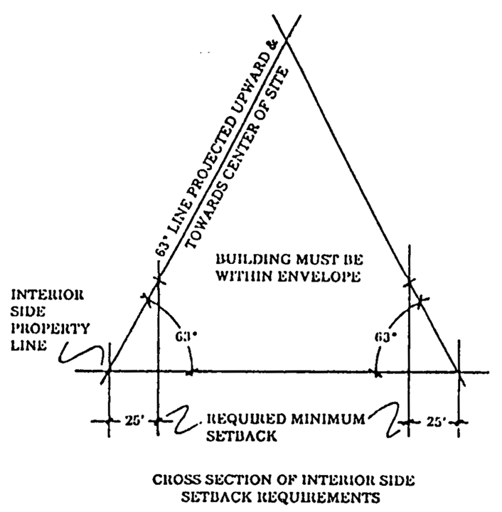

(4) Minimum setback between buildings shall be twenty (20) feet except where doors, windows or other openings in the building wall of a living unit face a wall of the same building and/or a wall of another building on the same site. In that case there shall be provided a minimum clear distance of not less than thirty (30) feet, said distance to be measured on a line projected at right angles from the opening to the opposite wall. Cantilevers and open porches may project from the building wall into the required open space (court only) not more than six (6) feet and stairways may project from the building wall into the required open space (court only) not more than ten (10) feet. Stairways when located in the required open space (court) shall be supported by the necessary columns only; support by a wall is strictly prohibited.

(Ord. No. 72-91, § 1, 12-5-72; Ord. No. 82-5, § 1, 2-2-82; Ord. No. 83-20, § 1, 4-19-83)

Sec. 33-211.1. Passageway areas to the bay or ocean.

There shall be a visual passageway area for sites abutting the bay or ocean, said area to extend from the bay or ocean to the street most nearly parallel to the mean high water line. Twenty (20) percent of the total frontage dimension of said sites shall be unencumbered with any structure or off-street parking, with the area(s) running the full length of the property from the street most nearly parallel to the mean high water line, to the bay or ocean. The maximum required view corridor for any one (1) development shall be one hundred (100) feet in width.

Properties donated or dedicated to Miami-Dade County and accepted by the Board of County Commissioners, or encumbered with a public or semipublic easement that lies within the interior setback areas shall be credited toward this requirement. The purpose of said dedications/easements is to encourage views of the bay or ocean and features such as walkways, public parking areas, fishing piers, gazebos, art objects and other similar amenities. A floor area ratio bonus shall be given for developments abutting the bay or ocean where said dedications/easements are granted pursuant to the provisions of [Section 33-213](../level3/PTIIICOOR_CH33ZO_ARTXVIIIHIDEAPHODI.docx#PTIIICOOR_CH33ZO_ARTXVIIIHIDEAPHODI_S33-213FLARRA).

(Ord. No. 82-5, § 1, 2-2-82)

Sec. 33-212. Height.

On sites which abut dedicated rights-of-way of one hundred (100) feet or more, each proposed building or structure which exceeds one hundred (100) feet in height shall be designed and situated such that the shadow created by the sun at 12:00 noon on December 21 (a sun angle of forty-one (41) degrees) will not fall on any adjacent property except for public road rights-of-way. Shadow studies shall be provided to the Department. Buildings or structures may be proposed to any height except as controlled by this shadow provision and other provisions in the Code, such as floor area ratio, setbacks, airport regulations, etc. For all other sites, no building or structure or part thereof shall be of a height greater than the width of the widest street upon which such building abuts, unless approved for additional height as a result of public hearing. (See following sketch.)

(Ord. No. 72-91, § 1, 12-5-72; Ord. No. 82-5, § 1, 2-2-82; Ord. No. 95-215, § 1, 12-5-95)

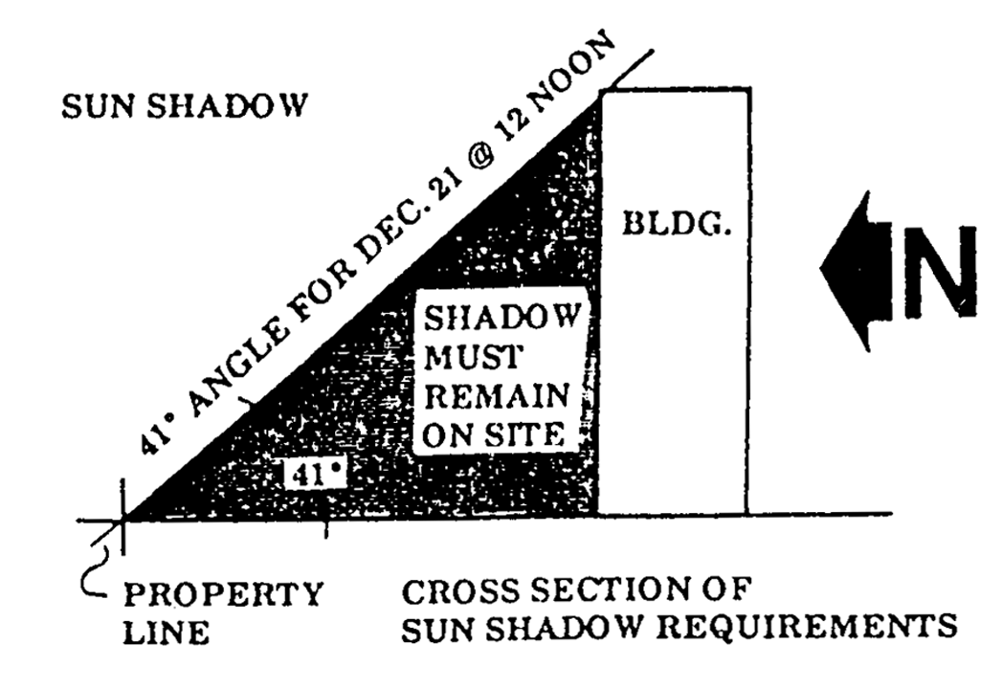

Sec. 33-213. Floor area ratio.

The floor area ratio shall not exceed the following, provided, however, that structure parking shall not count as a part of the floor area, but shall be counted in computing building height.

|  |  |
| --- | --- |
| Height of Building | Floor Area Ratio |
| 1 story | 0.40 |
| 2 story | 0.60 |
| 3 story | 0.80 |
| 4 story | 1.00 |
| 5 story | 1.20 |
| 6 story | 1.40 |
| 7 story | 1.60 |
| 8 story | 1.80 |
| 9 story or over | 2.00 |

A floor area ratio bonus shall be given for developments abutting the bay or ocean where easements are dedicated or granted to Miami-Dade County and accepted by the Board of County Commissioners and improved with features such as landscape, walkways, public parking areas, fishing piers, gazebos, restrooms, art objects and other similar amenities. Such areas are to extend the full length of the property from the street most nearly parallel to the mean high water line, to the bay or ocean. Such areas are to be included in density, open space and setback calculations.

The bonus shall be an additional two (2) square feet of floor area for each one (1) square foot of area devoted and improved for public access.

(Ord. No. 72-91, § 1, 12-5-72; Ord. No. 82-5, § 1, 2-2-82)

Sec. 33-214. Maximum number of units.

The maximum number of dwelling units shall not exceed a density of fifty (50) dwelling units per net acre or eight hundred seventy-one and two-tenths (871.2) square feet of lot area per dwelling unit.

(Ord. No. 72-91, § 1, 12-5-72)

Sec. 33-215. Parking.

Where a parking garage is not more than four (4) feet above grade, it shall not be considered as a structure for zoning purposes in the RU-4 District except as it applies to the special setback provisions in [Section 33-43](../level3/PTIIICOOR_CH33ZO_ARTIIBUCOSEARSI.docx#PTIIICOOR_CH33ZO_ARTIIBUCOSEARSI_S33-43USMOREDICOSPSELI); the same setbacks shall apply as with surface parking. The garage will not be calculated as a part of lot coverage requirements and will not be allowed in the twenty (20) percent unencumbered area, as enumerated in [Section 33-211.1](../level3/PTIIICOOR_CH33ZO_ARTXVIIIHIDEAPHODI.docx#PTIIICOOR_CH33ZO_ARTXVIIIHIDEAPHODI_S33-211.1PAARBAOC).

If the garage is to be used for parking on the top deck, it must be landscaped according to the provisions of [Chapter 18A](../level2/PTIIICOOR_CH18AMIDECOLAOR.docx#PTIIICOOR_CH18AMIDECOLAOR) of the Code of Miami-Dade County; if it is not to be used for parking on the top deck, it shall be developed with landscaping, recreational facilities, etc., with those portions devoted to landscaping being counted as open space pursuant to the provisions of [Section 33-216](../level3/PTIIICOOR_CH33ZO_ARTXVIIIHIDEAPHODI.docx#PTIIICOOR_CH33ZO_ARTXVIIIHIDEAPHODI_S33-216OPSP).

(Ord. No. 72-91, § 1, 12-5-72; Ord. No. 82-5, § 1, 2-2-82; Ord. No. 91-36, § 4, 3-19-91)

Sec. 33-215.1. Trees.

Landscaping and trees shall be provided in accordance with [Chapter 18A](../level2/PTIIICOOR_CH18AMIDECOLAOR.docx#PTIIICOOR_CH18AMIDECOLAOR) of this Code.

(Ord. No. 82-5, § 1, 2-2-82; Ord. No. 95-223, § 1, 12-5-95)

Sec. 33-216. Open space.

On each lot there shall be provided an open space equal to a minimum of forty (40) percent of the total lot area. Said open space shall be unencumbered with any structure or off-street parking, and shall be landscaped and well maintained with grass, trees, and shrubbery, excepting only areas used as pedestrian walks and ingress and egress drives provided that such drives shall not exceed the minimum width required to serve the parking area.

(Ord. No. 72-91, § 1, 12-5-72)

Sec. 33-216.1. Convenience retail facilities.

Apartment developments having a minimum of three hundred (300) residential units may have BU-1 type convenience uses not exceeding one thousand (1,000) square feet as an accessory use to apartment developments, provided that:

(1) Such services relate to the needs of the inhabitants of the proposed complex;

(2) Such services are not provided direct access from public roads;

(3) Such services are not visible from public roads;

(4) Detached signs and signs visible from public roads are not used; and

(5) Such services are designed as an integral part of the total design as determined by site plan review; and

(6) Such services are located in the principal structure or in a community service center structure.

An additional one (1) square foot of retail area shall be permitted for each apartment unit above three hundred (300) units; provided, however, that the maximum square footage for such facilities shall not exceed three thousand (3,000) square feet.

(Ord. No. 72-91, § 1, 12-5-72; Ord. No. 82-5, § 1, 2-2-82)

Sec. 33-216.2. Reserved.

**Editor's note—**

Ord. No. 82-5, § 1, adopted Feb. 2, 1982, deleted [§ 33-216.2](../level3/PTIIICOOR_CH33ZO_ARTXVIIIHIDEAPHODI.docx#PTIIICOOR_CH33ZO_ARTXVIIIHIDEAPHODI_S33-216.2RE), concerning site plan reviews, as derived from Ord. No. 72-91, § 1, adopted Dec. 5, 1972.

Sec. 33-216.3. Consolidation of requests requiring approval by public hearing into one (1) hearing application.

All requests requiring approval by public hearing may be consolidated into one (1) hearing application.

(Ord. No. 72-91, § 1, 12-5-72)

FOOTNOTE(S):

--- (**23**) ---

**Editor's note—** Ord. No. 72-91, § 1, adopted Dec. 5, 1972, amended Art. XVIII to read as set out in §§ 33-208—33-216.3. Formerly Art. XVIII, §§ 33-208—33-216, was derived from Ord. No. 57-19, § 12(A)—(I), adopted Oct. 22, 1957 and Ord. No. 70-65, § 1, adopted Sept. 1, 1970. (Back)

**Cross reference—** Height of fences, walls land hedges in RU District, § 33-11. (Back)

### ARTICLE XIX. RU-4A, HOTEL APARTMENT HOUSE DISTRICT [24]

Sec. 33-217. Uses permitted.

Sec. 33-217.1. Site plan review—Generally.

Sec. 33-217.2. Same—Criteria.

Sec. 33-218. Minimum lot width and area.

Sec. 33-219. Lot coverage.

Sec. 33-220. Setback requirements.

Sec. 33-220.1. Passageway areas to the bay or ocean.

Sec. 33-221. Height.

Sec. 33-222. Floor area ratio.

Sec. 33-222.1. Maximum number of units.

Sec. 33-222.1.1. Subdivision of hotels and motels.

Sec. 33-222.2. Parking.

Sec. 33-222.3. Open space.

Sec. 33-222.3.1. Trees.

Sec. 33-222.4. Accessory uses.

Sec. 33-222.5. Other spacing.

Sec. 33-222.6. Reserved.

Sec. 33-223. Consolidation of requests requiring approval by public hearing into one (1) hearing application.

Sec. 33-217. Uses permitted.

No land, body of water or structure shall be used, or permitted to be used and no structure shall be hereafter erected, constructed, moved or reconstructed, structurally altered or maintained for any purpose in an RU-4A District which is designed, arranged, or intended to be used or occupied for any purpose, except for one (1) of the following uses:

(1) Those uses permitted in the RU-1, RU-2, RU-1M(a), RU-1M(b), RU-3, RU-TH and RU-RH Districts subject only to the requirements, limitations and restrictions applicable thereto in said districts, including, but not limited to, lot width, area, setbacks, yard areas, height and coverage.

(1.1) Workforce housing units in compliance with the provisions of Article XIIA of this code.

(2) Multiple family apartment house, apartment, hotel, apartment hotel and motel containing fewer than eleven (11) units in a single building.

(3) Hotels, motels, apartment houses, and apartment hotels containing eleven (11) or more units, subject to site plan review hereinafter provided. Where applicant fails to secure the approval of both departments the site plan reviewed shall be deemed denied. Where the site plan has been denied, the applicant may correct the same to secure the approval of both departments or appeal the denial for review by the Community Zoning Appeals Board.

(4) Multiple family housing developments, provided they are reviewed under the provisions of site plan review hereinafter provided, and only on approval after staff review of the site plan(s) to ensure compliance with all RU-4A District requirements and the plan review criteria. Said plan shall be in compliance with the requirements hereinafter provided. Where motel developments consist of two (2) or more structures, unless each such structure is located on a site meeting all standards of this district, the area shall be restricted to one (1) ownership by covenant running with the land.

(5) Convalescent homes, eleemosynary and philanthropic institutions, only upon approval after public hearing. Hospitals (other than animal hospitals) including accessory office buildings and accessory commercial service facilities, only upon approval by public hearing; said accessory uses shall comply with the following additional criteria:

(a) Office buildings:

1. Office buildings shall be located on a hospital site containing a minimum of ten (10) acres.

2. Hospital and office buildings shall be under one (1) ownership and the property owner shall file a unity of title agreement or other similar agreement or covenant in lieu thereof in conformance with the provisions of [Section 33-31](../level3/PTIIICOOR_CH33ZO_ARTIINGE.docx#PTIIICOOR_CH33ZO_ARTIINGE_S33-31UNTIREREDE)

3. Tenants of the office buildings shall be limited to medical personnel affiliated with, and having staff privileges at, the hospital.

4. The hospital must contain a minimum of one hundred (100) beds.

5. The office complex shall not exceed forty (40) percent of the hospital's total square footage.

(b) Commercial service facilities:

1. Service facilities shall be restricted to cafeterias or restaurant, florist shop, gift shop, financial institution, pharmacy, newspaper and magazine stand, and other similar uses determined by the director to be ancillary to a hospital/office complex.

2. Services shall be permitted and available exclusively for use by medical staff, hospital personnel, patients and visitors of the hospital.

3. Outside advertising or signs (including wall signs) shall be prohibited.

4. Service facilities shall not exceed three (3) percent of the hospital floor area, nor shall they exceed seven (7) percent of the office floor area.

5. Service facilities meeting the above criteria shall not require further public hearing(s) if located within hospitals or related office buildings approved at public hearing(s) held after the effective date of Ordinance Number 88-93.

(5.1) Medical observation dormitory as defined in [Section 33-1](../level3/PTIIICOOR_CH33ZO_ARTIINGE.docx#PTIIICOOR_CH33ZO_ARTIINGE_S33-1DE)(69.05) subject to the following conditions:

(a) That such uses on sites of ten (10) net acres or more shall be approved only after public hearing;

(b) That such uses shall be located on sites having frontage on a major access road, including major roadways (three (3) or more lanes) and frontage roadways serving limited access highways and expressways;

(c) That a minimum five (5) foot high masonry wall be provided along all perimeter property lines abutting residentially zoned property penetrated only at points approved by the Directors of the Planning and Zoning Department and the Public Works Department for ingress and egress;

(d) That the facility is located on a site consisting of at least three (3) or more net acres, that research conducted at the property shall be limited to testing of normal volunteers and of clinically stable representatives of diseased states for which the medications being tested are ultimately intended;

(e) That protocols that require treating of mentally ill subjects, including persons with any mental or psychological disorder, such as intellectual disability, organic brain syndrome, emotional or mental illness, and specific learning disabilities, shall not be performed at the research facility;

(f) That such use shall be located no less than twenty-five hundred (2,500) feet from any other such establishments. For the purposes of this subsection, the distance shall be measured by following a straight line from the front door of the proposed place of business to the nearest property line of the existing place of business. For the purpose of establishing the distance between such establishments, the operator shall furnish a certified sketch of survey from a registered engineer or surveyor. Such sketch shall indicate the distance between the proposed place of business and any existing establishment within 2,500 feet. Each sketch shall indicate all such distances and routes. In case of dispute, the measurement scaled by the director shall govern;

(g) That the operator obtains an annually renewable certificate of use and occupancy for such use on the property.

(6) Private clubs, lodges, fraternities and sororities, only upon approval after public hearing.

(7) Public art galleries, public libraries and public museums.

(8) Bungalow villa arrangements (each structure limited to not more than two-family occupancy). See definition in this chapter.

Before a permit shall be granted to place buildings on a lot under the bungalow villa provision, plans shall be filed covering the size and spacing of all buildings intended in the villa and the total area of lot is to be included; not less than ten (10) dwelling units shall be permitted under the provisions of the bungalow villa regulations and, further, the entire area shall be restricted to one (1) ownership by covenant running with the land. Permits shall be obtained for the required ten (10) units at one (1) time and work on all structures shall proceed concurrently.

(9) Housing projects, whether in single or multiple buildings, and as defined in Chapter 421 of the Florida Statutes, built for or by the Miami-Dade County Department of Housing and Urban Development.

(10) A community residential facility as defined in [Section 33-1](../level3/PTIIICOOR_CH33ZO_ARTIINGE.docx#PTIIICOOR_CH33ZO_ARTIINGE_S33-1DE)(30.1) shall be permitted in a dwelling unit upon establishing the following:

(a) That the total number of resident clients on the premises not exceed fourteen (14) in number. Facilities for more than fourteen (14) resident clients must be approved through public hearing pursuant to [Section 33-13](../level3/PTIIICOOR_CH33ZO_ARTIINGE.docx#PTIIICOOR_CH33ZO_ARTIINGE_S33-13UNUS)

(b) That the operation of the community residential home be licensed by the State of Florida Department of Health and Rehabilitative Services;

(c) That the community residential home not be located within a radius of one thousand two hundred (1,200) feet of another existing, unabandoned legally established community residential home in a multi-family zone. The one thousand two hundred-foot distance requirement shall be measured by following a straight line from the nearest portion of the structure of the proposed use to the nearest portion of the structure of the existing use;

(d) That the community residential home conform to existing zoning regulations applicable to other multiple family uses permitted by this section;

(e) That the sponsoring agency of the community residential home notify the Director in writing of its intention to establish said facility. Such notice shall contain the address and legal description of the site, the number of resident clients, as well as a statement from the State of Florida Department of Health and Rehabilitative Services indicating the need for and licensing status of the proposed facility. Absence of this notification and statement shall prohibit the use and occupancy of any structure for use as a community residential home; and

(f) Nothing in this section shall permit persons to occupy a community residential home who would constitute a direct threat to the health and safety of other persons or whose residency would result in substantial physical damage to the property of others.

Provisions of Ord. No. 82-6 shall not apply to those buildings for which a building permit has been issued and is in effect and where multiple family housing development or project site plan has been approved prior to February 2, 1982, by resolution of the Zoning Appeals Board or Board of County Commissioners, or prior to February 2, 1982, an agreement, letter of intent, or performance standards encompassing all of the basic items constituting a site plan has been recorded or adopted by resolution of the Zoning Appeals Board or the Board of County Commissioners.

(Ord. No. 72-92, § 1, 12-5-72; Ord. No. 75-90, § 5, 10-15-75; Ord. No. 82-6, § 1, 2-2-82; Ord. No. 83-20, § 2, 4-19-83; Ord. No. 88-93, § 1, 10-4-88; Ord. No. 91-51, § 4, 5-7-91; Ord. No. 91-81, § 1, 7-23-91; Ord. No. 95-135, § 16, 7-25-95; Ord. No. 95-215, § 1, 12-5-95; Ord. No. 98-125, § 21, 9-3-98; Ord. No. 01-131, § 2, 9-13-01; Ord. No. 06-96, § 8, 6-20-06; Ord. No. 07-05, § 11, 1-25-07; Ord. No. 08-51, § 1, 5-6-08; Ord. No. 13-83, § 7, 9-17-13)

Sec. 33-217.1. Site plan review—Generally.

The Department shall review plans for compliance with zoning regulations and for compliance with the site plan review criteria. The purpose of the site plan review is to encourage logic, imagination, innovation and variety in the design process and thereby ensure the congruity of the proposed development and its compatibility with the surrounding area. All plans submitted to the Department shall be reviewed and approved or denied within fifteen (15) days from the date of submission. The applicant shall have the right to extend the fifteen-day period by an additional fifteen (15) days upon timely request made in writing to the Department. The Department shall have the right to extend the fifteen-day period by written notice to the applicant that additional information is needed to process the site plan. Denials shall be in writing and shall specifically set forth the grounds for denial. If the plan is disapproved the applicant may appeal to the appropriate Community Zoning Appeals Board in accordance with procedure established for appeals of administrative decision.

Procedure. Exhibits prepared by design professionals such as architects and landscape architects shall be submitted to the Department and shall include, but not be limited to the following:

(1) Site plan including the following information:

(a) Lot lines and setbacks.

(b) Location, shape, size and height of existing and proposed buildings, decorative walls and entrance features.

(c) Landscaping in accordance with [Chapter 18A](../level2/PTIIICOOR_CH18AMIDECOLAOR.docx#PTIIICOOR_CH18AMIDECOLAOR) of this Code.

(d) Location of off-street parking and loading facilities and waste collection areas.

(e) Indication of exterior graphics, as required.

(f) Indication of any site design methods used to conserve energy.

(2) Floor plans and elevations of all structures, including total gross square foot area of each floor.

(3) Figures indicating the following:

(a) Gross and net acreage.

(b) Amount of landscaped open space in square feet required and provided.

(c) Amount of building coverage at ground level in square feet.

(d) Total trees required and provided in accordance with [Chapter 18A](../level2/PTIIICOOR_CH18AMIDECOLAOR.docx#PTIIICOOR_CH18AMIDECOLAOR) of this Code.

(e) Parking required and provided.

(f) Total amount of paved area in square feet.

(g) Such other design data as may be needed to evaluate the project.

(Ord. No. 82-6, § 1, 2-2-82; Ord. No. 95-215, § 1, 12-5-95; Ord. No. 95-223, § 1, 12-5-95; Ord. No. 96-127, § 10, 9-4-96)

Sec. 33-217.2. Same—Criteria.

The following criteria shall be utilized in the plan review process:

(1) *Purpose and intent:* The proposed development fulfills the objectives of this article.

(2) *Planning studies:* Design, planning studies or neighborhood area studies accepted or approved by the Board of County Commissioners that include development patterns or environmental design criteria which would apply to the development proposal under review shall be utilized in the plan review process.

(3) *Landscape:* Landscape shall be preserved in its natural state insofar as is practicable by minimizing tree removal. Landscape shall be used to shade and cool, direct wind movements, enhance architectural features, relate structure design to site, visually screen noncompatible uses and block noise generated by the major roadways and intense-use areas.

(4) *Buffers:* Buffering elements in the form of architectural design and landscape design that provide a logical transition to adjoining existing or permitted uses shall be provided.

(5) *Scale:* Scale of proposed structure shall be compatible with surrounding proposed or existing uses or shall be made compatible by the use of buffering elements.

(6) *Circulation:* Pedestrian and auto circulation shall be separated insofar as is practicable, and all circulation systems shall adequately serve the needs of the development and be compatible and functional with circulation systems outside the development.

(7) *Energy considerations:* Site design methods to reduce energy consumption shall be encouraged. Energy site conservation methods may include siting of structures in relation to prevailing breezes and sun angles and use of landscape materials for shade and transpiration.

(8) *Parking areas:* Building wall extensions, planting, berms or other innovative methods shall be used as a means of minimizing the adverse effect of the visual impact of parking areas. This requirement is in addition to the requirements of the landscape regulations of the Code of Miami-Dade County.

(9) *Open spaces:* Open space shall relate to any natural characteristics in such a way as to preserve and enhance their scenic and functional qualities to the fullest extent possible.

(10) *Graphics:* Graphics, as required, shall be designed as an integral part of the overall design of the project.

(11) *Art display:* Permanent interior and exterior art displays and water features should be encouraged in the overall design of the project.

(12) *Visual screening for decorative walls:* In an effort to prevent graffiti vandalism, the following options shall be utilized for walls abutting zoned or dedicated rights-of-way:

(a) *Wall with landscaping.* The wall shall be setback two and one-half (2½) feet from the right-of-way line and the resulting setback area shall contain a continuous extensively landscaped buffer which must be maintained in a good healthy condition by the property owner, or where applicable, by the condominium, homeowners or similar association. The landscape buffer shall contain one (1) or more of the following planting materials:

(1) *Shrubs.* Shrubs shall be a minimum of three (3) feet in height when measured immediately after planting and shall be planted and maintained to form a continuous, unbroken, solid, visual screen within one (1) year after time of planting.

(2) *Hedges.* Hedges shall be a minimum of three (3) feet in height when measured immediately after planting and shall be planted and maintained to form a continuous, unbroken, solid, visual screen within one (1) year after time of planting.

(3) *Vines.* Climbing vines shall be a minimum of thirty-six (36) inches in height immediately after planting.

(b) *Metal picket fence.* Where a metal picket fence abutting a zoned or dedicated right-of-way is constructed in lieu of a decorative wall, landscaping shall not be required.

(Ord. No. 82-6, § 1, 2-2-82; Ord. No. 95-19, § 6, 2-7-95; Ord. No. 99-38, § 7, 4-27-99)

Sec. 33-218. Minimum lot width and area.

The minimum lot width shall be one hundred (100) feet and the minimum lot area shall be ten thousand (10,000) square feet.

(Ord. No. 72-92, § 1, 12-5-72)

Sec. 33-219. Lot coverage.

The total lot coverage permitted for all buildings on the site shall not exceed forty (40) percent of the total lot area.

(Ord. No. 72-92, § 1, 12-5-72)

Sec. 33-220. Setback requirements.

The setbacks shall be as follows:

(1) Front setback. For structures not exceeding thirty-five (35) feet in height, the minimum setback shall be twenty-five (25) feet; for structures over thirty-five (35) feet in height the setbacks shall be increased by forty (40) percent of the additional height; provided, however, that the required front setback shall not exceed fifty (50) feet.

(2) Rear setback. For structures not exceeding thirty-five (35) feet in height, the minimum setback shall be twenty-five (25) feet; for structures over thirty-five (35) feet in height the setbacks shall be increased by forty (40) percent of the additional height.

(3) Interior side setbacks and side street setbacks. Minimum setbacks for all structures shall be determined by a sixty-three-degree line projected from the interior side property line(s) or side street property line(s) upward towards the center of the site; provided, however, that no structure shall be permitted to be closer than twenty-five (25) feet to the interior side property line(s) or side street property line(s) (see the following sketch) and further provided that the passageway areas to Biscayne Bay or the Atlantic Ocean are adhered to as provided in this article.

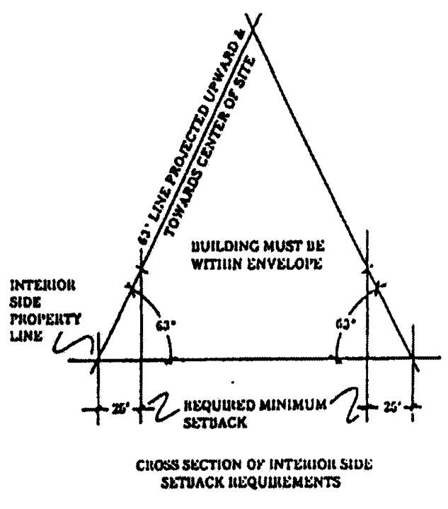

**Cross Section of Interior Side Setback Requirements**

(4) Minimum setback between buildings shall be twenty (20) feet, except where doors, windows or other openings in the building wall of a living unit face a wall of the same building and/or a wall of another building on the same site. In that case there shall be provided a minimum clear distance of not less than thirty (30) feet, said distance to be measured on a line projected at right angles from the opening to the opposite wall. Cantilevers and open porches may project from the building wall into the required open space (court only) not more than six (6) feet and stairways may project from the building wall into the required open space (court only) not more than ten (10) feet. Stairways, when located in the required open space (court), shall be supported by the necessary columns only; support by a wall is strictly prohibited.

(5) Bungalow villas shall be setback as follows:

(a) Twenty-five (25) feet from the front property line.

(b) Twenty (20) feet from a side property line abutting a highway right-of-way, except where the rear of the lot abuts a key lot; in which event, the setback for the key lot shall govern.

(c) Ten (10) feet from an interior side lot line.

(d) Ten (10) feet from the rear property line.

(e) The minimum clear distance between units of a bungalow villa shall be twenty (20) feet. Ingress and egress to all units shall be provided by a common and continuous clear space with a thirty (30) foot minimum width.

(Ord. No. 72-92, § 1, 12-5-72; Ord. No. 82-6, § 1, 2-2-82; Ord. No. 83-20, § 2, 4-19-83)

Sec. 33-220.1. Passageway areas to the bay or ocean.

There shall be a visual passageway area for sites abutting the bay or ocean, said area to extend from the bay or ocean to the street most nearly parallel to the mean high water line. Twenty (20) percent of the total frontage dimension of said sites shall be unencumbered with any structure or off-street parking, with the area(s) running the full length of the property from the street most nearly parallel to the mean high water line, to the bay or ocean. The maximum required view corridor for any one (1) development shall be one hundred (100) feet in width.

Properties donated or dedicated to Miami-Dade County and accepted by the Board of County Commissioners, or encumbered with a public or semipublic easement that lies within the interior setback areas shall be credited toward this requirement. The purpose of said dedications/easements is to encourage views of the bay or ocean and features such as walkways, public parking areas, fishing piers, gazebos, art objects and other similar amenities. A floor area ratio bonus shall be given for developments abutting the bay or ocean where said dedications/easements are granted pursuant to the provisions of [Section 33-222](../level3/PTIIICOOR_CH33ZO_ARTXIXHOAPHODI.docx#PTIIICOOR_CH33ZO_ARTXIXHOAPHODI_S33-222FLARRA).

(Ord. No. 82-6, § 1, 2-2-82)

Sec. 33-221. Height.

On sites which abut dedicated rights-of-way of one hundred (100) feet or more, each proposed building or structure which exceeds one hundred (100) feet in height shall be designed and situated such that the shadow created by the sun at 12:00 noon on December 21 (a sun angle of forty-one (41) degrees) will not fall on any adjacent property except for public road rights-of-way. Shadow studies shall be provided to the Department. Buildings or structures may be proposed to any height except as controlled by this shadow provision and other provisions in the Code, such as floor area ratio, setbacks, airport regulations, etc. For all other sites, no building or structure or part thereof shall be of a height greater than the width of the widest street upon which such building abuts, unless approved for additional height as a result of public hearing. (See following sketch.)

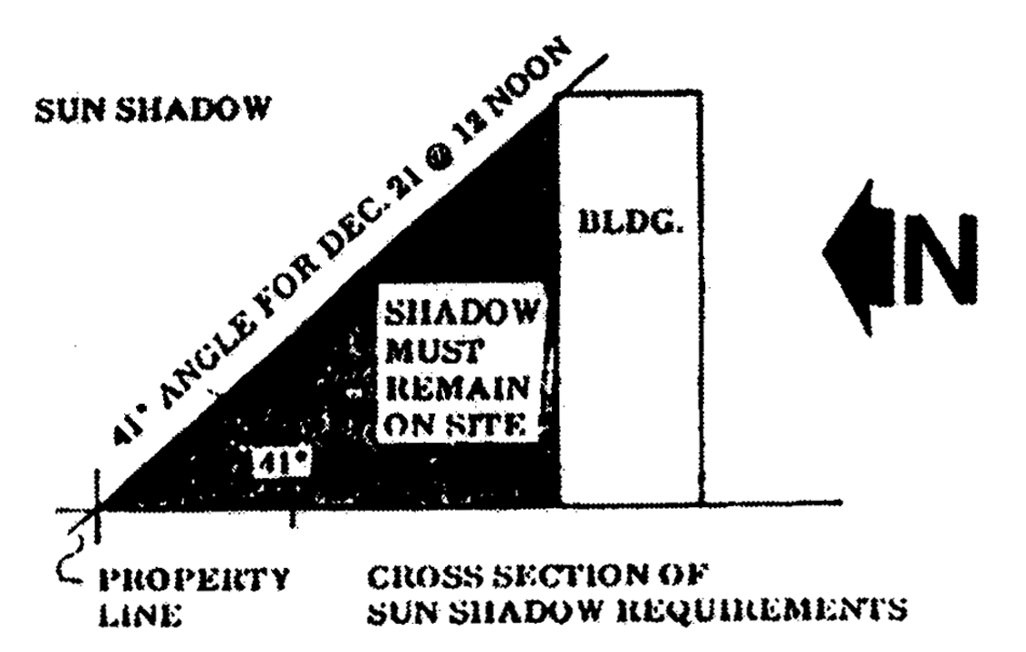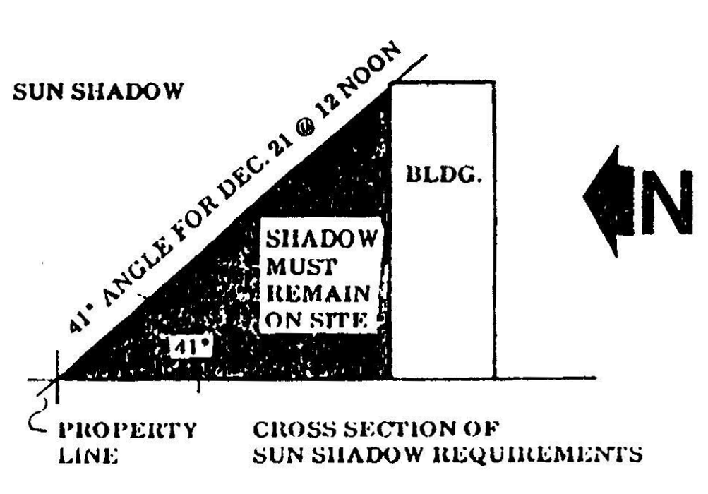

**Cross Section of Sun Shadow Requirements**

(Ord. No. 72-92, § 1, 12-5-72; Ord. No. 82-6, § 1, 2-2-82; Ord. No. 95-215, § 1, 12-5-95)

Sec. 33-222. Floor area ratio.

The floor area ratio shall not exceed the following; provided, however, that covered structure parking shall not count as a part of the floor area, but shall be counted in computing building height:

|  |  |
| --- | --- |
| *Height of*  *Buildings* | *Floor Area*  *Ratio* |
| 1 story | 0.40 |
| 2 story | 0.60 |
| 3 story | 0.80 |
| 4 story | 1.00 |
| 5 story | 1.20 |
| 6 story | 1.40 |
| 7 story | 1.60 |
| 8 story | 1.80 |
| 9 story or over | 2.00 |

A floor area ratio bonus shall be given for developments abutting the bay or ocean where improved easements are dedicated or granted to Miami-Dade County and accepted by the Board of County Commissioners for features such as landscape, walkways, public parking areas, fishing piers, gazebos, restrooms, art objects and other similar amenities. Said areas are to extend the full length of the property from the street most nearly parallel to the mean high water line, to the bay or ocean. Such areas are to be included in density, open space and setback calculations.

The bonus shall be an additional two (2) square feet of floor area for each one (1) square foot of area devoted for improved public access.

(Ord. No. 72-92, § 1, 12-5-72; Ord. No. 82-6, § 1, 2-2-82; Ord. No. 83-20, § 2, 4-19-83)

Sec. 33-222.1. Maximum number of units.

The maximum number of dwelling units in a multiple family housing development, apartment, or housing project shall not exceed a density of fifty (50) dwelling units per acre, or eight hundred seventy-one and two-tenths (871.2) square feet of lot area per dwelling unit. Hotels, motels and apartment hotels developed for transient residential usage shall not exceed a density of seventy-five (75) dwelling units per net acre or five hundred eighty and eight-tenths (580.8) square feet of lot area per dwelling unit.

Each dwelling unit of a bungalow villa shall provide at least two thousand (2,000) square feet of lot area.

(Ord. No. 72-92, § 1, 12-5-72; Ord. No. 96-81, § 3, 6-4-96)

Sec. 33-222.1.1. Subdivision of hotels and motels.

(a) Definitions.

(1) For the purposes of this section the term "subdivision of a hotel or motel" shall mean the sale, conveyance, or long-term lease or sublease (for more than six (6) months) of five (5) percent or more, cumulatively, of the units in a hotel or motel by the same seller, lessor or sublessor. This definition is not applicable to the transfer of an entire hotel or motel to the same transferee.

(2) For purposes of this section the term "subdivided property" shall mean all hotel or motel units and all other components of any subdivided hotel or motel.

(b) Any person or entity who subdivides a hotel or motel shall deliver written notice of said subdivision to the Director on or before the earlier of either offering to enter into or entering into any sale, conveyance, lease, or sublease which would result in a subdivision.

(c) If there shall be a subdivision of any hotel or motel no permit, certificate of use and occupancy or any other governmental approval shall be issued or granted except in emergencies for any subdivided property, unless and until the owner shall demonstrate to the Director that the subdivided property shall continue to comply with all the provisions and regulations of this chapter and any resolutions adopted pursuant hereto. The procedure for demonstrating such compliance shall be established by submission of documentation pursuant to regulations to be promulgated by the Director and approved by the Board of County Commissioners.

(d) (1)  
It shall be presumed that the subdivision of a hotel or motel results in a change of use to nonhotel or nonmotel use. This presumption may be rebutted administratively at a public hearing. An application to rebut shall be filed for public hearing before the appropriate Community Zoning Appeals Board. The presumption shall be rebutted whenever such an applicant shall establish at public hearing that the property will continue to be utilized as a hotel or motel. In civil proceedings the presumption of change of use shall shift the burden of proof on this issue to the party against whom it operates; and in criminal proceedings the presumption shall constitute prima facie evidence of a change in use.

(2) The presumption established by this subsection shall not go into effect for a hotel or motel if: 1) prior to June 6, 1984, units in the hotel or motel have been offered to the public for sale, conveyance, lease, or sublease which would result in a subdivision; 2) an application to rebut is filed pursuant to this subsection within sixty (60) days after June 15, 1984; and 3) said application is approved. For a hotel or motel which may qualify pursuant to this paragraph, no presumption shall go into effect until the later of the expiration of said sixty-day period without the filing of an application to rebut, or a final determination that the applicant has failed to rebut the presumption.

(e) This section shall not apply to any units or other components of a subdivided property which were sold, conveyed, leased, or subleased to the public in bona fide transactions by the subdivider prior to June 15, 1984 nor to any units or components so transferred after June 15, 1984 pursuant to a bona fide contract with the transferee entered into before June 15, 1984. The term "bona fide" shall mean for a valid business purpose other than avoiding the applicability of this section. Except as otherwise specifically provided herein all provisions of this section shall be applicable to all hotel or motel property undergoing subdivision after June 15, 1984 regardless of whether there was any prior subdivision thereof. Nothing contained in this section shall prevent the Director from taking any and all enforcement actions authorized by the Code of Miami-Dade County, Florida, independent of this section.

(Ord. No. 84-46, § 2, 6-5-84; Ord. No. 96-127, § 11, 9-4-96)

Sec. 33-222.2. Parking.

Where a parking garage is not more than four (4) feet above grade, it shall not be considered as a structure for zoning purposes in the RU-4 District except as it applies to the special setback provisions in [Section 33-43](../level3/PTIIICOOR_CH33ZO_ARTIIBUCOSEARSI.docx#PTIIICOOR_CH33ZO_ARTIIBUCOSEARSI_S33-43USMOREDICOSPSELI); the same setbacks shall apply as with surface parking. The garage will not be calculated as a part of lot coverage requirements and will not be allowed in the twenty (20) percent unencumbered area, as enumerated in [Section 33-220.1](../level3/PTIIICOOR_CH33ZO_ARTXIXHOAPHODI.docx#PTIIICOOR_CH33ZO_ARTXIXHOAPHODI_S33-220.1PAARBAOC).

If a garage is to be used for parking on the top deck, it must be landscaped according to the provisions of [Chapter 18A](../level2/PTIIICOOR_CH18AMIDECOLAOR.docx#PTIIICOOR_CH18AMIDECOLAOR) of the Code of Miami-Dade County; if it is not to be used for parking on the top deck, it shall be developed with landscaping, recreational facilities, etc., with those portions devoted to landscaping being counted as open space pursuant to the provisions of [Section 33-222.3](../level3/PTIIICOOR_CH33ZO_ARTXIXHOAPHODI.docx#PTIIICOOR_CH33ZO_ARTXIXHOAPHODI_S33-222.3OPSP).

(Ord. No. 72-92, § 1, 12-5-72; Ord. No. 82-6, § 1, 2-2-82; Ord. No. 83-20, § 2, 4-19-83; Ord. No. 91-36, § 5, 3-19-91)

Sec. 33-222.3. Open space.

On each lot there shall be provided an open space equal to a minimum of forty (40) percent of the total lot area. Said open space shall be unencumbered with any structure or off-street parking, and shall be landscaped and well maintained with grass, trees, and shrubbery, excepting only areas used as pedestrian walks and ingress and egress drives provided that such drives shall not exceed the minimum width required to serve the parking area.

(Ord. No. 72-92, § 1, 12-5-72)

Sec. 33-222.3.1. Trees.

Landscaping and trees shall be provided in accordance with [Chapter 18A](../level2/PTIIICOOR_CH18AMIDECOLAOR.docx#PTIIICOOR_CH18AMIDECOLAOR) of this Code.

(Ord. No. 82-6, § 1, 2-2-82; Ord. No. 95-223, § 1, 12-5-95)

Sec. 33-222.4. Accessory uses.

(1) Business or commercial establishments of the BU-1 type, bars and cabarets shall be permitted in hotels, motels and apartment hotels provided they are located within the principal building, which contains at least one hundred (100) units, and provided the exterior of any such principal building shall not have store fronts or give the appearance of commercial or mercantile activity as viewed from the highway: in the event the use contains windows which may be seen from the street or highway, said windows shall be of fixed, obscure glass. Such business or commercial establishments and bars in this district shall be entered only through the lobby and no additional entrances shall be permitted, except when the same opens into a courtyard or patio (away from the street side) which is enclosed and which is not visible from the street and, except that a fire door or emergency exit shall be permitted. Hotels, motels, and apartment-hotels which extend from a street to the ocean or bay, and which have the required number of guest rooms or apartment units may have the permitted business or commercial establishment on the extreme end of the structure on the waterway side with a direct opening, provided that the opening is from the waterway side and cannot be viewed from the street or highway.

These restrictions shall not apply when the site is in a commercial district and these commercial uses are a permitted use in said district and conform to all of the requirements of said district.

(2) Apartment developments having a minimum of three hundred (300) residential units may have BU-1 type convenience uses not exceeding one thousand (1,000) square feet as an accessory use to apartment developments, provided that:

(a) Such services relate to the needs of the inhabitants of the proposed complex;

(b) Such services are not provided direct access from public roads;

(c) Such services are not visible from public roads;

(d) Detached signs and signs visible from public roads are not used;

(e) Such services are designed as an integral part of the total design as determined by site plan review; and

(f) Said facility is located in the principal structure or in a community service center structure.

An additional one (1) square foot of retail area shall be permitted for each apartment unit above three hundred (300) units provided, however, that the maximum square footage for such facilities shall not exceed three thousand (3,000) square feet.

(3) Hotels and motels with one hundred fifty (150) or more guest rooms may contain liquor package use on the premises for the accommodation and use of their guests only, provided the establishment housing such use is entered only through the lobby within the building and does not have the appearance of commercial or mercantile activity as viewed from the highway. No advertisement of the use will be permitted which can be seen from the outside of the building. These restrictions shall not apply when the hotel or motel site is in a commercial district and the package store is a permitted use and conforms to all of the requirements of said district.

(4) Hotels and motels with two hundred (200) or more guest rooms or apartment units under one (1) roof may contain a night club on the premises, provided the exterior of any such building shall not have store fronts or give the appearance of commercial or mercantile activity as viewed from the highway. In the event the use contains windows which may be seen from the highway, said windows shall be of fixed obscure glass. Such night club shall be entered only through the lobby, and no additional entrance shall be permitted, except when the same opens into a courtyard or patio (away from street side) which is enclosed and which is not visible from the street and, except that a fire door or exit shall be permitted.

(5) Coffee shop and dining room may be permitted in bungalow villa arrangements having fifty (50) or more guest rooms or fifty (50) or more units designed as one-family dwellings, provided that the exterior or any such building shall not contain store fronts and shall not have the appearance of commercial or mercantile activity as viewed from the public highway, nor be identified by any type of sign. Strip lighting by neon or other type of electric lighting to outline a building shall not be permitted.

The total square foot area of coffee shop or dining room, including kitchen facilities, etc., shall not total more than fifteen (15) square feet, multiplied by each living unit erected on the project.

(6) Cabanas, provided they are strictly incidental to apartment house, apartment hotel, motel or hotel.

Cabanas shall not be used for overnight sleeping quarters nor rented or leased to any person other than a guest of the apartment house, apartment hotel, motel or hotel.

(Ord. No. 72-92, § 1, 12-5-72; Ord. No. 82-6, § 1, 2-2-82)

Sec. 33-222.5. Other spacing.

No hospital, convalescent home, eleemosynary or philanthropic institution shall be located within one hundred (100) feet of any EU, RU-1 or RU-2 Zone or within fifty (50) feet of any property under different ownership.

(Ord. No. 72-92, § 1, 12-5-72)

Sec. 33-222.6. Reserved.

**Editor's note—**

Ord. No. 82-6, § 1, adopted Feb. 2, 1982, deleted [§ 33-222.6](../level3/PTIIICOOR_CH33ZO_ARTXIXHOAPHODI.docx#PTIIICOOR_CH33ZO_ARTXIXHOAPHODI_S33-222.6RE), concerning site plan review, as derived from Ord. No. 72-92, § 1, adopted Dec. 5, 1972.

Sec. 33-223. Consolidation of requests requiring approval by public hearing into one (1) hearing application.

All requests requiring approval by public hearing may be consolidated into one (1) hearing application.

(Ord. No. 72-92, § 1, 12-5-72)

FOOTNOTE(S):

--- (**24**) ---

**Editor's note—** Ord. No. 72-92, § 1, adopted Dec. 5, 1972, amended Art. XIX, §§ 33-217—33-223, to read as herein set out. Prior to amendment by said Ord. No. 72-92, Art. XIX was derived from Ord. No. 57-19, § 13(A)—(H), adopted Oct. 22, 1957, and Ord. No. 70-65, § 1, adopted Sept. 1, 1970. (Back)

Section 4 of Ord. No. 82-6, which amended most of the sections in Art. XIX, provides: (Back)

"This ordinance shall become effective ten (10) days after the date of enactment. However: `Provisions of this ordinance shall not apply to those buildings for which a building permit has been issued and is in effect and where multiple family housing development or project site plan has been approved prior to the adoption of this ordinance by resolution of the Zoning Appeals Board or Board of County Commissioners, or prior to the adoption of this ordinance, an agreement, letter of intent, or performance standards encompassing all of the basic items constituting a site plan has been recorded or adopted by resolution of the Zoning Appeals Board or the Board of County Commissioners.'" (Back)

**Cross reference—** Height of fences, walls and hedges in RU District, § 33-11. (Back)

### ARTICLE XIXA. RU-5, RESIDENTIAL—SEMI-PROFESSIONAL OFFICE DISTRICT

Sec. 33-223.1. Uses permitted.

Sec. 33-223.2. Minimum lot width and area.

Sec. 33-223.3. Lot coverage; setback requirements; accessory buildings; type of building permitted.

Sec. 33-223.4. Floor area ratios and height of buildings.

Sec. 33-223.5. Other specific requirements.

Sec. 33-223.5.1. Site plan review.

Sec. 33-223.1. Uses permitted.

No land, body of water or structure shall be used, or permitted to be used, and no structure shall be hereafter erected, constructed, reconstructed, moved or structurally altered or maintained for any purpose in an RU-5 District which is designed, arranged, or intended to be used or occupied for any purpose, except for one (1) or more of the following uses, and all other uses are hereby prohibited:

(1) Duplex use—those uses permitted in the RU-2 District subject only to the requirements, limitations and restrictions specified in said district, and except that it shall be permissible to use a fifty- by one hundred-foot lot for two-family use in an old subdivision

(1.1) Rowhouse development, subject only to the requirements, limitations and restrictions specified for the RU-RH district.

(2) Apartment house as permitted in the RU-3 District subject only to the requirements, limitations and restrictions applicable in the RU-3 District for such use

(3) Multiple-family housing projects

(3.1) Workforce housing units in compliance with the provisions of Article XIIA of this code.

(4) Abstract title

(5) Accountants—bookkeeping

(6) Actuaries

(6.1) Adult day care center

(7) Advertising (no shops)

(8) Adjusters (insurance)

(9) Aerial survey and photography

(10) Appraisals—no sale or rental of any type of merchandise or equipment

(11) Architects

(12) Attorneys

(13) Auditors

(14) Banks without drive-in teller facilities

(15) Business analysts—counselors or brokers

(16) Building contractors, office only (no shops or storage)

(17) Chiropodists

(18) Chiropractors

(19) Consulates

(20) Counseling, child guidance and family service

(21) Court reporter, public stenographer

(22) Credit reporting

(22A) Day nursery, kindergarten and afterschool care licensed by the State of Florida Department of Health and Rehabilitative Services and established in accordance with the requirements of Article XA

(23) Dentists

(24) Detective agencies and investigating service

(25) Drafting and plan service

(26) Engineers, professional

(27) State or Federal savings and loan associations as defined in 12 U.S.C.A., Section 1464, which do not require drive-in tellers

(28) Insurance and bonds

(29) Manufacturers' agents

(30) Market research

(31) Medical doctors

(32) Model agencies (no school)

(33) Mortgage broker

(34) Notary public

(35) Optician

(36) Optometrists

(37) Public libraries

(38) Public relations

(39) Real estate

(40) Real estate management

(41) Secretarial service

(42) Shoppers' information service

(43) Social service bureau

(44) Stock broker exchange—investment service

(45) Tax consultants

(46) Telephone answering service

(47) Theater ticket agencies

(48) Travel agencies

(49) Zoning consultants

(50) Any use which is found by the Director to be a use similar to one (1) of the above numbered uses and, in his opinion, conforms to the intent of this section.

(Ord. No. 60-8, § 1A, 2-9-60; Ord. No. 64-18, § 2, 5-5-64; Ord. No. 76-35, § 1, 4-20-76; Ord. No. 83-37, § 1, 6-7-83; Ord. No. 90-145, § 2, 12-18-90; Ord. No. 95-215, § 1, 12-5-95; Ord. No. 06-96, § 9, 6-20-06; Ord. No. 07-05, § 12, 1-25-07; Ord. No. 08-51, § 1, 5-6-08; Ord. No. 11-04, § 3, 2-1-11)

Sec. 33-223.2. Minimum lot width and area.

Minimum lot width shall be one hundred (100) feet and the minimum lot area shall be ten thousand (10,000) square feet for multiple-family housing projects, listed office uses or mixed office and residential uses except that a lot with a minimum of fifty (50) [foot] frontage and five thousand (5,000) square feet in area, which is in a platted old subdivision, can be utilized for office use upon compliance with all other requirements of this district.

(Ord. No. 60-8, § 1B, 2-9-60; Ord. No. 64-18, § 2, 5-5-64; Ord. No. 83-37, § 1, 6-7-83)

Sec. 33-223.3. Lot coverage; setback requirements; accessory buildings; type of building permitted.

(a) *Lot coverage.* The maximum lot coverage for all structures on the site shall be forty (40) percent. The structures must comply with the following minimum setback requirements.

(b) *Principal building setbacks.*

(1) Minimum setback from front property line shall be twenty-five (25) feet.

(2) Minimum setback from side property line abutting a highway right-of-way shall be fifteen (15) feet.

(3) Minimum setback from interior side property line shall be fifteen (15) feet.

(4) Minimum setback from rear property line shall be twenty-five (25) feet.

(c) *Accessory buildings.* No accessory building shall be permitted.

(d) *Type of building permitted.* The building(s) to be erected shall be without store fronts or display windows.

(Ord. No. 60-8, § 1C—F, 2-9-60; Ord. No. 64-18, § 2, 5-5-64; Ord. No. 83-37, § 1, 6-7-83)

Sec. 33-223.4. Floor area ratios and height of buildings.

(a) *Floor area ratios.* The floor area ratio shall not exceed the following; provided, however, that structure parking shall not count as part of the floor area, but shall be counted in computing building height:

One story: 0.40 FAR.

Two (2) stories: 0.60 FAR.

(b) *Heights.* The maximum height of any structure shall be two (2) stories but not to exceed thirty-five (35) feet above finished grade.

(Ord. No. 60-8, § 1G, H, 2-9-60; Ord. No. 64-18, § 2, 5-5-64; Ord. No. 83-37, § 1, 6-7-83)

Sec. 33-223.5. Other specific requirements.

(a) *Open space.* On each lot there shall be provided an open space equal to a minimum of twenty-five (25) percent of the total lot area. Said open space shall be unencumbered with any structure or off-street parking and shall be landscaped and well maintained with grass, trees and shrubbery, excepting only areas used as pedestrian walks and water bodies; provided said water bodies shall not be credited for more than twenty (20) percent of the open space required (five (5) percent of the total lot area). Open space areas may also include tree preservation zones of "natural forest communities" as defined in Section 26B-1, Code of Miami-Dade County. Tree preservation zones shall be delineated on all plans submitted to Miami-Dade County for site plan review under [Section 33-223.5.1](../level3/PTIIICOOR_CH33ZO_ARTXIXAREEOFOFDI.docx#PTIIICOOR_CH33ZO_ARTXIXAREEOFOFDI_S33-223.5.1SIPLRE) of the Code of Miami-Dade County, for the purposes of determining overall preservation area and percent of overall landscaped area. The requirements contained herein do not replace or substitute for any requirements contained within [Chapter 18A](../level2/PTIIICOOR_CH18AMIDECOLAOR.docx#PTIIICOOR_CH18AMIDECOLAOR), Code of Miami-Dade County.

(b) *Maintenance.* All landscaped areas shall be continuously maintained in a good, healthy vigorous condition and in general good appearance equivalent to Florida No. 1 requirements as provided in the State of Florida's "Grades and Standards for Nursery Plants," Part I, dated Revised Edition 1973, and Part II, dated Revised Edition 1975, respectively. Sprinkler systems of sufficient size and spacing shall be installed to serve and irrigate all landscaped areas, except within trees preservation zones of "natural forest communities" as defined in Section 26B-1, Code of Miami-Dade County. Tree preservation zones shall also be maintained in a healthy natural condition free from trash, debris and disturbance of understory vegetation.

(c) *Reserved.*

(d) *Mixed uses.* Depending on lot area available, it shall also be permissible for the occupant of an office to have an accompanying residential use in connection therewith.

(e) *Wall.* A decorative wall of masonry, reinforced concrete, precast concrete, or wood fence or other like material that will be compatible with the main structure, five (5) feet in height, shall be erected along all interior property lines including the rear property line; provided, however, in the event that the rear property line abuts a secondary road, said wall shall be set in ten (10) feet from the official right-of-way of the secondary road and said ten-foot strip shall be landscaped; provided further, in the event that the interior side property line abuts property zoned RU-5, RU-5A, or a more liberal zoning district, the requirement for the wall along said common interior property line shall not apply.

(f) *Through lots.* Where the building site is on a through lot, the structure shall front on the principal road, and if there is any question as to which of the two (2) roads is the principal road, the decision of the Zoning Director shall be adhered to.

(g) *Trees.* Landscaping and trees shall be provided in accordance with [Chapter 18A](../level2/PTIIICOOR_CH18AMIDECOLAOR.docx#PTIIICOOR_CH18AMIDECOLAOR) of this Code.

(h) *Accessory use.* A snack bar for convenience and use of the occupants and patrons of an office development shall be permitted; said snack bar shall not exceed five hundred (500) square feet in size and shall be permitted with an office facility of at least twenty thousand (20,000) square feet. Said snack bar shall be completely enclosed in the building(s) and have no outside advertising or entrance.

(Ord. No. 60-8, § 1, I—N, 2-9-60; Ord No. 64-18, § 2, 5-5-64; Ord. No. 66-67, § 1, 12-20-66; Ord. No. 83-37, § 1, 6-7-83; Ord. No. 85-59, § 1, 7-18-85; Ord. No. 85-85, § 1, 10-1-85; Ord. No. 95-223, § 1, 12-5-95)

Sec. 33-223.5.1. Site plan review.

(a) *Required; purpose.* The Department shall, prior to issuance of any permits, review plans for compliance with zoning regulations and for compliance with the site plan review criteria. The purpose of the site plan review is to encourage logic, imagination, innovation and variety in the design process and ensure the congruity of the proposed development and its compatibility with the surrounding area. If requested approval is denied, proposed project may be appealed to the appropriate Community Zoning Appeals Board, in accordance with regulations as provided in [Chapter 33](../level2/PTIIICOOR_CH33ZO.docx#PTIIICOOR_CH33ZO) of the Code of Miami-Dade County governing appeals from administrative decisions.

(b) *Required exhibits.* The following exhibits shall be prepared by design professionals such as architects and landscape architects and submitted to the Department:

(1) Site plan, including the following information:

a. Lot lines and setbacks.

b. Location, shape, size and height of existing and proposed buildings, decorative walls and entrance features.

c. Landscaping and sprinkler systems in accordance with [Chapter 18A](../level2/PTIIICOOR_CH18AMIDECOLAOR.docx#PTIIICOOR_CH18AMIDECOLAOR) of this Code.

d. Location of off-street parking and loading facilities and waste collection areas.

e. Indication of exterior graphics.

f. Indication of any design methods used to conserve energy.

(2) Floor plans and elevations of all structures, including total gross quare foot area of each floor.

(3) Figures indicating the following:

a. Gross and net acreage.

b. The total building coverage.

c. The proposed F.A.R. in square feet.

d. The total square feet of residential uses.

e. The total square feet of office uses.

f. Total square feet of snack bar facility if proposed.

g. Amount of landscaped open space in square feet required and provided.

h. Amount of building coverage at ground level in square feet.

i. Total trees required and provided in accordance with [Chapter 18A](../level2/PTIIICOOR_CH18AMIDECOLAOR.docx#PTIIICOOR_CH18AMIDECOLAOR) of this Code.

j. Parking required and provided.

k. Total amount of paved area in square feet.

l. Indication of the design of exterior graphics and signage.

m. Such other design data as may be needed to evaluate the project.

(c) *Plan review standards.* The following criteria shall be utilized in the plan review process:

(1) *Planning studies.* Design, planning studies or neighborhood area studies accepted or approved by the Board of County Commissioners that include development patterns or environmental design criteria which would apply to the development proposal under review shall be utilized in the plan review process.

(2) *Landscape.* Landscape shall be preserved in its natural state insofar as is practicable by minimizing tree removal. Landscape shall be used to shade and cool, direct wind movements, enhance architectural features, relate structure design to site, visually screen noncompatible uses and block noise generated by the major roadways and intense-use areas.

(3) *Buffers.* Buffering elements in the form of architectural design and landscape design that provide a logical transition to adjoining existing or permitted uses shall be provided.

(4) *Scale.* Scale of proposed structures shall be compatible with surrounding proposed or existing uses or shall be made compatible by the use of buffering elements.

(5) *Circulation.* Pedestrian and auto circulation shall be separated insofar as is practicable, and all circulation systems shall adequately serve the needs of the development and be compatible and functional with circulation systems outside the development.

(6) *Energy conservation.* Design methods to reduce energy consumption shall be encouraged. Energy conservation methods may include, but not be limited to, natural ventilation of structures, siting of structures in relation to prevailing breezes and sun angles, insulation of structures, use of landscape materials for shade and transpiration, and orientation of breezes.

(7) *Parking areas.* Building wall extensions, planting, berms or other innovative methods shall be used as a means of minimizing the adverse effect of the visual impact of parking areas. This requirement is in addition to the requirements of the landscape regulations of the Code of Miami-Dade County.

(8) *Open space.* Open space shall relate to any natural characteristics in such a way as to preserve and enhance their scenic and functional qualities to the fullest extent possible.

(9) *Subtropic architectural characteristics.* Architecture and site development should incorporate consideration of the subtropical characteristics of the area. The provision of sun-control devices, shaded areas, vegetation, roof terraces and similar features characteristic of subtropical design shall be encouraged

(10) *Outdoor furniture and graphics.* All outdoor furniture and graphics shall be designed as an integral part of the overall design of the project.

(11) *Art display.* Permanent interior and exterior art displays and water features should be encouraged in the overall design of the project.

(12) *Visual screening for decorative walls:* In an effort to prevent graffiti vandalism, the following options shall be utilized for walls abutting zoned or dedicated rights-of-way:

(a) *Wall with landscaping.* The wall shall be setback two and one-half (2½) feet from the right-of-way line and the resulting setback area shall contain a continuous extensively landscaped buffer which must be maintained in a good healthy condition by the property owner, or where applicable, by the condominium, homeowners or similar association. The landscape buffer shall contain one (1) or more of the following planting materials:

(1) *Shrubs.* Shrubs shall be a minimum of three (3) feet in height when measured immediately after planting and shall be planted and maintained to form a continuous, unbroken, solid, visual screen within one (1) year after time of planting.

(2) *Hedges.* Hedges shall be a minimum of three (3) feet in height when measured immediately after planting and shall be planted and maintained to form a continuous, unbroken, solid, visual screen within one (1) year after time of planting.

(3) *Vines.* Climbing vines shall be a minimum of thirty-six (36) inches in height immediately after planting.

(b) *Metal picket fence.* Where a metal picket fence abutting a zoned or dedicated right-of-way is constructed in lieu of a decorative wall, landscaping shall not be required.

(Ord. No. 83-37, § 1, 6-7-83; Ord. No. 95-19, § 7, 2-7-95; Ord. No. 95-215, § 1, 12-5-95; Ord. No. 95-223, § 1, 12-5-95; Ord. No. 96-127, § 12, 9-4-96; Ord. No. 99-38, § 8, 4-27-99)

### ARTICLE XIXB. RU-5A, SEMI-PROFESSIONAL OFFICE DISTRICT

Sec. 33-223.6. Uses permitted.

Sec. 33-223.7. Minimum lot width and area.

Sec. 33-223.8. Lot coverage; setback requirements; accessory buildings; type of building permitted.

Sec. 33-223.9. Minimum square foot content and height of buildings and floor area ratio.

Sec. 33-223.10. Other specific requirements for the RU-5A District.

Sec. 33-223.11. Site plan review.

Sec. 33-223.6. Uses permitted.

No land, body of water or structure shall be used, or permitted to be used, and no structure shall be hereafter erected, constructed, reconstructed, moved or structurally altered or maintained for any purpose in an RU-5A District which is designed, arranged, or intended to be used or occupied for any purpose, except for one (1) or more of the following uses, and all other uses are hereby prohibited:

(1) Abstract tile

(2) Accountants—bookkeeping

(3) Actuaries

(3.1) Adult day care center

(4) Advertising (no shops)

(5) Adjusters (insurance)

(6) Aerial survey and photography

(7) Appraisers—no sale or rental of any type of merchandise or equipment

(8) Architects

(8.1) Arts foundations as defined in [Section 33-1](../level3/PTIIICOOR_CH33ZO_ARTIINGE.docx#PTIIICOOR_CH33ZO_ARTIINGE_S33-1DE)(9.1), subject to the following conditions:

(a) That the main offices of the foundation, related lecture and seminar rooms, together with the art exhibition space, shall be the principal uses located on the premises, occupying in excess of 50% of the gross floor area. Related art exhibition space shall be ancillary to the principal uses.

(b) That the art display areas shall be for the exhibition of artwork created by artists who are sponsored by the foundation, and all artwork displayed shall be of the visual arts only.

(c) That all art exhibitions shall be conducted within the principal structure.

(d) That there shall be a maximum of six art shows per year.

(e) That off-street parking requirements for the art display area shall be calculated at one parking space for every 250 square feet, or fractional part thereof. Office and other use areas shall have off-street parking spaces provided for such areas as otherwise provided in this code.

(f) That the sale of art shall be prohibited.

(9) Attorneys

(10) Auditors

(10A) Banks, excluding drive-thru banking facilities

(11) Banks, including drive-thru banking facilities, upon approval after public hearing on:

(a) Office complex sites of three (3) acres or more, or

(b) On sites of one (1) acre or more located adjacent to a section line road.

(12) Business analysts—counselors or brokers

(13) Building contractors, office only (no shop or storage)

(14) Chiropodists

(15) Chiropractors

(16) Consulates

(17) Counseling, child guidance and family service

(18) Court reporter, public stenographer

(19) Credit reporting

(19A) Day nursery, kindergarten and afterschool care licensed by the State of Florida Department of Health and Rehabilitative Services and established in accordance with the requirements of Article XA.

(20) Dentist

(21) Detective agencies and investigating service

(22) Drafting and plan service

(23) Engineers, professional

(24) Insurance and bonds

(25) Manufacturers agents

(26) Market research

(27) Medical doctors

(27A) Medical Allied Training Facility that on a site of two net acres or more.

a) That such uses shall be located on sites having frontage on a major access road, including major roadways (three or more lanes) and frontage roadways serving limited access highways and expressways;

b) That no ingress/egress driveways be located other than from the major access road as indicated in (a) above;

c) That the hours of operation be limited to 8:00 a.m. to 10:00 p.m. Monday through Friday; 9:00 a.m. to 4:00 p.m. on Saturdays;

d) That the number of students be limited to no greater than 100 students per session;

e) That a maximum of 2 sessions be conducted daily.

(28) Model agencies (no school)

(29) Mortgage broker

(30) Notary public

(31) Optician

(32) Optometrist

(33) Public libraries

(34) Public relations

(35) Real estate

(36) Real estate management

(37) Secretarial service

(38) Shoppers information service

(39) Social service bureau

(40) Stock brokers exchange—investment service

(41) Tax consultants

(42) Telephone answering service

(43) Theater ticket agencies

(44) Travel agencies

(45) Zoning consultants

(46) Any use which is found by the Director to be a use similar to one (1) of the above numbered uses and, in his opinion, conforms to the intent of this section.

(Ord. No. 64-18, § 3, 5-5-64; Ord. No. 89-108, § 1, 11-7-89; Ord. No. 90-145, § 3, 12-18-90; Ord. No. 95-215, § 1, 12-5-95; Ord. No. 99-48, § 1, 5-11-99; Ord. No. 03-213, § 2, 10-7-03; Ord. No. 04-118, § 2, 6-8-04; Ord. No. 11-04, § 4, 2-1-11; Ord. No. 11-26, § 1, 5-3-11)

Sec. 33-223.7. Minimum lot width and area.

(a) Minimum lot width shall be seventy-five (75) feet.

(b) Minimum lot area shall be ten thousand (10,000) square feet.

(Ord. No. 64-18, § 3, 5-5-64)

Sec. 33-223.8. Lot coverage; setback requirements; accessory buildings; type of building permitted.

(a) *Lot coverage.* The maximum lot coverage for all structures on the site shall be forty (40) percent.

(b) *Principal building setbacks.*

(1) Minimum setback from front property line shall be twenty-five (25) feet.

(2) Minimum setback from side property line abutting a highway right-of-way shall be fifteen (15) feet.

(3) Minimum setback from interior side property line shall be fifteen (15) feet.

(4) Minimum setback from rear property line shall be twenty-five (25) feet.

(c) *Accessory buildings.* Accessory building(s) shall be permitted provided that they comply with the following minimum setback requirements.

(1) Minimum setback from front property line shall be seventy-five (75) feet.

(2) Minimum setback from side property line abutting a highway right-of-way shall be twenty (20) feet.

(3) Minimum setback from interior side property line shall be seven and one-half (7½) feet.

(4) Minimum setback from rear property line shall be five (5) feet.

(d) *Type of buildings permitted.* The buildings to be erected shall be without store fronts or display windows.

(Ord. No. 64-18, § 3, 5-5-64; Ord. No. 80-118, § 1, 10-21-80; Ord. No. 84-82, § 1, 10-2-84)

Sec. 33-223.9. Minimum square foot content and height of buildings and floor area ratio.

(a) *Minimum square foot content.* The gross interior square foot area of the principal structure shall not be less than one thousand (1,000) square feet.

(b) *Heights.* The maximum height of any structure shall be two (2) stories but not to exceed twenty-four (24) feet above finished grade.

(c) *Floor area ratios.* The floor area ratio shall not exceed the following, providing, however, that structure parking shall not count as part of the floor area, but shall be counted in computing building height.

One (1) story: 0.40 FAR

Two (2) stories: 0.60 FAR

(Ord. No. 64-18, § 3, 5-5-64; Ord. 80-118, § 1, 10-21-80; Ord. No. 84-82, § 1, 10-2-84)

Sec. 33-223.10. Other specific requirements for the RU-5A District.

(a) *Open space.* On each lot there shall be provided an open space equal to a minimum of twenty-five (25) percent of the total lot area. Said open space shall be unencumbered with any structure or off-street parking, and shall be landscaped and well maintained with grass, trees and shrubbery, excepting only areas used as pedestrian walks and water bodies provided said water bodies do not count for more than twenty (20) percent of the open space requirement. Open space areas may also include tree preservation zones of "natural forest communities" as defined in Section 26B-1, Miami-Dade County Code. Tree preservation zones shall be delineated on all plans submitted to Miami-Dade County for site plan review under Section 33-233.11 of the Code of Miami-Dade County, for the purposes of determining overall preservation area and percent of overall landscaped area. The requirements contained herein do not replace or substitute for any requirements contained within [Chapter 18A](../level2/PTIIICOOR_CH18AMIDECOLAOR.docx#PTIIICOOR_CH18AMIDECOLAOR), Code of Miami-Dade County.

(b) *Maintenance.* All landscaped areas shall be continuously maintained in a good, healthy condition, and sprinkler systems of sufficient size and spacing shall be installed to serve all required landscaped areas, except within trees preservation zones of "natural forest communities" as defined in Section 26B-1, Miami-Dade County Code. Tree preservation zones shall also be maintained in a healthy natural condition free from trash, debris and disturbance of understory vegetation.

(c) *Reserved.*

(d) *Mixed uses.* Depending on lot area available, it shall also be permissible for the occupant of an office to have an accompanying residential use in connection therewith.

(e) *Wall.* A decorative wall of masonry, reinforced concrete, precast concrete, or wood fence or other like material that will be compatible with the main structure, five (5) feet in height, shall be erected along all interior property lines including the rear property line; provided, however, in the event that the rear property line abuts a secondary road, said wall shall be set in ten (10) feet from the official right-of-way of the secondary road and said ten-foot strip shall be landscaped; provided further, in the event that the interior side property line abuts property zoned RU-5, RU-5A, or a more liberal zoning district, the requirement for the wall along said common interior property line shall not apply.

(f) *Through lots.* Where the building site is on a through lot, the structure shall front on the principal road, and if there is any question as to which of the two (2) roads is the principal road, the decision of the Director shall be adhered to.

(g) *Trees.* Landscaping and trees shall be provided in accordance with [Chapter 18A](../level2/PTIIICOOR_CH18AMIDECOLAOR.docx#PTIIICOOR_CH18AMIDECOLAOR) of this Code.

(h) *Minimum spacing between principal buildings and accessory buildings.* Minimum spacing between principal buildings shall be twenty (20) feet to nearest portion of building(s) and for accessory buildings, ten (10) feet. Cantilevers may project from the building wall into the required open space (court only) not more than four (4) feet and the stairways may project from the building wall into the required open space (court only) not more than seven and one-half (7½) feet.

(i) *Accessory use.* A snack bar for the convenience and use of the occupants and patrons of an office development shall be permitted; said snack bar shall not exceed five hundred (500) square feet in size and shall be permitted within an office facility of at least twenty thousand (20,000) square feet. Said snack bar shall be completely enclosed in the building(s) and have no outside advertising or entrance. The hours of operation for any such snack bar shall be limited to 7:00 a.m. to 3:30 p.m. The snack bar area shall be provided one parking space for each three hundred square feet or fractional part thereof.

(Ord. No. 64-18, § 3, 5-5-64; Ord. No. 66-67, § 2, 12-20-66; Ord. No. 80-118, § 1, 10-21-80; Ord. No. 84-82, § 1, 10-2-84; Ord. No. 85-59, § 1, 7-18-85; Ord. No. 85-85, § 2, 10-1-85; Ord. No. 95-215, § 1, 12-5-95; Ord. No. 95-223, § 1, 12-5-95; Ord. No. 02-57, § 1, 4-23-02)

Sec. 33-223.11. Site plan review.

(A) [*Required; purpose.*] The Department shall, prior to issuance of any permits, review plans for compliance with zoning regulations and for compliance with the site plan review criteria. The purpose of the site plan review is to encourage logic, imagination, innovation and variety in the design process and ensure the congruity of the proposed development and its compatibility with the surrounding area. If requested approval is denied, the proposed project may be appealed to the appropriate Community Zoning Appeals Board, in accordance with regulations as provided in [Chapter 33](../level2/PTIIICOOR_CH33ZO.docx#PTIIICOOR_CH33ZO) governing appeals from administrative decisions contained in the Code of Miami-Dade County.

(B) *Required exhibits.* The following exhibits shall be prepared by design professionals such as architects and landscape architects and submitted to the Department of Planning and Zoning:

(1) Site plan, including the following information:

(a) Lot lines and setbacks.

(b) Location, shape, size and height of existing and proposed buildings, decorative walls and entrance features.

(c) Landscaping in accordance with [Chapter 18A](../level2/PTIIICOOR_CH18AMIDECOLAOR.docx#PTIIICOOR_CH18AMIDECOLAOR) of this Code.

(d) Location of off-street parking and loading facilities and waste collection areas.

(e) Indication of exterior graphics.

(f) Indication of any design methods used to conserve energy.

(2) Floor plans and elevations of all structures, including total gross quare foot area of each floor.

(3) Figures indicating the following:

(a) Gross and net acreage.

(b) Amount of landscaped open space in square feet required and provided.

(c) Amount of building coverage at ground level in square feet.

(d) Total trees required and provided in accordance with [Chapter 18A](../level2/PTIIICOOR_CH18AMIDECOLAOR.docx#PTIIICOOR_CH18AMIDECOLAOR) of this Code.

(e) Parking required and provided.

(f) Total amount of paved area in square feet.

(g) Such other design data as may be needed to evaluate the project.

(C) *Plan review standards.* The following criteria shall be utilized in the plan review process:

(1) *Purpose and intent.* The proposed development fulfills the objectives of this article.

(2) *Planning studies.* Design, planning studies or neighborhood area studies accepted or approved by the Board of County Commissioners that include development patterns or environmental design criteria which would apply to the development proposal under review shall be utilized in the plan review process.

(3) *Landscape.* Landscape shall be preserved in its natural state insofar as is practicable by minimizing tree removal. Landscape shall be used to shade and cool, direct wind movements, enhance architectural features, relate structure design to site, visually screen noncompatible uses and block noise generated by the major roadways and intense-use areas.

(4) *Buffers.* Buffering elements in the form of architectural design and landscape design that provide a logical transition to adjoining existing or permitted uses shall be provided.

(5) *Scale.* Scale of proposed structures shall be compatible with surrounding proposed or existing uses or shall be made compatible by the use of buffering elements.

(6) *Circulation.* Pedestrian and auto circulation shall be separated insofar as is practicable, and all circulation systems shall adequately serve the needs of the development and be compatible and functional with circulation systems outside the development.

(7) *Energy conservation.* Design methods to reduce energy consumption shall be encouraged. Energy conservation methods may include, but not be limited to, natural ventilation of structures, siting of structures in relation to prevailing breezes and sun angles, insulation of structures, use of landscape materials for shade and transpiration, and orientation of breezes.

(8) *Parking areas.* Building wall extensions, planting, berms or other innovative methods shall be used as a means of minimizing the adverse effect of the visual impact of parking areas. This requirement is in addition to the requirements of the landscape regulations of the Code of Miami-Dade County.

(9) *Open space.* Open space shall relate to any natural characteristics in such a way as to preserve and enhance their scenic and functional qualities to the fullest extent possible.

(10) *Subtropic architectural characteristics.* Architecture and site development should incorporate consideration of the subtropical characteristics of the area. The provision of sun-control devices, shaded areas, vegetation, roof terraces and similar features characteristic of subtropical design shall be encouraged.

(11) *Outdoor furniture and graphics.* All outdoor furniture and graphics shall be designed as an integral part of the overall design of the project.

(12) *Art display.* Permanent interior and exterior art displays and water features should be encouraged in the overall design of the project.

(13) *Visual screening for decorative walls:* In an effort to prevent graffiti vandalism, the following options shall be utilized for walls abutting zoned or dedicated rights-of-way:

(a) *Wall with landscaping.* The wall shall be setback two and one-half (2½) feet from the right-of-way line and the resulting setback area shall contain a continuous extensively landscaped buffer which must be maintained in a good healthy condition by the property owner, or where applicable, by the condominium, homeowners or similar association. The landscape buffer shall contain one (1) or more of the following planting materials:

(1) *Shrubs.* Shrubs shall be a minimum of three (3) feet in height when measured immediately after planting and shall be planted and maintained to form a continuous, unbroken, solid, visual screen within one (1) year after time of planting.

(2) *Hedges.* Hedges shall be a minimum of three (3) feet in height when measured immediately after planting and shall be planted and maintained to form a continuous, unbroken, solid, visual screen within one (1) year after time of planting.

(3) *Vines.* Climbing vines shall be a minimum of thirty-six (36) inches in height immediately after planting.

(b) *Metal picket fence.* Where a metal picket fence abutting a zoned or dedicated right-of-way is constructed in lieu of a decorative wall, landscaping shall not be required.

(Ord. No. 80-118, § 1, 10-21-80; Ord. No. 95-19, § 8, 2-7-95; Ord. No. 95-215, § 1, 12-5-95; Ord. No. 95-223, § 1, 12-5-95; Ord. No. 96-127, § 13, 9-4-96; Ord. No. 98-125, § 21, 9-3-98; Ord. No. 99-38, § 9, 4-27-99; Ord. No. 99-48, § 1, 5-11-99)

### ARTICLE XX. EU-M, ESTATE MODIFIED DISTRICT [25]

Sec. 33-224. Uses permitted.

Sec. 33-225. Area, frontage and depth of lots.

Sec. 33-224. Uses permitted.

No land, body of water and/or structure shall be used or permitted to be used and no structure shall be hereafter erected, constructed, reconstructed, moved or structurally altered or maintained for any purpose in an EU-M District, unless otherwise provided for, except for one (1) or more of the following uses:

(1) Every use as a one (1) family residence, including every customary use not inconsistent therewith, and including guest house, private garage or garages and apartment designed for servants' quarters only, not over one (1) story in height.

(1.1) Workforce housing units in compliance with the provisions of Article XIIA of this code.

(2) Noncommercial boat piers on slips for docking of private watercraft under same conditions as in an RU-1 District.

(3) A group home shall be permitted in a dwelling unit provided:

(a) That the total number of resident clients on the premises not exceed six (6) in number.

(b) That the operation of the facility be licensed by the State of Florida Department of Health and Rehabilitative Services and that said Department or sponsoring agency promptly notify the Director of said licensure no later than the time of home occupancy.

(c) That the structure used for a group home shall be located at least one thousand (1,000) feet from another existing, unabandoned legally established group home. The 1,000-foot distance requirement shall be measured by following a straight line from the nearest portion of the structure of the proposed use to the nearest portion of the structure of the existing use.

(4) Reserved.

(Ord. No. 57-19, § 14(A), 10-22-57; Ord. No. 81-26, § 4, 3-17-81; Ord. No. 81-25, § 1, 5-17-81; Ord. No. 81-60, § 1, 6-2-81; Ord. No. 91-51, §§ 2, 3, 5-7-91; Ord. No. 95-215, § 1, 12-5-95; Ord. No. 07-05, § 13, 1-25-07; Ord. No. 08-51, § 1, 5-6-08)

**Cross reference—** Type of accessory buildings for watercraft in RU-1 District, § 33-199(5).

Sec. 33-225. Area, frontage and depth of lots.

(a) In any area zoned EU-M the minimum area of each site or lot shall be not less than fifteen thousand (15,000) square feet, having a minimum frontage of one hundred twenty (120) feet, and a minimum depth of one hundred fifteen (115) feet.

(b) Where lots in a subdivision have been platted or a lot has been deeded and recorded with a minimum frontage of less than one hundred twenty (120) feet, but having a frontage of at least one hundred (100) feet and an area of at least fifteen thousand (15,000) square feet prior to July 18, 1957, the site shall be deemed conforming, if the property concerned was zoned LRU prior to July 18, 1957.

(Ord. No. 57-19, § 14(B), 10-22-57)

**Cross reference—** Maximum setback of principal residential building in EU-M Districts, § 33-45.

FOOTNOTE(S):

--- (**25**) ---

**Cross reference—** Height of fences, walls and hedges in EU-M District, § 33-11. (Back)

### ARTICLE XXA. EU-S, ESTATE USE SUBURBAN

Sec. 33-225.1. Uses; lot area, frontage and depth.

Sec. 33-225.1. Uses; lot area, frontage and depth.

(a) *Use permitted.* No land, no body of water and no structure shall be used or permitted to be used and no structure shall be hereafter erected, constructed, reconstructed, moved or structurally altered or maintained for any purpose in an EU-S Zone, unless otherwise provided for, except for one (1) or more of the following uses:

(1) Every use as a one (1) family residence, including every customary use not inconsistent therewith, and including guest house, private garage or garages and apartment designed for servant's quarters only, not over one (1) story in height.

(1.1) Workforce housing units in compliance with the provisions of Article XIIA of this code.

(2) Noncommercial boat piers or slips for docking of private watercraft under same conditions as in an RU-1 Zone.

(3) A group home shall be permitted in a dwelling unit provided:

(a) That the total number of resident clients on the premises not exceed six (6) in number.

(b) That the operation of the facility be licensed by the State of Florida Department of Health and Rehabilitative Services and that said Department or sponsoring agency promptly notify the Director of said licensure no later than the time of home occupancy.

(c) That the structure used for a group home shall be located at least one thousand (1,000) feet from another existing, unabandoned legally established group home. The 1,000-foot distance requirement shall be measured by following a straight line from the nearest portion of the structure of the proposed use to the nearest portion of the structure of the existing use.

(4) Reserved.

(b) *Lot area; frontage; depth.* In any area zoned EU-S the minimum area of each site or lot shall be not less than twenty-five thousand (25,000) square feet (inc. r/w), having a minimum frontage of one hundred twenty-five (125) feet, and a minimum depth of one hundred thirty-five (135) feet.

(Ord. No. 59-43, § 1, 11-24-59; Ord. No. 81-26, § 5, 3-17-81; Ord. No. 81-25, § 1, 3-17-81; Ord. No. 81-60, § 1, 6-2-81; Ord. No. 91-51, §§ 1, 2, 5-7-91; Ord. No. 95-215, § 1, 12-5-95; Ord. No. 07-05, § 14, 1-25-07; Ord. No. 08-51, § 1, 5-6-08)

### ARTICLE XXI. EU-1 SINGLE-FAMILY ONE ACRE ESTATE DISTRICT [26]

Sec. 33-226. Uses permitted.

Sec. 33-227. Lot area.

Sec. 33-228. Lot coverage; minimum lot width; minimum lot depth.

Sec. 33-229. Height of buildings.

Sec. 33-226. Uses permitted.

No land, body of water and/or structure shall be used or permitted to be used and no structure shall be hereafter erected, constructed, moved, reconstructed or structurally altered or maintained in any district of EU-1 classification, which is designed, arranged or intended to be used or occupied for any purpose, unless otherwise provided herein, excepting for one (1) or more of the following uses:

(1) Every use as one (1)family residence, including every customary use not conflicting therewith.

(1.1) Workforce housing units in compliance with the provisions of Article XIIA of this code.

(2) Guest house and/or servants quarters (incidental to principal residence only).

(3) Raising of poultry and fowl provided same are not kept within one hundred (100) feet of a residential building on adjoining property nor within fifty (50) feet of a side or rear property line and provided further that in no case shall the size of a flock of poultry or fowl exceed twenty-five (25) in number (incidental to existing residential use).

(4) It shall be permissible to keep and maintain any combination of the following animals, not to exceed two (2) in number; horses and cows, provided (1) such use is incidental to an existing residential use, (2) the area used to keep and maintain such animals is part of the residential site, and (3) that such animals are fenced at least fifty (50) feet from property under different ownership. One (1) additional animal may likewise be kept and maintained for each acre in excess of the first acre that is part of the residential site on those estates which are five (5) acres or less in size. On those estates which are between five (5) and nine (9) acres in size, one (1) additional animal may likewise be kept and maintained for each additional two (2) acres that forms part of the residential site larger than five (5) acres. On those estates which are larger than nine (9) acres in size, one (1) additional animal may likewise be kept and maintained for each additional five (5) acres that forms part of the residential site larger than nine (9) acres. The total of all such animals shall not exceed ten (10). In no event shall the property be used for the keeping of such animals owned by others than those residing on the property. The Director may waive the set back requirements between any portion or all of the subject property and the abutting properties, provided the abutting property owner or owners consent thereto in writing to the Director, and the Director finds the public health, safety or welfare would not be detrimentally affected; provided however that the Director may revoke the said waiver if he finds that the conditions pertinent thereto have changed. All animals so kept and maintained shall be housed in properly constructed stalls, stables, or places of shelter approved as to location and construction by the Department.

(5) Boat piers or slips for the docking of privately owned watercraft, except houseboats without power, provided no remuneration is charged for the use of either such motor craft or docking space. Such use shall be limited to the owner of the premises and/or occupant of a residential building on the premises or guest of such occupant.

(6) Limited truck gardening, incidental to an existing residential use, and fruit growing, provided no signs are displayed regarding the sale of products so raised. Such use shall be confined to an area no closer than ten (10) feet to an official highway right-of-way line. No trees shall be planted within thirty-five (35) feet of the intersection of official right-of-way lines or the official highway right-of-way lines projected to an intersection.

(7) Beekeeping not to exceed five (5) hives, provided the same are located no closer than one hundred fifty (150) feet to a highway line nor closer than one hundred fifty (150) feet to a residential structure.

(8) A group home shall be permitted in a dwelling unit provided:

(a) That the total number of resident clients on the premises not exceed six (6) in number.

(b) That the operation of the facility be licensed by the State of Florida Department of Health and Rehabilitative Services and that said Department or sponsoring agency promptly notify the Director of said licensure no later than the time of home occupancy.

(c) That the structure used for a group home shall be located at least one thousand (1,000) feet from another existing, unabandoned legally established group home. The 1,000-foot distance requirements shall be measured by following a straight line from the nearest portion of the structure of the proposed use to the nearest portion of the structure of the existing use.

(9) Reserved.

(Ord. No. 57-19, § 15(A), 10-22-57; Ord. No. 71-59, § 1, 7-6-71; Ord. No. 72-74, § 1, 10-31-72; Ord. No. 81-26, § 6, 3-17-81; Ord. No. 81-25, § 1, 3-17-81; Ord. No. 81-60, § 1, 6-21-81; Ord. No. 91-51, §§ 2, 3, 5-7-91; Ord. No. 95-215, § 1, 12-5-95; Ord. No. 07-05, § 15, 1-25-07; Ord. No. 08-51, § 1, 5-6-08)

Sec. 33-227. Lot area.

Lots for any use in EU-1 District shall contain minimum of one (1) acre in area. Credit shall be given in area for right-of-way dedicated from site.

(Ord. No. 57-19, § 15(B), 10-22-57)

Sec. 33-228. Lot coverage; minimum lot width; minimum lot depth.

(a) The maximum area covered by the main structure on lots in EU-1, Single-family one (1) acre Estate Districts shall be fifteen (15) percent of total lot area; provided, however, that where the main structure is no higher than one (1) story, then such maximum area covered by the main structure shall be twenty (20) percent.

(b) The minimum lot width shall be one hundred twenty-five (125) feet. The minimum lot width requirement shall not be retroactive, i.e., lots with a smaller width can be used if before April 17, 1951 said lot:

(1) Was platted or recorded in compliance with old EU-1, EU-1A or EU-1B standards, or

(2) Was purchased under a contract for deed arrangement and meets the old EU-1, EU-1A or EU-1B standards.

(c) The minimum lot depth measured from the center line of the abutting front right-of-way shall be two hundred (200) feet; provided that said minimum depth shall not apply to property that has been lawfully subdivided prior to the effective date of this subsection into lots with less than the said minimum depth.

(Ord. No. 57-19, § 15(C), (D), 10-22-57; Ord. No. 71-21, § 1, 3-2-71; Ord. No. 04-123, § 1, 6-8-04)

**Editor's note—**

Ord. No. 04-123, § 1, adopted June 8, 2004, amended Section 33-328 of the Code. As Section 33-328 of the Code does not exist and hence is reserved, the provisions of said ordinance have been interpreted by the editor as amending [Section 33-228](../level3/PTIIICOOR_CH33ZO_ARTXXISIMIONACESDI.docx#PTIIICOOR_CH33ZO_ARTXXISIMIONACESDI_S33-228LOCOMILOWIMILODE)

Sec. 33-229. Height of buildings.

The principal residence and/or accessory buildings in EU-1 Districts may be two (2) stories or thirty-five (35) feet in height.

(Ord. No. 57-19, § 15(E), 10-22-57)

FOOTNOTE(S):

--- (**26**) ---

**Cross reference—** Height of fences, walls and hedges in EU District, § 33-11(h). (Back)

### ARTICLE XXII. EU-1C, SINGLE-FAMILY TWO AND ONE-HALF ACRE ESTATE DISTRICT [27]

Sec. 33-230. Uses permitted.

Sec. 33-231. Lot area.

Sec. 33-232. Height of buildings.

Sec. 33-233. Minimum width and depth of lots.

Sec. 33-230. Uses permitted.

No land, body of water and/or structures shall be used or permitted to be used and no structure shall be hereafter erected, constructed, moved, reconstructed, or structurally altered or maintained in any EU-1C District, which is designed, arranged or intended to be used or occupied for any purpose, unless otherwise herein provided, excepting for one (1) or more of the following uses:

(1) Every use as a one (1) family residence, including every customary use not conflicting therewith.

(1.1) Workforce housing units in compliance with the provisions of Article XIIA of this code.

(2) Guest houses and/or servant's quarters (incidental to principal residence only).

(3) Raising of poultry and fowl provided same are not kept within one hundred (100) feet of a residential building on adjoining property nor within fifty (50) feet of a side or rear property line. In no case shall the size of a flock of poultry or fowl exceed twenty-five (25) in number (incidental to existing residential use).

(4) Reserved.

(5) Boat piers or slips for the docking of privately owned watercraft, except houseboats without power, provided no remuneration is charged for the use of either such motorcraft or docking space. Such use shall be limited to the owner of the premises and/or occupant of a residential building on the premises or guest of such occupant.

(6) A group home shall be permitted in a dwelling unit provided:

(a) That the total number of resident clients on the premises not exceed six (6) in number.

(b) That the operation of the facility be licensed by the State of Florida Department of Health and Rehabilitative Services and that said Department or sponsoring agency promptly notify the Director of said licensure no later than the time of home occupancy.

(c) That the structure used for a group home shall be located at least one thousand (1,000) feet from another existing unabandoned legally established group home. The 1,000-foot distance requirement shall be measured by following a straight line from the nearest portion of the structure of the proposed use to the nearest portion of the structure of the existing use.

(7) Reserved.

(Ord. No. 57-19, § 16(A), 10-22-57; Ord. No. 72-74, § 2, 10-31-72; Ord. No. 81-26, § 7, 3-17-81; Ord. No. 81-25, § 1, 3-17-81; Ord. No. 81-60, § 1, 6-2-81; Ord. No. 91-51, §§ 2, 3, 5-7-91; Ord. No. 95-215, § 1, 12-5-95; Ord. No. 07-05, § 16, 1-25-07; Ord. No. 08-51, § 1, 5-6-08)

Sec. 33-231. Lot area.

Lots for use in EU-1C District shall contain a minimum of two and one-half (2½) acres in area. Credit shall be given in area for rights-of-way dedicated from site.

(Ord. No. 57-19, § 16(B), 10-22-57)

Sec. 33-232. Height of buildings.

The principal residence and/or accessory buildings in EU-1C Districts may be two (2) stories or thirty-five (35) feet in height.

(Ord. No. 57-19, § 16(C), 10-22-57)

Sec. 33-233. Minimum width and depth of lots.

The minimum lot width for lots in EU-1C Districts shall be one hundred fifty (150) feet. Minimum lot depth measured from the center line of the abutting front right-of-way for lots in the EU-1C District shall be two hundred fifty (250) feet; provided that said minimum depth shall not apply to property that has been lawfully subdivided prior to March 12, 1971, into lots with less than the said minimum depth.

(Ord. No. 57-19, § 16(D), 10-22-57; Ord. No. 71-21, § 2, 3-2-71)

FOOTNOTE(S):

--- (**27**) ---

**Cross reference—** Height of fences, walls and hedges in EU District, § 33-11(h). (Back)

### ARTICLE XXIII. EU-2, SINGLE-FAMILY FIVE ACRE ESTATE DISTRICT [28]

Sec. 33-234. Uses permitted.

Sec. 33-235. Setbacks.

Sec. 33-236. Minimum lot area, width, and depth.

Sec. 33-234. Uses permitted.

No land, body of water and/or structure shall be used or permitted to be used and no structure shall be hereafter erected, constructed, moved, reconstructed or structurally altered or maintained in any EU-2 District, which is designed, arranged or intended to be used or occupied for any purpose, unless otherwise herein provided, excepting for one (1) or more of the following uses:

(1) Every use permitted in EU-1 District, except that the minimum area of land for one (1) family residential use shall be not less than five (5) acres.

(2) Servant's quarters, as provided in EU-1 District, and in addition an entrance lodge for a gate-keeper's family; provided said lodge is situated not nearer than fifty (50) feet to the property line abutting any public street or highway, and not nearer than three hundred (300) feet to adjoining premises or to a residence other than that owned by the owner of the premises on which it is situated. Plans for such entrance lodge shall meet the approval of the Director.

(3) A group home shall be permitted in a dwelling unit provided:

(a) That the total number of resident clients on the premises not exceed six (6) in number.

(b) That the operation of the facility be licensed by the State of Florida Department of Health and Rehabilitative Services and that said Department or sponsoring agency promptly notify the Director of said licensure no later than the time of home occupancy.

(c) That the structure used for a group home shall be located at least one thousand (1,000) feet from another existing, unabandoned legally established group home. The 1,000-foot distance requirement shall be measured by following a straight line from the nearest portion of the structure of the proposed use to the nearest portion of the structure of the existing use.

(4) Reserved.

(Ord. No. 57-19, § 17(A), 10-22-57; Ord. No. 81-26, § 8, 3-17-81; Ord. No. 81-25, § 1, 3-17-81; Ord. No. 81-60, § 1, 6-2-81; Ord. No. 91-51, §§ 2, 3, 5-7-91; Ord. No. 95-215, § 1, 12-5-95)

Sec. 33-235. Setbacks.

All buildings in EU-2 Districts, other than the principal residence and entrance lodge shall not be closer than eighty-five (85) feet to the highway right-of-way.

(Ord. No. 57-19, § 17(B), 10-22-57)

Sec. 33-236. Minimum lot area, width, and depth.

Lots for use in EU-2 District shall contain a minimum of five (5) acres in area. Credit shall be given in area for rights-of-way dedicated from site. Minimum lot width shall be two hundred (200) feet. Minimum lot depth measured from the center line of the abutting front right-of-way shall be three hundred thirty (330) feet; provided that said minimum depth shall not apply to property that has been lawfully subdivided prior to the effective date of this subsection into lots with less than the said minimum depth.

(Ord. No. 57-19, § 17(C), 10-22-57; Ord. No. 71-21, § 3, 3-2-71)

FOOTNOTE(S):

--- (**28**) ---

**Cross reference—** Height of fences, walls and hedges in EU District, § 33-11(h); combination of horses, cows, permitted in EU-1 District, § 33-226(4). (Back)

### ARTICLE XXIV. BU-1, NEIGHBORHOOD BUSINESS DISTRICT [29]

Sec. 33-237. Purpose.

Sec. 33-238. Uses permitted.

Sec. 33-239. Setbacks, cubic content, yard area, etc.

Sec. 33-240. Height.

Sec. 33-241. Floor area ratio and lot coverage.

Sec. 33-242. Landscaped open space.

Sec. 33-243. Prohibited uses.

Sec. 33-244. Enclosed uses.

Sec. 33-245. Business property adjacent to residential districts.

Sec. 33-245.1. Reserved.

Sec. 33-245.2. Plan review standards.

Sec. 33-237. Purpose.

The purpose of the BU-1, Neighborhood District, is to provide for retail and service convenience facilities which satisfy the essential and frequent needs of the adjacent residential neighborhood.

(Ord. No. 74-22, § 1, 4-16-74)

Sec. 33-238. Uses permitted.

No land, body of water or structure shall be used or permitted to be used and no structure shall be hereafter erected, constructed, moved, reconstructed or structurally altered or maintained in any BU-1 District, which is designed, arranged or intended to be used or occupied for any purpose, except for one (1) or more of the following uses:

(1) Residential uses may be permitted as a combination of permitted business uses and residential uses housed in the same building; the floor area of the residential use shall not exceed fifty (50) percent of the floor area of the building.

(1.1) Workforce housing units in compliance with the provisions of this section and Article XIIA of this code.

(1.2) Allied health care clinical colleges/universities.

(1.3) Adult day care center.

(2) Antique shops.

(3) Apparel stores selling new and/or used merchandise, provided such establishments offering used merchandise contain not more than four thousand (4,000) square feet of gross floor area. The incidental sales of used jewelry, used toys, and used furniture shall be permitted in conjunction with the sales of used apparel, provided that the floor area devoted to the display of those incidental sales items does not exceed thirty (30) percent of the total gross floor area of the apparel store.

(4) Art good stores, artist studios and photograph shops and galleries.

(5) Attended, nonmotorized donation collection vehicles as described in [Section 33-19](../level3/PTIIICOOR_CH33ZO_ARTIINGE.docx#PTIIICOOR_CH33ZO_ARTIINGE_S33-19DOCOBIPREX); provided, however, that such attended non-motorized donation collection vehicles are placed only on improved property on sites of not less than one-half acre in size, in compliance with required setbacks, and not in required landscape areas or required parking areas and not in an area which would impede traffic circulation. It is further provided, that no attended non-motorized donation collection vehicle shall be placed within twenty-six hundred (2600) feet of another non-motorized donation collection vehicle; the distance shall be measured by following a straight line from the nearest property line where the proposed attended, non-motorized donation collection vehicle is to be located to the nearest property line of an existing attended, non-motorized donation collection vehicle. Notwithstanding any ordinance, resolution or administrative order to the contrary no fee shall be charged for the issuance of a certificate of use and occupancy.

(6) Banks, excluding drive-in teller service.

(7) Beauty parlors.

(8) Bakeries, retail only (baking permitted on premises).

(9) Barber shops.

(10) Bicycle sales, rentals and repairs (nonmotorized).

(10.1) Computer, video, videogame and DVD stores, including the retail sale or rental of new hardware, software, players, videotapes and videogames, consoles, and related computer, video, videogame and DVD products, and the ancillary resale or exchange of pre-played computer, video, videogame and DVD products, provided such establishments contain not more than four thousand (4,000) square feet of floor area.

(11) Confectionery, ice cream stores and dairy stores.

(12) Conservatories and music and dance schools, provided no such establishment is located within five hundred (500) feet of any RU, or EU District except after approval after public hearing.

(13) Dairy stores.

(13.5) Drugstores.

(14) Donated goods centers for the acceptance only of new or used merchandise, upon compliance with the following conditions:

(a) The portion of the donated goods center which is open to the public shall not exceed 2000 square feet;

(b) A solid wall shall separate the public area of the donated goods center from the balance of the said center and shall prevent public access to the balance of said center;

(c) The donated goods center must be operated by an organization which has been incorporated as a not-for-profit organization under the laws of the State of Florida for a charitable purpose and which has been declared exempt from the payment of federal income taxes by the United States Internal Revenue Service;

(d) The donated goods must be accepted by personnel directly employed by or volunteers for the not-for-profit organization;

(e) The monetary proceeds resulting from the sale of donations collected at a donated goods center must be used in accordance with the organization's charitable purpose pursuant to [Section 33-238](../level3/PTIIICOOR_CH33ZO_ARTXXIVNEBUDI.docx#PTIIICOOR_CH33ZO_ARTXXIVNEBUDI_S33-238USPE)(14)(c) to benefit persons within the boundaries of Miami-Dade County or outside of Miami-Dade County to provide emergency relief for victims of natural, manmade or economic disasters;

(f) The operation of the donated goods center, the collection and use of donations and proceeds thereof must be conducted by said not-for-profit organization and not by a licensee, subcontractor or agent of the not-for-profit organization;

(g) A declaration of use in a form meeting with the approval of the Director shall be submitted to the Department prior to the issuance of a certificate of use and occupancy specifying compliance with the foregoing conditions. Said declaration of use shall include a floor plan for the intended use as required by the Department.

(15) Florist shops.

(16) Grocery stores, fruit stores, health food stores, delicatessen, meat and fish markets and other similar food stores, provided such establishments contain not more than four thousand (4,000) square feet of floor area.

(17) Hardware stores.

(18) Information booth, gate house and security station. The structure housing these uses shall comply with principal building setback requirements but need not comply with any minimum square foot requirements for the districts.

(19) Interior design shops, office and display only.

(20) Jewelry stores, including incidental sales and purchases of used jewelry.

(21) Leather goods and luggage shops.

(22) Mail order offices, without storage of products sold.

(22.1) Museum.

(23) Newsstand.

(24) Office buildings.

(25) Optical stores.

(25.1) Outdoor dining as an ancillary use in conjunction with restaurants, snack shops and other food service facilities where the primary use is the preparation of food for consumption on premises shall be permitted, subject to the following restrictions:

(a) The outdoor dining area shall be managed, operated and maintained as an integral part of the immediately adjacent food service facility; and

(b) The outdoor dining area shall not reduce required parking or landscaping for the site; and

(c) The outdoor seating area shall be included in the calculations for required parking; and

(d) There shall be no outdoor cooking or food preparation; and

(e) No outdoor dining area shall obstruct or impede pedestrian traffic; and

(f) The outdoor dining area shall comply with handicapped accessibility requirements; and

(g) No outside public address system shall be permitted. Unamplified music shall be permitted in the outdoor dining area, subject to compliance with [Section 21-28](../level3/PTIIICOOR_CH21OFMIPR_ARTIVMI.docx#PTIIICOOR_CH21OFMIPR_ARTIVMI_S21-28NOUNEXPR) of this Code; and

(h) Blinking and flashing type lighting shall be prohibited; and

(i) Alcoholic beverages may be served where such service is strictly incidental to the service of food and is from a service bar only, subject to compliance with the regulations specified in Article X (Alcoholic Beverages) of this chapter; and

(j) The use shall be subject to plan review and approval through the building permit review process. The plans for such use shall include all restrooms, furniture, umbrellas, lighting, and other related services and functions associated with the proposed use, together with all required and provided parking calculations. Plans shall be subject to all the applicable building and zoning code regulations; and

(k) The use shall require a Certificate of Use which shall be renewed annually and shall be subject to revocation upon violation of any applicable building and zoning code regulations, or when a continuation of the permit would constitute a hazard or nuisance.

(26) Paint and wallpaper stores.

(27) Photograph galleries.

(28) Pottery shops.

(29) Restaurants and coffee houses or dining room where kitchen is screened or located altogether within an enclosed building or room and with ample provisions for carrying away or dissipating fumes, odors, smoke or noise and where premises are so arranged and the business is so conducted as not to be offensive or obnoxious to occupants of adjoining premises or to passersby. Restaurants and outdoor (where approved by public hearing) cafes may serve alcoholic beverages where such service is strictly incidental to the service of food and from a service bar only provided no entertainment of any kind is furnished. No sign of any type or character shall be exhibited or displayed to the outside denoting that alcoholic beverages are obtainable within.

(29.1) Religious facilities located inside the Urban Development Boundary. Religious facilities outside the Urban Development Boundary will be permitted only upon approval after public hearing.

(30) Schools, subject to compliance with the requirements of Sections [33-151.11](../level3/PTIIICOOR_CH33ZO_ARTXAEDCHCAFANO.docx#PTIIICOOR_CH33ZO_ARTXAEDCHCAFANO_S33-151.11APDE) through [33-151.22](../level3/PTIIICOOR_CH33ZO_ARTXAEDCHCAFANO.docx#PTIIICOOR_CH33ZO_ARTXAEDCHCAFANO_S33-151.22EN) of this code.

(31) Self-service post office which contains mechanical or computer equipment designed to provide limited postal service for walk-up trade.

(32) Shoe stores and shoe repair shops.

(33) Sporting goods stores.

(34) Tailor shops, provided such establishments contain not more than four thousand (4,000) square feet of floor area.

(35) Tobacco shops.

(36) Variety stores, provided such establishments contain not more than four thousand (4,000) square feet of floor area.

(37) Any property in a BU District may be used as access for egress and ingress only to property zoned in any BU classification or in any IU classification provided that both properties are under the same ownership.

(38) Outside walk-up window service (no outside stools, chairs or tables), in connection with establishments where the principal use is selling food and drink products, and where a sidewalk of at least seven (7) feet in width abuts the store unit concerned.

(Ord. No. 74-22, § 1, 4-16-74; Ord. No. 76-45, § 1, 5-18-76; Ord. No. 77-60, § 2, 9-6-77; Ord. No. 77-69, § 2, 9-20-77; Ord. No. 92-144, § 1, 11-17-92; Ord. No. 95-80, § 1, 5-2-95; Ord. No. 95-123, § 1, 7-11-95; Ord. No. 96-129, § 1, 9-10-96; Ord. No. 97-13, § 1, 2-25-97; Ord. No. 98-46, § 1, 4-21-98; Ord. No. 99-99, § 2, 9-9-99; Ord. No. 02-46, § 5, 4-9-02; Ord. No. 02-123, § 1, 7-9-02; Ord. No. 07-05, § 17, 1-25-07; Ord. No. 08-51, § 1, 5-6-08; Ord. No. 09-47, § 2, 6-2-09; Ord. No. 10-08, § 3, 2-2-10; Ord. No. 11-04, § 5, 2-1-11)

Sec. 33-239. Setbacks, cubic content, yard area, etc.

Setbacks, cubic content, yard area, lot sizes, etc., shall be as specified in article II of this chapter.

(Ord. No. 74-22, § 1, 4-16-74)

Sec. 33-240. Height.

The maximum height of a building shall be two (2) stories and shall not exceed thirty-five (35) feet in height.

(Ord. No. 74-22, § 1, 4-16-74)

Sec. 33-241. Floor area ratio and lot coverage.

The floor area ratio shall be forty-one-hundredths (0.40) at one (1) story and shall be increased by eleven-one-hundredths (0.11) for each additional story. Structure parking shall not count as part of the floor area, but shall be counted in computing building height and number of stories. The total lot coverage permitted for all buildings on the site shall not exceed forty (40) percent of the total lot area. Enclosed or nonenclosed mall areas shall not count as part of the floor area, for floor area ratio computation purposes, nor as part of the lot coverage.

(Ord. No. 74-22, § 1, 4-16-74)

Sec. 33-242. Landscaped open space.

The minimum landscaped open space at one (1) story shall be in accordance with the following table:

|  |  |
| --- | --- |
| *Size of the*  *Total Lot Area* | *Percent of the*  *Total Lot Area* |
| Up to one (1) acre | 18.0% |
| More than one (1) acre and up to five (5) acres | 16.0% |
| More than five (5) acres and up to twenty-five (25) acres | 14.0% |
| More than twenty-five (25) acres | 12.0% |

The minimum landscaped open space shall be increased by one and one-half (1.5) percent for each additional story or part thereof. For the purpose of computing the amount of required landscaped open space where the building height varies, the number of stories shall be equal to the sum of the products of the number of stories of each part of the building(s) of a different height times its floor area divided by the sum of the floor area of all parts of the building(s). Said open space shall be extensively landscaped with grass, trees and shrubbery. Water areas may be used as part of the required landscaped open space provided such water areas do not exceed twenty (20) percent of the required landscaped open space. The specific areas within enclosed or nonenclosed malls which are landscaped with grass, trees and/or shrubbery, water areas therein, and areas therein with permanent art display may be used as part of the required landscaped open space provided such areas do not exceed ten (10) percent of the required landscaped open space. Landscaping and trees shall be provided in accordance with [Chapter 18A](../level2/PTIIICOOR_CH18AMIDECOLAOR.docx#PTIIICOOR_CH18AMIDECOLAOR) of this Code.

(Ord. No. 74-22, § 1, 4-16-74; Ord. No. 95-223, § 1, 12-5-95)

Sec. 33-243. Prohibited uses.

Sale of fruit or merchandise from trucks, wagons or other vehicles parked on or along public or private streets shall be prohibited.

(Ord. No. 74-22, § 1, 4-16-74; Ord. No. 13-42, § 4, 5-7-13)

Sec. 33-244. Enclosed uses.

All uses shall be conducted within completely enclosed buildings, unless otherwise specifically provided herein. All materials and products shall be stored within the building or within an area completely enclosed with walls which have a life expectancy of twenty (20) years or more from the date of installation of said walls. Storage shall not be made above the height of the walls.

(Ord. No. 74-22, § 1, 4-16-74)

Sec. 33-245. Business property adjacent to residential districts.

Where a business lot abuts an AU, GU, RU or EU zoned property, a decorative masonry wall at least five (5) feet in height shall be erected on the business lots along the common property line separating the two (2) districts. Where a dedicated alley separates the two (2) districts, the five-foot decorative masonry wall shall be erected along the business lots adjacent to the alley, permitting only openings for egress and ingress purposes with the smallest width possible for this purpose. Where the business property is a through lot, and the rear of the business lot lies across the street right-of-way from AU, GU, RU or EU zoned property, said wall shall be located on the business lot ten (10) feet in from the official right-of-way line at the rear of the lot, and the ten-foot strip shall be substantially landscaped. The Director shall determine which part of the lot is the rear property line. No wall will be required along the front property line of the business lot where the same is separated from a residential zone by a street. Where the common property line between the two (2) districts is an interior side property line, the required wall shall extend only to a point fifteen (15) feet from the official front property line.

(Ord. No. 74-22, § 1, 4-16-74)

Sec. 33-245.1. Reserved.

**Editor's note—**

[Section 33-245.1](../level3/PTIIICOOR_CH33ZO_ARTXXIVNEBUDI.docx#PTIIICOOR_CH33ZO_ARTXXIVNEBUDI_S33-245.1RE), pertaining to expansion of existing commercial structures, has been deleted as obsolete. It was derived from Ord. No. 74-22, § 1, adopted April 16, 1974.

Sec. 33-245.2. Plan review standards.

(A) The Department shall review plans for compliance with zoning regulations and for compliance with the site plan review criteria. The decision of the Department in relation to the site plan review criteria may be appealed by the party(ies) which filed the application for the project to the appropriate Community Zoning Appeals Board within thirty (30) days of the date the project was denied approval in writing. Appeals will be heard as expeditiously as possible. The purpose of the site plan review is to encourage logic, imagination and variety in the design process and thereby insure the congruity of the proposed development and its compatibility with the surrounding area. All final plans submitted for building permits shall be substantially in compliance with plans approved under the plan review procedure herein established.

(B) Exhibits which the applicant shall submit to the Department of Planning and Zoning shall include, but not be limited to the following:

(1) Schematic site plans at a scale of not less than one (1) inch equals one hundred (100) feet containing the following information:

(a) Proposed commercial floor area.

(b) Height, size, shape and location of existing and proposed buildings.

(c) Parking layouts.

(d) Proposed grades if significantly altered.

(e) Existing and proposed fences, walls, signs, architectural accents, street furniture and locations of advertising or graphic features.

(f) Landscaping and trees shall be provided in accordance with [Chapter 18A](../level2/PTIIICOOR_CH18AMIDECOLAOR.docx#PTIIICOOR_CH18AMIDECOLAOR) of this Code.

(2) Schematic building plans including elevation and/or sections of major structures.

(3) Isometrics or perspective and/or model(s) of the proposed development.

The Director shall have the right to waive any of the items required because of the nature or timing of the development or because the information cannot be furnished at the time of this review.

(C) The following checklist of criteria shall be utilized as a guide by the Department and by the appropriate board, upon appeal, in the review process:

(1) Planning studies. Design or planning studies completed by the Department and submitted to the County Commission that include recommendations for development patterns or site plan criteria which would apply to the development proposal under review shall be utilized in the site plan review process.

(2) Exterior spatial relationships. The three-dimensional air-space volume created by the arrangement of structures and landscape shall produce spatial relationships that function with the intended use of the project and are compatible with the development or zoning in the adjoining area.

(3) Landscape. Landscape shall be preserved in its natural state insofar as practicable by minimizing tree removal. Landscape treatment shall be provided to enhance architectural features, strengthen vistas and important axes and provide shade.

(4) Buffers. Buffering elements that provide a logical transition to adjoining, existing or permitted uses shall be provided.

(5) Scale. Scale of proposed structures shall be compatible with surrounding existing or permitted uses or shall be made compatible by the use of the buffering element.

(6) Signs and outdoor lighting. All outdoor lighting, signs or permanent outdoor advertising or identification features shall be designed as an integral part of and be harmonious with building design and the surrounding landscape.

(7) Roof installation and facilities. All permitted installations housing mechanical equipment located on the roof shall be screened from ground view and from view at the level in which the installations are located, and shall be designed as an integral part and be harmonious with the building design.

(8) Circulation. Pedestrian and auto circulation shall be separated insofar as practicable and all circulation systems shall adequately serve the needs of the project and be compatible and functional with circulation systems outside the development. When head-in parking is located directly adjacent to a storefront an anti-ram fixture with a minimum Department of State protection rating of K4 shall be placed along the outer edge of the sidewalk to visually and physically separate the vehicular and pedestrian areas. Installations must include a landscaping/planting component to mitigate the visual impacts of the anti-ram fixture. The anti-ram fixture shall be continuous with reasonable breaks provided to allow for pedestrian access and compliance with the Americans with Disabilities Act.

(9) Parking areas. Building wall extensions, plantings, berms or other innovative means shall be used as a means of minimizing the adverse effect of the visual impact of parking areas. This requirement is in addition to the requirements of the landscape regulations of the Code of Miami-Dade County.

(10) Service areas. Service areas which may be provided shall be screened and so located as not to be visible from view.

(11) *Visual screening for decorative walls:* In an effort to prevent graffiti vandalism, the following options shall be utilized for walls abutting zoned or dedicated rights-of-way:

(a) *Wall with landscaping.* The wall shall be setback two and one-half (2½) feet from the right-of-way line and the resulting setback area shall contain a continuous extensively landscaped buffer which must be maintained in a good healthy condition by the property owner, or where applicable, by the condominium, homeowners or similar association. The landscape buffer shall contain one (1) or more of the following planting materials:

(1) *Shrubs.* Shrubs shall be a minimum of three (3) feet in height when measured immediately after planting and shall be planted and maintained to form a continuous, unbroken, solid, visual screen within one (1) year after time of planting.

(2) *Hedges.* Hedges shall be a minimum of three (3) feet in height when measured immediately after planting and shall be planted and maintained to form a continuous, unbroken, solid, visual screen within one (1) year after time of planting.

(3) *Vines.* Climbing vines shall be a minimum of thirty-six (36) inches in height immediately after planting.

(b) *Metal picket fence.* Where a metal picket fence abutting a zoned or dedicated right-of-way is constructed in lieu of a decorative wall, landscaping shall not be required.

(12) Window Height. When head-in parking is located directly adjacent to a storefront, ground floor windowsills shall be placed at a minimum height of 24 inches and a maximum of 48 inches above grade.

(Ord. No. 74-22, § 1, 4-16-74; Ord. No. 95-19, § 9, 2-7-95; Ord. No. 95-215, § 1, 12-5-95; Ord. No. 95-223, § 1, 12-5-95; Ord. No. 96-127, § 14, 9-4-96; Ord. No. 98-125, § 21, 9-3-98; Ord. No. 99-38, § 10, 4-27-99; Ord. No. 12-47, § 1, 7-3-12)

FOOTNOTE(S):

--- (**29**) ---

**Editor's note—** Ord. No. 74-22, § 1, adopted April 16, 1974, amended Art. XXIV, pertaining to the BU-1 District, to read as set out in §§ 33-327—33-245.2. Formerly Art. XXIV, §§ 33-237—33-245, was derived from Ord. No. 57-19, § 18(A)—(C), (E)—(G), adopted Oct. 22, 1957; Ord. No. 62-18, § 1, adopted April 17, 1962; Ord. No. 64-19, § 6, adopted May 5, 1964; and Ord. No. 69-54, § 1, adopted Sept. 17, 1969. (Back)

Section 4 of said Ord. No. 74-22 provides: (Back)

"Section 4. The provisions of this ordinance shall become effective ten (10) days from date of its enactment. However: (Back)

"Provisions of this ordinance shall not apply to those buildings for which a building permit has been issued and is in effect or for which proper and complete applications and plans have been submitted for building permits within sixty (60) days from the effective date of this ordinance provided that the construction under the permit shall be commenced and progressively carried to a conclusion within the time limitations for permits established by the Building Code. As to all such buildings, the pertinent zoning regulations in effect prior to the effective date of this ordinance shall be applicable. Where a development or project site plan has been approved prior to the adoption of this ordinance by resolution of the Zoning Appeals Board or Board of County Commissioners, or prior to the adoption of this ordinance, an agreement, letter of intent, or performance standards encompassing all of the basic items constituting a site plan has been recorded or adopted by resolution of the Zoning Appeals Board or the Board of County Commissioners, this ordinance shall not be applicable thereto so long as the following conditions are met: (Back)

(1)This exception shall apply only to those properties covered by that specific site plan, letter of intent, performance standards, or agreement. (Back)

(2)Such project is developed in accordance with the approved site plan or agreement letter of intent or performance standards and in accordance with pertinent regulations in effect prior to the effective date of this ordinance. (Back)

(3)Such development or project shall be commenced on or before the expiration of nine (9) months from the effective date of this ordinance. Site preparation, such as filling or excavating as well as commencement of construction of buildings, shall, for the purpose of this section, constitute commencement of work. (Back)

(4)Such project is under continual construction unless acts of God cause an interruption in construction. Any cessation of construction for a period of nine (9) months shall be conclusive presumption of an abandonment of the approved project or development and the uncompleted portion of said project or development shall be subject to terms and conditions of this ordinance." (Back)

### ARTICLE XXV. BU-1A, LIMITED BUSINESS DISTRICT [30]

Sec. 33-246. Purpose.

Sec. 33-247. Uses permitted.

Sec. 33-248. Setbacks, cubic content, yard area, etc.

Sec. 33-249. Height.

Sec. 33-250. Floor area ratio and lot coverage.

Sec. 33-251. Landscaped open space.

Sec. 33-251.1. Prohibited uses.

Sec. 33-251.2. Enclosed uses.

Sec. 33-251.3. Business property adjacent to residential districts.

Sec. 33-251.4. Reserved.

Sec. 33-251.5. Plan review standards.

Sec. 33-246. Purpose.

The purpose of the BU-1A, General Business District, is to provide for retail and service convenience facilities which satisfy the essential and frequent needs of the adjacent residential neighborhood as well as the more specialized commercial facilities which may serve several neighborhoods.

(Ord. No. 74-23, § 1, 4-16-74)

Sec. 33-247. Uses permitted.

No land, body of water and/or structure shall be used or permitted to be used, and no structure shall be hereafter erected, constructed, reconstructed, moved, maintained or occupied for any purpose in any BU-1A District, except for one (1) or more of the following uses:

(1) All uses permitted in the BU-1 District except that residential uses are subject to approval at a public hearing.

(1.1) Amusement center as defined in [Section 33-1](../level3/PTIIICOOR_CH33ZO_ARTIINGE.docx#PTIIICOOR_CH33ZO_ARTIINGE_S33-1DE)(5.1).

(2) Auditoriums.

(3) Automobile new parts and equipment, sales only. Notwithstanding the provisions of [Section 33-251.2](../level3/PTIIICOOR_CH33ZO_ARTXXVLIBUDI.docx#PTIIICOOR_CH33ZO_ARTXXVLIBUDI_S33-251.2ENUS) to the contrary, as an ancillary service, a facility selling new automobile parts and equipment may perform minimal automobile maintenance repairs in that facility's on-site designated parking area, provided that all of the following conditions are satisfied:

(a) Such repairs are performed at no charge, solely as a courtesy for which no payment is charged or received;

(b) The sum of the repairs performed on an individual vehicle shall take no more than a total of twenty (20) minutes to perform;

(c) Such repairs shall not include oil changes, oil filter changes, transmission fluid changes, transmission fluid filter changes, engine coolant or engine anti-freeze changes, brake fluid changes, power steering fluid changes, tire repair, tire installation, tire rotation, or any other repair that falls within the scope of the repair certification categories set forth in [Section 8A-161.25](../level3/PTIIICOOR_CH8ABURE_ARTVIIAMOVEREOR.docx#PTIIICOOR_CH8ABURE_ARTVIIAMOVEREOR_S8A-161.25SPMEPABOTECEREWOCAMAMECE)(2)(a)—(e) and (g) of this Code:

(d) The price(s) charged by the facility for automobile parts or equipment is not increased because of the performance of such repairs;

(e) The repairs are performed by an employee of the facility; and

(f) All residual, discarded, or waste products, parts, equipment, packaging, fluids, and other materials left over from such repairs are stored or disposed of by the facility immediately after the completion of the repairs, in compliance with all applicable laws, ordinances, and regulations governing the storage, handling, and disposal of such items.

(4) Automobile and light truck, new sales agency or rental shall be permitted only upon approval after public hearing and subject to the following conditions:

(a) That a continuous, densely planted greenbelt of not less than fifteen (15) feet in width, penetrated only at points approved by the Director and the Director of the Public Works Department for ingress or egress to the property, shall be provided along all property lines abutting public rights-of-way or properties zoned residential. Said greenbelt shall have shade trees planted at a maximum spacing of thirty (30) feet on center. The shade trees shall have a minimum caliper of two and one-half (2½) inches at time of planting.

(b) That a decorative masonry wall at least five (5) feet in height shall enclose the vehicle storage area and repair area approved through public hearing. The placement of said wall and openings through same shall comply with the requirements contained elsewhere in this article.

(c) That all outdoor paging or speaker systems are expressly prohibited.

(d) That no repair work of any type is permitted on premises unless approved after public hearing.

(e) That accessory used vehicle sales shall be permitted providing said vehicles are late model and in operable condition.

(f) That the applicant obtain a certificate of use and occupancy which shall be automatically renewable yearly upon compliance with all terms and conditions applicable.

(5) Automobile gas stations/mini marts (which may include facilities available for sale of other retail products and services related to the servicing of automobiles) including rental of single axle hauling trailers. Plans for paved areas, driveways or curb cuts of gas stations shall be submitted to and approved by the Department of Public Works and Waste Management and, where required, the Florida State Department of Transportation before a permit can be issued. Gas stations providing self-service dispensing of fuel with attendant control of pumps shall ensure that the attendant-control area has clear visibility to all pumps. The use of signs on windows of the attendant-control area that would obstruct the clear visibility to all pumps are prohibited. As an accessory use, the gas stations may perform minor automobile repairs as herein listed:

(a) Sale and servicing of spark plugs and batteries.

(b) Tire repair and servicing, but no recapping.

(c) Replacement of mufflers and tailpipes, water hose, fan belts, brake fluids, light bulbs, floor mats, seat covers, wiper blades, arms for windshields and replacement of grease retainers and wheel bearings.

(d) Radiator cleaning and flushing.

(e) Washing and polishing.

(f) Greasing and lubrication.

(g) Exchanging fuel pumps and installing fuel lines.

(h) Minor servicing or replacement of carburetors.

(i) Emergency wiring repairs.

(j) Adjusting brakes and installing or exchanging brake shoes.

(k) Tuning engines, with the exception of grinding valves, cleaning carbon or removing the head of engines and/or crankcases.

(l) Wheel balancing and aligning.

(m) Shock absorbers.

(6) Reserved.

(7) Automobile storage within a building.

(8) Automobile tires, batteries and accessories (new) retail only installation permitted.

(9) Automobile washing.

(10) Bait and tackle shops.

(11) Banks, including drive-in teller service.

(12) Billiard rooms and pool rooms.

(13) Boats carrying passengers on excursion, sightseeing, pleasure or fishing trips.

(14) Bowling alleys, provided that such establishments are not located closer than five hundred (500) feet to an RU, or EU District, unless such building is so constructed as to prevent the emission of sound and vibration.

(15) Convention halls.

(16) Dancing halls or dancing academies in air conditioned buildings providing no intoxicating beverages of any kind are served, providing that such establishments are not located closer than five hundred (500) feet to an RU, or EU District, unless such building is so constructed as to prevent the emission of sound and vibration.

(17) Dog and pet hospitals in air-conditioned buildings.

(17.1) Donated goods centers, including drive-through drop-off facilities, for the acceptance and sale of new or used merchandise, excluding furniture and major appliances, upon compliance with the following conditions:

(a) The donated goods center must be operated by an organization which has been incorporated as a not-for-profit organization under the laws of Florida for a charitable purpose and which has been declared exempt from the payment of federal income taxes by the United States Internal Revenue Service;

(b) The donated goods must be accepted by personnel directly employed by or volunteers for the not-for-profit organization;

(c) The monetary proceeds resulting from the sale of said merchandise must be used in accordance with the organization's charitable purpose to benefit persons within the boundaries of Miami-Dade County or outside of Miami-Dade County to provide emergency relief for victims of natural, man-made or economic disasters;

(d) The operation of the donated goods center, the collection and use of donations and proceeds thereof must be conducted by said not-for-profit organization and not by a licensee, subtenant, subcontractor or agent of the not-for-profit organization;

(e) The merchandise sold in the donated goods center must be neatly sorted and displayed.

(18) Dry cleaning establishments, using noninflammable solvents in self-contained dry cleaning units of the Prosperity type or Dedrick type or an equal approved by the Director, provided such establishments contain not more than four thousand (4,000) square feet of floor area.

(19) Electrical appliance and fixtures stores including related repair shops.

(20) Employment agencies.

(21) Furniture stores, retail of new merchandise only.

(22) Grocery stores.

(23) Handcrafted-products shop.

(24) Health and exercise clubs, including bath and massage parlors.

(24.1) Home improvement centers, subject to the conditions enumerated below. As used herein, a home improvement center is a facility engaged in the retail sale of a variety of home improvement products, including hardware, appliances, cleaning supplies, construction supplies, electrical and plumbing fixtures and supplies, paint and wall coverings, lumber, pool supplies, and tools as well as lawn and graden supplies. As an accessory use, a home improvement center may offer the short-term rental of tools, compressors, chain saws, ladders, post-hole diggers, hand trucks and similar light equipment as well as trucks (subject to the limitations set forth below). Additionally, a home improvement center may perform customer-requested cutting of pre-cut wood products and other products offered for sale, provided such cutting is done within the roofed area of the principal building.

(a) Lawn, garden and pool supplies may also be stored, displayed and sold from attached areas with or without a solid roof, subject to the following limitations:

(1) such storage, display and sales areas does not exceed thirty-five percent (35%) of the home improvement center's gross building floor area; and

(2) all such storage, display and sales areas must be enclosed by a solid masonry wall or ornamental metal picket fence or combination thereof, a minimum of eight (8) feet in height. The items stored within these areas shall not exceed the height of the wall or metal picket fence. Openings for ingress and egress purposes, restricted to the narrowest width necessary, are permitted, subject to site plan review; and

(3) setbacks as required for the principal building shall apply to all storage, display and sales areas; and

(4) parking for the home improvement center, including such storage, display and sales areas, shall be provided in accordance with [Section 33-124](../level3/PTIIICOOR_CH33ZO_ARTVIIOREPA.docx#PTIIICOOR_CH33ZO_ARTVIIOREPA_S33-124ST)(h)(3.1) herein.

(b) The rental of trucks for the convenience of customers purchasing items only shall be permitted at home improvement centers with greater than one hundred thousand (100,000) square feet of gross floor area, subject to the following limitations:

(1) The total number of trucks available for rental shall not exceed five (5);

(2) The location of storage areas for rental trucks shall be subject to site plan review;

(3) Storage areas for rental trucks shall not utilize any of the facility's minimum required parking spaces; and

(4) No repairs or maintenance of rental trucks shall take place on the premises.

Loading dock facilities for the purpose of supplying the home improvement center shall be oriented away from adjacent residential zoning districts unless screened from view by a masonry wall of not less than six (6) feet in height but not more than eight (8) feet in height.

(25) Junior department stores.

(26) Lawn mowers, retail, sales and service.

(26.1) Medical observation dormitory as defined in [Section 33-1](../level3/PTIIICOOR_CH33ZO_ARTIINGE.docx#PTIIICOOR_CH33ZO_ARTIINGE_S33-1DE)(69.05) subject to the following conditions:

(a) That such uses on sites of ten (10) net acres or more shall be approved only after public hearing;

(b) That such uses shall be located on sites having frontage on a major access road, including major roadways (three (3) or more lanes) and frontage roadways serving limited access highways and expressways;

(c) Minimum five (5) foot high masonry wall be provided along all perimeter property lines abutting residentially zoned property, penetrated only at points approved by the Directors of the Planning and Zoning Department and the Public Works Department for ingress and egress;

(d) That the facility is located on a site consisting of at least three (3) or more net acres;

(e) That research conducted at the property shall be limited to testing of normal healthy volunteers and of clinically stable representatives of the diseased states for which medications being tested are ultimately intended;

(f) That protocols that require treating of mentally ill subjects, including persons with any mental or psychological disorder, such as intellectual disability, organic brain syndrome, emotional or mental illness, and specific learning disabilities, shall not be performed at the research facility;

(g) That such use shall be located no less than twenty-five hundred (2,500) feet from any other such establishments. For the purposes of this subsection, the distance shall be measured by following a straight line from the front door of the proposed place of business to the nearest property line of the existing place of business. For the purpose ofestablishing the distance between such establishments, the operator shall furnish a certified sketch of survey from a registered engineer or surveyor. Such sketch shall indicate the distance between the proposed place of business and any existing establishment within 2,500 feet. Each sketch shall indicate all such distances and routes. In case of dispute, the measurement scaled by the director shall govern;

(h) That the operator obtains an annually renewable certificate of use and occupancy for such use on the property.

(27) Mortuaries or funeral homes.

(28) Motorcycles sales and repair.

(29) Natatoriums.

(30) Open-air theaters.

(31) Package stores in shopping centers provided the shopping center is in full compliance with all provisions of [Section 33-150](../level3/PTIIICOOR_CH33ZO_ARTXALBE.docx#PTIIICOOR_CH33ZO_ARTXALBE_S33-150LOES)(E)(9) of this Code.

(32) Pet shops, pet care centers and dog beauty parlors in air-conditioned buildings.

(33) Post office stations and branches, operated by postal service employees or agents, which directly serve the public.

(34) Printing shops.

(35) Private clubs.

(36) Propagating and growing plants for sale. Fertilizers, manure, compost and soil shall be limited for sale. Fertilizers, manure, compost and soil shall be limited in quantities for immediate use and shall be kept at least two hundred (200) feet from residential buildings in RU and EU Districts.

(37) Pubs and bars if approved at public hearing.

(37.1) Restaurants providing an accessory children's outdoor playground facility subject to the following requirements:

(a) The restaurant providing such an accessory use shall contain not less than two thousand five hundred (2,500) square feet of improved building area;

(b) The total outdoor playground area shall not exceed thirty-five (35) percent of the square footage of the subject restaurant structure;

(c) The playground equipment shall be the non-mechanical type and shall be designed and intended for children two (2) through twelve (12) years of age;

(d) The playground shall be immediately adjacent to, visible from, and accessible from the indoor patron area;

(e) The playground area shall be enclosed with a masonry wall or fence not less than four (4) feet in height and any gates shall be of the spring lock type, so that they shall automatically be in a closed and fastened position at all times; and

(f) The playground area shall not reduce required parking or landscaping for the site and shall be set back no less than ten (10) feet from any property line and in compliance with all Code requirements;

(g) Site plan review and approval shall be required as provided in [Section 33-251.5](../level3/PTIIICOOR_CH33ZO_ARTXXVLIBUDI.docx#PTIIICOOR_CH33ZO_ARTXXVLIBUDI_S33-251.5PLREST)

(37.2) Restaurants with an accessory cocktail lounge-bar use, subject to compliance with Article X, Alcoholic Beverages, of this code.

(38) Self-service storage facility. Use will only be permitted upon the submission of a site plan which shall be approved at public hearing. "Self-service storage facility" shall be defined as a fully enclosed space used for warehousing which contains individual storage units with floor area no greater than four hundred (400) square feet and an interior height not to exceed twelve (12) feet. No wholesale or retail sales are permitted.

(39) Skating rinks, provided same are not located closer than one thousand (1,000) feet to an RU or EU District, or any lawful existing residential use, provided that such building is so constructed as to prevent the emission of sound and vibration. The 1,000-foot distance requirement shall be measured by following a straight line from the nearest portion of the skating rink structure to the nearest residential property line. For purposes of establishing such distances, the applicant for skating rink use shall furnish a certified survey from a registered surveyor, which shall indicate such distances. In case of dispute, the measurement scaled by the Director of the Department of Planning and Zoning shall govern.

(40) Supermarkets.

(41) Tailor shops.

(42) Telegraph stations.

(43) Telephone exchange.

(44) Theaters for live stage production and motion pictures.

(45) Variety stores.

(46) Rentals of trucks other than light trucks are allowed in conjunction with and ancillary to self-storage facilities, providing the following conditions are met in addition to those specified in sub-articles (4)(a) and (4)(c)—(f) above:

(i) That a decorative masonry wall at least eight (8) feet in height shall enclose the vehicle storage area and repair area. The placement of said wall and openings through same shall comply with the requirements contained elsewhere in this article. Prior to the granting of any building permit for such wall, the permit applicant shall post with the director a bond in the amount of two thousand five hundred dollars ($2,500.00) to provide for the costs of removal of graffiti from the wall by the department as provided in [Section 21-30.1](../level3/PTIIICOOR_CH21OFMIPR_ARTIVMI.docx#PTIIICOOR_CH21OFMIPR_ARTIVMI_S21-30.1PUDAHA)(d)(6), Code of Miami-Dade County, as amended, should the applicant fail after notice to remove such graffiti.

(ii) There shall be a landscaped buffer between the masonry wall and any abutting roads which may be a hedge, and/or trees at least forty-eight (48) inches high at the time of planting, or other reasonable landscape plans acceptable to the department.

(iii) That there be no rental of any truck having a net vehicle weight exceeding twelve thousand six hundred pounds (12,600) pounds.

(iv) That for each one hundred (100) self-storage units there shall be no more than one (1) rental truck stored, e.g., 1—100 units: 1 rental truck; 101—200 units; 2 rental trucks, etc.; provided however, no more than eight (8) rental trucks may be stored on the premises.

(v) That no building in the area enclosed by the wall shall exceed two (2) stories in height.

(vi) That no loading or unloading of trucks is permitted outside the enclosed area and all trucks must be stored inside the enclosed area at all times.

(vii) That there shall be no repairs or maintenance work on vehicles on the premises of the self-storage facility.

(viii) That the area of self-storage facilities be not less than 2.5 acres.

(Ord. No. 74-23, § 1, 4-16-74; Ord. No. 76-5, §§ 3, 4, 1-20-76; Ord. No. 77-45, § 1, 7-5-77; Ord. No. 77-69, § 3, 9-20-77; Ord. No. 80-35, § 1, 5-6-80; Ord. No. 81-58, § 2, 5-19-81; Ord. No. 85-37, § 1, 6-6-85; Ord. No. 87-6, § 2, 2-17-87; Ord. No. 90-118, § 1, 11-6-90; Ord. No. 91-92, § 1, 9-16-91; Ord. No. 95-105, § 1, 6-20-95; Ord. No. 95-215, § 1, 12-5-95; Ord. No. 96-127, § 15, 9-4-96; Ord. No. 01-131, § 2, 9-13-01; Ord. No. 02-4, § 2, 1-29-02; Ord. No. 02-176, § 2, 10-8-02; Ord. No. 02-227, § 1, 11-19-02; Ord. No. 03-80, § 2, 4-8-03; Ord. No. 04-60, § 2, 3-16-04; Ord. No. 09-103, § 1, 11-17-09; Ord. No. 13-76, § 4, 9-4-13; Ord. No. 13-83, § 8, 9-17-13)

Sec. 33-248. Setbacks, cubic content, yard area, etc.

Setbacks, cubic content, yard area, lot sizes, etc., shall be as specified in Article II of this chapter.

(Ord. No. 74-23, § 1, 4-16-74)

Sec. 33-249. Height.

The maximum height of a building shall be four (4) stories and shall not exceed forty-five (45) feet in height.

(Ord. No. 74-23, § 1, 4-16-74)

Sec. 33-250. Floor area ratio and lot coverage.

The floor area ratio shall be 0.40 at one (1) story and shall be increased by 0.11 for each additional story. Structure parking shall not count as part of the floor area, but shall be counted in computing building height and number of stories. The total lot coverage permitted for all buildings on the site shall not exceed forty (40) percent of the total lot area. Enclosed or nonenclosed mail areas shall not count as part of the floor area for floor area ratio computation purposes, nor as part of the lot coverage.

(Ord. No. 74-23, § 1, 4-16-74)

Sec. 33-251. Landscaped open space.

The minimum landscaped open space at one (1) story shall be in accordance with the following table:

|  |  |
| --- | --- |
| Size of the Total Lot Area | Percent of the Total Lot Area |
| Up to one (1) acre | 18.0 |
| More than one (1) acre and up to five (5) acres | 16.0 |
| More than five (5) acres and up to twenty-five (25) acres | 14.0 |
| More than twenty-five (25) acres | 12.0 |

The minimum landscaped open space shall be increased by one and one-half (1.5) percent for each additional story or part thereof. For the purpose of computing the amount of required landscaped open space where the building height varies, the number of stories shall be equal to the sum of the products of the number of stories of each part of the building(s) of a different height times its floor area divided by the sum of the floor area of all parts of the building(s). Said open space shall be extensively landscaped with grass, trees and shrubbery. Water areas may be used as part of the required landscaped open space provided such water areas do not exceed twenty (20) percent of the required landscaped open space. The specific areas within enclosed or nonenclosed malls which are landscaped with grass, trees and/or shrubbery, water areas therein, and area therein with permanent art display may be used as part of the required landscaped open space provided such areas do not exceed ten (10) percent of the required landscaped open space. Landscaping and trees shall be provided in accordance with [Chapter 18A](../level2/PTIIICOOR_CH18AMIDECOLAOR.docx#PTIIICOOR_CH18AMIDECOLAOR) of this Code.

(Ord. No. 74-23, § 1, 4-16-74; Ord. No. 95-223, § 1, 12-5-95)

Sec. 33-251.1. Prohibited uses.

Sale of fruit or merchandise from trucks, wagons or other vehicles parked on or along public or private streets or from open stands or vacant lots shall be prohibited. Such business on private or public property shall be conducted only from within approved permanent substantial buildings.

(Ord. No. 74-23, § 1, 4-16-74)

Sec. 33-251.2. Enclosed uses.

All uses shall be conducted within completely enclosed buildings, unless otherwise specifically provided herein. All materials and products shall be stored within the building or within an area completely enclosed with walls which have a life expectancy of twenty (20) years or more from the date of installation of said walls. Storage shall not be made above the height of the walls.

(Ord. No. 74-23, § 1, 4-16-74)

Sec. 33-251.3. Business property adjacent to residential districts.

Where a business lot abuts an AU, GU, RU or EU zoned property, a decorative masonry wall at least five (5) feet in height shall be erected on the business lots along the common property line separating the two (2) districts. Where a dedicated alley separates the two (2) districts, the five-foot decorative masonry wall shall be erected along the business lots adjacent to the alley, permitting only openings for egress and ingress purposes with the smallest width possible for this purpose. Where the business property is a through lot, and the rear of the business lot lies across the street right-of-way from AU, GU, RU or EU zoned property, said wall shall be located on the business lot ten (10) feet in from the official right-of-way line at the rear of the lot, and the ten-foot strip shall be substantially landscaped. The Director shall determine which part of the lot is the rear property line. No wall will be required along the front property line of the business lot where the same is separated from a residential zone by a street. Where the common property line between the two (2) districts is an interior side property line, the required wall shall extend only to a point fifteen (15) feet from the official front property line.

(Ord. No. 74-23, § 1, 4-16-74)

Sec. 33-251.4. Reserved.

**Editor's note—**

[Section 33-251.4](../level3/PTIIICOOR_CH33ZO_ARTXXVLIBUDI.docx#PTIIICOOR_CH33ZO_ARTXXVLIBUDI_S33-251.4RE), pertaining to expansion of existing commercial structures, has been deleted as obsolete. The section was derived from Ord. No. 74-23, § 1, adopted April 16, 1974.

Sec. 33-251.5. Plan review standards.

(A) The Department shall review plans for compliance with zoning regulations and for compliance with the site plan review criteria. The decision of the Department in relation to the site plan review criteria may be appealed by the party(ies) which filed the application for the project to the appropriate Community Zoning Appeals Board within thirty (30) days of the date the project was denied approval in writing. Appeals will be heard as expeditiously as possible. The purpose of the site plan review is to encourage logic, imagination and variety in the design process and thereby insure the congruity of the proposed development and its compatibility with the surrounding area. All final plans submitted for building permits shall be substantially in compliance with plans approved under the plan review procedure herein established.

(B) Exhibits which the applicant shall submit to the Department of Planning and Zoning shall include, but not be limited to the following:

(1) Schematic site plans at a scale of not less than one (1) inch equals one hundred (100) feet containing the following information:

(a) Proposed commercial floor area.

(b) Height, size, shape and location of existing and proposed buildings.

(c) Parking layouts.

(d) Proposed grades if significantly altered.

(e) Existing and proposed fences, walls, signs, architectural accents, street furniture and location of advertising or graphic features.

(f) Landscaping and trees shall be provided in accordance with [Chapter 18A](../level2/PTIIICOOR_CH18AMIDECOLAOR.docx#PTIIICOOR_CH18AMIDECOLAOR) of this Code.

(2) Schematic building plans including elevation and/or sections of major structures.

(3) Isometrics or perspective and/or model(s) of the proposed development.

The Director shall have the right to waive any of the items required because of the nature or timing of the development or because the information cannot be furnished at the time of this review.

(C) The following checklist of criteria shall be utilized as a guide by the Department and by the appropriate board, upon appeal, in the review process:

(1) Planning studies. Design or planning studies completed by the Department and submitted to the County Commission that include recommendations for development patterns or site plan criteria which would apply to the development proposal under review shall be utilized in the site plan review process.

(2) Exterior spatial relationships. The three-dimensional air-space volume created by the arrangement of structures and landscape shall produce spatial relationships that function with the intended use of the project and are compatible with the development or zoning in the adjoining area.

(3) Landscape. Landscape shall be preserved in its natural state insofar as practicable by minimizing tree removal. Landscape treatment shall be provided to enhance architectural features, strengthen vistas and important axes and provide shade.

(4) Buffers. Buffering elements that provide a logical transition to adjoining, existing or permitted uses shall be provided.

(5) Scale. Scale of proposed structures shall be compatible with surrounding existing or permitted uses or shall be made compatible by the use of the buffering element.

(6) Signs and outdoor lighting. All outdoor lighting, signs or permanent outdoor advertising or identification features shall be designed as an integral part of and be harmonious with building design and the surrounding landscape.

(7) Roof installation and facilities. All permitted installations housing mechanical equipment located on the roof shall be screened from ground view and from view at the level in which the installations are located, and shall be designed as an integral part of and be harmonious with the building design.

(8) Circulation. Pedestrian and auto circulation shall be separated insofar as practicable and all circulation systems shall adequately serve the needs of the project and be compatible and functional with circulation systems outside the development. When head-in parking is located directly adjacent to a storefront an anti-ram fixture with a minimum Department of State protection rating of K4 shall be placed along the outer edge of the sidewalk to visually and physically separate the vehicular and pedestrian areas, installations must include a landscaping/planting component to mitigate the visual impacts of the anti-ram fixture. The anti-ram fixture shall be continuous with reasonable breaks provided to allow for pedestrian access and compliance with the Americans with Disabilities Act.

(9) Parking areas. Building wall extensions, plantings, berms or other innovative means shall be used as a means of minimizing the adverse effect of the visual impact of parking areas. This requirement is in addition to the requirements of the landscape regulations of the Code of Miami-Dade County.

(10) Service areas. Service areas which may be provided shall be screened and so located as not to be visible from view.

(11) *Visual screening for decorative walls:* In an effort to prevent graffiti vandalism, the following options shall be utilized for walls abutting zoned or dedicated rights-of-way:

(a) *Wall with landscaping.* The wall shall be setback two and one-half (2½) feet from the right-of-way line and the resulting setback area shall contain a continuous extensively landscaped buffer which must be maintained in a good healthy condition by the property owner, or where applicable, by the condominium, homeowners or similar association. The landscape buffer shall contain one (1) or more of the following planting materials:

(1) *Shrubs.* Shrubs shall be a minimum of three (3) feet in height when measured immediately after planting and shall be planted and maintained to form a continuous, unbroken, solid, visual screen within one (1) year after time of planting.

(2) *Hedges.* Hedges shall be a minimum of three (3) feet in height when measured immediately after planting and shall be planted and maintained to form a continuous, unbroken, solid, visual screen within one (1) year after time of planting.

(3) *Vines.* Climbing vines shall be a minimum of thirty-six (36) inches in height immediately after planting.

(b) *Metal picket fence.* Where a metal picket fence abutting a zoned or dedicated right-of-way is constructed in lieu of a decorative wall, landscaping shall not be required.

(12) Window Height. When head-in parking is located directly adjacent to a storefront, ground floor windowsills shall be placed at a minimum height of 24 inches and a maximum of 48 inches above grade.

(Ord. No. 74-23, § 1, 4-16-74; Ord. No. 95-19, § 10, 2-7-95; Ord. No. 95-215, § 1, 12-5-95; Ord. No. 95-223, § 1, 12-5-95; Ord. No. 96-127, § 16, 9-4-96; Ord. No. 98-125, § 21, 9-3-98; Ord. No. 99-38, § 11, 4-27-99; Ord. No. 12-47, § 2, 7-3-12)

FOOTNOTE(S):

--- (**30**) ---

**Editor's note—** Ord. No. 74-23, § 1, adopted April 16, 1974, amended Art. XXV, pertaining to the BU-1A District, to read as set out in §§ 33-246—33-251.5. Section 4 of said Ord. No. 74-23 provided: (Back)

"Section 4. The provisions of this ordinance shall become effective ten (10) days from date of its enactment. However: (Back)

"Provisions of this ordinance shall not apply to those buildings for which a building permit has been issued and is in effect or for which proper and complete applications and plans have been submitted for building permits within sixty (60) days from the effective date of this ordinance provided that the construction under the permit shall be commenced and progressively carried to a conclusion within the time limitations for permits established by the Building Code. As to all such buildings, the pertinent zoning regulations in effect prior to the effective date of this ordinance shall be applicable. Where a development or project site plan has been approved prior to the adoption of this ordinance by resolution of the Zoning Appeals Board or Board of County Commissioners, or prior to the adoption of this ordinance, an agreement, letter of intent, or performance standards encompassing all of the basic items constituting a site plan has been recorded or adopted by resolution of the Zoning Appeals Board or the Board of County Commissioners, this ordinance shall not be applicable thereto so long as the following conditions are met: (Back)

(1)This exception shall apply only to those properties covered by the specific site plan, letter of intent, performance standards, or agreement. (Back)

(2)Such project is developed in accordance with the approved site plan or agreement, letter of intent or performance standards and in accordance with pertinent regulations in effect prior to the effective date of this ordinance. (Back)

(3)Such development or project shall be commenced on or before the expiration of nine (9) months from the effective date of this ordinance. Site preparation, such as filling or excavating as well as commencement of construction of buildings, shall, for the purpose of this section, constitute commencement of work. (Back)

(4)Such project is under continual construction unless acts of God cause an interruption in construction. Any cessation of construction for a period of nine (9) months shall be conclusive presumption of an abandonment of the approved project or development and uncompleted portion of said project or development shall be subject to terms and conditions of this ordinance." (Back)

Formerly Art. XXV, §§ 33-246—33-251, was derived from Ord. No. 57-19, § 19(A)—(C), adopted Oct. 22, 1957; Ord. No. 58-30, § 1, adopted July 17, 1958; Ord. No. 62-15, § 1, adopted March 6, 1962; Ord. No. 65-50, § 1, adopted July 27, 1965; Ord. No. 67-50, § 1, adopted July 11, 1967; Ord. No. 68-19, § 1, adopted April 16, 1968; Ord. No. 68-28, § 1, adopted May 21, 1968; and Ord. No. 69-54, § 2, adopted Sept. 17, 1969. (Back)

### ARTICLE XXVI. BU-2, SPECIAL BUSINESS DISTRICT [31]

Sec. 33-252. Purpose.

Sec. 33-253. Uses permitted.

Sec. 33-253.1. Setbacks, cubic content, yard area, etc.

Sec. 33-253.2. Height.

Sec. 33-253.3. Floor area ratio and lot coverage.

Sec. 33-253.4. Landscaped open space.

Sec. 33-253.5. Prohibited uses.

Sec. 33-253.6. Enclosed uses.

Sec. 33-253.7. Business property adjacent to residential districts.

Sec. 33-253.8. Reserved.

Sec. 33-253.9. Plan review standards.

Sec. 33-252. Purpose.

The purpose of the BU-2, Regional Shopping Center and Office Park District, is to provide for large scale commercial and/or office facilities which service the needs of large urban areas.

(Ord. No. 74-24, § 1, 4-16-74)

Sec. 33-253. Uses permitted.

No land, body of water and/or structure shall be used or permitted to be used, and no structure shall be hereafter erected, constructed, reconstructed, moved, occupied or maintained for any purpose in any BU-2 District except for one (1) or more of the following uses:

(1) All uses permitted in the BU-1 and BU-1A Districts except that residential uses are subject to approval at a public hearing.

(2) Automobile parking lots and garages as a primary use. Automobile parking garages, not over six (6) stories in height, shall be permitted provided they are not located closer than two hundred (200) feet to an RU-1, RU-2, RU-TH or EU District or to a hospital, church or building used for public assemblage. Automobile parking garages shall meet all open space, lot coverage and other applicable requirements of this article. Parking lots shall comply with all applicable off-street parking requirements as set forth in Article VII of this chapter and all applicable landscaping requirements as set forth in [Chapter 18A](../level2/PTIIICOOR_CH18AMIDECOLAOR.docx#PTIIICOOR_CH18AMIDECOLAOR) of this Code.

(2.05) Commuter Colleges/Universities.

(2.1) Hospitals (other than animal hospitals), subject to the following conditions:

(a) That such uses shall be on sites of at least ten (10) net acres;

(b) That the facility shall have capacity for a minimum of one hundred (100) beds.

(c) The certificate of use for the hospital shall be annually renewed.

(d) That the hospital operates a 24 hour emergency room.

(e) Notwithstanding the provisions of [Section 33-253.3](../level3/PTIIICOOR_CH33ZO_ARTXXVISPBUDI.docx#PTIIICOOR_CH33ZO_ARTXXVISPBUDI_S33-253.3FLARRALOCO) of this Code, the net lot coverage permitted for all buildings on the site shall not exceed 50% of the total lot area; the floor area ratio shall be fifty one-hundredths (0.50) at one (1) story and shall be increased by fourteen-one hundredths (0.14) for each additional story up to eight (8) stories, and thereafter the floor area ratio shall be increased by six-one-hundredths (0.06) for each additional story. Structured parking shall not count as part of the floor area, but shall be counted in computing building height and number of stories. Enclosed or nonenclosed mall areas shall not count as part of the floor area, for floor area ratio computation purposes, nor as part of the lot coverage.

(f) Notwithstanding the provisions of [Section 33-253.4](../level3/PTIIICOOR_CH33ZO_ARTXXVISPBUDI.docx#PTIIICOOR_CH33ZO_ARTXXVISPBUDI_S33-253.4LAOPSP) of this Code, the minimum landscaped open space at one (1) story shall be fourteen percent (14%).

The minimum landscaped open space shall be increased by one (1) percent for each additional story or part thereof, up to eight (8) stories, thereafter the landscaped open space shall increase by two (2) percent for each additional story or part thereof. For the purpose of computing the amount of required landscaped space where the building height varies, the number of stories shall be equal to the sum of the products of the number of stories of each part of the building(s) of a different height times its floor area divided by the sum of the floor area of all parts of the building(s). Said open space shall be extensively landscaped with grass, trees and shrubbery. Water areas may be used as part of the required landscaped open space provided such water areas do not exceed twenty (20) percent of the required landscaped open space. The specific areas within enclosed or nonenclosed malls which are landscaped with grass, trees and/or shrubbery, water areas therein, and areas therein with permanent art display may be used as part of the required landscaped open space provided such areas do not exceed ten (10) percent of the required landscaped open space. Landscaping and trees shall be provided in accordance with [Chapter 18A](../level2/PTIIICOOR_CH18AMIDECOLAOR.docx#PTIIICOOR_CH18AMIDECOLAOR) of this Code.

(g) That such uses shall be located within sites having frontage on a major access road, including major roadways (three (3) or more lanes), section or half section line roads and/or frontage roadways serving limited access highways and expressways.

(h) The site shall meet and comply with the provisions of [Section 33-253.7](../level3/PTIIICOOR_CH33ZO_ARTXXVISPBUDI.docx#PTIIICOOR_CH33ZO_ARTXXVISPBUDI_S33-253.7BUPRADREDI) of this Code, except that the wall may be penetrated at points approved by the Directors of the Planning and Zoning Department and the Public Works Department for ingress and egress to afford pedestrian or vehicular access between the sites, and if the property where the facility is located is separated from the AU, GU, RU or EU zoned property by a canal or a previously existing, dedicated and improved roadway, then a wall shall not be required on that portion of the property which is separated by the canal or roadway.

(2.2) Hotel and motel uses, subject to all provisions of the RU-4A District pertaining to such uses.

(3) Liquor package stores.

(4) Major department stores.

(5) Marinas for the following purposes only: Commercial boat piers or slips for docking purposes; yacht or boat storage, for laying up, but not for repairs or overhaul; and boats carrying passengers on excursion, sightseeing, pleasure or fishing trips.

(6) Night clubs located no closer than five hundred (500) feet of any RU or EU District, if approved at a public hearing.

(7) Office parks.

(8) Pubs and bars.

(9) Regional shopping centers.

(9.5) Vehicle Retail Showroom, provided that:

(1) No on-site vehicle storage/stock beyond the showroom is allowed; and

(2) No more than six (6) vehicles on site to be used for test drives purposes; and

(3) No test drive shall be conducted on residential local streets (fifty-foot wide rights-of-way); and

(4) No new, purchased vehicle deliveries at showroom are allowed.

(10) Warehouse, membership.

(Ord. No. 74-24, § 1, 4-16-74; Ord. No. 96-129, § 1, 9-10-96; Ord. No. 03-129, § 1, 6-3-03; Ord. No. 06-33, § 1, 3-7-06; Ord. No. 09-102, § 3, 11-17-09; Ord. No. 13-15, § 1, 2-5-13; Ord. No. 13-40, § 1, 5-7-13; Ord. No. 13-82, § 2, 9-17-13)

Sec. 33-253.1. Setbacks, cubic content, yard area, etc.

Setbacks, cubic content, yard area, lot sizes, etc., shall be specified in article II of this chapter.

(Ord. No. 74-24, § 1, 4-16-74)

Sec. 33-253.2. Height.

The maximum height of a building is not limited except as all other provisions of this article must be compiled with, especially the floor area ratio and lot coverage and the landscaped open space requirements.

(Ord. No. 74-24, § 1, 4-16-74)

Sec. 33-253.3. Floor area ratio and lot coverage.

The floor area ratio shall be forty-one-hundredths (0.40) at one (1) story and shall be increased by eleven-one-hundredths (0.11) for each additional story up to eight (8) stories, thereafter the floor area ratio shall be increased by six-one-hundredths (0.06) for each additional story. Structure parking shall not count as part of the floor area, but shall be counted in computing building height and number of stories. The total lot coverage permitted for all buildings on the site shall not exceed forty (40) percent of the total lot area. Enclosed or nonenclosed mall areas shall not count as part of the floor area, for floor area ratio computation purposes, nor as part of the lot coverage.

(Ord. No. 74-24, § 1, 4-16-74)

Sec. 33-253.4. Landscaped open space.

The minimum landscaped open space at one (1) story shall be in accordance with the following table:

|  |  |
| --- | --- |
| *Size of the*  *Total Lot Area* | *Percent of the*  *Total Lot Area* |
| Up to one (1) acre | 18.0% |
| More than one (1) acre and up to five (5) acres | 16.0% |
| More than five (5) acres and up to twenty-five (25) acres | 14.0% |
| More than twenty-five (25) acres | 12.0% |

The minimum landscaped open space shall be increased by one and one-half (1½) percent for each additional story or part thereof, up to eight (8) stories, thereafter the landscaped open space shall increase by two and one-half (2½) percent for each additional story or part thereof. For the purpose of computing the amount of required landscaped open space where the building height varies, the number of stories shall be equal to the sum of the products of the number of stories of each part of the building(s) of a different height times its floor area divided by the sum of the floor area of all parts of the building(s). Said open space shall be extensively landscaped with grass, trees and shrubbery. Water areas may be used as part of the required landscaped open space provided such water areas do not exceed twenty (20) percent of the required landscaped open space. The specific areas within enclosed or nonenclosed malls which are landscaped with grass, trees and/or shrubbery, water areas therein, and areas therein with permanent art display may be used as part of the required landscaped open space provided such areas do not exceed ten (10) percent of the required landscaped open space. Landscaping and trees shall be provided in accordance with [Chapter 18A](../level2/PTIIICOOR_CH18AMIDECOLAOR.docx#PTIIICOOR_CH18AMIDECOLAOR) of this Code.

(Ord. No. 74-24, § 1, 4-16-74; Ord. No. 95-223, § 1, 12-5-95)

Sec. 33-253.5. Prohibited uses.

Sale of fruit or merchandise from trucks, wagons or other vehicles parked on or along public or private streets or from open stands or vacant lots shall be prohibited. Such business on private or public property shall be conducted only from within approved permanent substantial buildings.

(Ord. No. 74-24, § 1, 4-16-74)

Sec. 33-253.6. Enclosed uses.

All uses shall be conducted within completely enclosed buildings, unless otherwise specifically provided herein. All materials and products shall be stored within the building or within an area completely enclosed with walls which have a life expectancy of twenty (20) years or more from the date of installation of said walls. Storage shall not be made above the height of the walls.

(Ord. No. 74-24, § 1, 4-16-74)

Sec. 33-253.7. Business property adjacent to residential districts.

Where a business lot abuts an AU, GU, RU or EU zoned property, a decorative masonry wall at least five (5) feet in height shall be erected on the business lots along the common property line separating the two (2) districts. Where a dedicated alley separates the two (2) districts, the five-foot decorative masonry wall shall be erected along the business lots adjacent to the alley, permitting only openings for egress and ingress purposes with the smallest width possible for this purpose. Where the business property is a through lot, and the rear of the business lot lies across the street right-of-way from AU, GU, RU or EU zoned property, said wall shall be located on the business lot ten (10) feet in from the official right-of-way line at the rear of the lot, and the ten-foot strip shall be substantially landscaped. The Director shall determine which part of the lot is the rear property line. No wall will be required along the front property line of the business lot where the same is separated from a residential zone by a street. Where the common property line between the two (2) districts is an interior side property line, the required wall shall extend only to a point fifteen (15) feet from the official front property line.

(Ord. No. 74-24, § 1, 4-16-74)

Sec. 33-253.8. Reserved.

**Editor's note—**

[Section 33-253.8](../level3/PTIIICOOR_CH33ZO_ARTXXVISPBUDI.docx#PTIIICOOR_CH33ZO_ARTXXVISPBUDI_S33-253.8RE), pertaining to expansion of existing commercial structures, has been deleted as obsolete. The section was derived from Ord. No. 74-24, § 1, adopted April 16, 1974.

Sec. 33-253.9. Plan review standards.

(A) The Department shall review plans for compliance with zoning regulations and for compliance with the site plan review criteria. The decision of the Department in relation to the site plan review criteria may be appealed by the party(ies) which filed the application for the project to the appropriate Community Zoning Appeals Board within thirty (30) days of the date the project was denied approval in writing. Appeals will be heard as expeditiously as possible. The purpose of the site plan review is to encourage logic, imagination and variety in the design process and thereby insure the congruity of the proposed development and its compatibility with the surrounding area. All final plans submitted for building permits shall be substantially in compliance with plans approved under the plan review procedure herein established.

(B) Exhibits which the applicant shall submit to the Department of Planning and Zoning shall include, but not be limited to the following:

(1) Schematic site plans at a scale of not less than one (1) inch equals one hundred (100) feet containing the following information:

(a) Proposed commercial floor area.

(b) Height, size, shape and location of existing and proposed buildings.

(c) Parking layouts.

(d) Proposed grades if significantly altered.

(e) Existing and proposed fences, walls, signs, architectural accents, street furniture and location of advertising or graphic features.

(f) Landscaping and trees shall be provided in accordance with [Chapter 18A](../level2/PTIIICOOR_CH18AMIDECOLAOR.docx#PTIIICOOR_CH18AMIDECOLAOR) of this Code.

(2) Schematic building plans including elevation and/or sections of major structures.

(3) Isometrics or perspective and/or model(s) of the proposed development.

The Director shall have the right to waive any of the items required because of the nature or timing of the development or because the information cannot be furnished at the time of this review.

(C) The following checklist of criteria shall be utilized as a guide by the Department and by the appropriate board, upon appeal, in the review process.

(1) Planning studies. Design or planning studies completed by the Department and submitted to the County Commission that include recommendations for development patterns or site plan criteria which would apply to the development proposal under review shall be utilized in the site plan review process.

(2) Exterior spatial relationships. The three-dimensional air-space volume created by the arrangement of structures and landscape shall produce spatial relationships that function with the intended use of the project and are compatible with the development or zoning in the adjoining area.

(3) Landscape. Landscape shall be preserved in its natural state insofar as practicable by minimizing tree removal. Landscape treatment shall be provided to enhance architectural features, strengthen vistas and important axes and provide shade.

(4) Buffers. Buffering elements that provide a logical transition to adjoining, existing or permitted uses shall be provided.

(5) Scale. Scale of proposed structures shall be compatible with surrounding existing or permitted uses or shall be made compatible by the use of the buffering element.

(6) Signs and outdoor lighting. All outdoor lighting, signs or permanent outdoor advertising or identification features shall be designed as an integral part of and be harmonious with the building design and the surrounding landscape.

(7) Roof installation and facilities. All permitted installations housing mechanical equipment located on the roof shall be screened from ground view and from view at the level in which the installations are located, and shall be designed as an integral part of and be harmonious with the building design.

(8) Circulation. Pedestrian and auto circulation shall be separated insofar as practicable and all circulation systems shall adequately serve the needs of the project and be compatible and functional with circulation systems outside the development. When head-in parking is located directly adjacent to a storefront, an anti-ram fixture with a minimum Department of State protection rating of K4 shall be placed along the outer edge of the sidewalk to visually and physically separate the vehicular and pedestrian areas. Installations must include a landscaping/planting component to mitigate the visual impacts of the anti-ram fixture. The anti-ram fixture shall be continuous with reasonable breaks provided to allow for pedestrian access and compliance with the Americans with Disabilities Act.

(9) Parking areas. Building wall extensions, plantings, berms or other innovative means shall be used as a means of minimizing the adverse effect of the visual impact of parking areas. This requirement is in addition to the requirements of the landscape regulations of the Code of Miami-Dade County.

(10) Service areas. Service areas which may be provided shall be screened and so located as not to be visible from view.

(11) Visual screening for decorative walls. In an effort to prevent graffiti vandalism, the following options shall be utilized for walls abutting zoned or dedicated rights-of-way:

(a) *Wall with landscaping.* The wall shall be setback two and one-half (2½) feet from the right-of-way line and the resulting setback area shall contain a continuous extensively landscaped buffer which must be maintained in a good healthy condition by the property owner, or where applicable, by the condominium, homeowners or similar association. The landscape buffer shall contain one (1) or more of the following planting materials:

(1) *Shrubs.* Shrubs shall be a minimum of three (3) feet in height when measured immediately after planting and shall be planted and maintained to form a continuous, unbroken, solid, visual screen within one (1) year after time of planting.

(2) *Hedges.* Hedges shall be a minimum of three (3) feet in height when measured immediately after planting and shall be planted and maintained to form a continuous, unbroken, solid, visual screen within one (1) year after time of planting.

(3) *Vines.* Climbing vines shall be a minimum of thirty-six (36) inches in height immediately after planting.

(b) *Metal picket fence.* Where a metal picket fence abutting a zoned or dedicated right-of-way is constructed in lieu of a decorative wall, landscaping shall not be required.

(12) Window Height. When head-in parking is located directly adjacent to a storefront, ground floor windowsills shall be placed at a minimum height of 24 inches and a maximum of 48 inches above grade.

(Ord. No. 74-24, § 1, 4-16-74; Ord. No. 95-19, § 11, 2-7-95; Ord. No. 95-215, § 1, 12-5-95; Ord. No. 95-223, § 1, 12-5-95; Ord. No. 96-127, § 17, 9-4-96; Ord. No. 98-125, § 21, 9-3-98; Ord. No. 99-38, § 12, 4-27-99; Ord. No. 12-47, § 3, 7-3-12)

FOOTNOTE(S):

--- (**31**) ---

**Editor's note—** Article XXVI, § 33-252—33-253.9, is currently derived from Ord. No. 74-24, 1, adopted April 16, 1974. Section 4 of said ordinance provided: (Back)

"Section 4. The provisions of this ordinance shall become effective ten (10) days from the date of its enactment. However: (Back)

"Provisions of this ordinance shall not apply to those buildings for which a building permit has been issued and is in effect or for which proper and complete applications and plans have been submitted for building permits within sixty (60) days from the effective date of this ordinance provided that the construction under the permit shall be commenced and progressively carried to a conclusion within the time limitations for permits established by the Building Code. As to all such buildings, the pertinent zoning regulations in effect prior to the effective date of this ordinance shall be applicable. Where a development or project site plan has been approved prior to the adoption of this ordinance by resolution of the Zoning Appeals Board or Board of County Commissioners, or prior to the adoption of this ordinance, an agreement, letter of intent, or performance standards encompassing all of the basic items constituting a site plan has been recorded or adopted by resolution of the Zoning Appeals Board or the Board of County Commissioners, this ordinance shall not be applicable thereto so long as the following conditions are met: (Back)

(1)This exception shall apply only to those properties covered by the specific site plan, letter of intent, performance standards, or agreement. (Back)

(2)Such project is developed in accordance with the approved site plan or agreement, letter of intent or performance standards and in accordance with pertinent regulations in effect prior to the effective date of this ordinance. (Back)

(3)Such development or project shall be commenced on or before the expiration of nine (9) months from the effective date of this ordinance. Site preparation, such as filling or excavating as well as commencement of construction of buildings, shall, for the purpose of this section, constitute commencement of work. (Back)

(4)Such project is under continual construction unless acts of God cause an interruption in construction. Any cessation of construction for a period of nine (9) months shall be conclusive presumption of an abandonment of the approved project or development and the uncompleted portion of said project or development shall be subject to terms and conditions of this ordinance." (Back)

Formerly Art. XXVI, §§ 33-252, 33-252.1 and 33-253, was derived from Ord. No. 57-19, § 20(A)—(C), adopted Oct. 22, 1957; Ord. No. 62-15, § 2, adopted March 6, 1962; Ord. No. 65-66, § 1, adopted Oct. 5, 1965; Ord. No. 69-54, § 3, adopted Sept. 17, 1969; and Ord. No. 71-22, § 2, adopted March 2, 1971. (Back)

### ARTICLE XXVII. BU-3 LIBERAL BUSINESS DISTRICT [32]

Sec. 33-254. Purpose.

Sec. 33-255. Uses permitted.

Sec. 33-255.1. Reserved.

Sec. 33-256. Setbacks, cubic content, yard area, etc.

Sec. 33-256.1. Height.

Sec. 33-256.2. Floor area ratio and lot coverage.

Sec. 33-256.3. Landscaped open space.

Sec. 33-256.4. Prohibited uses.

Sec. 33-256.5. Enclosed uses.

Sec. 33-256.6. Business property adjacent to residential districts.

Sec. 33-256.7. Reserved.

Sec. 33-256.8. Plan review standards.

Sec. 33-254. Purpose.

The purpose of the BU-3 Liberal Business District is to provide for large scale commercial activities.

(Ord. No. 74-25, § 1, 4-16-74)

Sec. 33-255. Uses permitted.

No land, body of water and/or structure in the BU-3 District shall be used or permitted to be used, and no structure shall be hereafter erected, constructed, arranged or intended to be used, occupied or maintained for any purpose, unless otherwise provided for, excepting for one (1) or more of the following uses:

(1) All uses permitted in the BU-1, BU-1A and BU-2 Districts except that residential uses shall not be permitted.

(2) Airports, airport hangars and airplane repair facilities.

(3) Automobile and truck services and facilities including:

(a) Open lot car and truck sales new and or used, including as ancillary uses, automobile repairs, body and top work and painting, provided that no more than fifteen (15) percent of the gross building area is devoted to such ancillary uses, and subject to the following conditions:

(1) That a continuous, densely planted greenbelt of not less than fifteen (15) feet in width, penetrated only at points approved by the Directors of the Planning and Zoning and Public Works Departments for ingress and egress to the property, shall be provided along all property lines abutting public rights-of-way or properties zoned residential. Said greenbelt shall have shade trees planted at a maximum spacing of thirty (30) feet on center and a hedge of a minimum of six (6) feet in height abutting residentially zoned property and a minimum of three (3) feet in height abutting public rights-of-way. The shade trees shall have a minimum caliper of two and one-half (2 ½) inches at time of planting.

(2) A minimum of twenty (20) percent of the net lot area of the site shall be developed as landscaped open space.

(3) That such uses be located only on major access roads, including major roadways (three (3) or more lanes) and frontage roadways serving limited access highways and expressways.

(4) That such uses be conducted on sites consisting of at least one (1) net acre.

(5) That attention attracting devices, such as blinking or flashing lights, streamer lights, pennants, banners, streamers and all fluttering, spinning advertising devices (either mobile or stationary) are prohibited, except as permitted under point of sale sign regulations.

(6) That outdoor lighting shall be designed to avoid spilling beyond the site boundaries.

(7) That no vehicular test drives shall be conducted on residential local traffic streets (fifty-foot right-of-way or less).

(8) That the applicant obtains a certificate of use, which shall be automatically renewable yearly upon compliance with all terms and conditions.

(9) All outdoor paging or speaker systems are expressly prohibited. This provision (9) shall also apply to all establishments in existence as of September 10, 1996..

(b) Open lot car rental.

(c) Automobile parts, secondhand from store building only.

(d) Automobile body and top work and painting.

All outdoor paging or speaker systems are expressly prohibited. This provision shall also apply to all establishments in existence as of the effective date of this ordinance.

(4) Bakeries, retail and wholesale.

(5) Barbecue stands or barbecue pits provided that establishments using wood burning for cooking are permitted only upon approval at a public hearing.

(6) Bottling of beverages.

(7) Cabinet working and carpentry shops.

(8) Cold storage warehouse and pre-cooling plants.

(9) Contractor's plants and storage yards.

(9.1) Dog kennels, as an exception to [Section 33-256.5](../level3/PTIIICOOR_CH33ZO_ARTXXVIILIBUDI.docx#PTIIICOOR_CH33ZO_ARTXXVIILIBUDI_S33-256.5ENUS), subject to the following conditions:

(a) All outdoor exercise runs shall be set back fifty (50) feet from property lines and shall not be located closer than five hundred (500) feet from residentially zoned or residentially developed property. Where outside exercise runs are provided, a landscaped buffer or decorative masonry wall shall enclose the runs, and use of the runs shall be restricted to use during daylight hours.

(b) Where outside exercise runs are not provided, an outside area shall be designated for dogs (or cats) to relieve themselves, and that area shall be enclosed by a landscape buffer or masonry wall. Additionally such area shall be set back fifty (50) feet from property lines and shall not be located closer than five hundred (500) feet from residentially zoned or residentially developed property.

(c) All kennel buildings shall be soundproofed and air-conditioned.

(d) An administrative site plan review (ASPR) shall be required. The site plan shall show all fencing, berms, and soundproofing designed to mitigate the noise impact of the kennel on the surrounding properties.

(10) Dry cleaning and dyeing establishments.

(11) Engines, gas, gasoline, steam and oil; sales and service.

(12) Feed, hay and other livestock supplies.

(13) Fertilizer stores.

(14) Garage or mechanical service. * including automobile repairs, body and top work and painting. All outdoor paging or speaker systems are expressly prohibited. This provision shall also apply to all establishments in existence as of September 10, 1996.

(15) Glass installation.

(16) Gun shops.

(17) Leather goods manufacturing, excluding tanning.

(18) Locksmith shops, sharpening and grinding shops.

(19) Lumber yards.*

(20) Pawnbrokers shall be permitted only upon approval after public hearing.

(21) Poultry markets and commercial chicken hatcheries.*

(22) Railroad motor truck and water freight and passenger stations.

(23) Secondhand stores for the disposal of furniture, fixtures and tools.

(23.1) Self-service mini-warehouse storage facility. "Self-service mini-warehouse storage facility" shall be defined as a fully enclosed space used for warehousing which contains individual storage units with floor area no greater than four hundred (400) square feet and an interior height not to exceed twelve (12) feet. No business or business activity, and no wholesale or retail sales are permitted in an individual storage area within a self-service mini-warehouse storage facility.

(a) Ancillary rentals of trucks other than light trucks are permitted in conjunction with a self-service mini-warehouse storage facility, providing such facility is situated on a site containing not less than 2.5 acres gross, subject to compliance with the following requirements:

(1) That a decorative masonry wall at least 8 feet in height shall enclose the rental truck storage area; and

(2) There shall be a landscaped buffer between the masonry wall and any abutting roads which may be a hedge, and/or trees at least 48 inches high at the time of planting, or other reasonable landscape plans acceptable to the department; and

(3) That there be no rental of any truck having a net vehicle weight exceeding 12,600 pounds; and

(4) That for each 100 self-storage units there shall be no more than two rental trucks stored, e.g., 1-100 units: 2 rental trucks; 101-200 units; 4 rental trucks, etc.; provided however, no more than ten rental trucks may be stored on the premises; and

(5) That no loading or unloading of trucks is permitted outside the enclosed area and all trucks must be stored inside the enclosed area at all times; and

(6) That there shall be no repairs or maintenance work on the rental trucks on the premises of the self-service mini-warehouse storage facility.

(b) Ancillary storage of recreational vehicles and boats is permitted in conjunction with a self-service mini-warehouse storage facility, subject to compliance with the following requirements:

(1) That a decorative masonry wall at least 8 feet in height shall enclose the recreational vehicle and boat storage area; and

(2) There shall be a landscaped buffer between the masonry wall and any abutting roads which may be a hedge, and/or trees at least 48 inches high at the time of planting, or other reasonable landscape plans acceptable to the department; and

(3) That there shall be no repairs or maintenance work on the recreational vehicles or boats on the premises of the self-service mini-warehouse storage facility.

(24) Television and broadcasting stations, including studio, transmitting station and tower, power plants and other incidental and unusual uses permitted to such a station.

(25) Tire vulcanizing and retreading or sale of used tires.*

(26) Truck storage, only within an enclosed building or an area enclosed by a CBS wall.

(27) Upholstery and furniture repairs.

(28) Wholesale salesroom and storage rooms.

(29) Other similar uses as approved by the Director.

*NOTE: Provided no such establishment is located within five hundred (500) feet of any RU or EU District except after approval after public hearing. Provided, that, this spacing limitation shall be two hundred fifty (250) feet if the use is confined within a building and an exterior wall or walls of the building located on the establishment is not penetrated with any openings directly facing the RU or EU District. It is further provided that, except for exterior uses, such distances shall be measured from the closest point of the subject use in the building to the RU or EU District. In connection with exterior uses, the distance of five hundred (500) feet shall be measured from the closest point of the IU District to the RU or EU District. For purposes of establishing such distances, the applicant for such use shall furnish a certified survey from a registered surveyor, which shall indicate such distances. In case of dispute, the measurement scaled by the Director of the Department of Planning and Zoning shall govern.

(Ord. No. 74-25, § 1, 4-16-74; Ord. No. 85-37, § 2, 6-6-85; Ord. No. 88-122, § 1, 12-20-88; Ord. No. 95-215, § 1, 12-5-95; Ord. No. 96-129, § 1, 9-10-96; Ord. No. 00-74, § 1, 6-6-00; Ord. No. 03-78, § 1, 4-8-03; Ord. No. 03-238, § 1, 11-4-03; Ord. No. 08-11, § 3, 1-22-08)

Sec. 33-255.1. Reserved.

**Editor's note—**

Ord. No. 02-23, § 1, adopted Feb. 12, 2002, repealed [section 33-255.1](../level3/PTIIICOOR_CH33ZO_ARTXXVIILIBUDI.docx#PTIIICOOR_CH33ZO_ARTXXVIILIBUDI_S33-255.1RE) in its entirety. Former [section 33-255.1](../level3/PTIIICOOR_CH33ZO_ARTXXVIILIBUDI.docx#PTIIICOOR_CH33ZO_ARTXXVIILIBUDI_S33-255.1RE) pertained to additional uses permitted and derived from Ord. No. 91-112, § 1, adopted Oct. 1, 1991; Ord. No. 92-122, § 1, adopted Oct. 13, 1992; Ord. No. 96-12, § 1, adopted Jan. 16, 1996; Ord. No. 98-125, [§ 21](../level2/PTIIICOOR_CH21OFMIPR.docx#PTIIICOOR_CH21OFMIPR), adopted Sept. 3, 1998; Ord. No. 99-32, § 1, adopted April 13, 1999; and Ord. No. 01-227, § 1, adopted Dec. 20, 2001.

Sec. 33-256. Setbacks, cubic content, yard area, etc.

Setbacks, cubic content, yard area, lot sizes, etc., shall be as specified in article II of this chapter.

(Ord. No. 74-25, § 1, 4-16-74)

Sec. 33-256.1. Height.

The maximum height of a building is not limited except as all other provisions of this article must be complied with, especially the floor area ratio and lot coverage and the landscaped open space requirements.

(Ord. No. 74-25, § 1, 4-16-74)

Sec. 33-256.2. Floor area ratio and lot coverage.

The floor area ratio shall be forty-one-hundredths (0.40) at one (1) story and shall be increased by eleven-hundredths (0.11) for each additional story up to eight (8) stories, thereafter the floor area ratio shall be increased by six-hundredths (0.06) for each additional story. Structure parking shall not count as part of the floor area, but shall be counted in computing building height and number of stories. The total lot coverage permitted for all buildings on the site shall not exceed forty (40) percent of the total lot area. Enclosed or nonenclosed mall areas shall not count as part of the floor area, for floor area ratio computation purposes, nor as part of the lot coverage.

(Ord. No. 74-25, § 1, 4-16-74)

Sec. 33-256.3. Landscaped open space.

The minimum landscaped open space at one (1) story shall be in accordance with the following table:

|  |  |
| --- | --- |
| Size of the Total Lot Area | Percent of the Total Lot Area |
| Up to one (1) acre | 18.0% |
| More than one (1) acre and up to five (5) acres | 16.0% |
| More than five (5) acres and up to twenty-five (25) acres | 14.0% |
| More than twenty-five (25) acres | 12.0% |

The minimum landscaped open space shall be increased by one and one-half (1.5) percent for each additional story or part thereof, up to eight (8) stories, thereafter the landscaped open space shall increase by two and one-half (2.5) percent for each additional story or part thereof. For the purpose of computing the amount of required landscaped open space where the building height varies, the number of stories shall be equal to the sum of the product(s) of the number of stories of each part of the building(s) of a different height times its floor area divided by the sum of the floor area of all parts of the building(s). Said open space shall be extensively landscaped with grass, trees and shrubbery. Water areas may be used as part of the required landscaped open space provided such water areas do not exceed twenty (20) percent of the required landscaped open space. The specific areas within enclosed or nonenclosed malls which are landscaped with grass, trees and/or shrubbery, water areas therein, and areas therein with permanent art displays may be used as part of the required landscaped open space provided such areas do not exceed ten (10) percent of the required landscaped open space. Landscaping and trees shall be provided in accordance with [Chapter 18A](../level2/PTIIICOOR_CH18AMIDECOLAOR.docx#PTIIICOOR_CH18AMIDECOLAOR) of this Code.

(Ord. No. 74-25, § 1, 4-16-74; Ord. No. 95-223, § 1, 12-5-95)

Sec. 33-256.4. Prohibited uses.

Sale of fruit or merchandise from trucks, wagons or other vehicles parked on or along public or private streets or from open stands or vacant lots shall be prohibited. Such business on private or public property shall be conducted only from within approved permanent substantial buildings.

(Ord. No. 74-25, § 1, 4-16-74)

Sec. 33-256.5. Enclosed uses.

All uses shall be conducted within completely enclosed buildings unless otherwise specifically provided herein. All materials and products shall be stored within the building or within an area completely enclosed with walls which have a life expectancy of twenty (20) years or more from the date of installation of said walls. Storage shall not be made above the height of the walls.

(Ord. No. 74-25, § 1, 4-16-74)

Sec. 33-256.6. Business property adjacent to residential districts.

Where a business lot abuts an AU, GU, RU or EU zoned property, a decorative masonry wall at least five (5) feet in height shall be erected on the business lots along the common property line separating the two (2) districts. Where a dedicated alley separates the two (2) districts, the five-foot decorative masonry wall shall be erected along the business lots adjacent to the alley, permitting only openings for egress and ingress purposes with the smallest width possible for this purpose. Where the business property is a through lot, and the rear of the business lot lies across the street right-of-way from AU, GU, RU or EU zoned property, said wall shall be located on the business lot ten (10) feet in from the official right-of-way line at the rear of the lot, and the ten-foot strip shall be substantially landscaped. The Director shall determine which part of the lot is the rear property line. No wall will be required along the front property line of the business lot where the same is separated from a residential zone by a street. Where the common property line between the two (2) districts is an interior side property line, the required wall shall extend only to a point fifteen (15) feet from the official front property line.

(Ord. No. 74-25, § 1, 4-16-74)

Sec. 33-256.7. Reserved.

**Editor's note—**

[Section 33-256.7](../level3/PTIIICOOR_CH33ZO_ARTXXVIILIBUDI.docx#PTIIICOOR_CH33ZO_ARTXXVIILIBUDI_S33-256.7RE), pertaining to expansion of existing commercial structures, has been deleted as obsolete. The section was derived from Ord. No. 74-25, § 1, adopted April 16, 1974.

Sec. 33-256.8. Plan review standards.

(A) The Department shall review plans for compliance with zoning regulations and for compliance with the site plan review criteria. The decisions of the Department in relation to the site plan review criteria may be appealed by the party(ies) which filed the application for the project to the appropriate Community Zoning Appeals Board within thirty (30) days of the date the project was denied approval in writing. Appeals will be heard as expeditiously as possible. The purpose of the site plan review is to encourage logic, imagination and variety in the design process and thereby insure the congruity of the proposed developments and its compatibility with the surrounding area. All final plans submitted for building permits shall be substantially in compliance with plans approved under the plan review procedure herein established.

(B) Exhibits which the applicant shall submit to the Department shall include, but not be limited to the following:

(1) Schematic site plan at a scale of not less than one (1) inch equals one hundred (100) feet containing the following information:

(a) Proposed commercial floor area.

(b) Height, size, shape and location of existing and proposed buildings.

(c) Parking layouts.

(d) Proposed grades if significantly altered.

(e) Existing and proposed fences, walls, signs, architectural accents, street furniture and location of advertising or graphic features.

(f) Landscaping and trees shall be provided in accordance with [Chapter 18A](../level2/PTIIICOOR_CH18AMIDECOLAOR.docx#PTIIICOOR_CH18AMIDECOLAOR) of this Code.

(2) Schematic building plans including elevation and/or sections of major structures.

(3) Isometrics or perspective and/or model(s) of the proposed development.

The Director shall have the right to waive any of the items required because of the nature or timing of the development or because the information cannot be furnished at the time of this review.

(C) The following checklist of criteria shall be utilized as a guide by the Department and by the appropriate board, upon appeal, in the review process.

(1) Planning studies. Design or planning studies completed by the Department and submitted to the County Commission that include recommendations for development patterns or site plan criteria which would apply to the development proposal under review shall be utilized in the site plan review process.

(2) Exterior spatial relationships. The three-dimensional air-space volume created by the arrangement of structures and landscape shall produce spatial relationships that function with the intended use of the project and are compatible with the development or zoning in the adjoining area.

(3) Landscape. Landscape shall be preserved in its natural state insofar as practicable by minimizing tree removal. Landscape treatment shall be provided to enhance architectural features, strengthen vistas and important axes and provide shade.

(4) Buffers. Buffering elements that provide a logical transition to adjoining, existing or permitted uses shall be provided.

(5) Scale. Scale of proposed structures shall be compatible with surrounding existing or permitted uses or shall be made compatible by the use of the buffering element.

(6) Signs and outdoor lighting. All outdoor lighting, signs or permanent outdoor advertising or identification features shall be designed as an integral part of and be harmonious with building design and the surrounding landscape.

(7) Roof installation and facilities. All permitted installations housing mechanical equipment located in the roof shall be screened from ground view and from view at the level in which the installations are located, and shall be designed as an integral part of and be harmonious with the building design.

(8) Circulation. Pedestrian and auto circulation shall be separated insofar as practicable and all circulation systems shall adequately serve the needs of the project and be compatible and functional with circulation systems outside the development. When head-in parking is located directly adjacent to a storefront, an anti-ram fixture with a minimum Department of State protection rating of K4 shall be placed along the outer edge of the sidewalk to visually and physically separate the vehicular and pedestrian areas. Installations must include a landscaping/planting component to mitigate the visual impacts of the anti-ram fixture. The anti-ram fixture shall be continuous with reasonable breaks provided to allow for pedestrian access and compliance with the Americans with Disabilities Act.

(9) Parking areas. Building wall extensions, plantings, berms or other innovative means shall be used as a means of minimizing the adverse effect of the visual impact of parking areas. This requirement is in addition to the requirements of the landscape regulations of the Code of Miami-Dade County.

(10) Service areas. Service areas which may be provided shall be screened and so located as not to be visible from view.

(11) *Visual screening for decorative walls:* In an effort to prevent graffiti vandalism, the following options shall be utilized for walls abutting zoned or dedicated rights-of-way:

(a) *Wall with landscaping.* The wall shall be setback two and one-half (2½) feet from the right-of-way line and the resulting setback area shall contain a continuous extensively landscaped buffer which must be maintained in a good healthy condition by the property owner, or where applicable, by the condominium, homeowners or similar association. The landscape buffer shall contain one (1) or more of the following planting materials:

(1) *Shrubs.* Shrubs shall be a minimum of three (3) feet in height when measured immediately after planting and shall be planted and maintained to form a continuous, unbroken, solid, visual screen within one (1) year after time of planting.

(2) *Hedges.* Hedges shall be a minimum of three (3) feet in height when measured immediately after planting and shall be planted and maintained to form a continuous, unbroken, solid, visual screen within one (1) year after time of planting.

(3) *Vines.* Climbing vines shall be a minimum of thirty-six (36) inches in height immediately after planting.

(b) *Metal picket fence.* Where a metal picket fence abutting a zoned or dedicated right-of-way is constructed in lieu of a decorative wall, landscaping shall not be required.

(12) Window Height. When head-in parking is located directly adjacent to a storefront, ground floor windowsills shall be placed at a minimum height of 24 inches and a maximum of 48 inches above grade.

(Ord. No. 74-25, § 1, 4-16-74; Ord. No. 95-19, § 12, 2-7-95; Ord. No. 95-215, § 1, 12-5-95; Ord. No. 95-223, § 1, 12-5-95; Ord. No. 96-127, § 18, 9-4-96; Ord. No. 99-38, § 13, 4-27-99; Ord. No. 12-47, § 4, 7-3-12)

FOOTNOTE(S):

--- (**32**) ---

**Editor's note—** Ord. No. 74-25, § 1, amended Art. XXVII to read as set out in §§ 33-254—33-256.8. Section 4 of said ordinance provided: (Back)

"Section 4. The provisions of this ordinance shall become effective ten (10) days from date of its enactment. However: (Back)

"Provisions of this ordinance shall not apply to those buildings for which a building permit has been issued and is in effect or for which proper and complete applications and plans have been submitted for building permits within sixty (60) days from the effective date of this ordinance provided that the construction under the permit shall be commenced and progressively carried to a conclusion within the time limitations for permits established by the Building Code. As to all such buildings, the pertinent zoning regulations in effect prior to the effective date of this ordinance shall be applicable. Where a development or project site plan has been approved prior to the adoption of this ordinance by resolution of the Zoning Appeals Board or Board of County Commissioners, or prior to the adoption of this ordinance, an agreement, letter of intent, or performance standards encompassing all of the basic items constituting a site plan has been recorded or adopted by resolution of the Zoning Appeals Board or the Board of County Commissioners, this ordinance shall not be applicable thereto so long as the following conditions are met: (Back)

(1)This exception shall apply only to those properties covered by that specific site plan, letter of intent, performance standards, or agreement. (Back)

(2)Such project is developed in accordance with the approved site plan or agreement, letter of intent or performance standards and in accordance with pertinent regulations in effect prior to the effective date of this ordinance. (Back)

(3)Such development or project shall be commenced on or before the expiration of nine (9) months from the effective date of this ordinance. Site preparation, such as filling, or excavating as well as commencement of construction of buildings, shall, for the purpose of this section, constitute commencement of work. (Back)

(4)Such project is under continual construction unless acts of God cause an interruption in construction. Any cessation of construction for a period of nine (9) months shall be conclusive presumption to be an abandonment of the approved project or development and the uncompleted portion of said project or development shall be subject to terms and conditions of this ordinance." (Back)

(Back)

### ARTICLE XXVIII. ADDITIONAL BUSINESS INDUSTRIAL AND OFFICE DISTRICT REGULATIONS [33]

Sec. 33-257. Unity of title; covenant in lieu thereof.

Sec. 33-258. Reserved.

Sec. 33-257. Unity of title; covenant in lieu thereof.

In the RU-5, RU-5A, BU-1, BU-1A, BU-2, BU-3, IU-1, IU-2, IU-3, IU-C, and OPD Districts, all applications for building permits where multiple buildings are proposed for a single site shall be accompanied by one (1) of the following documents:

(1) A unity of title, approved for legal form and sufficiency by the County Attorney, which shall run with the land and be binding upon the heirs, successors, personal representatives and assigns, and upon all mortgagees or lessees and others presently or in the future having any interest in the property; or

(2) A declaration of restrictive covenants, approved for legal form and sufficiency by the County Attorney, which shall run with the land and be binding upon the heirs, successors, personal representatives and assigns, and upon all mortgagees and lessees and others presently or in the future having any interest in the property. The declaration shall contain the following necessary elements:

(a) That the subject site will be developed in substantial accordance with the approved site plan. That no modification shall be effectuated without the written consent of the then owner(s) of the phase or portion of the property for which modification is sought, and the Director; provided the Director finds that the modification would not generate excessive noise or traffic, tend to create a fire or other equally or greater dangerous hazard, or provoke excessive overcrowding of people, or tend to provoke a nuisance, or be incompatible with the area concerned, when considering the necessity and reasonableness of the modification in relation to the present and future development of the area concerned. Should the Director withhold such approval, the then owner(s) of the phase or portion of the property for which modification is sought shall be permitted to seek such modification by application to modify the plan or covenant at public hearing before the Community Zoning Appeals Board or Board of County Commissioners of Miami-Dade County, Florida (whichever by law has jurisdiction over such matters).

(b) That if the subject property will be developed in phases, that each phase will be developed in substantial accordance with the site plan.

(c) That in the event of multiple ownerships subsequent to site plan approval, that each of the subsequent owners shall be bound by the terms, provisions and conditions of the declaration of restrictive covenants. The owner shall further agree that he or she will not convey portions of the subject property to such other parties unless and until the owner and such other party (parties) shall have executed and mutually delivered, in recordable form, an instrument to be known as an "easement and operating agreement" which shall contain, among other things:

(i) Easements in the common area of each parcel for ingress to and egress from the other parcels;

(ii) Easements in the common area of each parcel for the passage and parking of vehicles;

(iii) Easements in the common area of each parcel for the passage and accommodation of pedestrians;

(iv) Easements for access roads across the common area of each parcel to public and private roadways;

(v) Easements for the installation, use, operation, maintenance, repair, replacement, relocation and removal of utility facilities in appropriate areas in each such parcel;

(vi) Easements on each such parcel for construction of buildings and improvements in favor of each such other parcel;

(vii) Easements upon each such parcel in favor of each adjoining parcel for the installation, use, maintenance, repair, replacement and removal of common construction improvements such as footings, supports and foundations;

(viii) Easements on each parcel for attachment of buildings;

(ix) Easements on each parcel for building overhangs and other overhangs and projections encroaching upon such parcel from adjoining parcel such as, by way of example, marquees, canopies, lights, lighting devices, awnings, wing walls and the like;

(x) Appropriate reservation of rights to grant easements to utility companies;

(xi) Appropriate reservation of rights to road right-of-ways and curb cuts;

(xii) Easements in favor of each such parcel for pedestrian and vehicular traffic over dedicated private ring roads and access roads; and

(xiii) Appropriate agreements between the owners of the several parcels as to the obligation to maintain and repair all private roadways, parking facilities, common areas and common facilities and the like.

These provisions or portions thereof may be waived by the Director if they are not applicable to the subject property. These provisions of the easement and operating agreement shall not be amended without prior written approval of the Office of the County Attorney. In addition, such easement and operating agreement shall contain such other provisions with respect to the operation, maintenance and development of the property as to which the parties thereto may agree, all to the end that although the property may have several owners, it will be constructed, conveyed, maintained and operated in accordance with the approved site plan.

Nonuse variances created solely by separate ownerships, pursuant to Subsection (2)(c) shall be waived by the Director.

(d) The declaration of restrictive covenants shall be in effect for a period of thirty (30) years from the date the documents are recorded in the public records of Miami-Dade County, Florida, after which time they shall be extended automatically for successive periods of ten (10) years unless released in writing by the owners and the Director, acting for and on behalf of Miami-Dade County, Florida, upon the demonstration and affirmative finding that the same is no longer necessary to preserve and protect the property for the purposes herein intended.

(e) Enforcement of the declaration of restrictive covenants shall be by action at law or in equity with costs and reasonable attorney's fees to the prevailing party.

(Ord. No. 80-120, § 1, 10-21-80; Ord. No. 85-38, § 1, 6-6-85; Ord. No. 95-215, § 1, 12-5-95; Ord. No. 98-125, § 21, 9-3-98)

Sec. 33-258. Reserved.

FOOTNOTE(S):

--- (**33**) ---

**Editor's note—** Ord. No. 80-120, § 1, adopted Oct. 21, 1980, amended the Code by enacting § 33-257. At the editor's discretion, an article title was supplied. Formerly Art. XXVIII has been reserved, subsequent to the repeal of prior §§ 33-257 and 33-258 by Ord. No. 72-41. Section 1 of Ord. No. 85-38, adopted June 6, 1985, added "Industrial and Office" to this article title. (Back)

### ARTICLE XXIX. IU-1, INDUSTRIAL, LIGHT MANUFACTURING DISTRICT [34]

Sec. 33-259. Uses permitted.

Sec. 33-259.1. Additional uses permitted.

Sec. 33-260. Uses confined to building.

Sec. 33-261. Minimum landscaped open space, greenbelts, trees, and maintenance.

Sec. 33-261.1. Site plan review.

Sec. 33-261.2. Reserved.

Sec. 33-261.3. Validity of site plans.

Sec. 33-259. Uses permitted.

No land, body of water or structure shall be used or permitted to be used and no structure shall be erected, constructed, moved or reconstructed, structurally altered, or maintained, which is designed, arranged or intended to be used or occupied for any purpose, unless otherwise provided herein, in IU-1 District, excepting for one (1) or more of the following:

(1) Residential uses as a watchman's or caretaker's quarters in connection with an existing industrial use located on the premises concerned.

(2) Adult entertainment uses as defined in [Section 33-259.1](../level3/PTIIICOOR_CH33ZO_ARTXXIXINLIMADI.docx#PTIIICOOR_CH33ZO_ARTXXIXINLIMADI_S33-259.1ADUSPE), subject to all the restrictions and spacing requirements contained in said [Section 33-259.1](../level3/PTIIICOOR_CH33ZO_ARTXXIXINLIMADI.docx#PTIIICOOR_CH33ZO_ARTXXIXINLIMADI_S33-259.1ADUSPE)

(2.1) Adult day care center.

(3) Aircraft hangars and repair shops, aircraft assembling and manufacturing. [35]

(4) Animal hospitals within soundproof, air-conditioned buildings.

(5) Armories, arsenals.

(6) Auditoriums.

(7) Auto painting, top and body work.*

(7.2) Automobile self-service gas stations shall be permitted only on major access roads, including major roadways (three or more lanes) and frontage roadways serving limited access expressways, and shall be subject to the conditions enumerated in [Section 33-247](../level3/PTIIICOOR_CH33ZO_ARTXXVLIBUDI.docx#PTIIICOOR_CH33ZO_ARTXXVLIBUDI_S33-247USPE)(6) of this code.

(7.3) Automobile service stations shall be permitted only on major access roads, including major roadways (three or more lanes) and frontage roadways serving limited access expressways, and shall be subject to the conditions enumerated in [Section 33-247](../level3/PTIIICOOR_CH33ZO_ARTXXVLIBUDI.docx#PTIIICOOR_CH33ZO_ARTXXVLIBUDI_S33-247USPE)(5) of this code.

(8) Automobile and truck sales for new and/or used vehicles including as ancillary uses automobile and truck rentals, wholesale distribution and automobile repairs, provided that no more than fifteen (15) percent of the total gross building area is devoted to repair/service bays, subject to the following conditions:

(a) That a continuous, densely planted greenbelt of not less than fifteen (15) feet in width, penetrated only at points approved by the Directors of the Planning and Zoning and Public Works Departments for ingress and egress to the property, shall be provided along all property lines abutting public rights-of-way or properties zoned residential. Said greenbelt shall have shade trees planted at a maximum spacing of thirty (30) feet on center and a hedge of a minimum of six (6) feet in height abutting residentially zoned property and a minimum of three (3) feet in height abutting public rights-of-way. The shade trees shall have a minimum caliper of two and one-half (2½) inches at time of planting.

(b) A minimum of twenty (20) percent of the net lot area of the site shall be developed as landscaped open space.

(c) That such uses be located only on major access roads, including major roadways (three (3) or more lanes) and frontage roadways serving limited access highways and expressways.

(d) That such uses on sites of ten (10) acres or more shall be approved only after public hearing.

(e) That such uses be conducted on sites consisting of at least two (2) acres.

(f) That attention attracting devices, such as blinking or flashing lights, streamer lights, pennants, banners, streamers and all fluttering, spinning advertising devices (either mobile or stationary) are prohibited, except as permitted under point of sale sign regulations, or as approved at public hearing.

(g) That outdoor loudspeakers are prohibited.

(h) That outdoor lighting shall be designed to avoid spilling beyond the site boundaries.

(i) That no vehicular test drives shall be conducted on residential local traffic streets (fifty-foot right-of-way or less).

(9) Automotive repairs.*

(10) Automobile and truck rentals and wholesale distribution.

(11) Bakeries—wholesale only with incidental retail uses.

(12) Banks.

(13) Blacksmith, gas steam fitting shops.

(14) Boat or yacht repairing or overhauling, or boat building.*

(15) Boat slips used for the tying up of boats for the purpose of overhauling or repairing.

(16) Bottling plants.

(17) Brewery.

(18) Cabinet shops.*

(19) Canning factories.*

(20) Carpet cleaning.

(21) Caterers.

(22) Clubs, private.

(23) Cold storage warehouses and precooling plants.

(24) Commercial chicken hatcheries.*

(24.1) Commuter colleges/universities.

(25) Concrete, clay or ceramic products, hand manufacture or involving only small mixer where all such manufacturing and equipment is within an approved building and storage and drying areas are enclosed as provided in this chapter.

(26) Contractors' offices and yards.

(27) Day nursery, kindergarten, schools and after school care licensed by the State of Florida Department of Health and Rehabilitative Services and established in accordance with the requirements of Article XA provided, however, that schools may only be located on a site consisting of at least five (5) acres and adjacent to a major roadway (three (3) or more lanes).

(27.1) Dog kennels, as an exception to [Section 33-260](../level3/PTIIICOOR_CH33ZO_ARTXXIXINLIMADI.docx#PTIIICOOR_CH33ZO_ARTXXIXINLIMADI_S33-260USCOBU), subject to the following conditions:

(a) All outdoor exercise runs shall be set back fifty (50) feet from property lines and shall not be located closer than five hundred (500) feet from residentially zoned or residentially developed property. Where outside exercise runs are provided, a landscaped buffer or decorative masonry wall shall enclose the runs, and use of the runs shall be restricted to use during daylight hours.

(b) Where outside exercise runs are not provided, an outside area shall be designated for dogs (or cats) to relieve themselves, and that area shall be enclosed by a landscape buffer or masonry wall. Additionally such area shall be set back fifty (50) feet from property lines and shall not be located closer than five hundred (500) feet from residentially zoned or residentially developed property.

(c) All kennel buildings shall be soundproofed and air-conditioned.

(d) An administrative site plan review (ASPR) shall be required. The site plan shall show all fencing, berms, and soundproofing designed to mitigate the noise impact of the kennel on the surrounding properties.

(28) Dredging base or place where dredging supplies are kept and where dredges or boats or machinery are stored, repaired or rebuilt.*

(29) Dry cleaning and dyeing plants.

(29.1) Electric substation.

(30) Engine sales and service, gas, oil, steam, etc.

(31) Fertilizer storage.*

(32) Food products, including the grinding, cooking, roasting, preserving, drying, smoking or airing of meats, fish, fruits or vegetables (where more than five (5) persons are employed on premises).

(33) Fruit packing and fruit preserving. [36]

(34) Furniture manufacturing.*

(35) Furniture refinishing.

(36) Garages—storage mechanical, including trucks, buses, heavy equipment.

(37) Glass installations.

(38) Grinding shops.*

(39a) Hotel and motel use (freestanding); the use shall comply fully with all provisions, pertaining to the use, of the RU-4A District.

(39b) Hotel and motel use (mixed use, i.e., connected with, and attached to a structure containing another use permitted in the industrial district); subject to the following conditions:

(1) Minimum lot width and area: The minimum lot width shall be three hundred thirty (330) feet and the minimum lot area five (5) acres including right-of-way dedications made from the property.

(2) Lot coverage: There shall be no restriction on lot coverage except as it might be controlled by other specific requirements.

(3) Setbacks: The setbacks shall be as follows:

(a) Thirty-five (35) feet from all property lines to that portion of the structure not exceeding three (3) stories in height and not exceeding thirty-five (35) feet in height.

(b) A distance from all property lines to any portion of the tower structure above three (3) stories in height equal to seventy (70) percent of the overall height of the tower, the height being measured from the third-floor level (but not exceeding thirty-five (35) feet) to the top of the tower structure.

(4) Height: There shall be no limitation as to height except those applicable under the airport zoning regulations.

(5) Floor area ratio: No limitation.

(6) Maximum number of units: The number of dwelling units shall not exceed a density of seventy-five (75) dwelling units per net acre, based on thirty-three and one-third (331/3) percent of the entire building site.

(7) Parking: Parking shall be provided for the combined uses in a total number as may be required elsewhere in the Code for each of the uses on the property.

(8) Open space: There shall be provided open landscaped space equal to a minimum of fifteen (15) percent of the lot area (entire site) in all the industrial districts except that in the IU-C District a minimum of twenty (20) percent shall be provided.

(9) Accessory uses:

(a) Business or commercial establishments of the BU-1 type, bars and cabarets shall be permitted in motels and hotels provided they are located within the principal building, which contains at least one hundred (100) units, and provided the exterior of any such principal building shall not have storefronts or give the appearance of commercial or mercantile activity as viewed from the highway: in the event the use contains windows which may be seen from the street or highway, said windows shall be of fixed, obscure glass. Such business or commercial establishments and bars in this district shall be entered only through the lobby, and no additional entrances shall be permitted except when the same opens into a courtyard or patio (away from the street side) which is enclosed and which is not visible from the street, and except that a fire door or emergency exit shall be permitted.

(b) Hotels and motels with one hundred fifty (150) or more guest rooms may contain liquor package use on the premises for the accommodation and use of their guests only, provided the establishment housing such use is entered only through the lobby within the building and does not have the appearance of commercial or mercantile activity as viewed from the highway. No advertisement of the use will be permitted which can be seen from the outside of the building.

(c) Hotels and motels with two hundred (200) or more guest rooms under one (1) roof may contain a night club on the premises, provided the exterior of any such building shall not have storefronts or give the appearance of commercial or mercantile activity as viewed from the highway. In the event the use contains windows which may be seen from the highway, said windows shall be of fixed obscure glass. Such night club shall be entered only through the lobby, and no additional entrance shall be permitted except when the same opens into a courtyard or patio (away from street side) which is enclosed and which is not visible from the street, and except that a fire door or exit shall be permitted.

(40) Ice manufacturing. [37]

(41) Insecticide, mixing, packaging and storage.*

(42) Laboratories, material testing.

(43) Leather goods manufacturing, excluding tanning.

(44) Livery stables, for riding clubs, or a stable for sheltering horses, not closer than three hundred (300) feet to an RU or EU District.

(45) Locksmiths.

(46) Lumberyards.*

(47) Machine shops.

(48) Marine warehouses.

(49) Mattress manufacturing and renovating.

(50) Metalizing processes.

(51) Milk or ice distributing station from which extensive truck or wagon deliveries are customarily made.

(52) Millwork shops.*

(53) Motion picture production studios.

(54) Novelty works. [38]

(55) Office buildings.

(56) Ornamental metal workshops.*

(56.1) Outdoor dining as an ancillary use in conjunction with restaurants, snack shops and other food service facilities where the primary use is the preparation of food for consumption on premises, shall be permitted subject to the following restrictions:

(a) The outdoor dining area shall be managed, operated and maintained as an integral part of the immediately adjacent food service facility; and

(b) The outdoor dining area shall not reduce required parking or landscaping for the site; and

(c) The outdoor seating area shall be included in the calculations for required parking; and

(d) There shall be no outdoor cooking or food preparation; and

(e) No outdoor dining area shall obstruct or impede pedestrian traffic; and

(f) The outdoor dining area shall comply with handicapped accessibility requirements; and

(g) No outside public address system shall be permitted. Unamplified music shall be permitted in the outdoor dining area, subject to compliance with [Section 21-28](../level3/PTIIICOOR_CH21OFMIPR_ARTIVMI.docx#PTIIICOOR_CH21OFMIPR_ARTIVMI_S21-28NOUNEXPR) of this Code; and

(h) Blinking and flashing type lighting shall be prohibited; and

(i) Alcoholic beverages may be served where such service is strictly incidental to the service of food and is from a service bar only, subject to compliance with the regulations specified in Article X (Alcoholic Beverages) of this chapter; and

(j) The use shall be subject to plan review and approval through the building permit review process. The plans for such use shall include all restrooms, furniture, umbrellas, lighting, and other related services and functions associated with the proposed use, together with all required and provided parking calculations. Plans shall be subject to all the applicable building and zoning code regulations; and

(k) The use shall require a Certificate of Use which shall be renewed annually and shall be subject to revocation upon violation of any applicable building and zoning code regulations, or when a continuation of the permit would constitute a hazard or nuisance.

(57) Oxygen storage and filling of cylinders.

(58) Parking lots—commercial and noncommercial.

(59) Passenger and freight—stations and terminals—boats, trucks, buses, and railroads.

(60) Pharmaceutical storage, subject to compliance with the following conditions:

(a) That the applicant secure a license from the State of Florida Department of Health and Rehabilitative Services (HRS) for such pharmaceutical storage.

(b) That the pharmaceutical storage area shall be air conditioned to continuously control temperature and humidity as required by HRS for pharmaceutical products.

(c) That the premises be secured with a security system as required by HRS for the storage of pharmaceutical products.

(d) That a declaration of use be provided permitting a building and zoning enforcement officer to enter the premises to conduct inspection to assure compliance.

(e) That upon compliance with the conditions enumerated above, a certificate of use and occupancy is secured from the Department.

(61) Police and fire stations.

(62) Post offices, which shall include self-service post offices, stations and branches, and mail processing centers.

(63) Power or steam laundries. [39]

(64) Printing shops.

(65) Radio and television transmitting stations and studios.

(66) Religious facilities located inside the Urban Development Boundary. Religious facilities outside the Urban Development Boundary will be permitted only upon approval after public hearing.

(67) Restaurants.

(67.1) Restaurants with an accessory cocktail lounge-bar use, subject to compliance with Article X, Alcoholic Beverages, of this Code.

(68) Salesrooms and storage show rooms—wholesale.

(69) (a) Salesrooms and showrooms, subject to the prohibitions and limitations in Subsection (b), incorporated as a part of a permitted industrial use upon compliance with the following conditions:

(1) Any industrial use and its related retail sales/showroom uses in different units or bays within the same building must be under one (1) certificate of use and occupancy, and all areas under one (1) such certificate must be connected by communicating doors between units or bays.

(2) Only merchandise which is warehoused, stored, manufactured or assembled on the premises can be sold on a retail basis.

(3) The size of retail sales/showroom floor area must be less than fifty (50) percent of the total floor area of the subject premises under a single certificate of use and occupancy. Outside storage areas are to be excluded from consideration in determining the percentage of uses.

(4) A solid wall shall separate retail sales/showroom area from the balance of the industrial area which shall prevent public access to the industrial portion of the building. The industrial use area shall not be accessible to the general public.

(5) Required parking is to be calculated based upon the floor area assigned to the use classifications within the building in accordance with the provisions of [Section 33-124](../level3/PTIIICOOR_CH33ZO_ARTVIIOREPA.docx#PTIIICOOR_CH33ZO_ARTVIIOREPA_S33-124ST)

(6) A declaration of use in a form meeting with the approval of the Director shall be submitted to the Department prior to the issuance of a certificate of use and occupancy specifying compliance with the foregoing conditions. Said declaration of use shall include a floor plan for the intended use as required by the Department.

(b) Subsection (a) above is intended to permit retail salesrooms and showrooms in recognition of the compatibility and reasonableness of incorporating certain retial uses into the other uses permitted in this district. To assure said compatibility and reasonableness, the retail uses hereinafter enumerated, and uses similar thereto, shall be subject to the following additional conditions: (1) the primary and permitted industrial use shall be the manufacture or assembly of the products being offered for sale; and (2) the retail sales area shall not exceed fifteen (15) percent of the total floor area of the subject premises under a single certificate of use and occupancy. The retail uses subject to the conditions of this subsection are:

(1) Antique and secondhand goods shops.

(2) Apparel stores.

(3) Art and crafts supplies and finished products.

(4) Art galleries.

(5) Bait and tackle shop.

(6) Bakeries.

(7) Bicycle sales, rentals and repairs (nonmotorized).

(8) Card shops.

(9) Confectionery, ice cream stores and dairy stores.

(10) Drugstores.

(11) Florist shops.

(12) Furniture stores less than ten thousand (10,000) square feet.

(13) Gift stores.

(14) Grocery stores, supermarkets, fruit stores, health food stores, meat and fish markets and other similar food stores.

(15) Hardware stores less than ten thousand (10,000) square feet.

(16) Jewelry stores.

(17) Leather goods and luggage shops.

(18) Liquor package stores.

(19) Optical stores.

(20) Paint and wallpaper stores less than ten thousand (10,000) square feet.

(21) Photograph studio and photo supply.

(22) Pottery shops.

(23) Shoe stores and shoe repair shops.

(24) Sporting good stores.

(25) Tobacco shops.

(26) Variety stores and junior and major department stores.

(27) Retail uses determined by the Director to be similar to those enumerated above. In determining similarity between a proposed use and the uses enumerated above the Director shall be guided by the intent of this Subsection and shall consider common characteristics including the nature of products offered for sale, the generation of pedestrian and vehicular traffic, and incompatibility with the primary uses permitted in this district.

(c) Failure to comply with any of the provisions of Subsection (a) or (b) shall be deemed a change in use from an industrial to retail business use for which a use variance shall be required.

(d) Any ancillary retail sales use pursuant to a lawful, valid, permanent certificate of use and occupancy issued by the Department prior to July 29, 1983, which use is in compliance with the Department's percentage of use and parking requirements on said effective date will be considered a legal, nonconforming use. Legal, nonconforming use status will also be granted to any ancillary retail sales use for which a certificate of use and occupancy has not been issued as of July 29, 1983, where the property owner or tenant:

(1) Has obtained a building permit based on the submission of plans on which the intended retail sales area has been clearly represented by physical separation from the industrial use through placement of a solid wall, and adequate parking for the retail sales use and landscaping has been provided, and said permit remains valid in accordance with the provisions of the South Florida Building Code; or

(2) Has submitted a declaration of use, parking plan and floor plan for an existing building which have been approved by the Department provided that a physical separation of the retail and industrial uses has been effected through placement of a solid wall and a temporary certificate of use and occupancy as provided in the South Florida Building Code has been obtained from the Department before July 29, 1983. Legal nonconforming use status will not be perfected if the temporary certificate of use and occupancy is not converted to a permanent certificate of use and occupancy before it expires.

(3) Has a covenant, accepted and approved by Miami-Dade County on or before July 5, 1983, and recorded in the public records, providing assurances to Miami-Dade County to comply with the provisions of Subsection (a) above and has materially changed his position in reliance thereon. The property owner or tenant shall be permitted sixty (60) days to obtain a building permit and an additional sixty (60) days to complete construction in compliance therewith.

(70) School—technical trade schools, such as, but not limited to aviation, electronic, mechanics; also physical training schools, such as, but not limited to gymnastics and karate. (All school uses shall be subject to compliance with off-street parking requirements and shall comply with Sections [33-151.12.1](../level3/PTIIICOOR_CH33ZO_ARTXAEDCHCAFANO.docx#PTIIICOOR_CH33ZO_ARTXAEDCHCAFANO_S33-151.12.1LIPLCEPREDFA) through [33-151.22](../level3/PTIIICOOR_CH33ZO_ARTXAEDCHCAFANO.docx#PTIIICOOR_CH33ZO_ARTXAEDCHCAFANO_S33-151.22EN) of this Code.)

(71) Ship chandlers.

(72) Shipyards and dry docks.

(73) Sign painting shops.

(74) Steel fabrication. [40]

(75) Storage warehouse for food, fodder, etc.

(76) Taxidermy. Use will be permitted only within a fully enclosed, air-conditioned building.*

(77) Telecommunications hubs:*

(1) At least eighty-five (85) percent of the gross floor area of a telecommunications hub building shall be designated for equipment or machinery; no more than fifteen (15) percent of the gross floor area shall be designated for employees and support personnel;

(2) A declaration of use in a form meeting with the approval of the Director and specifying compliance with the conditions set forth in subsection (1), above, shall be submitted to the Department prior to the issuance of a building permit. Said declaration of use shall include a floor plan and site plan for the intended use as required by the Department.

(78) Telephone exchanges.

(79) Telephone service unit yards.

(80) Textile, hosiery and weaving mills not closer than two hundred (200) feet to an RU or EU District.

(81) Upholstery shops.

(82) Utility work centers—power and telephone, etc.

(83) Vending machine sales and service.

(84) Veterinarians.

(85) Vulcanizing.*

(86) Warehouses for storage or products in the form sold in a BU District.

(87) Warehouse, membership, subject to the following minimum standards, unless otherwise approved by public hearing as a non-use variance:

(a) The area of such occupancy shall contain no less than one hundred thousand (100,000) square feet of gross floor area;

(b) The subject use shall be located on a major or minor roadway as depicted on the adopted Land Use Plan map and shall be within one quarter (¼) mile of that roadway's intersection with another major or minor roadway; and

(c) Site plan review criteria set forth in [Section 33-261.1](../level3/PTIIICOOR_CH33ZO_ARTXXIXINLIMADI.docx#PTIIICOOR_CH33ZO_ARTXXIXINLIMADI_S33-261.1SIPLRE) shall be met.

(d) Subject to compliance with Article X (Alcoholic Beverages) of this Code, liquor package sales shall be permitted. Package sales areas shall be divided from the rest of the membership warehouse area by a solid floor-to-ceiling wall and shall have a separate exterior entrance.

(87.1) Home Improvement Warehouses—the sale of a variety of home improvement products, including hardware, construction supplies, electrical and plumbing fixtures, lumber, tools, and lawn and garden supplies to contractors, developers, and wholesale and retail consumers, subject to the following conditions:

(a) The subject use shall be located on a site having access on a major access road, including major roadways (three (3) or more lanes) and frontage roadways serving limited access highways and expressways, or on a minor roadway as depicted on the adopted Comprehensive Development Master Plan, Land Use Plan map, within one-quarter (¼) mile of that roadway's intersection with a major roadway;

(b) The short term rental of tools, compressors, chainsaws, ladders, post hole diggers, hand trucks and similar equipment and trucks (for the convenience of customers purchasing items) may only be provided as an accessory use;

(c) The subject use is permitted only as a freestanding structure on a site of twenty (20) acres or less and containing no less than 100,000 square feet of gross building floor area;

(d) Setbacks as required for the principal building shall apply to all storage, display, and sales areas;

(e) Parking shall be provided in accordance with [Section 33-124](../level3/PTIIICOOR_CH33ZO_ARTVIIOREPA.docx#PTIIICOOR_CH33ZO_ARTVIIOREPA_S33-124ST)(h)(3.1) of this chapter;

(f) Site plan review shall meet the criteria set forth in [Section 33-261.1](../level3/PTIIICOOR_CH33ZO_ARTXXIXINLIMADI.docx#PTIIICOOR_CH33ZO_ARTXXIXINLIMADI_S33-261.1SIPLRE) of this article.

(88) Welding shops.*

(89) Welding supplies.

(89.1) Plant nurseries are authorized in utility easements and railroad rights-of-way, with the consent of the property owner, subject to the following conditions:

(a) The nursery use shall be conducted by a not-for-profit corporation and shall be incidental to an on-site educational program that provides career training or medical or educational therapy programs.

(b) No on-site sales shall be permitted;

(c) The use shall be conducted on sites with a minimum of one (1) acre net lot area;

(d) A Certificate of Use shall be obtained, and shall be renewed annually subject to the conditions contained in this subsection; and

(e) The use shall not be permitted on property abutting residentially zoned properties or properties designated on the Land Use Plan (LUP) map for residential use.

(90) Wood and coal yards.

(91) The operation of an equipment and appliance center for the testing, repairing, overhauling and reconditioning of any and all equipment, appliances, and machinery sold by the operator/occupant; provided such may be manufactured at the location of the operation and in connection therewith individual customers bringing equipment to the site for such repairing, overhauling or reconditioning, may purchase parts for such equipment, appliances, or machinery.

*NOTE: Provided no such establishment is located within five hundred (500) feet of any RU or EU District except after approval after public hearing. Provided that this spacing limitation shall be two hundred fifty (250) feet if the use is confined within a building and an exterior wall or walls of the building located on the establishment is not penetrated with any openings directly facing the RU or EU District. It is further provided that, except for exterior uses, such distances shall be measured from the closest point of the subject use in the building to the RU or EU District. In connection with exterior uses, the distance of five hundred (500) feet shall be measured from the closest point of the IU District to the RU or EU District. For purposes of establishing such distances, the applicant for such use shall furnish a certified survey from a registered surveyor, which shall indicate such distances. In case of dispute, the measurement scaled by the Director of the Department of Planning and Zoning shall govern.

(Ord. No. 57-19, § 23(A), 10-22-57; Ord. No. 67-84, § 1, 11-7-67; Ord. No. 69-51, § 1, 9-3-69; Ord. No. 70-8, §§ 1, 2, 2-11-70; Ord. No. 76-20, § 1, 2-3-76; Ord. No. 76-80, § 1, 9-21-76; Ord. No. 76-90, § 1, 10-5-76; Ord. No. 77-69, § 1, 9-20-77; Ord. No. 80-36, § 1, 5-6-80; Ord. No. 83-62, § 1, 7-19-83; Ord. No. 92-81, § 2, 7-21-92; Ord. No. 93-62, § 1, 6-15-93; Ord. No. 93-126, § 5, 11-16-93; Ord. No. 95-123, § 1, 7-11-95; Ord. No. 95-215, § 1, 12-5-95; Ord. No. 96-103, § 1, 7-2-96; Ord. No. 96-129, § 1, 9-10-96; Ord. No. 97-197, § 1, 11-4-97; Ord. No. 98-125, § 21, 9-3-98; Ord. No. 00-74, § 1, 6-6-00; Ord. No. 01-41, § 1, 3-8-01; Ord. No. 01-99, § 2, 6-5-01; Ord. No. 01-227, § 2, 12-20-01; Ord. No. 02-46, § 6, 4-9-02; Ord. No. 02-23, § 3, 2-12-02; Ord. No. 02-103, § 2, 6-18-02; Ord. No. 02-176, § 3, 10-8-02; Ord. No. 03-79, § 1, 4-8-03; Ord. No. 03-116, § 1, 5-6-03; Ord. No. 06-85, § 1, 6-6-06; Ord. No. 08-11, § 4, 1-22-08; Ord. No. 09-47, § 3, 6-2-09; Ord. No. 09-69, § 1, 9-1-09; Ord. No. 09-102, § 4, 11-17-09; Ord. No. 11-04, § 6, 2-1-11; Ord. No. 11-85, § 1, 11-15-11)

**Cross reference—** Circuses and carnivals permitted in IU Districts without public hearing, § 33-13(f).

Sec. 33-259.1. Additional uses permitted.

(a) In the development and enforcement of this section it is recognized that there are uses which because of their very nature are recognized as having serious objectionable characteristics, particularly when several of them are concentrated in any given location, thereby having a deleterious effect upon the adjacent business and residential areas. It is desirable, therefore, to locate these adult oriented activities away from residential areas and public facilities that are used frequently by minors such as schools, churches, parks, libraries, day care centers or nurseries.

(b) For the purpose of this section the following definitions for terms used herein shall apply:

(1) *Adult bookstore.* Any business engaged in displaying, distributing, bartering, renting or selling printed matter, pictures, films, graphic or other materials which activity requires the exclusion of minors pursuant to Chapter 847, Florida Statutes, unless such activity comprises no more than fifteen (15) percent of the total floor area and is kept from clear view of minors.

(2) *Adult theater.* Any business engaged in presenting films, theatrical productions, performances, recitals, displays, printed matter or other entertainment which activity requires the exclusion of minors pursuant to Chapter 847, Florida Statutes.

(3) *Adult entertainment club.* Any business which features live entertainment requiring the exclusion of minors pursuant to Chapter 847, Florida Statutes.

(4) *Adult video store.* Any business engaged in displaying, renting or selling videotapes which activity requires the exclusion of minors pursuant to Chapter 847, Florida Statutes, unless such activity comprises no more than fifteen (15) percent of the total floor area and is kept from clear view of minors.

(5) *Massage establishment.*

a. Any shop, parlor, establishment or place of business wherein all or any one (1) or more of the following named subjects and methods of treatments are administered or practiced: Body massage either by hand or by any mechanical or electrical apparatus or device (excluding fever therapy), applying such movements as stroking, friction, rolling, vibration, kneading, cupping, petrissage, rubbing, effleurage or tapotement.

b. Nothing in this section shall be construed as applying to State of Florida licensed massage therapists, barbers, cosmetologists, manicurists, pedicurists, physical therapists' assistants, midwives, practical nurses, agents, servants or employees in licensed hospitals or nursing home or other licensed medical institutions, licensed physicians, osteopaths, chiropractors, podiatrists, naturopathic physicians or other licensed medical practitioners, or their agents, servants, or employees acting in the course of such agency, service or employment under the supervision of the licensee.

c. Provided, however, that, for the purpose of this section, the term "massage establishment" shall not include any massage establishment wherein at least one (1) State of Florida licensed massage therapist is employed and on duty full time during the hours open for business.

(6) *Adult modelling establishments.* Any establishment offering nude or partially nude modelling sessions or lingerie, swimwear or photography modelling sessions between two (2) or more persons requiring the exclusion of minor pursuant to Chapter 847, Florida Statutes.

(7) *Encounter studio.* All establishments offering nude or partially nude encounter sessions between two (2) or more persons, nude or partially nude dance encounter sessions between two (2) or more persons, and sexual consultation requiring the exclusion of minors pursuant to Chapter 847, Florida Statutes.

(c) The following additional uses shall be permitted in the IU-1 zone:

(1) Adult bookstore;

(2) Adult theater;

(3) Adult entertainment club;

(4) Adult video store;

(5) Massage establishment;

(6) Adult modelling establishment;

(7) Encounter studio.

(d) Unless approved as a special exception, none of the uses set forth in Subsection 33.259.1(c) shall be permitted (i) within one thousand (1,000) feet of a private school as defined in [Section 33-151.11](../level3/PTIIICOOR_CH33ZO_ARTXAEDCHCAFANO.docx#PTIIICOOR_CH33ZO_ARTXAEDCHCAFANO_S33-151.11APDE), public school, church, public park, public library, day care center or nursery for children; (ii) within one thousand two hundred (1,200) feet of any of the uses described in Subsection 33.259.1(c); and (iii) within seven hundred fifty (750) feet of any residential zoning (with the exception of AU) district located within either the unincorporated areas of Miami-Dade County or within a municipality; provided, however, that the spacing requirements above shall not apply where the adult entertainment use is separated from the uses set forth at Subsection 33.259.1(d)(i) and Subsection 33.259.1(d)(iii) above by a county or state road of not less than six (6) lanes, or an expressway. All other distance and spacing requirements pursuant to the Code shall apply, as well as those spacing requirements imposed by State Statute, if such State spacing requirements are more restrictive than the regulations contained herein. Any application seeking a variance from State imposed spacing requirements shall be heard directly by the Board of County Commissioners pursuant to [Section 33-314](../level3/PTIIICOOR_CH33ZO_ARTXXXVIZOPR.docx#PTIIICOOR_CH33ZO_ARTXXXVIZOPR_S33-314DIAPAPCOCO)(C)(8).

(e) The distance and spacing requirements set forth in Subsection (d) shall be measured as follows:

(1) From a church, the distance shall be measured by following a straight line from the nearest point of the proposed place of business, whether it is the structure itself or the parking lot used by the patrons of the proposed place of business, to the nearest point on the church property.

(2) From a private or public school, the distance shall be measured by following a straight line from the nearest point of the proposed place of business, whether it is the structure itself or the parking lot used by the patrons of the proposed place of business, to the nearest point on the school grounds.

(3) From another Subsection 33.259.1(b) use, the distance shall be measured by following a straight line from the front door of the proposed place of business to the nearest point of the existing Subsection 33.259.1(b) use.

(4) From residential zoning districts, the distance shall be measured by following a straight line from the nearest point of the proposed place of business, whether it is the structure itself or the parking lot used by the patrons of the proposed place of business, to the nearest boundary of the residential zoning district.

(5) From a public park, the distance shall be measured by following a straight line from the nearest point of the proposed place of business, whether it is the structure itself or the parking lot used by the patrons of the proposed place of business, to the nearest point on park grounds.

(6) From a public library, the distance shall be measured by following a straight line from the nearest point of the proposed place of business, whether it is the structure itself or the parking lot used by the patrons of the proposed place of business, to the nearest point of the library property.

(7) From day care centers or nurseries for children, the distance shall be measured by following a straight line from the nearest point of the proposed place of business, whether it is the structure itself or the parking lot used by the patrons of the proposed place of business, to the nearest point on the property of the day care center or the nursery.

(f) For the purposes of establishing the distance between the uses set forth in Subsection 33.259.1(b), and between such uses and private schools as defined in [Section 33-151.11](../level3/PTIIICOOR_CH33ZO_ARTXAEDCHCAFANO.docx#PTIIICOOR_CH33ZO_ARTXAEDCHCAFANO_S33-151.11APDE), public schools, churches, public parks, public libraries, day care centers or nurseries for children, or residential zoning districts, the applicant for such use shall furnish a certified survey from a registered surveyor. Such sketch shall indicate the distance between the proposed place of business, and any existing Subsection 33.259.1(b) use, any church, public school, private school, public park, public library, day care center or nursery for children or residential zoning district. Each sketch shall indicate all such distances and routes. In case of dispute, the measurement, scaled by the Director of the Department of Planning and Zoning shall govern.

(g) *Exemptions to spacing requirements.* This section shall not apply to accredited universities, accredited colleges or other accredited educational institutions, museums, art exhibits, arts and cultural performance theaters and playhouses or commercial professional photography and portrait studios which may use nude subjects for their photographs or portraits.

(h) *Legally existing nonconforming uses.* The following uses shall be deemed legally existing, whether or not such uses comply with the regulations enacted by this section, provided however, that nothing contained herein shall exempt such uses from complying with [Section 33-35](../level3/PTIIICOOR_CH33ZO_ARTIINGE.docx#PTIIICOOR_CH33ZO_ARTIINGE_S33-35NOUS) of the Code Miami-Dade County.

(1) Any adult entertainment use for which a building permit has been issued to establish such use prior to January 1, 2002, provided the work authorized by the building permit is completed and a Certificate of Use and Occupancy ("CO") is issued within the time prescribed by applicable regulations; or

(2) Any adult entertainment use for which a CO has been issued prior to January 1, 2002, provided such CO is valid (not expired or revoked) as of January 1, 2002.

(Ord. No. 02-23, § 2, 2-12-02)

Sec. 33-260. Uses confined to building.

At all manufacturing establishments or rebuilding, storage or repair places permitted in an IU-1 District, all materials and products shall be stored and all manufacturing, rebuilding, storing or renovating operations shall be carried on entirely within an enclosed building or confined and completely enclosed within masonry walls not less than six (6) feet in height; provided the water frontage of shipyards, dry docks, boat slips, and like uses may be open.

(Ord. No. 57-19, § 23(B), 10-22-57; Ord. No. 64-19, § 5, 5-5-64; Ord. No. 68-3, § 1, 2-6-68; Ord. No. 69-51, § 1, 9-3-69)

Sec. 33-261. Minimum landscaped open space, greenbelts, trees, and maintenance.

(a) *Landscaped open space.* A minimum of ten (10) percent of the net lot area of the site shall be developed as landscaped open space; provided, however, that an industrial-zoned site that abuts residentially zoned or developed property shall provide fifteen (15) percent of the net lot area as landscaped open space. It is further provided, however, that if the industrial-zoned site abuts property which is depicted as "Industrial & Office" on the Land Use Plan map of the Comprehensive Development Master Plan, is zoned GU and no building permit has been issued for a residence at the time of the approval of the building permit for the industrial use, the landscape open space requirement shall be ten (10) percent of the net lot area. Said landscaped open space may include entrance features, greenbelts, unpaved passive and active recreation areas, and other similar landscaped open space at ground level. Open space areas may also include tree preservation zones of "natural forest communities" as defined in Section 26B-1, Code of Miami-Dade County. Tree preservation zones shall be delineated on all plans submitted to Miami-Dade County for site plan review under [Section 33-261.1](../level3/PTIIICOOR_CH33ZO_ARTXXIXINLIMADI.docx#PTIIICOOR_CH33ZO_ARTXXIXINLIMADI_S33-261.1SIPLRE) of the Code of Miami-Dade County, for the purposes of determining overall preservation area and percent of overall landscaped area. The requirements contained herein do not replace or substitute for any requirements contained within [Chapter 18A](../level2/PTIIICOOR_CH18AMIDECOLAOR.docx#PTIIICOOR_CH18AMIDECOLAOR), Code of Miami-Dade County.

Water bodies may be used as part of the required landscaped open space but such water areas shall not be credited for more than twenty (20) percent of the required open space. The specific areas within enclosed or unenclosed malls which are landscaped with grass, trees and/or shrubbery, water areas therein and areas therein with permanent art display may be used as part of the required landscaped open space, but such areas shall not be credited for more than ten (10) percent of the required landscaped open space. For approved structures exceeding four (4) stories in height, additional landscaped open space shall be provided equivalent to twenty-five (25) percent of the gross floor area of each floor above four (4) stories.

(b) *Greenbelts.* Continuous, extensively planted greenbelts, penetrated only at approved points for ingress or egress to the property, shall be provided along all property lines abutting public rights-of-way or properties zoned residential, in accordance with the following minimum standards:

|  |  |
| --- | --- |
| *Size of Net*   *Lot Area* | *Width of*  *Greenbelts* |
| Up to 3 acres | 8 feet |
| More than 3 acres | 10 feet |

It is provided, however, that this greenbelt requirement shall not apply along property lines abutting property which is depicted as "Industrial & Office" on the Land Use Plan map of the Comprehensive Development Master Plan, is zoned GU and no building permit has been issued for a residence at the time of the approval of the building permit for the industrial use.

(c) Landscaping and trees shall be provided in accordance with [Chapter 18A](../level2/PTIIICOOR_CH18AMIDECOLAOR.docx#PTIIICOOR_CH18AMIDECOLAOR) of this Code.

(d) *Maintenance.* All landscaped areas shall be continuously maintained in a good, healthy condition, and sprinkler systems of sufficient size and spacing shall be installed to serve all required landscaped areas except within tree preservation zones of "natural forest communities," as defined in Section 26B-1, Code of Miami-Dade County. Tree preservation zones shall also be maintained in a healthy natural condition free from trash, debris and disturbance of understory vegetation.

(Ord. No. 79-97, § 1, 11-20-79; Ord. No. 85-87, § 4, 10-1-85; Ord. No. 95-223, § 1, 12-5-95; Ord. No. 03-76, § 1, 4-8-03)

Sec. 33-261.1. Site plan review.

(A) *[Responsibility; purpose; procedures generally.]* The Department shall review plans for compliance with zoning regulations and for compliance with the site plan review criteria. The purpose of the site plan review is to encourage logic, imagination, innovation and variety in the design process and encourage the congruity of the proposed development and its compatibility with the surrounding area. All plans submitted to the Department shall be reviewed and approved or denied within fifteen (15) days from the date of submission. The applicant shall have the right to extend the fifteen-day period by an additional fifteen (15) days upon request made in writing to the Department. Denials shall be in writing and shall specifically set forth the grounds for denial. Receipt of applicant's plans for fifteen (15) days without formal written denial shall constitute approval. If the plan is disapproved, the applicant may appeal to the appropriate Community Zoning Appeals Board. Appeals by the applicant shall be filed within thirty (30) days of the date the project was denied.

(B) *Required exhibits.* The following exhibits shall be prepared by design professionals such as architects and landscape architects and submitted to the Department of Planning and Zoning:

(1) Dimensioned site plan(s) indicating, as a minimum, the following information:

(a) Existing zoning on the site and on adjacent properties.

(b) The basic use, height, bulk and location of all buildings and other structures with setbacks.

(c) Vehicular and pedestrian circulation systems, including connection(s) to existing or proposed roadway and sidewalk system and the layout of parking, service and loading areas.

(d) Graphics and/or notations indicating the site planning or structure design methods used to minimize the impact of those industrial activities that could have a negative impact on existing or proposed adjacent land uses.

(e) Sketches of design elements to be used for buffering surrounding uses.

(2) Elevation of the proposed buildings and other major design elements.

(3) Landscape plans: Landscaping and trees shall be provided in accordance with [Chapter 18A](../level2/PTIIICOOR_CH18AMIDECOLAOR.docx#PTIIICOOR_CH18AMIDECOLAOR) of this Code.

(4) Figures indicating the following:

(a) Proposed uses.

(b) Gross floor area: ..... square feet

(c) Gross floor area above four (4)  
floors: ..... square feet

(d) Land area:

Gross:  
..... square feet  
.....acres  
Net:  
;b3; ..... square feet  
.....acres

(e) Landscaped open space:

Required:  
..... square feet  
..... % of net land area

Provided:  
..... square feet  
..... % of net land area

(f) Trees:  
Required: .....  
Provided .....

(g) Off-street parking spaces:  
Required: .....  
Provided: .....

(C) *Criteria.* The following shall be considered in the plan review process:

(1) *Planning studies:* Planning studies approved by the Board of County Commissioners that include development patterns or environmental and other design criteria shall be considered in the plan review process.

(2) *Landscape:* Landscape shall be preserved in its natural state insofar as is practicable by minimizing removal of existing vegetation. Landscape shall be used to shade and cool, enhance architectural features, relate structure design to the site, visually screen noncompatible uses and ameliorate the impact of noise.

(3) *Compatibility:* The architectural design and scale of the proposed structures shall be compatible with surrounding existing or proposed uses or shall be made compatible by the use of screening elements. Screening elements can include such devices as trees and shrubs, walls and fencing, berming or any combination of these elements. Visual buffering shall be provided between parking and service areas and adjacent nonindustrial uses.

(4) *Emergency access:* Unobstructed on-site access for emergency equipment shall be considered.

(5) *Circulation:* Internal vehicular and pedestrian circulation systems shall be designed to function with existing and/or approved systems outside the development. Vehicular traffic generated from the industrial activity should be routed in such a manner as to minimize impact on residential development.

(6) *Energy conservation:* Applicants are advised to consider requirements of Chapter 52 of the South Florida Building Code.

(7) *Visual screening for decorative walls:* In an effort to prevent graffiti vandalism, the following options shall be utilized for walls abutting zoned or dedicated rights-of-way:

(a) *Wall with landscaping.* The wall shall be setback two and one-half (2½) feet from the right-of-way line and the resulting setback area shall contain a continuous extensively landscaped buffer which must be maintained in a good healthy condition by the property owner, or where applicable, by the condominium, homeowners or similar association. The landscape buffer shall contain one (1) or more of the following planting materials:

(1) *Shrubs.* Shrubs shall be a minimum of three (3) feet in height when measured immediately after planting and shall be planted and maintained to form a continuous, unbroken, solid, visual screen within one (1) year after time of planting.

(2) *Hedges.* Hedges shall be a minimum of three (3) feet in height when measured immediately after planting and shall be planted and maintained to form a continuous, unbroken, solid, visual screen within one (1) year after time of planting.

(3) *Vines.* Climbing vines shall be a minimum of thirty-six (36) inches in height immediately after planting.

(b) *Metal picket fence.* Where a metal picket fence abutting a zoned or dedicated right-of-way is constructed in lieu of a decorative wall, landscaping shall not be required.

(Ord. No. 79-97, § 1, 11-20-79; Ord. No. 95-19, § 13, 2-7-95; Ord. No. 95-215, § 1, 12-5-95; Ord. No. 95-223, § 1, 12-5-95; Ord. No. 96-127, § 19, 9-4-96; Ord. No. 99-38, § 14, 4-27-99)

Sec. 33-261.2. Reserved.

**Editor's note—**

[Section 33-261.2](../level3/PTIIICOOR_CH33ZO_ARTXXIXINLIMADI.docx#PTIIICOOR_CH33ZO_ARTXXIXINLIMADI_S33-261.2RE), pertaining to expansion of existing commercial structures, has been deleted as obsolete. The section was derived from Ord. No. 79-97, § 1, adopted Nov. 20, 1979.

Sec. 33-261.3. Validity of site plans.

Where a site plan has been or is submitted to the Department for review and approval, and the same has been or is approved, and no construction has yet commenced, the site plan shall be valid for a period of twelve (12) months, within which time the applicant must file complete plans for building permit.

(Ord. No. 79-97, § 1, 11-20-79; Ord. No. 95-215, § 1, 12-5-95)

FOOTNOTE(S):

--- (**34**) ---

**Cross reference—** Barbed wire fences in IU Districts, § 33-11(i); fence in lieu of wall in IU District, § 33-11(j). (Back)

--- (**35**) ---

**Note—** See note at end of schedule of uses contained in this section. (Back)

--- (**36**) ---

**Note—** See note at end of schedule of uses contained in this section. (Back)

--- (**37**) ---

**Note—** See note at end of schedule of uses contained in this section. (Back)

--- (**38**) ---

**Note—** See note at end of schedule of uses contained in this section. (Back)

--- (**39**) ---

**Note—** See note at end of schedule of uses contained in this section. (Back)

--- (**40**) ---

**Note—** See note at end of schedule of uses contained in this section. (Back)

### ARTICLE XXX. IU-2 INDUSTRIAL, HEAVY MANUFACTURING DISTRICT [41]

Sec. 33-262. Uses permitted.

Sec. 33-263. Location of industrial use; use confined to building; location of petroleum tanks; residential uses limited.

Sec. 33-263.1. Minimum landscaped open space, greenbelts, trees, maintenance.

Sec. 33-263.2. Site plan review.

Sec. 33-263.3. Reserved.

Sec. 33-263.4. Validity of site plans.

Sec. 33-262. Uses permitted.

No land, body of water or structure shall be used or permitted to be used and no structure shall be hereafter constructed, reconstructed or structurally altered, maintained or moved in any IU-2 District, which is designed, arranged or intended to be used for any purpose, unless otherwise provided herein, except for one (1) of the following uses:

(1) Every use permitted in IU-1 District, except adult entertainment uses as defined in [Section 33-259.1](../level3/PTIIICOOR_CH33ZO_ARTXXIXINLIMADI.docx#PTIIICOOR_CH33ZO_ARTXXIXINLIMADI_S33-259.1ADUSPE), and private schools and nonpublic educational facilities as defined in [Section 33-151.11](../level3/PTIIICOOR_CH33ZO_ARTXAEDCHCAFANO.docx#PTIIICOOR_CH33ZO_ARTXAEDCHCAFANO_S33-151.11APDE) are prohibited in the IU-2 District.

(2) Asphalt drum mixing plants which produce less than one hundred fifty (150) tons per hour in self-contained drum mixers.

(3) Rock and sand yards.

(4) Cement and clay products, such as concrete blocks, pipe, etc.

(5) Soap manufacturing, vegetable byproducts, only.

(6) Railroad shops.

(7) Sawmills.

(8) Petroleum products storage tank not exceeding 30,000-gallon capacity or a group of such tanks with an aggregate capacity not in excess of thirty thousand (30,000) gallons.

(9) Petroleum products storage tank with a capacity of over thirty thousand (30,000) gallons or a group of such tanks with an aggregate capacity in excess of thirty thousand (30,000) gallons if approved after public hearing or if placed below the surface of the ground or in a rockpit.

(10) Dynamite storage.

(11) Construction debris materials recovery transfer facility, provided such use shall be conducted entirely within an enclosed building consisting of a minimum of 15,000 square feet. Counted toward this minimum floor area shall be areas set aside for office shop space and equipment storage associated with the construction debris materials recovery transfer facility.

(Ord. No. 57-19, § 24(A), 10-22-57; Ord. No. 68-37, § 1, 6-4-68; Ord. No. 69-51, § 2, 9-3-69; Ord. No. 92-98, § 1, 9-15-92; Ord. No. 01-227, § 3, 12-20-01; Ord. No. 02-23, § 4, 2-12-02; Ord. No. 02-103, § 3, 6-18-02; Ord. No. 04-56, § 2, 3-16-04)

**Cross reference—** Storage, use, sale, possession of explosives, Ch. 13; circuses and carnivals permitted in IU Districts without public hearing, § 33-13(f).

Sec. 33-263. Location of industrial use; use confined to building; location of petroleum tanks; residential uses limited.

(a) No establishment or industrial use permitted in this district, however, shall be located within five hundred (500) feet of any RU, EU, or BU-1 District, except after a public hearing. Provided that the spacing limitation shall be two hundred fifty (250) feet if the use is confined within a building and an exterior wall or walls of the building located on the establishment is not penetrated with any openings directly facing the RU, EU or BU-1 District. It is further provided that, except for exterior uses, such distances shall be measured from the closest point of the subject use in the building to the RU or EU or BU-1 District. In connection with exterior uses, the distance of five hundred (500) feet shall be measured from the closest point of the IU District to the RU or EU or BU-1 District. For purposes of establishing such distances, the applicant for such use shall furnish a certified survey from a registered surveyor, which shall indicate such distances. In case of dispute, the measurement scaled by the Director of the Department of Planning and Zoning shall govern.

(b) At all manufacturing establishments or rebuilding, processing, packaging, storage or repair places permitted in an IU-2 District, all materials and products shall be stored and all manufacturing, rebuilding, processing, packaging, storing or renovating operations shall be carried on entirely within an enclosed building or confined and completely enclosed within masonry walls not less than six (6) feet in height, excepting only shipyards, dry docks, boat slips, and the like, where necessary frontage on the water may be open.

(c) In no case shall petroleum storage tanks be located closer than three hundred (300) feet to a residential building.

(d) No residential uses will be permitted, except a watchman's or caretaker's quarters used in connection with industrial use on the premises concerned.

(Ord. No. 57-19, § 24(B), (C), 10-22-57; Ord. No. 68-3, § 2, 2-6-68; Ord. No. 69-51, § 2, 9-3-69; Ord. No. 96-129, § 1, 9-10-96; Ord. No. 00-74, § 1, 6-6-00)

Sec. 33-263.1. Minimum landscaped open space, greenbelts, trees, maintenance.

(a) *Landscaped open space.* A minimum of ten (10) percent of the net lot area of the site shall be developed as landscaped open space; provided, however, that an industrial-zoned site that abuts residentially zoned or developed property shall provide fifteen (15) percent of the net lot area as landscaped open space. It is further provided, however, that if the industrial-zoned site abuts property which is depicted as "Industrial & Office" on the Land Use Plan (LUP) map of the Comprehensive Development Master Plan (CDMP), is zoned GU and no building permit has been issued for a residence at the time of the approval of the building permit for the industrial use, the landscape open space requirement shall be ten (10) percent of the net lot area. Said landscaped open space may include entrance features, greenbelts, unpaved passive and active recreation areas, and other similar landscaped open space at ground level. Open space areas may also include tree preservation zones of "natural forest communities" as defined in Section 26B-1, Code of Miami-Dade County. Tree preservation zones shall be delineated on all plans submitted to Miami-Dade County for site plan review under [Section 33-263.2](../level3/PTIIICOOR_CH33ZO_ARTXXXINHEMADI.docx#PTIIICOOR_CH33ZO_ARTXXXINHEMADI_S33-263.2SIPLRE) of the Code of Miami-Dade County, for the purposes of determining overall preservation area and percent of overall landscaped area. The requirements contained herein do not replace or substitute for any requirements contained within [Chapter 18A](../level2/PTIIICOOR_CH18AMIDECOLAOR.docx#PTIIICOOR_CH18AMIDECOLAOR), Code of Miami-Dade County.

Water bodies may be used as part of the required landscaped open space, but such water areas shall not be credited for more than twenty (20) percent of the required open space. The specific areas within enclosed or unenclosed malls which are landscaped with grass, trees and/or shrubbery, water areas therein and areas therein with permanent art display may be used as part of the required landscaped open space, but such areas shall not be credited for more than ten (10) percent of the required landscaped open space. For approved structures exceeding four (4) stories in height, additional landscaped open space shall be provided equivalent to twenty-five (25) percent of the gross floor area of each floor above four (4) stories.

(b) *Greenbelts.* Continuous, extensively planted greenbelts, penetrated only at approved points for ingress or egress to the property, shall be provided along all property lines abutting public rights-of-way or properties zoned residential, in accordance with the following minimum standards:

|  |  |
| --- | --- |
| *Size of Net*   *Lot Area* | *Width of*  *Greenbelts* |
| Up to 3 acres | 8 feet |
| More than 3 acres | 10 feet |

It is provided, however, this greenbelt requirement shall not apply along property lines abutting property which is depicted as "Industrial & Office" on the LUP map of the CDMP, is zoned GU and no building permit has been issued for a residence at the time of the approval for the building permit for the industrial use.

(c) *Trees.* Landscaping and trees shall be provided in accordance with [Chapter 18A](../level2/PTIIICOOR_CH18AMIDECOLAOR.docx#PTIIICOOR_CH18AMIDECOLAOR) of this Code.

(d) *Maintenance.* All landscaped areas shall be continuously maintained in a good, healthy condition, and sprinkler systems of sufficient size and spacing shall be installed to serve all required landscaped areas except within tree preservation zones of "natural forest communities," as defined in Section 26B-1, Code of Miami-Dade County. Tree preservation zones shall also be maintained in a healthy natural condition free from trash, debris and disturbance of understory vegetation.

(Ord. No. 79-98, § 1, 11-20-79; Ord. No. 85-87, § 5, 10-1-85; Ord. No. 95-223, § 1, 12-5-95; Ord. No. 03-76, § 2, 4-8-03)

Sec. 33-263.2. Site plan review.

(A) *[Responsibility; purpose; procedures generally.]* The Department shall review plans for compliance with zoning regulations and for compliance with the site plan review criteria. The purpose of the site plan review is to encourage logic, imagination, innovation and variety in the design process and encourage the congruity of the proposed development and its compatibility with the surrounding area. All plans submitted to the Department shall be reviewed and approved or denied within fifteen (15) days from the date of submission. The applicant shall have the right to extend the fifteen-day period by an additional fifteen (15) days upon request made in writing to the Department. Denials shall be in writing and shall specifically set forth the grounds for denial. Receipt of applicant's plans for fifteen (15) days without formal written denial shall constitute approval. If the plan is disapproved, the applicant may appeal to the appropriate Community Zoning Appeals Board. Appeals by the applicant shall be filed within thirty (30) days of the date the project was denied.

(B) *Required exhibits.* The following exhibits shall be prepared by design professionals such as architects and landscape architects and submitted to the Department of Planning and Zoning:

(1) Dimensioned site plan(s) indicating, as a minimum, the following information:

(a) Existing zoning on the site and on adjacent properties.

(b) The basic use, height, bulk and location of all buildings and other structures with setbacks.

(c) Vehicular and pedestrian circulation systems including connection(s) to existing or proposed roadway and sidewalk system and the layout of parking, service and loading areas.

(d) Graphics and/or notations indicating the site planning or structure design methods used to minimize the impact of those industrial activities that could have a negative impact on existing or proposed adjacent land uses.

(e) Sketches of design elements to be used for buffering surrounding uses.

(2) Elevation of the proposed buildings and other major design elements.

(3) Landscape plans: Landscaping and trees shall be provided in accordance with [Chapter 18A](../level2/PTIIICOOR_CH18AMIDECOLAOR.docx#PTIIICOOR_CH18AMIDECOLAOR) of this Code.

(4) Figures indicating the following:

(a) Proposed uses.

(b) Gross floor area: .....square feet

(c) Gross floor area above four (4)  
floors: .....square feet

(d) Land area:  
Gross:  
..... square feet  
..... acres  
Net:  
.....square feet  
..... acres

(e) Landscaped open space:  
Required:  
..... square feet  
..... % of net land area  
Provided:  
..... square feet  
..... % of net land area

(f) Trees:  
Required: .....  
Provided: .....

(g) Off-street parking spaces:  
Required: .....  
Provided: .....

(C) *Criteria.* The following shall be considered the plan review process:

(1) *Planning studies:* Planning studies approved by the Board of County Commissioners that include development patterns or environmental and other design criteria shall be considered in the plan review process.

(2) *Landscape:* Landscape shall be preserved in its natural state insofar as is practicable by minimizing removal of existing vegetation. Landscape shall be used to shade and cool, enhance architectural features, relate structure design to the site, visually screen noncompatible uses and ameliorate the impact of noise.

(3) *Compatibility:* The architectural design and scale of the proposed structures shall be compatible with surrounding existing or proposed uses or shall be made compatible by the use of screening elements. Screening elements can include such devices as trees and shrubs, walls and fencing, berming or any combination of these elements. Visual buffering shall be provided between parking and service areas and adjacent nonindustrial uses.

(4) *Emergency access:* Unobstructed on-site access for emergency equipment shall be considered.

(5) *Circulation:* Internal vehicular and pedestrian circulation systems shall be designed to function with existing and/or approved systems outside the development. Vehicular traffic generated from the industrial activity should be routed in such a manner as to minimize impact on residential development.

(6) *Energy conservation:* Applicants are advised to consider requirements of Chapter 52 of the South Florida Building Code.

(7) *Visual screening for decorative walls:* In an effort to prevent graffiti vandalism, the following options shall be utilized for walls abutting zoned or dedicated rights-of-way:

(a) *Wall with landscaping.* The wall shall be setback two and one-half (2½) feet from the right-of-way line and the resulting setback area shall contain a continuous extensively landscaped buffer which must be maintained in a good healthy condition by the property owner, or where applicable, by the condominium, homeowners or similar association. The landscape buffer shall contain one (1) or more of the following planting materials:

(1) *Shrubs.* Shrubs shall be a minimum of three (3) feet in height when measured immediately after planting and shall be planted and maintained to form a continuous, unbroken, solid, visual screen within one (1) year after time of planting.

(2) *Hedges.* Hedges shall be a minimum of three (3) feet in height when measured immediately after planting and shall be planted and maintained to form a continuous, unbroken, solid, visual screen within one (1) year after time of planting.

(3) *Vines.* Climbing vines shall be a minimum of thirty-six (36) inches in height immediately after planting.

(b) *Metal picket fence.* Where a metal picket fence abutting a zoned or dedicated right-of-way is constructed in lieu of a decorative wall, landscaping shall not be required.

(Ord. No. 79-98, § 1, 11-20-79; Ord. No. 95-19, § 14, 2-7-95; Ord. No. 95-215, § 1, 12-5-95; Ord. No. 95-223, § 1, 12-5-95; Ord. No. 96-127, § 20, 9-4-96; Ord. No. 98-125, § 21, 9-3-98; Ord. No. 99-38, § 15, 4-27-99)

Sec. 33-263.3. Reserved.

**Editor's note—**

[Section 33-263.3](../level3/PTIIICOOR_CH33ZO_ARTXXXINHEMADI.docx#PTIIICOOR_CH33ZO_ARTXXXINHEMADI_S33-263.3RE), pertaining to the expansion of existing commercial structures, has been deleted as obsolete. It was derived from Ord. No. 79-98, § 1, adopted Nov. 20, 1979.

Sec. 33-263.4. Validity of site plans.

Where a site plan has been or is submitted to the Department for review and approval, and the same has been or is approved, and no construction has yet commenced, the site plan shall be valid for a period of twelve (12) months within which time the applicant must file complete plans for building permit.

(Ord. No. 79-98, § 1, 11-20-79; Ord. No. 95-215, § 1, 12-5-95)

FOOTNOTE(S):

--- (**41**) ---

**Cross reference—** Barbed-wire fences in IU Districts, § 33-11(f); height of fences, walls and hedges in IU Districts, § 33-11(i); fence in lieu of wall in IU Districts, § 33-11(j); metal buildings in IU-2 Districts, § 33-32. (Back)

### ARTICLE XXXI. IU-3, INDUSTRIAL, UNLIMITED MANUFACTURING DISTRICT [42]

Sec. 33-264. Uses permitted.

Sec. 33-265. Control of uses.

Sec. 33-266. Wall or dike for storage of petroleum products.

Sec. 33-266.1. Uses confined to buildings or within wall enclosures.

Sec. 33-266.2. Minimum landscaped open space, greenbelts, trees, maintenance.

Sec. 33-266.3. Site plan review.

Sec. 33-266.4. Reserved.

Sec. 33-266.5. Validity of site plans.

Sec. 33-264. Uses permitted.

No land, body of water or structure shall be used or permitted to be used, and no structure shall be hereafter erected, constructed, moved or reconstructed, structurally altered or maintained for any purpose in an IU-3 District which is designed, arranged or intended to be used or occupied for any purpose, except for any one (1) or more of the uses listed in this section.

(1) Every use permitted in the IU-1 and IU-2 Districts, except adult entertainment uses as defined in [Section 33-259.1](../level3/PTIIICOOR_CH33ZO_ARTXXIXINLIMADI.docx#PTIIICOOR_CH33ZO_ARTXXIXINLIMADI_S33-259.1ADUSPE), adult day care centers, and private schools and nonpublic educational facilities as defined in [Section 33-151.11](../level3/PTIIICOOR_CH33ZO_ARTXAEDCHCAFANO.docx#PTIIICOOR_CH33ZO_ARTXAEDCHCAFANO_S33-151.11APDE) are prohibited in the IU-3 District.

(2) Residential uses as a watchman's or caretaker's quarters used in connection with an existing industrial use located on the premises concerned but for no other residential use.

(3) Uses listed below, subject to the provisions of [Section 33-265](../level3/PTIIICOOR_CH33ZO_ARTXXXIINUNMADI.docx#PTIIICOOR_CH33ZO_ARTXXXIINUNMADI_S33-265COUS)

Acetylene, generation and storage.

Acids and derivatives.

Alcohol, industrial.

Aluminum, powder and paint manufacture.

Ammonia.

Animal reduction plants.

Asphalt or asphalt products.

Atomic reactor.

Blast furnace.

Bleaching products.

Blooming mill.

Boiler manufacture (other than welded).

Brass and bronze foundries.

Calcium carbide.

Casein.

Caustic soda.

Celluloid.

Cellulose products.

Cement, lime, gypsum or plaster of Paris.

Charcoal, lampblack or fuel briquettes.

Charcoal pulverizing.

Chlorine.

Cider and vinegar.

Cleaning and polishing preparation: dressings and blackings.

Coal tar product.

Coke oven products (including fuel gas) and coke oven product storage.

Cotton wadding.

Cottonseed oil, refining.

Creosote.

Distillation, manufacture or refining of coal, tar, asphalt, wood, bones.

Distillery (alcoholic), breweries and alcoholic spirits.

Dyestuff.

Dynamite storage.

Excelsior.

Explosives.

Fat rendering.

Fertilizer, organic or inorganic, manufacture.

Film, photographic.

Fireworks.

Fish cannery or curing.

Fish oils, meal and by-products.

Flour, feed and grain milling.

Forge plant, pneumatic drop and forging hammering.

Foundries.

Gelatin products.

Glue, gelatin (animal) or glue and size (vegetable).

Graphite.

Guncotton (explosive).

Hair, felt or feathers, washing, curing and dyeing.

Hair, hides and raw fur, curing, tanning, dressing, dyeing and storage.

Hydrogen and oxygen manufacturing.

Insecticides, fungicides, disinfectants, or related industrial and household products (depending on materials and quantities used).

Ink manufacture from primary raw materials (including colors and pigments).

Jute, hemp and sisal products.

Lampblack, carbonblack and boneblack.

Lead oxide.

Linoleum and other similar hard surface floor coverings (other than wood).

Locomotive and railroad car building and repair.

Match manufacture and storage.

Metal and metal ores, reduction, refining, smelting and alloying.

Molasses.

Nitrate (manufactured and natural) of an explosive nature; and storage.

Nitroleng of cotton or other materials.

Nylon.

Oil cloth, oil treated products and artificial leather.

Oil refinery.

Oil wells.

Oils, shortening and fats (edible).

Ore pumps and elevators.

Paint manufacture, depending upon materials and quantities used.

Paper and paperboard (from paper machine only).

Paper and pulp mills.

Petroleum, gasoline and lubricating oil—refining and wholesale storage.

Phenol.

Pickles, vegetable relish and sauces, sauerkraut.

Plastic material and synthetic resins.

Potash.

Poultry slaughtering and packing (wholesale).

Pyroxylin.

Radioactive waste handling.

Rayon and rayon yarns.

Refractories (coal fired).

Refuse disposal.

Rendering and storage of dead animals, offal, garbage and waste products.

Rubber—natural or synthetic, including tires, tubes, or similar products, gutta percha, chickle and valata processing.

Sawmill.

Scrap metal reduction.

Shoddy.

Slaughterhouse.

Smelting.

Soaps (other than from vegetable by-products) or detergents, including fat rendering.

Solvent extraction.

Starch manufacture.

Steel works and rolling (ferrous).

Stockyards.

Storage batteries, wet cell.

Sugar refining.

Testing—jet engines and rockets.

Textiles bleaching.

Turpentine and resin.

Wallboard and plaster, building insulation.

Wire ropes and cable.

Wood preserving treatment.

Wool pulling or scouring.

Yeast.

(Ord. No. 57, § 25(A), 10-22-57; Ord. No. 64-66, §§ 1, 2, 12-15-64; Ord. No. 69-51, § 3, 9-3-69; Ord. No. 01-227, § 4, 12-20-01; Ord. No. 02-23, § 5, 2-12-02; Ord. No. 02-103, § 4, 6-18-02; Ord. No. 11-04, § 7, 2-1-11)

**Cross reference—** Use, possession and storage of explosives, Ch. 13; circuses and carnivals permitted in IU Districts without public hearing, § 33-13(f).

Sec. 33-265. Control of uses.

Any person, firm, corporation or other legal entity desiring to use any property or premises situated in an IU-3 District for the manufacture, assembly, processing or packaging of any article or matter enumerated in [Section 33-264](../level3/PTIIICOOR_CH33ZO_ARTXXXIINUNMADI.docx#PTIIICOOR_CH33ZO_ARTXXXIINUNMADI_S33-264USPE)(3), or for the storage of relatively large quantities of such article or matter (not to include storage where storage is relatively small and incidental to the use of small quantities of such article or matter in connection with manufacture, processing or use permitted in more restrictive districts), or manufacture, assembly, processing, packaging or storage of similar articles or matter, or for any use or operation enumerated in said [Section 33-264](../level3/PTIIICOOR_CH33ZO_ARTXXXIINUNMADI.docx#PTIIICOOR_CH33ZO_ARTXXXIINUNMADI_S33-264USPE)(3) or for similar use or operation, shall file with the Director a written application setting forth a full description of the proposed use or occupancy, and accurate legal description of the property or premises, a description of the structure or structures to be constructed or occupied, satisfactory proof that the proposed use will conform to the requirements of the Miami-Dade County Pollution Control Ordinance, and such other information as may be reasonably required by the Director, who shall determine from such information, whether or not the proposed use will, in fact, create objectionable influences ordinarily associated with the general type of such uses. If it is found that such use because of the method of operation, or type of materials used, the usual degree of hazardous conditions will not be created, the Director may assign the use to the IU-3 District or to a less restrictive zoning district. However, if it is determined that the high hazards usually anticipated in connection with the uses listed involving fire, explosions, noise, vibration, dust or emissions of smoke, odors, or toxic gases, or other hazards to public health, safety or welfare will be created, the Director shall require approval as result of a public hearing before such use is permitted. Upon filing of the application, the Director shall transmit such application, together with his recommendations, to the Community Zoning Appeals Board, who shall consider the application in accordance with the zoning procedure prescribed by article XXXVI of this chapter, and transmit its recommendations to the County Commission. Provided, however, no use specified in [Section 33-264](../level3/PTIIICOOR_CH33ZO_ARTXXXIINUNMADI.docx#PTIIICOOR_CH33ZO_ARTXXXIINUNMADI_S33-264USPE)(3) shall be established within five hundred (500) feet of any RU or EU District except after approval after public hearing. Provided, that the spacing limitation shall be two hundred fifty (250) feet if the use is confined within a building and an exterior wall or walls of the building located on the establishment is not penetrated with any openings directly facing the RU or EU District. It is further provided that, except for exterior uses, such distances shall be measured from the closest point of the subject use in the building to the RU or EU District. In connection with exterior uses, the distance of five hundred (500) feet shall be measured from the closest point of the IU District to the RU or EU District. For purposes of establishing such distances, the applicant for such use shall furnish a certified survey from a registered surveyor, which shall indicate such distances. In case of dispute, the measurement scaled by the Director of the Department of Planning and Zoning shall govern.

(Ord. No. 57-19, § 25(B), 10-22-57; Ord. No. 69-51, § 3, 9-3-69; Ord. No. 96-129, § 1, 9-10-96; Ord. No. 98-125, § 21, 9-3-98; Ord. No. 00-74, § 1, 6-6-00)

Sec. 33-266. Wall or dike for storage of petroleum products.

The premises used by gasoline, oil and petroleum storage tanks shall be surrounded by an unpierced fire wall or dike of such height and dimensions as to contain the maximum capacity required by current applicable Miami-Dade County codes. Where an abandoned rock pit is located in an IU-2 or IU-3 District, a permit may be issued to use such pits for oil storage tanks in which dikes may be omitted if the pit has the required capacity. All storage tanks and adjacent structures shall meet the requirements of the current applicable Miami-Dade County codes.

The foregoing paragraph requiring an unpierced fire wall or dike shall not apply to storage tanks containing liquefied petroleum, commonly known as bottled gas; such tanks may be erected without said wall or dike.

(Ord. No. 57-19, § 25(C), 10-22-57; Ord. No. 69-51, § 3, 9-3-69)

Sec. 33-266.1. Uses confined to buildings or within wall enclosures.

At all manufacturing establishments or rebuildings, storage or repair places permitted in an IU-3 District, all materials and products shall be stored and all manufacturing, rebuilding, storing or renovating operations shall be carried on entirely within an enclosed building or confined and completely enclosed within masonry walls, at least six (6) feet in height but no higher than eight (8) feet, excepting only shipyards, dry docks, boat slips, and the like, where necessary frontage on the water may be open.

(Ord. No. 68-3, § 4, 2-6-68; Ord. No. 69-51, § 3, 9-3-69)

Sec. 33-266.2. Minimum landscaped open space, greenbelts, trees, maintenance.

(a) *Landscaped open space.* A minimum of ten (10) percent of the net lot area of the site shall be developed as landscaped open space; provided, however, that an industrial-zoned site that abuts residentially zoned or developed property shall provide fifteen (15) percent of the net lot area as landscaped open space. It is further provided, however, that if the industrial-zoned site abuts property which is depicted as "Industrial & Office" on the Land Use Plan map of the Comprehensive Development Master Plan, is zoned GU and no building permit has been issued for a residence at the time of the approval of the building permit for the industrial use, the landscape open space requirement shall be ten (10) percent of the net lot area. Said landscaped open space may include entrance features, greenbelts, unpaved passive and active recreation areas, and other similar landscaped open space at ground level. Open space areas may also include tree preservation zones of "natural forest communities" as defined in Section 26B-1, Code of Miami-Dade County. Tree preservation zones shall be delineated on all plans submitted to Miami-Dade County for site plan review under [Section 33-266.3](../level3/PTIIICOOR_CH33ZO_ARTXXXIINUNMADI.docx#PTIIICOOR_CH33ZO_ARTXXXIINUNMADI_S33-266.3SIPLRE) of the Code of Miami-Dade County, for the purpose of determining overall preservation area and percent of overall landscaped area. The requirements contained herein do not replace or substitute for any requirements contained within [Chapter 18A](../level2/PTIIICOOR_CH18AMIDECOLAOR.docx#PTIIICOOR_CH18AMIDECOLAOR), Code of Miami-Dade County.

Water bodies may be used as part of the required landscaped open space, but such water areas shall not be credited for more than twenty (20) percent of the required open space. The specific areas within enclosed or unenclosed malls which are landscaped with grass, trees and/or shrubbery, water areas therein and areas therein with permanent landscaped open space, but such areas shall not be credited for more than ten (10) percent of the required landscaped open space. For approved structures exceeding four (4) stories in height, additional landscaped open space shall be provided equivalent to twenty-five (25) percent of the gross floor area of each floor above four (4) stories.

(b) *Greenbelts.* Continuous, extensively planted greenbelts, penetrated only at approved points for ingress or egress to the property, shall be provided along all property lines abutting public rights-of-way or properties zoned residential, in accordance with the following minimum standards:

|  |  |
| --- | --- |
| *Size of Net*   *Lot Area* | *Width of*  *Greenbelts* |
| Up to 3 acres | 8 feet |
| More than 3 acres | 10 feet |

It is provided, however, this greenbelt requirement shall not apply along property lines abutting property which is depicted as "Industrial & Office" on the Land Use Plan map of the Comprehensive Development Master Plan, is zoned GU and no building permit has been issued for a residence at the time of the approval of the building permit for the industrial use.

(c) *Trees.* Landscaping and trees shall be provided in accordance with [Chapter 18A](../level2/PTIIICOOR_CH18AMIDECOLAOR.docx#PTIIICOOR_CH18AMIDECOLAOR) of this Code.

(d) *Maintenance.* All landscaped areas shall be continuously maintained in a good, healthy condition, and sprinkler systems of sufficient size and spacing shall be installed to serve all required landscaped areas except within tree preservation zones of "natural forest communities," as defined in Section 26B-1, Code of Miami-Dade County. Tree preservation zones shall also be maintained in a healthy natural condition free from trash, debris and disturbance of understory vegetation.

(Ord. No. 79-99, § 1, 11-20-79; Ord. No. 85-87, § 6, 10-1-85; Ord. No. 95-223, § 1, 12-5-95; Ord. No. 03-76, § 3, 4-8-03)

Sec. 33-266.3. Site plan review.

(A) *[Responsibility; purpose; procedures generally.]* The Department shall review plans for compliance with zoning regulations and for compliance with the size plan review criteria. The purpose of the site plan review is to encourage logic, imagination, innovation and variety in the design process and encourage the congruity of the proposed development and its compatibility with the surrounding area. All plans submitted to the Department shall be reviewed and approved or denied within fifteen (15) days from the date of submission. The applicant shall have the right to extend the fifteen-day period by an additional fifteen (15) days upon request made in writing to the Department. Denials shall be in writing and shall specifically set forth the grounds for denial. Receipt of applicant's plans for fifteen (15) days without formal written denial shall constitute approval. If the plan is disapproved, the applicant may appeal to the appropriate Community Zoning Appeals Board. Appeals by the applicant shall be filed within thirty (30) days of the date the project was denied.

(B) *Required exhibits.* The following exhibits shall be prepared by design professionals such as architects and landscape architects and submitted to the Department of Planning and Zoning:

(1) Dimensioned site plan(s) indicating, as a minimum, the following information:

(a) Existing zoning on the site and on adjacent properties.

(b) The basic use, height, bulk and location of all buildings and other structures with setbacks.

(c) Vehicular and pedestrian circulation systems including connection(s) to existing or proposed roadway and sidewalk system and the layout of parking, service and loading areas.

(d) Graphics and/or notations indicating the site planning or structure design methods used to minimize the impact of those industrial activities that could have a negative impact on existing or proposed adjacent land uses.

(e) Sketches of design elements to be used for buffering surrounding uses.

(2) Elevation of the proposed buildings and other major design elements.

(3) Landscape plans: Landscaping and trees shall be provided in accordance with [Chapter 18A](../level2/PTIIICOOR_CH18AMIDECOLAOR.docx#PTIIICOOR_CH18AMIDECOLAOR) of this Code.

(4) Figures indicating the following:

(a) Proposed uses.

(b) Gross floor area: .....square feet

(c) Gross floor area above four (4)  
floors: .....square feet

(d) Land area:  
Gross:  
..... square feet  
.....acres  
Net:  
..... square feet  
..... acres

(e) Landscaped open space:  
Required:  
..... square feet  
..... % of net land area  
Provided:  
..... square feet  
..... % of net land area

(f) Trees:  
Required: .....  
Provided: .....

(g) Off-street parking spaces:  
Required: .....  
Provided: .....

(C) *Criteria.* The following shall be considered in the plan review process:

(1) *Planning studies:* Planning studies approved by the Board of County Commissioners that include development patterns or environmental and other design criteria shall be considered in the plan review process.

(2) *Landscape:* Landscape shall be preserved in its natural state insofar as is practicable by minimizing removal of existing vegetation. Landscape shall be used to shade and cool, enhance architectural features, relate structure design to the site, visually screen noncompatible uses, and ameliorate the impact of noise.

(3) *Compatibility:* The architectural design and scale of the proposed structures shall be compatible with surrounding existing or proposed uses or shall be made compatible by the use of screening elements. Screening elements can include such devices as trees and shrubs, walls and fencing, berming or any combination of these elements. Visual buffering shall be provided between parking and service areas and adjacent nonindustrial uses.

(4) *Emergency access:* Unobstructed on-site access for emergency equipment shall be considered.

(5) *Circulation:* Internal vehicular and pedestrian circulation systems shall be designed to function with existing and/or approved systems outside the development. Vehicular traffic generated from the industrial activity should be routed in such a manner as to minimize impact on residential development.

(6) *Energy conservation:* Applicants are advised to consider requirements of Chapter 52 of the South Florida Building Code.

(7) *Visual screening for decorative walls:* In an effort to prevent graffiti vandalism, the following options shall be utilized for walls abutting zoned or dedicated rights-of-way:

(a) *Wall with landscaping.* The wall shall be setback two and one-half (2½) feet from the right-of-way line and the resulting setback area shall contain a continuous extensively landscaped buffer which must be maintained in a good healthy condition by the property owner, or where applicable, by the condominium, homeowners or similar association. The landscape buffer shall contain one (1) or more of the following planting materials:

(1) *Shrubs.* Shrubs shall be a minimum of three (3) feet in height when measured immediately after planting and shall be planted and maintained to form a continuous, unbroken, solid, visual screen within one (1) year after time of planting.

(2) *Hedges.* Hedges shall be a minimum of three (3) feet in height when measured immediately after planting and shall be planted and maintained to form a continuous, unbroken, solid, visual screen within one (1) year after time of planting.

(3) *Vines.* Climbing vines shall be a minimum of thirty-six (36) inches in height immediately after planting.

(b) *Metal picket fence.* Where a metal picket fence abutting a zoned or dedicated right-of-way is constructed in lieu of a decorative wall, landscaping shall not be required.

(Ord. No. 79-99, § 1, 11-20-79; Ord. No. 95-19, § 15, 2-7-95; Ord. No. 95-215, § 1, 12-5-95; Ord. No. 95-223, § 1, 12-5-95; Ord. No. 96-127, § 21, 9-4-96; Ord. No. 98-125, § 21, 9-3-98; Ord. No. 99-38, § 16, 4-27-99)

Sec. 33-266.4. Reserved.

**Editor's note—**

[Section 33-266.4](../level3/PTIIICOOR_CH33ZO_ARTXXXIINUNMADI.docx#PTIIICOOR_CH33ZO_ARTXXXIINUNMADI_S33-266.4RE), pertaining to expansion of existing commercial structures, has been deleted as obsolete. The section was derived from Ord. No. 79-99, § 1, adopted Nov. 20, 1979.

Sec. 33-266.5. Validity of site plans.

Where a site plan has been or is submitted to the Department for review and approval, and the same has been or is approved, and no construction has yet commenced, the site plan shall be valid for a period of twelve (12) months, within which time the applicant must file complete plans for building permit.

(Ord. No. 79-99, § 1, 11-20-79; Ord. No. 95-215, § 1, 12-5-95)

FOOTNOTE(S):

--- (**42**) ---

**Editor's note—** Barbed-wire fences in IU Districts, § 33-11(f); height of fences, walls and hedges in IU Districts, § 33-11(i); fence in lieu of wall in IU Districts, § 33-11(j); metal buildings in IU Districts, § 33-32 (Back)

### ARTICLE XXXII. IU-C, INDUSTRIAL DISTRICT, CONDITIONAL [43]

Sec. 33-267. Intent.

Sec. 33-268. Permitted uses.

Sec. 33-269. Permit for use; issuance; denial; appeals.

Sec. 33-270. Uses confined to buildings or within wall enclosures.

Sec. 33-271. Platting of land before use.

Sec. 33-272. Frontage; depth and area.

Sec. 33-273. Setbacks.

Sec. 33-274. Off-street parking.

Sec. 33-275. Water supply, sewage and waste disposal.

Sec. 33-276. Fire protection.

Sec. 33-277. Multiple industrial uses.

Sec. 33-278. Application of other provisions.

Sec. 33-278.1. Minimum landscaped open space, greenbelts, trees, maintenance.

Sec. 33-278.2. Site plan review.

Sec. 33-278.3. Reserved.

Sec. 33-278.4. Validity of site plan.

Sec. 33-267. Intent.

IU-C District shall be applied only to those lands that appropriately may be used and utilized for the development, construction and operation of large industrial projects and industrial park development of the nature, type and character commensurate with the public health, safety, comfort, convenience, and the general welfare of the County. It is intended that this district shall be utilized to provide an adequate reservoir of lands suited for the needs and requirements of large industries, and industrial park developments, to the end that desirable industrial concerns may be attracted to this area. It is intended, however, that this district shall not be used indiscriminately, so as to permit any industrial use which might be offensive or obnoxious by reason of the emanation of odors, gases, dust, noise or vibration, pollution of air or water, or otherwise detrimental to the general welfare of this community; but that it shall be restricted and confined to only those large industrial uses and industrial park type developments which produce a net gain to the community. It is recognized that the rapid development of new and different industrial uses and operations makes it impossible and impractical to accurately enumerate those which would be beneficial or detrimental to the welfare of this community. Therefore, the intent and purpose for the establishment of this district is expressly set forth, and standards set forth for the use of lands embraced within this district.

(Ord. No. 58-40, § 2(A), 10-7-58; Ord. No. 69-51, § 4, 9-3-69)

Sec. 33-268. Permitted uses.

No land, body of water, or structure in an IU-C District shall be used or permitted to be used, and no structure shall be erected, constructed, moved or reconstructed, structurally altered, used, occupied or maintained for any purpose (except as a legal nonconforming building or use), except for one (1) or more of the uses hereinafter enumerated, and then only in accordance with the conditions hereinafter set forth:

(1) Every use permitted in the IU-1 District, except adult entertainment uses as defined in [Section 33-259.1](../level3/PTIIICOOR_CH33ZO_ARTXXIXINLIMADI.docx#PTIIICOOR_CH33ZO_ARTXXIXINLIMADI_S33-259.1ADUSPE), and private schools and nonpublic educational facilities as defined in [Section 33-151.11](../level3/PTIIICOOR_CH33ZO_ARTXAEDCHCAFANO.docx#PTIIICOOR_CH33ZO_ARTXAEDCHCAFANO_S33-151.11APDE) are prohibited in the IU-C District, and every use permitted in the IU-3 Districts (uses permitted in IU-2 District specifically prohibited) and all other industrial uses similar in character shall be permitted in the IU-C District, and shall include utility plants and substations such as, but not limited to, sewage, water, power, communications and gas. Notwithstanding the preceding sentence, commuter colleges/universities are permitted within the IU-C District.

(2) All residential buildings and uses shall be prohibited in IU-C Districts, except for caretakers' quarters incidental to a permitted industrial use.

(Ord. No. 58-40, § 2(B), 10-7-58; Ord. No. 69-51, § 4, 9-3-69; Ord. No. 01-227, § 5, 12-20-01; Ord. No. 02-23, § 6, 2-12-02; Ord. No. 02-103, § 5, 6-18-02; Ord. No. 09-102, § 5, 11-17-09)

**Cross reference—** Use, possession and storage of explosives, Ch. 13; circuses and carnivals permitted in IU Districts without public hearing, § 33-13(f).

Sec. 33-269. Permit for use; issuance; denial; appeals.

No use whatsoever shall be permitted in a IU-C District until the applicant for the use shall have filed a written application specifying the use and containing such detailed information and certified reports as may be reasonably required to determine whether or not the proposed use would be commensurate with the public health, safety, comfort, convenience and general welfare of the community and in compliance with other Code provisions. Such written report shall be filed in triplicate with the Director, and shall be reviewed, studied and considered by the Department and such other appropriate department or governmental unit that may be interested or may regulate the use. Said agency shall promptly make a written report of its findings and recommendations to the Director, and simultaneously furnish a copy thereof to the applicant. The proposed use shall be permitted unless the aforesaid report shows that the proposed use would be detrimental to the public health, safety, comfort, convenience or general welfare of the County, or that the proposed use would be offensive or obnoxious by reason of the emission of odors, gases, dust, noise or vibration, or would cause any pollution of the air or water, or otherwise would be contrary to the intent and purpose of this chapter. If the aforesaid report and findings are favorable to the applicant, and it is recommended that the proposed use be permitted, then the Director shall issue appropriate permits and permit the use requested and set forth in the application. If such report is unfavorable to the applicant, no permits shall be issued and the requested use shall not be permitted; provided the applicant has a right of appeal pursuant to [Section 33-311](../level3/PTIIICOOR_CH33ZO_ARTXXXVIZOPR.docx#PTIIICOOR_CH33ZO_ARTXXXVIZOPR_S33-311COZOAPBOUTDU)(C) of this Code. Nothing herein, however, shall prohibit the issuance of a building permit for an industrial building that complies with all applicable requirements prior to a determination of what use shall occupy such building, the ultimate occupancy being subject to the requirements of this section. No new application for the same proposed use shall be permitted within the period of six (6) months from the date of final determination of a prior application.

(Ord. No. 58-40, § 2(C)(1), 10-7-58; Ord. No. 69-51, § 4, 9-3-69; Ord. No. 72-5, § 1, 1-18-72; Ord. No. 95-215, § 1, 12-5-95)

Sec. 33-270. Uses confined to buildings or within wall enclosures.

At all manufacturing establishments or rebuilding, storage or repair places permitted in an IU-C District, all materials and products shall be stored and all manufacturing, rebuilding, storing or renovating operations shall be carried on entirely within an enclosed building or confined and completely enclosed within masonry walls, excepting only shipyards, dry docks, boat slips, and the like, where necessary frontage on the water may be open.

(Ord. No. 58-40, § 2(C)(2), 10-7-58; Ord. No. 68-3, § 3, 2-6-68; Ord. No. 69-51, § 4, 9-3-69)

Sec. 33-271. Platting of land before use.

No uses shall be established, and no building permits issued for structures, until a plat of the land to be used has been recorded with the platting and required improvements resulting from such platting taking into consideration the establishment of a continuity of road pattern and drainage in the general area, including proper and adequate access to existing adequate drainage facilities. In addition, the area proposed for use shall be platted and improved in such a manner as to promote the orderly and logical development and platting of adjacent lands and the area in general, all in accordance with the provisions of [Chapter 28](../level2/PTIIICOOR_CH28SU.docx#PTIIICOOR_CH28SU) of this Code.

(Ord. No. 58-40, § 2(C)(3), 10-7-58; Ord. No. 69-51, § 4, 9-3-69)

Sec. 33-272. Frontage; depth and area.

No application for zoning of a tract of land for IU-C or for the platting thereof shall be permitted unless such tract consist of at least ten (10) acres of land, credit being given for right-of-way dedications; and such tract shall have not less than three hundred thirty (330) feet of frontage and three hundred thirty (330) feet in depth, credit being given for right-of-way dedication in computing such frontage and depth.

(Ord. No. 58-40, § 2(C)(4), 10-7-58; Ord. No. 69-51, § 4, 9-3-69)

Sec. 33-273. Setbacks.

(1) Minimum building setback from front property line shall be twenty-five (25) feet on parcels of up to two (2) acres (net) in size. For parcels of two (2) acres (net) or more, the minimum building setback from front property line shall be fifteen (15) percent of the lesser dimension of the property proposed for use, but the maximum front setback need not be greater than fifty (50) feet and the minimum such setback shall be not less than twenty-five (25) feet.

(2) Minimum building setback from side property line abutting a highway right-of-way shall be twenty-five (25) feet.

(3) Minimum building setback from interior side property line shall be ten (10) feet.

(4) Minimum setback from rear property line on a through lot shall be the same as required for the front setback of the particular lot concerned.

(5) Rear setbacks shall be as follows: twenty (20) feet from a residential district boundary, provided that credit shall be given for full width of dedicated alleys in computing this setback; five (5) feet from a business or industrial district boundary where any openings are provided int he wall of a proposed structure adjacent to the rear lot line; zero feet from a business or industrial district boundary where no openings are proposed in the wall of a proposed structure adjacent to the rear lot line. The rear setbacks established above shall also apply to accessory buildings.

(Ord. No. 58-40, § 2(C)(5), 10-7-58; Ord. No. 68-8, § 1, 2-21-68; Ord. No. 69-51, § 4, 9-3-69; Ord. No. 79-100, § 1, 11-20-79; Ord. No. 80-89, § 2, 9-2-80; Ord. No. 83-56, § 1, 7-5-83)

Sec. 33-274. Off-street parking.

All off-street parking areas shall be provided in accordance with applicable zoning regulations, and such off-street parking shall be located outside of areas which are allocated for any other use. Off-street parking shall be permitted within the setback areas as established in [Section 33-273](../level3/PTIIICOOR_CH33ZO_ARTXXXIIINDICO.docx#PTIIICOOR_CH33ZO_ARTXXXIIINDICO_S33-273SE) on the following basis:

(1) Not closer than ten (10) feet to a side property line adjoining a side street.

(2) Not closer than five (5) feet to an interior side or rear property line.

(3) Off-street parking shall not be permitted within a twenty-five-foot setback distance from the front property line for the particular lot concerned.

(Ord. No. 58-40, § 2(C)(6), 10-7-58; Ord. No. 68-8, § 2, 2-21-68; Ord. No. 69-51, § 4, 9-3-69; Ord. No. 84-72, § 1, 9-4-84; Ord. No. 91-36, § 6, 3-19-91)

**Cross reference—** Additional provisions relating to off-street parking, § 33-122 et seq.

Sec. 33-275. Water supply, sewage and waste disposal.

Adequate water supply, sewage and waste disposal facilities shall be provided to serve the proposed use, subject to the approval of the Department of Public Health and the Department of Environmental Regulation; and no use permit or certificate of occupancy shall be issued until satisfactory facilities have been completed and actually in operation.

(Ord. No. 58-40, § 2(C)(7), 10-7-58; Ord. No. 69-51, § 4, 9-3-69)

Sec. 33-276. Fire protection.

Adequate fire hose connections and water supply must be provided for fire protection subject to the approval of the Fire Department. No use permit shall be issued until such facilities have been installed and are operative.

(Ord. No. 58-40, § 2(C)(8), 10-7-58; Ord. No. 69-51, § 4, 9-3-69)

Sec. 33-277. Multiple industrial uses.

Multiple industrial uses, and platting into lots in the form of industrial park development, or waiver of plat to subdivide into lots where such tract has been platted, shall be permitted on the minimum tract described herein, subject to compliance with all applicable requirements of this chapter, and except that such lots shall have a minimum frontage of one hundred twenty-five (125) feet, and a minimum depth of one hundred fifty (150) feet. The adequacy of the plan for development of the proposed park, and the plan for the proper control of those facilities and uses which must be installed and maintained for the joint use of the users of the property, if any, shall be subject to the approval of the Director.

(Ord. No. 58-40, § 2(C)(9), 10-7-58; Ord. No. 69-51, § 4, 9-3-69; Ord. No. 95-215, § 1, 12-5-95)

Sec. 33-278. Application of other provisions.

All other zoning regulations applicable to industrial uses which are not superseded or modified by the provisions of this section shall apply to the use of property in IU-C District, except that the spacing requirements from residential zone boundaries shall not apply.

(Ord. No. 58-40, § 2(C)(10), 10-7-58; Ord. No. 69-51, § 4, 9-3-69)

Sec. 33-278.1. Minimum landscaped open space, greenbelts, trees, maintenance.

(a) *Landscaped open space.* A minimum of twenty (20) percent of the net lot area of the site shall be developed as landscaped open space. Said landscaped open space may include entrance features, greenbelts, unpaved passive and active recreation areas, tree preservation zones of "natural forest communities," as defined in Section 26B-1, Code of Miami-Dade County, and other similar landscaped open space at ground level.

Water bodies may be used as part of the required landscaped open space, but such water areas shall not be credited for more than twenty (20) percent of the required open space. The specific areas within enclosed or unenclosed malls which are landscaped with grass, trees and/or shrubbery, water areas therein and areas therein with permanent art display may be used as part of the required landscaped open space, but such areas shall not be credited for more than ten (10) percent of the required landscaped open space. For approved structures exceeding four (4) stories in height, additional landscaped open space shall be provided equivalent to twenty-five (25) percent of the gross floor area of each floor above four (4) stories.

(b) *Greenbelts.* Continuous, extensively planted greenbelts, penetrated only at approved points for ingress or egress to the property, shall be provided along all property lines abutting public rights-of-way or properties zoned residential, in accordance with the following minimum standards:

|  |  |
| --- | --- |
| *Size of Net*   *Lot Area* | *Width of*  *Greenbelts* |
| Up to 3 acres | 8 feet |
| More than 3 acres | 10 feet |

(c) *Trees.* Landscaping and trees shall be provided in accordance with [Chapter 18A](../level2/PTIIICOOR_CH18AMIDECOLAOR.docx#PTIIICOOR_CH18AMIDECOLAOR) of this Code.

(d) *[Maintenance.]* All landscaped areas shall be continuously maintained in good, healthy condition, and sprinkler systems of sufficient size and spacing shall be installed to serve all required landscaped areas except within tree preservation zones of "natural forest communities," as defined in Section 26B-1, Code of Miami-Dade County. Tree preservation zones shall be delineated on all plans submitted to Miami-Dade County for site plan review under [Section 33-278.2](../level3/PTIIICOOR_CH33ZO_ARTXXXIIINDICO.docx#PTIIICOOR_CH33ZO_ARTXXXIIINDICO_S33-278.2SIPLRE) of the Code of Miami-Dade County, for the purposes of determining overall preservation area and percent of overall landscaped area. The requirements contained herein do not replace or substitute for any requirements contained within [Chapter 18A](../level2/PTIIICOOR_CH18AMIDECOLAOR.docx#PTIIICOOR_CH18AMIDECOLAOR), Code of Miami-Dade County.

(Ord. No. 79-100, § 2, 11-20-79; Ord. No. 85-87, § 3, 10-1-85; Ord. No. 95-223, § 1, 12-5-95)

Sec. 33-278.2. Site plan review.

(A) *[Responsibility; purpose; procedures generally.]* The Department shall review plans for compliance with zoning regulations and for compliance with the site plan review criteria. The purpose of the site plan review is to encourage logic, imagination, innovation and variety in the design process and encourage the congruity of the proposed development and its compatibility with the surrounding area. All plans submitted to the Department shall be reviewed and approved or denied within fifteen (15) days from the date of submission. The applicant shall have the right to extend the fifteen-day period by an additional fifteen (15) days upon request made in writing to the Department. Denials shall be in writing and shall specifically set forth the grounds for denial. Receipt of applicant's plans for fifteen (15) days without formal written denial shall constitute approval. If the plan is disapproved, the applicant may appeal to the appropriate Community Zoning Appeals Board. Appeals by the applicant shall be filed within thirty (30) days of the date the project was denied.

(B) *Required exhibits.* The following exhibits shall be prepared by design professionals such as architects and landscape architects and submitted to the Department:

(1) Dimensioned site plan(s) indicating, as a minimum, the following information:

(a) Existing zoning on the site and on adjacent properties.

(b) The basic use, height, bulk and location of all buildings and other structures with setbacks.

(c) Vehicular and pedestrian circulation systems including connection(s) to existing or proposed roadway and sidewalk system and the layout of parking, service and loading areas.

(d) Graphics and/or notations indicating the site planning or structure design methods used to minimize the impact of those industrial activities that could have a negative impact on existing or proposed adjacent land uses.

(e) Sketches of design elements to be used for buffering surrounding uses.

(2) Elevation of the proposed buildings and other major design elements.

(3) Landscape plans: Landscaping and trees shall be provided in accordance with [Chapter 18A](../level2/PTIIICOOR_CH18AMIDECOLAOR.docx#PTIIICOOR_CH18AMIDECOLAOR) of this Code.

(4) Figures indicating the following:

(a) Proposed uses.

(b) Gross floor area: ..... square feet

(c) Gross floor area above four (4)  
floors: ..... square feet

(d) Land area:  
Gross:  
..... square feet  
.....acres  
Net:  
..... square feet  
.....acres

(e) Landscaped open space:  
Required:  
..... square feet  
..... % of net land area  
Provided:  
..... square feet  
..... % of net land area

(f) Trees:  
Required: .....  
Provided: .....

(g) Off-street parking spaces:  
Required: .....  
Provided: .....

(C) *Criteria.* The following shall be considered in the plan review process:

(1) *Planning studies:* Planning studies approved by the Board of County Commissioners that include development patterns or environmental and other design criteria shall be considered in the plan review process.

(2) *Landscape:* Landscape shall be preserved in its natural state insofar as is practicable by minimizing removal of existing vegetation. Landscape shall be used to shade and cool, enhance architectural features, relate structure design to the site, visually screen noncompatible uses, and ameliorate the impact of noise.

(3) *Compatibility:* The architectural design and scale of the proposed structures shall be compatible with surrounding existing or proposed uses or shall be made compatible by the use of screening elements. Screening elements can include such devices as trees and shrubs, walls and fencing, berming or any combination of these elements. Visual buffering shall be provided between parking and service areas and adjacent nonindustrial uses.

(4) *Emergency access:* Unobstructed on-site access for emergency equipment shall be considered.

(5) *Circulation:* Internal vehicular and pedestrian circulation systems shall be designed to function with existing and/or approved systems outside the development. Vehicular traffic generated from the industrial activity should be routed in such a manner as to minimize impact on residential development.

(6) *Energy conservation:* Applicants are advised to consider requirements of Chapter 52 of the South Florida Building Code.

(7) *Visual screening for decorative walls:* In an effort to prevent graffiti vandalism, the following options shall be utilized for walls abutting zoned or dedicated rights-of-way:

(a) *Wall with landscaping.* The wall shall be setback two and one-half (2½) feet from the right-of-way line and the resulting setback area shall contain a continuous extensively landscaped buffer which must be maintained in a good healthy condition by the property owner, or where applicable, by the condominium, homeowners or similar association. The landscape buffer shall contain one (1) or more of the following planting materials:

(1) *Shrubs.* Shrubs shall be a minimum of three (3) feet in height when measured immediately after planting and shall be planted and maintained to form a continuous, unbroken, solid, visual screen within one (1) year after time of planting.

(2) *Hedges.* Hedges shall be a minimum of three (3) feet in height when measured immediately after planting and shall be planted and maintained to form a continuous, unbroken, solid, visual screen within one (1) year after time of planting.

(3) *Vines.* Climbing vines shall be a minimum of thirty-six (36) inches in height immediately after planting.

(b) *Metal picket fence.* Where a metal picket fence abutting a zoned or dedicated right-of-way is constructed in lieu of a decorative wall, landscaping shall not be required.

(Ord. No. 79-100, § 2, 11-20-79; Ord. No. 95-19, § 16, 2-7-95; Ord. No. 95-215, § 1, 12-5-95; Ord. No. 95-223, § 1, 12-5-95; Ord. No. 96-127, § 22, 9-4-96; Ord. No. 99-38, § 17, 4-27-99)

Sec. 33-278.3. Reserved.

**Editor's note—**

[Section 33-278.3](../level3/PTIIICOOR_CH33ZO_ARTXXXIIINDICO.docx#PTIIICOOR_CH33ZO_ARTXXXIIINDICO_S33-278.3RE), pertaining to expansion of existing commercial structures, has been deleted as obsolete. The section was derived from Ord. No. 79-100, § 2, adopted Nov. 20, 1979.

Sec. 33-278.4. Validity of site plan.

Where a site plan has been or is submitted to the Department for review and approval, and the same has been or is approved, and no construction has yet commenced, the site plan shall be valid for a period of twelve (12) months, within which time the applicant must file complete plans for building permit.

(Ord. No. 79-100, § 2, 11-20-79; Ord. No. 95-215, § 1, 12-5-95)

FOOTNOTE(S):

--- (**43**) ---

**Cross reference—** Barbed-wire fences in IU Districts, § 33-11(f); height of fences, walls and hedges in IU Districts, § 33-11(i); fence in lieu of wall in IU Districts, § 33-11(j); metal buildings in IU Districts, § 33-32. (Back)

### ARTICLE XXXIIA. BIRD ROAD DESIGN AND INDUSTRIAL DISTRICT

Sec. 33-278.5. Applicability.

Sec. 33-278.6. Uses permitted.

Sec. 33-278.7. General requirements.

Sec. 33-278.8. Conflicts with other chapters and regulations.

Sec. 33-278.9. Nonconforming structures, uses and occupancies.

Sec. 33-278.5. Applicability.

The Bird Road Design and Industrial District (BRDI) District shall be applied only to those lands, in the area bounded on the north by S.W. 40th Street (Bird Road), on the south by S.W. 48th Street, on the east by S.W. 70th Avenue, and on the west by S.W. 74th Avenue, that appropriately may be used and utilized to provide for uncommon commercial uses and other commercial uses with unusual siting requirements in areas designated as "Industrial and Office" on the Comprehensive Development Master Plan Land Use Plan map that are of the nature, type and character commensurate with the public health, safety, comfort, convenience, and the general welfare of the County.

(Ord. No. 09-71, § 1, 9-1-09)

Sec. 33-278.6. Uses permitted.

No land, body of water, or structure shall be used or permitted to be used, and no structure shall be hereafter erected, constructed, reconstructed, moved, structurally altered, or maintained for any purpose in the Bird Road Design and Industrial (BRDI) District, except as provided in this article. The uses delineated herein shall be permitted only in compliance with the general requirements provided in this article.

(1) Antique and secondhand goods shops.

(2) Apparel stores.

(3) Art galleries.

(4) Artisanal use.

(5) Artists' studios.

(6) Bakeries.

(7) Banquet halls.

(8) Bars and lounges.

(9) Brewery.

(10) Cabinet shops.

(11) Card and stationery shops.

(12) Confectionery, ice cream stores.

(13) Custom woodworking.

(14) Dance studios.

(15) Decorative home items.

(16) Designing, making and assembling of art and craft products including sale of finished products, art and craft type products and curios designed, made and assembled in the district.

(17) Florist shops.

(18) Furniture stores less than ten thousand (10,000) square feet.

(19) Gift stores.

(20) Interior design shops.

(21) Ironworks.

(22) Jewelry stores.

(23) Lamps and lighting fixtures.

(24) Leather goods and luggage shops.

(25) Live-work units defined as follows: Single-family unit containing a maximum of two bedrooms in connection with one of the uses delineated in this section.

(26) Office uses.

(27) Paint and wallpaper stores less than ten thousand (10,000) square feet.

(28) Photograph studio and photo supply.

(29) Plant sales (no nurseries or fertilizer).

(30) Pottery shops.

(31) Religious facilities.

(32) Self-service mini-warehouse storage facility.

(33) Shoe stores and shoe repair shops.

(34) Stained glass art and windows.

(35) Tobacco shops for hand rolling cigars and sale of tobacco products.

(36) Training schools for arts and crafts work.

(37) Restaurants and coffeehouses.

(38) Uses determined by the Director to be similar to those enumerated above. In determining similarity between a proposed use and the uses enumerated above the Director shall be guided by the intent of this section and shall consider common characteristics including the nature of products offered for sale, the generation of pedestrian and vehicular traffic, and incompatibility with the primary uses permitted in this district.

(Ord. No. 09-71, § 1, 9-1-09)

Sec. 33-278.7. General requirements.

(a) *Building Placement and Design Parameters.* Each use shall comply with the building content, setback, area, height, and landscape requirements for the IU-1 zoning district set forth in [Section 33-49](../level3/PTIIICOOR_CH33ZO_ARTIIBUCOSEARSI.docx#PTIIICOOR_CH33ZO_ARTIIBUCOSEARSI_S33-49TAMIWIARLOMALOCOMIBUSI) (Table of minimum widths, area of lots; maximum lot coverage, and minimum building sizes), [Section 33-51](../level3/PTIIICOOR_CH33ZO_ARTIIBUCOSEARSI.docx#PTIIICOOR_CH33ZO_ARTIIBUCOSEARSI_S33-51SEBUINDI) (Setbacks in business and industrial districts), [Section 33-58](../level3/PTIIICOOR_CH33ZO_ARTIIIHEBU.docx#PTIIICOOR_CH33ZO_ARTIIIHEBU_S33-58HEBULIWISTCEDI) (Height of building limited to width of street in certain districts), and [Section 33-261](../level3/PTIIICOOR_CH33ZO_ARTXXIXINLIMADI.docx#PTIIICOOR_CH33ZO_ARTXXIXINLIMADI_S33-261MILAOPSPGRTRMA) (Minimum landscaped open space, greenbelts, trees, and maintenance).

(b) *Outdoor Display Areas.* Products sold on the premises may be displayed against the front facade of the bay or building.

(c) *Parking.*

(1) For all uses except for banquet halls, bars, lounges, breweries, restaurants, and coffeehouses, parking shall be provided at a minimum of 1.25 parking spaces for each 1,600 square feet of gross floor area in the building, or fractional part thereof. Live-work units shall provide an additional 1.75 parking spaces per unit.

(2) Parking for banquet halls, bars, lounges, breweries, restaurants, and coffeehouses shall be provided in accordance with [Section 33-124](../level3/PTIIICOOR_CH33ZO_ARTVIIOREPA.docx#PTIIICOOR_CH33ZO_ARTVIIOREPA_S33-124ST) of this chapter. Notwithstanding the foregoing, if the required amount of parking is not available on the same lot, parcel, or premises as the banquet hall, bar, lounge, brewery, restaurant, or coffeehouse to be served, then parking may be provided on a lot or parcel of land that is in a BRDI, IU, or BU District and is within 300 feet from the site of the use to be served by submitting a covenant in accordance with [Section 33-128](../level3/PTIIICOOR_CH33ZO_ARTVIIOREPA.docx#PTIIICOOR_CH33ZO_ARTVIIOREPA_S33-128LOSALOUSEX)(a) of this chapter. It is further provided that, if the availability of parking on the other lot or parcel is dependent on the hours of operation of the uses, then parking may be provided through such a covenant where the covenant specifies that the uses on the lot or parcel providing the parking are not in operation at the same time that the use to be served is in operation.

(Ord. No. 09-71, § 1, 9-1-09)

Sec. 33-278.8. Conflicts with other chapters and regulations.

This article shall govern in the event of conflicts with other zoning, subdivision, or landscape regulations of this code, or with the Miami-Dade Department of Public Works Manual of Public Works.

(Ord. No. 09-71, § 1, 9-1-09)

Sec. 33-278.9. Nonconforming structures, uses and occupancies.

Nothing contained in this article shall be deemed or construed to prohibit a continuation of a legal nonconforming structure, use, or occupancy in the Bird Road Design and Industrial (BRDI) District that either (1) was existing as of the date of the district boundary change on the property to BRDI District, or (2) on or before said date, had received final site plan approval through a public hearing pursuant to this chapter or through administrative site plan review or had a valid building permit. However, any structure, use, or occupancy in the BRDI District that is discontinued for a period of at least six months, or is superseded by a lawful structure, use or occupancy permitted under this chapter, or that incurs damage to the roof or structure to an extent of 50 percent or more of its market value, shall be subject to [Section 33-35](../level3/PTIIICOOR_CH33ZO_ARTIINGE.docx#PTIIICOOR_CH33ZO_ARTIINGE_S33-35NOUS)(c) of this Code.

(Ord. No. 09-71, § 1, 9-1-09)

### ARTICLE XXXIII. AU, AGRICULTURAL DISTRICT [44]

Sec. 33-279. Uses permitted.

Sec. 33-279.1. Agricultural Uses Permitted in Open Land Subareas Areas 1 and 4 of the Comprehensive Development Master Plan (CDMP).

Sec. 33-280. Lot area and width.

Sec. 33-280.1. Vested rights; property rezoned to AU.

Sec. 33-281. Lot coverage.

Sec. 33-282. Setbacks and spacing.

Sec. 33-283. Cubic content of buildings; height; construction.

Sec. 33-283.1. Site plan review for commercial vehicle storage.

Sec. 33-284. Fees and permits.

Sec. 33-284.1. Agricultural disclosure.

Secs. 33-284.2—33-284.5. Reserved.

Sec. 33-279. Uses permitted.

No land, body of water and/or structure shall be maintained, used or permitted to be used, and no structure shall be hereafter maintained, erected, constructed, moved, reconstructed or structurally altered or be permitted to be erected, constructed, moved, reconstructed or structurally altered for any purpose in an AU District which is designed, arranged, or intended to be used or occupied for any purpose other than the following:

(1) All uses, except golf courses, permitted in the RU-1, EU-M or EU-1 Districts and subject to the restrictions thereof not inconsistent with this article.

(1.1) A bed and breakfast establishment shall be permitted subject to the following limitations:

(a) The facility shall be owner-occupied and located in property that is subject to a lawful agricultural property tax classification and designated in the Comprehensive Development Master Plan for Agriculture, except as provided in (k) below.

(b) No more than six (6) bedrooms shall be allocated for rental and no more than six (6) bedrooms shall be rented out per 24-hour period.

(c) The bed and breakfast establishment use may be conducted from both a principal residence and a legally established accessory guest house detached from the principal residence.

(d) The maximum length of total stay for any bed and breakfast guest shall be 30 days per consecutive 12-month period.

(e) No cooking facilities shall be permitted in any of the bedrooms available for rent.

(f) Meals will be served only for overnight guests.

(g) The property owner shall obtain a certificate of use from the Department and promptly renew the same annually.

(h) Regarding compliance with the applicable provisions of [Chapter 24](../level2/PTIIICOOR_CH24ENPRBIBAENDEAQPACOARBIBAENENTRFUENENLAPR.docx#PTIIICOOR_CH24ENPRBIBAENDEAQPACOARBIBAENENTRFUENENLAPR) of this Code only, bed and breakfast establishments shall be considered residential establishments.

(i) The property owner shall obtain and maintain the appropriate licenses for operating a bed and breakfast establishment from the State of Florida, including the Department of Business and Professional Regulation, Division of Hotels and Restaurants, or successor agency, if applicable.

(j) The property owner will maintain the single-family residential appearance of the bed and breakfast establishment.

(k) If designated historic by the Miami-Dade County Historic Preservation Board, structures located on a property designated Agriculture and situated outside the Urban Development Boundary of the Comprehensive Development Master Plan Land Use Plan Map shall be exempt from the requirement of (a) above, except that the establishment shall be owner-occupied.

(2) (a) Barns and sheds used for cattle or stock and ancillary feed storage; provided such barns and sheds shall not be used for hogs and shall not be permitted unless approved after public hearing if located within two hundred fifty (250) feet of a residence under different ownership or if located within two hundred fifty (250) feet of an RU, or EU District.

(b) Barns, sheds or other buildings used for the storage of equipment, feed, fertilizer, produce or other items ancillary with the use permitted in this section. Such use shall be accessory to the agricultural use conducted on the property upon which the barns, sheds, or other buildings are located unless approved after public hearing and shall be fifty (50) feet from any residence under different ownership and any RU or EU zoned property unless approved after public hearing.

(c) 1. Small packing facilities used for the packing of fruit and vegetables upon compliance with the following conditions:

a. Such use shall be accessory to an agricultural use conducted on the property upon which the packing facility is located and said agricultural use must encompass fifty-one (51) percent or more of the property.

b. The packing facility shall be located at least one hundred (100) feet from any property line.

c. The small packing facility shall not exceed three thousand five hundred (3,500) square feet.

2. Large packing facilities used for the packing of fruit and vegetables upon compliance with all of the following conditions:

a. Such use shall be accessory to an agricultural use conducted on the entire property upon which the packing facility is located, and said agricultural use must encompass fifty-one (51) percent or more of the property.

b. The lot upon which the packing facility is located shall not be less than ten (10) acres.

c. Packing operations shall be discontinued if the farm or grove use is abandoned.

d. Incidental cleaning, storage and shipping of the fruit and vegetables is permitted.

e. Outside storage of refrigerated containers is prohibited unless the refrigeration system is powered by electricity. The parking of trucks with refrigeration powered by means other than electricity is permitted on a temporary basis only until the truck is loaded for delivery.

f. The packing facility shall be one hundred (100) feet from any property line.

g. Site plan approval is secured from the Department.

h. Upon compliance with all conditions enumerated, a certificate of use and occupancy is secured from the Building and Zoning Department.

3. The term packing facility shall include any building, lean-to, pole barn or open area utilized by the farmer or grove owner in the course of packing fruit or vegetables as well as any areas whether or not within a building used for the cleaning of produce, storing of trucks, equipment, coolers, refrigerated containers, packing crates or other items used in the packing operation and parking of any vehicles including employee cars and trucks used by the farmer or grove owner to transport the produce to or from the site as well as any trucks on the property being loaded for the purpose of transporting the produce onto or off the property.

(d) Outdoor storage of vehicles and equipment associated with agricultural, aquacultural or horticultural production occurring on property(ies) other than the property on which the storage is located, provided the storage is not a principal use but is ancillary to a use permitted in this section other than residential, subject to all of the following conditions:

1. The storage of refrigerated containers is prohibited, unless such refrigeration is electrically powered. Storage within the containers or within other types of equipment is permitted only on a recurrent basis with each occurrence limited to a maximum of thirty (30) days.

2. Such equipment, vehicles and the area of storage shall be maintained in compliance with [Section 33-4](../level3/PTIIICOOR_CH33ZO_ARTIINGE.docx#PTIIICOOR_CH33ZO_ARTIINGE_S33-4OFCODESMNOETNUMOLOBEAPLOLASUFL) of this chapter. The vehicles and equipment shall be maintained in operable condition at all times, except as otherwise provided herein.

3. Major repairs or overhaul shall be permitted on equipment or vehicles associated with agricultural, aquacultural or horticultural production.

4. The equipment and vehicles shall be located on the property with the following setbacks:

a. From front property line, fifty (50) feet;

b. From rear property line, twenty-five (25) feet;

c. From interior side property line, fifteen (15) feet; and

d. From side street property line, twenty-five (25) feet.

(e) Outdoor storage of vehicles and equipment associated with agricultural, aquacultural or horticultural production occurring on property(ies) other than the property on which the storage is located, provided the storage is not a principal use but is ancillary to a residential use permitted in this section subject to all of the following conditions:

1. Such storage shall be limited to equipment and/or vehicles owned or leased by the occupant-owner or occupant-lessee of the site where the storage is located.

2. The location for such parked equipment and vehicles shall be in the rear yard or in the side yard to the rear of a line established by the front building line farthest from the street and set back to at least the rear building line. Such equipment and vehicles shall be set back from side property lines a distance at least equivalent to the required side setback for the principal building and shall be set back from the rear property line at least ten (10) feet.

3. Such equipment, vehicles and the area of storage shall be maintained in compliance with [Section 33-4](../level3/PTIIICOOR_CH33ZO_ARTIINGE.docx#PTIIICOOR_CH33ZO_ARTIINGE_S33-4OFCODESMNOETNUMOLOBEAPLOLASUFL) of this chapter. The vehicles and equipment shall be maintained in operable condition at all times, except as otherwise provided herein.

4. Major repairs or overhaul shall be permitted on equipment or vehicles associated with agricultural, aquacultural or horticultural production.

5. The number of vehicles and amount of equipment stored on a residential site is limited by [Section 33-4](../level3/PTIIICOOR_CH33ZO_ARTIINGE.docx#PTIIICOOR_CH33ZO_ARTIINGE_S33-4OFCODESMNOETNUMOLOBEAPLOLASUFL) of this chapter. The storage of refrigerated containers is prohibited, unless such refrigeration is electrically powered. Storage within commercial vehicles or within other types of equipment is permitted only on a recurrent basis with each occurrence limited to a maximum of thirty (30) days.

(3) Cattle or stock grazing (not including hog raising).

(3.1) *Commercial Vehicle Storage* as defined in [Section 33-1](../level3/PTIIICOOR_CH33ZO_ARTIINGE.docx#PTIIICOOR_CH33ZO_ARTIINGE_S33-1DE) of this code, subject to the following conditions:

(a) Commercial vehicle storage is limited to that portion of Open Land Subarea 1, as defined under the County's CDMP, that is located within the area of an arc no more than 7,000 lineal feet from the intersection of Okeechobee Road and Homestead Extension of the Florida Turnpike. Storage of agricultural equipment in connection with a bona fide agricultural use shall be permitted as provided in this Section.

(b) Minimum site size shall be 20 gross acres.

(c) The site shall be under one ownership.

(d) An annual operating permit from the Department of Environmental Resources Management and quarterly groundwater quality monitoring shall be required. A ground water monitoring plan and well locations shall be approved by DERM prior to installation of the wells.

(e) Mechanical repair or maintenance of any kind, including truck washing, shall be prohibited.

(f) Notwithstanding any provisions of [section 33-282](../level3/PTIIICOOR_CH33ZO_ARTXXXIIIAUAGDI.docx#PTIIICOOR_CH33ZO_ARTXXXIIIAUAGDI_S33-282SESP), the following minimum setbacks shall apply to the paved area utilized for the storage and the parking area of commercial vehicles:

1. 50 feet from front and side street property line.

2. 25 feet from interior side and rear property line.

The setback area shall be landscaped in accordance with [section 33-283.1](../level3/PTIIICOOR_CH33ZO_ARTXXXIIIAUAGDI.docx#PTIIICOOR_CH33ZO_ARTXXXIIIAUAGDI_S33-283.1SIPLRECOVEST)(C)(6).

(g) A guard house and office may be permitted as an ancillary use to the commercial vehicle storage and parking facility provided that said guard house and office is set back at least 50 feet from the front property line and does not exceed 350 square feet of floor space.

(h) An annual certificate of use shall be obtained from the Department of Planning and Zoning.

(i) Landscaping shall comply with [Section 33-283.1](../level3/PTIIICOOR_CH33ZO_ARTXXXIIIAUAGDI.docx#PTIIICOOR_CH33ZO_ARTXXXIIIAUAGDI_S33-283.1SIPLRECOVEST)(C)(6).

(j) Administrative site plan review shall be required in accordance with [section 33-283.1](../level3/PTIIICOOR_CH33ZO_ARTXXXIIIAUAGDI.docx#PTIIICOOR_CH33ZO_ARTXXXIIIAUAGDI_S33-283.1SIPLRECOVEST)

(k) Building permits shall be obtained for the construction of any structures and other improvements as required under the Florida Building Code.

(l) Discharge and handling of waste and hazardous material: The storage, handling, use, discharge and disposal of liquid or hazardous wastes or hazardous materials shall be prohibited.

(4) Raising or keeping of two hogs per site. Hog farms and hog raising, in excess of two hogs per site, shall be permitted only upon approval after public hearing.

(5) Dairy barns shall be subject to approval by public hearing, if to be located within fifty (50) feet of a residence under separate and different ownership or if to be located within five hundred (500) feet of an RU, EU-M, or EU District boundary.

(6) Farms.

(6.1) Fruit and vegetable stands may be permitted in the area designated agriculture on the Adopted Land Use Plan Map of the Comprehensive Development Master Plan upon compliance with the following conditions:

(a) The property upon which the fruit and vegetable stand is located shall be not less than five (5) acres gross.

(b) Such fruit and vegetable stand shall be accessory to a bonafide, actively farmed and harvested agricultural crop, and said agricultural crop must encompass 51 percent or more of the property. The fruit and vegetable stand shall be operated only by the party engaged in the production of the crop on that property. The stand shall be operated only during the period of time that the crop is being produced on the site, and the fruit and vegetable stand use shall be discontinued when farming on the property is abandoned. Farming on the property shall not be deemed abandoned if the property is fallow between seasonal growing periods. Fruit and vegetables sold shall not be limited to products grown on the property.

(c) Refrigerated storage area(s) are prohibited unless the refrigeration system is powered by electricity.

(d) A minimum of six (6) parking spaces shall be provided; said spaces shall be located a minimum of thirty-five (35) feet from right-of-way pavement.

(e) The stand shall be located on the property with the following setbacks:

1. From right-of-way pavement sixty (60) feet;

2. From rear property line, twenty-five (25) feet;

3. From side street property line, twenty-five (25) feet; and

4. From interior side property line, one hundred (100) feet.

(f) The stand shall be on open-sided, non-self propelled vehicle or conveyance permanently equipped to travel upon the public highways; however, a mobile home shall not be utilized as a fruit and vegetable stand.

(g) The maximum size of the stand shall not exceed one thousand (1,000) square feet. Refrigerated storage area(s) shall be included in computing the size of the stand.

(h) Food products offered for retail sale shall be derived from the agricultural crop on the property where the fruit and vegetable stand is located and such food products shall be manufactured by the fruit stand operator.

(i) The hours of operation of the fruit and vegetable stand shall be limited to between 6:30 a.m. and 9:00 p.m.

(7) Groves.

(8) Greenhouses, nurseries—commercial.

(9) Dude ranches and riding academies shall be permitted only upon approval after public hearing.

(10) Horticultural farming—commercial.

(11) Hydroponics or other chemical farming.

(12) Nurseries—horticultural.

(13) The raising of one hundred (100) poultry, or more, shall be considered as commercial poultry raising. Buildings housing poultry must be at least five hundred (500) feet from any EU or RU District boundary, and at least fifty (50) feet from any residence under separate ownership on any adjacent property.

(13.1) Recreational vehicles as temporary watchman's quarters in accordance with [Section 33-20](../level3/PTIIICOOR_CH33ZO_ARTIINGE.docx#PTIIICOOR_CH33ZO_ARTIINGE_S33-20ACBUUTSHPESWPOFASHBOSTPOMIORUN)(g) of this chapter.

(14) Truck gardens.

(15) One single-family permanent or temporary structure to house farm labor personnel will be permitted on a farm site for the first ten (10) acres (or less, if smaller, but not less than five (5) acres) and an additional one-family structure for each five (5) acres of additional land in said farm site will be permitted under the following conditions:

(a) Providing the structures are located a minimum of one hundred (100) feet from any property under separate and different ownership.

(16) Except as permitted under item (15), temporary or permanent barracks or structures to house farm labor may be erected only upon approval after public hearing.

(17) Fish pools shall conform to setbacks for accessory buildings, as provided in [Section 33-282](../level3/PTIIICOOR_CH33ZO_ARTXXXIIIAUAGDI.docx#PTIIICOOR_CH33ZO_ARTXXXIIIAUAGDI_S33-282SESP)(b).

(18) Schools, including institutions of higher learning and primary and secondary schools only shall be permitted; provided, the school structures, buildings or improvements, as well as all incidental school uses, are at least two hundred fifty (250) feet from the boundary, property or lot line and further provided that such uses comply with the regulations of sections [33-151.11](../level3/PTIIICOOR_CH33ZO_ARTXAEDCHCAFANO.docx#PTIIICOOR_CH33ZO_ARTXAEDCHCAFANO_S33-151.11APDE) through [33-151.22](../level3/PTIIICOOR_CH33ZO_ARTXAEDCHCAFANO.docx#PTIIICOOR_CH33ZO_ARTXAEDCHCAFANO_S33-151.22EN) of this code.

(19) A group home shall be permitted in a dwelling unit provided:

(a) That the total number of resident clients on the premises not exceed six (6) in number.

(b) That the operation of the facility be licensed by the State of Florida Department of Health and Rehabilitative Services and that said Department or sponsoring agency promptly notify the Director of said licensure no later than the time of home occupancy.

(c) That the structure used for a group home shall be located at least one thousand (1,000) feet from another existing, unabandoned legally established group home. The 1,000-foot distance requirement shall be measured by following a straight line from the nearest portion of the structure of the proposed use to the nearest portion of the structure of the existing use.

(20) Seed drying facility on a parcel of land not less than ten (10) acres gross shall be permitted as a special exception upon approval after public hearing.

(21) Wineries, breweries and distilleries (farm related) as defined in [Section 33-1](../level3/PTIIICOOR_CH33ZO_ARTIINGE.docx#PTIIICOOR_CH33ZO_ARTIINGE_S33-1DE), subject to the following conditions:

(a) The principal use of the property shall be a working farm producing products utilized in the winery, brewery, or distillation process.

(b) The farm winery, brewery, or distillery shall be ancillary to the principal use of said farm.

(c) The property upon which the farm and ancillary farm winery, brewery, or distillery is located shall not be less than ten (10) acres gross.

(d) No more than 250,000 gallons of wine, and 250,000 gallons of malted beverage/beer, and 125,000 gallons of distilled spirits shall be produced in any one calendar year.

(e) Such a farm winery, brewery, or distillery may be open to the public for events and activities related to the preserving, processing, packaging or selling of agricultural products from Florida including tours, product tasting, festivals, parties and other similar events.

(f) Off-street parking requirements for the tasting and sales areas shall be calculated at one parking space for every 250 square feet of gross floor area or fractional part thereof. Office and other use areas shall have off-street parking spaces provided for such areas as otherwise provided in this code. In addition to the aforementioned parking requirements, at the time of application for ZIP, parking for indoor or outdoor farm-related festivals shall be determined by the Director and such requirements shall be based on the number of people that can reasonably be assumed to be on such premises at one (1) time. Said determination shall be calculated on a basis of one (1) parking space for each four (4) persons.

(g) Food service, preparation and consumption shall be accessory to the production of wine, beer or distilled spirits.

(h) The hours of retail sales operation for the farm-related winery, brewery, or distillery shall not extend beyond 11:00 p.m.

(i) Outdoor farm-related festivals shall be allowable on properties having a current Certificate of Use for a farm-related winery, brewery, or distillery provided:

a. No such outdoor farm-related festival shall be more than three (3) days long.

b. A Zoning Improvement Permit (ZIP) for outdoor farm-related festivals shall be obtained for each festival. No more than a total of six (6) outdoor farm-related festivals shall be held per calendar year per farm. Such outdoor farm-related festivals shall be restricted to daylight hours only.

(j) The use of mechanically amplified outdoor entertainment shall be prohibited from 11:00 p.m. to 9:00 a.m.

(k) The winery, brewery, or distillery shall not be located in the East Everglades Area of Environmental Concern as that area is described in [Chapter 33B](../level2/PTIIICOOR_CH33BARCRENCO.docx#PTIIICOOR_CH33BARCRENCO), Code of Miami-Dade County.

(22) Uses ancillary to and directly supportive of agriculture.

(a) The following uses shall be permitted on property meeting the requirements of this section when ancillary to an ongoing agricultural use:

(1) The packing, processing and sale of agricultural goods or products from the State of Florida.

(2) Farm tours, farm meals, cooking classes, agricultural workshops, agricultural education and agri-tourism.

(3) Farmers' markets, restricted to the sale of fruits, vegetables, live farm animals, and plants, as well as products derived directly therefrom.

(4) Uses determined by the Director to be similar to those enumerated above. In determining similarity between a proposed use and the uses enumerated above, the Director shall be guided by whether the proposed use is ancillary to and directly supportive of agriculture.

(b) The following uses that are directly supportive of agriculture shall be permitted on property meeting the requirements of this section and subject to the provisions of [Chapter 24](../level2/PTIIICOOR_CH24ENPRBIBAENDEAQPACOARBIBAENENTRFUENENLAPR.docx#PTIIICOOR_CH24ENPRBIBAENDEAQPACOARBIBAENENTRFUENENLAPR) of this code:

(1) The sale of farm supplies.

(2) The sale and service of farm machinery and implements.

(c) All uses permitted in (a) and (b) above shall be subject to the following requirements:

(1) The property shall be designated Agriculture in the Comprehensive Development Master Plan Land Use Plan Map and shall be utilized for a bona fide agricultural use as evidenced by an agricultural property classification approved by the Miami-Dade County Property Appraiser's Office.

(2) The property or business owner shall obtain a certificate of use for the ancillary agricultural use from the Department and promptly renew the same annually.

(Ord. No. 57-19, § 26(A), 10-22-57; Ord. No. 59-9, § 1, 4-28-59; Ord. No. 61-33, § 2, 7-19-61; Ord. No. 69-21, § 1, 4-1-69; Ord. No. 69-52, § 1, 9-3-69; Ord. No. 74-16, § 1, 4-2-74; Ord. No. 81-26, § 9, 3-17-81; Ord. No. 81-25, § 1, 3-17-81; Ord. No. 81-60, § 1, 6-2-81; Ord. No. 87-68, § 1, 10-6-87; Ord. No. 91-51, §§ 2, 3, 5-7-91; Ord. No. 91-94, § 1, 9-16-91; Ord. No. 92-48, § 2, 6-2-92; Ord. No. 94-159, § 1, 9-13-94; Ord. No. 94-160, § 1, 9-13-94; Ord. No. 95-215, § 1, 12-5-95; Ord. No. 95-219, § 1, 12-5-95; Ord. No. 96-2, § 2, 1-9-96; Ord. No. 02-46, § 7, 4-9-02; Ord. No. 04-215, § 2, 12-2-04; Ord. No. 10-19, § 2, 3-2-10; Ord. No. 10-20, § 3, 3-2-10; Ord. No. 10-21, § 1, 3-2-10; Ord. No. 10-73, § 2, 11-4-10; Ord. No. 11-59, § 1, 8-2-11)

Sec. 33-279.1. Agricultural Uses Permitted in Open Land Subareas Areas 1 and 4 of the Comprehensive Development Master Plan (CDMP).

Notwithstanding any provisions to the contrary in [Chapter 33](../level2/PTIIICOOR_CH33ZO.docx#PTIIICOOR_CH33ZO) or [Chapter 33B](../level2/PTIIICOOR_CH33BARCRENCO.docx#PTIIICOOR_CH33BARCRENCO) of this Code, the agricultural uses provided in this Section are permissible in areas zoned AU or GU with an AU trend in the Open Land Subareas 1 and 4, as designated in the Comprehensive Development Master Plan, to the extent such uses are permissible under [Section 33-279](../level3/PTIIICOOR_CH33ZO_ARTXXXIIIAUAGDI.docx#PTIIICOOR_CH33ZO_ARTXXXIIIAUAGDI_S33-279USPE) of this Code. No additional agricultural uses shall be permitted in these areas.

The CDMP acknowledges that the lands within these Subareas have special hydrologic conditions and are prone to flooding, and these lands are subject to wetlands regulation (where applicable) and stormwater management regulation pursuant to [Chapter 24](../level2/PTIIICOOR_CH24ENPRBIBAENDEAQPACOARBIBAENENTRFUENENLAPR.docx#PTIIICOOR_CH24ENPRBIBAENDEAQPACOARBIBAENENTRFUENENLAPR) and floodplain regulations pursuant to [Chapter 11C](../level2/PTIIICOOR_CH11CDEWIFLHADI.docx#PTIIICOOR_CH11CDEWIFLHADI) of this Code.

The County does not provide flood protection for properties in these areas, nor does the County have plans to provide flood protection in the future. Property owners should consider the risks of flooding in these areas.

(a) Residential uses are only permitted to the extent otherwise allowed under this Code. This Section does not provide any additional residential uses.

(b) The following uses are permissible, to the extent that such uses are permissible under [Section 33-279](../level3/PTIIICOOR_CH33ZO_ARTXXXIIIAUAGDI.docx#PTIIICOOR_CH33ZO_ARTXXXIIIAUAGDI_S33-279USPE) of this Code:

a. Barns and sheds for cattle or stock.

b. Barns and sheds for storage of equipment.

c. Beekeeping.

d. Farms.

e. Fish pools.

f. Fruit and vegetable stands.

g. Groves.

h. Greenhouses or nurseries, commercial.

i. Horticultural farming, commercial.

j. Hydroponics or other chemical farming.

k. Nurseries, horticultural.

l. Seed drying facilities.

m. Truck gardens.

n. Raising or keeping of 2 hogs per site.

o. Raising or keeping of 2 of any of the following per acre: cows, horses or other equine animals.

p. Raising or keeping of 3 of any of the following per acre: goats or sheep.

q. Raising or keeping of 40 of any of the following per acre: chickens, poultry or fowl.

r. Raising or keeping of 40 rabbits per acre.

s. Raising or keeping of cows, horses or other equine animals, goats, sheep, chickens, poultry, rabbits or fowl in excess of any of the above thresholds, only upon issuance of a Certificate of Use (CU) for the property where the uses are to be conducted, subject to site plan approval by the Department. The site plan shall indicate, at a minimum, onsite stormwater retention and waste stream management.

(c) The following uses are permissible only upon approval after public hearing, as provided in [Section 33-279](../level3/PTIIICOOR_CH33ZO_ARTXXXIIIAUAGDI.docx#PTIIICOOR_CH33ZO_ARTXXXIIIAUAGDI_S33-279USPE) of this Code, and for floodplain management purposes, the application package must include a site plan which indicates 1) existing and proposed locations of structures, fences or buffers; 2) onsite stormwater retention; and 3) waste stream management.

a. Dude ranch.

b. Hog farm or hog raising, except for the raising of 2 hogs.

(Ord. No. 11-59, § 2, 8-2-11)

Sec. 33-280. Lot area and width.

Lots for any use in AU District shall contain a minimum of five (5) acres, and have a minimum street frontage of two hundred (200) feet. Credit shall be given towards lot area requirements for right-of-way dedication from the site.

Exceptions to be foregoing requirements shall be as follows:

(1) Lots platted prior to April 12, 1974, or lots for which tentative plats have been approved as of April 12, 1974, and finally approved and recorded within ninety (90) days from April 12, 1974, or lots purchased under a contract for deed or deeded prior to April 12, 1974, and which lots contain a minimum of one (1) acre in lot area and have a minimum street frontage of one hundred fifty (150) feet for any use provided for in this section except poultry raising; or lots for the raising of one hundred (100) poultry or more containing a minimum lot area of two and one-half (2½) acres. Credit shall be given for right-of-way dedication from the site for both frontage and area computations. If contiguous property of more than the minimum area and frontage indicated herein, but less than the five (5) acres required by this section is already under one (1) ownership on April 12, 1974, such property shall be considered as one (1) parcel of land and cannot be divided or used except as one (1) lot.

(2) Lots platted or purchased under a contract for a deed or deeded prior to February 13, 1951, containing a minimum lot area of ten thousand (10,000) square feet and having a minimum street frontage of one hundred (100) feet may be used as a building site for residential use.

(3) A lot rezoned to AU pursuant to application of the Director, which does not meet the five-acre area or the minimum frontage requirements of this section may be used for any use permitted in the AU District where:

(a) The zoning immediately prior to such rezoning would have allowed the issuance of a building permit on said lot; and either

(b) Said lot was platted or a waiver of plat was approved prior to the effective date of the rezoning; or

(c) Said lot was the subject of an approval of tentative plat prior to the date of the rezoning and the plat was finally approved within one hundred twenty (120) days of the tentative plat approval as provided in [Section 28-7](../level2/PTIIICOOR_CH28SU.docx#PTIIICOOR_CH28SU_S28-7SAROPL)(e); or

(d) Said lot was purchased under a contract for deed or deeded prior to the effective date of the rezoning, provided that if contiguous property is already under one (1) ownership at the effective date of the rezoning, such property shall be considered as one (1) parcel of land and cannot be divided or used pursuant to this subsection except as one (1) lot.

Subsections [33-280](../level3/PTIIICOOR_CH33ZO_ARTXXXIIIAUAGDI.docx#PTIIICOOR_CH33ZO_ARTXXXIIIAUAGDI_S33-280LOARWI)(1) and (2) shall not apply to any lot which was rezoned to AU from another zoning district pursuant to application of the Director, subsequent to December 28, 1984.

(Ord. No. 57-19, § 26(B), 10-22-57; Ord. No. 59-9, § 1, 4-28-59; Ord. No. 74-16, § 2, 4-2-74; Ord. No. 84-96, § 1, 12-18-84; Ord. No. 95-215, § 1, 12-5-95)

Sec. 33-280.1. Vested rights; property rezoned to AU.

(a) Any landowner whose property was rezoned to AU subsequent to December 28, 1984, as the result of an application by the Director and who claims a vested right to develop or use his property contrary to [Section 33-280](../level3/PTIIICOOR_CH33ZO_ARTXXXIIIAUAGDI.docx#PTIIICOOR_CH33ZO_ARTXXXIIIAUAGDI_S33-280LOARWI), may submit an application for a determination of vested rights to the Department within ninety (90) days after the later of: (1) the date that the official resolution of the zoning action by the Board of County Commissioners was transmitted to the owner; or, (2) the date of final judicial action.

(b) Any person filing an application for a determination of vested rights with the Department shall attach an affidavit setting forth the facts upon which the applicant bases his claim for vested rights. The applicant shall include copies of any contracts, letters and other documents upon which a claim of vested rights is based. The mere existence of zoning prior to the effective date of said resolution transmittal or final judicial action shall not vest rights.

(c) The Department shall review the application and determine whether the applicant has demonstrated:

(1) An act of development approval by an agency of Miami-Dade County,

(2) Upon which the developer has in good faith relied to his detriment,

(3) Such that it would be highly inequitable to deny the landowner the right to complete the previously approved development.

(d) A determination that a landowner is entitled to a vested right to develop or use property contrary to [Section 33-280](../level3/PTIIICOOR_CH33ZO_ARTXXXIIIAUAGDI.docx#PTIIICOOR_CH33ZO_ARTXXXIIIAUAGDI_S33-280LOARWI) shall entitle development or use in accord with said determination. However, the development or use shall not be excepted from compliance with other standards set forth in this Code.

(Ord. No. 84-96, § 2, 12-18-84; Ord. No. 95-215, § 1, 12-5-95)

Sec. 33-281. Lot coverage.

The maximum lot coverage for one-acre lots or larger shall be fifteen (15) percent of the total lot area, and for the smaller lots (excepted under [Section 33-280](../level3/PTIIICOOR_CH33ZO_ARTXXXIIIAUAGDI.docx#PTIIICOOR_CH33ZO_ARTXXXIIIAUAGDI_S33-280LOARWI)) shall be twenty-five (25) percent of the total lot area. There shall be no minimum or maximum lot coverage requirements on buildings housing poultry; nor on nursery buildings housing plants where the same are of glass, slats, saran, or of a similar type construction.

(Ord. No. 57-19, § 26(C), 10-22-57; Ord. No. 59-9, § 1, 4-28-59)

Sec. 33-282. Setbacks and spacing.

(a) (1) Minimum setback requirements for the one-acre lots or larger shall be as follows:

From front property line, fifty (50) feet.

From rear property line, twenty-five (25) feet.

From interior side property line, fifteen (15) feet.

From side street property line, twenty-five (25) feet.

(2) Minimum setback requirements for the smaller lots (ten thousand (10,000) square foot lots to one (1) acre) shall be as follows:

From front property line, twenty-five (25) feet.

From rear property line, twenty-five (25) feet.

From interior side property line, fifteen (15) feet.

From side street property line, twenty-five (25) feet.

(b) Minimum setbacks for accessory buildings are:

From front property line, seventy-five (75) feet.

From rear property line, seven and one-half (7½) feet.

Between buildings on same lot, parcel or tract of land, twenty (20) feet.

From interior side property line, twenty (20) feet.

From side street property line, thirty (30) feet.

(c) Minimum setbacks for horticultural nursery buildings, without a solid roof, consisting of but not limited to vertical poles or slats and cables draped with plastic screening or other similar materials, that are used for the production of plant material:

From front property line, thirty (30) feet.

From rear property line, seven and one-half (7½) feet.

From interior side property line, seven and one-half (7½) feet.

From side street property line, fifteen (15) feet.

There shall be no minimum spacing requirement.

(d) Horticultural nursery buildings with a solid roof shall comply with accessory building setbacks, except that no minimum spacing need be provided between such structures on the same property and such structures may be constructed to within thirty (30) feet of the front property line.

(e) Buildings housing poultry shall comply with accessory building setbacks (except as otherwise provided in [Section 33-279](../level3/PTIIICOOR_CH33ZO_ARTXXXIIIAUAGDI.docx#PTIIICOOR_CH33ZO_ARTXXXIIIAUAGDI_S33-279USPE), item (13) above), except that no minimum spacing need be provided between such buildings on the same property. Fence enclosures for poultry shall be the same as other fence requirements in this district.

(f) Hogs, cattle and other stock shall not be placed closer than two hundred fifty (250) feet to a residential district and no enclosure for hogs shall be closer than five hundred (500) feet to a residence under separate and different ownership. No hogs, cattle or other stock shall be permitted closer than ten (10) feet to any highway right-of-way.

(Ord. No. 57-19, § 26, 10-22-57; Ord. No. 59-9, § 1, 4-28-59; Ord. No. 74-16, §§ 3, 4, 4-2-74; Ord. No. 84-69, § 1, 9-4-84; Ord. No. 05-113, § 1, 6-7-05)

Sec. 33-283. Cubic content of buildings; height; construction.

(a) The minimum cubic content of any principal residential structure shall be seven thousand five hundred (7,500) cubic feet, except where a higher minimum cubic content may be established in a particular district, area or neighborhood. There shall be no minimum cubic content requirement for agricultural support structures including, but not limited to, barns, horse stalls, shade houses, or sheds.

(b) The maximum height of any building in this district shall be thirty-five (35) feet, two (2) stories.

(c) All structures in the AU (Agricultural) District shall comply with all technical code requirements for the unincorporated area of the County, as the same may be provided for in this or other ordinances.

(Ord. No. 57-19, § 26, 10-22-57; Ord. No. 59-9, § 1, 4-28-59; Ord. No. 92-18, § 1, 3-17-92)

Sec. 33-283.1. Site plan review for commercial vehicle storage.

(a) *Procedures.* The Department shall review plans for compliance with zoning regulations and for compliance with the site plan review criteria. The purpose of the site plan criteria is to insure compatibility and adequate buffering of the uses with the surrounding area. All plans submitted to the Department shall be reviewed and approved or denied by the Department within fifteen (15) days from the date of submission. The applicant shall have the right to extend the fifteen-day period by an additional fifteen (15) days upon timely request made in writing to the Department. The Department shall have the right to extend the fifteen-day period by written notice to the applicant that additional information is needed to process the site plan. Denials should be in writing and shall specifically set forth the grounds for denial.

The written decisions of the Department in relation to the site plan review criteria may be appealed by the party(ies) which filed the application for the project to the appropriate Community Zoning Appeals Board within thirty (30) days of the date the project was denied approval in writing. Appeals will be heard as expeditiously as possible. All final plans submitted for building permits shall be substantially in compliance with plans approved under the plan review procedure herein established.

(b) *Required Exhibits.* Exhibits prepared by design professionals such as architects and landscape architects shall be submitted to the Department of Planning and Zoning and shall include, but not be limited to, the following:

(1) Schematic site plan at a scale of not less than one (1) inch equals one hundred (100) feet containing the following information:

a. Proposed commercial vehicle and equipment storage area.

b. Location of proposed paved area and driveway connections.

c. Parking and driveway layouts.

d. Proposed grades.

e. Existing and proposed fences, signs, architectural accents, guard house (if provided) and location of advertising or graphic features.

f. Landscaping and trees.

g. Plans showing the location, height, lights, shades, deflectors and beam directions.

h. Stormwater management improvements.

i. Other information and plans as deemed necessary by the Director to evaluate compliance with the CDMP and Chapters 33 and 24 of the Code of Miami-Dade County.

(c) *Criteria.* The following criteria shall be considered in the review process:

(1) *Parking and storage:* All vehicles and equipment shall be stored or parked only on paved impervious surfaces. The drainage system shall be approved by the Department of Environmental Resources Management.

(2) *Emergency access:* Unobstructed access for on-site access for emergency equipment shall be considered.

(3) *Site enclosure:* The subject site shall be enclosed by an eight (8) foot high masonry wall, vinyl coated chain link fence, or a chain link fence with visual screening. Said wall/fence shall be located on all property lines.

(4) *Lighting:* All outdoor lighting, or outdoor signs or identification features shall be designed as an integral part of the surrounding landscape. Light fixtures shall be designed with a maximum height of 35 feet. Shielding shall be provided to prevent light from projecting upward. Any overspill of lighting onto adjacent properties shall not exceed one-half (½) foot-candle (vertical) and shall not exceed one-half (½) foot-candle (horizontal) illumination on adjacent properties or structures. Lighting shall comply with the standards in [Section 8C-3](../level2/PTIIICOOR_CH8CBUSEME.docx#PTIIICOOR_CH8CBUSEME_S8C-3ILOPPALOALACTHPANOARUNWIBU) of this Code.

(5) *Visual screening:* Buffer and visual screening shall be provided to make the use compatible with rural and agricultural land uses and to prevent negative visual impact to surrounding areas. The following minimum landscaping shall be provided along all property lines within the required setback area:

a. A continuous extensively landscaped buffer which shall be maintained in a good healthy condition by the property owner. The required buffer shall be located on the interior side of the required fence or wall along rights-of-way within required setback areas. The landscape buffer shall contain the following plant materials:

1. *Ground Cover.* Ground cover shall consist of grass or plants. Plants used in lieu of grass, in whole or in part, shall be planted in such a manner as to present a finished appearance and reasonably complete coverage within one (1) year after planting.

2. *Continuous Hedge.* Hedges shall be a minimum of three (3) feet in height when measured immediately after planting, shall be planted at a maximum average spacing of 48 inches on center and shall be planted and maintained to form a continuous, unbroken, solid, visual screen within one (1) year after time of planting. Of the provided hedge at least:

(i) Thirty (30) percent shall be native species; and

(ii) Fifty (50) percent shall be low maintenance and drought tolerant; and

(iii) Eighty (80) percent shall be listed in the Miami-Dade Landscape Manual, the Miami-Dade Street Tree Master Plan and/or the University of Florida's Low-Maintenance Landscape Plants for South Florida list.

3. *Trees.* Trees shall be of a species typically grown in Miami-Dade County which normally mature to a height of at least twenty (20) feet. Trees shall have a clear trunk of four (4) feet, an overall height of twelve (12) feet and a minimum caliper of two (2) inches at time of planting, and shall be provided within the buffer area along all property lines at a maximum average spacing of thirty-five (35) feet on center. Of the required trees at least:

(i) Thirty (30) percent shall be native species; and

(ii) Fifty (50) percent shall be low maintenance and drought tolerant; and

(iii) No more than thirty (30) percent shall be palms.

(iv) Eighty (80) percent of the trees shall be listed in the Miami-Dade Landscape Manual, the Miami-Dade Street Tree Master Plan and/or the University of Florida's Low-Maintenance Landscape Plants for South Florida list.

b. A stormwater management plan shall be approved by the Department of Environmental Resources Management.

c. Stormwater retention/detention facilities may be located within the required setback provided all landscaping requirements are met.

(Ord. No. 10-73, § 3, 11-4-10)

Sec. 33-284. Fees and permits.

Permits shall be required and must be obtained for all structures erected, constructed, moved, reconstructed or structurally altered in this district.

Fees shall be paid for all permits on all residential structures. For all nonresidential structures, fees shall be paid on all structures in excess of two hundred (200) square feet in area. All fees shall be paid in accordance with the fee schedule as otherwise provided for.

(Ord. No. 57-19, § 26, 10-22-57; Ord. No. 59-9, § 1, 4-28-59)

Sec. 33-284.1. Agricultural disclosure.

(a) *Definitions.*

(1) *Affected land* for the purpose of this section means:

a. Any parcel of land that is located outside of the Urban Development Boundary (UDB) delineated on the Comprehensive Development Master Plan Land Use Plan Map and either designated Agriculture, zoned AU or zoned interim (GU) and determined by the director to be subject to an agricultural (AU) trend of development pursuant to [Section 33-196](../level3/PTIIICOOR_CH33ZO_ARTXIIIGUINDI.docx#PTIIICOOR_CH33ZO_ARTXIIIGUINDI_S33-196STDEZOREBEAPGUPR), Code of Miami-Dade County, Florida; or

b. Any parcel of land that is located inside the UDB and designated Agriculture, or zoned AU, or abutting any AU zoned parcel.

(2) *Interest in real property* means a nonleasehold, legal or equitable estate in land or any severable part thereof created by deed, contract, mortgage, easement, covenant or other instrument.

(3) *Purchaser* means a buyer, transferee, grantee, donee or other party acquiring an interest in real property.

(4) *Real property transaction* means the sale, grant, conveyance, mortgage or transfer of an interest in real property.

(5) *Seller* means a transferor, grantor, donor [or] other party conveying an interest in real property.

(b) *Disclosure statement for real property transactions involving Affected land.* The seller shall provide the purchaser with the following statement, which shall be set forth on a separate sheet of paper and shall be signed by the prospective purchaser prior to the execution of any other instrument committing the purchaser to acquire title to such real property or any other interest in any Affected land, as follows:

(1) For all Affected land, the statement shall include the following language:

LAND INVOLVED IN THIS TRANSACTION IS ZONED AGRICULTURAL (AU) OR LIES ADJACENT TO LAND THAT IS ZONED AU, OR IS DESIGNATED FOR AGRICULTURAL USE BY THE MIAMI-DADE COUNTY COMPREHENSIVE DEVELOPMENT MASTER PLAN (CDMP), OR IS SUBJECT TO AU REGULATIONS.

AGRICULTURAL ACTIVITIES WHICH MAY BE LAWFULLY CONDUCTED WITHIN THIS AREA INCLUDE BUT MAY NOT BE LIMITED TO CULTIVATION AND HARVESTING OF CROPS; PROCESSING AND PACKING OF FRUIT AND VEGETABLES; BREEDING OF LIVESTOCK AND POULTRY; OPERATION OF IRRIGATION PUMPS AND OTHER MACHINERY; GROUND OR AERIAL SEEDING OR SPRAYING; APPLICATION OF CHEMICAL FERTILIZERS, CONDITIONERS, PESTICIDES AND HERBICIDES; GENERATION OF TRACTOR AND TRUCK TRAFFIC AND OF NOISE, ODORS, DUST AND FUMES ASSOCIATED WITH THE CONDUCT OF THE FOREGOING ACTIVITIES; AND THE EMPLOYMENT AND USE OF AGRICULTURAL LABOR. SUCH AGRICULTURAL ACTIVITIES MAY BE PROTECTED FROM NUISANCE SUITS BY THE "FLORIDA RIGHT TO FARM ACT," SECTION 823.14, FLORIDA STATUTES.

(2) In addition to the language set forth in [Section 33-284.1](../level3/PTIIICOOR_CH33ZO_ARTXXXIIIAUAGDI.docx#PTIIICOOR_CH33ZO_ARTXXXIIIAUAGDI_S33-284.1AGDI)(b)(1) the statement for all AU land not in the East Everglades Area of Critical Environmental Concern shall include the following language:

Miami-Dade COUNTY ZONING REGULATIONS REQUIRE A MINIMUM OF TWO HUNDRED (200) FEET OF STREET FRONTAGE AND A MINIMUM OF FIVE (5) ACRES OF LAND AREA (INCLUDING RIGHT-OF-WAY DEDICATIONS) AS PREREQUISITES TO ANY USE OF AU LAND, INCLUDING DEVELOPMENT OF ANY SINGLE-FAMILY RESIDENCE THEREON.

(3) In addition to the language set forth in [Section 33-284.1](../level3/PTIIICOOR_CH33ZO_ARTXXXIIIAUAGDI.docx#PTIIICOOR_CH33ZO_ARTXXXIIIAUAGDI_S33-284.1AGDI)(b)(1) the statement for all AU land in the East Everglades Area of Critical Environmental Concern shall include the following language:

AU LAND IN THE EAST EVERGLADES AREA OF CRITICAL ENVIRONMENTAL CONCERN IS SUBJECT TO RESTRICTIONS LIMITING DENSITY TO NO GREATER THAN ONE (1) DWELLING UNIT PER FORTY (40) ACRES, OR UNDER CERTAIN CONDITIONS TO ONE (1) DWELLING UNIT PER TWENTY (20) ACRES, AS PROVIDED BY [SECTION 33B-25](../level4/PTIIICOOR_CH33BARCRENCO_ARTIIEAEV_DIV2OVZORE.docx#PTIIICOOR_CH33BARCRENCO_ARTIIEAEV_DIV2OVZORE_S33B-25AUUS), CODE OF MIAMI-DADE COUNTY, FLORIDA.

(4) In addition to the language set forth in [Section 33-284.1](../level3/PTIIICOOR_CH33ZO_ARTXXXIIIAUAGDI.docx#PTIIICOOR_CH33ZO_ARTXXXIIIAUAGDI_S33-284.1AGDI)(b)(1) the statement for all nonresidential AU land served or to be served by a septic tank shall include the following language:

ALL NONRESIDENTIAL AU LAND SERVED OR TO BE SERVED BY A SEPTIC TANK SHALL BE SUBJECT TO THE FOLLOWING PROVISIONS:

THE ONLY LIQUID WASTE (EXCLUDING LIQUID WASTES ASSOCIATED WITH THE PROCESSING OF AGRICULTURAL PRODUCE IN AGRICULTURAL PACKING HOUSES AND LIQUID WASTES ASSOCIATED WITH AGRICULTURAL VEHICLE OR AGRICULTURAL EQUIPMENT MAINTENANCE FACILITIES WHICH REPAIR OR MAINTAIN VEHICLES OR EQUIPMENT ANCILLARY TO AND DIRECTLY SUPPORTIVE OF A BONA FIDE AGRICULTURAL PURPOSE AND WHICH VEHICLE OR EQUIPMENT ARE OWNED OR OPERATED BY THE OWNER OR LESSEE OF THE AGRICULTURAL VEHICLE OR AGRICULTURAL EQUIPMENT MAINTENANCE FACILITY) WHICH SHALL BE GENERATED, DISPOSED OF, DISCHARGED, OR STORED ON THE PROPERTY SHALL BE DOMESTIC SEWAGE DISCHARGED INTO A SEPTIC TANK.

NON DOMESTIC WASTE, INCLUDING WASTE RESULTING FROM AN AGRICULTURAL VEHICLE OR AGRICULTURAL EQUIPMENT MAINTENANCE FACILITY SHALL NOT BE DISCHARGED TO A SEPTIC TANK AND MUST BE DISPOSED OF IN ACCORDANCE WITH APPLICABLE REGULATIONS.

(5) For all AU land, the statement shall conclude with the following language:

THE ZONING CODE OF Miami-Dade COUNTY ENUMERATES CERTAIN EXCEPTIONS WHERE SMALLER COUNTY LOT SIZES ARE PERMITTED. IF THE LAND WHICH IS THE SUBJECT OF THIS TRANSACTION DOES NOT QUALIFY FOR AN EXCEPTION, AND DOES NOT MEET BOTH THE LOT FRONTAGE AND AREA REQUIREMENTS NOTED ABOVE, NO SINGLE-FAMILY RESIDENTIAL USE OR ANY OTHER USE OF THE PROPERTY MAY BE PERMITTED UNLESS FIRST APPROVED AFTER PUBLIC HEARING.

I HEREBY CERTIFY THAT I HAVE READ AND UNDERSTAND THE FOREGOING STATEMENT.

____________    ____________

Signature of Purchaser   Date

(c) *Acknowledgment of agricultural disclosure statement on instrument of conveyance.* It shall be the seller's responsibility that the following statement shall appear in a prominent location on the face of any instrument conveying title to or any other interest in Affected land. The seller shall record the notarized statement with the Clerk of the Court:

I HEREBY CERTIFY THAT I HAVE READ, UNDERSTAND AND HAVE SIGNED THE AGRICULTURAL DISCLOSURE STATEMENT FOR THE SALE OF OR OTHER TRANSACTION INVOLVING THIS PARCEL OF AFFECTED LAND AS REQUIRED BY [SECTION 33-284.1](../level3/PTIIICOOR_CH33ZO_ARTXXXIIIAUAGDI.docx#PTIIICOOR_CH33ZO_ARTXXXIIIAUAGDI_S33-284.1AGDI), CODE OF Miami-Dade COUNTY, FLORIDA.

____________     ____________

Signature of Purchaser    Date

(d) *Penalties.* Any seller who violates any provision of this section, or fails to comply therewith, or with any lawful rule, regulation or written order promulgated under this section, shall be subject to the penalties, civil liability, attorney's fees and enforcement proceedings set forth in Sections [33-39](../level3/PTIIICOOR_CH33ZO_ARTIINGE.docx#PTIIICOOR_CH33ZO_ARTIINGE_S33-39PEVICH) through [33-39.3](../level3/PTIIICOOR_CH33ZO_ARTIINGE.docx#PTIIICOOR_CH33ZO_ARTIINGE_S33-39.3COAG), Code of Miami-Dade County, Florida, and to such other penalties, sanctions and proceedings as may be provided by law. Miami-Dade County shall not be held liable for any damages or claims resulting from the seller's failure to comply with provisions of this section.

(e) *Exceptions.* Notwithstanding any other provision of the Code of Miami-Dade County, real property that is zoned AU (agriculture) or that is zoned GU (interim) and determined by the Director to be subject to an agricultural trend of development, and which property or property interest is being transferred to the South Florida Water Management District, shall be exempt from all disclosure requirements pertaining to AU land.

(Ord. No. 94-162, § 2, 9-13-94; Ord. No. 97-89, § 1, 7-17-97; Ord. No. 98-29, § 3, 2-19-98; Ord. No. 00-162, § 1, 12-7-00)

Secs. 33-284.2—33-284.5. Reserved.

FOOTNOTE(S):

--- (**44**) ---

**Cross reference—** Height and type of fences in AU Districts, § 33-11(h); circuses and carnivals in AU Districts without public hearing, § 33-13(f); public hearing required for establishing cemeteries, mausoleums or crematories, § 33-23; permit to use metal buildings in AU Districts, § 33-32. (Back)

### ARTICLE XXXIIIA. CLUSTERED DEVELOPMENTS [45]

Sec. 33-284.6. Purpose and intent.

Sec. 33-284.7. Permissible districts.

Sec. 33-284.8. Uses permitted.

Sec. 33-284.9. General requirements.

Sec. 33-284.9.1. Site plan review.

Sec. 33-284.6. Purpose and intent.

It is the purpose and intent of this article to promote more imaginative and appropriate site plans and significant amounts of common open space in the EU-1, EU-S, EU-M, and RU-1 Residential Districts by permitting the clustering of single-family units subject to review and approval of specific regulations and criteria.

(Ord. No. 78-43, § 2, 7-5-78)

Sec. 33-284.7. Permissible districts.

A cluster development may be permitted in the EU-1, EU-S, EU-M, and RU-1 Single-Family Residential Districts subject to the regulations and limitations established in this article.

(Ord. No. 78-43, § 2, 7-5-78)

Sec. 33-284.8. Uses permitted.

No land, body of water or structure shall be used or permitted to be used, and no structure shall be hereafter erected, constructed, moved or reconstructed, structurally altered or maintained for any purpose under a cluster development which is designed, arranged or intended to be used or occupied for any purpose, except for one (1) or more of the following uses, provided the site plan review exhibits are approved after public hearing and all necessary plats and agreements or restrictions have been recorded in the public records of Miami-Dade County:

(a) Every use as a one-family residence, including every customary use not inconsistent therewith.

(b) Structures for common usage on commonly owned property, provided they are shown on the site plan approved at a public hearing.

(Ord. No. 78-43, § 2, 7-5-78)

Sec. 33-284.9. General requirements.

(A) *Minimum site area.* The minimum site area, including dedicated rights-of-way, areas reserved and/or dedicated for public parks and for school sites and existing and proposed canals, lakes, and lagoons, shall be five (5) acres in the RU-1 District and ten (10) acres in the EU Districts.

(B) *Density.* Density shall be based on net area. Net area shall include all portions of the site, including easements, private streets, and areas dedicated for public parks and for school sites, but excluding dedicated, zoned or proposed rights-of-way, areas proposed or reserved but not dedicated for public parks and for school sites, existing and proposed canals, lakes, lagoons and golf courses.

The maximum number of dwelling units per net acre that will be permitted in each district shall be as follows:

|  |  |  |
| --- | --- | --- |
| *District* | *Description* | *Units per*  *Net Acre* |
| EU-1 | 1-acre, single-family estate | 1.5 |
| EU-S | 3/4-acre, single-family estate | 2.5 |
| EU-M | 1/2-acre, single-family estate | 3.0 |
| RU-1 | Single-family | 5.6 |

Approval for the maximum number of units established above may be granted only for site plans which incorporate the cluster concept, are compatible with the surrounding areas, are consistent with design studies, planning studies and/or neighborhood area studies accepted or approved by the Board of County Commissioners, and fully satisfy the site plan criteria hereafter included.

(C) *Lot frontage.* Each cluster lot shall have a clear, direct frontage on public streets or to accessways complying with private street requirements.

(D) *Setbacks.* The following setback requirements shall be maintained:

(1) Single-family dwellings and structures for common usage shall be setback twenty-five (25) feet from the development perimeter property lines.

(2) Accessory uses in connection with single-family dwellings shall comply with the setback requirements for such structures of the respective zoning district only when adjacent to the development perimeter property line.

(E) *Attached single-family dwellings.* If attached single-family dwellings are proposed and approved, they shall be separated by either a common party fire wall or fire walls. Where units are offset from one (1) another and a common party wall is used, the wall may be placed equidistant on each side of the lot line not exceeding the length of the offset.

(F) *Utilities.* Each single-family dwelling unit, either detached or attached, shall be serviced with separate utilities and other facilities and shall otherwise be independent of one (1) another.

(G) *Reserved.*

(H) *Common open space.* Open space for the common benefit of the residents of the proposed development shall be provided in accordance with the requirements herein established. Areas to be credited toward the common open space requirements are categorized as follows:

(1) *Category 1:*

(a) Landscaped areas at ground level with grass, trees and shrubbery, and unencumbered with any structure or off-street parking, or private drives.

(b) All of the following uses when located at ground levels: entrance features, sitting areas, pedestrian walks, passive recreational uses and permanent outdoor art displays.

(2) *Category 2:*

(a) Active outdoor recreational uses including sports facilities such as tennis courts, baseball fields, and other similar uses.

(b) Existing and proposed water bodies, including lakes, lagoons and canals.

Following are the minimum and maximum percentages for each category of common open space:

|  |  |  |
| --- | --- | --- |
|  | Minimum (in percent) | Maximum (in percent) |
| Category 1 ..... | 75 | None |
| Category 2 ..... | None | 25 |

Common open space shall be provided in accordance with the following chart:

|  |  |
| --- | --- |
| District | Percentages of the Net Area (percent) |
| EU-1 ..... | 60 |
| EU-S ..... | 55 |
| EU-M ..... | 50 |
| RU-1 ..... | 40 |

Landscaping and trees shall be provided in accordance with [Chapter 18A](../level2/PTIIICOOR_CH18AMIDECOLAOR.docx#PTIIICOOR_CH18AMIDECOLAOR) of this Code.

(I) *Private open space.* Private open space on individual lots shall inure to the benefit of the individual lot and it shall be the responsibility of the individual lot owner to maintain the same. Privately owned open space shall constitute no less than twenty (20) percent of each individual lot.

(J) *Common ownership provisions.* Provisions satisfactory to the County shall be made to assure that all common areas and facilities for use of all residents shall be maintained in a continuous and satisfactory manner, and without expense to the general taxpayer of Miami-Dade County. Such may be provided by the incorporation of an automatic and mandatory membership in the homeowners' association for the purpose of holding title to such areas and facilities and levying assessments against each individual ownership for the purpose of maintaining such common areas and facilities. These areas and facilities shall include, but not be limited to, all commonly owned recreational facilities, open space, off-street parking areas, private streets, sidewalks, streetlights. Such maintenance may include the upkeep of individual privately owned lots and structures and water bodies such as lakes, lagoons, and canals. Such assessments shall be a lien superior to all other liens save and except tax liens and first mortgage liens, which are amortized in monthly or quarter-annual payments over a period of not less than ten (10) years.

Other methods, including special taxing districts, may be acceptable if the same positively provide for the proper and continuous payment of taxes for common areas and facilities and maintenance without expense to the general taxpayers.

Homeowners' associations or condominium owners' associations shall not grant exclusive rights to any individual lot owner.

The instrument incorporating such provisions shall be approved by the County Attorney as to form and legal sufficiency before submission to the Board of County Commissioners and after approval shall be recorded in the public records of Miami-Dade County.

(K) *Reserved.*

(L) *Development in stages.* Where the proposed development is in excess of the minimum site area requirements the same may be developed in stages providing that each stage meets minimum site area requirements and all other requirements of residential cluster development regulations are met for each stage.

(M) *Condominium provisions.* Anything herein to the contrary notwithstanding, ownership of a cluster development may be by way of a condominium in accordance with law in that regard made and provided.

(N) *Additions.* Additions and/or changes to single-family dwellings, to accessory uses in connection therewith and/or to the structures for common usage such as utility rooms, swimming pools, greenhouses, open terraces or patios roofed and/or screened but not enclosed, new facade treatments, trellis and other similar garden amenities, and sun control devices such as awnings may be authorized provided:

(1) That such proposed additions and/or changes will be compatible with the existing development in the area, in harmony with the general appearance and character of the community, in compliance with the site plan review criteria hereinafter provided and will not otherwise be detrimental to the public welfare.

(2) That such proposed additions and/or changes are designed and arranged on the site in a manner that minimizes aural and visual impact on the adjacent structures while affording the applicant a reasonable use of the land.

(3) That such proposed additions and/or changes and the structures adjacent thereto in individually owned lots or on commonly owned land are illustrated by means of site plans, floor plans, sections and elevations at a scale of no less than one (1) inch equal to sixteen (16) feet.

(4) That such proposed additions and/or changes are approved in writing from an official authorized body designated by the cluster development to approve architectural changes in the cluster community and providing further that written approval of the immediate adjacent cluster unit owners is secured. If the applicant is unable to contact an adjacent property owner for such approval, the applicant may present proof that he has mailed the request for approval to each adjacent unit owner, by certified mail, return receipt requested, at each adjacent property owner's mailing address as listed in the most current Miami-Dade County tax roll, and that the notice has been returned undeliverable.

(5) *Exceptions.* The installation of temporary storm panels approved under Chapter 35, South Florida Building Code shall be permitted as a matter of right and shall not be subject to homeowners' association approval, nor shall such installation be subject to adjacent single-family dwelling owners' approval. However, homeowners' association approval shall be required for the installation of permanent storm shutters. For the purposes of this subsection, temporary storm panels shall be defined as detachable protection devices that are installed temporarily over building openings in the event of an approaching hurricane or tropical storm.

(Ord. No. 78-43, § 2, 7-5-78; Ord. No. 84-27, § 1, 4-3-84; Ord. No. 91-36, § 7, 3-19-91; Ord. No. 93-73, § 2, 7-15-93; Ord. No. 94-146, § 2, 7-14-94; Ord. No. 95-223, § 1, 12-5-95; Ord. No. 00-141, § 2, 11-14-00)

Sec. 33-284.9.1. Site plan review.

*Procedure.* Cluster developments shall be reviewed by the Department for compliance with all applicable requirements, including the site plan review exhibits and criteria hereinafter provided. The recommendation of the Department shall be transmitted to the Community Zoning Appeals Board for their consideration. If after approval of the site plan review exhibits a substantial change therein is desired, application may be filed as a special exception with the Community Zoning Appeals Board to modify or change such exhibits, all in accordance with this article and Article XXXVI of [Chapter 33](../level2/PTIIICOOR_CH33ZO.docx#PTIIICOOR_CH33ZO) of this Code.

In approving a development plan, the Community Zoning Appeals Board may, by special exception, vary, amend or modify the following otherwise applicable zoning district regulations and/or subdivision regulations in order to effectuate the plan, provided the elements affected by such special exceptions are specifically noted upon the site plan review exhibits and provided the same are in harmony with the general purpose and intent thereof:

Lot area, width and depth.

Street frontage.

Setbacks.

Structure height and cubic content.

Sidewalks.

Street rights-of-way and improvements.

Off-street parking location and improvements.

Walls and fences, including their height.

Lot coverage of principal and accessory buildings.

Spacing between buildings, including attachment of units.

*Exhibits.* Exhibits which the applicant shall submit to the Department of Planning and Zoning shall include, but not be limited to, the following:

(1) Aerial photograph or map indicating site and development in the immediate area within at least five hundred (500) feet of the site at no less than one (1) inch equals three hundred (300) feet (one (1) copy only).

(2) A location map indicating existing zoning on the site and adjacent areas within at least five hundred (500) feet of the site at no less than one (1) inch equals three hundred (300) feet.

(3) Site plan at no less than one (1) inch equals one hundred (100) feet, with a typical section at one (1) inch equals sixty (60) feet, including the following information:

(a) Lot lines.

(b) Location, shape, size and height of existing and proposed buildings, decorative walls and elements and entrance features.

(c) Landscaping in accordance with [Chapter 18A](../level2/PTIIICOOR_CH18AMIDECOLAOR.docx#PTIIICOOR_CH18AMIDECOLAOR) of this Code.

(d) Recreation facilities.

(e) Fire lanes.

(f) Stages of development, if any.

(4) Floor plans, section and elevations of all the different proposed buildings including all typical dwelling units at no less than one (1) inch equals sixteen (16) feet [and] including the following information:

(a) Location, shape, size and height of all enclosed and unenclosed spaces within the proposed buildings.

(b) Design of the outdoor surfaces of the proposed buildings.

(5) Models or three-dimensional drawings of typical portions of the proposed development. Perspectives may be provided as three-dimensional drawings.

(6) Figures indicating the following:

(a) Gross and net acreage.

(b) Net density.

(c) Building heights.

(d) Amounts and percentages of the different categories of common open space.

(e) Number of parking spaces required and provided. If the development is proposed to be developed in stages, all the above figures shall be indicated for each stage. In addition, the method(s) used to determine all the above shall be clearly demonstrated.

(7) Proposed alternatives, modifications and/or additions to the design of the common facilities and/or to the design of the individual dwelling units may be indicated where appropriate in the above exhibits, such as enclosed or nonenclosed spaces, walks, fences, patios and/or swimming pools.

*Criteria.* The following criteria shall be utilized in the site plan review process:

(1) *Purpose and intent.* The proposed development fulfills the purpose and intent of this article.

(2) *Studies.* Design studies, planning studies and/or neighborhood area studies accepted or approved by the Board of County Commissioners that include development patterns or environmental design criteria which would apply to the development proposal under review shall be utilized in the plan review process.

(3) *Clustering.* The major site planning elements, buildings, open space, both common and private, and automobile areas including roads and parking shall be so arranged as to group the dwelling units into physically definable clusters.

(4) *Buffers.* Architectural and landscape elements that provide a logical transition to adjoining existing or permitted uses shall be provided.

(5) *Exterior spatial relationships.* The three-dimensional airspace created by the arrangement of structures and landscape shall produce spatial relationships that function with the intended use and occupancy of the project and are compatible with the development or zoning in the adjoining area. Spacing between buildings shall provide ample access for emergency equipment.

(6) *Scale.* Scale of proposed structures shall be compatible with surrounding proposed or existing uses or shall be made compatible by the use of buffering elements.

(7) *Circulation.* Pedestrian and auto circulation shall be separated insofar as is practicable, and all circulation systems shall adequately serve the needs of the development and be compatible and functional with circulation systems outside the development.

(8) *Parking areas.* Parking areas shall be so designed as to appropriately relate to the development, its environs, and adjacent properties.

(9) *Storage areas for boats and trailers.* Storage areas for boats and trailers, when provided, shall be screened and so designed as to appropriately relate to the development, its environs and adjacent properties.

(10) *Trash containers.* Trash containers shall be screened and so designed as to be conveniently accessible to their users.

(11) *Landscape.* Landscape shall be preserved in its natural state insofar as is practicable by minimizing tree removal. Landscape shall be used to shade and cool, direct wind movements, enhance architectural features, relate the design of the structure to the site, visually screen noncompatible uses and block noise generated by major roadways and intense-use areas.

(12) *Common open space.* Common open spaces shall be provided, appropriate to the needs of the particular type of development. Common open space shall relate to any natural characteristics in such a way as to preserve and enhance their scenic and functional qualities to the fullest extent possible, shall be so located and developed as to be accessible by all residents of the development, and clearly define the physical structuring of the units.

(13) *Private open space.* Open space intended for the private use of each individual dwelling unit should be so located and designed as to maximize its utility to the dwelling unit it serves and maximize its privacy, especially in relation to adjacent dwelling units.

(14) *Privacy.* Aural and visual privacy shall be considered in the design of the development.

(15) *Subtropic architectural characteristics.* Site design and building design should incorporate consideration of the subtropical characteristics of the area. The provision of sun control devices, shaded areas, vegetation, roof terraces and similar features characteristic of subtropical design shall be encouraged.

(16) *Energy conservation.* The design of the site and buildings shall be such as to reduce energy consumption. Energy conservation methods may include, but not be limited to, siting of structures in relation to sun angles and wind direction, natural ventilation of structures, provision of shading devices including landscaping and insulation of structures.

(17) *Visual screening for decorative walls.* In an effort to prevent graffiti vandalism, the following options shall be utilized for walls abutting zoned or dedicated rights-of-way:

(a) *Wall with landscaping.* The wall shall be setback two and one-half (2½) feet from the right-of-way line and the resulting setback area shall contain a continuous extensively landscaped buffer which must be maintained in a good healthy condition by the property owner, or where applicable, by the condominium, homeowners or similar association. The landscape buffer shall contain one (1) or more of the following planting materials:

(1) *Shrubs.* Shrubs shall be a minimum of three (3) feet in height when measured immediately after planting and shall be planted and maintained to form a continuous, unbroken, solid, visual screen within one (1) year after time of planting.

(2) *Hedges.* Hedges shall be a minimum of three (3) feet in height when measured immediately after planting and shall be planted and maintained to form a continuous, unbroken, solid, visual screen within one (1) year after time of planting.

(3) *Vines.* Climbing vines shall be a minimum of thirty-six (36) inches in height immediately after planting.

(b) *Metal picket fence.* Where a metal picket fence abutting a zoned or dedicated right-of-way is constructed in lieu of a decorative wall, landscaping shall not be required.

(Ord. No. 78-43, § 2, 7-5-78; Ord. No. 95-19, § 17, 2-7-95; Ord. No. 95-215, § 1, 12-5-95; Ord. No. 95-223, § 1, 12-5-95; Ord. No. 96-127, § 23, 9-4-96; Ord. No. 98-125, § 21, 9-3-98; Ord. No. 99-38, § 18, 4-27-99)

FOOTNOTE(S):

--- (**45**) ---

**Editor's note—** Ord. No. 78-43, § 1, adopted July 5, 1978, repealed former Art. XXXIIIA of Ch. 33, §§ 33-284.6, 33-284.7, in lieu of said former article, § 2 of Ord. No. 78-43 enacted a new Art. XXXIIIA, §§ 33-284.6—33-284.9.1. Former Art. XXXIIIA pertained to cluster developments and was derived from Ord. No. 70-66, §§ 1, 2, adopted Sept. 15, 1970; Ord. No. 72-97, § 1, adopted Dec. 19, 1972; Ord. No. 74-21, § 2, 4-3-74. (Back)

### ARTICLE XXXIIIB. PLANNED DEVELOPMENT [46]

Sec. 33-284.10. Scope of the planned development.

Sec. 33-284.11. Applicability.

Sec. 33-284.12. Unity of title.

Sec. 33-284.13. Uses permitted.

Sec. 33-284.14. Densities.

Sec. 33-284.14.1. Computation of commercial floor area.

Sec. 33-284.15. Common open space.

Sec. 33-284.15.1. Computation of open space for residential development.

Sec. 33-284.15.2. Computation of common open space for commercial development.

Sec. 33-284.15.3. Trees.

Sec. 33-284.16. Private open space.

Sec. 33-284.17. Common ownership provisions.

Sec. 33-284.18. Structure height.

Sec. 33-284.19. Perimeter setback.

Sec. 33-284.20. Convenience retail facilities.

Sec. 33-284.21. Plan review procedure.

Sec. 33-284.10. Scope of the planned development.

A planned development allows a more flexible combination of the various housing types permitted under the RU-TH, RU-3M, RU-4L, RU-4M, RU-4 and RU-4A Zoning Districts; permits in some instances a combination of commercial and residential [uses]; requires more extensive open space; and is subject to review and approval of a specific site development plan according to appropriate environmental design criteria. Said planned development shall be designed and executed in such a manner as to produce a stable and desirable environment, compatible with its surrounding area.

(Ord. No. 73-28, § 2, 3-20-73; Ord. No. 78-39, § 1, 6-6-78)

Sec. 33-284.11. Applicability.

A planned development may be permitted on any parcel which is three (3) or more gross acres in size and which includes two (2) or more of the following Residential Zoning Districts: RU-TH, RU-3M, RU-4L, RU-4M, RU-4 and RU-4A. A planned development may also be permitted on any parcel of three (3) or more gross acres which includes one (1) or more of the above residential districts and one (1) or more of the following Commercial Zoning Districts: BU-1, BU-1A and BU-2. A joint application for a district boundary change and a special exception to permit a planned development shall be permitted.

(Ord. No. 73-28, § 2, 3-20-73; Ord. No. 78-39, § 2, 6-6-78)

Sec. 33-284.12. Unity of title.

A unity of title agreement shall be submitted to and meet with the approval of the Director at least five (5) days prior to a scheduled public hearing. In order to preserve the integrity of the plan and ensure its execution, the planned development shall be maintained under an overall unity of title. If designed and planned to be developed in several tracts, and each tract complies independently with requirements contained herein, then an overall unity of title will not be required, so long as an individual unity of title is provided for each individual tract.

If development involves a plat for detached single-family, attached townhouse or duplex units, then upon recording of the applicable plat, the overall or tract unity of title will be released on that portion being platted.

(Ord. No. 73-28, § 2, 3-20-73; Ord. No. 78-39, § 3, 6-6-78; Ord. No. 95-215, § 1, 12-5-95)

Sec. 33-284.13. Uses permitted.

Uses permitted under planned development shall be residential dwelling units and hotel and motel rooms as provided in [Section 33-284.14](../level3/PTIIICOOR_CH33ZO_ARTXXXIIIBPLDE.docx#PTIIICOOR_CH33ZO_ARTXXXIIIBPLDE_S33-284.14DE) with accompanying convenience retail facilities hereinafter provided. A combination of commercial and residential development may also be permitted if in accordance with the requirements contained herein. Development need not reflect the particular dwelling type, setbacks, floor area ratios or other criteria inherent in the individual zoning districts within the planned development site unless planning studies or previously approved site plans specify certain criteria that shall be adhered to.

Permitted commercial uses shall be those permitted under the most liberal commercial zoning existing on the site.

(Ord. No. 73-28, § 2, 3-20-73; Ord. No. 74-41, § 1, 6-4-74; Ord. No. 78-39, § 4, 6-6-78)

Sec. 33-284.14. Densities.

Total dwelling units permitted in the planned development shall be determined by multiplying the net acreage of each differently zoned parcel by the number of units permitted by the underlying residential zoning for said parcel, and adding the resulting number of units for each differently zoned parcel. The resulting number of dwelling units is the total permitted dwelling units unless otherwise modified by provisions included herein. If a prior density limitation was set by County Commission, Zoning Appeals Board or Community Zoning Appeals Board resolution or other document(s) filed for public record, then the total densities shall not exceed densities established by said documents.

If an RU-4A Zone is part of a planned development, and hotels and/or motel units are proposed in the planned development, the total number of units used in computing the units per acre permitted in the RU-4A Zone shall be fifty (50) or any number less than fifty (50) established by County Commission or Community Zoning Appeals Board resolution or other documents filed for public record which have previously limited density. If fewer than the permitted maximum number of hotel/motel units are proposed in the planned development, the remaining hotel/motel units can be converted to other types of residential dwelling units in the planned development. If an RU-4A parcel is to be used as part of a planned development, the proposed uses shall not be other than hotel, motel, and/or apartment units.

The Community Zoning Appeals Board shall have the authority to approve an increase in the total number of dwelling units established above by ten (10) percent provided that:

(a) The total densities do not exceed fifty (50) units per net acre.

(b) An increase in densities will not violate any criteria established in planning studies approved by the County Commission.

(c) The increase in densities will not overcrowd the proposed development.

(d) The increase in densities will not violate any recorded restriction(s) which has (have) been established byCounty Commission or Community Zoning Appeals Board resolution or other documents that previously established density limitations.

The fact that a parcel is divided by or contains within the parcel platted streets shall not disqualify the parcel for a planned development under this chapter.

(Ord. No. 73-28, § 2, 3-20-73; Ord. No. 73-80, § 1, 9-18-73; Ord. No. 74-41, § 1, 6-4-74; Ord. No. 78-39, § 5, 6-6-78; Ord. No. 96-127, § 24, 9-4-96)

Sec. 33-284.14.1. Computation of commercial floor area.

Total interior square footage of commercial floor area shall be determined by multiplying the total net square footage of each commercially zoned parcel by one (1) of the following factors: parcels zoned BU-1=0.50; parcels zoned BU-1A=0.75; parcels zoned BU-2=1.00. The sum of the resulting square footage figures for each individual commercially zoned parcel shall be the maximum permitted interior gross square footage, provided all other requirements of this article are met.

(Ord. No. 78-39, § 6, 6-6-78)

Sec. 33-284.15. Common open space.

Common open space shall be defined as a parcel or parcels of exterior surface area. Said open space shall be required for both residential and commercial development as provided herein. The following uses shall be considered as common open space: Landscaped green areas, water areas, specific areas within enclosed or unenclosed malls that are landscaped with grass, trees and shrubbery, water areas therein, and areas with permanent art display, swimming pools and accessory buildings related to active or passive recreational uses. Roof decks and other outdoor above-grade surfaces may count towards the common open space requirements provided that such spaces are landscaped and developed for outdoor living. A combination of shaded sitting areas, landscaped and garden areas and grassed areas shall be considered as appropriate roof deck development. Tennis courts, swimming pools and other active recreational areas developed on above-grade surfaces may count towards the common open space requirements; provided, however, that an equal amount of above-grade surfaces are extensively landscaped.

(Ord. No. 73-28, § 2, 3-20-73; Ord. No. 74-41, § 1, 6-4-74; Ord. No. 78-39, § 7, 6-6-78)

Sec. 33-284.15.1. Computation of open space for residential development.

Sixty (60) percent of the area required as common open space as indicated in the following chart shall be landscaped ground areas. Said landscaped areas shall be unencumbered with any structure, off-street parking, or other paved surfaces and shall be landscaped and well-maintained with grass, trees and shrubbery.

Common open space shall be provided in accordance with the following chart:

|  |  |
| --- | --- |
| *Units per Net Acre* | *Percent of the Total Net Buildable Area of an RU-Zoned Parcel(s) of the Development That Shall be*  *Maintained as*  *Common Open*  *Space* |
| 0 to 10 | 35 |
| Above 10 to 15 | 40 |
| Above 15 to 20 | 45 |
| Above 20 to 25 | 50 |
| Above 25 to 30 | 55 |
| Above 30 to 35 | 60 |
| Above 35 to 40 | 65 |
| Above 40 to 45 | 70 |
| Above 45 | 75 |

(Ord. No. 78-39, § 8, 6-6-78)

Sec. 33-284.15.2. Computation of common open space for commercial development.

In addition to the common open space required for residential development as provided above, all planned developments that include business zoning shall provide open space equivalent to a minimum of twenty (20) percent of the net acreage for each commercially zoned parcel. Said open space shall be landscaped ground area unencumbered with any structure, off-street parking or other paved surface, and shall be landscaped and well-maintained with grass, trees and shrubbery. Said open space shall not necessarily be retained in the commercial areas, but may be distributed anywhere on the site at ground level, subject to site plan review as provided herein.

(Ord. No. 78-39, § 9, 6-6-78)

Sec. 33-284.15.3. Trees.

Landscaping and trees shall be provided in accordance with [Chapter 18A](../level2/PTIIICOOR_CH18AMIDECOLAOR.docx#PTIIICOOR_CH18AMIDECOLAOR) of this Code.

(Ord. No. 78-39, § 10, 6-6-78; Ord. No. 95-223, § 1, 12-5-95)

Sec. 33-284.16. Private open space.

Private open space is required for each single-family attached (townhouse) or detached unit that has direct ground floor access. Said space shall be for the exclusive recreational or leisure use of the inhabitants of the dwelling unit, and shall be located immediately adjacent to the unit, and designed in such a way as to provide privacy from adjacent dwelling units. Said private open space shall be in addition to the common open space required and the amount of such space shall be five hundred (500) square feet of each attached unit (townhouse) and eight hundred (800) square feet for each detached unit. Provisions shall be made in the sale or rental of such units that such private open space is for the exclusive use of the unit concerned.

(Ord. No. 73-28, § 2, 3-20-73; Ord. No. 74-41, § 1, 6-4-74)

Sec. 33-284.17. Common ownership provisions.

Provisions shall be made to assure that all nonpublic areas and facilities for the common or joint use of all residents shall be maintained in a continuous and satisfactory manner and without expense to the general taxpayers of Miami-Dade County. Such may be provided by the requirements of home association memberships for the purpose of holding title to such areas and facilities, and levying assessments against each individual ownership for the purpose of maintaining such areas and facilities. These areas and facilities shall include, but not be limited to, all commonly owned recreational facilities, open space, off-street parking areas, streets, sidewalks and street lights. Such assessments shall be superior to all other liens which are amortized over a period of not less than ten (10) years. Other methods may be acceptable if they provide for the proper and continuous payment of taxes of common areas and all maintenance costs without expense to the general taxpayers. The instrument incorporating such provisions shall be approved by the County Attorney as to form and legal sufficiency before submission to the Community Zoning Appeals Board and after approval shall be recorded in the public records of Miami-Dade County.

(Ord. No. 73-28, § 2, 3-20-73; Ord. No. 96-127, § 25, 9-4-96)

Sec. 33-284.18. Structure height.

The Community Zoning Appeals Board shall have the authority to determine structure height as hereinafter provided under plan review standards; provided, however, that the Community Zoning Appeals Board shall not permit any structure to be of a height greater than that established by the following criteria:

There are three (3) steps in the procedure by which the ultimate height limit is determined. Steps A and B establish a height envelope based on existing adjacent zoning. Step C sets a height limit within the envelope based on the on-site zoning. In all cases the most restrictive limit shall govern.

*Step A* establishes the first part of the height envelope as it applies to a one-hundred-foot strip along the entire perimeter of the subject property. In this strip, the height envelope equals the maximum height and number of stories permitted by the zoning district immediately adjacent to the property. Where the property is adjacent to the Atlantic Ocean, the permitted height shall be thirty-five (35) feet. Where the existing adjacent zoning varies, it shall be directly reflected in the height envelope. At corners and at other areas where more than one (1) control overlaps, or any situation where there is a conflict, the more restrictive shall govern.

*Step B* establishes a height control line for the property interior to the one-hundred-foot perimeter strip, providing for gradually increasing height upward and toward the center of the site. This line is the projection of a twenty-two-and-one-half-degree angle from the perimeter height limit at the inner edge of the perimeter strip toward the center of the property. At corners and at other areas where more than one (1) height control overlaps, or in any situation where there is conflict, the more restrictive shall govern. The lines established in Steps A and B constitute the height envelope.

*Step C* establishes a height control based on the most liberal existing residential zoning district on the subject property plus an additional twelve (12) feet or one (1) story; provided, however, that additional height may be permitted in a building in which, for purposes of light, air, view and recreation, one (1) story is left unclosed and unencumbered with parking [and] provided the story is seventy (70) percent open and appropriately developed as usable open space. In no case shall any structure be permitted having an overall height greater than that permitted by the height envelope.

Where the entire tract fronts on one (1) public road, it shall be assumed for height limitation purposes that the property with the most liberal zone fronts on the public road.

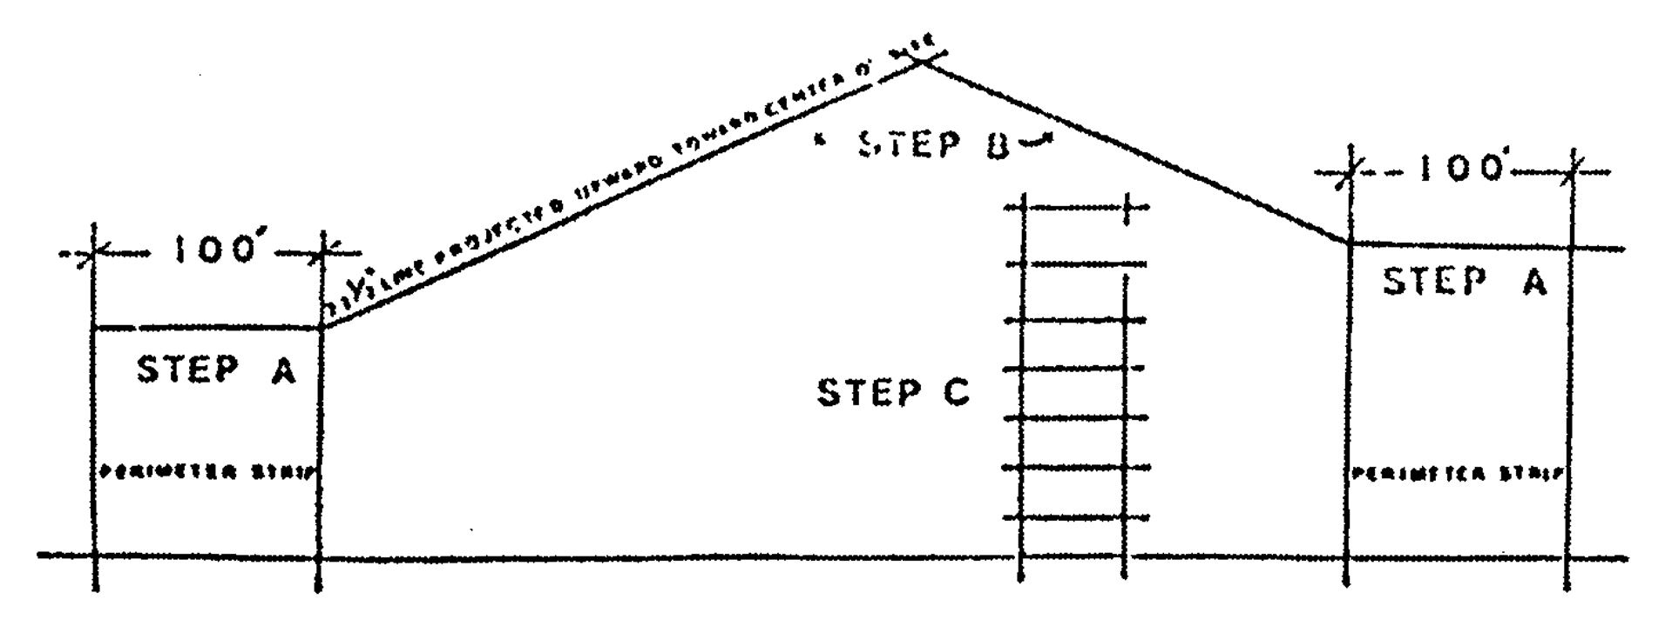

**Cross Section Sketch of Height Controls**

*Step A:* Height requirement(s) for one-hundred-foot perimeter strip is determined by adjacent zoning

*Step B:* Height requirement(s) interior to the perimeter strip is determined by a twenty-two-and- one-half-degree line projected upward toward center of the site

*Step C:* No structure shall exceed the height permitted by the most liberal on-site residential zoning district plus one (1) floor and plus additional height for unenclosed floors

(Ord. No. 73-28, § 2, 3-20-73; Ord. No. 74-41, § 1, 6-4-74; Ord. No. 78-39, § 11, 6-6-78; Ord. No. 96-127, § 25, 9-4-96)

Sec. 33-284.19. Perimeter setback.

For structures not exceeding thirty-five (35) feet in height, minimum setbacks from property lines shall be twenty-five (25) feet. For structures over thirty-five (35) feet in height, the setback shall be increased by forty (40) percent of the additional height.

(Ord. No. 73-28, § 2, 3-20-73)

Sec. 33-284.20. Convenience retail facilities.

Planned developments of three hundred (300) or more residential units that do not include BU Zoning shall be permitted to have food, drug, and personal service convenience retail service facilities not exceeding one thousand five hundred (1,500) square feet of gross retail floor area. An additional three (3.0) square feet of gross retail area shall be permitted for each residential unit above three hundred (300) units; provided, however, that the maximum square footage for such facilities does not exceed four thousand (4,000) square feet and provided that such services relate to the needs of the inhabitants of the proposed complex; such service facilities and identification signs for said service facilities are not visible from public roads; and such service facilities and signs are designed as an integral part of the total design as determined by site plan review.

Where an RU-4 or RU-4A District constitutes a part of the planned development, densities resulting from tracts zoned under either of these districts shall not be used in determining the amount of convenience retail facilities.

(Ord. No. 73-28, § 2, 3-20-73; Ord. No. 78-39, § 12, 6-6-78)

Sec. 33-284.21. Plan review procedure.

The application for a planned development shall be reviewed by the Department to determine its compliance with applicable regulations and review criteria contained herein. An instrument, suitable for recording, shall be submitted prior to the advertising of the public hearing, which covenants that development will occur substantially in accordance with plans approved at the public hearing.

The Community Zoning Appeals Board shall review the plans and documents, and may approve, approve with modifications, or disapprove the application.

If a Community Zoning Appeals Board incorporates specific modifications to the planned development in its resolution of approval, those modifications shall be made by the applicant prior to filing documents and plans with the Department. Such filing shall be completed within sixty (60) working days from date of a Community Zoning Appeals Board's action. Failure to do so shall nullify the Community Zoning Appeals Board's action unless waived by formal vote of the Community Zoning Appeals Board.

Subsequent to the public hearing, minor design modifications may be granted by approval of the Director, provided that such modifications do not result in an increase in the approved number of dwelling units or approved maximum commercial floor area and provided that the design modifications are in general agreement with the intent of this article.

*Required exhibits.* The following exhibits shall be prepared by design professionals such as architects and landscape architects and shall be filed with the application for a planned development:

(1) A plan indicating existing zoning on site and adjacent areas.

(2) Aerial photograph or map indicating site and development in the immediate area.

(3) A plan and cross section(s), at the same scale, of the height envelope.

(4) The use, height, bulk, dwelling unit per net acre and location of all buildings and other structures including specific locations for all commercial activities—models may be required when needed for adequate review.

(5) Aerial perspective sketches of the total project.

(6) Pedestrian and vehicular circulation systems.

(7) Landscape development plan in accordance with [Chapter 18A](../level2/PTIIICOOR_CH18AMIDECOLAOR.docx#PTIIICOOR_CH18AMIDECOLAOR) of this Code.

(8) The design for entrance features and the signage system.

(9) Parking layouts and drives.

(10) Figures indicating the following:

(a) Net density per acre for the total project and the total number of residential units, including hotel and motel units.

(b) The total amount of gross retail floor area or the total amount of gross convenience retail facilities as provided in [Section 33-284.20](../level3/PTIIICOOR_CH33ZO_ARTXXXIIIBPLDE.docx#PTIIICOOR_CH33ZO_ARTXXXIIIBPLDE_S33-284.20COREFA)

(c) Amount and percentage of common open space by categories provided in [Section 33-284.15.1](../level3/PTIIICOOR_CH33ZO_ARTXXXIIIBPLDE.docx#PTIIICOOR_CH33ZO_ARTXXXIIIBPLDE_S33-284.15.1COOPSPREDE)

(d) Amount and percentage of private open space as required in [Section 33-284.16](../level3/PTIIICOOR_CH33ZO_ARTXXXIIIBPLDE.docx#PTIIICOOR_CH33ZO_ARTXXXIIIBPLDE_S33-284.16PROPSP)

(e) Number of parking spaces as related to the amount of residential and commercial development.

(f) In addition, the methods used to determine the above figures shall be provided. Where practicable, such material shall be prepared in a table format.

(11) Other material required for an adequate plan review by the Department.

*Plan review standards.* The following criteria shall be utilized in the plan review process:

(1) Purpose and intent—The proposed development fulfills the purpose and intent of this article.

(2) Planning studies—Design or planning studies accepted or approved by the Board of County Commissioners that include development patterns or environmental design criteria which would apply to the development proposal under review shall be utilized in the plan review process.

(3) Exterior spatial relationships—The three-dimensional airspace created by the arrangement of the structures and landscape shall produce spatial relationships that function with the intended use and occupancy of the project and are compatible with the development or zoning in the adjoining area.

(4) Landscape—Landscape shall be preserved in its natural state insofar as is practicable by minimizing tree removal. Landscaping shall be used to shade and cool, direct wind movements, provide shade, enhance architectural features, relate structure design to the site, visually screen noncompatible uses and block noise generated by the major roadways and intense-use areas.

(5) Buffers—Buffering elements that provide a logical transition to adjoining existing or permitted uses shall be provided.

(6) Scale—Scale of proposed structures shall be compatible with surrounding proposed or existing uses or shall be made compatible by the use of buffering elements.

(7) Privacy—Due consideration of aural and visual privacy shall be evidenced in the design of the overall development and in the design of individual units.

(8) Building configuration—Access for emergency equipment to various parts of the building shall be considered in the design of the project. Buildings shall be arranged in a manner that allows sufficient light and air to penetrate the development. The elimination of the first floor of structures for purposes of improved ventilation at ground level shall be encouraged.

(9) Circulation—Pedestrian, bicycle trails and equestrian trails shall be separated from auto circulation insofar as is practicable and all circulation systems shall adequately serve the needs of the development and be compatible and functional in its relationship to circulation systems outside the development.

(10) Energy conservation—Design methods to reduce energy consumption shall be encouraged. Energy conservation methods may include, but not be limited to, natural ventilation of structures, siting of structures in relation to prevailing breezes and sun angles, insulation of structures, use of landscape material for shade, direction of breezes and transpiration.

(11) Subtropic characteristics—Subtropic characteristics of the area should be considered in the architectural design and site planning of the project. The provision of sun control devices, shaded areas, vegetation, roof terraces, and similar features characteristic of subtropical design shall be considered.

(12) Parking areas—Parking areas shall be provided that are screened and so located as not to interfere with the livability of the development, its environs, and adjacent properties.

(13) Service areas—Service areas shall be provided that are screened and so located as not to interfere with the livability of the development or adjacent properties.

(14) Building height—Building height shall be in scale with the development in surrounding areas. As a maximum, building heights shall not exceed the height limitations hereinabove established.

(15) Open space—A variety of open spaces shall be provided, appropriate to the needs of the particular type of development. Open space shall relate to any natural characteristics in such a way as to preserve and enhance their scenic and functional qualities to the fullest extent possible and shall be so located and developed as to be easily accessible to all residents of the development.

(16) Visual screening for decorative walls—In an effort to prevent graffiti vandalism, the following options shall be utilized for walls abutting zoned or dedicated rights-of-way:

(a) *Wall with landscaping.* The wall shall be setback two and one-half (2½) feet from the right-of-way line and the resulting setback area shall contain a continuous extensively landscaped buffer which must be maintained in a good healthy condition by the property owner, or where applicable, by the condominium, homeowners or similar association. The landscape buffer shall contain one (1) or more of the following planting materials:

(1) *Shrubs.* Shrubs shall be a minimum of three (3) feet in height when measured immediately after planting and shall be planted and maintained to form a continuous, unbroken, solid, visual screen within one (1) year after time of planting.

(2) *Hedges.* Hedges shall be a minimum of three (3) feet in height when measured immediately after planting and shall be planted and maintained to form a continuous, unbroken, solid, visual screen within one (1) year after time of planting.

(3) *Vines.* Climbing vines shall be a minimum of thirty-six (36) inches in height immediately after planting.

(b) *Metal picket fence.* Where a metal picket fence abutting a zoned or dedicated right-of-way is constructed in lieu of a decorative wall, landscaping shall not be required.

(Ord. No. 73-28, § 2, 3-20-73; Ord. No. 74-21, § 3, 4-3-74; Ord. No. 74-41, § 1, 6-4-74; Ord. No. 78-39, § 13, 6-6-78; Ord. No. 95-19, § 18, 2-7-95; Ord. No. 95-215, § 1, 12-5-95; Ord. No. 95-223, § 1, 12-5-95; Ord. No. 96-127, § 26, 9-4-96; Ord. No. 99-38, § 19, 4-27-99; Ord. No. 06-23, § 1, 2-21-06)

FOOTNOTE(S):

--- (**46**) ---

**Editor's note—** Ord. No. 73-28, § 2, adopted March 20, 1973, amended Ch. 33 by adding Art. XXXIIIB, §§ 33-284.10—33-284.21. (Back)

### ARTICLE XXXIIIC. GP, GOVERNMENTAL PROPERTY

Sec. 33-284.22. Uses permitted.

Sec. 33-284.23. Designation of property.

Sec. 33-284.22. Uses permitted.

(a) No land, body of water and/or structure shall be maintained, used or permitted to be used, and no structure shall be hereafter maintained, erected, constructed, moved, reconstructed or structurally altered or permitted to be erected, constructed, moved, reconstructed or structurally altered for any purpose in a GP District which is designed, arranged, or intended to be used or occupied for any purpose other than the following:

(1) Public parks, playgrounds and buildings, and structures supplementary and incidental to such uses;

(2) Fire stations;

(3) Police stations;

(4) Public auto inspection stations;

(5) Public water and sewer treatment and distribution facilities;

(6) Public libraries;

(7) Public buildings and centers;

(8) Public hospitals, nursing homes and health facilities;

(9) Public auditoriums, arenas, museums, art galleries;

(10) Maximum and minimum detention facilities;

(11) Solid waste collection and disposal facilities;

(12) Public maintenance and equipment yards;

(13) Public bus stations and rapid transit stations and facilities;

(14) Public airports, including those particular uses allowed under the applicable airport zoning regulations;

(15) And other similar governmental uses.

(Ord. No. 76-36, § 1, 4-20-76; Ord. No. 99-164, § 1, 12-7-99; Ord. No. 06-20, § 1, 2-7-06)

Sec. 33-284.23. Designation of property.

All governmental property in the unincorporated area of Miami-Dade County heretofore and hereafter purchased and/or designated for a governmental use shall be so noted in the public records and maps of the Department. If a specific governmental use or uses has or have been designated pursuant to [Section 33-303](../level3/PTIIICOOR_CH33ZO_ARTXXXVIZOPR.docx#PTIIICOOR_CH33ZO_ARTXXXVIZOPR_S33-303EXPR) of the Code for a particular property, the public records and maps of the Department shall so reflect said designation(s). All land subject to the permitted uses enumerated in [Section 33-284.22](../level3/PTIIICOOR_CH33ZO_ARTXXXIIICGPGOPR.docx#PTIIICOOR_CH33ZO_ARTXXXIIICGPGOPR_S33-284.22USPE)(a) and owned in fee simple by a governmental entity shall be designated as governmental property. The designation GP shall be deemed an overlay zoning district and shall be in addition to any other zoning district by which the property is designated. If applicable, a GP District shall automatically revert to its other district classification if the property is no longer utilized as provided in [Section 33-284.22](../level3/PTIIICOOR_CH33ZO_ARTXXXIIICGPGOPR.docx#PTIIICOOR_CH33ZO_ARTXXXIIICGPGOPR_S33-284.22USPE)(a) of the Code.

(Ord. No. 76-36, § 1, 4-20-76; Ord. No. 77-24, § 1, 4-19-77; Ord. No. 95-215, § 1, 12-5-95)

### ARTICLE XXXIIID. PLANNED AREA DEVELOPMENT DISTRICT (PAD) [47]

Sec. 33-284.24. Purpose and intent.

Sec. 33-284.25. Ownership requirements.

Sec. 33-284.26. Review procedures.

Sec. 33-284.27. Development parameters.

Sec. 33-284.28. Fees.

Sec. 33-284.24. Purpose and intent.

The purpose and intent of the Planned Area Development District, is to create living environments that are responsive to the needs of their inhabitants; to provide flexibility in planning, design and development; to encourage innovative approaches to the design of community environments; to encourage the fulfillment of housing needs appropriate to various life styles and income levels; to encourage the integration of different housing types within a development; to provide for necessary commercial, recreational and educational facilities conveniently located in relation to housing; to provide for an efficient use of land; to provide an environment compatible with surrounding land use; to adapt the zoning process to changes in construction and development technology; to encourage the preservation of the natural site features; to provide community environments that are so designed and located as to be an integral part of the total ecosystem; to encourage the design of communities and structures adapted to the local subtropical climate; thereby promoting the public health, safety, and general welfare of Miami-Dade County.

(Ord. No. 76-106, § 1(1), 12-7-76; Ord. No. 98-7, § 1, 1-13-98)

Sec. 33-284.25. Ownership requirements.

An applicant(s) for approval of a planned area development shall be owner(s) of record, or a lessee with the sworn-to consent of the owner(s).

(Ord. No. 76-106, § 1(2), 12-7-76)

Sec. 33-284.26. Review procedures.

The planned area development review procedures are divided into four (4) steps: (A) Preapplication conference; (B) total development plan review; (C) development tract review; and (D) review criteria.

(A) *Preapplication conference.*

To obtain information each applicant shall confer with the Department, other affected interested department heads, and where applicable, representatives of adjacent municipalities, in connection with the preparation of the planned area development application. It shall be the responsibility of the Department to coordinate and invite department heads, municipalities or their representatives to a joint meeting. The general outlines of the proposal evidenced schematically by sketch plans and including narrative information sufficient for the understanding of the proposed development shall be provided by the applicant for consideration at said joint meeting, before submission of the zoning application for Planned Area District boundary change. Thereafter and within ten (10) working days after the preapplication conference, the Director shall furnish the applicant with all written comments resulting from such conference including appropriate recommendations to inform and assist the applicant in his preparation of the components of the planned area development application.

(B) *Total development plan review.*

Following the preapplication conference the total development plan reviews shall be initiated by the applicant. Required exhibits listed below and a completed development impact statement if required by [Chapter 33](../level2/PTIIICOOR_CH33ZO.docx#PTIIICOOR_CH33ZO) of the Miami-Dade County Code, together with an application for public hearing as required by [Chapter 33](../level2/PTIIICOOR_CH33ZO.docx#PTIIICOOR_CH33ZO) of the Miami-Dade County Code, shall be submitted to the Department.

(1) Required exhibits—Written documents. The following written documents shall be submitted as part of the planned area development zoning application:

(a) Recordable agreement guaranteeing the development in accordance with promises made in the written and graphic documents listed below as approved by the Community Zoning Appeals Board. Said agreement shall be submitted to the Department after the Development Impact Committee review and prior to the Community Zoning Appeals Board review.

(b) A completed development impact statement, if required in [Chapter 33](../level2/PTIIICOOR_CH33ZO.docx#PTIIICOOR_CH33ZO) of the Miami-Dade County Code.

(c) A development schedule indicating the approximate date(s) when construction of the planned area development and stages thereof can be expected to be initiated.

(d) Quantitative data for the following: Total number of dwelling units; total number of bedrooms; size of total development proposed land coverage of buildings and structures; acres of common open space; gross and net residential densities; total amount of open space; total amount of nonresidential construction, amount of public and private roads, and population projections.

(e) Tentative agreements with appropriate governmental agencies for the proposed dedication of land for public uses prior to public hearing.

(2) Required exhibits—Graphic documents. Maps, site plans and drawings of the proposed planned area development shall be submitted as part of the total development plan and shall contain the following minimum information:

(a) The existing site characteristics including any major variations of elevations, water course(s), unique natural features, and natural vegetation.

(b) Legal description and size of developmental tracts (see [Section 33-284.27](../level3/PTIIICOOR_CH33ZO_ARTXXXIIIDPLARDEDIPA.docx#PTIIICOOR_CH33ZO_ARTXXXIIIDPLARDEDIPA_S33-284.27DEPA)(B) for details of developmental tracts).

(c) The location of all major land uses with densities and/or floor area of such uses including structure heights, with drawings indicating basic development concepts of the proposed development.

(d) The location and size in acres or square feet of all areas to be conveyed, dedicated, or reserved as common open spaces, public facility space, common recreational areas, school sites, and similar public and semipublic uses.

(e) The existing and proposed circulation system of arterial and collector streets, and major points of access to public rights-of-way including major points of ingress and egress to the development. Notations of proposed ownership of roadways—public or private—should be included where appropriate.

(f) The existing and proposed pedestrian, equestrian and bicycle circulation systems including interrelationships with the vehicular circulation system, indicating proposed treatment of points of conflicts.

(g) A schematic landscape plan in accordance with [Chapter 18](../level2/PTIIICOOR_CH18IMSPRPDI.docx#PTIIICOOR_CH18IMSPRPDI) A of this Code, indicating the proposed design of major landscape elements. Plant names and sizes of tree masses shall be provided.

(h) Adequate information on land areas adjacent to the proposed planned area development to indicate the relationships between the proposed development and adjacent areas, including existing land uses, zoning classifications, densities, vehicular, pedestrian and equestrian circulation systems and public facilities, as well as unique natural features of the landscape.

(i) The proposed treatment of the perimeter of the planned area development including materials and techniques to be used such as screens, landscape buffer, fences, walls and berms when appropriate.

(j) Any additional information required by the review authority necessary to evaluate the character and impact of the proposed planned area development.

(3) Review process. The review of the total development plan of a planned area development shall be by the Developmental Impact Committee, and review and action by the Community Zoning Appeals Board shall be in accord with [Section 33-304](../level3/PTIIICOOR_CH33ZO_ARTXXXVIZOPR.docx#PTIIICOOR_CH33ZO_ARTXXXVIZOPR_S33-304AP)(f) of the Miami-Dade County Code.

(C) *Development tract review.*

Following approval of the total development plan by the Community Zoning Appeals Board, review at the development tract level may be initiated.

(1) Required exhibits. The following exhibits shall be prepared by Florida registered landscape architects, architects and engineers and shall accompany the development tract review application to be filed with the Department:

(a) A plan indicating existing zoning on site and adjacent areas.

(b) Aerial photograph or map indicating site and development in the immediate area.

(c) Site plan at no less than one (1) inch to fifty (50) feet which shall include the following information:

1. Location, shape, size and height of existing and proposed buildings, fences and walls.

2. Pedestrian, equestrian and vehicular circulation systems.

3. Parking layouts and drives.

4. Landscaping in accordance with [Chapter 18A](../level2/PTIIICOOR_CH18AMIDECOLAOR.docx#PTIIICOOR_CH18AMIDECOLAOR) of this Code.

5. Major changes in grades.

6. Building setbacks and spacing.

7. A legend including the following applicable information shall be provided as part of the site plan in accordance with the following format:

|  |  |  |  |
| --- | --- | --- | --- |
| Total gross acreage | ____________ | Acres | 100% |
| Coverage building at ground level | ____________ | Acres | ____________ |
| Private roads and parking areas | ____________ | Acres | ____________ |
| Common open space | ____________ | Acres | ____________ |
| Private open space | ____________ | Acres | ____________ |
| Water bodies | ____________ | Acres | ____________ |
| Public facilities | ____________ | Acres | ____________ |
| Public roads | ____________ | Acres | ____________ |

8. The following information shall be provided on the site plan or in a separate document:

Amount of pervious and impervious surfaces.

Maximum density of development tract approved at public hearing.

Density as proposed.

Total dwelling units.

Table of dwelling unit mix.

Total number of bedrooms.

Total number of building types including accessory buildings.

Table of buildings by heights, stories, unit types, and square footage.

Name of water utility.

Name of sewer utility.

Required private open space.

Provided minimum and average private open space.

Table of parking spaces required and provided.

Acreage dedicated for public and semipublic facilities.

Survey of existing trees.

Total trees required and provided in accordance with [Chapter 18A](../level2/PTIIICOOR_CH18AMIDECOLAOR.docx#PTIIICOOR_CH18AMIDECOLAOR) of this Code.

Any supplementary data needed to adequately review the proposed development.

(d) Floor plans, elevations, sections, when appropriate, and either isometrics or perspectives for the different proposed buildings at no less than one (1) inch equals sixteen (16) feet which shall include the following information:

1. Location, shape, size and heights of enclosed and unenclosed spaces within the proposed buildings.

2. Horizontal and vertical circulation systems of the proposed buildings.

3. Design of the outdoor surfaces of the proposed buildings.

(2) Review process. Prior to the development of a development tract (see [Section 33-284.27](../level3/PTIIICOOR_CH33ZO_ARTXXXIIIDPLARDEDIPA.docx#PTIIICOOR_CH33ZO_ARTXXXIIIDPLARDEDIPA_S33-284.27DEPA)(B)) or prior to the sale, transfer or lease of any portion of a development tract, a development tract plan shall be prepared, submitted to, and approved by the Department for review and approval in accordance with review criteria, [Section 33-284.26](../level3/PTIIICOOR_CH33ZO_ARTXXXIIIDPLARDEDIPA.docx#PTIIICOOR_CH33ZO_ARTXXXIIIDPLARDEDIPA_S33-284.26REPR)(D), and development plan(s) approved by the Community Zoning Appeals Board. Said development tract plan is a detailed refinement of information provided in the approved total development plan. If the planned area development involves only one (1) development tract the same procedure shall be followed.

Upon approval of a development tract plan, a copy of said approved plan and statement of approval shall be forwarded to the applicant and to the Department for filing in the planned area development file for the particular project.

If requested approval is denied, the proposed project may be appealed to the Community Zoning Appeals Board, in accordance with regulations as provided in [Chapter 33](../level2/PTIIICOOR_CH33ZO.docx#PTIIICOOR_CH33ZO) governing appeals from administrative decisions contained in the Code of Miami-Dade County.

(D) *Review criteria.*

The following criteria shall be utilized as a basis for the review of the total development plan and the development tract plans:

(1) Purpose and intent. The proposed development shall fulfill the purpose and intent of this article.

(2) Planning studies. Design, planning or development studies accepted or approved by the Board of County Commissioners that include development patterns or environmental design criteria which would apply to the development proposal under review shall be utilized in the site plan review process.

(3) Exterior spatial relationships. The three-dimensional airspace volume created by the arrangement of structures and landscape shall produce spatial relationships that function with the intended use and occupancy of the project and are compatible with the development or zoning in the adjoining area. Building height shall reflect a scale compatible with the development or zoning in the adjoining area. Elements that provide a logical transition to adjoining existing or permitted uses shall be provided. Spacing between buildings shall provide ample access for emergency equipment.

(4) Subtropical characteristics. Architecture and site development should incorporate consideration of the subtropical characteristics of the area. The provision of sun-control devices, shaded areas, vegetation, roof terraces and similar features characteristic of subtropical design shall be encouraged.

(5) Energy conservation. Design methods to reduce energy consumption shall be encouraged. Energy conservation methods may include but not be limited to natural ventilation of structures, siting of structures in relation to prevailing breezes and sun angles, insulation of structures, use of landscape material for shade, direction of breezes and transpiration.

(6) Privacy. Due consideration of aural and visual privacy shall be evidenced in the design of the overall development and in the design of individual units.

(7) Open space. A variety of open spaces shall be provided, appropriate to the needs of the particular type of development. Open space shall relate to any natural characteristics in such a way as to preserve and enhance their scenic and functional qualities to the fullest extent possible and shall be so located and developed as to be easily accessible to all residents of the development.

(8) Landscape. The landscape shall be preserved in its natural state insofar as is practicable by minimizing tree removal. Landscaping shall be used to shade and cool, direct wind movements, provide scale, enhance architectural features, relate structure design to the site, visually screen noncompatible uses and block noise generated by the major roadways and intense use areas.

(9) Location of public and semipublic uses. All public uses and semipublic uses such as churches, schools, day care centers, post offices, and other similar facilities shall be so located as to provide easy access by residents of the proposed development.

(10) Circulation. Pedestrian, bicycle trails and equestrian trails shall be separated from auto circulation insofar as is practicable and all circulation systems shall adequately serve the needs of the development and be compatible and functional in its relationship to circulation systems outside the development.

(11) Parking areas. Parking areas shall be provided that are screened and so located as not to interfere with the livability of the development, its environs, and adjacent properties. Parking areas shall be conveniently located for occupants of the residential structures.

(12) Service areas. Service areas shall be provided that are screened and so located as not to interfere with the livability of the development or adjacent properties.

(13) Visual screening for decorative walls. In an effort to prevent graffiti vandalism, the following options shall be utilized for walls abutting zoned or dedicated rights-of-way:

(a) *Wall with landscaping.* The wall shall be setback two and one-half (2½) feet from the right-of-way line and the resulting setback area shall contain a continuous extensively landscaped buffer which must be maintained in a good healthy condition by the property owner, or where applicable, by the condominium, homeowners or similar association. The landscape buffer shall contain one (1) or more of the following planting materials:

(1) *Shrubs.* Shrubs shall be a minimum of three (3) feet in height when measured immediately after planting and shall be planted and maintained to form a continuous, unbroken, solid, visual screen within one (1) year after time of planting.

(2) *Hedges.* Hedges shall be a minimum of three (3) feet in height when measured immediately after planting and shall be planted and maintained to form a continuous, unbroken, solid, visual screen within one (1) year after time of planting.

(3) *Vines.* Climbing vines shall be a minimum of thirty-six (36) inches in height immediately after planting.

(b) *Metal picket fence.* Where a metal picket fence abutting a zoned or dedicated right-of-way is constructed in lieu of a decorative wall, landscaping shall not be required.

(Ord. No. 76-106, § 1(3), 12-7-76; Ord. No. 78-2, § 1, 1-3-78; Ord. No. 84-28, § 1, 4-3-84; Ord. No. 95-19, § 19, 2-7-95; Ord. No. 95-215, § 1, 12-5-95; Ord. No. 95-223, § 1, 12-5-95; Ord. No. 96-127, § 27, 9-4-96; Ord. No. 99-38, § 20, 4-27-99)

Sec. 33-284.27. Development parameters.

All applications for the Planned Area District shall comply with the following applicable development parameters:

(A) *Size of development site.*

The minimum size of the site to be developed as a Planned Area Development shall be five (5) acres.

(B) *Development tracts.*

Proposed development shall be structured into separate geographical units termed development tracts. The tract shall be subject to unity of title and be so designed as to constitute a self-sufficient unit. The unity of title shall continue on record unless the plat includes individual lot development which was approved as such in the total development plan, in which case that part may be released from the unity of title upon final plat approval by the County Commission. The tract shall be buildable in one (1) phase, having common open space, a road system and a sufficient identity of its own in the event the overall project is not completed.

The scheduling capabilities of the developer should relate to the size and delineation of the proposed development tract. In the design of the development tract, consideration shall be given to factors such as natural characteristics of the site, the major road patterns, the location of retail commercial facilities, water bodies, public facilities, common open space, the phasing of the development and other factors which provide definition for development tracts.

At any time after a Planned Area Development District boundary change is approved at final hearing, any tract so approved may be subdivided in accordance with the subdivision ordinances of Miami-Dade County without any prior public hearing before the Community Zoning Appeals Board, providing that the new tract or tracts so created shall meet all of the provisions of this article, all existing agreements of record, and the written approval of the Department.

The foregoing is not intended to preclude phased condominium development as contemplated by Section 718.403 of the Florida Statutes 1979.

(C) *Permitted residential uses.*

All residential types, including single-family, and multi-family, and workforce housing units in compliance with the provisions of this section and Article XIIA of this code, whether detached, attached or any combination thereof, shall be permissible in the Planned Area Development zoning classification upon approval by the Community Zoning Appeals Board.

(D) *Maximum permitted density.*

Maximum permitted densities, in terms of number of units per gross residential acre and total number of dwelling units and bedrooms, shall be established for each development tract at the time of approval of the development plan by the Community Zoning Appeals Board. All uses and land areas devoted thereto approved under the other use provision, [Section 33-284.27](../level3/PTIIICOOR_CH33ZO_ARTXXXIIIDPLARDEDIPA.docx#PTIIICOOR_CH33ZO_ARTXXXIIIDPLARDEDIPA_S33-284.27DEPA)(H), shall be excluded in the computation of the overall residential density. Said number of dwelling units and densities shall be in conformance with the Comprehensive Development Master Plan (Ordinance No. 75-22, as amended from time to time), neighborhood planning studies and existing zoning and development in adjacent and in immediate areas shall be considered in the establishment of the maximum density for the Planned Area Development District. The information provided in the development impact statement shall be considered in the establishment of densities.

Maximum permitted densities within a development tract shall be increased up to a maximum of fifteen (15) percent for each development tract that incorporates an equivalent percentage of government subsidized low- and/or moderate-income housing, as defined in the Housing and Community Development Act of 1974.

(E) *Accessory uses.*

Accessory uses which are designed in a manner compatible with the planned area development and relate to the common needs of its inhabitants shall be permitted. Accessory uses shall include but not be limited to parking garages, recreation buildings, swimming pools, play fields, utility or maintenance buildings and other similar uses.

(F) *Convenience retail service facilities.*

Convenience retail service facilities as permitted in the BU-1 Neighborhood Business District shall be permitted on the basis of the following standards:

(1) Three (3) square feet of interior convenience retail floor area per dwelling unit shall be permitted.

(2) Such services shall be designed as an integral part of the total development and conveniently located for the use of the residents of the proposed development.

(3) Such facilities shall not be constructed prior to initiation of construction of the residential units which justify the need for such retail facilities.

(4) Such services are not visible from public roads, detached signs and signs visible from public roads are not permitted.

(G) *Public facilities.*

If dedicated by the developer, land for public facilities shall be appropriately located in terms of projected user needs. Said public facility space shall not be considered in meeting common open space requirements.

(H) *Other uses with PAD application.*

Other zoning districts not previously listed as permitted uses in this article but related to the needs of the inhabitants of a proposed development or to Countywide needs shall be permitted if approved under the provisions of this article. Such other uses shall be included as separate development tracts on the basis of the zoning districts in which they are permitted and shall comply with all requirements of the applicable zoning districts, as well as all applicable requirements for development tracts. Deviations from required setback regulations need not be in conformity with the provisions of [Chapter 33](../level2/PTIIICOOR_CH33ZO.docx#PTIIICOOR_CH33ZO) of the Code of Miami-Dade County. Separate requests for zoning districts shall be made at the time of the PAD application and shall be deemed an integral part of said application.

Other uses that are permitted only by the special exception, new use or unusual use procedure under the zoning regulations are permitted in a development tract, subject to the required Community Zoning Appeals Board approval. In all instances the development tracts in which such other uses are located shall comply with all applicable requirements for development tracts and shall be filed with the application for the Planned Area Development District. No separate request or application for special exceptions or unusual uses shall be required so long as they are clearly noted on the development plan.

(I) *Common open space.*

Open space for the common benefit of the residents of the proposed development shall be provided in accordance with the requirements in the following table:

|  |  |
| --- | --- |
| Dwelling Units per Residential Net Acre | Percentage of the Development Tract, Site Area to be Developed to Common Open Space |
| Up to 10 | 30% |
| 11—20 | 33% |
| 21—30 | 35% |
| [31](../level2/PTIIICOOR_CH31VEHI.docx#PTIIICOOR_CH31VEHI)—40 | 38% |
| 41 or more | 40% |

Areas to be credited toward the common open space requirements may include the following:

(1) Landscaped ground areas maintained with grass, trees and shrubbery, and unencumbered with any structure or off-street parking or private drives including those on roof decks and other above-grade surfaces.

(2) Entrance features, pedestrian walks and sitting areas, shuffle boards, swimming pools, tennis courts, accessory buildings related to active or passive recreational uses and other passive or active uses including golf courses, which shall be restricted for said use.

(3) Tree preservation zones of "natural forest communities" as defined in Section 24B-1, Code of Miami-Dade County.

(4) Water bodies, but such water areas shall not be credited for more than 50 percent of the required common open space.

(5) Land for perimeter walls, buffers, fences and berms shall be considered part of the common open space.

The following criteria shall apply to the provisions of common open space:

(a) Recreational use or uses appropriate for the use of the projected future residents of the proposed development shall be provided.

(b) Common open space shall be so located and developed as to be accessible to residents of the development.

(c) Common open space shall relate to any natural site characteristics in such a way as to preserve and enhance both their functional and scenic qualities to the fullest extent.

(d) Improvements to common open space areas in accordance with the development tract plan shall be coordinated with and shall keep pace with the construction of dwelling units.

(J) *Conveyance and maintenance of common open space.*

All land designated on approved plans as common open space will be conveyed under one (1) of the following procedures:

(1) For those projects developed under a condominium arrangement, common open space shall be maintained under the applicable Florida State law.

(2) The common open space may be conveyed to a homeowners' association in which case conveyance shall be subject to covenants to be approved by the County restricting the open space to uses specified in the final plan and providing for the maintenance of the common open space in a manner that assures its continuing use for its intended purpose provided that:

(a) Approval by the Miami-Dade County Attorney's Office shall be required.

(b) A homeowners' association shall be established before the units or individual building lots are sold.

(c) Membership shall be mandatory for each resident and said association shall have the authority to adjust the assessment to meet the needs of maintaining the open space.

(d) Any sums levied by the homeowners' association that remain unpaid shall become a lien on the individual property and said lien shall be superior to all other liens save and except tax liens and mortgage liens, provided said mortgage liens are first liens against the property encumbered thereby, subject only to tax liens and secure indebtedness which are amortized in monthly or quarter annual payments over a period of not less than ten (10) years.

(e) The homeowners' association shall be responsible for maintenance and local taxes.

(K) *Private open space.*

Private open space is required for each single-family attached or detached unit that has direct ground floor access. Said space shall be for the exclusive recreational or leisure use of the inhabitants of the dwelling unit, and shall be located immediately adjacent to the unit, and designed in such a way as to provide privacy from adjacent dwelling units. Said private open space shall be in addition to the common open space required and the amount of such space shall be equivalent to sixty (60) percent of the interior gross floor area of each attached unit and equivalent to one hundred twenty-five (125) percent of the interior gross floor area of each detached unit. Provisions shall be made in the sale or rental of such units that such private open space is for the exclusive use of the unit concerned.

(L) *Trees.*

Landscaping and trees shall be provided in accordance with [Chapter 18A](../level2/PTIIICOOR_CH18AMIDECOLAOR.docx#PTIIICOOR_CH18AMIDECOLAOR) of this Code.

(M) *Parking.*

All required parking shall comply with [Chapter 33](../level2/PTIIICOOR_CH33ZO.docx#PTIIICOOR_CH33ZO), Article VII, Off-Street Parking, [Section 33-124](../level3/PTIIICOOR_CH33ZO_ARTVIIOREPA.docx#PTIIICOOR_CH33ZO_ARTVIIOREPA_S33-124ST), Miami-Dade County Code.

(N) *Minimum square footage.*

The minimum square footage for a single-family attached or detached unit that has direct ground floor access shall be eight hundred fifty (850) square feet. Multifamily residential units shall have a minimum square footage of four hundred (400) square feet for efficiencies, five hundred fifty (550) square feet for one (1) bedroom units with an additional one hundred (100) square feet for each additional bedroom.

(Ord. No. 76-106, § 1(4), 12-7-76; Ord. No. 81-90, § 1, 7-21-81; Ord. No. 95-215, § 1, 12-5-95; Ord. No. 95-223, § 1, 12-5-95; Ord. No. 96-127, § 27, 9-4-96; Ord. No. 98-7, § 2, 1-13-98; Ord. No. 02-149, § 1, 9-12-02; Ord. No. 07-05, § 18, 1-25-07; Ord. No. 08-51, § 1, 5-6-08)

Sec. 33-284.28. Fees.

An application fee for development tract review shall be paid to the Department in accordance with a schedule adopted pursuant to [Section 33-285](../level3/PTIIICOOR_CH33ZO_ARTXXXIVFE.docx#PTIIICOOR_CH33ZO_ARTXXXIVFE_S33-285SCFE).

(Ord. No. 76-106, § 1(15), 12-7-76; Ord. No. 90-137, § 1, 12-4-90; Ord. No. 95-215, § 1, 12-5-95)

FOOTNOTE(S):

--- (**47**) ---

**Editor's note—** Article XXXIIID, §§ 33-284.24—33-284.28, is derived from Ord. No. 76-106, § 1, enacted Dec. 7, 1976. (Back)

### ARTICLE XXXIIIE. OFFICE PARK DISTRICT (OPD) [48]

Sec. 33-284.29. Legislative purposes.

Sec. 33-284.30. Uses permitted.

Sec. 33-284.31. Unity of ownership.

Sec. 33-284.32. Minimum site size and frontage requirements.

Sec. 33-284.33. Floor area ratio.

Sec. 33-284.34. Height.

Sec. 33-284.35. Landscaped open space; trees; landscape maintenance.

Sec. 33-284.36. Setbacks.

Sec. 33-284.37. Parking.

Sec. 33-284.38. Site plan review.

Sec. 33-284.39. Reserved.

Sec. 33-284.40. Reserved.

Sec. 33-284.29. Legislative purposes.

The Office Park District (OPD) incorporates a concept which delineates an open space character for buildings whose principal uses are administrative, professional or research. The major objectives to be achieved by this district are to provide office complexes in an open space environment, to provide freedom for the designer to take a creative approach to the development of an office park and thereby to enhance the visual quality of Miami-Dade County, to encourage developers to seek professional design expertise in the design of office parks, to promote the use of energy saving techniques, to provide a variety of office uses with associated service facilities, and to encourage the efficient use of land with reduction of street and utility networks.

(Ord. No. 77-64, § 1, 9-20-77)

Sec. 33-284.30. Uses permitted.

(A) No land, body of water and/or structures shall be used or permitted to be used, and no structure shall be hereafter erected, constructed, moved, reconstructed, or structurally altered or maintained in any OPD District, which is designed, arranged or intended to be used or occupied for any purpose, unless otherwise herein provided, excepting for one (1) or more of the following uses:

(1) *Principal uses.* Principal uses are those permitted uses that will form the major use concentration within the office park complex and include the following:

(a) Office buildings for business, professional and secretarial uses that cater to the provision of services. Retail and industrial activities are not permitted as principal uses.

(b) Laboratories for scientific and industrial research and development, including the use of scientific laboratory equipment and devices, shall be permitted. Assembly of precision instruments requiring a clinical environment in conjunction with scientific and medical research and development is also permitted upon approval of the Director. Any dust, fumes, gases, noises, odors and vibrations resulting from industrial or scientific research shall be completely contained within an enclosed building. It shall be the applicant's responsibility to provide sufficient data demonstrating that all potential impacts as listed above are so contained.

(c) Commuter colleges/universities.

(2) *Accessory uses.* Accessory uses are those uses that are associated with the principal use(s) and which provide service primarily to employees and patrons of the office park. The accumulative total of all accessory uses shall be limited to a maximum of fifteen (15) percent of the total gross interior square footage of the buildings proposed for the site. Such uses shall have no outside advertising. Areas devoted to structure parking shall not be included in the above calculations. Service facilities shall constitute the following:

(a) Auditorium(s).

(b) Eating establishments such as a cafeteria, coffee shop, food carry-out, restaurant and sandwich shop. Liquor, beer and wine, if associated with normal restaurant operation, shall be permitted under the terms specified in the BU-1 District. Drive-in facilities are prohibited.

(c) Office and stationery supplies.

(d) Personal services such as:

(i) Banks and savings and loans;

(ii) Barbershop;

(iii) Beauty shop;

(iv) Chapel;

(v) Day care center, nursery and kindergarten, subject to compliance with the requirements of sections [33-151.11](../level3/PTIIICOOR_CH33ZO_ARTXAEDCHCAFANO.docx#PTIIICOOR_CH33ZO_ARTXAEDCHCAFANO_S33-151.11APDE) through [33-151.22](../level3/PTIIICOOR_CH33ZO_ARTXAEDCHCAFANO.docx#PTIIICOOR_CH33ZO_ARTXAEDCHCAFANO_S33-151.22EN) of this code;

(vi) Dry cleaning and laundry (pickup only, no cleaning or washing on premises);

(vii) Newsstands;

(viii) Shoe repair shop and shoeshine parlor;

(ix) Tobacco shops;

(x) Adult day care center.

(e) Pharmacies restricted to the preparation and sale of drugs and medicines and other pharmaceutical supplies.

(f) Print shops.

(g) Private clubs.

(h) Recreational facilities within enclosed structures:

(i) Court games;

(ii) Putting greens;

(iii) Saunas;

(iv) Swimming pool.

(i) Other similar uses as approved by the Director, provided such uses are primarily accessory uses to the principal office park use(s).

(B) All uses shall be within enclosed building(s) except for approved passive and active recreational uses.

(Ord. No. 77-64, § 1, 9-20-77; Ord. No. 95-215, § 1, 12-5-95; Ord. No. 02-46, § 8, 4-9-02; Ord. No. 09-102, § 6, 11-17-09; Ord. No. 11-04, § 8, 2-1-11)

Sec. 33-284.31. Unity of ownership.

In order to preserve the integrity of the plan and ensure its execution, the Office Park District shall be maintained under one (1) ownership or so designed and planned that it can logically be developed in sections or units, each complying independently with all district regulations.

A unity of title agreement, suitable for recording, shall be submitted to and meet with the approval of the Director at the time of the filing of the application for rezoning, unless the application is filed in the name of the Director, in which case the agreement shall be submitted with the application for permit. In those cases where the project is designed and planned to be developed in sections, the agreement shall permit the severance of the property into sections or units providing that the sections or units are placed under a unity of ownership and further provided that the section or unit complies with minimum lot width and area requirements.

(Ord. No. 77-64, § 1, 9-20-77; Ord. No. 95-215, § 1, 12-5-95)

Sec. 33-284.32. Minimum site size and frontage requirements.

The minimum frontage requirements shall be one hundred (100) feet, with a minimum lot area of three (3) net acres including right-of-way dedications.

(Ord. No. 77-64, § 1, 9-20-77)

Sec. 33-284.33. Floor area ratio.

The floor area ratio shall be thirty one-hundredths (0.30) at one (1) story and shall be increased by eight one-hundredths (0.08) for each additional story. Structure parking shall not count as part of the floor area, but shall be counted in computing building height and number of stories.

(Ord. No. 77-64, § 1, 9-20-77)

Sec. 33-284.34. Height.

The maximum permitted height for any structure shall be eight (8) stories or one hundred (100) feet above finished grade, whichever is less.

(Ord. No. 77-64, § 1, 9-20-77)

Sec. 33-284.35. Landscaped open space; trees; landscape maintenance.

(A) [*Landscaped open space.*] Landscaped open space, unencumbered with any structure or off-street parking, ingress or egress drives or private drives, shall be provided in accordance with the requirements herein established. Areas to be credited toward the landscaped open space requirements are categorized as follows:

(1) Not less than eighty (80) percent of the required landscaped open space shall be provided at ground level, outside of any structure and such area shall be well maintained with grass, trees and shrubbery, and may include water bodies which are completely enclosed within the office park development, provided, however, that such water areas shall not exceed fifty (50) percent of the required landscaped open space. Entrance features, passive recreational uses, pedestrian walks, permanent outdoor art displays, sitting areas and putting greens may also be included in the required landscaped open space.

(2) Specific areas within the enclosed or nonenclosed malls which are landscaped with grass, trees and/or shrubbery, water areas therein, and areas therein with permanent art displays.

(3) Roof decks and other above-grade surfaces.

The minimum landscaped open space shall be in accordance with the following:

|  |  |
| --- | --- |
| Net Acreage | Minimum Percentage |
| Up to 10.0 | 25% |
| 10.1 to 20.0 | 30% |
| 20.1 to 30.0 | 35% |
| Above 30 | 40% |

The minimum landscaped open space shall be increased by three (3) percent for each additional story or part thereof above two (2) stories, based on the tallest structure on the property. Each parking level within the structure shall be calculated as one story.

(B) *Trees.* Landscaping and trees shall be provided in accordance with [Chapter 18A](../level2/PTIIICOOR_CH18AMIDECOLAOR.docx#PTIIICOOR_CH18AMIDECOLAOR) of this Code.

(C) *Landscape maintenance.* Sprinkler systems shall be provided that are adequately sized to provide water for landscaped areas. All plant material shall be maintained in a healthy condition.

(Ord. No. 77-64, § 1, 9-20-77; Ord. No. 95-223, § 1, 12-5-95; Ord. No. 03-130, § 1, 6-3-03)

Sec. 33-284.36. Setbacks.

All structures shall be setback a minimum of thirty (30) feet from property lines abutting any residential zoning districts in which only single-family, duplex or townhouse uses are permitted. Setbacks from front street property lines shall be a minimum of fifty (50) feet for structures and twenty-five (25) feet for paved parking areas. All other setbacks shall not be less than fifteen (15) feet.

(Ord. No. 77-64, § 1, 9-20-77)

Sec. 33-284.37. Parking.

Parking shall meet the applicable requirements provided elsewhere in the Miami-Dade County Zoning Code.

(Ord. No. 77-64, § 1, 9-20-77)

Sec. 33-284.38. Site plan review.

(A) [*Generally.*] The Department shall review plans for compliance with zoning regulations and for compliance with the site plan review criteria. The purpose of the site plan review is to encourage logic, imagination, innovation and variety in the design process and ensure the congruity of the proposed development and its compatibility with the surrounding area. If plan(s) are denied, the applicant may appeal to the appropriate Community Zoning Appeals Board for action.

(B) *Required exhibits.* The following exhibits shall be prepared by design professionals such as architects and landscape architects and submitted to the Department of Planning and Zoning:

(1) The overall site plan shall indicate existing zoning on the site and adjacent areas.

(2) [As to] the use, height, bulk and location of all buildings and other structures, study models may be required when needed for adequate review.

(3) Three-dimensional drawings such as isometric or perspective sketches of major design elements.

(4) Pedestrian and vehicular circulation systems.

(5) Landscape development plan, including plant names, quantities and sizes of major plant masses; location and size of sprinkler system shall also be indicated in accordance with [Chapter 18A](../level2/PTIIICOOR_CH18AMIDECOLAOR.docx#PTIIICOOR_CH18AMIDECOLAOR) of this Code.

(6) Demonstration of specific methods used to conserve energy.

(7) Demonstration of the design graphics and permanent advertising features and outdoor furniture.

(8) Indication of permanent outdoor art features.

(9) Parking layouts and drives.

(10) Figures indicating the following:

|  |  |  |  |
| --- | --- | --- | --- |
| (a) | Gross land area | ____________ | s.f. |
|  | Less lakes, canals | ____________ | s.f. |
| (b) | Net land area | ____________ | s.f. | 100% |
|  | Building lot coverage | ____________ | s.f. | ____________% |
|  | Paved areas | ____________ | s.f. | ____________ % |
|  | Landscaped open space in category 1* | ____________ | s.f. | ____________% |
| (c) | Percentages of landscaped open space. | | | |
|  | Category 1* | ____________ | s.f. | ____________% |
|  | Category 2* | ____________ | s.f. | ____________% |
|  | Category 3* | ____________ | s.f. | ____________% |
|  | Category 4* | ____________ | s.f. | ____________% |
| (d) | Floor area ratio. |  |  |  |
|  | Floor 1 | ____________ | s.f. |  |
|  | Floor 2 | ____________ | s.f. |  |
|  | Etc. | ____________ | s.f. |  |
| (e) | Maximum height | ____________ | stories _____ft. | |

**Editor's note—**The categories referred to herein are presumably those categories delineated in [§ 33-284.35](../level3/PTIIICOOR_CH33ZO_ARTXXXIIIEOFPADIOP.docx#PTIIICOOR_CH33ZO_ARTXXXIIIEOFPADIOP_S33-284.35LAOPSPTRLAMA)(A).

In addition the method(s) used to determine all the above shall be clearly demonstrated.

(11) Name of water and sewer utilities.

(12) Other material and data which may be required for an adequate plan review by the Department.

(C) *Plan review standards.* The following criteria shall be utilized in the plan review process:

(1) *Purpose and intent:* The proposed development fulfills the objectives of this article.

(2) *Planning studies:* Design, planning studies or neighborhood area studies accepted or approved by the Board of County Commissioners that include development patterns or environmental design criteria which would apply to the development proposal under review shall be utilized in the plan review process.

(3) *Exterior spatial relationships:* The three-dimensional air space created by the arrangement of structures and landscape shall produce spatial relationships that function with the intended use and occupancy of the project and are compatible with the development or zoning in the adjoining area. Spacing between buildings shall provide ample access for emergency equipment.

(4) *Landscape:* Landscape shall be preserved in its natural state insofar as is practicable by minimizing tree removal. Landscape shall be used to shade and cool, direct wind movements, enhance architectural features, relate structure design to site, visually screen noncompatible uses and block noise generated by the major roadways and intense-use areas.

(5) *Buffers:* Buffering elements in the form of architectural design and landscape design that provide a logical transition to adjoining existing or permitted uses shall be provided.

(6) *Scale:* Scale of proposed structures shall be compatible with surrounding proposed or existing uses or shall be made compatible by the use of buffering elements.

(7) *Circulation:* Pedestrian and auto circulation shall be separated insofar as is practicable, and all circulation systems shall adequately serve the needs of the development and be compatible and functional with circulation systems outside the development.

(8) *Energy conservation:* Design methods to reduce energy consumption shall be encouraged. Energy conservation methods may include, but not be limited to, natural ventilation of structures, siting of structures in relation to prevailing breezes and sun angles, insulation of structures, use of landscape materials for shade and transpiration, and orientation of breezes.

(9) *Parking areas:* Parking areas shall be provided that are screened and so located as not to adversely impact the development, its environs, and adjacent properties. On-site parking shall be screened so that it is not visible from any abutting property zoned under the AU, GU, RU or EU Districts, unless found unnecessary at time of site plan review because of existing conditions in the area.

(10) *Open space:* Open space shall relate to any natural characteristics in such a way as to preserve and enhance their scenic and functional qualities to the fullest extent possible.

(11) *Subtropic architectural characteristics:* Architecture and site development should incorporate consideration of the subtropical characteristics of the area. The provision of sun control devices, shaded areas, vegetation, roof terraces and similar features characteristic of subtropical design shall be encouraged.

(12) *Outdoor furniture and graphics:* All outdoor furniture and graphics shall be designed as an integral part of the overall design of the project.

(13) *Art display:* Permanent interior and exterior art displays and water features should be encouraged in the overall design of the project.

(14) *Visual screening for decorative walls:* In an effort to prevent graffiti vandalism, the following options shall be utilized for walls abutting zoned or dedicated rights-of-way:

(a) *Wall with landscaping.* The wall shall be setback two and one-half (2½) feet from the right-of-way line and the resulting setback area shall contain a continuous extensively landscaped buffer which must be maintained in a good healthy condition by the property owner, or where applicable, by the condominium, homeowners or similar association. The landscape buffer shall contain one (1) or more of the following planting materials:

(1) *Shrubs.* Shrubs shall be a minimum of three (3) feet in height when measured immediately after planting and shall be planted and maintained to form a continuous, unbroken, solid, visual screen within one (1) year after time of planting.

(2) *Hedges.* Hedges shall be a minimum of three (3) feet in height when measured immediately after planting and shall be planted and maintained to form a continuous, unbroken, solid, visual screen within one (1) year after time of planting.

(3) *Vines.* Climbing vines shall be a minimum of thirty-six (36) inches in height immediately after planting.

(b) *Metal picket fence.* Where a metal picket fence abutting a zoned or dedicated right-of-way is constructed in lieu of a decorative wall, landscaping shall not be required.

(Ord. No. 77-64, § 1, 9-20-77; Ord. No. 95-19, § 20, 2-7-95; Ord. No. 95-215, § 1, 12-5-95; Ord. No. 95-223, § 1, 12-5-95; Ord. No. 96-127, § 28, 9-4-96; Ord. No. 98-125, § 21, 9-3-98; Ord. No. 99-38, § 21, 4-27-99)

Sec. 33-284.39. Reserved.

**Editor's note—**

Section 1 of Ord. No. 85-59, adopted July 18, 1985, repealed [§ 33-284.39](../level3/PTIIICOOR_CH33ZO_ARTXXXIIIEOFPADIOP.docx#PTIIICOOR_CH33ZO_ARTXXXIIIEOFPADIOP_S33-284.39RE), concerning signs, as derived from § 1 of Ord. No. 83-66, adopted July 19, 1983.

Sec. 33-284.40. Reserved.

FOOTNOTE(S):

--- (**48**) ---

**Editor's note—** Ord. No. 77-64, § 1, adopted Sept. 20, 1977, added provisions to the zoning code relative to Office Park District; inclusion herein as Art. XXXIIIE. of Ch. 33, §§ 33-284.29—33-284.38, is at the discretion of the editor, no section numbers having been designated by the County. (Back)

### ARTICLE XXXIIIF. ZERO LOT LINE DEVELOPMENTS (ZLL) [49]

Sec. 33-284.41. Legislative purposes.

Sec. 33-284.42. Districts in which permitted.

Sec. 33-284.43. Development parameters.

Sec. 33-284.44. Site plan review.

Sec. 33-284.44.1. Grandfather provisions.

Sec. 33-284.41. Legislative purposes.

The principal purposes of the zero lot line concept are:

(1) The more efficient use of land, as compared with the typical single-family development, making available needed housing at a more affordable cost.

(2) The design of dwellings that integrate and relate internal-external living areas resulting in more pleasant and enjoyable living facilities.

(3) By placing the dwelling against one (1) of the property lines, permitting the outdoor space to be grouped and utilized to its maximum benefit.

(Ord. No. 81-9, § 1, 2-3-81)

Sec. 33-284.42. Districts in which permitted.

A zero lot line development, with a maximum of six (6) units per net acre, for one (1) family dwelling only, may be permitted in the RU-1Z, RU-2, RU-TH, RU-3, RU-3M, RU-4, RU-4A, RU-4L and RU-4M Districts without a public hearing upon approval of the site plan(s) by the Department and upon compliance with all other specified conditions in this article. A zero lot line development with greater than six (6) units per net acre shall require a public hearing before the Community Zoning Appeals Board. Where the regulations included herein conflict with regulations included in the individual districts or other sections of [Chapter 33](../level2/PTIIICOOR_CH33ZO.docx#PTIIICOOR_CH33ZO), the regulations included herein shall apply.

(Ord. No. 81-9, § 1, 2-3-81; Ord. No. 88-9, § 1, 2-16-88; Ord. No. 94-163, § 1, 9-13-94; Ord. No. 95-215, § 1, 12-5-95; Ord. No. 96-127, § 29, 9-4-96)

Sec. 33-284.43. Development parameters.

All applications for a zero lot line development shall comply with the following applicable development parameters:

(A) *Uses permitted.* Detached one-family dwellings on individually platted lots, including every customary accessory use not inconsistent therewith, shall be permitted. Fencing, walls, trellises, and other similar uses can be used as connecting elements between one-family dwellings on adjacent lots subject to site plan review. Garages, carports and utility storage structures shall be permitted accessory uses; however, said structures shall not be used as connecting elements.

(B) *Minimum lot sizes and widths.* Calculation of lot size shall not include any credit for streets, recreation areas, common open space, water bodies, or private roads.

(1) The minimum net lot size shall be four thousand five hundred (4,500) square feet for sites zoned RU-1Z. For each lot that is less than five thousand (5,000) square feet, there shall be two (2) lots of five thousand (5,000) square feet or greater in size. The minimum lot width shall be forty-five (45) feet.

(2) The minimum net lot size shall be four thousand (4,000) square feet for sites zoned RU-2, RU-TH, RU-3, RU-3M, RU-4, RU-4A, RU-4L, or RU-4M. For each lot that is less than four thousand five hundred (4,500) square feet, there shall be two lots of four thousand five hundred (4,500) square feet or greater in size. The minimum lot width shall be forty (40) feet.

(C) *Dwelling unit setback.*

*Interior side yard.* The dwelling unit or a portion thereof shall be placed on one (1) interior side property line with a zero (0) setback and the dwelling unit setback on the other interior side property line shall be a minimum of ten (10) feet excluding the connecting elements such as fences, walls and trellises. It is provided, however, that units are not required to be placed on the zero lot line property line when said units fall at the end of a sequential row of units and where said units cannot be placed on a separate zero lot line without attaching the unit to an adjacent unit. In that event a minimum spacing of ten (10) feet shall be provided from the residence on the adjacent zero lot line lot. Patios, pools, garden features and other similar elements shall be permitted within the ten-foot setback area; provided, however, no structure, with the exception of fences or walls shall be placed within easements required by Subsection (K).

*Front setback.* All dwelling structures shall be set back a minimum of twenty (20) feet from the front property line for a minimum of fifty (50) percent of the width of the lot and shall be set back a minimum of ten (10) feet along the remaining width of the lot.

*Rear setback.* The minimum rear spacing between dwelling units shall be thirty (30) feet between two (2) story units or between a one (1) story and a two (2) story unit. The minimum rear spacing between one (1) story units shall be twenty (20) feet.

*Side street setback.* The dwelling setback shall be a minimum of fifteen (15) feet from the side street property line.

*Accessory buildings and structures* shall comply with the following minimum setback requirements.

|  |  |
| --- | --- |
| Pool, spa, gazebo and shed setbacks: | |
| Front | 35′ |
| Rear | 5′ |
| Interior sides | 5′ |
| Side Street | ten (10) percent of lot width but not less than fifteen (15) feet |
| Spacing from house for pools or spas | 2′ |
| Spacing from house for structures | 10′ |
|  |  |
| Screen enclosure and trellis setbacks: | |
| Front | 20′ |
| Rear | 5′ |
| Interior side | 4′ |
| ZLL side | 0′ |
| Side Street | 10′ |
|  |  |
| Accessory structures of four (4) feet high or less: | |
| Front | 35′ |
| Rear | 2′ |
| Side(s) | 2′ |

(D) *Alleys.* Alleys shall be permitted in zero lot line developments. Said alleys shall provide auto access to individual units and provide service access for trash collection and other public and private services. Alleys shall not be used as storage or parking areas.

(E) *Street frontage.* Each lot shall have a clear, direct frontage on public streets or to accessways complying with private street requirements.

(F) *Maximum lot coverage permitted.* The total lot coverage permitted for all buildings on the site shall not exceed fifty (50) percent of the lot area.

(G) *Platting requirements.* Each dwelling shall be located on its own individual platted lot. If areas for common use of occupants of the development are shown on the plat, satisfactory arrangements shall be made for the maintenance of the common open space and facilities as provided in Subsection (N) of this article [section]. The plat shall indicate the zero lot lines and easements appurtenant thereto.

(H) *Building heights.* The maximum building height shall not exceed two (2) stories and thirty-five (35) feet in height.

(I) *Integration of interior/exterior areas through the use of penetrable openings.* The amount of penetrable opening shall be determined by multiplying 0.018 times the interior floor area, excluding garages, up to a maximum of one thousand (1,000) square feet on the ground floor of a dwelling unit. Said penetrable openings shall be provided to exterior patio court areas and shall be totally visual and physically passable. The amount of penetrable opening for units between one thousand (1,000) square feet and fifteen hundred (1,500) square feet shall be calculated on a basis of 0.014 times the square feet of interior floor area on the ground floor. No additional penetrable opening shall be required when the ground floor square footage, excluding garage, exceeds fifteen hundred (1,500) square feet. In all cases, the final linear dimension of said openings shall be calculated to the nearest even foot.

(J) *Openings prohibited on the zero lot line side.* The wall of the dwelling unit located on the lot line shall have no windows, doors, air-conditioning units, or any other type of openings except for the following:

(1) Atriums or courts shall be permitted on the zero lot line side when the court or atrium is enclosed by three (3) walls of the dwelling unit, and a solid wall of at least eight (8) feet in height is provided on the zero lot line. Said wall shall be constructed of the same material as exterior walls of the unit.

(2) Windows shall be permitted on the zero lot line side provided said windows are placed at a minimum height of six (6) feet above the finished floor level of any floor adjacent to the wall below the window.

(3) Windows shall be permitted on a building wall which is located perpendicular to the zero lot line property line or where said windows are located at least ten (10) feet from the property line.

(K) *Maintenance and drainage easements.* A perpetual four-foot wall-maintenance easement shall be provided on the lot adjacent to the zero lot line property line, which, with the exception of walls and/or fences, shall be kept clear of structures. This easement shall be shown on the plat and incorporated into each deed transferring title to the property. The wall shall be maintained in its original color and treatment unless otherwise agreed to in writing by the two (2) affected lot owners. Roof overhangs may penetrate the easement on the adjacent lot a maximum of twenty-four (24) inches but the roof shall be so designed that water runoff from the dwelling placed on the lot line is limited to the easement area. Building footings may penetrate the easement on the adjacent lot a maximum of eight (8) inches.

(L) *Reserved.*

(M) *Trees and shrubs.* Trees, as defined within [Chapter 18A](../level2/PTIIICOOR_CH18AMIDECOLAOR.docx#PTIIICOOR_CH18AMIDECOLAOR), Landscaping, shall be provided on the basis of four (4) trees for each platted lot. In addition, street shade trees shall be provided along each side of the roadway(s) at a minimum spacing of thirty (30) feet on center for private roads. In case of developments with public roads, the trees may be placed on private lots in lieu of the public right-of-way, provided the thirty-foot spacing and the rowing of trees are maintained. This shall be in addition to the four (4) trees required for each platted lot. Existing trees, excluding those trees exempt from the protection provisions within [Chapter 26B](../level2/PTIIICOOR_CH26BRE.docx#PTIIICOOR_CH26BRE), Tree Preservation, shall be preserved to the maximum extent practical and shall count towards meeting the total tree requirements. Removal of any existing trees shall be in accordance with the provisions within [Chapter 26B](../level2/PTIIICOOR_CH26BRE.docx#PTIIICOOR_CH26BRE), Tree Preservation. A minimum of twenty (20) shrubs of a minimum height of eighteen (18) inches shall be planted in the front yard of each dwelling unit. Where double frontage lots are proposed, a minimum five-foot landscape buffer is required. Landscaping and trees shall be provided in accordance with [Chapter 18A](../level2/PTIIICOOR_CH18AMIDECOLAOR.docx#PTIIICOOR_CH18AMIDECOLAOR) of this Code.

(N) *Common open space and maintenance of facilities.* Common open space is not required but may be permitted. If common open space is provided, provisions satisfactory to the Community Zoning Appeals Board shall be made to assure that nonpublic areas and facilities for the common use of occupants of zero lot line development shall be maintained in a satisfactory manner, without expense to the general taxpayer of Miami-Dade County. Such may be provided by the incorporation of an automatic membership home association for the purpose of continually holding title to such nonpublic areas and facilities, and levying assessments against each lot, whether improved or not, for the purpose of paying the taxes and maintaining such common open space. Such assessments shall be a lien superior to all other liens save and except tax liens and first mortgage liens, which are amortized in monthly or quarter-annual payments over a period of not less than ten (10) years. Other methods may be acceptable if the same positively provide for the proper and continuous payment of taxes and maintenance without expense to the general taxpayers. The instrument incorporating such provisions shall be approved by the County Attorney, as to form and legal sufficiency, before submission to the Community Zoning Appeals Board or the Board of County Commissioners, and shall be recorded in the public records of Miami-Dade County, if satisfactory to the Board of County Commissioners.

(O) *Fence/walls requirements.* Fences and/or walls, with an overall height of six (6) feet, shall be provided on all side and rear property lines that are located behind the front building line and where said walls and/or fences are needed, as determined by site plan review, to visually screen patio/or deck areas from nearby units, or from public or private roadways. Chain link fencing shall be permitted only when shrubbery is planted with, and along, the fencing; shrubbery shall be provided at a maximum spacing of thirty (30) inches on center with an overall height of twenty-four (24) inches at time of planting. Species selected shall be of a variety that grows to a minimum overall height of six (6) feet. Planting shall be installed and maintained on both sides of a chain link fence where said fence is placed on a property line that divides individual zero lot line lots. Fences and/or walls are not required on property lines which abut a lake, canal, or golf course and other similar areas.

(P) *Storage area.* Forty (40) square feet of storage area per unit with outdoor access shall be provided when a garage is not provided.

(Q) *Minimum number of elevations.* Projects with fifty (50) or fewer units shall have a minimum of three (3) different elevations. Projects with more than fifty (50) units shall have a minimum of five (5) different elevations.

(R) *Sidewalks.* Sidewalks shall be required on both sides of all streets.

(Ord. No. 81-9, § 1, 2-3-81; Ord. No. 83-38, § 1, 6-7-83; Ord. No. 88-9, § 2, 2-16-88; Ord. No. 91-36, § 8, 3-19-91; Ord. No. 93-111, § 1, 10-19-93; Ord. No. 94-163, § 1, 9-13-94; Ord. No. 95-223, § 1, 12-5-95; Ord. No. 96-127, § 30, 9-4-96; Ord. No. 99-39, § 1, 4-27-99)

Sec. 33-284.44. Site plan review.

(A) [*Purpose.*] The purpose of the site plan review is to encourage logic, imagination, innovation and variety in the design process and ensure the congruity of the proposed development and its compatibility with the surrounding area. The Department shall review plans for compliance with zoning regulations and for compliance with the site plan review criteria.

(B) *Required exhibits.* The following exhibits shall be prepared by design professionals, such as architects and landscape architects, and submitted to the Department of Planning and Zoning:

(1) A location map indicating existing zoning on the site and adjacent areas.

(2) Site plan at no less than one (1) inch equals one hundred (100) feet, including the following information:

(a) Lot lines and setbacks.

(b) Location, shape, size and height of existing and proposed buildings, decorative walls and elements and entrance features.

(c) Landscaping in accordance with [Chapter 18A](../level2/PTIIICOOR_CH18AMIDECOLAOR.docx#PTIIICOOR_CH18AMIDECOLAOR) of this Code.

(d) Recreation facilities (if applicable).

(e) Stages of development, if any.

(f) Location of off-street parking.

(g) Indication of exterior graphics.

(h) Indication of design methods used to conserve energy.

(3) Floor plans, and elevations of all typical units and any other structures such as recreation buildings. The total amount of lineal exterior wall area and that portion which has visual and physical access to outside patio/court areas shall be indicated for each typical unit.

(4) Information indicating the following:

(a) Gross and net acreage.

(b) Lot sizes (dimensions and square footage).

(c) Building heights and stories.

(d) Building coverage for each lot.

(e) Amount of common open space in square feet (if applicable).

(f) Total trees provided and total trees required in accordance with [Chapter 18A](../level2/PTIIICOOR_CH18AMIDECOLAOR.docx#PTIIICOOR_CH18AMIDECOLAOR) of this Code.

(g) Parking required and provided.

(h) Such other architectural and engineering data as may be required to evaluate the project.

(C) *Plan review standards.* The following criteria shall be utilized in the plan review process:

(1) *Planning studies.* Planning studies approved by the Board of County Commissioners that include development patterns or environmental and other design criteria shall be utilized in the plan review process.

(2) *Definition of private outdoor living spaces.* The zero lot line unit shall be designed to integrate interior and exterior living areas. The configuration of the exterior walls of the unit shall define and enclose and/or partially enclose outdoor living areas.

(3) *[Block length.]* Visual monotony created by excessive block lengths shall be avoided.

(4) *Landscape.* Landscape shall be preserved in its natural state insofar as is practicable by minimizing removal of existing vegetation. Landscape shall be used to shade and cool, direct wind movements, enhance architectural features, relate structure design to the site, visually screen noncompatible uses and ameliorate the impact of noise.

(5) *Buffers.* Architectural and/or landscape elements that provide a logical transition to adjoining, existing, or permitted uses shall be provided.

(6) *Subtropic architectural characteristics.* Architecture and site development should incorporate consideration of the subtropical characteristics of the area. The provision of sun-control devices, shaded areas, vegetation, roof terraces and similar features characteristic of subtropical design is encouraged.

(7) *Energy conservation.* Design methods to reduce energy consumption are encouraged. Energy conservation methods may include, but not be limited to, natural ventilation of structures, siting of structures in relation to prevailing breezes and sun angles, insulation of structures, use of landscape materials for shade and transpiration, and orientation of breezes.

(8) *Graphics.* Outdoor graphics shall be designed as an integral part of the overall design of the project.

(9) *Visual access.* Visual access shall be provided for the driver of an automobile backing out of the individual lot into the adjacent roadway. Dwelling units on corner lots shall be so situated and set back so as to provide unobstructed visual clearance at a roadway intersection.

(10) *Private open space.* Open space intended for the private use of each individual dwelling unit should be so located and designed as to maximize its utility to the dwelling unit it serves and maximize its privacy, especially in relation to adjacent dwelling units.

(11) *Trash containers.* Trash containers shall be screened and so designed as to be conveniently accessible to their users and collectors.

(12) *Visual screening for decorative walls.* In an effort to prevent graffiti vandalism, the following options shall be utilized for walls abutting zoned or dedicated rights-of-way:

(a) *Wall with landscaping.* The wall shall be setback two and one-half (2½) feet from the right-of-way line and the resulting setback area shall contain a continuous extensively landscaped buffer which must be maintained in a good healthy condition by the property owner, or where applicable, by the condominium, homeowners or similar association. The landscape buffer shall contain one (1) or more of the following planting materials:

(1) *Shrubs.* Shrubs shall be a minimum of three (3) feet in height when measured immediately after planting and shall be planted and maintained to form a continuous, unbroken, solid, visual screen within one (1) year after time of planting.

(2) *Hedges.* Hedges shall be a minimum of three (3) feet in height when measured immediately after planting and shall be planted and maintained to form a continuous, unbroken, solid, visual screen within one (1) year after time of planting.

(3) *Vines.* Climbing vines shall be a minimum of thirty-six (36) inches in height immediately after planting.

(b) *Metal picket fence.* Where a metal picket fence abutting a zoned or dedicated right-of-way is constructed in lieu of a decorative wall, landscaping shall not be required.

(Ord. No. 81-9, § 1, 2-3-81; Ord. No. 88-9, § 2, 2-16-88; Ord. No. 95-19, § 21, 2-7-95; Ord. No. 95-223, § 1, 12-5-95; Ord. No. 98-125, § 21, 9-3-98)

Sec. 33-284.44.1. Grandfather provisions.

Any request for a substantial change to a zero lot line plan, previously or hereafter approved in the RU-1 District, shall be reviewed and decided by the Community Zoning Appeals Board.

Any zero lot line projects which were approved prior to the effective date of this Ordinance Number 88-9 as a result of a public hearing shall remain in effect as approved unless modified or rescinded.

(Ord. No. 88-9, § 2, 2-16-88; Ord. No. 96-127, § 31, 9-4-96)

**Editor's note—**

The first sentence of [Section 33-284.44.1](../level3/PTIIICOOR_CH33ZO_ARTXXXIIIFZELOLIDEZL.docx#PTIIICOOR_CH33ZO_ARTXXXIIIFZELOLIDEZL_S33-284.44.1GRPR) has been deleted as obsolete.

FOOTNOTE(S):

--- (**49**) ---

**Editor's note—** Ord. No. 81-9, § 1, adopted Feb. 3, 1981, amended Ch. 33 but did not specify manner of disposition; therefore, designation as Art. XXXIIIF, §§ 33-284.41—33-284.45, has been at the discretion of the editor. The illustration originally included in § 33-284.43(I) has not been reproduced herein, but may be found on file in the Clerk's office. (Back)

### ARTICLE XXXIIIG. RESERVED [50]

Sec. 33-284.45. Reserved.

Sec. 33-284.45. Reserved.

FOOTNOTE(S):

--- (**50**) ---

**Editor's note—** Ord. No. 93-54, § 3, adopted May 20, 1993, repealed former Art. XXXIIIG, § 33-284.45, relative to the Northwest Wellfield Zoning Overlay District, which derived from Ord. No. 86-95, § 8, adopted Dec. 2, 1986. (Back)

### ARTICLE XXXIIIH. TRADITIONAL NEIGHBORHOOD DEVELOPMENT (TND) DISTRICT

Sec. 33-284.46. Purpose and intent.

Sec. 33-284.47. Design criteria.

Sec. 33-284.48. Development parameters.

Sec. 33-284.49. Ownership requirements.

Sec. 33-284.50. Review procedure.

Sec. 33-284.51. Land use categories.

Sec. 33-284.52. Limitation on variances.

Sec. 33-284.52.1. Special exception to the use of alleys.

Sec. 33-284.53. Ownership and maintenance of common open space(s) and civic use buildings.

Sec. 33-284.54. Conflicts with other Chapters.

Sec. 33-284.46. Purpose and intent.

The TND District is designed to ensure the development of land along the lines of traditional neighborhoods. Its provisions adapt the urban conventions which were normal in the United States from colonial times until the 1940's. The TND ordinance prescribes the following physical conventions:

(A) The neighborhood is spatially understood and limited in size.

(B) Residences, shops, workplaces, and civic buildings are interwoven within the neighborhood, all in close proximity.

(C) A hierarchy of streets serves equitably the needs of the pedestrian, the bicycle and the automobile.

(D) Carefully placed civic buildings, squares, and greens reinforce the identity of the neighborhood.

(E) Spatially defined squares, parks, and greens provide places for social activity and recreation.

(F) Civic buildings provide places of assembly for social, cultural and religious activities, becoming symbols of community identity through their architectural clarity.

(G) Private buildings form a disciplined edge, spatially delineating the public street space and the private block interior.

(H) Architecture and landscape respond to the unique character of the region.

Where the terms, design criteria, development parameters, and review procedure contained herein conflict with those provisions provided elsewhere in [Chapter 33](../level2/PTIIICOOR_CH33ZO.docx#PTIIICOOR_CH33ZO), the provisions of the TND shall apply.

(Ord. No. 91-41, § 1, 4-2-91; Ord. No. 99-82, § 1, 7-13-99; Ord. No. 03-47, § 1, 3-11-03)

Sec. 33-284.47. Design criteria.

(A) The following design criteria and requirements shall be applicable in the TND District. Terms used throughout this ordinance shall take their commonly accepted meaning unless otherwise defined in [Chapter 33](../level2/PTIIICOOR_CH33ZO.docx#PTIIICOOR_CH33ZO) or [Chapter 28](../level2/PTIIICOOR_CH28SU.docx#PTIIICOOR_CH28SU) of the Code of Miami-Dade County. Terms requiring interpretation specific to this ordinance are as follows:

(1) *Alley:* A vehicular passageway providing primary, secondary and/or service access to the sides or rear of building lots. Posted speed shall not exceed fifteen (15) miles per hour.

(2) *Artisanal use:* The manufacture and sale of artifacts utilizing only handheld and/or table mounted electrical tools contained within an enclosed structure.

(3) *Block:* A combination of building lots serviced by an alley, the perimeter of which abuts public use lands (in most cases public right-of-way).

(4) *Building lot:* A separately platted portion of private land, not including the specified sidewalk area.

(5) *Civic building:* Any permitted or required civic use building when located in a civic use lot.

(6) *Clear zone:* An area beyond the curb radius, so specified, which shall be kept clear of all objects to provide emergency vehicle clearance.

(7) *Colonnade:* A roof or building structure, extending over the sidewalk, open to the street and sidewalk except for supporting columns or piers. Colonnades shall have, at the sidewalk, a minimum clear height of ten (10) feet (excluding signage or lighting) and a minimum clear width of eight (8) feet (from frontage line to inside column face). Colonnades shall be constructed eighteen (18) inches to twenty-four (24) inches from the face of the curb. Awnings are permitted within the TND but are not considered colonnades. Colonnades shall not cause roof drainage into the public right-of-way.

(8) *Congregate living facilities:* A group home for a maximum of six (6) resident clients who are cared for by the owner who permanently resides in the residential unit. The facility must be licensed by the State of Florida Department of Health and Rehabilitative Services and meet Code criteria for such use. In the shopfront use location the total residents may be in excess of six (6) if the use meets the other requirements of the shopfront use category. Congregate living facilities shall include homes for the aged.

(9) *Cornice line:* A molded and projecting horizontal member that crowns an architectural composition. A cornice line shall project a minimum of two (2) inches from the front elevation of the structure.

(10) *Curb radius:* The curved edge of the street at intersections, measured at the edge of the travel lanes. Curbs at intersections shall not intrude into the intersection beyond the specified maximum curb radius. Where streets of different use categories intersect, the requirements of the higher intensity use shall govern.

(11) *Front porch:* A front porch is an unairconditioned roofed structure attached to the front of the unit. A front porch shall have a minimum depth of six (6) feet and a minimum width of twelve (12) feet and, except for insect screening, shall only have supporting columns visible above forty-two (42) inches from the finished porch floor level. Side and rear porches are not subject to these requirements. All or a portion of the front porch may encompass a ramp providing access for people with disabilities.

(12) *Frontage line:* The shorter building lot line which coincides to the right-of-way of the street or square. In the case of a building lot abutting upon only one (1) street, the frontage line is the line parallel to and common with the edge of sidewalk. In the case of a corner lot, that part of the building lot having the narrowest frontage on any street shall be considered the frontage line.

(13) *Greenbelt:* An optional open space area adjoining the neighborhood proper and no less than one (1) hundred fifty (150) feet wide at any place. The area shall be preserved in perpetuity in its natural condition, or enhanced by the owner, as determined by the Miami-Dade County Department of Environmental Resources Management. The greenbelt area may be used for non-row crop farming, wetlands, water retention, animal husbandry, bulky waste site (for the exclusive use of the TND), golf courses, or subdivided into house lots no smaller than five (5) acres. Roadways, exclusive of through streets, may penetrate greenbelts in order to provide access to areas outside the TND.

(14) *Green:* A public open space located within the neighborhood proper and bounded by streets. Paved areas in greens shall not exceed twenty percent (20%) of the green area exclusive of dedicated rights-of-way. Greens shall have a length to width ratio no greater than four to one (4:1). A green may be enclosed with a wrought iron or electrostatic plated aluminum fence not exceeding five (5) feet in height.

(14a) *Habitable space:* building space whose use involves human presence and entertainment, excluding balconies and terraces.

(15) *Height:* Building height shall be measured from the average elevation of the finished exterior building site to the eave line or to the top of the parapet. Flat roofs shall have parapet walls on all sides.

(16) *Home occupation use:* Premises used for the transaction of business or the supply of professional services excluding medical and dental. Home occupation shall be limited to the following: Architect, artist, broker, consultant, dressmaker, draftsman, engineer, interior decorator, lawyer, manufacturer's agent, notary public, teacher (excluding group instruction), and other similar occupations. Such use shall not simultaneously employ more than two (2) persons, one (1) of whom must reside on the property. The total gross area of the home occupational use shall not exceed twenty-five percent (25%) of the gross square footage of the residential unit. Certificates of use and occupancy shall be reviewed annually.

(17) *Limited lodging use:* The provision of no more than four (4) bedrooms for letting. Food service may be included between the hours of 6:00 a.m. to 11:00 a.m. The maximum length of stay shall not exceed fourteen (14) days.

(18) *Limited office use:* The transaction of business or the supply of professional services, employing no more than eight (8) persons.

(19) *Lodging use:* Buildings providing food service and bedrooms for letting.

(20) *Maintenance easement:* A perpetual four-foot wide wall maintenance easement shall be provided on a lot adjacent to a zero lot line property line, which, with the exception of walls and/or fences, shall be kept clear of structures. This easement shall be shown on the plat and incorporated into each deed transferring title to the property. The wall shall be maintained in its original color and treatment unless otherwise agreed to in writing by the affected lot owners. Roof overhangs may penetrate the easement on the adjacent lot a maximum of twenty-four (24) inches but the roof shall be so designed that water runoff from the dwelling placed on the lot line is limited to the easement area. The easement shall be maintained unless otherwise agreed to, in writing, by the two (2) affected lot owners.

(21) *Meeting hall:* A building(s) or an area or room within a building located on a civic use lot, designed for public assembly and equivalent in size to four (4) square feet per dwelling unit or twenty-four hundred (2,400) gross square feet, whichever is greater. The total number of dwelling units shall be established at the time of the TND approval.

(22) *Neighborhood proper:* The built-up area planned for development within a TND, including blocks, streets, squares greens and parks, but excluding greenbelts or other open green periphery areas.

(23) *Outbuilding:* An accessory use building, for residential, parking, or storage use only, contiguous with the rear lot line, of a maximum of twenty-four (24) feet in height and having a maximum building footprint of five hundred (500) gross square feet.

(24) *Park:* An area of land designated for active or passive recreation.

(25) *Pedestrian pathways:* Pedestrian pathways are interconnecting paved walkways that provide pedestrian passage through blocks running from street to street. Said pathways shall not be less than ten (10) feet, nor more than twenty (20) feet in width, with a minimum pavement width of ten (10) feet. Pedestrian pathways shall provide an unobstructed view, from street to street, no less than ten (10) feet wide.

(26) *Plaza:* An open space area within a town center on which all shopfront lots front. Plazas shall include landscaping, permanent architectural features and/or water oriented features. Parking may be included, but shall be limited to seventy-five percent (75%) of the total area of the plaza.

(26a) *Porte-cochere:* A house use category feature consisting of a roofed structure attached to a building and erected over a driveway. It shall be open on three (3) sides and may have a part of the main or principal building over it.

(27) *Private open space:* That space on each building lot that is for the private use of the inhabitants of such lot. Said space shall be unenclosed, and open to the sky except for roofed porches. Atriums, gardens, garden courts, walks, ramps, patios, and other similar spaces shall count as private open space. Up to one-third (1/3) of the private open space area may be a roofed porch.

(28) *Prohibited uses:* The following uses are not permitted anywhere within a TND: Vending machines, including newspaper, except as an accessory use within a commercial building; detached signs; chemical manufacturing, storage or distribution as a primary use; gun shops, pawn shops, chicken hatcheries, packing houses, tire vulcanizing and retreading, automobile sales and rental, any commercial use in which patrons remain in their automobiles while receiving goods or services, except service stations; on-site enameling, painting or plating, of materials for off-site use, except artist's studios and as provided in the workshop land use category; outdoor advertising or billboard; terminal or yard used for the business of carting, moving, or hauling goods, except delivery of goods to businesses within a TND; prisons, or detention centers, except as accessory to police station; manufacture, storage or disposal of hazardous waste materials; scrap yards; mobile homes; sand, gravel, or other mineral extraction; kennels.

(29) *Residential use:* The term residential is applied herein to any lot, plot, parcel, or piece of land or any building used for dwelling purposes.

(30) *Setback:* An absolute distance between the building lot line and the outside of the facade closest to said building lot line of the enclosed portion of the building. Front porches and ramps for people with disabilities are exempt from setback requirements. On curvilinear lots only, the required front setback shall be measured at the closest point to the lot line and may exceed the required front setback along the curvilinear property line.

(31) *Shared parking:* Any parking spaces intended to be utilized for more than one (1) use occurring on a single lot or within a single building, where persons utilizing the spaces are unlikely to need the spaces at the same time of day.

(32) *Square:* An outdoor public tract defined by streets on at least three (3) sides. Squares shall be at least seventy-five percent (75%) paved and surrounded by shopfront use lots or rowhouse use lots on at least sixty percent (60%) of its perimeter (perimeter being defined as the aggregate of the frontage lines of the surrounding lots). Squares shall have a length to width ratio no greater than three to one (3:1).

(33) *Streetedge:* A masonry wall, wood fence, or electrostatic plated black aluminum or wrought iron fence, no less than fifty percent (50%) opaque, or a hedge on thirty-inch centers, between two and one-half (2½) and four (4) feet in height, at time of planting positioned along the frontage line. Any wall, or fence built or hedge planted built between the frontage line and a point even with the nearest enclosed edge of the house shall not be of greater height than the streetedge.

(34) *Streetwall:* A masonry or wood wall, or electrostatic plated black aluminum or wrought iron fence between six (6) feet and twelve (12) feet in height, no less than twenty-five percent (25%) and no more than fifty percent (50%) opaque, except for service yards which require no less than fifty percent (50%) opacity, built along the frontage line. Any openings shall be gated. The percent opacity shall be calculated including all openings.

(35) *Streetlamp:* A light standard not to exceed fifteen (15) feet in height. Streetlamps shall be installed on both sides of streets at no more than seventy-five-foot intervals measured parallel to the street. Any streetlights in alleys shall be designed in accordance with the standards developed by the Illumination Engineering Society. The installation and maintenance of the street light system will be through a special taxing district. Street lighting design shall meet the minimum standards developed by the Illumination Engineering Society.

(36) *Street vista:* A view through or along a street centerline.

(37) *Through street:* A street constructed in accordance with major and minor roadways as depicted on the adopted comprehensive development land use plan map. A TND may be located adjacent to, but shall not be bisected by a through street.

(38) *Town center:* A town center is an optional and accessory use to the TND providing for larger scale commercial shopfront uses in buildings that front a plaza. A portion of the town center plaza may be used for parking. The town center buildings shall surround the plaza on at least thirty-five percent (35%) of its perimeter. The town center shall meet all requirements of said shopfront use category, except as modified below, and all other requirements of the TND, including requirements for parking lots, if any part of the plaza is used for parking.

A maximum of seventy-five percent (75%) of the TND's allocation for shopfront use lots may be transferred to the town center. Any additional commercial area shall only be permitted where designated on CDMP, land use plan map.

A town center shall only be located where through streets or any street adjacent to the neighborhood proper intersect. There shall be no more than one (1) town center in a TND. Town center plazas shall extend no further than six hundred (600) feet along the through street from the centerline of the intersection and shall have a maximum area of fourteen hundred (1,400) square feet per TND acre in area to a maximum of two hundred thousand (200,000) square feet. There shall be a direct street connection between the mandatory square or green and the town center plaza. A minimum of thirty-five percent (35%) of the gross leasable building area (taken in sum) of the lots fronting the plaza shall be for residential use. A maximum of four (4) lots fronting the town center plaza may be consolidated. Colonnades are required on all shopfront use buildings fronting the town center plaza. At least ten percent (10%) of the plaza shall be devoid of parking and developed with permanent architectural and/or water features as a focal point for the town center. Said focal point shall be in addition to other landscape requirements as provided in the TND. Town centers may include, in addition to uses provided in the shopfront use category, one (1) grocery and/or department store use, each not exceeding forty thousand (40,000) square feet of building area.

(39) *Warranted traffic control device:* A device (typically a yield or stop sign, or a traffic signal) that has met the minimum criteria for installation based on the Manual on Uniform Traffic Control Devices; National Manual, 1988 Edition.

(Ord. No. 91-41, § 1, 4-2-91; Ord. No. 99-26, § 1, 5-4-99; Ord. No. 99-82, § 1, 7-13-99; Ord. No. 03-47, § 2, 3-11-03; Ord. No. 11-83, § 1, 11-15-11)

Sec. 33-284.48. Development parameters.

All applications for a TND shall comply with the following development parameters:

(A) *Size and location of site.* The minimum size of the neighborhood proper shall be forty (40) acres and the maximum size shall not exceed two hundred (200) acres. Larger parcels shall be developed as multiple TND's, each individually subject to all the provisions. A TND may be located adjacent to, but shall not be bisected by a through street.

(B) *Density.* The requested densities, in terms of number of units per gross residential acre and total number of dwelling units shall be made at the time of application. Said number of dwelling units and densities shall be in conformance with the Comprehensive Development Master Plan (Ordinance No. 88-110), as amended from time to time, including any density bonus as provided therein.

(C) *General development criteria.*

(1) *Land use.* The entire land area of a TND shall be divided into a neighborhood proper and optional natural or greenbelt areas.

(2) *Land allocation.*

(a) Except for the public use category, land uses in the TND are regulated by net lot area (street and alley rights-of-way excluded) as a percentage of the gross area of the neighborhood proper.

(b) Similar land use categories shall face across streets. Dissimilar uses may abut at rear lot lines. Public uses and civic uses are considered similar land uses with all TND use categories.

(c) Land use categories described in [Section 33-284.51](../level3/PTIIICOOR_CH33ZO_ARTXXXIIIHTRNEDETNDI.docx#PTIIICOOR_CH33ZO_ARTXXXIIIHTRNEDETNDI_S33-284.51LAUSCA) of one (1) category greater or lesser intensity may abut at side lot lines (the street requirements of the greater intensity use shall govern) or face across a square or park. For example, across a square or park, house use may front rowhouse use; rowhouse use may front house use or shopfront use; shopfront use may front rowhouse use or workshop use; workshop use may front shopfront use.

(d) Land use for corner lots which front on streets of dissimilar use shall be designated the more intensive use category.

(3) *Lots and buildings.*

(a) All lots shall share a frontage line with a street, square or green.

(b) All buildings shall have their main entrance opening to a street or square (except outbuildings).

(c) All uses shall be conducted within completely enclosed buildings, unless otherwise specified herein.

(d) Stoops, and front porches may encroach up to ten (10) feet into the front setbacks.

(4) *Streets, alleys and pedestrian pathways.*

(a) Traffic control signing shall be established for each community to satisfy intersecting street geometrics and installed at entrances and other appropriate locations.

(b) Streets or alleys shall provide access to all tracts and building lots.

(c) All streets, alleys and pedestrian pathways shall connect to other streets within the TND and connect to existing and projected streets outside the TND, if applicable. Cul-de-sacs, T-turnarounds and gated or dead-end streets are not permitted within the TND.

(d) There shall be a continuous network of alleys to the rear of building lots within the TND except as may be provided herein.

(e) The average perimeter of all blocks within the TND shall not exceed thirteen hundred (1,300) feet. No block face shall have a length greater than four hundred (400) feet without an alley or pedestrian pathway providing through access to another street or alley.

(f) All streets shall have a six-inch high curb except for streets in house use areas.

(g) A curb is required at all street intersections. There shall be curb cuts providing access for people with disabilities at all intersections and points of pedestrian crossing.

(h) Curb interruptions are permitted only for alleys, access for people with disabilities and other parking access points specified herein.

(i) A warranted traffic control device shall be placed at intervals no further than six hundred (600) feet on all streets internal to the TND.

(j) All sidewalks shall have a continuous unobstructed clear area of a width no less than forty-two (42) inches. This area shall be unobstructed by utility poles, fire hydrants, benches or any other temporary or permanent structures. Free and clear public use of the sidewalk area beyond the right-of-way shall be protected by a public access easement, except as provided herein for the shopfront use category.

(k) Utilities shall run underground.

(l) Rights-of-way in a TND shall extend a minimum of eighteen (18) inches beyond the curbface/edge of the sidewalk, measured away from the right-of-way centerline.

(m) Street furniture such as trash containers and bus benches shall be permanently secured to the sidewalk. One bench shall be provided along all edges of squares, greens and parks

(n) No sign, awning, lighting, wiring or other object higher than twenty-seven (27) inches from the ground shall extend more than four (4) inches horizontally over any sidewalk from the column, post or wall on which it is mounted or shall hang down above the sidewalk unless its bottom edge is more than eighty (80) inches above the sidewalk.

(5) *Parking.*

(a) Parking lots shall be located at the rear or at the side of buildings, except as otherwise permitted in a plaza. Streetwalls or streetedge shall be built on the frontage line.

(b) Parking lots and parking garages shall not: (1) abut street intersections or civic use lots; (2) be adjacent to squares, parks, or greens; or (3) occupy lots which terminate a street vista, except as provided in a plaza.

(c) Adjacent parking lots shall have vehicular connections, via an alley.

(d) Except as otherwise provided by the ordinance, parking requirements for all uses shall be in accordance with sections [33-122](../level3/PTIIICOOR_CH33ZO_ARTVIIOREPA.docx#PTIIICOOR_CH33ZO_ARTVIIOREPA_S33-122REDEPASP) through [33-132](../level3/PTIIICOOR_CH33ZO_ARTVIIOREPA.docx#PTIIICOOR_CH33ZO_ARTVIIOREPA_S33-132MAPASPBAOUINSTIMFR) of this Code. On-street parking directly fronting a lot shall count toward fulfilling the parking requirement of that lot. One (1) parking space credit shall be given for every space in front of a lot that is over fifty percent (50%)of the length of the parking space. Civic use lots within or adjacent to public use tracts may count on-street parking fronting the public use tract towards its parking requirements. A group or common parking lot is permitted in shopfront, rowhouse and workshop uses and shall be credited to the required parking for individual uses. Attached and detached single-family units shall have a minimum of two (2) parking spaces.

(e) There shall be provided a minimum of one (1) parking space for people with disabilities within one hundred (100) feet of each intersection. Such parking shall have a clear unobstructed space five (5) feet from the curb side, measured toward the lot line and shall be the full length of the parking space.

If a combination of on-street parking places and parking lot spaces is used to meet the total number of parking spaces required by sections [33-122](../level3/PTIIICOOR_CH33ZO_ARTVIIOREPA.docx#PTIIICOOR_CH33ZO_ARTVIIOREPA_S33-122REDEPASP) through [33-132](../level3/PTIIICOOR_CH33ZO_ARTVIIOREPA.docx#PTIIICOOR_CH33ZO_ARTVIIOREPA_S33-132MAPASPBAOUINSTIMFR) of this Code, then the number of parking spaces for people with disabilities provided in the lot shall be at least as many spaces as would be required to be provided if all of the required parking spaces were provided in the lot.

(f) Parking requirements for on-site parking may, at the applicants discretion, be reduced by twenty-five (25.0) percent, except in those instances where the use is exclusively residential or town center.

(g) Shared parking shall be permitted if approved at public hearing, in accordance with Subsection [33-284.47](../level3/PTIIICOOR_CH33ZO_ARTXXXIIIHTRNEDETNDI.docx#PTIIICOOR_CH33ZO_ARTXXXIIIHTRNEDETNDI_S33-284.47DECR)(A)(30) of the Code.

(h) Parking for community related retail and service uses as listed below shall not require on-site parking provided that: (1) the total floor space for the individual uses does not exceed five hundred (500) square feet of gross floor area; (2) such uses be restricted to shopfront and rowhouse areas and (3) that such uses shall be restricted to the following:

1. Art galleries.

2. Bakery.

3. Barber/beauty parlor.

4. Bookstore.

5. Coffee house.

6. Confectionary, sale of cookies/ice cream.

7. Convenience grocery.

8. Dry cleaning (no cleaning on premises).

9. Sale of newspapers, magazines.

10. Shoe repair (no sale of shoes).

(6) *Landscape.* Landscaping shall be provided in accordance with [Chapter 18A](../level2/PTIIICOOR_CH18AMIDECOLAOR.docx#PTIIICOOR_CH18AMIDECOLAOR) of this Code.

(Ord. No. 91-41, § 1, 4-2-91; Ord. No. 95-223, § 1, 12-5-95; Ord. No. 03-47, § 3, 3-11-03)

Sec. 33-284.49. Ownership requirements.

An application for approval of a TND District shall meet the requirements of [Section 33-304](../level3/PTIIICOOR_CH33ZO_ARTXXXVIZOPR.docx#PTIIICOOR_CH33ZO_ARTXXXVIZOPR_S33-304AP), Code of Miami-Dade County.

(Ord. No. 91-41, § 1, 4-2-91)

Sec. 33-284.50. Review procedure.

The TND review procedures are divided into four (4) steps: (A) preapplication conference; (B) initial TND review; (C) intermediate site plan review; and (D) final review.

(A) *Preapplication conference.* It shall be the responsibility of the Developmental Impact Committee to coordinate with other affected departments, and where applicable, representatives of adjacent municipalities to a joint meeting for the purposes of participating in the review of the TND. Prior to said joint meeting, the applicant may confer with the Department, other affected departments and, where applicable, representatives of adjacent municipalities, in connection with the preparation of the TND District application. The applicant shall provide a general outline of the proposal through schematics and sketch plans including narrative information sufficient for the understanding of the proposed development. Thereafter and within ten (10) working days after the preapplication conference, the Developmental Impact Committee shall furnish the applicant with all written comments resulting from such conference including appropriate recommendations to inform and assist the applicant in the preparation of the components of the TND District application. The applicant shall have the right to apply for an additional preapplication conference prior to filing a formal application with the Department. The same procedure as above shall be followed.

(B) *Initial TND review.*

(1) Following the preapplication conference(s), the total development plan reviews shall be initiated by the applicant. Required exhibits listed below together with an application for public hearing shall be submitted to the Department in accordance with the requirements of [Section 33-304](../level3/PTIIICOOR_CH33ZO_ARTXXXVIZOPR.docx#PTIIICOOR_CH33ZO_ARTXXXVIZOPR_S33-304AP), Code of Miami-Dade County.

(a) *Required exhibits—Written documents.* The following written documents shall be submitted to the Developmental Impact Committee for review prior to the public hearing.

1. Recordable agreement guaranteeing the development in accordance with promises made in the written and graphic documents listed below as approved by the Community Zoning Appeals Board. A draft of said agreement shall be submitted to the Developmental Impact Committee twelve (12) days prior to Developmental Impact Committee Executive Council review with final executed agreement received fifteen (15) days prior to Community Zoning Appeals Board review and action.

2. A development schedule indicating the approximate date(s) when construction of the TND and phases thereof including the mix of residential and commercial, will be initiated and completed.

3. Quantitative data in a table format indicating the intensity of the land uses proposed in the TND and the total maximum number of units.

(b) *Required exhibits—Graphic documents.* Map, site plans and drawings, depicting the proposed TND shall be submitted as part of the development plan and shall contain the following minimum information:

1. A certificated survey indicating the existing site characteristics including any major variations of elevations, watercourse(s), unique natural historical and archeological features, existing buildings and vegetation.

2. A plan at a scale of 1″=300′ indicating all land uses on perimeter lots greenbelts, existing and proposed circulation systems for arterial, (i.e. through streets), and major points of ingress and egress to the development.

3. Adequate information on land areas adjacent to the proposed TND at a scale of 1″=300′ to indicate the relationships between the proposed development and adjacent areas, including existing land uses, zoning districts, densities, vehicular, pedestrian and equestrian circulations systems, access for people with disabilities, and public facilities, as well as unique natural features of the landscape.

4. The proposed treatment of the perimeter of the TND including materials and techniques to be used to provide transition to other developments.

5. Any additional information required by the Developmental Impact Committee to evaluate the character and impact of the proposed TND.

It is provided, however, that the requirements of Subsections [33-284.50](../level3/PTIIICOOR_CH33ZO_ARTXXXIIIHTRNEDETNDI.docx#PTIIICOOR_CH33ZO_ARTXXXIIIHTRNEDETNDI_S33-284.50REPR)(B)(1)(a)(1) and (2), and [33-284.50](../level3/PTIIICOOR_CH33ZO_ARTXXXIIIHTRNEDETNDI.docx#PTIIICOOR_CH33ZO_ARTXXXIIIHTRNEDETNDI_S33-284.50REPR)(B)(1)(b)(4) shall not apply to applications of the Director or Zoning Official.

(2) Upon the filing of a complete application, the Department shall submit the required exhibits for the TND to the Developmental Impact Committee for review in accordance with standards and review procedures of the Developmental Impact Committee as provided in [Section 33-303.1](../level3/PTIIICOOR_CH33ZO_ARTXXXVIZOPR.docx#PTIIICOOR_CH33ZO_ARTXXXVIZOPR_S33-303.1DEIMCO). At a public hearing held by the Community Zoning Appeals Board, the applicant shall present the proposal. The Community Zoning Appeals Board shall have the recommendations of the Developmental Impact Committee. The Community Zoning Appeals Board shall consider the information presented by the applicant, the recommendations of the Developmental Impact Committee and viewpoints of the public expressed at the hearing. The Community Zoning Appeals Board shall take formal action either approving the plan as presented, approving it subject to certain specified modifications, and/or conditions disapproving it, or a combination of the foregoing. Upon approval, plans, documents and recordable development agreements shall be filed with the Department and recorded in the official records and shall thereby constitute the TND District. If the TND is approved with specific modifications, as incorporated in the Community Zoning Appeals Board's resolution, those modifications shall be made by the applicant on all applicable documents and plans prior to filing the same with the Department. Such filing shall be completed within sixty (60) calendar days from date the decision becomes final including all appeals. Failure to do so shall nullify the Community Zoning Appeals Board's action unless waived by the Community Zoning appeals Board or if appealed, by the County Commission. The Director shall review all modifications in accordance with the Community Zoning Appeals Board's decision. The approved TND shall be indicated on the zoning maps as would any other district boundary change. Intermediate site plan review shall not be initiated until the above requirements have been met.

(C) *Intermediate site plan review.*

(1) Following final approval of the TND zoning district by the Community Zoning Appeals Board or the Board of County Commissioners, the following plans and documents shall be submitted for Developmental Impact Committee review and approval together with any other relevant information required by said Committee.

The site plan(s) to be reviewed and approved administratively by the Developmental Impact Committee shall include:

(a) A master plan at a scale of no less than 1″=100′ which shall include the following information:

1. All land use categories, blocks, squares and parks, greenbelts, greens, civic and/or public/semi-public building footprints, parking, and landscaped open space. In addition, the plan shall indicate existing and proposed circulation systems, including streets, alleys and major points of access.

2. Drawings of typical street sections.

3. A table shall be provided as part of the site plan in accordance with the following:

|  |  |  |
| --- | --- | --- |
| Areas | Quantity (Acreage, sq. ft. linear ft.) | Percent of Gross Area Neighborhood Proper |
| Total Gross Acres TND | Ac/sq.ft. | N/A |
| Greenbelt | Ac/sq.ft. | N/A |
| Gross Acres Neighborhood Proper | Ac/sq.ft. | N/A |
| Public Use Tracts | Ac/sq.ft. |  |
| Civic Use Lots | Ac/sq.ft. |  |
| Shopfront Use Lots | Ac/sq.ft. |  |
| Rowhouse Use Lots | Ac/sq.ft. |  |
| House Use Lots | Ac/sq.ft. |  |
| Workshop Use Lots | Ac/sq.ft. |  |
| Average block perimeter | linear ft. | N/A |
| Parking Areas (with more than 6 spaces) | Ac/sq.ft. |  |
| Parking Spaces | quantity | N/A |
| Trees | quantity | N/A |
| Total Dwelling Units | quantity | N/A |

(2) Following administrative site plan approval by the Developmental Impact Committee, subsequent substantial modifications to the site plan with regard to land use including, but not limited to, the location of streets, parks and squares, civic use lots, greenbelts, greens and parking shall be required to be approved after a public hearing in accordance with the procedures contained in subsection (B) herein.

(D) *Final review.*

(1) Final review for all or a portion of the TND shall be by the Department of Planning and Zoning in accordance with all plans and documents as approved by the Community Zoning Appeals Board or the Board of County Commissioners, the Developmental Impact Committee, and as filed with the Department. Said final review shall be completed prior to tentative plat approval. Upon approval by the Department, the applicant may proceed to develop any portion of the TND as approved under final review. The Building Department shall issue building permits in accordance with all previously approved plans and documents and in accordance with applicable requirements of the Florida Building Code and other applicable State and Miami-Dade County requirements. The following information shall be submitted to the Department of Planning and Zoning.

(a) Master plan at a scale of not less than 1″=100′ which shall include the following information:

1. All land use categories, blocks, squares and parks, greenbelts, greens, civic and/or public/semi-public building footprints, parking, and landscaped open space. In addition, the plan shall indicate existing and proposed circulation systems, including streets, alleys and major points of access.

2. Footprint and height of existing and proposed civic use buildings, fences and walls.

3. Building lots.

4. Pedestrian, equestrian and vehicular circulation systems.

5. Drawings of typical street sections at 1″=20′.

6. Drawings indicating the type of street furniture, signage, and street lights proposed for the TND.

7. Parking layouts and drives.

8. Landscaping and trees shall be provided in accordance with [Chapter 18A](../level2/PTIIICOOR_CH18AMIDECOLAOR.docx#PTIIICOOR_CH18AMIDECOLAOR) of this Code.

9. Building design control which will establish the design criteria for the TND referring to materials and methods of construction, proportions and conformance to regional environmental and design issues including the general use of roof overhangs, colonnades, porches, pergolas, trellises and the maximization of cross ventilation.

10. A calculation of maximum potential lot coverage for stormwater drainage engineering purposes.

(Ord. No. 91-41, § 1, 4-2-91; Ord. No. 95-215, § 1, 12-5-95; Ord. No. 95-223, § 1, 12-5-95; Ord. No. 96-127, § 32, 9-4-96; Ord. No. 99-26, § 1, 5-4-99; Ord. No. 99-82, § 1, 7-13-99; Ord. No. 03-47, § 4, 3-11-03)

Sec. 33-284.51. Land use categories.

(A) *Public and/or semi-public use.*

(1) *Land use.*

(a) Land designated for public and/or semi-public use shall be tracts consisting of parks, squares, greens, greenbelts, and civic use lots and buildings.

(b) The only buildings permitted in public and/or semi-public use tracts shall be civic use buildings.

(c) A maximum of fifteen percent (15%) of a park, green or square may be used as a civic use lot.

(d) Large area recreational uses such as golf courses and multiple game fields shall be located outside the neighborhood proper.

(2) *Land allocation.*

(a) A minimum of five percent (5%) of the gross area of the neighborhood proper, or five (5.0) acres, (whichever is greater) shall be permanently allocated to tracts totally comprised of parks, squares or greens. Each neighborhood proper shall contain at least one (1) square or green, no less than forty-five thousand (45,000) square feet and no greater than ninety thousand (90,000) square feet. This mandatory square or green shall be within a six-hundred-foot radius of the geometric center of the neighborhood proper.

(b) The remaining required public use tracts shall be divided into lesser tracts and distributed such that no part of the neighborhood proper is further than a six-hundred-foot radius from a park, square or green.

(c) Squares, parks and waterfronts shall have at least fifty (50.0) percent of their perimeter abutting public or semi-public tracts or streets.

(3) *Lots and buildings.*

(a) Setbacks for civic use buildings shall be indicated on the master plan at the time of intermediate and final review.

(4) *Parking.*

(a) Parking on public use tracts shall be restricted to required parking for civic use facilities located thereon. Such parking shall be graded, compacted and paved in accordance with the requirements of sections [33-122](../level3/PTIIICOOR_CH33ZO_ARTVIIOREPA.docx#PTIIICOOR_CH33ZO_ARTVIIOREPA_S33-122REDEPASP) through [33-132](../level3/PTIIICOOR_CH33ZO_ARTVIIOREPA.docx#PTIIICOOR_CH33ZO_ARTVIIOREPA_S33-132MAPASPBAOUINSTIMFR) of this Code.

(B) *Civic use.*

(1) *Land use.*

(a) Land designated for civic use shall be lots containing community buildings, including meeting halls, libraries, schools, child care centers, police stations, fire stations, post offices, clubhouses, religious buildings, playgrounds, museums, cultural societies, visual and performance arts buildings, and governmental buildings.

(b) The construction of commonly owned buildings on civic use lots shall be supported by a permanent assessment dedicated to this purpose and administered according to the common maintenance provisions provided in [Section 33-284.53](../level3/PTIIICOOR_CH33ZO_ARTXXXIIIHTRNEDETNDI.docx#PTIIICOOR_CH33ZO_ARTXXXIIIHTRNEDETNDI_S33-284.53OWMACOOPSPCIUSBU)

(2) *Land allocation.*

(a) Civic use building lots shall constitute a minimum of two (2.0) percent of the gross area of the neighborhood proper.

(b) Civic use lots shall be located within or adjacent to a square, park, green or on a lot terminating a street vista.

(c) The developer shall covenant to construct a minimum of one (1) meeting hall on a civic use lot upon the sale or lease of fifty (50) percent of the lots and/or units of the neighborhood proper.

(d) The developer shall designate a minimum of any one (1) of the following use lots or an area within a building placed on said use lots for a day care center: civic, shopfront or workshop. The developer shall covenant that a building for said use shall be constructed for a day care center or an area within a building constructed on said use lots be reserved for a day care center when building permits have been obtained for fifty (50) percent of the residential units. Day care centers shall be in accordance with the sections [33-122](../level3/PTIIICOOR_CH33ZO_ARTVIIOREPA.docx#PTIIICOOR_CH33ZO_ARTVIIOREPA_S33-122REDEPASP) through [33-132](../level3/PTIIICOOR_CH33ZO_ARTVIIOREPA.docx#PTIIICOOR_CH33ZO_ARTVIIOREPA_S33-132MAPASPBAOUINSTIMFR) of this Code. The developer shall have the option of selling, leasing or transferring title of the lot and building reserved for day care center.

(3) *Lots and buildings.*

(a) Buildings located on civic use lots shall not exceed forty (40) feet in height excluding spires, cupolas, monuments, flag poles, and chimneys.

(4) *Parking.*

(a) The number of required parking spaces for civic uses shall be in accordance with sections [33-122](../level3/PTIIICOOR_CH33ZO_ARTVIIOREPA.docx#PTIIICOOR_CH33ZO_ARTVIIOREPA_S33-122REDEPASP) through [33-132](../level3/PTIIICOOR_CH33ZO_ARTVIIOREPA.docx#PTIIICOOR_CH33ZO_ARTVIIOREPA_S33-132MAPASPBAOUINSTIMFR) of this Code; however, required parking may be provided within a six hundred-foot radius of the civic use facility provided that the required parking is under common lease or ownership with the civic use building it serves.

(b) Civic uses within or adjacent to a public use tract may utilize the on-street parking fronting the public use tract toward its parking requirement.

(c) When on-site parking is provided, no less than seventy-five percent (75%) of the off-street parking spaces shall be placed to the rear of the building. Access may be through the frontage.

(5) *Signage.*

(a) Two (2) wall signs shall be permitted for each structure not to exceed a combined total of eight (8) square feet.

(C) *Shopfront use.*

(1) *Land use.*

(a) Land designated for shopfront use shall be on lots containing buildings for residential use, including lodging, and commercial uses as provided below, and other similar uses as approved by the Director at the time of the TND approval, except those listed as prohibited uses in the design criteria. At least twenty-five percent (25%) of the gross square footage shall be restricted to residential use, including lodging and commercial uses as provided below. The following uses shall be permitted on shopfront use parcels. No building for a single use shall exceed four thousand (4,000) square feet of interior floor area.

1. Antique shops, architects, interior designers, offices.

2. Apparel stores.

3. Art goods stores, artist studios and photograph shops and galleries.

4. Banks, excluding drive-in teller service.

5. Beauty parlors.

6. Bakeries, retail only (baking permitted on premises).

7. Barber shops.

8. Bicycle sales, rentals and repairs (nonmotorized).

9. Book stores.

10. Confectionery, ice cream stores and dairy stores.

11. Conservatories and music and dance schools.

11a. Day care center.

12. Drugstores.

13. Floral shops.

14. Galleries.

15. Grocery stores, fruit stores, health food stores, delicatessen, meat and fish markets and other similar food stores.

16. Hardware stores.

17. Insurance and Bonds.

18. Jewelry stores.

19. Leather goods and luggage shops.

20. Liquor package store.

21. Medical equipment and supply stores.

22. Mail order offices, without storage of products sold.

23. Music, tape, CD and record stores.

24. Museum.

25. Newsstand.

26. Office.

27. Office supply stores.

28. Optician/Optometrist.

29. Paint and wallpaper stores.

29a. Police sub-stations.

30. Post office.

31. Pottery shops.

32. Pubs, bars, and mini-breweries.

33. Real Estate.

34. Restaurants and coffee houses including outdoor dining and including alcoholic beverage service. A minimum of forty-two (42) inches clearance shall be reserved along the outside edge of a sidewalk for pedestrian passage.

35. Religious facilities.

36. Schools.

37. Shoe stores and shoe repair shops.

38. Sporting goods.

39. Tobacco shops.

40. Travel Agencies.

41. Variety stores.

(b) Residential uses, except for entries and lobbies to residential uses, are not permitted on the ground floors of shopfront use buildings.

(c) An outbuilding is permitted on each lot.

(2) *Land allocation.*

(a) Shopfront use lots shall comprise a minimum of two percent (2%) and a maximum of twenty percent (20%) of the gross area of the neighborhood proper.

(b) A maximum of three (3) shopfront use lots may be consolidated for the purpose of constructing a single building.

(c) A maximum of fifty (50.0) percent of all shopfront use lots may be consolidated.

(d) A minimum of two (2) shopfront use lots may front on a mandatory square or be placed within two hundred (200) feet of a mandatory green.

(3) *Lots and buildings.*

(a) Shopfront use lots shall have a maximum width of fifty (50) feet and a minimum width of sixteen (16) feet.

(b) Street-front entries shall be at grade to allow access for people with disabilities.

(c) Buildings on shopfront use lots shall have the facade, including colonnades if provided, built directly on the frontage line along at least seventy percent (70%) of its linear frontage. For lots at street intersections, the building shall be built directly on the side street frontage for at least fifty percent (50%) of its linear frontage.

(d) The unbuilt portion of the frontage line shall have a streetwall built directly upon it.

(e) Buildings on shopfront use lots shall have a setback of zero (0) feet along at least one (1) side property line. For buildings without a side setback, a perpetual four foot maintenance easement shall be provided on the lot adjacent to the shopfront property line. There shall be no required rear setback.

(f) Buildings on shopfront use lots shall cover no more than fifty percent (50%) of the net lot area. Outbuildings shall not count against lot coverage.

(g) Buildings on shopfront use lots shall not be less than twenty-four (24) feet in height and shall not exceed forty (40) feet in height (excluding chimneys and elevator towers). When fronting a square, buildings shall be no less than thirty (30) feet in height. A cornice line shall define the first floor.

(h) At least twenty-five percent (25%) of the net lot area shall be reserved for private open space.

(i) Unenclosed balconies with a minimum of nine (9) feet of clearance above grade shall be permitted to extend up to six (6) feet over the sidewalk.

(j) Colonnades, are required when shopfront use lots front on the mandatory square. Enclosed space shall be permitted directly above the sidewalk.

(4) *Streets and alleys.*

(a) Shopfront use lots shall front on streets of sixty (60) feet maximum width consisting of two (2) twelve-foot wide travel lanes, and an eight-foot wide parallel parking lane on at least one (1) side. Parallel parking shall be located adjacent to all shop front lots when such lots front a square, park, green and/or plaza. If the parking lane is provided on only one (1) side, there shall be a planting strip, at least four (4) feet wide, between the opposite travel lane and the sidewalk. Two (2) sidewalks are required and shall be no less than ten (10) feet wide. A public access easement shall provide for public passage—excepting an area within four (4) feet of the shopfronts which may be occupied by furniture for restaurants. (As an example, refer to Figures 1 and 2). Shopfront use lots may also front on a square, park, or green.

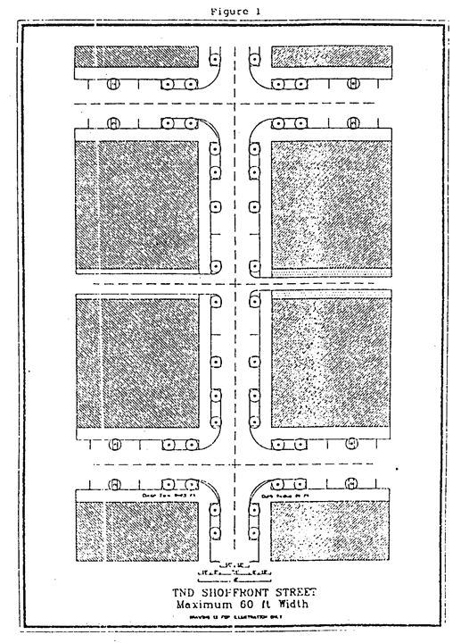

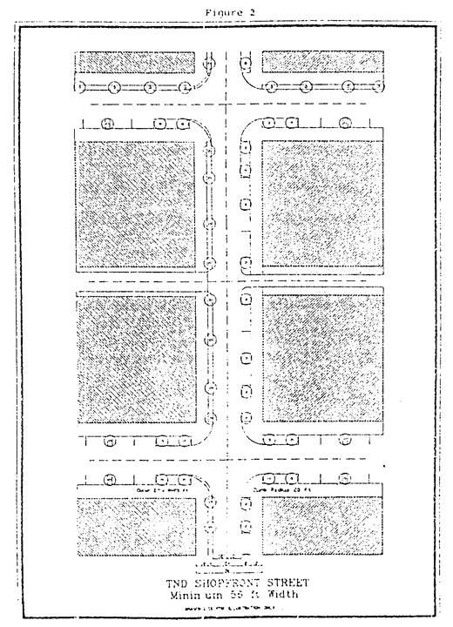

(b) Posted vehicle speed for shopfront use streets shall not exceed twenty-five (25) miles per hour.

(c) At intersections, the curb radius shall be twenty (20) feet, with a clear zone radius of twenty-five (25) feet. Parking lanes shall not be closer than twenty-five (25) feet to the nearest intersecting building lot line.

(d) Signs in colonnades shall have a minimum clearance of eight (8) feet above the sidewalk.

(e) Shopfront use lots shall have their rear or side lot lines coinciding with an alley twenty-four (24) feet wide, containing a vehicular pavement width of at least nine (9) feet one-way, and a maximum of eighteen (18) feet two-way.

(5) *Parking.*

(a) No less than seventy-five (75.0) percent of the parking spaces shall be to the rear of the building. Access may be through the frontage only if an alley or side street providing access to the alley is not within two hundred (200) linear feet of the lot.

(6) *Signage.*

(a) All signs shall be wall signs or cantilever signs and shall not exceed a total of twenty-four (24) square feet per building with no more than three (3) signs. Individual cantilever signs shall be mounted perpendicular to the building face and shall not exceed eight (8) square feet. No sign shall be mounted above the first floor of the structure.

(D) *Rowhouse use.*

(1) *Land use.*

(a) Land designated for rowhouse use shall be on lots containing buildings for residential uses including townhouse, apartment, limited office as permitted in the RU-5A Zoning District, limited lodging, congregate living facilities, family day care, and artisanal use. Where nonresidential uses are proposed, at least fifty percent (50%) of the gross square footage shall be restricted to residential use as demonstrated by the submittal of floor plans identifying the use of each room.

(b) One hundred (100) percent of the building area above the ground floor shall be designated for residential use.

(c) An outbuilding is permitted on each lot.

(2) *Land allocation.*

(a) Rowhouse use lots shall constitute a minimum of twenty percent (20%) and a maximum of fifty percent (50%) of the gross area of the neighborhood proper.

(b) Rowhouse use lots may be consolidated for the purpose of constructing multifamily dwellings.

(c) A maximum of fifty (50.0) percent of all rowhouse use lots may be consolidated.

(3) *Lots and buildings.*

(a) Rowhouse use lots shall have a maximum width of thirty-two (32) feet.

(b) Rowhouse use buildings with the minimum setback shall have their front entry set to one (1) side of the facade. This is to preserve the possibility of retro-fitting a ramp for wheelchair access.

(c) Rowhouse use buildings shall be attached (built with no side setback or as a single building) at not less than five-unit segments. Lots comprising the end of the block adjacent to the street or alley or along street curves may be attached in segments of two (2) to five (5) units.

(d) Buildings on rowhouse use lots shall be setback eight (8) or fifteen (15) feet from the frontage line. Buildings at street intersections shall be set back eight (8) feet from the frontage line and six (6) feet from the side street line. Setback requirements shall apply to the enclosed portion of the buildings only.

(e) Buildings on rowhouse use lots shall have a setback of zero (0) feet from at least one (1) side property line. There shall be no required rear setback.

(f) Outbuildings shall have no required setbacks.

(g) Setbacks on consolidated rowhouse use lots shall apply as in a single lot.

(h) Buildings on rowhouse use lots shall cover no more than sixty (60) percent of the net lot area. Outbuildings shall not count towards the lot coverage when the principal buildings do not cover more than fifty (50%) percent of the net lot area. Front porches and covered stoops without habitable space above shall not count towards the lot coverage.

(i) Buildings on rowhouse use lots shall not exceed thirty-five (35) feet in height (excluding chimneys and elevator towers) and a cornice line shall be used to define the first floor.

(j) Buildings on rowhouse use lots shall have a minimum first floor front elevation eighteen (18) inches above finished sidewalk grade, except that an apartment building(s), as defined in [Section 33-1](../level3/PTIIICOOR_CH33ZO_ARTIINGE.docx#PTIIICOOR_CH33ZO_ARTIINGE_S33-1DE)(6.1) of the Code of Miami-Dade County, in rowhouse use lots shall not be subject to the elevation requirement. Rear entrance(s) shall be accessible for people with disabilities by grading or ramping. Space shall be provided in the front yard area for the construction of a ramp.

(k) A minimum of thirty percent (30%) of the net lot area shall be developed as private open space.

(l) Rowhouse use lots shall have a streetedge built along the unbuilt parts of the frontage line.

(m) A minimum of twenty-five percent (25%) of the buildings on rowhouse use lots shall have front porches. Said front porches may encroach into the front setback and shall not count against lot coverage requirements but shall count towards private open space requirements.

(4) *Streets and alleys.*

(a) Rowhouse use lots shall front on streets consisting of a fifty-foot maximum width, including two (2) ten-foot wide travel lanes and an eight-foot wide parallel parking lane on at least one (1) side. If the parking lane is provided on only one (1) side there shall be a planting strip, at least five (5) feet wide, provided between the opposite sidewalk and travel lane. Two (2) sidewalks are required and shall be no less than six (6) feet wide. (As an example, refer to Figures 3 and 4). Rowhouse use lots may also front on squares or park tracts.

(b) No parking shall be permitted in the front setback area.

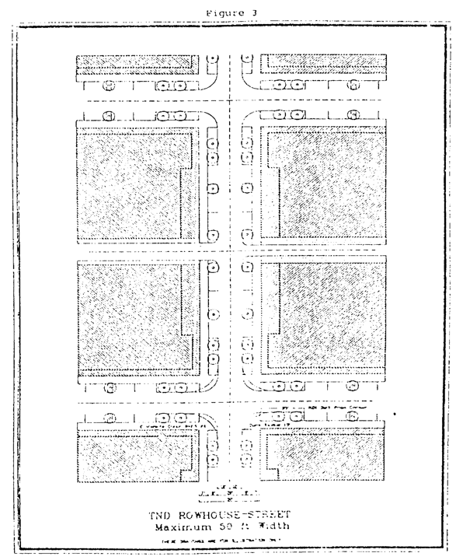

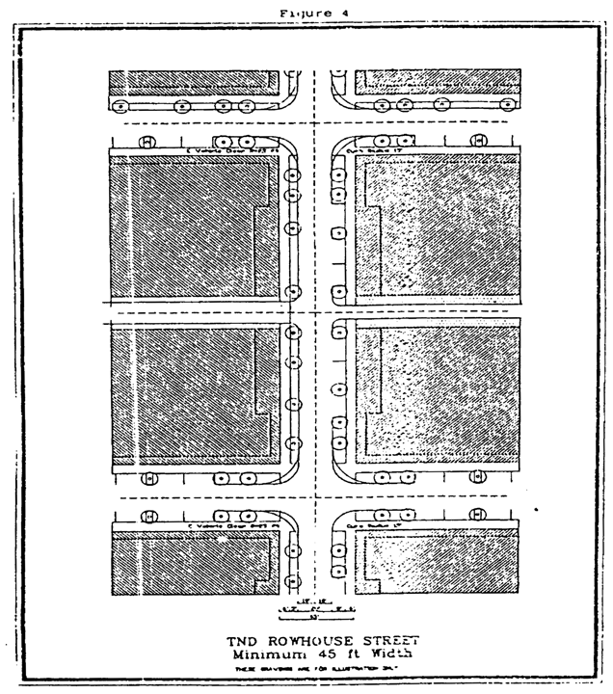

(b) Posted vehicle speed for rowhouse use streets shall not exceed twenty (20) miles per hour.

(c) At intersections, the curb radius shall be fifteen (15) feet with a clear zone radius of twenty-five (25) feet. Parking lanes shall not be closer than twenty-five (25) feet from the lot line adjoining intersecting streets.

(d) Rowhouse use lots shall have their rear or side lot lines coinciding with an alley twenty-four (24) feet wide containing a vehicular pavement width of at least ten (10) feet one-way and sixteen (16) feet two-way.

(5) *Parking.*

(a) All off-street parking places shall be to the rear of the building. Access shall be through a vehicular alley only.

(b) No parking shall be permitted in the front setback area.

(6) *Signage.*

(a) All signs shall be wall signs and limited to two (2) signs and shall not exceed a cumulative total of four (4) square feet. No signs shall be mounted above the first floor of a structure.

(E) *House use.*

(1) *Land use.*

(a) Land designated for house use shall be on lots containing buildings for residential uses including single-family houses, guest houses as outbuildings, home occupation, and family day care.

(b) One hundred (100) percent of the building area above the ground floor shall be designated for residential use.

(c) An outbuilding is permitted on each lot.

(2) *Land allocation.*

(a) House use lots shall constitute a maximum of thirty percent (30%) of the gross area of the neighborhood proper.

(b) A maximum of two (2) house use lots may be consolidated for the purpose of constructing a single residence.

(c) A maximum of fifty (50.0) percent of all house use lots may be consolidated.

(3) *Lots and buildings.*

(a) Houses on house use lots shall be raised a minimum of eighteen (18) inches from finished exterior sidewalk grade. At least one (1) entrance shall be accessible for people with disabilities either by grading or ramping, and the other entrance shall have sufficient space to construct a possible future ramp

(b) Buildings on house use lots shall be set back ten (10) or twenty (20) feet from the frontage line. Buildings at street intersections shall be set back ten (10) feet from the frontage line and the side street frontage line.

(c) House use lots shall have a minimum width of thirty-six (36) feet and a minimum lot size of three thousand six hundred (3,600) square feet with a minimum average lot size of five thousand (5,000) square feet.

(d) Setbacks on consolidated house use lots shall apply as on a single lot.

(e) Buildings on house use lots shall be set back from the side lot lines equivalent (in total) to no less than twenty percent (20%) of the width of the building lot. The entire setback may be allocated to one (1) side. If buildings have a zero (0) foot setback on one (1) side, a four-foot maintenance easement shall be provided on the adjacent lot.

(f) Buildings on house use lots shall be set back no less than five (5) feet from the rear lot line. Outbuildings on house use lots shall have a setback no less than five (5) feet from the rear lot line except on an alley where it shall have a zero-foot setback.

(g) Buildings on house use lots between 3,600 square feet and 4,999 square feet shall cover no more than forty (40%) percent of the lot area. Buildings on 5,000 square foot and greater house use lots shall cover no more than fifty (50%) percent of the lot area. Outbuildings shall not count towards the lot coverage when the principal buildings do not cover more than forty (40%) percent of the net lot area. Front porches, porte-cocheres and covered stoops without habitable space above shall not count towards the lot coverage.

(h) Buildings on house use lots shall not exceed twenty-four (24) feet in height (excluding chimneys).

(i) Buildings on house use lots shall have a streetedge built along the frontage line.

(j) A minimum of twenty-five percent (25%) of the buildings on house use lots shall have front porches which may encroach into the front setback not closer than eight (8) feet from the inside edge of the sidewalk.

(4) *Streets and alleys.*

(a) House use lots shall front on streets of a forty-six-foot maximum width consisting of two (2) ten-foot travel lanes, two (2) planting strips of at least six (6) feet wide each, and two (2) sidewalks which shall be no less than five (5) feet wide. A parallel parking lane eight (8) feet wide may be used in place of either planting strip. (As an example, refer to Figures 5 and 6.)

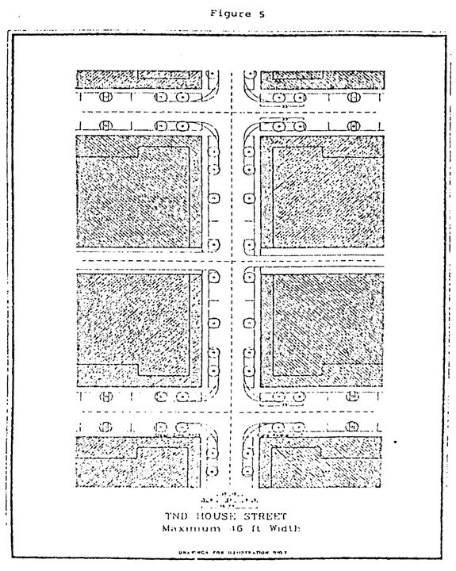

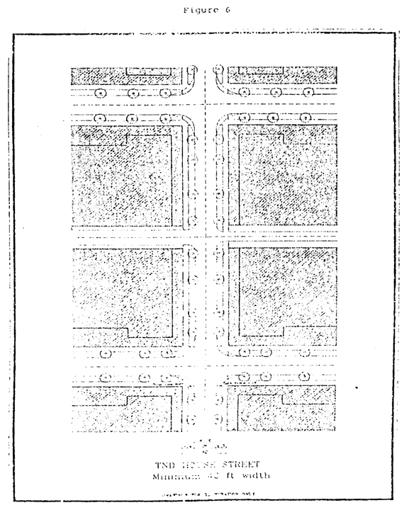

(b) Posted vehicle speed for house use streets shall not exceed twenty (20) miles per hour.

(c) At intersections, the curb radius shall be fifteen (15) feet with a clear zone radius of twenty-five (25) feet. Parking lanes shall not be closer than twenty-five (25) feet from the lot line adjoining intersecting streets.

(d) House use lots may have their rear or side lot lines coinciding with an alley twenty-four (24) feet wide containing a pavement width of at least ten (10) feet one-way and sixteen (16) feet two-way, except where the rear lot adjoins a greenbelt, lake or canal.

(5) *Parking.*

(a) No parking shall be permitted in the front setback area of residential lots of less than fifty (50) foot frontage.

(b) All off-street parking places shall be to the side or the rear of the building. Where no alley access exists and vehicular access is through the frontage, garages shall be located a minimum of twenty (20) feet behind the front building setback. Porte-cocheres may be located at the front building setback line. Porte-cocheres without habitable space above may encroach into the front setback a maximum of eight (8) feet.

(6) *Signage.*

(a) One wall, or streetedge mounted, sign not to exceed one (1) square foot shall be permitted.

(F) *Workshop use.*

(1) *Land use.*

(a) Land designated for workshop use shall be in land containing buildings for the following uses: No building for a single use shall exceed thirty thousand (30,000) square feet of interior floor area.

1. Artists studios and accessory gallery use.

2. Artisanal use.

3. Automobile and motorcycle body shops.

4. Automobile parking garages.

5. Automobile service and repairs.

6. Bait and tackle shops.

7. Bakeries (wholesale).

8. Banks excluding drive-in teller services.

9. Bottling of beverages.

10. Cabinet shops.

11. Cold storage warehouse.

12. Dance studios.

12a. Day care centers.

13. Dog and pet hospitals in air conditioned buildings.

14. Dry cleaning and dyeing establishments.

15. Engines, sales and services.

16. Gasoline service stations excluding markets.

17. Glass installation.

18. Health and exercise clubs.

19. Interior design shops.

20. Leather goods manufacturing, excluding tanning.

21. Locksmith shops, sharpening and grinding shops.

22. Lumber yards.

23. Mail order offices and storage.

24. Medical equipment and supplies.

25. Office supply stores.

26. Office buildings.

27. Post office substations and police substations.

28. Photography labs.

29. Pottery shops.

30. Printing shops.

31. Residential use shall be permitted on the second and/or third floor above workplace use. A second floor residential unit must provide access to people with disabilities.

32. Restaurants excluding drive-in service.

33. Secondhand stores and antique shops.

34. Upholstery and furniture shops.

35. Wholesale salesroom and storage rooms.

36. Other similar uses as approved by the Director.

(2) *Land allocation.*

(a) Workshop use lots shall constitute a minimum of three percent (3%) and a maximum of seven percent (7%) of the gross area of the neighborhood proper. When a TND borders land designated in the CDMP as agriculture or open land, the land allocation for workshop use lots may constitute only one and one-half (1.5%) percent of the gross area of the neighborhood proper.

(b) Workshop use lots shall not be within three hundred (300) feet of the geometric center of the neighborhood proper or the mandatory square or green. When a TND borders land designated in the CDMP as agriculture or open land, then workshop use lots shall not be permitted within three hundred thirty (330) feet of said TND boundary except if necessary to maintain consistency with the Goals, Objectives and Policies of the CDMP including the Guidelines for Urban Form.

(c) All workshop use lots shall be contiguous and located within one (1) area with no intervening uses, provided however, in TNDs exceeding one hundred (100) acres in size, two (2) workshop use areas shall be permitted.

(3) *Lots and buildings.*

(a) Buildings on workshop use lots shall have a setback of zero (0) or five (5) feet from the frontage line. The setback at street intersections shall not exceed five (5) feet from the frontage line and the side street line.

(b) Street-front entries shall be at grade to allow access for people with disabilities.

(c) Buildings on workshop use lots shall cover no more than seventy percent (70%) of the net lot area.

(d) A minimum of fifteen percent (15%) of the net lot area shall be developed as landscaped open space.

(e) Buildings on workshop use lots shall not exceed thirty-five (35) feet in height.

(f) Workshop use lots shall be separated from other use types at the side and rear lot lines (excepting an entry on the alley) by a continuous masonry wall no less than six (6) feet in height.

(g) Workshop use lots shall have a maximum width of three hundred (300) feet.

(4) *Streets and alleys.*

(a) Workshop use lots shall front on streets of a sixty (60) feet maximum width consisting of two (2) twelve-foot wide travel lanes, and eight-foot wide parallel parking on at least one (1) side of the road. If the parking lane is provided on only one (1) side there shall be a planting strip of at least eight (8) feet wide between the opposite lane and the sidewalk. Sidewalks shall be no less than eight (8) feet wide and are required on both sides of the street. (As an example, refer to Figures 7 and 8).

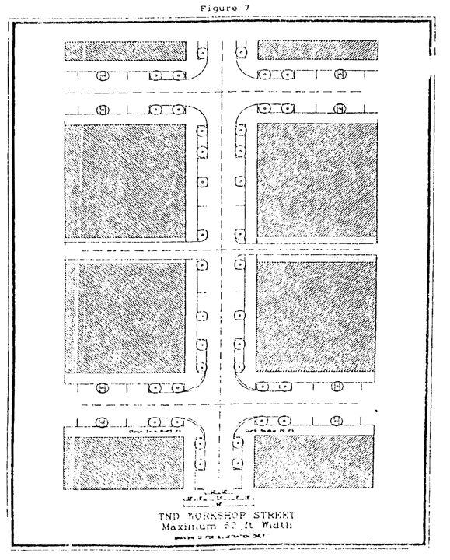

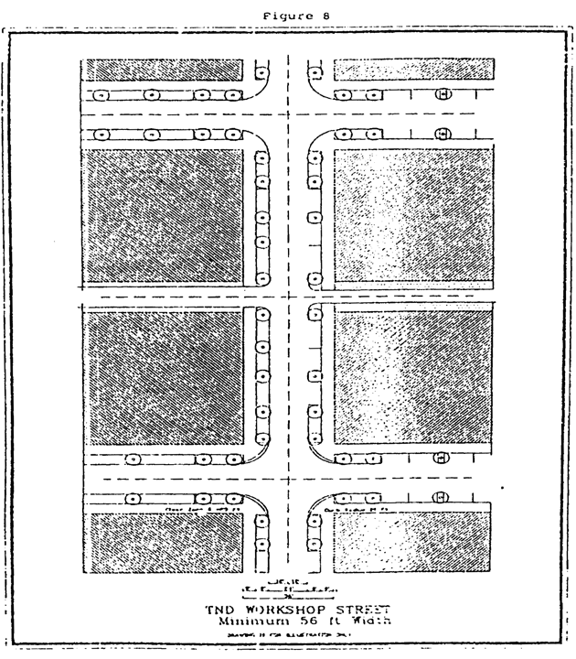

(b) Posted vehicle speed for workshop use streets shall not exceed twenty-five (25) miles per hour.

(c) At intersections the curb radius shall be twenty (20) feet, with a clear zone radius of twenty-five (25) feet. Parking lanes shall not be closer than twenty-five (25) feet to the nearest intersecting building lot line.

(d) Workshop use lots shall have their rear or side lot lines adjacent to an alley twenty-four (24) feet wide containing a vehicular pavement width of at least ten (10) feet one-way and eighteen (18) feet two-way, except where the rear lot line adjoins a greenbelt, lake or canal.

(5) *Parking.*

(a) Off-street parking shall be placed to the side or the rear of the building.

(6) *Signage.*

(a) All signs shall be wall mounted perpendicular to the building face with an eight-foot clearance to the sidewalk and shall not exceed a total of twenty-four (24) square feet and shall be limited to three (3) signs.

(Ord. No. 91-41, § 1, 4-2-91; Ord. No. 96-127, § 32, 9-4-96; Ord. No. 99-26, § 1, 5-4-99; Ord. No. 02-46, § 9, 4-9-02; Ord. No. 03-47, § 5, 3-11-03; Ord. No. 11-83, § 2, 11-15-11)

Sec. 33-284.52. Limitation on variances.

The following provisions of the TND ordinance shall not be varied:

(a) Curb requirements.

(b) Front porch requirements.

(c) Location of on-site parking.

(d) Colonnades.

(e) Rowhouse and house use with first floor of eighteen (18) inches above finished grade.

(f) Average block perimeter.

(g) Public/semi-public use and civic use land allocation requirements.

(h) Minimum land allocation requirements, except for workplace uses which may be reduced by fifty percent (50%).

(i) Street width requirements.

(j) Maximum and minimum setback requirements.

(Ord. No. 91-41, § 1, 4-2-91; Ord. No. 03-47, § 6, 3-11-03)

Sec. 33-284.52.1. Special exception to the use of alleys.

No alley shall be required for any location where one of the following conditions exist as demonstrated at public hearing;

(a) Required parking is provided in the rear and due to design or intensity of such parking, alleys cannot provide safe or logical access to such parking, or

(b) Required parking is provided by on-street parking where permitted.

(Ord. No. 03-47, § 7, 3-11-03

Sec. 33-284.53. Ownership and maintenance of common open space(s) and civic use buildings.

All land designated on approved plans as common open space, including squares, greens and parks, and all structures devoted to the common use of the inhabitants of a TND will be owned and/or maintained under one or more of the following structures:

(A) Those projects developed under a condominium ownership shall be in accordance with applicable Florida law, or

(B) The common open space and civic uses shall be maintained under a special taxing improvement district or community development district as approved by the Board of County Commissioners, or

(C) The common open space and civic uses shall be owned and maintained as provided under the provisions of the property homeowners' association declaration, which shall, at a minimum, provide for the maintenance of all common facilities covered by the documents in a manner that assures their continued use for their intended purposes and provided further that the property homeowners' association declaration shall comply with the following requirements:

(1) Approval for form and legal sufficiency as to compliance with the ordinance by the Miami-Dade County Attorney's Office.

(2) A homeowners' association shall be established before the units or individual building lots are sold.

(3) Membership shall be mandatory for each property owner and said association shall have the authority to adjust the assessment to meet the needs of maintaining the open space and common facilities.

(4) Any sums levied by the homeowners' association that remain unpaid, shall become a lien on the individual property and said lien shall be superior to all other liens save and except tax liens and mortgage liens, provided said mortgage liens are first liens against the property encumbered thereby, subject only to tax liens and secure indebtedness which are amortized in monthly or quarter annual payments over a period of not less than ten (10) years.

(Ord. No. 91-41, § 1, 4-2-91; Ord. No. 03-47, § 8, 3-11-03; Ord. No. 11-83, § 3, 11-15-11)

Sec. 33-284.54. Conflicts with other Chapters.

In the event of express conflict with any provision of [Chapter 18A](../level2/PTIIICOOR_CH18AMIDECOLAOR.docx#PTIIICOOR_CH18AMIDECOLAOR) (Landscape Ordinance) or any other provision of [Chapter 33](../level2/PTIIICOOR_CH33ZO.docx#PTIIICOOR_CH33ZO), the provisions of this Article shall prevail. The requirement of [Section 33-284.51](../level3/PTIIICOOR_CH33ZO_ARTXXXIIIHTRNEDETNDI.docx#PTIIICOOR_CH33ZO_ARTXXXIIIHTRNEDETNDI_S33-284.51LAUSCA)(d) to provide a child care use in a TND zoning district shall not apply where the Director of Planning and Zoning determines that the TND zoning district is encumbered in whole or in part by conflicting airport regulations and no suitable site within a TND zoning district exists for a child care facility outside the areas that are in conflict with the airport regulations.

(Ord. No. 03-47, § 9, 3-11-03)

### ARTICLE XXXIII(I). DOWNTOWN KENDALL URBAN CENTER DISTRICT

Sec. 33-284.55. Purpose and intent.

Sec. 33-284.56. Definitions.

Sec. 33-284.57. Review procedure.

Sec. 33-284.58. Zoning hearing review.

Sec. 33-284.59. Conflicts with other chapters and regulations.

Sec. 33-284.60. Organization of this article.

Sec. 33-284.61. Regulating plans.

Sec. 33-284.62. Development parameters.

Sec. 33-284.63. Additional parameters.

Sec. 33-284.63.1. Center DRI Sub-District Alternative Development Parameters.

Sec. 33-284.64. Effective date.

Sec. 33-284.65. Nonconforming structures, uses and occupancies.

Sec. 33-284.55. Purpose and intent.

This article applies to two (2) contiguous areas on each side of US Highway 1. The western area is bounded by the Palmetto Expressway on the west, the Snapper Creek Expressway on the north and US Highway 1 on the east. The eastern area is bounded by US Highway 1 on the west, SW 80th Street on the north, SW 65th and SW 67th Avenues on the east, and SW 84th Street and Snapper Creek Canal on the south. The intention of this Article is to produce a Metropolitan urban center that fulfills the goals, objectives and policies of the County's Comprehensive Development Master Plan by:

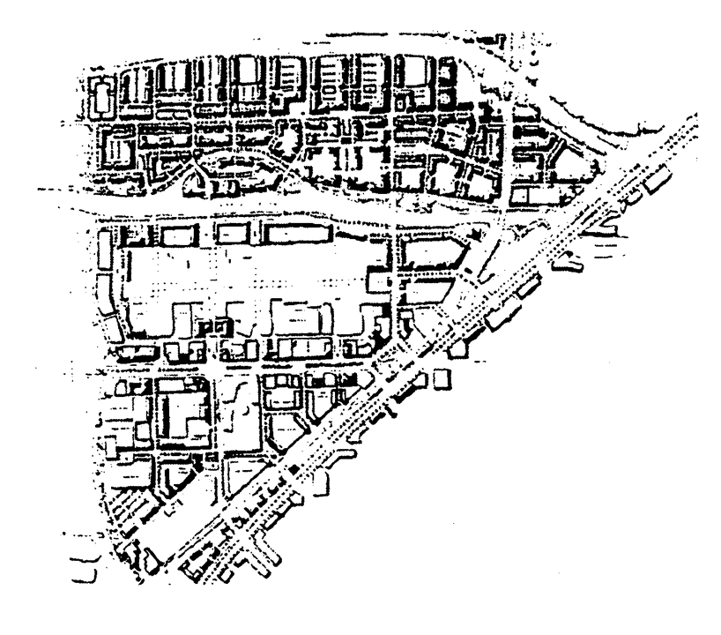

(A) Coordinating the development intensity within the district by the proximity to mass transit;

(B) Organizing an interconnected network of colonnaded or tree lined streets to improve pedestrian access to transit; and

(C) Creating good public open space with specific square and plaza locations and by shaping the way buildings front onto the open space and streets.

The Illustrative Plan (Figure 1), illustrates the vision and may be used to better interpret this Article. Where there is conflict between the illustrative plan and the text of this article, the text shall govern.

(Ord. No. 99-166, § 1, 12-16-99)

Sec. 33-284.56. Definitions.

Terms used throughout this Article shall take their commonly accepted meaning unless otherwise defined in [Chapter 33](../level2/PTIIICOOR_CH33ZO.docx#PTIIICOOR_CH33ZO) or [Chapter 28](../level2/PTIIICOOR_CH28SU.docx#PTIIICOOR_CH28SU) of the Code of Miami-Dade County. Terms requiring interpretation specific to this article are as follows:

(1) *Anchor Point:* The location depicted on the Designated Open Space Plan on which some portion of the required plaza or square must be situated.

(2) *Block:* A combination of building lots, the perimeter of which abuts streets.

(3) *Block face:* The right-of-way line or easement line which delineates a block edge.

(4) *Build-to line:* A line parallel to the block face, along which a building shall be built.

(5) *Building Height:* A limit to the vertical extent of a building measured in stories above grade. Building height shall be measured in stories from the average elevation of the enfronting curb to the eave line.

(6) *Civic Use:* Premises used primarily for public education, cultural performances, gatherings and displays administered by non-profit cultural, educational, governmental, and religious organizations.

(7) *Clear Zone:* An area within the curb radius, which shall be kept clear of all objects to a prescribed height to provide vehicle clearance.

(8) *Colonnade:* A roofed structure, extending over the sidewalk, open to the street that is supported by columns or piers.

(9) *Courtyard Garden:* A grade-level garden which may be included as part of the open space requirement and is described in this Article's General Requirements.

(10) *Curb Radius:* The curved edge of street paving at an intersection, measured at the inside travel edge of the travel lane.

(11) *Designated Open Space:* Colonnades, Squares, and Plazas as indicated on the Designated Open Space Plan.

(11.5) *Electric Vehicle Retail Showroom:* Retail showroom for electric vehicles provided that:

(a) No on-site vehicle storage/stock beyond the showroom and vehicles for test drives is allowed: and

(b) No more than six (6) electric vehicles, outside of the showroom, to be used for test drive purposes: and

(c) No test drive shall be conducted on residential local streets (fifty-foot wide rights-of-way): and

(d) Vehicles used for test drives and display in the showroom are not permitted to be sold on-site.

(12) *Expression Line:* A horizontal line, the full width of a facade, expressed by a material change or by a continuous projection not less than three (3) inches nor more than one (1) foot.

(13) *Floorplate:* The total indoor and outdoor area of any given story of a building, measured to the exterior of the wall.

(14) *Frontage:* The property line or lines of a lot which coincide with a right-of-way or other public open space line as shown on the Regulating Plan.

(15) *Garden Wall:* A wall separating a courtyard garden from a public open space.

(16) *Habitable Space:* Building space whose use involves human presence with direct view of the enfronting streets or open space, excluding parking garages, self-service storage facilities, warehouses, and display windows separated from retail activity.

(17) *Open Space:* An outdoor, at grade space which is accessible to the public all or most of the time, including parks, plazas, squares, canal-walks, colonnades, courtyard gardens, paseos (when designed predominantly for pedestrians), and pedestrian paths and/or associated ornamental or shading landscaped areas.

(18) *Paseo:* A cross-block, primarily pedestrian passage connecting one (1) right-of-way or paseo to another. Paseos shall be designed for pedestrian comfort, but may serve vehicles when minimum standards set forth in this Article are met. Also known as a C Street.

(19) *Penthouse:* Topmost built area of a building with a floorplate area less than that of the tower below.

(20) *Pedestal:* The bottom portion of a building that creates the street frontage.

(21) *Plaza:* An open space with a majority of paved surface. Plazas are fronted with buildings that continue the adjacent street frontage requirements and uses.

(22) *Retail Use:* Premises used for the exchange of services or goods.

(23) *Square:* An open space surrounded by streets or other vehicular passages.

(24) *Shared Parking:* Parking used by more than one (1) use or building.

(25) *Storefront:* The portion of a building at the first story of a retail frontage that is made available for retail use.

(26) *Story:* A floor level within a building as described in this Article's General Requirements.

(27) *Street:* A thoroughfare for the movement of pedestrians and/or vehicles, as provided in this Article.

(28) *Streetwall:* The vertical surface of a building or structure that faces public open space.

(29) *Tower:* The middle portion of a building above the pedestal and below the penthouse.

(30) *Turnout Radius:* the inside turning radius between intersecting travel lanes, which may be independent from the actual curb of the street edge.

(Ord. No. 99-166, § 1, 12-16-99; Ord. No. 09-81, § 1, 9-1-09; Ord. No. 13-41, § 1, 5-7-13)

Sec. 33-284.57. Review procedure.

Projects following the provisions of this Article and the Regulating Plans shall be processed and approved administratively. The Miami-Dade County Department of Planning and Zoning shall review the applications including exhibits listed below for completeness and compliance with the provisions of this Article and the Regulating Plans. All complete submissions to the Department shall be reviewed and approved or denied, within twenty-one (21) days from the date of submission. The applicant shall have the right to extend the twenty-one (21) day period by an additional twenty-one (21) days upon timely request made in writing to the Department. The Department shall have the right to extend the twenty-one (21) day period by written notice to the applicant that additional information is needed to process the site plan. Denials shall be in writing and shall specifically set forth the grounds for the denial. Any final decision of the Director may be appealed in accordance with the public hearing procedure established in Article XXXVI of this Code and in accordance with the procedure established for appeals of administrative decision.

Exhibits prepared by design professionals such as architects and landscape architects shall be submitted to the Department and shall include, but not be limited, to the following:

(A) Site plan(s) including:

(1) Lot lines and setbacks.

(2) Location, shape, size and height of existing and proposed building construction and landscaping.

(3) Location of on-street and off-street parking, loading facilities, waste collection areas, and all above ground utilities.

(4) Indication of signage.

(5) Indication of any site or building design methods used to conserve energy.

(6) Street type designations as per this Article.

(7) Indication of Sub-District boundaries as per this Article.

(B) Landscape plans including specification of plant material, location and size.

(C) Floor plans and elevations of all structures, including total gross square foot area of each floor and all dimensions relating to the requirements of this Article.

(D) Figures indicating the following:

(1) Gross and net acreage.

(2) Amount of landscaped open space in square feet and percentage required and provided.

(3) Total square footage of all land uses.

(4) Amount of building coverage at ground level in square feet and percentage.

(5) Total trees required and provided, indicating on site and off site contribution within the District.

(6) Parking required and provided.

(7) Total amount of paved area in square feet.

(8) Total number of dwelling units.

(9) Such other design data as may be needed to evaluate the project.

In the case of multiple-phase development, each phase of the development, whether standing independently or in conjunction with existing developed or proposed future contiguous phases, shall meet all the requirements of this Article. For future development outside the Center DRI Sub-District, expansions or additions to legal structures, if not in substantial compliance with previously approved plans, shall be subject to those requirements of this Article applicable to the entire block or blocks in the Regulating Plans for which the expansion or addition is proposed.

Notwithstanding the review procedure contained herein, all requests for the subdivision of property within the Downtown Kendall Urban Center District shall have previously received site plan approval in accordance with the requirements of this section or [Section 33-284.58](../level3/PTIIICOOR_CH33ZO_ARTXXXIII_I_DOKEURCEDI.docx#PTIIICOOR_CH33ZO_ARTXXXIII_I_DOKEURCEDI_S33-284.58ZOHERE) below.

(Ord. No. 99-166, § 1, 12-16-99; Ord. No. 02-11, § 1, 1-29-02)

Sec. 33-284.58. Zoning hearing review.

Applications for zoning hearing which seek relief from the regulations contained within this Article shall be in accordance with the procedures set forth in Article XXXVI of this Code. In no event, however, shall the following provisions of this Article be varied:

(1) Building height restrictions.

(2) Habitable space regulations.

(3) Colonnade regulations.

(4) Landscape regulations for streets, squares, and medians.

(Ord. No. 99-166, § 1, 12-16-99; Ord. No. 09-81, § 2, 9-1-09)

Sec. 33-284.59. Conflicts with other chapters and regulations.

When conflicts with other Zoning, Subdivision or the Landscape regulations occur, the Downtown Kendall Urban Center District Article shall take precedence. Where conflicts occur with Miami-Dade Department of Public Works Manual of Public Works, unless otherwise approved by the Director of the Public Works Department and the Director of the Department of Planning and Zoning, this Article shall take precedence.

(Ord. No. 99-166, § 1, 12-16-99)

Sec. 33-284.60. Organization of this article.

(A) This Article is organized into three (3) primary sections:

(1) The Regulating Plans allocate Sub-Districts, street frontages, and designated open space that serve as the controlling factors of the plan;

(2) The Development Parameters are the instructions for implementing the Regulating Plans; and

(3) The Additional Parameters address issues of quality in the design of buildings and their grounds.

(B) The controlling factors are the three (3) Regulating Plans which establish four Sub-Districts, five (5) street frontage types and a number of designated open spaces that interact. Each different interaction is illustrated as part of this Article.

(1) The Sub-District Plan delineates four sub-districts, the Core, the Center, the Center DRI and the Edge. These Sub-Districts control land use and intensity of development in accordance with the County's Comprehensive Development Master Plan. Unless developed in accordance with [Section 33-284.63.1](../level3/PTIIICOOR_CH33ZO_ARTXXXIII_I_DOKEURCEDI.docx#PTIIICOOR_CH33ZO_ARTXXXIII_I_DOKEURCEDI_S33-284.63.1CEDRSSTALDEPA) below, property in the Center DRI Sub-district shall be subject to the provisions of this article applicable to the Center Sub-district.

(2) The Street Frontage Plan establishes a hierarchy of street types in existing and future locations which shall be provided and shown in all future development. The five (5) street types are lettered "A" through "E." An "A" street is the most important street to accommodate pedestrian activity.

(3) The Designated Open Space Plan establishes essential open spaces which shall be provided in all future development and construction. The designated open spaces are controlled by anchor points which are shown on a larger map at a scale of one (1) inch equals two hundred (200) feet on file at the Miami-Dade County Department of Planning and Zoning. The Downtown Kendall Urban Center District Designated Open Space Plan Map's legend contains colonnades, squares & greenspaces, and anchor point. The map, shown below, specifies the exact location and size of all squares and greenspaces required within the Downtown Kendall Urban Center District.

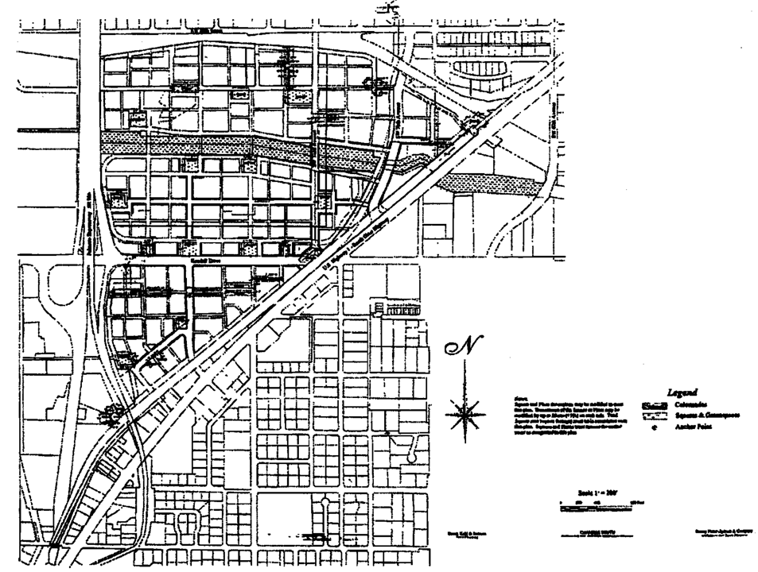

**Downtown Kendall Urban Center District Designated Open Space Plan Map**

(Ord. No. 99-166, § 1, 12-16-99; Ord. No. 02-11, § 2, 1-29-02; Ord. No. 06-114, § 1, 7-18-06)

Sec. 33-284.61. Regulating plans.

(A) Sub-District Plan.

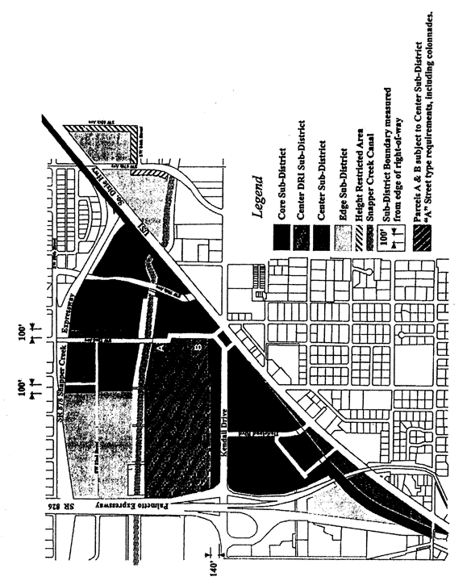

**Sub-District Plan**

(B) Street Frontage Plan.

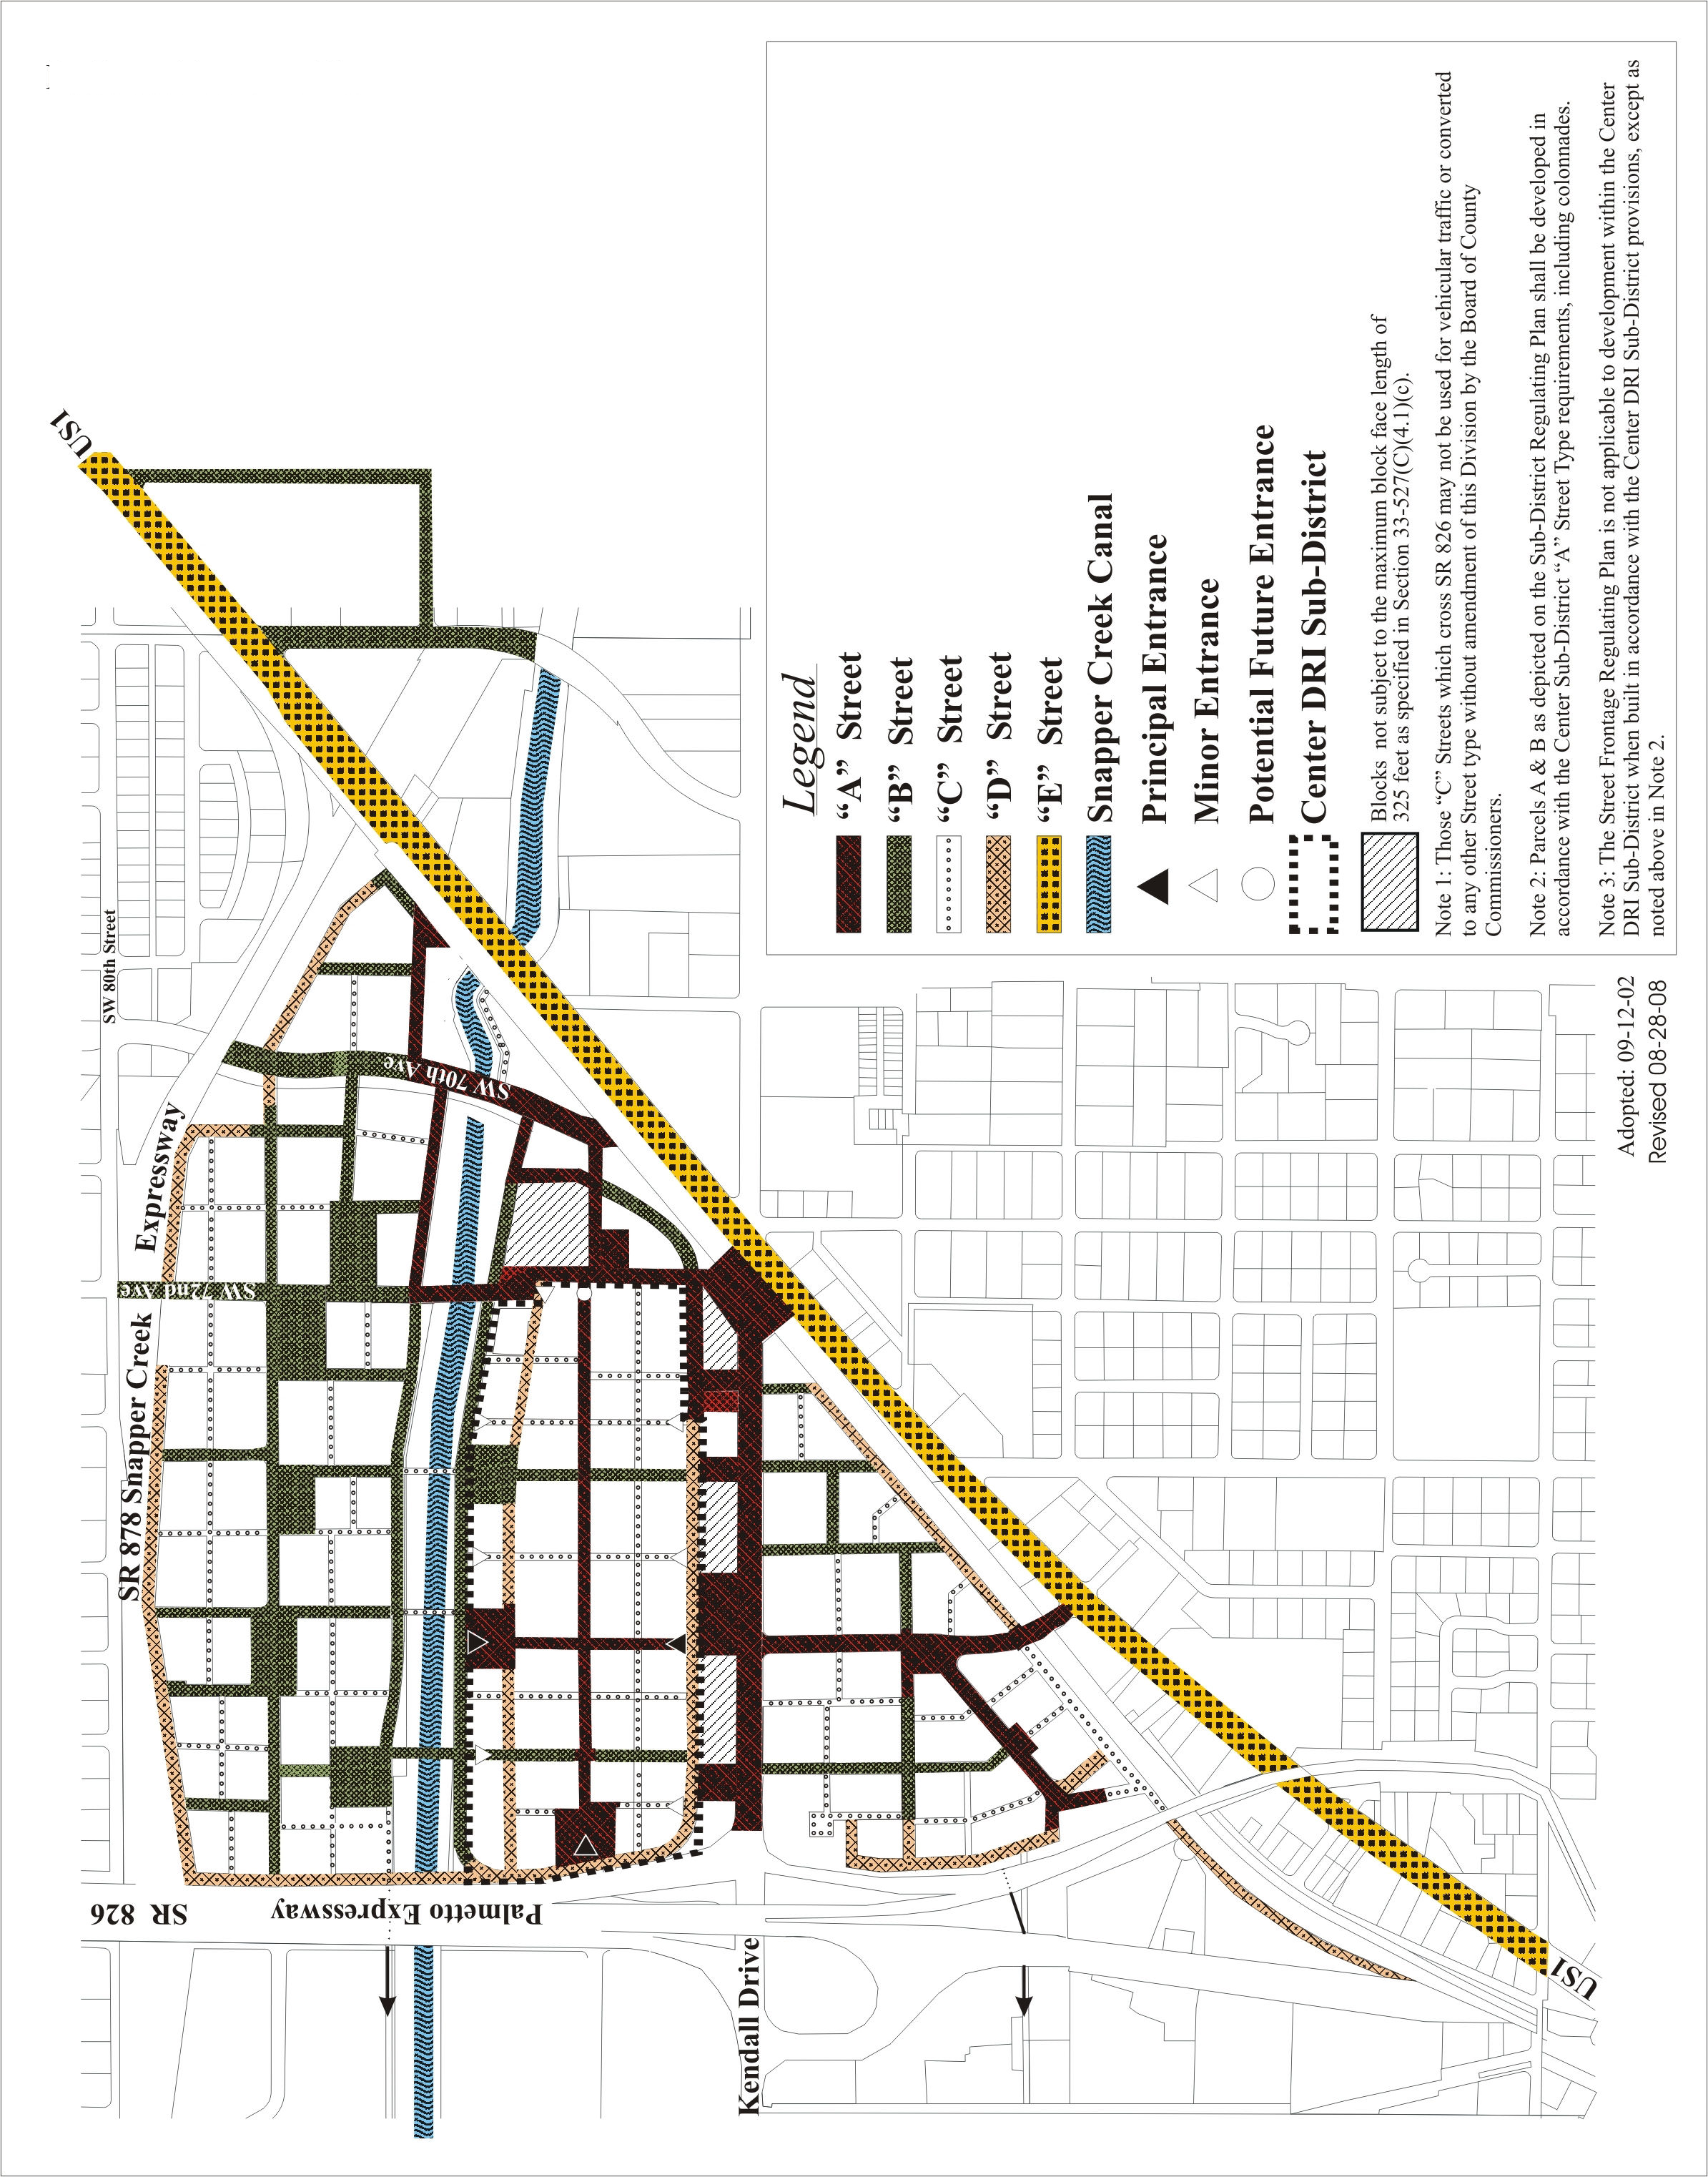

(C) Designated Open Space Plan.

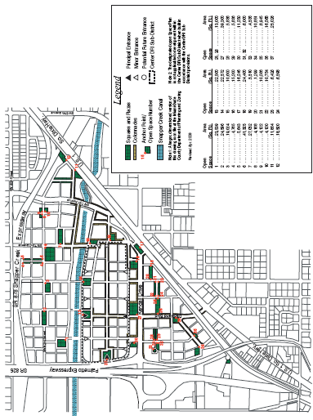

(Ord. No. 99-166, § 1, 12-16-99; Ord. No. 02-11, § 3, 1-29-02; Ord. No. 02-152, § 1, 9-12-02; Ord. No. 05-197, § 1, 11-3-05; Ord. No. 09-81, § 3, 9-1-09)

Sec. 33-284.62. Development parameters.

(A) Placement Diagrams. The following diagrams in this section identify design parameters specifically for the thirteen (13) Sub-district and frontage type situations.

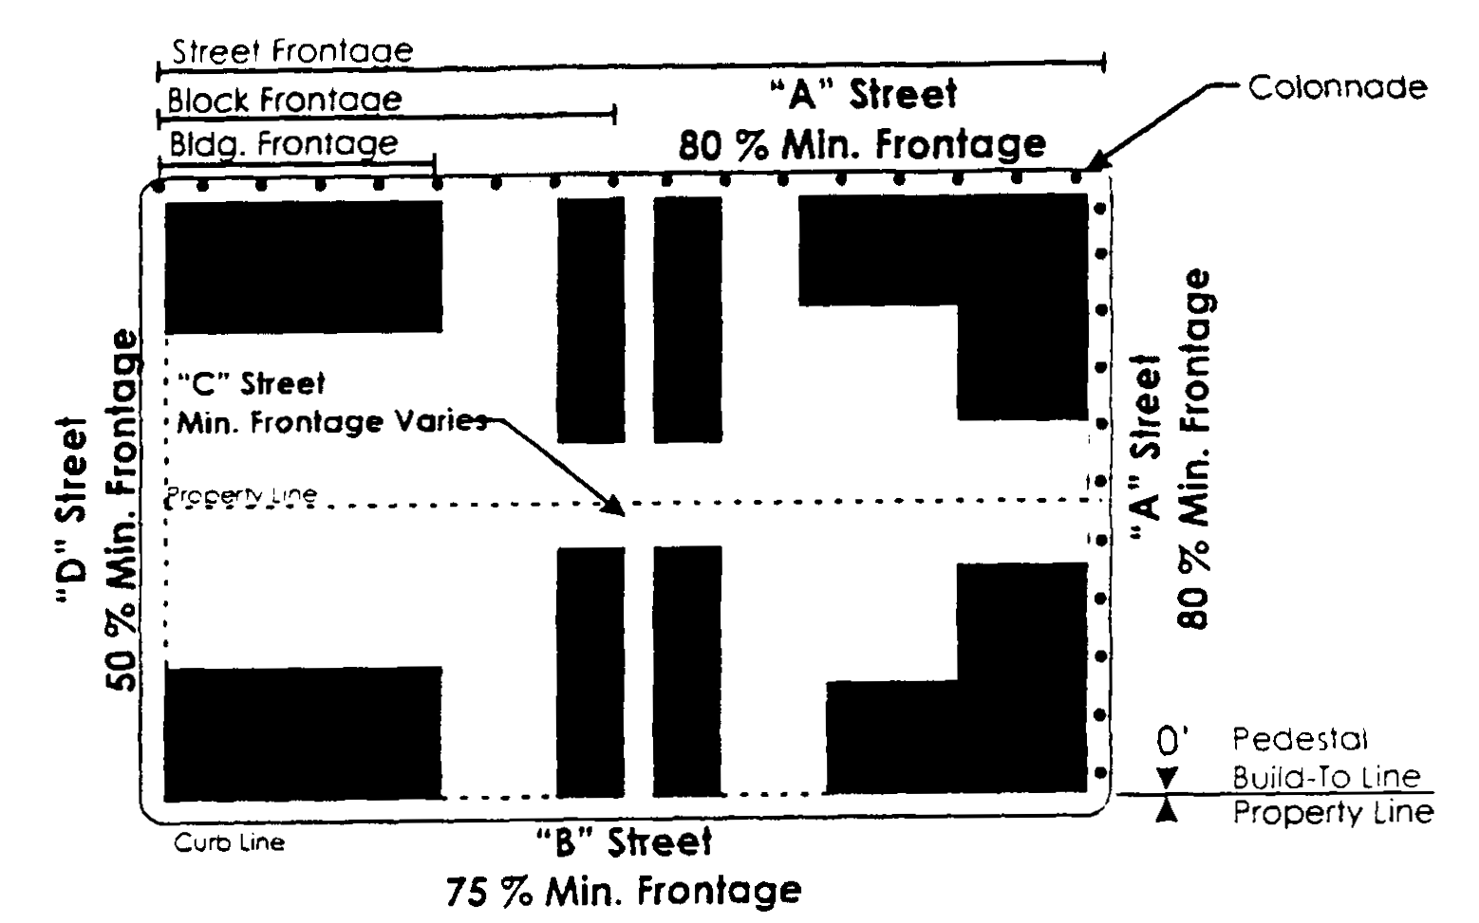

**Core/Center Sub-District Placement Program**

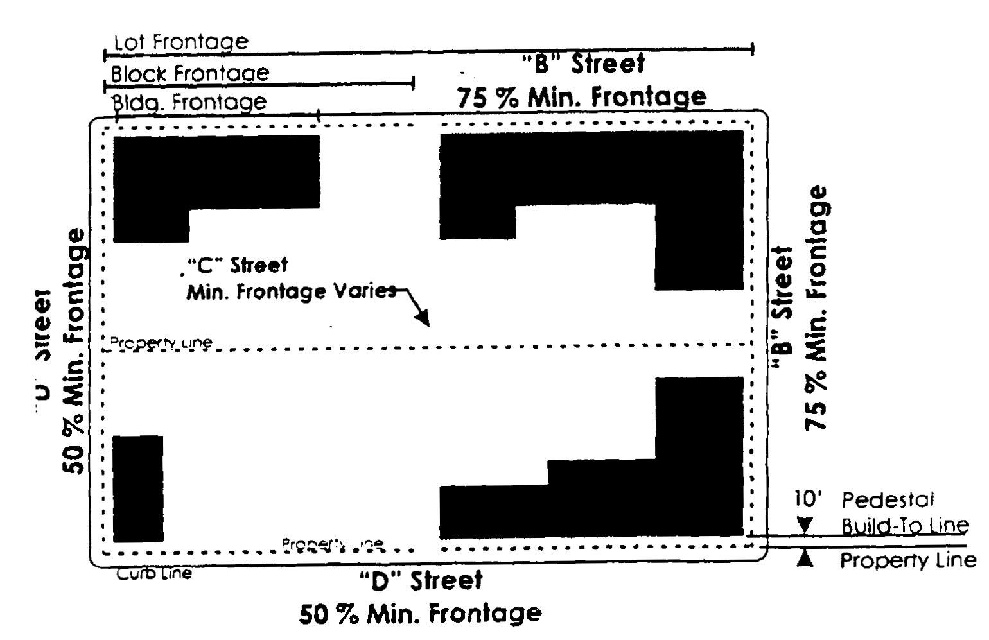

**Edge Sub-District Placement Program**

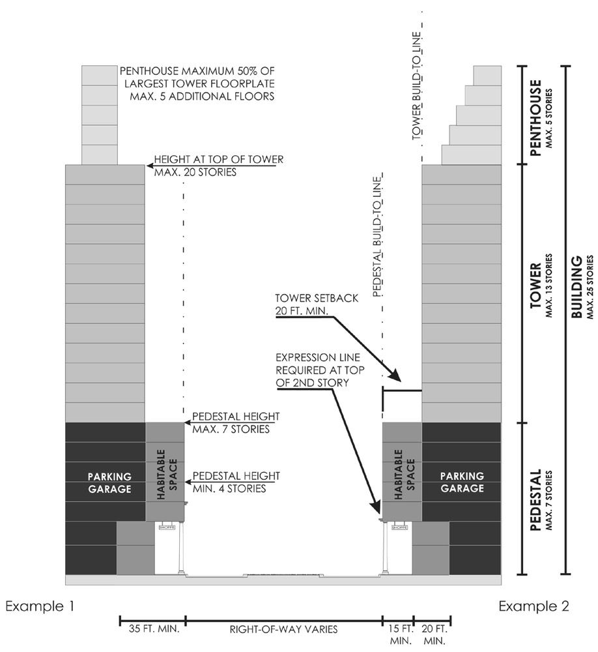

Core Sub-District—"A" Street

|  |  |
| --- | --- |
| Building Height | Pedestal—At street front four (4) stories minimum/seven (7) stories maximum. |
|  | Tower—Thirteen (13) stories maximum. |
|  | Penthouse—Five (5) stories maximum. Floorplate maximum is fifty (50) percent of largest tower floorplate below. |
| Building Placement | Front—Zero (0) foot build-to line for pedestal/twenty (20) foot minimum setback for tower and penthouse. |
|  | Interior Side/Rear—Zero (0) foot minimum setback for pedestal, tower and penthouse. |
|  | Frontage Length—Minimum eighty (80) percent of lot width. Free standing colonnades shall not count for frontage length. |
| Streetwalls | Colonnade—Two (2) story high for full required frontage at build-to line. Fifteen (15) foot minimum depth. Colonnade depth shall not exceed colonnade height. Exterior of colonnade shall be no closer than two (2) feet from curb line. |
|  | Vehicular Entries—Not permitted, except when not accessible from a street of lesser hierarchy. If other frontages do not permit vehicular entries, the maximum vehicular entry width permitted shall be thirty-three (33) feet. |
|  | Habitable Space—Twenty (20) foot minimum depth for full height and length of pedestal. |
|  | Expression Line—Required at the top of the second story. |
| Off-Street Parking | Colonnade Levels—Twenty (20) foot minimum setback from interior wall of colonnade. |
|  | Other Levels—Twenty (20) foot minimum setback from pedestal's build-to line. |

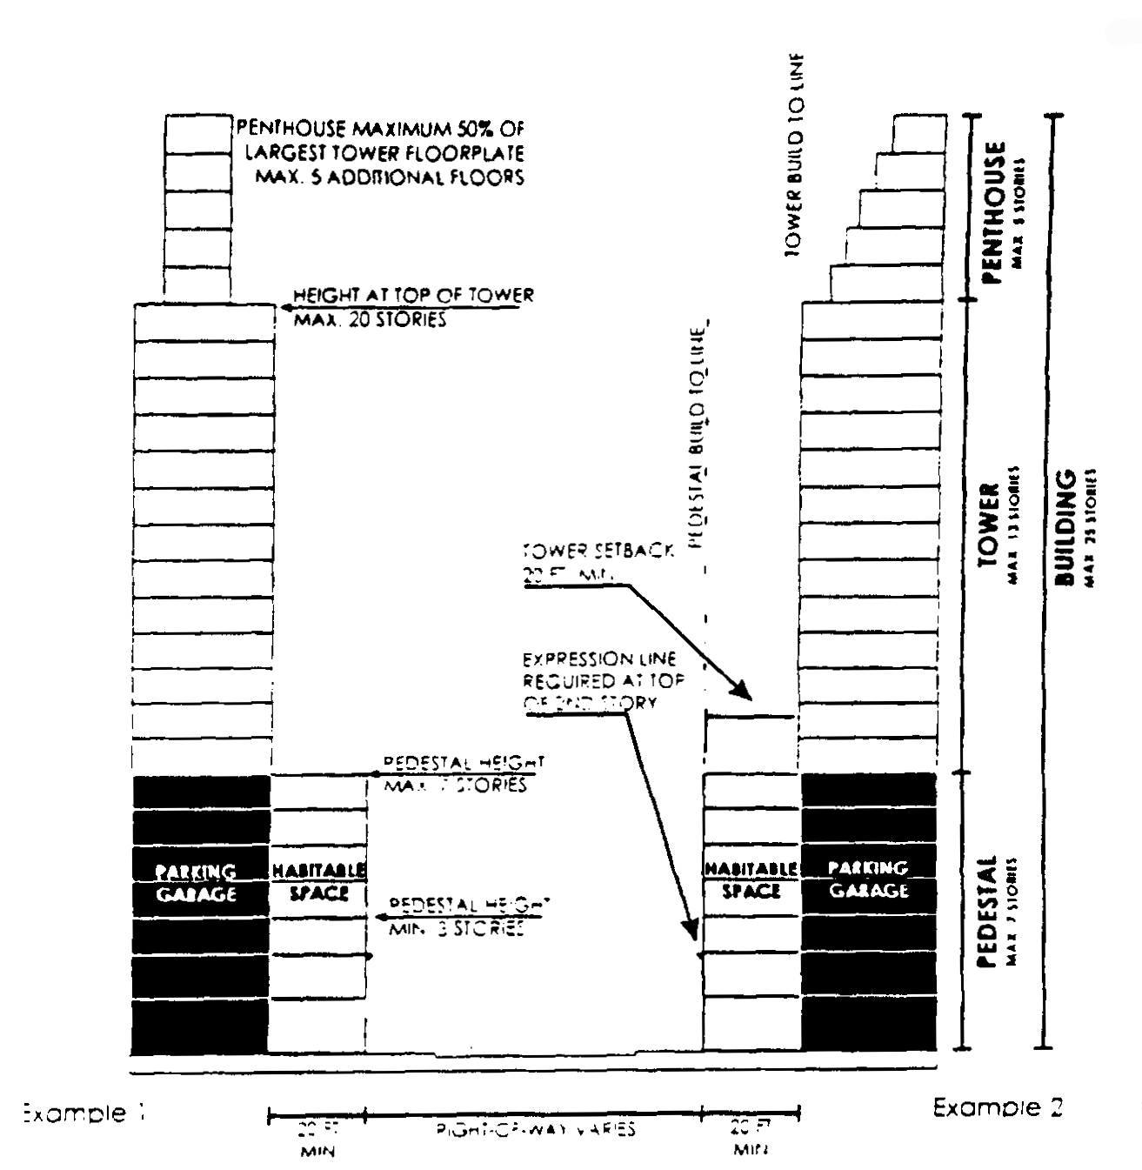

Core Sub-District—"B" Street

|  |  |
| --- | --- |
| Building Height | Pedestal—At street front three (3) stories minimum/seven (7) stories maximum. |
|  | Tower—Thirteen (13) stories maximum. |
|  | Penthouse—Five (5) stories maximum. Floorplate maximum is fifty (50) percent of largest tower floorplate below. |
| Building Placement | Front—Zero (0) foot build-to line for pedestal/twenty (20) foot minimum setback for tower and penthouse. |
|  | Interior Side/Rear—Zero (0) foot minimum setback for pedestal, tower and penthouse. |
|  | Frontage Length—Minimum seventy-five (75) percent of lot width. |
| Streetwalls | Vehicular Entries—Allowed. Each entry may be up to thirty-three (33) feet wide, with a minimum interval of sixty (60) feet of habitable space between each vehicular entry -along frontage. |
|  | Habitable Space—Twenty (20) foot minimum depth for full height and length of pedestal. |
|  | Expression Line—Required at the top of the second story. |
| Off-Street Parking | All Levels—Twenty (20) foot minimum setback from pedestal's build-to line. |

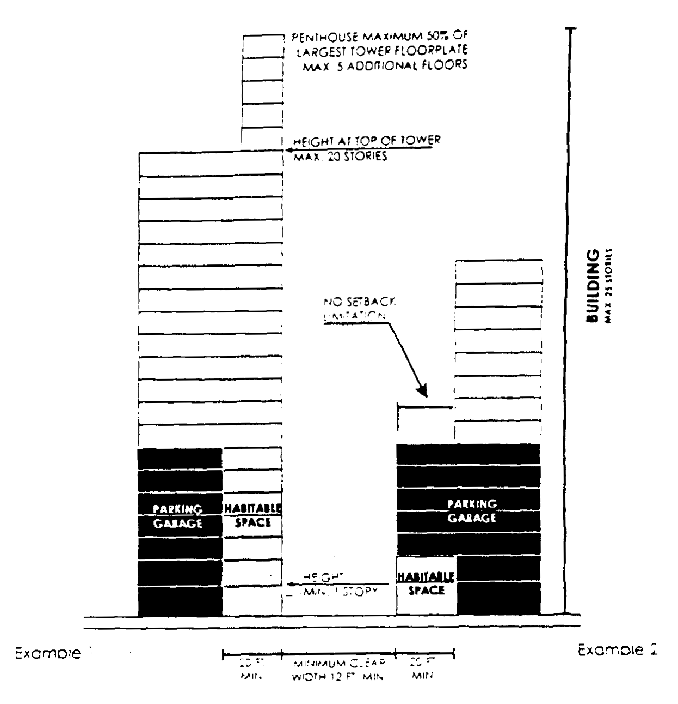

Core Sub-District—"C" Street

|  |  |
| --- | --- |
| Building Height | Pedestal—At street front one (1) story minimum/seven (7) stories maximum. |
|  | Tower—Thirteen (13) stories maximum. |
|  | Penthouse—Five (5) stories maximum. Floorplate maximum is fifty (50) percent of largest tower floorplate. |
| Building Placement | Spacing—A minimum clear width of twelve (12) feet is required between buildings. For vehicular access, a minimum clear width of sixteen (16) feet is required. |
|  | Interior Side/Rear—Zero (0) foot minimum setback for pedestal, tower and penthouse. |
|  | Overhead Cover—A maximum of twenty-five (25) percent of the street may be covered above the first floor with structures connecting buildings including roofs, upper story terraces, pedestrian bridges, or automobile bridges between parking garages. |
|  | Frontage Length—Minimum seventy-five (75) percent of lot width. |
| Streetwalls | Vehicular Entries—Allowed. Each entry may be up to thirty-three (33) feet wide, with a minimum interval of sixty (60) feet of habitable space between each vehicular entry along frontage. |
|  | Habitable Space—Twenty (20) foot minimum depth for first two (2) stories and full length of pedestal. |
|  | Expression Line—None required. |
| Off-Street Parking | Street Level—Twenty (20) foot minimum setback from pedestal's build-to line. |
|  | Other Levels—No setback required from pedestal's build-to line. |

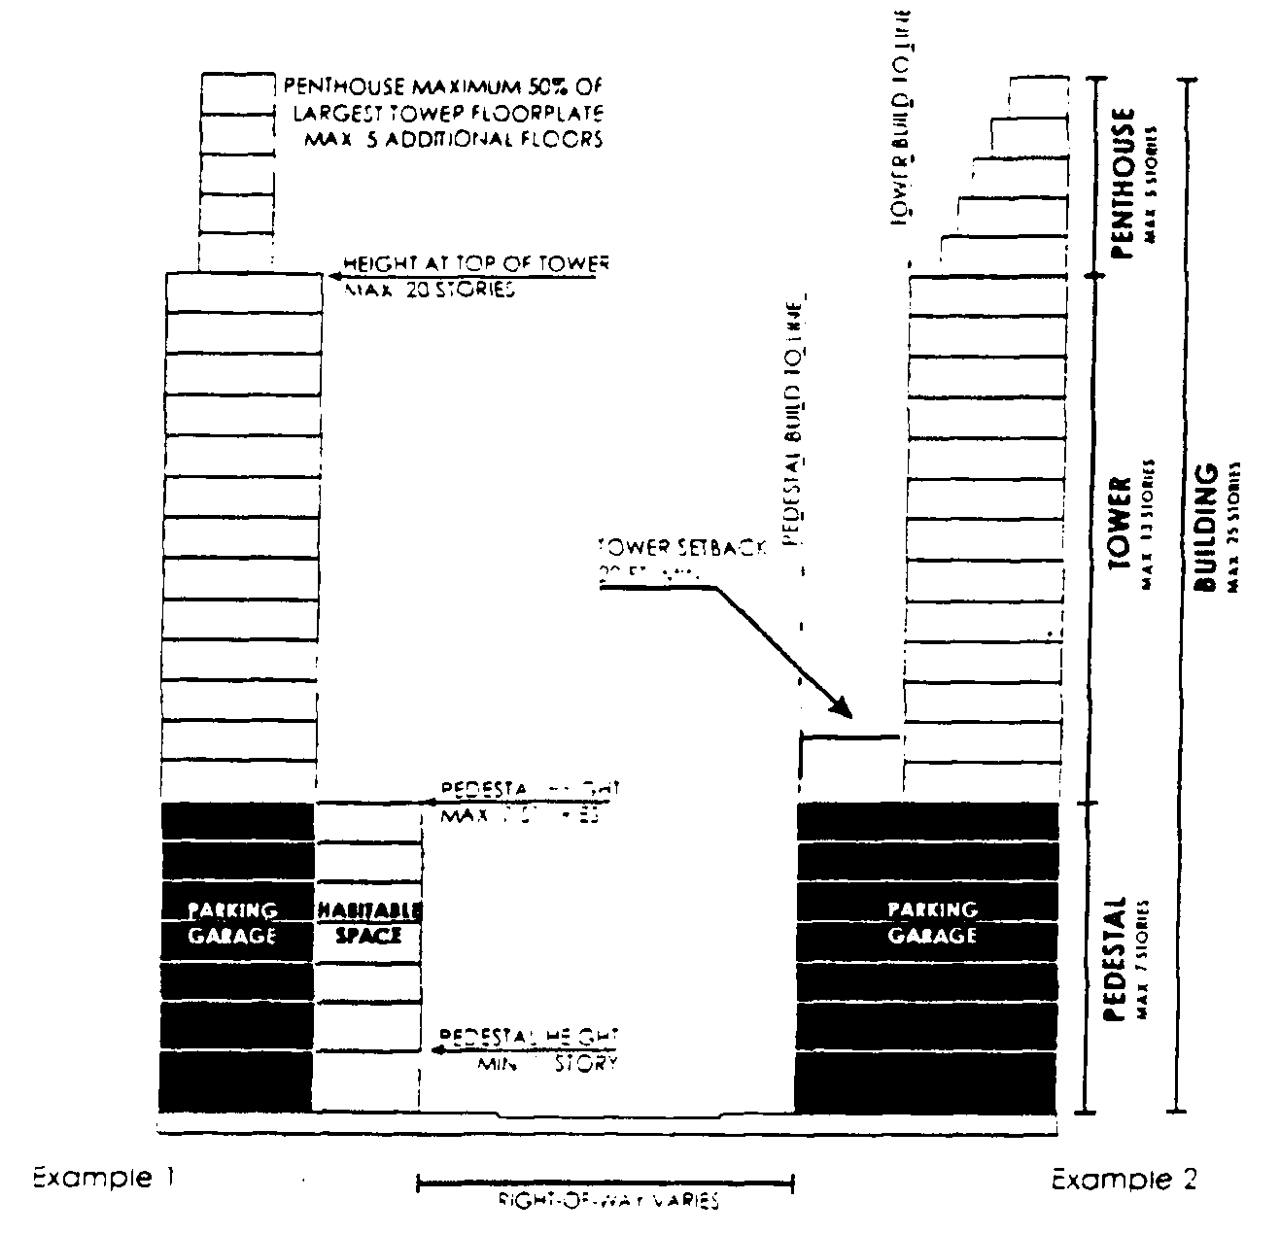

Core Sub-District—"D" Street

|  |  |
| --- | --- |
| Building Height | Pedestal—At street front one (1) story minimum/seven (7) stories maximum. |
|  | Tower—Thirteen (13) stories maximum. |
|  | Penthouse—Five (5) stories maximum. Floorplate maximum is fifty (50) percent of largest tower floorplate below. |
| Building Placement | Front—Zero (0) foot build-to line for pedestal/twenty (20) foot minimum setback for tower and penthouse. |
|  | Interior Side/Rear—Zero (0) foot minimum setback for pedestal, tower and penthouse. |
|  | Frontage Length—Minimum fifty (50) percent of lot width. |
| Streetwalls | Vehicular Entries—Vehicular entries and utility entries are permitted. |
|  | Habitable Space—No limitations. |
|  | Expression Line—None required. |
| Off-Street Parking | Street Level—No setback required from pedestal's build-to line. |
|  | Other Levels—No setback required from pedestal's build-to line. |

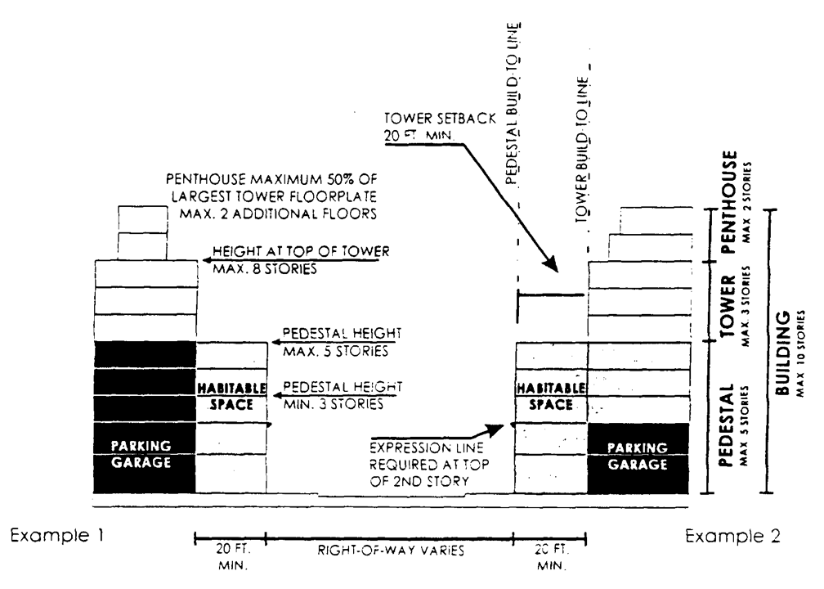

Center Sub-District—"A" Street

|  |  |
| --- | --- |
| Building Height | Pedestal—At street front three (3) stories minimum/five (5) stories maximum. |
|  | Tower—Three (3) stories maximum. |
|  | Penthouse—Two (2) stories maximum. Floorplate maximum is fifty (50) percent of largest tower floorplate below. |
| Building Placement | Front—Zero (0) foot build-to line for pedestal/twenty (20) foot minimum setback for tower and penthouse. |
|  | Interior Side/Rear—Zero (0) foot minimum setback for pedestal, tower and penthouse. |
|  | Frontage Length—Minimum eighty (80) percent of lot width. Free standing colonnades shall not count for frontage length. |
| Streetwalls | Colonnade—Two (2) story high for full required frontage at build-to line. Fifteen (15) foot minimum depth. Colonnade depth shall not exceed colonnade height. Exterior of colonnade shall be no closer than two (2) feet from curb line. |
|  | Vehicular Entries—Not permitted, except when not accessible from a street of lesser hierarchy. If other frontages do not permit vehicular entries, the maximum vehicular entry width permitted shall be thirty-three (33) feet. |
|  | Habitable Space—Twenty (20) foot minimum depth for full height and length of pedestal. |
|  | Expression Line—Required at the top of the second story. |
| Off-Street Parking | Colonnade Levels—Twenty (20) foot minimum setback from interior wall of colonnade. |
|  | Other Levels—Twenty (20) foot minimum setback from pedestal's build-to line. |

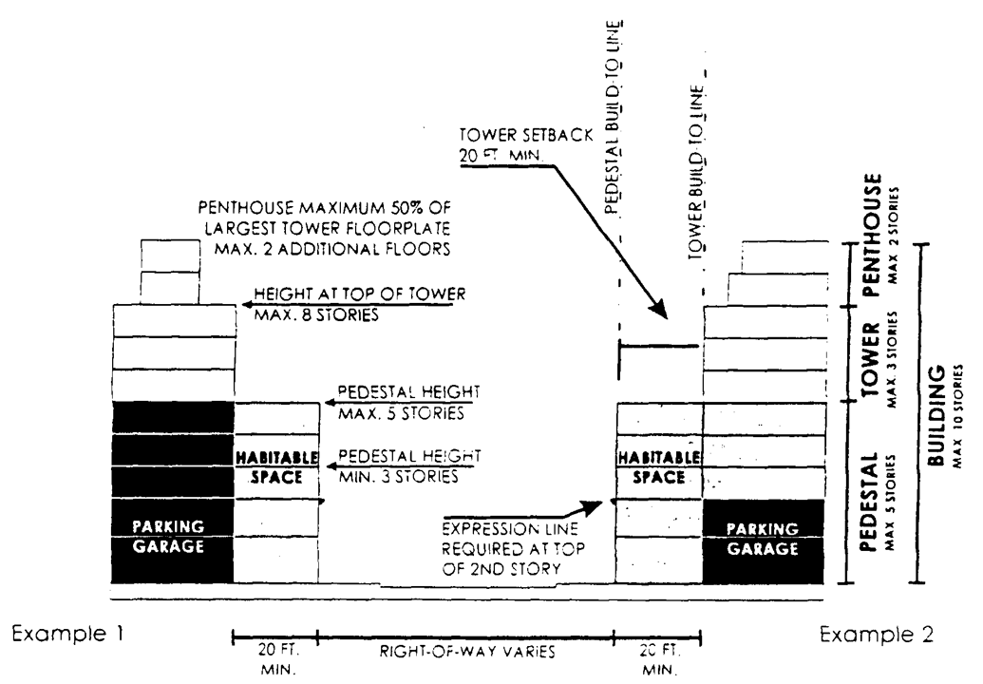

Center Sub-District—"B" Street

|  |  |
| --- | --- |
| Building Height | Pedestal—At street front three (3) stories minimum/five (5) stories maximum. |
|  | Tower—Three (3) stories maximum. |
|  | Penthouse—Two (2) stories maximum. Floorplate maximum is fifty (50) percent of largest tower floorplate below. |
| Building Placement | Front—Zero (0) foot build-to line for pedestal/twenty (20) foot minimum setback for tower and penthouse. |
|  | Interior Side/Rear—Zero (0) foot minimum setback for pedestal, tower and penthouse. |
|  | Frontage Length—Minimum seventy-five (75) percent of lot width. |
| Streetwalls | Vehicular Entries—Allowed. Each entry may be up to thirty-three (33) feet wide, with a minimum interval of sixty (60) feet of habitable space between each vehicular entry along frontage. |
|  | Habitable Space—Twenty (20) foot minimum depth for full height and length of pedestal. |
|  | Expression Line—Required at the top of the second story. |
| Off-Street Parking | All Levels—Twenty (20) foot minimum setback from pedestal's build-to line. |

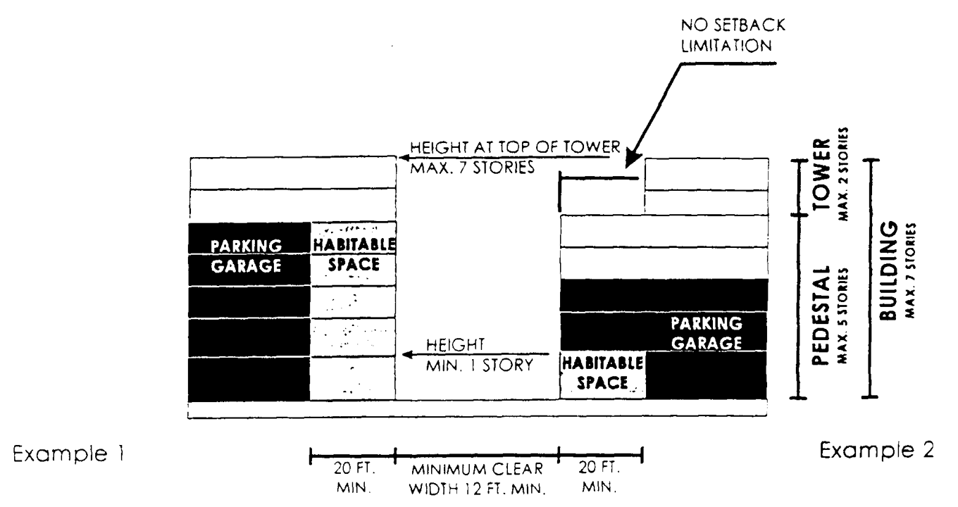

Center Sub-District—"C" Street

|  |  |
| --- | --- |
| Building Height | Pedestal—At street front one (1) story minimum/five (5) stories maximum. |
|  | Tower—Three (3) stories maximum. |
|  | Penthouse—Two (2) stories maximum. Floorplate maximum is fifty (50) percent of largest tower floorplate below. |
| Building Placement | Spacing—A minimum clear width of twelve (12) feet is required between buildings. For vehicular access, a minimum clear width of sixteen (16) feet is required. |
|  | Interior Side/Rear—Zero (0) foot minimum setback for pedestal, tower and penthouse. |
|  | Overhead Cover—A maximum of twenty-five (25) percent of the street may be covered above the first floor with structures connecting buildings including roofs, upper story terraces, pedestrians bridges, or automobile bridges between parking garages. |
|  | Frontage Length—Minimum fifty (50) percent of lot width. |
| Streetwalls | Vehicular Entries—Allowed. Each entry may be up to thirty-three (33) feet wide, with a minimum interval of sixty (60) feet of habitable space between each vehicular entry along frontage. |
|  | Habitable Space—Twenty (20) foot minimum depth for first story and full length of pedestal. |
|  | Expression Line—None required. |
| Off-Street Parking | Street Level—Twenty (20) foot minimum setback from pedestal's build-to line. |
|  | Other Levels—No setback required from pedestal's build-to line. |

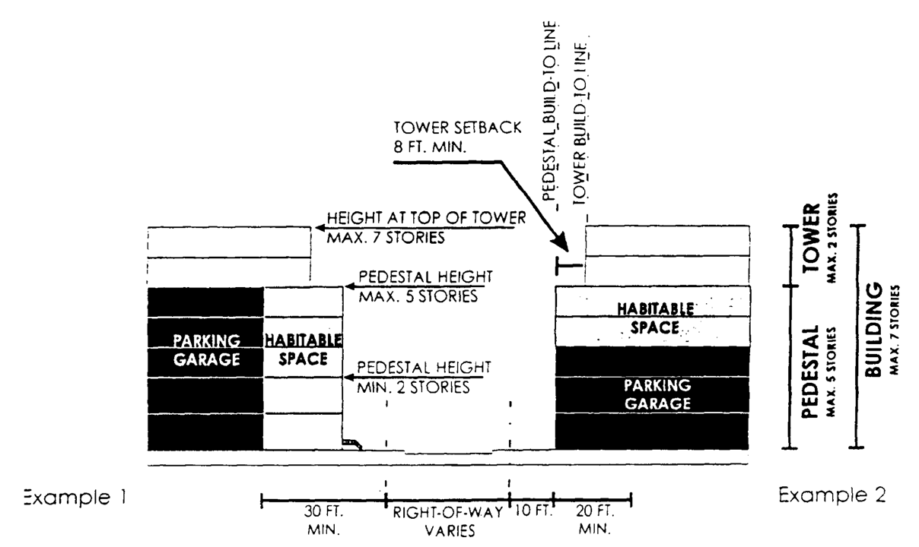

Center Sub-District—"D" Street

|  |  |
| --- | --- |
| Building Height | Pedestal—At street front one (1) story minimum/five (5) stories maximum. |
|  | Tower—Three (3) stories maximum. |
|  | Penthouse—Two (2) stories maximum. Floorplate maximum is fifty (50) percent of largest tower floorplate below. |
| Building Placement | Front—Zero (0) foot build-to line for pedestal/twenty (20) foot minimum setback for tower and penthouse. |
|  | Interior Side/Rear—Zero (0) foot minimum setback for pedestal, tower and penthouse. |
|  | Frontage Length—Minimum fifty (50) percent of lot width. |
| Streetwalls | Vehicular Entries—Vehicular entries and utility entries are permitted. |
|  | Habitable Space—No limitations. |
|  | Expression Line—None required. |
| Off-Street Parking | Street Level—Twenty (20) foot minimum setback from pedestal's build-to line. |
|  | Other Levels—No setback required from pedestal's build-to line. |

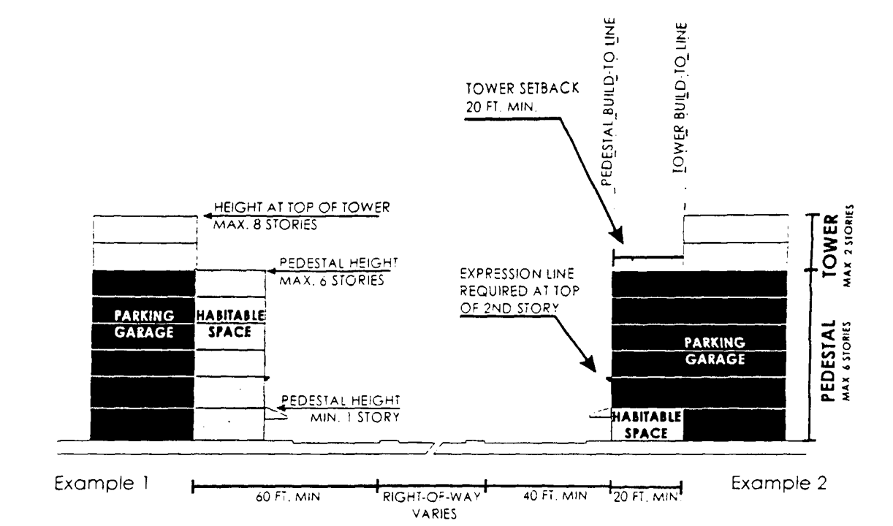

|  |  |
| --- | --- |
| Building Height | Pedestal—At street front one (1) story minimum/six (6) stories maximum. |
|  | Tower—Two (2) stories maximum. |
| Building Placement | Front—Build-to line forty (40) feet from right-of way for pedestal/sixty (60) foot minimum setback from right-of-way for tower. |
|  | Interior Side/Rear—Twenty (20) foot minimum setback for pedestal/thirty (30) foot minimum setback for tower. |
|  | Frontage Length—Minimum fifty (50) percent of lot width. |
| Streetwalls | Vehicular Entries—Allowed. Each entry may be up to thirty-three (33) feet wide, with a minimum interval of seventy (70) feet between each vehicular entry along frontage. |
|  | Habitable Space—Twenty (20) foot depth minimum for first story and entire length of pedestal. |
|  | Expression Lines—Required at the top of the second story. |
| Off-Street Parking | Street Level—Eight (8) foot minimum setback from the front property line. |
|  | Other Levels—Parking garages may be no closer to the front property line than the build-to line. At least one (1) vehicular connection shall be provided between surface parking lots and garages, across property lines. |

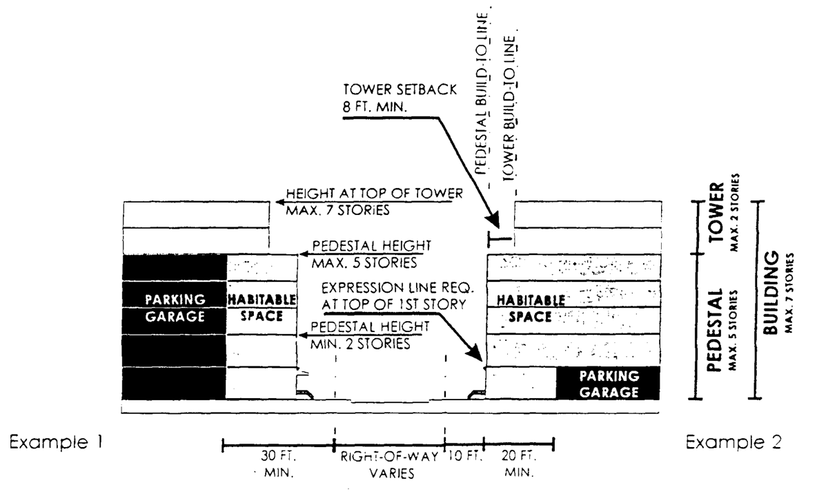

**Edge Sub-District—"B" Street**

|  |  |
| --- | --- |
| Building Height | Pedestal—At street front two (2) stories minimum/five (5) stories maximum. |
|  | Tower—Two (2) stories maximum, including pedestal. |
| Building Placement | Front—Build-to line ten (10) feet from right-of-way for pedestal/eighteen (18) foot minimum setback from right-of-way for tower. |
|  | Interior Side/Rear—Eight (8) foot minimum setback for first two (2) stories, two (2) foot additional setback for each additional story. |
|  | Frontage Length—Minimum seventy-five (75) percent of lot width. |
| Streetwalls | Vehicular Entries—Allowed. Each entry may be up to thirty-three (33) feet wide, with a minimum interval of sixty (60) feet of habitable space between each vehicular entry along frontage. |
|  | Habitable Space—Twenty (20) foot minimum depth for full height and length of pedestal. |
|  | Expression Line—Required at the top of the first story. |
| Off-Street Parking | All Levels—Twenty (20) foot minimum setback from pedestal's build-to line. |



**Edge Sub-District—"C" Street**

|  |  |
| --- | --- |
| Building Height | Pedestal—At street front one (1) story minimum/five (5) stories maximum. |
|  | Tower—Two (2) stories maximum. |
| Building Placement | Spacing—A minimum clear width of twelve (12) feet is required between buildings. For vehicular access, a minimum clear width of sixteen (16) feet is required. For a minimum fifty (50) percent of its length. C street width shall be at a minimum thirty-three (33) percent of its abutting building height. If a C street abuts a property line, there shall be a twelve (12) foot minimum setback for the pedestal and thirty (30) foot minimum setback for the tower. |
|  | Overhead Cover—A maximum of twenty-five (25) percent of the street may be covered above the first floor with structures connecting buildings including roofs, upper story terraces, pedestrians bridges, or automobile bridges between parking garages. |
|  | Frontage Length—Minimum twenty-five (25) percent of lot width. |
| Streetwalls | Vehicular Entries—Allowed. Each entry may be up to thirty-three (33) feet wide, with a minimum interval of sixty (60) feet of habitable space between each vehicular entry along frontage. |
|  | Habitable Space—Twenty (20) foot minimum depth for first story and full length of pedestal. |
|  | Expression Line—None required. |
| Off-Street Parking | Street Level—Twenty (20) foot minimum setback from pedestal's build-to line. |
|  | Other Levels—No setback required from pedestal's build-to line. |



**Edge Sub-District—"D" Street**

|  |  |
| --- | --- |
| Building Height | Pedestal—At street front two (2) stories minimum/five (5) stories maximum. |
|  | Tower—Two (2) stories maximum. |
| Building Placement | Front—Build-to line ten (10) feet from right-of-way for pedestal/eighteen (18) foot minimum setback from right-of-way for tower. |
|  | Interior Side/Rear—Eight (8) foot minimum setback for first two (2) stories, two (2) foot additional setback for each additional story. |
|  | Frontage Length—Minimum fifty (50) percent of lot width. |
| Streetwalls | Vehicular Entries—Vehicular entries and utility entries are permitted. |
|  | Habitable Space—No limitations. |
|  | Expression Line—None required. |
| Off-Street Parking | Street Level—Twenty (20) foot minimum setback from pedestal's build-to line. |
|  | Other Levels—No setback required from pedestal's build-to line. |

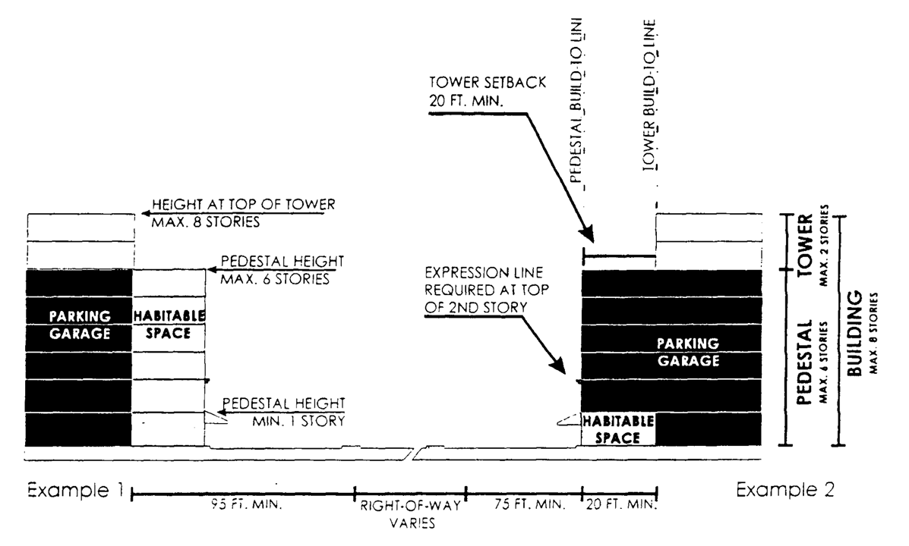

**Edge Sub-District—"E" Street**

|  |  |
| --- | --- |
| Building Height | Pedestal—At street front one (1) story minimum/six (6) stories maximum. |
|  | Tower—Two (2) stories maximum. |
| Building Placement | Front—Build-to line seventy-five (75) feet from right-of-way for pedestal/ninety-five (95) foot minimum setback from right-of-way for tower. |
|  | Interior Side/Rear—Twenty (20) feet minimum setback for pedestal/thirty (30) foot minimum setback for tower. |
|  | Frontage Length—Minimum fifty (50) percent of lot width. |
| Streetwalls | Vehicular Entries—Allowed. Each entry may be up to thirty-three (33) feet wide, with a minimum interval of seventy (70) feet between each vehicular entry along frontage. |
|  | Habitable Space—Twenty (20) foot minimum depth for first story and entire length of pedestal. |
|  | Expression Lines—Required at the top of the second story. |
| Off-Street Parking | Street Level—Eight (8) foot minimum setback from the front property line. |
|  | Other Levels—Parking garages may be no closer to the front property line than the build-to line. At least one (1) vehicular connection shall be provided. |

(B) General Requirements. All new development and redevelopment shall comply with the following parameters irrespective of Sub-District and frontage categories:

(1) Permitted Uses.

(a) Permitted uses in Core and Center Sub-Districts shall be as follows:

All business and civic uses permitted in the BU-1, BU-1A, BU-2 Districts, and the following:

i. Area for residential uses shall not require public hearing.

ii. The following BU-3 uses shall be permitted:

a. Bakeries, retail and wholesale.

b. Cabinet working and carpentry shops.

c. Locksmith shops.

d. Secondhand stores.

e. Television and broadcasting stations.

f. Upholstery and furniture repairs.

iii. Outside food sales and services including, but not limited to, outdoor dining, cart vendors, and merchandise displays shall not require public hearing.

iv. Drive-in services shall be concealed from "A", "B" and "C" streets by buildings or garden walls.

v. The provisions of [Section 33-150](../level3/PTIIICOOR_CH33ZO_ARTXALBE.docx#PTIIICOOR_CH33ZO_ARTXALBE_S33-150LOES)(A) and (B) of this Code regarding alcoholic beverages shall not apply.

(b) Land uses permitted in Edge Sub-Districts shall be as follows:

1. Edge Sub-district west of SW 72nd Avenue and north of Snapper Creek Canal.

i. All residential and civic uses permitted in the RU-4, RU-4A, and RU-4M Districts.

ii. Up to one (1) percent of each building's floor area may be BU-1 business uses. Up to four (4) percent of each building's floor area that fronts a street or a square may have BU-1 business uses facing the street or square.

2. Edge Sub-district east of U.S. Highway 1.

i. All residential and civic uses permitted in the RU-4, RU-4M and RU-4A Districts.

ii. All business and civic uses permitted in the BU-1, BU-1A, BU-2, BU-3, RU-5, RU-5A Districts, except as follows:

iii. Area for residential uses shall not require public hearing.

iv. Outside food sales and service including, but not limited to, outdoor dining, cart vendors, and merchandise displays shall not require public hearing.

v. Drive-in services shall be concealed from "A", "B" and "C" streets by buildings or garden walls.

For Edge Sub-District properties east of US Highway 1 that border an adjacent residential zone, the buildings located within of one hundred (100) feet of the affected rear or side of the property boundary shall not exceed the adjacent district height restrictions by more than two (2) stories.

Primary access to all retail uses fronting on both a street and a paseo, or on both a street and a courtyard garden, shall be from the street.

(2) Lots and Buildings.

(a) Minimum lot size is two thousand (2,000) square feet with a minimum frontage of twenty (20) feet.

(b) All lots shall share a frontage line with a street or square.

(c) Each story shall be between eight (8) feet and fourteen (14) feet high from floor to ceiling. Floors more than fourteen (14) feet, as measured from floor to ceiling, will count as additional floors. Within the pedestal, one (1) story may exceed fourteen (14) feet, up to thirty (30) feet, provided no mezzanine area intended for commercial use exceeds ten (10) percent and no mezzanine area intended for residential use exceeds eighty (80) percent of the area of the floor immediately below.

(d) No replatting or subdivision shall serve as a basis for deviating from this Article.

(e) All buildings shall have their main pedestrian entrance opening to an "A", "B", "C", or "E" street, courtyard garden or square. There shall be pedestrian entrances at maximum intervals of seventy-five (75) feet along "A," and "B" Streets. When ground level uses have entries from both streets and other public open space, the primary entrance will be from the street. Doors facing streets shall remain operational during business hours.

(f) Maximum building floorplates above eight stories for all uses shall be twenty thousand (20,000) square feet. Cantilever balconies six (6) feet or less in depth shall not be counted towards the maximum building floorplate area.

(g) Minimum spacing between towers within any one (1) continuous property line is sixty (60) feet.

(h) Aggregate tower frontage facing any street may not exceed two hundred twenty-five (225) feet per block or seventy (70) percent of street frontage, whichever is greater.

(i) Where an "A" "B" or "D" street intersects with another street, the corner of the building may need to be chamfered (angled) or rounded to satisfy view triangle and minimum sidewalk width requirements, and to make room for traffic signal poles (see diagram 1). The angled wall of the building shall count toward frontage requirements for both streets that it fronts. In situations where the view triangle causes the front facade to "bend" at a shallow angle from the street, the angled or rounded wall may set back farther from the street intersection for esthetic and structural reasons. However, the setback shall not be farther than twenty (20) feet measured from the intersection of the two (2) property lines perpendicularly to the front plane of the angled wall. For curved walls this will be measured to the midpoint of the curve. The depth of the colonnade underneath the angled wall of the building shall also be a minimum of fifteen (15) feet.

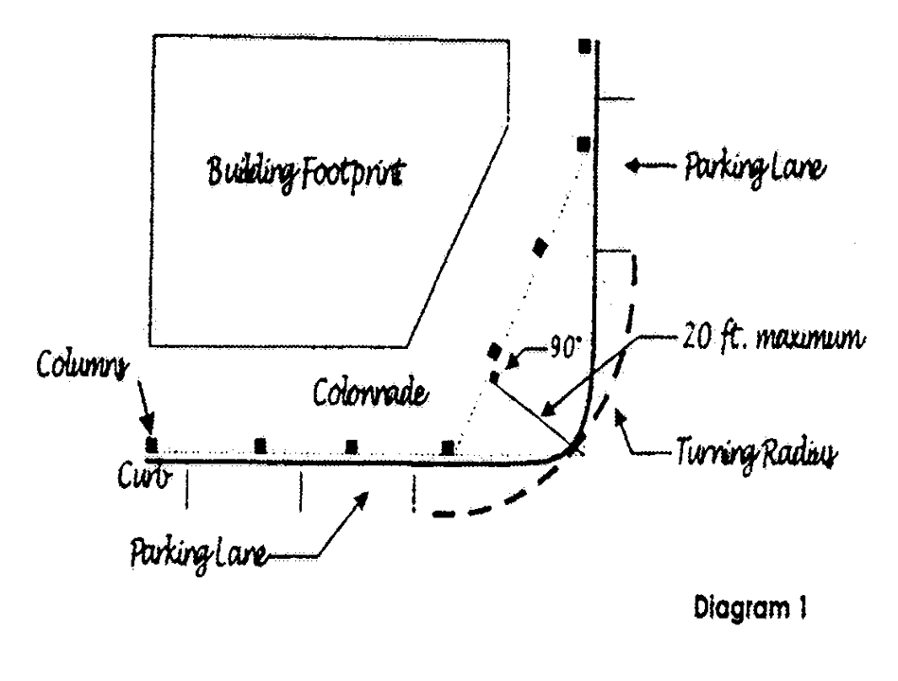

**Diagram 1**

(j) Building design shall use energy conservation measures including, but not limited to, self-shading, natural lighting, natural ventilation, outdoor circulation, and reduced dependence on artificial lighting and air conditioning. Porches, balconies, breezeways, pergolas, deep eaves, eyebrows and other elements promoting natural ventilation and shading are encouraged. Each building shall dedicate a specific location for recycling separation, storage and access.

(k) Vehicular entry gates at garage entries shall be positioned a minimum of twenty (20) feet behind the front wall of the building. At colonnaded frontages, this distance is measured from the interior/rear wall of the colonnade. To increase safety during off-hours, the setback area between the entry gate and the public sidewalk may be gated at the sidewalk edge during times when the garage is closed.

(l) Exterior finish material shall be limited to concrete, stucco, quarried stone, cast stone, decorative concrete block, terra cotta, tile, metal, and glass. Wood and marble door and window surrounds are permitted, as are wood pergolas and trellises. Fabric awnings are permitted without back lighting.

(m) Glazing and Transparency Requirements:

(1) Building streetwall surfaces shall be a minimum thirty (30) percent glazed. Mirror-type glass shall not be allowed. All glazing shall be of a type that permits view of human activities and spaces within. Glazing shall be clear or very lightly tinted, except where used for screening garages, where it may be translucent.

(2) Storefronts shall be provided on the first floor, directly accessible from Public Space. Storefronts shall be a minimum of sixty (60) percent clear-glazed except for jewelry stores, which may be a minimum of twenty (20) percent, and for residential uses which may be a minimum of forty (40) percent. Except for entrance doors, the bottom edge of the glazed areas shall be between eighteen (18) and thirty-six (36) inches above the sidewalk.

(3) Storefront security screens, if any, shall be of the mesh type that pedestrians can see through and shall be located behind storefront displays. Storefronts shall remain open to view and lit from within at night.

(4) Parking garage and loading area security screens and gates shall be a minimum of fifty (50) percent transparent.

(n) Colonnade column spacing, windows, and doors shall have a vertical proportion. The spacing of the columns of a colonnade, measured from the centerline of the columns, shall not be greater than the height of the colonnade.

(o) Cantilevers and moldings shall not exceed three (3) feet in extension beyond the vertical wall surface, unless visibly supported by brackets or other supports.

(p) Parking garages shall have all architectural expression facing public open space consistent and harmonious with that of habitable space. The architectural expression shall include vertically proportioned openings, balconies, glazing, awnings, or other similar architectural elements. Ramping is encouraged to be internalized wherever possible. Exposed spandrels are prohibited. The exposed top level of parking structures shall be covered a minimum of sixty (60) percent with a shade producing structure such as a vined pergola or retractable canvas shade structure. All garage lighting installations shall be designed to minimize direct spillage, sky glow and hazardous interference with vehicular traffic on adjacent rights-of-way and all adjacent properties; this may be achieved through the use of down-turned building beams, garage screening, landscaping, or other similar architectural elements.

(q) No building fixtures such as backflow preventers, pumps, underground ventilation exhausts, substations or similar shall be permitted above the ground within colonnades, sidewalks and open spaces.

(3) Streets, Alleys, and Paseos. New streets shall be located according to the Street Frontage Plan. These locations are schematic to allow flexibility in the design of the site plan. The design of new streets and modifications to existing streets shall follow the requirements below:

(a) Streets shall provide access to all building lots and tracts.

(b) All streets, alleys and paseos shall connect to other streets. Cul-de-sacs, and T-turnarounds are not permitted. Dead-end streets are only permitted for those shown on the Street Frontages Plan when the adjacent property has not been developed or redeveloped.

(c) No block face shall have a length greater than three hundred and twenty-five (325) feet without a street, paseo, courtyard garden or alley providing through access to another street, alley, or paseo.

(d) All new "A", "B" and "D" streets, both public and private, shall have a minimum right-of-way width of fifty-four (54) feet. All new "A", "B" and "D" streets shall have curb and gutter, and have sidewalks on both sides of the travel lanes. Where possible, there shall be parking lanes which in addition to on-street parking may be used for "drop off" areas, valet stands, or bus stops.

i. All sidewalks shall have a minimum width of ten (10) feet, and a continuous unobstructed area of a width no less than sixty (60) inches. This area shall be unobstructed by utility poles, fire hydrants, benches or any other temporary or permanent structures. Free and clear public use of sidewalk area outside of the right-of-way shall be protected by a public access easement.

ii. On-street parking lanes shall not be closer than twenty-five (25) feet to intersections measured from the intersecting property lines (see diagram 2).

iii. All streets, except "C" streets, shall have at least two (2) travel lanes, one (1) in each direction; however, streets around squares may have one (1) travel lane with one-way traffic.

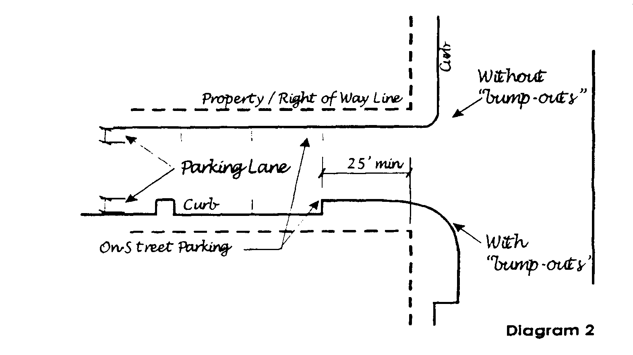

**Diagram 2**

(e) In addition to the required "D" streets designated in the Street Frontage Plan, "D" streets or alleys are encouraged to the rear of building lots.

(f) Curb radii at intersections shall be thirty-four (34) feet six (6) inches or less.

(g) A minimum turning radius of thirty-six (36) feet shall be provided at street intersections. A clear zone is required when the curb extends beyond the turnout radius.

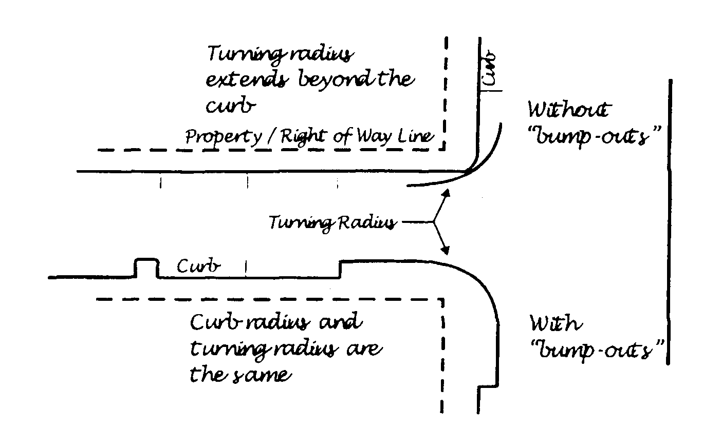

**Diagram 3**

(h) Awnings, balconies, roof eaves, signs, porches stoops and ramps may encroach into setbacks. Awnings, balconies, roof eaves and signs may encroach into rights-of-way; however, they shall not extend a distance closer than six (6) inches from the curb face. All right-of-way encroachments shall be a minimum one hundred thirty-two (132) inches above the sidewalk. Encroachments shall not be taller than the building or pedestal, whichever is lower.

(i) With the exception of fire hydrants, utilities shall run underground and above-ground projections of utilities shall be placed in or along rights-of-way of streets of lower pedestrian quality, wherever practicable.

(4) Courtyard Gardens, Street and Garden Walls, Fences and Hedges. Street and garden walls, fences and hedges may be placed along property lines, at a height not to exceed ninety-six (96) inches, except in the Edge Sub-District, where side and rear yard walls are limited to seventy-two (72) inches in height. At street frontages, street and garden walls and fences shall be minimum fifty (50) percent transparent, and between thirty-six (36) inches and seventy-two (72) inches above grade for at least eighty (80) percent of the length. Pillars and posts shall average no more than ten (10) feet apart. Chain link fences are not permitted, except for temporary construction fences.

Only where necessary, walls, fences and hedges along street frontages shall angle away from street intersections and driveways to avoid obstructing the sight visibility triangles or to provide the minimum eight (8) foot sidewalk width at the intersecting streets.

A courtyard garden shall have at least two (2) sides enclosed by building walls; the remaining sides shall be enclosed by either fences or garden walls, and a minimum thirty (30) percent of its area shall be landscaped. The street opening to the courtyard garden shall not exceed the width of the street or square that it opens on to.

(5) Open Space and Recreation Areas.

(a) Private Open Spaces. A minimum of fifteen (15) percent of each net site shall be reserved for private open space. Colonnades, greens, landscaped roof terraces on buildings or garage structures can be counted towards this requirement.

(b) Designated Open Spaces. Designated open space in the form of colonnades, squares and plazas shall be located according to the Designated Open Space Plan. All designated open spaces shall be at grade level and shall be accessible to the public. No replatting or other land division shall divide property in such a way that the provision of the required designated open space is avoided or its location changed. Designated open space areas provided in compliance with this section of the code shall count towards the private open space requirement provided herein.

Location, area and dimensions of the designated open spaces shall conform with the Designated Open Space Plan. Total square area must be in accordance with the Designated Open Space Plan; and the square must include the anchor point specified on the Designated Open Space Plan. At least three (3) corners of a square shall have a street intersection; and squares shall have a minimum dimension of one hundred fifty (150) feet between surrounding vehicular access ways.

Squares and plazas shall be densely shaded and provide seating. Trees and shrubs (shrubs are not permitted in plazas) shall be of sufficient quantity and located as to define a specific geometry of open space and shall promote security by allowing visibility through all areas. Ground surface shall be a combination of paving, lawn or ground cover integrated in design with trees and shrubs. Fountains, sculpture, and works of art are encouraged. Street furniture in squares such as trash containers and bus benches shall be permanently secured to the sidewalk. Street furniture shall not obstruct sight visibility triangles at street intersections.

(c) Recreation Areas. Educational and child care facilities located within an Urban Center District shall be exempt from the outdoor recreation area requirements of Section [33-151.18](../level3/PTIIICOOR_CH33ZO_ARTXAEDCHCAFANO.docx#PTIIICOOR_CH33ZO_ARTXAEDCHCAFANO_S33-151.18PHST)(a) of this Code and shall be required to provide indoor and/or outdoor recreation areas subject to the following requirements:

|  |  |
| --- | --- |
| Categories | Required Recreation Area (*) |
| Child care/day nursery/kindergarten and preschool and after-school care | 22.5 square feet per child calculated in terms of half of the proposed maximum number of children for attendance at the school at one (1) time. |
| ;hg0;* Recreation Area consists of indoor and outdoor recreation areas. Indoor-recreation areas may consist of indoor playgrounds, indoor pools, gymnasiums and/or indoor ball courts and/or similar indoor recreation facilities. Outdoor recreation areas may include rooftop facilities. | |

(6) Parking.

(a) Parking shall be provided as per [Section 33-124](../level3/PTIIICOOR_CH33ZO_ARTVIIOREPA.docx#PTIIICOOR_CH33ZO_ARTVIIOREPA_S33-124ST) of this Code, except as follows:

(1) In the Core Sub-District, for all single use projects, the minimum parking permitted shall be:

i. Residential—One (1) parking space per dwelling unit.

ii. Office—One (1) parking space per four-hundred (400) square feet of gross floor area.

iii. Hotel—One (1) parking space for every two (2) guest rooms.

iv. Other uses—Use parking standard as specified in [Section 33-124](../level3/PTIIICOOR_CH33ZO_ARTVIIOREPA.docx#PTIIICOOR_CH33ZO_ARTVIIOREPA_S33-124ST) of this Code.

(2) In the Core Sub-District, required parking for mixed-use projects shall be calculated by applying the Urban Land Institute (ULI) Shared Parking Methodology, on file with the Director, to the parking standards above. Required parking shall fulfill between ninety (90) percent and one hundred ten (110) percent of the calculated requirement.

(3) In the Center and Edge Sub-Districts, parking requirements for mixed-use projects shall be calculated by applying the (ULI) Shared Parking Methodology to the parking standards as specified in [Section 33-124](../level3/PTIIICOOR_CH33ZO_ARTVIIOREPA.docx#PTIIICOOR_CH33ZO_ARTVIIOREPA_S33-124ST) of this Code. Parking shall fulfill between ninety (90) percent and one hundred ten (110) percent of the ULI calculated requirement.

(4) Off-street parking areas shall be located on the same lot, parcel or premises as the use to be served; or may be on a lot or parcel of land that is in the Downtown Kendall Urban Center District and is within three hundred (300) feet from the site of such use(s) to be served; provided such use(s) shall immediately terminate in the event such parking area therefor is not available and all those having any right, title or interest in and to such property site shall execute and place on the public records of this County a covenant approved by the Director that such use(s) shall cease and terminate upon the elimination of such parking area, and that no use shall be made of such property until the required parking area is available and provided.

(5) On-street parking spaces directly abutting a lot shall count toward the parking requirement for development of that lot, except that such spaces shall not count toward parking requirements for disabled persons or persons transporting baby strollers. All such on-street spaces shall be designed in accordance with the requirements of [Section 33-284.62](../level3/PTIIICOOR_CH33ZO_ARTXXXIII_I_DOKEURCEDI.docx#PTIIICOOR_CH33ZO_ARTXXXIII_I_DOKEURCEDI_S33-284.62DEPA)(C) of this code.

(b) Surface parking lots shall be located a minimum of twenty (20) feet from the front property line along "A" and "B" Streets. Streetwalls and/or habitable space shall be built at the frontage line or at the build-to line to screen parking from view.

(c) Parking garages shall be screened at all frontages except "D" streets by a minimum setback of twenty (20) feet of habitable space.

(d) Parking garages on parcels of record as of the date of approval of this Article facing "A" streets that have a lot depth at any one (1) point of less than one hundred fifty (150) feet are required to provide habitable space only at the colonnade levels. However, architectural expression shall remain required as per this article.

(e) Drop off drives and porte-cocheres fronting onto "A" or "B" street frontages may only occur behind habitable space, in courtyard gardens, on "C" and "D" streets, and alleys.

(f) Loading and service entries shall be allowed only on "D" streets, alleys and within parking lots and structures. For those properties with frontages only on "A", "B" and "C" streets loading and servicing shall be allowed on the street frontage.

(g) Pedestrian entries to parking garages shall be directly from the street or paseo as well as from the contiguous building. Pedestrian entries to garages shall be linked to cross-block paseos wherever possible.

(h) Vehicular entries to garages shall be allowed only from rights-of-way, paseos and alleys. Vehicular entries on "A", "B", "C", and "E" frontages shall have a maximum width of thirty-three (33) feet with a minimum separation of seventy (70) feet between entries. On "D" streets they shall not be limited.

(i) Parking lots shall provide for pedestrian and vehicular cross access to existing and prospective adjacent parking lots.

(j) Parking stall dimensions and spaces for persons with disabilities and/or strollers shall be in accordance with Article VII of the Miami-Dade County Code.

(k) Bicycle racks shall be provided on all sites as per Ordinance No. 99-81.

(l) Mechanized parking shall be allowed for residential multi-family and non-residential buildings and when provided it shall be exempt from the provisions of [Section 33-122](../level3/PTIIICOOR_CH33ZO_ARTVIIOREPA.docx#PTIIICOOR_CH33ZO_ARTVIIOREPA_S33-122REDEPASP) of this Code. For the purpose of this article, mechanized parking shall be defined as a mechanism with vertical and horizontal transport capability that provides for automobile storage or retrieval. A mechanized parking space may be counted as a parking space required in this section provided that:

a. A queuing analysis is submitted and approved during the Administrative Site Plan and Architectural Review.

b. Mechanized parking shall be located within an enclosed building/garage which shall be screened along all frontages, except along a service road or a pedestrian passage, by a liner building containing a minimum depth of 20 feet of habitable space.

(m) The provisions of [Section 33-131](../level3/PTIIICOOR_CH33ZO_ARTVIIOREPA.docx#PTIIICOOR_CH33ZO_ARTVIIOREPA_S33-131USPAARCOPALO) of this Code shall not apply to the required parking for mixed-use developments.

(n) Child care facilities located within a mixed-use building shall be exempt from the auto-stacking requirements of Section [33-151.18](../level3/PTIIICOOR_CH33ZO_ARTXAEDCHCAFANO.docx#PTIIICOOR_CH33ZO_ARTXAEDCHCAFANO_S33-151.18PHST)(c) of this Code.

(Ord. No. 99-166, § 1, 12-16-99; Ord. No. 01-156, §§ 1, 2, 9-25-01; Ord. No. 01-161, § 2, 10-23-01; Ord. No. 02-11, § 3, 1-29-02; Ord. No. 02-152, § 1, 9-12-02; Ord. No. 09-81, § 4, 9-1-09)

Sec. 33-284.63. Additional parameters.

The following are required irrespective of frontage and Sub-District categories:

(A) *Landscape.* With the exception of Sections [18A-7](../level2/PTIIICOOR_CH18AMIDECOLAOR.docx#PTIIICOOR_CH18AMIDECOLAOR_S18A-7LAPLRECR), [18A-8](../level2/PTIIICOOR_CH18AMIDECOLAOR.docx#PTIIICOOR_CH18AMIDECOLAOR_S18A-8PRCELACO), [18A-9](../level2/PTIIICOOR_CH18AMIDECOLAOR.docx#PTIIICOOR_CH18AMIDECOLAOR_S18A-9COLAAD), [18A-11](../level2/PTIIICOOR_CH18AMIDECOLAOR.docx#PTIIICOOR_CH18AMIDECOLAOR_S18A-11LAMA), [18A-12](../level2/PTIIICOOR_CH18AMIDECOLAOR.docx#PTIIICOOR_CH18AMIDECOLAOR_S18A-12PR) and [18A-13](../level2/PTIIICOOR_CH18AMIDECOLAOR.docx#PTIIICOOR_CH18AMIDECOLAOR_S18A-13EN), the provisions of [Chapter 18A](../level2/PTIIICOOR_CH18AMIDECOLAOR.docx#PTIIICOOR_CH18AMIDECOLAOR) of the Code of Miami-Dade County, Florida, shall not apply, except as provided for below. Trees and landscape shall be required for streets, medians, squares, plazas, and private property in accordance with the following:

(1) Street Trees: Street trees shall be placed along "B", "C" and "E" Streets at a maximum average spacing of twenty (20) feet on center. Street trees shall have a minimum caliper of six (6) inches and shall have a minimum clear trunk of eight (8) feet at the time of planting. Palms shall not be used as street trees. Street trees are not required when colonnades are provided along the street.

(2) Median Trees: Median trees shall have a minimum caliper of six (6) inches and shall have a minimum clear trunk of eight (8) feet at time of planting. Median planting shall provide a one hundred (100) percent canopy coverage within two (2) years of installation. Median trees may be a maximum of twenty (20) percent flowering trees or palms, which at time of planting shall have a minimum height of fifteen (15) feet, a minimum spread of ten (10) feet, and a minimum caliper of three (3) inches.

(3) Square and Plaza Trees: Trees on squares and plazas shall have a minimum caliper of six (6) inches and shall have a minimum clear trunk of eight (8) feet. Trees on squares and plazas shall provide a one-hundred (100) percent canopy coverage for eighty (80) percent of the entire square within five (5) years of installation. Trees for squares and plazas may be ten (10) percent palms of the following species: phoenix canariensis (Canary Island Date Palm); phoenix dactylifera (North African Date Palm); 'Medjool' (Date Palm); and 'Zahidi' (Date Palm); phoenix sylvestris (Wild Date Palm); roystonea elata (Florida Royal Palm) and regia (Cuban Royal Palm).

(4) With the exception of squares as provided in Section 33.284.62 (C)(6) above, no shrubs are required.

(5) Tree requirements for private property shall be based on sixteen (16) trees per net acre of lot area and, in addition to the lot, may be placed in squares, plazas and medians within the District. Trees shall have a minimum caliper of six (6) inches and shall have a minimum clear trunk of eight (8) feet at time of planting.

(6) At grade parking lots shall follow all requirements of [Section 18A](../level2/PTIIICOOR_CH18AMIDECOLAOR.docx#PTIIICOOR_CH18AMIDECOLAOR)(6)(J) of this Code.

(7) All landscaped areas of squares and required setbacks shall be continuously maintained in a good, healthy condition, and sprinkler systems of sufficient size and spacing shall be installed to serve all required landscaped areas and parking lots. Irrigation shall supply a minimum of the equivalent one and one-half (1½) inch rainfall per week. Rain sensors shall be installed in all systems.

(8) To ensure quality and longevity, the following additional conditions for tree planting in streets, medians, squares, and plazas shall apply:

i. All trees shall be Florida Grade #1 or better.

ii. All trees shall be shaped and branched typical for the species and variety.

iii. A signed and sealed "Professional Preparer's Statement of Compliance" shall be submitted by the Project Landscape Architect at time of submission for Administrative Site Plan Approval (ASPR), zoning, or other approval.

iv. A signed and sealed "Professional Preparer's Certification at time of Final Inspection" shall be submitted by the project Landscape Architect before a Certificate of Occupancy may be issued.

v. A minimum of thirty (30) percent of the total of all trees or palms planted shall be of a native species.

vi. A minimum six (6) foot by six (6) foot opening, clear of utilities, shall be provided for all trees.

vii. Root barriers shall be provided for all tree plantings.

viii. Tree grates or other approved devices shall be provided around all trees in hard surfaced areas to ensure adequate water and air penetration.

(B) *Signage.* Three (3) types of signs are allowed: temporary signs, point of sale signs and directional signs. Outdoor advertising signs, automatic electric changing signs, and entrance features are not permitted. All signs shall not obstruct sight visibility triangles at street intersections. Lawful freestanding signs existing on December 16, 1999, shall be permitted to remain, and shall be permitted to be updated and maintained in substantial compliance with plans approved as of that date.

(1) Temporary Signs.

(a) Real Estate for sale, lease, or rent.

(i) Size: One hundred fifty (150) square inches maximum.

(ii) Number: One (1) sign per street frontage.

(iii) Setback and Spacing: The outer edge of real estate signs shall be no closer than: five (5) feet to an official right-of-way line unless attached to an existing building; fifteen (15) feet to an interior side property line; or they shall be centered on a lot between interior side property lines.

(iv) Illumination: [Section 33-96](../level4/PTIIICOOR_CH33ZO_ARTVISI_DIV2GEPR.docx#PTIIICOOR_CH33ZO_ARTVISI_DIV2GEPR_S33-96IL), Illumination, of this Code, shall apply, except that revolving, rotating and otherwise moving signs shall be prohibited.

(v) Maximum Height: Maximum height to top of sign shall be six (6) feet above grade for detached signs. For attached signs, minimum height shall be five (5) feet above grade.

(vi) Special Conditions: No permit shall be required for signs that are no larger than one hundred fifty (150) square inches and which are not electrically illuminated. Real estate signs shall only be permitted on premises advertised for lease or sale. Upon sale or lease, the sign shall be immediately removed.

(b) Construction Signs.

(i) Size: Thirty-two (32) square feet maximum for a detached sign. When construction signs are painted on an approved construction shed or trailer, there is no size limitation.

(ii) Number: One (1) per street frontage.

(iii) Setback and Spacing: The outer edge of the sign shall be no closer than zero (0) feet from official right of way, and five (5) feet minimum from property under different ownership.

(iv) Illumination: [Section 33-96](../level4/PTIIICOOR_CH33ZO_ARTVISI_DIV2GEPR.docx#PTIIICOOR_CH33ZO_ARTVISI_DIV2GEPR_S33-96IL), Illumination, of this Code, shall apply, except that revolving, rotating and otherwise moving signs shall be prohibited.

(v) Maximum Height: Maximum height to top of sign shall be six (6) feet above grade for detached signs.

(vi) Special Conditions: No permit shall be required for signs that are no larger than thirty-two (32) square feet and which are not electrically illuminated. Construction signs shall only be permitted on premises visibly under construction. Upon sale or lease, the sign shall be immediately removed.

(c) *Special Event Signs.*

(i) Size: Thirty-two (32) square feet maximum for a detached sign.

(ii) Number: One (1) per street frontage.

(iii) Setback and Spacing: The outer edge of the sign shall be no closer than zero (0) feet from official right-of-way and five (5) feet minimum from property under different ownership.

(iv) Illumination: [Section 33-96](../level4/PTIIICOOR_CH33ZO_ARTVISI_DIV2GEPR.docx#PTIIICOOR_CH33ZO_ARTVISI_DIV2GEPR_S33-96IL), Illumination, of this Code, shall apply, except that revolving, rotating and otherwise moving signs shall be prohibited.

(v) Maximum Height: Maximum height above grade to top of sign shall be six (6) feet for detached signs, except for suspended fabric signs.

(vi) Special Conditions: Back lit awnings and balloon signs are not allowed. Special event signs require permits and shall be removed within five (5) days after the special event or last election which candidate or issue was on ballot. Promoters, sponsors and candidates shall be responsible for compliance with the provisions of this section and shall remove signs promoting or endorsing their respective special events or candidacies when such signs are displayed or used in violation of this section. Additionally, any private owner who fails to remove an unlawful special events sign from his or her property shall be deemed in violation of this section.

(vii) No sign shall exhibit thereon any lewd or lascivious matter.

(2) Permanent Point of Sale Signs.

(a) Permanent point of sale signs in the Edge Sub-District North of Snapper Creek Canal and west of US Highway 1: Detached, flat, awning, projecting, pylon signs are all allowed:

(i) Size: Maximum six (6) square feet except for churches, schools and universities which are permitted twenty-four (24) square feet. Cantilever projecting signs shall be mounted perpendicular to buildings.

(ii) Number: One (1) sign per tenant per street frontage.

(iii) Setback and spacing: The outer edge of the sign shall be no closer than zero (0) feet from right-of-way, and five (5) feet minimum from interior side property.

(iv) Illumination: [Section 33-96](../level4/PTIIICOOR_CH33ZO_ARTVISI_DIV2GEPR.docx#PTIIICOOR_CH33ZO_ARTVISI_DIV2GEPR_S33-96IL), Illumination, of this Code, shall apply, except that revolving, rotating and otherwise moving signs shall be prohibited.

(v) Maximum Height: Four (4) feet maximum height above grade to top of sign for detached signs; nine (9) feet minimum from bottom of sign to grade for awning and projecting signs; no limits for flat attached signs, or signs painted on the facade of a building.

(vi) Special Conditions: No permit required for awnings following these regulations. Letters attached or painted to fabric shall be limited to the identification of the occupant and/or use of the property. Back-lit awnings and balloon signs are not allowed. Decorative neon may be used only inside windows. Building name and quotations carved in stone or stucco relief may occupy up to ten (10) percent of facade.

(vii) No sign shall exhibit thereon any lewd or lascivious matter.

(b) Permanent point of sale signs in the Core and Center Sub-Districts and in the Edge Sub-District north of Snapper Creek Canal and East of US Highway 1: Detached, flat, awning, projecting, pylon and marquee are all allowed:

(i) Size: Twenty-four (24) square feet maximum, except eight (8) square feet maximum for cantilever projecting signs, which shall be mounted perpendicular to buildings. Further, in the Edge Sub-District north of Snapper Creek Canal and East of U.S. Highway 1 flat wall signs are permitted at a maximum size no greater than seven and one half (7.5) percent of the wall area for the first fifteen (15) feet of building height and 1.5 percent for each foot of building height above the 15 feet measured to the bottom of the sign.

(ii) Number: One (1) of each sign type, up to a total of three (3) per street frontage for each tenant.

(iii) Building identification wall signs shall be permitted in the Core and Center Sub-Districts above the eighth floor. One (1) sign per frontage is permitted, each sign shall be a maximum of three hundred (300) square feet.

(iv) Setbacks and Spacing: The outer edge of the sign shall be no closer than zero (0) feet from right-of-way and five (5) feet minimum from side or rear property line.

(v) Illumination: [Section 33-96](../level4/PTIIICOOR_CH33ZO_ARTVISI_DIV2GEPR.docx#PTIIICOOR_CH33ZO_ARTVISI_DIV2GEPR_S33-96IL), Illumination, of this Code, shall apply, except that revolving, rotating and otherwise moving signs shall be prohibited.

(vi) Maximum Height: Four (4) feet maximum height above grade to top of sign for detached signs.

(vii) Special Conditions: No permit required for awnings following these regulations. Letters attached or painted to fabric shall be limited to the identification of the occupant and/or use of the property. Back-lit awnings and balloons signs are not allowed. Decorative neon may be used only inside windows. Building name and quotations carved in stone or stucco relief may occupy up to ten (10) percent of a facade.

(viii) No sign shall exhibit thereon any lewd or lascivious matter.

(3) Directional Signs. Directional signs, to direct traffic flow and locate entrances and exits shall be permitted on private property in connection with any permitted use provided they do not exceed three (3) square feet in area and do not exceed four (4) feet in height above grade; and providing they are shown and approved on site plans which indicate sign size, location, copy, etc. Logos, names and advertising are not permitted on such signs.

Maintenance: In addition to the general maintenance requirements for this section, the owner and/or the tenant of the sign shall be responsible for maintaining the landscaping and the signs concerned in good condition and appearance and the site free from trash or debris. Failure to do so shall constitute cause for cancellation of the permit and removal of the sign, if owner and/or tenant fails to correct same within ten (10) days after written notice of nonconformance.

Removal of dilapidated signs. The Director may cause to be removed any sign which shows neglect or become dilapidated or where the area around such sign is not maintained as provided herein after due notice has been given. The owner and/or tenant of the sign and/or the property shall be financially responsible for the removal of the sign.

(Ord. No. 99-166, § 1, 12-16-99; Ord. No. 02-11, § 4, 1-29-02; Ord. No. 05-197, § 2, 11-3-05; Ord. No. 09-81, § 5, 9-1-09)

Sec. 33-284.63.1. Center DRI Sub-District Alternative Development Parameters.

Notwithstanding the provisions of sections [33-284.62](../level3/PTIIICOOR_CH33ZO_ARTXXXIII_I_DOKEURCEDI.docx#PTIIICOOR_CH33ZO_ARTXXXIII_I_DOKEURCEDI_S33-284.62DEPA) and [33-284.63](../level3/PTIIICOOR_CH33ZO_ARTXXXIII_I_DOKEURCEDI.docx#PTIIICOOR_CH33ZO_ARTXXXIII_I_DOKEURCEDI_S33-284.63ADPA), property within the Center DRI Sub-district may be developed in compliance with the following provisions. Development undertaken pursuant to the following provisions shall be subject exclusively to those provisions and not to any of the provision or requirements of sections [33-284.62](../level3/PTIIICOOR_CH33ZO_ARTXXXIII_I_DOKEURCEDI.docx#PTIIICOOR_CH33ZO_ARTXXXIII_I_DOKEURCEDI_S33-284.62DEPA) or [33-284.63](../level3/PTIIICOOR_CH33ZO_ARTXXXIII_I_DOKEURCEDI.docx#PTIIICOOR_CH33ZO_ARTXXXIII_I_DOKEURCEDI_S33-284.63ADPA). Development in the Center DRI Sub-district pursuant to sections [33-284.62](../level3/PTIIICOOR_CH33ZO_ARTXXXIII_I_DOKEURCEDI.docx#PTIIICOOR_CH33ZO_ARTXXXIII_I_DOKEURCEDI_S33-284.62DEPA) and [33-284.63](../level3/PTIIICOOR_CH33ZO_ARTXXXIII_I_DOKEURCEDI.docx#PTIIICOOR_CH33ZO_ARTXXXIII_I_DOKEURCEDI_S33-284.63ADPA) shall be subject exclusively to the provisions and requirements of those sections and not to the provision contained herein.

(A) *Uses permitted.* No land, body of water or structure in the Center DRI Sub-district shall be used or permitted to be used, and no structure shall be hereafter erected, constructed, arranged or intended to be used, occupied or maintained for any purpose, except for one or more of the following uses:

(1) All uses permitted in the BU-2 District.

(2) Electric Vehicle Retail Showroom.

(B) *Setbacks, cubic content, yard area and lot size requirements.* There shall be no setback requirements, minimum cubic content requirements, yard area requirements, or minimum lot size requirements.

(C) *Building height and number of stories.* Building height shall be limited to eight (8) stories. A story shall be measured from floor to ceiling, with a minimum clearance of eight (8) feet and a maximum clearance of fourteen (14) feet. In the event that the clearance in any story is greater than fourteen (14) feet, it shall be counted as more than one story.

(D) *Floor area and lot coverage.* The floor area ratio and lot coverage are not limited.

(E) *Landscaped open space.* There shall be no landscaping requirement. However, if landscaping is provided, all plant material shall be in accordance with [Chapter 18A](../level2/PTIIICOOR_CH18AMIDECOLAOR.docx#PTIIICOOR_CH18AMIDECOLAOR) of this Code.

(F) *Parking.* No parking spaces are required, but if parking spaces are provided, such spaces shall comply with sections [33-122](../level3/PTIIICOOR_CH33ZO_ARTVIIOREPA.docx#PTIIICOOR_CH33ZO_ARTVIIOREPA_S33-122REDEPASP), [33-122.2](../level3/PTIIICOOR_CH33ZO_ARTVIIOREPA.docx#PTIIICOOR_CH33ZO_ARTVIIOREPA_S33-122.2PASPPETRYOCHST), [33-122.3](../level3/PTIIICOOR_CH33ZO_ARTVIIOREPA.docx#PTIIICOOR_CH33ZO_ARTVIIOREPA_S33-122.3REBIRAOTMEST) and [33-131](../level3/PTIIICOOR_CH33ZO_ARTVIIOREPA.docx#PTIIICOOR_CH33ZO_ARTVIIOREPA_S33-131USPAARCOPALO) of this Code.

(G) *Enclosed uses.* All uses in the Center DRI Sub-district shall be conducted within completely enclosed buildings, unless otherwise specifically provided herein. All materials and products shall be stored within the building or within an area completely enclosed with masonry walls not less than six (6) feet in height. Storage shall not be made above the height of the walls.

(H) *Plan review standards for the Center DRI Sub-district.*

(1) The purpose of the plan review is to encourage logic, imagination and variety in the design process and thereby insure the congruity of the proposed development and its compatibility with the surrounding area. The Department shall review plans for compliance with zoning regulations and for compliance with the site plan review criteria contained herein. The decision of the Department in relation to the plan review criteria may be appealed by the applicant to the Board of County Commissioners within thirty (30) days of the date the project was denied approval in writing. Such appeals shall be in accordance with [Section 33-309](../level3/PTIIICOOR_CH33ZO_ARTXXXVIZOPR.docx#PTIIICOOR_CH33ZO_ARTXXXVIZOPR_S33-309COZOAPBOBOCOCOAPPUHE) and shall be heard as expeditiously as possible. All final plans submitted for building permits shall be substantially in compliance with the plans approved under the plan review procedure herein established.

(2) Exhibits which the applicant shall submit to the Department shall include, but not be limited to, the following:

(a) Schematic and fully dimensioned site plan including the following information:

(i) Lot lines and setbacks.

(ii) Location, shape, size, height and use of all existing and proposed buildings.

(iii) Location of decorative walls, entrance features and signage.

(iv) Location of landscaping, if any.

(v) Location of off-street parking, if any, and parking layout.

(vi) Location of outdoor lighting.

(vii) Location of loading facilities, waste collection areas and other service areas.

(viii) Location of internal drives, including ingress and egress drives to existing or proposed roadway and sidewalk systems.

(ix) Location of pedestrian access points, including connections to existing or proposed bridges, roadways, or sidewalk areas.

(b) Floor plans and elevations of all structures, including total gross square footage of each floor, the floor area ratio of each building and the total floor area ratio.

(c) Figures indicating the following:

(i) Gross and net acreage.

(ii) Amount of building coverage at ground level in square feet.

(iii) Total trees and shrubs, if any, percentage of landscaping and type of plant material.

(iv) Location and number of parking spaces, if any, parking layout and total amount of paved areas in square feet.

(v) Such other design data as may be needed to evaluate the project.

(3) The following checklist of criteria shall be utilized by the Department in the review process:

(a) *Circulation.* Pedestrian and auto circulation shall be separated insofar as is practicable, and all circulation systems shall adequately serve the needs of the development and be compatible and functional with circulation systems outside the development.

(b) *Signs and outdoor lighting.* All signs and outdoor lighting shall be designed as an integral part of and be harmonious with the building design and the surrounding landscape.

(c) *Service areas.* Service areas shall be screened and so located as not to be visible from view.

(d) *Roof installations and facilities.* All permitted installations housing mechanical equipment located on the roof shall be screened from ground view at the level at which the installations are located, and shall be designed as an integral part of and be harmonious with the building design.

(e) *Outdoor furniture and graphics.* All outdoor furniture and graphics shall be designed as an integral part of the overall design of the project.

(f) *Art display.* Permanent interior and exterior art displays, sculptures and water features should be encouraged in the overall design of the project.

(Ord. No. 02-11, § 5, 1-29-02; Ord. No. 13-41, § 2, 5-7-13)

Sec. 33-284.64. Effective date.

This Article shall become effective (10) days after the date of enactment, unless vetoed, and if vetoed, shall become effective only upon an override by this Board. The Director is hereby authorized to make the necessary notations upon the maps and records of the Miami-Dade County Department of Planning and Zoning and to issue all permits in accordance with the terms and conditions of this article. It is provided however that this Article shall not apply to any project or structure located within the Downtown Kendall Urban Center District that has previously received site plan approval through a public hearing or administrative site plan review (ASPR), yet has not been constructed at the time of adoption of this Article. Said projects may be constructed in accordance with the terms of its approval within the ensuing five (5) years. Any structure that has been issued a valid building permit which is still valid five (5) years from the date of adoption of this Article, may proceed to construction under the terms of that permit. For the purpose of calculating the five (5) year period under this section, the time shall be tolled during the pendency of administrative or judicial proceedings relating to development permits or development orders.

(Ord. No. 99-166, § 1, 12-16-99)

Sec. 33-284.65. Nonconforming structures, uses and occupancies.

All legal nonconforming structures, uses, and occupancies in the Downtown Kendall Urban Center District that either: (1) were existing on December 16, 1999, or (2) on or before December 16, 1999, had received final site plan approval through a public hearing pursuant to [Chapter 33](../level2/PTIIICOOR_CH33ZO.docx#PTIIICOOR_CH33ZO) of this Code or through administrative site plan review (ASPR), by the date specified in [Section 33-284.64](../level3/PTIIICOOR_CH33ZO_ARTXXXIII_I_DOKEURCEDI.docx#PTIIICOOR_CH33ZO_ARTXXXIII_I_DOKEURCEDI_S33-284.64EFDA), shall be exempt from the provisions of [Section 33-35](../level3/PTIIICOOR_CH33ZO_ARTIINGE.docx#PTIIICOOR_CH33ZO_ARTIINGE_S33-35NOUS)(c) of this Code upon compliance with the requirements of this section. Such nonconforming structures shall be allowed to be rebuilt and such uses and occupancies resumed in compliance with plans of record and certificates of use and occupancy approved as of December 16, 1999. Such structures, uses and occupancies shall be in compliance with all other provisions of this Code in effect at the time of the application to rebuild or resume occupancy. Building permits for rebuilding pursuant to this section shall be obtained within one year after the date of damage or destruction of the nonconforming structure. If the building permits necessary to rebuild a nonconforming structure have not been obtained within one year after the date of damage or destruction, or if such permits expire or are revoked after that year has concluded, the structure shall be subject to the provisions of -35(c).

(Ord. No. 01-129, § 1, 7-24-01)

### ARTICLE XXXIII(J). NARANJA COMMUNITY URBAN CENTER DISTRICT [51]

Sec. 33-284.66. Purpose and applicability.

Sec. 33-284.67. Naranja Community Urban Center District (NCUC) Requirements.

Sec. 33-284.68. Uses.

Sec. 33-284.69. Regulating Plans.

Sec. 33-284.70. Building Placement and Street Type Development Parameters

Sec. 33-284.71. General Requirements.

Sec. 33-284.72. Nonconforming Structures, Uses, and Occupancies.

Secs. 33-284.73, 33-284.74. Reserved.

Sec. 33-284.75. Conflicts with other chapters and regulations.

Sec. 33-284.76. Reserved.

Secs. 33-284.77—33-284.80. Reserved.

Sec. 33-284.66. Purpose and applicability.

1. The Comprehensive Development Master Plan (CDMP) contains directives to promote urban centers in places where mass transit, roadways, and highways are highly accessible. The CDMP provides for three types of urban centers: community (CUC), metropolitan (MUC) and regional (RUC). CUCs are a mechanism by which those CDMP directives can be addressed, because CUCs are compact, mixed-use, and pedestrian-friendly areas. In the Naranja CUC area these CDMP directives are intended to be achieved by the following means:

A. allocating development intensities within the Naranja CUC according to proximity to mass transit, and by creating Core, Center and Edge sub-districts to allocate the various development intensities within the CUC; and

B. by organizing an interconnected network of tree-lined streets and sidewalks to improve pedestrian access to transit, jobs, and shopping; and

C. by providing for open space with specific square, green and/or plaza locations, and by shaping the way buildings front onto open space and streets.

2. The regulations contained in this chapter and Chapter 18-A, Code of Miami-Dade County, Florida, shall apply to this article, except as otherwise added to or modified herein.

3. The Illustrative Plan (Figure 1), shall be used to assist in interpreting this article. Where there is conflict between the Illustrative Plan and the text of this article, the text shall govern.

4. The boundaries shown in Figure 1 shall constitute the Naranja CUC Boundary Plan and are generally described as follows: from the northwest corner of the intersection of SW 137 Avenue and SW 272 Street, north along the west side of SW 137 Avenue to the south side of SW 256 Street, then west along the south side of SW 256 Street to the UDB line, as reflected on the maps on file with the Department of Planning and Zoning dated September 22, 2003, then south and west along the UDB to the centerline of SW 149 Avenue, then south along the centerline of SW 149 Avenue to the C-103N canal, then southeast along the canal to the north side of SW 272 Street, then east along the north side of SW 272 Street to the west side of SW 142 Avenue, then north along the west side of SW 142 Avenue to the south side of SW 270 Street, then east along the north side of SW 270 Street to the east side of the FEC easement, then southeast along the east side of the FEC easement to the north side of SW 272 Street, then east along the north side of SW 272 Street to the west side of SW 137 Avenue. The exact location of the UDB line as of the effective date of this ordinance is on file with the Department of Planning and Zoning. An approximate delineation of the UDB line is depicted in the Regulating Plans. Any amendment to the CDMP resulting in a movement of the UDB line following the effective date of this ordinance shall be followed by an amendment to this section of the code to reflect the new UDB line or the westernmost boundaries of the NCUC in compliance with the half-a-mile radius CDMP requirement for Community Urban Centers.

A more detailed legal description of the boundaries follows:

Begin at the NE corner of the SE ¼ of Section 27-56-39. Thence W. along the centerline of SW 256 St for a distance of 1877' + to the centerline of State Hwy. #5. Thence SW/ly along the centerline of State Hwy. #5 for 285'+/- to a point. Thence N47°-04'-12"W for 300'+/- to the centerline of SW 256 St. Thence W. along SW 256 St. centerline for 1600'+/- to a point. Thence S40°34'07"W for 2380'+/- to the theoretical W/ly R/wy of SW 147 Ave. Thence S. along the theoretical W/ly R/wy of SW 147 Avenue for 850'+/- to the N/ly R/wy of SW 264 St. Thence W. along the N/ly line of SW 264 St. for 1287'+/- to theoretical centerline of SW 149 Ave. Thence S. along SW 149 Ave for 1030'+/- to the N/ly R/wy of Canal C-103 N. Thence SE/ly along the N. line of canal for 2450'+/- to the centerline of SW 272 St. Thence E. along SW 272 St centerline for 2340'+/- to the centerline of SW 142 Ave. Thence N. along 142 Ave for 682'+/- to the centerline of SW 270 St. Thence E. for 1050'+/- to the W/ line of FEC EASEMENT. Thence SE/ly along the W. line of FEC EASEMENT 895'+/- to the centerline of SW 272 St. Thence E. 1080'+/- to SW 137 Ave. Thence N. along 137 Ave for a distance of 5280'+/- to the point of beginning.

Full scale maps of the Illustrative Plan presented in Figure 1, as well as all the Regulating Plans and Street Development Parameters figures in this article, are on file with the Miami-Dade Department of Planning and Zoning.

5. No provision in this article shall be applicable to any property except lands lying within the boundaries of the Naranja Community Urban Center District as described herein. No property lying within the boundaries of the Naranja Community Urban Center shall be entitled to the uses or subject to the regulations provided in this article until an application for a district boundary change to the Naranja Community Urban Center District has been heard and approved in accordance with the provisions of this chapter.

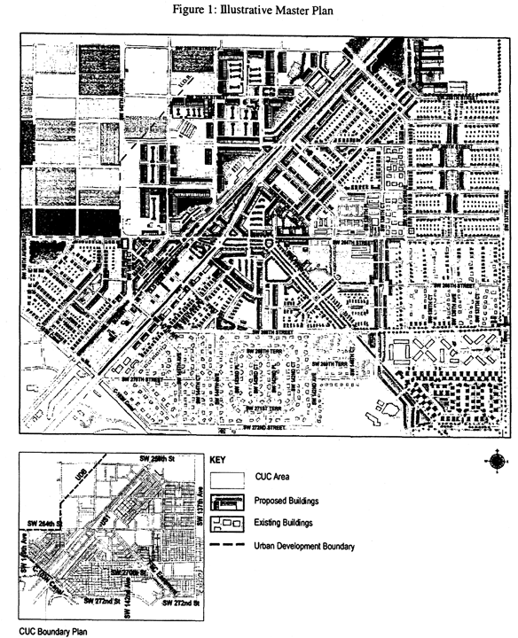

**Figure 1: Illustrative Master Plan**

(Ord. No. 04-217, § 1, 12-2-04)

Sec. 33-284.67. Naranja Community Urban Center District (NCUC) Requirements.

Except as provided herein, all developments within the NCUC shall comply with the requirements provided in Article XXXIII(K), Standard Urban Center District Regulations, of this code.

(Ord. No. 06-11, § 1, 1-24-06)

Sec. 33-284.68. Uses.

Except as provided herein, all permitted, conditionally permitted, and temporary uses within the NCUC shall comply with [Section 33-284.83](../level3/PTIIICOOR_CH33ZO_ARTXXXIII_K_STURCEDIRE.docx#PTIIICOOR_CH33ZO_ARTXXXIII_K_STURCEDIRE_S33-284.83US) of this code.

A. *Permitted Uses.* In addition to the uses provided in [Section 33-284.83](../level3/PTIIICOOR_CH33ZO_ARTXXXIII_K_STURCEDIRE.docx#PTIIICOOR_CH33ZO_ARTXXXIII_K_STURCEDIRE_S33-284.83US)(A), the following shall be permitted:

1. On the east side of U.S. 1, Residential Modified (RM) lots abutting designated Mixed Use Corridor (MC) lots on at least one side are allowed to have uses permitted in the MC area for a depth from U.S. 1 not to exceed that of the MC lots.

2. In the Industrial District (ID) area:

a. all uses permitted in the IU-C zoning district after public hearing pursuant to [Section 33-311](../level3/PTIIICOOR_CH33ZO_ARTXXXVIZOPR.docx#PTIIICOOR_CH33ZO_ARTXXXVIZOPR_S33-311COZOAPBOUTDU)(A)(3) of this code.

b. in the Core and Center sub-districts only, on lots fronting on US 1, all uses permitted in Mixed-Use Corridor (MC) at a minimum residential density of 12 dwelling units per acre net to a maximum density of 52 dwelling units per acre net without the use of Severable Use Rights (SUR's) or a maximum density of 60 dwelling units per acre net with the use of SUR's.

c. in the Edge and Center sub-districts, except for properties along US 1, automobile service stations when in compliance with the requirements of [Section 33-284.83](../level3/PTIIICOOR_CH33ZO_ARTXXXIII_K_STURCEDIRE.docx#PTIIICOOR_CH33ZO_ARTXXXIII_K_STURCEDIRE_S33-284.83US)(B) of this code.

d. in the Edge and Center sub-districts, except for properties along US 1, drive-through facilities when in compliance with the requirements of [Section 33-284.83](../level3/PTIIICOOR_CH33ZO_ARTXXXIII_K_STURCEDIRE.docx#PTIIICOOR_CH33ZO_ARTXXXIII_K_STURCEDIRE_S33-284.83US)(B)(3) of this code.

3. In the Market District (MD) area:

a. outdoor produce markets, and

b. all uses permitted in the Mixed-Use Corridor (MC) except for residential.

(Ord. No. 06-11, § 1, 1-24-06)

Sec. 33-284.69. Regulating Plans.

The Regulating Plans consist of the following controlling plans as defined and graphically depicted in this section.

A. The Street Types Plan establishes a hierarchy of street types in existing and future locations that shall be provided and shown in all development plans. The five (5) Street Types and the hierarchy of streets (from most important to least important in accommodating pedestrian traffic) are U.S. 1, Boulevard, Main Street, Minor Street, and Service Road.

B. The Sub-districts Plan delineates three (3) sub-districts: the Core, Center and Edge. These sub-districts regulate the allowable intensity of development in accordance with the Comprehensive Development Master Plan and this article.

C. The Land Use Plan delineates the areas where specified land uses and development of various types and intensities will be permitted.

D. The Building Heights Plan establishes the minimum and maximum allowable number of floors.

E. The Designated Open Space Plan designates open spaces, which shall be shown in all development plans. The designated open spaces are controlled by anchor points.

F. The New Streets Plan shows the location and the number of new streets needed to create the prescribed network of streets within the NCUC District. All new A streets are required in the same general location as shown on the New Streets Plan. All B streets shall be located as provided in [Section 33-284.86](../level3/PTIIICOOR_CH33ZO_ARTXXXIII_K_STURCEDIRE.docx#PTIIICOOR_CH33ZO_ARTXXXIII_K_STURCEDIRE_S33-284.86GERE)(F) of this code.

G. The Bike Route Plan depicts the designated bike routes, which shall be shown in all development plans.

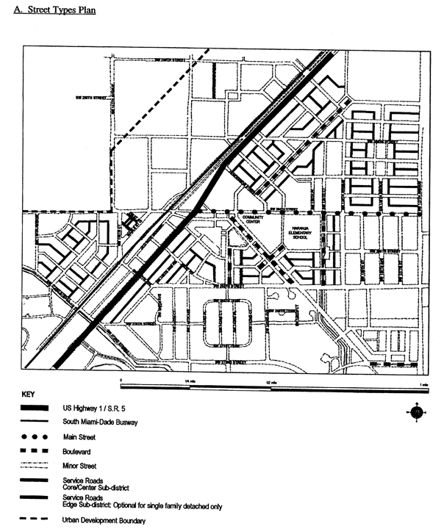

**A. Street Types Plan**

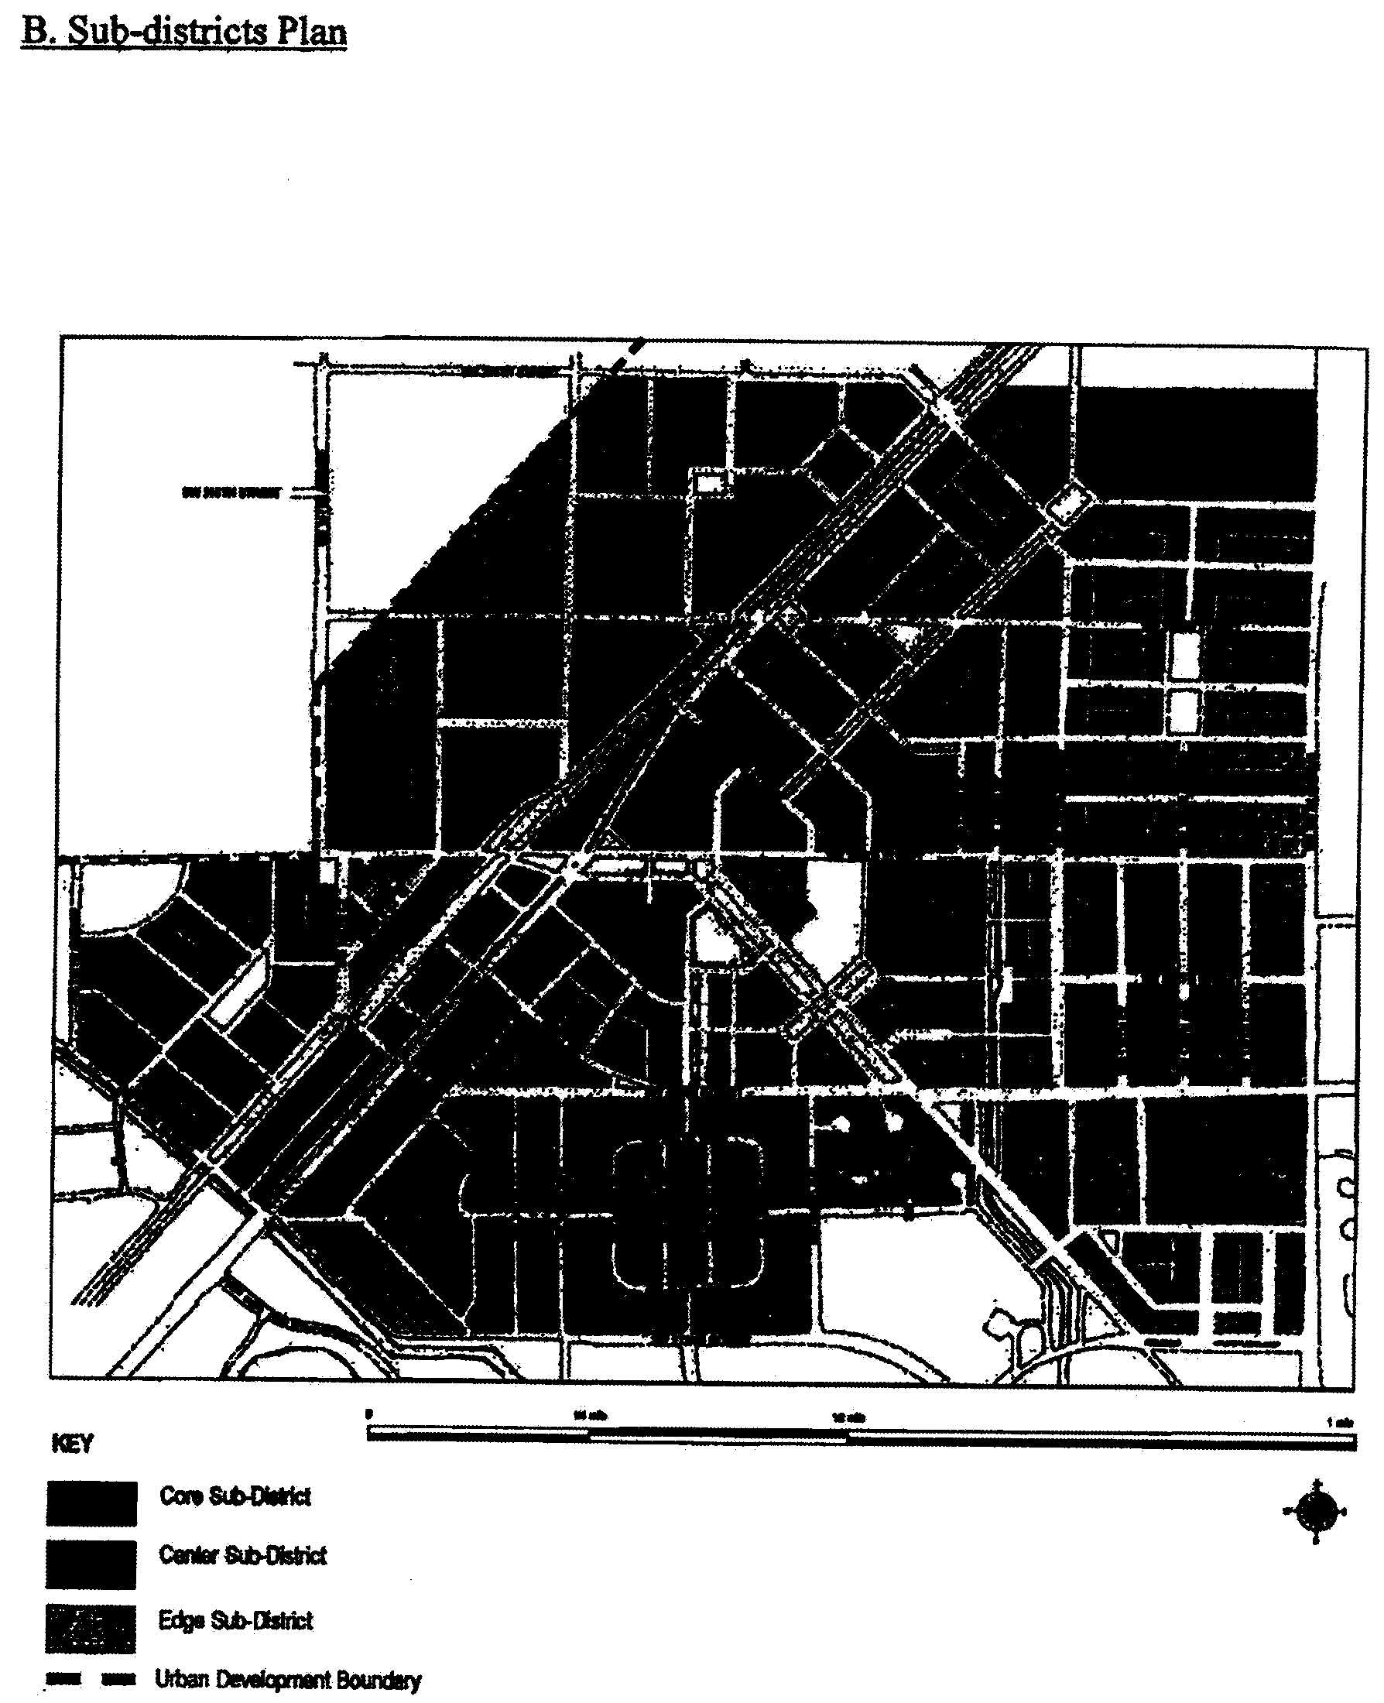

**B. Sub-Districts Plan**

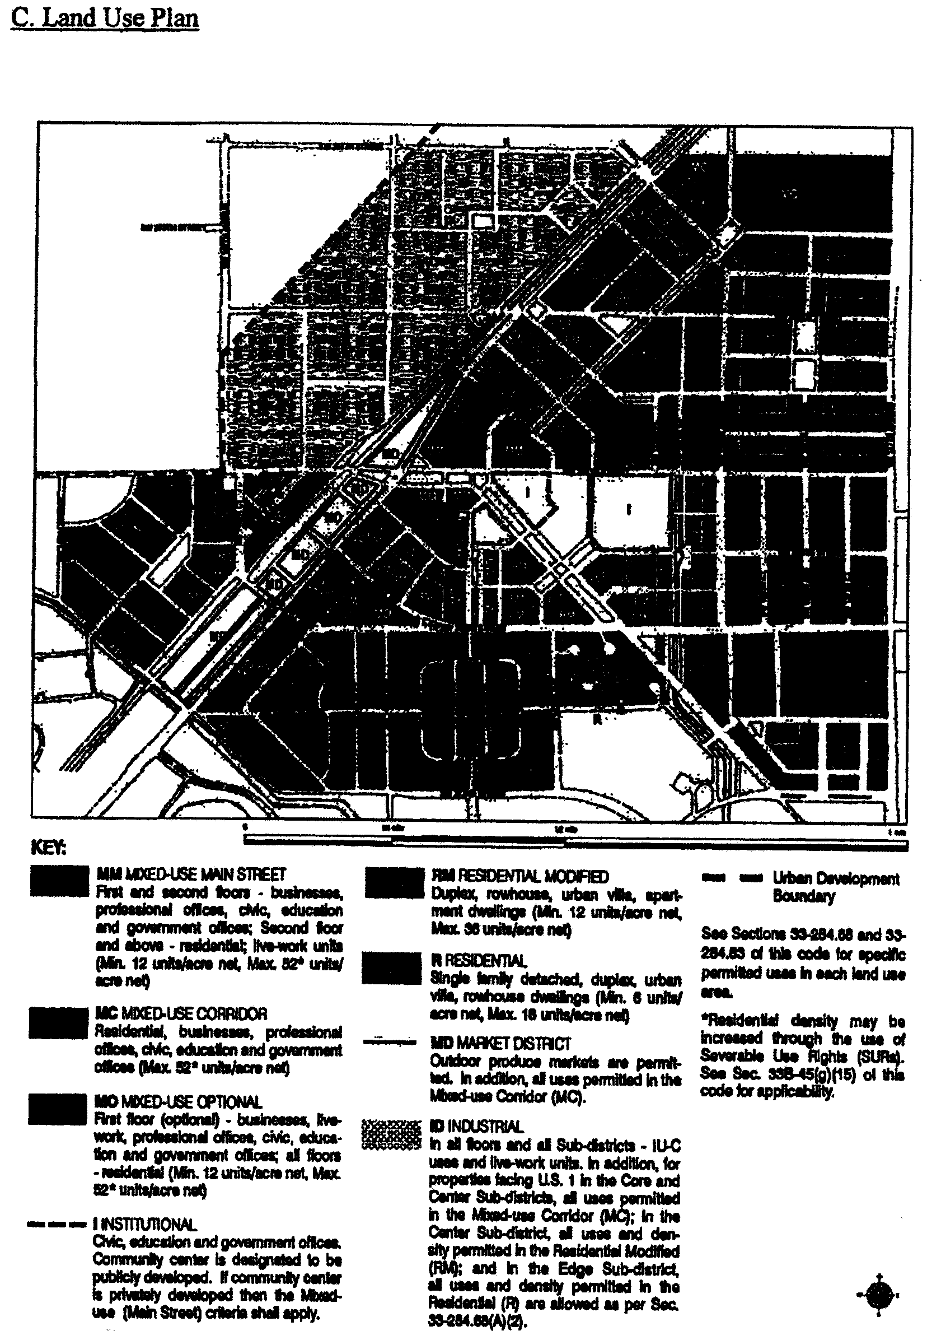

**C. Land Use Plan**

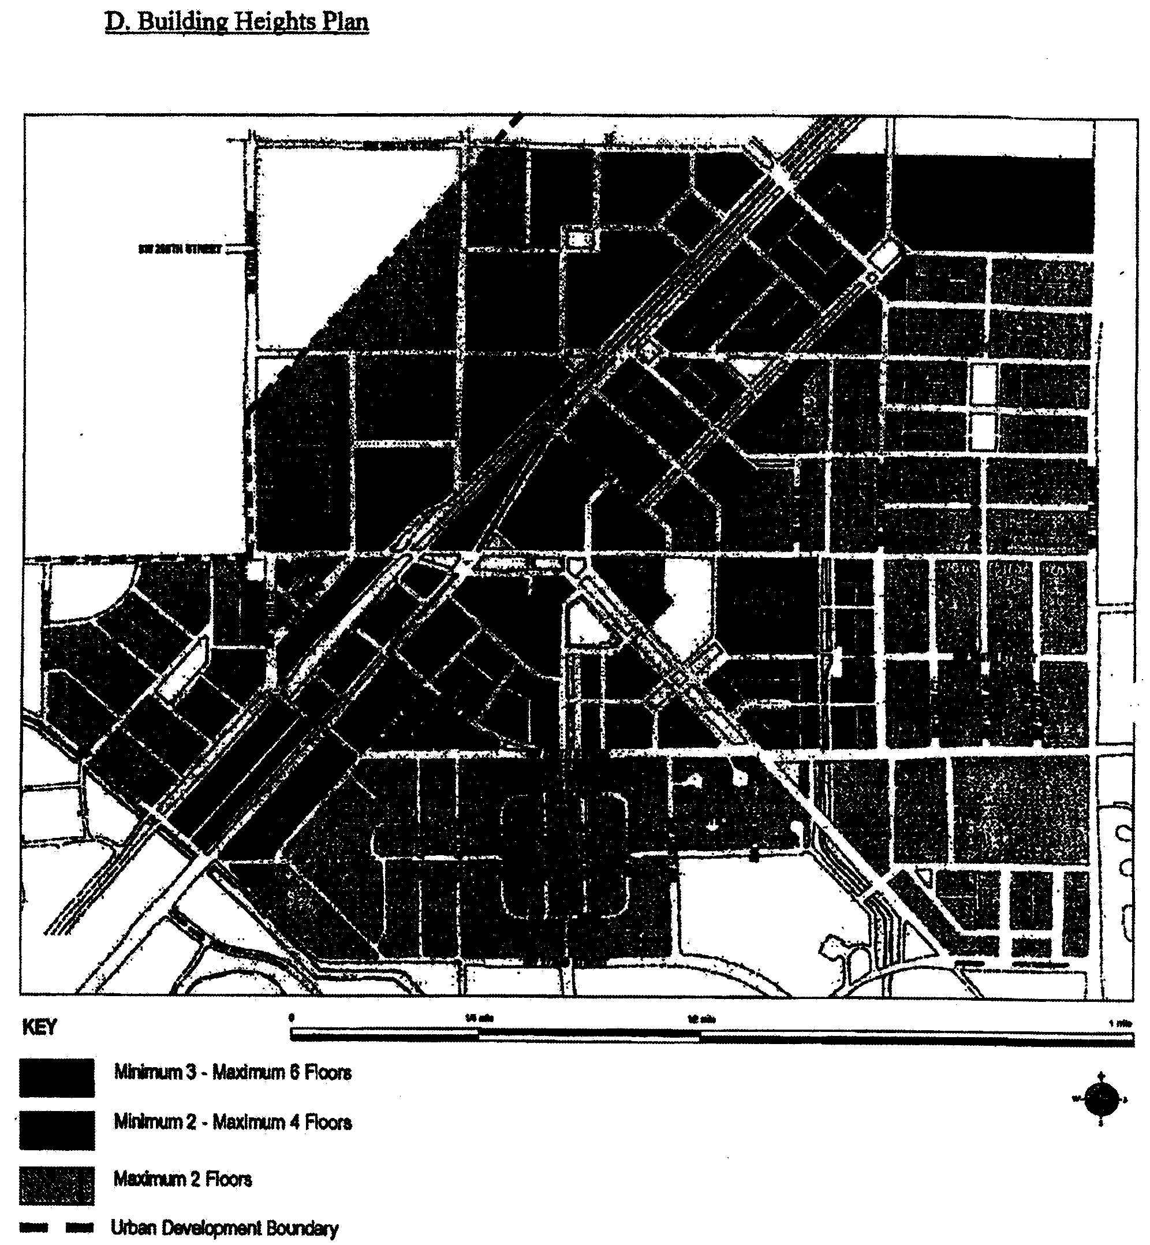

**D. Buildings Plan**

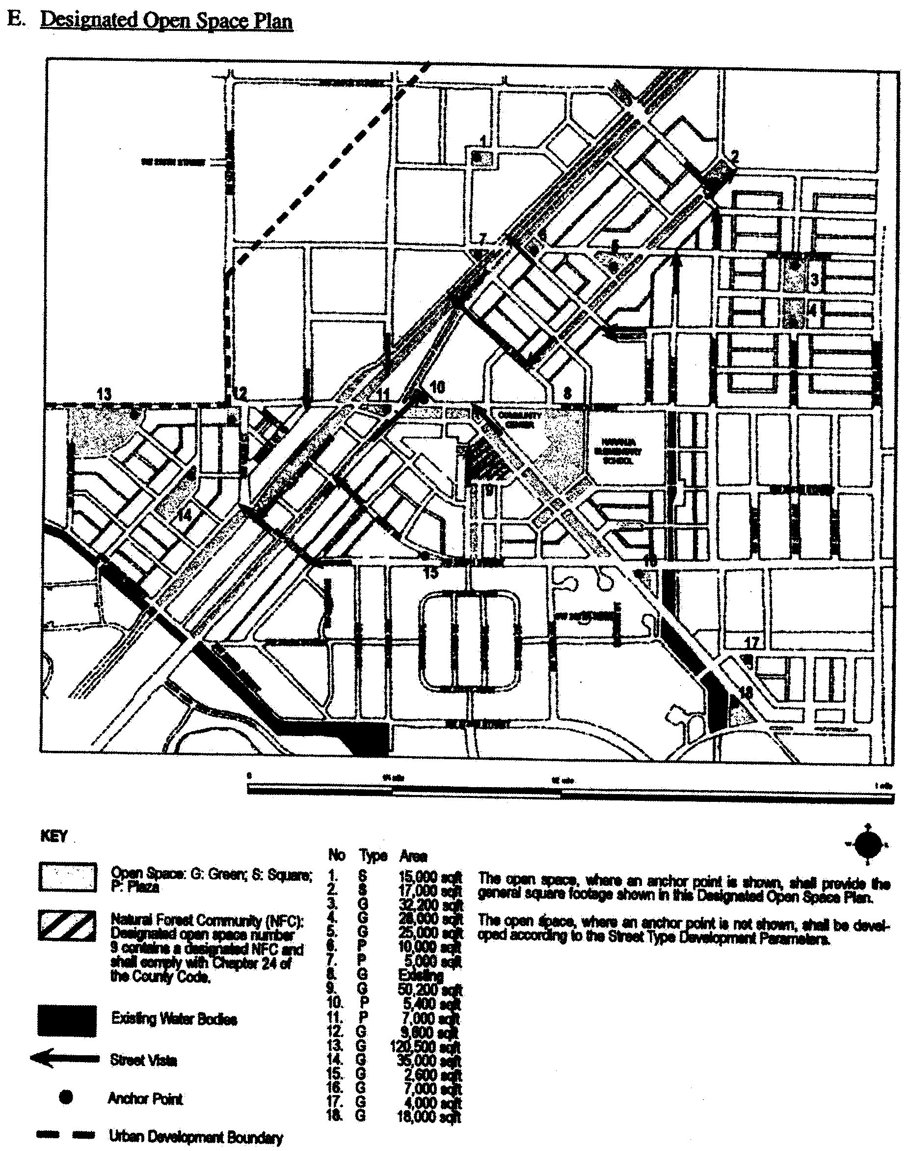

**E. Designated Open Space Plan**

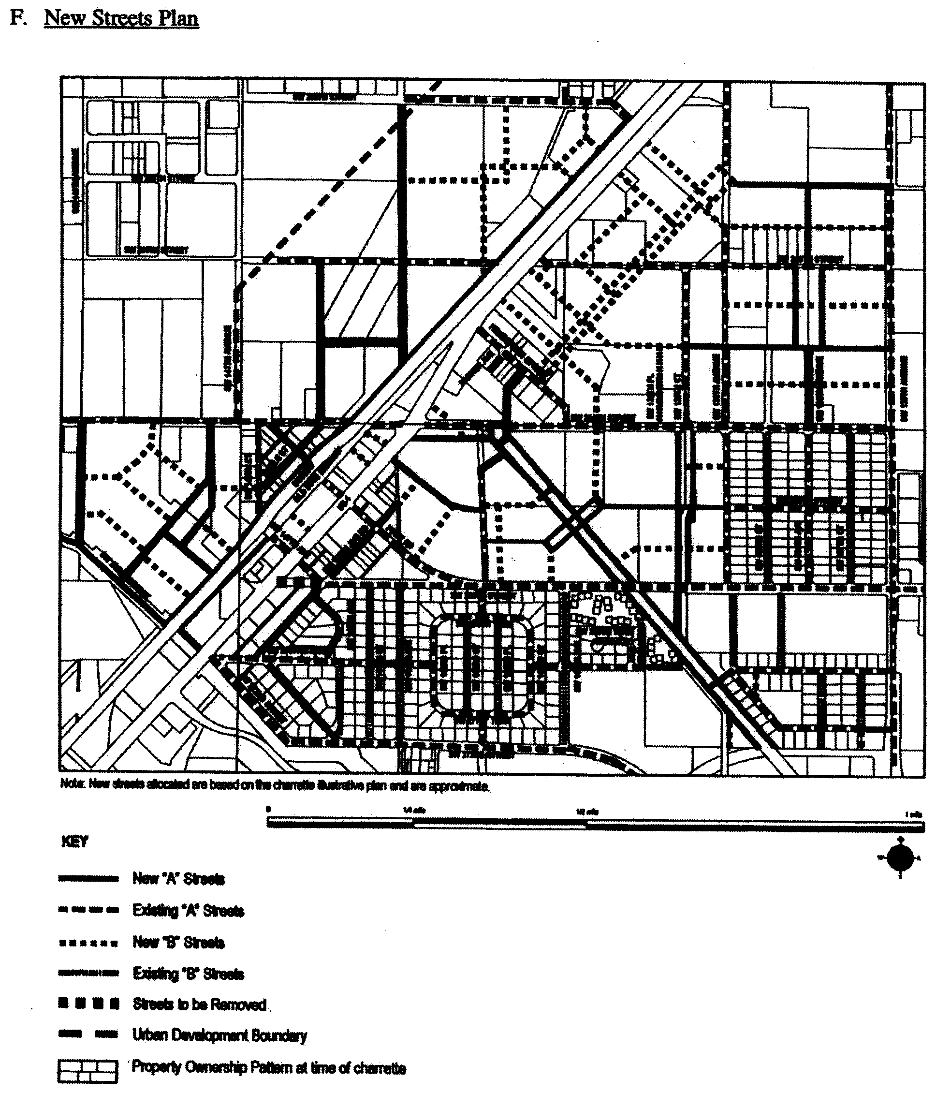

**F. New Streets Plan**

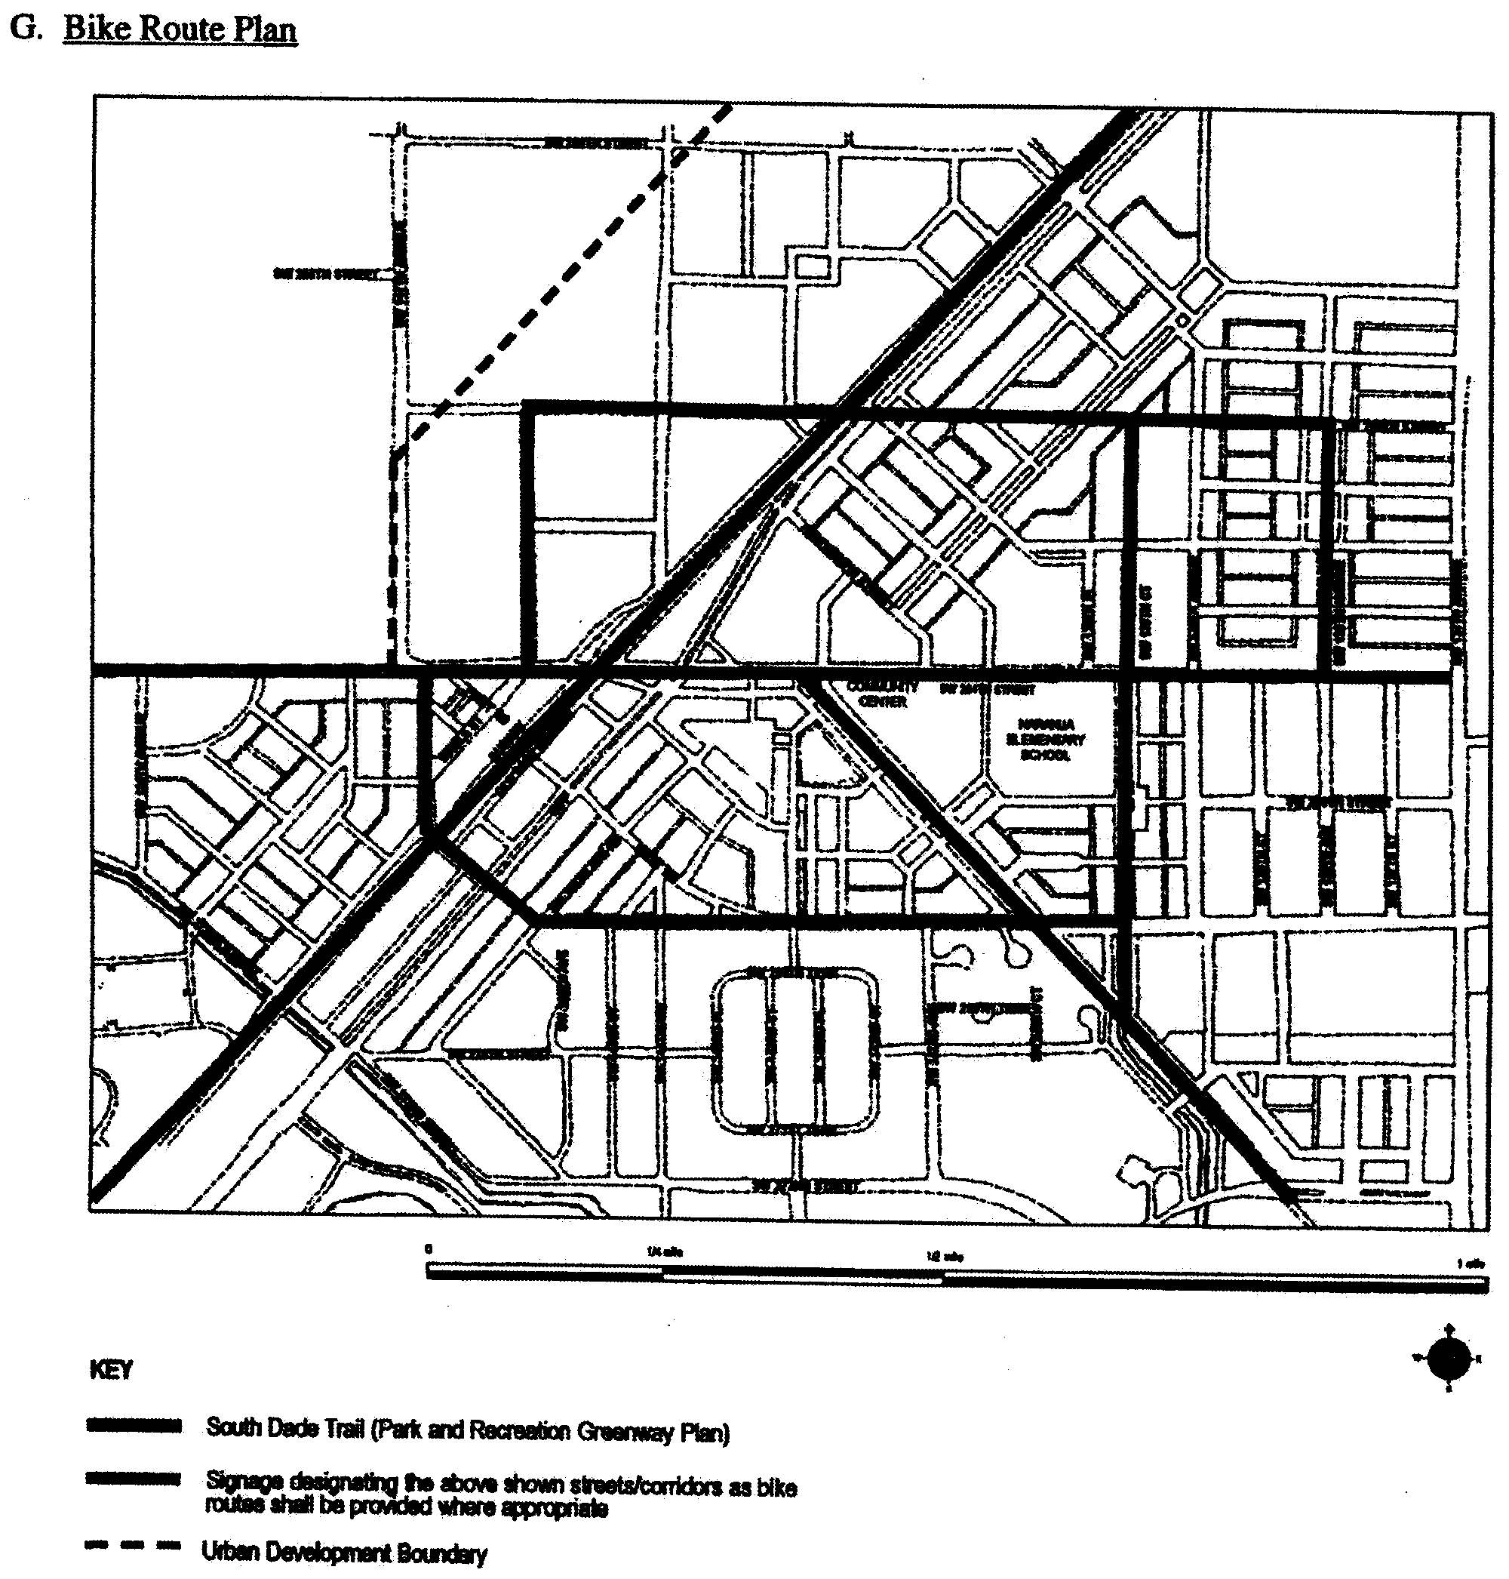

**G. Bike Route Plan**

(Ord. No. 06-11, § 1, 1-24-06; Ord. No. 07-96, § 1, 7-10-07)

Sec. 33-284.70. Building Placement and Street Type Development Parameters

A. All new development and redevelopment within the NCUC shall comply with the Building Placement and Design Parameters as provided in [Section 33-284.85](../level3/PTIIICOOR_CH33ZO_ARTXXXIII_K_STURCEDIRE.docx#PTIIICOOR_CH33ZO_ARTXXXIII_K_STURCEDIRE_S33-284.85BUPLST) of this code. Outdoor produce markets in the Market District shall comply with the Building Placement for Civic Uses in [Section 33-284.85](../level3/PTIIICOOR_CH33ZO_ARTXXXIII_K_STURCEDIRE.docx#PTIIICOOR_CH33ZO_ARTXXXIII_K_STURCEDIRE_S33-284.85BUPLST) of this code.

B. All new development and redevelopment within the NCUC shall comply with the Street Type Development Parameters as provided herein:

|  |  |
| --- | --- |
| Street type | Minimum Required Configuration Core/Center/Edge |
| U.S. 1 | As provided in this section |
| Main Street | As provided in this section |
| Boulevard | As provided in [Section 33-284.85](../level3/PTIIICOOR_CH33ZO_ARTXXXIII_K_STURCEDIRE.docx#PTIIICOOR_CH33ZO_ARTXXXIII_K_STURCEDIRE_S33-284.85BUPLST) |
| Minor Street | As provided in [Section 33-284.85](../level3/PTIIICOOR_CH33ZO_ARTXXXIII_K_STURCEDIRE.docx#PTIIICOOR_CH33ZO_ARTXXXIII_K_STURCEDIRE_S33-284.85BUPLST) |
| Service Road | As provided in [Section 33-284.85](../level3/PTIIICOOR_CH33ZO_ARTXXXIII_K_STURCEDIRE.docx#PTIIICOOR_CH33ZO_ARTXXXIII_K_STURCEDIRE_S33-284.85BUPLST) |
| Pedestrian Passage | As provided in [Section 33-284.85](../level3/PTIIICOOR_CH33ZO_ARTXXXIII_K_STURCEDIRE.docx#PTIIICOOR_CH33ZO_ARTXXXIII_K_STURCEDIRE_S33-284.85BUPLST) |

C. Unless otherwise provided by the Building Placement and Design Parameters in [Section 33-284.85](../level3/PTIIICOOR_CH33ZO_ARTXXXIII_K_STURCEDIRE.docx#PTIIICOOR_CH33ZO_ARTXXXIII_K_STURCEDIRE_S33-284.85BUPLST) of this code, the following street setbacks shall be required for mixed-use/industrial buildings located in areas designated as MM, MC, MO, MD and ID within the NCUC:

|  |  |  |  |
| --- | --- | --- | --- |
| Street Type | Required Setback | | |
|  | Core | Center | Edge |
| U.S. 1 | 0'* | 10' ** | 10' or 15' ** |
| Main Street | 0' * | 10' ** | 10' or 15' ** |
| Boulevard | 0' or 10'** | 0' or 10' ** | 10' or 15' ** |
| Minor Street | 10' ** | 10' ** | 10' ** |
| Note: * colonnade required      ** if a colonnade is provided the front setback shall be 0'      N/A not applicable | | | |

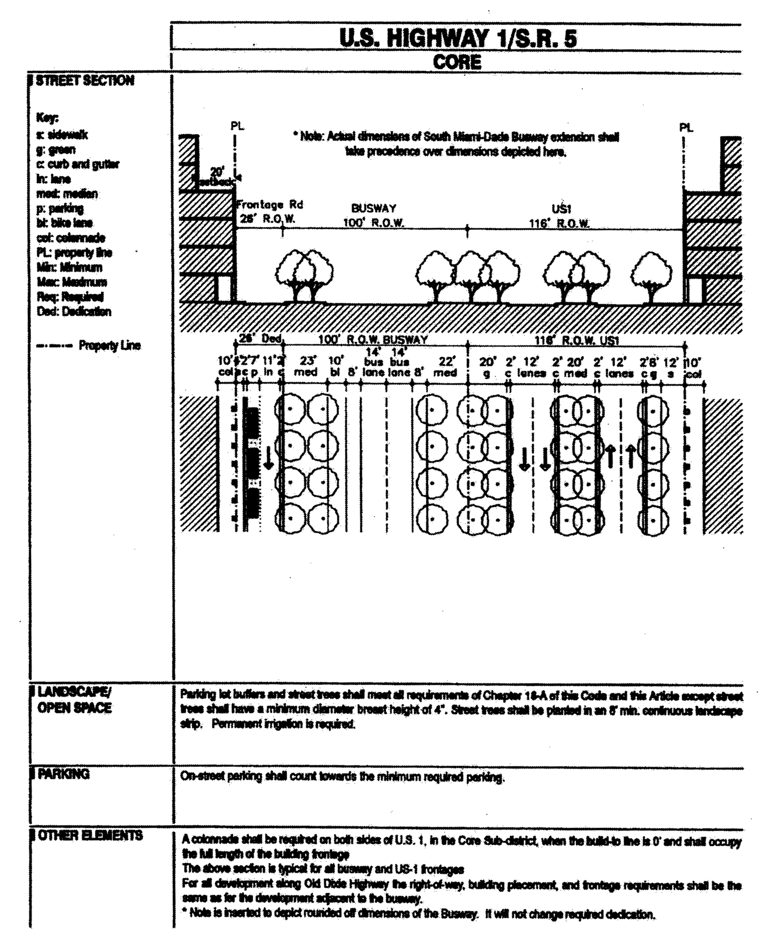

**U.S. Highway 1/S.R. 5 Core**

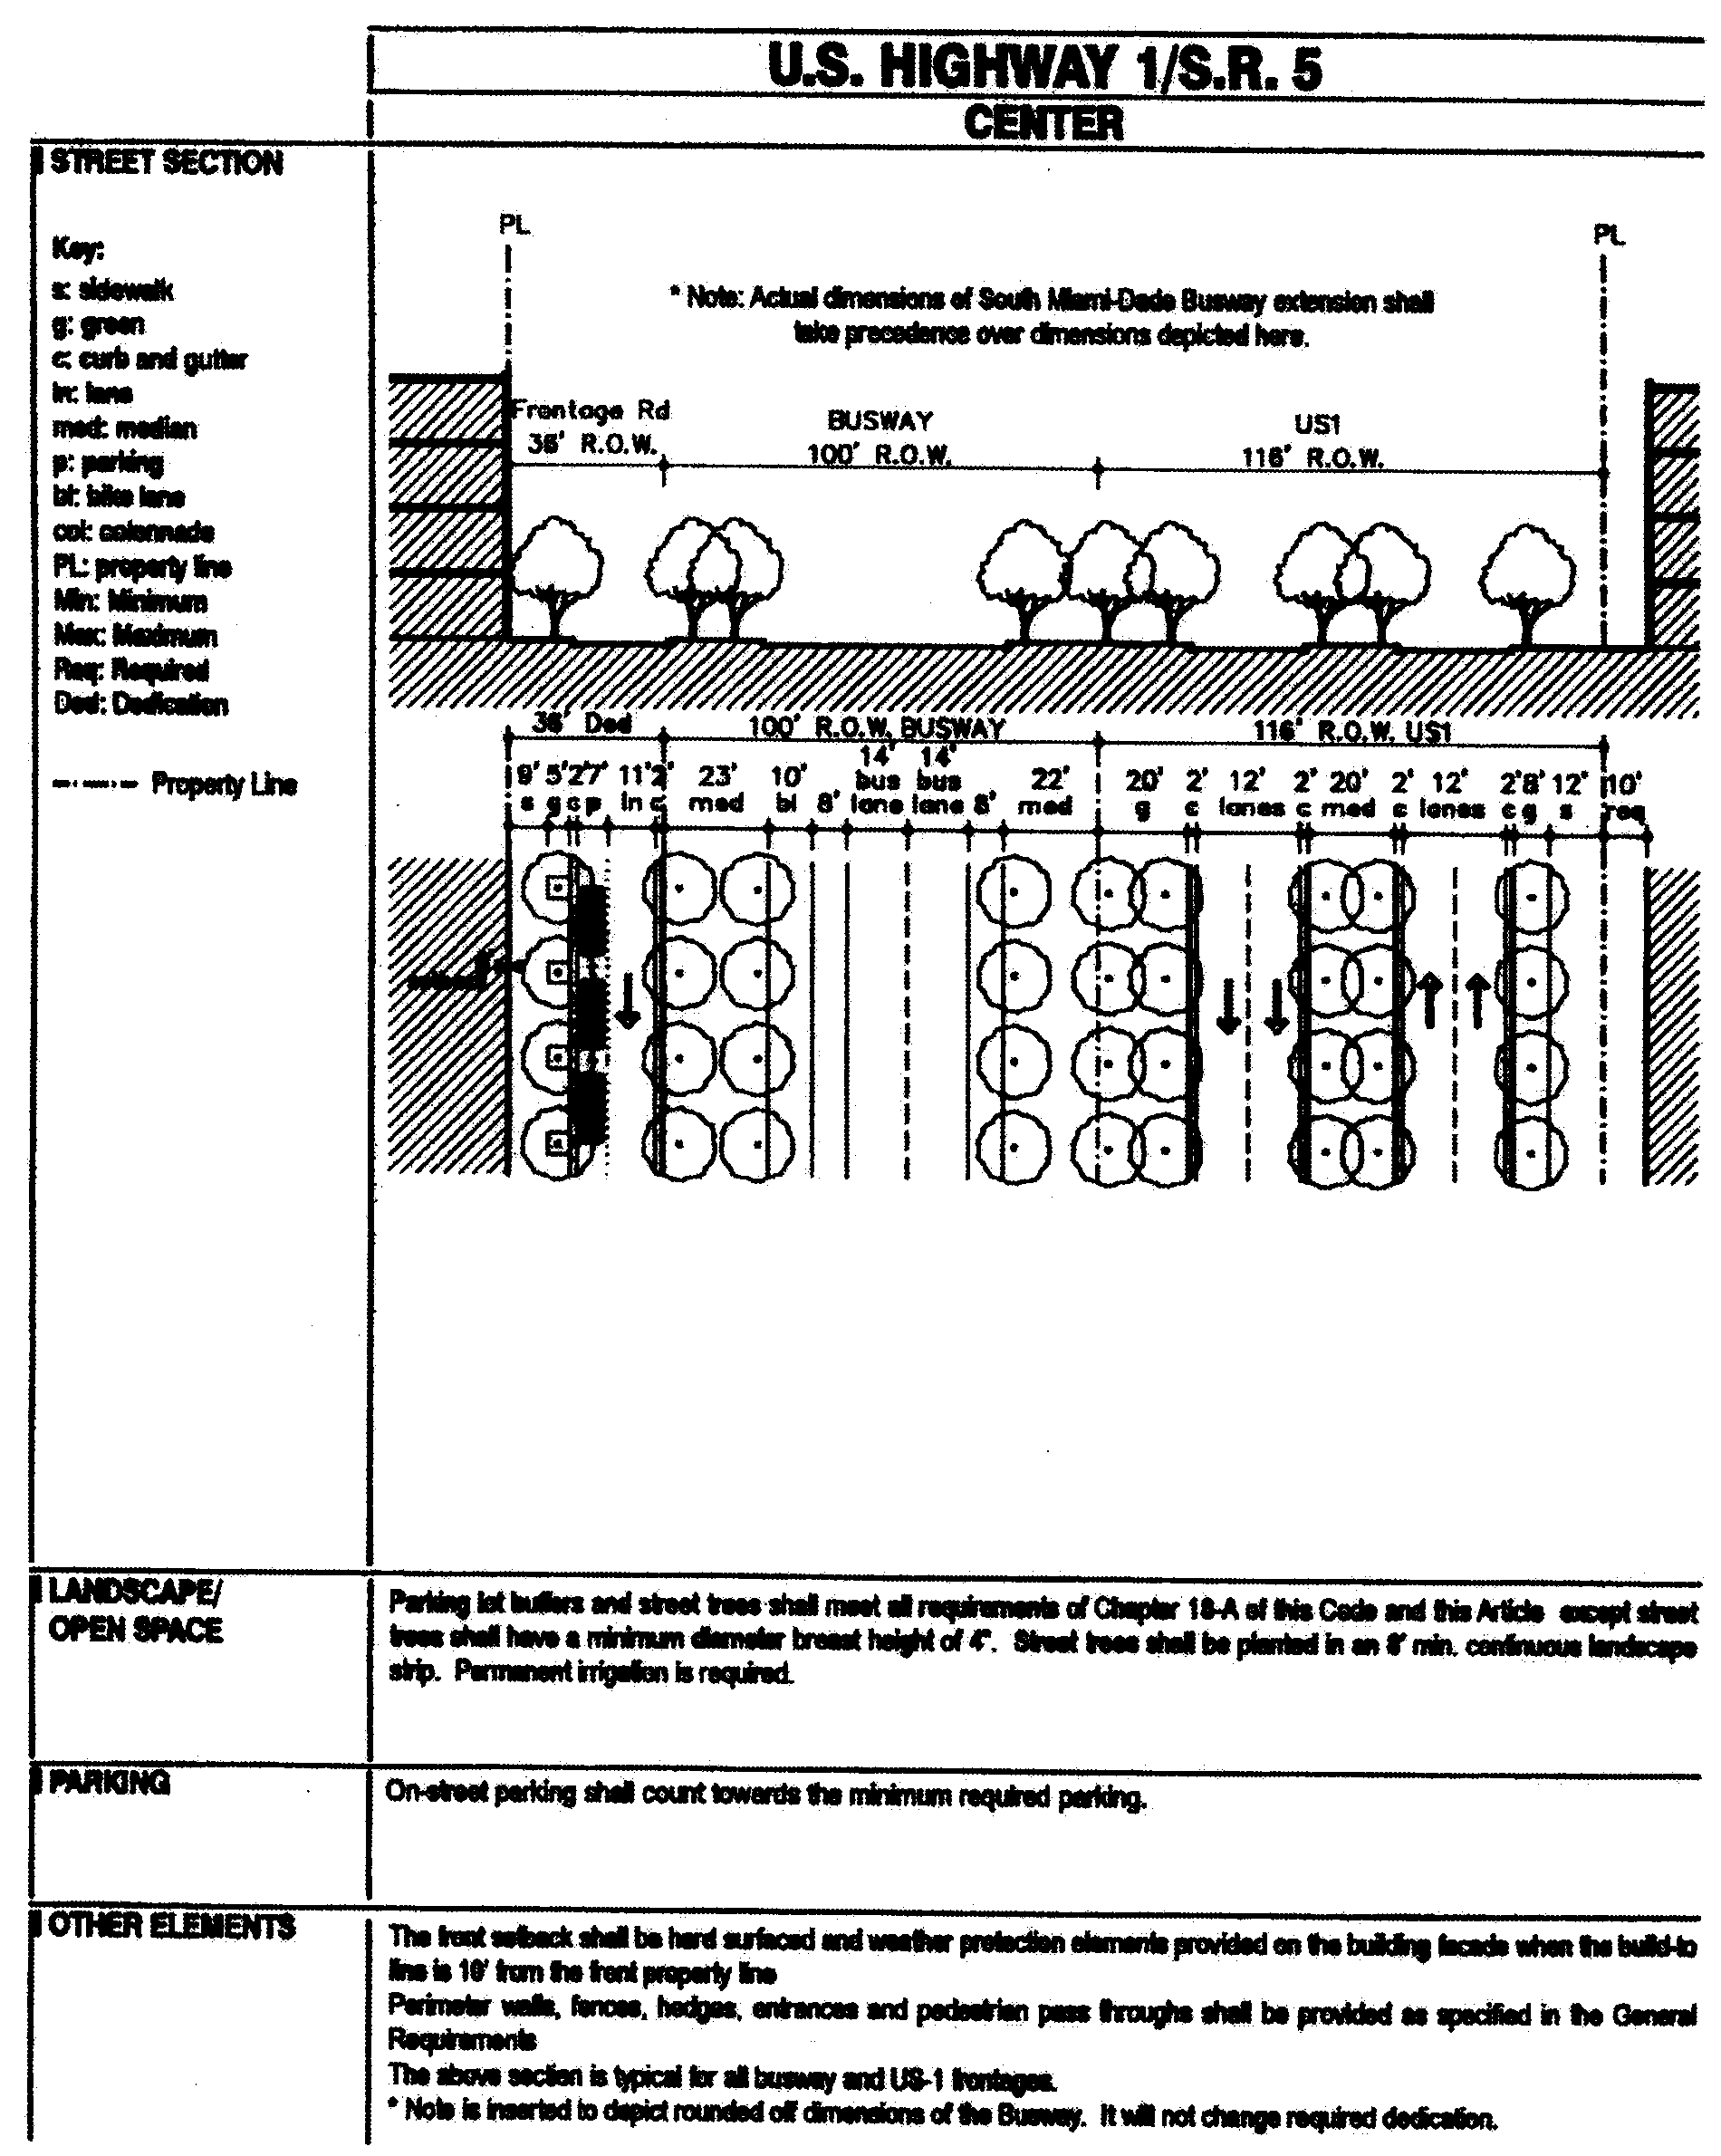

**U.S. Highway 1/S.R. 5 Center**

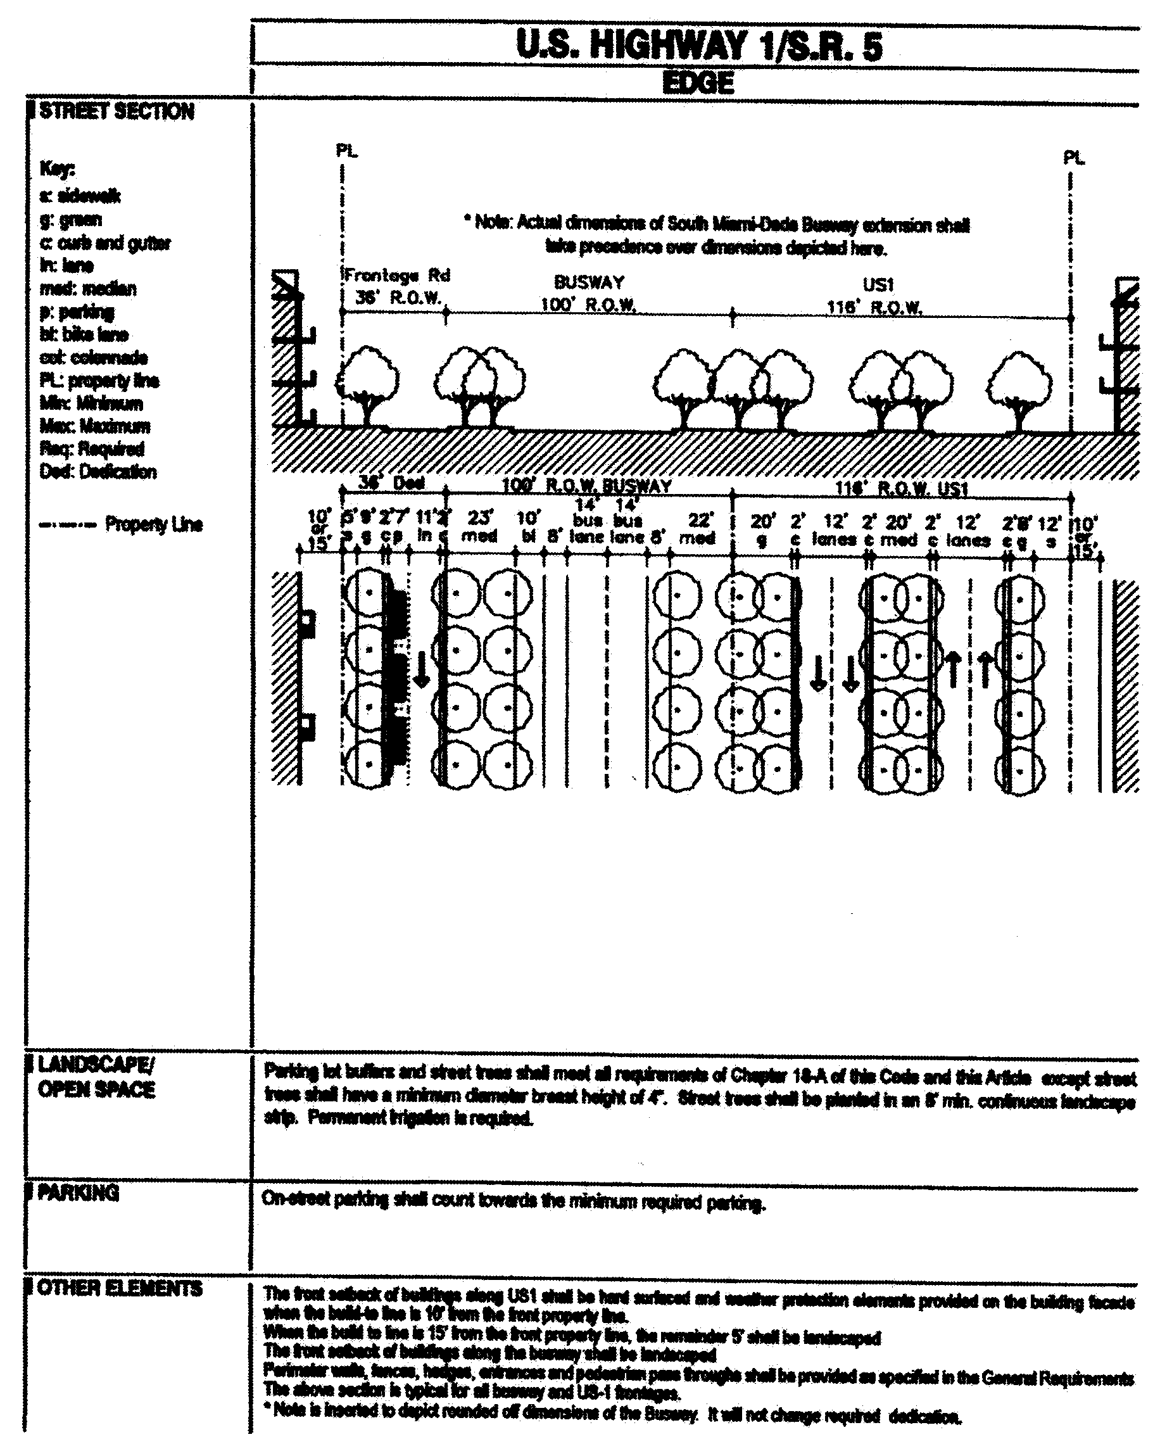

**U.S. Highway 1/S.R. 5 Edge**

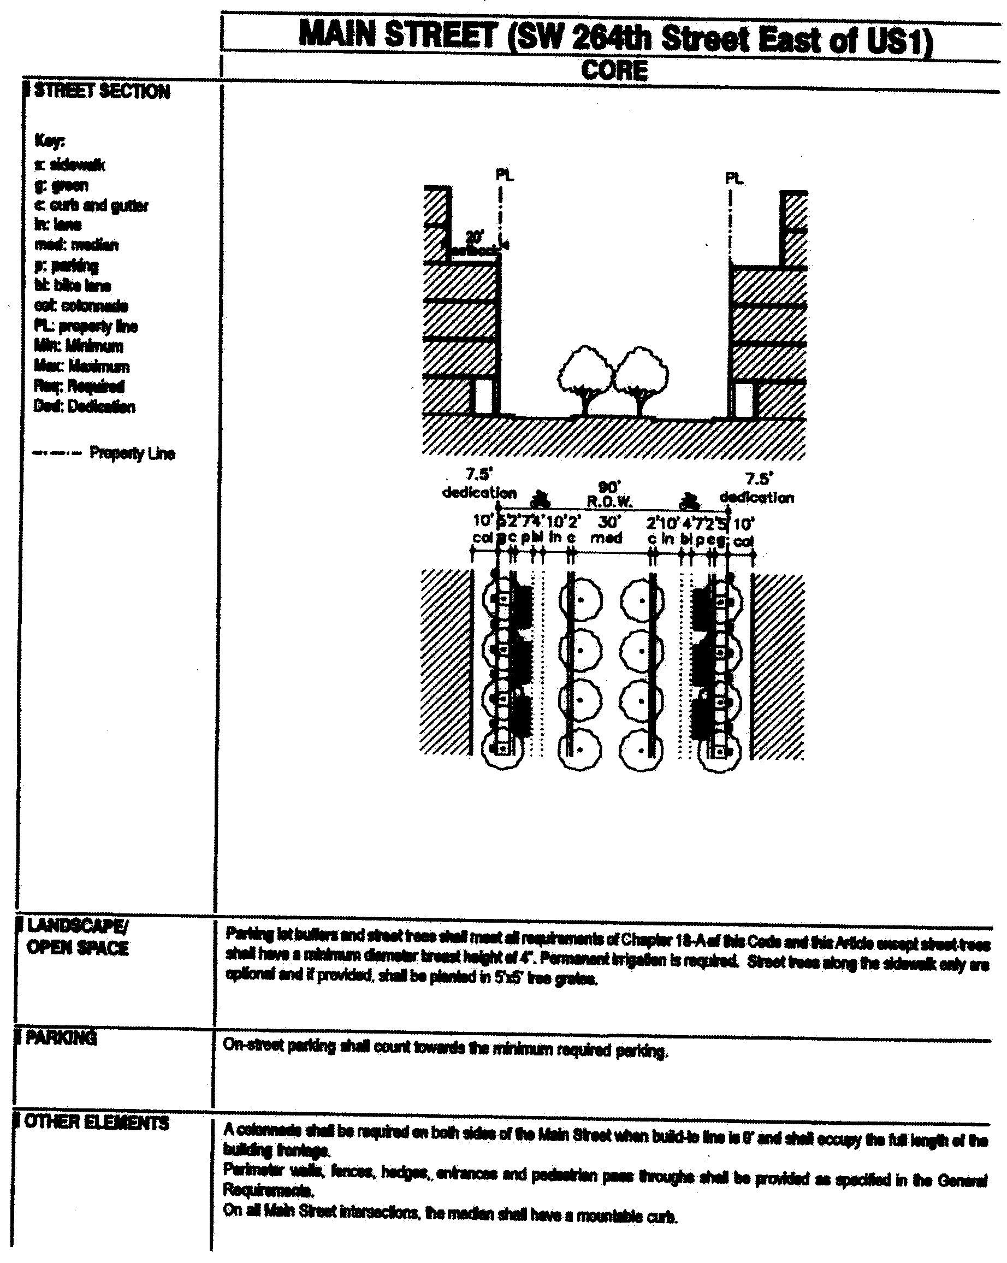

**Main Street (SW 264th Street East of US1) Core**

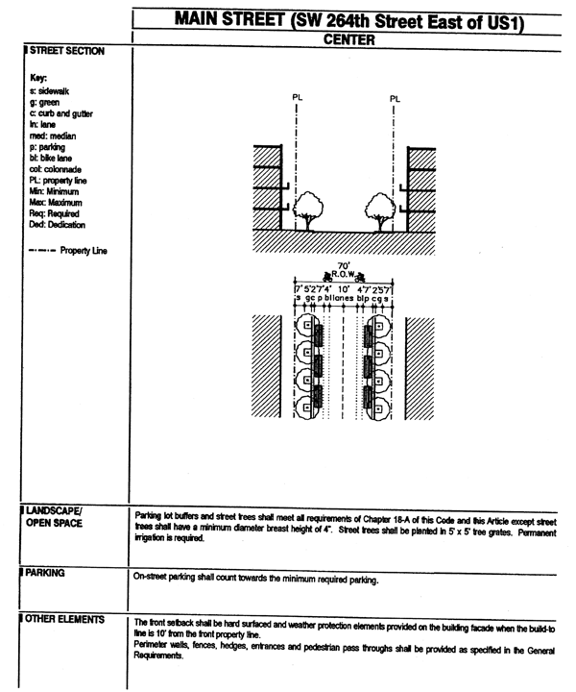

**Main Street (SW 264th Street East of US1) Center**

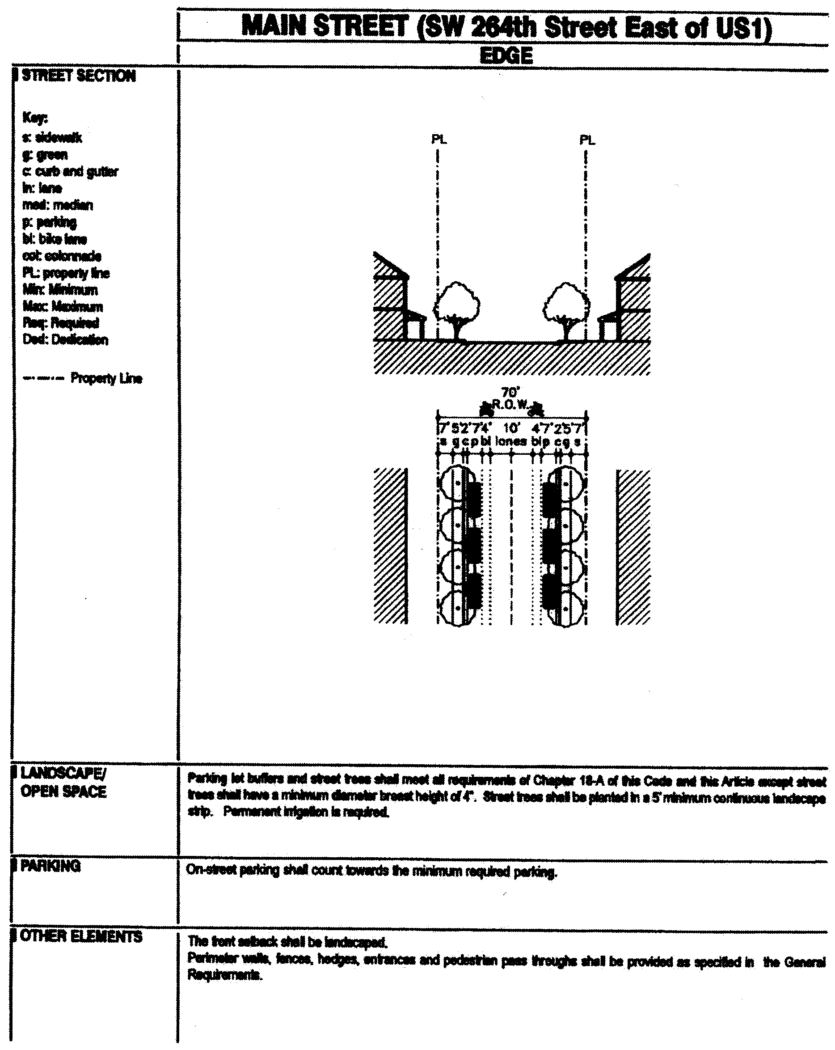

**Main Street (SW 264th Street East of US1) Edge**

(Ord. No. 06-11, § 1, 1-24-06; Ord. No. 07-96, § 2, 7-10-07)

Sec. 33-284.71. General Requirements.

In addition to the general requirements provided in [Section 33-284.86](../level3/PTIIICOOR_CH33ZO_ARTXXXIII_K_STURCEDIRE.docx#PTIIICOOR_CH33ZO_ARTXXXIII_K_STURCEDIRE_S33-284.86GERE) of this code, all developments within the NCUC shall comply with the following:

A. *Buildings.*

1. A cornice line is required on all building facades on U.S. 1 and the Main Street frontages as follows: at the top of the first story of buildings in the Mixed-Use Main Street (MM) area and the top of the second story of buildings in the Mixed-Use Corridor (MC) area.

2. Colonnades are required along all building frontages facing U.S. 1 and Main Street in the Core sub-district.

(Ord. No. 06-11, § 1, 1-24-06)

Sec. 33-284.72. Nonconforming Structures, Uses, and Occupancies.

Nothing contained in this article shall be deemed or construed to prohibit a continuation of a legal nonconforming structure, use, and occupancy in the NCUC District that either (1) was existing as of the date of the district boundary change on the property to NCUC District or (2) on or before said date, had received final site plan approval through a public hearing pursuant to this chapter or through administrative site plan review or had a valid building permit. However, any structure, use or occupancy in the NCUC District that is discontinued for a period of at least six months, or is superseded by a lawful structure, use or occupancy permitted under this chapter, or that incurs damage to the roof or structure to an extent of 50 percent or more of its market value, shall be subject to [Section 33-35](../level3/PTIIICOOR_CH33ZO_ARTIINGE.docx#PTIIICOOR_CH33ZO_ARTIINGE_S33-35NOUS)(c) of this code. However, a lawfully existing single-family home use that is discontinued for a period of at least six months or that incurs damage to the roof or structure to an extent of 50 percent or more of its market value, shall not be subject to [Section 33-35](../level3/PTIIICOOR_CH33ZO_ARTIINGE.docx#PTIIICOOR_CH33ZO_ARTIINGE_S33-35NOUS)(c) of this code.

(Ord. No. 04-217, § 11, 12-2-04; Ord. No. 05-145, § 4, 7-7-05; Ord. No. 06-11, § 2, 1-24-06)

Secs. 33-284.73, 33-284.74. Reserved.

Sec. 33-284.75. Conflicts with other chapters and regulations.

This article shall govern in the event of conflicts between this article and other zoning, subdivision, or landscape regulations of this code.

(Ord. No. 04-217, § 10, 12-2-04)

Sec. 33-284.76. Reserved.

**Editor's note—**

See Editor's note at article XXXIII(J).

Secs. 33-284.77—33-284.80. Reserved.

FOOTNOTE(S):

--- (**51**) ---

**Editor's note—** Ord. No. 06-11, § 1, adopted Jan. 24, 2006, repealed sections 33-284.67—33-284.74, and replaced them with new sections 33-284.67—33-284.71. Section 2 of said ordinance renumbered former section 33-284.76 as new section 33-284.72. Former sections 33-284.67—33-284.74 pertained to similar material and derived from Ord. No. 04-217, §§ 2—9, adopted Dec. 2, 2004; Ord. No. 05-145, §§ 1—3, adopted July 7, 2005. (Back)

### ARTICLE XXXIII(K). STANDARD URBAN CENTER DISTRICT REGULATIONS

Sec. 33-284.81. Purpose and applicability.

Sec. 33-284.82. Definitions.

Sec. 33-284.83. Uses.

Sec. 33-284.84. Regulating Plans.

Sec. 33-284.85. Building Placement Standards.

Sec. 33-284.86. General Requirements.

Sec. 33-284.87. Signs.

Sec. 33-284.88. Review Procedure/Administrative Site Plan and Architectural Review.

Sec. 33-284.89. Zoning relief from certain requirements.

Sec. 33-284.89.1. Special Exceptions Procedures.

Sec. 33-284.89.2. Nonconforming Lots, Uses and Structures.

Sec. 33-284.90. Conflicts with other chapters and regulations.

Sec. 33-284.81. Purpose and applicability.

A. The Comprehensive Development Master Plan (CDMP) contains directives to promote urban centers in places where mass transit, roadways, and highways are highly accessible. The CDMP provides for three types of urban centers: community (CUC), metropolitan (MUC) and regional (RUC).

B. The regulations in this article shall apply to urban centers, as defined in the CDMP. Specifically, these standard regulations apply to the Urban Center Districts provided for in this code that were created after the effective date of this ordinance (July 27, 2005). Each Urban Center District, as adopted by the Board of County Commissioners by separate ordinances, shall contain a set of regulating plans and additional regulations addressing unique circumstances that, in conjunction with this article, shall control development in each particular urban center.

C. The standard regulations contained in this chapter and Chapter 18-A, Code of Miami-Dade County, Florida, shall apply to this article, except as otherwise added to or modified herein.

D. The area within the boundaries of an urban center is divided in three Sub-districts: Core, Center and Edge. The highest density and intensity within an urban center shall be allocated to the Core Sub-districts, a mixed-use area adjacent to the transit station(s) or major transit stop(s). The densities and intensities shall then gradually decrease from the Core to the Center Sub-district where mixed-uses are still permitted and then further decrease to the Edge Sub-district which is characterized by single uses, including low density residential.

E. In the case of multiple-phase development, each phase of the development, whether standing independently or in conjunction with existing developed or proposed future contiguous phases, shall meet all the requirements of this article and of the additional requirements and of the regulating plans provided in each Urban Center Districts. In addition, construction of each phase shall be directed first toward the street of higher hierarchy as provided in the Urban Center Districts; and the minimum building frontage length requirements may be disregarded in approving each individual phase, provided that the building frontage length requirements are met at the conclusion of all phases.

(Ord. No. 05-143, § 1, 7-7-05)

Sec. 33-284.82. Definitions.

Terms used throughout this article shall take their commonly accepted meaning unless otherwise defined in Chapters 18-A, 28 or 33 of the Code of Miami-Dade County. Terms requiring interpretation specific to this article are as follows:

1. *Accessory Building:* An enclosed building that is subordinate to and not the main or principal building on a lot or parcel and that is used as a dwelling unit, garage, storage shed, or similar use.

2. *Accessory Structure:* An unenclosed structure that is subordinate to and not the main or principal building on a lot or parcel and that is used: as a garden feature, such as a fountain, gazebo or cabana; for recreation, such as a pool or hard courts; for the accommodation of mechanical equipment, such as a pump, a/c compressor or electrical generator units; or uses similar to the foregoing.

3. *Anchor point:* The location depicted on the Open Space Plan on which some portion of a plaza, green, or square must be situated.

4. *Bike lane:* A corridor dedicated specifically for bicycle use.

5. *Block:* A combination of contiguous building lots, the perimeter of which abuts public street(s), private street(s) or easement(s) or designated open space(s).

6. *Block face:* The public street, private street or easement line that delineates a block edge.

7. *Boulevard:* A public street, private street or easement flanked with a landscaped median, sidewalks, on-street parking, street trees and buildings.

8. *Building Frontage:* The portion of the building required to be located along the build-to line.

9. *Building placement diagrams:* Diagrams that provide a schematic representation of the permissible footprints and profiles of structures by land use and Sub-district.

10. *Build-to line:* A line parallel to the block face, along which a building shall be built.

11. *Busway:* A restricted access right-of-way for the exclusive use of buses.

12. *Clear zone:* An area within the curb radius, which shall be kept clear of all objects to a prescribed height to provide vehicle clearance.

13. *Close:* A landscaped median divided street with a closed turning area in one end and an intersecting street on the other (see Fig. 1).

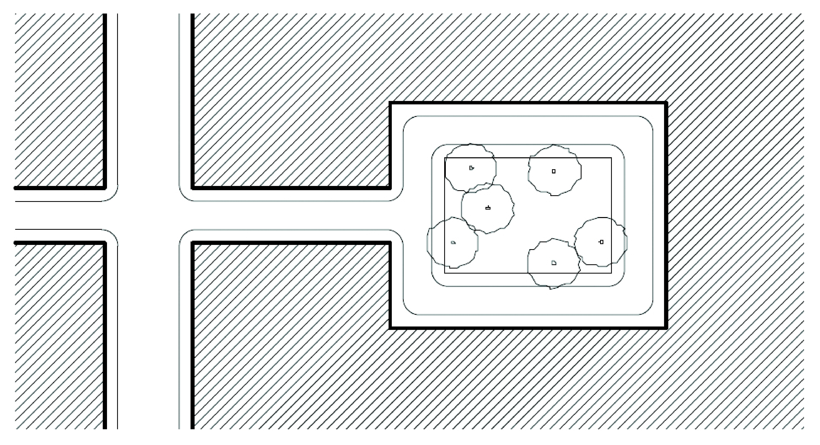

**Fig. 1: Close**

14. *Colonnade:* A roofed structure, extending over a private walkway that is open to the street and sidewalk except for supporting columns or piers.

15. *Community Garden:* Open space set aside for the cultivation and harvesting of produce such as flowers, fruits and vegetables.

16. *Courtyard House:* A single-family dwelling containing a court or atrium. The court shall be enclosed on at least three sides by habitable space and shall provide penetrable openings such as windows and doors between the interior of the dwelling and the court. A Courtyard house may occupy the full width of the lot (see Fig. 2).

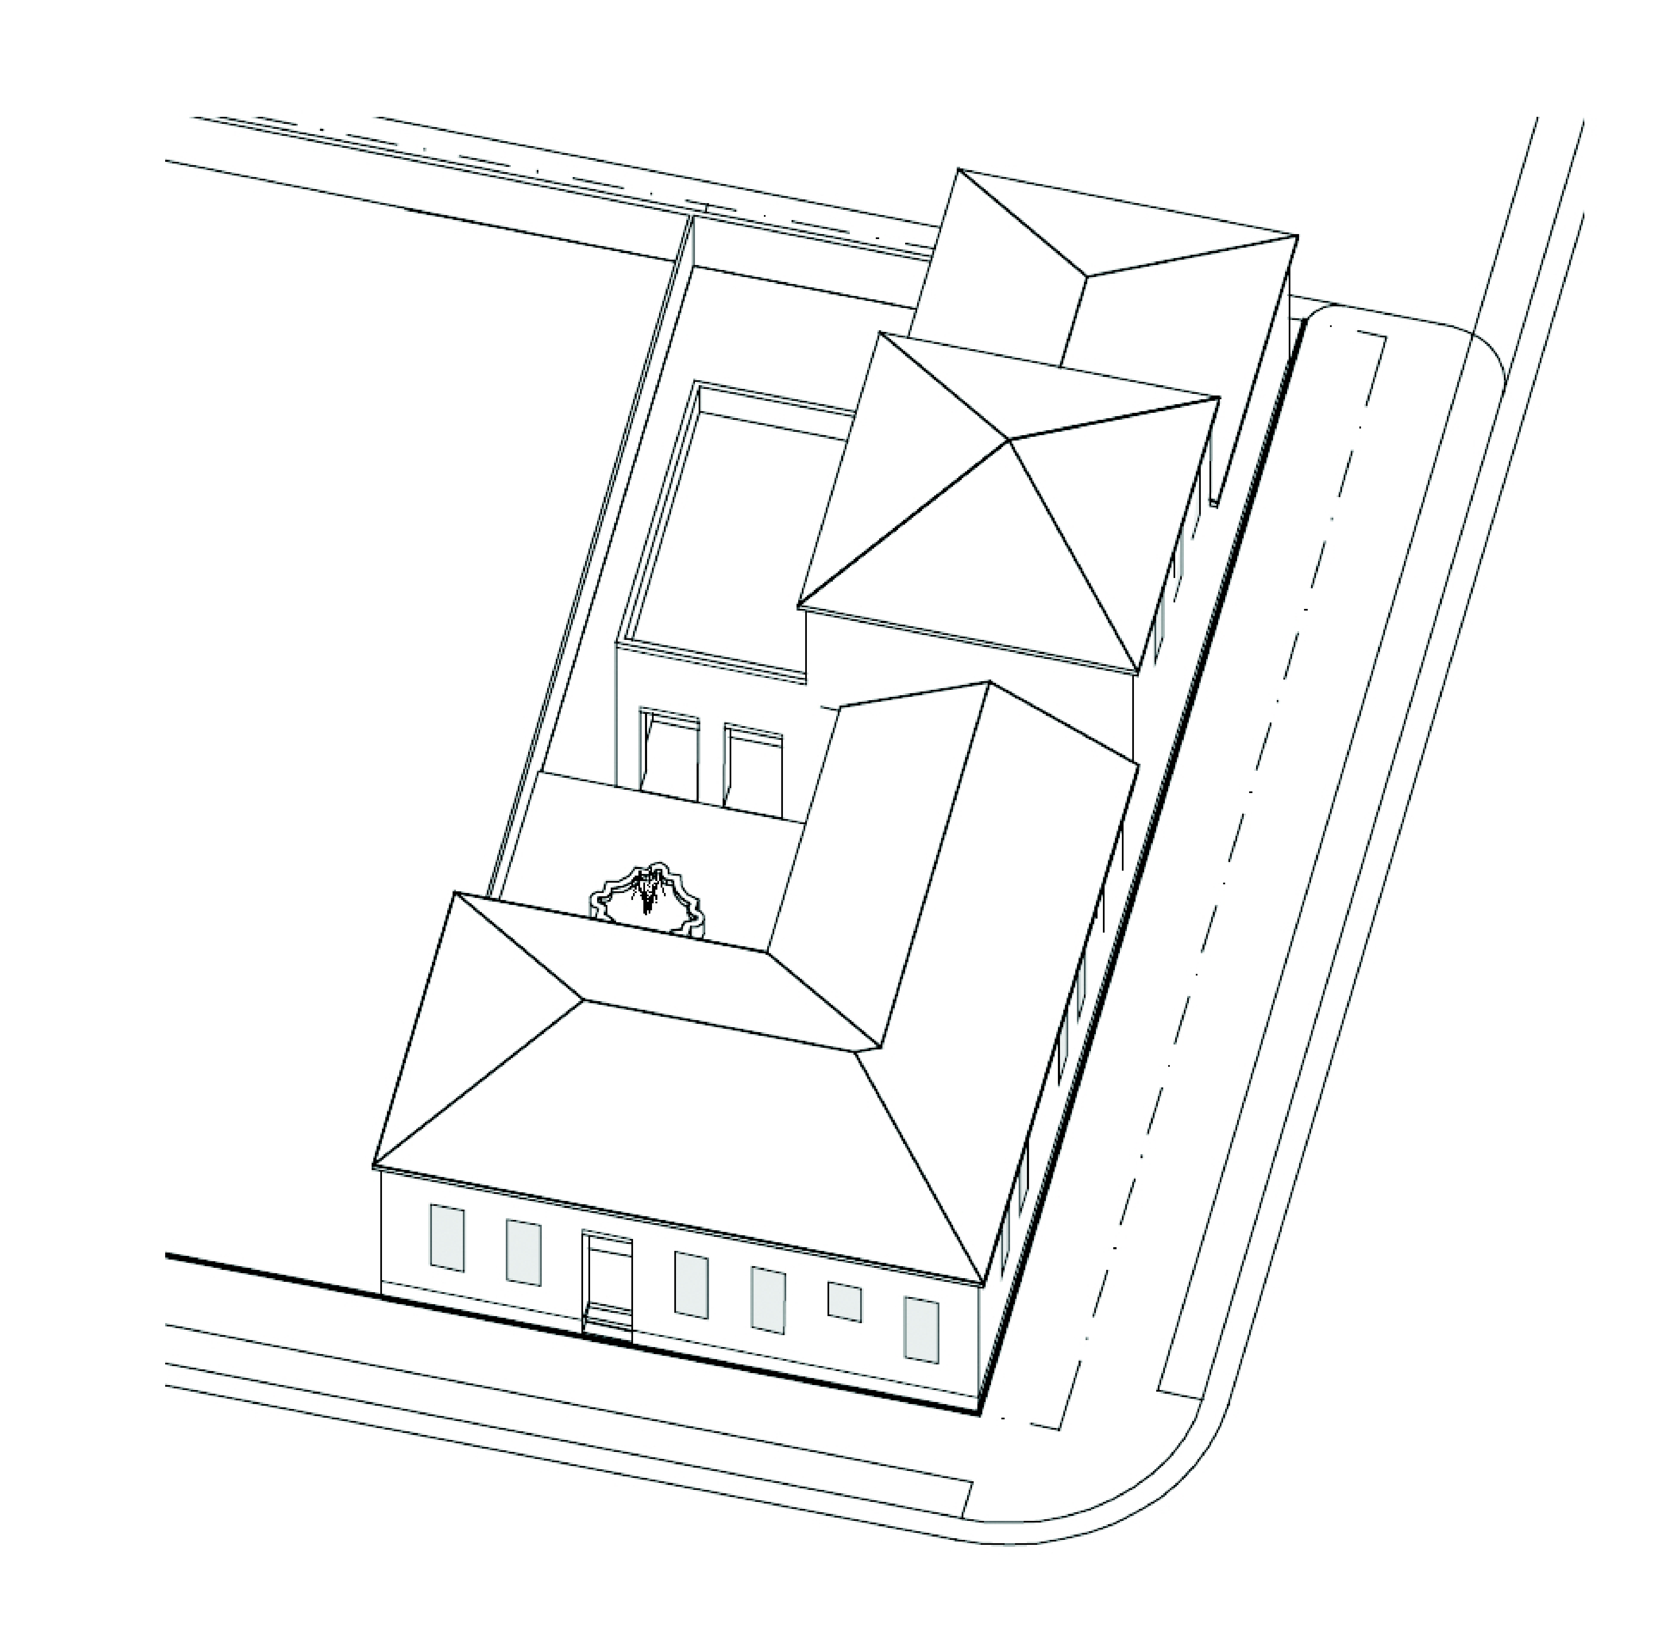

**Fig. 2: Courtyard House**

17. *Designated open space:* An outdoor, at-grade space including greens, squares, plazas and colonnades as indicated on the Designated Open Space Plan.

18. *Entertainment Center:* An enclosed building or open lot area designated for amusement, entertainment, cultural, ecological, or historical complex (or any combination thereof) that is open to the public, including without limitation: buildings for public assembly; mechanical rides; games and contests; exhibits and demonstrations; art exhibits and musical shows; retail sales; marketplaces, including second-hand sales; food services, including fast food restaurants; and water attractions.

19. *Fenestration:* Design and position of windows, entrances, and other structural openings in a building.

20. *Floorplate:* The shape and size of any given floor of a building. The floorplate that touches the ground is called the footprint, after the shape it leaves on the land.

21. *Forecourt:* The front yard area defined by three sides of the principal building and a low garden wall parallel to the street making the space suitable for gardens and outdoor seating (see Fig. 3). At street corners, the forecourt edges are defined by two (2) principal building walls and a low garden wall parallel to the street (see Fig. 4).

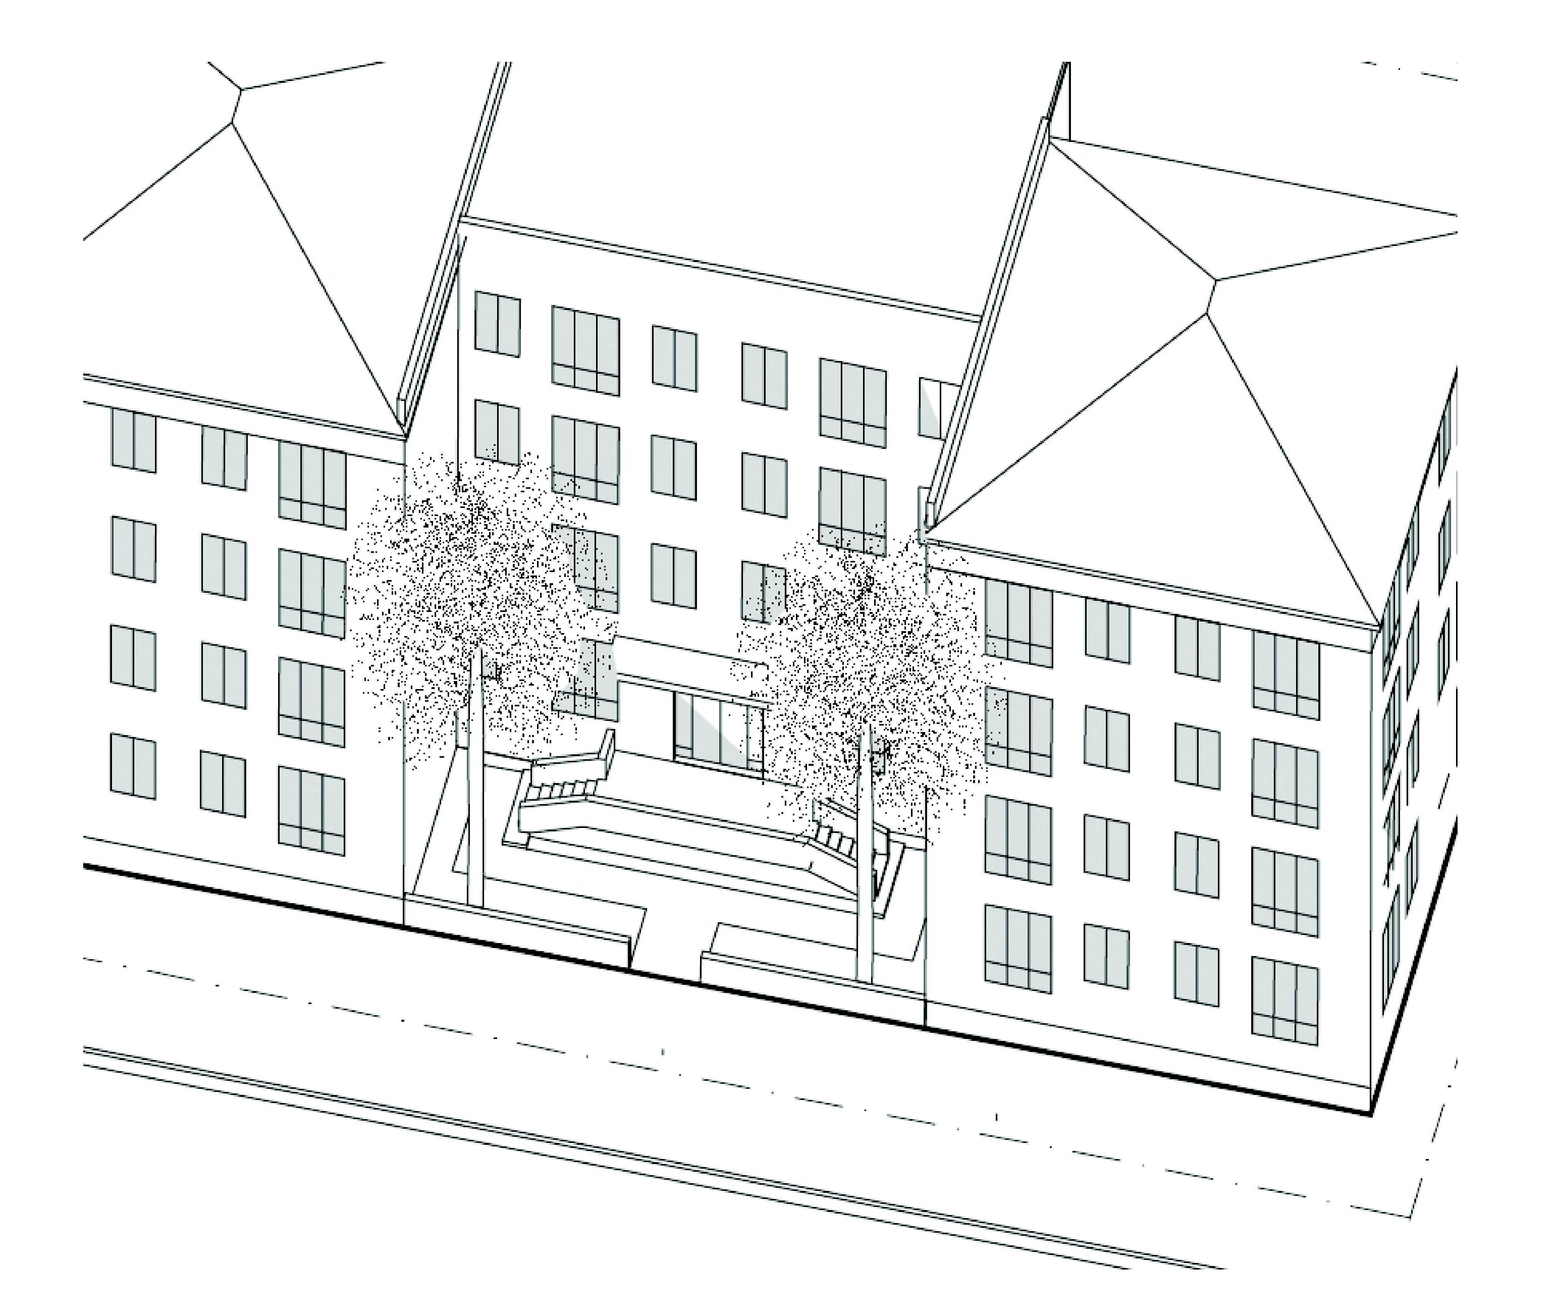

**Fig. 3: Interior Lot Forecourt**

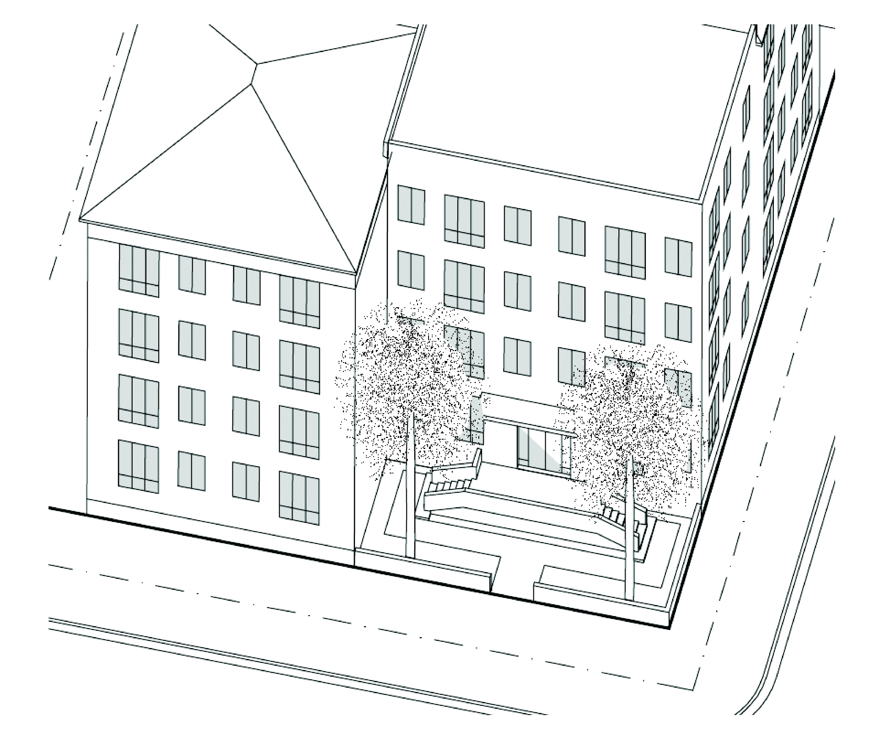

**Fig. 4: Corner Lot Forecourt**

22. *Front Property Line:* The property line abutting the higher ranking street in accordance with the urban centers Street Types Regulating Plan. For equal ranking streets, either frontage may be designated as the front property line.

23. *Green:* An outdoor open space that shall not be hard surfaced for more than twenty (20) percent of the area exclusive of dedicated streets. The landscapes shall consist primarily of lawn, trees, and garden structures (see Fig. 5).

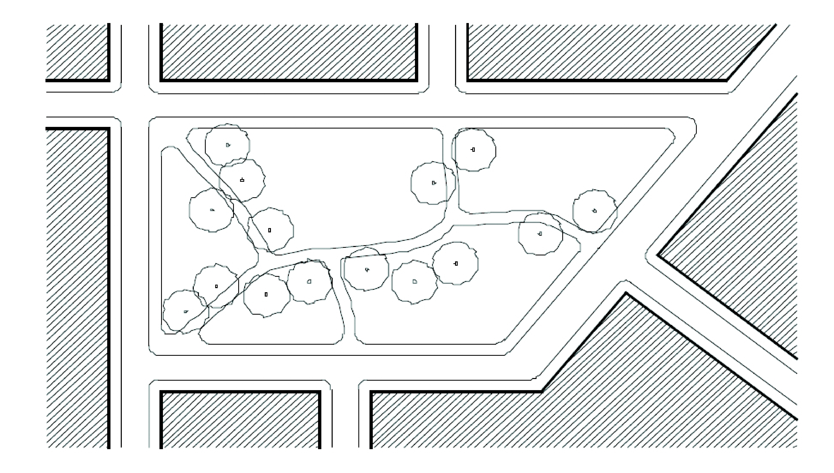

**Fig. 5: Green**

24. *Greenway or linear park:* An outdoor open space along a natural edge, including without limitation, a river front, a canal, a scenic road, or other route. Greenways provide passage for pedestrians or bicycles and are used to link nature reserves, cultural features, other parks, and open spaces and/or historic sites.

25. *Habitable Space:* Building space the use of which involves regular human presence. Habitable space shall not include areas devoted to parking, storage, or warehouses.

26. *Home Office:* A professional office use within a residential use, as provided in [Section 33-25.1](../level3/PTIIICOOR_CH33ZO_ARTIINGE.docx#PTIIICOOR_CH33ZO_ARTIINGE_S33-25.1HOOF) of this code.

27. *Irregularly shaped lot:* A lot in areas designated Residential (R) and Residential Modified (RM) with an irregular shape due to its location on a corner or intersection or at the end of a grouping of single-family detached or attached units. The dimensions of the front yard of such lot shall be similar to the dimensions of the front yards of adjacent homes.

28. *Live-work building:* A mixed-use building type with residential dwellings located above work spaces.

29. *Main street:* A vehicular and pedestrian thoroughfare lined primarily with mixed-use buildings, as depicted on the Street Types Regulating Plan.

30. *Minor street:* A street that is predominantly residential in character as depicted on the Street Types Regulating Plan.

31. *Mixed-use building:* A building that includes a combination of two or more vertically integrated uses, such as retail and/or office uses on the ground floor, with residential uses above.

32. *Off-street parking:* Garage parking or surface parking not on a public or private street.

33. *On-street parking:* Parking on a public or private street.

34. *Outdoor Market:* An outdoor commercial establishment where produce, hand-made crafts and other items are offered for sale.

35. *Pedestal:* The bottom portion of a building that creates the street frontage.

36. *Pedestrian passages:* Interconnected paved walkways that provide pedestrian passage through blocks and that connect directly with the network of sidewalks and open spaces.

37. *Penthouse:* Topmost built area of a building with a floorplate area less than that of the tower below.

38. *Permeable Materials:* Materials used for paving parking lot and roadway surfaces that allow stormwater run-off to infiltrate the ground, such as porous concrete, porous asphalt, concrete, brick, stone or similar materials.

39. *Plaza:* An outdoor open space fronted by mixed-use, retail, and office uses. A minimum of fifty (50) percent and a maximum of seventy-five (75) percent of the plaza's area, exclusive of dedicated streets, shall be hard surfaced. The landscape of plazas shall consist primarily of hard-surfaced areas, permanent architecture or water-oriented features, and trees that are placed in an orderly fashion and that are regularly spaced as shown below (see Fig. 6).

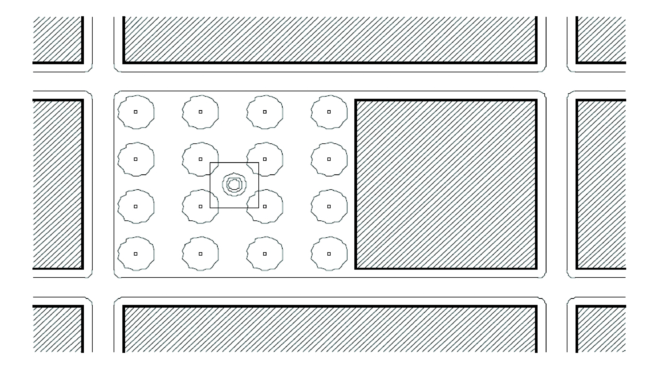

**Fig. 6: Plaza**

40. *Residential Building Type:* One of the following residential building types permitted in the Urban Center or Area Districts: single-family detached; duplex; rowhouse; courtyard house; sideyard house; urban villa, and apartment.

41. *Rowhouse:* A single-family attached dwelling unit of a group of three (3) or more units, each separated from the adjoining unit by a common party fire wall. Each common party fire wall shall extend to the roof line or above the roof of units that it serves and shall have no openings therein. Each rowhouse unit shall be serviced with separate utilities and shall otherwise be independent of any other unit.

42. *Service road:* A private or public vehicular passageway providing primary, secondary, or service access to the sides or rear of building lots.

43. *Setback Area:* The area between the street, either public or private, and the build-to line.

44. *Sideyard house:* A single-family dwelling that provides an extensive porch oriented toward a side yard; the side yard is screened from the view of the street by a six (6) foot masonry wall along the build-to line (see Fig. 7).

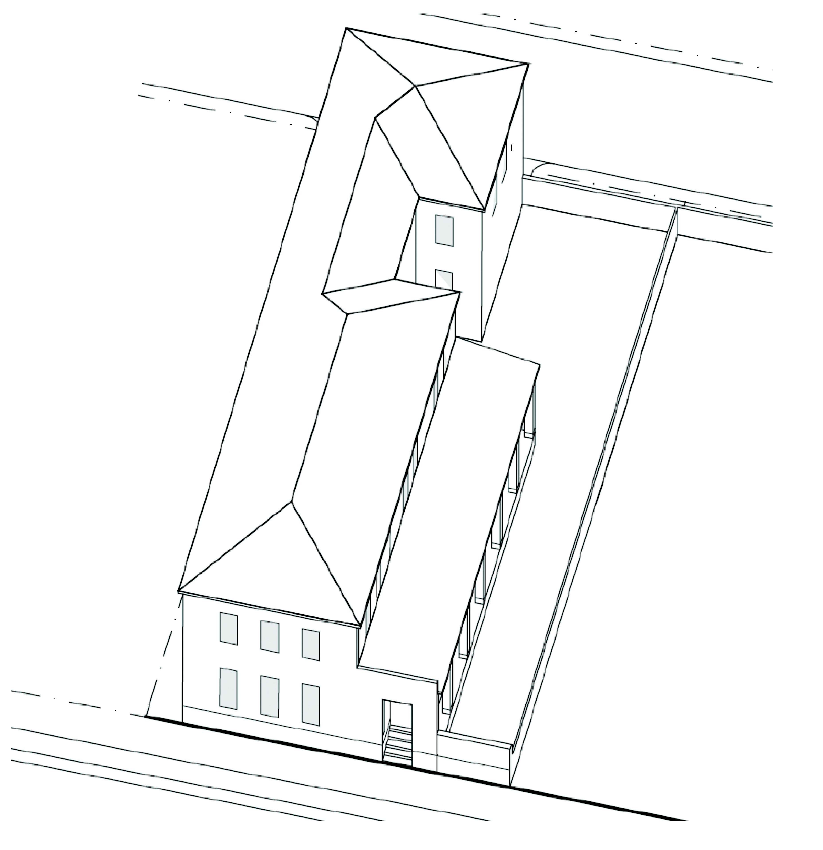

**Fig. 7: Sideyard House**

45. *Site Improvements:* Improvements to a site including, but not limited to: buildings, walls, signage, paved areas and installed landscaping.

46. *Square:* An outdoor open space that shall be flanked by streets on at least three (3) sides and shall not be hard-surfaced for more than fifty (50) percent of the area exclusive of dedicated streets. Squares shall be located according to the Designated Open Space Plan, and their landscapes shall consist primarily of hard-surfaced walks, lawns, and trees that are placed in an orderly fashion and that are regularly spaced (see Fig. 8).

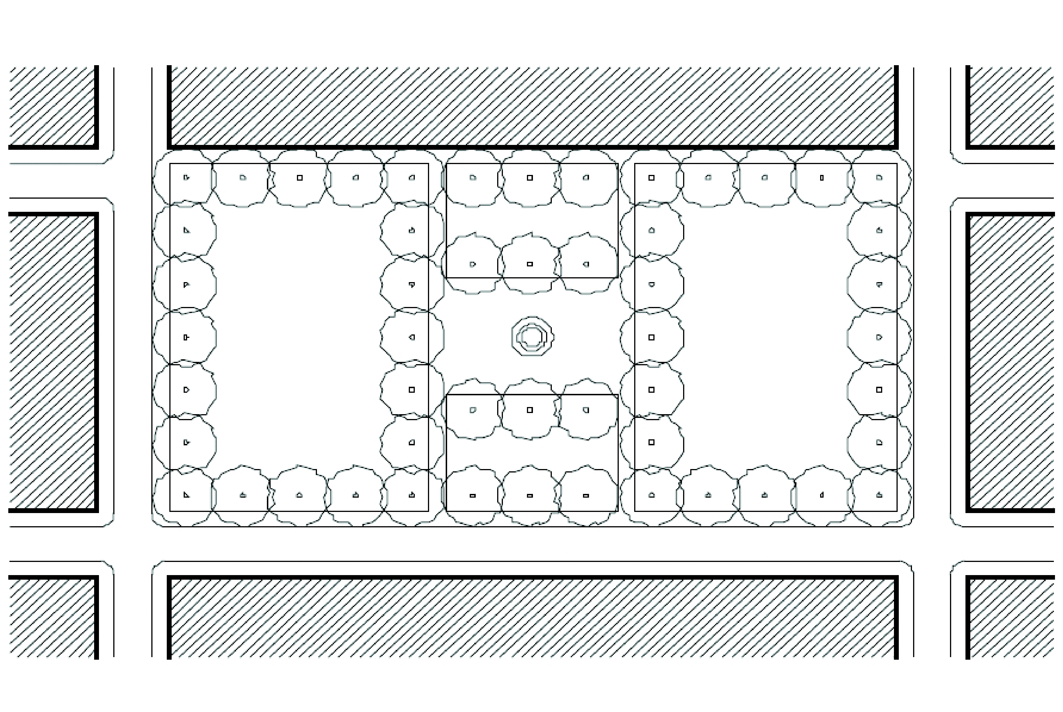

**Fig. 8: Square**

47. *Storefront:* The first story portion of a mixed-use building consisting of habitable space used for business, office, or institutional purposes.

48. *Story:* an enclosed floor level within a building containing habitable space.

49. *Street:* Any thoroughfare, such as a public street, private street, or easement that affords primary access to abutting property.

50. *Street network:* A system of intersecting and interconnecting streets and service roads.

51. *Street Type Development Parameters:* The design criteria that establish the required elements for the placement and size of the following: sidewalks; curbs and gutters; parking; medians; bike lanes; traffic lanes; street trees; and landscape strips in the street.

52. *Street vista:* A view through or along a street centerline terminating with the view of a significant visual composition of an architectural structure or element. Street Vistas are indicated on the Open Space Regulating Plan by arrows; direction of the vista is indicated by the direction of the arrow. Garages and blank walls are not significant visual compositions.

53. *Tower:* The middle portion of a building above the pedestal and below the penthouse.

54. *Urban Center District:* A zoning district established for a CDMP-designated urban center. A zoning district established for the unincorporated portion of a CDMP-designated urban center or for an area encompassing more than one CDMP-designated urban center, may also be referred to as an Urban Area District.

55. *Urban Villa:* A single-family dwelling where the primary structure shall be built in close proximity to the front property line as depicted in the building placement diagrams in this article. Walled courts, patios or roof terraces may be used to provide open space. Vehicular parking areas and driveways shall be screened from the view of the street by garage doors and/or walls.

56. *Weather Protection Features:* Architectural features that provide protection from the sun and rain, including without limitation, colonnades, awnings, bus shelters, or projecting roofs.

57. *Work-force Housing Unit or WHU:* A dwelling unit, the sale, rental or pricing which is restricted to households whose income is up to one hundred forty (140) percent of the most recent median family income for the County reported by the U.S. HUD as maintained by the Department of Planning and Zoning.

(Ord. No. 05-143, § 2, 7-7-05; Ord. No. 06-10, § 1, 1-24-06; Ord. No. 07-93, § 1, 7-10-07; Ord. No. 12-86, § 1, 10-2-12)

Sec. 33-284.83. Uses.

No land, body of water, or structure shall be used or permitted to be used, and no structure shall be hereafter erected, constructed, reconstructed, moved, structurally altered, or maintained for any purpose in the Urban Center (UC) or Urban Area (UA) Districts, except as provided in this article. The uses delineated herein shall be permitted only in compliance with the Regulating Plans and standards provided in this article. The following regulations outline permitted uses in the R (Residential), RM (Residential Modified), MC (Mixed-Use Corridor), MM (Mixed-Use Main Street), MO (Mixed-Use Optional), MCS (Mixed-Use Special), MCI (Mixed-Use Industrial), ID (Industrial District) and I (Institutional) Land Use Areas.

A. *Land Uses in General.*

1. *Outdoor uses/enclosed uses.* All uses shall be conducted within completely enclosed buildings, except outdoor uses expressly permitted in this article. Materials and products shall be stored within an enclosed building or within an area completely enclosed within walls having a life expectancy of twenty (20) years or more from the date of installation. Storage shall not be visible above the height of the walls. Commercial vehicles shall be stored or parked within an enclosed building or an area enclosed by a fence, wall, or hedge, and out of the view from adjacent properties.

2. *Density Calculation.*

a. Density averaging shall be permitted when a unified development is located on one or more parcels, with different land uses or Sub-district designations, under the same ownership.

b. A single accessory dwelling unit permitted with a single-family residence shall not count towards the minimum required and maximum permitted density thresholds.

3. *Work-force Housing.* Unless otherwise specified in the District regulations, all residential or mixed-use developments that: (a) are located within the Core or Center Sub-districts of an urban center district adopted by the Board or County Commissioners after July 10, 2007, and (b) have more than four (4) residential units, shall provide a minimum of twelve and a half (12.5) percent of their units as Work-force Housing Units.

4. *Mixed Use.* The vertical or horizontal integration of residential, business and office, and institutional uses shall be permitted as provided herein. Vertical integration allows any combination of primary uses, with business uses typically located on the ground floor and office and/or residential uses on the upper floors. Horizontal integration allows any combination of parcels with different primary uses within the same block.

5. *Temporary Uses.* Temporary uses including seasonal tent sales; stands for the sale of flowers, fruit and similar uses; and festivals and farmers' markets are permitted in the MC, MO, MM, MCS, MCI, ID and I categories, subject to the following conditions:

a. Except for the following, no temporary use shall be permitted for more than fourteen (14) consecutive days and the time between temporary activities shall be at least three times as long as the duration of the last event.

i. A temporary use for the sale of holiday related items such as holiday trees, fireworks, and similar items shall be permitted for thirty (30) consecutive days leading up to the holiday date.

ii. A temporary use that occurs on two (2) or less consecutive days shall be permitted weekly.

b. When applicable, a Zoning Improvement Permit (ZIP) and Certificate of Use shall be obtained. A site plan shall be submitted with the ZIP application indicating, at a minimum;

i. Location of temporary activities and structures, which shall not be subject to the Building Placement Standards set forth in [Section 33-284.85](../level3/PTIIICOOR_CH33ZO_ARTXXXIII_K_STURCEDIRE.docx#PTIIICOOR_CH33ZO_ARTXXXIII_K_STURCEDIRE_S33-284.85BUPLST) of this article;

ii. Anticipated number of patrons;

iii. Location of parking facilities;

iv. Temporary street closures;

v. Hours of operation;

vi. Location and description of lighting and amplification devices.

c. Outdoor festivals and farmers' markets shall be restricted to daylight hours unless written waivers of objection for the specific use and hours of operation are obtained from all property owners within five hundred (500) feet. The Director may reduce or expand the notification requirement based on potential visual, noise or traffic impacts to adjacent properties.

d. A carnival or circus, that involves an amusement ride, acrobatic apparatus, or trained animal, shall only be permitted if approved upon public hearing.

6. *Unusual and New Uses.* Except as expressly permitted in this article, unusual and new uses, as outlined in [Section 33-13](../level3/PTIIICOOR_CH33ZO_ARTIINGE.docx#PTIIICOOR_CH33ZO_ARTIINGE_S33-13UNUS) of this chapter, shall only be permitted if approved upon public hearing.

B. *Land Use Groups.* The uses listed following each group in this section shall be permitted in the land use categories shown in Table (C) subject to the provisions noted for each land use category. Uses provided in Table (C) below not listed in this subsection shall be permitted subject to the provisions noted for each land use area. The Director shall have the authority to determine that a use not specifically enumerated below may nevertheless be permitted in a land use category because it is similar to an enumerated use.

1. *Accommodation Uses:* Facilities that provide short-term lodging including hotels, motels, rooming houses, bed and breakfasts, and similar uses.

2. *Automotive Uses:* Establishments specializing in the service or repair of automobiles; automobile tire sales and replacement; automobile parts sales and installation; sales of new and used automobiles; and gas stations or other form of stations used for the powering/charging of automobile vehicles.

3. *Child Care Facilities:* Child care facilities shall be those defined in Article XA of this chapter and shall be subject to the requirements therein, as applicable; except that child care facilities shall provide recreation areas in accordance with [Section 33-284.86](../level3/PTIIICOOR_CH33ZO_ARTXXXIII_K_STURCEDIRE.docx#PTIIICOOR_CH33ZO_ARTXXXIII_K_STURCEDIRE_S33-284.86GERE)(D)(2) of this article. Where conflicts exist, the provisions of this article shall apply.

4. *Civic Uses:* Uses that are accessible to the public and serves the religious, recreational, educational, cultural and/or governmental needs of the community. Civic uses include, but are not limited to: convention halls or meeting halls; private clubs; libraries; schools; police stations; fire stations; post offices; clubhouses; religious buildings; museums; athletic facilities; auditoriums theaters, movie theaters, and other visual and performance arts buildings; and governmental facilities. The architecture of a civic use building shall reflect its civic nature. The sale of alcohol, if provided, shall be ancillary to the primary civic use and shall comply with Article X of this Chapter.

5. *Private Colleges/Universities:* Facilities that serve the educational needs of the adult population. This group shall include universities; colleges; commuter colleges; trade schools; and similar uses.

6. *Commercial Parking Garage:* Structures that provide parking as the primary on-site use. These facilities offer short-term parking of vehicles and may charge a fee for such use. This group includes: shared parking facilities; shuttle parking facilities; and transit park-and-ride facilities. This group shall not include parking facilities that are ancillary to another on-site use.

7. *Health Care Services:* A facility that provides out-patient health care services to the local community. These facilities shall include: clinics; doctor's office; dentist's offices; federally qualified health centers; urgent care facilities; diagnostic centers including sleep centers; and similar uses. These facilities shall not provide in-patient care.

8. *Drive-Through Facilities:* Drive-through facilities associated with a retail use, personal service establishment or restaurant.

9. *Entertainment Use:* Uses in this group shall include: nightclubs; arcades; movie theaters; performance theaters; radio, movie and/or television studios; billiard halls; skating rinks; bingo halls; piano bars; adult entertainment uses (as defined in [Section 33-259.1](../level3/PTIIICOOR_CH33ZO_ARTXXIXINLIMADI.docx#PTIIICOOR_CH33ZO_ARTXXIXINLIMADI_S33-259.1ADUSPE) of this chapter); bowling alleys; and similar uses. The sale of alcohol, if provided, shall be ancillary to the primary entertainment use and shall comply with Article X of this chapter.

10. *Food/Beverage Establishments:* This group shall include: full service restaurants; fast food restaurants; bars and pubs; and similar uses. The sale of alcohol, if provided, shall comply with Article X of this chapter, except that full-service restaurants serving alcoholic beverages shall be exempt from Sections [33-150](../level3/PTIIICOOR_CH33ZO_ARTXALBE.docx#PTIIICOOR_CH33ZO_ARTXALBE_S33-150LOES)(A) and [33-150](../level3/PTIIICOOR_CH33ZO_ARTXALBE.docx#PTIIICOOR_CH33ZO_ARTXALBE_S33-150LOES)(B) of this chapter.

11. *General Retail/Personal Service Establishments:* Establishments that provide goods and services geared toward an individual consumer. This group shall include businesses such as: banks; beauty parlors; adult day care; bakeries; bookstores; apparel stores; grocery stores; pharmacies; tailor shops; health clubs; gift shops; indoor pet care centers/boarding and indoor kennels (soundproofed and air-conditioned building required); vehicle retail showrooms; and similar uses. This group shall also include schools offering instruction in dance, music, martial arts and similar activities, but this group shall not include colleges/universities. Except as otherwise authorized in this article, uses enumerated in the BU-3 zoning district shall only be permitted in the MCS and MCI categories and shall be subject to the public hearing and spacing requirements set forth in [Section 33-255](../level3/PTIIICOOR_CH33ZO_ARTXXVIILIBUDI.docx#PTIIICOOR_CH33ZO_ARTXXVIILIBUDI_S33-255USPE) of this chapter.

12. *Group Residential Home:* A dwelling unit licensed by the State of Florida Department of Children and Families that serves resident clients and provides a living environment for unrelated residents who operate as a functional equivalent of a family. Uses in this group shall include: nursing homes, assisted living facilities; congregate living facilities; foster care facilities; community residential homes; group homes; and other similar uses. Services that support the daily operation of group homes are permitted and shall include dining facilities, doctor's offices, nurse's offices, staff offices, recreation rooms, and similar facilities and services.

13. *Industrial Uses:* The Industrial Use group shall include uses permitted in [Section 33-259](../level3/PTIIICOOR_CH33ZO_ARTXXIXINLIMADI.docx#PTIIICOOR_CH33ZO_ARTXXIXINLIMADI_S33-259USPE) of this chapter, unless specifically prohibited by this chapter. Residential spacing requirements shall not be required for uses in this group.

14. *Live/work Units:* An individual residential unit integrated with a general retail/personal service establishment, professional business office, or workshop.

15. *Professional Business Offices:* Facilities used primarily for the business of professionals with only limited transactions occurring on-site. This group shall include offices for: accountants; architects; appraisers; attorneys; consulates; financial firms; insurance adjusters; realtors; medical offices and other uses found by the Director to be similar.

16. *Residential Uses:* Single-family detached homes, urban villas, courtyard houses, sideyard houses, duplexes, rowhouses, apartments (including student housing), and other similar uses. Home offices as provided in [Section 33-25.1](../level3/PTIIICOOR_CH33ZO_ARTIINGE.docx#PTIIICOOR_CH33ZO_ARTIINGE_S33-25.1HOOF) of this chapter shall be permitted.

17. *Workshop:* an enclosed workplace on the ground floor area of a building used as an office or for the manufacturing of artifacts and crafts utilizing only hand held and/or table mounted electrical tools.

C. *Table of Permitted Uses.* Unless the regulations for a specific urban center district provide otherwise, the Land Use Groups in paragraph (B) of this section shall be permitted in the R (Residential), RM (Residential Modified), MC (Mixed-Use Corridor), MM (Mixed-Use Main Street), MO (Mixed-Use Optional), MCS (Mixed-Use Special), MCI (Mixed-Use Industrial), ID (Industrial District) and I (Institutional) land use categories in accordance with the following table:

|  |  |  |  |  |  |  |  |  |  |
| --- | --- | --- | --- | --- | --- | --- | --- | --- | --- |
| LAND USE GROUP | LAND USE CATEGORY | | | | | | | | |
| R[3][4] | RM[3][4] | MC[1][3] | MM[1][3] | MO[1][3] | MCS[1][3] | MCI[1][3] | ID | I |
| Residential Uses: |  | | | | | | | | |
| Single-Family: | P | P |  |  |  |  |  |  |  |
| Duplex: | P | P |  |  |  |  |  |  |  |
| Multi-Family Apartments: |  | P | P[2] | P | P[2] | P[2] | P[2] | P[2][5] |  |
| Live/Work Units: |  |  |  |  |  |  | P[17] | P[17] |  |
| Civic Uses: | P | P | P | P | P | P | P | P | P |
| Religious Facilities: | P | P | P | P | P | P | P | P | P |
| Schools (K—12): | P[7] | P[7] | P[7] | P[7] | P[7] | P[7] | P[7] | P[7] | P[7] |
| Hospitals: |  |  | SE | SE | SE | SE | SE |  | SE |
| Group Residential Home: | P[6] | P[6] | P[6] | P[6] | P[6] | P[6] | P[6] |  |  |
| Health Care Services: | SE | SE | P | P | P | P | P | P |  |
| General Retail/Personal Service Establishments: |  |  | P[8] | P[8] | P[8] | P[8] | P[8] | P[8] |  |
| Liquor Package Stores: |  |  | P[11] | P[11] | P[11] | P[11] | P[11] |  |  |
| Automotive Uses: |  |  |  |  |  | P | P | P |  |
| Gas/Service Stations: |  |  |  |  |  | P[10] | P[10] | P[10] |  |
| Professional Business Offices: |  |  | P | P | P | P | P | P |  |
| Industrial Uses: |  |  |  |  |  |  | P | P |  |
| Colleges and Universities: |  |  | P | P | P | P | P |  | P |
| Entertainment Uses: |  |  | P[16] | P[16] | P[16] | P[16] | P[16] | P[16] |  |
| Accommodation Uses: |  | P[12] | P[12] | P[12] | P[12] | P[12] | P[12] | P[12] |  |
| Child Care Facilities: | P[15] | P[15] | P | P | P | P | P |  | P |
| Food/Beverage Establishments: |  |  | P[13] | P[13] | P[13] | P[13] | P[13] | P[13] |  |
| Drive-Through Facilities: |  |  | P[9] | P[9] | P[9] | P[9] | P[9] | P[9] |  |
| Commercial Parking Garage: |  |  | P[14] | P[14] | P[14] | P[14] | P[14] |  |  |

P: Permitted Use, although specific uses may require approval as special exception

SE: Special Exception - only permitted if approved upon public hearing

[#] Footnote (as provided below)

*Footnotes:*

1. The vertical integration of uses shall be required in the MM category and shall be encouraged in the MC, MO, MCS, and MCI categories. When residential uses are provided in the MM category, uses other than residential shall be required on the first floor.

2. Residential uses shall be permitted in noted categories, either alone or when vertically integrated with other lawful uses; except that developments with more than fifty (50) residential units shall provide a minimum of ten (10) square feet of retail space for each residential unit.

3. Accessory structures shall be permitted as ancillary to the noted uses.

4. For single-family homes in the R and RM categories, an accessory building may be used as a dwelling unit only if: (a) it contains a maximum of six hundred (600) square feet of habitable space; and (b) it is maintained under the same ownership as the single family home.

5. The following limited residential uses shall be permitted in the ID category when fronting an "A" Street and when buffered from an industrial use by a street, a service road, or a live-work unit:

a. In the Edge Sub-district, the residential uses permitted in the R category at a minimum density of six (6) dwelling units per net acre and a maximum density of eighteen (18) dwelling units per net acre.

b. In the Center Sub-district, the residential uses permitted in the RM category at a minimum density of twelve (12) dwelling units per net acre and a maximum density of thirty-six (36) units per net acre.

6. In the R category, group residential homes shall meet the requirements outlined in [Section 33-199](../level3/PTIIICOOR_CH33ZO_ARTXIVSIMIREDI.docx#PTIIICOOR_CH33ZO_ARTXIVSIMIREDI_S33-199USER)(10) of this chapter. In the RM, MC, MM, MO, MCS, and MCI categories, group residential homes shall meet the following requirements:

a. Three (3) occupants shall be deemed to be one (1) dwelling unit, and the maximum number of dwelling units allowed shall be equal to the permitted residential density.

b. The proposed group residential home shall not be located within a radius of one thousand two hundred (1,200) feet of another existing, unabandoned, legally established group residential home. The 1,200-foot distance requirement shall be measured by following a straight line from the nearest portion of the structure of the proposed use to the nearest portion of the structure of the existing use.

7. Schools shall be subject to the requirements of Article XA or XI of this chapter, as applicable; except that non-public educational facilities shall provide recreation areas in accordance with [Section 33-284.86](../level3/PTIIICOOR_CH33ZO_ARTXXXIII_K_STURCEDIRE.docx#PTIIICOOR_CH33ZO_ARTXXXIII_K_STURCEDIRE_S33-284.86GERE)(D)(2) of this article. Where conflicts exist, the provisions of this article shall apply.

8. General retail and personal service establishment shall be limited to forty thousand (40,000) square feet of ground floor area; a greater ground floor area for such uses shall only be permitted if approved as a special exception.

a. Indoor pet kennels shall be permitted subject to the following conditions: (i) all kennel buildings shall be soundproofed and air-conditioned; (ii) where outside exercise runs are provided, a landscaped buffer or decorative masonry wall shall enclose the runs, and use of the runs shall be restricted to use during daylight hours; (iii) where outside exercise runs are not provided, an outside area shall be designated for dogs (or cats) to relieve themselves, and that area shall be enclosed by a landscape buffer or masonry wall; (iv) an administrative site plan review (ASPR) shall be required, and the site plan shall show all fencing, berms, and soundproofing designed to mitigate the noise impact of the kennel on the surrounding properties.

b. Vehicle Retail Showrooms shall only be permitted in accordance with the conditions set forth in [Section 33-253](../level3/PTIIICOOR_CH33ZO_ARTXXVISPBUDI.docx#PTIIICOOR_CH33ZO_ARTXXVISPBUDI_S33-253USPE)(9.5) of this chapter.

c. The following uses shall only be permitted if approved as special exceptions: on-site storage of vehicles; and outdoor pet kennels subject to the conditions set forth in [Section 33-255](../level3/PTIIICOOR_CH33ZO_ARTXXVIILIBUDI.docx#PTIIICOOR_CH33ZO_ARTXXVIILIBUDI_S33-255USPE)(9.1) of this chapter, except that ASPR shall not be required if a site plan is approved upon public hearing.

9. Drive-through facilities shall be permitted in all Sub-districts, provided that such facilities are concealed from streets by buildings or walls. Said walls shall be six (6) feet in height (except that in the ID category, walls shall be eight (8) feet in height) and shall be placed at the build-to line.

10. Gas/Service stations shall:

a. Be permitted in the MCS category in all Sub-districts and in the MCI and Industrial (ID) categories in the Center and Edge Sub-districts; and

b. Be exempt from the minimum height requirements; and

c. Provide a continuous street facade consisting of buildings or walls along all streets except driveways. When provided, walls shall not exceed three and a half (3.5) feet in height and shall be a minimum of seventy-five (75) percent opaque. The main building shall provide a minimum of forty (40) percent of building frontage along the front property line.

11. Liquor package stores shall be permitted only in the Core and Center Sub-district and only in compliance with Article X of this chapter and all other applicable regulations of this code.

12. In the RM category, accommodation uses shall be permitted only in conjunction with an owner-occupied residence; the total number of units shall not exceed the density permitted by the land use designation. In the MM, MC, MO, MCS, MCI, and ID categories, hotel/motel uses shall not exceed seventy-five (75) units per net acre or the maximum density permitted by the land use category, whichever is greater. For all density calculations required by this subsection, one hotel room shall equal one dwelling unit.

13. Outdoor table service and outside walk-up window service in conjunction with restaurants and coffee houses may be provided subject to the following requirements:

a. The restaurant furniture located on the sidewalk shall maintain a minimum five (5) foot wide obstacle-free corridor for pedestrian circulation along the sidewalk.

b. Alcoholic beverages may be served outdoors only where such service is strictly incidental to the service of food.

14. Commercial parking garages shall meet the requirements of [Section 33-284.86](../level3/PTIIICOOR_CH33ZO_ARTXXXIII_K_STURCEDIRE.docx#PTIIICOOR_CH33ZO_ARTXXXIII_K_STURCEDIRE_S33-284.86GERE)(F)(6) of this article.

15. In the R and RM categories, child care uses shall be subject to the requirements for such uses in the RU-1 District, as set forth in [Section 33-199](../level3/PTIIICOOR_CH33ZO_ARTXIVSIMIREDI.docx#PTIIICOOR_CH33ZO_ARTXIVSIMIREDI_S33-199USER) of this chapter, except that the total number of children may exceed five (5) if approved as a special exception.

16. Adult entertainment uses, as defined in [Section 33-259.1](../level3/PTIIICOOR_CH33ZO_ARTXXIXINLIMADI.docx#PTIIICOOR_CH33ZO_ARTXXIXINLIMADI_S33-259.1ADUSPE) of this chapter, shall be prohibited in all land use categories except MCI and ID. In the MCI and ID categories, such adult entertainment uses shall only be permitted if approved as special exceptions.

17. Only the following uses shall be permitted in connection with a residence in a live-work unit in the MCI and ID land use categories:

a. Antique shops

b. Art goods stores, artist studios, galleries

c. Artisanal use

d. Bait and tackle shops

e. Bakeries

f. Cabinet shops

g. Dance studios

h. Dry cleaning and dyeing establishments

i. Engines, sales and service

j. Glass installation

k. Health and exercise clubs

l. Interior design shops

m. Leather goods manufacturing, excluding tanning

n. Locksmith shops, sharpening and grinding shops

o. Mail order office, including storage of products

p. Office uses

q. Photography labs

r. Pottery shops

s. Printing shops

t. Restaurants, excluding drive-through service

u. Secondhand stores

v. Shoe stores and shoe repair shops

w. Upholstery and furniture shops

x. Wholesale salesrooms

y. Other similar uses as determined by the Director.

(Ord. No. 05-143, § 3, 7-7-05; Ord. No. 07-93, § 2, 7-10-07; Ord. No. 08-102, § 1, 9-2-08; Ord. No. 12-86, § 2, 10-2-12; Ord. No. 13-82, § 3, 9-17-13)

Sec. 33-284.84. Regulating Plans.

A set of Regulating Plans shall be provided with each adopted Urban Center or Area District. The Regulating Plans shall consist of a series of controlling plans that include the following:

A. The Street Types Plan, which establishes a hierarchy of street types in existing and future locations that shall be provided and shown in all development plans.

B. The Sub-districts Plan, which delineates three (3) sub-districts: Core, Center and Edge. These Sub-districts shall regulate the allowable intensity of development in accordance with the Comprehensive Development Master Plan and this article.

C. The Land Use Plan, which delineates the areas where specified land uses and development of various types and intensities shall be permitted.

D. The Building Heights Plan, which establishes the minimum and maximum allowable number of stories and permits developments to reach CDMP Urban Center intensity ranges.

1. Developments in Community Urban Centers shall meet the intensity range by:

a. Providing the required minimum/maximum number of stories; or

b. Providing a minimum of one (1) story and the following applicable minimum floor-area ratio:

i. In the Edge Sub-district, a minimum floor area ratio of one-half (0.5);

ii. In the Center Sub-district, a minimum floor area ratio of one (1); and

iii. In the Core Sub-district a minimum of floor area ratio of one and one-half (1.5).

2. Developments in Metropolitan Urban Centers shall meet the intensity range by:

a. Providing the required minimum/maximum number of stories; or

b. Providing a minimum of one (1) story and the applicable minimum floor-area ratio:

i. In the Edge Sub-district, a minimum floor area ratio of one and one-half (1.5);

ii. In the Center Sub-district, a minimum floor area ratio of one and three-quarters (1.75); and

iii. In the Core Sub-district, a minimum floor area ratio of three (3).

E. The Designated Open Space Plan, which designates open spaces, which shall be shown in all development plans. The designated open spaces shall be controlled by anchor points.

F. The New Streets Plan, which shows the location and the number of new streets needed to create the prescribed network of streets within each Urban Center or Area District. All new A streets shall be required in the same general location as shown on the New Streets Plan. All B streets shall be located as provided in [Section 33-284.86](../level3/PTIIICOOR_CH33ZO_ARTXXXIII_K_STURCEDIRE.docx#PTIIICOOR_CH33ZO_ARTXXXIII_K_STURCEDIRE_S33-284.86GERE)(C) of this article.

G. The Bike Route Plan, which depicts the designated bike routes, including the bike facility requirements if any, which shall be shown in all development plans.

(Ord. No. 05-143, § 4, 7-7-05; Ord. No. 12-86, § 3, 10-2-12)

Sec. 33-284.85. Building Placement Standards.

A. The diagrams in paragraph (G) of this section establish the Building Placement Standards by land use category. Building frontage and setback areas shall be required as illustrated in the Building Placement Standards Diagrams.

B. Where Building Placement Standards Diagrams reference a Frontage Table, such table specific to each Urban Center or Area District shall be provided in the regulations for each individual District. It is provided, however, that colonnades may be placed on the property line regardless of any such frontage requirements. Unless otherwise provided, the colonnade height and width shall be in accordance with [Section 33-284.86](../level3/PTIIICOOR_CH33ZO_ARTXXXIII_K_STURCEDIRE.docx#PTIIICOOR_CH33ZO_ARTXXXIII_K_STURCEDIRE_S33-284.86GERE)(B) of this article. When a Frontage Table is not provided in the individual Urban Center or Area District regulations, building setbacks shall be required as set forth in the following table:

**Standard Frontage Table**

|  |  |  |  |
| --- | --- | --- | --- |
| STREET TYPE | DISTRICT REQUIREMENT | | |
| CORE (Build-to line) | CENTER (Build-to line) | EDGE (Build-to line) |
| Major Roadway | 10′ * | 10′ * | 15′ |
| Minor Roadway | 10′ * | 10′ * | 15′ |
| Main Street | 6′ * | 10′ * | 15′ |
| Service Road | 0′ (min) | 0′ (min) | 0′ (min) |
| Pedestrian Passage | 0′ (min) | 0′ (min) | 0′ (min) |
| * Where a colonnade is provided, the build-to line shall be zero (0) feet. | | | |

C. In all Sub-districts, mixed-use, non-residential, and multi-family, developments shall comply with the following:

1. Minimum building frontage requirements may be met by a single building, multiple buildings or multi-phased developments, and such requirements shall apply along the front property line only.

2. Where a minimum number of stories is required, said stories above the second story may be set back further than the requirements set forth in the Building Placement Standards Diagrams.

3. To articulate the building facade, fifty (50) percent of the portion of the building required to be located along the build-to line may be recessed up to two (2) feet. Further, once the minimum building frontage requirement is met, the remainder of the building may be set back from the build-to line.

4. A portion of the building may be set back up to twenty-five (25) feet to accommodate a forecourt.

5. Belfries, chimneys, spires/steeples, and other such non-habitable structures shall comply with [Section 33-55](../level3/PTIIICOOR_CH33ZO_ARTIIIHEBU.docx#PTIIICOOR_CH33ZO_ARTIIIHEBU_S33-55CESTEX) of this chapter.

6. Accessory buildings shall follow parking and/or allowable building area setbacks provided in the Building Placement Standards Diagrams.

D. In all Sub-districts, accessory buildings for rowhouse, courtyard, sideyard, single-family detached, duplex and urban villa shall follow the accessory building/dwelling/parking area setbacks provided in the Building Placement Standards Diagrams.

E. In all Sub-districts, for all land use categories, accessory structures shall be permitted provided that they do not encroach on the front and side street setbacks.

F. The table below identifies the Building Placement Standards that apply to each Land Use Category:

|  |  |  |  |  |  |  |  |  |  |  |
| --- | --- | --- | --- | --- | --- | --- | --- | --- | --- | --- |
| BUILDING PLACEMENT STANDARD | LAND USE CATEGORY | | | | | | | | | |
| Metro-politan Centers | Metropolitan and Community Centers | | | | | | | | |
| MM MC MCS MO | R | RM | MC | MM | MO | MCS | MCI | ID | I |
| 1. Mixed Use, Multi-Family | X |  |  |  |  |  |  |  |  |  |
| 2. Mixed Use, Multi-Family |  |  |  | X | X | X | X | X |  |  |
| 3. Industrial |  |  |  |  |  |  |  | X | X |  |
| 4. Rowhouse, Multi-Family |  |  | X |  |  |  |  |  |  |  |
| 5. Rowhouse |  | X | X |  |  |  |  |  |  |  |
| 6. Courtyard, Sideyard |  | X | X |  |  |  |  |  |  |  |
| 7. Single-family |  | X |  |  |  |  |  |  |  |  |
| 8. Single-family |  | X |  |  |  |  |  |  |  |  |
| 9. Duplex |  | X | X |  |  |  |  |  |  |  |
| 10. Duplex |  | X | X |  |  |  |  |  |  |  |
| 11. Civic | X | X | X | X | X | X | X | X | X | X |
| 12. Urban Villa |  | X | X |  |  |  |  |  |  |  |
| X: Standard is applicable in the indicated Land Use Category | | | | | | | | | | |

G. Building Placement Standards Diagrams.

1. Mixed Use, Multi-Family:

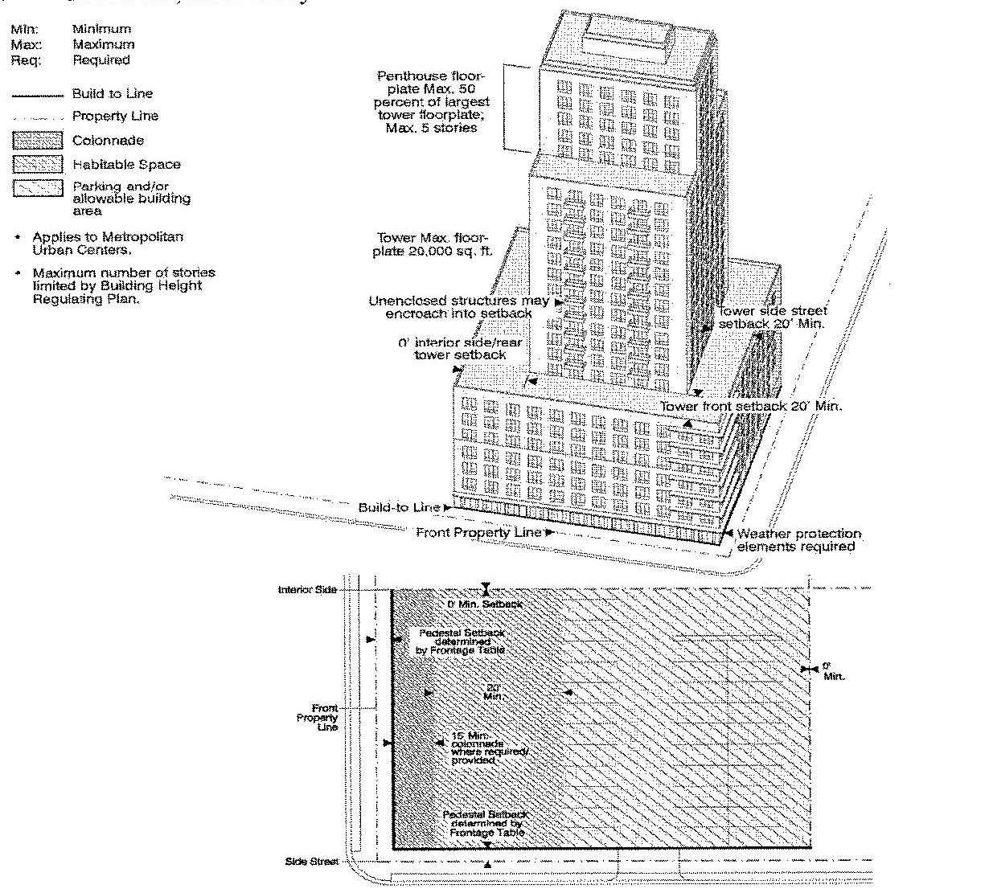

a. Building Frontage Required: Seventy (70) percent minimum at build-to line. Minimum frontage requirement applies along the front property line only.

b. Build-to lines or street setback requirements shall be measured from the edge of sidewalk.

c. All on-site parking shall be accessed from a service road or the lowest ranking street.

d. The vehicular entry width permitted shall be a maximum of thirty-three (33) feet.

e. The minimum interior side/rear setback for the pedestal, tower, and penthouse shall be zero (0) feet.

f. Where a wall or fence is used to screen parking areas along streets, a five (5) foot landscape strip with a hedge shall be required in front of the wall or fence.

g. Colonnades shall be two (2) stories high and a minimum of fifteen (15) feet deep. The colonnade depth shall not exceed the colonnade height. The exterior of the colonnade shall be no closer than two (2) feet from the curb line.

2. Mixed Use, Multi-Family:

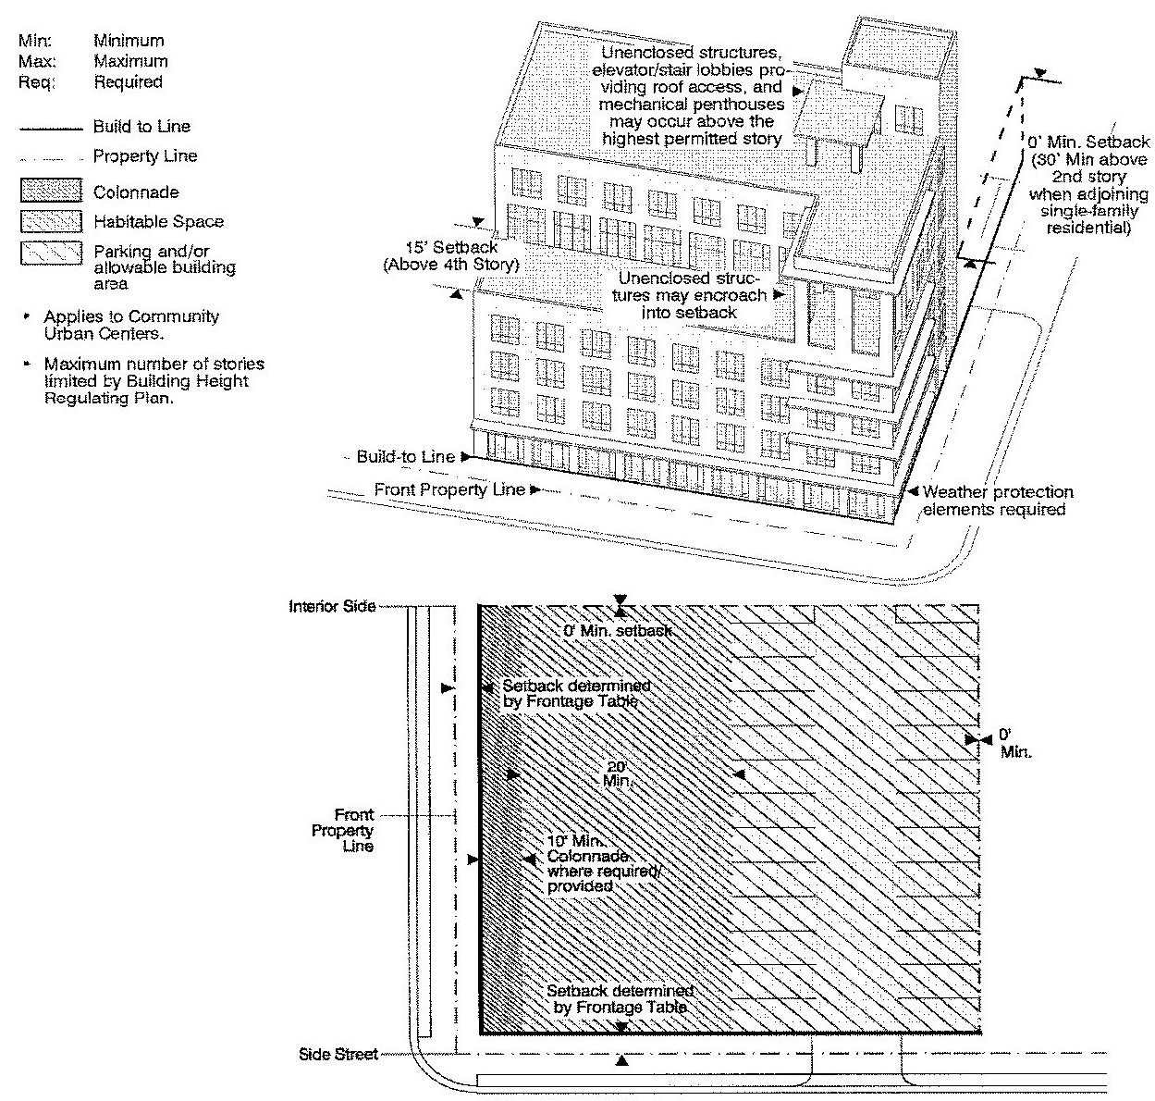

a. Building Frontage Required: Seventy (70) percent minimum at build-to line in all Sub-districts. Minimum frontage requirement applies along the front property line only.

b. Build-to lines or street setback requirements shall be measured from the edge of sidewalk.

c. The interior side/rear setbacks shall be as shown above.

d. When provided, the front setback shall be hard surfaced and finished to match the adjoining sidewalk. A minimum of five (5) feet clear width within the setback shall be kept unobstructed for pedestrians.

e. All on-site parking shall be accessed from the service road or lowest ranking street.

f. Where a wall or fence is used to screen parking areas along streets, a five (5) foot landscape strip with a hedge shall be required in front of the wall or fence.

g. Above the fourth story the setback shall be from the property line.

3. Industrial:

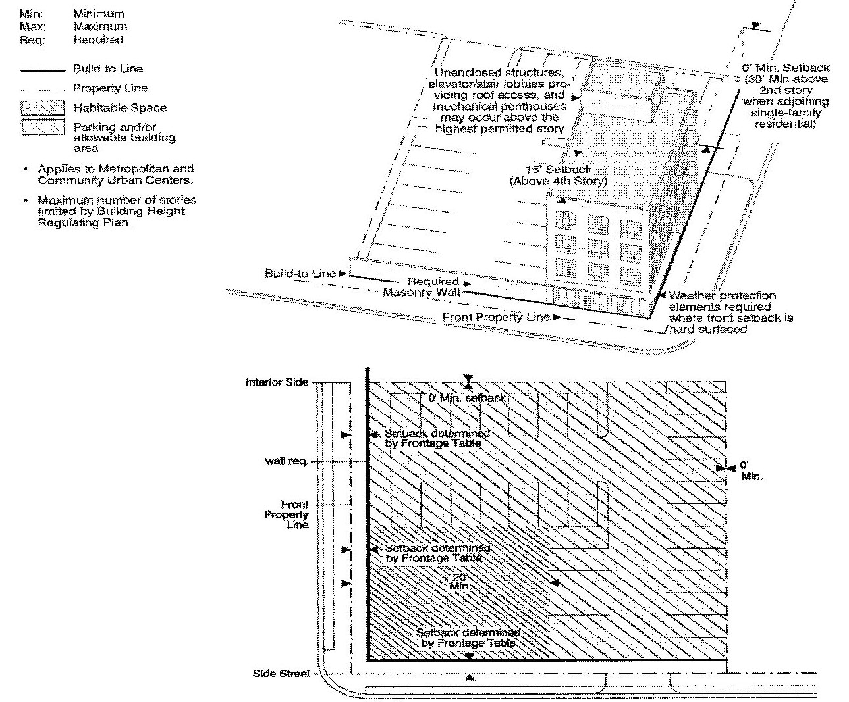

a. Building Frontage Required: Twenty-five (25) percent minimum at build-to line. Minimum frontage requirement applies along the front property line only.

b. Build-to lines or street setback requirements shall be measured from the edge of sidewalk.

c. For industrial uses, any part of the build-to line not occupied by a building shall have an eight (8) foot high masonry wall, not pierced except to provide pedestrian and vehicular ingress/egress.

d. For all other uses permitted in the ID category, walls, fences and hedges shall be provided in accordance with [Section 33-284.86](../level3/PTIIICOOR_CH33ZO_ARTXXXIII_K_STURCEDIRE.docx#PTIIICOOR_CH33ZO_ARTXXXIII_K_STURCEDIRE_S33-284.86GERE)(H) of this article, and where a wall or fence is used to screen parking areas along streets, a 5-foot landscape strip with a hedge shall be required in front of the wall or fence.

e. The interior side/rear setbacks shall be as shown above.

f. When provided, the front setback and side street setback shall be landscaped or hard surfaced and finished to match the adjoining sidewalk.

g. Above the fourth story the setback shall be from the property line.

h. All on-site parking shall be accessed from a service road or from the lowest ranking street.

4. Rowhouse, Multi-Family:

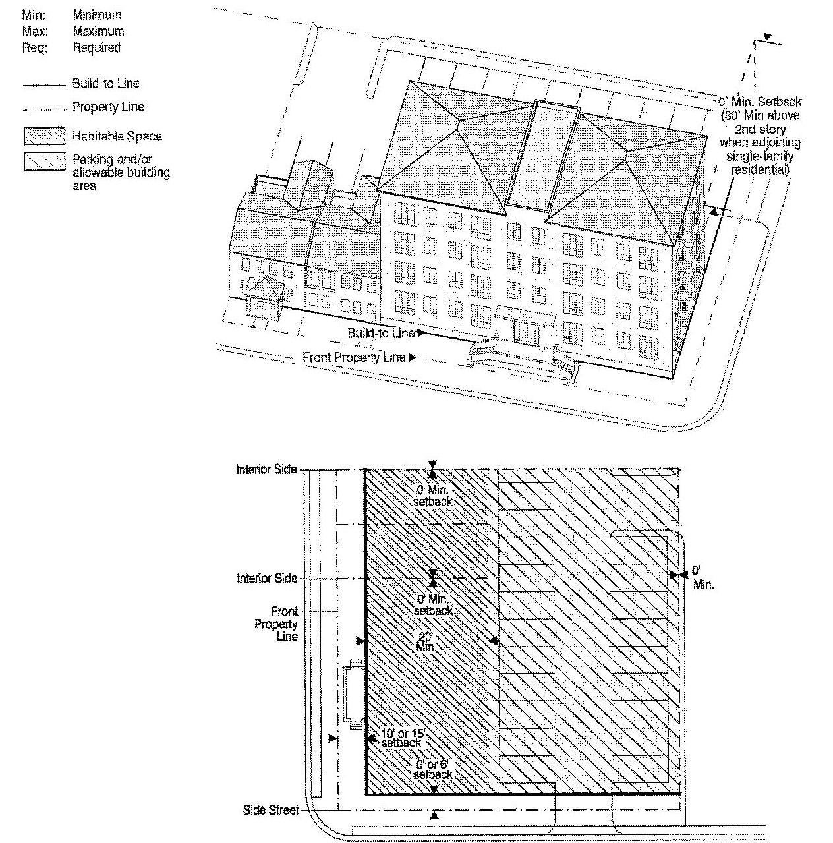

a. Building Frontage Required: Seventy (70) percent minimum at build-to line. Minimum frontage requirement applies along the front property line only.

b. Front and side street setback requirements shall be measured from the edge of sidewalk.

c. All on-site parking shall be accessed from the service road or lowest ranking street.

d. The front setback and, when provided, the side street setback shall be landscaped.

e. Where a wall or fence is used to screen parking areas along streets, a five (5) foot landscape strip with a hedge shall be required in front of the wall or fence.

f. Above the fourth story the setback shall be from the property line.

5. Rowhouse:

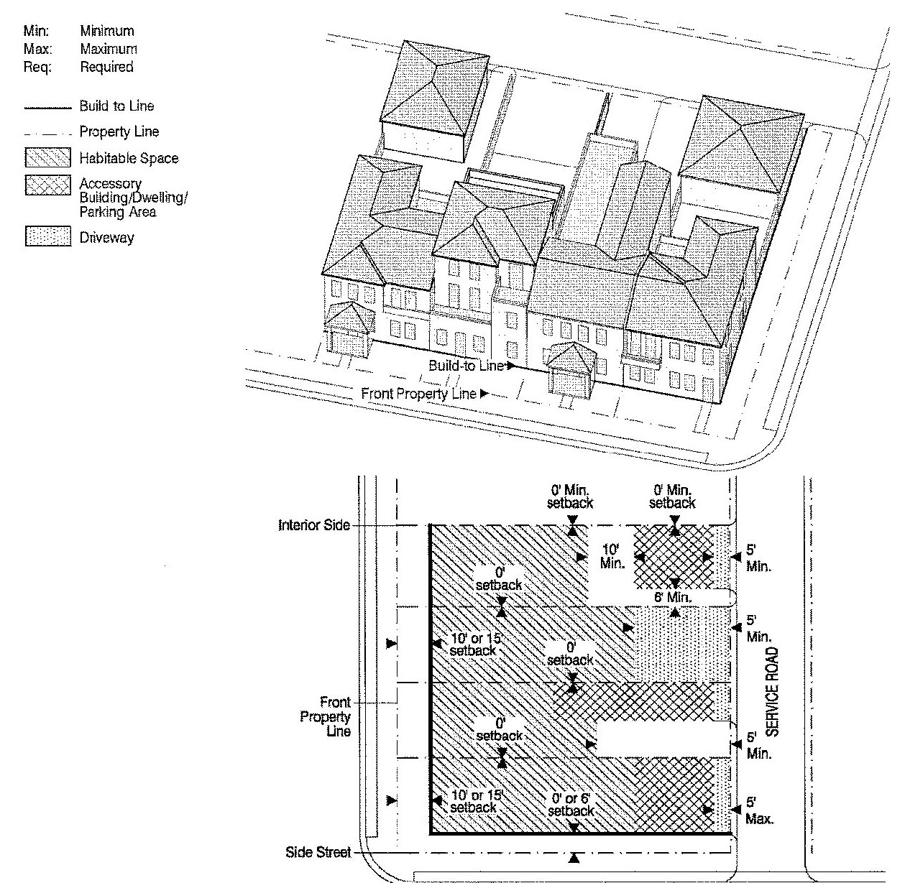

a. Building Frontage Required: One hundred (100) percent at build-to line except at end of building groups. Minimum frontage requirement applies along the front property line only.

b. Front and side street setback requirements shall be measured from the edge of sidewalk.

c. For Rowhouses all on-site parking shall be accessed from the service road.

d. The front setback and, when provided, the side street setback shall be landscaped.

e. Common parking facilities shall be permitted.

6. Courtyard, Sideyard:

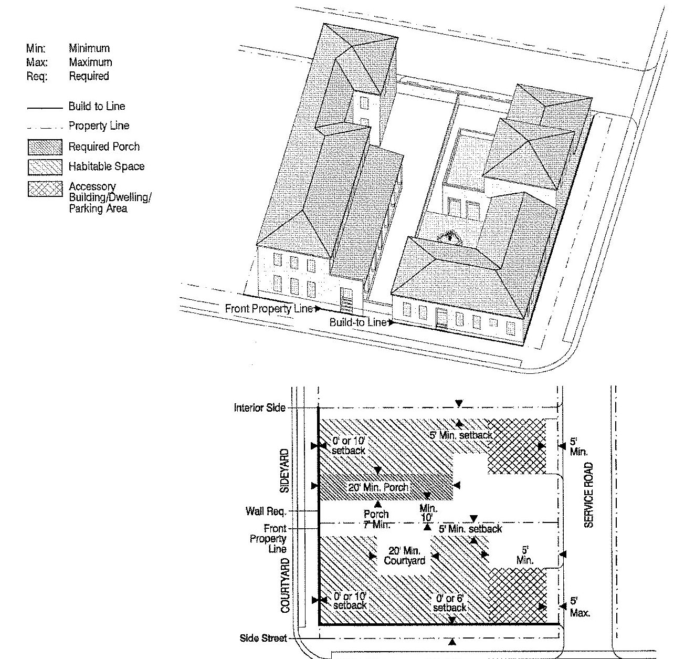

a. For Sideyard and Courtyard Houses, all on-site parking shall be accessed from the service road.

b. Front and side street setback requirements shall be measured from the edge of sidewalk.

c. Any part of the build-to line not occupied by a building shall have a masonry wall with a minimum height of forty-two (42) inches and a maximum height of seventy-two (72) inches, not pierced except to provide pedestrian and vehicular ingress/egress.

d. The front setback and, when provided, the side street setback shall be landscaped.

7. Single-Family:

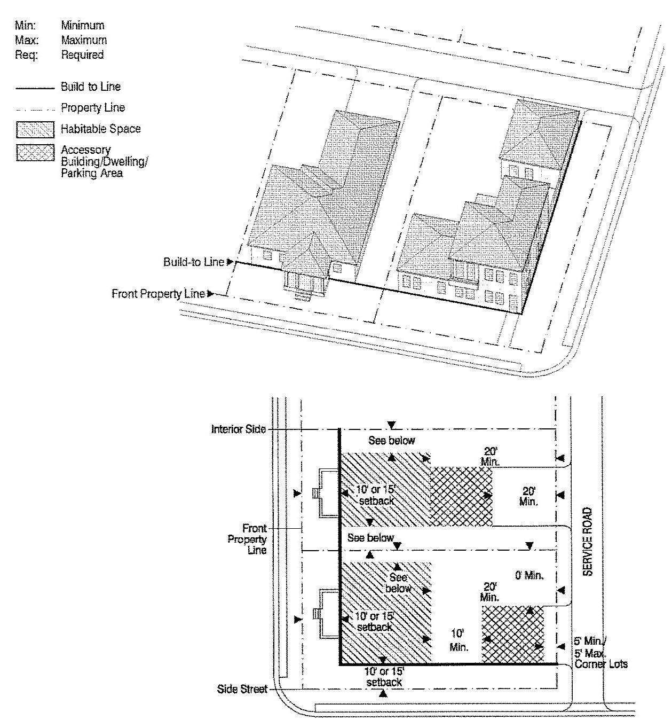

a. All on-site parking shall be accessed from the service road, where provided.

b. Front and side street setback requirements shall be measured from the edge of sidewalk.

c. For lots with frontages between fifty (50) and seventy-five (75) feet, the minimum interior side setback shall be ten (10) percent of the lot frontage; for lots with frontage greater than seventy-five (75) feet, the interior side setback shall be a minimum of seven and a half (7.5) feet.

d. The front and side street setback shall be landscaped.

8. Single-Family:

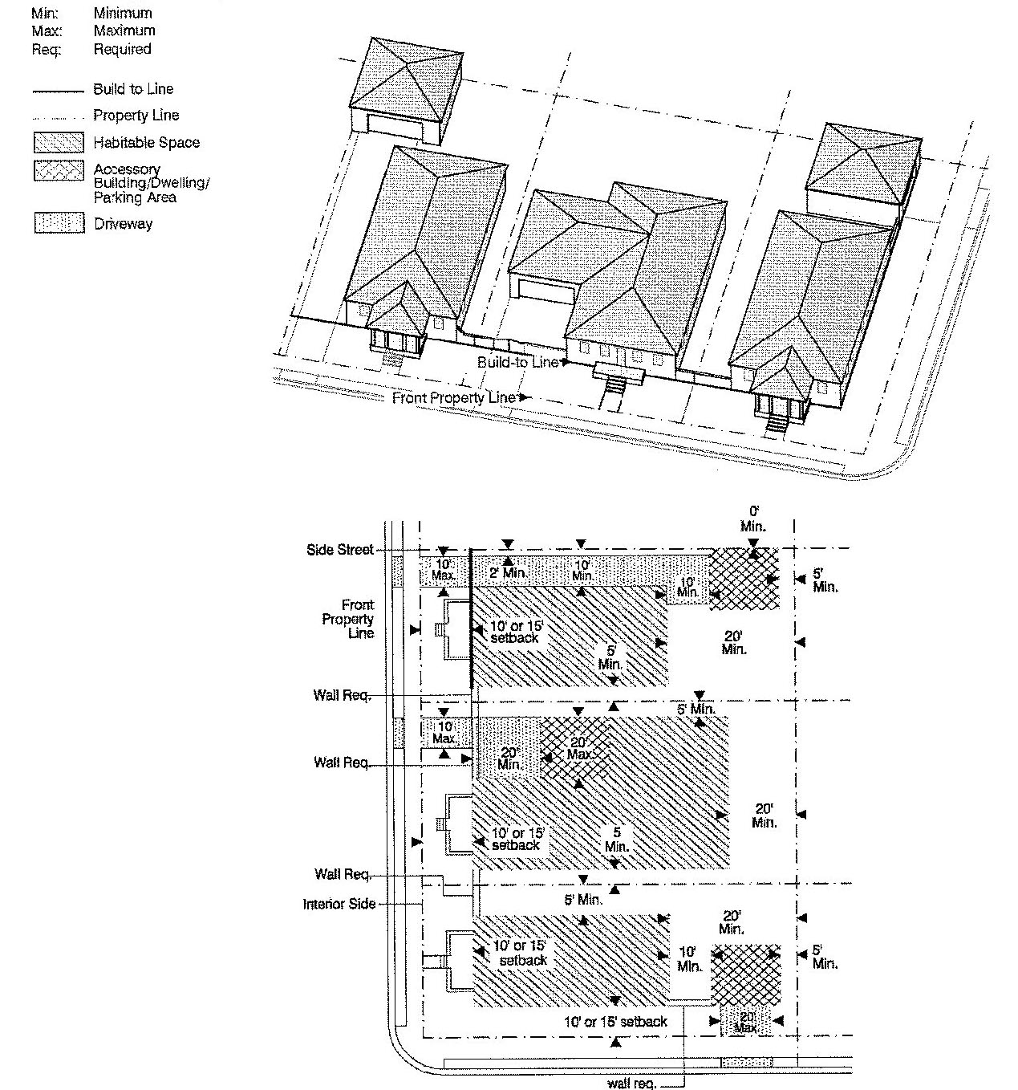

a. All on-site parking shall be accessed from the street as shown above.

b. Front and side street setback requirements shall be measured from the edge of sidewalk.

c. The front and side street setback shall be landscaped.

d. Any part of the build-to line not occupied by a building shall have a masonry wall with a minimum height of forty-two (42) inches and a maximum height of seventy-two (72) inches, not pierced except to provide pedestrian and vehicular ingress/egress.

e. Driveways between the front property line and build-to line shall be a maximum of ten (10) feet wide.

9. Duplex:

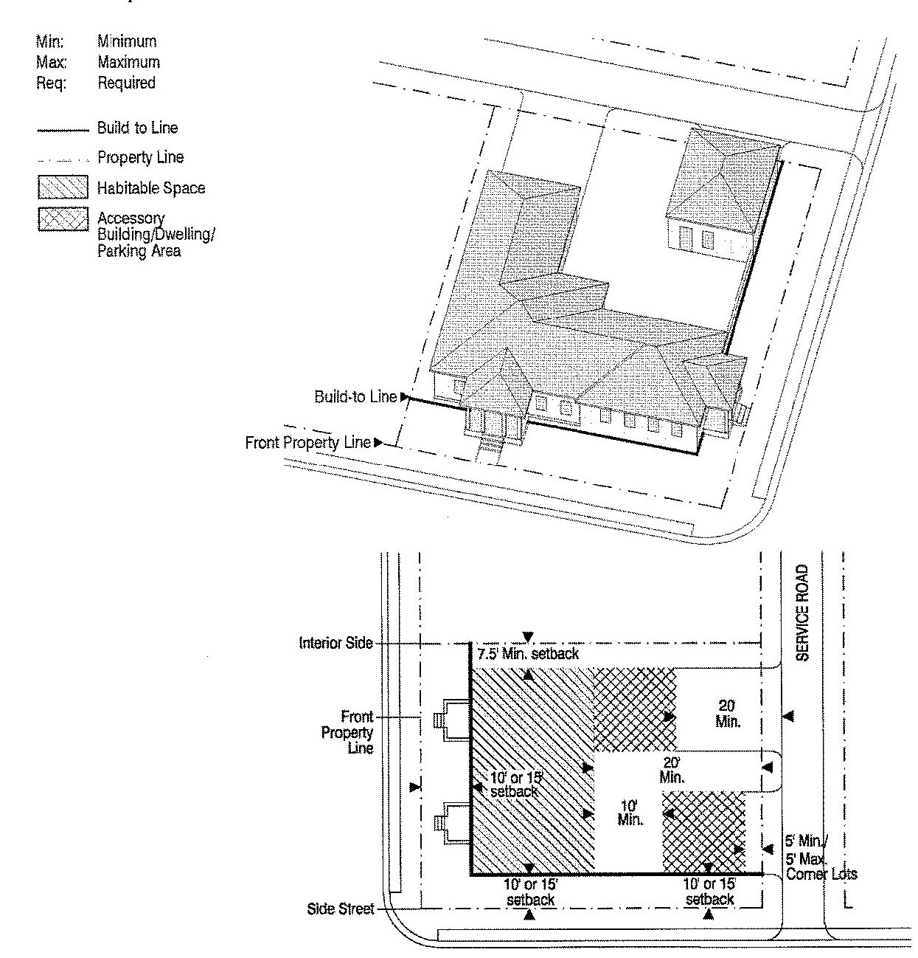

a. All on-site parking shall be accessed from the service road.

b. Front and side street setback requirements shall be measured from the edge of sidewalk.

c. The front and side street setback shall be landscaped.

10. Duplex:

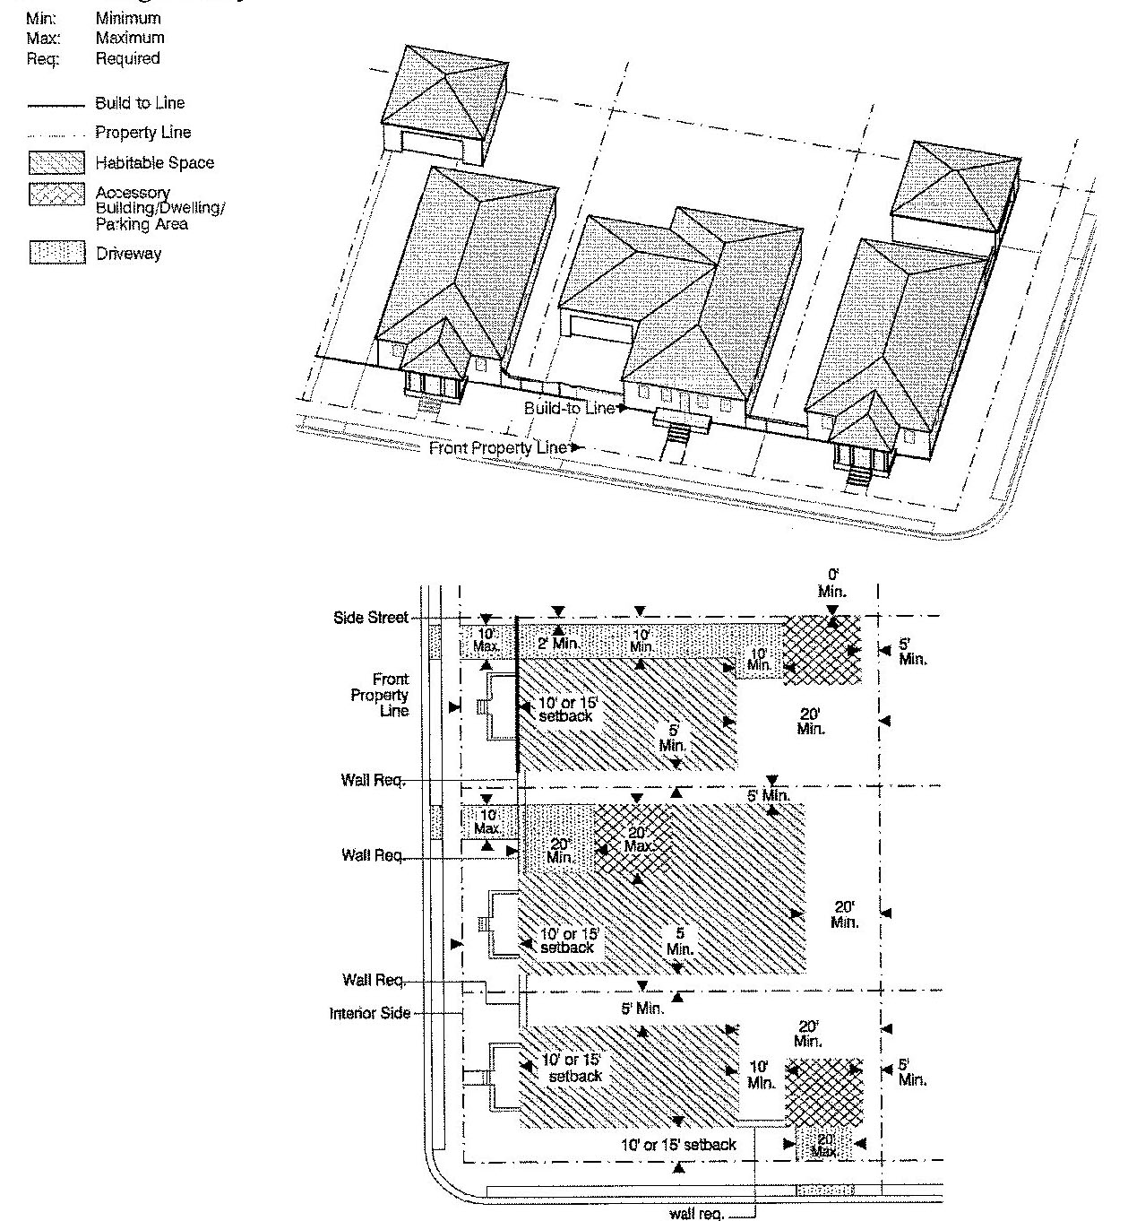

a. This building standard shall only be permitted on existing platted lots less than twelve thousand (12,000) square feet in area.

b. Front and side street setback requirements shall be measured from the edge of sidewalk.

c. All on-site parking shall be accessed from the street as shown above.

d. Any part of the build-to line not occupied by a building shall have a masonry wall with a minimum height of forty-two (42) inches and a maximum height of seventy-two (72) inches, not pierced except to provide pedestrian and vehicular ingress/egress.

e. Driveways between the front or side street property lines and build-to line shall be a maximum of ten (10) feet wide.

f. The front and side street setback shall be landscaped.

11. Civic:

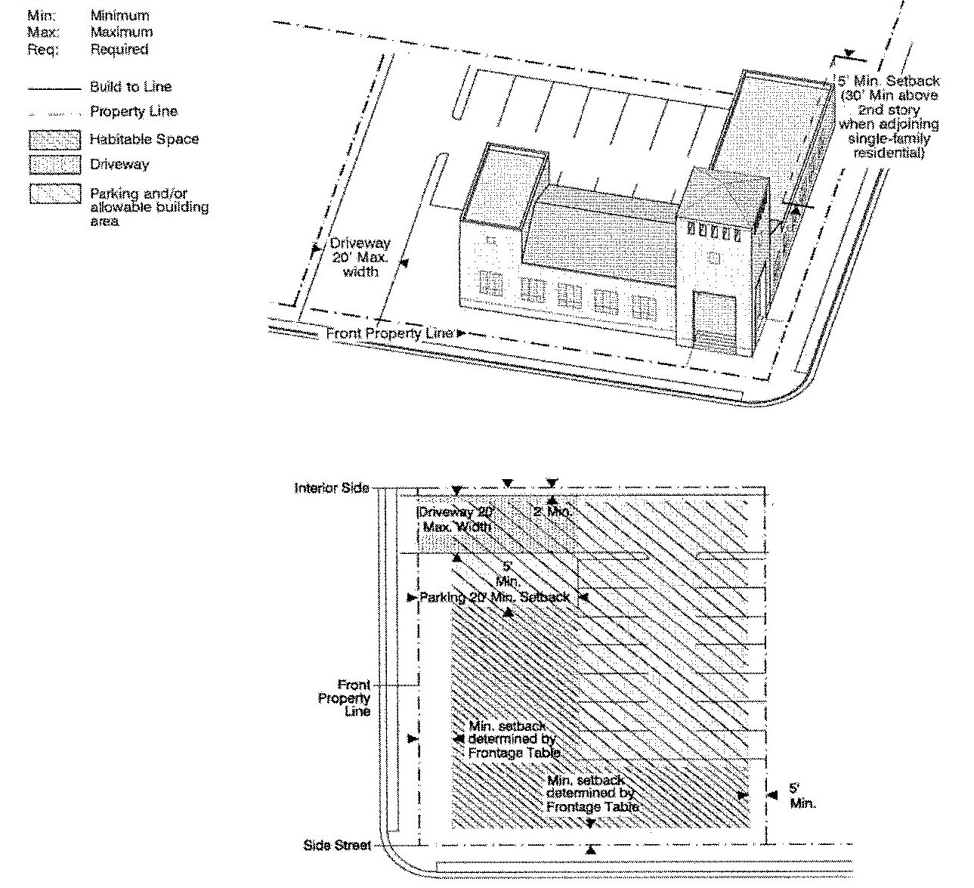

a. All on-site parking shall be accessed from the service road, where provided. For properties without an adjoining service road, parking may be accessed from the street through a driveway as shown above.

b. Build-to lines and street setback requirements shall be measured from the edge of sidewalk.

c. When on-site parking is provided, the off-street parking spaces shall be placed to the rear of the building.

d. Civic uses shall not be required to comply with height requirements indicated on the Building Heights Plan.

e. When provided, the front and side street setback areas shall be treated as a green or plaza. When treated as a plaza, the setback area shall not be required to be fronted by mixed-use, retail, or office uses. When treated as a plaza or green, the plaza or green shall be in addition to any designated open space required by the regulating plan.

f. Where a wall or fence is used to screen parking areas along streets, a five (5) foot landscape strip with a hedge shall be required in front of the wall or fence.

12. Urban Villa:

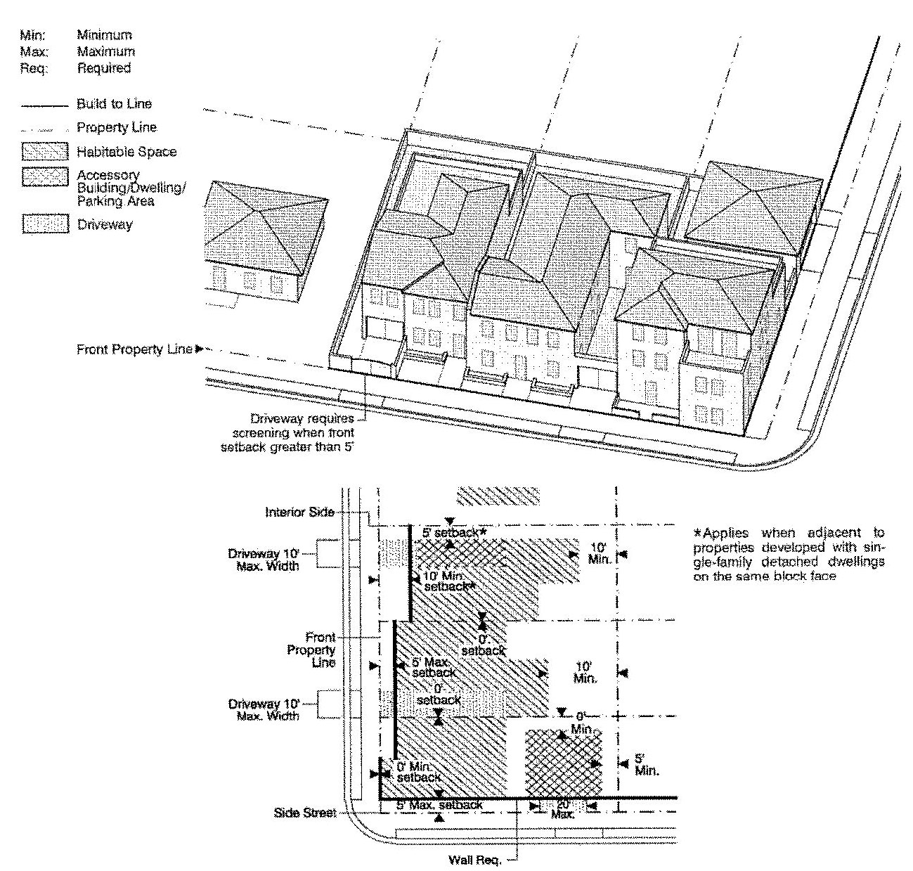

a. Building Frontage Required. Eighty (80) percent minimum at build-to line. Minimum frontage requirement applies along the front property line only. At least fifty (50) percent of Urban Villas along a block face shall provide a walled court or patio between the front property line and the building face; maximum setback shall be fifteen (15) feet only where such court or patio is provided.

b. Front and side street setback requirements shall be measured from the edge of sidewalk.

c. Parking shall be accessed from the street as shown above. Garage entrances accessed from the front property line shall be a maximum of ten (10) feet in width and no further than ten (10) feet from the front property line. Walled courts or patios shall not be used for parking.

d. The minimum height for an Urban Villa shall be two (2) stories.

e. The front setback, and when provided, the side street setback, shall be landscaped.

(Ord. No. 05-143, § 5, 7-7-05; Ord. No. 06-10, § 2, 1-24-06; Ord. No. 07-93, § 3, 7-10-07; Ord. No. 07-169, § 8, 11-6-07; Ord. No. 08-102, § 2, 9-2-08; Ord. No. 12-86, § 4, 10-2-12)

Sec. 33-284.86. General Requirements.

A. *Lots and blocks.* The following shall be required:

|  |  |  |
| --- | --- | --- |
|  | Size (Square Feet) | Frontage (Feet) |
| *Minimum Lot Requirements* | | |
| Rowhouse | 1,200* | 20 |
|  | 1,250* | 18 |
| Courtyard house and Sideyard house | 3,000* | 35 |
| Single-family detached | 5,000** | 50 |
|  | 4,375*** |  |
| Urban villa | 3,000 | 30 |
| Duplex | 7,500 | 75 |
| Duplex on parcels with less than 12,000 square feet**** | 3,000 | 40 |
| Live-work units | 1,700 | 20 (max 40) |
| Irregularly shaped lots |  | 15**** |
| All lots shall share a frontage line with a street or a designated open space | | |
| * service roads are required in all Sub-districts when these types are provided. ** when service roads are not provided. *** when service roads are provided. **** parcels established prior to the effective date of this ordinance. | | |
| *Block Requirements* | | |
| Unless otherwise provided in the Regulating Plans the perimeter of a block shall not exceed 1,600 feet, and the maximum length of a block shall be: | | |
| In the Edge Sub-district | 660 feet | |
| In the Core and Center Sub-districts | 500 feet | |

B. *Buildings.*

1. Storefronts shall be provided on the first floor of mixed-use buildings, and shall be directly accessible from a street frontage or a designated open space as follows:

a. For properties with two or more frontages, storefronts shall be located on a minimum of two frontages, with priority given to frontages on a designated open space and the highest ranking street.

b. Storefronts shall have a transparent clear glazed area of not less than seventy (70) percent of the facade area and shall be occupied by habitable uses that generate pedestrian activity and provide surveillance of the street. Security enclosures, if any, shall be of the mesh type that pedestrians can see through, and shall be located behind storefront displays.

2. All colonnades shall comply with the following:

a. Finished floor elevation of the colonnade shall match the adjoining sidewalk.

b. Colonnades shall have a minimum unobstructed clear height of ten (10) feet and a minimum clear width of ten (10) feet. Awnings shall be permitted but shall not count towards the required colonnades. Colonnades shall not cause roof drainage into the street. Colonnades shall be attached to buildings. In no instance shall the depth of a colonnade exceed the colonnade's height.

c. Freestanding colonnades shall not satisfy the build-to line requirement.

3. A minimum of thirty (30) percent of all building streetwalls shall be fenestrated with windows. Mirror type glass shall be prohibited. All glazing shall be of a type that permits view of human activities and spaces within the structure. Colonnade column spacing, windows, and doors shall be proportioned such that the height of each opening is greater than its width. At least fifty (50) percent of the area of security screens and gates shall be transparent.

4. The height of an accessory building shall not exceed the height of the principal building.

5. An open, covered, or paved connection between an accessory building and a single-family detached house, urban villa, courtyard house, sideyard house, duplex, or rowhouse may be built within the minimum required ten (10) foot spacing as shown in the Building Placement Standards set forth in [Section 33-284.85](../level3/PTIIICOOR_CH33ZO_ARTXXXIII_K_STURCEDIRE.docx#PTIIICOOR_CH33ZO_ARTXXXIII_K_STURCEDIRE_S33-284.85BUPLST) of this article.

6. Weather protection features shall be required when storefronts are provided in the MM, MC, MO, MCS, and MCI categories. In the ID category, weather protection features shall be required when the front setback is hard surfaced.

7. Awnings, balconies, stoops, stairs, open porches, and bay windows shall be permitted to extend into the minimum required setbacks, to a maximum of:

|  |  |  |  |
| --- | --- | --- | --- |
|  | Front, Rear, Side Street Setback | | Interior Side |
|  | In a setback of 10 feet or less | In a setback of greater than 10 feet |  |
| Bay windows | 3 feet | 3 feet | 3 feet |
| Balconies | 6 feet | 6 feet | 3 feet |
| Awnings | 6 feet | 6 feet | 3 feet |
| Stoops | 6 feet | 6 feet | 3 feet |
| Stairs | 6 feet | 8 feet | 3 feet |
| Porches* | 6 feet | 8 feet | 3 feet |
| * The encroachment of porches shall be permitted in conjunction with residential units, including multifamily residential developments. Ground floor porches provided for multifamily residential developments shall be enclosed on at least two (2) sides by a minimum three (3) foot high wall or metal fence. | | | |

Roof eaves, chimneys, signs, and ramps may encroach into all setbacks. Porticoes, canopies, and colonnades shall be guttered, and drainage shall be deposited onsite.

8. Where a zero (0) foot setback is permitted, roof eaves, bay windows, and balconies may encroach beyond the property line a maximum of three (3) feet, except when abutting private property. In all Sub-districts, awnings may encroach into the street no more than six (6) inches from the face of the curb. All street encroachments shall be a minimum of eleven (11) feet above the sidewalk.

9. In the Edge Sub-district, accessory buildings shall be permitted to have balconies or bay windows that encroach a maximum of three (3) feet into the rear yard setback.

10. Service areas shall be located out of the view from adjacent properties or from the street and shall be screened by a wall or fence in accordance with Subsection (H) below.

11. The primary entrance of a building shall provide access to a street or a designated open space. The primary entrance to the upper levels of a mixed-use building with colonnades shall be through the colonnaded area along the front property line.

12. Each story shall have a maximum height of sixteen (16) feet, as measured from floor to floor. Any height above sixteen (16) feet shall count as an additional story, except as follows:

a. Buildings with less than six (6) stories may have a single story with a maximum height of thirty (30) feet, provided that no mezzanine area intended for commercial use exceeds ten (10) percent and no mezzanine area intended for residential use exceeds eighty (80) percent of the floor area of that story. Multiple levels of parking shall be permitted within this single story provided that they are in compliance with Subsection (F)(6) below.

b. Buildings with six (6) or more stories, may have two stories with a maximum height of thirty (30) feet, provided that no mezzanine area intended for commercial use exceeds ten (10) percent and no mezzanine area intended for residential use exceeds eighty (80) percent of the floor area of a story. Multiple levels of parking shall be permitted within these two stories provided that they are in compliance with Subsection (F)(6) below.

13. Notwithstanding the building heights regulating plans, rowhouses may have up to three (3) stories.

14. A live-work unit shall have two components: a workshop and a residential unit. The workshop shall be located on the first floor and shall be directly accessible from the primary street frontage or a designated open space. The workshop's facade shall have a transparent clear glazed area of not less than seventy (70) percent of the facade. The residential component of a live-work unit shall connect internally with the work component.

15. Projects with fifty (50) or fewer single-family units shall have a minimum of three (3) substantially different front elevations. Projects with more than fifty (50) and up to one hundred (100) single-family units shall have a minimum of five (5) substantially different front elevations and shall provide, within each block, a minimum of two (2) different single-family building types. Projects with more than one hundred (100) single-family units shall have a minimum of five (5) substantially different front elevations and shall provide, within each block, a minimum of three (3) different single-family building types. Substantially different front elevations shall include variations in fenestration, material, and color.

16. Rowhouses shall provide a minimum of fifteen (15) feet between building groups and the length of a building group shall not exceed two hundred forty (240) feet.

17. Floorplates above eight (8) stories shall not exceed twenty thousand (20,000) square feet. Cantilever balconies shall not count towards floor plate calculation.

18. Civic use designated parcels and lots with less than twenty-five thousand (25,000) square feet shall not be required to comply with the minimum height requirement on the Building Heights Plan.

C. *Streets, Service Roads and Utilities.* All streets and service roads shall comply with the Street Types parameters as set forth in this section.

1. *Typical Minor Street Illustration.*

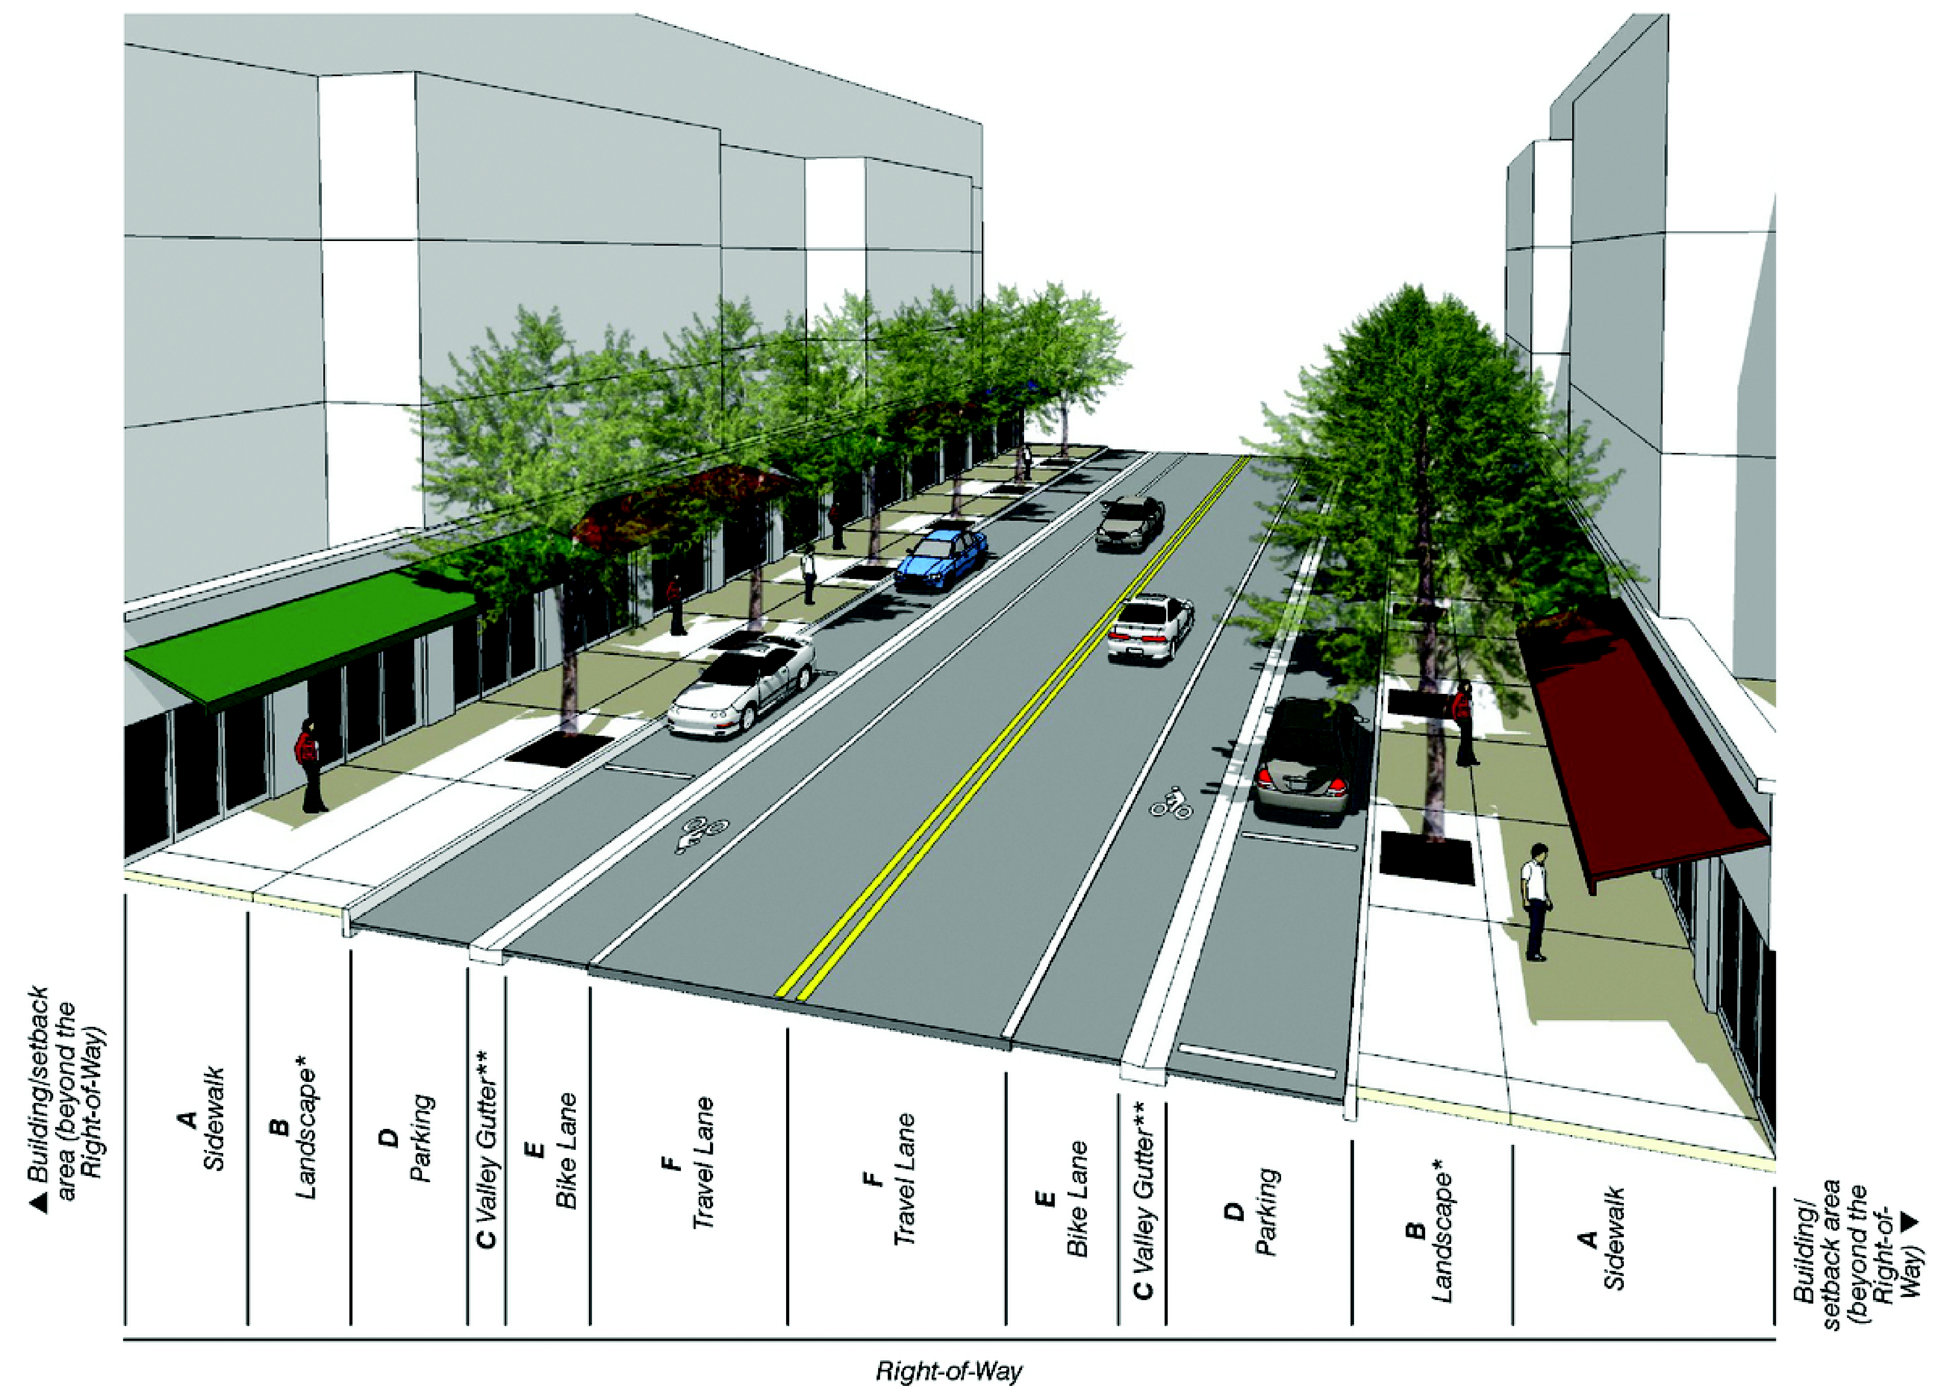

* Refer to column B in the Street Types Table for required landscape elements.

** Curb and gutter between the sidewalk and parking/travel lanes may be utilized in place of the valley gutter illustrated.

2. *Typical Two-Lane Boulevard Street Illustration.*

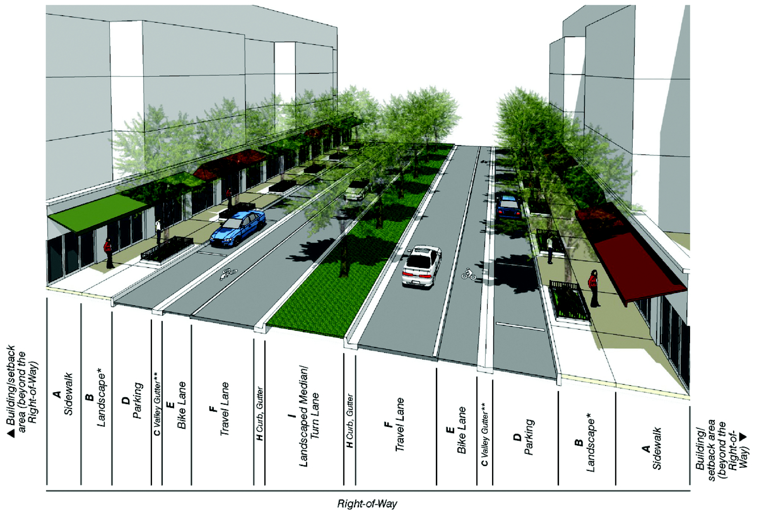

* Refer to column B in Street Types Table for required landscape elements.

** Curb and gutter between the sidewalk and parking/travel lanes may be utilized in place of the valley gutter illustrated.

3. *Typical Four-Lane Boulevard Street Illustration.*

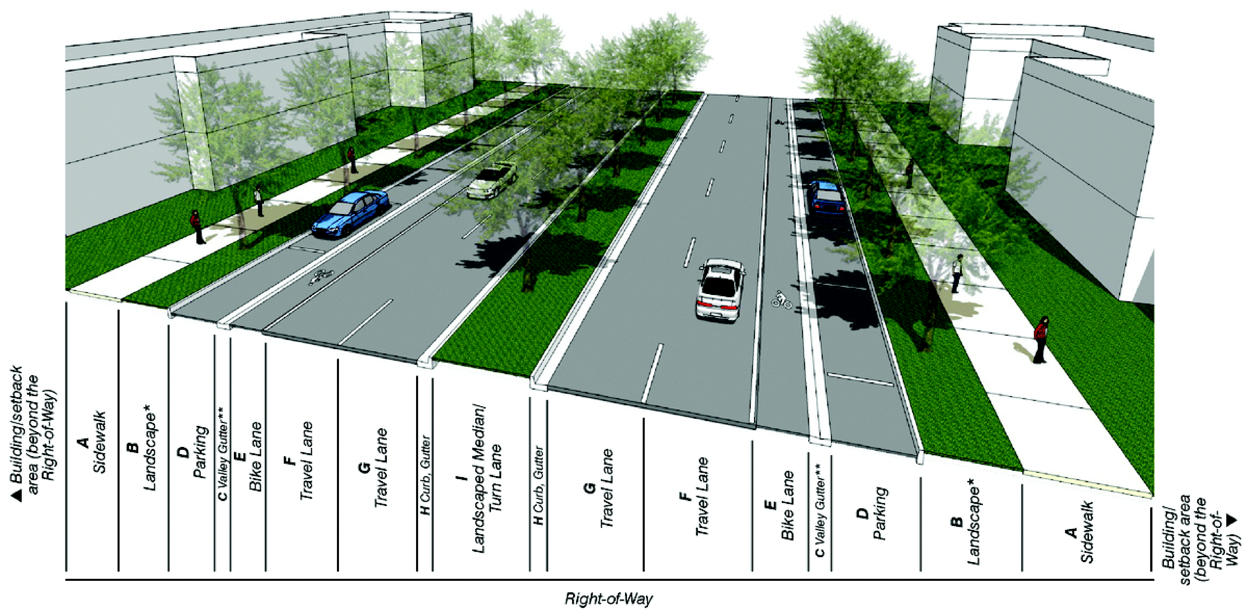

* Refer to column B in Street Types Table for required landscape elements

** Curb and gutter between the sidewalk and parking/travel lanes may be utilized in place of the valley gutter illustrated

4. *Street Types Development Parameters.*

|  |  |  |  |  |  |  |  |  |  |
| --- | --- | --- | --- | --- | --- | --- | --- | --- | --- |
| Street Type | Required Elements | | | | | | | | |
|  | A. Sidewalk (Min.) [a, h] | B. Landscape [b, c, d] | C. Curb/Gutter [e] | D. Parking Lane [f] | E. Bike Lane [g] | F. Travel Lanes [h] | G. Additional Travel/Turn Lanes (Min.) | H. Curb/Gutter | I. Median (Min.) |
| Type 1 Boulevard (Parking both sides) *Core/Center* | 9' (Core) 8' (Center) | Tree grates; tree planters; continuous landscape strip (Center only) | 2' | 7' | Required where indicated on Bike Route Plan | 11' | 10' where provided | 2' | 6' |
| Type 1 Boulevard (Parking both sides) *Edge* | 6' | Continuous landscape strip | 2' | 7' | Required where indicated on Bike Route Plan | 11' | 10' where provided | 2' | 6' |
| Type 2 Boulevard (No Parking) *Core/Center* | 9' (Core) 8' (Center) | Tree grates; tree planters; continuous landscape strip (Center only) | 2' | N/A | Required where indicated on Bike Route Plan | 11' | 10' where provided | 2' | 6' |
| Type 2 Boulevard (No Parking) *Edge* | 6' | Continuous landscape strip | 2' | N/A | Required where indicated on Bike Route Plan | 11' | 10' where provided | 2' | 6' |
| Type 3 Minor Street (Parking both sides) *Core/Center* | 9' (Core) 8' (Center) | Tree grates; tree planters; continuous landscape strip (Center only) | 2' | 7' | Required where indicated on Bike Route Plan | 10' | 10' where provided | N/A | N/A |
| Type 3 Minor Street (Parking both sides) *Edge* | 6' | Continuous landscape strip | 2' | 7' | Required where indicated on Bike Route Plan | 10' | 10' where provided | N/A | N/A |
| Type 4 Minor Street (Parking one side) *Core/Center/Edge* | 9' (Core) 8' (Center) 6' (Edge) | Tree grates, tree planters, continuous landscape strip (Center, Edge only) | 2' | 7' on one side | Required where indicated on Bike Route Plan | 10' | 10' where provided | N/A | N/A |
| Type 5 Minor Street (No Parking) *Core/Center* | 9' (Core) 8' (Center) | Tree grates; tree planters; continuous landscape strip (Center only) | 2' | N/A | Required where indicated on Bike Route Plan | 10' | 10' where provided | N/A | N/A |
| Type 5 Minor Street (No Parking) *Edge* | 6' | Continuous landscape strip | N/A | N/A | Required where indicated on Bike Route Plan | 10' | 10' where provided | N/A | N/A |
| Type 6 Minor Street (Canal Side) *Core/Center* | 9' (Core) 8' (Center) | Tree grates; tree planters; continuous landscape strip (Center only) | 2' | 7' on side opposite canal | Required where indicated on Bike Route Plan | 10' | 10' where provided | N/A | N/A |
| Type 6 Minor Street (Canal Side) *Edge* | 6' | Continuous landscape strip | N/A | 7' on side opposite canal | Required where indicated on Bike Route Plan | 10' | 10' where provided | N/A | N/A |
| Type 7 Service Road *Core/Center/Edge* | N/A | N/A | N/A | N/A | N/A | 10' | N/A | N/A | N/A |
| Type 8 Pedestrian Passage *Core/Center/Edge* | 10' | Tree grates; tree planters | N/A | N/A | N/A | N/A | N/A | N/A | N/A |
| N/A: Not Applicable [#] Footnote (as provided below) | | | | | | | | | |

*Footnotes:*

a. Landscape area is exclusive of the minimum sidewalk width.

b. Street trees shall have a minimum caliper of six (6) inches at time of planting.

c. Permanent irrigation is required.

d. Tree grates shall have a minimum area of twenty-four (24) square feet; tree planters shall have a minimum area of thirty-two (32) square feet; continuous landscape strips shall have a minimum width of six (6) feet in the Core and Center Sub-districts, eight (8) feet in the Edge Sub-district.

e. In all Sub-districts, curbs and gutters shall be provided at all intersections and roadway edges of arterials, boulevards and Main Street; in Core and Center Sub-districts, curbs and gutters shall be provided at all intersections and roadway edges of minor streets.

f. On-street parking shall count towards the minimum required parking.

g. Bike lanes shall be four (4) feet in width when adjacent to curb or swale; five (5) feet in width when adjacent to a parking lane.

h. The minimum required width of one-lane/one-way travel lanes shall be determined by the Department of Public Works and Waste Management and Fire Rescue Department on a case-by-case basis during the Administrative Site Plan Review process (ASPR).

i. The use of permeable materials to pave private street sidewalks, on-street parking, and vehicular drives is permitted. Use of permeable materials to pave public street sidewalks, on-street parking and vehicular drives shall require approval from the Director of the Department of Public Works and Waste Management.

5. *All streets shall be located according to the New Streets Plan.*

a. All new A streets shall be in the same general location shown on the New Streets Plan and may be modified with respect to alignment, provided that the final realignment does not compromise street connectivity. No new A streets shall be deleted.

b. B streets and service roads shown on the New Streets Plan are encouraged to promote connectivity and to conform with block length requirements. New B streets and service roads may be modified or deleted as provided in paragraph (6) below.

c. All streets shall allow general public access. Privately built streets shall provide an approved plat restriction to allow general public access. No gates that impede through traffic are permitted along A or B streets.

6. *[Modification approval.]* The Director shall approve the modification of A or B streets or service road or the deletion of a B street if the following conditions are satisfied:

a. The modification/deletion has been approved by the Director of the Public Works and Waste Management Department who shall review the proposed modification for traffic and safety issues.

b. The modification/deletion does not diminish the general size and location of an open space shown in the Designated Open Space Plan.

c. The modification/deletion maintains connectivity to the surrounding area.

d. The modification/deletion enhances pedestrian safety.

e. The modification/deletion is compatible with the surrounding area.

f. The modification/deletion allows for the appropriate use of private property.

7. *[Design compliance.]* The design of new streets and modifications of existing streets shall comply with the following requirements:

a. Streets shall be in accordance with the Street Types Development Parameters criteria set forth in this section.

b. All streets and service roads shall connect to other streets or service roads. Dead-end streets and T-turnarounds shall only be permitted temporarily for new streets when the adjacent property is not platted, not developed, or both. When the adjacent property is platted or developed, a street shall connect to existing development and the dead-end street or T-turnaround removed.

c. Cul-de-sacs shall be prohibited, except that a close shall be permitted when:

i. A street is interrupted by a natural barrier such as a river, protected land, or similar natural resource designated by Miami-Dade County or any government agency responsible for the protection of such natural resources; and

ii. Such agency prohibits the street to continue through said natural resource; and

iii. Existing development adjacent to or near the natural resource does not provide a means for the street to connect to the existing or proposed street network.

The median of such a close shall be landscaped. The landscaped area shall be maintained by a special taxing district, homeowner's association or other mechanism acceptable to the Department of Public Works and Waste Management to positively provide for the proper and continuous payment of maintenance without expense to general taxpayers.

d. All sidewalks shall provide the following:

i. Minimum width of six (6) feet, unless a different width is required by the Street Types Development Parameters set forth in this section;

ii. Minimum unobstructed area of sixty (60) inches;

iii. Where a colonnade is required, free and clear use of a continuous unobstructed area of at least sixty (60) inches within the colonnade; and

iv. No utility poles, fire hydrants or any other temporary or permanent structures within the unobstructed area.

e. Where on-street parking is provided, parking lanes shall be no closer than twenty-five (25) feet from the intersection measured from the outermost corner of the nearest corner property line.

f. Maximum curb radii at intersections shall not be larger than required for the safe travel of emergency and service vehicles.

g. Curbs and gutters shall be provided as follows:

i. All Sub-districts: At all intersections and roadway edges of arterials, boulevards and Main Street.

ii. Core and Center Sub-districts: At all intersections and roadway edges of minor streets.

iii. Edge Sub-district: Not required, except when indicated by the urban center street type development parameters.

h. Utilities other than fire hydrants shall run underground.

i. Buildings placed at the end of a Street Vista may provide one additional story above that otherwise permitted by the Building Heights Regulating Plan; such additional story shall occupy up to fifteen (15) percent of the floor area of the story immediately below.

j. Service roads may occur within buildings.

k. Service road access from the front property line shall be limited to one (1) point of access for every two hundred fifty (250) feet of frontage.

D. *Open Spaces and Recreation Areas.*

1. Open spaces under this article shall be classified as (a) designated or (b) private open spaces.

a. Designated open spaces shall be subject to the following requirements:

i. The general location, area, and dimensions shall conform with the Designated Open Space Plan. The street area on the side adjoining the designated open space and consisting of the curb, street tree landscape strip and sidewalk shall count towards the square footage of the open space.

ii. Designated open spaces shall include the anchor point depicted on the Regulating Plan, and shall be provided at grade level.

iii. Provided that all other parameters on the Designated Open Space Plan are met and that an individual/developer owns the entire designated open space area and an adjacent area, the final location of the designated open space may be pivoted around its anchor point onto such adjacent area, allowing the area previously designated as open space to be developed as permitted in the land use regulating plan.

iv. Designated open spaces shall be provided in the form of squares, greens, or plazas as provided in the Designated Open Space Plan. Golf courses and parking lot buffers shall not count towards the designated open space requirement. Fifty (50) percent of an area designated as open space may contain a lake.

v. No replatting or other land subdivision shall divide property in such a way that required designated open space is avoided or its location changed.

vi. Designated open spaces shall be shaded, and their ground surface shall be a combination of paving materials, lawn, or groundcover.

vii. If a lot or group of lots is designated entirely as open space in the Designated Open Space Plan, half of the lot or group shall be developable in a contiguous pattern and at a density in compliance with its land use designation for the entire parcel. Two (2) additional stories above the number of stories permitted by the Sub-districts and Building Heights Plans shall be permitted. Under this circumstance, the developable portion shall not be required to comply with the private open space requirement for residential development provided herein.

viii. If a lot or group of lots is designated partially as open space in the Designated Open Space Plan, the portion not designated as open space shall be developable in a contiguous pattern at a density/intensity which will equal the density/intensity permitted by the land use designation for the entire parcel. Up to an additional two (2) stories above the number of stories permitted by the Sub-districts and Building Heights Plans shall be permitted to allow the increased density/intensity only.

ix. Around designated open spaces, the building's frontage, height and placement shall be in accordance with the Building Placement Standards set forth in [Section 33-284.85](../level3/PTIIICOOR_CH33ZO_ARTXXXIII_K_STURCEDIRE.docx#PTIIICOOR_CH33ZO_ARTXXXIII_K_STURCEDIRE_S33-284.85BUPLST) of this article.

b. Private open spaces shall be subject to the following requirements:

i. Private open spaces shall be provided in the form of colonnades, courtyards, terraces, lawns, community gardens, and landscaped roof terraces/gardens on buildings or garage structures. Designated open spaces shall count towards the private open space requirement. Lakes, golf courses, and parking lot buffers shall not count towards the open space requirement.

ii. All residential developments, except for multi-family residential and live-work units, shall provide a minimum of four hundred (400) square feet of private open space per lot, in the form of courtyards, terraces, or lawns.

iii. All multi-family residential, nonresidential and mixed-use developments shall reserve a minimum of ten (10) percent of the site for common, private open space.

iv. Private open spaces shall be shaded, and their ground surface shall be a combination of paving materials, lawn, ground cover, flowers, fruits or vegetables. Enclosures of private open spaces shall comply with subsection (H) below.

c. Community gardens shall be permitted in all land use categories to satisfy private open space requirements, subject to the following restrictions:

i. Cultivated and harvested products may only be sold at permitted farmers markets and at grocery stores.

ii. The raising or sale of livestock or poultry is prohibited.

iii. Only handheld tools shall be permitted in the cultivation and harvesting process. Use of heavy agriculture equipment is prohibited.

iv. All tools, equipment and products used to grow and harvest plant material shall be stored in an enclosed structure subject to the Building Placement Standards set forth in [Section 33-284.85](../level3/PTIIICOOR_CH33ZO_ARTXXXIII_K_STURCEDIRE.docx#PTIIICOOR_CH33ZO_ARTXXXIII_K_STURCEDIRE_S33-284.85BUPLST) of this article.

v. Gardens shall only be tended between sunrise and sunset.

2. Recreation Areas. Educational and child care facilities located within an Urban Center District shall be exempt from the outdoor recreation area requirements of Section [33-151.18](../level3/PTIIICOOR_CH33ZO_ARTXAEDCHCAFANO.docx#PTIIICOOR_CH33ZO_ARTXAEDCHCAFANO_S33-151.18PHST)(a) of this chapter and shall be required to provide indoor and/or outdoor recreation areas subject to the following requirements:

|  |  |
| --- | --- |
| Categories | Required Recreation Area (**) |
| Child care/day nursery/kindergarten and preschool and after-school care | 22.5 square feet per child calculated in terms of half of the proposed maximum number of children for attendance at the school at one (1) time. |
| Elementary school (grades 1—6) | 250 square feet per student for the first 30 students; thereafter, 150 square feet per student. |
| Junior and senior high school (grades 7—12) | 400 square feet per student for the first 30 students; 150 square feet per student for the next 300 students; thereafter, 75 square feet per student. |
| * Where there are category combinations, each classification shall be calculated individually ** Recreation Area consists of indoor and outdoor recreation areas. Indoor-recreation areas may consist of indoor playgrounds, indoor pools, gymnasiums and/or indoor ball courts and/or similar indoor recreation facilities. Outdoor recreation areas may include rooftop facilities. | |

E. *Landscape.* Except as provided herein, landscape shall be provided as required by [Chapter 18A](../level2/PTIIICOOR_CH18AMIDECOLAOR.docx#PTIIICOOR_CH18AMIDECOLAOR) of this code. In the Core and Center Sub-districts, landscape shall be provided as follows:

1. Street trees shall be planted at a maximum of twenty-five (25) feet average on center, with a minimum six (6) inch diameter at breast height. Unless otherwise indicated by the Urban Center District or Area street type parameters, street trees shall be planted in one or more of the following methods of installation as required by [Section 33-284.86](../level3/PTIIICOOR_CH33ZO_ARTXXXIII_K_STURCEDIRE.docx#PTIIICOOR_CH33ZO_ARTXXXIII_K_STURCEDIRE_S33-284.86GERE)(C)(4) above;

a. *Tree grates.* Trees are planted within openings on the sidewalk. The openings shall be covered by permanently installed grates perforated to permit natural irrigation. The grates shall be installed flush with the surrounding sidewalk.

b. *Tree planters.* Trees are planted within a raised planter located on the sidewalk. The planter shall be defined on all sides by a permanent masonry structure to consist of a minimum six (6) inch raised curb. The area within the planter, in addition to the required trees, shall be planted with ground cover, shrubs, or other appropriate plant material.

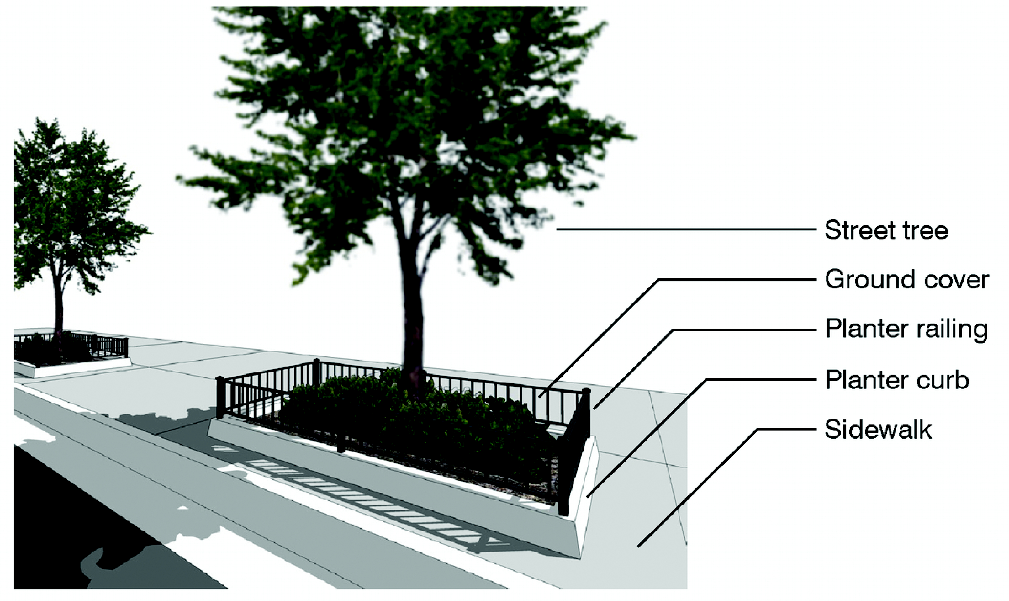

c. *Continuous landscape strips.* Trees are planted in the area between the curb or roadway edge and the sidewalk. This area, in addition to the required trees, shall be planted with grass.

2. For all land uses except for single-family or duplex, tree requirements for private property shall be based on sixteen (16) trees per net acre of lot area and, in addition to the placement on the lot, may be placed in greens, squares, plazas and medians within the Urban Center District or Area.

F. *Parking.* Except as provided herein, parking shall be provided as required by [Section 33-124](../level3/PTIIICOOR_CH33ZO_ARTVIIOREPA.docx#PTIIICOOR_CH33ZO_ARTVIIOREPA_S33-124ST) of this chapter.

1. Multi-story parking garages, parking lots, and on-street parking shall count toward all parking requirements except for the parking requirements of detached single-family residences, courtyard and sideyard houses, rowhouses, urban villa, or duplexes.

2. At a minimum, parking shall be provided as follows:

Single-Family Residential (off-street):

Single-family detached: 2 spaces/unit  
Courtyard or sideyard house: 2 spaces/unit  
Rowhouse or urban villa: 2 spaces/unit  
Duplex: 2 spaces/unit

Multi-Family Residential:

1 spaces/1 bedroom unit  
1.5 spaces/2 bedroom unit  
1.75 spaces/3 or more bedroom units

Housing for the elderly: 0.5 spaces/unit

Hotel/Motel: 1 space/first 40 guest rooms and 1 additional space/ every 2 guest rooms or suites thereafter

General Retail/Personal Services and Entertainment Uses: 1 space/250 square feet of gross floor area

Professional Business Offices and Health Care Services: 1 space/400 square feet of gross floor area

Food/Beverage Establishments: 1 space/ 50 square feet of patron area

Industrial: shall comply with [Section 33-124](../level3/PTIIICOOR_CH33ZO_ARTVIIOREPA.docx#PTIIICOOR_CH33ZO_ARTVIIOREPA_S33-124ST) of this chapter.

Live-work units:

(1) Residential component: 2 spaces/unit, and  
(2) Workshop component: 1 space/325 square feet of workshop area

Live-work buildings:

(1) Residential component: shall comply with the multi-family residential requirements described in this subsection, and  
(2) Work space, nonresidential component: shall comply with [Section 33-124](../level3/PTIIICOOR_CH33ZO_ARTVIIOREPA.docx#PTIIICOOR_CH33ZO_ARTVIIOREPA_S33-124ST), of this chapter.

Civic uses: shall comply with [Section 33-124](../level3/PTIIICOOR_CH33ZO_ARTVIIOREPA.docx#PTIIICOOR_CH33ZO_ARTVIIOREPA_S33-124ST) of this chapter.

All other uses shall comply with the parking standards provided in [Section 33-124](../level3/PTIIICOOR_CH33ZO_ARTVIIOREPA.docx#PTIIICOOR_CH33ZO_ARTVIIOREPA_S33-124ST) of this chapter. Educational and child care facilities located within a mixed-use building shall be exempt from the auto-stacking requirements of Section [33-151.18](../level3/PTIIICOOR_CH33ZO_ARTXAEDCHCAFANO.docx#PTIIICOOR_CH33ZO_ARTXAEDCHCAFANO_S33-151.18PHST)(c) of this chapter.

3. Parking reduction. Development meeting certain criteria shall be permitted to reduce the number of parking spaces required. Specific use, location, and parcel requirements and permitted reductions are provided in the following table:

|  |  |  |  |  |
| --- | --- | --- | --- | --- |
| Use | Location, Parcel Requirement | Permitted reduction of required parking as otherwise provided in this section | | |
| Core | Center | Edge |
| *Group 1: Work-force reduction* | | | | |
| Work-force housing units (WHU) as defined in this article | No location limitation | 25%* | 25%* | 25%* |
| *Group 2: Location reduction* | | | | |
| Nonresidential, mixed-use, multi-family residential | Within five hundred (500) feet of a bus stop or rail station serviced by premium transit | 50% | 50% | N/A |
| Nonresidential, mixed-use, multi-family residential | Within one-quarter (¼) mile of a bus stop or rail station serviced by premium transit | 30% | 30% | N/A |
| Nonresidential, mixed-use, multi-family residential | Within one-half (½) mile of a bus stop or rail station serviced by premium transit | 10% | 10% | N/A |
| *Group 3: Parcel size reduction* | | | | |
| Mixed-use | Parcels less than fifteen thousand (15,000) square feet | 40% | 40% | N/A |
| Mixed-use | Parcels between fifteen thousand (15,000) and thirty thousand (30,000) square feet | 30% | 30% | N/A |
| Mixed-use | Parcels greater than thirty thousand (30,000) square feet | 20% | 10% | N/A |
| * Percentage reduction applies only to those spaces required by WHU restricted residential units N/A: Not Applicable | | | | |

Developments meeting more than one of the use, location, and parcel criteria shall be permitted to combine each permitted reduction; the combined reduction shall be calculated by reducing the first applicable criteria from each group in the order of the table above.

4. Mixed-use, multi-family residential, or non-residential developments in all Sub-districts may provide the required parking off-site, where the off-site parking is within seven hundred fifty (750) feet of the development and in a land use designation that is similar to or higher intensity than the land use designation of the development being served. Any certificate of use for mixed-use, multi-family residential, or nonresidential development shall immediately terminate in the event such parking area is not available. An applicant for approval of a mixed-use, multi-family residential or nonresidential development with off-site parking shall execute and record in the public records of this County a declaration of restrictions approved by the Director covenanting that such development shall cease and terminate upon the elimination of such parking area, and that no development requiring such parking shall be made of such property until the required parking area is available and provided.

5. Except for detached single-family homes, courtyard or sideyard houses, and duplexes, all parking may be in the form of parking garage structures or parking lots which shall be located in the rear or on one side of the building, and shall be screened from the street. Parking is not permitted in setback areas required along street frontages.

6. Parking garage structures shall be screened by a liner building containing a minimum depth of twenty (20) feet of habitable space for all stories along the primary frontage, and for parcels with three (3) or more frontages, on at least two (2) frontages. For all other frontages, architectural features of a parking structure shall appear consistent and harmonious with that of habitable space. On parcels having a lot depth at any one point of less than one hundred fifty (150) feet, as measured from the front property line, a liner building shall only be required on the ground floor. No vehicles parked within the structure shall be visible from the street.

7. Mechanized parking shall be allowed for mixed-use, nonresidential, and multi-family developments and, when provided, shall be exempt from the provisions of [Section 33-122](../level3/PTIIICOOR_CH33ZO_ARTVIIOREPA.docx#PTIIICOOR_CH33ZO_ARTVIIOREPA_S33-122REDEPASP) of this code. For the purpose of this article, mechanized parking shall be defined as a mechanism with vertical and horizontal transport capability that provides for automobile storage and retrieval. A mechanized parking space shall be counted toward the parking requirements of this section. When provided, mechanized parking shall comply with the following:

a. A queuing analysis is submitted and approved during the Administrative Site Plan Review process.

8. Parking lots shall provide for vehicular connectivity to adjacent parking areas.

9. The use of permeable materials for paving parking lots shall be permitted in the urban center districts.

10. Parking for individuals with disabilities shall comply with the Florida Building Code.

11. Parking for persons transporting strollers shall comply with [Section 33-122.2](../level3/PTIIICOOR_CH33ZO_ARTVIIOREPA.docx#PTIIICOOR_CH33ZO_ARTVIIOREPA_S33-122.2PASPPETRYOCHST) of this chapter.

12. Individual parking garages for single-family homes shall count towards the parking requirement.

13. In the Edge Sub-district, parking for detached single family homes and duplexes on platted lots of 12,000 square feet or less shall be subject to the following:

a. Where there is no service road, parking shall be in the form of individual garages or carports accessed through a driveway from the street. When provided, attached garages and carports shall be located as provided in the Building Placement Standards set forth in [Section 33-284.85](../level3/PTIIICOOR_CH33ZO_ARTXXXIII_K_STURCEDIRE.docx#PTIIICOOR_CH33ZO_ARTXXXIII_K_STURCEDIRE_S33-284.85BUPLST) of this article.

b. Along the front property line the maximum width of the driveways in front of the build-to line shall be ten (10) feet. On any other frontage the maximum width of the driveway shall be twenty (20) feet.

c. The parking area shall be screened at the build-to line through the use of walls, hedges, or fences in accordance with Subsection (H) below and the Building Placement Standards set forth in [Section 33-284.85](../level3/PTIIICOOR_CH33ZO_ARTXXXIII_K_STURCEDIRE.docx#PTIIICOOR_CH33ZO_ARTXXXIII_K_STURCEDIRE_S33-284.85BUPLST) of this article.

d. The sidewalk shall be continuous and remain at a constant level at all instances where a driveway intersects it.

14. Required parking for single-family homes, courtyard or sideyard houses, duplexes, urban villas and rowhouses may be provided in a tandem configuration.

15. Where a wall or fence is used for screening parking areas along streets, a five (5) foot landscape strip with a hedge shall be required in front of the wall or fence.

16. The provisions of [Section 33-131](../level3/PTIIICOOR_CH33ZO_ARTVIIOREPA.docx#PTIIICOOR_CH33ZO_ARTVIIOREPA_S33-131USPAARCOPALO) of this chapter shall not apply to the required parking for mixed-use and nonresidential developments.

G. *Lighting.*

1. Street lighting shall comply with the following:

a. Street lighting shall be provided in these areas: commercial and live-work unit driveways and parking areas, sidewalks and pedestrian passages, commercial establishment entryways, recreation areas, and multi-family residential common areas and entryways.

b. Outdoor lighting of these areas shall comply with [Section 33-4.1](../level3/PTIIICOOR_CH33ZO_ARTIINGE.docx#PTIIICOOR_CH33ZO_ARTIINGE_S33-4.1OULI) of this chapter.

c. All light fixtures shall be of a pedestrian scale, with a maximum height of eighteen (18) feet and a maximum spacing between fixtures of sixty (60) feet or such other spacing as may be required by the Department of Public Works and Waste Management, whichever is the most restrictive.

d. The type and spacing of light fixtures shall be approved by the Department of Public Works and Waste Management or its successor. Approval shall be based on uniformity of types, location, right-of-way width, and luminosity.

e. Weather and vandalism resistant covers shall protect all light fixtures.

f. Streetlamps shall be installed on both sides of streets.

g. Cobra-head lights shall not be permitted.

2. Open parking lot, access road, and service road lighting shall be provided as required in [Section 8C-3](../level2/PTIIICOOR_CH8CBUSEME.docx#PTIIICOOR_CH8CBUSEME_S8C-3ILOPPALOALACTHPANOARUNWIBU) of this Code. Lighting fixtures in these areas shall have a maximum height of eighteen (18) feet above grade.

_____

H. *Walls, fences, and hedges.* The following shall be permitted:

|  |  |  |  |
| --- | --- | --- | --- |
| Location | Type and Material | Spacing | Height |
| Around perimeter of designated open space | Walls: masonry. Fences: wood, electrostatic plated aluminum, or wrought iron. | N/A | Max. 3'—6" |
| Hedges and shrubs | Max. 48" O.C. | At time of planting Min. 18" |
| Max. 3'—6" |
| In front of the build-to line (BL): Along front (F), side street (SS), and interior side (IS) | Walls: masonry. Fences: wood, electrostatic plated aluminum, or wrought iron. | N/A | Max. 3'—6" |
| Hedges and shrubs |  | At time of planting Min. 18" |
| Max. 48" O.C. | Max. 3'—6" |
| Behind the build-to line (BL): Along interior side (IS) and rear (R) property lines | Walls: masonry. Fences: wood, electrostatic plated aluminum, or wrought iron | N/A | Max. 72" |
| Hedges and Shrubs |  | At time of planting Min. 18" |
| Max. 48" O.C. | Max. 96" |
| Chain Link | N/A |  |
| Along the build-to line (BL) | Walls: masonry. Fences: wood, electrostatic plated aluminum, or wrought iron | N/A | Max. 72" |
| Hedges and shrubs | Max. 48" O.C. | Max. 72" |
| Parking Areas Along Streets | Walls: masonry. Fences: wood, electrostatic plated aluminum, or wrought iron | N/A | Min. 3'—6" |
| Hedges and shrubs | Max. 48" O.C. |  |
| Service Areas | Walls: masonry. Fences: wood, electrostatic plated aluminum, or wrought iron | N/A | Height required to mitigate the visual impact of service area features |
| Construction Areas | Chain Link | N/A |  |
| Min.: Minimum Max.: Maximum N/A: Not Applicable O.C.: On Center | | | |

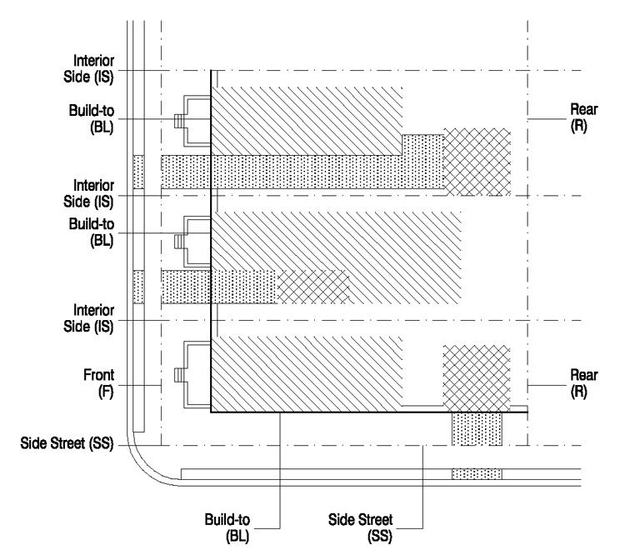

*Note:*

Hedges and shrubs shall be subject to [Chapter 18A](../level2/PTIIICOOR_CH18AMIDECOLAOR.docx#PTIIICOOR_CH18AMIDECOLAOR) of this Code.

Additional requirements for walls, fences and hedges may be included in the Building Placement Standards set forth in [Section 33-284.85](../level3/PTIIICOOR_CH33ZO_ARTXXXIII_K_STURCEDIRE.docx#PTIIICOOR_CH33ZO_ARTXXXIII_K_STURCEDIRE_S33-284.85BUPLST) of this article, and in the event of a conflict, the Building Placement Standards shall govern.

(Ord. No. 05-143, § 6, 7-7-05; Ord. No. 06-10, § 3, 1-24-06; Ord. No. 07-93, § 4, 7-10-07; Ord. No. 07-169, § 9, 11-6-07; Ord. No. 08-102, § 3, 9-2-08; Ord. No. 12-86, § 5, 10-2-12)

Sec. 33-284.87. Signs.

Except as provided herein, the definitions set forth in [Section 33-84](../level4/PTIIICOOR_CH33ZO_ARTVISI_DIV1TIAPPUDE.docx#PTIIICOOR_CH33ZO_ARTVISI_DIV1TIAPPUDE_S33-84DE) of this chapter shall apply. In the event of a conflict, the provisions of this section shall govern.

A. For purposes of this section, the following definitions shall apply:

1. *Digital technology (signs):* Electronic technology that allows for changes to a sign copy resulting from digital data input. Included in this technology are signs that use series of lights, including light emitting diodes (LED), fiber optics, or other similar technology.

2. *Nits:* Luminance is the measure of the light emanating from an object with respect to its size and is the term used to quantify electronic sign brightness. The unit of measurement for luminance is nits (nt), which is the total amount of light emitted from a sign divided by the surface area of the sign [candelas per square meter (cd/m2)].

B. *Temporary Signs in MUCs and CUCs.* Temporary signs (Class A) shall be permitted in compliance with [Section 33-99](../level4/PTIIICOOR_CH33ZO_ARTVISI_DIV3SISTRECH.docx#PTIIICOOR_CH33ZO_ARTVISI_DIV3SISTRECH_S33-99CLTESI) of this chapter.

C. *Permanent Point of Sale Signs.* Permanent point of sale signs (Class B) shall be permitted as follows:

1. The following permanent point of sale signs are permitted in all Sub-districts in conjunction with permitted business and industrial uses: flat attached, hanging, awning, cantilever, projecting, and monument. No other detached sign shall be permitted except monument signs.

a. Projecting signs shall be mounted and perpendicular to the building.

b. The copy of an awning sign shall only be located on the valance of the awning.

c. The bottom of a hanging sign shall be located at a minimum height of eight (8) feet from the finished floor.

d. Monument signs, which are freestanding, 2-faced signs, shall have a base at least seventy-five (75) percent of the horizontal width of the sign and located directly on the ground or a maximum of twelve (12) inches above grade.

e. Cantilever signs are mounted on those portions of the building that project horizontally.

2. Maximum size, location, and number of signs shall be as follows:

|  |  |  |
| --- | --- | --- |
| Sign Type | Size | Number of Signs |
| Flat Attached, Cantilever, Projecting* | 10% of wall area** | Not limited |
| Hanging, Awning | 6 sq. ft. | Not limited |
| Monument | 25 sq. ft. maximum for first 50 feet of street frontage plus .75 sq. ft. for each additional foot of street frontage to a maximum of 40 sq. ft. per sign face. | One per street frontage |
| * Each side of a projecting sign with multiple faces shall count toward the maximum permitted sign area. ** Where a building may be occupied by multiple tenants, the permitted sign area that results from the percentage of wall area is shared among all tenants. A sign survey shall be required at time of permitting to demonstrate compliance with the maximum sign area permitted. In all Sub-districts, for flat attached signs only, up to thirty (30) percent of the sign may be illuminated using digital technology. | | |

3. Illumination/lighting shall comply with the following:

Flat attached, cantilever, and projecting signs utilizing flashing, moving, intermittent, chasing, or rotating lights shall be permitted in conjunction with convention halls or meeting halls and auditoriums, theaters, movie theaters, athletic facilities, museums, and other visual and performance arts buildings.

Where digital technology is allowed, it shall be provided in compliance with the following:

a. No auditory message or mechanical sounds shall be emitted from the sign.

b. The sign shall not display any illumination that moves, appears to move, blinks, fades, rolls, dissolves, flashes, scrolls, shows animated movement, or changes in intensity during the static display period.

c. All digital signs shall be modulated so that, from sunset to sunrise, the brightness shall not be more than 500 Nits. Sunset and sunrise times are those times established by the Miami office of the National Weather Service. At all other times, the maximum brightness levels shall not exceed 5,000 Nits. All digital signs shall have installed ambient light monitors and at all times shall allow such monitors to automatically adjust the brightness level of the sign based on ambient light conditions.

d. The message display shall not change more often than once each eight seconds, with all moving parts or illumination moving or changing simultaneously.

e. Any digital sign that malfunctions, fails, or ceases to operate in its usual or normal programmed manner shall immediately revert to a black screen and shall be restored to its normal operation conforming to the requirements of this section within twenty-four (24) hours.

4. Maximum heights shall be as follows:

a. Six (6) feet above grade to top of sign for monument signs; except, for signs associated with nonconforming structures located on corner parcels fronting major or minor roads identified on the Land Use Plan, one monument sign may be constructed at a maximum height of twelve (12) feet above grade to top of sign in lieu of two six-foot signs;

b. No height limits for flat attached, cantilever, or projecting signs;

c. For signs painted on the facade of a building or on the valance of an awning, the copy shall not exceed one (1) foot.

5. No setback is required for any sign. Cantilever, projecting, and awning signs may encroach into any required setback. Awning signs and projecting signs attached to awnings may encroach into the right-of-way. Where a zero (0) foot setback is permitted, cantilever and projecting signs may encroach into the right-of-way up to three (3) feet. Signs encroaching into the right-of-way shall be a minimum of eleven (11) feet above the sidewalk.

D. *Directional Signs.* Directional signs, to direct traffic flow and locate entrances and exits shall be permitted on private property in connection with any permitted use. Detached directional signs shall not exceed three (3) square feet in area; directional signs attached to buildings shall not exceed twelve (12) square feet in area. The maximum height of a detached directional sign shall be ten (10) feet. Directional signs shall be shown and approved on site plans which indicate sign size, location, copy, etc.

E. *Flags.* Each parcel may display no more than three (3) flags and three (3) flagpoles. Flagpoles shall not exceed seventy (70) feet in height. Flag dimensions shall be proportional to the pole such that the hoist side of the flag is not more than fifty (50) percent of the vertical height of the flagpole. For purposes of this section, "flag" means any fabric or bunting containing colors, patterns, or symbols.

F. *Prohibited Signs.* The following types of outdoor signs shall be prohibited:

1. Revolving, rotating, and other moving signs.

2. Backlit signs of any type.

3. Banners.

4. Roof signs.

5. Balloon signs.

6. Class C commercial signs or other outdoor advertising, except those within bus shelters.

(Ord. No. 05-143, § 7, 7-7-05; Ord. No. 06-10, § 4, 1-24-06; Ord. No. 08-102, § 4, 9-2-08; Ord. No. 12-86, § 6, 10-2-12)

Sec. 33-284.88. Review Procedure/Administrative Site Plan and Architectural Review.

Except for individual single-family homes and duplexes, all applications for development approval within an Urban Center District that are not otherwise permitted as nonconforming uses or structures shall comply with the requirements of this article and with the site plan and architectural review criteria contained herein. Developments shall be processed and approved administratively as follows:

A. Administrative site and architectural plan review. The Department shall review plans, including the exhibits listed below for completeness and compliance with the provisions of this article, including the Regulating Plans, and for compliance with the site plan review criteria provided herein. Additionally, all applications shall be reviewed by the following departments of Miami-Dade County and other public entities for potential impacts on infrastructure and other services resulting from the application: Department of Public Works and Waste Management or its successor, Department of Regulatory and Economic Resources or its successor, Miami-Dade Fire Rescue Department or its successor, and the Miami-Dade County School Board. In the event the application indicates impacts on services and infrastructure provided by any of the foregoing, the applicant shall meet with the affected department or entity to discuss potential mitigation of the impacts and shall submit evidence to the Department of such discussion. The Director shall issue a final decision within twenty-one (21) days of the date of submission of the completed application. The applicant shall have the right to extend the twenty-one (21) day period by an additional twenty-one (21) days upon timely request made in writing to the Department. The Department shall have the right to extend the twenty-one (21) day period by written notice to the applicant that additional information is needed. Denials shall be in writing and shall specifically set forth the grounds for the denial. Any final decision of the Director may be appealed in accordance with the procedures established in this chapter for appeals of administrative decisions.

B. Applications for administrative site plan and architectural review under this article shall be accompanied by exhibits prepared by registered architects and landscape architects which shall be submitted to the Department and shall include the following:

1. Site plan(s) including:

a. Sub-district location;

b. Street layouts and designations as per this article;

c. Locations, shape, size, and height of existing buildings;

d. Building exterior finish material;

e. Indication of street vistas;

f. Lot lines, setbacks and build-to lines;

g. Location of open spaces including anchor points if applicable;

h. Location of on-street and off-street parking including type of permeable materials if used on parking lots, loading facilities, and waste collection areas;

i. Indication of signage;

j. Indication of any site or building design methods used to conserve energy;

k. Locations of backflow prevention devices and connections; and

l. Indication of the placement and type(s) of lighting fixtures illuminating roadways and parking areas.

2. Landscape plans, including specifications of species of plant material, location, and size in accordance with this article and [Chapter 18A](../level2/PTIIICOOR_CH18AMIDECOLAOR.docx#PTIIICOOR_CH18AMIDECOLAOR) of this code.

3. Street cross-sections, including adjacent buildings and open space.

4. Floor plans, elevations, and sections of all buildings, including total gross square feet of area for each floor and all dimensions relating to the requirements of this article. A pattern book may be submitted for detached and attached single-family units including, at a minimum, unit plans and elevations, elevation of unit groupings, and typical design details such as street lamps, benches, fencing, and paving details.

5. Figures indicating the following:

a. Gross and net acreage;

b. Total square footage for each use by type;

c. Total number of dwelling units;

d. Amount of passive and active open space in square feet; and

e. Such other design data as may be needed to evaluate the project's compliance with the requirements of this article and Chapter.

(Ord. No. 05-143, § 8, 7-7-05; Ord. No. 12-86, § 7, 10-2-12)

Sec. 33-284.89. Zoning relief from certain requirements.

Relief from the following requirements of this article shall be permitted only pursuant to the standards and requirements of [Section 33-311](../level3/PTIIICOOR_CH33ZO_ARTXXXVIZOPR.docx#PTIIICOOR_CH33ZO_ARTXXXVIZOPR_S33-311COZOAPBOUTDU)(A)(4)(a) of this code:

1. Minimum and maximum densities;

2. Required liner buildings used to screen parking;

3. Colonnade regulations, including minimum horizontal and vertical clearances;

4. Provision of A streets;

5. Requirements for street trees, greens, plazas, squares and medians;

7. Maximum size of blocks;

8. Curb requirement in the Core and Center sub-district; and

9. Signage.

(Ord. No. 05-143, § 9, 7-7-05)

Sec. 33-284.89.1. Special Exceptions Procedures.

A. Requests for special exceptions as permitted in this article shall be in accordance with [Section 33-311](../level3/PTIIICOOR_CH33ZO_ARTXXXVIZOPR.docx#PTIIICOOR_CH33ZO_ARTXXXVIZOPR_S33-311COZOAPBOUTDU)(A)(3) of this Code.

B. Standards for Site Plan Review. To ensure compatibility with the surrounding area, the following site plan review standards shall be utilized by the Director, the Community Zoning Appeals Board, and the Board of County Commissioners in the consideration of requests for special exceptions pursuant to this article:

1. Except for street tree requirements, developments shall provide two (2) times the landscaping required by this article and applicable [Chapter 18A](../level2/PTIIICOOR_CH18AMIDECOLAOR.docx#PTIIICOOR_CH18AMIDECOLAOR) (Landscape Code) regulations.

2. The proposed development's scale and architecture shall be compatible with buildings in the surrounding area. Building height transitions shall be used when the proposed permitted maximum height for a development is greater than existing or proposed buildings in the adjoining or adjacent neighborhood.

3. The development shall meet the standards and criteria of the urban center's land use category designation and Building Placement Standards as provided in this article, and shall meet all other requirements for such particular use set forth in this chapter.

(Ord. No. 12-86, § 9, 10-2-12)

Sec. 33-284.89.2. Nonconforming Lots, Uses and Structures.

A. *Purpose/Applicability.*

1. Nothing contained in this article shall be deemed or construed to prohibit the continuation of a legally established non-conforming use, structure, or occupancy, as those terms are defined in Sections [33-1](../level3/PTIIICOOR_CH33ZO_ARTIINGE.docx#PTIIICOOR_CH33ZO_ARTIINGE_S33-1DE), [33-34](../level3/PTIIICOOR_CH33ZO_ARTIINGE.docx#PTIIICOOR_CH33ZO_ARTIINGE_S33-34EXUS), and [33-35](../level3/PTIIICOOR_CH33ZO_ARTIINGE.docx#PTIIICOOR_CH33ZO_ARTIINGE_S33-35NOUS) of this chapter. The intent of this Section is to encourage nonconformities to ultimately be brought into compliance with current regulations. This section shall govern in the event of conflicts with other regulations of this code pertaining to legally established nonconforming uses, structures, and occupancies.

2. The term "nonconformity" shall refer to a use, building, or lot that does not comply with the regulations of this article. Only legally established nonconformities shall have rights under this section.

3. For purposes of this section, the term "expansion" shall mean an improvement, addition, enlargement, extension, or modification to a structure that increases the square footage of the structure.

4. For the purposes of this section, "legally established" shall apply to the following circumstances:

a. A lot that does not meet the lot frontage, lot width, lot depth, and/or lot area requirements of the current zoning district, provided that such lot met the regulations in effect at the time of platting.

b. A site or improvement that is rendered nonconforming through the lawful use of eminent domain, an order of a court of competent jurisdiction, or the voluntary dedication of property.

c. An existing use which conformed to the code at the time it was established.

d. A building and/or site improvement that was permitted in accordance with regulations in effect at the time of permitting or that was approved pursuant to a public hearing.

e. A building and/or site improvement that had received final site plan approval through a public hearing pursuant to this chapter or through administrative site plan review or had a valid building permit.

f. Discontinuation of the use, structure, or occupancy would abrogate a vested right as determined by Sections [2-114.1](../level3/PTIIICOOR_CH2AD_ARTXVDEPLDERE.docx#PTIIICOOR_CH2AD_ARTXVDEPLDERE_S2-114.1ADRETAVERICL) to [2-114.4](../level3/PTIIICOOR_CH2AD_ARTXVDEPLDERE.docx#PTIIICOOR_CH2AD_ARTXVDEPLDERE_S2-114.4MOVEDE) of this Code.

B. *Nonconforming Lots, Uses and Structures.*

1. *Nonconforming Lots.*

a. Development on a legally established, nonconforming lot that does not meet the lot frontage and/or lot area requirements of this article shall be permitted, provided that the development meets all other requirements of this article.

b. Expansions to structures on legally established, nonconforming lots shall be permitted in accordance with this section.

c. Variances from other requirements of this article shall require a public hearing, pursuant to this article and [Section 33-311](../level3/PTIIICOOR_CH33ZO_ARTXXXVIZOPR.docx#PTIIICOOR_CH33ZO_ARTXXXVIZOPR_S33-311COZOAPBOUTDU) of this chapter.

2. *Nonconforming Uses.*

a. A legally established nonconforming use may continue. Expansions to a structure containing a nonconforming use shall require Administrative Site Plan Review [see Subsection (C)] below.

b. If a nonconforming use is discontinued for a period of more than one year, the use may not be reestablished. A use shall be considered discontinued once the activities or commerce, essential to the continuation of the use are abandoned. Discontinuance due to acts of force majeure shall not constitute abandonment, provided that a good faith effort is made to reestablish the use.

c. Expansions of nonconforming single-family and two-family residences shall be permitted and shall not require Administrative Site Plan approval, provided that the project complies with the Building Placement Standards for single-family detached or duplex lots set forth in [Section 33-284.85](../level3/PTIIICOOR_CH33ZO_ARTXXXIII_K_STURCEDIRE.docx#PTIIICOOR_CH33ZO_ARTXXXIII_K_STURCEDIRE_S33-284.85BUPLST) of this article.

3. *Nonconforming Structures.*

a. To prevent changes in regulation from unduly burdening property owners, legally established, nonconforming structures may continue to be used and maintained. Expansions, repairs, alterations, and improvements to nonconforming structures shall be permitted only in accordance with the following provisions:

i. Internal and external repairs, alterations, and improvements that do not increase the square footage of the nonconforming structure shall be permitted and shall not be subject to the requirements of this article.

ii. Expansions to a nonconforming structure shall be permitted as follows:

(a) If the total square footage of the proposed improvement is less than fifty (50) percent of the structure's net square footage at the time it became nonconforming, the improvement shall require Administrative Site Plan Review [see Subsection (C) below].

(b) If the total square footage of the proposed improvement is equal to or exceeds fifty (50) percent of the structure's net square footage at the time it became nonconforming, the entire structure and site improvements shall be brought into compliance with current regulations.

(c) Once the cumulative total of additional square footage of improvements equals to fifty (50) percent of the structure's net square footage at the time it became nonconforming, no additional expansions shall be permitted and the entire structure and site improvements shall be brought into compliance with current regulations.

(d) For the purposes of this article, net square footage shall refer to the square footage indicated on the building permit or determined through equivalent evidence.

b. If a nonconforming structure is damaged by fire, flood, explosion, wind, war, riot or any other act of force majeure, repairs shall be subject to the following provisions:

i. If the repair/replacement cost is less than fifty (50) percent of the value of the structure based upon the average of two (2) independent appraisals, the structure may be reconstructed up to the same building height and within the same building footprint existing prior to the damage, provided that an application for final building permit has been submitted within twelve (12) months of the date of such damage unless extended by the Board of County Commissioners.

ii. If the repair/replacement cost is equal to or exceeds fifty (50) percent of the building's value based upon the average of two (2) independent appraisals, the building and site improvements shall be brought into compliance with current regulations.

iii. Routine internal and external maintenance, repairs and material replacement such as re-roofing, painting, window or door replacement, mechanical equipment repair and replacement, plumbing and electrical maintenance, and similar repair, maintenance and replacements shall be permitted and shall not be subject to the requirements of this Article.

c. If a nonconforming building is deemed to be unsafe pursuant to [Chapter 8](../level2/PTIIICOOR_CH8BUCO.docx#PTIIICOOR_CH8BUCO) of this Code, and demolition is required, the building shall be rebuilt in accordance with current regulations.

d. In addition to the requirements of this section, all repairs, improvements and expansions to a nonconforming building shall comply with the Florida Building Code.

C. *Administrative Site Plan Review Standards.*

1. Where Subsection (B) above permits the expansion of a nonconforming use or structure subject to administrative review, the project shall be reviewed according to the plan review standards outlined in this sub-section. The intent of the plan review shall be to allow for the continuation of viable uses and structures while seeking opportunities to lessen the adverse impacts of proposed expansions and encouraging nonconformities to ultimately be brought into compliance.

2. Expansions to nonconforming single-family and two-family residences are permitted and shall not require Administrative Site Plan Review (ASPR) approval, provided said expansion complies with the single-family detached or duplex lot criteria indicated in the building placement standards of this article. One-family and two-family residences that were rendered nonconforming due to the assignment of a nonresidential land use designation shall be permitted to continue and expand in accordance with Subsection (B) above. The expansion shall not require ASPR approval provided said expansion meets the applicable single-family detached or duplex lot criteria indicated in the building placement standards of this article.

3. Expansions permitted under Subsection (B) above subject to the Administrative Site Plan Review (ASPR) process, shall be permitted by the Department upon a showing that the project satisfies all of the following criteria:

a. The expansions will not cause adverse impacts, such as traffic, noise, dust, odors and parking congestion, on surrounding properties or significantly change the character of the area.

b. The expansion shall comply with the setback requirements applicable only to the expanded area, as indicated in the Building Placement Standards set forth in [Section 33-284.85](../level3/PTIIICOOR_CH33ZO_ARTXXXIII_K_STURCEDIRE.docx#PTIIICOOR_CH33ZO_ARTXXXIII_K_STURCEDIRE_S33-284.85BUPLST) of this article. Other requirements set forth in [Section 33-284.85](../level3/PTIIICOOR_CH33ZO_ARTXXXIII_K_STURCEDIRE.docx#PTIIICOOR_CH33ZO_ARTXXXIII_K_STURCEDIRE_S33-284.85BUPLST) such as building frontage may be waived by the Director.

c. The number of parking spaces necessitated by the expansion is provided in accordance with the minimum number of parking spaces requirements in [Section 33-284.86](../level3/PTIIICOOR_CH33ZO_ARTXXXIII_K_STURCEDIRE.docx#PTIIICOOR_CH33ZO_ARTXXXIII_K_STURCEDIRE_S33-284.86GERE)(F)(2).

d. The expansion shall comply with the street tree requirement in this article and with the parking lot buffers requirement in [Chapter 18A](../level2/PTIIICOOR_CH18AMIDECOLAOR.docx#PTIIICOOR_CH18AMIDECOLAOR) (Landscape Code).

4. If the project does not meet the aforementioned criteria, it shall be permitted if approved upon public hearing. At public hearing, additional conditions may be imposed to enhance compatibility of the project with the surrounding area, including without limitation, the following:

a. Limit the manner in which the use is conducted, including restricting hours of operation and other restraints, to minimize adverse impacts such as noise, vibration, air pollution, glare and odor.

b. Specify additional screening or open space to minimize impacts to surrounding properties or the character of the area.

c. Restrict the height, size, or location of a building or other structure.

d. Require additional right-of-way dedication or road improvements.

e. Restrict the number, size, location, height or lighting of signage.

f. Limit the location and intensity of outdoor lighting or require its shielding.

g. Restrictions to protect existing natural, cultural and historical resources.

h. Impose additional restrictions necessary to protect existing natural, cultural, and historical resources.

i. Impose additional conditions necessary to further the intent and purpose of this article and the Comprehensive Development Master Plan.

(Ord. No. 12-86, § 10, 10-2-12; Ord. No. 13-43, § 14, 5-7-13)

Sec. 33-284.90. Conflicts with other chapters and regulations.

This article shall govern in the event of conflicts with other zoning, subdivision, or landscape regulations of this code, or with the Miami-Dade Department of Public Works Manual of Public Works.

(Ord. No. 05-143, § 10, 7-7-05)

### ARTICLE XXXIII(L). GOULDS COMMUNITY URBAN CENTER DISTRICT

Sec. 33-284.91. Purpose and Intent.

Sec. 33-284.92. Goulds Community Urban Center District (GCUC) Requirements.

Sec. 33-284.93. Uses.

Sec. 33-284.94. The Regulating Plans.

Sec. 33-284.95. Building Placement and Design and Street Type Development Parameters.

Sec. 33-284.96. Conflicts with other Chapters and Regulations.

Sec. 33-284.97. Non-conforming Structures, Uses, and Occupancies.

Sec. 33-284.91. Purpose and Intent.

A. The regulations contained in this chapter and [Chapter 18A](../level2/PTIIICOOR_CH18AMIDECOLAOR.docx#PTIIICOOR_CH18AMIDECOLAOR), Landscape Code, Code of Miami-Dade County, Florida, shall apply to this article, except as otherwise added to or modified herein.

B. The Illustrative Master Plan (Figure 1), illustrates the citizens' vision and may be used to interpret this article. Where the Illustrative Master Plan conflicts with the text of this article, the text shall govern.

C. The boundaries shown in Figure 1 shall constitute the Goulds Community Urban Center Boundary Plan and are generally described as follows: from the intersection of the south side of the right-of-way of the Black Creek Canal with the extension of the centerline of SW 114th Avenue, then south along the centerline of SW 114th Avenue to the centerline of SW 214th Street, then east along theoretical SW 214th Street to the centerline of SW 113th Avenue, then south along the centerline of SW 113th Avenue to the centerline of SW 216th Street, then west along the centerline of SW 216th Street to the centerline of SW 115th Avenue, then south along the centerline of SW 115th Avenue to the centerline of SW 220th Street, then west along the centerline of SW 220th Street to a point located approximately 190 feet west of the centerline SW 120th Avenue, then north along an imaginary line at 190 feet to the west of the centerline of SW 120th Avenue to the south side of the right-of-way of the Black Creek Canal, then east along the south side of the right-of-way of the Black Creek Canal to the beginning point.

A more detailed legal description of the boundaries follows:

Beginning in the intersection of south side of the R/W of the Black Creek Canal and the centerline of SW 114th Avenue, then South along the centerline of SW 114th Avenue to the intersection with the centerline of SW 214th Street, then East along the centerline of 214th Street, to the intersection with the centerline of SW 113 Avenue, then South along the centerline of SW 113 Avenue to the intersection with the centerline of SW 216th Street, then Westerly along the centerline of SW 216th Street to the intersection with the centerline of SW 115 Avenue, then South along the centerline of SW 115 Avenue to the intersection with the centerline of SW 220th Street, then West along the centerline of SW 220th Street to a point located approximately 190 feet West of the centerline of SW 120th Avenue, and intersecting with the centerline of the SW 220th Street, then North along an imaginary line at 190 feet parallel and west of the centerline of SW 120th Avenue to the intersection with the south side of the R/W of the Black Creek Canal, then East along the south side of the R/W of the Black Creek Canal to the point of beginning (the intersection with the centerline of SW 114th Avenue).

D. Full scale maps of the Illustrative Master Plan presented in Figure 1, as well as all the Regulating Plans and Street Development Parameters figures in this article, are on file with the Miami-Dade Department of Planning and Zoning.

E. No provision in this article shall be applicable to any property lying outside the boundaries of the Goulds Community Urban Center District (GCUC) as described herein. No property lying within the boundaries of the GCUC shall be entitled to the uses or subject to the regulations provided in this article until an application for a district boundary change to GCUC has been heard and approved in accordance with the provisions of this chapter.

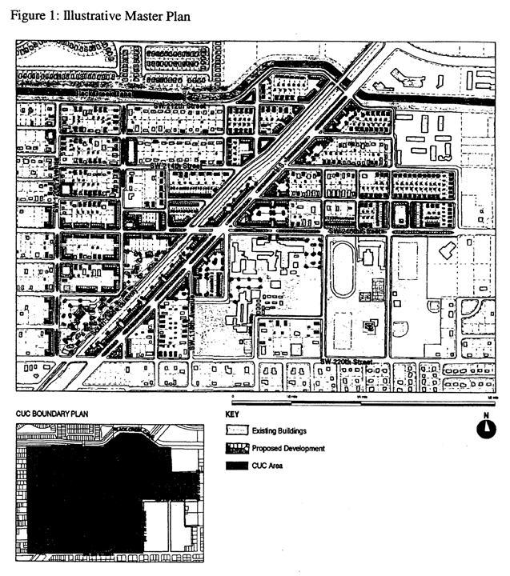

(Ord. No. 05-144, § 1, 7-7-05)

Sec. 33-284.92. Goulds Community Urban Center District (GCUC) Requirements.

Except as provided herein, all developments within the GCUC shall comply with the requirements provided in Article XXXIII(K), Standard Urban Center District Regulations, of this code.

(Ord. No. 05-144, § 2, 7-7-05)

Sec. 33-284.93. Uses.

Except as provided herein, all permitted, conditionally permitted, and temporary uses within the GCUC shall comply with [Section 33-284.83](../level3/PTIIICOOR_CH33ZO_ARTXXXIII_K_STURCEDIRE.docx#PTIIICOOR_CH33ZO_ARTXXXIII_K_STURCEDIRE_S33-284.83US) of this Code.

A. Permitted Uses. The following uses shall be permitted in the Store Porch Special District (SD) Area:

1. outdoor produce markets

2. on lots fronting a Main Street, all uses permitted in Mixed Use Main Street (MM)

3. all uses permitted in the Mixed Use Corridor (MC)

B. Conditionally Permitted Uses. An entertainment center shall be permitted after public hearing pursuant to [Section 33-311](../level3/PTIIICOOR_CH33ZO_ARTXXXVIZOPR.docx#PTIIICOOR_CH33ZO_ARTXXXVIZOPR_S33-311COZOAPBOUTDU)(A)(3) of this code, provided that the following conditions are also satisfied:

1. The site contains a minimum of 5 net acres and a maximum of 20 net acres.

2. A landscaped buffer of 25 feet is provided along all property lines, allowing only access and egress therein, except that Main Street frontage shall comply with the Building Placement and Design Parameters.

3. All buildings are setback a minimum of 30 feet from all property lines except along a Main Street.

(Ord. No. 05-144, § 3, 7-7-05; Ord. No. 06-10, § 5, 1-24-06)

Sec. 33-284.94. The Regulating Plans.

The Regulating Plans shall consist of the following controlling plans, as defined and graphically depicted in this section.

A. The Street Types Plan, which establishes a hierarchy of street types in existing and future locations. The five Street Types and the hierarchy of streets (from most important to least important in accommodating all types of activity) are U.S. 1, Main Street, Boulevard, Minor Street, and Service Road.

B. The Sub-districts Plan, which delineates 3 Sub-districts: Core, Center and Edge. These Sub-districts shall regulate the allowable intensity of development in accordance with the Comprehensive Development Master Plan and this article.

C. The Land Use Plan, which delineates the areas where specified land uses and development of various types and intensities shall be permitted.

D. The Building Heights Plan, which establishes the minimum and maximum allowable number of stories.

E. The Designated Open Space Plan, which designates open spaces. The designated open spaces shall be controlled by anchor points.

F. The New Streets Plan, which shows the location and the number of new streets needed to create the prescribed network of streets within each Urban Center District. All new A streets shall be required in the same general location as shown on the New Streets Plan. All B streets shall be located as provided in [Section 33-284.86](../level3/PTIIICOOR_CH33ZO_ARTXXXIII_K_STURCEDIRE.docx#PTIIICOOR_CH33ZO_ARTXXXIII_K_STURCEDIRE_S33-284.86GERE)(F) of this code.

G. The Bike Route Plan, which depicts the designated bike routes, including the bike facility requirements if any, which shall be shown in all development plans.

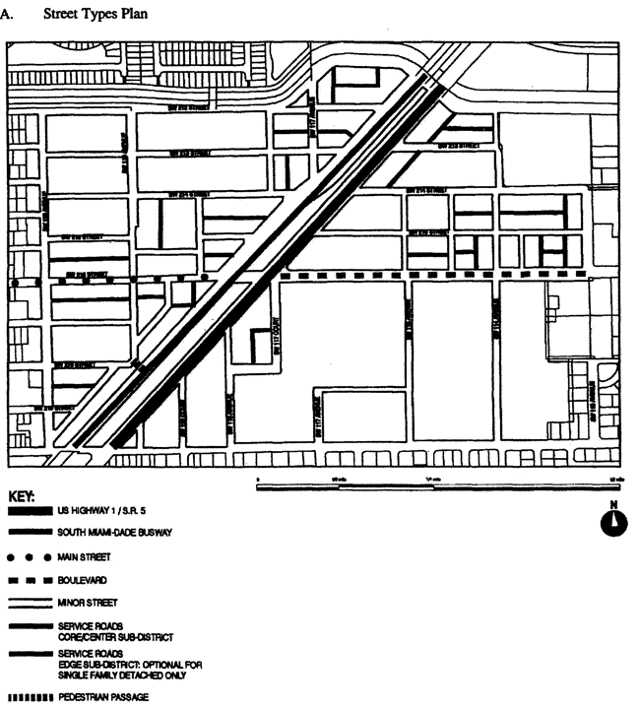

**Street Types Plan**

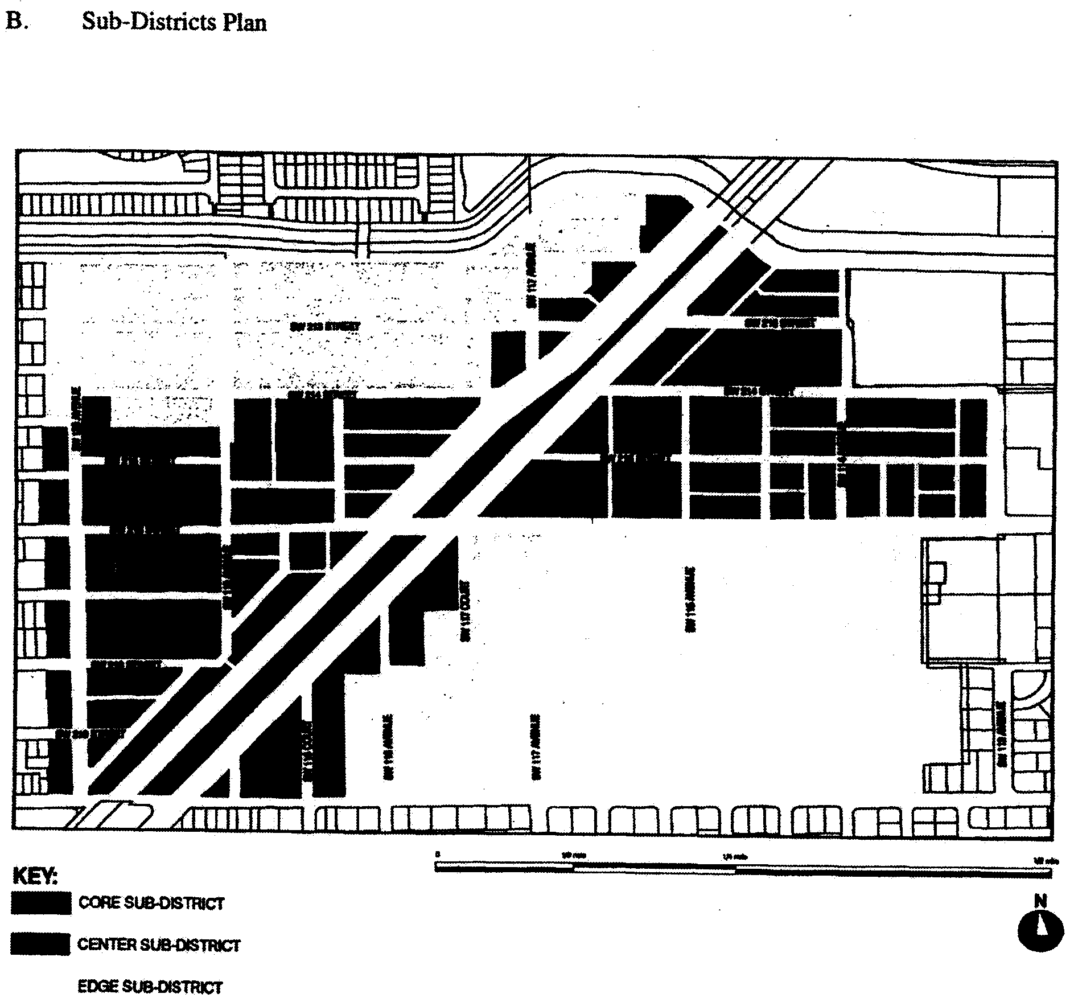

**Sub-Districts Plan**

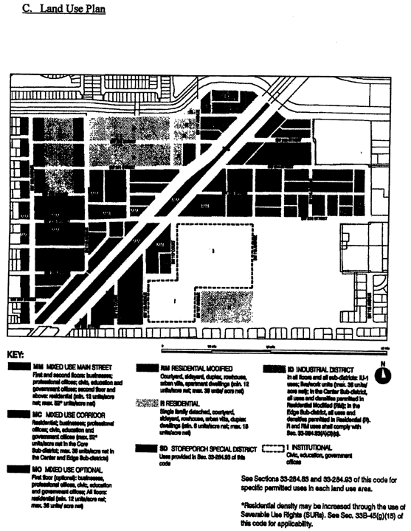

**Land Use Plan**

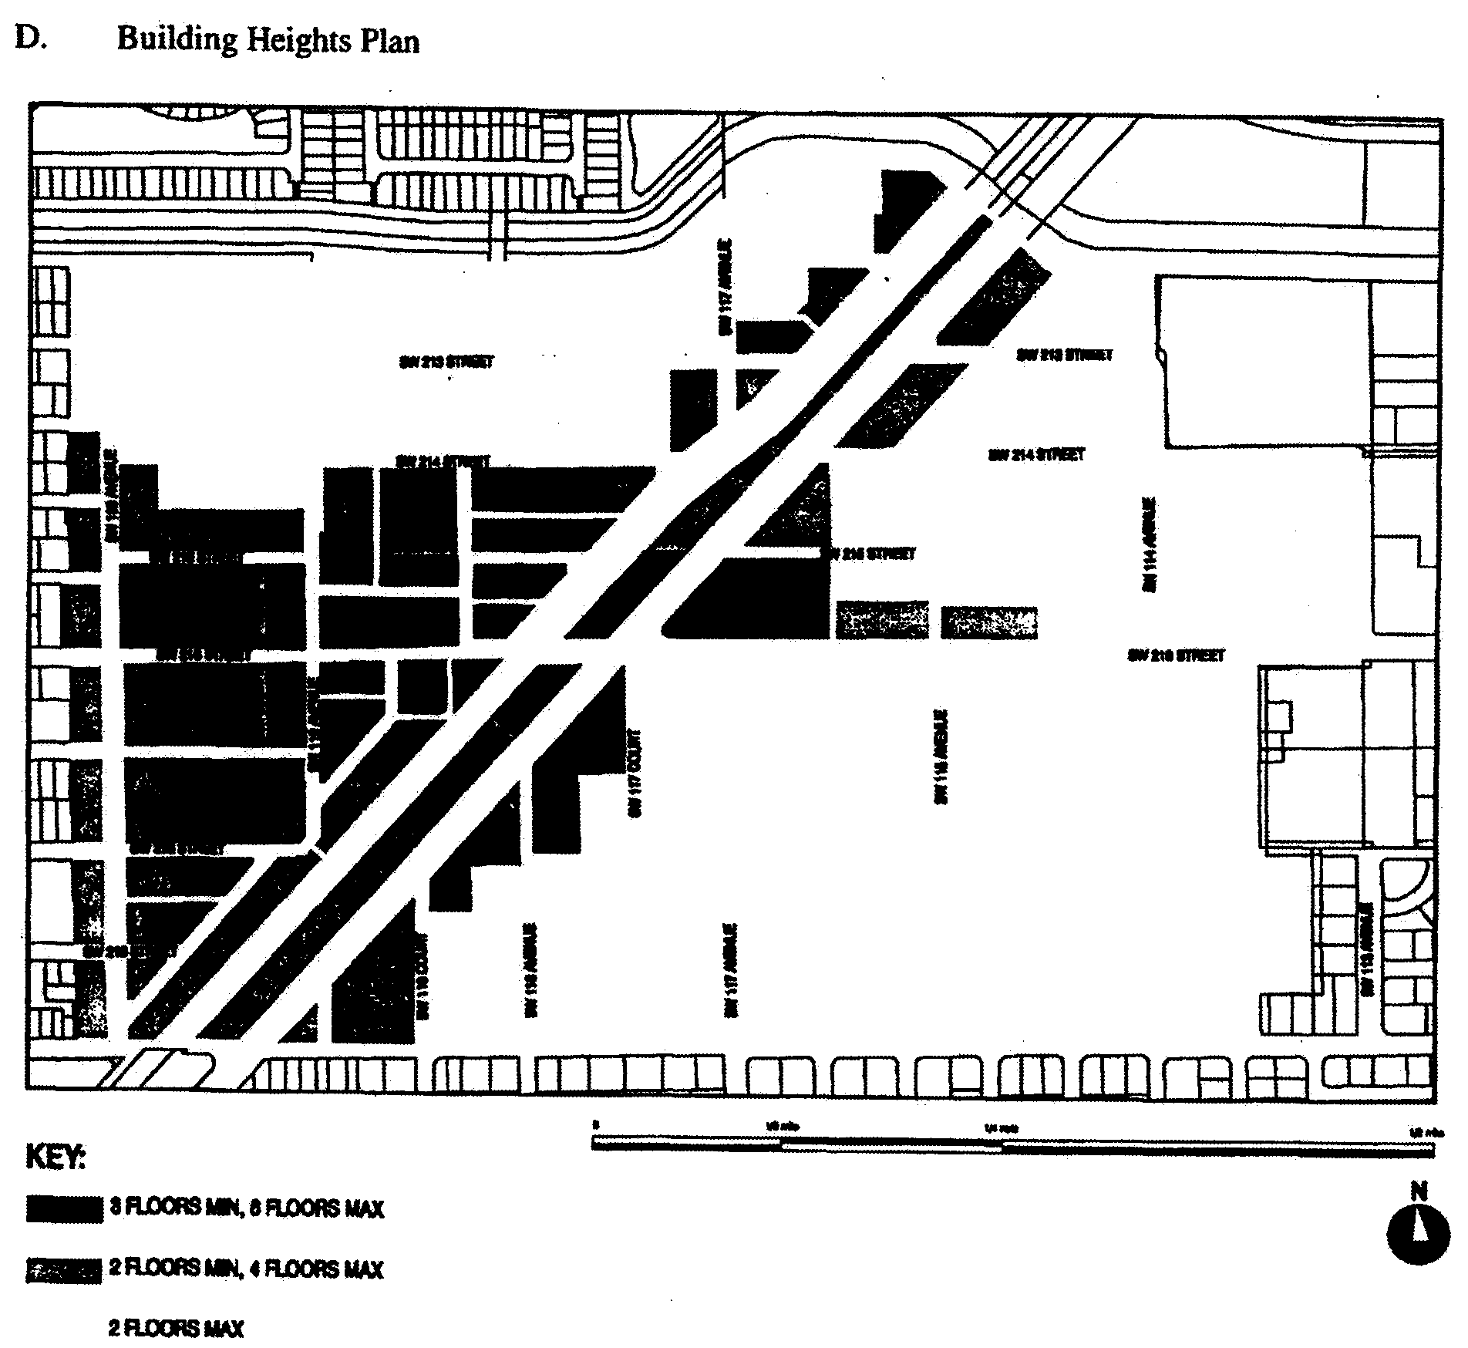

**Building Heights Plan**

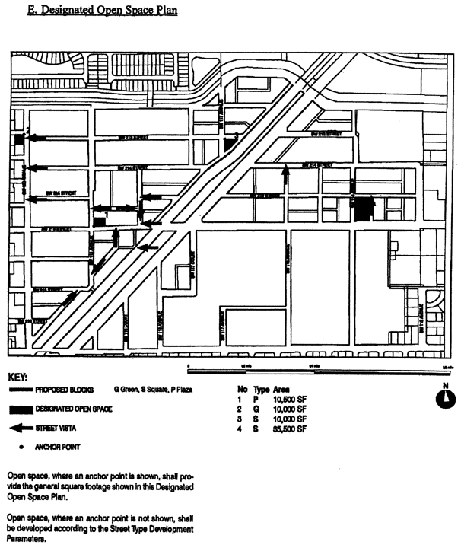

**Designated Open Space Plan**

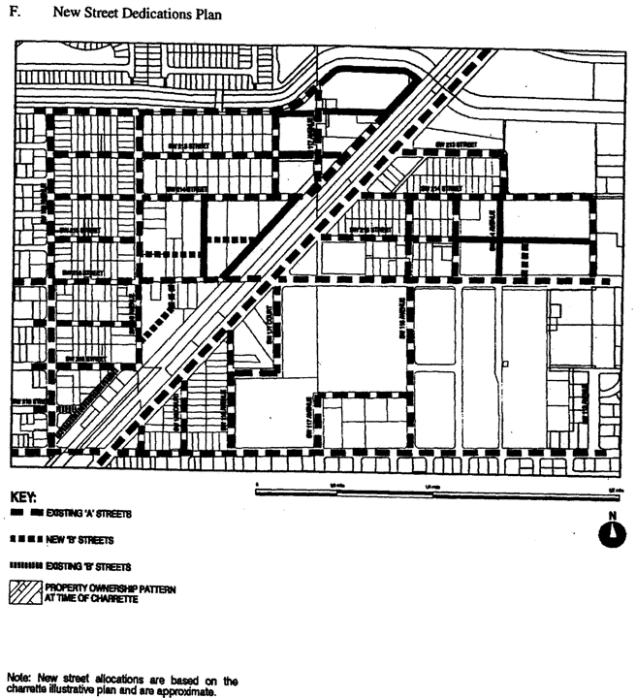

**New Street Dedications Plan**

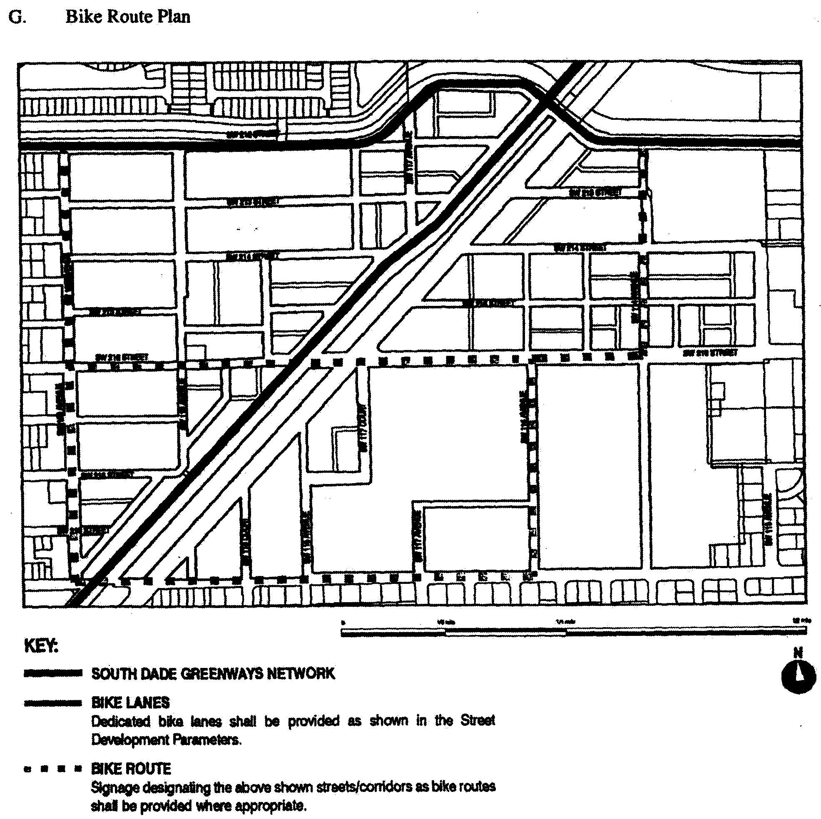

**Bike Route Plan**

(Ord. No. 05-144, § 4, 7-7-05; Ord. No. 06-10, § 6, 1-24-06; Ord. No. 07-95, § 1, 7-10-07)

Sec. 33-284.95. Building Placement and Design and Street Type Development Parameters.

A. All new development and redevelopment within the GCUC shall comply with the Building Placement and Design Parameters as provided in [Section 33-284.85](../level3/PTIIICOOR_CH33ZO_ARTXXXIII_K_STURCEDIRE.docx#PTIIICOOR_CH33ZO_ARTXXXIII_K_STURCEDIRE_S33-284.85BUPLST) of this code.

B. All new development and redevelopment within the GCUC shall comply with the Street Type Parameters as provided herein:

|  |  |  |
| --- | --- | --- |
| Street type | Minimum Required Configuration | |
|  | Core/Center | Edge |
| U.S. 1 | As provided in this section | |
| Main Street | As provided in this section | |
| Boulevard | Street type 1, parking both sides | Street type 1 or 2 |
| Minor Street | Street type 4, parking one side | Street type 4 or 5 |
| Service Road | As provided in [Section 33-284.85](../level3/PTIIICOOR_CH33ZO_ARTXXXIII_K_STURCEDIRE.docx#PTIIICOOR_CH33ZO_ARTXXXIII_K_STURCEDIRE_S33-284.85BUPLST) | |
| Pedestrian Passage | As provided in [Section 33-284.85](../level3/PTIIICOOR_CH33ZO_ARTXXXIII_K_STURCEDIRE.docx#PTIIICOOR_CH33ZO_ARTXXXIII_K_STURCEDIRE_S33-284.85BUPLST) | |

C. Unless otherwise provided by the Building Placement and Design Parameters in [Section 33-284.85](../level3/PTIIICOOR_CH33ZO_ARTXXXIII_K_STURCEDIRE.docx#PTIIICOOR_CH33ZO_ARTXXXIII_K_STURCEDIRE_S33-284.85BUPLST) of this code, the following front and side street setbacks shall be required within the GCUC:

|  |  |  |  |
| --- | --- | --- | --- |
| Street type | Required Setback | | |
|  | Core | Center | Edge |
| U.S. 1 | 6 feet | 6 feet | 10 feet |
| Main Street | 0 feet* | 0 feet* | 10 feet |
| Boulevard | 0 feet | 0 feet | 10 feet |
| Minor Street | 10 feet | 6 feet | 10 feet |
| Service Road | 0 feet | 0 feet | 0 feet |
| Pedestrian Passage | 0 feet | 0 feet | 10 or 15 feet |
| *Colonnade required | | | |

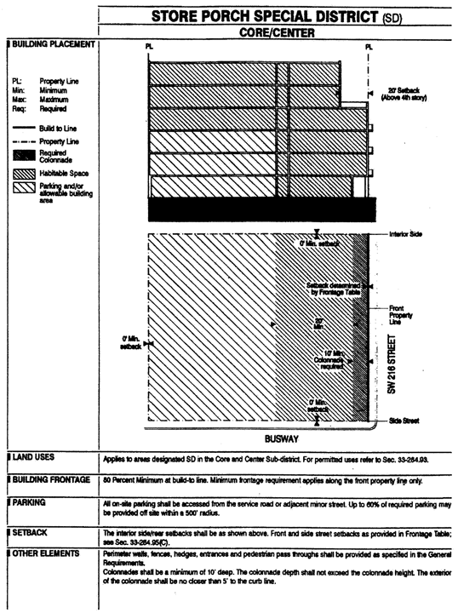

**Store Porch Special District**

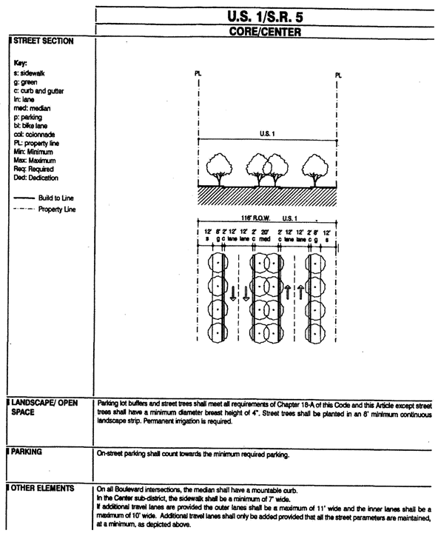

**U.S. 1/S.R. 5 Core/Center**

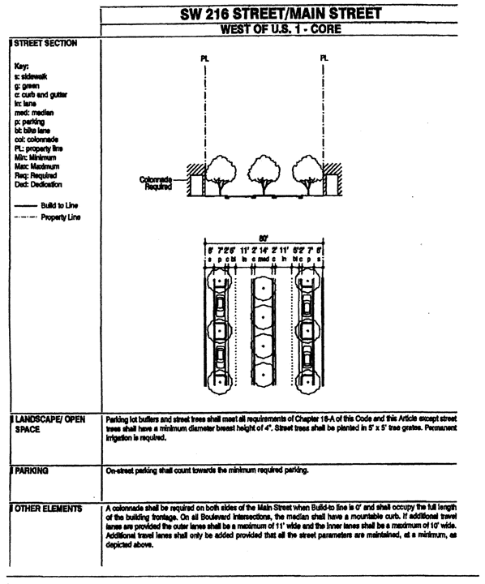

**SW 216 Street/Main Street West of U.S. 1 Core**

(Ord. No. 05-144, § 5, 7-7-05; Ord. No. 07-95, § 2, 7-10-07)

Sec. 33-284.96. Conflicts with other Chapters and Regulations.

This article shall govern in the event of conflicts with other zoning, subdivision, or landscape regulations of this code, or with the Miami-Dade Department of Public Works Manual of Public Works.

(Ord. No. 05-144, § 5, 7-7-05)

Sec. 33-284.97. Non-conforming Structures, Uses, and Occupancies.

Nothing contained in this article shall be deemed or construed to prohibit a continuation of a legal nonconforming structure, use, or occupancy in the GCUC that either (1) was existing as of the date of the district boundary change on the property to GCUC District or (2) on or before said date, had received final site plan approval through a public hearing pursuant to this chapter or through administrative site plan review or had a valid building permit. However, any structure, use, or occupancy in the GCUC District that is discontinued for a period of at least six months, or is superseded by a lawful structure, use or occupancy permitted under this chapter, or that incurs damage to the roof or structure to an extent of 50 percent or more of its market value, shall be subject to [Section 33-35](../level3/PTIIICOOR_CH33ZO_ARTIINGE.docx#PTIIICOOR_CH33ZO_ARTIINGE_S33-35NOUS)(c) of this code. However, a lawfully existing single-family home use that is discontinued for a period of at least six months or that incurs damage to the roof or structure to an extent of 50 percent or more of its market value, shall not be subject to [Section 33-35](../level3/PTIIICOOR_CH33ZO_ARTIINGE.docx#PTIIICOOR_CH33ZO_ARTIINGE_S33-35NOUS)(c) of this code.

(Ord. No. 05-144, § 5, 7-7-05; Ord. No. 06-10, § 7, 1-24-06)

### ARTICLE XXXIII(M). PRINCETON COMMUNITY CENTER URBAN DISTRICT

Sec. 33-284.98 Purpose, intent and applicability.

Sec. 33-284.99. Princeton Community Urban Center District (PCUC) Requirements.

Sec. 33-284.99.1. Uses.

Sec. 33-284.99.2. The Regulating Plans.

Sec. 33-284.99.3. Building Placement and Street Type Development Parameters.

Sec. 33-284.99.4. Conflicts with other Chapters and Regulations.

Sec. 33-284.99.5. Non-conforming Structures, Uses, and Occupancies.

Sec. 33-284.98 Purpose, intent and applicability.

A. The regulations contained in this chapter and [Chapter 18A](../level2/PTIIICOOR_CH18AMIDECOLAOR.docx#PTIIICOOR_CH18AMIDECOLAOR), Landscape Code, Code of Miami-Dade County, Florida, shall apply to this article, except as otherwise added to or modified herein.

B. The Illustrative Master Plan (Figure 1), illustrates the citizens' vision and may be used to interpret this article. Where the Illustrative Master Plan conflicts with the text of this article, the text shall govern.

C. The boundaries shown in Figure 1 shall constitute the Princeton Community Urban Center Boundary Plan and are generally described as follows: from the northwest corner of the intersection of SW 256 Street and SW 127 Avenue, then north along the west side of SW 127 Avenue to the south side of SW 240 Street, then west along the south side of SW 240 Street to the Urban Development Boundary (UDB) line, as of the effective date of this ordinance, then south, east and west along the UDB to the north side of SW 256 Street, then east along the north side of SW 256 Street to the west side of SW 127 Avenue. The exact location of the UDB line as of the effective date of this ordinance (July 17, 2005) is on file with the Department of Planning and Zoning. An approximate delineation of the UDB line is depicted in the Illustrative Master Plan and in the Regulating Plans.

A more detailed legal description of the boundaries follows:

Beginning at the centerline of the intersection of SW 127th Avenue and SW 256th Street of section 26-56-39, thence North, along the centerline of SW 127th avenue to the intersection with the centerline of SW 240th Street, thence west along the centerline of SW 240 Street to the intersection with the centerline of SW 137 AVE the (UDB). Thence continue west along the centerline of SW 240 Street for 542' + to a point (theoretical UDB). Thence on an assumed bearing S00-44-41W for 1440' + to a point. Thence N89-26-32E for 542' + to the centerline of SW 137 AVE. Thence south along the centerline of SE 137 AVE to the intersection with the centerline of SW 248 Street. Thence west along centerline of SW 248 Street to the intersection with the centerline of SW 139 AVE. Thence south along the centerline of SW 139 AVE to the intersection with the centerline of SW 252 Street. Thence west along the centerline of SW 252 Street to the intersection with the centerline of SW 142 AVE. Thence on an assumed bearing S41-03-51W for approximately 1737' + to the centerline of the intersection of SW 256 Street. Thence east along the centerline of SW 256 Street for 1563' + to the intersection with the Centerline of Packing House Road. Thence on an assumed bearing S50-44-50E for approximately 371.65' + to the centerline of State Hwy # 5. Thence NE/ly along the centerline of the State HWY # 5 for 334.99 + to a point. Thence east for 427.30 + to the centerline of SW 139 Ave. Thence east along the centerline of SW 256 ST to the point of beginning. (The intersection with the centerline of SW 127 AVE).

D. Full scale maps of the Illustrative Master Plan presented in Figure 1, as well as all the Regulating Plans and Street Development Parameters figures in this article, are on file with the Miami-Dade Department of Planning and Zoning.

E. No provision in this article shall be applicable to any property lying outside the boundaries of the Princeton Community Urban Center District (PCUC) as described herein. No property lying within the boundaries of the PCUC shall be entitled to the uses or subject to the regulations provided in this article until an application for a district boundary change to PCUC has been heard and approved in accordance with the provisions of this chapter.

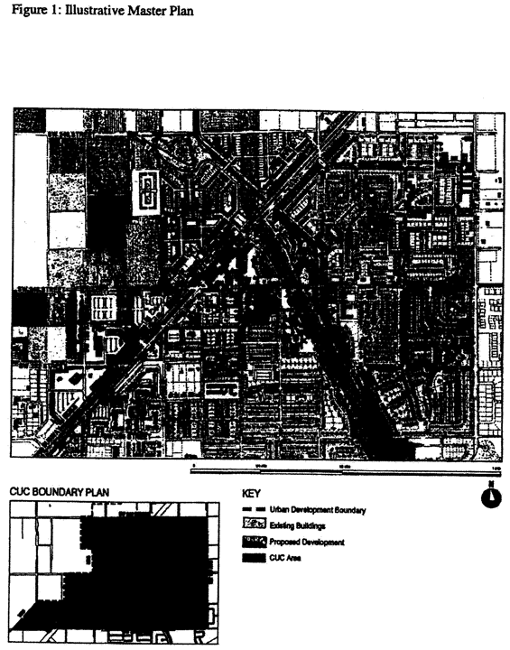

**Figure 1: Illustrative Master Plan**

(Ord. No. 05-146, § 1, 7-7-05)

Sec. 33-284.99. Princeton Community Urban Center District (PCUC) Requirements.

Except as provided herein, all developments within the PCUC shall comply with the requirements provided in Article XXXIII(K), Standard Urban Center District Regulations, of this code.

(Ord. No. 05-146, § 2, 7-7-05)

Sec. 33-284.99.1. Uses.

Except as provided herein, all permitted, conditionally permitted, and temporary uses within the PCUC shall comply with [Section 33-284.83](../level3/PTIIICOOR_CH33ZO_ARTXXXIII_K_STURCEDIRE.docx#PTIIICOOR_CH33ZO_ARTXXXIII_K_STURCEDIRE_S33-284.83US) of this code,

A. Permitted Uses. The following uses shall be permitted.

1. On the west side of South Dade Busway right-of-way, Industrial (ID) lots abutting designated Mixed Use Corridor (MC) lots on at least one side, may have uses permitted in the MC area for a depth not to exceed 300 feet, as measured from the Busway right-of-way.

2. In the Industrial District (ID) area, all uses permitted in the IU-2 zoning district after public hearing pursuant to [Section 33-311](../level3/PTIIICOOR_CH33ZO_ARTXXXVIZOPR.docx#PTIIICOOR_CH33ZO_ARTXXXVIZOPR_S33-311COZOAPBOUTDU)(A)(3) of this code.

3. The following uses in the Marketplace Special District (SD) area:

a. outdoor produce markets

b. all uses permitted in the IU-1 zoning district

c. in the Core and Center Sub-districts only, on lots fronting on SW 244 Street or SW 137 Avenue, all uses permitted in the Arts District (AD)

4. The following uses in the Arts District (AD) area:

a. live-work buildings, only along A-Streets and with the following uses:

(1) for the residential area: multiple family apartment units when vertically integrated with other lawful uses in work space area

(2) for the work space area:

(i) all uses permitted in the workshop portion of a live-work unit in the ID area

(ii) arts and crafts stores

(iii) caterers

(iv) drugstores

(v) food preparation

(vi) furniture manufacturing and refinishing

(vii) hardware stores

(viii) hotels/motels

(ix) labs

(x) micro-breweries

(xi) movie theaters, excluding drive-in theaters

(xii) police substations

(xiii) post office substations

(xiv) other similar uses that promote the arts and handcrafts as approved by the Director

b. uses permitted in the Industrial District (ID) area.

c. when contiguous to a property located in the Marketplace Special District (SD) that is under the same ownership, all uses permitted in the SD District.

5. The following uses in the Utilities District (UD) area:

a. all uses permitted in the GU zoning district, excluding residences and permanent storage.

B. Conditionally Permitted Uses. An entertainment center shall be permitted after public hearing pursuant to [Section 33-311](../level3/PTIIICOOR_CH33ZO_ARTXXXVIZOPR.docx#PTIIICOOR_CH33ZO_ARTXXXVIZOPR_S33-311COZOAPBOUTDU)(A)(3) of this code, provided that the following conditions are also satisfied:

1. The site contains a minimum of 5 net acres and a maximum of 20 net acres.

2. A landscaped buffer of 25 feet is provided along all property lines, allowing only access and egress therein, except that facilities with frontages along SW 244 Street and US 1/Busway shall comply with the Building Placement and Design Parameters.

3. All buildings are setback a minimum of 30 feet from all property lines except along SW 244 Street.

(Ord. No. 05-146, § 3, 7-7-05)

Sec. 33-284.99.2. The Regulating Plans.

The Regulating Plans shall consist of the following controlling plans, as defined and graphically depicted in this section.

A. The Street Types Plan, which establishes a hierarchy of street types in existing and future locations. The five Street Types and the hierarchy of streets (from most important to least important in accommodating all types of activity) are U.S. 1, Main Street, Boulevard, Minor Street, and Service Road.

B. The Sub-districts Plan, which delineates 3 Sub-districts: Core, Center and Edge. These Sub-districts shall regulate the allowable intensity of development in accordance with the Comprehensive Development Master Plan and this article.

C. The Land Use Plan, which delineates the areas where specified land uses and development of various types and intensities shall be permitted.

D. The Building Heights Plan, which establishes the minimum and maximum allowable number of stories.

E. The Designated Open Space Plan, which designates open spaces. The designated open spaces shall be controlled by anchor points.

F. The New Streets Plan, which shows the location and the number of new streets needed to create the prescribed network of streets within each Urban Center District. All new A streets shall be required in the same general location as shown on the New Streets Plan. All B streets shall be located as provided in [Section 33-284.86](../level3/PTIIICOOR_CH33ZO_ARTXXXIII_K_STURCEDIRE.docx#PTIIICOOR_CH33ZO_ARTXXXIII_K_STURCEDIRE_S33-284.86GERE)(F) of this code.

G. The Bike Route Plan, which depicts the designated bike routes, including the bike facility requirements if any, which shall be shown in all development plans.

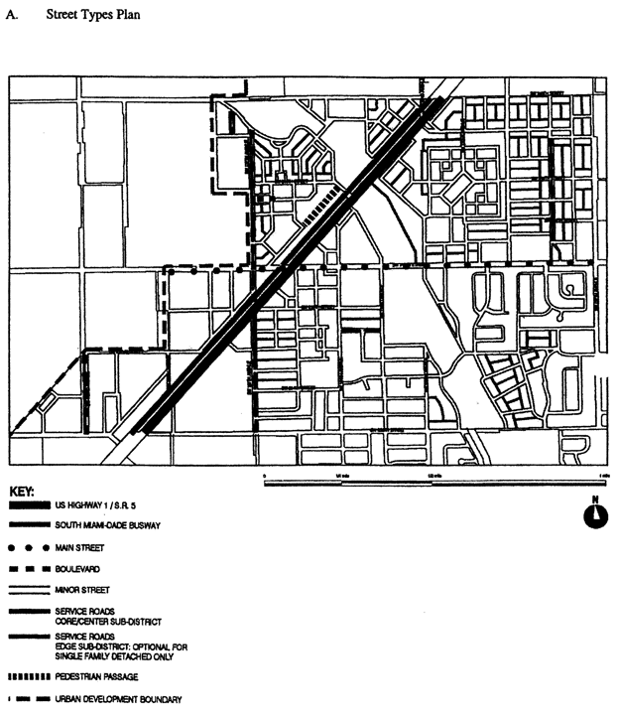

**Street Types Plan**

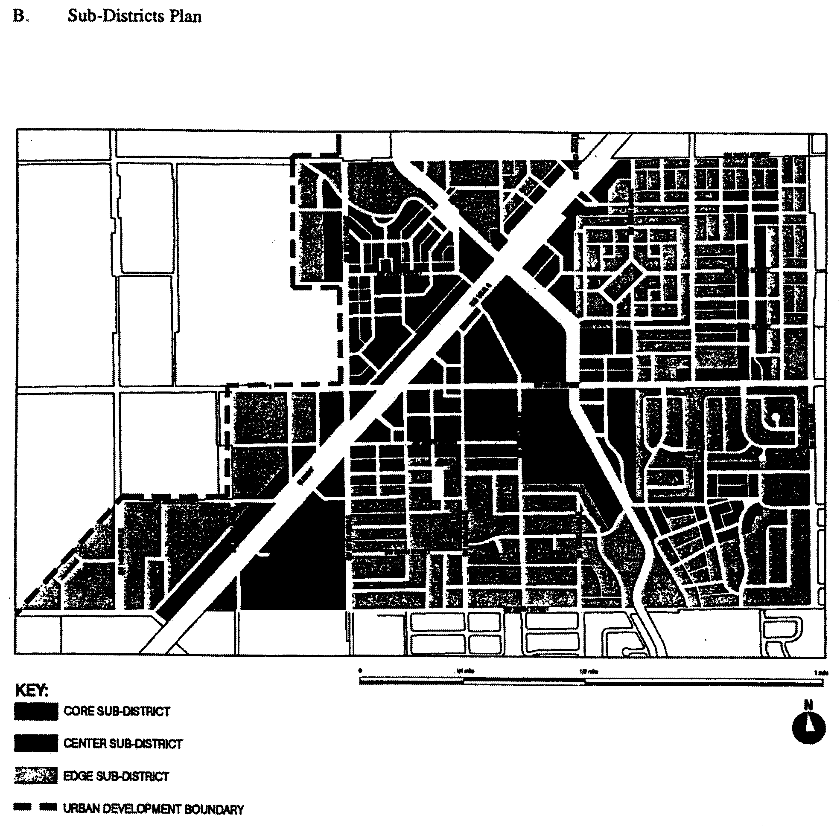

**Sub-Districts Plan**

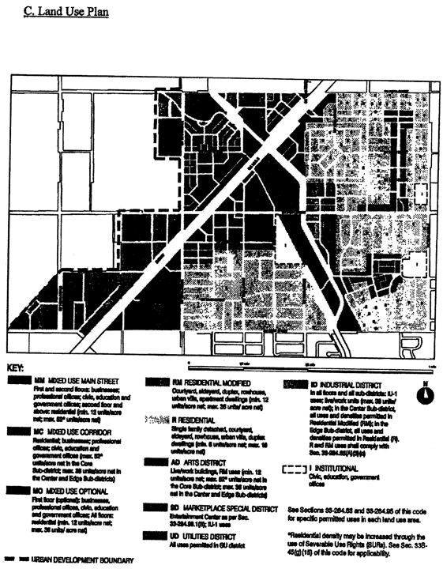

**Land Use Plan**

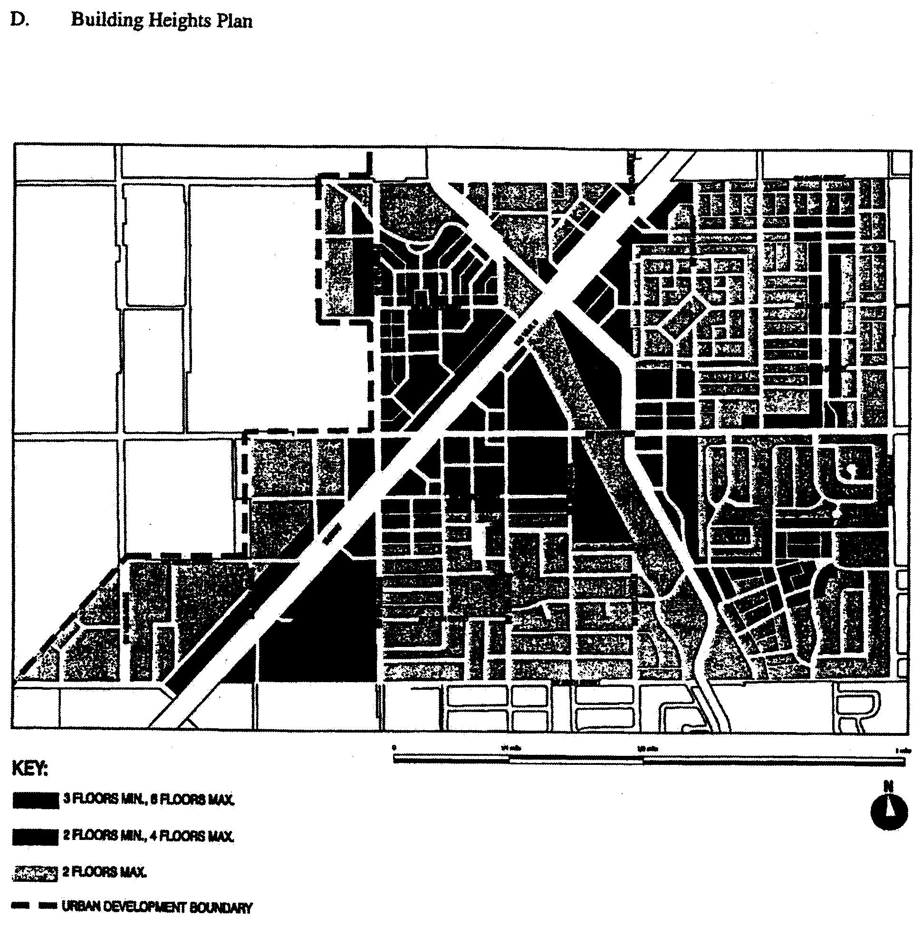

**Building Heights Plan**

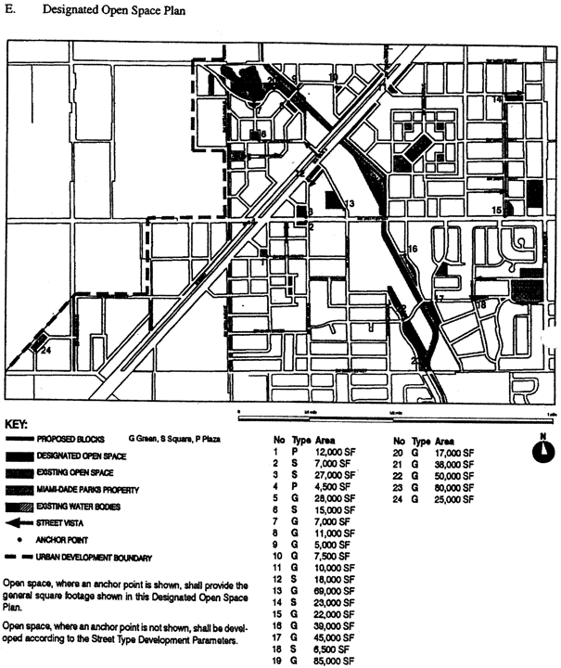

**Designated Open Space Plan**

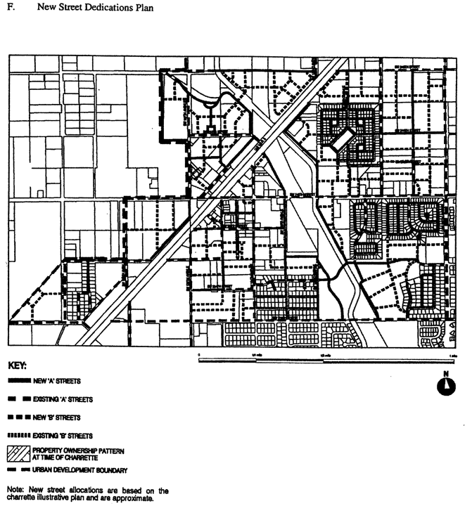

**New Street Dedications Plan**

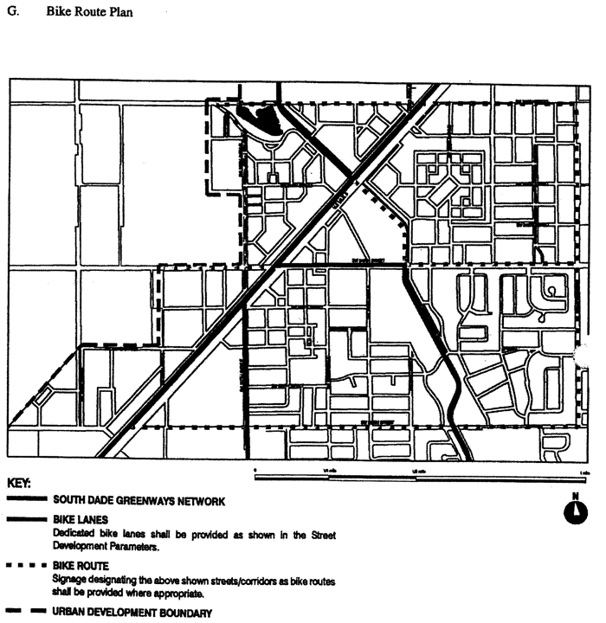

**Bike Route Plan**

(Ord. No. 05-146, § 4, 7-7-05; Ord. No. 07-96, § 3, 7-10-07)

Sec. 33-284.99.3. Building Placement and Street Type Development Parameters.

A. All new development and redevelopment within the PCUC shall comply with the Building Placement and Design Parameters as provided in [Section 33-284.85](../level3/PTIIICOOR_CH33ZO_ARTXXXIII_K_STURCEDIRE.docx#PTIIICOOR_CH33ZO_ARTXXXIII_K_STURCEDIRE_S33-284.85BUPLST) of this code.

B. All new development and redevelopment within the PCUC shall comply with the Street Type Parameters as provided herein:

|  |  |  |
| --- | --- | --- |
| Street type | Minimum Required Configuration | |
|  | Core/Center | Edge |
| U.S. 1 | As provided in this section | |
| Main Street | As provided in this section | |
| Boulevard | Street type 1, parking both sides | Street type 1 or 2 |
| Minor Street | Street type 4, parking one side | Street type 4 or 5 |
| Service Road | As provided in [Section 33-284.85](../level3/PTIIICOOR_CH33ZO_ARTXXXIII_K_STURCEDIRE.docx#PTIIICOOR_CH33ZO_ARTXXXIII_K_STURCEDIRE_S33-284.85BUPLST) | |
| Pedestrian Passage | As provided in [Section 33-284.85](../level3/PTIIICOOR_CH33ZO_ARTXXXIII_K_STURCEDIRE.docx#PTIIICOOR_CH33ZO_ARTXXXIII_K_STURCEDIRE_S33-284.85BUPLST) | |

C. Unless otherwise provided by the Building Placement and Design Parameters in [Section 33-284.85](../level3/PTIIICOOR_CH33ZO_ARTXXXIII_K_STURCEDIRE.docx#PTIIICOOR_CH33ZO_ARTXXXIII_K_STURCEDIRE_S33-284.85BUPLST) of this code, the following front and side street setbacks shall be required within the PCUC:

|  |  |  |  |
| --- | --- | --- | --- |
| Street type | Required Setback | | |
|  | Core | Center | Edge |
| U.S. 1 | 6 feet | 6 feet | 10 feet |
| Main Street | 6 feet | 6 feet | 10 feet |
| Boulevard | 0 feet | 0 feet | 10 feet |
| Minor Street | 10 feet | 6 feet | 10 feet |
| Service Road | 0 feet | 0 feet | 0 feet |
| Pedestrian Passage | 0 feet | 0 feet | 10 or 15 feet |

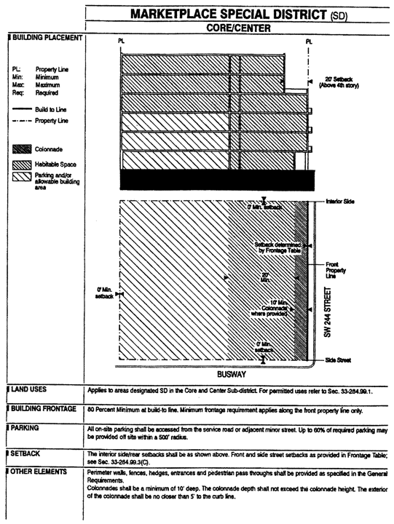

**Marketplace Special District Core/Center**

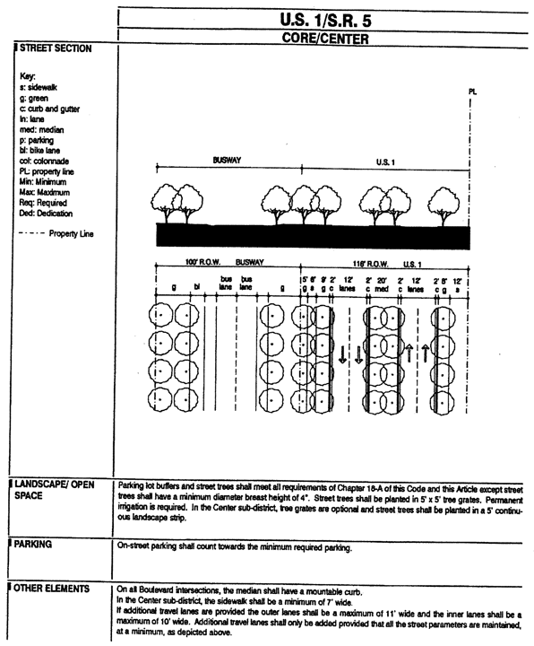

**U.S. 1/S.R. 5 Core/Center**

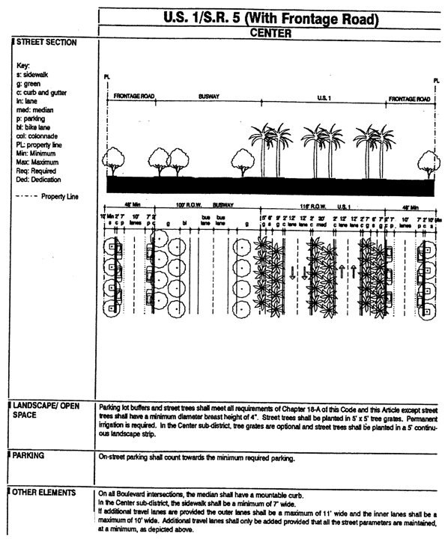

**U.S. 1/S.R. 5 (With Frontage Road) Center**

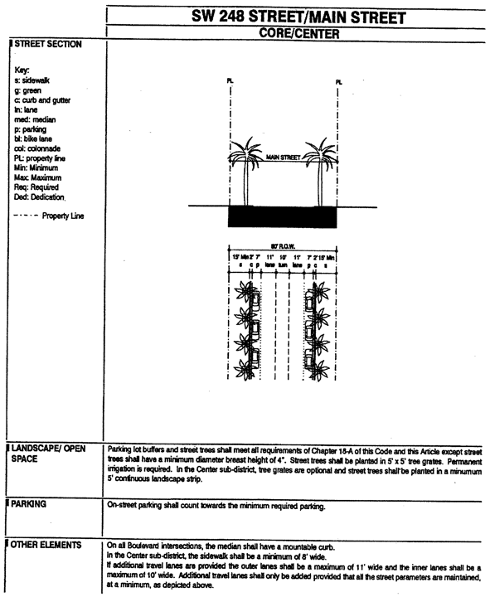

**SW 248 Street/Main Street Core/Center**

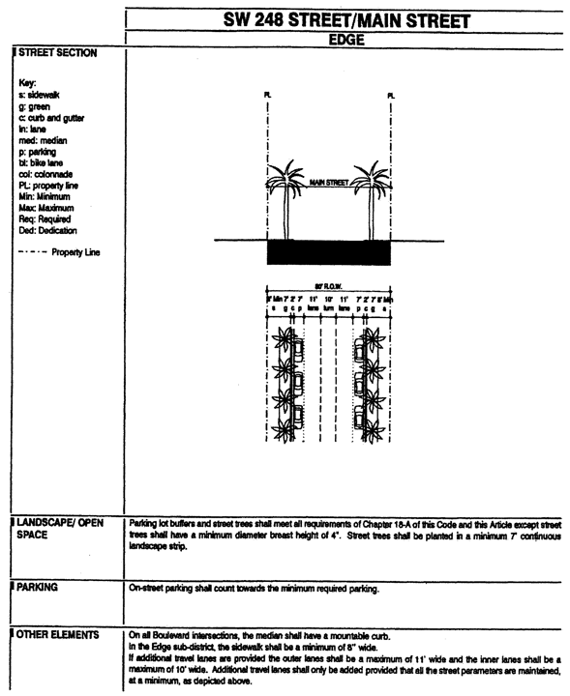

**SW 248 Street/Main Street Edge**

(Ord. No. 05-146, § 5, 7-7-05)

Sec. 33-284.99.4. Conflicts with other Chapters and Regulations.

This article shall govern in the event of conflicts with other zoning, subdivision, or landscape regulations of this code, or with the Miami-Dade Department of Public Works Manual of Public Works.

(Ord. No. 05-146, § 6, 7-7-05)

Sec. 33-284.99.5. Non-conforming Structures, Uses, and Occupancies.

Nothing contained in this article shall be deemed or construed to prohibit a continuation of a legal nonconforming structure, use, or occupancy in the PCUC District that either (1) was existing as of the date of the district boundary change on the property to PCUC District or (2) on or before said date, had received final site plan approval through a public hearing pursuant to this chapter or through administrative site plan review or had a valid building permit. However, any structure, use, or occupancy in the PCUC District that is discontinued for a period of at least six months, or is superseded by a lawful structure, use, or occupancy permitted under this chapter, or that incurs damage to the roof or structure to an extent of 50 percent or more of its market value, shall be subject to [Section 33-35](../level3/PTIIICOOR_CH33ZO_ARTIINGE.docx#PTIIICOOR_CH33ZO_ARTIINGE_S33-35NOUS)(c) of this code. However, a lawfully existing single-family home use that is discontinued for a period of at least six months or that incurs damage to the roof or structure to an extent of 50 percent or more of its market value, shall not be subject to [Section 33-35](../level3/PTIIICOOR_CH33ZO_ARTIINGE.docx#PTIIICOOR_CH33ZO_ARTIINGE_S33-35NOUS)(c) of this code.

(Ord. No. 05-146, § 7, 7-7-05; Ord. No. 06-10, § 8, 1-24-06)

**Editor's note—**

Ord. No. 05-146, § 7, adopted July 7, 2005, amended the Code with the addition of a new [section 33-284.99.4](../level3/PTIIICOOR_CH33ZO_ARTXXXIII_M_PRCOCEURDI.docx#PTIIICOOR_CH33ZO_ARTXXXIII_M_PRCOCEURDI_S33-284.99.4COOTCHRE). In order to avoid duplication of section numbers, the provisions of said ordinance have been included herein as [section 33-284.99.5](../level3/PTIIICOOR_CH33ZO_ARTXXXIII_M_PRCOCEURDI.docx#PTIIICOOR_CH33ZO_ARTXXXIII_M_PRCOCEURDI_S33-284.99.5NNFSTUSOC) at the discretion of the editor.

### ARTICLE XXXIII(N). PERRINE COMMUNITY URBAN CENTER DISTRICT (PECUCD)

Sec. 33-284.99.6. Purpose, intent and applicability.

Sec. 33-284.99.7. Perrine Community Urban Center (PECUC) District Requirements.

Sec. 33-284.99.8. Uses.

Sec. 33-284.99.9. The Regulating Plans.

Sec. 33-284.99.10. Building Placement and Street Type Development Parameters.

Sec. 33-284.99.11. General Requirements.

Sec. 3-284.99.12. Conflicts with other Chapters and Regulations.

Sec. 33-284.99.13. Non-conforming Structures, Uses, and Occupancies.

Sec. 33-284.99.6. Purpose, intent and applicability.

A. The regulations contained in this chapter and [Chapter 18A](../level2/PTIIICOOR_CH18AMIDECOLAOR.docx#PTIIICOOR_CH18AMIDECOLAOR), Landscape Code, Code of Miami-Dade County, Florida, shall apply to this article, except as otherwise added to or modified herein.

B. The Illustrative Master Plan (Figure 1) illustrates the citizens' vision and may be used to interpret this article. Where the Illustrative Master Plan conflicts with the text of this article, the text shall govern.

C. The boundaries shown in Figure 1 shall constitute the Perrine Community Urban Center (PECUC) Boundary Plan and are generally described as follows: from the intersection of the centerline of the southbound U. S Highway 1 (US 1) and SW 168 Street, then west along the centerline of SW 168 Street to the centerline of SW 107 Avenue, then south along the centerline of SW 107 Avenue to the centerline of SW 184 Street, then west along the centerline of SW 184 Street to the east side of the Homestead Extension of the Florida Turnpike — State Road 821 (HEFT), then south and east along the east side of the HEFT to the centerline of SW 186 Street, Quail Roost Drive, then east along the centerline of SW 186 Street to the east side of the C-1N canal, then south and east along the east and north side of the C-1N canal to the centerline of Marlin Drive, the southeasterly along the centerline of Marlin Drive to the centerline of the South Miami-Dade Busway, then north along the centerline of the South Miami-Dade Busway to SW 186 Street, then east along the centerline of SW 186 Street the centerline of US 1, then north along the center1ine of US 1 to SW 183 Street, then north along the centerline of the southbound US 1 to the point of beginning.

A more detailed legal description of the boundaries follows:

Beginning at the intersection of the centerline of the southbound U.S. Highway 1 (US 1) and the centerline of SW 168 Street, thence West along the aforementioned centerline of SW 168 Street to the intersection with the centerline of SW 107 Avenue, thence South along the aforementioned centerline of SW 107 Avenue to the intersection with the centerline of SW 184 Street, thence West along the centerline of the aforementioned centerline of SW 184 Street to the intersection with the East Right-of-Way line of the Homestead Extension of the Florida Turnpike - State Road 821 (HEFT), thence South and Southeasterly along the afore mentioned East Right-of-Way line of the Homestead Extension of the Florida Turnpike - State Road 821 (HEFT) to the centerline of SW 186 Street (Quail Roost Drive), thence East along the centerline of the aforementioned centerline of SW 186 Street (Quail Roost Drive) to the intersection with the East Right-of-Way line of the C-1N Canal, thence South and East along the afore mentioned East and North Right-of-Way line of the C-1N Canal to the intersection with the centerline of Marlin Drive, thence Southeasterly along the aforementioned centerline of Marlin Drive to the intersection with the centerline of the South Miami-Dade Busway, thence Northeasterly along the aforementioned centerline of the South Miami-Dade Busway to the centerline of SW 186 Street, thence East along the aforementioned centerline of SW 186 Street to the intersection of the centerline of U.S. Highway 1 (US 1), thence Northeasterly along the aforementioned centerline of U.S. Highway 1 (US 1) to the intersection with the extension of the centerline of SW 183 Street, thence Northeasterly along the centerline of the southbound U.S. Highway 1 (US 1) back to the Point of Beginning.

D. Full scale maps of the Illustrative Master Plan presented in Figure 1, as well as all the Regulating Plans and Street Development Parameters figures in this article, are on file with the Miami-Dade Department of Planning and Zoning.

E. No provision in this article shall be applicable to any property lying outside the boundaries of the Perrine Community Urban Center District (PECUC) as described herein. No property lying within the boundaries of the PECUC shall be entitled to the uses or subject to the regulations provided in this article until an application for a district boundary change to the PECUC has been heard and approved in accordance with the provisions of this chapter.

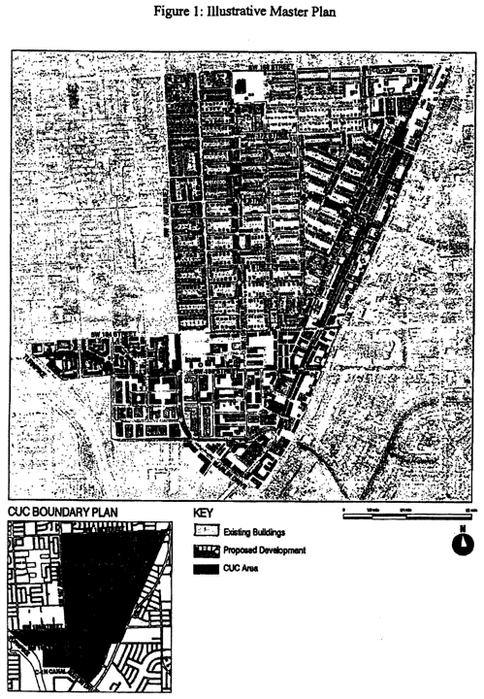

**Figure 1: Illustrative Master Plan**

(Ord. No. 06-127, § 1, 9-12-06)

Sec. 33-284.99.7. Perrine Community Urban Center (PECUC) District Requirements.

Except as provided herein, all developments within the PECUC shall comply with the requirements provided in Article XXXIII(K), Urban Center District Regulations, of this code.

(Ord. No. 06-127, § 2, 9-12-06)

Sec. 33-284.99.8. Uses.

Except as provided herein, all permitted, conditionally permitted, and temporary uses within the PECUC shall comply with [Section 33-284.83](../level3/PTIIICOOR_CH33ZO_ARTXXXIII_K_STURCEDIRE.docx#PTIIICOOR_CH33ZO_ARTXXXIII_K_STURCEDIRE_S33-284.83US) of this code.

A. *Permitted Uses.* The following uses shall be permitted.

1. In the Residential (R) area, all uses provided in [Section 33-284.83](../level3/PTIIICOOR_CH33ZO_ARTXXXIII_K_STURCEDIRE.docx#PTIIICOOR_CH33ZO_ARTXXXIII_K_STURCEDIRE_S33-284.83US)(A)(1), except that rowhouses shall be permitted only in those areas specifically designated as permitting rowhouses in the Land Use Regulating Plan, as provided in Section 33.284.99.9 of this article.

2. In the Mixed-Use Corridor (MC) area, all uses provided in [Section 33-284.83](../level3/PTIIICOOR_CH33ZO_ARTXXXIII_K_STURCEDIRE.docx#PTIIICOOR_CH33ZO_ARTXXXIII_K_STURCEDIRE_S33-284.83US)(A)(3) and the following uses:

(A) Automobile and truck services and facilities including:

(1) Open lot car and truck sales new or used, including as ancillary uses, automobile repairs, body and top work and painting, provided that no more than fifteen (15) percent of the gross building area is devoted to such ancillary uses, and subject to the following conditions:

(a) That attention attractive devices, such as blinking or flashing lights, streamer lights, pennants, banners, streamers and all fluttering, spinning advertising devices (either mobile or stationary) are prohibited.

(b) That outdoor lighting shall be designed to avoid spilling beyond the site boundaries.

(c) That no vehicular test drives shall be conducted on residential local traffic streets (fifty-foot right-of-way or less).

(d) That the applicant obtains a certificate of use, which shall be automatically renewable yearly upon compliance with all terms and conditions.

(e) All outdoor paging or speaker systems are expressly prohibited.

(2) Open lot car rental.

(3) Automobile parts, secondhand from store building only.

(4) Automobile body and top work and painting.

(B) Engines, gas, gasoline, steam and oil; sales and service.

(C) Garage or mechanical service. Including automobile repairs, body and top work and painting. All outdoor paging or speaker systems are expressly prohibited.

(D) Glass installation.

(E) Self-service mini-warehouse storage facility in compliance with [Section 33-255](../level3/PTIIICOOR_CH33ZO_ARTXXVIILIBUDI.docx#PTIIICOOR_CH33ZO_ARTXXVIILIBUDI_S33-255USPE)(23.1) of this code.

(F) Tire vulcanizing and retreading or sale of use tires.

(G) Truck storage, only within an enclosed building or an area enclosed by a CBS wall.

(H) Automobile washing.

3. Industrial uses. Notwithstanding the provisions of [Section 33-284.83](../level3/PTIIICOOR_CH33ZO_ARTXXXIII_K_STURCEDIRE.docx#PTIIICOOR_CH33ZO_ARTXXXIII_K_STURCEDIRE_S33-284.83US)(A)(4), only the following uses shall be permitted in the Industrial District (ID) area. These uses shall be allowed in conformance with the Land Use Regulating Plan and the Street Type Development Parameters.

(A) All uses permitted in the IU-1 zoning district.

(B) All uses permitted in the IU-2 zoning district after public hearing pursuant to [Section 33-311](../level3/PTIIICOOR_CH33ZO_ARTXXXVIZOPR.docx#PTIIICOOR_CH33ZO_ARTXXXVIZOPR_S33-311COZOAPBOUTDU)(A)(3) of this code.

(C) All uses permitted in the Mixed-Use Corridor (MC) on lots located north of SW 184 Street and east of the Busway.

(D) All uses permitted in the Mixed-Use Optional (MO) on lots located north of SW 184 Street and west of the Busway.

4. In the Mixed-Use Corridor/Industrial (MCI) area, all uses permitted in the MC and ID areas, as provided in this section. Development in the MCI area shall comply with the Mixed-Use Building or Industrial Building placement standards provided in [Section 33-284.85](../level3/PTIIICOOR_CH33ZO_ARTXXXIII_K_STURCEDIRE.docx#PTIIICOOR_CH33ZO_ARTXXXIII_K_STURCEDIRE_S33-284.85BUPLST). Notwithstanding any other provisions to the contrary, Industrial uses in the MCL area shall be exempt from minimum height and density requirements.

(Ord. No. 06-127, § 1, 9-12-06; Ord. No. 07-97, § 1, 7-10-07; Ord. No. 11-30, § 1, 5-3-11)

Sec. 33-284.99.9. The Regulating Plans.

I. *Street Types Plan.*

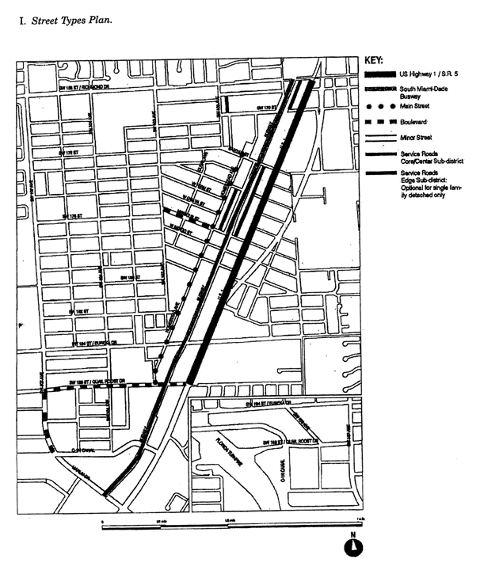

**Street Types Plan**

II. *Sub-District Plan.*

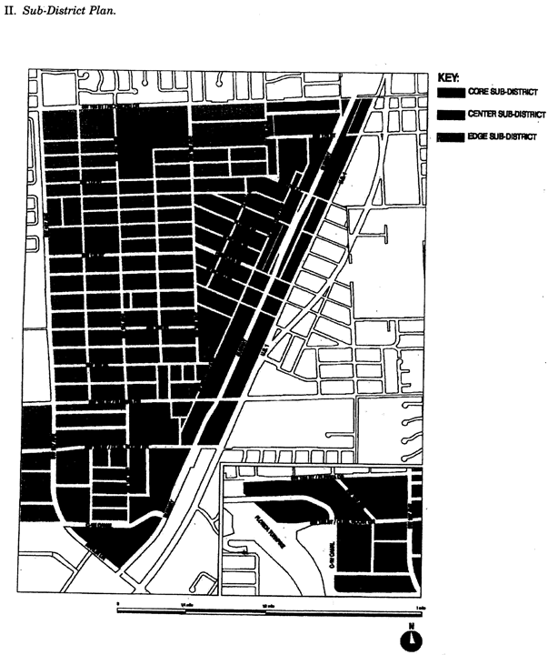

**Sub-District Plan**

III. *Land Use Plan.*

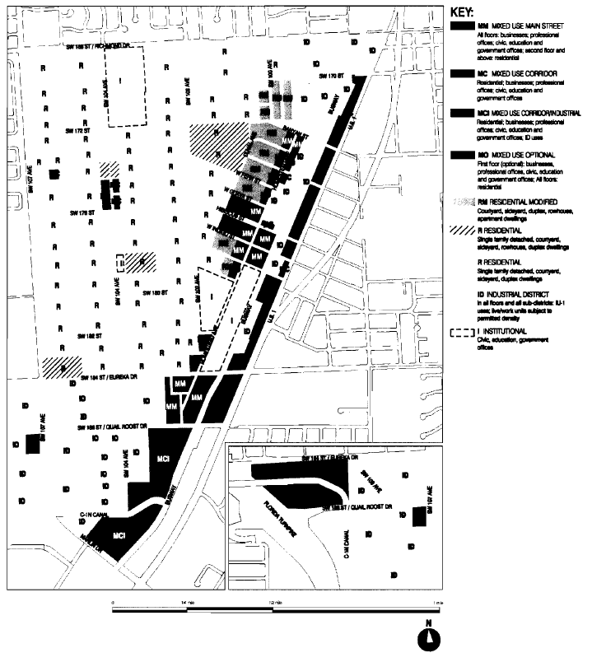

IV. *Density Plan.*

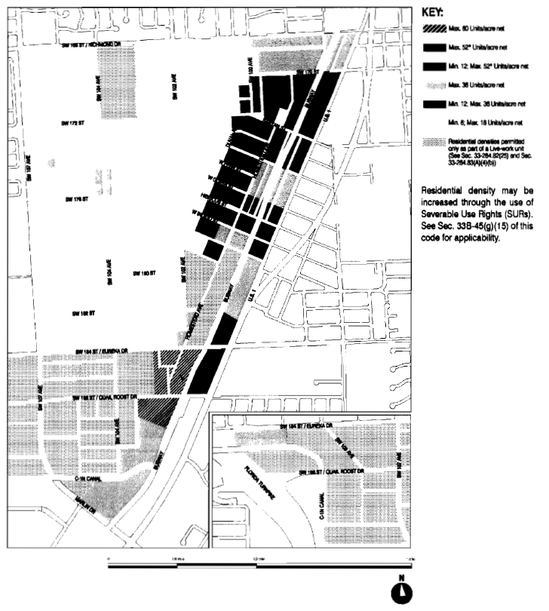

V. *Building Heights Plan.*

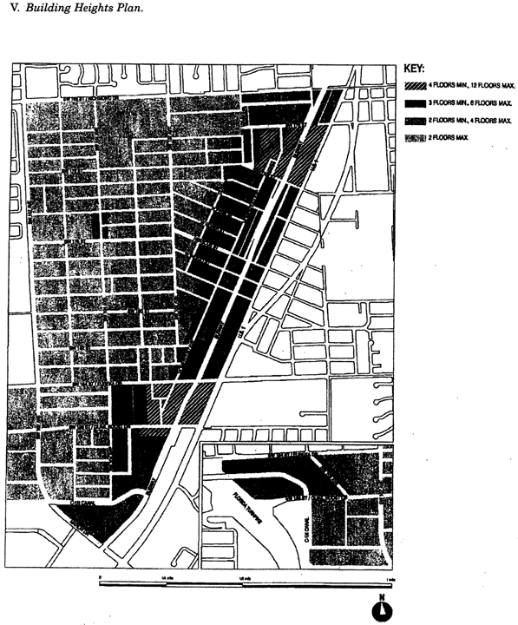

**Building Heights Plan**

VI. *Designated Open Space Plan.*

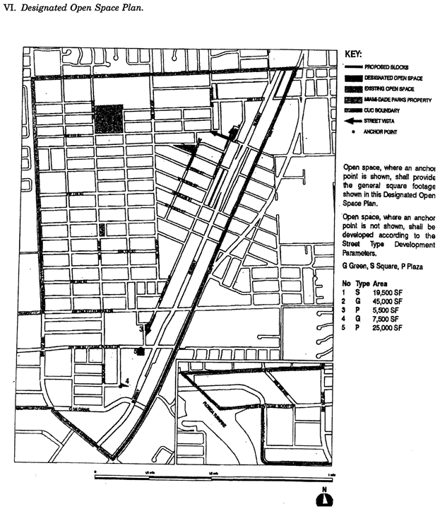

**Designated Open Space Plan**

VII. *New Street Dedications Plan.*

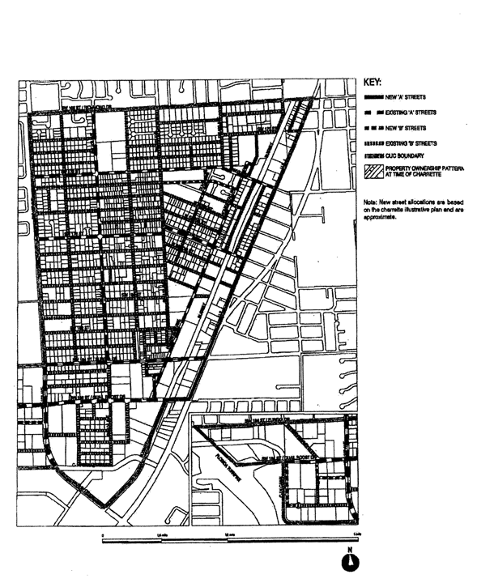

VIII. *Bike Route Plan.*

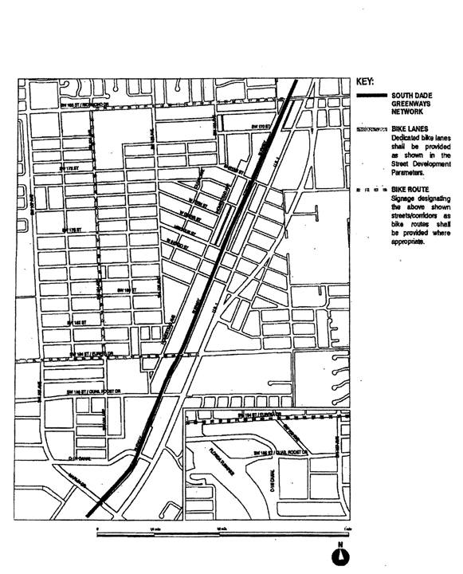

(Ord. No. 06-127, § 4, 9-12-06; Ord. No. 07-97, § 2, 7-10-07; Ord. No. 11-30, § 2, 5-3-11)

Sec. 33-284.99.10. Building Placement and Street Type Development Parameters.

A. All new development and redevelopment within the PECUC shall comply with the Building Placement and Design Parameters as provided in this section and in [Section 33-284.85](../level3/PTIIICOOR_CH33ZO_ARTXXXIII_K_STURCEDIRE.docx#PTIIICOOR_CH33ZO_ARTXXXIII_K_STURCEDIRE_S33-284.85BUPLST) of this code.

B. All new development and redevelopment within the PECUC shall comply with the Street Type Parameters as provided herein:

|  |  |  |
| --- | --- | --- |
| Street Type | Minimum Required Configuration | |
|  | Core/Center | Edge |
| U.S. 1 | As provided in this section | |
| Main Street | As provided in this section | |
| Boulevard | Street type 1, parking both sides | Street type 1 or 2 |
| Minor Street | Street type 4, parking one side | Street type 4 or 5 |
| Service Road | As provided in [Section 33-284.85](../level3/PTIIICOOR_CH33ZO_ARTXXXIII_K_STURCEDIRE.docx#PTIIICOOR_CH33ZO_ARTXXXIII_K_STURCEDIRE_S33-284.85BUPLST) | |
| Pedestrian Passage | As provided in [Section 33-284.85](../level3/PTIIICOOR_CH33ZO_ARTXXXIII_K_STURCEDIRE.docx#PTIIICOOR_CH33ZO_ARTXXXIII_K_STURCEDIRE_S33-284.85BUPLST) | |

Unless otherwise provided by the Building Placement and Design Parameters in [Section 33-284.85](../level3/PTIIICOOR_CH33ZO_ARTXXXIII_K_STURCEDIRE.docx#PTIIICOOR_CH33ZO_ARTXXXIII_K_STURCEDIRE_S33-284.85BUPLST) of this code, the following front and side street setbacks shall be required within the PECUC:

|  |  |  |  |
| --- | --- | --- | --- |
| Frontage Table | | | |
| Street Type | Required Setback | | |
|  | Core | Center | Edge |
| U.S. 1 | 6 feet | 6 feet | 10 feet |
| Main Street | 10 feet | 10 feet | 10 feet |
| Boulevard | 0 feet | 6 feet | 10 feet |
| Minor Street | 10 feet | 6 feet | 10 feet |
| Service Road | 0 feet | 0 feet | 0 feet |
| Pedestrian Passage | 0 feet | 0 feet | 10 or 15 feet |

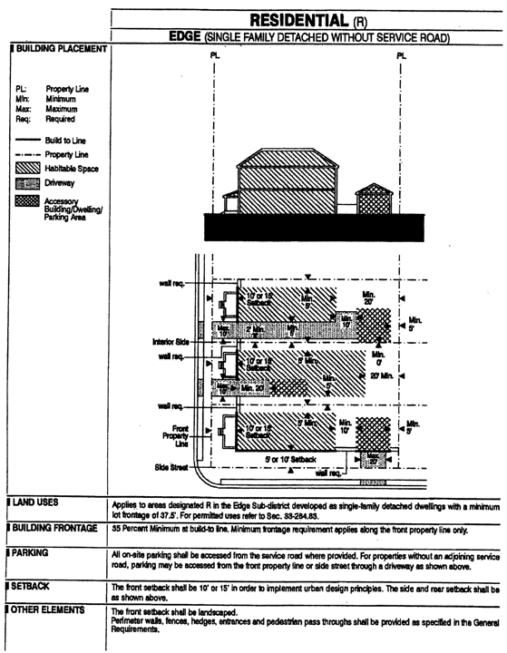

**Building Placement: Edge**

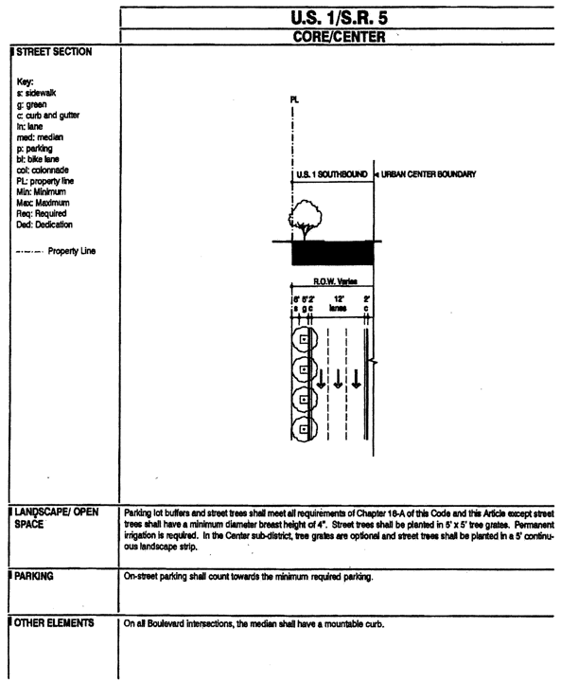

**Street Section: U.S. 1/S.R. 5**

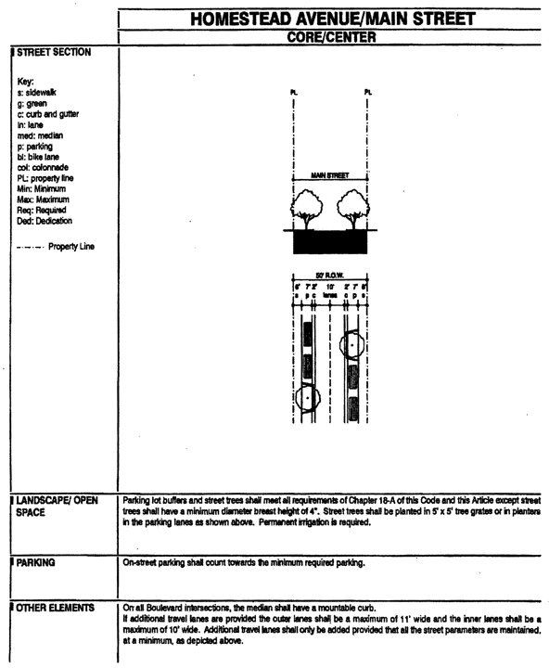

**Street Section: Homestead Ave./Main St.**

(Ord. No. 06-127, § 5, 9-12-06)

Sec. 33-284.99.11. General Requirements.

A. *Lots and Blocks.* In addition to the minimum lot requirements in [Section 33-284.86](../level3/PTIIICOOR_CH33ZO_ARTXXXIII_K_STURCEDIRE.docx#PTIIICOOR_CH33ZO_ARTXXXIII_K_STURCEDIRE_S33-284.86GERE)(A), the following shall be permitted in areas designated Residential (R) areas south of SW 170 Street:

|  |  |  |
| --- | --- | --- |
| Minimum Lot Requirements | | |
|  | Size (Square Feet) | Frontage (Feet) |
| Single-family detached | 3,750 | 37.5 |

B. *Architectural Guidelines.* To retain the character of the initial development of Perrine and to recognize the heritage of the early and current residents of the area, architectural elements typical of the Caribbean and the Southern United States as provided in this section shall be required.

1. *Architectural elements.* New development within the Perrine Community Urban Center District shall, to the greatest extent practicable, utilize the following architectural elements illustrated herein:

a. Projecting, roofed balconies

b. Continuous, wraparound verandahs

c. Vertically proportioned door and window openings

d. Hip roofs, finished with wood-shingles, flat concrete tile, or metal standing seam

e. Wood and masonry construction

f. Shading devices such as Bahama shutters, louvers, latticework, and projecting roof eaves

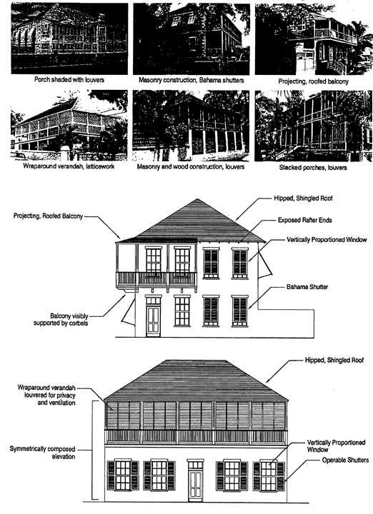

**Architectural Elements**

2. Architectural elements shall be required as follows:

|  |  |  |
| --- | --- | --- |
| Sub-Districts/ Land Use Areas | Required Elements | |
| All | Vertically proportioned door and window openings, exterior walls finished with smooth stucco or wood siding. | |
| Center and Edge Sub-Districts, in all land use areas except Industrial (ID) | Two or more elements required on the building elevation facing the front property line | Projecting balconies on the second story or above visibly supported by brackets or corbels, minimum of 4 ft. deep, extending across a minimum of 35% of the elevation; roofed balconies may not be enclosed except by louvers, shutters, or screening. |
| Recessed verandahs on any story, minimum of 8 ft. deep extending across a minimum of 50% of the elevation; verandahs may not be enclosed except by louvers, shutters, or screening. |
| Projecting porch on the ground story, minimum of 8 ft. deep extending across a minimum of 50% of the elevation; porches may not be enclosed except by louvers, shutters, or screening. |
| For sloped roofs not concealed by a parapet, roof eaves with rafter ends exposed. |
| Core and Center | Where arched openings are provided, such openings shall be round-headed or three-centered and shall spring from columns or piers; such openings shall not appear to be punched through the wall. | |

3. Prohibited elements. Arched, circular, and double-height openings are not permitted in areas designated Residential (R) and Residential Modified (RM) land use areas.

(Ord. No. 06-127, § 6, 9-12-06)

Sec. 3-284.99.12. Conflicts with other Chapters and Regulations.

This article shall govern in the event of conflicts with other zoning, subdivision, or landscape regulations of this code, or with the Miami-Dade Department of Public Works Manual of Public Works.

(Ord. No. 06-127, § 7, 9-12-06)

Sec. 33-284.99.13. Non-conforming Structures, Uses, and Occupancies.

Nothing contained in this article shall be deemed or construed to prohibit a continuation of a legal nonconforming structure, use, or occupancy in the PECUC that either (1) was existing as of the date of the district boundary change on the property to PECUC or (2) on or before said date, had received final site plan approved through a public hearing pursuant to this chapter or through administrative site plan review or had a valid building permit. However, any structure, use, or occupancy in the PECUC that is discontinued for a period of at least six (6) months, or is superseded by .a lawful structure, use, or occupancy permitted under this chapter, or that incurs damage to the roof or structure to an extent of fifty (50) percent or more of its market value, shall be subject to [Section 33-35](../level3/PTIIICOOR_CH33ZO_ARTIINGE.docx#PTIIICOOR_CH33ZO_ARTIINGE_S33-35NOUS)(c) of this code. However, a lawfully existing single-family home use that is discontinued for a period of at least six months or that incurs damage to the roof or structure to an extent of fifty (50) percent or more of its market value, shall not be subject to [Section 33-35](../level3/PTIIICOOR_CH33ZO_ARTIINGE.docx#PTIIICOOR_CH33ZO_ARTIINGE_S33-35NOUS)(c) of this code.

(Ord. No. 06-127, § 8, 9-12-06)

### ARTICLE XXXIII(O). OJUS URBAN AREA DISTRICT

Sec. 33-284.99.14. Purpose, intent and applicability.

Sec. 33-284.99.15. Ojus Urban Area District (OUAD) Requirements.

Sec. 33-284.99.16. Reserved.

Sec. 33-284.99.17. Uses.

Sec. 33-284.99.18. The Regulating Plans.

Sec. 33-284.99.19. Building Placement and Street Type Development Parameters.

Sec. 33-284.99.20. General Requirements.

Sec. 33-284.99.21. Conflicts with other Chapters and Regulations.

Sec. 33-284.99.22. Non-conforming Structures, Uses, and Occupancies.

Sec. 33-284.99.14. Purpose, intent and applicability.

A. The regulations contained in this chapter and [Chapter 18A](../level2/PTIIICOOR_CH18AMIDECOLAOR.docx#PTIIICOOR_CH18AMIDECOLAOR), Landscape Code, Code of Miami-Dade County, Florida, shall apply to this article, except as otherwise added to or modified herein.

B. The Illustrative Master Plan (Figure 1), illustrates the citizens' vision and may be used to interpret this article. Where the Illustrative Master Plan conflicts with the text of this article, the text shall govern.

C. The regulations contained in this chapter address portions of the Ojus/Aventura Metropolitan Urban Center and its surrounding area. Specifically it addresses an area with the boundaries shown in the Boundary Plan, hereafter the Ojus Urban Area District (OUAD) and generally described as follows: from the crossing of the Oleta River with the west side of the Florida East Cost (FEC) railroad easement, then north along the west side of the FEC railroad easement to the south side of NE 203 Street, then west along the south side of NE 203 Street to the west side of NE 26 Avenue, then north along the west side of NE 26 Avenue to the south side of theoretical NE 206 Street then west along the south side of theoretical NE 206 Street to the eastern boundary of the Highland Oaks Park, then north and west along the boundary of Highland Oaks Park to the east side of NE 23 Avenue, then south on the east side of NE 23 Avenue to the north side of NE 207 Street, then east along the north side of NE 207 Street to the east side of NE 24 Avenue, then south along the east side of NE 24 Avenue to the south side on NE 203 Street, then east along the south side of NE 203 Street to the Oleta River, then south along the Oleta River to the point of beginning.

A more detailed legal description of the boundaries follows:

Beginning at the intersection of the East Right-of-Way line of the Oleta River with the West Right-of-Way line of the Florida East Coast railroad, thence North along the aforementioned West Right-of-Way line of the Florida East Coast railroad to the intersection with the centerline of NE 203 Street, thence West along the aforementioned centerline of NE 203 Street to the intersection with the centerline of NE 26 Avenue, thence North along the aforementioned centerline of NE 26 Avenue to the intersection with the theoretical extension of the North Property line of Tract "A" of BETH TORAH ADATH YESHURUN as recorded in Plat Book 147, Page 50 of the Miami-Dade County Public Records, thence West along the aforementioned North Property line of Tract "A" to the intersection with the East Right-of-Way line of the Oleta River, thence North along the aforementioned East Right-of-Way line of the Oleta River to the intersection with the East Property line of Highland Oaks Park, thence North along the aforementioned East Property line of Highland Oaks Park to the intersection with the North Property line of Highland Oaks Park, thence West along the aforementioned North Property line of Highland Oaks Park to the theoretical intersection with the centerline of NE 23 Avenue, thence South along the aforementioned centerline of NE 23 Avenue to the intersection with the Northern boundary of Highland Oaks Elementary School, thence East along the aforementioned Northern boundary of Highland Oaks Elementary School for a distance of 546 feet (+/-) to a point, thence Southeast along the Northeast boundary of Highland Oaks Elementary School for a distance of 125 feet (+/-) to a point, thence East to the intersection with the centerline of NE 24 Avenue, thence South along the aforementioned centerline of NE 24 Avenue to the intersection with the centerline of NE 203 Street, thence East along the aforementioned centerline of NE 203 Street to the intersection with the East Right-of-Way line of the Oleta River, thence South along the aforementioned East Right-of-Way line of the Oleta River to the Point of Beginning.

D. Full scale maps of the Illustrative Master Plan presented in Figure 1, as well as all the Regulating Plans and Street Development Parameters figures in this article, are on file with the Miami-Dade Department of Planning and Zoning.

E. No provision in this article shall be applicable to any property lying outside the boundaries of the OUAD as described herein. No property lying within the boundaries of the OUAD shall be entitled to the uses or subject to the regulations provided in this article until an application for a district boundary change to OUAD has been heard and approved in accordance with the provisions of this chapter.

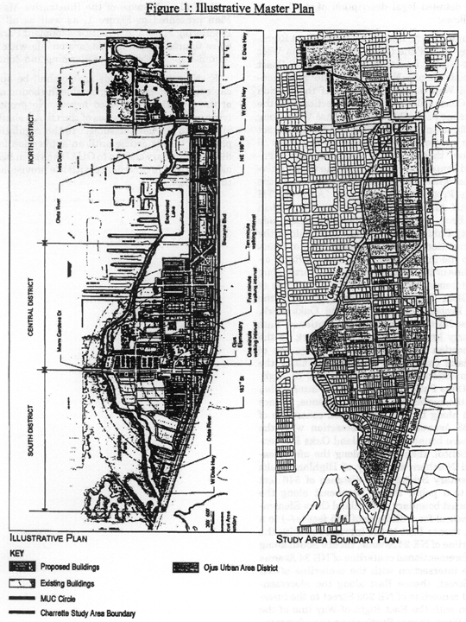

**Figure 1: Illustrative Master Plan**

(Ord. No. 06-86, § 1, 6-6-06)

Sec. 33-284.99.15. Ojus Urban Area District (OUAD) Requirements.

Except as provided herein, all developments within the OUAD shall comply with the requirements provided in Article XXXIII(K), Standard Urban Center District Regulations, of this code.

(Ord. No. 06-86, § 2, 6-6-06)

Sec. 33-284.99.16. Reserved.

**Editor's note—**

Section 1 of Ord. No. 07-94, adopted July 10, 2007, deleted [§ 33-284.99.16](../level3/PTIIICOOR_CH33ZO_ARTXXXIII_O_OJURARDI.docx#PTIIICOOR_CH33ZO_ARTXXXIII_O_OJURARDI_S33-284.99.16RE), which pertained to definitions and derived from Ord. No. 06-86, adopted June 6, 2006.

Sec. 33-284.99.17. Uses.

Except as provided herein, all permitted, conditionally permitted, and temporary uses within the OUAD shall comply with [Section 33-284.83](../level3/PTIIICOOR_CH33ZO_ARTXXXIII_K_STURCEDIRE.docx#PTIIICOOR_CH33ZO_ARTXXXIII_K_STURCEDIRE_S33-284.83US) of this Code.

1. As provided in the Land Use Regulating Plan, no duplexes shall be permitted in areas designated:

a. Residential (R) with a maximum permitted density of 6 dwelling units per net acre; and

b. Residential Modified (RM) with maximum permitted densities greater or equal to 36 units per net acre.

2. No municipal recreation building, playground, or park owned and operated by a municipality, county, state, or the federal government shall be permitted in areas designated R on the Land Use Regulating Plan.

3. No civic uses shall be permitted in areas designated R on the Land Use Regulating Plan, except for educational facilities on properties not to exceed 5 acres.

4. Industrial uses. Notwithstanding the provisions of [Section 33-284.83](../level3/PTIIICOOR_CH33ZO_ARTXXXIII_K_STURCEDIRE.docx#PTIIICOOR_CH33ZO_ARTXXXIII_K_STURCEDIRE_S33-284.83US) (A)(4), only the following uses shall be permitted in the Industrial District (ID) area. These uses shall be allowed in conformance with the Land Use Regulating Plan and the Street Type Development Parameters.

a. All uses permitted in the IU-1 zoning district

b. All uses permitted in the IU-2 zoning district after public hearing pursuant to [Section 33-311](../level3/PTIIICOOR_CH33ZO_ARTXXXVIZOPR.docx#PTIIICOOR_CH33ZO_ARTXXXVIZOPR_S33-311COZOAPBOUTDU)(A)(3) of this code.

c. MC uses at a maximum density of 52 units net acre or at a maximum density of 60 units per net acre with the purchase of the appropriate number of Severable Use Rights pursuant to Sections [33B-41](../level4/PTIIICOOR_CH33BARCRENCO_ARTIIEAEV_DIV3SEUSRI.docx#PTIIICOOR_CH33BARCRENCO_ARTIIEAEV_DIV3SEUSRI_S33B-41PU) to [33B-47](../level4/PTIIICOOR_CH33BARCRENCO_ARTIIEAEV_DIV3SEUSRI.docx#PTIIICOOR_CH33BARCRENCO_ARTIIEAEV_DIV3SEUSRI_S33B-47COCH33ZOCOCO) of this code.

d. live-work units as provided in [Sec. 33-284.83](../level3/PTIIICOOR_CH33ZO_ARTXXXIII_K_STURCEDIRE.docx#PTIIICOOR_CH33ZO_ARTXXXIII_K_STURCEDIRE_S33-284.83US)(A)(4)(b).

e. On lots fronting West Dixie Highway and south of NE 195 Street, all uses permitted in the Mixed Use Main Street (MM), at a minimum density of 12 units per net acre and at a maximum density of 52 units net acre, or a maximum density of 60 units per net acre with the purchase of the appropriate number of Severable Use Rights as permitted by [Section 33B-41](../level4/PTIIICOOR_CH33BARCRENCO_ARTIIEAEV_DIV3SEUSRI.docx#PTIIICOOR_CH33BARCRENCO_ARTIIEAEV_DIV3SEUSRI_S33B-41PU) to [Section 33B-47](../level4/PTIIICOOR_CH33BARCRENCO_ARTIIEAEV_DIV3SEUSRI.docx#PTIIICOOR_CH33BARCRENCO_ARTIIEAEV_DIV3SEUSRI_S33B-47COCH33ZOCOCO) of this code.

f. On lots fronting NE 26th Avenue, all uses permitted in the Residential Modified (RM), at a minimum density of 12 units per net acre and a maximum density of 36 units net acre.

5. Institutional uses. The following additional uses shall be permitted in the Institutional (I) area in accordance with the Land Use Regulating Plan and the Street Types Development Parameters.

a. Civic uses in accordance with the Street Types Development Parameters.

b. On lots located west of NE 25th Avenue, all uses permitted in the Residential (R), with a minimum density of 6 units per net acre and a maximum density of 13 units per net acre.

c. On lots located east of NE 25th Avenue, all uses permitted in the Residential Modified (RM), with a minimum density of 12 units per net acre and a maximum density of 36 units per net acre.

6. Conditionally Permitted Uses. Notwithstanding the provisions of [Section 33-284.83](../level3/PTIIICOOR_CH33ZO_ARTXXXIII_K_STURCEDIRE.docx#PTIIICOOR_CH33ZO_ARTXXXIII_K_STURCEDIRE_S33-284.83US) (B), only the following conditional uses shall be permitted subject to the administrative approval of a site plan, pursuant to [Section 33-284.88](../level3/PTIIICOOR_CH33ZO_ARTXXXIII_K_STURCEDIRE.docx#PTIIICOOR_CH33ZO_ARTXXXIII_K_STURCEDIRE_S33-284.88REPRADSIPLARRE) of this code.

1. Liquor package stores shall be permitted only in the Core Sub-district and only in compliance with all applicable regulations of this code.

(Ord. No. 06-86, § 4, 6-6-06; Ord. No. 07-94, § 2, 7-10-07)

Sec. 33-284.99.18. The Regulating Plans.

The Regulating Plans shall consist of the following controlling plans, as defined and graphically depicted in this section.

A. The Street Types Plan, which establishes a hierarchy of street types in existing and future locations. The five Street Types and the hierarchy of streets (from most important to least important in accommodating all types of activity) are U.S. 1, Main Street, Boulevard, Minor Street, and Service Road.

B. The Sub-districts Plan, which delineates 3 Sub-districts: Core, Center and Edge. These Sub-districts shall regulate the allowable intensity of development in accordance with the Comprehensive Development Master Plan and this article.

C. The Land Use Plan, which delineates the areas where specified land uses and development of various types and intensities shall be permitted.

D. The Building Heights Plan, which establishes the minimum and maximum allowable number of stories.

E. The Designated Open Space Plan, which designates open spaces. The designated open spaces shall be controlled by anchor points.

F. The New Streets Plan, which shows the location and the number of new streets needed to create the prescribed network of streets within the Ojus Urban Area. All new A streets shall be required in the same general location as shown on the New Streets Plan. All B streets shall be located as provided in [Section 33-284.86](../level3/PTIIICOOR_CH33ZO_ARTXXXIII_K_STURCEDIRE.docx#PTIIICOOR_CH33ZO_ARTXXXIII_K_STURCEDIRE_S33-284.86GERE)(F) of this code.

G. The Bike Route Plan, which depicts the designated bike routes, including the bike facility requirements if any, which shall be shown in all development plans.

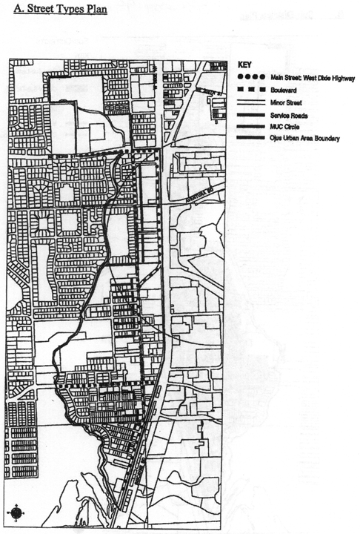

**Street Types Plan**

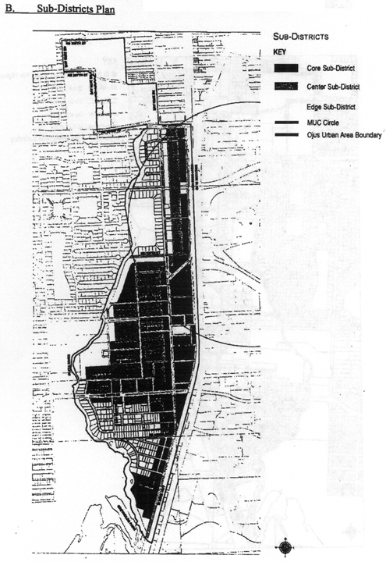

**Sub-Districts Plan**

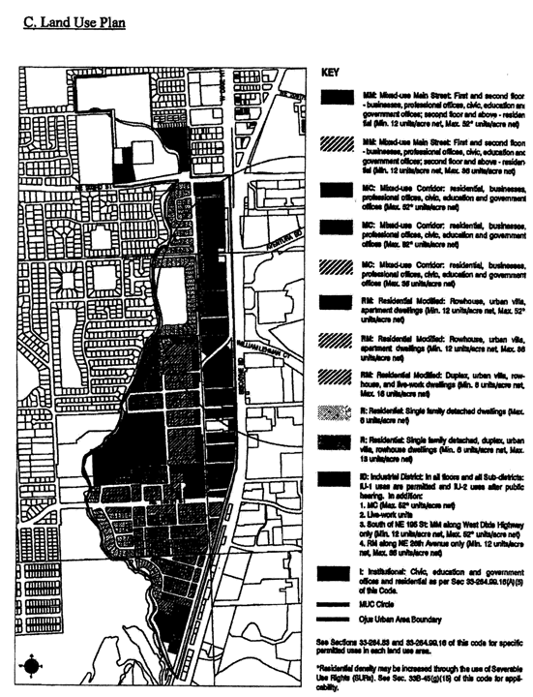

**Land Use Plan**

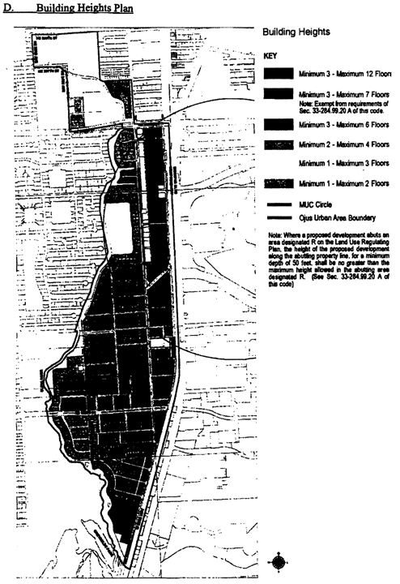

**Building Heights Plan**

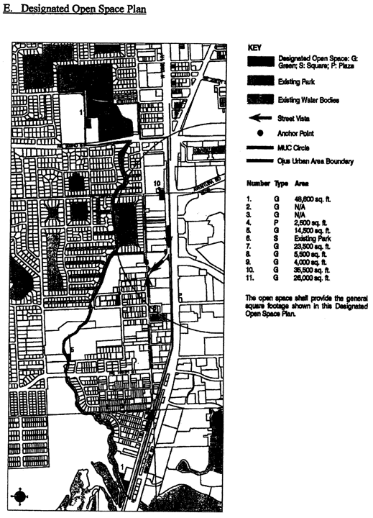

**Designated Open Space Plan**

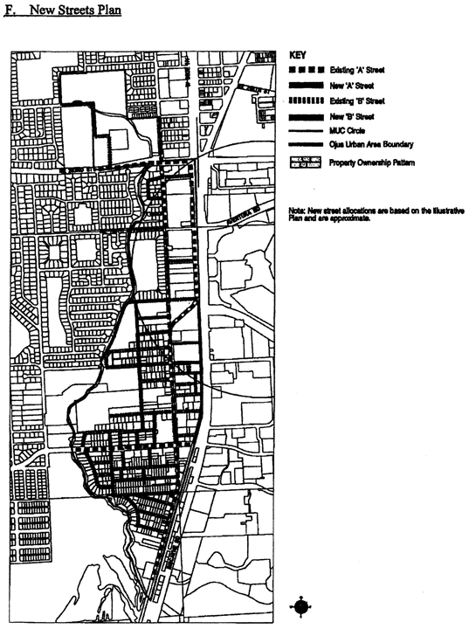

**New Streets Plan**

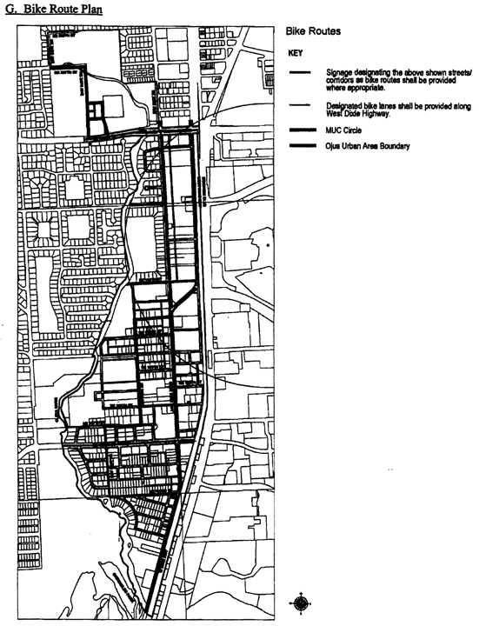

**Bike Route Plan**

(Ord. No. 06-86, § 5, 6-6-06; Ord. No. 07-94, § 3, 7-10-07)

Sec. 33-284.99.19. Building Placement and Street Type Development Parameters.

A. All new development and redevelopment within the OUAD shall comply with the Building Placement and Design Parameters as provided in [Section 33-284.85](../level3/PTIIICOOR_CH33ZO_ARTXXXIII_K_STURCEDIRE.docx#PTIIICOOR_CH33ZO_ARTXXXIII_K_STURCEDIRE_S33-284.85BUPLST) of this code.

B. All new development and redevelopment within the OUAD shall comply with the Street Type Parameters as provided herein:

|  |  |
| --- | --- |
| Street type | Minimum Required Configuration |
| Main Street | As provided herein |
| Boulevard (NE 26th Avenue) | As provided herein |
| Boulevard | As provided in [Section 33-284.85](../level3/PTIIICOOR_CH33ZO_ARTXXXIII_K_STURCEDIRE.docx#PTIIICOOR_CH33ZO_ARTXXXIII_K_STURCEDIRE_S33-284.85BUPLST) |
| Minor Street | As provided herein or in [Section 33-284.85](../level3/PTIIICOOR_CH33ZO_ARTXXXIII_K_STURCEDIRE.docx#PTIIICOOR_CH33ZO_ARTXXXIII_K_STURCEDIRE_S33-284.85BUPLST) |
| Service Road | As provided in [Section 33-284.85](../level3/PTIIICOOR_CH33ZO_ARTXXXIII_K_STURCEDIRE.docx#PTIIICOOR_CH33ZO_ARTXXXIII_K_STURCEDIRE_S33-284.85BUPLST) |
| Pedestrian Passage | As provided in [Section 33-284.85](../level3/PTIIICOOR_CH33ZO_ARTXXXIII_K_STURCEDIRE.docx#PTIIICOOR_CH33ZO_ARTXXXIII_K_STURCEDIRE_S33-284.85BUPLST) |

C. Unless otherwise provided by the Building Placement and Design Parameters in [Section 33-284.85](../level3/PTIIICOOR_CH33ZO_ARTXXXIII_K_STURCEDIRE.docx#PTIIICOOR_CH33ZO_ARTXXXIII_K_STURCEDIRE_S33-284.85BUPLST) of this code, the following front and side street setbacks shall be required for mixed-use/industrial buildings located in areas designated as MM, MC and ID within the OUAD:

|  |  |  |  |
| --- | --- | --- | --- |
| Street Type | Required Setback | | |
|  | Core | Center | Edge |
| Main Street | 0' * or 12' | N/A | N/A |
| Boulevard (NE 26 Avenue) | N/A | 0' or 10' | 10' or 15' |
| Boulevard (Other) | 0' | 0' or 10' | 10' or 15' |
| Minor Street | 0' or 10' | 0' or 10' | 10' Or 15' |
| *Note:* * 12' colonnade required when setback is 0'      ** as provided in [Section 33-284.99.19](../level3/PTIIICOOR_CH33ZO_ARTXXXIII_O_OJURARDI.docx#PTIIICOOR_CH33ZO_ARTXXXIII_O_OJURARDI_S33-284.99.19BUPLSTTYDEPA) of this code      N/A not applicable | | | |

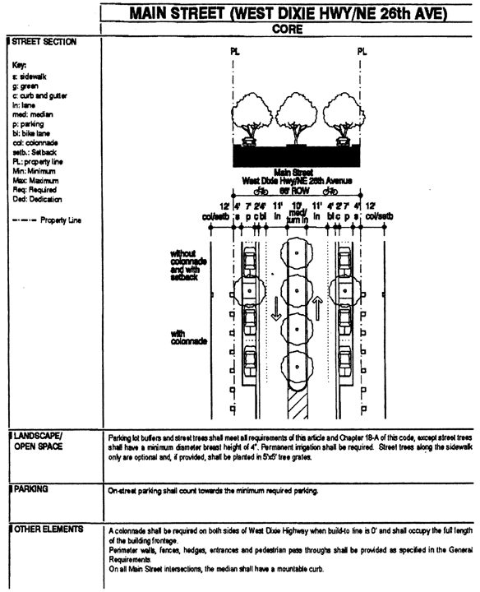

**Main Street (West Dixie Hwy/NE 26th Ave) Core**

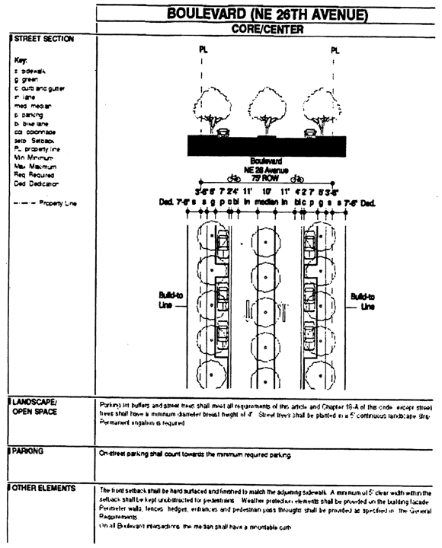

**Boulevard (NE 26th Ave) Core/Center**

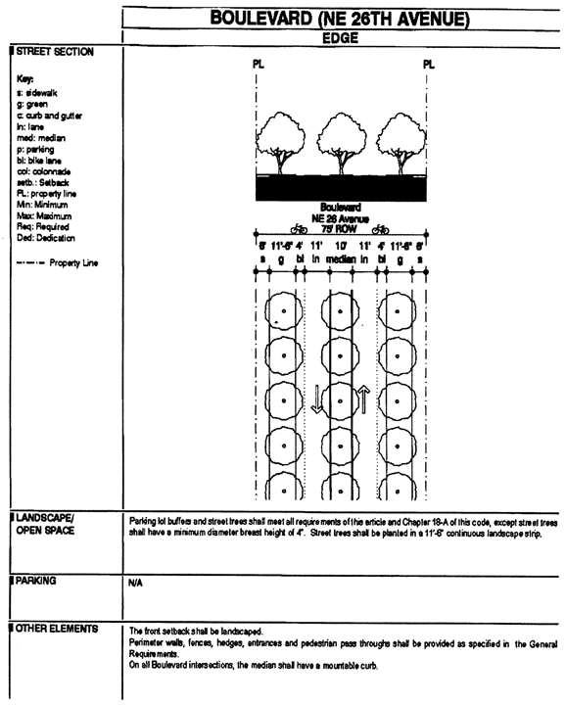

**Boulevard (NE 26th Ave) Edge**

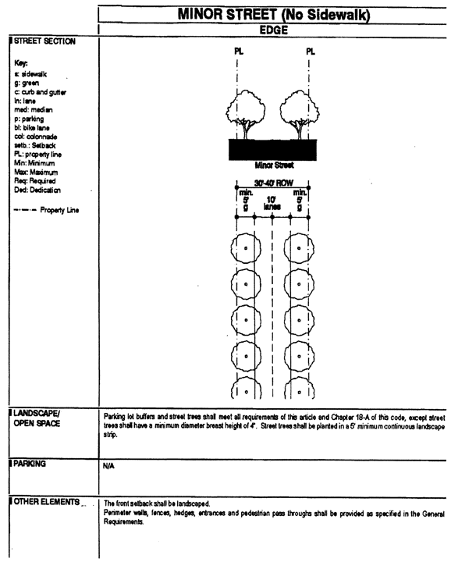

**Minor Street (No Sidewalk) Edge**

(Ord. No. 06-86, § 6, 6-6-06; Ord. No. 07-94, § 4, 7-10-07)

Sec. 33-284.99.20. General Requirements.

In addition to the requirements in [Section 33-284.86](../level3/PTIIICOOR_CH33ZO_ARTXXXIII_K_STURCEDIRE.docx#PTIIICOOR_CH33ZO_ARTXXXIII_K_STURCEDIRE_S33-284.86GERE) of this code, and to retain the character of the development within the OUAD, all new development and redevelopment shall comply with the following:

A. *Heights of Buildings.*

1. Except where exempted as depicted on the Building Heights Plan, where a proposed development abuts an area designated Residential (R) on the Land Use Regulating Plan, the height of the proposed development along the abutting property line, for a minimum depth of 50 feet, shall be no greater than the maximum height allowed in the abutting area designated R. Examples of the required height transition are shown herein.

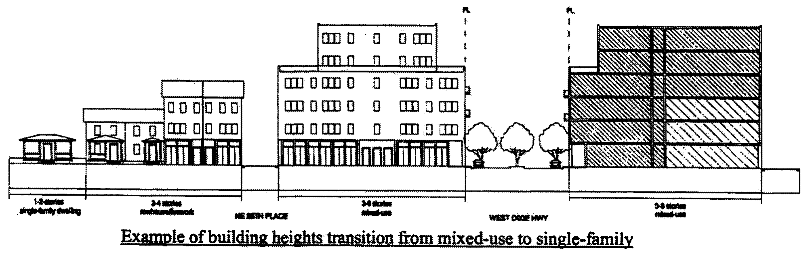

**Example of Building Heights Transition from Mixed-Use to Single-Family**

Each story shall have a maximum height of 16 feet, as measured from floor to floor. Any height above 16 feet shall count as an additional story, except that a single story may have a maximum height of 30 feet, provided that no mezzanine area intended for commercial use exceeds 10 percent and no mezzanine area intended for residential use exceeds 80 percent of the floor area of that story.

B. *Architectural Guidelines.*

To retain the character of the development in the OUAD area and to recognize its architectural history, all new single-family development within the OUAD area shall conform with either the Florida Vernacular or the Mission style as shown in the figures below. Specifically and at a minimum, all new single-family homes within the area shall include each of the required elements, respective to the chosen architectural style, described herein:

|  |  |
| --- | --- |
| Architectural Style | Required elements |
| Florida Vernacular | 1. Side gabled roof with shingles and a slope of 6:12 or 12:12 2. Operable, boarded shutters sized to the window opening 3. Attached front porch |
| Mission | 1. Shaped Mission dormer or roof parapet 2. Arched openings 3. Overhanging eaves with exposed rafters. Additional defining elements are shown in the figures provided herein, and shall be optional. |

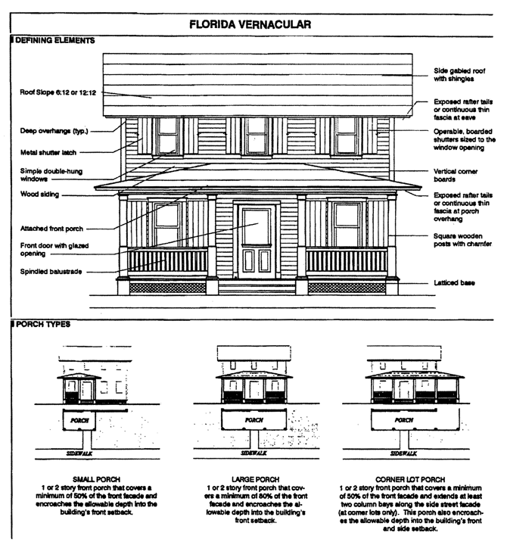

**Florida Vernacular**

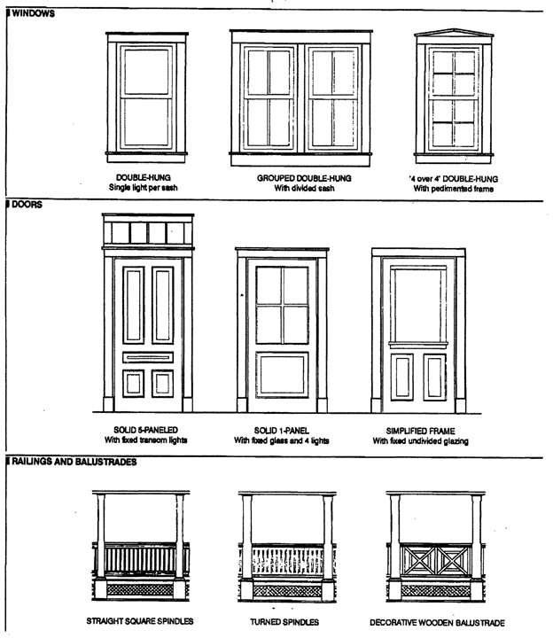

**Florida Vernacular (Windows, Doors, Railings/Balustrades)**

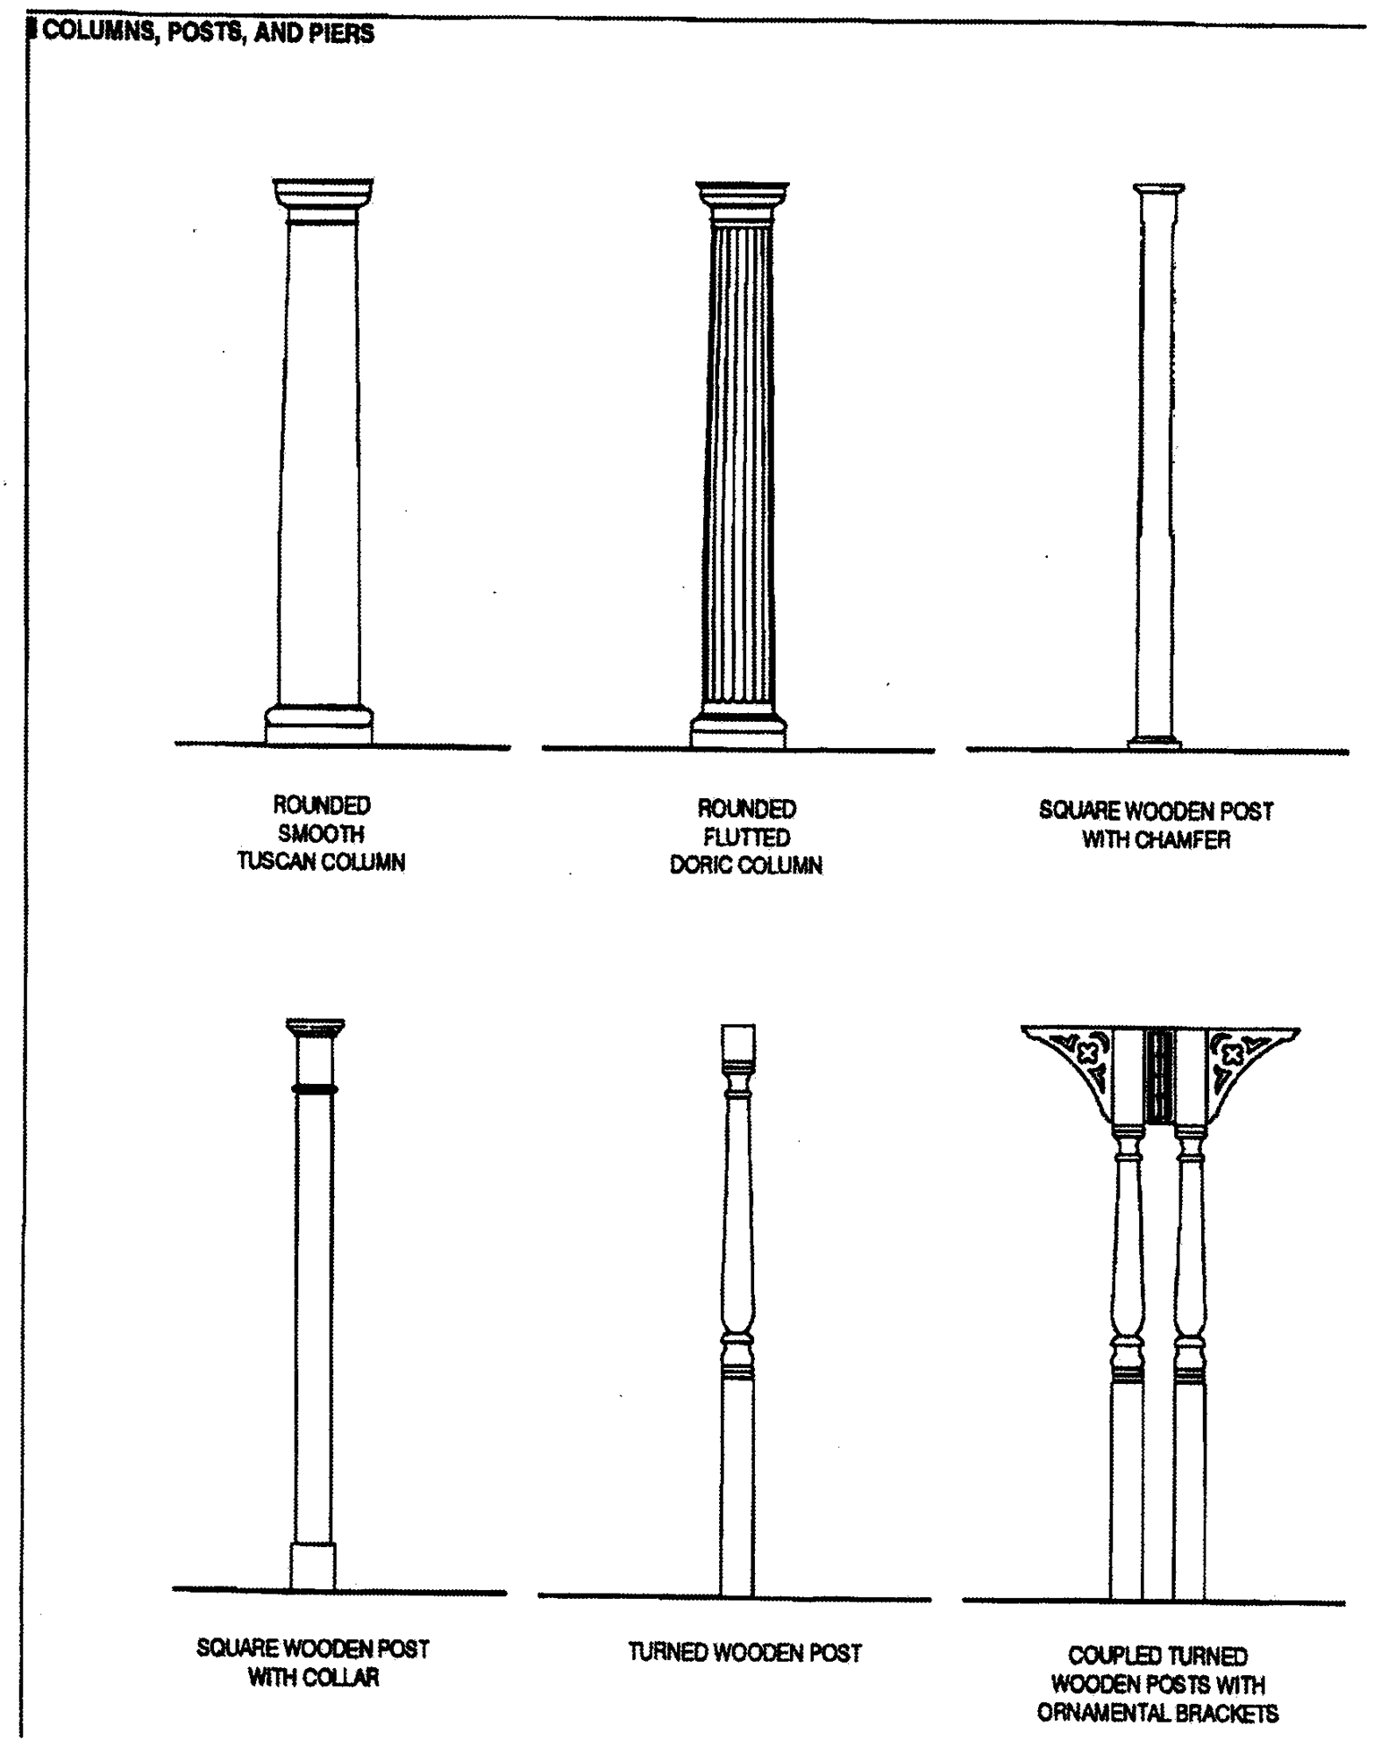

**Florida Vernacular (Columns, Posts, Piers)**

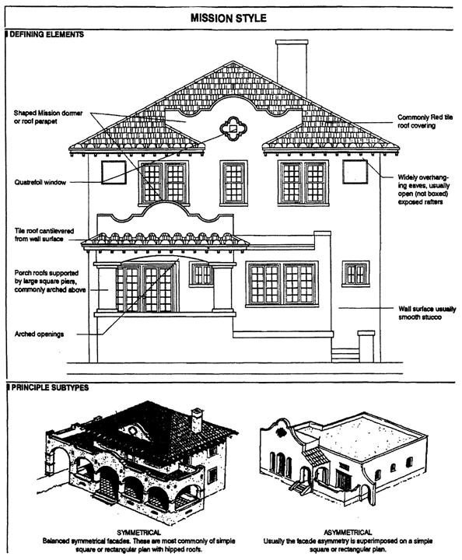

**Mission Style**

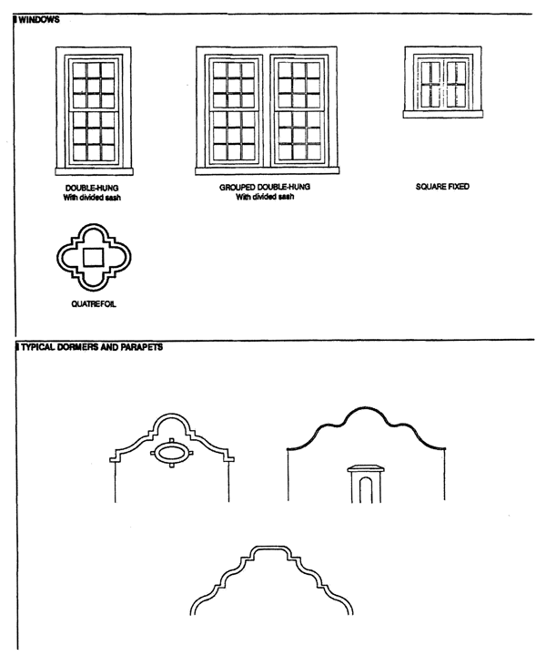

**Mission Style (Windows, Dormers, Parapets)**

(Ord. No. 06-86, § 7, 6-6-06)

Sec. 33-284.99.21. Conflicts with other Chapters and Regulations.

This article shall govern in the event of conflicts with other zoning, subdivision, or landscape regulations of this code, or with the Miami-Dade Department of Public Works Manual of Public Works.

(Ord. No. 06-86, § 8, 6-6-06)

Sec. 33-284.99.22. Non-conforming Structures, Uses, and Occupancies.

Nothing contained in this article shall be deemed or construed to prohibit a continuation of a legal nonconforming structure, use, or occupancy in the OUAD that either (1) was existing as of the date of the district boundary change on the property to OUAD or (2) on or before said date, had received final site plan approval through a public hearing pursuant to this chapter or through administrative site plan review or had a valid building permit. However, any structure, use, or occupancy in the OUAD that is discontinued for a period of at least six months, or is superseded by a lawful structure, use or occupancy permitted under this chapter, or that incurs damage to the roof or structure to an extent of 50 percent or more of its market value, shall be subject to [Section 33-35](../level3/PTIIICOOR_CH33ZO_ARTIINGE.docx#PTIIICOOR_CH33ZO_ARTIINGE_S33-35NOUS)(c) of this code. However, a lawfully existing single-family home use that is discontinued for a period of at least six months or that incurs damage to the roof or structure to an extent of 50 percent or more of its market value, shall not be subject to [Section 33-35](../level3/PTIIICOOR_CH33ZO_ARTIINGE.docx#PTIIICOOR_CH33ZO_ARTIINGE_S33-35NOUS)(c) of this code.

(Ord. No. 06-86, § 9, 6-6-06)

### ARTICLE XXXIII(P). CUTLER RIDGE METROPOLITAN URBAN CENTER DISTRICT (CRMUCD) [52]

Sec. 33-284.99.23. Purpose, intent and applicability.

Sec. 33-284.99.24. Cutler Ridge Metropolitan Urban Center District (CRMUC) Requirements.

Sec. 33-284.99.25. Uses.

Sec. 33-284.99.26. CRMUCD Regulating Plans.

Sec. 33-284.99.27. Building Placement and Street Type Development Parameters.

Sec. 33-284.99.28. General Requirements.

Sec. 33-284.99.29. Conflicts with other Chapters and Regulations.

Sec. 33-284.99.30. Non-conforming Structures, Uses, and Occupancies.

Sec. 33-284.99.31. Reserved.

Sec. 33-284.99.23. Purpose, intent and applicability.

A. The regulations contained in this chapter and [Chapter 18A](../level2/PTIIICOOR_CH18AMIDECOLAOR.docx#PTIIICOOR_CH18AMIDECOLAOR), Landscape Code, Code of Miami-Dade County, Florida, shall apply to this article, except as otherwise added to or modified herein.

B. The Illustrative Master Plan (Figure 1), illustrates the citizens' vision and may be used to interpret this article. Where the Illustrative Master Plan conflicts with the text of this article, the text shall govern.

C. The boundaries shown in Figure 1 that are labeled as 'Miami-Dade County' shall constitute the Cutler Ridge Metropolitan Urban Center Boundary Plan and are generally described as follows: from the intersection of the centerline of the SW 112 Avenue with the centerline of US 1, then south along the centerline of SW 112 Avenue to the north side of the C-1 Canal (Black Creek Canal), then west along the north side of the Black Creek Canal to the west side of the South Miami-Dade Busway, then north along the west side of the South Miami-Dade Busway to the centerline of SW 117 Avenue, then northwest along the centerline of SW 117 Avenue to the centerline of SW 114 Court, then north along the centerline of SW 114 Court to the centerline of SW 203 Terrace, then east along the centerline of SW 203 Terrace to the centerline of SW 112 Court, then south and southeast along the centerline of SW 112 Court to point of beginning.

A more detailed legal description of the boundaries follows:

Beginning at the intersection with the centerline of Black Creek Canal (C-1) and the west line of the Southeast one quarter of Section 7, Township 56 South, Range 40 East, Miami-Dade County Florida lying in SW 112th Avenue (Allapattah Road), thence westerly along the center line of Black Creek Canal (C-1) to the intersection with the East Right-of-Way of South Miami-Dade Bus way; thence north-easterly along the East Right-of-Way of South Miami-Dade Bus way to the intersection with theoretical extension of the Southwest Lot Line of Lot 1, block 12, of South Miami-Heights PB.72-PG.87; thence northwest along the theoretical extension of the Southwest Lot Line of Lot 1, block 12, of South Miami Heights PB.72-PG.87 to the intersection with the West Property Line of Lot 1 (SW Cor. of lot 1) Block 12, of South Miami Heights PB.72-PG.87; thence northeast along the West lot line of lot 1, block 12, South Miami Heights, PB.72-PG.87 to the intersection of the East Boundary Line of block 12, South Miami Heights PB.72-PG87; thence north along said Boundary Line to the intersection of the West Lot Line of Lot H of the Re-Subdivision of Cutler Gate PB.70-PG.100; then northeast along Lot Lines H, G, F, E of Re-Subdivision of Cutler Gate PB.70-PG.100 and Lot Lines 1 through 7, block 5, and Lot Lines 1 & 2 block 4, of Cutler Gate PB.64-PG.77 to the intersection with the East Right-of-Way Line of SW 113 Road; thence northwesterly along the East Right-of-Way of SW 113 Road to a point on the West Right-of-Way of SW 114 Ave; thence south on the West Right-of-Way of SW 114 Ave. to the intersection of the North Lot Line of lot 15, block 1, of Cutler Gate PB.64 — PG.77; thence northwest along the North lot line of said lot 15, block 1 to the intersection with the East boundary line of block 12, of South Miami Heights PB.72-PG.87; thence north along the East boundary line of said block 12 to the intersection of the North boundary line of Tr.A and Tr.B of Old Cutler Ridge Crossing PB.148-PG.90; thence east along the North Boundary line of TR.A and TR.B. to the intersection with the East Boundary line of TR. B. of Old Cutler Crossing, plat book 148 at page 90; thence south along the East Boundary line of TR.B of Old Cutler Crossing plat book 148 at page 90 and a Southerly prolongation of the East Boundary line of TR.B. with the West line of the Northeast one quarter of Section 7 and the West line of the Southeast one quarter (SW 112 Avenue Allapattah Road) to the point of beginning.

Full scale maps of the Illustrative Master Plan presented in Figure 1, as well as all the Regulating Plans and Street Development Parameters figures in this article, are on file with the Miami-Dade Department of Planning and Zoning.

D. No provision in this article shall be applicable to any property lying outside the boundaries of the Cutler Ridge Metropolitan Urban Center District (CRMUC) as described herein. No property lying within the boundaries of the CRMUC shall be entitled to the uses or subject to the regulations provided in this article until an application for a district boundary change to CRMUC has been heard and approved in accordance with the provisions of this chapter.

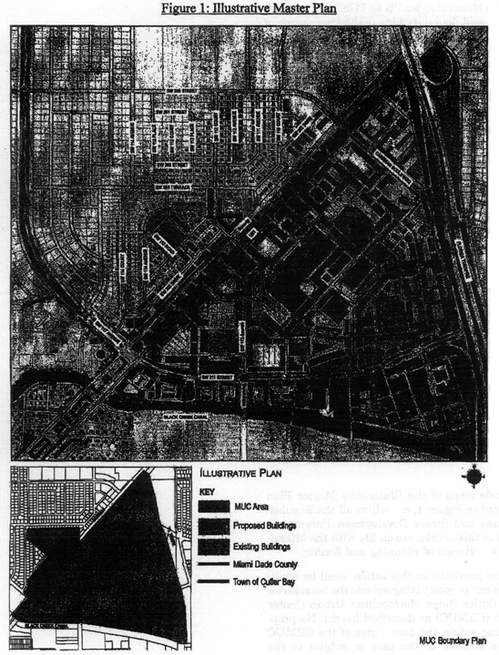

**Figure 1: Illustrative Master Plan**

(Ord. No. 06-152, § 1, 10-10-06)

Sec. 33-284.99.24. Cutler Ridge Metropolitan Urban Center District (CRMUC) Requirements.

Except as provided herein, all developments within the CRMUC shall comply with the requirements provided in Article XXXIII(K). Standard Urban Center District Regulations, of this code.

(Ord. No. 06-152, § 2, 10-10-06)

Sec. 33-284.99.25. Uses.

Except as provided herein, all permitted, conditionally permitted, and temporary uses within the CRMUC shall comply with [Section 33-284.83](../level3/PTIIICOOR_CH33ZO_ARTXXXIII_K_STURCEDIRE.docx#PTIIICOOR_CH33ZO_ARTXXXIII_K_STURCEDIRE_S33-284.83US) of this code.

A. *Permitted Uses.* The following uses shall be permitted in areas designated Industrial (ID).

1. In addition to all uses permitted in the Industrial area under Section 33.284.83, all uses permitted in the Mixed-Use Corridor (MC).

B. *Conditionally Permitted Uses.* In addition to the conditionally permitted uses in [Section 33-284.83](../level3/PTIIICOOR_CH33ZO_ARTXXXIII_K_STURCEDIRE.docx#PTIIICOOR_CH33ZO_ARTXXXIII_K_STURCEDIRE_S33-284.83US)(B) of this Code, the following conditional use shall be permitted subject to the administrative approval of a site plan, pursuant to [Section 33-284.88](../level3/PTIIICOOR_CH33ZO_ARTXXXIII_K_STURCEDIRE.docx#PTIIICOOR_CH33ZO_ARTXXXIII_K_STURCEDIRE_S33-284.88REPRADSIPLARRE) of this code, to assure compliance with the requirements established herein:

1. Automobile new sales agency shall be permitted only upon approval after public hearing, provided that the following conditions are also satisfied:

a. The building shall comply with the Building Placement and Street Type Development Parameters and the General Requirements in Section 33-284.85-86 of this Code and as established by the land use and sub-districts regulating plans provided in [Section 33-284.99.17](../level3/PTIIICOOR_CH33ZO_ARTXXXIII_O_OJURARDI.docx#PTIIICOOR_CH33ZO_ARTXXXIII_O_OJURARDI_S33-284.99.17US) of this code.

b. All outdoor paging or speaker systems shall be prohibited.

c. Repair work of any type shall not be permitted on premises unless approved after public hearing and maintained within an enclosed building and screened from the street.

d. The applicant shall obtain a certificate of use and occupancy, which shall be automatically renewable yearly upon compliance with all applicable terms and conditions.

(Ord. No. 06-152, § 3, 10-10-06)

Sec. 33-284.99.26. CRMUCD Regulating Plans.

The Regulating Plans consist of the following controlling plans, as defined and graphically depicted in this section.

• The Street Types Plan, which establishes a hierarchy of street types in existing and future locations. The five Street Types and the hierarchy of streets (from most important to least important in accommodating all types of activity) are U.S. 1, Main Street, Boulevard, Minor Street, and Service Road.

• The Sub-districts Plan, which delineates 3 Sub-districts: Core, Center and Edge. These Sub-districts shall regulate the allowable intensity of development in accordance with the Comprehensive Development Master Plan and this article.

• The Land Use Frontage Plan, which delineates the areas where specified land uses and development of various types and intensities shall be permitted.

• The Building Heights Plan, which establishes the minimum and maximum allowable number of stories.

• The Designated Open Space Plan, which designates open spaces. The designated open spaces shall be controlled by anchor points.

• The New Streets Plan, which shows the location and the number of new streets needed to create the prescribed network of streets within each Urban Center District. All new A streets shall be required in the same general location as shown on the New Streets Plan. All B streets shall be located as provided in [Section 33-284.86](../level3/PTIIICOOR_CH33ZO_ARTXXXIII_K_STURCEDIRE.docx#PTIIICOOR_CH33ZO_ARTXXXIII_K_STURCEDIRE_S33-284.86GERE)(F) of this code.

• The Bike Route Plan, which depicts the designated bike routes, including the bike facility requirements, if any, which shall be shown in all development plans.

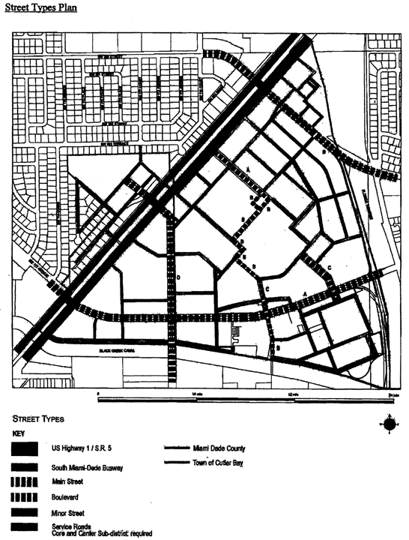

**Street Types Plan**

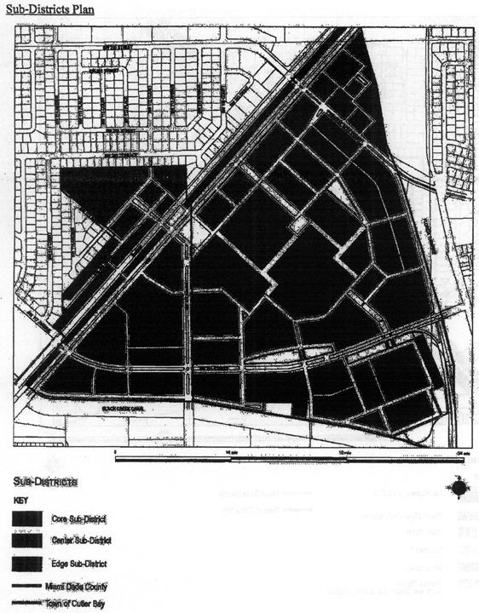

**Sub-Districts Plan**

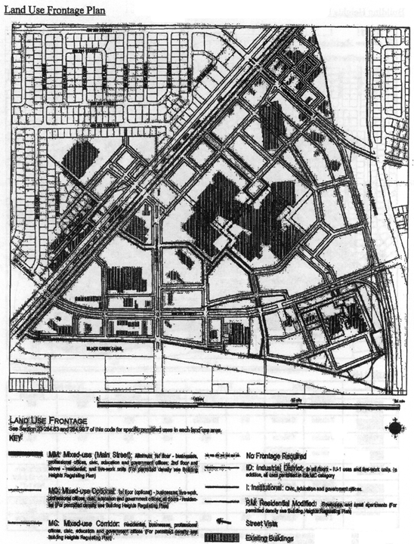

**Land Use Frontage Plan**

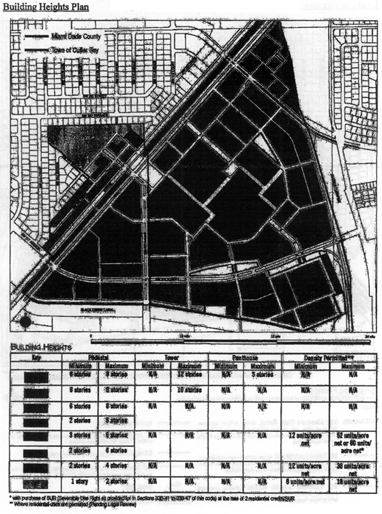

**Building Heights Plan**

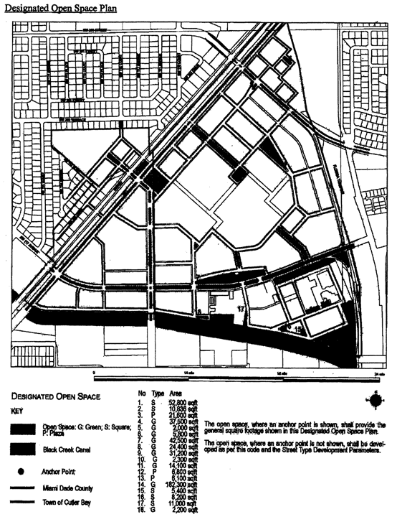

**Designated Open Space Plan**

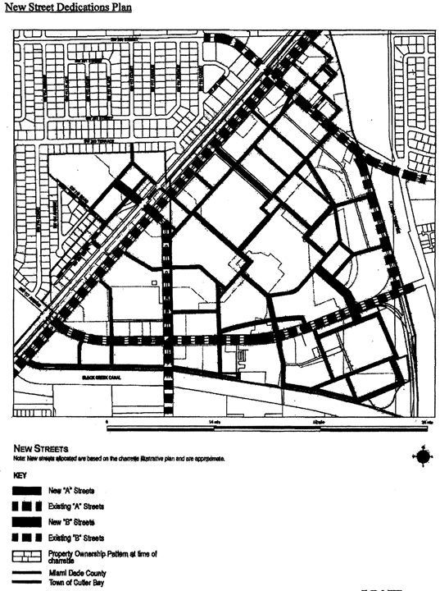

**New Street Dedications Plan**

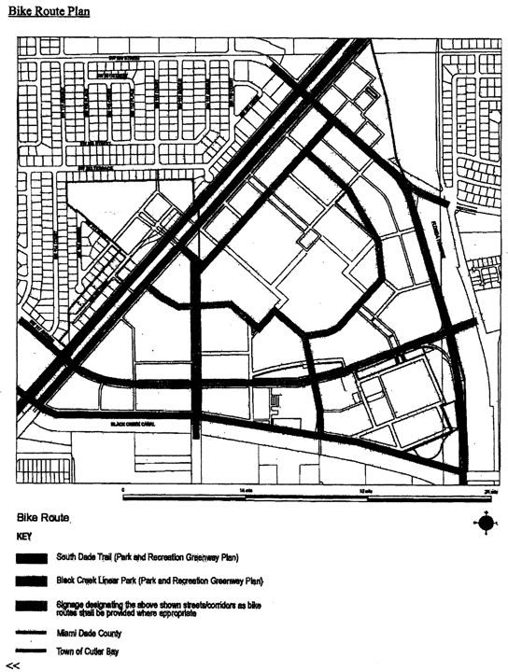

**Bike Route Plan**

(Ord. No. 06-152, § 4, 10-10-06)

Sec. 33-284.99.27. Building Placement and Street Type Development Parameters.

A. All new development and redevelopment within the CRMUC shall comply with the Building Placement and Design Parameters as provided in [Section 33-284.85](../level3/PTIIICOOR_CH33ZO_ARTXXXIII_K_STURCEDIRE.docx#PTIIICOOR_CH33ZO_ARTXXXIII_K_STURCEDIRE_S33-284.85BUPLST) of this code, except that the properties between the South Miami-Dade Busway and U.S.1, shall be exempt from the minimum frontage requirements. In addition, for properties between the South Miami-Dade Busway and U.S.1, parking shall be accessed from U.S.1, and the vehicular entry way shall be a maximum of 33 feet.

B. All new development and redevelopment within the CRMUC shall comply with the Street Types Parameters as provided herein:

|  |  |  |
| --- | --- | --- |
| Street type | Minimum Required Configuration | |
|  | Core/Center | Edge |
| U.S. 1 | As provided in this section | |
| Main Street | As provided in this section | |
| Boulevard | As provided in this section | |
| Minor Street | As provided in Section 33-284-85 | |
| Service Road | As provided in [Section 33-284.85](../level3/PTIIICOOR_CH33ZO_ARTXXXIII_K_STURCEDIRE.docx#PTIIICOOR_CH33ZO_ARTXXXIII_K_STURCEDIRE_S33-284.85BUPLST) | |
| Pedestrian Passage | As provided in [Section 33-284.85](../level3/PTIIICOOR_CH33ZO_ARTXXXIII_K_STURCEDIRE.docx#PTIIICOOR_CH33ZO_ARTXXXIII_K_STURCEDIRE_S33-284.85BUPLST) | |

C. Unless otherwise provided by the Building Placement and Design Parameters in [Section 33-284.85](../level3/PTIIICOOR_CH33ZO_ARTXXXIII_K_STURCEDIRE.docx#PTIIICOOR_CH33ZO_ARTXXXIII_K_STURCEDIRE_S33-284.85BUPLST) of this code, the following front and side street setbacks shall be required for MM, MO, MC, and ID uses within the CRMUC:

|  |  |  |  |
| --- | --- | --- | --- |
| Frontage Table | | | |
| Street type | Required Setback | | |
|  | Core | Center | Edge |
| U.S. 1 | 0 feet | 0 or 10 feet | 0 or 10 feet |
| Main Street | 0 feet * | 0 feet * | N/A |
| Boulevard | N/A | 0 or 10 feet | 0 or 10 feet |
| Minor Street | 0 feet | 0 or 10 feet | 0 or 10 feet |

* Colonnade Required 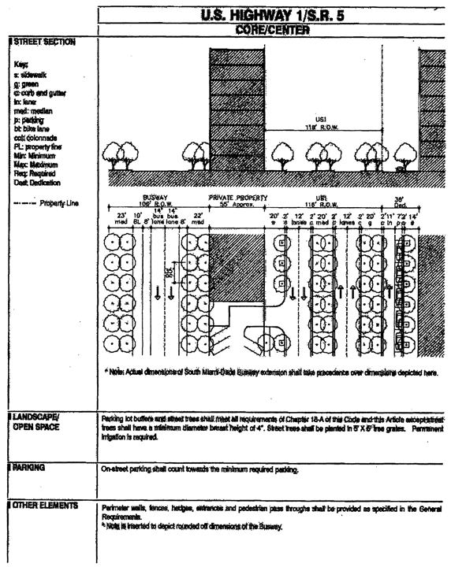

**U.S. Highway 1/S.R. 5 Core/Center**

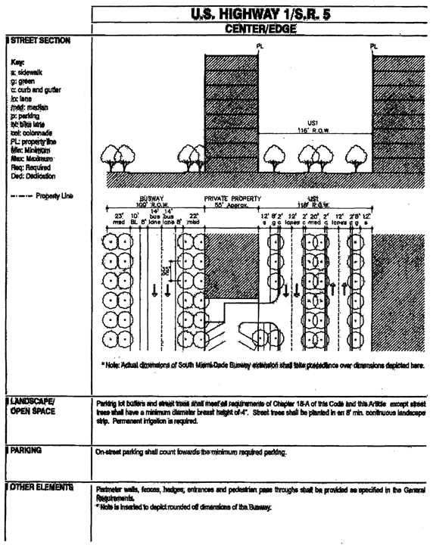

**U.S. Highway 1/S.R. 5 Center/Edge**

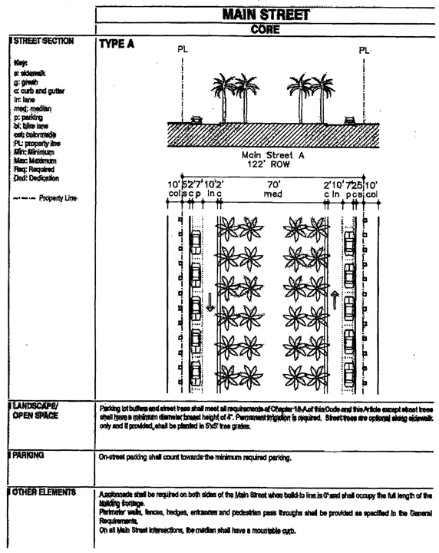

**Main Street Core**

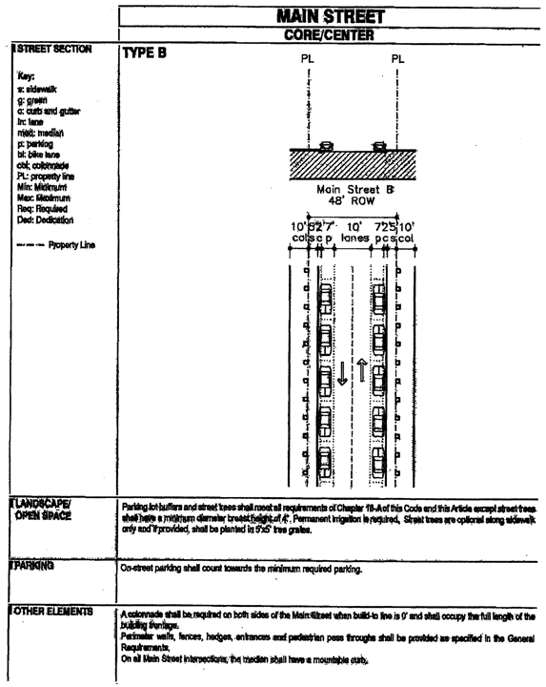

**Main Street Core/Center**

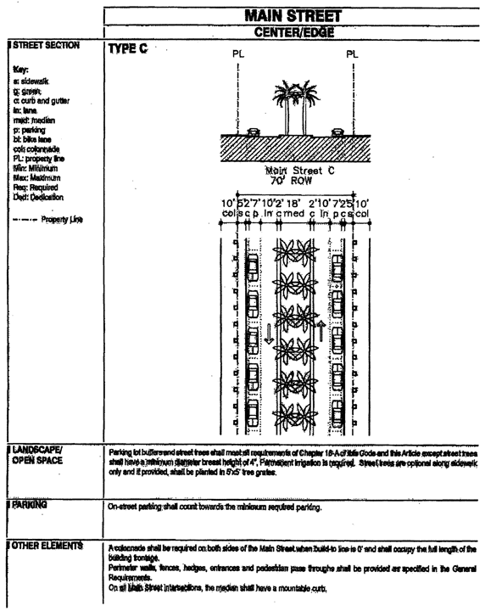

**Main Street Center/Edge**

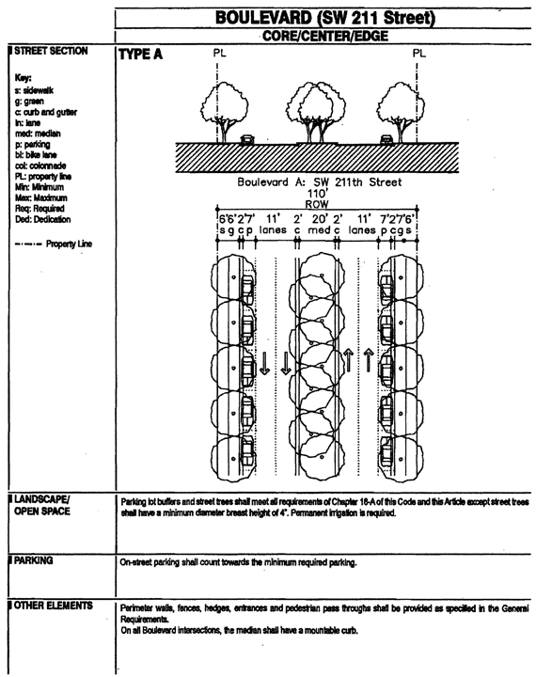

**Boulevard (SW 211 Street) Core/Center/Edge**

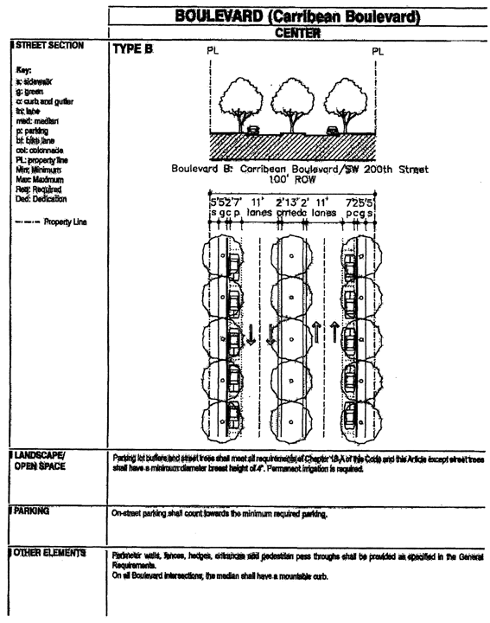

**Boulevard (Carribean Boulevard) Center**

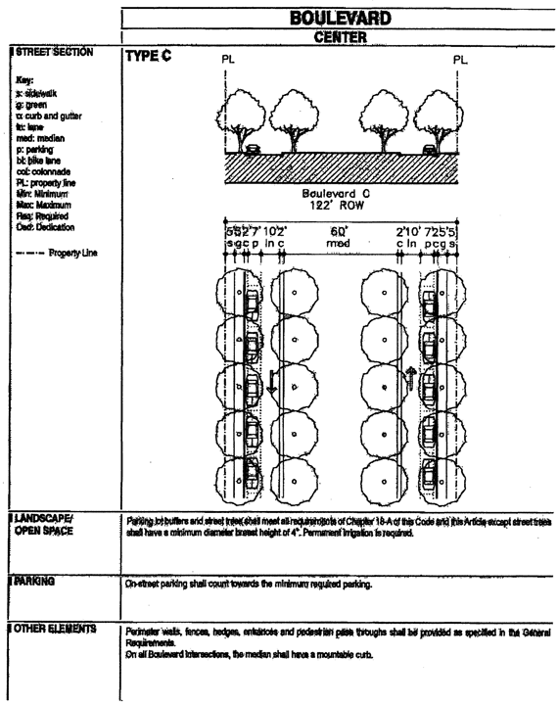

**Boulevard Center**

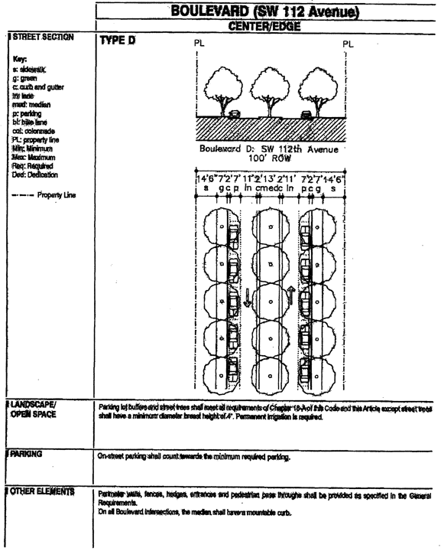

**Boulevard (SW 112 Avenue) Center/Edge**

(Ord. No. 06-152, § 5, 10-10-06)

Sec. 33-284.99.28. General Requirements.

Except as provided herein, all developments within the CRMUC shall comply with the requirements provided in [Section 33-284.86](../level3/PTIIICOOR_CH33ZO_ARTXXXIII_K_STURCEDIRE.docx#PTIIICOOR_CH33ZO_ARTXXXIII_K_STURCEDIRE_S33-284.86GERE) of this code.

A. *Buildings.* In addition to the requirements of [Section 33-284.86](../level3/PTIIICOOR_CH33ZO_ARTXXXIII_K_STURCEDIRE.docx#PTIIICOOR_CH33ZO_ARTXXXIII_K_STURCEDIRE_S33-284.86GERE) of this Code, all buildings within the CRMUC shall comply with the following requirements:

1) Where colonnades are provided, the colonnade shall be placed along the property line.

2) Minimum spacing between towers within any one contiguous property line shall be 60 feet.

3) Aggregate tower frontage facing any street may not exceed 225 feet per block or 70 percent of street frontage; whichever is greater.

4) Vehicular entry gates at garage entries shall be positioned a minimum of 20 feet behind the front wall of the building. At colonnaded frontages, this distance shall be measured from the interior/rear wall of the colonnade. To increase safety during off-hours, the setback area between the entry gate and the public sidewalk may be gated at the sidewalk edge during times when the garage is closed.

5) Drop off drives and porte-cocheres may only occur in the rear, on the side, and/or along service roads.

6) Loading and service entries shall be allowed only in the rear along service roads and/or within parking lots and structures.

7) Vehicular entries to garages shall be allowed only from service roads and/or minor streets. Along minor streets, vehicular entries shall have a maximum width of 33 feet and a minimum separation of 70 feet between entries. Along service roads, vehicular entries shall not be limited.

8) The penthouse shall occur above the tower level and shall be limited to 50 percent of the largest tower floorplate.

9) A cornice line shall be required at the top of the third story of MM, MO, MC, and ID buildings, as provided in [Section 33-284.86](../level3/PTIIICOOR_CH33ZO_ARTXXXIII_K_STURCEDIRE.docx#PTIIICOOR_CH33ZO_ARTXXXIII_K_STURCEDIRE_S33-284.86GERE) of this code.

(Ord. No. 06-152, § 6, 10-10-06)

Sec. 33-284.99.29. Conflicts with other Chapters and Regulations.

This article shall govern in the event of conflicts with other zoning, subdivision, or landscape regulations of this code, or with the Miami-Dade Department of Public Works Manual of Public Works.

(Ord. No. 06-152, § 7, 10-10-06)

Sec. 33-284.99.30. Non-conforming Structures, Uses, and Occupancies.

All legal nonconforming structures, uses, and occupancies in the CRMUC that either (1) were existing as of the date of the district boundary change on the property to CRMUC or (2) on or before said date, had received final site plan approval or had a valid building permit, shall be exempt from the provisions of [Section 33-35](../level3/PTIIICOOR_CH33ZO_ARTIINGE.docx#PTIIICOOR_CH33ZO_ARTIINGE_S33-35NOUS)(c) of this Code upon compliance with the requirements of this section for a period of 10 years from the date of the district boundary change on the property to CRMUC. Such nonconforming structures shall be allowed to be rebuilt and such uses and occupancies resumed in compliance with plans of record and certificates of use and occupancy approved as of the date of the district boundary change on the property to CRMUC. Such structures, uses and occupancies shall be in compliance with all other provisions of this Code in effect at the time of the application to rebuild or resume occupancy. Building permits for rebuilding pursuant to this section shall be obtained within one year after the date of damage or destruction of the nonconforming structure. If the building permits necessary to rebuild a nonconforming structure have not been obtained within one year after the date of damage or destruction, or if such permits expire or are revoked after that year has concluded, the structure shall be subject to the provisions of [Section 33-35](../level3/PTIIICOOR_CH33ZO_ARTIINGE.docx#PTIIICOOR_CH33ZO_ARTIINGE_S33-35NOUS)(c).

(Ord. No. 06-152, § 8, 10-10-06)

Sec. 33-284.99.31. Reserved.

FOOTNOTE(S):

--- (**52**) ---

**Editor's note—** Ord. No. 06-152, adopted Oct. 10, 2006, enacted provisions designated as art. XXXIII(O). Inasmuch as there already exists an article so numbered, said provisions have been redesignated as art. XXXIII(P), to avoid duplication, at the discretion of the editor. (Back)

### ARTICLE XXXIII(Q). LEISURE CITY COMMUNITY URBAN CENTER DISTRICT (LCUC)

Sec. 33-284.99.32. Purpose, intent and applicability.

Sec. 33-284.99.33. Leisure City Community Urban Center (LCUC) district requirements.

Sec. 33-284.99.34. Uses.

Sec. 33-284.99.35. LCUC Regulating Plans.

Sec. 33-284.99.36. Building placement and street type development parameters.

Sec. 33-284.99.37. Conflicts with other chapters and regulations.

Sec. 33-284.99.38. Nonconforming structures, uses, and occupancies.

Sec. 33-284.99.39. Reserved.

Sec. 33-284.99.32. Purpose, intent and applicability.

A. The regulations contained in this chapter and [Chapter 18A](../level2/PTIIICOOR_CH18AMIDECOLAOR.docx#PTIIICOOR_CH18AMIDECOLAOR), Landscape Code, Code of Miami-Dade County, Florida, shall apply to this article, except as otherwise added to or modified herein.

B. The Illustrative Master Plan (Figure 1) illustrates the citizens' vision and may be used to interpret this article. Where the Illustrative Master Plan conflicts with the text of this article, the text shall govern.

C. Figure 1 also shows the boundaries of the Leisure City Community Urban Center (CUC) District as well as the boundaries of the Designated Urban Center. As provided in the Standard Urban Center District Regulations, the Workforce Housing requirement shall apply to the area included within the Designated Urban Center boundaries. These boundaries shall be described as follows:

1. *Leisure City Community Urban Center (CUC) District:*

A Portion of section 4 and 5, Township 57 South Range 39 East and a portion of [Section 33](../level2/PTIIICOOR_CH33ZO.docx#PTIIICOOR_CH33ZO), Township 56 South, Range 39 East, Miami-Dade County, Florida, Being more particularly described as follows:

BEGIN at the intersection with the Center line of SW 296 Street (the South line of the Southeast 1/4 of said Section 5, Township 57 south, Range 39 East) and the Easterly Right-of-Way line of the South Dade Transportation Corridor (Busway) as shown on the Florida Department of Transportation Right-of-Way Map as recorded in Plat Book 124 Page 76 of the Public Records of said Miami-Dade-County; thence Northeasterly along said Easterly Right-of-Way line of the South Dade Transportation Corridor (Busway) to the intersection with the Northwest corner of Lot 4, Block 1, of NARANJA ASSOC. as recorded in Plat Book 111 Page 57 of the Public Records of said Miami-Dade County; thence Southeasterly along the North Line of said Lot 4 to the Northeast corner of said lot 4 lying on the Northwesterly Right Of Way Line of State Road 5 (US-1); thence Southeasterly across State Road 5 (US-1) to the intersection with the Southeasterly Right Of Way Line of said State Road 5 (US 1), said point of intersection being the Northwest corner of Tract 1, NARANJA LAKES SECTION ONE, as recorded in Plat Book 91 Page 7 of the Public Records of said Miami-Dade County; thence Southeasterly, Northeasterly and Southeasterly along the Northerly Lines of Tracts 1 and 2, of said NARANJA LAKES SECTION ONE, also being the Southerly Right Of Way Line Of Canal C-103N, to the intersection with the East line of said [Section 33](../level2/PTIIICOOR_CH33ZO.docx#PTIIICOOR_CH33ZO), Township 56 South, Range 39 East (also being the center line of theoretical SW 147 Avenue); thence Southerly along the East line of said [Section 33](../level2/PTIIICOOR_CH33ZO.docx#PTIIICOOR_CH33ZO) Township 56 South Range 39 East (also being the center line of theoretical SW 147 Avenue) to the Southeast corner of Tract 3, of said NARANJA LAKES SECTION ONE; thence Westerly along the South line of said Tract 3 to the intersection with the East line of Tract "E", of NARANJA LAKES SHOPPING PLAZA 1st ADDITION as recorded in Plat Book 128, Page 4 of the Public Records of said Miami-Dade County; thence Southwesterly along the East line of said Tract "E" and along the East line of Tract "D", of NARANJA LAKES SHOPPING PLAZA as recorded in Plat Book 120, Page 59 of the Public Records of said Miami-Dade County, to the Southeast corner of said Tract "D" and the North Right-of-Way line of Naranja Lake Boulevard as shown on said NARANJA LAKES SHOPPING PLAZA; thence Southwesterly across Naranja Lakes Boulevard to the Northeast corner of Tract 11 of NARANJA LAKES SECTION ONE as recorded in Plat book 91, Page 7 of the Public Records of said Miami-Dade County; thence Southerly along the East line of said Tract 11 to the Southeast corner of Tract 11; thence Northwesterly along the South line of said Tract 11 to the Southwest corner of said Tract 11; thence Northeasterly along the west line of Tract 11 to the Southeast corner of Tract 7 of said NARANJA LAKES SECTION ONE; thence Northwesterly along the South line of said Tract 7 to the Northeast corner of Tract "C" of NARANJA LAKES TRACTS as recorded in Plat Book 104, Page 15 of the Public Records of said Miami-Dade County; thence Southwesterly along the East line of Tracts "C" and "B" of said NARANJA LAKES TRACTS to the southeast corner of said TRACT "B"; thence continue Southwesterly Southeasterly and Southerly along the Easterly lines of Tract "A" of said NARANJA LAKES TRACTS to the Southeast corner of said Tract "A"; thence Westerly along the South line and the Westerly extension of the South line of Tract "A" to the intersection with the West line of the Southeast 1/4 of [Section 33](../level2/PTIIICOOR_CH33ZO.docx#PTIIICOOR_CH33ZO) Township 56 South Range 39 East (also being the center line of SW 152 Avenue); thence Southerly along West line of said Southeast 1/4 of said [Section 33](../level2/PTIIICOOR_CH33ZO.docx#PTIIICOOR_CH33ZO) (also being the center line of SW 152 Avenue) to the Southwest corner of the Southeast 1/4 of said [Section 33](../level2/PTIIICOOR_CH33ZO.docx#PTIIICOOR_CH33ZO) (also being the centerline of SW 280 Street); thence Easterly along the South line to of the Southeast 1/4 of said [Section 33](../level2/PTIIICOOR_CH33ZO.docx#PTIIICOOR_CH33ZO) (also being the center line of SW 280 Street) to the Southeast corner of the Southeast 1/4 of said [Section 33](../level2/PTIIICOOR_CH33ZO.docx#PTIIICOOR_CH33ZO) (also being the center line of SW 147 Avenue); thence Southerly along the East line of said Section 4 Township 57 South Range 39 East (also being the center line of SW 147 Avenue) to the intersection with the North line of the Southeast 1/4 of the Northeast 1/4 of said Section 4 (also being the center line of SW 284 Street); thence Westerly along the North line of Southeast 1/4 of the Northeast 1/4 of said Section 4 (also being the center line of SW 284 Street) to the intersection with West line of the Southeast 1/4 of the Northeast 1/4 of said Section 4 (also being the theoretical center line of SW 149 Avenue); thence Southerly along the West line of the Southeast 1/4 of the Northeast 1/4 of said Section 4 (also being the theoretical center line of SW 149 Avenue) to the intersection with the South line of the North 1/2 of said Section 4 (also being the center line of SW 288 Street); thence Westerly along the South line of the North 1/2 of said Section 4 and along the South line of the N 1/2 said Section 5, Township 57 South, Range 39 East (also being the center line of SW 288 Street) to the East line of said Section 5 (also being the center line of SW 157 Avenue); thence Southerly along the East line of said Section 5 (also being the center line of SW 157 Avenue) to the intersection with the South line of said Section 5 (also being the center line of SW 296 Street); thence Westerly along the South line of section 5, Township 57 South, Range 39 East (also being the center line of 296 Street) to the POINT OF BEGINNING.

2. *Designated Urban Center:*

A Portion of Sections 4 and 5, Township 57 South Range 39 East and a portion of [Section 33](../level2/PTIIICOOR_CH33ZO.docx#PTIIICOOR_CH33ZO), Township 56 South, Range 39 East, Miami-Dade County, Florida, being more particularly described as follows:

BEGIN at the intersection of the Center line of SW 288 Street (the South line of the Northeast 1/4 of said Section 5, Township 57 South, Range 39 East) and the Easterly Right-of-Way line of the South Dade Transportation Corridor (Busway) as shown on the Florida Department of Transportation Right-of-Way Map as recorded in Plat Book 124 Page 76 of the Public Records of said Miami-Dade-County; thence Northeasterly along said Easterly Right-of-Way line of the South Dade Transportation Corridor (Busway) to the Northwest corner of Lot 4, Block 1, of NARANJA ASSOC. as recorded in Plat Book 111, Page 57 of the Public Records of said Miami-Dade County; thence Southeasterly along the North line of said Lot 4 to the Northeast corner of said Lot 4 lying on the Northwesterly Right Of Way Line of State Road 5 (US-1); thence Southeasterly across State Road 5 (US-1) to the intersection with the Southeasterly Right Of Way Line of said State Road 5 (US 1), said point of intersection being the Northwest corner of Tract 1, NARANJA LAKES SECTION ONE, as recorded in Plat Book 91, Page 7 of the Public Records of said Miami-Dade County; thence Southeasterly, Northeasterly and Southeasterly along the Northerly lines of Tracts 1 and 2 of said NARANJA LAKES SECTION ONE, also being the Southerly Right Of Way Line of Canal C-103N, to the intersection with the East line of said [Section 33](../level2/PTIIICOOR_CH33ZO.docx#PTIIICOOR_CH33ZO), Township 56 South, Range 39 East, (also being the center line of theoretical SW 147 Avenue); thence Southerly along the East line of said [Section 33](../level2/PTIIICOOR_CH33ZO.docx#PTIIICOOR_CH33ZO) (also being the center line of theoretical SW 147 Avenue) to the Southeast corner of Tract 3, of said NARANJA LAKES SECTION ONE; thence Westerly along the South line of said Tract 3 to the intersection with the East line of Tract "E" of NARANJA LAKES SHOPPING PLAZA 1st ADDITION as recorded in Plat Book 128, Page 4 of the Public Records of said Miami-Dade County; thence Southwesterly along the East line of said Tract "E" and along the East line of Tract "D", of NARANJA LAKES SHOPPING PLAZA as recorded in Plat Book 120, Page 59 of the Public Records of said Miami-Dade County, to the Southeast corner of said Tract "D" and the North Right-of-Way line of Naranja Lakes Boulevard as shown on said NARANJA LAKES SHOPPING PLAZA; thence Southwesterly across Naranja Lakes Boulevard to the Northeast corner of Tract 11 of NARANJA LAKES SECTION ONE as recorded in Plat book 91, Page 7 of the Public Records of said Miami-Dade County; thence Southerly along the East line of said Tract 11 to the Southeast corner of said Tract 11; Thence Northwesterly along the South line of said Tract 11 to the Southwest corner of said Tract 11; Thence Northeasterly along the west line of said Tract 11 to the Southeast corner of Tract 7 of said NARANJA LAKES SECTION ONE: thence Northwesterly along the South line of said Tract 7 to the Northeast corner of Tract "C" of NARANJA LAKES TRACTS as recorded in Plat Book 104, Page 15 of the Public Records of said Miami-Dade County; thence Southwesterly along the East line of Tracts "C", and "B" of said NARANJA LAKES TRACTS to the southeast corner of said TRACT "B"; thence continue Southwesterly Southeasterly and Southerly along the Easterly lines of Tract "A" of said NARANJA LAKES TRACTS to the Southeast corner of said Tract "A"; thence Westerly along the South line and the Westerly extension of the South line of said Tract "A" to the intersection with the West line of the Southeast 1/4 of said [Section 33](../level2/PTIIICOOR_CH33ZO.docx#PTIIICOOR_CH33ZO), Township 56 South, Range 39 East (also being the center line of SW 152 Avenue); thence Southerly along the West line of said Southeast 1/4 of said [Section 33](../level2/PTIIICOOR_CH33ZO.docx#PTIIICOOR_CH33ZO) (also being the center line of SW 152 Avenue) to the Southwest corner of the Southeast 1/4 of said [Section 33](../level2/PTIIICOOR_CH33ZO.docx#PTIIICOOR_CH33ZO); (also being the centerline of SW 280 Street); thence Easterly along the South line of the Southeast 1/4 of said [Section 33](../level2/PTIIICOOR_CH33ZO.docx#PTIIICOOR_CH33ZO) (also being the center line of SW 280 Street) to the Southeast corner of the Southeast 1/4 of said [Section 33](../level2/PTIIICOOR_CH33ZO.docx#PTIIICOOR_CH33ZO) (also being the center line of SW 147 Avenue); thence Southerly along the East line of said Section 4, Township 57 South, Range 39 East (also being the center line of SW 147 Avenue) to the intersection with the North line of the Southeast 1/4 of the Northeast 1/4 of said Section 4 (also being the centerline of SW 284 street); thence Westerly along North line of the Southeast 1/4 of the Northeast 1/4 of said Section 4 (also being the centerline of SW 284 street) to the intersection with the West line of the Southeast 1/4 of the Northeast 1/4 of said Section 4 (also being the theoretical center line of SW 149 Avenue); thence Southerly along the West line of the Southeast 1/4 of the Northeast 1/4 of said Section 4 (also being the centerline of theoretical SW 149 Avenue) to the intersection with South line of the North 1/2 of said Section 4 (also being the center line of SW 288 Street); thence Westerly along the South line of the North 1/2 of said Section 4 and along the South line of the North 1/2 of said Section 5, Township 57 South, Range 39 East (also being the center line of SW 288 Street) to the POINT OF BEGINNING.

D. Full scale maps of the Illustrative Master Plan presented in Figure 1, as well as all the Regulating Plans and Street Development Parameters figures in this article, arc on file with the Miami-Dade Department of Planning and Zoning.

E. No provision in this article shall be applicable to any property lying outside the boundaries of the LCUC as described herein. No property lying within the boundaries of the LCUC shall be entitled to the uses or subject to the regulations provided in this article until an application for a district boundary change to LCUC has been heard and approved in accordance with the provisions of this chapter.

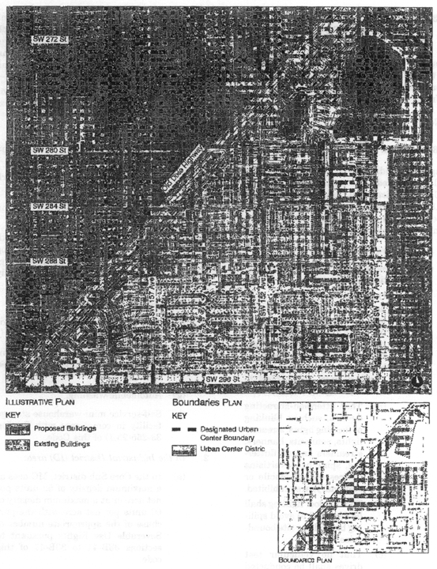

**Figure I. Illustrative Master Plan**

(Ord. No. 07-169, § 1, 11-6-07)

Sec. 33-284.99.33. Leisure City Community Urban Center (LCUC) district requirements.

Except as provided herein, all developments within the LCUC District shall comply with the requirements provided in Article XXXIII(K), Standard Urban Center District Regulations, of this Code.

(Ord. No. 07-169, § 2, 11-6-07)

Sec. 33-284.99.34. Uses.

Except as provided herein, all permitted, conditionally permitted, and temporary uses within the LCUC District shall comply with [Section 33-284.83](../level3/PTIIICOOR_CH33ZO_ARTXXXIII_K_STURCEDIRE.docx#PTIIICOOR_CH33ZO_ARTXXXIII_K_STURCEDIRE_S33-284.83US) of this code. In addition to the Permitted Uses provided in [Section 33-284.83](../level3/PTIIICOOR_CH33ZO_ARTXXXIII_K_STURCEDIRE.docx#PTIIICOOR_CH33ZO_ARTXXXIII_K_STURCEDIRE_S33-284.83US)(A), the following shall be permitted:

1. *In the Mixed-Use Corridor (MC) area:*

(a) Automobile and truck services and facilities including:

(1) Open lot car and truck sales new or used, including as ancillary uses, automobile repairs, body and top work and painting, provided that no more than fifteen (15) percent of the gross building area is devoted to such ancillary uses, and subject to the following conditions:

(a) That attention-attracting devices, such as blinking or flashing lights, streamer lights, pennants, banners, streamers and all fluttering, spinning advertising devices (either mobile or stationary) are prohibited.

(b) That outdoor lighting shall be designed to avoid spilling beyond the site boundaries.

(c) That no vehicular test drives shall be conducted on residential local traffic streets (fifty-foot right-of-way or less).

(d) That the applicant obtains a certificate of use, which shall be automatically renewable yearly upon compliance with all terms and conditions.

(e) All outdoor paging or speaker systems are expressly prohibited.

(2) Open lot car rental

(3) Automobile parts, secondhand from store building only.

(4) Automobile body and top work and painting.

(b) Engines, gas, gasoline, steam and oil; sales and service.

(c) Garage or mechanical service, including automobile repairs, body and top work and painting. All outdoor paging or speaker systems are expressly prohibited.

(d) Glass installation.

(e) Tire vulcanizing and retreading or sale of used tires.

(f) Truck storage, only within an enclosed building or an area enclosed by a CBS wall.

(g) Automobile washing.

(h) Self-service mini-warehouse storage facility in compliance with [Section 33-255](../level3/PTIIICOOR_CH33ZO_ARTXXVIILIBUDI.docx#PTIIICOOR_CH33ZO_ARTXXVIILIBUDI_S33-255USPE)(23.1) of this Code.

2. *In the Industrial District (ID) area:*

(a) In the Core Sub-district, MC uses at a maximum density of 52 units per net acre or at a maximum density of 60 units per net acre with the purchase of the appropriate number of Severable Use Rights pursuant to sections [33B-41](../level4/PTIIICOOR_CH33BARCRENCO_ARTIIEAEV_DIV3SEUSRI.docx#PTIIICOOR_CH33BARCRENCO_ARTIIEAEV_DIV3SEUSRI_S33B-41PU) to [33B-47](../level4/PTIIICOOR_CH33BARCRENCO_ARTIIEAEV_DIV3SEUSRI.docx#PTIIICOOR_CH33BARCRENCO_ARTIIEAEV_DIV3SEUSRI_S33B-47COCH33ZOCOCO) of this code.

(b) In the Center Sub-district, MC uses at a maximum density of 36 units per net acre.

3. *In the Institutional (I) area:*

(a) On properties located between SW 282 and SW 284 Streets, west of SW 152 Avenue, all uses permitted in the Residential (RM) with the density provided on the Density Plan in [Section 33-284.35](../level3/PTIIICOOR_CH33ZO_ARTXXXIIIEOFPADIOP.docx#PTIIICOOR_CH33ZO_ARTXXXIIIEOFPADIOP_S33-284.35LAOPSPTRLAMA) of this code.

(Ord. No. 07-169, § 3, 11-6-07)

Sec. 33-284.99.35. LCUC Regulating Plans.

The Regulating Plans shall consist of the following controlling plans as defined and graphically depicted in this section:

A. The Street Types Plan, which establishes a hierarchy of street types in existing and future locations. The five (5) Street Types and the hierarchy of streets (from most important to least important in accommodating pedestrian traffic) are U.S. 1, Boulevard, Main Street, Minor Street, and Service Road.

B. The Sub-districts Plan, which delineates three (3) sub-districts: the Core, Center, and Edge. These sub-districts shall regulate the allowable intensity of development in accordance with the Comprehensive Development Master Plan and this article.

C. The Land Use Plan, which delineates the areas where specified land uses and development of various types and intensities shall be permitted.

D. The Density Plan, which delineates areas where specified minimum and maximum residential densities shall be permitted.

E. The Building Heights Plan, which establishes the minimum and maximum allowable number of stories.

F. The Designated Open Space Plan, which designates open spaces. The designated open spaces shall be controlled by anchor points.

G. The New Streets Plan, which shows the location and the number of new streets needed to create the prescribed network of streets within the LCUC District. All new A streets shall be required in the same general location as shown on the New Streets Plan. All B streets shall be located as provided in [Section 33-284.86](../level3/PTIIICOOR_CH33ZO_ARTXXXIII_K_STURCEDIRE.docx#PTIIICOOR_CH33ZO_ARTXXXIII_K_STURCEDIRE_S33-284.86GERE)(F) of this Code.

H. The Bike Route Plan, which depicts the designated bike routes, including the bike facility requirements, if any, which shall be shown in all development plans.

A. Street Types Plan

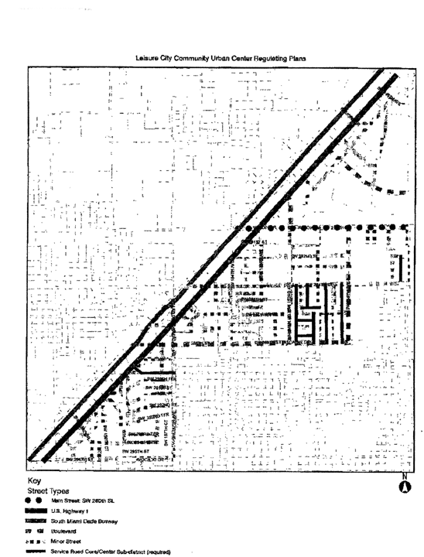

B. Sub-Districts Plan

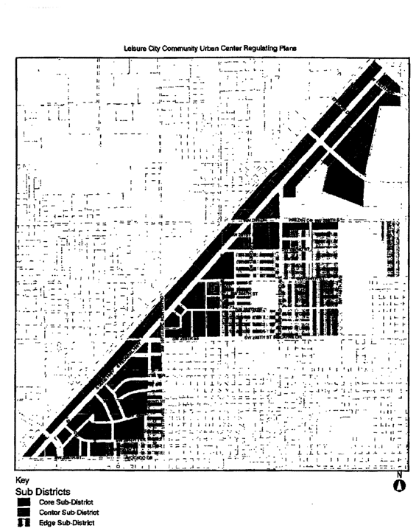

C. Land Use Plan

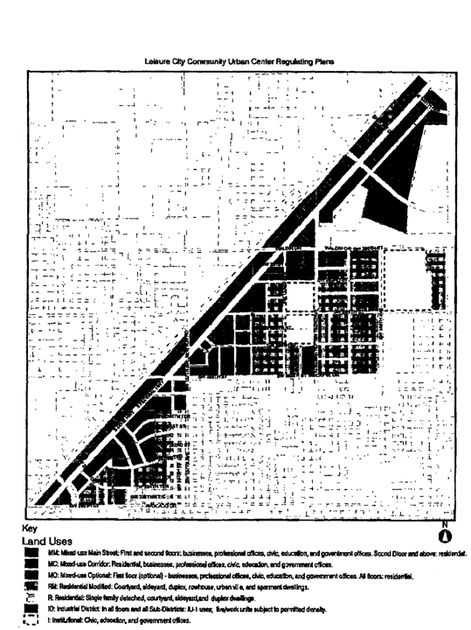

D. Density Plan

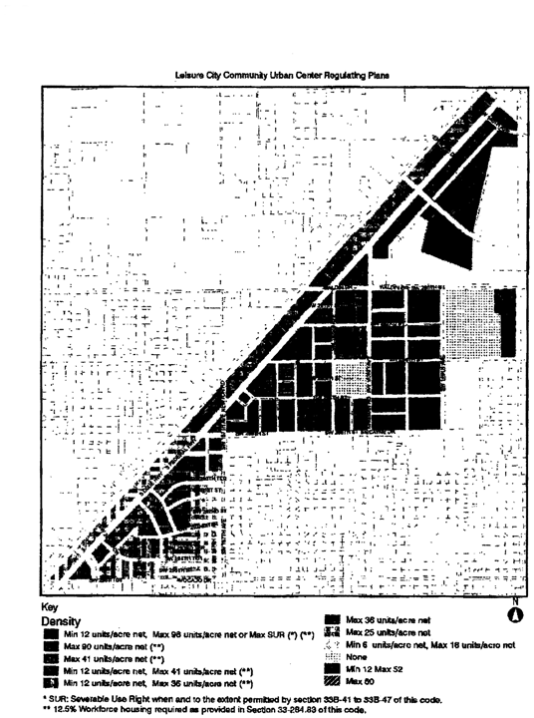

E. Building Heights Plan

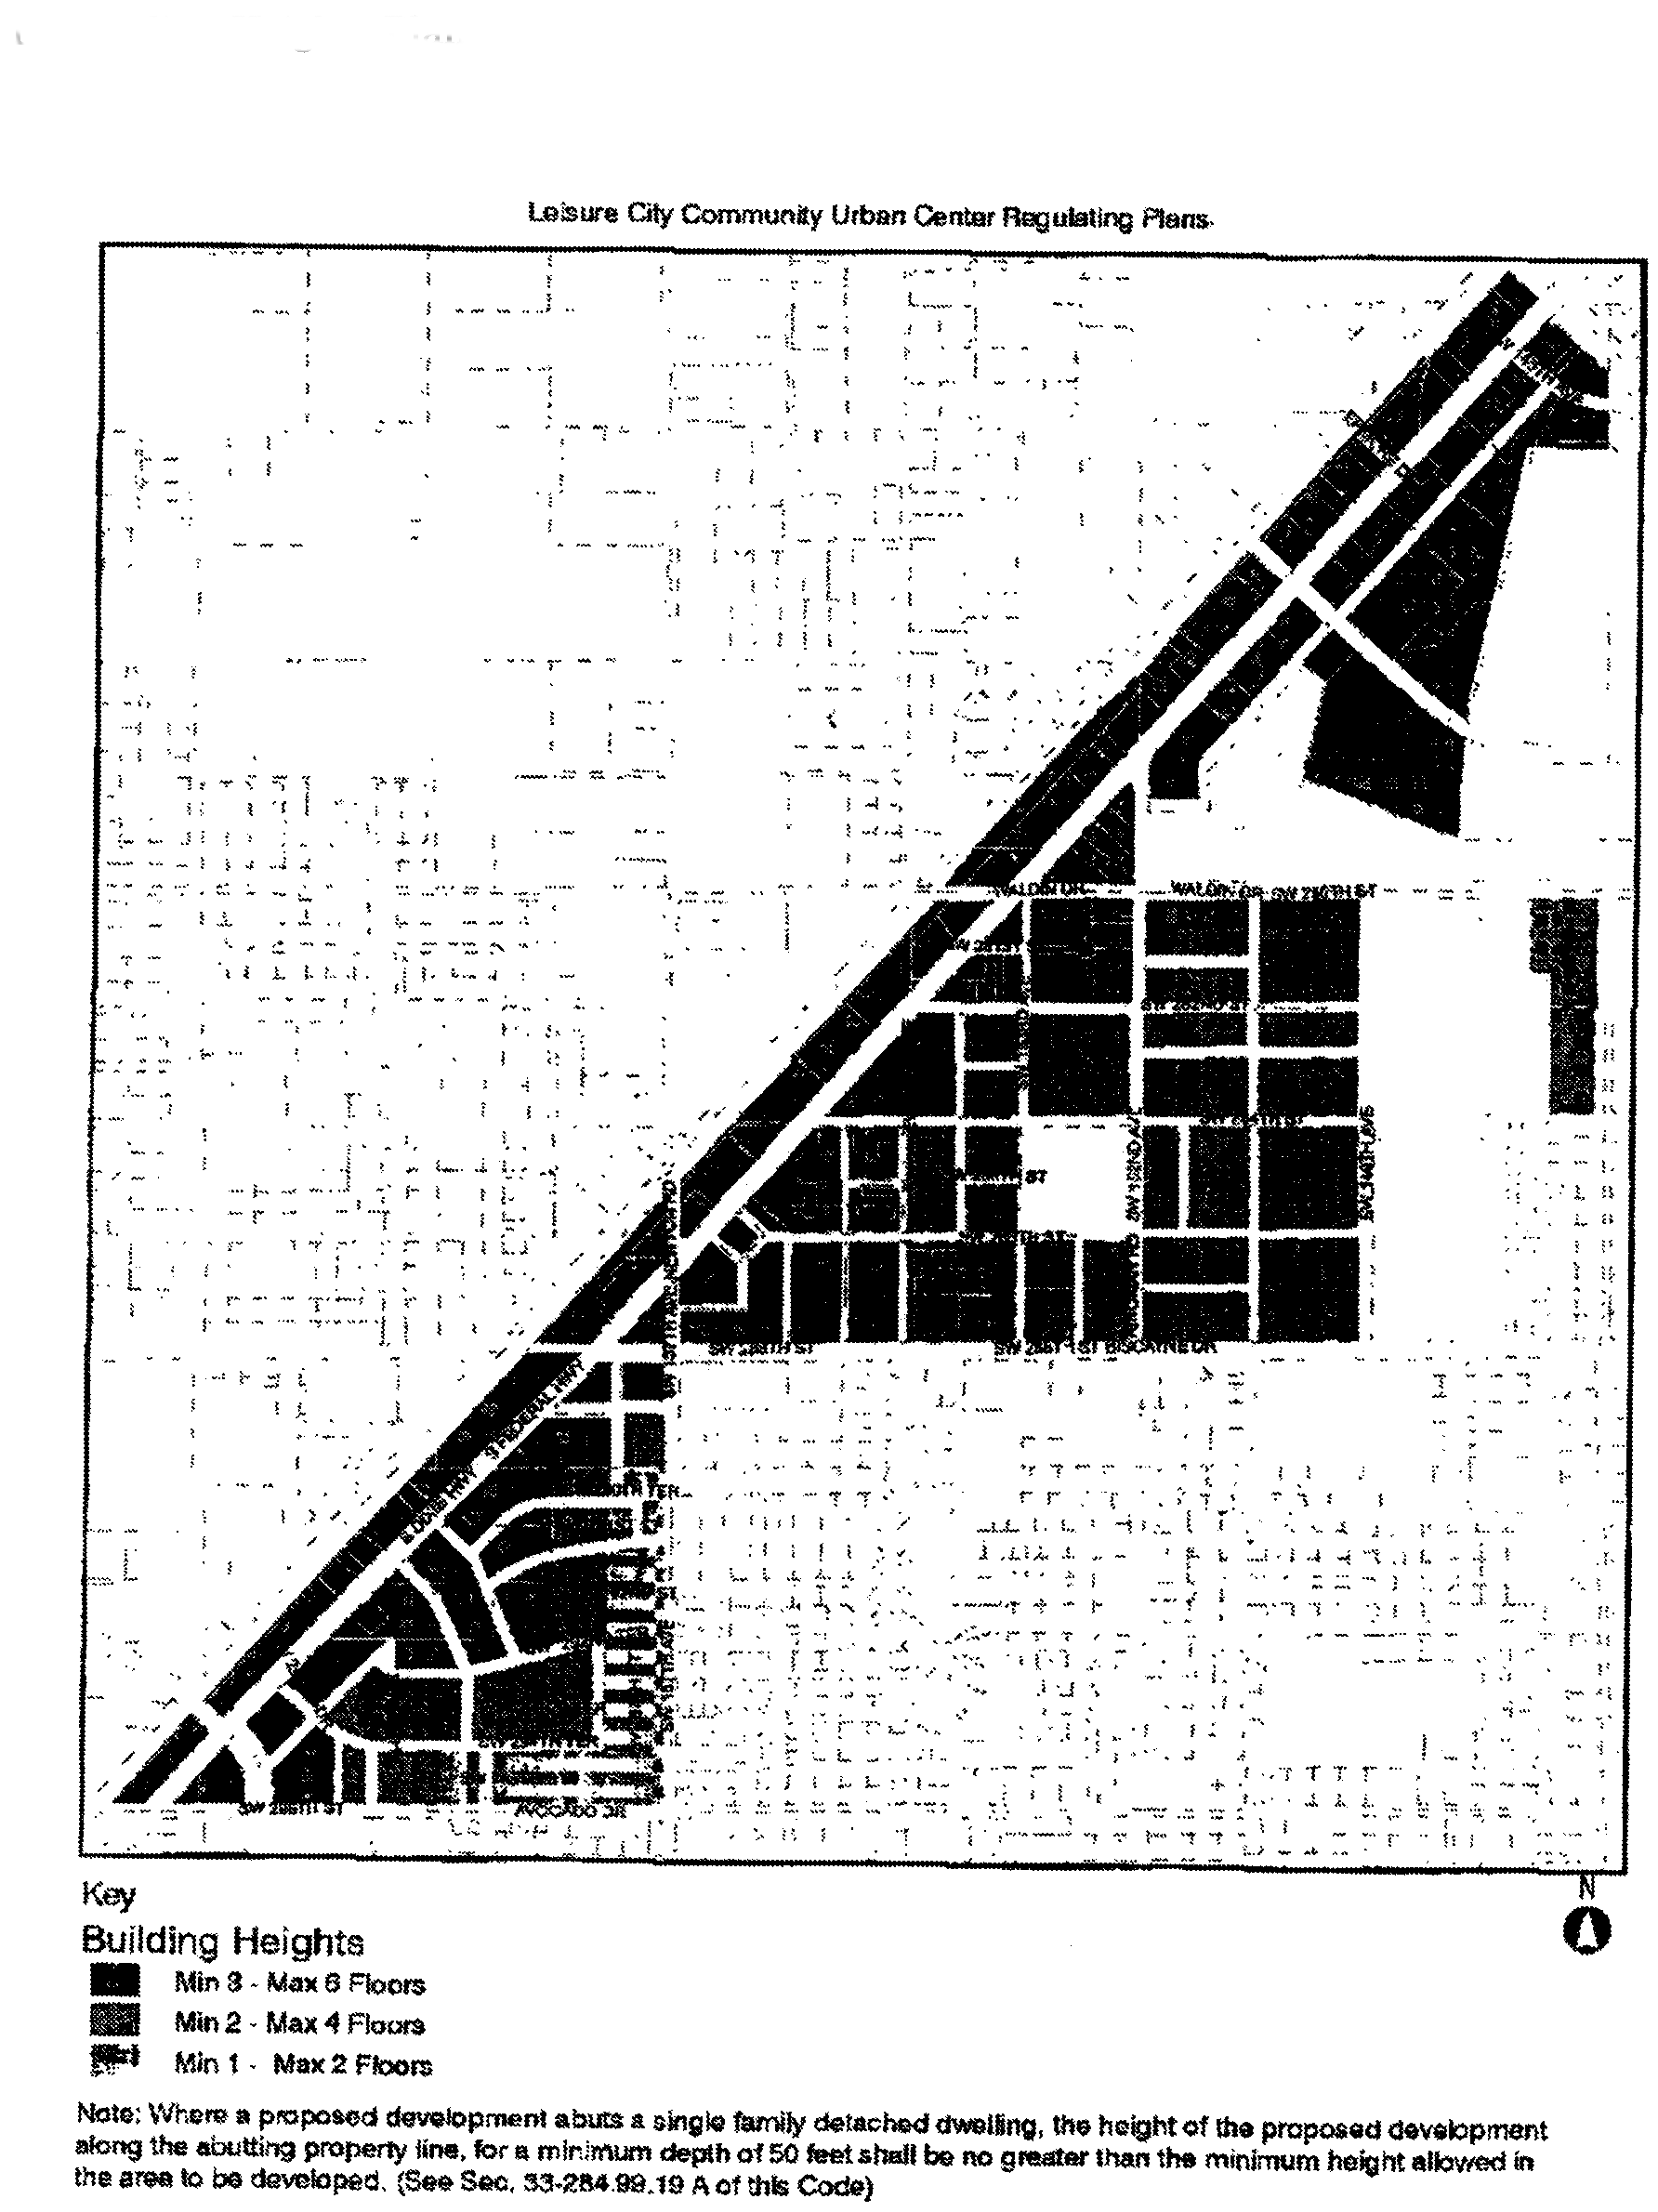

F. Designated Open Space Plan

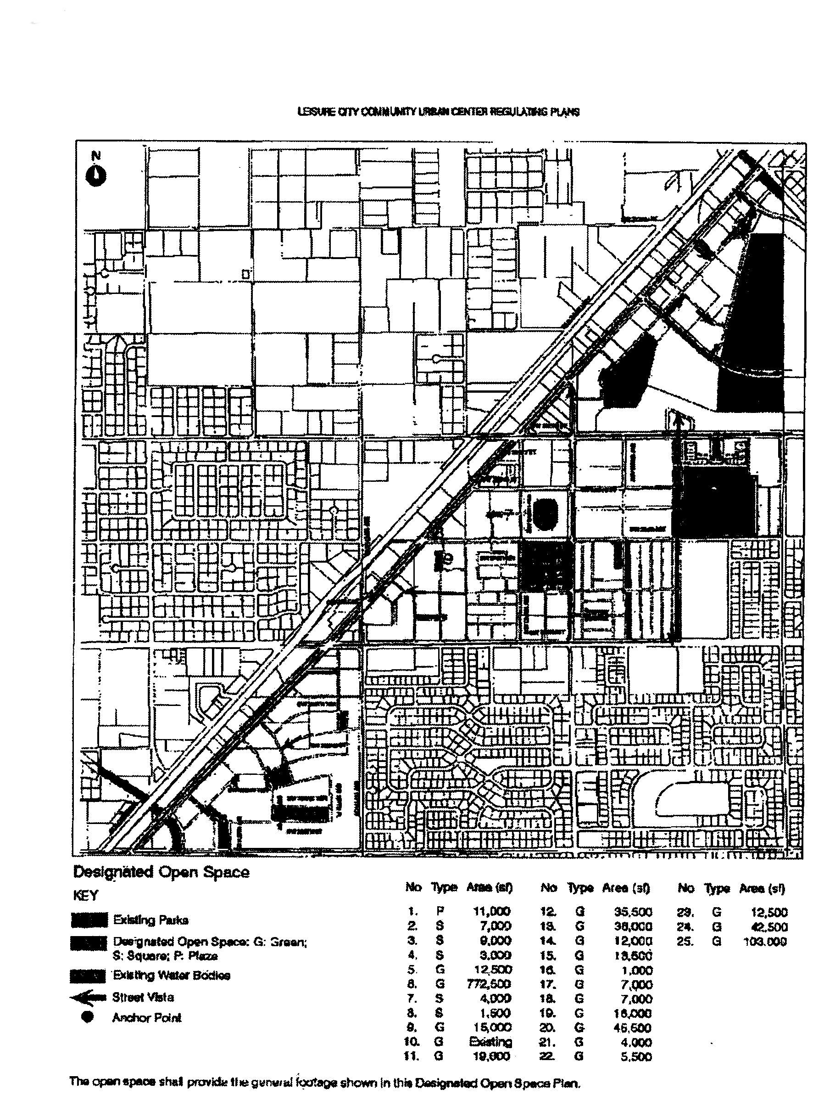

G. New Street Dedications Plan

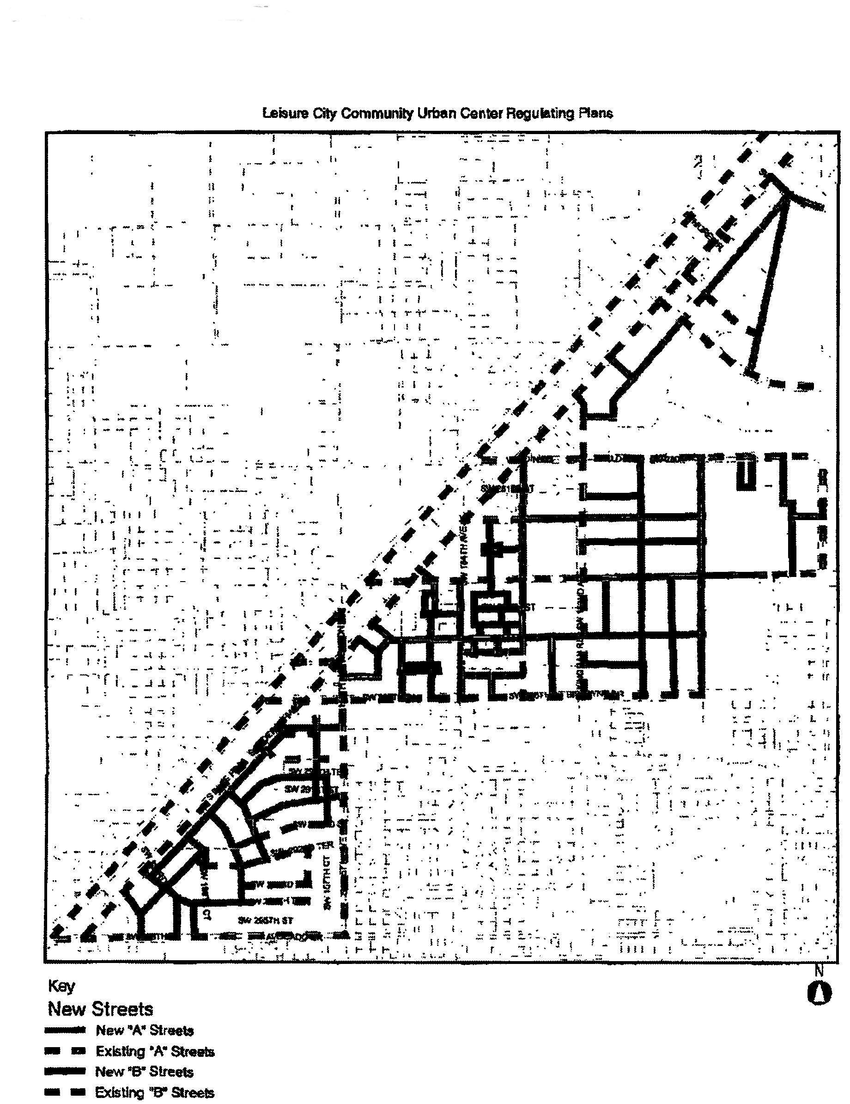

H. Bike Route Plan

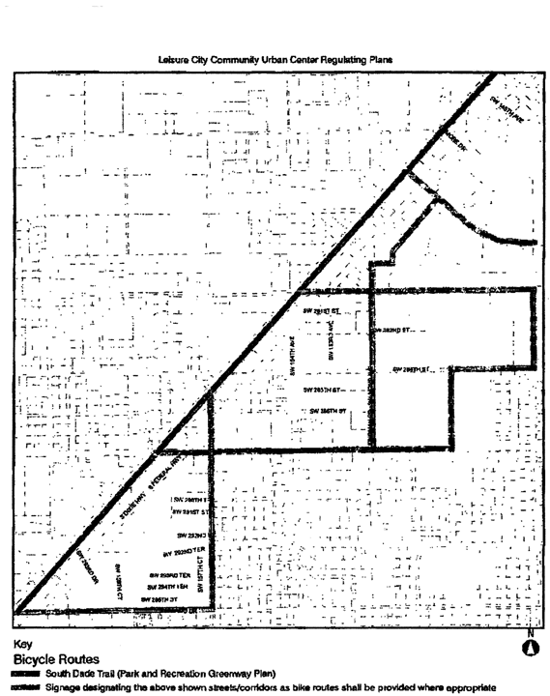

(Ord. No. 07-169, § 4, 11-6-07)

Sec. 33-284.99.36. Building placement and street type development parameters.

A. All new development and redevelopment within the LCUC District shall comply with the Building Placement and Design Parameters as provided in [Section 33-284.85](../level3/PTIIICOOR_CH33ZO_ARTXXXIII_K_STURCEDIRE.docx#PTIIICOOR_CH33ZO_ARTXXXIII_K_STURCEDIRE_S33-284.85BUPLST) of this code.

B. All new development and redevelopment within the LCUC District shall comply with the Street Type Parameters as provided herein:

|  |  |
| --- | --- |
| Street Type | Minimum Required Configuration |
| U.S. 1 | As provided herein |
| Main Street/SW 280 Street | As provided in [Section 33-284.85](../level3/PTIIICOOR_CH33ZO_ARTXXXIII_K_STURCEDIRE.docx#PTIIICOOR_CH33ZO_ARTXXXIII_K_STURCEDIRE_S33-284.85BUPLST) (Boulevard) |
| Boulevard | As provided in [Section 33-284.85](../level3/PTIIICOOR_CH33ZO_ARTXXXIII_K_STURCEDIRE.docx#PTIIICOOR_CH33ZO_ARTXXXIII_K_STURCEDIRE_S33-284.85BUPLST) |
| Minor Street | As provided in [Section 33-284.85](../level3/PTIIICOOR_CH33ZO_ARTXXXIII_K_STURCEDIRE.docx#PTIIICOOR_CH33ZO_ARTXXXIII_K_STURCEDIRE_S33-284.85BUPLST) |
| Service Road | As provided in [Section 33-284.85](../level3/PTIIICOOR_CH33ZO_ARTXXXIII_K_STURCEDIRE.docx#PTIIICOOR_CH33ZO_ARTXXXIII_K_STURCEDIRE_S33-284.85BUPLST) |

C. Unless otherwise provided by the Building Placement and Design Parameters in [Section 33-284.85](../level3/PTIIICOOR_CH33ZO_ARTXXXIII_K_STURCEDIRE.docx#PTIIICOOR_CH33ZO_ARTXXXIII_K_STURCEDIRE_S33-284.85BUPLST) of this Code, the following front and side street setbacks shall be required for mixed-use development within the LCUC District:

|  |  |  |  |
| --- | --- | --- | --- |
| Street Type | Required Setback | | |
|  | Core | Center | Edge |
| U.S. 1 | 0'* or 10' | 10' or 15' | N/A |
| Main Street | 0'* | 10'*** | N/A |
| Boulevard | 0' or 10' | 0' or 10' | ** |
| Minor Street | 0' or 10' | 10' or 15' | ** |
| Service Road | ** | ** | ** |
| Pedestrian Passage | ** | ** | ** |
| Notes: N/A = not applicable * colonnades required ** as provided in [Section 33-284.85](../level3/PTIIICOOR_CH33ZO_ARTXXXIII_K_STURCEDIRE.docx#PTIIICOOR_CH33ZO_ARTXXXIII_K_STURCEDIRE_S33-284.85BUPLST) of this code *** if a colonnade is provided, the front setback shall be 0' | | | |

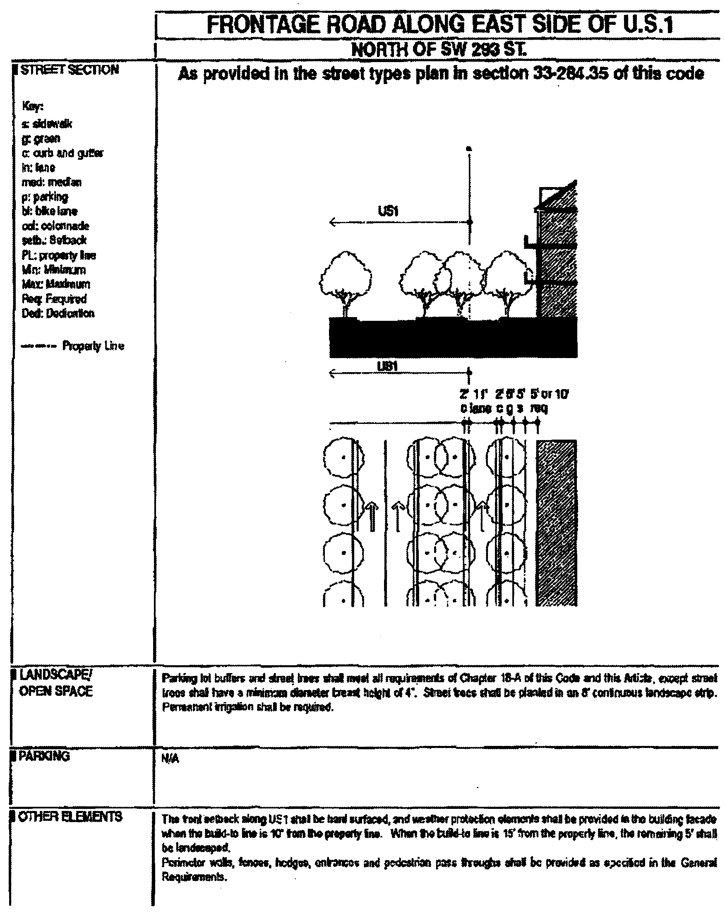

(Ord. No. 07-169, § 5, 11-6-07)

Sec. 33-284.99.37. Conflicts with other chapters and regulations.

This article shall govern in the event of conflicts with other zoning, subdivision, or landscape regulations of this code, or with the Miami-Dade Department of Public Works Manual of Public Works.

(Ord. No. 07-169, § 6, 11-6-07)

Sec. 33-284.99.38. Nonconforming structures, uses, and occupancies.

Nothing contained in this article shall be deemed or construed to prohibit a continuation of a legal nonconforming structure, use, or occupancy in the LCUC District that either: (1) was existing as of the date of the district boundary change on the property to LCUC District; or (2) on or before said date, had received final site plan approval through a public hearing pursuant to this chapter or through administrative site plan review or had a valid building permit. However, any structure, use, or occupancy in the LCUC District that is discontinued for a period of at least six months, or is superseded by a lawful structure, use, or occupancy permitted under this chapter, or that incurs damage to the roof or structure to an extent of 50 percent or more of its market value, shall be subject to [Section 33-35](../level3/PTIIICOOR_CH33ZO_ARTIINGE.docx#PTIIICOOR_CH33ZO_ARTIINGE_S33-35NOUS)(c) of this code. However, a lawfully existing single-family home use that is discontinued for a period of at least six months or that incurs damage to the roof or structure to an extent of 50 percent or more of its market value, shall not be subject to [Section 33-35](../level3/PTIIICOOR_CH33ZO_ARTIINGE.docx#PTIIICOOR_CH33ZO_ARTIINGE_S33-35NOUS)(c) of this code.

(Ord. No. 07-169, § 7, 11-6-07)

Sec. 33-284.99.39. Reserved.

### ARTICLE XXXIII(R). MODEL CITY URBAN CENTER DISTRICT (MCUCD)

Sec. 33-284.99.40. Purpose, intent and applicability.

Sec. 33-284.99.41. Model City Urban Center District (MCUCD) requirements.

Sec. 33-284.99.42. Uses.

Sec. 33-284.99.43. Regulating plans.

Sec. 33-284.99.44. Development parameters.

Sec. 33-284.99.45. Conflicts with other chapters and regulations.

Sec. 33-284.99.46. Nonconforming structures, uses, and occupancies.

Sec. 33-284.99.47. Reserved.

Sec. 33-284.99.40. Purpose, intent and applicability.

A. The regulations contained in this chapter and [Chapter 18A](../level2/PTIIICOOR_CH18AMIDECOLAOR.docx#PTIIICOOR_CH18AMIDECOLAOR), Landscape Code, Code of Miami-Dade County, Florida, shall apply to this article, except as otherwise added to or modified herein.

B. The Illustrative Master Plan (Figure 1) illustrates the citizens' vision and may be used to interpret this article. Where the Illustrative Master Plan conflicts with the provisions of this article, the provisions of this article shall govern.

C. Figure 1 also shows the boundaries of the Model City Urban Center District (MCUCD), as well as the boundaries of the Designated Urban Center. The MCUCD's Designated Urban Center shall consist of the areas designated as being the Core and Center Sub-districts on the Sub-districts Plan in [Section 33-284.99.43](../level3/PTIIICOOR_CH33ZO_ARTXXXIII_R_MOURCEDIMC.docx#PTIIICOOR_CH33ZO_ARTXXXIII_R_MOURCEDIMC_S33-284.99.43REPL) of this code. As provided in Standard Urban Center District Regulations, the Workforce Housing requirement shall apply to the area included in the Designated Urban Center boundaries. The legal descriptions of the boundaries of the MCUCD and the Designated Urban Center are on file with the Miami-Dade Department of Planning and Zoning.

D. Full scale maps of the Illustrative Master Plan presented in Figure 1, as well as all the Regulating Plans and Street Development Parameters figures in this article, are on file with the Miami-Dade Department of Planning and Zoning.

E. No provision in this article shall be applicable to any property lying outside the boundaries of the MCUCD as described herein. No property lying within the boundaries of the MCUCD shall be entitled to the uses or subject to the regulations provided in this article until an application for a district boundary change to MCUCD has been heard and approved in accordance with the provisions of this chapter.

Figure 1. Illustrative Master Plan

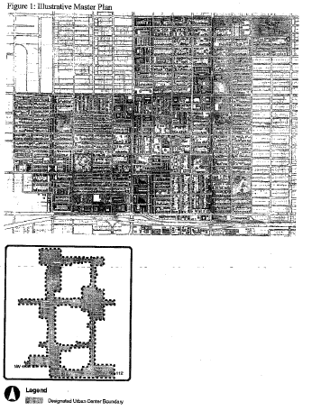

(Ord. No. 10-13, § 1, 2-2-10)

Sec. 33-284.99.41. Model City Urban Center District (MCUCD) requirements.

Except as provided herein, all developments within the MCUCD shall comply with the requirements provided in Article XXXIII(K), Standard Urban Center District Regulations, of this code.

(Ord. No. 10-13, § 2, 2-2-10)

Sec. 33-284.99.42. Uses.

Except as provided herein, all permitted, conditionally permitted, and temporary uses within the MCUCD shall comply with [Section 33-284.83](../level3/PTIIICOOR_CH33ZO_ARTXXXIII_K_STURCEDIRE.docx#PTIIICOOR_CH33ZO_ARTXXXIII_K_STURCEDIRE_S33-284.83US) of this code.

A. *Permitted uses.* In addition to the uses provided in [Section 33-284.83](../level3/PTIIICOOR_CH33ZO_ARTXXXIII_K_STURCEDIRE.docx#PTIIICOOR_CH33ZO_ARTXXXIII_K_STURCEDIRE_S33-284.83US)(A), the following shall be permitted:

1. In the Mixed-Use Corridor Special (MCS) area, all uses provided in [Section 33-284.83](../level3/PTIIICOOR_CH33ZO_ARTXXXIII_K_STURCEDIRE.docx#PTIIICOOR_CH33ZO_ARTXXXIII_K_STURCEDIRE_S33-284.83US)(A)(3) and the following uses:

(a) Automobile and truck services and facilities including:

(1) Open lot car and truck sales new or used, including, as ancillary uses, automobile repairs, body and top work and painting, provided that no more than fifteen (15) percent of the gross building area is devoted to such ancillary uses, and subject to the following conditions:

a. That attention attractive devices, such as blinking or flashing lights, streamer lights, pennants, banners, streamers and all fluttering, spinning advertising devices (either mobile or stationary) are prohibited.

b. That outdoor lighting shall be designed to avoid spilling beyond the site boundaries.

c. That no vehicular test drives shall be conducted on residential local traffic streets (fifty-foot right-of-way or less).

d. That the applicant obtains a certificate of use, which shall be automatically renewable yearly upon compliance with all terms and conditions.

e. All outdoor paging or speaker systems are expressly prohibited. This provision shall also apply to all establishments in existence as of September 10, 1996.

(2) Open lot car rental.

(3) Automobile parts, secondhand from store building only.

(4) Automobile body and top work and painting.

(b) Automobile self-service gas stations. When provided, gas stations shall be exempt from the provisions of this article and shall conform to the BU-1A development standards provided in Article XXV of this code.

(c) Engines, steam and oil; sales and service.

(d) Garage or mechanical service, including automobile repairs, body and top work and painting. All outdoor paging or speaker systems are expressly prohibited. This provision shall also apply to all establishments in existence as of September 10, 1996.

(e) Glass installation.

(f) Tire vulcanizing and retreading or sale of use tires.

(g) Truck storage, only within an enclosed building or an area enclosed by a CBS wall.

(h) Automobile washing.

(i) Self-service mini-warehouse storage facility in compliance with [Section 33-255](../level3/PTIIICOOR_CH33ZO_ARTXXVIILIBUDI.docx#PTIIICOOR_CH33ZO_ARTXXVIILIBUDI_S33-255USPE)(23.1) of this code.

2. In the Industrial District (ID) area, the following uses:

(a) MC uses at maximum residential densities shown on the Density Regulating Plan in [Section 33-284.99.43](../level3/PTIIICOOR_CH33ZO_ARTXXXIII_R_MOURCEDIMC.docx#PTIIICOOR_CH33ZO_ARTXXXIII_R_MOURCEDIMC_S33-284.99.43REPL) of this code.

B. *Conditionally permitted uses.* Notwithstanding the provisions of [Section 33-284.83](../level3/PTIIICOOR_CH33ZO_ARTXXXIII_K_STURCEDIRE.docx#PTIIICOOR_CH33ZO_ARTXXXIII_K_STURCEDIRE_S33-284.83US)(B), only the following conditional uses shall be permitted, subject to the administrative approval of a site plan pursuant to [Section 33-284.88](../level3/PTIIICOOR_CH33ZO_ARTXXXIII_K_STURCEDIRE.docx#PTIIICOOR_CH33ZO_ARTXXXIII_K_STURCEDIRE_S33-284.88REPRADSIPLARRE) of this code:

1. Liquor package stores only in the Core and Center Sub-districts, and only in compliance with Article X of this code.

C. *Workforce housing requirement alternative.* Notwithstanding the provisions of [Section 33-284.83](../level3/PTIIICOOR_CH33ZO_ARTXXXIII_K_STURCEDIRE.docx#PTIIICOOR_CH33ZO_ARTXXXIII_K_STURCEDIRE_S33-284.83US)(A)(1), all residential or mixed-use developments within the MCUCD that have more than four (4) residential units shall provide one of the following:

1. A minimum of 12.5 percent of their units as workforce housing units; or

2. A minimum of 10 percent of their units as affordable housing units. "Affordable housing unit" means a dwelling unit, the sale, rental, or pricing of which is restricted to households whose income range is up to 80 percent of the most recent median family income for the County reported by the U.S. HUD and maintained by the Department of Planning and Zoning.

(Ord. No. 10-13, § 3, 2-2-10)

Sec. 33-284.99.43. Regulating plans.

The Regulating Plans shall consist of the following controlling plans as defined and graphically depicted in this section:

A. The Land Use Plan, which delineates the areas where specified land uses and development of various types and intensities is permitted.

B. The Density Plan, which delineates areas where specified minimum and maximum residential densities shall be permitted.

C. The Building Heights Plan, which establishes the minimum and maximum allowable number of stories.

D. The Sub-districts Plan, which delineates three (3) sub-districts: the Core, Center and Edge. These sub-districts regulate the allowable intensity of development in accordance with the Comprehensive Development Master Plan and this article.

E. The Designated Open Space Plan, which designates open spaces, which shall be shown in all development plans. The designated open spaces are controlled by anchor points.

F. The New Streets Plan, which shows the location and the number of new streets needed to create the prescribed network of streets within the MCUCD District. All new A streets shall be required in the same general location as shown on the New Streets Plan. All B streets shall be located as provided in [Section 33-284.86](../level3/PTIIICOOR_CH33ZO_ARTXXXIII_K_STURCEDIRE.docx#PTIIICOOR_CH33ZO_ARTXXXIII_K_STURCEDIRE_S33-284.86GERE)(F) of this code.

A. Land Use Plan

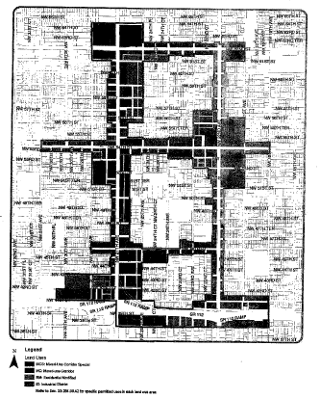

B. Density Plan

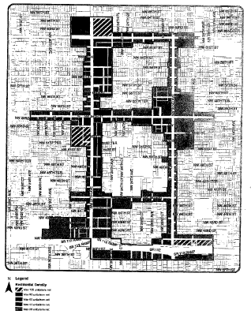

C. Building Heights Plan

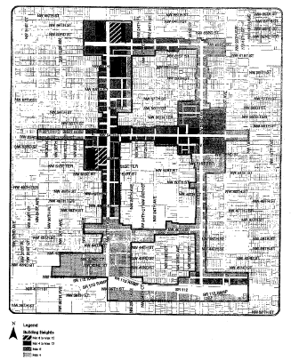

D. Sub-districts Plan

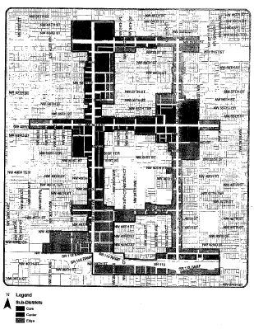

E. Designated Open Space Plan

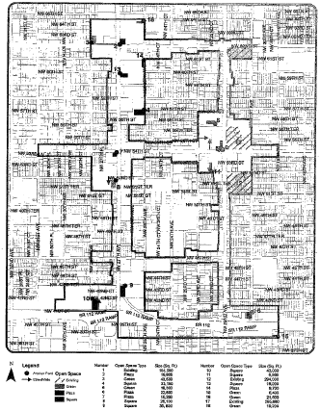

F. New Streets Plan

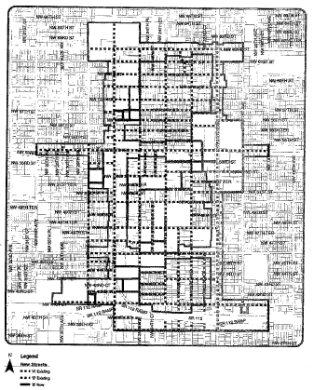

(Ord. No. 10-13, § 4, 2-2-10)

Sec. 33-284.99.44. Development parameters.

A. Except as otherwise provided in this section, all new development and redevelopment within the MCUCD shall comply with the development parameters as set forth in Article XXXIII(K) of this code.

B. All new development and redevelopment in areas designated MCS shall comply with the development parameters for the MC area as set forth in Article XXXIII(K) of this code, except that self-service gas stations shall comply with the development parameters applicable to the BU-1A district.

C. At a minimum, streets within the MCUCD shall comply with the Street Type Parameters for Type 5, Minor Street, as provided in [Section 33-284.85](../level3/PTIIICOOR_CH33ZO_ARTXXXIII_K_STURCEDIRE.docx#PTIIICOOR_CH33ZO_ARTXXXIII_K_STURCEDIRE_S33-284.85BUPLST) of this code.

(Ord. No. 10-13, § 5, 2-2-10)

Sec. 33-284.99.45. Conflicts with other chapters and regulations.

This article shall govern in the event of conflicts with other zoning, subdivision, or landscape regulations of this code, or with the Miami-Dade Department of Public Works Manual of Public Works.

(Ord. No. 10-13, § 6, 2-2-10)

Sec. 33-284.99.46. Nonconforming structures, uses, and occupancies.

Nothing contained in this article shall be deemed or construed to prohibit a continuation of a legal nonconforming structure, use, or occupancy in the MCUCD that either: (1) was existing as of the date of the district boundary change on the property to MCUCD; or (2) on or before said date, had received final site plan approval through a public hearing pursuant to this chapter or through administrative site plan review or had a valid building permit. However, any structure, use, or occupancy in the MCUCD that is discontinued for a period of at least six months, or is superseded by a lawful structure, use, or occupancy permitted under this chapter, or that incurs damage to an extent of 50 percent or more of its market value, shall be subject to [Section 33-35](../level3/PTIIICOOR_CH33ZO_ARTIINGE.docx#PTIIICOOR_CH33ZO_ARTIINGE_S33-35NOUS)(c) of this code. However, a lawfully existing single-family home use that is discontinued for a period of at least six months or that incurs damage to the roof or structure to an extent of 50 percent or more of its market value, shall not be subject to [Section 33-35](../level3/PTIIICOOR_CH33ZO_ARTIINGE.docx#PTIIICOOR_CH33ZO_ARTIINGE_S33-35NOUS)(c) of this code.

(Ord. No. 10-13, § 7, 2-2-10)

Sec. 33-284.99.47. Reserved.

### ARTICLE XXXIII(S). NORTH CENTRAL URBAN AREA DISTRICT (NCUAD)

Sec. 33-284.99.48. Purpose, intent and applicability.

Sec. 33-284.99.49. North Central Urban Area District (NCUAD) Requirements.

Sec. 33-284.99.50. Uses.

Sec. 33-284.99.51. Regulating Plans.

Sec. 33-284.99.52. Development Parameters.

Sec. 33-284.99.53. Conflicts with other Chapters and Regulations.

Sec. 33-284.99.54. Non-conforming Structures, Uses, and Occupancies.

Sec. 33-284.99.48. Purpose, intent and applicability.

A. The NCUAD regulating plans were guided by the three Urban Centers located within the boundary and the major roadways provisions of the Comprehensive Development Master Plan.

B. The regulations contained in this chapter and [Chapter 18A](../level2/PTIIICOOR_CH18AMIDECOLAOR.docx#PTIIICOOR_CH18AMIDECOLAOR), Landscape Code, Code of Miami-Dade County, Florida, shall apply to this article, except as otherwise added to or modified herein.

C. Figure 1 shows the boundaries of the North Central Urban Area District (NCUAD).

D. The NCUAD's Designated Urban Center shall consist of the areas designated as being the Core and Center Sub-districts on the Sub-districts Plan in [Sec. 33-284.99.51](../level3/PTIIICOOR_CH33ZO_ARTXXXIII_NOCEURARDINC.docx#PTIIICOOR_CH33ZO_ARTXXXIII_NOCEURARDINC_S33-284.99.51REPL) of this code. As provided in the Standard Urban Center District Regulations, the Workforce Housing requirement shall apply to the area included in the Designated Urban Center boundaries. The legal description of the boundaries of the NCUAD is on file with the Miami-Dade Department of Planning and Zoning.

E. Full scale map of the boundaries presented in Figure 1, as well as all the Regulating Plans and Street Development Parameters figures in this article, are on file with the Miami-Dade Department of Planning and Zoning.

F. No provision in this article shall be applicable to any property lying outside the boundaries of the NCUAD as described herein. No property lying within the boundaries of the NCUAD shall be entitled to the uses or subject to the regulations provided in this article until an application for a district boundary change to NCUAD has been heard and approved in accordance with the provisions of this chapter.

Figure 1: North Central Urban Area Boundary

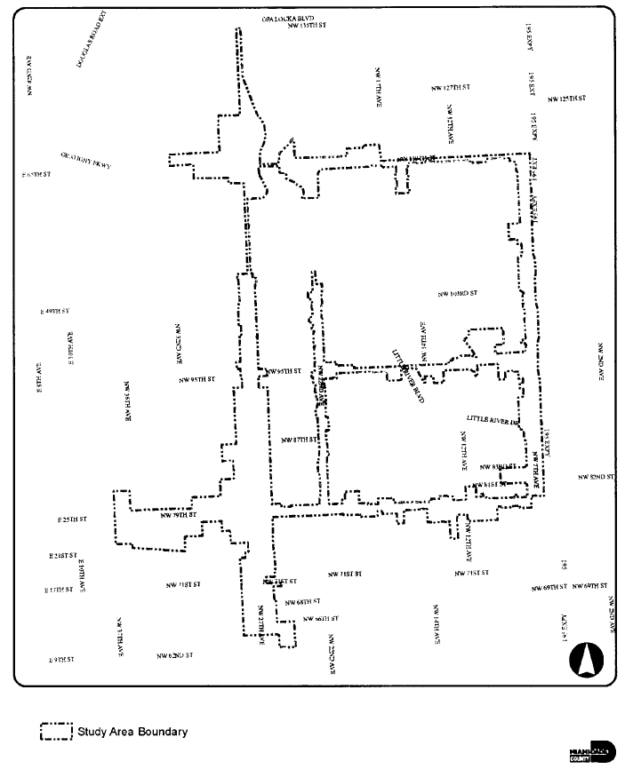

(Ord. No. 11-65, § 1, 8-2-11)

Sec. 33-284.99.49. North Central Urban Area District (NCUAD) Requirements.

Except as provided herein, all developments within the NCUAD shall comply with the requirements provided in Article XXXIII(K), Standard Urban Center District Regulations, of this chapter.

(Ord. No. 11-65, § 2, 8-2-11)

Sec. 33-284.99.50. Uses.

Except as provided herein, all permitted, conditionally permitted, and temporary uses within the NCUAD shall comply with [Section 33-284.83](../level3/PTIIICOOR_CH33ZO_ARTXXXIII_K_STURCEDIRE.docx#PTIIICOOR_CH33ZO_ARTXXXIII_K_STURCEDIRE_S33-284.83US) of this code.

A. *Permitted Uses.* In addition to the uses provided in [Section 33-284.83](../level3/PTIIICOOR_CH33ZO_ARTXXXIII_K_STURCEDIRE.docx#PTIIICOOR_CH33ZO_ARTXXXIII_K_STURCEDIRE_S33-284.83US)(A), the following shall be permitted:

1. In the Mixed-Use Corridor Special (MCS) area, all uses permitted in the Mixed-Use Corridor (MC) category and the following additional uses:

(a) Automobile and truck services and facilities including:

(1) Open lot car and truck sales new or used, including as ancillary uses, automobile repairs, body and top work and painting, provided that no more than fifteen (15) percent of the gross building area is devoted to such ancillary uses, and subject to the following conditions:

(a) That attention attractive devices, such as blinking or flashing lights, streamer lights, pennants, banners, streamers and all fluttering, spinning advertising devices (either mobile or stationary) are prohibited.

(b) That outdoor lighting shall be designed to avoid spilling beyond the site boundaries.

(c) That no vehicular test drives shall be conducted on residential local traffic streets (fifty-foot right-of-way or less).

(d) That the applicant obtains a certificate of use, which shall be automatically renewable yearly upon compliance with all terms and conditions.

(e) All outdoor paging or speaker systems are expressly prohibited.

(2) Open lot car rental.

(3) Automobile parts, secondhand from store building only.

(4) Automobile body and top work and painting.

(b) Automobile self-service gas stations. Gas stations shall be exempt from the provisions of this article and shall conform to the BU-1A development standards provided in Article XXV of this chapter.

(c) Engines, steam and oil; sales and service.

(d) Garage or mechanical service, including automobile repairs, body and top work and painting. All outdoor paging or speaker systems are expressly prohibited.

(e) Glass installation.

(f) Tire vulcanizing and retreading or sale of used tires.

(g) Truck storage, only within an enclosed building or an area enclosed by a CBS wall.

(h) Automobile washing.

(i) Self-service mini-warehouse storage facility in compliance with [Section 33-255](../level3/PTIIICOOR_CH33ZO_ARTXXVIILIBUDI.docx#PTIIICOOR_CH33ZO_ARTXXVIILIBUDI_S33-255USPE)(23.1) of this code.

2. Industrial uses. In the Industrial District (ID) area:

(a) MC uses at maximum residential densities shown on the Density Regulating Plan in [Section 33-284.99.51](../level3/PTIIICOOR_CH33ZO_ARTXXXIII_NOCEURARDINC.docx#PTIIICOOR_CH33ZO_ARTXXXIII_NOCEURARDINC_S33-284.99.51REPL) of this article.

B. *Conditionally Permitted Uses.* Notwithstanding the provisions of [Section 33-284.83](../level3/PTIIICOOR_CH33ZO_ARTXXXIII_K_STURCEDIRE.docx#PTIIICOOR_CH33ZO_ARTXXXIII_K_STURCEDIRE_S33-284.83US)(B), only the following conditional uses shall be permitted, subject to the administrative approval of a site plan as required by [Section 33-284.88](../level3/PTIIICOOR_CH33ZO_ARTXXXIII_K_STURCEDIRE.docx#PTIIICOOR_CH33ZO_ARTXXXIII_K_STURCEDIRE_S33-284.88REPRADSIPLARRE) of this code:

1. Liquor package stores, which shall only be permitted in the Core and Center Sub-districts, and only in compliance with Article X of this chapter.

(Ord. No. 11-65, § 3, 8-2-11)

Sec. 33-284.99.51. Regulating Plans.

The Regulating Plans consist of the following controlling plans as defined and graphically depicted in this section.

A. The Land Use Plan, which delineates the areas where specified land uses and development of various types and intensities shall be permitted.

B. The Density Plan, which delineates areas where specified maximum residential densities shall be permitted.

C. The Building Heights Plan, which establishes the minimum and maximum allowable number of stories.

D. The Sub-districts Plan, which delineates three (3) sub-districts: the Core, Center and Edge. These sub-districts shall regulate the allowable intensity of development in accordance with the Comprehensive Development Master Plan and this article.

E. The Designated Open Space Plan, which designates open spaces. Designated open spaces shall be shown in all development plans. The designated open spaces are controlled by anchor points.

F. The New Streets Plan, which shows the location and the number of new streets needed to create the prescribed network of streets within the NCUAD. All new A streets shall be required in the same general location as shown on the New Streets Plan. All B streets shall be located as provided in [Section 33-284.86](../level3/PTIIICOOR_CH33ZO_ARTXXXIII_K_STURCEDIRE.docx#PTIIICOOR_CH33ZO_ARTXXXIII_K_STURCEDIRE_S33-284.86GERE)(F) of this code.

A. Land Use Plan

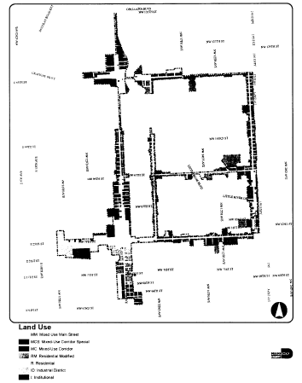

B. Density Plan

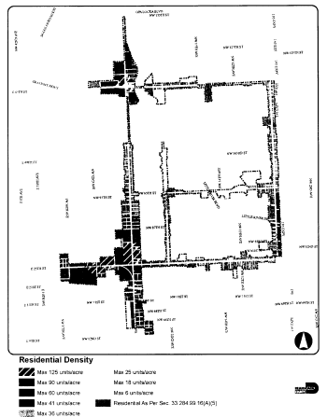

C. Building Heights Plan

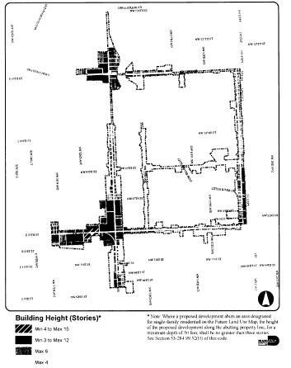

D. Sub-Districts Plan

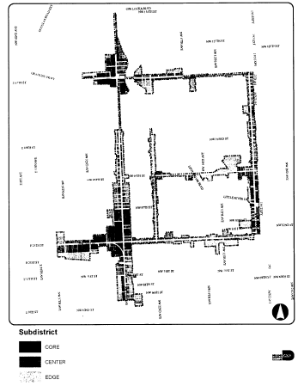

E. Designated Open Space Plan

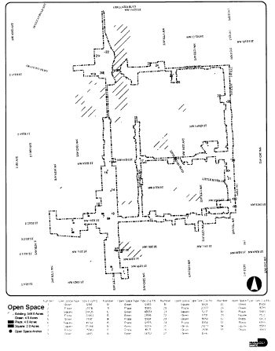

F. New Streets Plan

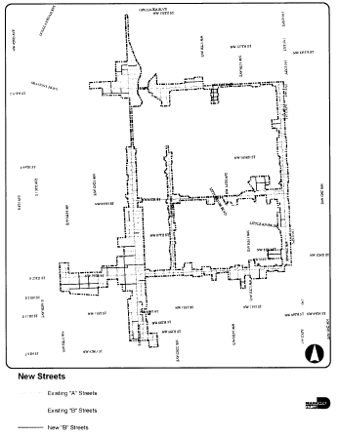

(Ord. No. 11-65, § 4, 8-2-11)

Sec. 33-284.99.52. Development Parameters.

A. Except as otherwise provided in this section, all new development and redevelopment within the NCUAD shall comply with the development parameters as set forth in Article XXXIII(K) of this chapter.

B. All new development and redevelopment in areas designated MCS shall comply with the development parameters for the MC area as set forth in Article XXXIII(K) of this chapter, except that self-service gas stations shall comply with the development parameters applicable to the BU-1A district as set forth in [Section 33-247](../level3/PTIIICOOR_CH33ZO_ARTXXVLIBUDI.docx#PTIIICOOR_CH33ZO_ARTXXVLIBUDI_S33-247USPE)

C. At a minimum, streets within the NCUAD shall comply with the Street Type Parameters for Type 5, Minor Street, as provided in [Section 33-284.85](../level3/PTIIICOOR_CH33ZO_ARTXXXIII_K_STURCEDIRE.docx#PTIIICOOR_CH33ZO_ARTXXXIII_K_STURCEDIRE_S33-284.85BUPLST)

D. Buffering between dissimilar land uses shall be in accordance with [Section 18A-6](../level2/PTIIICOOR_CH18AMIDECOLAOR.docx#PTIIICOOR_CH18AMIDECOLAOR_S18A-6MIST)(H) of this code.

E. Where a proposed development abuts an area designated for single-family residential on the Future Land Use Map of the CDMP, the height of the proposed development along the abutting property line, for a minimum depth of 50 feet, shall be no greater than three stories. Examples of the required height transition are shown below.

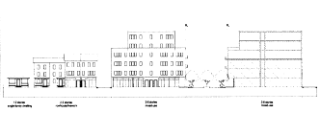

Example of building heights transition from mixed-use to single-family.

(Ord. No. 11-65, § 5, 8-2-11)

Sec. 33-284.99.53. Conflicts with other Chapters and Regulations.

This article shall govern in the event of conflicts with other zoning, subdivision, or landscape regulations of this code, or with the Miami-Dade Department of Public Works Manual of Public Works.

(Ord. No. 11-65, § 6, 8-2-11)

Sec. 33-284.99.54. Non-conforming Structures, Uses, and Occupancies.

Nothing contained in this article shall be deemed or construed to prohibit a continuation of a legal nonconforming structure, use, or occupancy in the NCUAD that either (1) was existing as of the date of the district boundary change on the property to NCUAD or (2) on or before said date, had received final site plan approval through a public hearing pursuant to this chapter or through administrative site plan review or had a valid building permit. However, any structure, use, or occupancy in the NCUAD that is discontinued for a period of at least six months, or is superseded by a lawful structure, use, or occupancy permitted under this chapter, or that incurs damage to an extent of 50 percent or more of its market value, shall be subject to [Section 33-35](../level3/PTIIICOOR_CH33ZO_ARTIINGE.docx#PTIIICOOR_CH33ZO_ARTIINGE_S33-35NOUS)(c) of this code. It is further provided, however, that no lawfully existing single-family home use or mobile home park use shall be subject to [Section 33-35](../level3/PTIIICOOR_CH33ZO_ARTIINGE.docx#PTIIICOOR_CH33ZO_ARTIINGE_S33-35NOUS)(c) of this code, even if it is discontinued for a period of six months or more or incurs damage to the roof or structure to an extent of 50 percent or more of its market value.

(Ord. No. 11-65, § 7, 8-2-11)

### ARTICLE XXXIII(T). PALMER LAKE METROPOLITAN URBAN CENTER DISTRICT (PLMUC)

Sec. 33-284.99.55. Purpose and intent.

Sec. 33-284.99.56. Definitions.

Sec. 33-284.99.57. Organization of this article.

Sec. 33-284.99.58. Regulating plans.

Sec. 33-284.99.59. Uses.

Sec. 33-284.99.60. Development parameters.

Sec. 33-284.99.61. Industrial uses disclosure.

Sec. 33-284.99.62. Review procedure.

Sec. 33-284.99.63. Zoning hearing review.

Sec. 33-284.99.64. Nonconforming structures and uses.

Sec. 33-284.99.65. Conflicts with other chapters and regulations.

Sec. 33-284.99.66. Legal description and applicability.

Sec. 33-284.99.55. Purpose and intent.

This Article applies to the area bounded by the Miami River on the northeast, the Seaboard Air Line Railroad on the west, and the Tamiami Canal on the south, hereinafter referred to as the Palmer Lake Metropolitan Urban Center District (PLMUC). A more detailed legal description of this boundary is provided in [Section 33-284.99.66](../level3/PTIIICOOR_CH33ZO_ARTXXXIII_T_PALAMEURCEDIPL.docx#PTIIICOOR_CH33ZO_ARTXXXIII_T_PALAMEURCEDIPL_S33-284.99.66LEDEAP) below. The intention of this Article is to permit the development of a Metropolitan Urban Center that fulfills the goals, objectives and policies of the Comprehensive Development Master Plan by:

(A) Coordinating development intensity within the district by the proximity to mass transit.

(B) Organizing an interconnected network of streets to improve pedestrian access to transit.

(C) Creating attractive and usable public space by shaping the way buildings front onto streets and open spaces.

(D) Maintaining and promoting marine activity on the Miami River by encouraging the retention of water dependent and/or water related uses consistent with the Port of Miami River Sub-element of the Comprehensive Development Master Plan.

The Illustrative Plan (Figure 1), illustrates the vision and may be used to better interpret this Article.  
Where there is conflict between the illustrative plan and the text of this Article, the text shall govern.



**Figure 1. Illustrative Plan.**

(Ord. No. 13-43, § 1, 5-7-13)

Sec. 33-284.99.56. Definitions.

Terms used throughout this Article shall take their commonly accepted meaning unless otherwise defined in [Chapter 33](../level2/PTIIICOOR_CH33ZO.docx#PTIIICOOR_CH33ZO) or [Chapter 28](../level2/PTIIICOOR_CH28SU.docx#PTIIICOOR_CH28SU) of the Code of Miami-Dade County. Terms requiring interpretation specific to this Article are as follows:

(1) *Block:* A combination of contiguous building lots, the perimeter of which abuts one or more public streets, private streets, easements or designated open spaces.

(2) *Building Frontage:* The portion of a building required to adjoin or be located within the frontage zone.

(3) *Building Frontage Zone:* The portion of a lot adjoining a street or right-of-way. The width of the building frontage zone is established by the applicable street type and/or Sub-district.

(4) *Elevated Pedestrian Walkway:* An enclosed structure located above private property and/or the public right-of-way allowing pedestrian access between and through buildings.

(5) *Floorplate:* The total indoor and outdoor area of any given story of a building, measured to the exterior of the wall.

(6) *Forecourt:* an open area where the building pedestal is recessed outside of the building frontage zone.

(7) *Frontage:* The property line or lines of a lot which coincide with a right-of-way or other public open space line as shown on a Regulating Plan.

(8) *Habitable Space:* Building space whose use involves human presence with direct view of the adjoining streets or open space, excluding parking garages, self-service storage facilities, and warehouses.

(9) *Mixed-use building:* A building that includes a combination of two or more vertically integrated uses, such as, but not limited to retail and/or office uses on the ground story, with residential uses above.

(10) *Pedestal:* The lower portion of the building including the ground story located adjoining or within the building frontage zone..

(11) *Retail Use:* Premises used for the exchange of services or goods.

(12) *Storefront:* Retail or office use areas, lobby areas or other habitable space located at the building frontage.

(13) *Story:* A floor level within a building as described in this Article's General Requirements.

(14) *Street:* A thoroughfare for the movement of pedestrians and vehicles, as provided in this Article.

(15) *Tower:* The upper portion of a building above the pedestal.

(16) *Water-dependent Use:* Activities that can be carried out only on, in, or adjacent to water areas because the use requires access to a water body, including without limitation: waterborne transportation hubs such as ports or marinas; or marine recreation.

(17) *Water-related Use:* Activities that are not directly dependent upon access to a water body, but that provide goods and services that are directly associated with water-dependent uses.

(18) *Weather Protection Features:* Architectural features that provide protection from the sun and rain, including without limitation, colonnades, awnings, or projecting roofs.

(19) *Work-force Housing Unit or WHU:* A dwelling unit, the sale, rental or pricing which is restricted to households whose income is up to one-hundred forty (140) percent of the most recent median family income for the County reported by the U.S. HUD as maintained by the Department of Planning and Zoning.

(Ord. No. 13-43, § 2, 5-7-13)

Sec. 33-284.99.57. Organization of this article.

This Article is organized into three (3) primary sections:

(1) The Regulating Plans allocate Sub-Districts and Street Types, which serve as the controlling plans for the district.

(2) The Uses section provides for the various uses permitted by Sub-District.

(3) The General Requirements are the instructions for implementing the Regulating Plans.

(Ord. No. 13-43, § 3, 5-7-13)

Sec. 33-284.99.58. Regulating plans.

(A) The Regulating Plans establish three (3) Sub-Districts, five (5) street types, and bicycle and greenway facilities, as set forth below:

(1) The Sub-District Plan delineates three sub-districts, the MIC Core, the Center, and the Riverside. These Sub-Districts control land use and intensity of development in accordance with the County's Comprehensive Development Master Plan.

(2) The Street Frontage Plan establishes a hierarchy of street types in existing and future locations, which shall be provided in all future development. The five (5) street types, in descending order of pedestrian activity, are lettered "A" through "E". An "A" street is the most important street to accommodate pedestrian activity.

(3) The Greenway and Bicycle Plan establishes the location of bicycle and greenway facilities within the PLMUC.

(B) Sub-District Plan



(C) Street Frontage Plan



(D) Greenway and Bicycle Plan



(Ord. No. 13-43, § 4, 5-7-13)

Sec. 33-284.99.59. Uses.

No land, body of water and/or structure shall be used or permitted to be used, and no structure shall be hereafter erected, constructed, reconstructed, moved, occupied, or maintained for any purpose in Palmer Lake Metropolitan Urban Center District except for one (1) or more of the following uses. All uses are subject to the airport safety uses and height restrictions provided in [Section 33-336](../level3/PTIIICOOR_CH33ZO_ARTXXXVIIMIINAIWIFIZO.docx#PTIIICOOR_CH33ZO_ARTXXXVIIMIINAIWIFIZO_S33-336ESAILAUSZOMACRUSREMIINAISUZOSNE) of this chapter. The uses delineated herein shall be permitted only in compliance with the development parameters provided in [Section 33-284.99.60](../level3/PTIIICOOR_CH33ZO_ARTXXXIII_T_PALAMEURCEDIPL.docx#PTIIICOOR_CH33ZO_ARTXXXIII_T_PALAMEURCEDIPL_S33-284.99.60DEPA) of this article. Water-dependent uses delineated herein shall be subject to the permit requirements of [Chapter 24](../level2/PTIIICOOR_CH24ENPRBIBAENDEAQPACOARBIBAENENTRFUENENLAPR.docx#PTIIICOOR_CH24ENPRBIBAENDEAQPACOARBIBAENENTRFUENENLAPR) of this code and be consistent with the Coastal Management Element of the Comprehensive Development Master Plan.

(A) Permitted uses in the MIC Core and Center Sub-Districts shall be as follows:

(1) All uses permitted in the IU-1, IU-2, and BU-2 Districts.

(2) The following BU-3 uses:

i. Bakeries, retail and wholesale.

ii. Secondhand stores.

iii. Television and broadcasting stations.

iv. Upholstery and furniture repairs.

(3) Residential uses shall be permitted up to two hundred fifty (250) units per acre. Developments having more than four (4) residential units shall provide a minimum of twelve and one-half (12.5) percent of their units as work-force housing units.

(4) Hotels, motels, and apartment hotels developed for transient residential usage shall be permitted up to three hundred seventy five (375) units per acre.

(5) Mobile food sales and services, including but not limited to outdoor dining, cart vendors, and merchandise displays, shall be permitted in accordance with [Section 33-13](../level3/PTIIICOOR_CH33ZO_ARTIINGE.docx#PTIIICOOR_CH33ZO_ARTIINGE_S33-13UNUS)(h) of this code.

(6) Commercial parking garages shall be permitted either alone or in conjunction with other permitted uses and shall comply with the storefront and screening requirements of this article.

(7) Drive-through services, provided that they shall be concealed from "A", "B" and "C" streets by buildings or walls.

(8) Alcoholic beverage uses shall be permitted in accordance with Article X of this chapter, except that such uses shall not be subject to the spacing/distance requirements set forth in [Section 33-150](../level3/PTIIICOOR_CH33ZO_ARTXALBE.docx#PTIIICOOR_CH33ZO_ARTXALBE_S33-150LOES)(A) and (B) therein.

(B) Permitted uses in the Riverside Sub-District shall be as follows:

(1) All uses permitted in the IU-1 and IU-2 Districts.

(2) The following water-dependent uses:

i. Storage of recreational boats, including rack storage facilities. A masonry wall at least ninety-six (96) inches in height shall enclose the boat storage area except along an adjoining lake, canal, or river.

ii. Marinas, non-live aboard, marine commercial. No permanent occupancy of private watercraft shall be permitted, except as required for a watchman's quarters. The following accessory uses shall be permitted at a commercial marina: Bait and tackle shop; Charter boat service; Dock master's office; Dry stack boat storage facility; Pleasure craft fueling facility; Pleasure craft rentals; Restaurants including therein any accessory outdoor dining area(s). Marinas shall provide electrical, water, and sewage disposal connections to each vessel berth.

iii. Other water-dependent uses not specifically enumerated in this section or in the IU-1 and IU-2 districts as approved by resolution of the County Commission.

(3) The following water-related uses:

i. Fish market and accessory seafood restaurant.

ii. Seafood products and by-products collection, cooking, processing, and wholesale distribution, including accessory eating and drinking establishments related to such operations.

iii. Vessel sales, wholesale or retail, and the following accessory uses: Marine supplies and equipment, retail and or wholesale distribution; Marine sporting goods and supplies, retail and or wholesale distribution.

iv. Other water-related uses not specifically enumerated in this section or in the IU-1 and IU-2 districts as approved by resolution of the County Commission.

(4) The additional uses listed below shall be permitted only in conjunction with one or more of the following water-dependent uses occurring on the same lot: marinas; marine terminals, passenger, freight; boat slips for the purpose of repair; boat and yacht repair, overhaul, manufacturing; shipyards. An annual certificate of use shall be required for the water dependent use when built as part of a mixed-use development that includes one of the uses listed in paragraphs (i) through (iii) below. Development shall comply with the waterfront setback and access requirements set forth in [Section 33-284.99.60](../level3/PTIIICOOR_CH33ZO_ARTXXXIII_T_PALAMEURCEDIPL.docx#PTIIICOOR_CH33ZO_ARTXXXIII_T_PALAMEURCEDIPL_S33-284.99.60DEPA)(B)(4)(b). The following additional uses shall be permitted only when the Director determines that such use: will not have an adverse impact on operation of the Port of the Miami River; will not substantially reduce or inhibit existing public access to marine or tidal waters; and will not interfere with the activities or operation of adjacent water-dependent uses or significantly impede access to vessel berthing or other access to the water by water-dependent uses.

i. Hotels, motels, and apartment hotels developed for transient residential use shall be allowed up to one hundred eighty-seven (187) units per acre, provided that such uses shall be constructed so that the Day Night Noise Level (DNL) within guest rooms are no greater than forty-five (45) decibels (db). Submitted plans for such uses shall include an acoustical analysis demonstrating that the proposed construction complies with the noise limit indicated, including documentation of noise levels at the development site, noise insulation measures to be utilized in building construction, and the predicted performance of the proposed measures. An annual certificate of use shall be required for these uses.

ii. Retail uses shall be allowed, provided that such use is limited to less than fifty (50) percent of the building gross floor area on the same lot, except that retail uses provided as accessory to permitted hotel uses shall not be subject to this limitation.

iii. On lots adjoining the Tamiami Canal, residential uses shall be permitted above the ground story and limited to less than fifty (50) percent of the building gross floor area on the same lot, except that hotels, motels, and apartment hotels shall not be subject to this limitation.

(C) In all sub-districts, public recreation buildings, playgrounds, and parks or reservations owned and operated by a municipality, County, State or the United States Government shall be permitted. No minimum building frontage shall be required for such recreation building.

(Ord. No. 13-43, § 5, 5-7-13)

Sec. 33-284.99.60. Development parameters.

(A) *Building Standards.*

(1) The below diagram illustrates the building placement standards for all Sub-districts:



(2) The below table provides minimum requirements for building and site development by Street Type:

|  |  |  |  |  |  |
| --- | --- | --- | --- | --- | --- |
| Building/Site Element | "A" Street | "B" Street | "C" Street | "D" Street | "E" Street |
| Minimum Sidewalk Width | 18 ft. | 10 ft. | 6 ft. | 6 ft. | 6 ft. |
| Building Frontage Zone Width | 25 ft. | 15 ft. | 6 ft. | 6 ft. | 12 ft. |
| Minimum Building Frontage | 80 percent | 50 percent | None | None | None |
| Minimum Storefront within the Building Frontage | 75 percent | 50 percent | None | None | None |

(3) The minimum sidewalk width may be provided in the right-of-way and building frontage zone in combination. The building pedestal shall be located adjoining or within the building frontage zone for the minimum linear distance required by the above table.

(4) The building pedestal shall be permitted to encroach into the building frontage zone such that the minimum sidewalk width is provided.



(B) *General Requirements.* All new development and redevelopment shall comply with the following parameters, irrespective of Sub-District and frontage categories:

(1) *Lots and Buildings.*

(a) Minimum lot size is two thousand (2,000) square feet, with a minimum frontage of twenty (20) feet.

(b) All lots shall share a frontage with a street.

(c) The maximum height of buildings shall be as provided in Article XXXVII - Miami International Airport (Wilcox Field) Zoning of this chapter.

(d) Minimum front and side street building setbacks shall be determined by the table in paragraph (A) above. Minimum building interior side and rear setbacks shall be zero (0) feet. Lot coverage and floor area of buildings shall not be limited.

(e) All buildings shall have their main pedestrian entrance opening to the street of highest pedestrian activity. Where storefronts are required, pedestrian entrances shall be provided at maximum intervals of seventy-five (75) feet. Where ground story uses have entries from more than one street frontage, the primary entrance shall be from the street of highest pedestrian activity.

(f) Building design shall use energy conservation measures, including but not limited to self-shading, natural lighting, natural ventilation, outdoor circulation, and reduced dependence on artificial lighting and air conditioning. Porches, balconies, breezeways, pergolas, deep eaves, eyebrows, and other elements promoting natural ventilation and shading are encouraged. Each building shall dedicate a specific location for recycling separation, storage, and access.

(g) Vehicular entry gates at garage entries shall be positioned a minimum of twenty (20) feet behind the front wall of the building. At colonnaded frontages, this distance is measured from the interior/rear wall of the colonnade. To increase safety during off-hours, the setback area between the entry gate and the public sidewalk may be gated at the sidewalk edge during times when the garage is closed.

(h) Glazing, Transparency and Storefront Requirements:

(1) Portions of buildings facing or adjoining the building frontage zone shall be glazed as follows: office, hotel, and residential, minimum thirty (30) percent; retail, minimum twenty (20) percent; industrial and marine, minimum ten (10) percent. Storefronts shall be glazed as provided below and may count toward the overall building glazed area. Glazing shall be clear or tinted, except where used for screening garages, where it may be translucent.

(2) Where required, storefronts shall occupy the ground story and be directly accessible from the building frontage zone and/or sidewalk. Storefronts shall be a minimum of sixty (60) percent clear-glazed for the height of the ground story.

(3) Storefront security screens, if any, shall be of the mesh type that pedestrians can see through and shall be located behind storefront displays. Storefronts shall remain open to view and be lit from within at night.

(i) Parking garages shall have all architectural expression facing public streets and open spaces and shall be consistent and harmonious with that of habitable space. Architectural expression shall include vertically proportioned openings, balconies, glazing, awnings, or other similar architectural elements. Ramping is encouraged to be internalized wherever possible. Exposed spandrels are prohibited. The exposed top level of parking structures shall be covered a minimum of sixty (60) percent with a shade producing structure such as a vined pergola or retractable canvas shade structure. All garage lighting installations shall be designed to minimize direct spillage, sky glow, and hazardous interference with vehicular traffic on adjacent rights-of-way and all adjacent properties; this may be achieved through the use of down-turned building beams, garage screening, landscaping, or other similar architectural elements.

(j) Elevated pedestrian walkways shall be permitted subject to the following:

i. Walkways shall be permitted to extend over the public right-of-way.

ii. The bottom of the walkway shall be a minimum of sixteen (16) feet six (6) inches above the street. Street and pedestrian lighting shall be provided at the underside of the walkway.

iii. Walkways and connecting corridors shall have a minimum interior clear width of fourteen (14) feet. The exterior width of the Walkway structure shall be no wider than thirty (30) feet.

iv. Walkways shall be single story and designed to be horizontally level with the street. Changes in grade between buildings shall be accommodated so that the walkway appears level from the exterior.

v. At least eighty (80) percent of the vertical enclosure of the walkway shall be transparent or open. Windows, if provided, shall be of clear or lightly tinted glass that allow views into and out of the walkway. Louvers or other shade structures are permitted for shading and weather protection within the walkway.

vi. Walkways shall be designed to facilitate access between street and walkway levels. Elevators, stairs and escalators linking the street and walkway levels shall be conveniently located with clear directional signs.

vii. Signage providing directional information on destinations accessible through the walkway shall be required within the walkway structure, along pedestrian routes connecting to the walkway in adjoining buildings, and at street level building entrances. Signage at building entrances leading to a walkway shall state that the walkways are open to the public and their hours of operation.

viii. The walkway shall be open to the general public seven (7) days a week from at least seven (7) AM to ten (10) PM.

ix. The walkway shall be maintained in good order for the life of the principal structure.

x. An agreement shall be recorded in the public records of Miami-Dade County between affected property owners and public entities establishing public access, maintenance, operation, and removal of the Walkway structure and adjoining accessways consistent with this article.

(k) Fixtures, including but not limited to backflow preventers, pumps, underground ventilation exhausts, and electrical vaults, shall be located within or to the side or rear of buildings; such fixtures shall not be located within the required building frontage zone.

(l) Backflow preventers shall be shielded from view, as required by [Sec. 32-157](../level3/PTIIICOOR_CH32WASERE_ARTVIIICRCOCOPR.docx#PTIIICOOR_CH32WASERE_ARTVIIICRCOCOPR_S32-157INBAPR)(d) of this code.

(m) Colonnades and cantilevered building elements shall be permitted in the building frontage zone. Colonnades shall be a minimum clear width of ten (10) feet. Colonnades shall be designed to maximize visibility from the street through the colonnade area and into building interiors.

(n) Awnings, balconies, roof eaves, open steps, pedestrian ramps, landscape planters and fountains may extend into or be located in the building frontage zone or forecourt area.

(o) The maximum width of a forecourt shall be fifty (50) percent of the minimum required building frontage. Where multiple forecourts are provided, their total width in aggregate shall be a maximum of fifty (50) percent of the minimum required building frontage. The maximum depth of a forecourt shall be fifty (50) percent of its width.

(2) *Streets.*

(a) Streets shall provide access to all building lots and tracts.

(b) All streets shall connect to other streets. Dead-end streets and T-turnarounds shall only be permitted temporarily for new streets when the adjacent property is not platted, not developed or both. When the adjacent property is platted or developed, a street shall connect to existing development and the dead-end street or T-turnaround removed.

(c) All streets shall have curb and gutter and have sidewalks on both sides of the travel lanes. Where possible, there shall be parking lanes, which, in addition to on-street parking, may be used for "drop off" areas, valet stands, or bus stops.

i. All sidewalks shall have a minimum width as required by the table in paragraph (A) above and a continuous unobstructed area of a width no less than sixty (60) inches.

ii. On-street parking lanes shall not be closer than twenty-five (25) feet to intersections measured from the intersecting lot lines.

(d) Designated bicycle facilities shall be provided along NW South River Drive, NW 37th Avenue, and NW 25th Street.

(e) Awnings, balconies, roof eaves and signs may encroach into rights-of-way; however, they shall not extend a distance closer than six (6) inches from the curb face. All right-of-way encroachments shall be a minimum one hundred thirty-two (132) inches above the sidewalk. Building encroachments in the right-of-way shall require review and approval from the Public Works and Waste Management Department.

(f) New utility installations shall run underground, and above-ground projections of utilities shall be placed in or along rights-of-way of streets of lower pedestrian activity, wherever practicable.

(g) Street lighting shall be required along all streets. The type and spacing of light fixtures shall be approved by the Public Works and Waste Management Department. Approval shall be based on uniformity of types, location, right-of-way width, and luminosity.

(h) Right-of-way improvements necessary to meet the requirements of this Article shall be constructed concurrently with any development activity. For multiple-phase developments, right-of-way improvements shall be constructed concurrently with those phases or portions of a property being developed.

(i) Street development standards. The diagrams below illustrate the sidewalk, bicycle facility, landscaping, and parking elements for streets within the Palmer Lake Metropolitan Urban Center District. Right-of-way improvements are subject to the review and approval of the Public Works and Waste Management Department and may vary from the below diagrams due to right-of way limitations, recorded easements, roadway geometry, or other constraints.

1. "A" Street:

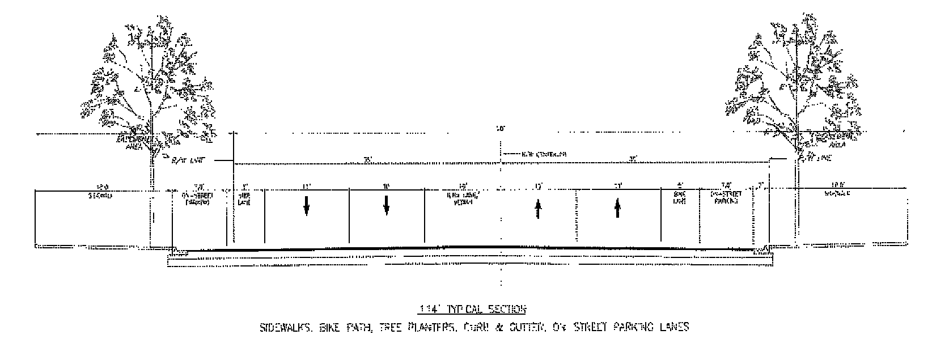

2. "B" Street with bicycle facility:

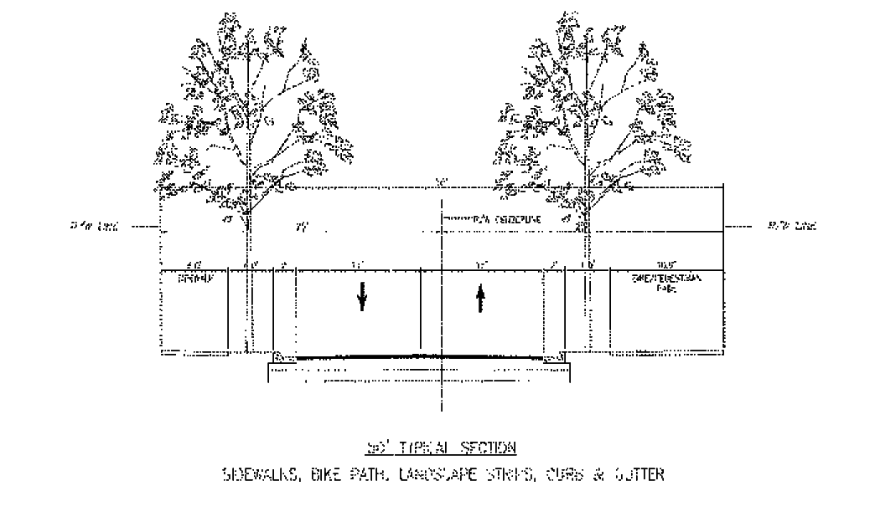

3. "C" Street with bicycle facility:

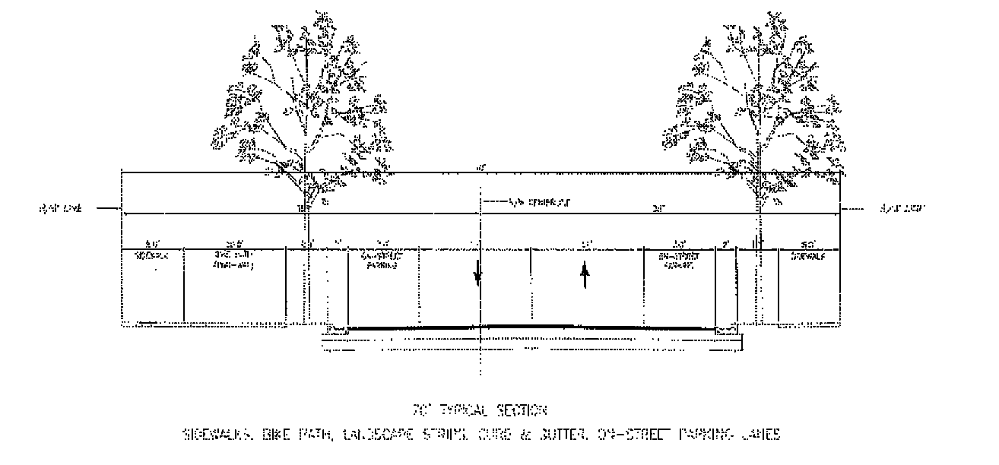

4. "C" Street with bicycle facility and truck parking/waiting area:

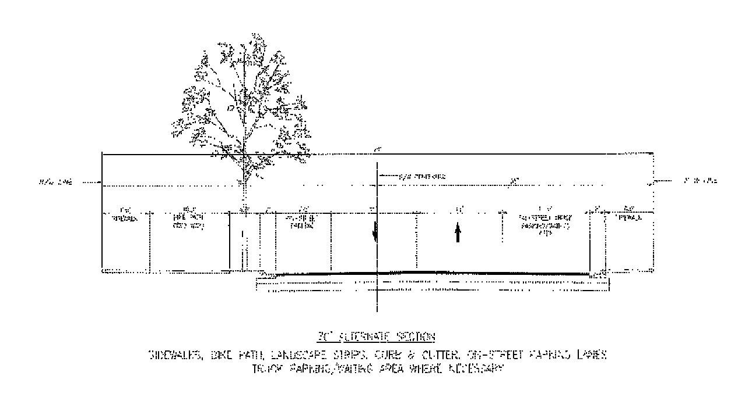

The truck parking/waiting area illustrated may occur on either or both sides of the street.

(3) *Walls, Fences, and Hedges.* Walls, fences, and hedges may be placed within the building frontage zone, provided that the minimum sidewalk width for the applicable street type is satisfied. Walls, fences, and hedges shall not exceed ninety-six (96) inches in height. Chain link fences shall not be permitted facing or within the Building Frontage Zone.

(4) *Open Space and Recreation Areas.*

(a) A minimum of ten (10) percent of net lot area shall be reserved for private open space. Colonnades, landscape areas, water features, pedestrian areas in the building frontage zone, landscaped roof terraces on buildings or garage structures may be counted towards this requirement. Up to twenty (20) percent of the area required for private open space may consist of submerged land areas.

(b) Development on lots adjoining the Miami River, Tamiami Canal, and/or Palmer Lake that contain uses permitted subject to the requirements of [Section 33-284.99.59](../level3/PTIIICOOR_CH33ZO_ARTXXXIII_T_PALAMEURCEDIPL.docx#PTIIICOOR_CH33ZO_ARTXXXIII_T_PALAMEURCEDIPL_S33-284.99.59US)(B)(4) shall provide a waterfront setback as provided below:

1. Lots with less than 150 feet of distance as measured perpendicular from the adjoining street right of way to the mean high water line or bulkhead for more than 50 percent of the width of the lot shall provide a waterfront setback of ten (10) feet.

2. Lots with less than 150 feet of frontage along the Miami River, Tamiami Canal, or Palmer Lake as measured along the mean high water line or bulkhead shall provide a waterfront setback of ten (10) feet.

3. All other lots shall provide a waterfront setback of twenty (20) feet.

4. Any portion of a lot with less than 50 feet of distance as measured perpendicular from the adjoining street right of way to the mean high water line or bulkhead shall not be required to provide a waterfront setback for that portion of the lot.

5. Within the setback area, a hard-surfaced walkway area shall be provided with a minimum width of sixty (60) percent of the required setback width. The setback area shall be furnished with seating areas, lighting, decorative trash receptacles, and landscaping as appropriate. Colonnades and/or cantilevered building elements shall be permitted to encroach into the setback area. Walkways shall be designed to permit connections to existing or future walkways located on adjoining waterfront lots. The setback area and walkway shall be accessed from the street by exterior walkways or through building interiors, courtyards, or breezeways. The setback area, walkway and accessways shall permit general public access seven (7) days a week from at least seven (7) AM to ten (10) PM. For lots adjoining Palmer Lake, docks or boardwalks located over the lake providing similar amenities shall satisfy the setback requirement. That portion of a lot occupied by a water-dependent use shall be exempt from the requirements of this sub-section.

(c) Along the Miami River Greenway, as shown in the "Greenway and Bicycle Plan" above, the following shall be required: sidewalk, multi-use path, and/or bicycle path.

(5) *Parking.*

(a) Parking shall be provided as per [Section 33-124](../level3/PTIIICOOR_CH33ZO_ARTVIIOREPA.docx#PTIIICOOR_CH33ZO_ARTVIIOREPA_S33-124ST) of this Code, except as follows:

(1) The minimum parking for the following types of development shall be as follows:

i. Residential—One (1) parking space per dwelling unit.

ii. Office—One (1) parking space per four-hundred (400) square feet of gross floor area.

iii. Hotel—One (1) parking space for the first forty (40) guest rooms and one (1) additional parking space for every two (2) guest rooms or suites thereafter.

(2) Parking reduction. Development meeting the following criteria shall be permitted to reduce the number of parking spaces required in accordance with the following table:

|  |  |  |  |  |
| --- | --- | --- | --- | --- |
| Use | Location, Parcel Requirement | Permitted reduction of required parking as otherwise provided in this section | | |
| MIC Core | Center | Riverside |
| **Group 1: Work-force reduction** | | | | |
| Work-force housing units (WHU) as defined in this Article | No location limitation | 25%* | 25%* | 25%* |
| **Group 2: Location reduction** | | | | |
| Non-residential, mixed-use, multi-family residential | Within one-quarter (¼) mile of a bus stop or rail station serviced by premium transit** | 75% | 60% | 50% |
| Non-residential, mixed-use, multi-family residential | Within one-half (½) mile of a bus stop or rail station serviced by premium transit** | 50% | 40% | 30% |
| Non-residential, mixed-use, multi-family residential | Within three-quarters (¾) mile of a bus stop or rail station serviced by premium transit** | 40% | 30% | 20% |
| **Group 3: Parcel size reduction** | | | | |
| Mixed-use | Parcels less than fifteen-thousand (15,000) square feet | 75% | 60% | 50% |
| Mixed-use | Parcels between fifteen-thousand (15,000) and thirty-thousand (30,000) square feet | 40% | 40% | 30% |
| Mixed-use | Parcels greater than thirty-thousand (30,000) square feet | 30% | 20% | 20% |
| * Percentage reduction applies only to those spaces required by WHU restricted residential units | | | | |
| ** Distance measured from the perimeter of Tracts "C," "F," and "G" of the Miami Intermodal Center, Plat Book 168, Page 53. | | | | |

Developments meeting more than one of the use, location, and parcel criteria shall be permitted to combine each permitted reduction; the combined reduction shall be calculated by reducing the first applicable criteria from each group in the order of the table above.

(3) Off-street parking areas shall be located:

i. On the same lot as the use to be served; or

ii. On a lot within the PLMUC that is within seven hundred fifty (750) feet of the site of the use(s) to be served, provided that such use(s) shall immediately terminate in the event such parking area therefor is not available, and provided that all parties having any right, title, or interest in and to the property being served shall execute and place on the public records of this County a covenant approved by the Director that such use(s) shall cease and terminate upon the elimination of such parking area, and that no use shall be made of such property until the required parking area is available and provided.

(4) On-street parking spaces directly abutting a lot shall count toward the parking requirement for development of that lot. In the event that on-street parking spaces are removed due to roadway improvements, those removed spaces that were counted toward a development's parking requirement shall not cause that development to become nonconforming.

(b) Surface parking lots shall be located a minimum of twenty (20) feet from the front property line along "A" and "B" Streets. Along all streets, surface parking lots shall not be permitted within the building frontage zone or forecourt areas. Walls and/or habitable space shall be built adjoining the building frontage zone to screen parking from view.

(c) Parking garages adjoining the building frontage zone along "A" street frontages shall be entirely screened by habitable space for a minimum depth of twenty (20) feet and the entire height of the garage structure.

(d) Parking garages adjoining the building frontage zone along "B" and "C" street frontages shall be entirely screened by habitable space for a minimum depth of twenty (20) feet at the ground story of the garage structure; except that lots with more than one street frontage shall be required to provide screening for fifteen (15) percent of the garage structure's ground story frontage along the lower-ranking streets.

(e) Parking garages facing "A" streets that have a lot depth at any one (1) point of less than one hundred fifty (150) feet shall be required to provide habitable space only at the ground floor. However, architectural expression shall comply with the requirements of this article.

(f) Drop-off drives and porte-cocheres shall not adjoin an "A" street frontage.

(g) Loading and service entries shall be allowed only on "C", "D" and "E" streets, alleys and within parking lots and structures. For those lots with frontages only on one street, loading and servicing shall be allowed from the street frontage.

(h) Pedestrian entries to parking garages shall be directly from the street frontage as well as from the contiguous building.

(i) Parking lots shall provide for pedestrian and vehicular cross access to existing and prospective adjacent parking lots.

(j) Parking stall dimensions and spaces for persons with disabilities and/or strollers shall comply with Article VII of this chapter.

(k) Bicycle racks shall be provided in accordance with [Section 33-122.3](../level3/PTIIICOOR_CH33ZO_ARTVIIOREPA.docx#PTIIICOOR_CH33ZO_ARTVIIOREPA_S33-122.3REBIRAOTMEST) of this Code.

(l) Mechanized parking shall be allowed for residential multi-family and non-residential buildings and, when provided, shall be exempt from the provisions of [Section 33-122](../level3/PTIIICOOR_CH33ZO_ARTVIIOREPA.docx#PTIIICOOR_CH33ZO_ARTVIIOREPA_S33-122REDEPASP) of this chapter. For the purposes of this article, mechanized parking shall be defined as a mechanism with vertical and horizontal transport capability that provides for automobile storage or retrieval. Mechanized parking spaces may be counted toward the minimum number of parking spaces required in this section, provided that:

i. A queuing analysis is submitted and approved during the Administrative Site Plan and Architectural Review; and

ii. Mechanized parking shall be located within an enclosed building/garage which shall be screened as provided in (c) and (d) above.

(m) The provisions of [Section 33-131](../level3/PTIIICOOR_CH33ZO_ARTVIIOREPA.docx#PTIIICOOR_CH33ZO_ARTVIIOREPA_S33-131USPAARCOPALO) of this chapter shall not apply to the required parking for any permitted use.

(n) Child care facilities located within mixed-use buildings shall be exempt from the auto-stacking requirements of Section [33-151.18](../level3/PTIIICOOR_CH33ZO_ARTXAEDCHCAFANO.docx#PTIIICOOR_CH33ZO_ARTXAEDCHCAFANO_S33-151.18PHST)(c) of this chapter.

(6) *Landscape.* With the exception of Sections [18A-7](../level2/PTIIICOOR_CH18AMIDECOLAOR.docx#PTIIICOOR_CH18AMIDECOLAOR_S18A-7LAPLRECR), [18A-8](../level2/PTIIICOOR_CH18AMIDECOLAOR.docx#PTIIICOOR_CH18AMIDECOLAOR_S18A-8PRCELACO), [18A-9](../level2/PTIIICOOR_CH18AMIDECOLAOR.docx#PTIIICOOR_CH18AMIDECOLAOR_S18A-9COLAAD), [18A-11](../level2/PTIIICOOR_CH18AMIDECOLAOR.docx#PTIIICOOR_CH18AMIDECOLAOR_S18A-11LAMA), [18A-12](../level2/PTIIICOOR_CH18AMIDECOLAOR.docx#PTIIICOOR_CH18AMIDECOLAOR_S18A-12PR) and [18A-13](../level2/PTIIICOOR_CH18AMIDECOLAOR.docx#PTIIICOOR_CH18AMIDECOLAOR_S18A-13EN), the provisions of [Chapter 18A](../level2/PTIIICOOR_CH18AMIDECOLAOR.docx#PTIIICOOR_CH18AMIDECOLAOR) of the Code of Miami-Dade County, Florida, shall not apply to properties in the PLMUC, except as provided herein. Trees and landscape shall be required for streets, medians, squares, plazas, and private property in accordance with the following:

(a) *Street Trees:* Street trees shall be placed along "A", "B", "C" and "E" Streets at a maximum average spacing of thirty-five (35) feet on center. Street trees shall have a minimum caliper of six (6) inches and shall have a minimum clear trunk of eight (8) feet at the time of planting. Where palms are used as street trees they shall be placed at a maximum average spacing of twenty-five (25) feet on center. Street trees shall be planted in one or more of the following methods of installation:

(1) *Tree grates.* Trees are planted within openings in the sidewalk. The openings shall be covered by permanently installed grates perforated to permit natural irrigation. The grates shall be installed flush with the surrounding sidewalk.

(2) *Tree planters.* Trees are planted within a raised planter located on the sidewalk. The planter shall be defined on all sides by a permanent masonry structure to consist of a minimum six (6) inch raised curb. The area within the planter, in addition to the required trees, shall be planted with ground cover, shrubs, or other appropriate plant material.

(3) *Continuous landscape strips.* Trees are planted in the area between the curb or roadway edge and the sidewalk. This area, in addition to the required trees, shall be planted with grass. Continuous landscape strips shall not be permitted along street frontages where the ground story of buildings are occupied by storefronts.

Street trees shall not be required where colonnades are provided and the sidewalk area outside of the colonnade is less than eight (8) feet in width. Where colonnades are provided and the sidewalk area outside the colonnade is between five (5) and eight (8) feet in width, one or more of the following shall be provided: landscaped planters located above the colonnade; a trellis attached to the colonnade structure and planted with climbing foliage; landscaped planters located adjoining the colonnade columns. On streets designated "Miami River Greenway" on the Greenway and Bicycle Plan, street trees shall not be planted within the required unobstructed sidewalk area.

(b) Median Trees: Median trees shall have a minimum caliper of six (6) inches and shall have a minimum clear trunk of eight (8) feet at time of planting. Median planting shall provide a one hundred (100) percent canopy coverage within two (2) years of installation. Median trees may be a maximum of twenty (20) percent flowering trees or palms, which at time of planting shall have a minimum height of fifteen (15) feet, a minimum spread of ten (10) feet, and a minimum caliper of three (3) inches.

(c) Tree requirements for private property shall be based on fifteen (15) trees per net acre of lot area. Trees shall have a minimum caliper of six (6) inches and shall have a minimum clear trunk of eight (8) feet at time of planting.

(d) At grade parking lots shall follow all requirements of [Section 18A](../level2/PTIIICOOR_CH18AMIDECOLAOR.docx#PTIIICOOR_CH18AMIDECOLAOR)(6)(J) of this Code.

All landscaped areas shall be continuously maintained in a good, healthy condition, and sprinkler systems of sufficient size and spacing shall be installed to serve all required landscaped areas and parking lots. Irrigation shall supply a minimum of the equivalent one and one-half (1½) inch rainfall per week. Rain sensors shall be installed in all systems.

(7) *Signs.* Except as provided herein, the definitions set forth in [Section 33-84](../level4/PTIIICOOR_CH33ZO_ARTVISI_DIV1TIAPPUDE.docx#PTIIICOOR_CH33ZO_ARTVISI_DIV1TIAPPUDE_S33-84DE) of this chapter shall apply. In the event of a conflict, the provisions of this section shall govern.

(a) *Temporary signs.* Temporary signs (Class A) shall be permitted in compliance with [Section 33-99](../level4/PTIIICOOR_CH33ZO_ARTVISI_DIV3SISTRECH.docx#PTIIICOOR_CH33ZO_ARTVISI_DIV3SISTRECH_S33-99CLTESI) of this chapter.

(b) *Permanent Point of Sale Signs.* Permanent point of sale signs (Class B) shall be permitted as follows:

(1) For purposes of this section, the following definitions shall apply:

i. *Digital technology (signs):* Electronic technology that allows for changes to a sign copy resulting from digital data input. Included in this technology are signs that use series of lights, including light emitting diodes (LED), fiber optics, or other similar technology.

ii. *Nits:* Luminance is the measure of the light emanating from an object with respect to its size and is the term used to quantify electronic sign brightness. The unit of measurement for luminance is nits (nt), which is the total amount of light emitted from a sign divided by the surface area of the sign [candelas per square meter (cd/m2)].

(2) The following permanent point of sale signs are permitted in all sub-districts in conjunction with permitted business and industrial uses: monument sign, pylon, flat attached, hanging, awning, cantilever, and projecting. No other detached sign shall be permitted except monument signs.

i. Projecting signs shall be mounted and perpendicular to the building.

ii. The copy of an awning sign shall only be located on the valance of the awning.

iii. The bottom of a hanging sign shall be located at a minimum height of eight (8) feet from the finished floor.

iv. Monument signs, which are freestanding, 2-faced signs, shall have a base at least seventy-five (75) percent of the horizontal width of the sign and located directly on the ground or a maximum of twelve (12) inches above grade.

v. Cantilever signs are mounted on that portion of the building projecting horizontally, whether it be on the same plane as the roof line or not.

(3) Maximum size, location, and number of signs shall be as follows:

|  |  |  |
| --- | --- | --- |
| Sign Type | Size | Number of Signs |
| Flat Attached, Cantilever, Pylon, Projecting* | 10% of wall area** | Not limited |
| Hanging, Awning | 6 sq. ft. | Not limited |
| Monument* | monument: 25 sq. ft. maximum for first 50 feet of street frontage plus .75 sq. ft. for each additional foot of street frontage to a maximum sign face area of 40 sq. ft. | One per street frontage |
| *  Each side of a projecting, pylon, or monument sign with two faces shall count toward the maximum permitted sign area. | | |
| **  Where a building may be occupied by multiple tenants, the permitted sign area that results from the percentage of wall area is shared among all tenants. A sign survey shall be required at time of permitting to demonstrate compliance with the maximum sign area permitted. Up to thirty (30%) percent of the sign may be illuminated using digital technology. | | |

(4) Illumination/lighting shall comply with the following: Where digital technology is allowed, it shall be provided in compliance with the following:

i. No auditory message or mechanical sounds shall be emitted from the sign.

ii. The sign shall not display any illumination that moves, appears to move, blinks, fades, rolls, dissolves, flashes, scrolls, shows animated movement, or changes in intensity during the static display period.

iii. All digital signs shall be modulated so that, from sunset to sunrise, the brightness shall not be more than 500 Nits. Sunset and sunrise times are those times established by the Miami office of the National Weather Service. At all other times, the maximum brightness levels shall not exceed 5,000 Nits. All digital signs shall have installed ambient light monitors and at all times shall allow such monitors to automatically adjust the brightness level of the sign based on ambient light conditions.

iv. The message display shall not change more often than once each eight seconds, with all moving parts or illumination moving or changing simultaneously.

v. Any digital sign that malfunctions, fails, or ceases to operate in its usual or normal programmed manner shall immediately revert to a black screen and shall be restored to its normal operation conforming to the requirements of this section within twenty-four (24) hours.

(c) *Commercial signs.* Commercial signs (Class C) shall be permitted as follows:

(1) In the MIC Core Sub-district and along A, B, and C streets: Class C signs shall be permitted attached to buildings of at least seventy-five feet in height. Freestanding Class C signs shall not be permitted.

i. The lowest portion of the sign shall be at least thirty (30) feet above grade.

ii. The total sign area shall not occupy more than ten (10) percent of the wall area.

iii. The sign shall not obstruct balconies or terraces; signs located in front of building windows shall be perforated so as not to obstruct visibility from within.

iv. The sign shall not be oriented toward any residential zoning district adjacent to PLMUC.

(2) In all other areas:

i. Class C signs shall be permitted within bus shelter structures and pedestrian information displays located in the building frontage zone and/or the right-of-way.

ii. The maximum size of Class C signs within such structures or displays shall be thirty-two (32) square feet. Two-sided signs shall be permitted with one side counting toward the permitted sign area.

iii. Bus shelter structures and pedestrian information displays containing Class C signs shall be spaced at least one hundred (100) feet apart as measured parallel to the street centerline.

iv. The design, location, and construction of such structures or displays located in the right-of-way shall be approved by the Director of the Public Works and Waste Management Department and the Director of the Department of Regulatory and Economic Resources.

(d) *Directional signs.* Directional signs, to direct traffic flow and locate entrances and exits shall be permitted on private property in connection with any permitted use. Directional signs shall not exceed thirty-two (32) square feet in area. The maximum height above grade of a detached directional sign shall be twelve (12) feet. The number, setback, and locations of the signs shall be determined for each facility as part of the site plan review process. Directional signs shall be shown on site plans indicating sign size, location, and copy.

(Ord. No. 13-43, § 6, 5-7-13)

Sec. 33-284.99.61. Industrial uses disclosure.

(A) *Definitions.*

(1) *Affected land* for the purpose of this section means: any parcel of land that is zoned Palmer Lake Metropolitan Urban Center (PLMUC).

(2) *Interest in real property* means a nonleasehold, legal or equitable estate in land or any severable part thereof created by deed, contract, mortgage, easement, covenant, or other instrument.

(3) *Purchaser* means a buyer, transferee, grantee, donee, or other party acquiring an interest in real property.

(4) *Real property transaction* means the sale, grant, conveyance, mortgage, or transfer of an interest in real property.

(5) *Seller* means a transferor, grantor, donor, or other party conveying an interest in real property.

(B) *Disclosure statement for real property transactions involving Affected land.* The seller shall provide the purchaser with the following statement, which shall be set forth on a separate sheet of paper and shall be signed by the prospective purchaser prior to the execution of any other instrument committing the purchaser to acquire title to such real property or any other interest in any Affected land, as follows:

(1) For all Affected land, the statement shall include the following language:

LAND INVOLVED IN THIS TRANSACTION IS ZONED PALMER LAKE METROPOLITAN URBAN CENTER (PLMUC).

INDUSTRIAL ACTIVITIES WHICH MAY BE LAWFULLY CONDUCTED WITHIN THIS AREA INCLUDE BUT MAY NOT BE LIMITED TO: OPERATION OF MACHINERY; ENGINE BUILDING AND REPAIR; MARINE VESSEL BUILDING AND REBUILDING; FOOD PROCESSING; PROCESSING OF FREIGHT INCLUDING PACKING, CRATING, WAREHOUSING, AND DISTRIBUTION/RECEIVING; TRACTOR AND TRUCK TRAFFIC; THE GENERATION OF NOISE, ODORS, DUST AND FUMES ASSOCIATED WITH THE CONDUCT OF THE FOREGOING ACTIVITIES. THESE ACTIVITIES MAY OCCUR AT ANY TIME THROUGH THE DAY OR NIGHT.

I HEREBY CERTIFY THAT I HAVE READ AND UNDERSTAND THE FOREGOING STATEMENT.

____________      ____________   
Date     Signature of Purchaser

(C) *Acknowledgment of industrial uses disclosure statement on instrument of conveyance.* It shall be the seller's responsibility that the following statement shall appear in a prominent location on the face of any instrument conveying title to or any other interest in Affected land. The seller shall record the notarized statement with the Clerk of the Court:

I HEREBY CERTIFY THAT I HAVE READ, UNDERSTAND AND HAVE SIGNED THE INDUSTRIAL USES DISCLOSURE STATEMENT FOR THE SALE OF OR OTHER TRANSACTION INVOLVING THIS PARCEL OF AFFECTED LAND AS REQUIRED BY [SECTION 33-284.99.61](../level3/PTIIICOOR_CH33ZO_ARTXXXIII_T_PALAMEURCEDIPL.docx#PTIIICOOR_CH33ZO_ARTXXXIII_T_PALAMEURCEDIPL_S33-284.99.61INUSDI), CODE OF MIAMI-DADE COUNTY, FLORIDA.

____________      ____________   
Date     Signature of Purchaser

(D) *Penalties.* Any seller who violates any provision of this section, or fails to comply therewith, or with any lawful rule, regulation or written order promulgated under this section, shall be subject to the penalties, civil liability, attorney's fees and enforcement proceedings set forth in Sections [33-39](../level3/PTIIICOOR_CH33ZO_ARTIINGE.docx#PTIIICOOR_CH33ZO_ARTIINGE_S33-39PEVICH) through [33-39.3](../level3/PTIIICOOR_CH33ZO_ARTIINGE.docx#PTIIICOOR_CH33ZO_ARTIINGE_S33-39.3COAG), Code of Miami-Dade County, Florida, and to such other penalties, sanctions and proceedings as may be provided by law. Miami-Dade County shall not be held liable for any damages or claims resulting from the seller's failure to comply with provisions of this section.

(Ord. No. 13-43, § 7, 5-7-13)

Sec. 33-284.99.62. Review procedure.

(1) Projects following the provisions of this article and the Regulating Plans shall be processed and approved administratively. The Miami-Dade County Department of Regulatory and Economic Resources shall review the applications, including exhibits listed below, for completeness and compliance with the provisions of this article and the Regulating Plans. All complete submissions to the Department shall be reviewed and approved or denied within twenty-one (21) days from the date of submission of the completed application. The applicant shall have the right to extend the twenty-one (21) day period by an additional twenty-one (21) days upon timely request made in writing to the Department. The Department shall have the right to extend the twenty-one (21) day period by written notice to the applicant that additional information is needed to process the site plan. Denials shall be in writing and shall specifically set forth the grounds for the denial. Any final decision of the Director may be appealed in accordance with the public hearing procedure established in Article XXXVI of this Code and in accordance with the procedure established for appeals of administrative decisions.

(2) Exhibits prepared by design professionals such as architects and landscape architects shall be submitted to the Department and shall include, but not be limited, to the following:

(A) Site plan(s) including:

(1) Lot lines, building frontage zone and setbacks.

(2) Location, shape, size and height of existing and proposed building construction and landscaping.

(3) Location of on-street and off-street parking, loading facilities, waste collection areas, and all above ground utilities.

(4) Indication of signage.

(5) Indication of any site or building design methods used to conserve energy.

(6) Street type designations as per this Article.

(7) Indication of Sub-District boundaries as per this Article.

(B) Landscape plans including specification of plant material, location and size.

(C) Floor plans and elevations of all structures, including total gross square foot area of each floor and all dimensions relating to the requirements of this Article.

(D) Figures indicating the following:

(1) Gross and net acreage.

(2) Amount of landscaped open space in square feet and percentage required and provided.

(3) Total square footage of all land uses.

(4) Amount of building coverage at ground level in square feet and percentage.

(5) Total trees required and provided, indicating on site and off site contribution within the District.

(6) Parking required and provided.

(7) Total amount of paved area in square feet.

(8) Total number of dwelling units.

(9) Such other design data as may be needed to evaluate the project.

(3) In the case of multiple-phase development, each phase of the development, whether standing independently or in conjunction with existing developed or proposed future contiguous phases, shall meet all the requirements of this Article. Notwithstanding the review procedure contained herein, all requests for the subdivision of property within the Palmer Lake Urban Center District shall have previously received site plan approval in accordance with the requirements of this section or [Section 33-284.99.63](../level3/PTIIICOOR_CH33ZO_ARTXXXIII_T_PALAMEURCEDIPL.docx#PTIIICOOR_CH33ZO_ARTXXXIII_T_PALAMEURCEDIPL_S33-284.99.63ZOHERE) below.

(Ord. No. 13-43, § 8, 5-7-13)

Sec. 33-284.99.63. Zoning hearing review.

Relief from the following requirements of this Article shall be permitted only pursuant to the standards and requirements of [Section 33-311](../level3/PTIIICOOR_CH33ZO_ARTXXXVIZOPR.docx#PTIIICOOR_CH33ZO_ARTXXXVIZOPR_S33-311COZOAPBOUTDU)(A)(4)(a) of this chapter:

(1) Building frontage requirements.

(2) Storefront requirements.

(3) Habitable space requirements.

(Ord. No. 13-43, § 9, 5-7-13)

Sec. 33-284.99.64. Nonconforming structures and uses.

Nonconforming uses and structures shall be governed by the provisions of [Section 33-284.89.2](../level3/PTIIICOOR_CH33ZO_ARTXXXIII_K_STURCEDIRE.docx#PTIIICOOR_CH33ZO_ARTXXXIII_K_STURCEDIRE_S33-284.89.2NOLOUSST) of this chapter.

(Ord. No. 13-43, § 10, 5-7-13)

Sec. 33-284.99.65. Conflicts with other chapters and regulations.

When conflicts with other Zoning, Subdivision or the Landscape regulations occur, this article shall take precedence. Where conflicts occur with Miami-Dade Department of Public Works and Waste Management Manual of Public Works, unless otherwise approved by the Director of the Public Works and Waste Management Department and the Director of the Department of Regulatory and Economic Resources, this article shall take precedence. Notwithstanding the foregoing, development in the Palmer Lake Metropolitan Urban Center District shall comply with the provisions of Article XXXVII - Miami International Airport (Wilcox Field) Zoning.

(Ord. No. 13-43, § 11, 5-7-13)

Sec. 33-284.99.66. Legal description and applicability.

A portion of Sections 28 and 29, Township 53 South, Range 41 East, Miami-Dade County, Florida; being more particularly described as follows:

BEGINNING AT A POINT being the intersection of NW 37th Avenue and NW 21st Street also being a point 436 feet north of the southwest corner of [Section 28](../level2/PTIIICOOR_CH28SU.docx#PTIIICOOR_CH28SU) Township 53 Range 41, thence west along the centerline of said NW 21st Street 720 feet to a point, thence north to a point being the southwest corner of TRACT F of MIAMI INTERMODAL CENTER (PB 168 PG 53), thence north 237.5 feet along the west line of said TRACT F to a point, thence east 55.92 feet east to a point being ±16 feet west of the southwest corner of TRACT D of MIAMI INTERMODAL CENTER (PB 168 PG 53), thence north along and parallel of the west line of said TRACT D to a point being 7.5 ft west of the northwest corner of said TRACT D, thence ±83 feet northeasterly to a point being the southwest corner of TRACT J of MIAMI INTERMODAL CENTER (PB 168 PG 53), thence north 842 feet along the west line of said TRACT J to a point, thence west ±59.5 feet to a point, thence northwesterly for a curvilinear distance of ±923 feet along the north right of way line of the south wye track of the SEABOARD AIR LINE RAILROAD to a point, thence northeasterly for a curvilinear distance of ±882 feet along the south right of way line of the north wye track of the SEABOARD AIR LINE RAILROAD to a point, thence north to ±203 feet to a point being the intersection of the centerline of NW South River Drive and SEABOARD AIR LINE RAILROAD, thence northwesterly ±283 feet to a point being the intersection of NW 31st Street and NW South River Drive, thence northeasterly 255 feet to a point, thence meandering southeasterly 6,340 feet along the centerline of MIAMI CANAL to a point being the northeast corner of CANAL POINT (PB 30 PG 63), thence southeasterly 697 feet along the centerline of MIAMI CANAL to a point being 84 feet west of the southeast corner of the SW 1/4 of the SE 1/4 of the SE 1/4 of [Section 28](../level2/PTIIICOOR_CH28SU.docx#PTIIICOOR_CH28SU) Township 53 Range 41, thence west 2,055 feet along the south line of [Section 28](../level2/PTIIICOOR_CH28SU.docx#PTIIICOOR_CH28SU) Township 53 Range 41 to a point, thence north 47 feet to a point being southwest corner of LOT 486 of GRAPELAND HEIGHTS (PB 14 PG 63), thence north along the west line of said LOT 486 to a point being the northwest corner of said LOT 486, thence north 40 feet to a point being the centerline of TAMIAMI CANAL, thence meandering westerly ±2,553 feet along the centerline of said TAMIAMI CANAL to a point being 191 feet north of the southwest corner of [Section 28](../level2/PTIIICOOR_CH28SU.docx#PTIIICOOR_CH28SU) Township 53 Range 41, thence north 245 feet along the west line of [Section 28](../level2/PTIIICOOR_CH28SU.docx#PTIIICOOR_CH28SU) Township 53 Range 41 to the POINT OF BEGINNING.

Full scale maps of the Palmer Lake Metropolitan Urban Center boundary are on file with the Department of Regulatory and Economic Resources.

No provision in this article shall be applicable to any property except lands lying within the boundaries of the Palmer Lake Metropolitan Urban Center as described herein. No property lying within the boundaries of the Palmer Lake Metropolitan Urban Center shall be entitled to the uses or subject to the regulations provided in this article until an application for a district boundary change to the Palmer Lake Metropolitan Urban Center has been heard and approved in accordance with the provisions of this chapter.

(Ord. No. 13-43, § 12, 5-7-13)

### ARTICLE XXXIV. FEES

Sec. 33-285. Schedule of fees.

Secs. 33-286—33-290. Reserved.

Sec. 33-291. Exemption from fees.

Sec. 33-285. Schedule of fees.

All fees charged for services provided by the Department are established by separate administrative order which shall not become effective until approved by resolution of the Board of County Commissioners.

(Ord. No. 57-19, § 39, 10-22-57; Ord. No. 58-29, § 1, 7-15-58; Ord. No. 59-3, § 1, 2-10-59; Ord. No. 59-31, § 1, 8-18-59; Ord. No. 60-2, § 2, 1-19-60; Ord. No. 61-41, § 1, 10-3-61; Ord. No. 62-3, § 2, 2-6-62; Ord. No. 62-24, § 1, 6-5-62; Ord. No. 62-26, § 1, 6-19-62; Ord. No. 68-21, § 1, 4-16-68; Ord. No. 68-76, § 1, 12-17-68; Ord. No. 69-58, § 1, 9-17-69; Ord. No. 69-64, § 6, 9-17-69; Ord. No. 75-19, § 1, 3-18-75; Ord. No. 76-70, § 6, 7-20-76; Ord. No. 95-215, § 1, 12-5-95)

Secs. 33-286—33-290. Reserved.

Sec. 33-291. Exemption from fees.

The Board of Public Instruction, the County of Miami-Dade, the State of Florida, the United States of America, and all corporate municipalities situated wholly within the boundaries of the County, shall be exempted from the payment of any fee for a building permit or a certificate of use and occupancy where the work is done wholly by personnel of any such agency; where the work done for such agency is let on contract, the contractor shall secure the necessary permits and pay the required fees; where the work is to be done solely by personnel of the governmental agency, the permit shall be issued in the name of such agency upon application for any building construction, occupancy or usage, not contrary to the provisions of this chapter.

(Ord. No. 57-19, § 40, 10-22-57)

### ARTICLE XXXV. HOMESTEAD AIR FORCE BASE ZONING [53]

Sec. 33-292. Definitions.

Sec. 33-293. Establishing airport hazard area.

Sec. 33-293.1. Reference points of airport hazard area.

Sec. 33-293.2. Division of airport hazard area into zone.

Sec. 33-293.3. Zoning map adopted.

Sec. 33-294. Heights limitations.

Sec. 33-295. Use restrictions.

Sec. 33-296. Permits.

Sec. 33-297. Variances and appeals.

Sec. 33-298. Hazard marking and lighting.

Sec. 33-299. Relation to comprehensive zoning regulations.

Sec. 33-300. Penalties.

Sec. 33-301. Severability.

Sec. 33-292. Definitions.

As used in this article, unless the context otherwise required:

(1) *Airport* is the Homestead Air Force Base Airport.

(2) *Airport hazard* is any structure or tree or use of land which obstructs the air space required for the safe flight of aircraft in landing or taking-off or maneuvering at or in the vicinity of the airport, or is otherwise hazardous to such landing or taking-off of aircraft.

(3) *Airport hazard area* is any area of land or water upon which an airport hazard might be established if not prevented as provided in this article.

(4) *Nonconforming use* is any structure, tree, or use of land which does not conform to this article as of the effective date thereof.

(5) *Person* is any individual, firm, co-partnership, corporation, company, association, joint stock association or body politic, and includes any trustee, receiver, assignee or other similar representative thereof.

(6) *Structure* is any object constructed or installed by man, including but without limitation, buildings, towers, smokestacks, utility poles and overhead transmission lines.

(7) *Land area* is any land or water area outside the governmental reservation and lying within the unincorporated and incorporated area of the County.

(8) *Tree* is any object of natural growth.

(9) *Landing area* is that part of the airfield that is used or intended to be used for landing and taking-off of aircraft, and the adjacent clear zone.

(10) *Primary surface* is that surface which defines the limits of the obstruction clearance requirements in the immediate vicinity of the landing area. This area is entirely within the government reservation.

(11) *Clear zone surface* is an area entirely within the government reservation and defines the limits of the obstruction clearance requirements in the vicinity contiguous to the ends of the primary surfaces.

(12) *Approach-departure clearance surface* is an imaginary plane symmetrical about the runway centerline extended, beginning as an inclined plane (known as the glide angle) two hundred (200) feet beyond each end of the ultimate primary surface at the centerline elevation of the runway end (established airfield elevation) and extends for fifty thousand (50,000) feet. The slope of the approach-departure clearance surface is eighty to one (80:1) along the runway centerline extended (glide angle) until it reaches an elevation of five hundred (500) feet above the established airfield elevation. It then continues horizontally at this elevation to a point fifty thousand (50,000) feet from the start of the original inclined plane. The width of this surface at the runway end is two thousand (2,000) feet; it flares uniformly to a width of sixteen thousand (16,000) feet at fifty thousand (50,000) feet.

(13) *Inner horizontal surface* is a plane; oval shape at a height of one hundred fifty (150) feet above the established airfield elevation. It is constructed by scribing an arc with a radius of seventy-five hundred (7500) feet about the centerline at the ends of the runway and interconnecting these arcs with tangents.

(14) *Conical surface* is an inclined surface extending outward and upward from the outer periphery of the inner horizontal surface for a horizontal distance of seven thousand (7,000) feet to a height of five hundred (500) feet above the established airfield elevation. The slope of the conical surface is 20:1. It is constructed by scribing an arc with a radius of fourteen thousand five hundred (14,500) feet about the centerline at the ends of the runway and interconnecting these arcs with tangents.

(15) *Outer horizontal surface* is a plane located five hundred (500) feet above the established airfield elevation. It extends for a horizontal distance of thirty thousand (30,000) feet from the outer periphery of the conical surface.

(16) *Transitional surfaces* connect the primary surfaces, clear zone surface, and approach-departure clearance surfaces to the inter horizontal surface, conical surface, outer horizontal surface or other transitional surfaces. The slope of the transitional surface is seven to one (7:1) outward and upward at right angles to the runway centerline.

(17) *Established airfield elevation* is seven (7) feet above MSL.

(18) *Airfield reference point* is a point or points on the airfield from which certain distances relative to specific criteria referred to in this article are measured. For the purpose of this article, the reference points will be at each end of the runway and on its centerline. These points are described and located in [Section 33-293.1](../level3/PTIIICOOR_CH33ZO_ARTXXXVHOAIFOBAZO.docx#PTIIICOOR_CH33ZO_ARTXXXVHOAIFOBAZO_S33-293.1REPOAIHAAR)

(19) *A zone* is that area of land falling beneath any surface and each zone will have the same name as the surface describing it.

(20) *Administrative agency* is the Department, with its Director as the chief executive, is hereby designated the administrative agency charged with the duty of administering and enforcing the regulations herein prescribed, including that of hearing for permits.

(21) *MSL—Mean sea level* whenever the term MSL or mean sea level is used in the article, the same shall mean one (1) and the same thing.

(22) *The County's Community Zoning Appeals Board* is hereby appointed the "Board of Adjustment," pursuant to Section 333.10, Florida Statutes.

(Ord. No. 68-33, § 1, 5-21-68; Ord. No. 95-215, § 1, 12-5-95; Ord. No. 98-125, § 21, 9-3-98)

Sec. 33-293. Establishing airport hazard area.

All of the land and water in this County which falls within the limits of the approach-departure clearance surfaces, and the outer horizontal surface, or surfaces closer to Homestead AFB, except land within the boundaries of Homestead Air Force Base, is declared to be in the airport hazard area and is subject to limitations of height and use control established by this article.

(Ord. No. 68-33, § 1, 5-21-68)

Sec. 33-293.1. Reference points of airport hazard area.

(1) Reference points 1 and 2 are the reference points of the airport hazard area and are related to a primary reference point two hundred fifty (250) feet east and one hundred (100) feet south of the northwest corner of the N ½ of the NW ¼ of the SW ¼ of the NW ¼ of Township 57 South, Range 39 East, [Section 12](../level2/PTIIICOOR_CH12EL.docx#PTIIICOOR_CH12EL), Miami-Dade County, Florida, which is the location of the control tower which is also described as being at

Lat  
25° - 29′ - 18.9″

Long  
80° - 23′ - 39.9″

For the purpose hereof, the elevation of this point is seven (7) feet above mean sea level.

(2) Reference point No. 1 is at the northeast end of the runway and on its centerline. This point is located one thousand (1,000) feet from surveying monument HAF-41 on a true bearing of S49°03′29″W. The location of HAF-41 monument is as follows:

N  
- 424, 425.21

E  
- 708, 243.92

Lat  
- 25° - 29′ - 59.808″

Lon  
- 80° - 22′ - 07.135″

For the purpose hereof, the elevation of this point is seven (7) feet above mean sea level.

(3) Reference point No. 2 is at the southwest end of the runway and on its centerline. This point is located one thousand two hundred sixty-two and thirty-five hundredths (1,262.35) feet from surveying monument HAF-25 on a true bearing of N 49° 02′ 29″ E. The location of HAF-25 monument is as follows:

N  
- 415, 609.25

E  
- 698, 081.42

Lat  
- 25° - 28′ - 32.958″

Lon  
- 80° - 23′ - 58.482″

For the purpose hereof, the elevation of this point is seven (7) feet above mean sea level.

(Ord. No. 68-33, § 1, 5-21-68)

Sec. 33-293.2. Division of airport hazard area into zone.

The airport hazard area outside of the government reservation boundary is divided into height limiting zones as follows: approach-departure clearance surface zones, inner horizontal surface zones, outer horizontal surface zones and transitional surface zones.

(Ord. No. 68-33, § 1, 5-21-68)

Sec. 33-293.3. Zoning map adopted.

The Board of County Commissioners shall, by resolution, adopt, approve, and ratify a drawing which shall be entitled Homestead Air Force Base, Tab. No. F 5, sheet 1 of 1, as revised by Base Civil Engineers on September 1, 1967, on drawing original[ly] prepared by Weed, Johnson Associates, April 1, 1960. Such drawing shall locate and identify Homestead Air Force Base and other topographic data pertinent thereto and to the purposes of this article and it shall also truly and faithfully depict the boundaries of airport zoning area; and by contour lines, the height limitations, for the several zone classification districts therein as the same are established herein and as the same may be changed, varied, amended or supplemented by resolution as provided and prescribed in [Chapter 33](../level2/PTIIICOOR_CH33ZO.docx#PTIIICOOR_CH33ZO) of the Code of Miami-Dade County, Florida. Copies or prints of such drawing shall be maintained and kept on file in the offices of the Homestead Air Force Base and the Department and shall be prima facie evidence of the boundaries of the zone classification districts and the height limitations applicable thereto and therein.

(Ord. No. 68-33, § 1, 5-21-68; Ord. No. 95-215, § 1, 12-5-95)

Sec. 33-294. Heights limitations.

Except as otherwise provided in this article, any structure which is erected, increased in height or tree allowed to grow so as to project above the height of the controlling imaginary surface as specified hereunder will be considered a flight hazard and in violation of this article.

(a) *Approach-departure clearance surfaces.* There is only one (1) runway at Homestead Air Force Base. This runway has a true north bearing of 49 degrees, 03 minutes, 29 seconds east. The magnetic declination at the Homestead Air Force Base is 1 degree, 10 minutes east. A height limitation within each surface is hereby established which will provide a clear space above the entire area of the approach-departure clearance surface, the height limitations being represented by a sloping plane, the base of which is two thousand (2,000) feet wide and begins two hundred (200) feet beyond the ultimate length of the runway and extends outward and upward on a ratio of eighty (80) feet horizontal to one (1) foot vertical for a horizontal distance of forty thousand (40,000) feet, at which point it reaches a vertical height of five hundred seven (507) feet above the mean sea level and a horizontal width of thirteen thousand two hundred (13,200) feet. This plane continues at a vertical height of five hundred seven (507) feet above MSL until it reaches a horizontal distance of fifty thousand (50,000) feet and horizontal width of sixteen thousand (16,000) feet. The maximum permissible heights within the approach-departure clearance surface zone, based on mean sea level, shall be listed in the following tabulation:

|  |  |  |
| --- | --- | --- |
| Dist. from end of runway in feet | Width of zone in feet | Max. permissible elev. in feet |
| 200 | 2,000 | 7 |
| 1,000 | 2,224 | [17](../level2/PTIIICOOR_CH17HO.docx#PTIIICOOR_CH17HO) |
| 5,000 | 3,344 | 67 |
| 10,000 | 4,744 | 129 |
| 15,000 | 6,144 | 192 |
| 20,000 | 7,544 | 255 |
| 25,000 | 8,944 | 317 |
| 30,000 | 10,344 | 380 |
| 35,000 | 11,744 | 442 |
| 40,000 | 13,144 | 504 |
| 40,200 | 13,200 | 507 |
| 50,200 | 16,000 | 507 |

(b) *Inner horizontal surface.* The height limitation within the inner horizontal surface zone is one hundred fifty (150) feet above the established airfield elevation or one hundred fifty-seven (157) feet above mean sea level.

(c) *Conical surface.* The height limitations within the conical surface zone are given in the following tabulations:

|  |  |
| --- | --- |
| *Distance from outer*  *edge of inner horizontal*  *surface (Feet)* | *Maximum permissible height above*  *MSL*  *(Feet)* |
| 0 | 157 |
| 1,000 | 207 |
| 2,000 | 257 |
| 3,000 | 307 |
| 4,000 | 357 |
| 5,000 | 407 |
| 6,000 | 457 |
| 7,000 | 507 |

(d) *Outer horizontal surface.* The height limitation within the outer horizontal surface zone is five hundred (500) feet above the established airfield elevation or five hundred seven (507) feet above mean sea level.

(e) *Transitional surfaces.* The height limitation along the intersection of the transitional surface zones and the approach-departure clearance surface are given in the following tabulations:

|  |  |  |
| --- | --- | --- |
| *Distance from end of*  *runway*  *(Feet)* | *Distance from*  *runway*  *centerline*  *(Feet)* | *Permissible height above mean sea level (Feet)* |
| 200 | 1,000 | 7 |
| 1,400 | 1,168 | [22](../level2/PTIIICOOR_CH22WATH.docx#PTIIICOOR_CH22WATH) |
| 2,600 | 1,336 | 37 |
| 3,800 | 1,504 | 52 |
| 5,000 | 1,672 | 67 |
| 7,400 | 2,008 | 97 |
| 9,800 | 2,344 | 127 |
| 12,200 | 2,680 | 157 |
| 14,600 | 3,016 | 187 |
| 19,400 | 3,688 | 247 |
| 29,000 | 5,032 | 367 |
| 38,600 | 6,376 | 487 |
| 40,200 | 6,600 | 507 |

(Ord. No. 68-33, § 1, 5-21-68)

Sec. 33-295. Use restrictions.

(a) Notwithstanding any other provisions of this article, no use may be made of land within the airport hazard area in such a manner as to create electrical interference with radio communications between the airport and aircraft, make it difficult for flyers to distinguish between airport lights and others, result in glare in the eyes of flyers using the airport, impair visibility in the vicinity of the airport, or otherwise endanger the landing, taking-off or maneuvering of aircraft.

(b) In addition to the height limitations which apply to the approach-departure surface zone, use of the land in the area defined as the approach-departure surface zones shall be controlled so as to prevent location or construction of places of public assembly, schools, churches, hospitals, barracks, and apartment housing, and such uses are hereby prohibited in these surface zones.

(Ord. No. 68-33, § 1, 5-21-68)

Sec. 33-296. Permits.

Before any new structure or use may be constructed or established and before any existing use or structure may be substantially changed or substantially altered or repaired, and before any nonconforming structure or tree may be replaced, substantially altered or repaired, rebuilt, allowed to grow higher, or replanted, a permit must be secured from the Administrative Agency. Except as provided herein, applications for permits shall be granted, provided the matter as applied for meets the provisions of this article.

(a) *New uses.* No material change shall be made in the use of land, and no structure shall be erected, altered, or otherwise established, in the airport hazard area, unless a permit has been applied for and granted by the administrative agency. No tree shall be planted within the transitional surface zones, within three thousand (3,000) feet from the ends of the runways, unless a permit has been applied for and granted by the administrative agency. Each such application shall indicate the purpose for which the permit is desired, with sufficient particularity to permit the administrative agency to determine whether the resulting use, structure, or tree would conform to this chapter. If such determination is in the affirmative, the permit applied for shall be granted. If such determination is in the negative, the permit applied for shall be denied.

(b) *Existing uses.* Before any existing use, structure or tree may be replaced, substantially altered or repaired, rebuilt, allowed to grow higher, or replanted, in the airport hazard area, a permit must be secured from the administrative agency, authorizing such replacement, change or repairs. No such permit shall be granted that would allow the establishment or creation of any airport hazard or permit a nonconforming use, structure, or tree to be made or become higher, or become a greater hazard to air navigation, than it was on the effective date of this article [ten (10) days after March 21, 1968] or than it was when the application for a permit is made.

(c) *Nonconforming uses.* Wherever the administrative agency determines that a nonconforming structure or tree has been abandoned or is more than eighty (80) percent torn down, destroyed, deteriorated or decayed:

(1) No permit shall be granted that would allow said structure or tree to exceed the applicable height limit or otherwise deviate from the zoning regulations; and

(2) Whether application is made for a permit under this subsection or not, the said agency may, by appropriate action, compel the owner of the nonconforming structure or tree, at his own expense, to lower, remove, reconstruct, or equip such object as may be necessary to conform to the regulations. If the owner of the nonconforming structure or tree shall neglect or refuse to comply with such order for ten (10) days after notice thereof, the said agency may report the violation to the political subdivision involved therein, which subdivision, through its appropriate agency, may proceed to have the object lowered, removed, reconstructed, or equipped and assess the cost and expense thereof upon the object or the land, whereon it is or was located, and unless such an assessment is paid within ninety (90) days from the service of the notice thereof on the owner or his agent of such object or land, the sum shall be a lien on said land, and shall bear interest thereafter at the rate of six (6) percent per annum until paid, and shall be collected in the same manner as taxes on real property are collected by said political subdivision, said lien may be enforced in the manner provided for enforcement of liens by Chapter 86, Florida Statutes.

(d) In addition to the permits required herein in the event the land area is in an incorporated area, building permits must be obtained from the applicable municipality.

(Ord. No. 68-33, § 1, 5-21-68)

Sec. 33-297. Variances and appeals.

Any person desiring to erect any structures, or increase the height of any structure, or permit the growth of any tree, or otherwise use his property in violation of the airport zoning regulations adopted under this chapter, may apply to the Community Zoning Appeals Board for a variance from the zoning regulations in question. Such variances shall be allowed where a literal application or enforcement of regulations would result in practical difficulty or unnecessary hardship and the relief granted would not be contrary to the public interest but do substantial justice and be in accordance with the spirit of these regulations. Provided, that any variance may be allowed subject to any reasonable conditions that the Board may deem necessary to effectuate the purpose of these regulations. All such variances shall be applied for in the same manner as any other variances and shall be granted only after the same notice and hearing as required in the case of other variances. Any person aggrieved, or taxpayer affected, by any decision of the administrative agency made in its administration of these airport zoning regulations or any governing body or Board of a political subdivision, or any airport zoning board, which is of the opinion that a decision of such administrative agency is an improper application of these airport zoning regulations of concern to such governing body, may appeal to the Community Zoning Appeals Board to hear and decide appeals from the decision of such administrative agency.

(Ord. No. 68-33, § 1, 5-21-68; Ord. No. 98-125, § 21, 9-3-98)

Sec. 33-298. Hazard marking and lighting.

In granting any permit or variance under these regulations, the administrative agency or Board of Adjustments may, if it deems such action advisable, to effectuate the purposes of these regulations and reasonable in the circumstances, so condition such permit or variance as to require the owner of the structure or tree in question to install, operate and maintain at his own expense, thereon hazard markers and lights which conform to the Federal Aviation Authority Standards as may be necessary to indicate to pilots the presence of an airport hazard. Upon conditions mutually agreeable to the United States Air Force and to the owner of an existing structure or tree, the United States Air Force shall be granted a permit to alter the height of the hazard or to install, operate and maintain thereon hazard markers and lights, at its own expense, as may be deemed necessary by the United States Air Force to indicate to pilots the presence of an airport hazard.

(Ord. No. 68-33, § 1, 5-21-68)

Sec. 33-299. Relation to comprehensive zoning regulations.

In the event of conflict between any airport zoning regulations adopted under this article and any other regulations applicable to the same area, whether the conflict be with respect to the height of structures or trees, the use of the land, or any other matter, the more stringent limitation or requirement shall govern and prevail.

(Ord. No. 68-33, § 1, 5-21-68)

Sec. 33-300. Penalties.

Each violation of these regulations, or any order or ruling promulgated hereunder, shall constitute a violation and shall be punishable by a fine of not more than five hundred dollars ($500.00) or by imprisonment, and each day a violation continues to exist shall constitute a separate offense.

(Ord. No. 68-33, § 1, 5-21-68)

Sec. 33-301. Severability.

If any of the provisions of this article or application thereof to any person or circumstances is held invalid, such invalidity shall not affect other provisions or applications of the resolution which can be given effect without the invalid provisions or applications, and to this end the provisions of this article are declared to be severable.

(Ord. No. 68-33, § 1, 5-21-68)

FOOTNOTE(S):

--- (**53**) ---

**Editor's note—** Article XXXV, §§ 33-292—33-301, is derived from Ord. No. 68-33, § 1, adopted May 21, 1968. This ordinance amended said sections to read as herein set out. Formerly said sections pertaining to similar subject matter were derived from Ord. No. 57-21, §§ 2—12, adopted Oct. 22, 1957. (Back)

### ARTICLE XXXVI. ZONING PROCEDURE [54]

Sec. 33-302. Definitions.

Sec. 33-303. Exclusive procedure.

Sec. 33-303.1. Developmental Impact Committee.

Sec. 33-303.2. Airport Developmental Impact Committee.

Sec. 33-304. Applications.

Sec. 33-304.1. Voluntary contribution or dedication of property to Miami-Dade County or Miami-Dade County School Board.

Sec. 33-305. District boundary maps.

Sec. 33-306. Community Zoning Appeals Boards—Establishment.

Sec. 33-307. Community Zoning Appeals Boards—Term of office.

Sec. 33-307.1. Community Zoning Appeals Board; prohibition of members appearance.

Sec. 33-308. Community Zoning Appeals Board—Organization.

Sec. 33-309. Community Zoning Appeals Board/Board of County Commissioners Applications for public hearing.

Sec. 33-310. Notice and hearing prerequisite to action by the Community Zoning Appeals Boards or Board of County Commissioners.

Sec. 33-310.1. Administrative modification or elimination of conditions and restrictive covenants.

Sec. 33-310.2. Application for administrative approval on existing mobile home park site.

Sec. 33-311. Community Zoning Appeals Board—Authority and duties.

Sec. 33-312. Community Zoning Appeals Board—Decisions.

Sec. 33-313. Appeals to Board of County Commissioners.

Sec. 33-313.1. Deletion or modification of covenants or common open spaces or amenities.

Sec. 33-314. Direct applications and appeals to the County Commission.

Sec. 33-315. Regulation amendment request.

Sec. 33-315.1. Reserved.

Sec. 33-315.2. Amendment or deletion of covenant proviso of resolution.

Sec. 33-316. Exhaustion of remedies; court review.

Sec. 33-317. Limitation on issuance of permits.

Sec. 33-318. Reserved.

Sec. 33-319. Administrative building moratoria.

Sec. 33-320. Other building moratoria.

Sec. 33-321. Exceptions.

Sec. 33-322. Variances, special exceptions and zoning changes.

Sec. 33-323. Administrative zoning moratoria.

Sec. 33-324. Other zoning moratoria.

Secs. 33-325—33-329. Reserved.

Sec. 33-302. Definitions.

In construing the provisions hereof and each and every word, term, phrase or part thereof where the context will permit the definitions provided in Section 1.01, Florida Statutes, and Chapter 33 of the Code of Miami-Dade County, Florida, and the following additional definitions, shall apply:

(a) *Comprehensive Development Master Plan.* The words "Comprehensive Development Master Plan" shall mean and refer to the Comprehensive Development Master Plan for Miami-Dade County adopted by Ordinance No. 75-22 on March 31, 1975, or as amended.

(b) *Conforms to the Comprehensive Development Master Plan.* The words "conforms to the Comprehensive Development Master Plan" shall mean and refer to zoning request or action which is consistent with the goals, objectives, standards and policies of the Comprehensive Development Master Plan.

(c) *Development.* The word "development" shall mean and refer to the carrying out of any use permitted on land by applicable zoning regulations (i.e., [Chapter 33](../level2/PTIIICOOR_CH33ZO.docx#PTIIICOOR_CH33ZO) of Code of Miami-Dade County, Florida) or making any material change in the use or character of the land, including, but not limited to, the placement of structure or structures on land. When appropriate to the context, development refers to the act of zoning or rezoning through district boundary changes, site or plot use approvals, or otherwise, which authorizes or permits development of the land.

(d) *Developments of County impact.* The words "developments of County impact" shall mean and refer to any development which, because of its character, magnitude or location, would have a substantial effect upon the health, safety and welfare of the citizens of Miami-Dade County, Florida. Development activity meeting one (1) of the criteria specified in [Section 33-304](../level3/PTIIICOOR_CH33ZO_ARTXXXVIZOPR.docx#PTIIICOOR_CH33ZO_ARTXXXVIZOPR_S33-304AP)(d) is declared to be a development of County impact.

(e) *Developmental Impact Committee (Committee).* The words "Developmental Impact Committee (Committee)" shall mean and refer to the Miami-Dade County Administrative Committee, created by Ord. No. 74-47, adopted on June 18, 1974.

(f) *Land.* The word "land" shall mean and refer to earth, water and air above, below or on the surface.

(g) *Director.* The word "Director" shall mean the Director Department of Planning and Zoning.

(h) *Department.* The word "Department" shall mean the Department of Planning and Zoning.

(i) *District.* The word "District" shall mean and refer to the various zoning districts provided by [Chapter 33](../level2/PTIIICOOR_CH33ZO.docx#PTIIICOOR_CH33ZO) of the Code of Miami-Dade County, Florida.

(j) *District boundary maps.* The words "district boundary maps" shall mean those maps kept on file in the Department showing the boundaries of the various districts, and more particularly described in [Section 33-3](../level3/PTIIICOOR_CH33ZO_ARTIINGE.docx#PTIIICOOR_CH33ZO_ARTIINGE_S33-3DIBOMA) of the Code of Miami-Dade County, Florida.

(k) *Record.* The word "record" when pertaining to the record of any board shall mean and include any application, exhibits, appeal papers, written objections, waivers or consents, considered by such board, transcript or stenographic notes taken for the Department at a hearing held before such board, if any, the board's minutes and resolution showing its decision or action, and if the record of a lower board is transmitted to a higher board, the record of the higher board shall include that of the lower board. The word "record" shall also include any and all applicable portions of [Chapter 33](../level2/PTIIICOOR_CH33ZO.docx#PTIIICOOR_CH33ZO) of the Code of Miami-Dade County, Florida, the report and recommendations of the Director and the Developmental Impact Committee; the Comprehensive Development Master Plan for Miami-Dade County, Florida; and Ordinance No. 75-22, or as amended, or applicable neighborhood or area studies or plans approved by action of the Board of County Commissioners, as well as applicable district boundary maps, aerial photographs and final zoning resolutions. It shall also include the record made as a result of any previous zoning application on the same property. The Clerk of the County Commission shall identify all exhibits used or referred to at the zoning hearing. All exhibits so identified or introduced shall be a part of the record. The record shall not include documents prepared or relied upon by an expert not filed in accordance with the provisions of Section 33-f(D) of the Code, or any oral testimony or written reports or documents which were not filed in accordance with the provisions of [Section 2-114.1](../level3/PTIIICOOR_CH2AD_ARTXVDEPLDERE.docx#PTIIICOOR_CH2AD_ARTXVDEPLDERE_S2-114.1ADRETAVERICL) of the Code.

(l) *Regulations or zoning regulations.* The word "regulations" or the words "zoning regulations" shall mean and refer to the contents of [Chapter 33](../level2/PTIIICOOR_CH33ZO.docx#PTIIICOOR_CH33ZO) of the Code of Miami-Dade County, Florida, as from time to time amended.

(m) *Administrative official.* The words "administrative official" shall mean the Director and any staff member of the Department authorized by the Director to enforce or interpret the regulations or various zoning resolutions.

(n) *Public benefit.* The words "public benefit" shall mean and refer to a development which, after consideration of all of its aspects (including, but not limited to, environmental impact on facilities, economic and social) would be consistent with and not detrimental to the welfare of the community.

(o) *Unit.* The word "unit" shall mean and refer to houses, apartments, group of rooms, or a single room occupied or intended for permanent or transient occupancy as separate living quarters.

(p) *Citizen participation.* The words "citizen participation" shall refer to the suggestions and comments of responsible and recognized persons and groups to the Developmental Impact Committee during the deliberative processes and prior to final recommendations on appropriate developments. Citizen participation shall not refer to public hearings or adversary proceedings of any nature before the Developmental Impact Committee. The Developmental Impact Committee shall prepare appropriate guidelines involving citizen participation in the process.

(q) *Zoning actions.* The words "zoning action" shall refer to any action pursuant to [Chapter 33](../level2/PTIIICOOR_CH33ZO.docx#PTIIICOOR_CH33ZO) of the Code of Miami-Dade County taken after a public hearing, including the acceptance of a declaration of restrictive covenants proffered at a public hearing.

(r) *Independent development parcel.* The words "independent development parcel" shall refer to a development parcel which is buildable in one (1) or more phases, which parcel has parking, an independent circulation system, and sufficient identity to be developed independently of surrounding property. A development parcel may consist of one (1) or more platted tracts, developed as a single independent development parcel.

(s) "Immediate vicinity" means an area in which a parcel of land proposed for alternative development is located that is physically, functionally or geographically identifiable as a distinct realm, place or neighborhood, or an area within a radius of not more than five hundred (500) feet from the parcel proposed for alternative development, whichever is smaller.

(t) "Open space" means that portion of a parcel of land which is not covered with a building and is open to the sky and may include patios, limited roof overhangs, screened enclosures with screened roofs, open trellises, walkways, swimming pools, tennis courts, landscaped areas, decks, and non-covered parking areas.

(u) "Parcel proposed for alternative development" means the site of the structure for which alternative site development option approval is sought.

(v) "Proposed alternative development" means any building activity for which alternative site development approval is sought.

(w) "Underlying district regulations" means the site development regulations of the particular zoning district in which proposed alternative development is located, such as setbacks, lot area, frontage, and depth, lot coverage, and structure height.

(Ord. No. 60-14, § 4-19-60; Ord. No. 61-30, § 1, 6-27-61; Ord. No. 75-47, § 1, 6-18-75; Ord. No. 77-40, § 2, 6-21-77; Ord. No. 83-59, § 1, 7-19-83; Ord. No. 89-10, § 3, 2-21-89; Ord. No. 95-215, § 1, 12-5-95; Ord. No. 96-127, § 33, 9-4-96; Ord. No. 97-131, § 1, 7-22-97; Ord. No. 98-125, § 21, 9-3-98; Ord. No. 03-91, § 1, 4-22-03; Ord. No. 13-16, § 2, 2-5-13)

Sec. 33-303. Exclusive procedure.

(a) The procedure provided herein shall be exclusive in the unincorporated area of the County; provided, however, that unless a governmental facility is authorized as a designated permitted use in a zoning district, Miami-Dade County and its agencies and authorities shall not be bound by the procedures herein contained in constructing, erecting or operating any governmental facility listed below in the unincorporated area of Miami-Dade County, and the Board of County Commissioners may establish any governmental facility listed as follows where the Board may direct without regard to the zoning or use classification of any particular site or location: public parks, playgrounds and buildings, and structures supplementary and incidental to such uses; domestic violence centers; fire stations; police stations; public auto inspection stations; public water and sewer treatment and distribution facilities; public libraries; public buildings and centers; public hospitals, nursing homes and health facilities; public auditoriums, arenas, museums, art galleries and convention halls; maximum and minimum detention facilities; solid-waste collection and disposal facilities; public maintenance and equipment yards; public bus stations and Rapid-Transit stations and facilities; and uses determined by the Board of County Commissioners to be similar to those listed above.

(b) The Board of County Commissioners may only authorize the erection, construction and operation of the governmental facilities enumerated in Subsection (a) above by resolution following public hearing. The said public hearing shall be held upon at least fifteen (15) days' notice of the time and place of such hearing published in a newspaper of general circulation in Miami-Dade County, which publication shall include the time and place of hearing before the Board of County Commissioners. A courtesy notice containing general information as to the date, time, and place of the hearing, the property location and general nature of the application may be mailed to the property owners of record, within a radius of three hundred (300) feet of the property described in the application, or such greater distance as the Director may prescribe; provided, however, that failure to mail or receive such courtesy notice shall not affect any action or proceeding taken hereunder. To provide additional notice to the public, the property shall be posted by a sign or signs indicating the action desired and the time and place of the public hearing thereon. Failure to post such property shall not affect any action taken hereunder. At the public hearing the Board of County Commissioners shall consider, among other factors, the type of function involved, the public need therefor, the existing land use pattern in the area, alternative locations for the facility and the nature of the impact of the facility on the surrounding property. After considering these said factors, the Board of County Commissioners shall take such action as is necessary to provide for and protect the public health, safety and welfare of the citizens and residents of Miami-Dade County.

(1) In the event the Board of County Commissioners authorizes the construction, erection, use or operation of a governmental facility in accordance with the procedures delineated above, or in the event the Board otherwise determines that County-owned property should be utilized by the County for a particular public purpose, the property shall be posted by a sign or signs conspicuously located thereon indicating the governmental facility or use authorized for the property. Such sign or signs may be removed upon the commencement of construction. The County Manager or designee shall periodically check the property to ensure that the signs provided for in this subsection remain in existence and accurately depict the proposed use of the subject property. This subsection shall be construed as directory only and failure to comply with the provisions hereof shall not affect the validity of the County Commission's action authorizing the use of the property for the designated purposes.

(c) Any facility which is designated as or intended to be operated as a domestic violence center at the time of consideration, planning, erection, construction or acquisition, shall be exempt from the notice and public hearing provisions set forth in Subsection (b) above.

(d) The procedure established by this chapter shall be the exclusive procedure when applicable to any airport zoning regulations in both the unincorporated and incorporated areas of the County, and no application for a district boundary change, change in zoning regulations, appeals of administrative decisions, special exceptions or unusual and new uses or variances shall be considered or granted by any County Board or Commission unless the same is provided for by this chapter and only by the procedure and method so provided; provided, however, the Board of County Commissioners may change the zoning regulations without following the procedure provided therefor in this article; provided, however, that no such change will be made unless the written recommendation of the Director and Zoning Official are first considered by the Board. No special permit shall be considered or granted by any County Board or Commission.

(e) A commissioner may request a deferral of consideration of any item relating to the construction, erection, use or operation of a governmental facility for up to thirty (30) days the first time the item appears on a commission agenda or the first time the item is raised at a commission meeting if the proposed construction, erection, use or operation of the governmental facility affects that commissioner's district exclusively or primarily. Upon the commissioner's invoking this right, discussion upon that item shall cease and the commission shall move to another item of business. The provisions of this Subsection (d) shall be deemed waived unless asserted by a commissioner before the board takes action on the resolution in question.

(Ord. No. 60-14, 4-19-60; Ord. No. 61-30, § 1, 6-27-61; Ord. No. 66-66, § 1, 12-20-66; Ord. No. 74-68, § 1, 9-3-74; Ord. No. 75-94, § 1, 11-4-75; Ord. No. 79-30, § 1, 4-17-79; Ord. No. 81-113, § 1, 10-6-81; Ord. No. 87-29, § 1, 5-19-87; Ord. No. 93-11, § 1, 2-16-93; Ord. No. 95-215, § 1, 12-5-95; Ord. No. 97-12, § 2, 2-25-97)

Sec. 33-303.1. Developmental Impact Committee.

(A) There is hereby established a Developmental Impact Committee composed of members representing the following County departments and agencies or their successor departments or agencies:

(1) Department of Public Works and Waste Management; two (2) members consisting of one representative from the Traffic Division and one representative from the Solid Waste Division.

(2) Department of Regulatory and Economic Resources; three (3) members consisting of one representative from the Division of Environmental Resource Management, one representative from the Division of Planning, and one representative from the Development Services Division.

(3) Parks, Recreation and Open Spaces Department.

(4) Miami-Dade Water and Sewer.

(5) Miami-Dade Police Department, consisting of a representative with responsibility for budget and the District Commander of the district where the application is located, or his or her designee.

(6) Fire Rescue Department.

(7) Miami-Dade Transit Department.

(8) Metropolitan Planning Organization.

(9) The County Mayor shall invite the School Board of Miami-Dade County, Florida and the South Florida Water Management District each to assign a permanent representative to the Developmental Impact Committee who shall remain permanent employees of the School Board and the district respectively.

(10) Whenever the Developmental Impact Committee is to consider a development of County impact that is proposed in a municipality, representatives of the municipal government shall be invited to serve and participate as ex officio members of the Committee upon all matters relating to the said development.

(B) The Executive Council of the Developmental Impact Committee shall consist of representatives from the following Departments: Department of Regulatory and Economic Resources; Department of Public Works and Waste Management; Water and Sewer Department; Parks, Recreation and Open Spaces Department; Transit Department; the Secretariat of the Metropolitan Planning Organization (MPO); and the County Mayor or his or her designee. Each Department shall be represented by the Director or an Assistant Director, except that the Department of Regulatory and Economic Resources shall be represented by two of the following: the Director, the Assistant Director for Development Services, or the Assistant Director for Environmental Resources Management. Each member may assign staff of the respective department to act on his/her behalf as needed. The Executive Council shall discharge such duties and functions as conferred by the Code of Miami-Dade County, Florida and by the ordinances, rules and regulations approved by the Board of County Commissioners. The duties and functions of the Executive Council Chair shall be assumed by each of its members on a rotating basis as needed.

(C) Each named department shall appoint a representative or representatives to the Committee who shall serve full-time in that capacity unless otherwise permitted by the Chairman. The Chairman and members of the Committee shall be furnished with such administrative and clerical assistance as the County Manager deems necessary. They shall sit en banc and shall hold such meetings as required by the Chairman or as prescribed by this section.

(D) Duties of the Developmental Impact Committee. The Developmental Impact Committee shall perform the following duties:

(1) Review all developments of County impact and recommend, where applicable, whether, and the extent to which:

(a) The development, as proposed, conforms to the Comprehensive Development Master Plan for Miami-Dade County, Florida, and is consistent with the recommendations of any applicable neighborhood or area studies or plans which have been approved by action of the Board of County Commissioners, or is otherwise compatible with the existing area or neighborhood development;

(b) The development would serve a public benefit;

(c) The development, as proposed, will have a favorable or unfavorable impact on the environment and natural resources of Miami-Dade County, including a consideration of the means and estimated cost necessary to minimize the adverse impacts, if any; the extent to which alternatives to alleviate adverse impacts may have a significant impact on the natural and human environment, and an identification of any irreversible or irretrievable commitment of natural resources which would be involved should the development be implemented;

(d) The development, as proposed, will have a favorable or unfavorable impact on the economy of Miami-Dade County, Florida;

(e) The development, as proposed, will efficiently use or unduly burden water, sewer, solid waste disposal, education, recreation or other necessary public facilities which have been constructed or planned and budgeted for construction in the area;

(f) The development, as proposed, will efficiently use or unduly burden or affect public transportation facilities, including mass transit, public streets, roads and highways, which have been planned and budgeted for construction in the area, and if the development is or will be accessible by private or public roads, streets, or highways.

(2) Review and make recommendations concerning all applications for development approval of a development of regional impact and notices of change to a previously approved development if regional impact which would change in any respect the conditions existing in a current development order, resolution or declaration of restrictions governing land development; provided, however, applications to extend a commencement, build-out date, expiration date, phasing deadline, or applicable mitigation requirements for the maximum period of time declared by state law regardless of any previous extension not to constitute a substantial deviation from existing development orders for currently valid developments of regional impact development orders, and related applications for zoning actions to accomplish only the requested extension, shall not be subject to review by the Developmental Impact Committee; it is further provided, however, that, pursuant to F.S. § 380.06(19)(c)(2), the foregoing exception from DIC review shall not apply to development orders for which, before December 1, 2011, the County has notified a developer that has commenced any construction within the phase for which mitigation is required that the County has entered into a contract for construction of a facility with funds to be provided from the development's mitigation funds for that phase as specified in the development order or written agreement with the developer.

(3) Upon application, determine whether a development of regional impact ("DRI") is essentially built out and issue an appropriate order.

(a) As used in this subsection "essentially built out" shall mean:

(i) The development is in compliance with all applicable terms and conditions of the development order except the build out date; and

(ii) Either:

(A) the amount of the development that remains to be built is less than the substantial deviation threshold specified in § 380.06(19)(b), Fla. Stat., as amended, for each individual land use category, or, for a multi-use development, the sum total of all unbuilt land used as a percentage of the applicable substantial deviation threshold is equal to or less than 100 percent; or

(B) The Developmental Impact Committee has determined, after the state land planning agency has previously agreed in writing, that the amount of the development to be built does not create the likelihood of any additional regional impact not previously reviewed.

(b) Hearings before the Executive Council of the DIC pursuant to this subsection shall be noticed in the same manner as applications filed before the Community Zoning Appeals Boards pursuant to [Section 33-310](../level3/PTIIICOOR_CH33ZO_ARTXXXVIZOPR.docx#PTIIICOOR_CH33ZO_ARTXXXVIZOPR_S33-310NOHEPRACCOZOAPBOBOCOCO) for modifications of DRIs.

(c) The DIC determination that a DRI is essentially built out may be appealed, within fourteen (14) days to the Board of County Commissioners pursuant to the provisions of [Section 33-314](../level3/PTIIICOOR_CH33ZO_ARTXXXVIZOPR.docx#PTIIICOOR_CH33ZO_ARTXXXVIZOPR_S33-314DIAPAPCOCO), Code of Miami-Dade County. The fourteen (14) day appeal period provided herein shall commence on the fourteenth day after transmittal of an order of the Executive Council to the Director. Where the fourteenth day falls on a weekend or legal holiday, the appeal period shall be deemed to extend to the next business day. If the DIC determination is not appealed, the determination shall become final.

(4) Review and make recommendations upon, pursuant to the criteria stated in (D)(1), those applications for zoning action or "development" as defined in [Section 33-302](../level3/PTIIICOOR_CH33ZO_ARTXXXVIZOPR.docx#PTIIICOOR_CH33ZO_ARTXXXVIZOPR_S33-302DE) which do not constitute developments of County impact but which, if granted, could result in developments having a significant impact on the natural and human environment of Miami-Dade County, Florida. Such developments shall include but not be limited to those listed in [Section 33-303.1](../level3/PTIIICOOR_CH33ZO_ARTXXXVIZOPR.docx#PTIIICOOR_CH33ZO_ARTXXXVIZOPR_S33-303.1DEIMCO)(D)(6)(a)1 through 8.

(5) Identify and develop guidelines, and propose rules and regulations concerning the preparation of recommendations to the Board of County Commissioners required by (D)(1), (3) and (6)(c); provided, however, that, as a minimum standard, all recommendations shall fully specify the basis for the conclusions reached as to each item listed in [Section 33-303.1](../level3/PTIIICOOR_CH33ZO_ARTXXXVIZOPR.docx#PTIIICOOR_CH33ZO_ARTXXXVIZOPR_S33-303.1DEIMCO)(D)(1), (3) and (6)(c). Where a development would have only a neutral impact in terms of the aforesaid items, the recommendation shall so specify.

(6) Upon request, assist the Director and the Zoning Official in the preparation of written recommendations and conditions to the Community Zoning Appeals Board and the Board of County Commissioners as required by [Chapter 33](../level2/PTIIICOOR_CH33ZO.docx#PTIIICOOR_CH33ZO) of the Code of Miami-Dade County. The nature and extent of such assistance shall be established by the Executive Council, after consultation with the Director and the Zoning Official, and shall be specified and adopted as part of the committee's rules and regulations, as herein prescribed.

(7) Review and make recommendations concerning County zoning actions, with the exception of applications which seek only non-use variances and/or a modification of a condition(s) or covenant(s) and which do not approve a change of use or an increase in the floor area for any and all nonresidential use(s), which are:

(a) Required by the regulations to be taken after public hearing, and which would allow individually, or cumulatively within an independent development parcel:

1. Residential developments involving in excess of two hundred fifty (250) dwelling units.

2. Business uses involving in excess of ten (10) acres or one hundred thousand (100,000) square feet of retail floor area, or one thousand (1,000) vehicle off-street parking space capacity.

3. Recreational, cultural, or entertainment facilities involving in excess of one thousand (1,000) vehicle off-street parking space capacity for single performance or twenty (20) acres.

4. Office buildings or office complexes involving in excess of one hundred twenty-five thousand (125,000) square feet of floor space, or one thousand (1,000) vehicle off-street parking space capacity.

5. Industrial, processing or manufacturing activity involving fifty (50) acres, or five hundred (500) vehicle off-street parking space capacity.

6. Hotel and/or motel developments involving in excess of two hundred fifty (250) units.

7. All planned area developments.

8. Mixed-use developments with two (2) or more of the land use types specified in 1. through 6. above where none of the individual land uses in the development meet or exceed the thresholds listed in 1. through 6. above and where the sum of the percentages of the appropriate thresholds listed in 1. through 6. above for each applicable land use in the development is greater than one hundred thirty (130) percent. Where a development addresses more than one (1) threshold within a particular land use type listed in 1. through 6. above, then the threshold in that land use type which generates the highest percentage shall be utilized in the calculation of the total mixed-use percentage for the subject development.

(b) Required by the regulations to be taken after public hearing, which zoning action would change in any respect an existing resolution pertaining to an application reviewed by the Developmental Impact Committee, and is presumed to constitute a substantial deviation. All such applications for change shall be presumed to request substantial deviation, unless the requested action neither equals, exceeds, or conflicts with either of the following limitations and standards:

1. An increase in the number of dwelling units of twenty (20) percent or one hundred (100) units, whichever is less.

2. An increase in the floor area for nonresidential uses of twenty (20) percent or thirty thousand (30,000) square feet, whichever is less;

The foregoing presumption of substantial deviation shall not apply whenever the Executive Council determines that the requested modification would not constitute a potential negative impact under the guidelines of Section 33-301.1(D)(1). The determination by the Executive Council shall be final and not subject to administrative appeal. There shall be no right of judicial review until after final action on the application by the Board of County Commissioners.

(c) The Committee shall recommend to the applicable Board whether, and to the extent to which, the development permitted by the approval of zoning action referred to in (6)(a) and (b) above will efficiently use or unduly burden water, sewer, solid waste disposal, education, recreation or other necessary public facilities or public transportation facilities, including roads, streets and highways, which have been constructed or planned and budgeted for construction in the area, and whether the proposed development will have a favorable or unfavorable impact on the economy of Miami-Dade County, Florida.

(d) No public hearing shall be held by any board on any application for zoning action approval subject to review by the Developmental Impact Committee until the Committee has made its recommendations with regard thereto.

(e) The Committee shall promulgate rules and regulations establishing guidelines, criteria and procedures for the expeditious review of all said zoning actions involving site or plot use plans. In establishing such criteria, the Committee is instructed to encourage originality, increase residential amenities, enhance the appearance of the neighborhood, and, where possible, to preserve the natural features and encourage the best utilization of the land for the benefit, use, and enjoyment of future residents and owners of the property consistent with the overall good of the community.

(8) Issue letters of interpretation as to whether an application would permit a "development of County impact."

(9) Assist the Director in the preparation of a development manual prescribing uniform standards of, and procedures for, development in Miami-Dade County.

(10) Establish, and from time to time amend, rules and regulations relating to the preparation of site plans, and other matters, which will assist the general public in complying with the provisions of this section, or such other ordinances relating hereto as may be enacted; provided, however, that such rules and regulations, and amendments thereto, shall only become effective when approved by the Board of County Commissioners following public hearing thereon and filed with the Clerk of the County Commission.

(11) Serve, in their individual capacities as Committee members, as liaison to the respective County departments or agencies on all matters herein prescribed.

(12) Render preliminary opinions, following preapplication conferences, if requested, on development impacts of zoning applications as established by rule and regulation.

(13) Assist in the preparation and updating of a capital improvement program for Miami-Dade County.

(14) Encourage in any manner deemed appropriate by the Developmental Impact Committee responsible citizen contributions to its deliberative processes prior to making final recommendations to the Board of County Commissioners.

(15) Perform such other functions as prescribed by the County Manager.

(16) Recommend a reasonable review fee to be established by administrative order. No such administrative order shall be effective until approved at a public hearing before the Miami-Dade County Board of County Commissioners.

(17) Serve as the Land Development Regulation Commission as provided for in Section 163.3164, Florida Statutes, and develop, recommend and review land development regulations, or amendments thereto, and make recommendations to the Board of County Commissioners as to the consistency of the proposal with the Comprehensive Development Master Plan.

(18) Review and make recommendations to the Board of County Commissioners concerning all development agreements as defined in [Section 33G-8](../level2/PTIIICOOR_CH33GSECOMAPR.docx#PTIIICOOR_CH33GSECOMAPR_S33G-8SE163DEAG) as required by [Section 33G-8](../level2/PTIIICOOR_CH33GSECOMAPR.docx#PTIIICOOR_CH33GSECOMAPR_S33G-8SE163DEAG)((a) and (b)) of the Code of Miami-Dade County.

(19) Review and make recommendations to the Board of County Commissioners on all applications for public charter school facilities and all applications for expansions or modifications to existing public charter school facilities.

(20) Review and accept on behalf of Miami-Dade County declarations of restrictive covenants running in favor of Miami-Dade County and proffered by applicants for public charter school facilities that are exempt pursuant to [Section 33-161](../level3/PTIIICOOR_CH33ZO_ARTXIPUCHSCFA.docx#PTIIICOOR_CH33ZO_ARTXIPUCHSCFA_S33-161PRAPPUCHSC) of this code from the zoning hearing process in this article, provided that said declarations provide for development restrictions or enhancements that will ensure development of proposed charter school facilities that are consistent with the Comprehensive Development Master Plan and with applicable zoning regulations.

(Ord. No. 75-47, § 2, 6-18-75; Ord. No. 76-51, § 1, 6-1-76; Ord. No. 76-56, § 1, 6-15-76; Ord. No. 76-107, § 2, 12-7-76; Ord. No. 77-3, § 1, 1-4-77; Ord. No. 80-93, § 1, 9-16-80; Ord. No. 82-4, § 2, 2-2-82; Ord. No. 83-59, § 2, 7-19-83; Ord. No. 87-48, § 1, 7-7-87; Ord. No. 88-50, § 1, 6-7-88; Ord. No. 89-10, § 4, 2-21-89; Ord. No. 89-66, § 2, 7-11-89; Ord. No. 91-24, § 2, 2-19-91; Ord. No. 95-215, § 1, 12-5-95; Ord. No. 98-125, § 21, 9-3-98; Ord. No. 98-176, § 1, 12-3-98; Ord. No. 99-123, § 3, 9-21-99; Ord. No. 00-31, § 2, 2-24-00; Ord. No. 01-87, § 1, 5-8-01; Ord. No. 03-133, § 1, 6-3-03; Ord. No. 04-108, § 3, 6-8-04; Ord. No. 09-76, § 1, 9-1-09; Ord. No. 11-86, § 1, 11-15-11; Ord. No. 13-16, § 3, 2-5-13

**Annotation—**AO 4-58.

Sec. 33-303.2. Airport Developmental Impact Committee.

There is hereby established an Airport Developmental Impact Committee Executive Council. When a zoning application under Article XXXVII of this code (Miami International Airport (Wilcox Field) Zoning) or under Article XXXVIII of this code (Opa Locka Airport Zoning) is for property located entirely in the unincorporated area of Miami-Dade County, the Airport Developmental Impact Committee Executive Council shall be composed of the County's Developmental Impact Committee Executive Council established by [Section 33-303.1](../level3/PTIIICOOR_CH33ZO_ARTXXXVIZOPR.docx#PTIIICOOR_CH33ZO_ARTXXXVIZOPR_S33-303.1DEIMCO) of this code, and the Director of Miami-Dade County Aviation Department, or designee, as a non-voting member. When a zoning application under Article XXXVII or Article XXXVIII of the code is for property located in whole or in part in the incorporated area of any municipality, the Airport Developmental Impact Committee Executive Council shall be composed of the persons described above and the Mayor of the municipality, if not a voting member of the municipal governing body, or if the Mayor is a voting member, then the City Manager of said municipality serving as the representative from the municipality where the application property is located. The Airport Developmental Impact Committee Executive Council shall, in accordance with the procedures in [Section 33-303.1](../level3/PTIIICOOR_CH33ZO_ARTXXXVIZOPR.docx#PTIIICOOR_CH33ZO_ARTXXXVIZOPR_S33-303.1DEIMCO) of this code, review and make recommendations to the Board of County Commissioners on all applications for exceptions, variances and appeals of decisions on applications for site plan approval under Article XXXVII and Article XXXVIII of this code.

Mailed notice of meetings of the Airport Developmental Impact Committee Executive Council shall be provided in the manner prescribed for notice of applications for special exceptions under [Section 33-310](../level3/PTIIICOOR_CH33ZO_ARTXXXVIZOPR.docx#PTIIICOOR_CH33ZO_ARTXXXVIZOPR_S33-310NOHEPRACCOZOAPBOBOCOCO)(d)(2) of this code. Mailed notice of meetings shall also be provided simultaneously to any municipality in which an application site is located. Applications shall comply with the procedural requirements of [Section 33-304](../level3/PTIIICOOR_CH33ZO_ARTXXXVIZOPR.docx#PTIIICOOR_CH33ZO_ARTXXXVIZOPR_S33-304AP) of this code.

(Ord. No. 04-203, § 15, 11-30-04; Ord. No. 08-73, § 1, 6-3-08)

Sec. 33-304. Applications.

(a) All requests for a district boundary change, changes in the zoning regulations, appeals of administrative decisions, special exceptions or unusual uses, new uses, variances, approvals of or modifications to developments of regional impact ("DRI"), including substantial deviation determinations, and determinations that a DRI is essentially built out, shall be made by filing an application therefor with the Director on application forms prescribed by the Director or by rule and regulation of the Developmental Impact Committee. Forms shall include, but not be limited to, disclosure forms for corporations, trusts, and partnerships, and disclosure of information regarding contract purchasers and their percentage(s) of interest. Disclosure shall not be required of: i) any entity, the equity interests in which are regularly traded on an established securities market in the United States or another country; or ii) pension funds or pension trusts of more than five thousand (5,000) ownership interests; or iii) any entity where ownership interests are held in a partnership, corporation or trust consisting of more than five thousand (5,000) separate interests, including all interests at every level of ownership, and where no one (1) person or entity holds more than a total of five (5) percent of the ownership interest in the partnership, corporation or trust. Entities whose ownership interests are held in a partnership, corporation, or trust consisting of more than five thousand (5,000) separate interests, including all interests at every level of ownership, shall only be required to disclose those ownership interest which exceed five (5) percent of the ownership interest in the partnership, corporation, or trust. Disclosure forms shall be established by administrative order to be approved by the Board of County Commissioners. Such disclosure forms shall be included in the agendas distributed in connection with the public hearing on the application. Where applicable, requests shall specify whether, and the extent to which, the requested change in land use or proposed development conforms to the Comprehensive Development Master Plan for Miami-Dade County, Florida.

All requests which authorizes or permits development filed pursuant to this section shall include a boundary survey of the property which is the subject of the application performed in accordance with Chapter 61G17-6.0031, Florida Administrative Code as may be amended from time to time in the event any portion of the property is contiguous to or across the street from a municipal boundary. It is further provided that such survey shall depict the location of any municipal boundary on or across the property being surveyed. The boundary survey submitted shall have been updated within one year proceeding the date of an application filed pursuant to this section.

Upon the approval of a zoning application in whole or in part, a period of six (6) months must run prior to the filing of any subsequent application on the same property; provided that the appropriate board upon approving the application may provide for a different waiting period upon a showing of good cause. Applications approved for withdrawal without prejudice must wait a period of six (6) months prior to the filing of any subsequent application on the same property; provided that the appropriate board upon approving the withdrawal without prejudice may provide for a different waiting period upon a showing of good cause. Upon the final denial of a zoning application without prejudice, a period of one (1) year must run prior to the filing of a subsequent application on the same property; provided that the appropriate board upon denying the application without prejudice may provide for a different waiting period upon a showing of good cause. Upon the withdrawal or final denial of a zoning application with prejudice in whole or in part, a period of eighteen (18) months must run prior to the filing of a subsequent application. In the event an application in whole or in part has been twice or more denied or withdrawn, a period of two (2) years must run prior to the filing of any subsequent application. Such periods of limitation shall not commence to run until the decision has been rendered by the last Board to consider the application. Further, such periods of limitation shall not apply to applications filed by the Director or the Zoning Official.

Notwithstanding the provisions in the foregoing paragraph, it is expressly provided that, except for applications that have been twice or more denied or withdrawn, there shall be no period of limitation for either (1) a subsequent application that proposes a lesser total density or a less intense use than the preceding application, as determined by the Director at the time of filing; (2) a subsequent application that proposes five (5) or fewer residential units; or (3) a subsequent application that proposes development in the "urban infill area," as that area is defined in the Comprehensive Development Master Plan.

An application may be withdrawn without prejudice by the applicant as a matter of right, provided the request for withdrawal is in writing and executed in the same manner as provided by [Section 33-309](../level3/PTIIICOOR_CH33ZO_ARTXXXVIZOPR.docx#PTIIICOOR_CH33ZO_ARTXXXVIZOPR_S33-309COZOAPBOBOCOCOAPPUHE) for the executing of application, and filed with the Department no later than forty (40) days prior to the public hearing; otherwise all such requests for withdrawal shall be with prejudice save and except that the Community Zoning Appeals Boards or the Board of County Commissioners may permit withdrawals without prejudice at the time the matter is considered by such Boards; provided, further, no application may be withdrawn after final action has been taken.

(b) All zoning hearing applications delineated in this chapter shall only be accepted during the established filing periods. which shall consist of three consecutive days beginning on the first and third Monday of each month. It is provided however that no zoning application will be accepted on a day set forth above which occurs on a legal holiday. Administrative variances may be filed at any time.

(c) At the end of each said time period set forth in subpart (b) the Director shall promptly identify and group those applications for district boundary changes, use special exceptions, unusual and new uses and use variances which relate to or affect any particular or immediate neighborhood or area as determined by the Director, and, to the extent possible, shall notice public hearings thereon, in accordance with [Section 33-310](../level3/PTIIICOOR_CH33ZO_ARTXXXVIZOPR.docx#PTIIICOOR_CH33ZO_ARTXXXVIZOPR_S33-310NOHEPRACCOZOAPBOBOCOCO) of the Code of Miami- Dade County, so as to allow the appropriate board to consider and determine the effect of the said applications on the said neighborhood or area as a whole and their relation to and conformity with the Comprehensive Development Master Plan. Upon receipt of an application, the Director shall forward the application to the appropriate Departments, as determined by the Director, for review. To allow for timely processing of applications. Department comments are to be provided to the Director within twenty-one (21) days following transmittal of the request for review, unless a greater review period is allowed by the Director.

(d) All applications for zoning action which would permit, if granted, development activity that meets one (1) of the following criteria are hereby declared "developments of county impact":

(1) Residential apartment developments involving in excess of eight hundred (800) units;

(2) All planned developments (provided by article XXXIIIB) or cluster developments (provided by article XXXIIIA) involving in excess of eight hundred (800) units;

(3) Business uses involving in excess of thirty (30) acres or one hundred fifty thousand (150,000) square feet of retail floor area, or one thousand five hundred (1,500) vehicle off-street parking space capacity;

(4) Mobile home parks involving in excess of eight hundred (800) mobile home units;

(5) Townhouse developments involving in excess of one hundred (100) acres or eight hundred (800) units;

(6) Recreational, cultural, or entertainment facilities, exclusive of golf courses, involving in excess of one thousand five hundred (1,500) vehicle off-street parking space capacity for single performances of fifty (50) acres;

(7) Office buildings or office complexes involving two hundred fifty thousand (250,000) square feet of floor space, or one thousand five hundred (1,500) vehicle off-street parking space capacity;

(8) Industrial, processing or manufacturing activity involving in excess of one hundred (100) acres, or one thousand (1,000) vehicle off-street parking space capacity;

(9) Hotel and/or motel developments involving in excess of five hundred (500) units;

(10) Detached single-family development involving in excess of eight hundred (800) units.

If any applicant is in doubt as to whether his proposed development would be a development of County impact, he may request a determination from the Developmental Impact Committee. Within thirty (30) days of the receipt of such request, the Chairman, on behalf of the Developmental Impact Committee, shall issue a letter of interpretation with respect to the proposed development. Where an application seeks only a special exception for site or plot use plan approval, the Developmental Impact Committee may require completion of a site plan application on a form prescribed by rule and regulation.

(e) Amendments to an application shall be permitted; provided that, unless otherwise requested, suggested or concurred in by the Developmental Impact Committee, no substantial amendment shall be accepted by the Director within thirty (30) days prior to the first scheduled hearing on the application by the appropriate board or once the application has been heard and determined by the Community Zoning Appeals Board; provided further that an applicant may petition the appropriate board to permit such amendment at the time of hearing on the application and such amendment shall be accepted if approved by majority vote of those present upon good cause shown and provided it falls within the scope of the legal advertisement. In determining good cause, the appropriate board shall consider, among other factors, the timeliness of the amendment and the degree of inconvenience or surprise to objectors to the application. It is further provided that an amendment to correct a scrivener's error shall be permitted at any time up to and including the time of hearing.

(f) All planned area development applications shall adhere to the following procedures which shall be deemed exclusive notwithstanding any other section herein: The Department shall submit the required exhibits for the total development plan to the Developmental Impact Committee for review in accordance with standards and review procedures of the Developmental Impact Committee. At a public hearing held by the Community Zoning Appeals Board, the developer shall present the proposal. The Community Zoning Appeals Board shall have the recommendations of the Developmental Impact Committee. The Community Zoning Appeals Board shall consider the information presented by the applicant, the recommendations of the Developmental Impact Committee and viewpoints of the public expressed at the hearing. The Community Zoning Appeals Board shall take formal action either approving the plan as presented, approving it subject to certain specified modifications, or disapproving it. Upon approval, plans, documents and recordable development agreements shall be filed with the Department and recorded in the official records and shall thereby constitute the planned area development district. If the planned area development is approved with specific modifications, as incorporated in the Community Zoning Appeals Board resolution, those modifications shall be made by the applicant prior to filing documents and plans with the Department. Such filing shall be completed within sixty (60) working days from the date the action of the Community Zoning Appeals Board becomes final including all appeals. Failure to do so shall nullify the Community Zoning Appeals Board's action unless waived by the Community Zoning Appeals Board or if appealed, by the County Commission. The Director shall review all modifications in accordance with the Community Zoning Appeals Board's resolution. The approved planned area development shall be indicated on the zoning map as would any other district boundary change. Review at the development tract level may then be initiated pursuant to the provisions of the planned area development districts.

(g) Extensions granted by the Florida Legislature for development orders or development permits shall be approved administratively upon application on a form prescribed by the Director and shall not be subject to the provisions of Sections [33-310](../level3/PTIIICOOR_CH33ZO_ARTXXXVIZOPR.docx#PTIIICOOR_CH33ZO_ARTXXXVIZOPR_S33-310NOHEPRACCOZOAPBOBOCOCO) and [33-310.1](../level3/PTIIICOOR_CH33ZO_ARTXXXVIZOPR.docx#PTIIICOOR_CH33ZO_ARTXXXVIZOPR_S33-310.1ADMOELCORECO) of this Chapter. It is provided, however, that an extension shall not be approved administratively where the Director determines: (i) that the permit holder is in significant noncompliance with the conditions of the permit or order, as established through the issuance of a warning letter or notice of violation, the initiation of formal enforcement, or other equivalent action; (ii) that extension of the permit or order would delay or prevent compliance with a court order; or (iii) that extension of the permit or order would create an immediate threat to public safety or health.

(Ord. No. 60-14, 4-19-60; Ord. No. 61-30, § 1, 6-27-61; Ord. No. 62-48, § 1A, 12-4-62; Ord. No. 63-12, § 1, 4-16-63; Ord. No. 71-35, § 1, 4-22-71; Ord. No. 74-20, § 1, 4-3-74; Ord. No. 74-40, § 1, 6-4-74; Ord. No. 75-47, § 3, 6-18-75; Ord. No. 76-107, § 1, 12-7-76; Ord. No. 78-16, §§ 1, 2, 3-21-78; Ord. No. 78-52, § 2, 7-18-78; Ord. No. 79-20, § 1, 3-6-79; Ord. No. 83-59, § 3, 7-19-83; Ord. No. 88-82, § 1, 9-6-88; Ord. No. 89-24, § 1, 4-4-89; Ord. No. 89-96, § 1, 10-17-89; Ord. No. 91-31, § 1, 3-5-91; Ord. No. 92-67, § 2, 7-7-92; Ord. No. 95-215, § 1, 12-5-95; Ord. No. 95-217, § 1, 12-5-95; Ord. No. 96-127, § 34, 9-4-96; Ord. No. 98-125, § 21, 9-3-98; Ord. No. 98-172, § 1, 12-1-98; Ord. No. 00-31, § 2, 2-24-00; Ord. No. 02-9, § 1, 1-29-02; Ord. No. 02-150, § 1, 9-12-02; Ord. No. 02-254, § 1, 12-3-02; Ord. No. 03-131, § 1, 6-3-03; Ord. No. 13-16, § 4, 2-5-13)

Sec. 33-304.1. Voluntary contribution or dedication of property to Miami-Dade County or Miami-Dade County School Board.

No applicant for zoning action pursuant to [Chapter 33](../level2/PTIIICOOR_CH33ZO.docx#PTIIICOOR_CH33ZO) shall seek to induce favorable consideration of such application through contribution, dedication or conveyance of land for use of Miami-Dade County or the Miami-Dade County School Board unless the following requirements have been met:

A. Property proposed to be conveyed to Miami-Dade County.

1. The zoning applicant has submitted to the Miami-Dade County Department of Environmental Resources Management an environmental site assessment for the subject property which specifically complies with the requirements set forth in the American Society for Testing and Materials (ASTM) Standards on Environmental Site Assessments for Commercial Real Estate, Second Edition, E1527-94 Standard Practice for Environmental Site Assessments: Phase I Environmental Site Assessment Process and 1528-93 Standard Practice for Environmental Site Assessments Transaction Screen Process.

2. The Miami-Dade County Department of Environmental Resources Management has provided a recommendation after considering the environmental site assessment.

B. Property proposed to be conveyed to the Miami-Dade County School Board.

1. The zoning applicant has submitted to the Miami-Dade County School Board an environmental site assessment for the subject property which specifically complies with the requirements set forth in the American Society for Testing and Materials (ASTM) Standards on Environmental Site Assessments for Commercial Real Estate, Second Edition, E1527-94 Standard Practice for Environmental Site Assessments: Phase I Environmental Site Assessment Process and 1528-93 Standard Practice for Environmental Site Assessments Transaction Screen Process.

2. The Miami-Dade County School Board has provided a recommendation regarding the School Board's acceptance of the proposed conveyance or dedication after considering the environmental site assessment.

This section shall not be the subject of any variance request.

(Ord. No. 97-92, § 1, 6-17-97)

Sec. 33-305. District boundary maps.

The Board of County Commissioners shall by resolution adopt, approve and ratify the district boundary maps as originally adopted by Resolution No. 895 of August 2, 1938, and as modified, amended and changed by subsequent resolutions, and the Director shall continue to maintain and keep on file in the Department such maps showing thereon the boundaries of districts. The district boundary maps shall be amended, modified and changed by resolution of the County Commission or Community Zoning Appeals Board as hereinafter provided, and shall be prima facie evidence of the boundaries of districts.

(Ord. No. 60-14, 4-19-60; Ord. No. 61-30, § 1, 6-27-61; Ord. No. 96-127, § 34, 9-4-96)

**Editor's note—**

[Section 33-3](../level3/PTIIICOOR_CH33ZO_ARTIINGE.docx#PTIIICOOR_CH33ZO_ARTIINGE_S33-3DIBOMA) refers to the zoning maps on file in the office of the Building and Zoning Department and provides that changes in the boundaries shall be made in accordance with appropriate law.

Sec. 33-306. Community Zoning Appeals Boards—Establishment.

(a) There are hereby established multiple Community Zoning Appeals Boards whose boundaries shall coincide with the boundaries of Community Councils established pursuant to the Code of Miami-Dade County. The Community Councils shall serve as Community Zoning Appeals Boards and shall have jurisdiction over zoning applications as provided in this chapter. Each member shall be a qualified elector of Miami-Dade County, with an outstanding reputation for civic interest, community welfare, integrity and responsibility; provided, no member shall be employed by Miami-Dade County, or be a member of the County Commission. The seven (7) members of each Community Zoning Appeals Board shall serve without compensation but shall be entitled to reimbursement for necessary expenses incurred in the performance of their official duties, upon approval of the County Commission.

(b) These boards are created and established pursuant to Section 4.08 of the Home Rule Charter, and for the purpose of facilitating the zoning powers granted by the Home Rule Charter to the Board of County Commissioners, and to provide a board to hear, consider and review appeals from the zoning regulations or decisions of an administrative official, and to take appropriate action as in this article provided and limited.

(Ord. No. 60-14, 4-19-60; Ord. No. 61-30, § 1, 6-27-61; Ord. No. 64-39, § 17, 9-1-64; Ord. No. 64-65, § 1, 12-15-64; Ord. No. 68-51, § 1, 9-19-68; Ord. No. 96-127, § 35, 9-4-96)

Sec. 33-307. Community Zoning Appeals Boards—Term of office.

The term of office of the members of each of the Community Zoning Appeals Boards shall be the terms established as members of Community Councils. In the event a vacancy should occur on a Community Zoning Appeals Board the appropriate Community Zoning Appeals Board may fill the vacancy for the remaining board member's term by appointment pursuant to [Section 20-43](../level3/PTIIICOOR_CH20MU_ARTIVCOCO.docx#PTIIICOOR_CH20MU_ARTIVCOCO_S20-43COCOME)(A)(7) of the Code.

(Ord. No. 60-14, 4-19-60; Ord. No. 61-30, § 1, 6-27-61; Ord. No. 64-39, § 18, 9-1-64; Ord. No. 65-7, § 1, 1-26-65; Ord. No. 67-15, § 11, 3-7-67; Ord. No. 68-51, § 2, 9-19-68; Ord. No. 96-127, § 35, 9-4-96)

Sec. 33-307.1. Community Zoning Appeals Board; prohibition of members appearance.

(A) No member of a Community Zoning Appeals Board may appear on behalf of a third person before another Community Zoning Appeals Board or before the County Commission sitting in its capacity as the zoning authority pursuant to [Chapter 33](../level2/PTIIICOOR_CH33ZO.docx#PTIIICOOR_CH33ZO), Code of Miami-Dade County.

(B) No member of a Community Zoning Appeals Board shall appear at any public hearings or meetings before the Board of County Commissioners or any other federal, state, or local board or tribunal, to advocate concerning any zoning application that was heard by, or that could reasonably be expected to be heard by, any Community Council.

(C) Violation of this section shall constitute grounds for removal pursuant to [§ 20-43.2](../level3/PTIIICOOR_CH20MU_ARTIVCOCO.docx#PTIIICOOR_CH20MU_ARTIVCOCO_S20-43.2COCORE)

(Ord. No. 99-64, § 1, 6-8-99; Ord. No. 05-139, § 1, 7-7-05)

Sec. 33-308. Community Zoning Appeals Board—Organization.

(A) The Director shall serve as secretary for the Community Zoning Appeals Boards, shall be in attendance at all meetings as an advisor and be permitted to propound questions and give evidence; provided, the Director shall have authority to designate a staff member of the Department to act in the Director's stead.

(B) Meetings of the Community Zoning Appeals Boards shall be held, where practical, in the area of each Community Zoning Appeals Board's jurisdiction at a time and place determined by the Director.

(C) Each Community Zoning Appeals Board shall elect a Chair and a Vice-Chair from its members, each of whom shall serve until a successor is elected.

(D) Rules and regulations for the Community Zoning Appeals Boards shall be adopted by the County Mayor or the Mayor's designee and approved by the County Commission.

(E) The Chair, or Vice-Chair, or Acting Chair, may administer oaths and compel the attendance of witnesses in the same manner prescribed in the Circuit Court.

(F) Voting Requirements. No action shall be taken on any matter before the Community Zoning Appeals Boards unless a quorum of four (4) members is present, and only upon not less than a majority vote of all members present and voting provided however that any approval or denial of any application or portion thereof pursuant to [Chapter 33](../level2/PTIIICOOR_CH33ZO.docx#PTIIICOOR_CH33ZO) shall require not less than three (3) votes. When there is an insufficient number of votes to either approve or deny an application, the result shall be deemed a tie vote. Whenever a tie vote occurs, and no other available motion on the application is made and approved before the next application is called for consideration or before a recess or adjournment is called, whichever occurs first, the matter shall be carried over to the next regularly scheduled meeting.

(G) Minutes will be kept of all meetings and proceedings and shall include and state the vote of each member on each question, and the motion shall state the reason upon which it is made; such reason or reasons being based upon the prescribed guides and standards and good zoning and planning principles. If a member is absent from voting, the minutes shall so indicate. The Community Zoning Appeals Boards shall keep accurate records of their public hearings which shall be filed, together with their minutes and resolutions, with the Department, and the same shall be open for public inspection at reasonable times and hours.

(H) The Director shall furnish from the Department such staff as may be necessary to assist and advise the Community Zoning Appeals Boards in the fulfillment of their duties, and is authorized to retain a qualified reporter to record and transcribe the public hearing proceedings of the Community Zoning Appeals Board, and shall provide County transportation for such Board for the purpose of making inspections of sites involved in zoning applications.

(Ord. No. 60-14, 4-19-60; Ord. No. 61-30, § 1, 6-27-61; Ord. No. 62-18, § 1B, 12-4-62; Ord. No. 64-3, § 1, 2-4-64; Ord. No. 64-39, § 19, 9-1-64; Ord. No. 64-54, § 1, 10-23-64; Ord. No. 64-65, § 2, 12-15-64; Ord. No. 66-66, § 2, 12-20-66; Ord. No. 68-51, § 3, 9-19-68; Ord. No. 72-99, § 2, 12-19-72; Ord. No. 79-104, § 1, 12-4-79; Ord. No. 80-20, § 1, 3-4-80; Ord. No. 91-19, § 2, 2-19-91; Ord. No. 91-20, § 1, 2-19-91; Ord. No. 96-127, § 35, 9-4-96; Ord. No. 97-16, § 3, 2-25-97; Ord. No. 11-62, § 2, 8-2-11)

Sec. 33-309. Community Zoning Appeals Board/Board of County Commissioners Applications for public hearing.

(a) All hearings before the Community Zoning Appeals Board or the Board of County Commissioners shall be initiated by the filing with the Department an application on forms prescribed by the Director, executed and sworn to by the owner or owners of at least seventy-five (75) percent of the property described in the application, or by tenant or tenants, with owner's written sworn-to consent or by duly authorized agents, evidenced by a written power of attorney, if not a member of the Florida Bar, or by the Director, or by any person aggrieved by an order, requirement, decision or determination of an administrative official when appealing the same, or by anyone desiring an amendment or repeal to the zoning regulations. All properties described in one (1) application must be contiguous and immediately adjacent to one (1) another, and the Director may require more than one (1) application if the property concerned contains more than forty (40) acres, or the fee paid for one (1) application would not equal the cost of processing the same. Only applications which the Community Zoning Appeals Board or the Board of County Commissioners are authorized to consider and act upon shall be accepted for filing.

(b) Applications which are to be considered by the Community Zoning Appeals Boards in accordance with this chapter shall be assigned by the Director to the Community Zoning Appeals Board which has jurisdiction based upon the location of the property which is encompassed by the application. In the event that the property which is encompassed by the application is located in more than one (1) Community Zoning Appeals Board's district the application shall be heard directly by the County Commission.

(c) Whenever any hearing is initiated by the Director or the Zoning Official, pursuant to this section, the County Mayor may order that no building permits shall be issued for any construction work on the property involved in the hearing, until the hearing has been finally concluded in accordance with the provisions of this Code. Should the County Mayor issue such an order the administrative personnel shall schedule the application for the first public hearing date after appropriate legal notice.

(Ord. No. 60-14, 4-19-60; Ord. No. 61-30, § 1, 6-27-61; Ord. No. 69-88, § 1, 12-3-69; Ord. No. 70-39, § 1, 5-13-70; Ord. No. 70-80, § 1, 10-27-70; Ord. No. 72-53, § 1, 9-19-72; Ord. No. 74-20, § 2, 4-3-74; Ord. No. 83-60, § 1, 7-19-83; Ord. No. 91-91, § 1, 9-16-91; Ord. No. 95-215, § 1, 12-5-95; Ord. No. 96-127, § 35, 9-4-96; Ord. No. 97-16, § 3, 2-25-97; Ord. No. 97-106, § 1, 7-8-97; Ord. No. 09-76, § 4, 9-1-09; Ord. No. 11-86, § 2, 11-15-11; Ord. No. 13-16, § 5, 2-5-13)

**Note—**According to Ordinance No. 97-66, § 1, adopted May 20, 1997, notwithstanding the provisions of Section 42 of Ordinance No. 97-127, all zoning applications that were filed prior to February 4, 1997, but have not been advertised for public hearing as of the effective date of this ordinance shall be heard by the appropriate Zoning Appeals Board if such hearing is otherwise within the jurisdiction of the Community Zoning Appeals Board. Further, all zoning applications pending before the Zoning Appeals Board and the Board of County Commissioners that have not been concluded prior to July 31, 1997, and that are otherwise within the jurisdiction of the Community Zoning Appeals Boards shall be heard by the appropriate Community Zoning Appeals Board, if necessary, readvertising shall be accomplished at the expense of the County. It is provided, however, that all appeals from the Zoning Appeals Board shall continue to be heard by the Board of County Commissioners.

Sec. 33-310. Notice and hearing prerequisite to action by the Community Zoning Appeals Boards or Board of County Commissioners.

(a) When an application as prescribed by Sections [33-304](../level3/PTIIICOOR_CH33ZO_ARTXXXVIZOPR.docx#PTIIICOOR_CH33ZO_ARTXXXVIZOPR_S33-304AP) and [33-309](../level3/PTIIICOOR_CH33ZO_ARTXXXVIZOPR.docx#PTIIICOOR_CH33ZO_ARTXXXVIZOPR_S33-309COZOAPBOBOCOCOAPPUHE) has been filed hereunder the Director shall, no later than thirty (30) days after filing, at the cost of the applicant, provide mailed courtesy notice of such filing as provided in [Section 33-310](../level3/PTIIICOOR_CH33ZO_ARTXXXVIZOPR.docx#PTIIICOOR_CH33ZO_ARTXXXVIZOPR_S33-310NOHEPRACCOZOAPBOBOCOCO)(d); provided, however, that the failure to mail or receive this courtesy notice shall not affect any action or proceeding taken hereunder. The courtesy notice shall include the applicant's name, the processing number, the property size, the location (and street address, if available) of the property, a general description of the action requested in the application, and a statement that the application was filed and is being reviewed by the Department and that a future notice will be provided prior to the public hearing thereon. The notice shall additionally state and make clear that any interested person is entitled to discuss the application with the County employees processing and reviewing the application to the same extent as the applicant is so entitled and that the application may change during the hearing process. The person or persons mailing the courtesy notice provided, herein shall attach an affidavit or affidavits thereof to the application's file setting forth the compliance with this subsection. The courtesy notice provided in this paragraph shall not be required for appeals filed in conjunction with [Section 33-313](../level3/PTIIICOOR_CH33ZO_ARTXXXVIZOPR.docx#PTIIICOOR_CH33ZO_ARTXXXVIZOPR_S33-313APBOCOCO) or [33-314](../level3/PTIIICOOR_CH33ZO_ARTXXXVIZOPR.docx#PTIIICOOR_CH33ZO_ARTXXXVIZOPR_S33-314DIAPAPCOCO) of the Code.

(b) Applications filed hereunder shall be promptly transmitted to the appropriate board, together with the written recommendation of the Director. Where applicable the Developmental Impact Committee shall issue its recommendation, which shall include a statement of the Director as to the application's relationship to the Comprehensive Development Master Plan. All such recommendations shall state all facts relevant to the application, including an accurate depiction of known living, working, traffic and transportation conditions in the vicinity of the property that is the subject of the application, and also a description of all projected effects of the proposed zoning action on those conditions. Before reaching a conclusion, each recommendation shall list all known factors both in favor of and against each application. All such recommendations shall be signed and considered final no earlier than thirty (30) days prior to the public hearing to give the public an opportunity to provide information to the staff prior to the recommendations becoming final. This shall not preclude earlier, preliminary recommendations. All documents of the County departments evaluating the application, which documents pertain to the application, are open for public inspection to applicants or other interested persons.

(c) No action on any application shall be taken by the Community Zoning Appeals Boards or the Board of County Commissioners on any appeal, until a public hearing has been held upon notice of the time, place and purpose of such hearing, the cost of said notice to be borne by the applicant. Notice shall be provided as follows:

(1) Said notice shall be published twice in a newspaper of general circulation in Miami-Dade County, as follows: (A) a full legal notice, to be published no later than twenty (20) days and no earlier than thirty (30) days prior to the public hearing, to contain the date, time and place of the hearing, the property's location (and street address, if available), and nature of the application, including all specific variances and other requests; and (B) a layman's notice, to be published in the newspaper of largest circulation in Miami-Dade County, no later than twenty-five (25) days and no earlier than thirty-five (35) days prior to the public hearing, to contain the same information as the above described full legal notice except that the property's legal description may be omitted and the nature of the application and requests contained therein may be summarized in a more concise, abbreviated fashion. The layman's notice may be published in a section or a supplement of the newspaper distributed only in the locality where the property subject to the application lies. In the event that any time periods specified in this subsection shall conflict with any applicable provision of the Florida Statutes, the provision of the Florida Statutes shall govern.

(2) Mailed notice containing general information, including, but not limited to, the date, time and place of the hearing, the property's location (and street address, if available), and nature of the application shall be sent as provided by Subsection [33-310](../level3/PTIIICOOR_CH33ZO_ARTXXXVIZOPR.docx#PTIIICOOR_CH33ZO_ARTXXXVIZOPR_S33-310NOHEPRACCOZOAPBOBOCOCO)(d) no sooner than thirty (30) days and no later than twenty (20) days prior to the hearing.

(3) The property shall be posted no later than twenty (20) days prior to the hearing in a manner conspicuous to the public, by a sign or signs containing information including, but not limited to, the applied for zoning action, application number, and the time and place of the public hearing. The property owner shall be responsible for ensuring that the sign is maintained on the site until completion of the public hearing and for removal of the sign within two (2) weeks following completion of the public hearing.

(d) Mailed notice shall be accomplished by placing in the United States mail a written notice to all property owners of record, as reflected on the Miami-Dade County Property Appraiser's tax roll as updated, within the following radius of the property described in the application, or such greater distance as the Director may prescribe:

(1) Approvals of or modifications to Developments of Regional Impact ("DRI"), including substantial deviation determinations or modifications thereof, one (1) mile.

(2) For applications, other than for Developments of Regional Impact, required to be reviewed by the Development Impact Committee; for district boundary changes, use variances, special exceptions, or unusual uses unless the foregoing are specifically itemized in subsection (d)(3) or (d)(4); for any modification of a covenant accepted or condition imposed in connection with a prior district boundary change or use variance; but this subsection shall not apply to residential uses of less than five (5) units, one-half (½) mile.

(3) For modification or elimination of conditions or restrictive covenants, or parts thereof, after public hearing, mailed notice shall be accomplished by placing in the United States mail a written notice to all property owners of record, as reflected on the Miami-Dade County Property Appraiser's tax roll as updated, within the same radius of the property as required to be noticed for zoning action imposing or accepting the condition or restrictive covenant sought to be modified or eliminated, or such greater distance as the Director may prescribe.

(4) For district boundary change involving a change of prefix within BU (Business) or IU (Industrial) and use variance involving such a use prefix change; for unusual use for outdoor patio dining, outdoor display, adult congregate living facility, day nursery, convalescent home, day camp, home for the aged, institution for the handicapped, kindergarten, nursing home, retirement village, entrance feature, mobile home as watchman's quarters, bathing beach; for special exception for resubdividing/refacing of platted lots, servant's quarters in RU-1 district, convalescent home, eleemosynary and philanthropic institution in RU-4 districts, dude ranch in AU district, temporary farm labor housing in AU district; and for all other applications for zoning action not specified in Subsections (d)(1), (2), (3) and (4), five hundred (500) feet.

A courtesy notice shall also be mailed to the president of any homeowners' association having any member who resides within the area of mailed notice described above when such residency is shown upon a current updated notice filed with the Director; provided, however, that the failure to mail or receive this courtesy notice shall not affect any action or proceeding taken hereunder. The Director shall establish and maintain a process by which homeowners' associations may provide notice of the areas in which their members reside. Homeowners' associations shall keep these notices current by updating them in accordance with procedures to be prescribed by the Director.

(e) The person or persons responsible for providing the notices provided in Subsection (c) above shall attach to the application file a sworn affidavit or affidavits setting forth that they have complied with said subsection. Failure to provide the newspaper notices as provided, or failure to mail the required written notices as provided, or failure to post the property as provided renders voidable any hearing held on the application. The failure to send out courtesy notices shall not render a hearing voidable.

(f) The Director shall have the discretion to expand any of the notice provisions contained in this section to provide more information if deemed appropriate.

(g) If the notices described in Subsection (c)(1) above are published, and the affidavits required by Subsection (e) are of record, no judicial proceeding to void a hearing shall be commenced after the time for appeal from a resolution of an administrative or quasijudicial tribunal as provided in the Florida Rules of Appellate Procedures.

(Ord. No. 60-14, 4-19-60; Ord. No. 61-30, § 1, 6-27-61; Ord. No. 64-30, § 1, 7-21-64; Ord. No. 64-65, § 3, 12-15-64; Ord. No. 74-20, § 3, 4-3-74; Ord. No. 74-40, § 2, 6-4-74; Ord. No. 75-47, § 4, 6-18-75; Ord. No. 87-29, § 1, 5-19-87; Ord. No. 89-129, § 1, 12-19-89; Ord. No. 94-200, § 1, 11-1-94: Ord. No. 95-26, § 1, 2-7-95; Ord. No. 95-180, § 1, 10-5-95; Ord. No. 95-215, § 1, 12-5-95; Ord. No. 96-127, § 35, 9-4-96; Ord. No. 98-175, § 1, 12-3-98; Ord. No. 00-31, § 2, 2-24-00; Ord. No. 03-93, § 2, 4-22-03; Ord. No. 09-76, § 2, 9-1-09; Ord. No. 11-86, § 3, 11-15-11; Ord. No. 13-16, § 6, 2-5-13)

Sec. 33-310.1. Administrative modification or elimination of conditions and restrictive covenants.

A. *Standards.* The Director is authorized to consider and approve applications to modify or eliminate any condition or part thereof which has been imposed by any final decision adopted by resolution, and to modify or eliminate any restrictive covenant, or part thereof, accepted at public hearing, where the requirements of at least one of the following subsections have been demonstrated. Upon demonstration that such requirements have been met, an application may be approved as to a portion of the property encumbered by the condition or the restrictive covenant where the condition or restrictive covenant is capable of being applied separately and in full force as to the remaining portion of the property that is not a part of the application and both the application portion and the remaining portion of the property will be in compliance with all other applicable requirements of prior zoning actions and of this chapter.

I. *Substantial Compliance With Previous Approval.* The Director shall approve an application to modify or eliminate a condition or part thereof, or a restrictive covenant or part thereof, where it is demonstrated that the proposed modification or elimination will result in substantial compliance with the previous zoning action regarding a site plan, as demonstrated by all of the following:

(A) Development density and intensity have not materially changed, in that:

1. the number of buildings is not increased by more than 10 percent;

2. the number of stories is the same or fewer;

3. the height of the building(s) is the same or less;

4. the number of units is the same or fewer;

5. the lot coverage and floor area ratio are the same or less;

6. the number of bedrooms and corresponding parking spaces may be increased or decreased by as much as 10%, based on the entire plan, provided the plan complies with all other requirements of this subsection and of this chapter; and

7. density or intensity (floor area ratio) may be transferred from one building to another or from one stage of development to another, provided that the total floor area ratio is not changed.

(B) Design has not materially changed, in that:

1. the roadway patterns, including ingress-egress points, are in the same general location as shown on the original plans, and are no closer to the rear or interior side property lines than shown on the original plans;

2. the parking area is in the same general location and configuration;

3. the building setbacks are the same or greater distance from perimeter property lines, except that the building setbacks for detached single-family development, zero lot line, rowhouse, townhouse and cluster development may also be decreased, provided that such decrease is limited such that the resulting setback distance will be the greater of either

(a) the underlying zoning district regulations, or

(b) any condition or restrictive covenant regulating the setback for which a substantial compliance determination is sought;

4. the landscaped open space is in the same general location, is of the same or greater amount, and is configured in a manner that does not diminish a previously intended buffering effect;

5. the proposed perimeter walls and/or fences are in the same general location and of a comparable type and design as previously approved;

6. elevations and renderings of buildings have substantially similar architectural expressions as those shown on the approved plans;

7. recreational facilities, if shown on plans approved by a prior zoning action, either remain the same or are converted from one recreational use to another;

8. if recreational facilities were not shown in the approved plans, they may be added, provided there is no increase in lot coverage or decrease in required open space and such facilities are located internally within the proposed development;

9. if a variance for signage has been granted, the proposed sign(s) are no greater in size and are placed in the same general location on the site as approved by zoning action. An entrance sign location may be moved the same proportional distance as a relocated entrance drive;

10. the proposed changes do not have the effect of creating any noncompliance or nonconformity with the strict application of the zoning code that were not previously approved at public hearing, or of expanding the scope of existing variances, alternative site development options, or other approvals pursuant to alternative development standards such that they would differ to a greater degree from the strict application of the zoning code;

11. additional outparcels may be added where:

(a) there is no increase in the project's total floor area ratio or lot coverage;

(b) there is no reduction in the total amount of landscaped open space; and

(c) addition of the outparcel does not result in noncompliance with any other provision of this subsection on any other portion of the subject property.

12. reductions in the number of parking spaces on the site are permitted if sufficient parking spaces are provided to satisfy the requirements of this code.

(C) The slope of any lake for which a modification is requested complies with [Section 33-16](../level3/PTIIICOOR_CH33ZO_ARTIINGE.docx#PTIIICOOR_CH33ZO_ARTIINGE_S33-16EXPUHEREEX) and all other applicable provisions of this code.

II. *Reformation of Resolutions and Declarations of Restrictive Covenants to Correct Clerical or Scrivener's Errors.*

(A) The Director shall approve an application to reform a clerical or scrivener's error, in a prior zoning action, including an error in an application, declaration of restrictive covenants accepted upon public hearing, or notice, which error causes the zoning action not to accurately reflect the board's intent, and where it is demonstrated that all of the following requirements are met:

1. the reformation shall not include a change of judgment, policy, or prior intent of the board;

2. prior to the conclusion of the public hearing at which the zoning action for which reformation is sought was taken, the current applicant either did not know of the error, or knew of the error and made it known to the adopting board;

3. the reformation of the previous resolution or declaration is essential to insure that the zoning action reflects the intent of the adopting board;

4. the record, including, but not limited to, the staff recommendation, minutes, and motion, evidences the clear intent of the board;

5. the substance of the decision of the board was evident at the time of the adoption of the zoning action, and there was no intent to deceive the public or the board on the part of the current applicant at any time;

6. failure to approve the reformation would lead to an unjust result;

7. the error in the prior zoning action did not mislead anyone in a way that would cause them to be prejudiced by the reformation; and

8. any errors related to public notice did not affect the legal sufficiency of the required notice.

(B) Notwithstanding the foregoing provisions, the Director, within thirty (30) days of the transmittal of a resolution, may reform a clerical or scrivener's error in a zoning action including a declaration of restrictive covenants accepted upon public hearing, without public notice, if:

1. the error is not related to public notice, and

2. the error causes the resolution or declaration as written to inaccurately reflect the clear decision of the board.

(C) A reformed zoning action shall relate back to the original zoning action and the effective date of the corrected language shall be deemed to be the same as the effective date of the previous resolution.

III. *Modification or Elimination of Conditions and Restrictive Covenants Associated with Voluntarily Abandoned Zoning Actions.* The Director shall approve an application to modify or eliminate a condition or part thereof, or a restrictive covenant or part thereof (except where the covenant requires a public hearing), where it is demonstrated by the following that the condition, restrictive covenant or part thereof was imposed to mitigate the adverse impacts of a zoning action which has been entirely and voluntarily abandoned, in that:

(A) the applicant has provided a sworn affidavit stating that the applicant has sufficient title and authority to abandon the development rights under the zoning action for the property for which the modification or elimination is sought, that the applicant intends to abandon the zoning action and all rights thereunder, and that no material changes to the character or use of the land have ever been undertaken pursuant to the zoning action;

(B) the development rights granted by the zoning action have been voluntarily abandoned in writing in a form approved by the Director;

(C) the zoning action which imposed or accepted the condition or restrictive covenant was not a district boundary change; and

(D) abandonment of the zoning action will not cause the subject property to fail to comply with any applicable provision of this code or the Comprehensive Development Master Plan.

IV. *Modification or Elimination of Conditions and Restrictive Covenants That Are Satisfied or Moot.* The Director shall approve an application to modify or eliminate a condition or part thereof, or a restrictive covenant or part thereof (except where the covenant requires a public hearing), where it is demonstrated by the following that the condition, restrictive covenant or part thereof either is satisfied or is moot:

(A) *Satisfied conditions, covenants, or restrictions.* The requirements imposed by a condition, restrictive covenant or part thereof do not create a continuing obligation, and are fully completed or satisfied; and, in the case of a restrictive covenant, any procedural or approval requirement set forth in the covenant is satisfied. Applications under this paragraph must be accompanied by a sworn affidavit that the conditions of this subsection have been satisfied.

(B) *Moot conditions, covenants, or restrictions.* The condition, restrictive covenant or part thereof is moot in that it can no longer serve the purpose for which it was imposed. A condition, restrictive covenant or part thereof in effect for a period of more than five (5) years shall be determined to be moot upon demonstration of any of the four (4) following:

1. The purpose of the condition, restrictive covenant or part thereof is apparent from the zoning record of the subject property, including record facts pertaining to the character of the subject property and its immediate vicinity, and the impacts that were projected to be generated by the zoning action at the time the condition or covenant was imposed; and either

(a) the property subject to the condition or covenant has been developed in a manner or to an extent which does not, and under existing zoning approvals cannot, generate the adverse impacts intended to be prevented or mitigated by the condition or covenant; or

(b) since the imposition of the condition or covenant, all abutting parcels and the immediate vicinity have been zoned or developed in a manner or to an extent that the impacts previously anticipated or projected to be prevented or mitigated by the condition or restrictive covenant are not, and cannot be, adverse to the abutting parcels or the immediate vicinity.

2. The purpose of the condition, restrictive covenant or part thereof is not apparent from the zoning record of the subject property, including record facts pertaining to the character of the subject property and its immediate vicinity, and

(a) the condition, restrictive covenant or part thereof if imposed under current circumstances, would not and could not mitigate or prevent any describable harm or create any describable benefit to the public or to owners or residents of property in the immediate vicinity to a degree that is greater than *de minimus*; and

(b) the condition or restrictive covenant does not include a date of expiration.

3. The condition or restrictive covenant for which modification or elimination is sought involves the timing or phasing of development, and

(a) the development which is the subject of the condition or restrictive covenant is completed; and

(b) no enforcement action regarding the condition or restrictive covenant has been initiated.

4. The condition or restrictive covenant for which modification or elimination is sought involves only the timeliness of filing or recording of a document, and

(a) the failure to file or record the document was due to circumstances beyond the control of the applicant, or to excusable neglect; and

(b) no one is prejudiced by the modification or elimination of the condition or restrictive covenant regarding the timing of the filing or recording; and

(c) the document has been recorded or filed subsequent to the deadline set by the original approval, and accepted by the County.

V. *Modification or Elimination of Conditions and Restrictive Covenants When No New Adverse Impacts Will Result.* The Director shall approve an application to modify an approved site plan, or modify or eliminate a condition or part thereof, or a restrictive covenant or part thereof (except where the covenant requires a public hearing), where it is demonstrated by the following that the modification or elimination will not result in a material new adverse impact on the public health, safety, welfare, or aesthetic values:

(A) The proposed modification or elimination does not contravene or eliminate an express prohibition or timing or phasing requirement contained in the prior zoning action;

(B) The request does not include a modification or elimination of conditions or restrictive covenants imposed simultaneously with a district boundary change;

(C) The modification or elimination of the condition, restrictive covenant, or part thereof will not create new adverse impacts. The application will be deemed not to create new adverse impacts upon demonstration of the following:

1. the modification or elimination will result in an increase of not more than 10% in trips generated above that generated by the approved development, except that trips generated in excess of 10% shall be permitted where completely mitigated by increased capacity constructed since the current development was approved. Trip generation shall be calculated based on the most current methodology applied by the County.

2. the modification or elimination will result in an increase in projected demand for local parks of no more than 10% or 1/5 acre, whichever is greater, except that demand in excess of 10% or 1/5 acre shall be permitted if there is sufficient capacity of local parks to accommodate the increase in demand created by the modification;

3. the modification or elimination will result in an increase in demand placed on public stormwater drainage systems of not more than 10%;

4. the modification or elimination will result in a projected increase in the number of school-age children residing on the subject property of not more than ten percent (10%), or not more than three (3) school-age children, whichever is greater;

5. the modification or elimination will not result in any increase in potable water, sanitary sewer, or solid waste disposal demand for which adequate capacity is not available, or any change in existing or planned facilities will not affect the level of service of potable water, sanitary sewer, or solid waste disposal;

6. the modification or elimination will not result in any material increase in the risk of potential for discharge or spillage of pollutants, or generation of carbon monoxide at unsafe levels;

7. the modification or elimination will not result in any material increase in the potential for damage to jurisdictional wetlands;

8. the modification or elimination will not result in a reduction in the area under tree canopy of greater than 10%;

9. the modification or elimination will not result in any material increase in the risk of smoke, fire, odors, gases, excessive noise or vibration;

10. the modification or elimination will result in an increase in building cubic content on the subject property of no more than 10%, or no more than 10% of the median building cubic content on similarly zoned parcels in the immediate vicinity, whichever is larger;

11. the modification or elimination will not result in a decrease in the features or landscaping that buffer the existing use from properties in the immediate vicinity;

12. the modification or elimination will not result in any material decrease in the privacy enjoyed by adjoining properties;

13. the modification or elimination will not result in any material diminution of an existing view or vista to any landmark, natural area, or waterbody from any window or door in any residential unit on an adjoining parcel of land;

14. the modification or elimination will not result in any material increase in the potential for vehicular-pedestrian conflicts;

15. the modification or elimination will not result in any material and obvious departure from the aesthetic character of the immediate vicinity, taking into account the architectural design, scale, height, mass and building materials of existing structures, pattern of development and open space;

16. the modification or elimination will not result in any material increase in the area of shadow, or of light from outdoor lighting, cast onto adjacent parcels;

17. the modification or elimination will not result in any material change in the manner or hours of operation on the subject property so differing from the similar existing or approved uses in the immediate vicinity that the convenient, safe, peaceful or intended uses of such uses is interrupted or materially diminished;

18. the modification or elimination will not result in any material change in the density or intensity of use of the subject property so differing from the density or intensity of other existing or approved uses in the immediate vicinity that the subject property would represent an obvious departure from the established development pattern of the immediate vicinity;

19. the modification or elimination will not result in any material change in the type of use of the subject property so differing from the existing or approved uses in the immediate vicinity that the subject property would represent an obvious departure from the established pattern of use in the immediate vicinity;

20. the modification or elimination will not result in a use of land that will have a significant adverse impact upon the value of properties in the immediate vicinity; and

21. the modification or elimination will not result in a material increase in height or volume of open lot uses or facilities, or a material increase in intensity of allowed open lot uses, including, but not limited to, outdoor storage of products, materials or equipment, fleamarkets, carnivals, telecommunications facilities, concrete and asphalt batching plants, landfills and private playgrounds and recreational facilities.

(D) The subject property complies with all other applicable requirements of prior zoning actions and this code.

VI. *Modification of Conditions and Restrictive Covenants to Extend Timing or Phasing Deadlines.* The Director shall approve an application to modify a condition or part thereof, or a restrictive covenant or part thereof (except where the covenant requires a public hearing) that is related solely to the timing or phasing of development, where the applicant demonstrates satisfaction of one of the following two requirements:

(A) The applicant has been reasonably diligent in fulfilling the requirements of the condition or restrictive covenant, but is unable to perform within the time set forth in the condition or restrictive covenant, and

1. No enforcement actions are pending with regard to the timing or phasing condition or covenant; and

2. The condition or restrictive covenant was not imposed to enforce compliance with an obligation that was imposed or accepted prior to the zoning action in which the condition or restrictive covenant sought to be modified was imposed or accepted; and

3. The extension of time or modification of phasing is:

a. no greater than fifty (50%) of the time frame set forth in the condition or restrictive covenant or six (6) months, whichever is less; or

b. no greater than ten percent (10%) of the number of residential units (if the time frame or phasing schedule is set forth in terms of completion of residential units) or twenty-five (25) residential units, whichever is less; or

(B) Development pursuant to the zoning action has not proceeded because of a pending appeal or pending litigation regarding the zoning action, and the application secks only an extension of time or modification of phasing for the length of time that development has not proceeded due to such appeal or litigation.

B. *Procedures for Administrative Determinations.*

(1) *Applications.* An application for administrative determination of substantial compliance with a prior administrative approval or zoning action, for reformation to correct a clerical or scrivener's error, for modification or elimination of conditions and restrictive covenants associated with voluntarily abandoned zoning actions or administrative approvals, or for modification or elimination of conditions or restrictive covenants which are satisfied or moot, or for modification or elimination of conditions or restrictive covenants where no new adverse impacts will result, or for modifications of conditions or restrictive covenants to extend timing or phasing deadlines, or for parts of any of the foregoing, shall be submitted to the Department on a form required by the Director. If the application involves a restrictive covenant, the application shall demonstrate that any procedural or other consent or approval requirements to modify or eliminate the restrictive covenant have been satisfied.

(2) *Notice.* Within fifteen (15) days after the determination, notice of the Director's decision shall be published in a newspaper of general circulation; except that substantial compliance determinations shall be published in the newspaper of largest circulation in Miami-Dade County or a section or supplement in the newspaper of largest circulation in Miami-Dade County distributed only in the locality where the property subject to the application lies. Additionally, for applications for administrative modification or elimination of conditions and restrictive covenants associated with voluntarily abandoned zoning actions or administrative approvals, or conditions or restrictive covenants which are satisfied or moot, or for modification or elimination of conditions or restrictive covenants where no new adverse impacts will result, or for modifications of conditions or restrictive covenants to extend timing or phasing deadlines, mailed written notice shall be provided to all property owners of record, as reflected on the Miami-Dade County Property Appraiser's tax roll as updated, within the same radius of the property as required to be noticed for the zoning action adopting or accepting the condition or restrictive covenant, or such greater distance as the Director may prescribe.

(3) *Appeals.* Any aggrieved person may appeal the Director's decision pursuant to [Section 33-314](../level3/PTIIICOOR_CH33ZO_ARTXXXVIZOPR.docx#PTIIICOOR_CH33ZO_ARTXXXVIZOPR_S33-314DIAPAPCOCO) within thirty (30) days after the date of newspaper publication. For purposes of this section, an applicant for a substantial compliance determination shall not be considered an aggrieved person. If no timely appeal is taken, the decision shall become final, and the necessary changes shall be made upon the zoning maps and records. Any modifications or releases of recorded restrictive covenants, or parts thereof, shall be promptly recorded in the public records of Miami-Dade County, Florida.

(Ord. No. 03-93, § 3, 4-22-03; Ord. No. 13-16, § 7, 2-5-13)

Sec. 33-310.2. Application for administrative approval on existing mobile home park site.

Within thirty (30) days of the filing of an application for an administrative approval pursuant to [Section 33-169.1](../level3/PTIIICOOR_CH33ZO_ARTXIIMOHOMOHOPA.docx#PTIIICOOR_CH33ZO_ARTXIIMOHOMOHOPA_S33-169.1APZOACDEPEPRUTMOHOPA) by the director for the full or partial redevelopment of an existing mobile home park, the Director shall, at the cost to applicant, provide notice in a newspaper of general circulation, and shall post notice in at least 4 locations on mobile home park property.

If the mobile home park is listed by the applicant as vacant, the applicant shall provide documentation demonstrating the expiration date of the last leasehold in the park and a copy of the closure notice to park residents. The department shall provide closure information to the appropriate state agency.

Notice of the Director's decision shall be published within fifteen (15) days after the determination, at the cost to applicant, in a newspaper of general circulation and posted in at least four locations on the park property. Any aggrieved person may appeal the Director's decision pursuant to [Section 33-311](../level3/PTIIICOOR_CH33ZO_ARTXXXVIZOPR.docx#PTIIICOOR_CH33ZO_ARTXXXVIZOPR_S33-311COZOAPBOUTDU) within thirty (30) days after the date of newspaper publication. If no timely appeal is taken, the decision shall become final, and the necessary changes shall be made upon the zoning maps and records.

(Ord. No. 10-58, § 9, 9-21-10)

Sec. 33-311. Community Zoning Appeals Board—Authority and duties.

(A) Except as otherwise provided by this chapter, the Community Zoning Appeals Boards and Board of County Commissioners shall have the authority and duty to consider and act upon applications, as hereinafter set forth, after first considering the written recommendations thereon of the Director or Developmental Impact Committee. Provided, however, no such action shall be taken until notice of time and place of the hearing at which the Community Zoning Appeals Boards will consider the application has been first published as provided in [Section 33-310.2](../level3/PTIIICOOR_CH33ZO_ARTXXXVIZOPR.docx#PTIIICOOR_CH33ZO_ARTXXXVIZOPR_S33-310.2APADAPEXMOHOPASI). The Community Zoning Appeals Boards are advised that the purpose of zoning and regulations is to provide a comprehensive plan and design to lessen the congestion in the highways; to secure safety from fire, panic and other dangers, to promote health, safety, morals, convenience and the general welfare; to provide adequate light and air; to prevent the overcrowding of land and water; to avoid undue concentration of population; to facilitate the adequate provisions of transportation, water, sewerage, schools, parks and other public requirements, with the view of giving reasonable consideration among other things to the character of the district or area and its peculiar suitability for particular uses and with a view to conserving the value of buildings and property and encouraging the most appropriate use of land and water throughout the County. The Community Zoning Appeals Board and Board of County Commissioners or any of their members may inspect the premises and area under consideration. The Community Zoning Appeals Boards shall have authority over the following zoning applications except where the Board of County Commissioners has direct jurisdiction.

(1) *Minimum square footage requirements.* Hear and grant or deny applications to increase or decrease the minimum square footage requirements for building in a particular area, provided, it finds that the increase or decrease would be comparable with that required for the area or surrounding area or that established by improvements in the area or surrounding area.

(2) *Appeal of administrative variances, administrative adjustments; and appeals of administrative determination regarding existing mobile home parks issued pursuant to* [*Section 33-310.2*](../level3/PTIIICOOR_CH33ZO_ARTXXXVIZOPR.docx#PTIIICOOR_CH33ZO_ARTXXXVIZOPR_S33-310.2APADAPEXMOHOPASI)*, administrative site plan review substantial compliance determinations, and administrative correction of clerical or scrivener's errors.*

(a) Upon application for, hear and decide appeals where it is alleged there is an error in the granting or denial of an administrative variance, administrative adjustment, administrative determination regarding mobile home park property redevelopment action pursuant to [Section 33-169.1](../level3/PTIIICOOR_CH33ZO_ARTXIIMOHOMOHOPA.docx#PTIIICOOR_CH33ZO_ARTXIIMOHOMOHOPA_S33-169.1APZOACDEPEPRUTMOHOPA), administrative site plan review, determination of substantial compliance, or administrative correction of a clerical or scrivener's error, pursuant to the provisions of this Code. Such administrative decisions shall not include appeals filed pursuant to Sections [2-114.1](../level3/PTIIICOOR_CH2AD_ARTXVDEPLDERE.docx#PTIIICOOR_CH2AD_ARTXVDEPLDERE_S2-114.1ADRETAVERICL) through [2-114.4](../level3/PTIIICOOR_CH2AD_ARTXVDEPLDERE.docx#PTIIICOOR_CH2AD_ARTXVDEPLDERE_S2-114.4MOVEDE)

(b) Pursuant to the provisions of [Section 33-36.1](../level3/PTIIICOOR_CH33ZO_ARTIINGE.docx#PTIIICOOR_CH33ZO_ARTIINGE_S33-36.1ADADPR) any aggrieved property owner in the area may appeal the decision of the Director to the appropriate Community Zoning Appeals Board within fifteen (15) days after the Director's decision is published in a newspaper of general circulation. An aggrieved applicant must file a new application with the appropriate Miami-Dade County Community Zoning Appeals Board pursuant to the provisions of this chapter and must comply fully with the requirements of [Section 33-311](../level3/PTIIICOOR_CH33ZO_ARTXXXVIZOPR.docx#PTIIICOOR_CH33ZO_ARTXXXVIZOPR_S33-311COZOAPBOUTDU) "Variances from Other Than Airport Regulations".

(3) *Special exceptions (for all applications other than public charter schools), unusual and new uses.* Hear application for and grant or deny special exceptions, except applications for public charter schools; that is, those exceptions permitted by the regulations only upon approval after public hearing, new uses and unusual uses which by the regulations are only permitted upon approval after public hearing; provided the applied for exception or use, including exception for site or plot plan approval, in the opinion of the Community Zoning Appeals Board, would not have an unfavorable effect on the economy of Miami-Dade County, Florida, would not generate or result in excessive noise or traffic, cause undue or excessive burden on public facilities, including water, sewer, solid waste disposal, recreation, transportation, streets, roads, highways or other such facilities which have been constructed or which are planned and budgeted for construction, are accessible by private or public roads, streets or highways, tend to create a fire or other equally or greater dangerous hazards, or provoke excessive overcrowding or concentration of people or population, when considering the necessity for and reasonableness of such applied for exception or use in relation to the present and future development of the area concerned and the compatibility of the applied for exception or use with such area and its development.

(a) Hear application for and grant or deny unusual uses for Wireless Supported Service Facilities, which by the regulations are only permitted upon approval after public hearing; provided the applied for use, in the opinion of the Community Zoning Appeals Board, would not have an unfavorable effect on the economy of Miami-Dade County, Florida, would not generate or result in excessive noise or traffic, cause undue or excessive burden on public facilities, including water, sewer, solid waste disposal, recreation, transportation, streets, roads, highways or other such facilities which have been constructed or which are planned and budgeted for construction, are accessible by private or public roads, streets or highways, tend to create a fire or other equally or greater dangerous hazards, or provoke excessive overcrowding or concentration of people or population, when considering the necessity for and reasonableness of such applied for use in relation to the present and future development of the area concerned and the compatibility of the applied for use with such area and its development, provided that:

i. The applicant shall demonstrate that the proposed Wireless Supported Service Facility will cure:

a. signal interference problems; or

b. the applicant's lack of wireless service coverage or capacity in the area intended to be served by the proposed Wireless Supported Service Facility

ii. The applicant shall provide information to permit independent verification of factual data relied upon by the applicant to establish 3(a)(i) above, including, but not limited to the following:

a. the purpose for the proposed Wireless Supported Service Facility; and

b. the following technical data for the proposed Wireless Supported Service Facility and for each existing, authorized, pending and proposed adjacent facility:

i. site name or other reference;

ii. facility latitude and longitude;

iii. site elevation;

iv. for each antenna at each of the included facilities:

1. height of antenna radiation center;

2. antenna type and manufacturer;

3. maximum effective radiated output power, including the maximum total power radiated from all channels;

4. azimuth of main antenna lobe; and

5. beam tilt and null-fill of each antenna.

c. a complete up- and down-link power budget for the proposed Wireless Supported Service Facility, including any differences that may exist with the power budgets of the adjacent facilities, to ensure that all of the gain and loss factors used by the applicant are included in a verification analysis.

d. complete descriptions of methodology, formulas, data presented in appropriate parameter data units (e.g., Erlangs, Watts, dBm, ft.), existing traffic studies and trend analyses if the proposed facility is intended to cure a lack of capacity, and any other information necessary for an independent engineer to verify statements concerning signal interference or lack of capacity or coverage; and

e. identification of any equipment that differs from industry standards.

iii. that the applicant shall reimburse the department for fees charged to the department for independent verification of factual data relied upon by the applicant, as required pursuant to paragraph 3 a ii above.

(4) (a) *Use variances from other than airport regulations.* Upon appeal or direct application in specific cases to hear and grant applications for use variances from the terms of the zoning regulations as will not be contrary to the public interest, where owing to special conditions, a literal enforcement of the provisions thereof will result in unnecessary hardship, and so the spirit of the regulations shall be observed and substantial justice done; provided, that the use variance will be in harmony with the general purpose and intent of the regulation, and that the same is the minimum use variance that will permit the reasonable use of the premises; and further provided, no variance from any airport zoning regulation shall be granted under this subsection; provided, however, no use variance shall be granted permitting a BU or IU use in any residential, AU or GU District, unless the premises immediately abuts a BU or IU District. A "use variance" is a variance which permits a use of land other than which is prescribed by the zoning regulations and shall include a change in permitted density.

(b) *Non-use variances from other than airport regulations.* Upon appeal or direct application in specific cases to hear and grant applications for non-use variances from the terms of the zoning and subdivision regulations, the Board (following a public hearing) may grant a non-use variance upon a showing by the applicant that the non-use variance maintains the basic intent and purpose of the zoning, subdivision and other land use regulations, which is to protect the general welfare of the public, particularly as it affects the stability and appearance of the community and provided that the non-use variance will be otherwise compatible with the surrounding land uses and would not be detrimental to the community. No showing of unnecessary hardship to the land is required. For the purpose of this subsection, the term "non-use variances" involves matters such as setback lines, frontage requirements, subdivision regulations, height limitations, lot size restrictions, yard requirements and other variances which have no relation to change of use of the property in question.

(c) *Alternative non-use variance standard.* Upon appeal or direct application in specific cases to hear and grant applications for non-use variances from the terms of the zoning and subdivision regulations, upon a showing by the applicant that the variance will not be contrary to the public interest, where owing to special conditions, a literal enforcement of the provisions thereof will result in unnecessary hardship, and so the spirit of the regulations shall be observed and substantial justice done; provided, that the non-use variance will be in harmony with the general purpose and intent of the regulation, and that the same is the minimum non-use variance that will permit the reasonable use of the premises; and further provided, no non-use variance from any airport zoning regulation shall be granted under this subsection.

(5) *Variances from airport zoning regulations.* Hear applications for and grant or deny variances from any airport zoning regulations, but in considering, granting or denying any such variance the Community Zoning Appeals Boards shall be governed and shall abide by the guides and standards, general purpose and intent of the particular airport zoning regulation concerned. No such application shall be heard until the recommendation of the Director of the Aviation Department is first obtained, which recommendation shall be considered, together with that of the Director's. The granting of a variance under this subsection does not authorize or permit violation of other zoning regulations or the zoning regulations of any municipality concerned unless authorized by the appropriate County or municipal board, body or commission concerned, as the case may be.

(6) *Variances from subdivision regulations.* Hear applications for and grant or deny variances from subdivision regulations (Chapter 28 of the Code of Miami-Dade County) in accordance with and pursuant to the authority and standards set forth in [Section 28-19](../level2/PTIIICOOR_CH28SU.docx#PTIIICOOR_CH28SU_S28-19VA) of the code.

(7) Hear applications to modify or eliminate any condition or part thereof which has been imposed by any final decision adopted by resolution, and to modify or eliminate any provisions of restrictive covenants, or parts thereof, accepted at public hearing, except as otherwise provided in [Section 33-314](../level3/PTIIICOOR_CH33ZO_ARTXXXVIZOPR.docx#PTIIICOOR_CH33ZO_ARTXXXVIZOPR_S33-314DIAPAPCOCO)(C)(3); provided, that the appropriate board finds after public hearing (a) that the modification or elimination, in the opinion of the Community Zoning Appeals Board, would not generate excessive noise or traffic, tend to create a fire or other equally or greater dangerous hazard, or provoke excessive overcrowding of people, or would not tend to provoke a nuisance, or would not be incompatible with the area concerned, when considering the necessity and reasonableness of the modification or elimination in relation to the present and future development of the area concerned, or (b) (i) that the resolution that contains the condition approved a school use that was permitted only as a special exception, (ii) that subsequent law permits that use as of right without the requirement of approval after public hearing, and (iii) that the requested modification or elimination would not result in development exceeding the standards provided for schools authorized as a matter of right without the requirement of approval after public hearing. It is further provided, however, that no zoning application to delete or modify, in a manner inconsistent with [Section 33-310.1](../level3/PTIIICOOR_CH33ZO_ARTXXXVIZOPR.docx#PTIIICOOR_CH33ZO_ARTXXXVIZOPR_S33-310.1ADMOELCORECO)(A)(I)(B)(7), a common open space or common use amenity within a residential site plan that was previously approved upon public hearing shall be approved except upon a two-thirds vote of the members present at the hearing at which the application is decided; this provision shall not apply to an application to modify or delete a condition or restrictive covenant, or parts thereof, within an urban center district or urban area district.

(8) Hear and grant or deny applications for district boundary changes on individual pieces of property or on a neighborhood or area-wide basis except where the Board of County Commissioners has direct jurisdiction.

(9) Hear and make recommendations to the Board of County Commissioners on applications for developments of regional impact and related requests, including requests for modifications thereof and substantial deviation determinations pursuant to F.S. § 380.06(19), as amended, as provided by Section [33-314](../level3/PTIIICOOR_CH33ZO_ARTXXXVIZOPR.docx#PTIIICOOR_CH33ZO_ARTXXXVIZOPR_S33-314DIAPAPCOCO) except an application for modification or elimination of a condition or restrictive covenant that is not a substantial deviation, or an application to extend a commencement date, build-out date, expiration date, phasing deadline, or applicable mitigation requirements for the maximum period of time declared by state law regardless of any previous extension not to constitute a substantial deviation from development orders for currently valid developments of regional impact development orders, and related applications for zoning actions to accomplish only the requested extension, where such application does not contain a request for any other action under this chapter requiring a public hearing apart from modifying the DRI development order; it is provided, however, that, pursuant to F.S. § 380.06(19)(c)(2), the foregoing exception from CZAB review shall not apply to development orders for which, before December 1, 2011, the County has notified a developer that has commenced any construction within the phase for which mitigation is required that the County has entered into a contract for construction of a facility with funds to be provided from the development's mitigation funds for that phase as specified in the development order or written agreement with the developer.

(10) The Community Zoning Appeals Boards shall review those plans submitted as part of an application for a planned development. The Community Zoning Appeals Board shall decide if the proposed development is in accordance with the provisions for a planned development and shall diligently consider the recommendations of the Director and the Zoning Official or the Developmental Impact Committee prior to recommending approval, approval with modification, or denial. The Community Zoning Appeals Board shall approve an application for a planned development only when plans and other exhibits are in compliance with the criteria for a planned development and otherwise meet the criteria contained in this section.

(11) Notwithstanding anything in Section 24-58.1 to the contrary, the Community Zoning Appeals Board shall hear, grant or deny applications for unusual uses or amendments or modifications thereto described in [Section 33-13](../level3/PTIIICOOR_CH33ZO_ARTIINGE.docx#PTIIICOOR_CH33ZO_ARTIINGE_S33-13UNUS)(e) when said unusual uses, amendments or modifications are in connection with a class I or class IV permit application, as defined in Section 24-58.1.

(12) Hear and make recommendations to the Board of County Commissioners on applications for projects or modifications thereto within the Core Sub-District of the Downtown Kendall Urban Center District as provided by [Section 33-314](../level3/PTIIICOOR_CH33ZO_ARTXXXVIZOPR.docx#PTIIICOOR_CH33ZO_ARTXXXVIZOPR_S33-314DIAPAPCOCO)

(13) Hear applications to modify or eliminate any condition or part thereof which has been imposed by any final decision adopted by resolution regulating any parcel of land located within the Downtown Kendall Urban Center, the Naranja Community Urban Center, or any other Urban Center zoning districts, where and to the extent that modification or elimination of the condition or part thereof is necessary to allow development conforming in all respects with the Downtown Kendall Urban Center District, the Naranja Community Urban Center District, or any other applicable Urban Center zoning district regulations.

(14) Alternative Site Development Option for Single-family and Duplex Dwellings. This subsection provides for the establishment of an alternative site development option, after public hearing, for single-family and duplex dwellings, when such uses are permitted by the underlying district regulations, in the GU, RU-1, RU-1Z, RU-1M(a), RU-1M(b), RU-2, RU-TH, RU-3, RU-3M, RU-3B, RU-4L, RU-4M, RU-4, RU-4A, RU-5, EU-M, EU-S, EU-1, EU-1C, EU-2, and AU zoning districts, in accordance with the standards established herein. In considering any application for approval hereunder, the Community Zoning Appeals Board shall consider the same subject to approval of a site plan or such other plans as necessary to demonstrate compliance with the standards herein.

(a) *Purpose.* The purpose of this subsection is to create objective standards to regulate the site-specific development of single-family and duplex uses in specified zoning districts. The standards provided in this subsection are alternatives to the generalized standards contained in regulations governing the specified zoning districts. The site development standards permit alternative patterns of site development in accordance with the Comprehensive Development Master Plan ("CDMP") where the public interest served by the underlying district regulations and CDMP will be served, and the objectives of the creative urban design, urban infill development and redevelopment, or the preservation and enhancement of property values will be promoted, as demonstrated by the proposed alternative development's compliance with the standards of this subsection. A zoning application for development in compliance with the alternative standards shall be approved upon demonstration at public hearing that the proposed development is in compliance with the applicable alternative standards and does not contravene the enumerated public interest standards established herein.

(b) For the purposes of this subsection, the following terms shall have the following meanings:

"Immediate vicinity" means an area in which a parcel of land proposed for alternative development is located that is physically, functionally or geographically identifiable as a distinct realm, place or neighborhood, or an area within a radius of not more than five hundred (500) feet from the parcel proposed for alternative development, whichever is smaller.

"Open space" means that portion of a parcel of land which is not covered with a building and is open to the sky and may include patios, limited roof overhangs, screened enclosures with screened roofs, open trellises, walkways, swimming pools, tennis courts, landscaped areas, decks, and non-covered parking areas.

"Parcel proposed for alternative development" means the site of the structure for which approval is sought under this subsection.

"Proposed alternative development" means any building activity for which approval is sought under this subsection.

"Underlying district regulations" means the site development regulations of the particular zoning district in which the proposed alternative development is located, such as setbacks, lot area, frontage, and depth, lot coverage, and structure height.

(c) Setbacks for a single-family or duplex dwelling shall be approved after public hearing upon demonstration of the following:

(1) the character and design of the proposed alternative development will not result in a material diminution of the privacy of adjoining residential property; and

(2) the proposed alternative development will not result in an obvious departure from the aesthetic character of the immediate vicinity, taking into account existing structures and open space; and

(3) the proposed alternative development will not reduce the amount of open space on the parcel proposed for alternative development to less than 40 percent of the total net lot area; and

(4) any area of shadow cast by the proposed alternative development upon an adjoining parcel of land during daylight hours will be no larger than would be cast by a structure constructed pursuant to the underlying district regulations, or will have no more than a de minimus impact on the use and enjoyment of the adjoining parcel of land; and

(5) the proposed alternative development will not involve the installation or operation of any mechanical equipment closer to the adjoining parcel of land than any other portion of the proposed alternative development, unless such equipment is located within an enclosed, soundproofing structure; and

(6) the proposed alternative development will not involve any outdoor lighting fixture that casts light on an adjoining parcel of land at an intensity greater than permitted by this code; and

(7) the architectural design, scale, mass, and building materials of any proposed structure or addition are aesthetically harmonious with that of other existing or proposed structures or buildings on the parcel proposed for alternative development; and

(8) the wall of any building within a setback area required by the underlying district regulations shall be improved with architectural details and treatments that avoid the appearance of a "blank wall"; and

(9) the proposed alternative development will not result in the destruction or removal of mature trees within a setback required by the underlying district regulations, with a diameter at breast height of greater than ten (10) inches, unless the trees are among those listed in Section 24-60(4)(f) of this code, or the trees are relocated in a manner that preserves the aesthetic and shade qualities of the same side of the lot; and

(10) any windows or doors in any building to be located within an interior side setback required by the underlying district regulations shall be designed and located so that they are not aligned directly across from facing windows or doors on buildings located on an adjoining parcel of land; and

(11) total lot coverage shall not be increased by more than twenty (20) percent of the lot coverage permitted by the underlying district regulations; and

(12) the area within an interior side setback required by the underlying district regulations located behind the front building line will not be used for off-street parking except:

(A) in an enclosed garage where the garage door is located so that it is not aligned directly across from facing windows or doors on buildings located on an adjoining parcel of land; or

(B) if the off-street parking is buffered from property that abuts the setback area by a solid wall at least six (6) feet in height along the area of pavement and parking, with either:

(i) articulation to avoid the appearance of a "blank wall" when viewed from the adjoining property, or

(ii) landscaping that is at least three (3) feet in height at time of planting, located along the length of the wall between the wall and the adjoining property, accompanied by specific provision for the maintenance of the landscaping, such as but not limited to, an agreement regarding its maintenance in recordable form from the adjoining landowner; and

(13) any structure within an interior side setback required by the underlying district regulations:

(A) is screened from adjoining property by landscape material of sufficient size and composition to obscure at least sixty (60) percent of the proposed alternative development to a height of the lower fourteen (14) feet of such structure at time of planting; or

(B) is screened from adjoining property by an opaque fence or wall at least six (6) feet in height that meets the standards set forth in paragraph (f) herein; and

(14) any proposed alternative development not attached to a principal building, except canopy carports, is located behind the front building line; and

(15) any structure not attached to a principal building and proposed to be located within a setback required by the underlying district regulations shall be separated from any other structure by at least three (3) feet; and

(16) when a principal building is proposed to be located within a setback required by the underlying district regulations, any enclosed portion of the upper floor of such building shall not extend beyond the first floor of such building within the setback; and

(17) the eighteen (18) inch distance between any swimming pool and any wall or enclosure required by this code is maintained; and

(18) safe sight distance triangles shall be maintained as required by this code; and

(19) the parcel proposed for alternative development will continue to provide on-site parking as required by this code; and

(20) the parcel proposed for alternative development shall satisfy underlying district regulations or, if applicable, prior zoning actions or administrative decisions issued prior to the effective date of this ordinance (August 2, 2002), regulating lot area, frontage and depth; and

(21) the proposed development will meet the following:

(A) interior side setbacks will be at least three (3) feet or fifty (50) percent of the side setbacks required by the underlying district regulations, whichever is greater;

(B) side street setbacks shall not be reduced by more than fifty (50) percent of the underlying district regulations;

(C) interior side setbacks for active recreational uses shall be no less than seven (7) feet in an EU, AU or GU zoning district or three (3) feet in all other zoning districts to which this subsection applies;

(D) front setbacks will be at least twelve and one-half (12½) feet or fifty (50) percent of the front setbacks required by the underlying district regulations, whichever is greater;

(E) rear setbacks will be at least three (3) feet for detached accessory structures and ten (10) feet for principal structures.

(d) The lot area, frontage, or depth for a single-family or duplex dwelling shall be approved upon demonstration of at least one of the following:

(1) the proposed lot area, frontage or depth will permit the development or redevelopment of a single-family or duplex dwelling on a parcel of land where such dwelling would not otherwise be permitted by the underlying district regulations due to the size or configuration of the parcel proposed for alternative development, provided that:

(A) the parcel is under lawful separate ownership from any contiguous property and is not otherwise grandfathered for single-family or duplex use; and

(B) the proposed alternative development will not result in the further subdivision of land; and

(C) the size and dimensions of the lot are sufficient to provide all setbacks required by the underlying district regulations; and

(D) the lot area is not less than ninety (90) percent of the minimum lot area required by the underlying district regulations; and

(E) the proposed alternative development will not result in an obvious departure from the aesthetic character of the immediate vicinity; and

(F) the parcel proposed for alternative development is not zoned AU of GU, nor is it designated agricultural or open land under the Comprehensive Development Master Plan; and

(G) Sufficient frontage shall be maintained to permit vehicular access to all resulting lots.

(2) the proposed alternative development will result in open space, community design, amenities or preservation of natural resources that enhances the function or aesthetic character of the immediate vicinity in a manner not otherwise achievable through application of the underlying district regulations, provided that:

(A) the density of the proposed alternative development does not exceed that permitted by the underlying district regulations; and

(B) the size and dimensions of each lot in the proposed alternative development are sufficient to provide all setbacks required by the underlying district regulations, or, if applicable, any prior zoning actions or administrative decisions issued prior to the effective date of this ordinance (August 2, 2002); and

(C) each lot's area is not less than eighty (80) percent of the lot area required by the underlying district regulations; and

(D) the proposed alternative development will not result in an obvious departure from the aesthetic character of the immediate vicinity; and

(E) the parcel proposed for alternative development is not zoned AU of GU, nor is it designated agricultural or open land under the Comprehensive Development Master Plan; and

(F) sufficient frontage shall be maintained to permit vehicular access to all resulting lots.

(3) the proposed lot area, frontage or depth is such that:

(A) the proposed alternative development will not result in the creation of more than three (3) lots; and

(B) the size and dimensions of each lot are sufficient to provide all setbacks required by the underlying district regulations; and

(C) no lot area shall be less than the smaller of:

(i) Ninety (90) percent of the lot area required by the underlying district regulations; or

(ii) The average area of the developed lots in the immediate vicinity within the same zoning district;

(D) the proposed alternative development will not result in an obvious departure from the aesthetic character of the immediate vicinity; and

(E) the parcel proposed for alternative development is not zoned AU or GU, nor is it designated agricultural or open land under the Comprehensive Development Master Plan; and

(F) sufficient frontage shall be maintained to permit vehicular access to all resulting lots.

(4) if the proposed alternative development involves the creation of new parcels of smaller than five (5) gross acres in an area designated agricultural in the Comprehensive Development Master Plan:

(A) the abutting parcels are predominately parcelized in a manner similar to the proposed alternative development on three (3) or more sides of the parcel proposed for alternative development; and

(B) the division of the parcel proposed for alternative development will not precipitate additional land division in the area; and

(C) the size and dimensions of each lot in the proposed alternative development are sufficient to provide all setbacks required by the underlying district regulations; and

(D) the proposed alternative development will not result in an obvious departure from the aesthetic character of the surrounding area defined by the closest natural and man-made boundaries lying with the agricultural designation; and

(E) Sufficient frontage shall be maintained to permit vehicular access to all resulting lots.

(e) A lot coverage ratio for a single-family or duplex dwelling shall be approved upon demonstration of the following:

(1) total lot coverage shall not be increased by more than twenty (20) percent of the lot coverage permitted by the underlying district regulations provided, however, that the proposed alternative development shall not result in total lot coverage exceeding 50% of the net lot area; and

(2) the proposed alternative development will not result in the destruction or removal of mature trees on the lot with a diameter at breast height of greater than ten (10) inches, unless the trees are among those listed in Section 24-60(4)(f) of this code, or the trees are relocated in a manner that preserves the aesthetic and shade qualities of the lot; and

(3) the increase in lot coverage will not result in a principal building with an architectural design, scale, mass or building materials that are not aesthetically harmonious with that of other existing or proposed structures in the immediate vicinity; and

(4) the proposed alternative development will not result in an obvious departure from the aesthetic character of in the immediate vicinity.

(f) An alternative maximum height of walls, hedges or fences for a single-family or duplex dwelling shall be approved upon demonstration of the following:

(1) no wall, hedge or fence shall exceed eight (8) feet in height; and

(2) no wall, hedge or fence located in a front setback required by the underlying district regulations shall exceed six (6) feet in height; and

(3) the additional height of a proposed wall, hedge or fence will not obscure in whole or in part an existing view or vista to any landmark, natural area, or waterbody from any window or door in a residential unit on an adjoining parcel of land; and

(4) proposed walls or fences shall be:

(A) articulated to avoid the appearance of a "blank wall" when viewed from adjoining property; or

(B) landscaped with landscaping that is at least three (3) feet in height at time of planting, located along the length of the wall between the wall and the adjoining property, accompanied by specific provision for the maintenance of the landscaping, such as but not limited to, an agreement from the landowner regarding its maintenance in recordable form from the adjoining property owner; or

(C) where facing a public right-of-way, set back at least two and one-half (2½) feet from the right-of-way line and extensively landscaped with shrubs of a minimum of three (3) feet in height when measured immediately after planting, which will form a continuous, unbroken, solid, visual screen within one (1) year after time of planting; hedges of a minimum of three (3) feet in height immediately after planting, which will form a continuous, unbroken, solid, visual screen within one (1) year after time of planting; and/or climbing vines of a minimum of thirty-six (36) inches in height immediately after planting; and

(5) proposed fences shall be constructed or installed so that the "unfinished" side is directed inward toward the center of the parcel proposed for alternative development; and

(6) proposed fences are constructed of durable materials and are decorative; and

(7) safe sight distance triangles are maintained pursuant to this code.

(g) Notwithstanding the foregoing, no proposed alternative development shall be approved upon demonstration that the proposed alternative development:

(1) will result in a significant diminution of the value of property in the immediate vicinity; or

(2) will have substantial negative impact on public safety due to unsafe automobile movements, heightened vehicular-pedestrian conflicts, or heightened risk of fire; or

(3) will result in a materially greater adverse impact on public services and facilities than the impact that would result from development of the same parcel pursuant to the underlying district regulations; or

(4) will combine severable use rights obtained pursuant to [Chapter 33B](../level2/PTIIICOOR_CH33BARCRENCO.docx#PTIIICOOR_CH33BARCRENCO) of this code in conjunction with the approval sought hereunder so as to exceed the limitations imposed by [Section 33B-45](../level4/PTIIICOOR_CH33BARCRENCO_ARTIIEAEV_DIV3SEUSRI.docx#PTIIICOOR_CH33BARCRENCO_ARTIIEAEV_DIV3SEUSRI_S33B-45DESEUSRI) of this code.

(h) Proposed alternative development under this subsection shall provide additional amenities or buffering to mitigate the impacts of the development as approved, where the amenities or buffering expressly required by this subsection are insufficient to mitigate the impacts of the development. The purpose of the amenities or buffering elements shall be to preserve and protect the quality of life of the residents of the approved development and the immediate vicinity in a manner comparable to that ensured by the underlying district regulations. Examples of such amenities include but are not limited to: active or passive recreational facilities, common open space, additional trees or landscaping, convenient covered bus stops or pick-up areas for transportation services, sidewalks (including improvements, linkages, or additional width), bicycle paths, buffer areas or berms, street furniture, undergrounding of utility lines, and decorative street lighting. In determining which amenities or buffering elements are appropriate for a proposed development, the following shall be considered:

(A) the types of needs of the residents of the parcel proposed for development and the immediate vicinity that would likely be occasioned by the development, including, but not limited to, recreational, open space, transportation, aesthetic amenities, and buffering from adverse impacts; and

(B) the proportionality between the impacts on residents of the proposed alternative development and the immediate vicinity and the amenities or buffering required. For example, a reduction in lot area for numerous lots may warrant the provision of additional common open space. A reduction in a particular lot's interior side setback may warrant the provision of additional landscaping.

(15) Alternative Site Development Option for Single-family Zero Lot line Dwellings. This subsection provides for the establishment of an alternative site development option, after public hearing, for zero lot line dwellings, when such uses are permitted by the underlying district regulations, or when such uses were approved for development by a prior public hearing action, in accordance with the standards established herein. In considering any application for approval hereunder, the Community Zoning Appeals Board shall consider the same subject to approval of a site plan or such other plans as necessary to demonstrate compliance with the standards herein.

(a) *Purpose.* The purpose of this subsection is to create objective standards to regulate site specific development of zero lot line dwellings. The standards provided in this subsection are alternatives to the generalized standards contained in regulations governing this specified type of residence. A zoning application for development in compliance with the alternative standards shall be approved upon demonstration at public hearing that the proposed development is in compliance with the applicable alternative standards and does not contravene the enumerated public interest standards established herein.

(b) Alternative setbacks for a zero lot line dwelling shall be approved after public hearing upon demonstration of the following:

(1) the character and design of the proposed alternative development will not result in a material diminution of the privacy of adjoining residential property; and

(2) the proposed alternative development will not result in an obvious departure from the aesthetic character of the immediate vicinity, taking into account existing structures and open space; and

(3) the proposed alternative development will not reduce the amount of open space on the lot proposed for alternative development to less than 40% of the total net lot area; and

(4) any area of shadow cast by the proposed alternative development upon an adjoining parcel of land during daylight hours will be no larger than would be cast by a structure constructed pursuant to the applicable underlying district regulations, or will have no more than a de minimus impact on the use and enjoyment of the adjoining parcel of land; and

(5) the proposed alternative development will not involve the installation or operation of any mechanical equipment closer to the adjoining parcel of land than any other portion of the proposed alternative development, unless such equipment is located within an enclosed, soundproofing structure; and

(6) the proposed alternative development will not involve any outdoor lighting fixture that casts light on an adjoining parcel of land at an intensity greater than permitted by this code; and

(7) the architectural design, scale, mass, and building materials of any proposed structure or addition are aesthetically harmonious with that of other existing or proposed structures or buildings on the parcel proposed for alternative development; and

(8) the wall of any building within a setback area required by the underlying district regulations or the regulations in effect at the time of development, shall be improved with architectural details and treatments that avoid the appearance of a "blank wall"; and

(9) the proposed alternative development will not result in the destruction or removal of mature trees within a setback required by the underlying district regulations or the regulations in effect at the time of development, with a diameter at breast height of greater than ten (10) inches, unless the trees are among those listed in Section 24-60(4)(f) of this code, or the trees are relocated in a manner that preserves the aesthetic and shade qualities of the same side of the lot; and

(10) any windows or doors in any building to be located within an interior side setback required by the underlying district regulations or the regulations in effect at the time of development shall be designed and located so that they are not aligned directly across from facing windows or doors on buildings located on an adjoining parcel of land; and

(11) total lot coverage shall not be increased by more than ten (10%) percent of the lot coverage permitted by the underlying district regulations or the regulations in effect at the time of development; and

(12) the area within an interior side setback required by the underlying district regulations or the regulations in effect at the time of development, located behind the front building line will not be used for off-street parking except

(A) in an enclosed garage where the garage door is located so that it is not aligned directly across from facing windows or doors on buildings located on an adjoining parcel of land; or

(B) if the off-street parking is buffered from property that abuts the setback area by a solid wall at least six (6) feet in height along the area of pavement and parking, with either:

(i) articulation to avoid the appearance of a "blank wall" when viewed from the adjoining property, or

(ii) landscaping that is at least three (3) feet in height at time of planting, located along the length of the wall between the wall and the adjoining property, accompanied by specific provision for the maintenance of the landscaping, such as but not limited to, an agreement regarding its maintenance in recordable form from the adjoining landowner; and

(13) any structure within an interior side setback required by the underlying district regulations or the regulations in effect at the time of development:

(A) is screened from adjoining property by landscape material of sufficient size and composition to obscure at least sixty percent (60%) of the proposed alternative development to a height of the lower fourteen (14) feet of such structure at time of planting; or

(B) is screened from adjoining property by an opaque fence or wall at least six (6) feet in height that meets the standards set forth in paragraph (f) herein; and

(14) any proposed alternative development not attached to a principal building, except canopy carports, is located behind the front building line; and

(15) any structure not attached to a principal building and proposed to be located within a setback required by the underlying district regulations or the regulations in effect at the time of development shall be separated from any other structure by at least three (3) feet; and

(16) when a principal building is proposed to be located within a setback required by the underlying district regulations or the regulations in effect at the time of development, any enclosed portion of the upper floor of such building shall not extend beyond the first floor of such building within the setback; and

(17) the eighteen (18) inch distance between any swimming pool and any wall or enclosure required by this code is maintained; and

(18) safe sight distance triangles shall be maintained as required by this code; and

(19) the parcel proposed for alternative development will continue to provide on-site parking as required by this code; and

(20) the parcel proposed for alternative development shall satisfy underlying district regulations or the regulations in effect at the time of development or, if applicable, prior zoning actions or administrative decisions issued prior to the effective date of this ordinance (May 2, 2003) regulating lot area, frontage and depth; and

(21) the proposed alternative development of the lot will meet the following:

(A) the interior side setbacks will be at least four (4) feet or the minimum distance necessary to comply with Fire safety requirements, whichever is greater;

(B) the side street setback shall not be reduced by more than fifty percent (50%) of the underlying district regulations or the regulations in effect at the time of development;

(C) the interior side setbacks for active recreational uses shall be no less than seven (7) feet or the minimum distance necessary to comply with Fire safety requirements, whichever is greater;

(D) the front setback of the dwelling or accessory use shall not be reduced;

(E) the rear setback will be at least three (3) feet for detached accessory structures and ten (10) feet for principal structures;

(F) the proposed alternative development shall not encroach into the maintenance easement as required by this chapter and shown on the approved plat; and

(G) the proposed alternative development shall not contain openings on the zero lot line side of the structure, other than permitted by the underlying district regulations.

(c) An alternative lot coverage ratio for a zero lot line dwelling shall be approved upon demonstration of the following:

(1) total lot coverage shall not be increased by more than ten percent (10%) of the lot coverage permitted by the underlying district regulations or the regulations in effect at the time of development; and

(2) the proposed alternative development will not result in the destruction or removal of mature trees on the lot with a diameter at breast height of greater than ten (10) inches, unless the trees are among those listed in Section 24-60(4)(f) of this code, or the trees are relocated in a manner that preserves the aesthetic and shade qualities of the lot; and

(3) the increase in lot coverage will not result in a principal building with an architectural design, scale, mass or building materials that are not aesthetically harmonious with that of other existing or proposed structures in the immediate vicinity; and

(4) the proposed alternative development will not result in an obvious departure from the aesthetic character of in the immediate vicinity.

(d) An alternative maximum height of walls, hedges or fences for a zero lot line dwelling shall be approved upon demonstration of the following:

(1) no wall, hedge or fence shall exceed eight (8) feet in height; and

(2) no wall, hedge or fence located in a front setback required by the underlying district regulations or the regulations in effect at the time of development shall exceed six (6) feet in height; and

(3) the additional height of a proposed wall, hedge or fence will not obscure in whole or in part an existing view or vista to any landmark, natural area, or waterbody from any window or door in a residential unit on an adjoining parcel of land; and

(4) proposed walls or fences shall be:

(A) articulated to avoid the appearance of a "blank wall" when viewed from adjoining property, or

(B) landscaped with landscaping that is at least three (3) feet in height at time of planting, located along the length of the wall between the wall and the adjoining property, accompanied by specific provision for the maintenance of the landscaping, such as but not limited to, an agreement from the landowner regarding its maintenance in recordable form from the adjoining property owner, or

(C) where facing a public right-of-way, set back at least two and one-half (2-½) feet from the right-of-way line and extensively landscaped with shrubs of a minimum of three (3) feet in height when measured immediately after planting, which will form a continuous, unbroken, solid, visual screen within one (1) year after time of planting; hedges of a minimum of three (3) feet in height immediately after planting, which will form a continuous, unbroken, solid, visual screen within one (1) year after time of planting; and/or climbing vines of a minimum of thirty-six (36) inches in height immediately after planting; and

(5) proposed fences shall be constructed or installed so that the "unfinished" side is directed inward toward the center of the parcel proposed for alternative development; and

(6) proposed fences are constructed of durable materials and are decorative; and

(7) safe sight distance triangles are maintained pursuant to this code.

(e) Notwithstanding the foregoing, no proposed alternative development shall be approved upon demonstration that the proposed alternative development:

(1) will result in a significant diminution of the value of property in the immediate vicinity; or

(2) will have substantial negative impact on public safety due to unsafe automobile movements, heightened vehicular-pedestrian conflicts, or heightened risk of fire; or

(3) will result in a materially greater adverse impact on public services and facilities than the impact that would result from development of the same parcel pursuant to the underlying district regulations.

(f) Proposed alternative development under this subsection shall provide additional amenities or buffering to mitigate the impacts of the development as approved, where the amenities or buffering expressly required by this subsection are insufficient to mitigate the impacts of the development. The purpose of the amenities or buffering elements shall be to preserve and protect the quality of life of the residents of the approved development and the immediate vicinity in a manner comparable to that ensured by the underlying district regulations. Examples of such amenities include but are not limited to: active or passive recreational facilities, common open space, additional trees or landscaping, convenient covered bus stops or pick-up areas for transportation services, sidewalks (including improvements, linkages, or additional width), bicycle paths, buffer areas or berms, street furniture, undergrounding of utility lines, and decorative street lighting. In determining which amenities or buffering elements are appropriate for a proposed development, the following shall be considered:

(A) the types of needs of the residents of the parcel proposed for development and the immediate vicinity that would likely be occasioned by the development, including, but not limited to, recreational, open space, transportation, aesthetic amenities, and buffering from adverse impacts; and

(B) the proportionality between the impacts on residents of the proposed alternative development and the immediate vicinity and the amenities or buffering required. For example, an increase in the lot area coverage for numerous lots may warrant the provision of additional common open space. A reduction in a particular lot's interior side setback may warrant the provision of additional landscaping.

(15.1) Alternative Site Development Option for Three-unit or Four-unit Apartment House, Multiple-Family Apartment House Use and Multiple-Family Housing Developments. This subsection provides for the establishment of an alternative site development option, after public hearing, for three-unit or four-unit apartment house use, multiple-family apartment house use and multiple-family housing developments, when such uses are permitted by the applicable district regulations, in the RU-3, RU-3M, RU-4L, RU-4M, RU-4, RU-4A, and RU-5 zoning districts, in accordance with the standards established herein. In considering any application for approval hereunder, the Community Zoning Appeals Board shall consider the same subject to approval of a site plan or such other plans as necessary to demonstrate compliance with the standards herein.

(a) *Purpose.* The purpose of this subsection is to create objective standards to regulate the site-specific development of three-unit or four-unit apartment house use, multiple-family apartment house use and multiple-family housing development uses in specified zoning districts. The standards provided in this subsection are alternatives to the generalized standards contained in regulations governing the specified zoning districts. The site development standards permit alternative patterns of site development in accordance with the Comprehensive Development Master Plan ("CDMP") where the public interest served by the underlying district regulations and CDMP will be served, and the objectives of the creative urban design, urban infill development and redevelopment, or the preservation and enhancement of property values will be promoted, as demonstrated by the proposed alternative development's compliance with the standards of this subsection. A zoning application for development in compliance with the alternative standards shall be approved upon demonstration at public hearing that the proposed development is in compliance with the applicable alternative standards and does not contravene the enumerated public interest standards established herein.

(b) For the purposes of this subsection, the following terms shall have the following meanings:

"Common open space" means that portion of a parcel of land which is not covered with a building and is open to the sky and may include, except as otherwise restricted by the regulations governing the specified zoning district, patios, limited roof overhangs, screened enclosures with screened roofs, open trellises, pedestrian walkways and sitting areas, shuffle board recreational areas, swimming pools, tennis courts, landscaped areas, decks, lakes, entrance features, accessory buildings related to active or passive recreational uses, golf courses, similar open space amenities on roof decks and other above-grade surfaces, and ingress and egress drives not exceeding the maximum width required to serve the parking area.

"Applicable district regulations" means the site development regulations of the particular zoning district in which the proposed alternative development is located or the requirements, limitations and restrictions applicable to the particular type of proposed alternative development such as setbacks, lot area and frontage, lot coverage, floor area ratio, common open space, private open space, structure height and densities.

(c) Setbacks for a three-unit or four-unit apartment house use, multiple-family apartment house use or multiple-family housing development shall be approved after public hearing upon demonstration of the following:

(1) the character and design of the proposed alternative development will not result in a material diminution of the privacy of adjoining property; and

(2) the proposed alternative development will not result in an obvious departure from the aesthetic character of the immediate vicinity, taking into account existing structures and open space; and

(3) the proposed alternative development will not reduce the amount of common open space on the parcel proposed for alternative development by less than 20% of the open space percentage required by the applicable district regulations; and

(4) any area of shadow cast by the proposed alternative development upon an adjoining parcel of land during daylight hours will be no larger than would be cast by a structure(s) constructed, pursuant to the underlying district regulations, or will have no more than a *de minimus* impact on the use and enjoyment of the adjoining parcel of land; and

(5) the proposed alternative development will not involve the installation or operation of any mechanical equipment closer to the adjoining parcel of land than any other portion of the proposed alternative development, unless such equipment is located within an enclosed, soundproofing structure and if located on the roof of such an alternative development shall screened from ground view and from view at the level in which the installations are located, and shall be designed as an integral part of and harmonious with the building design; and

(6) the proposed alternative development will not involve any outdoor lighting fixture that casts light on an adjoining parcel of land at an intensity greater than permitted by this code; and

(7) the architectural design, scale, mass, and building materials of any proposed structure(s) or addition(s) are aesthetically harmonious with that of other existing or proposed structure(s) or building(s) on the parcel proposed for alternative development; and

(8) the wall(s) of any building within a setback area required by the applicable district regulations shall be improved with architectural details and treatments that avoid the appearance of a "blank wall"; and

(9) the proposed alternative development will not result in the destruction or removal of mature trees within a setback required by the underlying district regulations, with a diameter at breast height of greater than ten (10) inches, unless the trees are among those listed in Section 24-60(4)(f) of this code, or the trees are relocated in a manner that preserves the aesthetic and shade qualities of the same side of the lot, parcel or tract; and

(10) any windows or doors in any building(s) to be located within an interior side setback required by the applicable district regulations shall be designed and located so that they are not aligned directly across from facing windows or doors on buildings located on an adjoining parcel of land; and

(11) total lot coverage shall not be increased by more than twenty percent (20%) of the lot coverage permitted by the applicable district regulations; and

(12) the area within an interior side setback required by the applicable district regulations located behind the front building line will not be used for off-street parking except:

(A) in any parking garage where the garage door or entrance(s) or exit(s) is located so that it is not aligned directly across from facing windows or doors on buildings located on an adjoining parcel of land; or

(B) if the off-street parking is buffered from property that abuts the setback area by a solid wall at least six (6) feet in height along the area of pavement and parking, with either:

(i) articulation to avoid the appearance of a "blank wall" when viewed from the adjoining property, or

(ii) landscaping that is at least three (3) feet in height at time of planting, located along the length of the wall between the wall and the adjoining property, accompanied by specific provision for the maintenance of the landscaping, such as but not limited to, an agreement regarding its maintenance in recordable form from the adjoining landowner; and

(13) any structure(s) within an interior side setback required by the applicable district regulations:

(A) is screened from adjoining property by landscape material of sufficient size and composition to obscure at least sixty percent (60%) of the proposed alternative development to a height of the lower fourteen (14) feet of such structure(s) at time of planting; or

(B) is screened from adjoining property by an opaque fence or wall at least six (6) feet in height that meets the standards set forth in paragraph (f) herein; and

(14) any proposed alternative development not attached to a principal building(s), except canopy carports, is located behind the front building line; and

(15) any structure(s) not attached to a principal building(s) and proposed to be located within a setback required by the applicable district regulations shall be separated from any other structure(s) by at least five (5) feet; and

(16) when a principal building(s) is proposed to be located within a setback required by the applicable district regulations, any enclosed portion of the upper floor of such building shall not extend beyond the first floor of such building within the setback; and

(17) the eighteen (18) inch distance between any swimming pool and any wall or enclosure required by this code is maintained; and

(18) safe sight distance triangles shall be maintained as required by this code; and

(19) the parcel proposed for alternative development will continue to provide on-site parking as required by this code; and

(20) the parcel proposed for alternative development shall satisfy applicable district regulations or, if applicable, prior zoning actions for similar uses issued prior to the effective date of this ordinance (May 16, 2003), regulating setbacks, lot area and frontage, lot coverage, floor area ratio, common open space, private open space, structure height and densities; and

(21) the proposed development will meet the following:

(A) interior side setbacks shall not be reduced by more than twenty-five percent (25%) of the setbacks required by the applicable district regulations, except that no such alternative interior side setback shall be permitted from an interior side property line adjoining lands approved or developed for single-family or duplex residential use or designated for Low Density, Agriculture or Open Land on the Land Use Plan map of the Comprehensive Development Master Plan;

(B) side street setbacks shall not be reduced by more than twenty-five percent (25%) of the setbacks required by the applicable district regulations;

(C) interior side setbacks for active recreational uses shall not be reduced by more than 25% of the setbacks required by the applicable district regulations, except that no such alternative interior side setback shall be permitted from any interior side property line adjoining lands approved or developed for single-family or duplex residential use or designated for Low Density, Agriculture or Open Land on the Land Use Plan map of the Comprehensive Development Master Plan;

(D) front setbacks shall not be reduced by more than twenty-five percent (25%) of the setbacks required by the applicable district regulations;

(E) rear setbacks shall not be reduced by more than twenty-five percent (25%) required by the applicable district regulations, except that no such alternative rear setback shall be permitted from a rear property line adjoining lands developed for single-family or duplex residential use or designated for Low Density, Agriculture or Open Land on the Land Use Plan map of the CDMP; and

(F) setbacks between principal building(s) shall not be reduced by more than twenty-five percent (25%) of the setback required by the applicable district regulations.

(d) A lot coverage or floor area ratio for a three-unit or four-unit apartment house use, multiple-family apartment house use or multiple-family housing development shall be approved upon demonstration of the following:

(1) total lot coverage or floor area ratio shall not be increased by more than twenty percent (20%) of the lot coverage and floor area ratio permitted by the applicable district regulations; and

(2) the proposed alternative development will not result in the destruction or removal of mature trees on the lot with a diameter at breast height of greater than ten (10) inches, unless the trees are among those listed in Section 24-60(4)(f) of this code, or the trees are relocated in a manner that preserves the aesthetic and shade qualities of the lot; and

(3) the increase in lot coverage or floor area ratio will not result in principal building(s) with an architectural design, scale, mass or building materials that are not aesthetically harmonious with that of other existing or proposed structures in the immediate vicinity; and

(4) the proposed alternative development will not result in an obvious departure from the aesthetic character of the immediate vicinity.

(e) Common open space for a multiple-family apartment house use or multiple-family housing development shall be approved upon demonstration of the following:

(1) common open space shall not be decreased by more than twenty percent (10%) of the common open space required by the applicable district regulations; and

(2) the proposed alternative development will not result in the destruction or removal of mature trees on the lot with a diameter at breast height of greater than ten (10) inches, unless the trees are among those listed in Section 24-60(4)(f) of this code, or the trees are relocated in a manner that preserves the aesthetic and shade qualities of the lot; and

(3) the common open space provided shall be used to shade and cool, direct wind movements, enhance architectural features, relate structure design to site, visually screen non-compatible uses and block noise generated by major roadways and intense use areas; and

(4) the common open space provided shall relate to any natural characteristics in such a way as to preserve and enhance their scenic and functional qualities to the fullest extent possible; and

(5) the proposed alternative development will not result in an obvious departure from the aesthetic character of the immediate vicinity.

(f) The lot area and frontage for a three-unit or four-unit apartment house use, multiple-family apartment house use or multiple-family housing development shall be approved upon demonstration of at least one of the following:

(1) the proposed lot area and lot frontage will permit the development or redevelopment of a lot, parcel or tract of land where such development would not otherwise be permitted by the applicable district regulations due to the size or configuration of the parcel proposed for alternative development, provided that:

(A) the lot, parcel or tract is under lawful separate ownership from any contiguous property; and

(B) the proposed alternative development will not result in the further subdivision of land; and

(C) the size and dimensions of the lot, parcel or tract are sufficient to provide all setbacks required by the underlying district regulations; and

(D) the lot area is not less than ninety percent (90%) of the minimum lot area required by the applicable district regulations; and

(E) the proposed alternative development will not result in an obvious departure from the aesthetic character of the immediate vicinity; and

(F) the parcel proposed for alternative development does not adjoin or lie adjacent to AU or GU zoned lands, nor lands designated for Low Density, Agricultural or Open Land under the Land Use Plan map of the Comprehensive Development Master Plan; and

(G) the lot frontage dimension is not less than ninety percent (90%) of the minimum lot frontage required by the applicable district regulations, except that the frontage dimension of a flag-lot, parcel or tract shall be permitted to be reduced to the minimum width necessary to allow vehicular access as determined by the County; and

(H) the resultant lot frontage provides vehicular ingress and egress to all resulting lots, parcels or tracts, including on-site access to emergency equipment.

(2) the proposed alternative development will result in open space, community design, amenities or preservation of natural resources that enhances the function or aesthetic character of the immediate vicinity in a manner not otherwise achievable through application of the applicable district regulations, provided that:

(A) the density of the proposed alternative development does not exceed that permitted by the applicable district regulations; and

(B) the size and dimensions of each lot, parcel or tract in the proposed alternative development are sufficient to provide all setbacks required by the applicable district regulations, or, if applicable, any prior zoning actions for similar uses issued prior to the effective date of this ordinance (May 16, 2003); and

(C) the area of each lot, parcel or tract is not less than eighty percent (80%) of the area required by the applicable district regulations; and

(D) the proposed alternative development will not result in an obvious departure from the aesthetic character of the immediate vicinity; and

(E) the parcel proposed for alternative development does not adjoin or lie adjacent to AU or GU zoned lands, nor lands designated for Low Density, Agricultural or Open Land under the Land Use Plan map of the Comprehensive Development Master Plan; and

(F) the resultant lot frontage provides vehicular ingress and egress to all resulting lots, parcels or tracts, including on-site access to emergency equipment.

(3) the proposed lot area and frontage is such that:

(A) the proposed alternative development will not result in the creation of more than two (2) lots, parcels or tracts; and

(B) the size and dimensions of each lot, parcel or tract are sufficient to provide all setbacks required by the applicable district regulations; and

(C) no lot area shall be less than the smaller of:

(i) ninety percent (90%) of the lot area required by the applicable district regulations; or

(ii) the average area of the developed lots, parcels or tracts in the immediate vicinity within the same zoning district; and

(D) the proposed alternative development will not result in an obvious departure from the aesthetic character of the immediate vicinity; and

(E) the parcel proposed for alternative development does not adjoin or lie adjacent to AU or GU zoned lands, nor lands designated for Low Density, Agricultural or Open Land under the Land Use Plan map of the Comprehensive Development Master Plan; and

(F) the resultant lot frontage provides vehicular ingress and egress to all resulting lots, parcels or tracts, including on-site access to emergency equipment.

(g) A lot coverage or floor area ratio for a three-unit or four-unit apartment house use, multiple-family apartment house use or multiple-family housing development shall be approved upon demonstration of the following:

(1) total lot coverage or floor area ratio shall not be increased by more than twenty percent (20%) of the lot coverage and floor area ratio permitted by the applicable district regulations; and

(2) the proposed alternative development will not result in the destruction or removal of mature trees on the lot with a diameter at breast height of greater than ten (10) inches, unless the trees are among those listed in Section 24-60(4)(f) of this code, or the trees are relocated in a manner that preserves the aesthetic and shade qualities of the lot; and

(3) the increase in lot coverage or floor area ratio will not result in principal building(s) with an architectural design, scale, mass or building materials that are not aesthetically harmonious with that of other existing or proposed structures in the immediate vicinity; and

(4) the proposed alternative development will not result in an obvious departure from the aesthetic character of the immediate vicinity.

(h) An alternative maximum height of walls, hedges or fences for a three-unit or four-unit apartment house use, multiple-family apartment house use or multiple-family housing development shall be approved upon demonstration of the following:

(1) no wall, hedge or fence shall exceed eight (8) feet in height; and

(2) no wall, hedge or fence located in a front or side street setback required by the applicable district regulations shall exceed six (6) feet in height; and

(3) the additional height of a proposed wall, hedge or fence will not obscure in whole or in part an existing view or vista to any landmark, natural area, natural feature of the site such as a lake or golf course, or waterbody from any window or door in a residential dwelling unit on an adjoining parcel of land; and

(4) proposed walls or fences shall be:

(A) articulated to avoid the appearance of a "blank wall" when viewed from adjoining property, or

(B) landscaped with landscaping that is at least three (3) feet in height at time of planting, located along the length of the wall between the wall and the adjoining property, accompanied by specific provision for the maintenance of the landscaping, such as but not limited to, an agreement from the landowner regarding its maintenance in recordable form from the adjoining property owner, or

(C) where facing a public right-of-way, set back at least two and one-half (2-½) feet from the right-of-way line and extensively landscaped with shrubs of a minimum of three (3) feet in height when measured immediately after planting, which will form a continuous, unbroken, solid, visual screen within one (1) year after time of planting; hedges of a minimum of three (3) feet in height immediately after planting, which will form a continuous, unbroken, solid, visual screen within one (1) year after time of planting; and/or climbing vines of a minimum of thirty-six (36) inches in height immediately after planting; and

(5) proposed fences shall be constructed or installed so that the sides are "finished" in accordance with the applicable regulations; and

(6) proposed fences are constructed of durable materials and are decorative; and

(7) safe sight distance triangles are maintained pursuant to this code.

(i) Notwithstanding the foregoing, no proposed alternative development shall be approved upon demonstration that the proposed alternative development:

(1) will result in a significant diminution of the value of property in the immediate vicinity; or

(2) will have substantial negative impact on public safety due to unsafe automobile movements, heightened vehicular-pedestrian conflicts, or heightened risk of fire; or

(3) will result in a materially greater adverse impact on public services and facilities than the impact that would result from development of the same parcel pursuant to the underlying district regulations; or

(4) will combine severable use rights obtained pursuant to [Chapter 33B](../level2/PTIIICOOR_CH33BARCRENCO.docx#PTIIICOOR_CH33BARCRENCO) of this Code in conjunction with the approval sought hereunder so as to exceed the limitations imposed by [Section 33B-45](../level4/PTIIICOOR_CH33BARCRENCO_ARTIIEAEV_DIV3SEUSRI.docx#PTIIICOOR_CH33BARCRENCO_ARTIIEAEV_DIV3SEUSRI_S33B-45DESEUSRI) of this code.

(j) Proposed alternative development under this subsection shall provide additional amenities or buffering to mitigate the impacts of the development as approved, where the amenities or buffering expressly required by this subsection are insufficient to mitigate the impacts of the development. The purpose of the amenities or buffering elements shall be to preserve and protect the quality of life of the residents of the approved development and the immediate vicinity in a manner comparable to that ensured by the underlying district regulations. Examples of such amenities include but are not limited to: active or passive recreational facilities, common open space, additional trees or landscaping, convenient covered bus stops or pick-up areas for transportation services, sidewalks (including improvements, linkages, or additional width), bicycle paths, buffer areas or berms, street furniture, undergrounding of utility lines, and decorative street lighting. In determining which amenities or buffering elements are appropriate for a proposed development, the following shall be considered:

(A) the types of needs of the residents of the parcel proposed for development and the immediate vicinity that would likely be occasioned by the development, including, but not limited to, recreational, open space, transportation, aesthetic amenities, and buffering from adverse impacts; and

(B) the proportionality between the impacts on residents of the proposed alternative development and the immediate vicinity and the amenities or buffering required. For example, a reduction in lot area for numerous lots, parcels or tracts may warrant the provision of additional common open space. A reduction in a particular lot, parcel, or tract's interior side setback may warrant the provision of additional landscaping.

(16) Alternative Site Development Option for Buildings and Structures in the BU Zoning Districts. This subsection provides for the establishment of an alternative site development option, after public hearing, for buildings and structures permitted by the underlying district regulations, except residential buildings and structures and religious facilities, in the BU-1, BU-1A, BU-2, and BU-3 zoning districts, in accordance with the standards established herein. In considering any application for approval hereunder, the Community Zoning Appeals Board shall consider the same subject to approval of a site plan or such other plans as necessary to demonstrate compliance with the standards herein.

(a) *Purpose.* The purpose of this subsection is to create objective standards to regulate the site-specific development of buildings and structures, except residential buildings and structures and religious facilities, in specified BU zoning districts. The standards provided in this subsection are alternatives to the generalized standards contained in regulations governing the specified zoning districts. The site development standards permit alternative patterns of site development in accordance with the Comprehensive Development Master Plan ("CDMP") where the public interest served by the underlying district regulations and CDMP will be served, and including the objectives of creative urban design, the Guidelines for Urban Form, landscaping and redevelopment opportunities, or the preservation and enhancement of property values will be promoted, as demonstrated by the proposed alternative development's compliance with the standards of this subsection. A zoning application for development in compliance with the alternative standards shall be approved upon demonstration at public hearing that the proposed development is in compliance with the applicable alternative standards and does not contravene the enumerated public interest standards established herein.

(b) For the purposes of this subsection, the following terms shall have the following meanings:

"Discordant Use" means adjacent land uses which

1) have a different zoning district prefix, or

2) contain an existing or approved use which is otherwise allowable as of right in a different zoning district prefix.

(c) Setbacks for a principal or accessory building or structure shall be approved after public hearing upon demonstration of the following:

(1) the character and design of the proposed alternative development will not result in a material diminution of the privacy of adjoining property; and

(2) the proposed alternative development will not result in an obvious departure from the aesthetic character of the immediate vicinity, taking into account existing structures and open space; and

(3) the proposed alternative development will not reduce the amount of open space on the parcel proposed for alternative development by more than 20% of the landscaped open space percentage required by the applicable district regulations; and

(4) any area of shadow cast by the proposed alternative development upon an adjoining property will be no larger than would be cast by a structure constructed pursuant to the underlying district regulations, or will have no more than a de minimus impact on the use and enjoyment of the adjoining parcel of land; and

(5) the proposed alternative development will not involve the installation or operation of any mechanical equipment closer to the adjoining parcel of land than any other portion of the proposed alternative development, unless such equipment is located within an enclosed, soundproofed structure and if located on the roof of such an alternative development shall be screened from ground view and from view at the level in which the installations are located, and shall be designed as an integral part of and harmonious with the building design; and

(6) the proposed alternative development will not involve any outdoor lighting fixture that casts light on an adjoining parcel of land at an intensity greater than permitted by this code; and

(7) the architectural design, scale, mass, and building materials of any proposed structure(s) or addition(s) are aesthetically harmonious with that of other existing or proposed structure(s) or building(s) on the parcel proposed for alternative development; and

(8) the wall(s) of any building within a front, side street or double frontage setback area or within a setback area adjacent to a discordant use, required by the underlying district regulations, shall be improved with architectural details and treatments that avoid the appearance of a "blank wall"; and

(9) the proposed alternative development will not result in the destruction or removal of mature trees within a setback required by the underlying district regulations, with a diameter at breast height of greater than ten (10) inches, unless the trees are among those listed in Section 24-60(4)(f) of this code, or the trees are relocated in a manner that preserves the aesthetic and shade qualities of the same side of the lot, parcel or tract; and

(10) any windows or doors in any building(s) to be located within an interior side or rear setback required by the underlying district regulations shall be designed and located so that they are not aligned directly across from facing windows or doors on building(s) of a discordant use located on an adjoining parcel of land; and

(11) total lot coverage shall not be increased by more than ten percent (10%) of the lot coverage permitted by the underlying district regulations; or a total floor area ratio shall not be increased by more than ten percent (10%) of the floor area ratio permitted by the underlying district regulations; and

(12) the area within an interior side or rear setback required by the underlying district regulations located adjacent to a discordant use will not be used for off-street parking except:

(A) in an enclosed garage where the garage door is located so that it is not aligned directly across from facing windows or doors on buildings of a discordant use located on an adjoining parcel of land; or

(B) if the off-street parking is buffered from property that abuts the setback area by a solid wall at least six (6) feet in height along the area of pavement and parking, with either:

(i) articulation to avoid the appearance of a "blank wall" when viewed from the adjoining property, or

(ii) landscaping that is at least three (3) feet in height at time of planting, located along the length of the wall between the wall and the adjoining property, accompanied by specific provision for the maintenance of the landscaping, such as but not limited to, an agreement regarding its maintenance in recordable form from the adjoining landowner; and

(13) any structure within an interior side setback required by the underlying district regulations:

(A) is screened from adjoining property by landscape material of sufficient size and composition to obscure at least eighty percent (80%) (if located adjoining or adjacent to a discordant use) of the proposed alternative development to a height of the lower fourteen (14) feet of such structure(s) at time of planting; or

(B) is screened from adjoining property by an opaque fence or wall at least eight (8) feet, six (6) feet if located adjoining or adjacent to a discordant use, in height that meets the standards set forth in paragraph (g) herein; and

(14) any structure not attached to a principal building and proposed to be located within a setback required by the underlying district regulations shall be separated from any other structure by at least 10 feet or the minimum distance to comply with fire safety standards, whichever is greater; and

(15) when a principal or accessory building is proposed to be located within a setback required by the underlying district regulations, any enclosed portion of the upper floor of such building shall not extend beyond the first floor of such building within the setback; and

(16) safe sight distance triangles shall be maintained as required by this code; and

(17) the parcel proposed for alternative development shall continue to provide the required number of on-site parking spaces as required by this Code, except that off-site parking spaces may be provided in accordance with [Section 33-128](../level3/PTIIICOOR_CH33ZO_ARTVIIOREPA.docx#PTIIICOOR_CH33ZO_ARTVIIOREPA_S33-128LOSALOUSEX) of this Code; and

(18) the parcel proposed for alternative development shall satisfy all other applicable underlying district regulations or, if applicable, prior zoning actions issued prior to the effective date of this ordinance (May 2, 2003), regulating setbacks, lot area and lot frontage, lot coverage, floor area ratio, landscaped open space and structure height; and

(19) the proposed development will meet the following:

(A) interior side setbacks shall not be reduced by more than fifty percent (50%) of the side setbacks required by the underlying district regulations, or the minimum distance required to comply with fire safety standards, whichever is greater when the adjoining parcel of land is a BU or IU district; interior side setbacks shall not be reduced by more than twenty-five (25%) percent of the interior side setbacks required by the underlying district regulations when the adjoining parcel of land allows a discordant use.

(B) side street setbacks shall not be reduced by more than twenty-five (25%) of the underlying district regulations;

(C) front setbacks (including double-frontage setbacks) shall not be reduced by more than twenty-five (25%) percent of the setbacks required by the underlying district regulations; and

(D) rear setbacks shall not be reduced below fifty (50%) percent of the rear setback required by the underlying district regulations, or the minimum distance required to comply with fire safety standards, whichever is greater, when the adjoining parcel of land is a BU or IU district; rear setbacks shall not be reduced below twenty-five (25%) percent of the rear setback required by the underlying district regulations when the adjoining parcel of land allows a discordant use.

(E) setbacks between building(s) shall not be reduced below 10 feet, or the minimum distance required to comply with fire safety standards, whichever is greater.

(d) An alternative lot coverage or floor area ratio for a building shall be approved upon demonstration of the following:

(1) total lot coverage or floor area ratio shall not be increased by more than ten percent (10%) of the lot coverage or floor area permitted by the underlying district regulations; and

(2) the proposed alternative development will not result in the destruction or removal of mature trees on the lot with a diameter at breast height of greater than ten (10) inches, unless the trees are among those listed in Section 24-60(4)(f) of this code, or the trees are relocated in a manner that preserves the aesthetic and shade qualities of the lot; and

(3) the increase in lot coverage or floor area ratio will not result in a principal or accessory building(s) with an architectural design, scale, mass or building materials that are not aesthetically harmonious with that of other existing or proposed structures in the immediate vicinity; and

(4) the proposed alternative development will not result in an obvious departure from the aesthetic character of in the immediate vicinity.

(e) An alternative amount of landscaped open space shall be approved upon demonstration of the following:

(1) landscaped open space shall not be decreased by more than ten percent (10%) of the landscaped open space required by the applicable district regulations; and

(2) the proposed alternative development will not result in the destruction or removal of mature trees on the lot with a diameter at breast height of greater than ten (10) inches, unless the trees are among those listed in Section 24-60(4)(f) of this code, or the trees are relocated in a manner that preserves the aesthetic and shade qualities of the lot; and

(3) the landscaped open space provided shall be used to shade and cool, direct wind movements, enhance architectural features, relate structure design to site, visually screen non-compatible uses and block noise generated by major roadways and intense use areas; and

(4) the landscaped open space provided shall relate to any natural characteristics in such a way as to preserve and enhance their scenic and functional qualities; and

(5) the proposed alternative development will not result in an obvious departure from the aesthetic character of the immediate vicinity, and

(6) the installation of the required percentage of landscaped parcel containing a previously approved and existing building, would necessitate a decrease in the number of parking spaces provided, or necessitate a decrease in the square footage of an existing building on the site; and

(7) that 20% more lot or street trees are provided on the site or within the adjacent rights-of-way, respectively; said trees to be of a type and size as required by [Chapter 18A](../level2/PTIIICOOR_CH18AMIDECOLAOR.docx#PTIIICOOR_CH18AMIDECOLAOR); and

(8) that an additional number of shrubs shall be provided commensurate with the trees in (7) above, said shrubs to be of a number, type and size as required by [Chapter 18A](../level2/PTIIICOOR_CH18AMIDECOLAOR.docx#PTIIICOOR_CH18AMIDECOLAOR)

(f) An alternative lot area and frontage shall be approved upon demonstration of at least one of the following:

(1) the proposed lot area and frontage shall permit the development or redevelopment of a structure(s) on a lot, parcel or tract of land where such structure(s) would not otherwise be permitted by the underlying district regulations due to the size or configuration of the parcel proposed for alternative development, provided that:

(A) the lot, parcel or tract is under lawful separate ownership from any contiguous property; and

(B) the proposed alternative development will not result in the further subdivision of land; and

(C) the size and dimensions of the lot, parcel or tract are sufficient to provide all setbacks required by the underlying district regulations; and

(D) the area of the lot, parcel or tract is not less than ninety percent (90%) of the minimum lot area required by the underlying district regulations; and

(E) the proposed alternative development does not departure from the aesthetic character of the immediate vicinity; and

(F) the lot, parcel or tract proposed for alternative development does not adjoin or lie adjacent to a discordant use; and

(G) the frontage dimension of the lot, parcel or tract is not less than ninety percent (90%) of the minimum frontage required by the applicable district regulations, except that the frontage dimension of a flag-lot, parcel or tract shall be permitted to be reduced to the minimum width necessary to allow vehicular access as determined by the County; and

(H) the resultant frontage dimension of the lot, parcel or tract provides vehicular ingress and egress to all resulting lots, parcels or tracts, including on-site access to emergency equipment.

(2) the proposed alternative development results in landscaped open space, community design, amenities or preservation of natural resources that enhances the function or aesthetic character of the immediate vicinity in a manner not otherwise achievable through application of the applicable district regulations, provided that:

(A) the number of lots of the proposed alternative development does not exceed that normally permitted by the lot area dimensions of the underlying district regulations; and

(B) the size and dimensions of each lot, parcel or tract development are sufficient to provide all setbacks required by the underlying district regulations, or, if applicable, any prior zoning actions for similar uses issued prior to the effective date of this ordinance (May 2, 2003); and

(C) the area of each lot, parcel or tract is not less than eighty percent (80%) of the area required by the applicable district regulations; and

(D) the proposed alternative development will not result in an obvious departure from the aesthetic character of the immediate vicinity; and

(E) the lot, parcel or tract proposed for alternative development does not adjoin or lie adjacent to a discordant use; and

(F) the resultant frontage of the lot, parcel or tract provides vehicular ingress and egress to all resulting lots, parcels or tracts, including on-site access to emergency equipment.

(3) the proposed lot area and frontage is such that:

(A) the proposed alternative development will not result in the creation of more than two (2) lots, parcels or tracts; and

(B) the size and dimensions of each lot, parcel or tract are sufficient to provide all setbacks required by the applicable district regulations; and

(C) no lot area shall be less than the smaller of:

(i) ninety percent (90%) of the lot area required by the applicable district regulations; or

(ii) the average area of the developed lots, parcels or tracts in the immediate vicinity within the same zoning district; and

(D) the proposed alternative development will not result in an obvious departure from the aesthetic character of the immediate vicinity; and

(E) the parcel proposed for alternative development does not adjoin or lie adjacent to a discordant use; and

(F) the resultant frontage provides vehicular ingress and egress to all resulting lots, parcels or tracts, including on-site access to emergency equipment.

(g) An alternative maximum height of walls, hedges or fences shall be approved upon demonstration of the following:

(1) no wall, hedge or fence shall exceed ten (10) feet in height when adjoining BU or IU zoned lot or parcel; no wall, hedge or fence shall exceed eight (8) feet when adjoining a discordant use, and

(2) no wall, hedge or fence located in a front or side street setback required by the applicable district regulations shall exceed six (6) feet in height; and

(3) the additional height of a proposed wall, hedge or fence will not obscure in whole or in part an existing view or vista to any landmark, natural area, or waterbody from any window or door of a building on an adjoining discordant use; and

(4) proposed walls or fences shall be:

(A) articulated to avoid the appearance of a "blank wall" when viewed from adjoining property, or

(B) improved with landscaping material that is at least three (3) feet in height at time of planting, located along the length of the wall between the wall and the adjoining property, accompanied by specific provision for the maintenance of the landscaping, such as but not limited to, an agreement from the landowner regarding its maintenance in recordable form from the adjoining property owner, or

(C) where facing a public right-of-way, set back at least two and one-half (2-½) feet from the right-of-way line and extensively landscaped with shrubs of a minimum of three (3) feet in height when measured immediately after planting, which will form a continuous, unbroken, solid, visual screen within one (1) year after time of planting; hedges of a minimum of three (3) feet in height immediately after planting, which will form a continuous, unbroken, solid, visual screen within one (1) year after time of planting; and/or climbing vines of a minimum of thirty-six (36) inches in height immediately after planting; and

(5) proposed fences shall be constructed or installed so that all sides of the fence are "finished" in accordance with the applicable regulations; and

(6) proposed fences are constructed of durable materials and are decorative; and

(7) proposed fences are not comprised of chain link or other wire mesh, unless hedges totally screen the fence; and

(8) safe sight distance triangles are maintained pursuant to this code.

(h) An alternative placement of a required perimeter wall setback from the property line(s) of a parcel where said property line adjoins or lies across the street right-of-way from a residential district, shall be approved after public hearing upon demonstration of the following:

(1) the setback of the wall is the minimum distance necessary so as not to encroach into an existing utility or landscape easement(s); and

(2) that visual screening for the wall by way of landscaping is included in the easement area to prevent graffiti vandalism in a manner provided by this Code; and

(3) that a suitable mechanism for maintenance of the landscaped area by the property owner, tenant association or similar association be provided in the form of a covenant running with the land.

(i) An alternative opening in a wall otherwise required by this code to be a solid, unbroken barrier when a parcel adjoins or lies adjacent to a residential district, shall be approved after public hearing upon demonstration of the following:

(1) the width of the wall opening is the minimum width necessary for pedestrians to access the parcel from adjoining or adjacent residential development(s); and

(2) the wall opening is immediately adjoining or adjacent to a residential lot, parcel or tract which is restricted in use as common open space.

(j) An alternative reduction in the number of required parking spaces shall be approved after public hearing upon demonstration of the following:

(1) the alternative reduction of the number of required parking spaces does not apply to parking spaces for the disabled, parking spaces for persons transporting small children, nor to bicycle racks or other means of bicycle storage; and either:

(2) the total number of required parking spaces is not reduced below ten percent (10%); and

(A) the lot, parcel or tract is located within six hundred and sixty (660) feet of an existing transportation corridor such as a Major Roadway identified on the Land Use Plan (LUP) map, within one-quarter (¼) mile from existing rail transit stations or existing express busway stops; or

(B) the hours of operation of multiple commercial uses within the development vary and do not overlap and a recordable agreement is provided which restricts the hours of operation; or

(3) the alternative development involves a mixed-use project in which the number of off-street parking spaces is calculated by applying the Urban Land Institute (ULI) Shared Parking Methodology to the required number of parking spaces.

(k) Notwithstanding the foregoing, no proposed alternative development shall be approved upon demonstration that the proposed alternative development:

(1) will result in a significant diminution of the value of property in the immediate vicinity; or

(2) will have substantial negative impact on public safety due to unsafe automobile movements, heightened vehicular-pedestrian conflicts, or heightened risk of fire; or

(3) will result in a materially greater adverse impact on public services and facilities than the impact that would result from development of the same parcel pursuant to the underlying district regulations.

(l) Proposed alternative development under this subsection shall provide additional amenities or buffering to mitigate the impacts of the development as approved, where the amenities or buffering expressly required by this subsection are insufficient to mitigate the impacts of the development. The purpose of the amenities or buffering elements shall be to preserve and protect the economic viability of any commercial enterprises proposed within the approved development and the quality of life of residents and other owners of property in the immediate vicinity in a manner comparable to that ensured by the underlying district regulations. Examples of such amenities include but are not limited to: active or passive recreational facilities, landscaped open space over and above that normally required by the code, additional trees or landscaping materials, the inclusion of residential use(s), convenient pedestrian connection(s) to adjacent residential development(s), convenient covered bus stops or pick-up areas for transportation services, sidewalks (including improvements, linkages, or additional width), bicycle paths, buffer areas or berms, street furniture, undergrounding of utility lines, monument signage (where detached signs are allowed) or limited and cohesive wall signage, and decorative street lighting. In determining which amenities or buffering elements are appropriate, the following shall be considered:

(A) the types of needs of the residents or other owners immediate vicinity and the needs of the business owners and employees of the parcel proposed for development that would likely be occasioned by the development, including, but not limited to, recreational, open space, transportation, aesthetic amenities, and buffering from adverse impacts; and

(B) the proportionality between the impacts on the residents or other owners of property of parcel(s) in the immediate vicinity and the amenities or buffering required. For example, a reduction in setbacks for numerous lots or significantly large commercial buildings may warrant the provision of additional landscaped open space.

(17) Modification or Elimination of Conditions and Covenants After Public Hearing. The Community Zoning Appeals Board shall approve applications to modify or eliminate any condition or part thereof which has been imposed by any zoning action, and to modify or eliminate any restrictive covenants, or parts thereof, accepted at public hearing, upon demonstration at public hearing that the requirements of at least one of the following paragraphs have been met. Upon demonstration that such requirements have been met, an application may be approved as to a portion of the property encumbered by the condition or the restrictive covenant where the condition or restrictive covenant is capable of being applied separately and in full force as to the remaining portion of the property that is not a part of the application, and both the application portion and the remaining portion of the property will be in compliance with all other applicable requirements of prior zoning actions and of this chapter.

I. *Modification or Elimination of Conditions and Covenants Associated with Voluntarily Abandoned Zoning Actions.* The Community Zoning Appeals Board shall approve an application to modify or eliminate a condition or part thereof, or a restrictive covenant or part thereof, where it is demonstrated that the condition, restrictive covenant or part thereof was imposed to prevent or mitigate the adverse impacts of a zoning action that has been entirely and voluntarily abandoned, in that:

(A) the applicant has provided a sworn affidavit stating that the applicant has sufficient title and authority to abandon the development rights under the zoning action for the property for which the modification or elimination is sought to abandon the zoning action and all rights thereunder, and stating that no material changes to the character or use of the land have ever been undertaken pursuant to the zoning action; and

(B) the development rights granted by the zoning action have been voluntarily abandoned in writing on a form approved by the Director; and

(C) abandonment of the zoning action will not cause the subject property to fail to comply with any applicable provision of this code or the Comprehensive Development Master Plan; and

(D) the zoning action under which the condition or restrictive covenant was imposed or accepted was not a district boundary change.

II. *Modification or Elimination of Conditions and Restrictive Covenants That Are Satisfied or Moot.* The Community Zoning Appeals Board shall approve an application to modify or eliminate a condition or part thereof, or a restrictive covenant or part thereof, where it is demonstrated by one of the following that the condition, restrictive covenant or part thereof either is satisfied or is moot:

(A) *Satisfied conditions, covenants, or restrictions.* The requirements imposed by a condition, restrictive covenant or part thereof do not create a continuing obligation, and are fully completed or satisfied; and, in the case of a restrictive covenant, any procedural or approval requirement for its modification or elimination is satisfied.

(B) *Moot conditions, covenants, or restrictions.* The condition, restrictive covenant or part thereof is moot in that it can no longer serve the purpose for which it was imposed. A condition, restrictive covenant or part thereof in effect for a period of more than five (5) years shall be determined to be moot upon demonstration of one of the four (4) following circumstances:

1. the purpose of the condition, restrictive covenant or part thereof is apparent from the zoning record of the subject property, including record facts pertaining to the character of the subject property and its immediate vicinity, and the impacts that were projected to be generated by the zoning action at the time the condition or covenant was imposed; and either

(a) the property subject to the condition or covenant has been developed in a manner or to an extent which does not, and under existing zoning approvals cannot, generate the adverse impacts intended to be prevented or mitigated by the condition or covenant; or

(b) since the imposition of the condition or covenant, all abutting parcels and the immediate vicinity have been zoned or developed in a manner or to an extent that the impacts previously anticipated or projected to be prevented or mitigated by the condition or restrictive covenant are not, and cannot be, adverse to the abutting parcels or the immediate vicinity.

2. the purpose of the condition, restrictive covenant or part thereof is not apparent from the zoning record of the subject property, including record facts pertaining to the character of the subject property and its immediate vicinity, and

(a) the condition, restrictive covenant or part thereof if imposed under current circumstances, would not and could not mitigate or prevent any describable harm or create any describable benefit to the public or to owners or residents of property in the immediate vicinity to a degree that is greater than *de minimus*; and

(b) the condition or restrictive covenant does not include a date of expiration, or

3. the condition or restrictive covenant for which modification or elimination is sought involves the timing or phasing of development, and:

(a) the development which is the subject of the condition or restrictive covenant is completed; and

(b) no enforcement action regarding the condition or restrictive covenant has been initiated.

4. the condition or restrictive covenant for which modification or elimination is sought involved only the timeliness of filing or recording of a document, and:

(a) the failure to file or record the document was due to circumstances beyond the control of the applicant, or to excusable neglect; and

(b) no one is prejudiced by the modification or elimination of the condition or restrictive covenant regarding the timing of the filing or recording; and

(c) the document has been recorded or filed subsequent to the deadline set by the original application, and accepted by the County.

III. *Modification or Elimination of Conditions and Restrictive Covenants When No New Adverse Impacts Will Result.* The Community Zoning Appeals Board shall approve an application to modify or eliminate a condition or part thereof, or a restrictive covenant or part thereof, where the applicant demonstrates that the modification or elimination will not result in a material new adverse impact on the public health, safety, welfare, or aesthetic values, according to the following criteria:

(A) If the request includes a modification or elimination of conditions or restrictive covenants imposed simultaneously with a district boundary change, the subject property would satisfy all current requirements and standards for a district boundary change to the property's present zoning district without the condition or restrictive covenant, or else the modification or elimination is sought in connection with an application for rezoning to a different district. For purposes of this requirement, new conditions or restrictive covenants may be imposed or proffered to satisfy such requirements and standards; and

(B) The modification or elimination of the condition, restrictive covenant, or part thereof will not create new adverse impacts. The application will be deemed not to create new adverse impacts upon demonstration of the following:

1. the modification or elimination will result in an increase of not more than 10% in trips generated above that generated by the approved development, except that trips generated in excess of 10% shall be permitted where completely mitigated by increased capacity constructed since the current development was approved. Trip generation shall be calculated based on the most current methodology applied by the County.

2. the modification or elimination will result in an increase in projected demand for local parks of no more than 10% or 1/5 acre, whichever is greater, except that demand in excess of 10% or 1/5 acre shall be permitted if there is sufficient capacity of local parks to accommodate the increase in demand created by the modification;

3. the modification or elimination will result in an increase in demand placed on public stormwater drainage systems of not more than 10%;

4. the modification or elimination will result in a projected increase in the number of school-age children residing on the subject property of not more than ten percent (10%), or not more than three (3) school-age children, whichever is greater;

5. the modification or elimination will not result in any increase in potable water, sanitary sewer, or solid waste disposal demand for which adequate capacity is not available, or any change in existing or planned facilities will not affect the level of service of potable water, sanitary sewer, or solid waste disposal;

6. the modification or elimination will not result in any material increase in the risk of potential for discharge or spillage of pollutants, or generation of carbon monoxide at unsafe levels;

7. the modification or elimination will not result in any material increase in the potential for damage to jurisdictional wetlands;

8. the modification or elimination will not result in a reduction in the area under tree canopy of more than 10%;

9. the modification or elimination will not result in any material increase in the risk of smoke, fire, odors, gases, excessive noise or vibration;

10. the modification or elimination will result in an increase in building cubic content on the subject property of no more than 10%, or no more than 10% of the median building cubic content on similarly zoned parcels in the immediate vicinity, whichever is larger;

11. the modification or elimination will not result in a decrease in the features or landscaping that buffer the existing use from properties in the immediate vicinity;

12. the modification or elimination will not result in any material decrease in the privacy enjoyed by adjoining properties;

13. the modification or elimination will not result in any material diminution of an existing view or vista to any landmark, natural area, or waterbody from any window or door in any residential unit on an adjoining parcel of land;

14. the modification or elimination will not result in any material increase in the potential for vehicular-pedestrian conflicts;

15. the modification or elimination will not result in any material and obvious departure from the aesthetic character of the immediate vicinity, taking into account the architectural design, scale, height, mass and building materials of existing structures, pattern of development and open space;

16. the modification or elimination will not result in any material increase in the area of shadow, or of light from outdoor lighting, cast onto adjacent parcels;

17. the modification or elimination will not result in any material change in the manner or hours of operation on the subject property so differing from the similar existing or approved uses in the immediate vicinity that the convenient, safe, peaceful or intended uses of such uses is interrupted or materially diminished;

18. the modification or elimination will not result in any material change in the density or intensity of use of the subject property so differing from the density or intensity of other existing or approved uses in the immediate vicinity that the subject property would represent an obvious departure from the established development pattern of the immediate vicinity;

19. the modification or elimination will not result in any material change in the type of use of the subject property so differing from the existing or approved uses in the immediate vicinity that the subject property would represent an obvious departure from the established pattern of use in the immediate vicinity;

20. the modification or elimination will not result in a use of land that will have a significant adverse impact upon the value of properties in the immediate vicinity; and

21. the modification or elimination will not result in a material increase in height or volume of open lot uses or facilities, or a material increase in intensity of allowed open lot uses, including, but not limited to, outdoor storage of products, materials or equipment, fleamarkets, carnivals, telecommunications facilities, concrete and asphalt batching plants, landfills and private playgrounds and recreational facilities.

(C) modification or elimination of the condition, restrictive covenant or part thereof will not result in a use of land that will have a significant adverse impact upon the value of properties in the immediate vicinity; and

(D) all applicable requirements of the underlying zoning district or if applicable any prior zoning action or administrative action, are satisfied.

IV. *Modification of Conditions and Restrictive Covenants to Extend Timing or Phasing Deadlines.* The Community Zoning Appeals Board shall approve an application to modify a condition or part thereof, or a restrictive covenant or part thereof that is related solely to the timing or phasing of development, where the applicant demonstrates that it has been reasonably diligent in fulfilling its obligations under the condition or restrictive covenant, but is unable to complete the obligation within the time set forth in the condition or restrictive covenant, and:

(A) an increase in time frames, deadlines, or phasing schedules will not result in a change of circumstances which would create a material delay between the approved development and the provision of public facilities and services or other improvements necessary or planned to mitigate the impact of the development; or

(B) impossibility, force majeure, a non-self-created inability to secure a required right-of-way, actions of another governmental entity, or other similar circumstance beyond the direct control of the applicant or owner prevents adherence to the time frames, deadlines, or phasing schedules set forth in the condition or restrictive covenant sought to be modified.

No extension of timing or phasing shall be approved if it is demonstrated that that the extension of timing or phasing deadlines will substantially diminish property values in the immediate vicinity, will pose a continued risk to human life or safety or to the environment, will constitute a nuisance, and will constitute an obvious and deleterious use adversely and materially impacting the community character, taking into account changes in the immediate vicinity occurring since the condition or restrictive covenant was imposed or accepted.

V. *Modification or Elimination of Conditions and Restrictive Covenants After Public Hearing, Where Public Benefits Are Created or Enhanced to a Level or Degree that Clearly Outweighs Additional New Public Burdens.* The Community Zoning Appeals Board shall approve an application to modify or eliminate a condition or part thereof, or a restrictive covenant or part thereof, where demonstratively greater public benefit will result from the modification or elimination than the resulting public burden as measured by the following:

(A) Approval of the application will result in the provision of public benefits in two (2) or more of the following categories of public benefits:

1. Enhancement and/or preservation of substantial open space, public parks, environmentally sensitive land, or natural or historic resources in terms of one or more of the following:

(a) provision of additional on- or off-site open space, configured in such a manner that it provides a public benefit in terms of either public use or improved aesthetics when viewed from public rights-of-way (except where 2 (d) below is relied upon); or

(b) an increase in the amount of land available for public parks acceptable to the Park and Recreation Department, or in the recreational facilities of public parks; or

(c) perpetual preservation of "environmentally endangered lands"; or

(d) perpetual preservation of additional wetlands (which may include, in addition, restoration or enhancement); or

(e) removal of a use or structure that either has an adverse effect on a wellfield or aquifer recharge area, or that poses a high risk of wellfield contamination, and replacement with a use or structure that significantly lessens the impact or risk; or

(f) removal, or reduction of the intensity of a use, that results in a substantial reduction of risk of groundwater contamination; or

(g) preservation of designated historic resources or rehabilitation of contributing historic structures.

2. A substantial improvement to the character of the immediate vicinity by one or more of the following means:

(a) elimination or rehabilitation of blighted buildings or other blighting influences; or

(b) substantial reduction of "sign clutter," where the character of the immediate vicinity is largely defined by an abundance of signage; or

(c) relocation of utility lines underground, where the character of the immediate vicinity is heavily impacted by overhead utilities; or

(d) substantial improvements to landscaping or streetscaping (except where 1(a) is relied upon); or

(e) substantial reduction in excessive noise, smoke, vibration, odors, gases, dust, risk of pollutants, or damage to jurisdictional wetlands.

3. Elimination of uses that are inappropriately located, by either:

(a) abandonment and elimination of a lawful existing nonconforming use; or

(b) elimination of a lawful use or building which, although not legally nonconforming, represents an obvious departure from the established pattern of development or use in the immediate vicinity.

4. Provision of one or more of the following facilities or services in and for locations in which there is a demonstrated need:

(a) schools or vocational training facilities; or

(b) day care services for children or the elderly; or

(c) a police station or substantion; or

(d) a fire station; or

(e) a library; or

(f) public buildings and facilities; or

(g) water or sanitary sewer lines.

5. Direct and specific implementation of adopted land use or community development plans of Miami-Dade County, by:

(a) implementation of two or more preferred development types or scenarios from the Miami-Dade County *Urban Design Manual*; or

(b) implementation of the "guidelines for urban form" in the Land Use Element of the Comprehensive Development Master Plan; or

(c) implementation of a portion of the Adopted Action Plan of the Consolidated Plan of the Miami-Dade County Office of Community and Economic Development.

6. A benefit to the function of the transportation network in the immediate vicinity, in terms of one or more of the following:

(a) a substantial decrease in trip generation during hours of peak use; or

(b) an increase in the proportion of pedestrian, bicycle, or transit trips in relation to total daily trips in the immediate vicinity by all modes of transportation as a result of providing multi-modal amenities or mixed-use development; or

(c) an improvement in the quality, capacity, and function of pedestrian and bicycle circulation systems in the immediate vicinity of the subject property; or

(d) a reduction in vehicle miles attributable to dwelling units within a one-half (½) mile radius of the subject property; or

(e) improvements to one or more roadways in the immediate vicinity that increase capacity or improve traffic flow or traffic safety beyond the marginal traffic impacts of the proposed development.

7. Improvements to the supply of affordable housing, by

(a) development of affordable housing for very low, low, and moderate income households in a location where the need for such housing has been identified pursuant to the Housing Element of the Comprehensive Development Master Plan or other adopted affordable housing initiatives; or

(b) rehabilitation or redevelopment of substandard housing units resulting in an increase in the number of very low, low, and moderate income units provided on the site of the rehabilitation or redevelopment.

8. The creation of 15 or more new permanent jobs.

9. Substantial improvement to the design of the subject property through improvements in two or more of the following:

(a) pedestrian, bicycle, or vehicular access and circulation; or

(b) the design of parking areas; or

(c) drainage or stormwater retention and treatment; or

(d) connectivity, by elimination of dead-end, cul-de-sac or similar street types, or elimination of walled-in residential communities, or by providing streets that interconnect within the development and connect to adjacent neighborhoods and rights-of-way.

(B) Notwithstanding the provisions of the preceding paragraphs, no application will be approved under this subsection if such approval would result in:

1. a use of land which will have a significant adverse effect upon the value of properties in the immediate vicinity;

2. community design, architecture, or layout and orientation of buildings, open space, or amenities that is inconsistent with and deleterious to the aesthetic character of the immediate vicinity;

3. a material change in the density, intensity, or use of the subject property that so differs from the density, intensity, or use of other existing or approved development in the immediate vicinity that the subject property would represent an obvious and significant departure from the established development pattern of the immediate vicinity which has a deleterious effect on its community character;

4. a substantial degradation of localized traffic patterns or a substantial adverse impact on the roadway network;

5. unmitigated demands on potable water, sanitary sewer, or stormwater treatment systems which exceed the capacity of those systems; or

6. a new or continued and substantial risk to human life or safety or to the environment, or a nuisance; or

7. a material increase in height or volume of open lot uses or facilities, or a material increase in intensity of allowed open lot uses, including, but not limited to, such open lot uses as outdoor storage of products, materials or equipment, fleamarkets, carnivals, telecommunications facilities, concrete and asphalt batching plants, landfills and private playgrounds and recreational facilities;

The Community Zoning Appeals Board shall impose such conditions and requirements in connection with an approval under this subsection as shall prevent or mitigate any resulting adverse impacts to the County or to any aggrieved person who has reasonably, demonstrably and detrimentally relied upon the condition or covenant sought to be modified or eliminated.

VI. *Modification or Elimination of Conditions or Restrictive Covenants After Public Hearing, Where the Conditions or Restrictive Covenants were Accepted or Imposed Simultaneously with a District Boundary Change.* The Community Zoning Appeals Board shall approve an application to modify or eliminate a condition or part thereof, or a restrictive covenant or part thereof, which requires development of a specific site plan and which was accepted or imposed simultaneously with a district boundary change, where it is demonstrated that:

(A) The subject property would satisfy all current requirements and standards for a district boundary change to the property's present zoning district without the condition or restrictive covenant, or else the modification or elimination in sought in connection with an application for rezoning to a different district. For purposes of this requirement, new conditions or restrictive covenants may be imposed or proffered to satisfy such requirements and standards.

(B) The Community Zoning Appeals Board shall impose such conditions and requirements in connection with an approval under this subsection as shall prevent or mitigate any resulting adverse impacts to the County or to any aggrieved person who has reasonably, demonstrably and detrimentally relied upon the condition or covenant sought to be modified or eliminated.

(C) Notwithstanding the provisions of the preceding paragraphs, no application will be approved under this subsection if such approval would result in:

1. a use of land which will have a significant adverse effect upon the value of properties in the immediate vicinity;

2. community design, architecture, or layout and orientation of buildings, open space, or amenities that is inconsistent with and deleterious to the aesthetic character of the immediate vicinity;

3. a material change in the density, intensity, or use of the subject property that so differs from the density, intensity, or use of other existing or approved development in the immediate vicinity that the subject property would represent an obvious and significant departure from the established development pattern of the immediate vicinity which has a deleterious effect on its community character;

4. a substantial degradation of localized traffic patterns or a substantial adverse impact on the roadway network;

5. unmitigated demands on potable water, sanitary sewer, or stormwater treatment systems which exceed the capacity of those systems; or

6. a continued and substantial risk to human life or safety or to the environment, or a nuisance.

(18) Wireless Supported Service Facilities, including Antenna Support Structures. This subsection provides for the establishment of criteria, after public hearing, to hear and grant applications to allow a Wireless Supported Service Facility, including Antenna Support Structures. In considering any application for approval hereunder, the Community Zoning Appeals Board shall consider the same subject to approval of a site plan or such other plans as necessary to demonstrate compliance with the standards herein.

(a) *Purpose.* The purpose of this subsection is to create objective standards to regulate Wireless Supported Service Facilities, including Antenna Support Structures. Upon demonstration at public hearing that a zoning application for a Wireless Supported Service Facility, including Antenna Support Structures is in compliance with the standards herein and the underlying district regulations in [Section 33-36.2](../level3/PTIIICOOR_CH33ZO_ARTIINGE.docx#PTIIICOOR_CH33ZO_ARTIINGE_S33-36.2ADMOELCOPRADAP) and does not contravene the enumerated public interest standards established herein, the Wireless Supported Service Facility, including any Antenna Support Structure, shall be approved.

1. General standards

a. The approval of the Wireless Support Facility shall not cause the subject property to fail to comply with any portion of this code or the Comprehensive Development Master Plan.

b. The proposed Antenna Support Structure and related equipment shall comply with the underlying zoning district standard lot coverage regulations.

c. The proposed Antenna Support Structure shall not involve any outdoor lighting fixture that casts light on the adjoining parcel of land at an intensity greater than that permitted by [Section 33-4.1](../level3/PTIIICOOR_CH33ZO_ARTIINGE.docx#PTIIICOOR_CH33ZO_ARTIINGE_S33-4.1OULI) of this code, unless providing safety lighting as required by FCC or FAA regulations.

d. A non-camouflaged Antenna Support Structure 100 feet in height or less, shall be setback from the property line of any existing residential dwelling and the property line of the nearest residentially zoned property located on a contiguous or adjacent parcel of land under different ownership a distance equal to 110 percent of the height of the Antenna Support Structure.

A non-camouflaged Antenna Support Structure exceeding 100 feet in height shall be setback a minimum of 200 feet from the property line of any existing residential dwelling and the property line of the nearest residentially zoned property located on a contiguous or adjacent parcel of land under different ownership, unless the Antenna Support Structure itself, excluding any Antennas attached thereto for the purposes of wireless communication, is otherwise substantially visually obscured by an intervening structure or landscaping (i.e., wall, building, trees etc.) in which case setback shall be equal to a minimum of 110 percent of the height of the Antenna Support Structure.

A survey, site plan or line of sight analysis illustrating this condition shall be provided by the applicant.

e. The proposed Wireless Supported Service Facility shall provide adequate parking and loading and provide ingress and egress so that vehicles servicing the facility will not block vehicular and pedestrian traffic on abutting streets.

f. The applicant's proposed Antenna Support Structure associated with the proposed Wireless Supported Service Facility shall be designed in such a manner that in the event of a structural failure, the failed portion of the Antenna Support Structure shall be totally contained within the parent tract.

g. Proposed fences have the "unfinished" side, if any, directed inward toward the center of the leased parcel proposed for installation of the Antenna Support Structure and related equipment.

h. Proposed fences will be constructed of durable materials and will not be comprised of chain link or other wire mesh, unless located in an AU or GU zoning districts.

i. In the event a wall is used to screen the base of a non-camouflaged Antenna Support Structure or the equipment building structure, the wall shall be articulated to avoid the appearance of a "blank wall" when viewed from the adjoining property residentially zoned and developed under different ownership. In an effort to prevent graffiti vandalism, the following options shall be utilized for walls abutting zoned or dedicated rights-of-way:

1. *Wall with landscaping.* The wall shall be setback two and one-half (2 ½) feet from the right-of-way line and the resulting setback area shall contain a continuous extensively landscaped buffer which must be maintained in a good healthy condition by the property owner, or where applicable, by the condominium, homeowners or similar association. The landscape buffer shall contain one (1) or more of the following planting materials:

a. *Shrubs.* Shrubs shall be a minimum of three (3) feet in height when measured immediately after planting and shall be planted and maintained to form a continuous, unbroken, solid, visual screen within one (1) year after time of planting.

b. *Hedges.* Hedges shall be a minimum of three (3) feet in height when measured immediately after planting and shall be planted and maintained to form a continuous, unbroken, solid, visual screen within one (1) year after time of planting.

c. *Vines.* Climbing vines shall be a minimum of thirty-six (36) inches in height immediately after planting.

2. *Metal picket fence.* Where a metal picket fence abutting a zoned or dedicated right-of-way is constructed in lieu of a decorative wall, landscaping shall not be required.

2. Health and safety standards

a. The proposed Wireless Support Service Facility shall not block vehicular or pedestrian traffic on adjacent uses or properties.

b. The proposed Wireless Supported Service Facility shall be accessible to permit entry onto the property by fire, police and emergency services.

c. The proposed Wireless Supported Service Facility shall comply with any applicable Miami-Dade County aviation requirements.

d. Safe sight distance triangles are maintained pursuant to [Section 33-11](../level3/PTIIICOOR_CH33ZO_ARTIINGE.docx#PTIIICOOR_CH33ZO_ARTIINGE_S33-11FEWABUSHHE) of this code.

3. Environmental standards

a. The proposed Antenna Support Structure and related equipment shall not result in the destruction of trees that have a diameter at breast height (as defined in [Section 18A-3](../level2/PTIIICOOR_CH18AMIDECOLAOR.docx#PTIIICOOR_CH18AMIDECOLAOR_S18A-3DE).(J) of this code) of greater than 10 inches, unless the trees are among those listed in Section 24-60(4)(f) of this code.

b. The proposed Wireless Supported Service Facility shall not be located in an officially designated natural forest community.

c. The proposed Wireless Supported Service Facility shall not be located in an officially designated wildlife preserve.

d. The applicant shall submit an environmental impact study prepared by a licensed environmental firm that the proposed Wireless Supported Service Facility will not affect endangered or threatened species or designated critical habitats as determined by the Endangered Species Act of 1974; and that the facility will not have a substantial deleterious impact on wildlife or protected plant species.

e. The applicant shall submit a historical analysis prepared by a professional cultural specialist that the proposed Wireless Supported Service Facility shall not affect districts, sites, buildings, structures or objects of American history, architecture, archeology, engineering or culture, that are listed in the National Register of Historic Places or applicable Miami-Dade County or State of Florida historic preservation regulations.

f. The proposed Wireless Supported Service Facility shall not be located on an Indian Religious site.

4. Necessity standards

a. The applicant shall establish that there are no available existing Wireless Supported Service Facilities or buildings within the prospective provider's search area suitable for the installation of the provider's proposed Antennas due to one or more of the following circumstances:

(i) existing Wireless Supporting Service Facilities or buildings within the search area have insufficient structural capacity to support the proposed antennas and related equipment; or

(ii) existing Wireless Supported Service Facilities or buildings within the search area are not of sufficient height to resolve the lack of wireless service coverage or capacity in the area intended to be served by the proposed Wireless Supported Service Facility or to cure the signal interference problem in that area; or

(iii) the proposed Antenna would cause radio frequency interference or other signal interference problems with existing Wireless Supported Service Facilities or buildings, or the Antenna on the existing Wireless Supported Service Facilities or buildings may cause signal interference with the provider's proposed Wireless Supported Service Facility; or

(iv) the owner of an existing building or Wireless Supported Service Facility located within the provider's search area that has existing height and structural capacity and would otherwise resolve the lack of wireless service coverage, a deficiency in capacity or signal interference problems, has rejected the provider's reasonable attempts to locate its Wireless Supported Service Facility on its building or facility.

The applicant shall provide evidence of one or more criteria listed in 4(a)(i)—(iv) above with an affidavit from a radio frequency engineer, structural engineer, owner or authorized provider's representative acceptable to the Department, as applicable. For purposes of this section, search area shall mean the geographic area within which the provider can demonstrate that the Wireless Supported Service Facility must be located in order to resolve the lack of wireless service coverage, a deficiency in capacity or signal interference problems.

b. The applicant shall demonstrate that the proposed Wireless Supported Service Facility will cure:

i. signal interference problems; or

ii. a total lack of wireless service coverage or capacity among all providers in the area intended to be served by the proposed Wireless Supported Service Facility; and

iii. will allow its customers to make and maintain wireless calls on a reliable basis as defined by the provider's quality criteria; and

c. The applicant shall provide information to permit independent verification of factual data relied upon by the applicant to establish 4(b) above, including, but not limited to the following:

i. the purpose for the proposed Wireless Supported Service Facility; and

ii. the following technical data for the proposed Wireless Supported Service Facility and for each existing, authorized, pending and proposed adjacent facility:

a. site name or other reference;

b. facility latitude and longitude;

c. site elevation;

d. for each antenna at each of the included facilities:

i. height of antenna radiation center;

ii. antenna type and manufacturer;

iii. maximum effective radiated output power, including the maximum total power radiated from all channels;

iv. azimuth of main antenna lobe; and

v. beam tilt and null-fill of each antenna.

iii. a complete up- and down-link power budget for the proposed Wireless Supported Service Facility, including any differences that may exist with the power budgets of the adjacent facilities, to ensure that all of the gain and loss factors used by the applicant are included in a verification analysis.

iv. complete descriptions of methodology, formulas, data presented in appropriate parameter data units (e.g., Erlangs, Watts, dBm, ft.), existing traffic studies and trend analyses if the proposed facility is intended to cure a lack of capacity, and any other information necessary for an independent engineer to verify statements concerning signal interference or lack of capacity or coverage; and

v. identification of any equipment that differs from industry standards.

d. The applicant shall reimburse the department for fees charged to the department for independent verification of factual data relied upon by the applicant, as required pursuant to paragraph 4c above.

5. Mitigation standards

a. A non-camouflaged Antenna Support Structure or equipment building shall be located so that it does not obscure, in whole or in part, an existing view to any historically designated landmark, natural area, or natural water body (i.e., river, lake, ocean) from any residentially zoned property under different ownership.

b. Existing landscaping, vegetation, trees, intervening buildings or permanent structures shall be utilized to the maximum extent possible to obscure the view of the non-camouflaged Antenna Support Structure from public right-of-way or residentially zoned property.

c. Any proposed Antenna Support Structure shall be designed to accommodate the collocation of at least two (2) Providers.

d. All new non-camouflaged Antenna Support Structures approved at public hearing after adoption of this Ordinance, when exceeding 125 feet in height, must be structurally designed to accommodate at least three (3) Providers.

e. To minimize visual impact in all cases, new or reconstructed Antenna Support Structures shall:

(i) if non-camouflaged, utilize non-reflective galvanized finish or coloration to blend in with the natural environment unless Federal Aviation Administration painting or markings are otherwise required. The part of the Antenna Support Structure that is viewed against the sky and all Antennas attached thereto shall be a single color, either light gray or similar neutral color; the part of the Antenna Support Structure and all Antennas not viewed against the sky shall also be colored to blend with its surrounding background and harmonize with the color of existing structures or vegetation, as applicable; and

(ii) be designed to preserve all vegetation to the maximum extent feasible to mitigate visual impact and create a buffer that harmonizes with the elements and characteristics of the existing parcel on which the Wireless Support Service Facility is located and adjacent properties; and

(iii) shall be designed to be harmonious with the architectural elements of the surrounding structures, such as bulk, massing and scale of surrounding properties; or be designed to blend and be harmonious with the principal structure on the property on which the Antenna Support Structure is proposed to be constructed and installed.

f. A camouflaged Antenna Support Structure shall be designed as an artificial tree or to serve a purpose other than supporting antennas (i.e., lighting of sports facilities, transmission of electrical and/or telephone lines, flag poles).

g. To reduce the visual impact, an Antenna Support Structure readily observable from residentially zoned districts located within the immediate vicinity of the leased parcel shall be a camouflaged Antenna Support Structure, unless the provider can demonstrate that an Antenna Support Structure of a monopole type would be less visually obtrusive or would reduce proliferation of additional Antenna Support Structures within the immediate vicinity of the search area of the leased parcel and thus reduce the cumulative visual impact caused by future additional Antenna Support Structures in the immediate vicinity. In all cases, Antenna Support Structures of the guyed wire or self-supporting lattice type for the purposes of providing wireless telecommunications services only, shall be prohibited within the immediate vicinity of all existing residentially zoned districts and residential structures, except that the parent tract of the application property site may contain a residential structure.

h. If a non-camouflaged Antenna Support Structure cannot be readily observed from residentially zoned property located within the immediate vicinity of the leased parcel, strongest support shall be given in the following order from most preferred to least preferred Antenna Support Structure type: existing Antenna Support Structures, existing buildings or structures, monopole, lattice or self-supporting or, guyed wire.

i. The architectural design, scale, mass, color, texture and building materials of any proposed equipment building structure shall be aesthetically harmonious with that of other existing or proposed structures or buildings on the parent and leased tracts and in the immediate vicinity.

j. The accessory wireless equipment building used in conjunction with the proposed Wireless Supported Service Facility shall be designed to mitigate visual impact and be comparable with the scale and character of the existing structures on the subject property and in the immediate vicinity, or blend into natural surrounding vegetation or buildings through the use of color, building materials, textures, fencing or landscaping to minimize visibility from or otherwise make the appearance of the accessory wireless equipment building the least visually obtrusive to adjacent uses and properties, as well as pedestrian and vehicular traffic.

k. If an alternative site exists, or could be constructed, for the Antenna Support Structure, that would provide substantially lesser impact upon residentially zoned districts located within the immediate vicinity of the proposed site and that would provide for a substantially equivalent level of coverage, interference or capacity mitigation as what the applicant demonstrated is necessary pursuant to [33-311](../level3/PTIIICOOR_CH33ZO_ARTXXXVIZOPR.docx#PTIIICOOR_CH33ZO_ARTXXXVIZOPR_S33-311COZOAPBOUTDU)(A)(18)(4)(b), then the applicant shall locate the proposed facility on the alternative site.

(b) *Alternative Development Option for Any Wireless Supported Facility, Including Antenna Support Structures.* Upon appeal or direct application in specific cases to hear and grant approval, approval with conditions or denial of applications for an alternative site development option applicable to Wireless Supported Service Facilities, including Antenna Support Structures, approved pursuant to the standards set forth in [Section 33-311](../level3/PTIIICOOR_CH33ZO_ARTXXXVIZOPR.docx#PTIIICOOR_CH33ZO_ARTXXXVIZOPR_S33-311COZOAPBOUTDU)(A)(18)(a) above and in [Section 33-36.2](../level3/PTIIICOOR_CH33ZO_ARTIINGE.docx#PTIIICOOR_CH33ZO_ARTIINGE_S33-36.2ADMOELCOPRADAP), based on the following:

1. *Setbacks.* An alternative development option setback for Antenna Support Structures and/or accessory wireless equipment buildings shall be approved after public hearing upon demonstration that the Antenna Support Structure is designed so that if the structure fails the failed portion of the structure will be contained within the parent tract and upon demonstration of the following:

(a) the applicant has obtained the recordable consent of the owner(s) of the property abutting the property line from which relief from the setback requirement is requested; and

(b) the applicant demonstrates that the setback requirement cannot be met on the property; and

1. that any feasible alternative site available is in closer proximity to single-family, duplex or agriculturally zoned property; or

2. that the modification to the setback requirement will reduce the visual impact of the Wireless Supported Service Facility; or

3. the location of an Antenna Support Structure on a parcel that satisfies all setback and fall zone requirements will create a greater visual impact on adjacent or surrounding residential uses than the proposed site that requires a reduction of applicable setback requirements.

2. *Landscaping.* An alternative site development option from the landscape requirements set forth in [Sec. 18A-1](../level2/PTIIICOOR_CH18AMIDECOLAOR.docx#PTIIICOOR_CH18AMIDECOLAOR_S18A-1SHTIAP)(B)(2)(d) shall be granted to allow a Wireless Supported Service Facility to be screened in a manner other than as provided in that section upon demonstration by the applicant that the alternate method of landscape screening proposed mitigates the visual impact of the Wireless Supported Service Facility as effectively as screening in accordance with [Section 18A-1](../level2/PTIIICOOR_CH18AMIDECOLAOR.docx#PTIIICOOR_CH18AMIDECOLAOR_S18A-1SHTIAP)(B)(2)(d).

3. *Lot Area/Parent Tract.* An alternative development option from the minimum parent tract area required by this subsection for any Wireless Supported Service Facility shall be approved upon demonstration of the following:

a. the size and dimensions of the lot are sufficient to provide all setbacks required by the underlying zoning district regulations or regulations of this subsection, which ever is greater; and

b. the lot area is not less than ninety (90) percent of the minimum lot area required by the underlying zoning district regulations; and

c. the density of the proposed alternative development does not exceed that permitted by the underlying zoning district regulations.

4. *Federal Telecommunications Act.* Notwithstanding the foregoing, a Wireless Supported Service Facility including a Antenna Support Structure shall be permitted in any zoning district where necessary to avoid the prohibition or effective prohibition of the provision of personal wireless services or discrimination among wireless service providers as contemplated by the Federal Telecommunications Act, 47 U.S.C. § 332 (1996), as amended.

(19) Alternative Site Development Option for Buildings and Structures in IU Zoning Districts. This subsection provides for the establishment of an alternative site development option, after public hearing, for buildings and structures permitted by the underlying district regulations, except residential buildings and structures and religious facilities, in the IU-1, IU-2, IU-3, and IU-C zoning districts, in accordance with the standards established herein. In considering any application for approval hereunder, the Community Zoning Appeals Board shall consider the same subject to approval of a site plan or such other plans as necessary to demonstrate compliance with the standards herein.

(a) *Purpose.* The purpose of this subsection is to create objective standards to regulate the site-specific development of industrial buildings and structures in specified zoning districts. The standards provided in this subsection are alternatives to the generalized standards contained in regulations governing the specified zoning districts. The site development standards permit alternative patterns of site development in accordance with the Comprehensive Development Master Plan ("CDMP") where the public interest served by the underlying district regulations and CDMP will be served, and the objectives of the creative urban design, urban infill development and redevelopment, or the preservation and enhancement of property values will be promoted, as demonstrated by the proposed alternative development's compliance with the standards of this subsection. A zoning application for development in compliance with the alternative standards shall be approved upon demonstration at public hearing that the proposed development is in compliance with the applicable alternative standards and does not contravene the enumerated public interest standards established herein.

(b) For the purposes of this subsection, the following term shall have the following meaning:

"Discordant Use" means adjacent land uses which

1) have a different zoning district prefix, or

2) contain an existing or approved use which is otherwise allowable as of right in a different zoning district prefix.

(c) Setbacks for a principal or accessory industrial building or structure shall be approved after public hearing upon demonstration of the following:

(1) the character and design of the proposed alternative development will not result in a material diminution of the privacy of adjoining property; and

(2) the proposed alternative development will not result in an obvious departure from the aesthetic character of the immediate vicinity, taking into account existing structures and open space; and

(3) the proposed alternative development will not reduce the amount of open space on the parcel proposed for alternative development by more than 20% of the landscaped open space percentage required by the applicable district regulations; and

(4) any area of shadow cast by the proposed alternative development upon an adjoining property will be no larger than would be cast by a structure constructed pursuant to the underlying district regulations, or will have no more than a de minimus impact on the use and enjoyment of the adjoining parcel of land; and

(5) the proposed alternative development will not involve the installation or operation of any mechanical equipment closer to the adjoining parcel of land than any other portion of the proposed alternative development, unless such equipment is located within an enclosed, soundproofing structure and if located on the roof of such an alternative development shall be screened from ground view and from view at the level in which the installations are located, and shall be designed as an integral part of and harmonious with the building design; and

(6) the proposed alternative development will not involve any outdoor lighting fixture that casts light on an adjoining parcel of land at an intensity greater than permitted by this code; and

(7) the architectural design, scale, mass, and building materials of any proposed structure(s) or addition(s) are aesthetically harmonious with that of other existing or proposed structure(s) or building(s) on the parcel proposed for alternative development; and

(8) the wall(s) of any building within a front, side street or double frontage setback area or within a setback area adjacent to a discordant use, required by the underlying district regulations, shall be improved with architectural details and treatments that avoid the appearance of a "blank wall"; and

(9) the proposed alternative development will not result in the destruction or removal of mature trees within a setback required by the underlying district regulations, with a diameter at breast height of greater than ten (10) inches, unless the trees are among those listed in Section 24-60(4)(f) of this code, or the trees are relocated in a manner that preserves the aesthetic and shade qualities of the same side of the lot, parcel or tract; and

(10) any windows or doors in any building(s) to be located within an interior side or rear setback required by the underlying district regulations shall be designed and located so that they are not aligned directly across from facing windows or doors on building(s) of a discordant use located on an adjoining parcel of land; and

(11) total lot coverage shall not be increased by more than ten percent (10%) of the lot coverage permitted by the underlying district regulations; or a total floor area ratio shall not be increased by more than ten percent (10%) of the floor area ratio permitted by the underlying district regulations; and

(12) the area within an interior side or rear setback required by the underlying district regulations located adjacent to a discordant use will not be used for off-street parking except:

(A) in an enclosed garage where the garage door is located so that it is not aligned directly across from facing windows or doors on buildings of a discordant use located on an adjoining parcel of land; or

(B) the off-street parking is buffered from property that abuts the setback area by a solid wall at least six (6) feet in height along the area of pavement and parking, with either: (i) articulation to avoid the appearance of a "blank wall" when viewed from the adjoining property, or (ii) landscaping that is at least three (3) feet in height at time of planting, located along the length of the wall between the wall and the adjoining property, accompanied by specific provision for the maintenance of the landscaping, such as but not limited to, an agreement regarding its maintenance in recordable form from the adjoining landowner; and

(13) any structure within an interior side setback required by the underlying district regulations:

(A) is screened from adjoining property by landscape material of sufficient size and composition to obscure at least sixty percent (60%), ninety percent (90%) if located adjoining or adjacent to a discordant use, of the proposed alternative development to a height of the lower fourteen (14) feet of such structure(s) at time of planting; or

(B) is screened from adjoining property by an opaque fence or wall at least eight (8) feet, six (6) feet if located adjoining or adjacent to a discordant use, in height that meets the standards set forth in paragraph (g) herein; and

(14) any structure not attached to a principal building and proposed to be located within a setback required by the underlying district regulations shall be separated from any other structure by at least 10 feet or the minimum distance to comply with fire safety standards, whichever is greater; and

(15) when a principal or accessory building is proposed to be located within a setback required by the underlying district regulations, any enclosed portion of the upper floor of such building shall not extend beyond the first floor of such building within the setback; and

(16) safe sight distance triangles shall be maintained as required by this code; and

(17) the parcel proposed for alternative development shall continue to provide the required number of on-site parking spaces as required by this Code, except that off-site parking spaces may be provided in accordance with [Section 33-128](../level3/PTIIICOOR_CH33ZO_ARTVIIOREPA.docx#PTIIICOOR_CH33ZO_ARTVIIOREPA_S33-128LOSALOUSEX) of this Code; and

(18) the parcel proposed for alternative development shall satisfy all other applicable underlying district regulations or, if applicable, prior zoning actions issued prior to the effective date of this ordinance (May 16, 2003), regulating setbacks, lot area and lot frontage, lot coverage, floor area ratio, landscaped open space and structure height; and

(19) the proposed development will meet the following:

(A) interior side setbacks shall not be reduced by more than fifty percent (50%) of the side setbacks required by the underlying district regulations, or the minimum distance required to comply with fire safety standards, whichever is greater when the adjoining parcel of land is a BU or IU district; interior side setbacks shall not be reduced by more than twenty-five (25%) percent of the interior side setbacks required by the underlying district regulations when the adjoining parcel of land allows a discordant use;

(B) side street setbacks shall not be reduced by more than twenty-five (25%) of the underlying district regulations;

(C) front setbacks (including double-frontage setbacks) shall not be reduced by more than twenty-five (25%) percent of the setbacks required by the underlying district regulations; and

(D) rear setbacks shall not be reduced below fifty (50%) percent of the rear setback required by the underlying district regulations, or the minimum distance required to comply with fire safety standards, whichever is greater, when the adjoining parcel of land is a BU or IU district; rear setbacks shall not be reduced below twenty-five (25%) percent of the rear setback required by the underlying district regulations when the adjoining parcel of land allows a discordant use.

(E) setbacks between building(s) shall not be reduced below 10 feet, or the minimum distance required to comply with fire safety standards, whichever is greater.

(d) A lot coverage or floor area ratio for an industrial building shall be approved upon demonstration of the following:

(1) total lot coverage or floor area ratio shall not be increased by more than ten percent (10%) of the lot coverage or floor area permitted by the underlying district regulations; and

(2) the proposed alternative development will not result in the destruction or removal of mature trees on the lot with a diameter at breast height of greater than ten (10) inches, unless the trees are among those listed in Section 24-60(4)(f) of this code, or the trees are relocated in a manner that preserves the aesthetic and shade qualities of the lot; and

(3) the increase in lot coverage or floor area ratio will not result in a principal or accessory building(s) with an architectural design, scale, mass or building materials that are not aesthetically harmonious with that of other existing or proposed structures in the immediate vicinity; and

(4) the proposed alternative development will not result in an obvious departure from the aesthetic character of in the immediate vicinity.

(e) Landscaped open space for an industrial development shall be approved after public hearing upon demonstration of the following:

(1) landscaped open space shall not be decreased by more than ten percent (10%) of the landscape open space required by the applicable district regulations; and

(2) the proposed alternative development will not result in the destruction or removal of mature trees on the lot with a diameter at breast height of greater than ten (10) inches, unless the trees are among those listed in Section 24-60(4)(f) of this code, or the trees are relocated in a manner that preserves the aesthetic and shade qualities of the lot; and

(3) the landscaped open space provided shall be used to shade and cool, direct wind movements, enhance architectural features, relate structure design to site, visually screen non-compatible uses and block noise generated by major roadways and intense use areas; and

(4) the landscaped open space provided shall relate to any natural characteristics in such a way as to preserve and enhance their scenic and functional qualities; and

(5) the proposed alternative development will not result in an obvious departure from the aesthetic character of the immediate vicinity.

(6) the installation of the required percentage of landscaped open space on an industrial site containing an existing building, would necessitate a decrease in the number of parking spaces provided, or necessitate a decrease in the square footage of an existing building on the site; and

(7) that twenty percent (20%) more lot or street trees are provided on the site or within the adjacent rights-of-way, respectively; said trees to be of a type and size as required by [Chapter 18A](../level2/PTIIICOOR_CH18AMIDECOLAOR.docx#PTIIICOOR_CH18AMIDECOLAOR); and

(8) that an additional number of shrubs shall be provided commensurate with the trees in (7) above; said shrubs to be of a number, type and size as required by [Chapter 18A](../level2/PTIIICOOR_CH18AMIDECOLAOR.docx#PTIIICOOR_CH18AMIDECOLAOR)

(f) The lot area and frontage for industrial development shall be approved upon demonstration of at least one of the following:

(1) the proposed lot area and frontage shall permit the development or redevelopment of an industrial building(s) on a lot, parcel or tract of land where such structure(s) would not otherwise be permitted by the underlying district regulations due to the size or configuration of the parcel proposed for alternative development, provided that:

(A) the lot, parcel or tract is under lawful separate ownership from any contiguous property; and

(B) the proposed alternative development will not result in the further subdivision of land; and

(C) the size and dimensions of the lot, parcel or tract are sufficient to provide all setbacks required by the underlying district regulations; and

(D) the area of the lot, parcel or tract is not less than ninety percent (90%) of the minimum lot area required by the underlying district regulations; and

(E) the proposed alternative development does not result in an obvious departure from the aesthetic character of the immediate vicinity; and

(F) he lot, parcel or tract proposed for alternative development does not adjoin or lie adjacent to a dissimilar use; and

(G) the frontage dimension of the lot, parcel or tract is not less than ninety percent (90%) of the minimum frontage required by the applicable district regulations, except that the frontage dimension of a flag-lot, parcel or tract shall be permitted to be reduced to the minimum width necessary to allow vehicular access as determined by the County; and

(H) the resultant frontage dimension of the lot, parcel or tract provides vehicular ingress and egress to all resulting lots, parcels or tracts, including on-site access to emergency equipment.

(2) the proposed alternative development results in landscaped open space, community design, amenities or preservation of natural resources that enhances the function or aesthetic character of the immediate vicinity in a manner not otherwise achievable through application of the applicable district regulations, provided that:

(A) the number of lots, parcels or tracts of the proposed alternative development does not exceed that normally permitted by the lot area dimensions of the underlying district regulations; and

(B) the size and dimensions of each lot, parcel or tract in the proposed alternative development are sufficient to provide all setbacks required by the underlying district regulations, or, if applicable, any prior zoning actions for similar uses issued prior to the effective date of this ordinance May 16, 2003); and

(C) the area of each lot, parcel or tract is not less than eighty percent (80%) of the area required by the applicable district regulations; and

(D) the proposed alternative development will not result in an obvious departure from the aesthetic character of the immediate vicinity; and

(E) the lot, parcel or tract proposed for alternative development does not adjoin or lie adjacent to a dissimilar use; and

(F) the resultant frontage of the lot, parcel or tract provides including on-site access to emergency equipment.

(3) the proposed lot area and frontage is such that:

(A) the proposed alternative development will not result in the creation of more than two (2) lots, parcels or tracts; and

(B) the size and dimensions of each lot, parcel or tract are sufficient to provide all setbacks required by the applicable district regulations; and

(C) no lot area shall be less than the smaller of:

(i) ninety percent (90%) of the lot area required by the applicable district regulations; or

(ii) the average area of the developed lots, parcels or tracts in the immediate vicinity within the same zoning district; and

(D) the proposed alternative development will not result in an obvious departure from the aesthetic character of the immediate vicinity; and

(E) the parcel proposed for alternative development does not adjoin or lie adjacent to a dissimilar use; and

(F) the resultant frontage provides vehicular ingress and egress to all resulting lots, parcels or tracts, including on-site access to emergency equipment.

(g) An alternative maximum height of walls, hedges or fences shall be approved upon demonstration of the following:

(1) no wall, hedge or fence shall exceed ten (10) feet in height when adjoining BU or IU zoned lot or parcel; no wall, hedge or fence shall exceed eight (8) feet when adjoining a discordant use, and

(2) no wall, hedge or fence located in a front or side street setback required by the applicable district regulations shall exceed six (6) feet in height; and

(3) the additional height of a proposed wall, hedge or fence will not obscure in whole or in part an existing view or vista to any landmark, natural area, or waterbody from any window or door of a building on an adjoining discordant use; and

(4) proposed walls or fences shall be:

(A) articulated to avoid the appearance of a "blank wall" when viewed from adjoining property, or

(B) landscaped with landscaping that is at least three (3) feet in height at time of planting, located along the length of the wall between the wall and the adjoining property, accompanied by specific provision for the maintenance of the landscaping, such as but not limited to, an agreement from the landowner regarding its maintenance in recordable form from the adjoining property owner, or

(C) where facing a public right-of-way, set back at least two and one-half (2-½) feet from the right-of-way line and extensively landscaped with shrubs of a minimum of three (3) feet in height when measured immediately after planting, which will form a continuous, unbroken, solid, visual screen within one (1) year after time of planting; hedges of a minimum of three (3) feet in height immediately after planting, which will form a continuous, unbroken, solid, visual screen within one (1) year after time of planting; and/or climbing vines of a minimum of thirty-six (36) inches in height immediately after planting; and

(5) proposed fences shall be constructed or installed so that all sides of the fence are "finished" in accordance with the applicable regulations; and

(6) proposed fences are constructed of durable materials and are decorative; and

(7) proposed fences are not comprised of chain link or other wire mesh, unless hedges totally screen the fence; and

(8) safe sight distance triangles are maintained pursuant to this code.

(h) An alternative placement of a required perimeter wall setback from the rear property line(s) of the IU site where said property line adjoins or lies across the street right-of-way from a residential district, shall be approved after public hearing upon demonstration of the following:

(1) the setback of the wall is the minimum distance necessary so as not to encroach into existing utility or landscaped easement(s); and

(2) that visual screening for the wall by way of landscaping is included in the easement area to prevent graffiti vandalism in a manner provided by this Code; and

(3) that a suitable mechanism for maintenance of the landscaped area by the property owner, tenant association, or similar association be provided in the form of a covenant running with the land.

(i) An alternative opening in a wall otherwise required by this code to be a solid, unbroken barrier when an outdoor industrial use is required to be confined within an area enclosed with walls when the use adjoins or lies adjacent to a residential district, shall be approved after public hearing upon demonstration of the following:

(1) that the width of the wall opening is the minimum width necessary for pedestrians to access the industrial site from adjoining or adjacent residential development(s); and

(2) that the wall opening is immediately adjoining or adjacent to a residential lot, parcel or tract which is restricted in use as common open space.

(j) An alternative reduction in the number of required parking spaces shall be approved on an IU site after public hearing upon demonstration of the following:

1) the alternative reduction of the number of parking spaces does not apply to parking spaces for the disabled, parking spaces for persons transporting small children, nor to bicycle racks or other means of bicycle storage; and either

2) the total number of required parking spaces is not reduced below 10%; and

(A) the alternative reduction of the number of required parking spaces does the lot, parcel or tract is located within 660 feet of an existing transportation corridor such as a Major Roadway identified on the Land Use Plan (LUP) Map, within one-quarter (¼) mile from existing rail, transit stations, or existing express busway stops; or

(B) the hours of operation of multiple industrial uses within the development vary and do not overlap and a recordable agreement is provided which restricts the hours of operation; or

3) the alternative development involves a mixed-use project in which the number of off-street parking spaces is calculated by applying the Urban Land Institute (ULI) Shared Parking Methodology to the required number of parking spaces.

(k) Notwithstanding the foregoing, no proposed alternative development shall be approved upon demonstration that the proposed alternative development:

(1) will result in a significant diminution of the value of property in the immediate vicinity; or

(2) will have substantial negative impact on public safety due to unsafe automobile movements, heightened vehicular-pedestrian conflicts, or heightened risk of fire; or

(3) will result in a materially greater adverse impact on public services and facilities than the impact that would result from development of the same parcel pursuant to the underlying district regulations.

(l) Proposed alternative development under this subsection shall provide additional amenities or buffering to mitigate the impacts of the development as approved, where the amenities or buffering expressly required by this subsection are insufficient to mitigate the impacts of the development. The purpose of the amenities or buffering elements shall be to preserve and protect the economic viability of any industrial enterprises proposed within the approved development and the quality of life of residents and other owners of property in the immediate vicinity in a manner comparable to that ensured by the underlying district regulations. Examples of such amenities include but are not limited to: active or passive recreational facilities, landscaped open space over and above that normally required by the code, additional trees or landscaping, convenient pedestrian connection(s) to adjacent residential development(s), convenient covered bus stops or pick-up areas for transportation services, sidewalks (including improvements, linkages, or additional width), bicycle paths, buffer areas or berms, street furniture, undergrounding of utility lines, monument signage (where detached signs are allowed) or limited wall signage, and decorative street lighting. In determining which amenities or buffering elements are appropriate, the following shall be considered:

(A) the types of needs of the residents or other owners of property in the immediate vicinity and the needs of the occupants of the parcel proposed for development that would likely be occasioned by the development, including, but not limited to, recreational, open space, transportation, aesthetic amenities, and buffering from adverse impacts; and

(B) the proportionality between the impacts on the residents or on other owners of property in parcel(s) in the immediate vicinity and the amenities or buffering required. For example, a reduction in lot area for numerous lots may warrant the provision of additional landscaped open space.

(20) Alternative Site Development Option for Semi-Professional Office Buildings and Structures. This subsection provides for the establishment of an alternative site development option, after public hearing, for semi-professional office buildings and structures, when such uses are permitted by the underlying district regulations, in the RU-5 and RU-5A zoning districts, in accordance with the standards established herein. In considering any application for approval hereunder, the Community Zoning Appeals Board shall consider the same subject to approval of a site plan or such other plans as necessary to demonstrate compliance with the standards herein.

(a) *Purpose.* The purpose of this subsection is to create objective standards to regulate the site-specific development of semi-professional office buildings and structures in specified zoning districts. The standards provided in this subsection are alternatives to the generalized standards contained in regulations governing the specified zoning districts. The site development standards permit alternative patterns of site development in accordance with the Comprehensive Development Master Plan ("CDMP") where the public interest served by the underlying district regulations and CDMP will be served, and the objectives of the creative urban design, urban infill development and redevelopment, or the preservation and enhancement of property values will be promoted, as demonstrated by the proposed alternative development's compliance with the standards of this subsection. A zoning application for development in compliance with the alternative standards shall be approved upon demonstration at public hearing that the proposed development is in compliance with the applicable alternative standards and does not contravene the enumerated public interest standards established herein.

(b) For the purposes of this subsection, the following term shall have the following meanings:

"Discordant Use" means adjacent land uses which:

1) are materially less intense or of a materially lesser density, or

2) are materially different in their manner of hours of operation, or

3) have a different zoning prefix, or

4) contain an existing or approved use, which is otherwise allowable as of right in a different zoning district prefix.

(c) Setbacks for a principal building, or accessory building or structure in the RU-5A, shall be approved after public hearing upon demonstration of the following:

(1) the character and design of the proposed alternative development will not result in a material diminution of the privacy of adjoining property; and

(2) the proposed alternative development will not result in an obvious departure from the aesthetic character of the immediate vicinity, taking into account existing structures and open space; and

(3) the proposed alternative development will not reduce the amount of open space on the parcel proposed for alternative development by more than twenty percent (20%) of the landscaped open space percentage required by the applicable district regulations; and

(4) any area of shadow cast by the proposed alternative development upon an adjoining property will be no larger than would be cast by a structure constructed pursuant to the underlying district regulations, or will have no more than a *de minimus* impact on the use and enjoyment of the adjoining parcel of land; and

(5) the proposed alternative development will not involve the installation or operation of any mechanical equipment closer to the adjoining parcel of land than any other portion of the proposed alternative development, unless such equipment is located within an enclosed, soundproofing structure and if located on the roof of such an alternative development shall be screened from ground view and from view at the level in which the installations are located, and shall be designed as an integral part of and harmonious with the building design; and

(6) the proposed alternative development will not involve any outdoor lighting fixture that casts light on an adjoining parcel of land at an intensity greater than permitted by this code; and

(7) the architectural design, scale, mass, and building materials of any proposed structure(s) or addition(s) are aesthetically harmonious with that of other existing or proposed structure(s) or building(s) on the parcel proposed for alternative development; and

(8) the wall(s) of any building within a front, side street or double frontage setback area or within a setback area adjacent to a discordant use, required by the underlying district regulations, shall be improved with architectural details and treatments that avoid the appearance of a "blank wall"; and

(9) the proposed alternative development will not result in the destruction or removal of mature trees within a setback required by the underlying district regulations, with a diameter at breast height of greater than ten (10) inches, unless the trees are among those listed in Section 24-60(4)(f) of this code, or the trees are relocated in a manner that preserves the aesthetic and shade qualities of the same side of the lot, parcel or tract; and

(10) any windows or doors in any building(s) to be located within an interior side or rear setback required by the underlying district regulations shall be designed and located so that they are not aligned directly across from facing windows or doors on building(s) of a discordant use located on an adjoining parcel of land; and

(11) total lot coverage shall not be increased by more than ten percent (10%) of the lot coverage permitted by the underlying district regulations; or a total floor area ratio shall not be increased by more than ten percent (10%) of the floor area ratio permitted by the underlying district regulations; and

(12) the area within an interior side or rear setback required by the underlying district regulations located adjacent to a discordant use will not be used for off-street parking except:

(A) in an enclosed garage where the garage door is located so that it is not aligned directly across from facing windows or doors on buildings of a discordant use located on an adjoining parcel of land; or

(B) if the off-street parking is buffered from property that abuts the setback area by a solid wall at least six (6) feet in height along the area of pavement and parking, with either:

(i) articulation to avoid the appearance of a "blank wall" when viewed from the adjoining property, or

(ii) landscaping that is at least three (3) feet in height at time of planting, located along the length of the wall between the wall and the adjoining property, accompanied by specific provision for the maintenance of the landscaping, such as but not limited to, an agreement regarding its maintenance in recordable form from the adjoining landowner; and

(13) any structure within an interior side setback required by the underlying district regulations:

(A) is screened from adjoining property by landscape material of sufficient size and composition to obscure at least eighty percent (80%) (if located adjoining or adjacent to a discordant use) of the proposed alternative development to a height of the lower fourteen (14) feet of such structure(s) at time of planting; or

(B) is screened from adjoining property by an opaque fence or wall at least five (5) feet in height, if located adjoining or adjacent to a discordant use, that meets the standards set forth in paragraph (g) herein; and

(14) any structure in the RU-5A district not attached to a principal building and proposed to be located within a setback required by the underlying district regulations shall be separated from any other structure by at least 10 feet or the minimum distance to comply with fire safety standards, whichever is greater; and

(15) when a principal building, or accessory building in the RU-5A district, is proposed to be located within a setback required by the underlying district regulations, any enclosed portion of the upper floor of such building shall not extend beyond the first floor of such building within the setback; and

(16) safe sight distance triangles shall be maintained as required by this code; and

(17) the parcel proposed for alternative development shall continue to provide the required number of on-site parking spaces as required by this Code; and

(18) the parcel proposed for alternative development shall satisfy underlying district regulations or, if applicable, prior zoning actions issued prior to the effective date of this ordinance (July 11, 2003), regulating setbacks, lot area and lot frontage, lot coverage, floor area ratio, landscaped open space and structure height; and

(19) the proposed development will meet the following:

(A) interior side setbacks shall not be reduced by more than fifty percent (50%) of the side setbacks required by the underlying district regulations, or the minimum distance required to comply with fire safety standards, whichever is greater when the adjoining parcel of land is a RU-5, RU-5A, BU, IU, or OPD district or use provided, however, interior side setbacks shall not be reduced by more than twenty-five percent (25%) of the interior side setbacks required by the underlying district regulations when the adjoining parcel of land allows a discordant use.

(B) side street setbacks shall not be reduced by more than twenty-five percent (25%) of the underlying district regulations;

(C) front setbacks (including double-frontage setbacks) shall not be reduced by more than twenty-five percent (25%) of the setbacks required by the underlying district regulations; and

(D) rear setbacks shall not be reduced below fifty percent (50%) of the rear setback required by the underlying district regulations, or the minimum distance required to comply with fire safety standards, whichever is greater, when the adjoining parcel of land is a RU-5, RU-5A, BU, IU, or OPD district or use provided, however, rear setbacks shall not be reduced below twenty-five percent (25%) of the rear setback required by the underlying district regulations when the adjoining parcel of land allows a discordant use.

(E) setbacks between building(s) shall not be reduced below 10 feet, or the minimum distance required to comply with fire safety standards, whichever is greater.

(d) An alternative lot coverage or floor area ratio for a building(s) shall be approved upon demonstration of the following:

(1) total lot coverage or floor area ratio shall not be increased by more than ten percent (10%) of the lot coverage or floor area permitted by the underlying district regulations; and

(2) the proposed alternative development will not result in the destruction or removal of mature trees on the lot with a diameter at breast height of greater than ten (10) inches, unless the trees are among those listed in Section 24-60(4)(f) of this code, or the trees are relocated in a manner that preserves the aesthetic and shade qualities of the lot; and

(3) the increase in lot coverage or floor area ratio will not result in a principal buildings, or accessory building(s) in the RU-5A district, with an architectural design, scale, mass or building materials that are not aesthetically harmonious with that of other existing or proposed structures in the immediate vicinity; and

(4) the proposed alternative development will not result in an obvious departure from the aesthetic character of in the immediate vicinity.

(e) An alternative amount of landscaped open space shall be approved upon demonstration of the following:

(1) landscaped open space shall not be decreased by more than twenty percent (20%) of the landscape open space required by the applicable district regulations; and

(2) the proposed alternative development will not result in the destruction or removal of mature trees on the lot with a diameter at breast height of greater than ten (10) inches, unless the trees are among those listed in Section 24-60(4)(f) of this code, or the trees are relocated in a manner that preserves the aesthetic and shade qualities of the lot; and

(3) the landscaped open space provided shall be used to shade and cool, direct wind movements, enhance architectural features, relate structure design to site, visually screen non-compatible uses and block noise generated by major roadways and intense use areas; and

(4) the landscaped open space provided shall relate to any natural characteristics in such a way as to preserve and enhance their scenic and functional qualities; and

(5) the proposed alternative development will not result in an obvious departure from the aesthetic character of the immediate vicinity; and

(6) the installation of the required percentage of landscaped open space on a parcel containing a previously approved and existing building, would necessitate a decrease in the number of parking spaces provided, or necessitate a decrease in the square footage of an existing building on the site; and

(7) the total number of lot or street trees shall be increased by twenty percent (20%) greater than the number required by the underlying zoning district regulations, or by an additional twenty percent (20%) of the number of trees previously approved, whichever number is greater, and provided such trees are provided on the site or within the adjacent rights-of-way, respectively; said trees to be of a type and size as required by [Chapter 18A](../level2/PTIIICOOR_CH18AMIDECOLAOR.docx#PTIIICOOR_CH18AMIDECOLAOR); and

(8) a prorata additional number of shrubs shall be provided commensurate with the trees in (7) above, said shrubs to be of a number, type and size as required by [Chapter 18A](../level2/PTIIICOOR_CH18AMIDECOLAOR.docx#PTIIICOOR_CH18AMIDECOLAOR)

(f) An alternative lot area and frontage shall be approved upon demonstration of at least one of the following:

(1) the proposed lot area and frontage shall permit the development or redevelopment of a structure(s) on a lot, parcel or tract of land where such structure(s) would not otherwise be permitted by the underlying district regulations due to the size or configuration of the parcel proposed for alternative development, provided that:

(A) the lot, parcel or tract is under lawful separate ownership from any contiguous property; and

(B) the proposed alternative development will not result in the further subdivision of land; and

(C) the size and dimensions of the lot, parcel or tract are sufficient to provide all setbacks required by the underlying district regulations; and

(D) the area of the lot, parcel or tract is not less than: seventy-five percent (75%) of the minimum lot area required by the underlying district regulations; or eighty-five percent (85%) of the underlying district regulations for an older subdivision of land caused by a conveyance or device of record prior to August 2, 1938, or a platted unrevoked subdivision recorded prior to August 2, 1938; and

(E) the proposed alternative development does not result in an obvious departure from the aesthetic character of the immediate vicinity; and

(F) the frontage dimension of the lot, parcel or tract is not less than: seventy-five percent (75%) of the minimum frontage required by the applicable district regulations; or eighty-five percent (85%) of the underlying district regulations for older subdivisions of land caused by a conveyance or device of record prior to August 2, 1938, or a platted unrevoked subdivision recorded prior to August 2, 1938, except that the frontage dimension of a flag-lot, parcel or tract shall be permitted to be reduced to the minimum width necessary to allow vehicular access as determined by the County; and

(G) the resultant frontage dimension of the lot, parcel or tract provides vehicular ingress and egress to all resulting lots, parcels or tracts, including on-site access to emergency equipment; or

(2) the proposed alternative development results in landscaped open space, community design, amenities or preservation of natural resources that enhances the function or aesthetic character of the immediate vicinity in a manner not otherwise achievable through application of the applicable district regulations, provided that:

(A) the number of lots of the proposed alternative development does not exceed that normally permitted by the lot area dimensions of the underlying district regulations; and

(B) the size and dimensions of each lot, parcel or tract in the proposed alternative development are sufficient to provide all setbacks required by the underlying district regulations, or, if applicable, any prior zoning actions for similar uses issued prior to the effective date of this ordinance (July 11, 2003); and

(C) the area of each lot, parcel or tract is not less than eighty percent (80%) of the area required by the applicable district regulations; and

(D) the proposed alternative development will not result in an obvious departure from the aesthetic character of the immediate vicinity; and

(E) the resultant frontage of the lot, parcel or tract provides vehicular ingress and egress to all resulting lots, parcels or tracts, including on-site access to emergency equipment, or

(3) the proposed lot area and frontage is such that:

(A) the proposed alternative development will not result in the creation of more than two (2) lots, parcels or tracts; and

(B) the size and dimensions of each lot, parcel or tract are sufficient to provide all setbacks required by the applicable district regulations; and

(C) no lot area shall be less than the smaller of:

(i) ninety percent (90%) of the lot area required by the applicable district regulations; or

(ii) the average area of the developed lots, parcels or tracts in the immediate vicinity within the same zoning district; and

(D) the proposed alternative development will not result in an obvious departure from the aesthetic character of the immediate vicinity; and

(E) the resultant frontage provides vehicular ingress and egress to all resulting lots, parcels or tracts, including on-site access to emergency equipment.

(g) An alternative maximum height of walls, hedges or fences for a commercial development shall be approved upon demonstration of the following:

(1) no wall, hedge or fence shall exceed eight (8) feet in height when adjoining RU-5, RU-5A, BU, IU or OPD zoned lands; no wall, hedge or fence shall exceed six (6) feet when adjoining a discordant use, and

(2) no wall, hedge or fence located in a front or side street setback required by the applicable district regulations shall exceed six (6) feet in height; and

(3) the additional height of a proposed wall, hedge or fence will not obscure in whole or in part an existing view or vista to any landmark, natural area, or waterbody from any window or door of a building on an adjoining discordant use; and

(4) proposed walls or fences shall be:

(A) articulated to avoid the appearance of a "blank wall" when viewed from adjoining property, or

(B) landscaped with landscaping that is at least three (3) feet in height at time of planting, located along the length of the wall between the wall and the adjoining property, accompanied by specific provision for the maintenance of the landscaping, such as but not limited to, an agreement from the landowner regarding its maintenance in recordable form, or

(C) where facing a public right-of-way, set back at least two and one-half (2-½) feet from the right-of-way line and extensively landscaped with shrubs of a minimum of three (3) feet in height when measured immediately after planting, which will form a continuous, unbroken, solid, visual screen within one (1) year after time of planting; hedges of a minimum of three (3) feet in height immediately after planting, which will form a continuous, unbroken, solid, visual screen within one (1) year after time of planting; and/or climbing vines of a minimum of thirty-six (36) inches in height immediately after planting; and

(5) proposed fences shall be constructed or installed so that all sides of the fence are "finished" in accordance with the applicable regulations; and

(6) proposed fences are constructed of durable materials and are decorative; and

(7) safe sight distance triangles are maintained pursuant to this code.

(h) An alternative placement of a required perimeter wall setback from the property line(s) of a parcel where said property line adjoins or lies across the street right-of-way from a residential district, shall be approved after public hearing upon demonstration of the following:

(1) the setback of the wall is the minimum distance necessary so as not to encroach into an existing utility or landscape easement(s); and

(2) that visual screening for the wall by way of landscaping is included in the easement area to prevent graffiti vandalism in a manner provided by this Code; and

(3) that a suitable mechanism for maintenance of the landscaped area by the property owner, tenant association or similar association, or special taxing district, be provided in the form of a recordable covenant running with the land.

(i) An alternative opening in a wall otherwise required by this code to be a solid, unbroken barrier when a parcel adjoins or lies adjacent to a residential district, shall be approved after public hearing upon demonstration of the following:

(1) the width of the wall opening is the minimum width necessary for pedestrians to access the parcel from adjoining or adjacent residential development(s); and

(2) the wall opening is immediately adjoining or adjacent to a residential lot, parcel or tract which is restricted in use as common open space.

(j) An alternative reduction in the number of required parking spaces shall be approved after public hearing upon demonstration of the following:

(1) the alternative reduction of the number of required parking spaces does not apply to parking spaces for the disabled, parking spaces for persons transporting small children, nor to bicycle racks or other means of storage; and

(2) the total number of required parking spaces is not reduced below five percent (5%) for medical or dental office uses, and ten percent (10%) for other semi-professional office uses; and

(A) the lot, parcel or tract is located within six hundred and sixty (660) feet of an existing transportation corridor such as a Major Roadway identified on the Land Use Plan (LUP) map, within one-quarter (¼) mile from existing rail transit stations or existing express busway stops; or

(B) the hours of operation of multiple uses within the development vary and do not overlap and a recordable agreement is provided which restricts the hours of operation.

(3) the alternative development involves a mixed-use project in which the number of off-street parking spaces is calculated by applying the Urban Land Institute (ULI) Shared Parking Methodology to the required number of parking spaces.

(k) Notwithstanding the foregoing, no proposed alternative development shall be approved upon demonstration that the proposed alternative development:

(1) will result in a significant diminution of the value of property in the immediate vicinity; or

(2) will have substantial negative impact on public safety due to unsafe automobile movements, heightened vehicular-pedestrian conflicts, or heightened risk of fire; or

(3) will result in a materially greater adverse impact on public services and facilities than the impact that would result from development of the same parcel pursuant to the underlying district regulations; or

(l) Proposed alternative development under this subsection shall provide additional amenities or buffering to mitigate the impacts of the development as approved, where the amenities or buffering expressly required by this subsection are insufficient to mitigate the impacts of the development. The purpose of the amenities or buffering elements shall be to preserve and protect the economic viability of any enterprises proposed within the approved development and the quality of life of residents and business tenants of the immediate vicinity in a manner comparable to that ensured by the underlying district regulations. Examples of such amenities include but are not limited to: active or passive recreational facilities, landscaped open space over and above that normally required by the code, additional trees or landscaping, the inclusion of residential use(s), convenient pedestrian connection(s) to adjacent residential development(s), convenient covered bus stops or pick-up areas for transportation services, sidewalks (including improvements, linkages, or additional width), bicycle paths, buffer areas or berms, street furniture, undergrounding of utility lines, cohesive wall signage, and decorative street lighting. In determining which amenities or buffering elements are appropriate for a proposed commercial development, the following shall be considered:

(A) the types of needs of the residents or business tenants of the immediate vicinity and the needs of the occupants of the parcel proposed for development that would likely be occasioned by the development, including, but not limited to, recreational, open space, transportation, aesthetic amenities, and buffering from adverse impacts; and

(B) the proportionality between the impacts on the residents, business tenants or occupants of parcel(s) in the immediate vicinity and the amenities or buffering required. For example, a reduction in lot area for numerous lots may warrant the provision of additional landscape open space.

(21) Alternative Site Development Option for Office Buildings, Laboratory Buildings and Associated Accessory Buildings and Structures. This subsection provides for the establishment of an alternative site development option, after public hearing, for office buildings, laboratory buildings and associated accessory buildings and structures, when such uses are permitted by the underlying district regulations, in the OPD zoning district, in accordance with the standards established herein. In considering any application for approval hereunder, the Community Zoning Appeals Board shall consider the same subject to approval of a site plan or such other plans as necessary to demonstrate compliance with the standards herein.

(a) *Purpose.* The purpose of this subsection is to create objective standards to regulate the site-specific development of office buildings, laboratory buildings, associated accessory use buildings, and structures in the OPD zoning district. The standards provided in this subsection are alternatives to the generalized standards contained in regulations governing the OPD zoning district. The site development standards permit alternative patterns of site development in accordance with the Comprehensive Development Master Plan ("CDMP") where the public interest served by the underlying district regulations and CDMP will be served, and the objectives of the creative urban design, guidelines for urban form, or the preservation and enhancement of property values will be promoted, as demonstrated by the proposed alternative development's compliance with the standards of this subsection. A zoning application for development in compliance with the alternative standards shall be approved upon demonstration at public hearing that the proposed development is in compliance with the applicable alternative standards and does not contravene the enumerated public interest standards established herein.

(b) For the purposes of this subsection, the following term shall have the following meanings:

"Discordant Use" means adjacent land uses which:

1) are materially less intense or of a materially lesser density, or

2) are materially different in their manner of hours of operation, or

3) have a different zoning prefix, or

4) contain an existing or approved use, which is otherwise allowable as of right in a different zoning district prefix.

(c) Setbacks for a principal building, or accessory building or structure in the OPD, shall be approved after public hearing upon demonstration of the following:

(1) the character and design of the proposed alternative development will not result in a material diminution of the privacy of adjoining property; and

(2) the proposed alternative development will not result in an obvious departure from the aesthetic character of the immediate vicinity, taking into account existing structures and open space; and

(3) the proposed alternative development will not reduce the amount of open space on the parcel proposed for alternative development by more than twenty percent (20%) of the landscaped open space percentage required by the applicable district regulations; and

(4) any area of shadow cast by the proposed alternative development upon an adjoining property will be no larger than would be cast by a structure constructed pursuant to the underlying district regulations, or will have no more than a *de minimus* impact on the use and enjoyment of the adjoining parcel of land; and

(5) the proposed alternative development will not involve the installation or operation of any mechanical equipment closer to the adjoining parcel of land than any other portion of the proposed alternative development, unless such equipment is located within an enclosed, soundproofing structure and if located on the roof of such an alternative development shall be screened from ground view and from view at the level in which the installations are located, and shall be designed as an integral part of and harmonious with the building design; and

(6) the proposed alternative development will not involve any outdoor lighting fixture that casts light on an adjoining parcel of land at an intensity greater than permitted by this code; and

(7) the architectural design, scale, mass, and building materials of any proposed structure(s) or addition(s) are aesthetically harmonious with that of other existing or proposed structure(s) or building(s) on the parcel proposed for alternative development; and

(8) the wall(s) of any building within a front, side street or double frontage setback area or within a setback area adjacent to a discordant use, required by the underlying district regulations, shall be improved with architectural details and treatments that avoid the appearance of a "blank wall"; and

(9) the proposed alternative development will not result in the destruction or removal of mature trees within a setback required by the underlying district regulations, with a diameter at breast height of greater than ten (10) inches, unless the trees are among those listed in Section 24-60(4)(f) of this code, or the trees are relocated in a manner that preserves the aesthetic and shade qualities of the same side of the lot, parcel or tract; and

(10) any windows or doors in any building(s) to be located within an interior side or rear setback required by the underlying district regulations shall be designed and located so that they are not aligned directly across from facing windows or doors on building(s) of a discordant use located on an adjoining parcel of land; and

(11) total floor area ratio shall not be increased by more than ten percent (10%) of the floor area ratio permitted by the underlying district regulations; and

(12) the area within an interior side or rear setback required by the underlying district regulations located adjacent to a discordant use will not be used for off-street parking except:

(A) in an enclosed garage where the garage door is located so that it is not aligned directly across from facing windows or doors on buildings of a discordant use located on an adjoining parcel of land; or

(B) if the off-street parking is buffered from property that abuts the setback area by a solid wall at least six (6) feet in height along the area of pavement and parking, with either:

(i) articulation to avoid the appearance of a "blank wall" when viewed from the adjoining property, or

(ii) landscaping that is at least three (3) feet in height at time of planting, located along the length of the wall between the wall and the adjoining property, accompanied by specific provision for the maintenance of the landscaping, such as but not limited to, an agreement regarding its maintenance in recordable form from the adjoining landowner; and

(13) any structure within an interior side setback required by the underlying district regulations:

(A) is screened from adjoining property by landscape material of sufficient size and composition to obscure at least eighty percent (80%) (if located adjoining or adjacent to a discordant use) of the proposed alternative development to a height of the lower fourteen (14) feet of such structure(s) at time of planting; or

(B) is screened from adjoining property by an opaque fence or wall at least five (5) feet in height, if located adjoining or adjacent to a discordant use, that meets the standards set forth in paragraph (g) herein; and

(14) any structure in the OPD district not attached to a principal building and proposed to be located within a setback required by the underlying district regulations shall be separated from any other structure by at least 10 feet or the minimum distance to comply with fire safety standards, whichever is greater; and

(15) when a principal building, or accessory building in the OPD district, is proposed to be located within a setback required by the underlying district regulations, any enclosed portion of the upper floor of such building shall not extend beyond the first floor of such building within the setback; and

(16) safe sight distance triangles shall be maintained as required by this code; and

(17) the parcel proposed for alternative development shall continue to provide the required number of on-site parking spaces as required by this Code; and

(18) the parcel proposed for alternative development shall satisfy underlying district regulations or, if applicable, prior zoning actions issued prior to the effective date of this ordinance regulating setbacks, lot area and lot frontage, floor area ratio, landscaped open space and structure height; and

(19) the proposed development will meet the following:

(A) interior side setbacks shall not be reduced by more than twenty-five percent (25%) of the side setbacks required by the underlying district regulations, or the minimum distance required to comply with fire safety standards, whichever is greater when the adjoining parcel of land is a RU-5, RU-5A, BU, IU, or OPD district or use provided, however, interior side setbacks shall not be reduced by more than fifteen percent (15%) of the interior side setbacks required by the underlying district regulations when the adjoining parcel of land allows a discordant use.

(B) side street setbacks shall not be reduced by more than twenty-five percent (25%) of the underlying district regulations;

(C) front setbacks (including double-frontage setbacks) shall not be reduced by more than ten percent (10%) of the setbacks required by the underlying district regulations; and

(D) rear setbacks shall not be reduced below twenty-five percent (25%) of the rear setback required by the underlying district regulations, or the minimum distance required to comply with fire safety standards, whichever is greater, when the adjoining parcel of land is a RU-5, RU-5A, BU, IU, or OPD district or use provided, however, rear setbacks shall not be reduced below fifteen percent (15%) of the rear setback required by the underlying district regulations when the adjoining parcel of land allows a discordant use.

(E) setbacks between building(s) shall not be reduced below 10 feet, or the minimum distance required to comply with fire safety standards, whichever is greater.

(d) An alternative setback for paved parking area(s) shall be approved upon demonstration of the following:

(1) setback for paved parking area(s) shall not be reduced by more than twenty-five percent (25%) of the underlying district regulations; and

(2) the proposed alternative development proposes an increase of twenty percent (20%) of the number of street trees required by the underlying district regulations; and

(3) a prorata additional number of shrubs shall be provided commensurate with the trees in (2) above; said shrubs to be of a number, type and size as required by [Chapter 18A](../level2/PTIIICOOR_CH18AMIDECOLAOR.docx#PTIIICOOR_CH18AMIDECOLAOR)

(e) An alternative floor area ratio for a building(s) shall be approved upon demonstration of the following:

(1) total lot coverage or floor area ratio shall not be increased by more than ten percent (10%) of the lot coverage or floor area permitted by the underlying district regulations; and

(2) the proposed alternative development will not result in the destruction or removal of mature trees on the lot with a diameter at breast height of greater than ten (10) inches, unless the trees are among those listed in Section 24-60(4)(f) of this code, or the trees are relocated in a manner that preserves the aesthetic and shade qualities of the lot; and

(3) the increase in lot coverage or floor area ratio will not result in a principal buildings, or accessory building(s) in the RU-5A district, with an architectural design, scale, mass or building materials that are not aesthetically harmonious with that of other existing or proposed structures in the immediate vicinity; and

(4) the proposed alternative development will not result in an obvious departure from the aesthetic character of in the immediate vicinity.

(f) An alternative amount of landscaped open space shall be approved upon demonstration of the following:

(1) landscaped open space shall not be decreased by more than twenty percent (20%) of the landscape open space required by the applicable district regulations; and

(2) the proposed alternative development will not result in the destruction or removal of mature trees on the lot with a diameter at breast height of greater than ten (10) inches, unless the trees are among those listed in Section 24-60(4)(f) of this code, or the trees are relocated in a manner that preserves the aesthetic and shade qualities of the lot; and

(3) the landscaped open space provided shall be used to shade and cool, direct wind movements, enhance architectural features, relate structure design to site, visually screen non-compatible uses and block noise generated by major roadways and intense use areas; and

(4) the landscaped open space provided shall relate to any natural characteristics in such a way as to preserve and enhance their scenic and functional qualities; and

(5) the proposed alternative development will not result in an obvious departure from the aesthetic character of the immediate vicinity; and

(6) the installation of the required percentage of landscaped open space on a parcel containing a previously approved and existing building, would necessitate a decrease in the number of parking spaces provided, or necessitate a decrease in the square footage of an existing building on the site; and

(7) the total number of lot or street trees shall be increased by twenty percent (20%) greater than the number required by the underlying zoning district regulations, or by an additional twenty percent (20%) of the number of trees previously approved, whichever number is greater, and provided such trees are provided on the site or within the adjacent rights-of-way, respectively; said trees to be of a type and size as required by [Chapter 18A](../level2/PTIIICOOR_CH18AMIDECOLAOR.docx#PTIIICOOR_CH18AMIDECOLAOR); and

(8) a prorata additional number of shrubs shall be provided commensurate with the trees in (7) above, said shrubs to be of a number, type and size as required by [Chapter 18A](../level2/PTIIICOOR_CH18AMIDECOLAOR.docx#PTIIICOOR_CH18AMIDECOLAOR)

(g) An alternative lot area and frontage shall be approved upon demonstration of at least one of the following:

(1) the proposed lot area and frontage shall permit the development or redevelopment of a structure(s) on a lot, parcel or tract of land where such structure(s) would not otherwise be permitted by the underlying district regulations due to the size or configuration of the parcel proposed for alternative development, provided that:

(A) the lot, parcel or tract is under lawful separate ownership from any contiguous property; and

(B) the proposed alternative development will not result in the further subdivision of land; and

(C) the size and dimensions of the lot, parcel or tract are sufficient to provide all setbacks required by the underlying district regulations; and

(D) the area of the lot, parcel or tract is not less than: seventy-five percent (75%) of the minimum lot area required by the underlying district regulations; and

(E) the proposed alternative development does not result in an obvious departure from the aesthetic character of the immediate vicinity; and

(F) the frontage dimension of the lot, parcel or tract is not less than: seventy-five percent (75%) of the minimum frontage required by the applicable district regulations; except that the frontage dimension of a flag-lot, parcel or tract shall be permitted to be reduced to the minimum width necessary to allow vehicular access as determined by the County; and

(G) the resultant frontage dimension of the lot, parcel or tract provides vehicular ingress and egress to all resulting lots, parcels or tracts, including on-site access to emergency equipment; or

(2) the proposed alternative development results in landscaped open space, community design, amenities or preservation of natural resources that enhances the function or aesthetic character of the immediate vicinity in a manner not otherwise achievable through application of the applicable district regulations, provided that:

(A) the number of lots of the proposed alternative development does not exceed that normally permitted by the lot area dimensions of the underlying district regulations; and

(B) the size and dimensions of each lot, parcel or tract in the proposed alternative development are sufficient to provide all setbacks required by the underlying district regulations, or, if applicable, any prior zoning actions for similar uses issued prior to the effective date of this ordinance (September 19, 2003); and

(C) the area of each lot, parcel or tract is not less than eighty percent (80%) of the area required by the applicable district regulations; and

(D) the proposed alternative development will not result in an obvious departure from the aesthetic character of the immediate vicinity; and

(E) the resultant frontage of the lot, parcel or tract provides vehicular ingress and egress to all resulting lots, parcels or tracts, including on-site access to emergency equipment; or

(3) the proposed lot area and frontage is such that:

(A) the proposed alternative development will not result in the creation of more than two (2) lots, parcels or tracts; and

(B) the size and dimensions of each lot, parcel or tract are sufficient to provide all setbacks required by the applicable district regulations; and

(C) no lot area shall be less than the smaller of:

(i) ninety percent (90%) of the lot area required by the applicable district regulations; or

(ii) the average area of the developed lots, parcels or tracts in the immediate vicinity within the same zoning district; and

(D) the proposed alternative development will not result in an obvious departure from the aesthetic character of the immediate vicinity; and

(E) the resultant frontage provides vehicular ingress and egress to all resulting lots, parcels or tracts, including on-site access to emergency equipment.

(h) An alternative reduction in the number of required parking spaces shall be approved after public hearing upon demonstration of the following:

(1) the alternative reduction of the number of required parking spaces does not apply to parking spaces for the disabled, parking spaces for persons transporting small children, nor to bicycle racks or other means of storage; and

(2) the total number of required parking spaces is not reduced below five percent (5%) for medical or dental office uses, and ten percent (10%) for other office, laboratory or associated accessory uses; and

(A) the lot, parcel or tract is located within six hundred and sixty (660) feet of an existing transportation corridor such as a Major Roadway identified on the Land Use Plan (LUP) map, within one-quarter (1 / 4) mile from existing rail transit stations or existing express busway stops; or

(B) the hours of operation of multiple uses within the development vary and do not overlap and a recordable agreement is provided which restricts the hours of operation.

(3) the alternative development involves a mixed-use project in which the number of off-street parking spaces is calculated by applying the Urban Land Institute (ULI) Shared Parking Methodology to the required number of parking spaces.

(i) Notwithstanding the foregoing, no proposed alternative development shall be approved upon demonstration that the proposed alternative development:

(1) will result in a significant diminution of the value of property in the immediate vicinity; or

(2) will have substantial negative impact on public safety due to unsafe automobile movements, heightened vehicular-pedestrian conflicts, or heightened risk of fire; or

(3) will result in a materially greater adverse impact on public services and facilities than the impact that would result from development of the same parcel pursuant to the underlying district regulations; or

(l) Proposed alternative development under this subsection shall provide additional amenities or buffering to mitigate the impacts of the development as approved, where the amenities or buffering expressly required by this subsection are insufficient to mitigate the impacts of the development. The purpose of the amenities or buffering elements shall be to preserve and protect the economic viability of any enterprises proposed within the approved development and the quality of life of residents and business tenants of the immediate vicinity in a manner comparable to that ensured by the underlying district regulations. Examples of such amenities include but are not limited to: active or passive recreational facilities, landscaped open space over and above that normally required by the code, additional trees or landscaping, convenient pedestrian connection(s) to adjacent residential development(s), convenient covered bus stops or pick-up areas for transportation services, sidewalks (including improvements, linkages, or additional width), bicycle paths, buffer areas or berms, street furniture, undergrounding of utility lines, cohesive wall signage, and decorative street lighting. In determining which amenities or buffering elements are appropriate for a proposed office park development, the following shall be considered:

(A) the types of needs of the residents or business tenants of the immediate vicinity and the needs of the occupants of the parcel proposed for development that would likely be occasioned by the development, including, but not limited to, recreational, open space, transportation, aesthetic amenities, and buffering from adverse impacts; and

(B) the proportionality between the impacts on the residents, business tenants or occupants of parcel(s) in the immediate vicinity and the amenities or buffering required. For example, a reduction in lot area for numerous lots may warrant the provision of additional landscape open space.

(B) Conditions, restrictions and limitations.

(1) In granting any application for increase or decrease in minimum space footage requirements, special exception, new uses or unusual use, use or nonuse variances or variances from airport regulations, the appropriate Community Zoning Appeals Boards may prescribe any reasonable conditions, restrictions and limitations it deems necessary or desirable, in order to maintain the plan of the area and compatibility therewith. The Community Zoning Appeals Boards may revoke, modify or change any resolution heretofore or hereafter adopted granting a special permit or a special exception, new uses, unusual use or variance, if upon, application filed at any time by the Director and after public hearing, the Community Zoning Appeals Board finds that there has been a violation of any imposed conditions, restrictions or limitations in any such resolution; provided, such public hearing shall not be held until published notice provided by [Section 33-310](../level3/PTIIICOOR_CH33ZO_ARTXXXVIZOPR.docx#PTIIICOOR_CH33ZO_ARTXXXVIZOPR_S33-310NOHEPRACCOZOAPBOBOCOCO) hereof has first been given; provided further, if the Director, upon written request of any aggrieved party, refuses or fails to make such an application, such aggrieved party may request the Board of County Commissioners, through the County Manager, to instruct the Director to do so.

(2) Any person who shall violate or fail to comply with any conditions, restrictions or limitations contained in any resolution or decision heretofore or hereafter adopted, granting a special permit or special exception, new uses, unusual use or variance or with any of the requirements of such a resolution, shall upon conviction thereof in the appropriate court be punished by a fine not to exceed five hundred dollars ($500.00) or by imprisonment in the County Jail for not more than sixty (60) days, or by both such fine and imprisonment. Each day of violation or noncompliance shall constitute a separate offense.

(C) Reserved.

(D) No document prepared or relied upon by an expert shall be admitted into evidence at a public hearing unless such document shall have been filed with the Director at least ten (10) days prior to the public hearing. No expert opinion testimony shall be admitted into evidence at a public hearing unless a written summary of the testimony setting out the substance and basis of such testimony shall have been filed with the Director at least ten (10) days prior to the public hearing.

(E) Takings and vested rights.

(1) No argument shall be made or evidence presented to a Community Zoning Appeals Board or the Board of County Commissioners to the effect that a decision may result in a temporary or permanent taking of private property or abrogation of vested rights unless the person making such argument: (1) files a sworn statement and supporting documents pursuant to [Section 2-114.1](../level3/PTIIICOOR_CH2AD_ARTXVDEPLDERE.docx#PTIIICOOR_CH2AD_ARTXVDEPLDERE_S2-114.1ADRETAVERICL) with the coordinator of the Development Impact Committee not less than forty-five (45) calendar days prior to the first hearing on the application, and (2) exhausts the remedy afforded by [Section 2-114.1](../level3/PTIIICOOR_CH2AD_ARTXVDEPLDERE.docx#PTIIICOOR_CH2AD_ARTXVDEPLDERE_S2-114.1ADRETAVERICL). Pursuant to [Section 33-314](../level3/PTIIICOOR_CH33ZO_ARTXXXVIZOPR.docx#PTIIICOOR_CH33ZO_ARTXXXVIZOPR_S33-314DIAPAPCOCO)(C)(2), the Board of County Commissioners has direct jurisdiction over the application to which such taking or vested rights argument pertains. Any individual or entity having an interest in property which is the subject of a zoning application filed by a County official shall be entitled to file an application for a taking or vested rights determination pursuant to [Section 2-114.1](../level3/PTIIICOOR_CH2AD_ARTXVDEPLDERE.docx#PTIIICOOR_CH2AD_ARTXVDEPLDERE_S2-114.1ADRETAVERICL) of the Code.

(2) Any individual or entity having an interest in property which is the subject of a zoning application filed by a County official shall be entitled to file an application for a taking or vested rights determination pursuant to [Section 2-114.1](../level3/PTIIICOOR_CH2AD_ARTXVDEPLDERE.docx#PTIIICOOR_CH2AD_ARTXVDEPLDERE_S2-114.1ADRETAVERICL) of the Code without payment of a fee. Whenever an application for zoning action is filed by a County official, the County Applicant shall provide notice by certified mail, return receipt requested, to the owners of record of any and all property to which the application pertains. Said notice shall include a copy of [Section 33-311](../level3/PTIIICOOR_CH33ZO_ARTXXXVIZOPR.docx#PTIIICOOR_CH33ZO_ARTXXXVIZOPR_S33-311COZOAPBOUTDU) and [Section 2-114.1](../level3/PTIIICOOR_CH2AD_ARTXVDEPLDERE.docx#PTIIICOOR_CH2AD_ARTXVDEPLDERE_S2-114.1ADRETAVERICL) of the Code. Any claimant having an interest in property subject to a County zoning application who contends that action thereon will constitute a taking or abrogation of vested rights shall file a notice of invoking administrative remedy with the Developmental Impact Committee pursuant to [Section 2-114.1](../level3/PTIIICOOR_CH2AD_ARTXVDEPLDERE.docx#PTIIICOOR_CH2AD_ARTXVDEPLDERE_S2-114.1ADRETAVERICL)(c)(1) of the Code within thirty (30) days after receipt of the certified mail notice required by this section. Said thirty-day filing period may be extended by the County Commission upon a showing of good cause. Application to show good cause shall be upon a form prescribed by the Director and pursuant to the same process used for fee waivers.

(3) The separate hearing option of [Section 2-114.1](../level3/PTIIICOOR_CH2AD_ARTXVDEPLDERE.docx#PTIIICOOR_CH2AD_ARTXVDEPLDERE_S2-114.1ADRETAVERICL)(d)(5) shall be applicable and no decision contrary to the position of one (1) asserting a taking or abrogation of vested rights shall be final as to such individual or entity unless and until the remedy afforded by [Section 2-114.1](../level3/PTIIICOOR_CH2AD_ARTXVDEPLDERE.docx#PTIIICOOR_CH2AD_ARTXVDEPLDERE_S2-114.1ADRETAVERICL) has been exhausted or waived.

(F) Detriments or benefits shall not be denied consideration ont he grounds that they are indirect, intangible or not readily quantifiable. In evaluating the application, among other factors related to the general welfare, whether, and the extent to which:

(1) The development permitted by the application, if granted, conforms to the Comprehensive Development Master Plan for Miami-Dade County, Florida; is consistent with applicable area or neighborhood studies or plans, and would serve a public benefit warranting the granting of the application at the time it is considered;

(2) The development permitted by the application, if granted, will have a favorable or unfavorable impact on the environmental and natural resources of Miami-Dade County, including consideration of the means and estimated cost necessary to minimize the adverse impacts; the extent to which alternatives to alleviate adverse impacts may have a substantial impact on the natural and human environment; and whether any irreversible or irretrievable commitment of natural resources will occur as a result of the proposed development;

(3) The development permitted by the application, if granted, will have a favorable or unfavorable impact on the economy of Miami-Dade County, Florida;

(4) The development permitted by the application, if granted, will efficiently use or unduly burden water, sewer, solid waste disposal, recreation, education or other necessary public facilities which have been constructed or planned and budgeted for construction;

(5) The development permitted by the application, if granted, will efficiently use or unduly burden or affect public transportation facilities, including mass transit, roads, streets and highways which have been constructed or planned and budgeted for construction, and if the development is or will be accessible by public or private roads, streets or highways.

(G) The Community Zoning Appeals Boards may defer action on any hearing in order to inspect the site in question, to refer the matter back to the Developmental Impact Committee for further consideration and recommendation, to refer the matter to any department for its recommendation, or for any other justifiable and reasonable reason.

(Ord. No. 60-14, 4-19-60; Ord. No. 61-30, § 1, 6-27-61; Ord. No. 63-24, § 1, 6-18-63; Ord. No. 64-65, § 4, 12-15-64; Ord. No. 66-66, § 3, 12-20-66; Ord. No. 71-42, § 1, 5-18-71; Ord. No. 72-20, § 2, 3-21-72; Ord. No. 73-28, § 1, 3-20-73; Ord. No. 74-20, § 4, 4-3-74; Ord. No. 74-40, § 3, 6-4-74; Ord. No. 75-47, § 5, 6-18-75; Ord. No. 77-12, § 2, 2-15-77; Ord. No. 77-68, § 2, 9-20-77; Ord. No. 78-10, § 1, 3-21-78; Ord. No. 87-6, § 1, 2-17-87; Ord. No. 87-75, § 2, 11-3-87; Ord. No. 89-10, § 5, 2-21-89; Ord. No. 92-150, § 3, 12-1-92; Ord. No. 94-37, § 2, 3-3-94; Ord. No. 95-215, § 1, 12-5-95; Ord. No. 96-127, § 35, 9-4-96; Ord. No. 97-9, § 2, 2-4-97; Ord. No. 97-198, § 2, 11-4-97; Ord. No. 98-175, § 2, 12-3-98; Ord. No. 99-166, § 4, 12-16-99; Ord. No. 00-31, § 2, 2-24-00; Ord. No. 00-51, § 1, 4-11-00; Ord. No. 01-121, § 1, 7-24-01; Ord. No. 02-56, § 1, 4-23-02; Ord. No. 02-77, § 1, 5-7-02; Ord. No. 02-115, § 1, 6-18-02; Ord. No. 02-138, §§ 1, 3, 7-23-02; Ord. No. 03-91, §§ 2, 3, 4-22-03; Ord. No. 03-92, § 1, 4-22-03; Ord. No. 03-93, § 4, 4-22-03; Ord. No. 03-118, § 1, 5-6-03; Ord. No. 03-119, § 1, 5-6-03; Ord. No. 03-120, § 1, 5-6-03; Ord. No. 03-134, § 1, 6-3-03; Ord. No. 03-162, § 1, 7-8-03; Ord. No. 03-163, § 2, 7-8-03; Ord. No. 03-185, § 1, 9-9-03; Ord. No. 04-108, § 2, 6-8-04; Ord. No. 04-216, § 1, 2, 12-2-04; Ord. No. 04-217, § 12, 12-2-04; Ord. No. 05-143, § 11, 7-7-05; Ord. No. 09-76, § 3, 9-1-09; Ord. No. 10-58, § 10, 9-21-10; Ord. No. 11-86, § 4, 11-15-11; Ord. No. 12-49, § 2, 7-3-12; Ord. No. R-13-09, § 1, 2-5-13; Ord. No. 13-16, § 8, 2-5-13)

Sec. 33-312. Community Zoning Appeals Board—Decisions.

All decisions of the Community Zoning Appeals Boards shall be by resolution. The decision, if for denial, shall specify whether it is with or without prejudice. A final finding by the Ethics Commission as provided in [Section 2-11.1](../level3/PTIIICOOR_CH2AD_ARTIINGE.docx#PTIIICOOR_CH2AD_ARTIINGE_S2-11.1COINCOETOR)(z) of a willful violation of Sections [2-11.1](../level3/PTIIICOOR_CH2AD_ARTIINGE.docx#PTIIICOOR_CH2AD_ARTIINGE_S2-11.1COINCOETOR) or [20-45](../level3/PTIIICOOR_CH20MU_ARTIVCOCO.docx#PTIIICOOR_CH20MU_ARTIVCOCO_S20-45COCOCOIN) of the Code by any member of a Community Zoning Appeals Board regarding a particular matter shall constitute malfeasance in office and shall render the action regarding that particular matter voidable by the Board of County Commissioners. Notwithstanding any provision to the contrary, a decision of the Board of County Commissioners to void a decision as provided in this section shall be by simple majority vote of the members present. Decisions of the Community Zoning Appeals Boards are final and may be appealed to circuit court pursuant to [Section 33-316](../level3/PTIIICOOR_CH33ZO_ARTXXXVIZOPR.docx#PTIIICOOR_CH33ZO_ARTXXXVIZOPR_S33-316EXRECORE) provided however within fourteen (14) days, but not thereafter, decisions of the Community Zoning Appeals Boards as specified in [Section 33-314](../level3/PTIIICOOR_CH33ZO_ARTXXXVIZOPR.docx#PTIIICOOR_CH33ZO_ARTXXXVIZOPR_S33-314DIAPAPCOCO), shall be appealed to the Board of County Commissioners, as provided by [Section 33-313](../level3/PTIIICOOR_CH33ZO_ARTXXXVIZOPR.docx#PTIIICOOR_CH33ZO_ARTXXXVIZOPR_S33-313APBOCOCO). The fourteen-day appeal period provided herein shall commence to run the day after notification that the appropriate Community Zoning Appeals Board has taken action on the particular matter, such notification to be given by the Department by posting a short, concise statement of the action taken on a conspicuous bulletin board that may be seen by the public at reasonable times and hours in the office of the Department. Where the fourteenth (14th) day falls on a weekend or legal holiday the fourteen-day period shall be deemed to extend through the next business day. No appeal may be withdrawn after a period of ten (10) days from the date of the decision of a Community Zoning Appeals Board; except at the appeal hearing before the Board of County Commissioners and with the permission of such Board. In no event shall an appellant be entitled to a refund of the appeal fee. It is hereby intended that the Community Zoning Appeals Board's decision concerning a requested regulation amendment shall be considered only as a recommendation, which shall be transmitted, together with the Community Zoning Appeals Board's record on each such application, to the Board of County Commissioners for final action by way of approval, disapproval or modification pursuant to [Section 33-314](../level3/PTIIICOOR_CH33ZO_ARTXXXVIZOPR.docx#PTIIICOOR_CH33ZO_ARTXXXVIZOPR_S33-314DIAPAPCOCO) hereof.

(Ord. No. 60-14, 4-19-60; Ord. No. 61-30, § 1, 6-27-61; Ord. No. 62-48, § 1C, 12-4-62; Ord. No. 71-22, § 1, 1-19-71; Ord. No. 74-20, § 5, 4-3-74; Ord. No. 96-127, § 35, 9-4-96; Ord. No. 98-125, § 21, 9-3-98; Ord. No. 04-92, § 1, 5-11-04)

Sec. 33-313. Appeals to Board of County Commissioners.

(A) Any appealable decision of the Community Zoning Appeals Board may be appealed by an applicant, governing body of any municipality, if affected, or any aggrieved party, including neighborhood, community and civic associations, whose name appears in the record of the appropriate Community Zoning Appeals Board by filing with the Department a petition in a form prescribed by the Director and a written statement specifying in brief, concise language the grounds and reasons for reversal of the ruling made by the Community Zoning Appeals Board, together with a fee for the processing of the appeal, as provided by Administrative Order No. 4-40, as amended from time to time, within the fourteen (14) days provided by [Section 33-312](../level3/PTIIICOOR_CH33ZO_ARTXXXVIZOPR.docx#PTIIICOOR_CH33ZO_ARTXXXVIZOPR_S33-312COZOAPBOEC) hereof.

(B) Upon the timely filing of an application for appeal, the Director shall transmit to the County Commission the petition for appeal, any associated documents which may be submitted on appeal, the application and Director's recommendation as presented to the Community Zoning Appeals Board, and the decision and record of the Community Zoning Appeals Board. If the ground for reversal is a failure to provide notice as required by [Section 33-310](../level3/PTIIICOOR_CH33ZO_ARTXXXVIZOPR.docx#PTIIICOOR_CH33ZO_ARTXXXVIZOPR_S33-310NOHEPRACCOZOAPBOBOCOCO), the name of the appellant need not appear in the record.

(C) If the decision of the Community Zoning Appeals Board has not been appealed within the fourteen-day period, the Director may appeal such decision within four (4) additional days in the manner aforestated, except that a fee will not be required.

(D) Upon the taking of an appeal, the County Commission shall conduct a de novo hearing and shall consider why the decision of the Community Zoning Appeals Board should or should not be sustained or modified. By resolution, the Board shall either affirm, modify or reverse the Community Zoning Appeals Board's decision and such action of the County Commission shall be by a majority vote of all members present except that a two-thirds (2/3) vote of all members present shall be required to reverse any Community Zoning Appeals Board decision denying a request for zoning action or to approve any Development of Regional Impact or modifications thereof, substantial deviation determination or related request pursuant to [Section 33-314](../level3/PTIIICOOR_CH33ZO_ARTXXXVIZOPR.docx#PTIIICOOR_CH33ZO_ARTXXXVIZOPR_S33-314DIAPAPCOCO) where a Community Zoning Appeals Board's recommendation is for denial.

(E) No appeal shall be heard or considered until notice has been provided in accordance with the provisions of [Section 33-310](../level3/PTIIICOOR_CH33ZO_ARTXXXVIZOPR.docx#PTIIICOOR_CH33ZO_ARTXXXVIZOPR_S33-310NOHEPRACCOZOAPBOBOCOCO)(c), (d), (e) and (f).

(F) With respect to appeals arising from the Downtown Kendall Urban Center District a two-thirds (2/3) vote of all members present shall be required to reverse any Community Zoning Appeals Board decision denying a request for zoning action for a development proposed within the Center or Edge Sub-Districts of the Downtown Kendall Urban Center District. For any application for a development proposed within the Core Sub-District of the Downtown Kendall Urban Center District pursuant to [Section 33-311](../level3/PTIIICOOR_CH33ZO_ARTXXXVIZOPR.docx#PTIIICOOR_CH33ZO_ARTXXXVIZOPR_S33-311COZOAPBOUTDU) shall be decided by a majority vote of all members then in office.

(Ord. No. 60-14, 4-19-60; Ord. No. 61-30, § 1, 6-27-61; Ord. No. 62-48, § 1D, 12-4-62; Ord. No. 64-3, § 2, 2-4-64; Ord. No. 64-65, § 5, 12-15-64; Ord. No. 65-11, § 1, 2-16-65; Ord. No. 66-66, § 4, 12-20-66; Ord. No. 74-20, § 6, 4-3-74; Ord. No. 74-40, § 4, 6-4-74; Ord. No. 77-54, § 1, 7-19-77; Ord. No. 78-18, § 1, 3-21-78; Ord. No. 78-52, § 2, 7-18-78; Ord. No. 80-88, § 1, 9-2-80; Ord. No. 87-29, § 1, 5-19-87; Ord. No. 89-129, § 1, 12-19-89; Ord. No. 95-215, § 1, 12-5-95; Ord. No. 96-127, § 35, 9-4-96; Ord. No. 97-16, § 3, 2-25-97; Ord. No. 99-166, § 4, 12-16-99; Ord. No. 00-31, § 2, 2-24-00; Ord. No. 00-100, § 1, 7-25-00; Ord. No. 05-32, § 1, 2-1-05; Ord. No. 13-16, § 9, 2-5-13)

Sec. 33-313.1. Deletion or modification of covenants or common open spaces or amenities.

For zoning applications heard by the County Commission, no zoning application (i) to delete or amend a declaration of restrictive covenants that was submitted in connection with a prior zoning application that would result in an increase in the density or intensity of a use or (ii) to delete or modify, in a manner inconsistent with [Section 33-310.1](../level3/PTIIICOOR_CH33ZO_ARTXXXVIZOPR.docx#PTIIICOOR_CH33ZO_ARTXXXVIZOPR_S33-310.1ADMOELCORECO)(A)(I)(B)(7), a common open space or common use amenity within a residential site plan that was previously approved upon public hearing, shall be approved except upon a two-thirds vote of the members present at the hearing at which the application is decided. It is provided, however, that this section shall not apply to an application to delete or amend a declaration of restrictive covenants or a condition in a resolution, or parts thereof, for a property within an urban center district or urban area district.

(Ord. No. 09-73, § 1, 9-1-09; Ord. No. 12-49, § 3, 7-3-12)

Sec. 33-314. Direct applications and appeals to the County Commission.

(A) The County Commission shall have jurisdiction to directly hear the following applications:

(1) Applications for development approval of Developments of Regional Impact ("DRI"), modification thereof or substantial deviation determination or modification thereof, including applications for modifications to restrictive covenants related thereto, after hearing and recommendation by the Community Zoning Appeals Board or Boards having jurisdiction over the area encompassed by the entire Development of Regional Impact. Where an application substantial deviation determination or for development approval of a DRI, modification thereof or substantial deviation determination also contains a request for any other action under this chapter requiring a public hearing or where there is pending on any property an application of or development approval for a DRI and an application for any other action under this chapter requiring a public hearing (related requests), except applications for essentially built out determinations, all such applications shall be heard in their entirety by the Board of County Commissioners after hearing and recommendation of the Community Zoning Appeals Board or Boards having jurisdiction over the area encompassed by the application or applications. Where an application requests a modification or elimination of a condition or restrictive covenant not constituting a substantial deviation, and where such application does not contain a request for any other action under this chapter requiring a public hearing apart from modifying the DRI development order, then such application shall be heard directly by the Board of County Commissioners after recommendation of the Developmental Impact Committee. Where practicable, all such items shall be acted upon at the same public hearing. Hearings pursuant to this subsection shall be noticed in the same manner as applications filed before the Community Zoning Appeals Boards. The procedural requirements of [Section 33-311](../level3/PTIIICOOR_CH33ZO_ARTXXXVIZOPR.docx#PTIIICOOR_CH33ZO_ARTXXXVIZOPR_S33-311COZOAPBOUTDU)(F) and [33-311](../level3/PTIIICOOR_CH33ZO_ARTXXXVIZOPR.docx#PTIIICOOR_CH33ZO_ARTXXXVIZOPR_S33-311COZOAPBOUTDU)(G) shall apply to hearings held pursuant to this section.

(2) Any application encompassing property located in more than one Community Zoning Appeals Board as set forth in [Section 33-309](../level3/PTIIICOOR_CH33ZO_ARTXXXVIZOPR.docx#PTIIICOOR_CH33ZO_ARTXXXVIZOPR_S33-309COZOAPBOBOCOCOAPPUHE)

(3) When as a result of municipal incorporation or annexation, a Community Zoning Appeals Board (CZAB) does not have enough members in office to hear and decide zoning applications, the Board of County Commissioners shall hear and decide all zoning applications in the remaining jurisdiction of the CZAB. Zoning actions advertised for hearing before the Board of County Commissioners shall be heard and decided by the board, and neither the subsequent appointment or election of additional CZAB members, nor the reconfiguration of the affected CZAB, shall divest the board of jurisdiction to hear such advertised applications. If prior to the mailing of the final notice of hearing pursuant to [Section 33-310](../level3/PTIIICOOR_CH33ZO_ARTXXXVIZOPR.docx#PTIIICOOR_CH33ZO_ARTXXXVIZOPR_S33-310NOHEPRACCOZOAPBOBOCOCO), new members of the affected CZAB have been appointed or elected, or the affected CZAB has been reconfigured, such that the CZAB has enough members to act, applications within the CZAB's jurisdiction shall be heard and decided by that CZAB upon notice pursuant to [Section 33-310](../level3/PTIIICOOR_CH33ZO_ARTXXXVIZOPR.docx#PTIIICOOR_CH33ZO_ARTXXXVIZOPR_S33-310NOHEPRACCOZOAPBOBOCOCO)

(4) Any application encompassing property located within a municipality when jurisdiction is vested in Miami-Dade County pursuant to applicable zoning regulations or municipal charter or interlocal agreement.

(B) The County Commission shall have jurisdiction to hear appeals from decisions of the Community Zoning Appeals Boards as follows:

(1) Applications for district boundary changes on individual pieces of property or on a neighborhood or area-wide basis.

(2) Applications for district boundary changes which also contain requests for unusual use, new use, variance or special exception which is incidental or related thereto, or where there is pending on the same property or portion thereof more than one (1) application for district boundary change, variance, special exception, unusual or new use. When possible an appeal containing such requests shall be acted upon at the same public hearing.

(3) All zoning applications by State and municipal entities and agencies.

(4) Applications for unusual uses or amendments or modifications thereto described in [Section 33-13](../level3/PTIIICOOR_CH33ZO_ARTIINGE.docx#PTIIICOOR_CH33ZO_ARTIINGE_S33-13UNUS)(e) when said unusual uses, amendments or modifications in connection with a class I or class IV permit application, as defined in Section 24-58.1.

(5) Any appeal filed by the Director from any action of the Community Zoning Appeals Boards.

(6) Notwithstanding any provision contained in any section of this Code, the Board of County Commissioners shall have appellate jurisdiction whenever it is contended that a decision of a Community Zoning Appeals Board constitutes a taking or deprivation of vested rights and administrative remedies of [Section 2-114](../level3/PTIIICOOR_CH2AD_ARTXVDEPLDERE.docx#PTIIICOOR_CH2AD_ARTXVDEPLDERE_S2-114ADCODEMAPLEGSTPLRENEARFUSTLEINDE) have been exhausted.

(7) Applications for appeals of administrative decisions pursuant to [Section 33-311](../level3/PTIIICOOR_CH33ZO_ARTXXXVIZOPR.docx#PTIIICOOR_CH33ZO_ARTXXXVIZOPR_S33-311COZOAPBOUTDU)(A)(2).

(8) Applications for development approval or modifications thereof for projects located within the Downtown Kendall Urban Center District.

(9) Applications for development approval or modifications thereof for projects located within the Center or Edge sub-districts of the Naranja Community Urban Center District and all other Urban Center zoning districts.

(10) Administrative determinations concerning mobile home parks pursuant to [Section 33-311](../level3/PTIIICOOR_CH33ZO_ARTXXXVIZOPR.docx#PTIIICOOR_CH33ZO_ARTXXXVIZOPR_S33-311COZOAPBOUTDU)(2)(a) of this Code.

(C) The County Commission shall have jurisdiction to directly hear other applications as follows:

(1) Upon application for, hear and decide appeals where it is alleged there is an error in any order, requirement, decision or determination made by the Development Impact Committee Executive Council or its Chairman in the discharge of its duties as defined in Sections [2-114.1](../level3/PTIIICOOR_CH2AD_ARTXVDEPLDERE.docx#PTIIICOOR_CH2AD_ARTXVDEPLDERE_S2-114.1ADRETAVERICL), [2-114.2](../level3/PTIIICOOR_CH2AD_ARTXVDEPLDERE.docx#PTIIICOOR_CH2AD_ARTXVDEPLDERE_S2-114.2SUOPVERIPR), [2-114.3](../level3/PTIIICOOR_CH2AD_ARTXVDEPLDERE.docx#PTIIICOOR_CH2AD_ARTXVDEPLDERE_S2-114.3REVERI), [2-114.4](../level3/PTIIICOOR_CH2AD_ARTXVDEPLDERE.docx#PTIIICOOR_CH2AD_ARTXVDEPLDERE_S2-114.4MOVEDE) and Chapters 28, [33-303.1](../level3/PTIIICOOR_CH33ZO_ARTXXXVIZOPR.docx#PTIIICOOR_CH33ZO_ARTXXXVIZOPR_S33-303.1DEIMCO)(D)(3), [33E](../level2/PTIIICOOR_CH33EROIMFE.docx#PTIIICOOR_CH33EROIMFE), [Section] [33G-6](../level2/PTIIICOOR_CH33GSECOMAPR.docx#PTIIICOOR_CH33GSECOMAPR_S33G-6EXCAREAPEQTOTRCOREPE), [33H](../level2/PTIIICOOR_CH33HPAIMFEOR.docx#PTIIICOOR_CH33HPAIMFEOR), [33I](../level2/PTIIICOOR_CH33IPOSEIMFE.docx#PTIIICOOR_CH33IPOSEIMFE) and [33J](../level2/PTIIICOOR_CH33JFIEMMESEIMFE.docx#PTIIICOOR_CH33JFIEMMESEIMFE) and [33K](../level2/PTIIICOOR_CH33KEDFAIMFE.docx#PTIIICOOR_CH33KEDFAIMFE) of the Code. The Board of County Commissioners shall also hear and decide appeals or other matters as provided by Sections [2-114.2](../level3/PTIIICOOR_CH2AD_ARTXVDEPLDERE.docx#PTIIICOOR_CH2AD_ARTXVDEPLDERE_S2-114.2SUOPVERIPR), [2-114.3](../level3/PTIIICOOR_CH2AD_ARTXVDEPLDERE.docx#PTIIICOOR_CH2AD_ARTXVDEPLDERE_S2-114.3REVERI), and [2-114.4](../level3/PTIIICOOR_CH2AD_ARTXVDEPLDERE.docx#PTIIICOOR_CH2AD_ARTXVDEPLDERE_S2-114.4MOVEDE) of the Code.

(2) Applications for developmental resolutions for which the applicant or the executive council of the DIC has invoked the administrative remedy set forth in [Section 2-114.1](../level3/PTIIICOOR_CH2AD_ARTXVDEPLDERE.docx#PTIIICOOR_CH2AD_ARTXVDEPLDERE_S2-114.1ADRETAVERICL), Code of Miami-Dade County, Florida and to which the procedure of [Section 33-311](../level3/PTIIICOOR_CH33ZO_ARTXXXVIZOPR.docx#PTIIICOOR_CH33ZO_ARTXXXVIZOPR_S33-311COZOAPBOUTDU)(E)(1) applies.

(3) Applications to modify or eliminate any provision of restrictive covenants, or part thereof, accepted at public hearing, where the covenant provides that only the Board of County Commissioners may modify or eliminate the provisions of such covenant.

(4) Applications for non-use variance from the requirements of [Section 33-35](../level3/PTIIICOOR_CH33ZO_ARTIINGE.docx#PTIIICOOR_CH33ZO_ARTIINGE_S33-35NOUS)(c) of this code as to any structure subject to the provision of Article XXXIII(I) that is existing at the effective date of this ordinance or approved as described in [Section 33-284.64](../level3/PTIIICOOR_CH33ZO_ARTXXXIII_I_DOKEURCEDI.docx#PTIIICOOR_CH33ZO_ARTXXXIII_I_DOKEURCEDI_S33-284.64EFDA)

(5) Applications for variances from the provisions of this chapter to permit development described in ground leases with the County in existence as of the effective date of this ordinance. Any variance granted pursuant to this provision shall satisfy the general intent of this chapter.

(6) Applications for appeals of administrative decisions. Upon application for, hear and decide appeals where it is alleged there is an error in the any order, requirement, decision or determination made by an administrative official in the interpretation of any portion of the regulations, or of any final decision adopted by resolution, except appeals of administrative site plan review, or appeals of administrative variances pursuant to the provisions of [Section 33-36.1](../level3/PTIIICOOR_CH33ZO_ARTIINGE.docx#PTIIICOOR_CH33ZO_ARTIINGE_S33-36.1ADADPR) of the code, said appeals first being under the jurisdiction of the Community Zoning Appeals Board. It is provided, however, that where zoning requests which would ordinarily be heard before the Community Zoning Appeals Board are joined with a request for an appeal of an administrative decision, the zoning requests shall remain pending before the Community Zoning Appeals Board until the appeal of the administrative decision has been determined by the Board of County Commissioners.

(7) Applications to modify or delete declarations of restrictive covenants recorded prior to December 16, 1999, encumbering property wholly located within the Downtown Kendall Urban Center District, as defined in [Section 33-284.55](../level3/PTIIICOOR_CH33ZO_ARTXXXIII_I_DOKEURCEDI.docx#PTIIICOOR_CH33ZO_ARTXXXIII_I_DOKEURCEDI_S33-284.55PUIN) of this code.

(8) Any application seeking a variance from adult entertainment establishment spacing requirements imposed by State Statute, as specified in Section 33-259.1.

(9) Applications to modify or eliminate any condition or part thereof which has been imposed by any final decision adopted by resolution regulating any parcel of land located within the Downtown Kendall Urban Center District, or other Urban Center zoning district, where and to the extent that modification or elimination of the condition or part thereof is necessary to allow development conforming in all respects to the Downtown Kendall Urban Center District or other Urban Center zoning district regulations.

(10) Upon application for, hear and decide appeals of decisions of the Rapid Transit Developmental Impact Committee pertaining to site plan approvals and related zoning actions issued pursuant to [Section 33C-2](../level2/PTIIICOOR_CH33CFIIDRATRSYEVZO.docx#PTIIICOOR_CH33CFIIDRATRSYEVZO_S33C-2RATRZO)(D)(9)(d) of the Code of Miami-Dade County.

(11) Hear application for and, upon recommendation of the Developmental Impact Committee, grant or deny those special exceptions for public charter school facilities permitted by the regulations only upon approval after public hearing, provided the applied for special exception, in the opinion of the Board of County Commissioners, is found to be in compliance with the standards contained in Article XI and [Section 33-311](../level3/PTIIICOOR_CH33ZO_ARTXXXVIZOPR.docx#PTIIICOOR_CH33ZO_ARTXXXVIZOPR_S33-311COZOAPBOUTDU)(A)(3) of this code.

(11.1) Notwithstanding the provisions of [Section 33-13](../level3/PTIIICOOR_CH33ZO_ARTIINGE.docx#PTIIICOOR_CH33ZO_ARTIINGE_S33-13UNUS)(e) of this code, applications for unusual uses for lake excavations to expand bona fide rockmining operations, as defined in [Section 33-422](../level3/PTIIICOOR_CH33ZO_ARTXLIROOVZOARRO.docx#PTIIICOOR_CH33ZO_ARTXLIROOVZOARRO_S33-422USPEAR)(3) of the code, onto property contiguous and immediately adjacent to existing bona fide rockmining operations; associated Class I and Class IV permit applications as defined in [Section 24-48.1](../level4/PTIIICOOR_CH24ENPRBIBAENDEAQPACOARBIBAENENTRFUENENLAPR_ARTIVNABIENREPEPRREDRSYSTMA_DIV1WOCARIWATIWASUBTTLAWEDECODRSY.docx#PTIIICOOR_CH24ENPRBIBAENDEAQPACOARBIBAENENTRFUENENLAPR_ARTIVNABIENREPEPRREDRSYSTMA_DIV1WOCARIWATIWASUBTTLAWEDECODRSY_S24-48.1PECLINPEREFEDEWE); and all applications for uses ancillary to bona fide rockmining pursuant to [Section 33-422](../level3/PTIIICOOR_CH33ZO_ARTXLIROOVZOARRO.docx#PTIIICOOR_CH33ZO_ARTXLIROOVZOARRO_S33-422USPEAR)(c) of this article.

(11.2) Hear application for and, upon recommendation of the Airport Developmental Impact Committee Executive Council, grant or deny applications for those special exceptions and variances pursuant to Article XXXVII of this code (Miami International Airport (Wilcox Field) Zoning).

(12) Applications for public charter school facilities and expansions or modifications to existing public charter school facilities.

(13) Applications for development approval or modifications thereof for projects located within the Core sub-district of the Naranja Community Urban Center District and all other Urban Center zoning districts after hearing and recommendation by the Community Zoning Appeals Board or Boards having jurisdiction over the area encompassed by the project.

(14) Applications to modify or delete declarations of restrictive covenants recorded prior to July 27, 2005 (the effective date of this ordinance), encumbering property wholly located within any Urban Center zoning district, as defined in this code, where and to the extent that modification or elimination of the declaration of restrictive covenant or part thereof is necessary to allow development conforming in all respects to the applicable Urban Center District regulations.

(15) Applications for zoning action on the property that is subject to a deed restriction or a restrictive covenant placed on the property in connection with its conveyance by the County, or in connection with a subsequent modification or release by the County of such restriction or covenant.

(16) Except where permitted in the IU-3 District, applications for unusual use pertaining to electric power plants and ancillary uses.

(17) Hear application for and grant or deny Director's applications for single-family and duplex lots owned by Miami-Dade County which have been designated for development under "The Infill Housing Initiative" pursuant to Article VII, [Chapter 17](../level2/PTIIICOOR_CH17HO.docx#PTIIICOOR_CH17HO) of this Code.

(D) The Board, after hearing why the application should or should not be granted, shall consider the matter in accordance with the criteria specified in this chapter, and shall by resolution either grant or deny the application. In granting any variances, special exceptions, new uses or unusual uses, the Board of County Commissioners may prescribe any reasonable conditions, restrictions and limitations it deems necessary or desirable in order to maintain the plan of the area and compatibility therewith. Such action of the Board of County Commissioners shall be final provided, no such action shall be taken until notice of time and place of the meeting at which the Board of County Commissioners will consider and take final action on the application has been first published as provided in [Section 33-310](../level3/PTIIICOOR_CH33ZO_ARTXXXVIZOPR.docx#PTIIICOOR_CH33ZO_ARTXXXVIZOPR_S33-310NOHEPRACCOZOAPBOBOCOCO) hereof. Anything in this article to the contrary notwithstanding, when an application for a district boundary change or special exception, new use, unusual use or variance is filed by the Director it will only be decided by the County Commission after receiving the recommendation of the Director and after the required noticed public hearing, and such decision shall then be final. Notwithstanding anything in this article or the Code of Miami-Dade County to the contrary, the Board of County Commissioners may reconsider its action upon a zoning application only in accordance with [Section 33-319](../level3/PTIIICOOR_CH33ZO_ARTXXXVIZOPR.docx#PTIIICOOR_CH33ZO_ARTXXXVIZOPR_S33-319ADBUMO)(k) of this code or only at the same meeting at which the action was taken and solely for the purpose of avoiding a manifest injustice. Except as otherwise specified hereby, if a motion to reconsider is adopted, no further affirmative action shall be taken until notice of such reconsideration and time and place of final action is provided in accordance with [Section 33-310](../level3/PTIIICOOR_CH33ZO_ARTXXXVIZOPR.docx#PTIIICOOR_CH33ZO_ARTXXXVIZOPR_S33-310NOHEPRACCOZOAPBOBOCOCO) hereof; provided, however, that such affirmative action may be taken before the next item on the zoning agenda is called for consideration or before a recess or adjournment is called, whichever occurs first.

(E) If an application is before the Board of County Commissioners pursuant to this article, be it by way of appeal, recommendation or otherwise, it shall have authority to consider and take final action upon any and all matters and requests contained in the application, any other provisions in this article notwithstanding. In making any final decisions, the Commission shall be guided by the standards and guides applicable to the Community Zoning Appeals Boards or as otherwise specified in this chapter. It shall consider all relevant and material evidence offered to show the impact of the development upon Miami-Dade County. The procedural requirements of [Section 33-311](../level3/PTIIICOOR_CH33ZO_ARTXXXVIZOPR.docx#PTIIICOOR_CH33ZO_ARTXXXVIZOPR_S33-311COZOAPBOUTDU)(F) and [33-311](../level3/PTIIICOOR_CH33ZO_ARTXXXVIZOPR.docx#PTIIICOOR_CH33ZO_ARTXXXVIZOPR_S33-311COZOAPBOUTDU)(G) shall apply to hearings held pursuant to this section.

(F) Reserved.

(G) The following additional procedures shall apply to zoning hearings before the County Commission:

(1) *Deferrals.* The County Commission may defer action on any matter before it in order to inspect the site in question, to remand to the Community Zoning Appeals Boards, or for any other justifiable and reasonable reason. Whenever a deferral is approved at the request of the applicant, the applicant shall be required to pay a deferral fee in the amount of round-trip public transit fare for each person present at the hearing in opposition to the application, or two hundred fifty dollars ($250.00), whichever is greater. The Clerk of the Board shall prepare and have available at the hearing appropriate voucher forms, in duplicate, to be filed under oath by persons present to oppose the application in question. Each objector presenting a completed voucher to the Clerk shall be given two (2) transit tokens. At the end of the meetings at which the deferral was requested, the Clerk shall, for each deferral, total the number of vouchers issued, determine the value of transit fares represented by the tokens, and submit the deferral fee to the applicant, or his attorney. The applicant requesting the deferral shall pay the deferral fee to the Department, which shall then pay an amount equal to the value of the transit fares to the transit agency. Except for that portion of the deferral fee paid to the transit agency, all monies collected by the Department as deferral fees shall be deposited into a separate account and shall be expended only for purposes of administering and enforcing the provisions hereof. In the event that the applicant does not pay the deferral fee prior to the date of the scheduled deferred hearing, the application shall be deemed to have been voluntarily withdrawn without prejudice, the applicant shall be deemed to be in violation of this provision, and enforcement may be effectuated through all available means including, but not limited to, [Chapter 8CC](../level2/PTIIICOOR_CH8CCCOEN.docx#PTIIICOOR_CH8CCCOEN) of the Code of Miami-Dade County, Florida. Notwithstanding the foregoing, the County Commission shall, at the time of approving a deferral, have the discretion to waive the provisions of this section upon a showing of good cause for the deferral.

(2) *Record.* When any final action has been taken by the Board of County Commissioners, its record, together with a certified copy of its minutes and resolutions pertaining to such action shall be transmitted to the Department for filing, and the same shall be open to the public for inspection at reasonable times and hours.

(3) *Voting Requirements.* Save and except as otherwise provided by ordinance, all actions taken by the Board of County Commissioners under this article shall be by a majority vote of all members present. When there is an insufficient number of votes to either affirm or reverse a Community Zoning Appeals Boards' resolution or on a direct application there is an insufficient number of votes to either approve or deny an application, the result shall be deemed a tie vote. Whenever a tie vote occurs, and no other available motion on the application is made and approved before the next application is called for consideration or before a recess or adjournment is called, whichever occurs first, the matter shall be carried over to the next regularly scheduled meeting.

(H) The procedures set forth in [Section 33-311](../level3/PTIIICOOR_CH33ZO_ARTXXXVIZOPR.docx#PTIIICOOR_CH33ZO_ARTXXXVIZOPR_S33-311COZOAPBOUTDU)(D) and (E) shall be applicable to hearings held pursuant to this section.

(I) The chair, or vice-chair or acting chair, may administer oaths and compel the attendance of witnesses in the same manner prescribed in the circuit court.

(Ord. No. 60-14, 4-19-60; Ord. No. 61-30, § 1, 6-27-61; Ord. No. 62-48, § 1E, 12-4-62; Ord. No. 73-46, § 1, 5-1-73; Ord. No. 74-20, § 7, 4-3-74; Ord. No. 74-40, § 5, 6-4-74; Ord. No. 74-69, § 1, 9-3-74; Ord. No. 75-47, § 6, 6-18-75; Ord. No. 75-100, § 2, 11-4-75; Ord. No. 77-55, § 1, 7-19-77; Ord. No. 83-70, § 16, 9-6-83; Ord. No. 84-70, § 1, 9-4-84; Ord. No. 87-6, § 1, 2-17-87; Ord. No. 88-112, § 2, 12-6-88; Ord. No. 89-10, § 6, 2-21-89; Ord. No. 90-26, § 3, 3-20-90; Ord. No. 90-31, § 3, 4-3-90; Ord. No. 90-36, § 1, 4-17-90; Ord. No. 90-59, § 3, 6-19-90; Ord. No. 90-76, § 4, 7-24-90; Ord. No. 92-84, § 2, 7-21-92; Ord. No. 95-79, § 3, 5-2-95; Ord. No. 95-215, § 1, 12-5-95; Ord. No. 96-62, § 1, 5-7-96; Ord. No. 96-123, § 1, 7-18-96; Ord. No. 96-127, § 35, 9-4-96; Ord. No. 97-9, § 2, 2-4-97; Ord. No. 97-16, § 3, 2-25-97; Ord. No. 97-131, § 1, 7-22-97; Ord. No. 97-198, § 2, 11-4-97; Ord. No. 98-2, § 2, 1-13-98; Ord. No. 98-125, § 21, 9-3-98; Ord. No. 98-175, § 3, 12-3-98; Ord. No. 99-3, § 1, 1-21-99; Ord. No. 99-118, § 2, 9-21-99; Ord. No. 99-166, § 5, 12-16-99; Ord. No. 00-31, § 2, 2-24-00; Ord. No. 00-51, § 2, 4-11-00; Ord. No. 01-121, § 2, 7-24-01; Ord. No. 01-161, § 1, 10-23-01; Ord. No. 01-227, § 6, 12-20-01; Ord. No. 02-23, § 7, 2-12-02; Ord. No. 02-56, § 2, 4-23-02; Ord. No. 02-77, § 2, 5-7-02; Ord. No. 03-93, § 5, 4-22-03; Ord. No. 03-113, § 1, 5-6-03; Ord. No. 03-120, § 2, 5-6-03; Ord. No. 03-272, § 1, 12-16-03; Ord. No. 04-108, § 4, 6-8-04; Ord. No. 04-163, § 3, 9-9-04; Ord. No. 04-203, § 16, 11-30-04; Ord. No. 04-217, § 13, 12-2-04; Ord. No. 05-143, § 12, 7-7-05; Ord. No. 06-09, § 1, 1-24-06; Ord. No. 06-23, § 2, 2-21-06; Ord. No. 06-66, § 1, 5-9-06; Ord. No. 06-190, § 1, 12-19-06; Ord. No. 07-37, § 1, 2-20-07; Ord. No. 09-81, § 6, 9-1-09; Ord. No. 10-09, § 1, 2-2-10; Ord. No. 10-58, § 11, 9-21-10; Ord. No. 11-62, § 3, 8-2-11; Ord. No. 13-16, § 10, 2-5-13)

**Editor's note—**

Section 1 of Ordinance No. 97-9, adopted February 4, 1997, which amended previous provision [§ 33-314](../level3/PTIIICOOR_CH33ZO_ARTXXXVIZOPR.docx#PTIIICOOR_CH33ZO_ARTXXXVIZOPR_S33-314DIAPAPCOCO)(c), shall apply to zoning applications filed with the Department of Planning, Development and Regulation prior to February 4, 1997. Section 2 of this ordinance shall apply to zoning applications filed with the Department of Planning, Development and Regulation on or after February 4, 1997.

Sec. 33-315. Regulation amendment request.

(A) Request for regulation amendments may be filed with the Director who shall assign the request on a blind filing basis to a Community Zoning Appeals Board.

(B) Notice of the Board's action on a request for regulation amendment shall be limited to the advertisement provision of [Section 33-310](../level3/PTIIICOOR_CH33ZO_ARTXXXVIZOPR.docx#PTIIICOOR_CH33ZO_ARTXXXVIZOPR_S33-310NOHEPRACCOZOAPBOBOCOCO)(C)(1) except the property's location and legal description need not be included.

(C) The Community Zoning Appeals Board's action on a regulation amendment shall take the form of a recommendation which shall be transmitted to the Board of County Commissioners.

(D) Recommendations of the Community Zoning Appeals Board for or against regulation amendments when received by the Board of County Commissioners shall be considered and if it is determined to amend the regulations in any manner, such amendment shall be enacted by ordinance as provided by law.

(Ord. No. 96-127, § 36, 9-4-96)

**Editor's note—**

Ordinance No. 96-127, § 36, adopted September 4, 1996, repealed [§ 33-315](../level3/PTIIICOOR_CH33ZO_ARTXXXVIZOPR.docx#PTIIICOOR_CH33ZO_ARTXXXVIZOPR_S33-315REAMRE) and replaced such section with a new [§ 33-315](../level3/PTIIICOOR_CH33ZO_ARTXXXVIZOPR.docx#PTIIICOOR_CH33ZO_ARTXXXVIZOPR_S33-315REAMRE). Formerly, such section pertained to action by Board of County Commissioners and derived from Ord. No. 60-14, 4-19-60; Ord. No. 61-30, § 1, 6-27-61; Ord. No. 64-3, § 3, 2-4-64; Ord. No. 71-12, § 2, 1-19-71; Ord. No. 74-20, § 8, 4-3-74; Ord. No. 75-47, § 7, 6-18-75; Ord. No. 77-40, § 1, 6-21-77; Ord. No. 89-10, § 7, 2-21-89; Ord. No. 91-16, § 1, 2-19-91; Ord. No. 91-21, § 1, 2-19-91; Ord. No. 92-95, § 1, 9-15-92; Ord. No. 94-37, § 3, 3-3-94; Ord. No. 95-63, § 1, 4-4-95; Ord. No. 95-91, § 1, 6-6-95; Ord. No. 95-122, § 1, 7-11-95; Ord. No. 95-215, § 1, 12-5-95.

Sec. 33-315.1. Reserved.

**Editor's note—**

Ord. No. 03-93, § 6, adopted April 22, 2003, repealed [section 33-315.1](../level3/PTIIICOOR_CH33ZO_ARTXXXVIZOPR.docx#PTIIICOOR_CH33ZO_ARTXXXVIZOPR_S33-315.1RE) in its entirety. Former [section 33-315.1](../level3/PTIIICOOR_CH33ZO_ARTXXXVIZOPR.docx#PTIIICOOR_CH33ZO_ARTXXXVIZOPR_S33-315.1RE) pertained to reformation of resolutions to correct technical errors, and derived from Ord. No. 94-153, § 1, adopted July 28, 1994; Ord. No. 96-127, § 37, adopted Sept. 4, 1996.

Sec. 33-315.2. Amendment or deletion of covenant proviso of resolution.

An application for public hearing may be filed to amend or delete, in whole or in part, that portion of a resolution which accepts or requires a restrictive covenant by condition or otherwise, hereinafter the covenant proviso, where the covenant has not been recorded in the Public Records of Miami-Dade County. An application to amend or delete a covenant proviso may seek effectively the same relief that could have been sought by modification or release of the restrictive covenant had such covenant been timely recorded. Notice shall be provided pursuant to [Section 33-310](../level3/PTIIICOOR_CH33ZO_ARTXXXVIZOPR.docx#PTIIICOOR_CH33ZO_ARTXXXVIZOPR_S33-310NOHEPRACCOZOAPBOBOCOCO) herein, except that the required mailed notices shall comply with the ½ mile radius provision. Original jurisdiction over applications under this section shall be with the board that issued the resolution containing the covenant proviso. The appellate process shall be the same as for the appeal of an application seeking the approvals contained in the prior resolution. No application under this section shall be filed and accepted unless (a) the applicant states under oath that the covenant in question has not been recorded as evidenced by a title search or attorney's opinion of title current to within 30 days of filing this application, and (b) states under oath why it is not reasonably practicable for said covenant to be timely recorded as contemplated by the prior resolution, and (c) the applicant has complied with all known requirements which would have pertained to the modification or release of the covenant had that covenant been recorded pursuant to the covenant proviso of the resolution. In considering an application pursuant to this section, the applicable board shall consider the following, in addition to all criteria pertaining to the approvals to which the covenant proviso of the prior resolution pertains:

1. The extent to which the County, the applicant and the applicant's predecessor(s) in title are responsible for the failure of the covenant to be timely recorded, including whether the failure to record the covenant is a result of clerical or other error;

2. Whether there was an intent to deceive or mislead the County in connection with the prior resolution containing the covenant proviso; and

3. Any detriment which the granting of the application may cause to the County, or the public, including the area affected. The consideration of detriment shall include, but not be limited to (a) whether granting relief will impair the County's ability to obtain compliance with the covenant proviso by the applicant or other property owners to the extent that the covenant proviso may remain in effect after a revision; and (b) whether the applicant will proffer a new, recordable covenant addressing the concerns that were to have been addressed by the prior covenant.

(Ord. No. 00-83, § 1, 6-20-00)

Sec. 33-316. Exhaustion of remedies; court review.

No person aggrieved by any zoning resolution order, requirement, decision or determination of an administrative official or by any decision of the Community Zoning Appeals Board may apply to the Court for relief unless such person has first exhausted the remedies provided for herein and taken all available steps provided in this article. It is the intention of the Board of County Commissioners that all steps as provided by this article shall be taken before any application is made to the Court for relief; and no application shall be made to the Court for relief except from a resolution adopted by the Board of County Commissioners, or where applicable from a resolution adopted by a Community Zoning Appeals Board pursuant to this article. Zoning resolutions of the Board of County Commissioners, or where applicable, zoning resolutions of Community Zoning Appeals Boards shall be reviewed in accordance with the procedure and within the time provided by the Florida Rules of Appellate Procedure for the review of the quasi-judicial rulings of any commission or board; and such time shall commence to run from the date the zoning resolution sought to be reviewed is transmitted to the Clerk of the Commission. The Director, or his duly authorized representative, shall affix to each zoning resolution the date said zoning resolution is transmitted to the Clerk of the Commission. The Clerk of the Board shall comply with all requirements of the Florida Rules of Appellate Procedure. For the purposes of appeal the Director shall make available, for public inspection and copying, the record upon which each final decision of the Board of County Commissioners or Community Zoning Appeals Board is based; provided, the Director may make a reasonable charge commensurate with the cost in the event the Department is able to and does furnish copies of all or any portion of the record. Prior to certifying a copy of any record or portion thereof, the Director or his designee shall make all necessary corrections in order that the copy is a true and correct copy of the record, or those portions requested, and shall make a charge as provided by administrative order as amended from time to time for preparation of the record, instrument maps, picture or other exhibit; provided, the charges here authorized are not intended to repeal or amend any fee or schedule of fees otherwise established. The Chair, Vice-chair or Acting Chair of the Board of County Commissioners or Community Zoning Appeals Board at any zoning hearing before the Commission or Community Zoning Appeals Board may swear witnesses and, upon timely request in writing, compel the attendance of witnesses in the same manner prescribed in the Circuit Court. The Director shall employ a qualified court reporter to report the proceedings before the Board of County Commissioners and Community Zoning Appeals Board, who shall transcribe the notes only at the request of the County or other interested party, at the expense of the one (1) making the request. Such transcript, as well as the transcript of the proceedings before the Community Zoning Appeals Board, when certified by the reporter, may be used in a court review of a matter in issue.

It is the intent of the Board of County Commissioners that no decision under this chapter shall constitute a temporary or permanent taking of private property or an abrogation of vested rights (taking or vested rights deprivation). In the event that any court shall determine that a decision of the Board of County Commissioners or Community Zoning Appeals Board under this chapter constitutes a taking or vested rights abrogation, such decision of the board is declared to be non-final and the court is hereby requested to remand the matter to the Board of County Commissioners, which shall reconsider the matter after notice of the County Commission hearing is given pursuant to [Section 33-310](../level3/PTIIICOOR_CH33ZO_ARTXXXVIZOPR.docx#PTIIICOOR_CH33ZO_ARTXXXVIZOPR_S33-310NOHEPRACCOZOAPBOBOCOCO)(c) through (f). In the event that a court fails to remand a matter to the Board of County Commissioners after finding that a taking or vested rights abrogation has occurred, the director is instructed to forthwith file an application to remedy such taking or vested rights abrogation, which application shall be heard directly by the Board of County Commissioners after notice is given pursuant to [Section 33-310](../level3/PTIIICOOR_CH33ZO_ARTXXXVIZOPR.docx#PTIIICOOR_CH33ZO_ARTXXXVIZOPR_S33-310NOHEPRACCOZOAPBOBOCOCO)(c) through (f). The Board of County Commissioners may elect to request that any remand or director's application be deferred until a later point in the litigation, including the completion of any judicial appeals. Notwithstanding anything to the contrary contained in this chapter, the Board of County Commissioners shall have original administrative jurisdiction over any remand or director's application pursuant to this paragraph.

(Ord. No. 60-14, 4-19-60; Ord. No. 61-30, § 1, 6-27-61; Ord. No. 62-48, § 1F, 12-4-62; Ord. No. 64-65, § 6, 12-15-64; Ord. No. 65-11, § 2, 2-16-65; Ord. No. 66-66, § 5, 12-20-66; Ord. No. 76-74, § 1, 7-20-76; Ord. No. 78-52, § 2, 7-18-78; Ord. No. 79-91, § 1, 10-16-79; Ord. No. 94-37, § 4, 3-3-94; Ord. No. 95-215, § 1, 12-5-95; Ord. No. 96-127, § 38, 9-4-96; Ord. No. 13-16, § 11, 2-5-13)

Sec. 33-317. Limitation on issuance of permits.

The Department shall not issue any type of permit or certificate based upon any action of the Community Zoning Appeals Board which the County Commission has jurisdiction to review until a final decision has been rendered on the application by the County Commission as provided by this chapter; provided, however, a temporary conditional permit or certificate may be issued prior to such final decision if the Director should first determine that the withholding of the same would cause imminent peril to life or property and then only upon such conditions and limitations, including the furnishing of an appropriate bond, as may be deemed proper by the Director.

Upon application of the Director, any variance, special exception, new use, special permit or unusual use heretofore or hereafter granted that is not utilized within the three-year period following the date of its grant or approval, may be terminated by the Board of County Commissioners after the required noticed public hearing or hearings, if it is determined that there have been sufficient changes in circumstances in the neighborhood and area concerned that to permit the same to be used would be detrimental to the area and incompatible therewith; provided, a variance shall not be terminated if the guidelines for granting the same exist. The foregoing provision shall not apply if the resolution granting the variance, special exception, new use, special permit or unusual use establishes a specific time limitation for utilizing the same. In such instances, the time limitation established by such resolution shall prevail.

In the event application is made for a change of zoning on property which possesses any variance, special exception, new use, special permit or unusual use not yet utilized, no permits or certificates shall be issued for such variance, special exception, new use, special permit or unusual use until the hearing has been concluded. If the application for change of zoning is approved, the variance, special exception, new use, special permit or unusual use shall terminate, unless continued by the rezoning resolution; otherwise such variance, special exception, new use, special permit or unusual use shall remain in full force and effect, unless terminated by other provisions in this section.

A variance, special exception, new use, special permit or unusual use shall be deemed to have been utilized if the use pursuant thereto shall have been established, or if a building permit has been issued, acted upon, and the development to which such variance, special exception, new use, special permit or unusual use is an integral part is progressively and continuously carried to conclusion.

(Ord. No. 60-14, 4-19-60; Ord. No. 61-30, § 1, 6-27-61; Ord. No. 73-104, § 1, 12-18-73; Ord. No. 96-127, § 38, 9-4-96)

Sec. 33-318. Reserved.

**Editor's note—**

[Section 33-318](../level3/PTIIICOOR_CH33ZO_ARTXXXVIZOPR.docx#PTIIICOOR_CH33ZO_ARTXXXVIZOPR_S33-318RE), pertaining to pending applications, has been deleted as obsolete. It was derived from Ord. No. 60-14, adopted April 19, 1960 and Ord. No. 61-30, § 1, adopted June 27, 1961.

Sec. 33-319. Administrative building moratoria.

(a) Whenever it shall be made to appear to the County Manager that it is in the public interest to make a comprehensive determination as to whether existing County zoning districts applying to a portion of the area of Miami-Dade County are appropriate, and it is further made to appear to him that the said existing zoning districts may be detrimental to the said area should they continue to remain applicable and building permits be issued predicated thereon the County Manager shall immediately issue his administrative order delineating the area in question and prohibiting the issuance of building permits therein.

(b) Any administrative order issued pursuant to Subsection (a) shall be complied with by all Miami-Dade County personnel and shall be effective until reversed, modified or superseded by order of the Board of County Commissioners.

(c) Immediately upon issuance of any administrative order pursuant to Subsection (a), the County Manager shall notify the Clerk of the Board of County Commissioners, whose duty it shall be to place the matter before the Board of County Commissioners for consideration and review following a public hearing as soon as is reasonably practicable.

(d) The aforesaid Clerk shall give reasonable notice by publication in a newspaper of general circulation in Miami-Dade County of the public hearing which he has scheduled before the Board of County Commissioners.

(e) At the public hearing the Board of County Commissioners shall inquire into the propriety of a building moratorium and may reverse, modify or supersede any moratorium order previously issued. The Board's determination shall be predicated upon the reasonable necessity for a detailed comprehensive analysis of the area in question and the probability of detriment to the character of the area by the continued application of the existing zoning districts.

(f) Should the Board of County Commissioners determine that a building moratorium is reasonably necessary, it shall order the same and direct that no building permits be issued within the affected area. The Board's order shall fix a time within which the County Manager shall report back to the Board with his recommendation relating to appropriate zoning districts for the affected area. The said time limitation shall be a reasonable one (1), predicated upon the time needed for a comprehensive analysis of the area. The initial commission moratorium shall be for a period not to exceed one hundred twenty (120) days. The Commission on its own motion or otherwise may continue any moratorium for a longer period of time if reasonably necessary. This provision is supplemental to Subsection (g) hereof.

(g) Should the County Manager be unable to report back to the Board within the time prescribed by its moratorium order, upon timely request by the County Manager and after public hearing on the need therefor, the Board may reasonably extend the time limitation.

(h) Upon the submission of the County Manager's report and recommendations to the Clerk of the Board, the Clerk shall call a public hearing thereon before the Board at the earliest practicable time, after reasonable notice by publication in a newspaper of general circulation in Miami-Dade County. After said public hearing the Board shall make its determination as to whether the zoning districts shall remain the same or shall be changed. Should the Board determine that the zoning districts shall remain the same, it shall immediately issue its order terminating the building moratorium. Should the Board determine that the applicable zoning districts should be changed, or new districts created therefor, it shall issue its order continuing the building moratorium and shall immediately take the actions required elsewhere within the Miami-Dade County Code for such changes. Provided, however, where zoning district boundary changes are involved the Board of County Commissioners shall hear the matters directly without intervening administrative review.

(i) Upon the completion of all zoning district changes relating to the affected area, the Board shall issue its order terminating the building moratorium.

(j) If any planning study performed by the Department, the Planning Advisory Board, or a specially hired or appointed County agency, indicates the necessity for zoning changes, the provisions of Sections [33-319](../level3/PTIIICOOR_CH33ZO_ARTXXXVIZOPR.docx#PTIIICOOR_CH33ZO_ARTXXXVIZOPR_S33-319ADBUMO) through [33-322](../level3/PTIIICOOR_CH33ZO_ARTXXXVIZOPR.docx#PTIIICOOR_CH33ZO_ARTXXXVIZOPR_S33-322VASPEXZOCH), Miami-Dade County Code, may be utilized to restrict the issuance of building permits until such changes have been finally considered by the Board of County Commissioners. These provisions of Sections [33-319](../level3/PTIIICOOR_CH33ZO_ARTXXXVIZOPR.docx#PTIIICOOR_CH33ZO_ARTXXXVIZOPR_S33-319ADBUMO) through [33-322](../level3/PTIIICOOR_CH33ZO_ARTXXXVIZOPR.docx#PTIIICOOR_CH33ZO_ARTXXXVIZOPR_S33-322VASPEXZOCH), Miami-Dade County Code, which anticipate a future planning study are rendered inapplicable to this subsection.

(k) An administrative building moratorium shall be imposed upon the occurrence of the following events:

(1) As soon as the County Manager learns that a grand jury has indicted or that an information has been formally returned against a County Commissioner, or Community Zoning Appeals Board member charging said Commissioner, Community Zoning Appeals Board member with bribery, accepting unauthorized compensation, or other act of fraud in a zoning case relating to a particular parcel or parcels of real property, then the County Manager shall immediately issue an administrative order identifying the real property in question and prohibiting the issuance of building permits for said property. Such order of moratorium shall remain in effect until the completion of the criminal judicial process and the determination of guilty or not guilty as to the County Commissioner, Community Zoning Appeals Board member involved being reviewed by the highest judicial tribunal to consider the case. Should the Commissioner, Community Zoning Appeals Board member be found not guilty, then the administrative order shall be deemed dissolved. Should the County Commissioner, Community Zoning Appeals Board member be found guilty, then a motion to reconsider the zoning on the real property in question may properly be made by any County Commissioner or when applicable by a Community Zoning Appeals Board member.

(2) If an order of moratorium is imposed on a parcel or parcels of real property pursuant to this subsection, and the owner or owners of such property request the Board of County Commissioners or where appropriate the Community Zoning Appeals Boards to reconsider the zoning on that property, then a motion to reconsider the said zoning may properly be made by any County Commissioner or where appropriate any Community Zoning Appeals Board member. If the motion to reconsider is approved by the Board of County Commissioners or where appropriate the Community Zoning Appeals Board and the reconsideration of the zoning on the said property occurs, then the building moratorium shall end with the conclusion of the reconsideration process delineated below in Subsection (3).

(3) Upon passage of a motion as provided in Subsection (2) above, the Clerk of the Board shall immediately notify the Director. The Board of County Commissioners or where appropriate the Community Zoning Appeals Board shall conduct its reconsideration only after notice of the time and place of the meeting has been first published as provided in [Section 33-310](../level3/PTIIICOOR_CH33ZO_ARTXXXVIZOPR.docx#PTIIICOOR_CH33ZO_ARTXXXVIZOPR_S33-310NOHEPRACCOZOAPBOBOCOCO) herein. If the existing zoning would permit a development of County impact (as defined in [Section 33-304](../level3/PTIIICOOR_CH33ZO_ARTXXXVIZOPR.docx#PTIIICOOR_CH33ZO_ARTXXXVIZOPR_S33-304AP) herein) the Developmental Impact Committee shall prepare a report and present its recommendations to the appropriate Board at the advertised public hearing; otherwise, the Director and the Zoning Official shall furnish their reports and recommendations to the appropriate Board. The sole issue to be considered by the Board of County Commissioners or Community Zoning Appeals Board shall be whether the present zoning on the subject property is appropriate. In determining this issue, the Board of County Commissioners or the Community Zoning Appeals Board shall be guided by the standards and guides specified in this chapter. The Board of County Commissioners, or where appropriate, the Community Zoning Appeals Board after considering the items delineated herein and the criteria specified in this chapter, shall by resolution either reaffirm the existing zoning or rezone the subject property. The provisions of [Section 33-316](../level3/PTIIICOOR_CH33ZO_ARTXXXVIZOPR.docx#PTIIICOOR_CH33ZO_ARTXXXVIZOPR_S33-316EXRECORE) relating to exhaustion of remedies and court review are fully applicable to proceedings held in accordance with this subsection.

(Ord. No. 72-18, § 1, 3-14-72; Ord. No. 73-55, §§ 1—5, 5-15-73; Ord. No. 75-100, § 1, 11-4-75; Ord. No. 75-109, § 1, 12-2-75; Ord. No. 75-117, § 1, 12-16-75; Ord. No. 76-8, § 1, 1-20-76; Ord. No. 95-215, § 1, 12-5-95; Ord. No. 96-127, § 38, 9-4-96)

Sec. 33-320. Other building moratoria.

(a) Should any person make written application to the County Manager for the issuance of an administrative order provided by [Section 33-319](../level3/PTIIICOOR_CH33ZO_ARTXXXVIZOPR.docx#PTIIICOOR_CH33ZO_ARTXXXVIZOPR_S33-319ADBUMO)(a), Miami-Dade County Code, and the County Manager refuses to issue such order, or fails to take action thereon within thirty (30) days, such person may make written application to the Board of County Commissioners for the issuance of a building moratorium by that Board. Such application to the Board shall be filed with the Clerk of the Board of County Commissioners, whose duty it shall be to placed the matter before the Board of County Commissioners as soon as is reasonably practicable for the Board's determination as to whether a public hearing shall be called thereon. The County Manager shall be notified by the Clerk of the date that the matter is to be considered by the Board. The word "person" as used in this subsection includes, but is not limited to, any individual, firm, corporation, and governmental entity, including the Planning Advisory Board, and the Community Zoning Appeals Board.

(b) Should the Board determine that a public hearing should be held as to whether a building moratorium is appropriate, it shall call the same for the earliest practicable date and give reasonable notice thereof by publication in a newspaper of general circulation in Miami-Dade County. Pending the public hearing the Board may issue an order prohibiting the issuance of building permits in the affected area.

(c) The procedure to be followed for this section, after the completion of the steps provided in Subsections (a) and (b) above, is that set forth in [Section 33-319](../level3/PTIIICOOR_CH33ZO_ARTXXXVIZOPR.docx#PTIIICOOR_CH33ZO_ARTXXXVIZOPR_S33-319ADBUMO)(e) through (i), Miami-Dade County Code.

(Ord. No. 72-18, § 1, 3-14-72; Ord. No. 98-125, § 21, 9-3-98)

Sec. 33-321. Exceptions.

Notwithstanding the issuance of any moratorium order, the County Manager may authorize the issuance of building permits for nondeleterious items including, but not limited to, fences, repairs and like matters, where he determines that such permit will not affect the outcome of the planning study; provided, however, that with regard to any particular moratorium the Board of County Commissioners may by ordinance increase or decrease allowable exemptions and may by ordinance provide either a supplemental or exclusive procedure for acting upon requests for exemptions. Such procedure may vest jurisdiction and responsibility for acting upon requests for exemptions in the County Manager or any County administrative or quasijudicial body or board.

(Ord. No. 72-18, § 1, 3-14-72; Ord. No. 83-83, § 1, 9-20-83)

Sec. 33-322. Variances, special exceptions and zoning changes.

During the existence of any building moratorium, no applications for variances, special exceptions, zoning district changes, minimum square footage requirement changes, unusual and new uses, modifications or elimination of conditions, restrictions or limitations within the affected area shall be acted upon by any County agency, except as provided in [Section 33-319](../level3/PTIIICOOR_CH33ZO_ARTXXXVIZOPR.docx#PTIIICOOR_CH33ZO_ARTXXXVIZOPR_S33-319ADBUMO)(h), or [Section 33-321](../level3/PTIIICOOR_CH33ZO_ARTXXXVIZOPR.docx#PTIIICOOR_CH33ZO_ARTXXXVIZOPR_S33-321EX), or unless otherwise specifically provided by the Board of County Commissioners by ordinance with regard to a specific moratorium.

(Ord. No. 72-18, § 1, 3-14-72; Ord. No. 73-55, § 6, 5-15-73; Ord. No. 83-83, § 2, 9-20-83)

Sec. 33-323. Administrative zoning moratoria.

(a) Whenever it shall be made to appear to the County Manager that it is in the public interest to make a comprehensive determination as to whether the existing County master plan as it applies to a portion of the area of Miami-Dade County is outdated and of little or no use in formulating correct zoning patterns in relation thereto, or as to whether existing zoning districts are compatible with existing or proposed growth patterns and land uses, the County Manager shall immediately issue his administrative order delineating the area in question and prohibiting the consideration by any County department, board or agency of any zoning amendment, modification, variance, special exception or other zoning change, in said area. However, applications for special exceptions not involving zoning changes but incorporating requests for site plan approval only may be considered and appropriate action taken thereon.

(b) Any administrative order issued pursuant to Subsection (a) shall be complied with by all Miami-Dade County departments, boards and agencies and shall be effective until reversed, modified or superseded by order of the Board of County Commissioners.

(c) Immediately upon issuance of any administrative order pursuant to Subsection (a), the County Manager shall notify the clerk of the Board of County Commissioners whose duty it shall then be to place the matter before the Board of County Commissioners for consideration and review following a public hearing as soon as is reasonably practicable. The aforesaid clerk shall give reasonable notice by publication in a newspaper of general circulation in Miami-Dade County of the public hearing which he has scheduled before the Board of County Commissioners.

(d) At the public hearing the Board of County Commissioners shall inquire into the propriety of the zoning moratorium and may reverse, modify or supersede the zoning moratorium order previously issued. The Board's determination shall be predicated upon the need for a detailed and comprehensive analysis of the area in question which would enable the Board to correct any deficiencies in the master plan or to provide any changes necessary or desirable in the master plan.

(e) Should the Board of County Commissioners determine that a zoning moratorium pending the preparation of a detailed and comprehensive analysis of the area in question is necessary or desirable, it shall order the continuance of the County Manager's zoning moratorium order. The Board's order shall fix a time within which the County Manager shall report back to the Board with his recommendations relating to modifying or correcting the County master plan as to the affected area. The said time limitation shall be a reasonable one, predicated upon the time needed for a comprehensive analysis of the area by the County Manager and all planning agencies of the County.

(f) Upon the submission of the County Manager's report and recommendations to the Clerk of the Board, the Clerk shall call a public hearing thereon before the Board at the earliest practicable time, after reasonable notice by publication in a newspaper of general circulation in Miami-Dade County. After said public hearing, the Board shall either amend the master plan and terminate the zoning moratorium order or, if it finds no amendment in order or necessary, terminate the zoning moratorium; provided, however, the Board may continue the moratorium or any portion thereof for an additional period of time if the Board finds such continuance to be reasonably necessary.

(g) Should the County Manager be unable to report back to the Board within the time prescribed by its moratorium order, upon timely request, by the County Manager and after public hearing on the need therefor, the Board may reasonably extend the time limitations for the report and the moratorium if the Board finds such extension is reasonably necessary.

(Ord. No. 72-89, § 1, 12-5-72; Ord. No. 73-19, § 1, 3-8-73; Ord. No. 83-83, § 3, 9-20-83)

Sec. 33-324. Other zoning moratoria.

(a) Should any person make written application to the County Manager for the issuance of an administrative order as provided by [Section 33-323](../level3/PTIIICOOR_CH33ZO_ARTXXXVIZOPR.docx#PTIIICOOR_CH33ZO_ARTXXXVIZOPR_S33-323ADZOMO)(a), Miami-Dade County Code, and the County Manager refuses to issue such order, or fails to take action thereon within thirty (30) days, such person may make direct application in writing to the Board of County Commissioners for the issuance of a zoning moratorium order. Such application to the Board shall be filed with the Clerk of the Board of County Commissioners, whose duty it shall be to place the matter before the Board of County Commissioners as soon as is reasonably practicable for the Board's determination as to whether a public hearing should be called thereon. The word "person" as used in this subsection includes, but is not limited to, any individual, firm, corporation, or governmental entity, including the Planning Advisory Board and the Community Zoning Appeals Board.

(b) Should the Board determine that a public hearing should be held on whether a zoning moratorium is appropriate, it shall call the same for the earliest practicable date and give reasonable notice thereof by publication in a newspaper of general circulation in Miami-Dade County. Pending the public hearing the Board may issue an order prohibiting the consideration by any County department, board or agency of any zoning amendment, modification, variance, special exception or other zoning change in said area.

(c) The procedure to be followed for this section, after the completion of the steps provided in Subsections (a) and (b) above, is that set forth in [Section 33-323](../level3/PTIIICOOR_CH33ZO_ARTXXXVIZOPR.docx#PTIIICOOR_CH33ZO_ARTXXXVIZOPR_S33-323ADZOMO)(e) and (f), Miami-Dade County Code.

(Ord. No. 72-89, § 1, 12-5-72; Ord. No. 98-125, § 21, 9-3-98)

Secs. 33-325—33-329. Reserved.

FOOTNOTE(S):

--- (**54**) ---

**Editor's note—** This article is derived from Ord. No. 61-30, enacted June 27, 1961, effective 60 days after enactment, which amended said article and Ord. No. 60-14, as amended by Ord. No. 61-11, from which the article was originally derived. (Back)

**Cross reference—** Procedure for preparation and adoption of neighborhood or area studies, § 2-116.2 et seq. (Back)

### ARTICLE XXXVII. MIAMI INTERNATIONAL AIRPORT (WILCOX FIELD) ZONING [55]

Sec. 33-330. Short title.

Sec. 33-330.1. Legislative intent, findings and purposes.

Sec. 33-331. Provisions hereof established as minimum standards governing zoning.

Sec. 33-332. Definitions.

Sec. 33-333. Establishment of airport zoning area for Miami International Airport (Wilcox Field).

Sec. 33-334. Establishment of airspace review criteria.

Sec. 33-335. Establishment of height limitations for zone classification districts in the airport zoning area.

Sec. 33-336. Establishment of airport land use zoning map, criteria and use restrictions for Miami International Airport and surrounding zones and sub-zones.

Sec. 33-337. Educational facilities standards.

Sec. 33-337.1. Uses permitted on Miami International Airport (Wilcox Field) lands in the GP Governmental Property zoning district.

Sec. 33-337.2. Site plan review.

Sec. 33-338. Airport land use zoning nonconforming uses, regulations not retroactive.

Sec. 33-339. Airport land use zoning administration and enforcement.

Sec. 33-340. Airport land use zoning permits.

Sec. 33-341. Airport land use zoning: nonconforming uses abandoned or destroyed.

Sec. 33-342. Variances and exceptions limited.

Sec. 33-343. Conditions to site plan approvals, public hearing approvals and variances.

Sec. 33-343.1. Notice of airport proximity (airport land use zoning).

Sec. 33-344. Penalties and enforcement.

Sec. 33-345. Conflicting regulations.

Sec. 33-346. Establishment of airport height zoning districts for airport obstruction analysis area.

Sec. 33-347. Establishment of height limitations for height zoning districts in the airport zoning area.

Sec. 33-348. Administration and enforcement of airport height zoning.

Sec. 33-349. Airspace approvals.

Sec. 33-350. Airport height zoning: nonconforming uses abandoned or destroyed.

Secs. 33-351—33-355. Reserved.

Sec. 33-330. Short title.

This article shall be known and may be cited as the "Miami International Airport (Wilcox Field) Zoning Ordinance."

(Ord. No. 69-39, § 1, 7-9-69)

Sec. 33-330.1. Legislative intent, findings and purposes.

The Board of County Commissioners for Miami-Dade County, Florida, hereby declares and finds that the uncoordinated use of lands within the County threatens the orderly development and the health, safety, order, convenience, prosperity and welfare of the present and future citizens of this County. Pursuant to Ordinance No. 75-22, the Board adopted and accepted the Comprehensive Development Master Plan (CDMP) for Miami-Dade County whereby it specifically declared that it was the continuing policy of Miami-Dade County, in cooperation with federal, state, regional and local governments, and other concerned public and private organizations, to use all reasonable means and measures to:

(a) foster and promote the general welfare;

(b) to create and maintain conditions under which man and nature can exist in productive harmony; and

(c) to fill the social, economic and other requirements of the present and future generations of citizens of Miami-Dade County, Florida.

The Board further finds that the CDMP was enacted to assure for all people of Miami-Dade County an attempt to create safe, healthful, productive and aesthetically and culturally pleasing surroundings; to attain the widest range of beneficial uses of the environment without unreasonable degradation, risk to the health or safety, or other undesirable and unintended consequences, to preserve important historic, cultural and natural aspects of our national heritage; to maintain, wherever possible, an environment which supports diversity and variety of individual choice; to achieve a balance between population and resources which will permit the high standards of living and a wide sharing of life's amenities, and to enhance the quality of renewal resources and approach the maximum attainable recycling of depletable resources.

Among the CDMP provisions designed to achieve these ends are goals, objectives and policies to ensure the provision of an economic, integrated environment and community sensitive and balanced system of air transportation, facilities and services; to maximize compatibility between airports and the surrounding communities; and to maximize aviation's support of local and regional economic growth. In furtherance of these goals, objectives and policies, the Board finds that the coordinated review and analysis of its airport facilities and surrounding communities is necessary to carry on a central metropolitan government in Miami-Dade County, Florida. Coordinated review and analysis of airport facilities and the surrounding communities' present and future land uses is susceptible to, and would be most effectively carried on, under a uniform plan of regulation applicable to the County as a whole. The planning of the efficient land use around the airport, combined with other plan implementation tools, can be effectively used in meeting social, economic and environmental needs and in creating a major influence on metropolitan development patterns and life styles. The capability of an efficient, safe airport system and associated industry and businesses, acting in conjunction with other urban services, including public and private educational facilities, to establish general development trends, is well recognized.

A maximum coordination of the airport system requirements and land use policy decisions is therefore essential to optimize the role of the airport system as a potent tool for implementing the desired patterns of metropolitan development in Miami-Dade County. To this end, height limitations for the high structure set-aside (HSA) height zoning district were developed in coordination with the Federal Aviation Administration (FAA) and the City of Miami. The height limitations for the HSA are at the maximums tolerable under the current state of aviation technology and should not be raised unless and until technological advances make greater height limits in the HSA both safe and feasible.

This Board further finds that the Legislature of the State of Florida has mandated the adoption of land use regulations by Miami-Dade County, as a political subdivision authorized to establish and operate airports within its territorial limits, to assure compatible land uses in the areas surrounding such airports. This Board acknowledges and adopts as its own those legislative findings in Chapter 333, Florida Statutes, that call for coordinated planning airports and coordinated land uses in proximity thereto.

Among the matters specifically required by Chapter 333, Florida Statutes, to be regulated are the siting and construction of public and private educational facilities in certain defined areas in proximity to airports. This Board hereby finds that public and private educational facilities for all of Miami-Dade's communities are an indispensable urban service, essential to achieving a high standard of living for Miami-Dade County's residents and to meeting critical social and economic needs. This Board further finds that meeting the escalating demand for such educational facilities in already developed or rapidly developing urban areas is expensive and difficult, due in part to dwindling supplies of available developable land. This Board further finds that where certain conditions and requirements are met, as prescribed by the zoning regulations contained herein, educational facilities can safely, effectively and economically be sited and constructed within defined areas in proximity to all of Miami-Dade County's airports, including Miami International Airport. This Board's adoption of the regulations contained herein reflect its balancing of the escalating need and demand for educational facilities to serve its residents, the health and safety concerns pertinent to allowing development in proximity to Miami International Airport, and the interest in maintaining and fostering business and industry associated with aviation in general and specifically with Miami International Airport.

(Ord. No. 04-203, § 1, 11-30-04; Ord. No. 07-92, § 1, 7-10-07)

Sec. 33-331. Provisions hereof established as minimum standards governing zoning.

It is established that the airport zoning area for Miami International Airport (Wilcox Field), the zone classification districts therein and the height limitations applicable to such districts, as the same are hereinafter set forth, shall be incorporated with all other minimum standards governing zoning heretofore or hereinafter adopted pursuant to Section 4.07 of the Home Rule Charter for Miami-Dade County, Florida.

(Ord. No. 69-39, § 2, 7-9-69; Ord. No. 04-203, § 2, 11-30-04)

Sec. 33-332. Definitions.

For purposes of this article, the following definitions shall apply:

(1) *Airport* means Miami International Airport (Wilcox Field), including those lands owned by Miami-Dade County generally from NW 12 to 36 Street, between NW 42 Avenue (LeJeune Road) to the Palmetto Expressway (SR 826).

(2) *Airport elevation* means the established elevation of the highest point on the usable landing area. The airport elevation for Miami International Airport (Wilcox Field) is ten (10.0) feet, mean sea level.

(3) *Airport hazard* means any structure, obstruction, tree or use of land which exceeds the federal obstruction standards contained in 14 C.F.R. sections 77.21, 77.23, 77.25, 77.28 and 77.29, or which obstructs the airspace required for the flight of aircraft in taking off, maneuvering, or landing, or which is otherwise hazardous to taking off, maneuvering, or landing of aircraft.

(3.1) *Aviation-related school* shall mean any educational facility whose greater portion of curriculum is in the education or training in the science and art of flight and airports, including, but not limited to: the operation and construction of aircraft, aircraft power plants and accessories, including the repair, packing and maintenance of parachutes; the design, establishment, construction, extension, operation, improvement, repair or maintenance of airports or other air navigation facilities; and instruction in flying or subjects pertaining thereto.

(3.2) *Educational facilities* shall mean both those facilities as defined by Chapter 1013, Florida Statutes, as amended, including, but not limited to, traditional public schools and charter schools, and also private schools, as defined by the Code of Miami-Dade County. It is provided, however, that for purposes of this article, educational facilities shall not include "baby-sitting services for shoppers" or "family day care homes," or, in the CA-B and CA-C sub-zones as defined in this article, day nurseries and after-school care, as those terms are defined in [Section 33-151.11](../level3/PTIIICOOR_CH33ZO_ARTXAEDCHCAFANO.docx#PTIIICOOR_CH33ZO_ARTXAEDCHCAFANO_S33-151.11APDE) of the Code, or day nurseries serving the workers in a lawful commercial or industrial use, when fully contained in the structure accommodating such commercial or industrial use.

(3.3) *Hazard to Air Navigation* means an object which will have substantial adverse effect upon the safe and efficient use of navigable airspace by aircraft, operation of air navigation facilities, or existing or potential airport capacity.

(4) *Height* shall mean the maximum vertical distance Above Mean Sea Level (AMSL) to the highest point of the structure or tree.

(5) *Instrument runway* means a runway equipped or to be equipped with electronic or visual air navigation aids adequate to permit the landing or takeoff of aircraft under restricted visibility conditions. The instrument runways at Miami International Airport are designated as Runways 8R/26L, 9/27 and 12/30. Their centerlines are described as follows:

(a) *Runway 8R/26L:* Commending at the SE corner of the NW ¼ of [Section 29](../level2/PTIIICOOR_CH29TA.docx#PTIIICOOR_CH29TA), Township 53 South, Range 41 East, Miami-Dade County, Florida; thence N 1° 43′ 33.8″ W a distance of 459.03 feet; thence S 87° 04′ 03″ W a distance of 1685.80 feet to the east end of the runway and the point of beginning; thence S 87° 04′ 03″ W a distance of 10,502 feet to the west end of the runway.

(b) *Runway 9/27:* Commencing at the SE corner of the NW ¼ of [Section 31](../level2/PTIIICOOR_CH31VEHI.docx#PTIIICOOR_CH31VEHI), Township 53 South, Range 41 East, Miami-Dade County, Florida; thence S 87° 20′ 34.4″ W a distance of 920.11 feet; thence N 10° 42′ 02″ W a distance of 670.40 feet; thence S 87° 04′ 03″ W a distance of 10,310 feet to the west end of the runway and the point of beginning; thence N 87° 04′ 03″ E a distance of 13,000 feet to the east end of the runway.

(c) *Runway 12/30:* Commencing at the SE corner of the NW ¼ of [Section 31](../level2/PTIIICOOR_CH31VEHI.docx#PTIIICOOR_CH31VEHI), Township 53 South, Range 41 East, Miami-Dade County, Florida; thence N 69° 45′ 53″ E a distance of 986.62 feet to the southeasterly end of the runway and the point of beginning; thence N 60° 51′ 27″ W a distance of 9,355 feet to the northwesterly end of the runway.

(6) *Landing area* means the area of the airport used or intended to be used for landing, takeoff, or taxiing of aircraft.

(7) *Nonconforming use* means any structure, tree or use of land lawfully in existence on the effective date hereof which does not conform to a regulation prescribed in this article or any amendment thereto, as of the effective date of such regulations.

(7.1) *Non-instrument runway* means a runway other than an instrument runway. The non-instrument runway at Miami International Airport is designated as Runway 8L/26R. Its centerline is described as follows:

(a) *Runway 8L/26R:* Commencing at the Northwest corner of [Section 25](../level2/PTIIICOOR_CH25AVDERURE.docx#PTIIICOOR_CH25AVDERURE), Township 53 South, Range 40 East, Miami-Dade County, Florida; thence southward along the west line of said [Section 25](../level2/PTIIICOOR_CH25AVDERURE.docx#PTIIICOOR_CH25AVDERURE) a distance of 3245.23 feet; thence N 87° 22' 38" E a distance of 1138.87 feet to the west end of the runway and the point of beginning; thence N 87° 22' 44" E a distance of 8,600 feet to the east end of the runway.

(7.2) *Obstruction* means any structure, growth, or other object including a mobile object, which exceeds the height limitation as set forth in this article.

(8) *Person* means an individual, firm, copartnership, corporation, company, association, joint stock association, any trustee, receiver, assignee, administrator, executor, governmental agency or body politic, and includes any trustee, receiver, assignee, administrator, executor, guardian or other similar representative thereof.

(9) *Precision approach surface* means an inclined imaginary surface centered on the extended centerline of a runway having an existing instrument approach procedure utilizing an instrument landing system (ILS) or a precision approach radar (PAR) or centered on the extended centerline of a runway for which such a precision approach system is planned and so indicated on an airport layout plan or on any other airport planning document. For the purposes of this article a precision approach surface is hereby established for each end of each runway. The positioning, extent and configuration for a precision approach surface shall be the same as hereinafter described for an IA or Instrument Approach District.

(10) *Runway* means the defined area on an airport prepared for landing and take-off of aircraft along its length.

(11) *Primary surface,* sometimes hereinafter called "landing district," means a surface longitudinally centered on a runway and extending two hundred (200) feet beyond each end of that runway. The elevation of any point on a primary surface is the same as the elevation of the nearest point on the runway centerline. The width of the primary surface for instrument runways is one thousand (1,000) feet. The width of the primary surface for non-instrument runways is five hundred (500) feet.

(12) *Structure* means an object constructed, installed, or transported by man, including, but without being limited to, buildings,, flagpoles, lightning rods, parapets, antennas, spires, cell towers, roof-mounted equipment or appurtenances, derricks, draglines, cranes and other boom-equipped machinery, towers, signs, smokestacks, utility poles, or overhead transmission lines, whether temporary or permanent.

(13) *Tree* means trees or other flora, whether naturally occurring or placed by man or machine, whether temporary or permanent.

(14) *All Objects AMSL Review Boundary* shall be defined by constructing 2000 foot radius arcs from the centerline of each runway end and connecting the outermost arcs with tangent lines. This boundary shall encircle the airport.

(15) *35 foot AMSL Review Boundary* shall be defined by connecting the 200 foot AMSL height limits contained in the various airport height zoning districts established within this article. This boundary shall encircle the airport.

(16) *200 foot AMSL or greater review area* shall be defined by all areas beyond the 35 foot AMSL Review Boundary and lying within the airport zoning area defined in [Section 33-333](../level3/PTIIICOOR_CH33ZO_ARTXXXVIIMIINAIWIFIZO.docx#PTIIICOOR_CH33ZO_ARTXXXVIIMIINAIWIFIZO_S33-333ESAIZOARMIINAIWIFI) of this article.

(17) *Development Permit* is any building permit, zoning permit or approval, subdivision approval, rezoning, certification, special exception, variance, or any other official action of the County or any municipality having the effect of permitting the development, alteration, use or occupancy; or change of use or occupancy, of any land or structure.

(Ord. No. 69-39, § 3, 7-9-69; Ord. No. 78-78, § 1, 11-7-78; Ord. No. 86-83, § 1, 10-28-86; Ord. No. 04-203, § 3, 11-30-04; Ord. No. 05-187, § 1, 10-18-05; Ord. No. 07-92, § 2, 7-10-07)

Sec. 33-333. Establishment of airport zoning area for Miami International Airport (Wilcox Field).

For the purpose of this article there is hereby created and established the airport zoning area for Miami International Airport (Wilcox Field), and it is hereby ordained that such area shall include, and that the provisions of this article shall be applicable to and embrace, all of the unincorporated and incorporated land and water area lying, situate and being in those certain portions of Miami-Dade County, Florida, within the following described boundaries:

(1) *Northern boundary.* Commencing at the intersection of the Miami-Dade County-Broward County line and the centerline of U.S. Highway 27, proceed easterly along the County line to the range line between Range 42 East and Range 43 East.

(2) *Eastern boundary.* Commencing at the intersection of the Miami-Dade County-Broward County extended, and the range line between Range 42 East and Range 43 East, proceed southerly along said range line to the intersection of theoretical S.E. 152 Street.

(3) *Southern boundary.* Commencing at the intersection of theoretical S.E. 152 Street and the range line between Range 42 East and Range 43 East, proceed westerly along theoretical S.E. 152 Street and S.W. 152 Street to the intersection S.W. 152 Street and Krome Avenue.

(4) *Western boundary.* Commencing at the intersection of Krome Avenue and S.W. 152 Street, proceed northerly along the centerline of Krome Avenue to the intersection of U.S. Highway 27, thence northerly along the centerline of U.S. Highway 27 to the Miami-Dade County-Broward County line.

(Ord. No. 69-39, § 4, 7-9-69; Ord. No. 78-78, § 1, 11-7-78; Ord. No. 86-83, § 1, 10-28-86; Ord. No. 04-203, § 4, 11-30-04)

Sec. 33-334. Establishment of airspace review criteria.

The Board of County Commissioners hereby adopts, approves and ratifies the map entitled "Airspace Review Criteria MIA" as prepared by the Miami-Dade Aviation Department (MDAD), dated January 2, 2007. This map depicts the regions within the Airport Zoning Area in which structures and trees of varying height levels are subject to review by MDAD. The map is on file in the Miami-Dade Aviation Department and the Department of Planning and Zoning. Such map shall be the official height review criteria map for Miami International Airport, and shall establish the locations and heights of structures and trees that shall be reviewed by MDAD for the issuance of a letter of determination by MDAD pursuant to [Section 33-349](../level3/PTIIICOOR_CH33ZO_ARTXXXVIIMIINAIWIFIZO.docx#PTIIICOOR_CH33ZO_ARTXXXVIIMIINAIWIFIZO_S33-349AIAP) of this article prior to the issuance of any development permit.

If a property, parcel, or project (as defined by its folio number(s)) is bifurcated by any of the review boundaries defined in this section and depicted in the Airspace Review Criteria MIA Map, then the more restrictive review criteria shall apply to the entire property, parcel, or project.

For the purposes of this article, the following shall establish the criteria, based upon a structure or tree's height and location, that determines if such structure or tree is subject to MDAD's review pursuant to [Section 33-349](../level3/PTIIICOOR_CH33ZO_ARTXXXVIIMIINAIWIFIZO.docx#PTIIICOOR_CH33ZO_ARTXXXVIIMIINAIWIFIZO_S33-349AIAP).

Within the All Objects Review Boundary, MDAD shall review all applications for development permits.

Between the All Objects Review Boundary and the 35 foot AMSL Review Boundary, all development permit applications for structures or trees greater than or equal to 35 feet AMSL shall be reviewed by MDAD.

Outside of the 35 foot AMSL Review Boundary but within or partially within the MIA Airport Zoning Area, all development permit applications for structures or trees greater than or equal to 200 feet in height shall be reviewed by MDAD.

Any crane use within the airport zoning area shall be coordinated with MDAD and the Federal Aviation Agency (FAA) for a "Determination of No Hazard" by the FAA.

(Ord. No. 69-39, § 5, 7-9-69; Ord. No. 78-78, § 1, 11-7-78; Ord. No. 86-83, § 1, 10-28-86; Ord. No. 99-65, § 1, 6-8-99; Ord. No. 04-203, § 5, 11-30-04; Ord. No. 07-92, § 3, 7-10-07)

Sec. 33-335. Establishment of height limitations for zone classification districts in the airport zoning area.

Except as otherwise provided elsewhere in this article, no structure shall be erected or altered and no tree shall be allowed to grow or be maintained in any district created and established by this article to a height in excess of the height limits herein established for such district, as established by the Airport Height Zoning Area Map for Miami International Airport defined in this section. Such height limitations will, in applying the provisions of this article, be corrected to elevations referred to the heretofore established mean sea level datum plane, by adding such height limitations to the mean sea level elevation of the point, line or plane to which such height limitation is referenced, or to the airport elevation, as the context of this article requires. An area, a structure or a tree located in more than one (1) of the described districts is considered to be only in the district with the more restrictive height limitation.

The Board of County Commissioners hereby adopts, approves and ratifies the map entitled "Airport Height Zoning Area Map for Miami International Airport" as prepared by the Miami-Dade Aviation Department, dated August 26, 2003, reflecting the above-defined height limitations, which is on file in the Office of the Miami-Dade County Department of Planning and Zoning. Such map shall be the official height zoning map for the Miami International Airport, shall establish the maximum height of the structures and shall be applicable to and controlling of such height limitations established herein.

Such limitations are hereby established for the districts as follows:

(1) For Runways 8R, 26L, 12 and 30: One (1) foot vertically for each sixty-five (65) feet horizontally beginning at a point two hundred (200) feet from the end of each instrument runway and extending for a distance of ten thousand two hundred (10,200) feet from the end of each runway; thence one (1) foot vertically for each forty (40) feet horizontally for a distance of forty thousand (40,000) feet to a point fifty thousand two hundred (50,200) feet from the end of each runway.

(2) For Runways 9 and 27, one (1) foot vertically for each fifty (50) feet horizontally beginning at a point two hundred (200) feet from the end of these instrument runways and extending for a distance of ten thousand two hundred (10,200) feet from the end of each runway; thence one (1) foot vertically for each forty (40) feet horizontally for a distance of forty thousand (40,000) feet to a point fifty thousand two hundred (50,200) feet from the end of each runway.

(3) *Horizontal district:* One hundred fifty (150) feet above the hereinbefore established airport elevation.

(4) *Conical district:* One (1) foot vertically to twenty (20) feet horizontally beginning at the periphery of the hereinbefore described horizontal surface for a horizontal distance of four thousand (4,000) feet.

(5) *Departure zone district:* For departure zone surface 1, one (1) foot vertically to forty (40) feet horizontally beginning at the departure end of each runway at an elevation of forty-five (45) feet MSL and extending outward a distance of two (2) nautical miles (12,152 feet) from the end of the runway. For departure zone surface 2, one (1) foot vertically to forty (40) feet horizontally beginning at the edge of each runway and the edge of the departure zone surface 1, and at an elevation of three hundred forty-nine (349) feet MSL, which is the elevation at the high end of the departure zone 1 surface, then extending until an elevation of one thousand five hundred ten (1,510) feet MSL is reached. The one thousand five hundred ten-foot elevation continues outward from the airport as a horizontal plane to the boundaries of the airport zoning area. The height restrictions in the departure zone district do not apply within the high structure set-aside district.

(6) *High structure set-aside district:* For the 949-foot level surface, nine hundred forty-nine (949) feet MSL; for the 660-foot shelf, six hundred sixty (660) feet MSL; for the 710 foot shelf, seven hundred ten (710) feet MSL; for the west climb gradient surface, one (1) foot vertically to thirty and eight hundredths (30.08) feet horizontally beginning at the westerly edge of the 949-foot level surface down to the hereinbefore described westerly boundary of the high structure set-aside district; for southeast climb gradient surface, one (1) foot vertically to twenty-four and three-tenths (24.3) feet horizontally beginning at an elevation of eight hundred forty (840) feet MSL at the easterly boundary of the 710-foot shelf up to the easterly boundary of the high structure set-aside district; and for the transition surfaces, one (1) foot vertically to seven (7) feet horizontally as a continuation of the transition surfaces described hereinbefore under transition district, beginning at the northerly boundaries of the 660 shelf, the 710 shelf and the southeast climb gradient, and the northerly boundary of the high structure set-aside district and extending up to the 949-foot level surface or the west climb gradient surface.

(7) *Transition district:* One (1) foot vertically for each seven (7) feet horizontally from the sides of the primary surfaces and from the sides of the approach surfaces. Transition surfaces from the primary surfaces to the horizontal surface, and from the approach surfaces to the adjacent horizontal surface, conical surface or departure zone surface. Within the high structure set-aside district, the transitional surfaces extend from the adjacent departure zone surface on the north to the 949-foot level surface and to the west climb gradient surface; and from the northerly boundaries of the 660-foot shelf, the 710-foot shelf and the southeast climb gradient to the 949-foot level surface and to the west climb gradient surface.

(8) *Non-Instrument approach districts:*

(a) For Runways 8L and 26R, the non-instrument approach surface shall extend outward and upward from its base, the elevation of which shall be the same as that of the runway end adjacent thereto, with a slope of one (1) foot vertically to thirty-four (34) feet horizontally for its entire length.

(Ord. No. 69-39, § 6, 7-9-69; Ord. No. 78-78, § 1, 11-7-78; Ord. No. 86-83, § 1, 10-28-86; Ord. No. 99-65, § 1, 6-8-99; Ord. No. 04-203, § 6, 11-30-04)

Sec. 33-336. Establishment of airport land use zoning map, criteria and use restrictions for Miami International Airport and surrounding zones and sub-zones.

The Board of County Commissioners hereby adopts, approves and ratifies the map "Airport Land Use Zoning Map for Miami International Airport and Surrounding Area," as prepared by the Miami-Dade Aviation Department MDAD, dated July 19, 2004, reflecting the location and identifying Miami International Airport and other topographic data pertinent thereto depicting the boundaries of the airport zoning area and the land use zones and sub-zones. Such map establishes the boundaries of the airport zoning area, land use zones and sub-zones, and the prohibitions, restrictions and limitations on uses permitted thereon. The above defined map, which is on file in the Miami-Dade County Department of Planning and Zoning, shall be an official land use zoning map for the Miami International Airport and surrounding area, shall evidence the boundaries of the zones and sub-zones depicted thereon, and shall be applicable to and controlling of zoning for such land use zones and sub-zones.

(A) For the purpose of this article all of the land use zoning criteria for Miami International Airport, and surrounding area, as the same is created established and described hereinbefore, is hereby divided into zones as follows:

(1) *Inner Safety Zone (ISZ),* also referred to as the Runway Protection Zone (RPZ). For Miami International Airport, the ISZ is defined as an area which is centered about the extended runway centerline and begins 200 feet beyond the end of the area usable for take-off or landing. The ISZ dimension for Runways 12/30, 9R/27L, 9L/27R and 8/26 begin at a width of 1,000 feet and extends 2,500 feet to a width of 1,750 feet. The ISZ dimension for Runways 8/26 begin at a width of five hundred (500) feet and extends one thousand seven hundred (1,700) feet to a width of one thousand ten (1,010) feet.

(2) *Outer Safety Zone (OSZ).* The OSZ is described as an area that extends outward from the ISZ to a point that is five thousand (5,000) feet from the runway end. The OSZ dimensions for Runways 12/30, 9R/27L and 9L/27R begin at a width of 1,750 feet and extend outward 2,300 feet to a width at 2,440 feet. The OSZ dimensions for Runways 8/26 begin at a width of one thousand ten (1,010) feet and extend outward three thousand one hundred (3,100) feet to a width at one thousand nine hundred forty (1,940) feet.

(3) *Inner Land Use Zone (ILZ).* An ILZ for Miami International Airport is considered to be within the 75 decibel and greater Day Night Noise Level (DNL) Noise Contour which depicts concentrations of aircraft noise around an airport based on day night noise levels averaged over a year. The ILZ is depicted on the Airport Land Use Zoning Map for Miami International Airport and Surrounding Area defined herein.

(4) *Outer Land Use Zone (OLZ).* The OLZ for Miami International Airport is within the 65 to 74 decibel Day Night Noise Level (DNL) Noise Contour, which depicts concentrations of aircraft noise around an airport based on day night noise levels averaged over a year. The OLZ is depicted on the Airport Land Use Zoning Map for Miami International Airport and Surrounding Area defined herein.

(5) *Critical Area Approach Zone (CA).* A CA for each runway at Miami International Airport covers an area that extends five (5) statute miles from the end of a runway in a direct line along the extended centerline of the runway, and has a width measuring one-half (½) the length of the longest runway at Miami International Airport. The CA for each runway consist of a CA-A, a CA-B and a CA-C sub-zone. The CA-A is the area closest to the runway and extends out two (2) miles from the end of the runway; the CA-B extends out the next one-and-one-half miles from the end of the CA-A; and the CA-C extends out the remaining one-and-one-half miles from the end of the CA-B. The CA is depicted on the Airport Land Use Zoning Map for Miami International Airport and Surrounding Area.

(B) No land, body of water or structure shall be used, or permitted to be used and no structures shall be hereafter erected, constructed, moved or reconstructed, structurally altered or maintained for any purpose in the Miami International Airport (Wilcox Field) Zoning Area, which is designed, arranged, or intended to be used or occupied for any purpose otherwise permitted in the underlying zoning district, except in compliance with the following restrictions, limitations and prohibitions:

(1) Inner Safety Zone (ISZ). New residential construction, educational facilities (excluding aviation related schools), and buildings for public assembly in excess of 1000 persons are prohibited within this land use zone. It is provided, however, that the prohibition on buildings for public assembly shall not apply to hotels or motels and their ancillary uses. Additionally, the prohibition on buildings for public assembly as provided herein shall not apply to structures used in connection with public transportation. In no event shall this prohibition be varied.

(2) Outer Safety Zone (OSZ). New residential construction, educational facilities (excluding aviation related schools), and buildings for public assembly in excess of 1000 persons are prohibited within this zone. It is provided, however, that the prohibition on buildings for public assembly shall not apply to hotels or motels and their ancillary uses. Additionally, the prohibition on buildings for public assembly as provided herein shall not apply to structures used in connection with public transportation. There shall be no variance pertaining to the residential and educational uses prohibited herein nor any variance permitting a use for public assembly other than as permitted in this [Section 33-336](../level3/PTIIICOOR_CH33ZO_ARTXXXVIIMIINAIWIFIZO.docx#PTIIICOOR_CH33ZO_ARTXXXVIIMIINAIWIFIZO_S33-336ESAILAUSZOMACRUSREMIINAISUZOSNE)

(3) *Inner Land Use Zone (ILZ).* New residential construction and educational facilities (excluding aviation related schools) are prohibited within this zone. In no event shall this prohibition be varied.

(4) *Outer Land Use Zone (OLZ).* New residential construction constructed after the effective date of this ordinance and educational facilities (excluding aviation related schools) within this land use zone are only permitted where not otherwise prohibited and where a minimum of 25 decibel (db) Noise Level Reduction (NLR) materials are incorporated in the design and construction of the structure.

(5) *Critical Area Approach Zone (CA).* Educational facilities in the CA (excluding aviation related schools) are subject to the following prohibitions, restrictions and limitations. Exceptions listed in this paragraph shall be applicable to all sub-zones, except when particular sub-zones are expressly indicated.

Nothing in this subsection shall be construed to require the removal, alteration, sound conditioning, or other change, or to interfere with the continued use or adjacent expansion of any educational structure or site in existence on July 1, 1993, or be construed to prohibit the construction of any new structure for which a site has been determined as provided in former Section 235.19, Florida Statutes, as of July 1, 1993. It is provided, however, that applicants for new structures or modifications to existing structures shall be subject to all other zoning regulations in this code applicable to charter schools and private schools.

A new public educational facility site proposed or selected after the effective date of this ordinance (February 24, 2005), when located partially within the CA-B or CA-C sub-zone, shall not be subject to the requirements of this subsection, where no more than 49% of the site is within the CA and no portion of the site within the CA is designated or will be used for classroom space.

The requirements of this subsection shall not apply to replacement or modification of an existing public educational facility where there is no increase in the total number of student stations authorized for such facility as of the effective date of this ordinance (February 24, 2005) and there is no expansion of the site.

*CA-A.* No new educational facilities (except aviation related schools and except as provided above) are permitted in the CA-A sub-zone. In no event shall this prohibition be varied.

Educational facilities existing as of the effective date of this ordinance (February 24, 2005), except as otherwise provided in this section, shall be permitted to expand, upon demonstration that the requirements and standards established in [Section 33-337](../level3/PTIIICOOR_CH33ZO_ARTXXXVIIMIINAIWIFIZO.docx#PTIIICOOR_CH33ZO_ARTXXXVIIMIINAIWIFIZO_S33-337EDFAST)(A), the underlying applicable zoning district standards, and all other standards in this Chapter have been met. In no event shall this provision be varied.

*CA-B.* Except as otherwise provided in this section, establishment of an educational facility is permitted in the CA-B sub-zone, after public hearing upon demonstration that the requirements and standards established in [Section 33-337](../level3/PTIIICOOR_CH33ZO_ARTXXXVIIMIINAIWIFIZO.docx#PTIIICOOR_CH33ZO_ARTXXXVIIMIINAIWIFIZO_S33-337EDFAST)(A), the underlying applicable zoning district standards, and all other standards in this Chapter applicable to educational facilities have been met. Expansions and modifications of an educational facility shall be permitted in the CA-B sub-zone, upon application for building permit pursuant to [Section 33-340](../level3/PTIIICOOR_CH33ZO_ARTXXXVIIMIINAIWIFIZO.docx#PTIIICOOR_CH33ZO_ARTXXXVIIMIINAIWIFIZO_S33-340AILAUSZOPE) of this code, when otherwise in compliance with the zoning regulations, including all prior zoning approvals, where any of the following is proposed:

(i) any on-site expansion or modification of non-occupied space, including, but not limited to, bus drop-offs, parking lots, and playing field improvements;

(ii) any on-site expansion or modification of non-classroom occupied space, up to 40% above the square footage of the educational facility as of the effective date of this ordinance (February 24, 2005); or

(iii) any on-site expansion or modification of classroom space, up to 40% above the number of student stations at a traditional public educational facility authorized as of the effective date of this ordinance (February 24, 2005), or in the case of private and charter educational facilities, the number of students lawfully authorized for the facility as of the effective date of this ordinance (February 24, 2005) by zoning action or building permit, whichever is less restrictive.

Any applicant for a building permit pursuant to the foregoing shall certify that the proposed expansion or modification, together with all prior expansions or modifications after the effective date of this ordinance (February 24, 2005), does not exceed the limitations prescribed, and with such certification shall provide a listing of all building permits issued after such date authorizing expansions or modifications.

All other applications for expansions or modifications of an educational facility in the CA-B sub-zone shall be permitted upon demonstration that the requirements and standards established in [Section 33-337](../level3/PTIIICOOR_CH33ZO_ARTXXXVIIMIINAIWIFIZO.docx#PTIIICOOR_CH33ZO_ARTXXXVIIMIINAIWIFIZO_S33-337EDFAST)(B)(2), (3) and (4) have been met.

A new traditional public educational facility proposed in this sub-zone for the sole purpose of relieving overcrowding at an existing traditional public educational facility shall be deemed an expansion and subject to the requirements and standards of [Section 33-337](../level3/PTIIICOOR_CH33ZO_ARTXXXVIIMIINAIWIFIZO.docx#PTIIICOOR_CH33ZO_ARTXXXVIIMIINAIWIFIZO_S33-337EDFAST)(B)(2), (3), and (4), where the School Board has provided assurances by interlocal agreement that:

(i) the existing public educational facility is at or exceeds 115% of the Florida Inventory of School Houses capacity, as of the effective date of this ordinance (February 24, 2005), and that the existing and new educational facilities shall not cumulatively provide for a greater number of students than enrolled in the existing educational facility as of the effective date of this ordinance (February 24, 2005);

(ii) the new reliever public educational facility will provide for a number of students equal to or fewer than the reduction of the number of students at the existing educational facility, and

(iii) the new reliever school will be located in a sub-zone no more restrictive than the sub-zone of the existing educational facility.

Any facility not in compliance with the foregoing shall be deemed a new school subject to the requirements of the sub-zone for which it is proposed.

*CA-C.* Except as otherwise provided in this section, establishment of an educational facility is permitted in the CA-C sub-zone, when in compliance with the requirements of [Section 33-337](../level3/PTIIICOOR_CH33ZO_ARTXXXVIIMIINAIWIFIZO.docx#PTIIICOOR_CH33ZO_ARTXXXVIIMIINAIWIFIZO_S33-337EDFAST)(B), the underlying applicable zoning district standards, and all other standards in this Chapter applicable to educational facilities. Expansions and modifications of an educational facility shall be permitted in the CA-C sub-zone, upon application for building permit pursuant to [Section 33-340](../level3/PTIIICOOR_CH33ZO_ARTXXXVIIMIINAIWIFIZO.docx#PTIIICOOR_CH33ZO_ARTXXXVIIMIINAIWIFIZO_S33-340AILAUSZOPE) of this code, when otherwise in compliance with the zoning regulations, including all prior zoning approvals, where any of the following is proposed:

(i) any on-site expansion or modification of non-occupied space, including, but not limited to, bus drop-offs, parking lots, and playing field improvements;

(ii) any on-site expansion or modification of non-classroom occupied space, up to 40% above the square footage of the educational facility as of the effective date of this ordinance (February 24, 2005); or

(iii) any on-site expansion or modification of classroom space, up to 40% above the number of student stations at a traditional public educational facility authorized as of the effective date of this ordinance (February 24, 2005), or in the case of private and charter educational facilities, the number of students lawfully authorized for the facility as of the effective date of this ordinance (February 24, 2005) by zoning action or building permit, whichever is less restrictive.

Any applicant for a building permit pursuant to the foregoing shall certify that the proposed expansion or modification, together with all prior expansions or modifications after the effective date of this ordinance (February 24, 2005), does not exceed the limitations prescribed, and with such certification shall provide a listing of all building permits issued after such date authorizing expansions or modifications.

All other applications for expansions or modifications of an educational facility in the CA-C sub-zone shall be permitted upon demonstration that the requirements and standards established in [Section 33-337](../level3/PTIIICOOR_CH33ZO_ARTXXXVIIMIINAIWIFIZO.docx#PTIIICOOR_CH33ZO_ARTXXXVIIMIINAIWIFIZO_S33-337EDFAST)(B)(2), (3) and (4) have been met.

A new traditional public educational facility proposed in this sub-zone for the sole purpose of relieving overcrowding at an existing traditional public educational facility shall be deemed an expansion and subject to the requirements and standards of [Section 33-337](../level3/PTIIICOOR_CH33ZO_ARTXXXVIIMIINAIWIFIZO.docx#PTIIICOOR_CH33ZO_ARTXXXVIIMIINAIWIFIZO_S33-337EDFAST)(B)(2), (3), and (4), where the School Board has provided assurances by interlocal agreement that:

(i) the existing public educational facility is at or exceeds 115% of the Florida Inventory of School Houses capacity, as of the effective date of this ordinance (February 24, 2005), and that the existing and new educational facilities shall not cumulatively provide for a greater number of students than enrolled in the existing educational facility as of the effective date of this ordinance (February 24, 2005);

(ii) the new reliever public educational facility will provide for a number of students equal to or fewer than the reduction of the number of students at the existing educational facility, and

(iii) the new reliever school will be located in a sub-zone no more restrictive than the sub-zone of the existing educational facility.

Any facility not in compliance with the foregoing shall be deemed a new school subject to the requirements of the sub-zone for which it is proposed.

(C) *Additional* limitations. Any use otherwise permitted under this section or pursuant to the underlying zoning district shall be prohibited in the L, T, and TR Districts and within the inner ten thousand (10,000) feet of any IA District and the adjoining portions of TR Districts, all as depicted in the Airport Height Zoning Area Map defined herein, where such use constitutes or includes any of the following uses:

(1) establishments or uses that emit smoke, gases, or dust in quantities or densities sufficient to jeopardize the safe use of the airport;

(2) any establishment or use within the airport zoning area that may create electrical interference with radio communications between the airport and aircraft; make it difficult for aircraft pilots and tower control operators to distinguish between airport lights, aircraft and others; result in glare in the eyes of aircraft pilots using the airport, or in the eyes of the tower control operators; impair visibility in the vicinity of the airport; or otherwise endanger the landing, taking off or maneuvering of aircraft;

(3) landfills and associated uses that emit smoke gases, or dust or any use that may attract birds, within 10,000 feet of any runway; and

(4) aircraft touch and goes.

(D) The prohibitions, restrictions and limitations in this section are minimum standards. Compliance with these standards shall not serve as a conclusive basis to approve a land use not otherwise in conformity with the CDMP, nor as a basis to amend the CDMP.

(Ord. No. 69-39, § 7, 7-9-69; Ord. No. 78-78, § 1, 11-7-78; Ord. No. 86-83, § 1, 10-28-86; Ord. No. 95-215, § 1, 12-5-95; Ord. No. 04-203, § 7, 11-30-04; Ord. No. 07-92, § 4, 7-10-07)

Sec. 33-337. Educational facilities standards.

(A) CA-B.

(1) *Required information.* Except as otherwise provided in [Section 33-336](../level3/PTIIICOOR_CH33ZO_ARTXXXVIIMIINAIWIFIZO.docx#PTIIICOOR_CH33ZO_ARTXXXVIIMIINAIWIFIZO_S33-336ESAILAUSZOMACRUSREMIINAISUZOSNE)(B)(5), all applicants for educational facilities in the CA-B sub-zone shall submit the following applicable information to the Department in accordance with the filing provisions of Article XXXVI of this Chapter for review by the Department and for consideration at public hearing.

(a) *Written information.*

(1) Total size of the site. Gross and net figures shall be provided.

(2) Maximum number of students to be served

(3) Maximum number of teachers and administrative and clerical personnel

(4) Maximum number of classrooms and total square footage of classroom space

(5) Total square footage of non-classroom space

(6) Amount and location of exterior recreational/play area in square footage

(7) Maximum number and type of vehicles that will be used in conjunction with the operation of the facility.

(8) Number of parking spaces provided for staff, visitors, and transportation and operation vehicles, and justification that those spaces are sufficient for this facility

(9) Grades or age groups that will be served

(10) Days and hours of operation, weekly and annually

(11) An explanation of any such activities anticipated to be conducted in association with the educational facility but typically conducted outside of the hours of operation of the educational facility

(12) Means of compliance with requirements by the Miami-Dade County Fire Department, Miami-Dade County Department of Public Health, the Department of Health and Rehabilitative Services, and any Federal or State regulations applicable to the specific application

(13) A copy of the charter approved by the Miami-Dade County Public School Board in the case of a charter school.

(14) Where an educational facility is to be operated in a structure simultaneously used as a residence, religious facility or other type of facility, the area which will be specifically used for the educational facility during the hours of operation shall be clearly defined.

(15) The applicant for approval of an educational facility shall additionally provide explanation regarding any activities anticipated to be conducted in conjunction with the educational facility, including, but not limited to, adult education classes, community outreach facilities, and civic building use. Such uses not determined by the Director to be directly associated with the educational facility operation shall require approval as otherwise specified within this code.

(b) *Graphic information.* The following graphic information shall be prepared by design professionals, such as registered Florida architects and landscape architects:

(1) A plan indicating existing zoning on the site and adjacent areas

(2) A plan indicating the applicable and adjacent sub-zones of the Airport Land Use Zoning Map for Miami International Airport and Surrounding Area and distances from the application property line to the nearest property line of each sub-zone, and a plan depicting the maximum structure height in the applicable Airport Height Zoning Area Map for Miami International Airport.

(3) A dimensioned site plan drawn to scale indicating the following:

(a) Location of all structures and setback dimensions from all property lines

(b) Parking area layout, automobile stacking area for drop-off and pick-up of children, and drives

(c) Walkways

(d) Location of recreation areas and play equipment which shall include surrounding fences and/or walls

(e) Any other features which can appropriately be shown in plan form.

(4) Floor plans and elevations of all proposed structures.

(5) Landscape development plan listing quantities, size, height and names of all plants.

(2) *Exception Standards.* Except as otherwise provided in [Section 33-336](../level3/PTIIICOOR_CH33ZO_ARTXXXVIIMIINAIWIFIZO.docx#PTIIICOOR_CH33ZO_ARTXXXVIIMIINAIWIFIZO_S33-336ESAILAUSZOMACRUSREMIINAISUZOSNE)(B)(5), the establishment of an educational facility is permitted in the CA-B sub-zone after public hearing upon demonstration that the following standards have been met, when not otherwise in conflict with the requirements for school districts established by the Florida Statutes:

a. *Public policy standard.* For each new educational facility or an expansion or modification to an existing educational facility, there shall be specific findings made that the public policy reasons for allowing construction of such a facility or expansion outweigh health and safety concerns of such construction at the specified location. The phrase "public policy reasons" includes the need for additional student stations to serve the immediate population within a specified area, as determined by data supplied by Miami-Dade County Public Schools.

b. *No comparable site.* Evidence that no suitable comparable site exists outside of the CA-B sub-zone where the facility could be located.

c. *Impact on aviation related industrial or commercial operations and activities.* Where educational facilities are proposed in or adjacent to industrial or commercial areas it shall be clearly demonstrated, in graphic form and otherwise, how the impact on the commercial or industrial area has been minimized through site design techniques, traffic control methods and/or operational modifications. In particular it shall be clearly demonstrated how the impact on operations of those commercial and/or industrial areas whose primary mode of transport for goods is Miami International Airport is minimized.

d. *Operation of the airport.* No public hearing approval, or any condition or restriction on such approval, shall impose or result in any limitation or operational modification associated with the operation of the airport.

e. *Objection of transportation authorities.* Objections to the application by the Federal Aviation Administration (FAA) or the Florida Department of Transportation (FDOT) have been satisfactorily addressed.

f. *Ingress, egress and traffic compatibility.* Traffic generated by the users of the facility shall be controlled to an extent so that congestion is not created on adjoining rights-of-way and so that the ingress or egress of vehicles and/or pedestrians to, or associated with, the lawful use of adjoining properties is not impeded. The applicant shall demonstrate in its application how such control will be implemented and maintained through the use of traffic control measures, including by not limited to, traffic enforcement officers, hours of operation, speed limits and signalization.

g. *Auto Stacking.* Designated area(s) for auto stacking shall be included on any site plan for an educational facility and shall be located the farthest distance possible from the principal points of ingress/egress to the site. Sufficient auto stacking spaces shall be provided on site to eliminate any spillover of waiting vehicles onto adjacent rights-of-way or adjacent properties.

h. *Hours of operation.* The hours of operation of the facility shall not cause or create pedestrian and/or vehicular conflicts with the lawful use of adjoining properties. The hours of operation of all activities associated with the educational facility shall be limited to those reasonable hours deemed compatible with the use of adjoining properties.

i. *Environmental hazard potential.* The educational facility, expansion or modification shall not be located on any site that poses an environmental hazard potential to users of, or visitors to, the facility.

j. *CDMP standards.* The educational facility, its site and operations, shall be consistent with the goals objectives and policies of the Comprehensive Development Master Plan, in particular those policies which seek to maximum compatibility of land use around airports.

k. *Transportation Safety Analysis.* Historical transportation safety data shall be provided to demonstrate that the transportation of students via bus to a reasonable alternative educational facility site may place students at a greater safety risk than if the proposed educational facility is located in the CA-B sub-zone. Such data shall include but not be limited to, data on school bus accidents as compiled by Miami-Dade County Public Schools.

l. *Noise.* Educational facilities with outdoor recreational areas shall not be located in the vicinity of any nonresidential property from which noise exceeding sixty (60) decibels at the property line is produced.

m. *Gas transmission or fuel facilities.* Educational facilities shall not be located on a site within one hundred (100) feet of any gas transmission line or fuel facilities.

n. *Emergency access.* Unobstructed on-site access for emergency equipment shall be provided.

o. *Circulation.* Internal vehicular and pedestrian circulation systems shall be designed to function with existing and/or approved systems outside the development. Vehicular traffic generated from the educational facility should be routed in such a manner as to minimize impact on surrounding development.

p. *Signs and outdoor lighting.* All lighting, signs or permanent outdoor advertising or identification features shall be designed as an integral part of and be harmonious with the building design and shall not interfere with the continued use and operation of Miami International Airport.

q. *Roof installations and facilities.* All permitted installations housing mechanical or other equipment located on the roof shall be screened from ground view and from the view at the level at which the installations are located, and shall not interfere with the continued use and operation of Miami International Airport.

(B) CA-C.

(1) *Public policy determination.* The establishment, expansion or modification of an educational facility is permitted in the CA-C sub-zone without a public hearing. As to new educational facilities or expansions of existing educational facilities within the CA-C sub-zone, the Board finds that the public policy reasons for allowing construction of such facilities or expansions outweigh health and safety concerns of such construction, where the requirements of this subsection are met. The phrase "public policy reasons" is defined as the need for additional student stations to serve the immediate population within a specified area, as determined by data supplied by Miami-Dade County Public Schools.

(2) *Required information.* All applicants for educational facilities in the CA-C sub-zone shall submit to the department the information required in paragraph (A)(1)(a) and (b) above.

(3) *Site Plan Review Criteria.* Except as otherwise provided in [Section 33-336](../level3/PTIIICOOR_CH33ZO_ARTXXXVIIMIINAIWIFIZO.docx#PTIIICOOR_CH33ZO_ARTXXXVIIMIINAIWIFIZO_S33-336ESAILAUSZOMACRUSREMIINAISUZOSNE)(B)(5) and when not in otherwise in conflict with requirements for public school districts established by the Florida Statutes, for both unincorporated and incorporated areas, the Department shall review plans and required information for new educational facilities, and expansions and modifications to existing educational facilities for compliance with the zoning regulations and for compliance with the site plan review criteria. The decision of the Department pursuant to the site plan review criteria may be appealed to the Board of County Commissioners within thirty (30) days after decision is rendered in writing. The purpose of the site plan review is to encourage logic, imagination and variety in the design process and thereby insure the congruity of the proposed development and its compatibility with the surrounding and adjacent areas. All final plans submitted for building permits shall be substantially in compliance with plans approved under the plan review procedure herein established.

The following criteria shall be utilized by the Department and by the Board, upon appeal, in the review process, when not otherwise in conflict with requirements for school districts established by the Florida Statutes:

(1) *CDMP standards.* The educational facility, its site and operations, shall be consistent with the goals, objectives and policies of the Comprehensive Development Master Plan, in particular those policies contained within the Land Use Element which seek to maximize compatibility of land use around airports.

(2) *Planning studies.* Planning studies approved by the Board of County Commissioners that include development patterns or environmental and other design criteria shall be considered in the plan review process.

(3) *Landscape.* Landscape shall be preserved in its natural state insofar as is practicable by minimizing removal of existing vegetation. Landscape shall be used to shade and cool, enhance architectural features, relate structure design to the site, visually screen non-compatible uses and ameliorate the impact of noise.

(4) *Compatibility.* The architectural design and scale of the proposed structures shall be compatible with surrounding existing or proposed uses or shall be made compatible by the use of screening elements. Screening elements can include such devices as trees and shrubs, walls and fencing, berming or any combination of these elements. Visual buffering shall be provided between parking and service areas and adjacent uses.

(5) *Impact on industrial or commercial operations and activities.* Where educational facilities are proposed in or adjacent to, industrial or commercial areas it shall be clearly demonstrated in graphic form and otherwise, how the impact on the commercial or industrial area has been minimized through site design techniques, traffic control methods and/or operational modifications. In particular it shall be clearly demonstrated how the impact on operations of those commercial and/or industrial areas whose primary mode of transport for goods is Miami International Airport is minimized.

(6) *Environmental hazard potential.* The educational facility, expansion or modification shall not be located on any site that poses an environmental hazard potential to users of or visitors to the facility.

(7) *Emergency access.* Unobstructed on-site access for emergency equipment shall be provided.

(8) *Circulation.* Internal vehicular and pedestrian circulation systems shall be designed to function with existing and/or approved systems outside the development. Vehicular traffic generated from the educational facility should be routed in such a manner as to minimize impact on surrounding development.

(9) *Ingress, egress and traffic compatibility.* Traffic generated by the users of the facility shall be controlled to an extent so that congestion is not created on adjoining rights-of-way and so that the ingress or egress of vehicles and/or pedestrians to, or associated with, the lawful use of adjoining properties is not impeded. The applicant shall demonstrate in its application how such control will be implemented and maintained through the use of traffic control measures, including by not limited to, traffic enforcement officers, hours of operation, speed limits and signalization.

(10) *Transportation safety analysis.* Historical transportation safety data shall be provided to demonstrate that the transportation of students via bus to a reasonable alternative educational facility site outside the CA-C may place students at a greater safety risk than if the proposed educational facility is located at the application site in the CA-C sub-zone. Such data shall include but not be limited to, data on school bus accidents as compiled by Miami-Dade County Public Schools.

(11) *Hours of operation.* The hours of operation of the facility shall not cause to create pedestrian and/or vehicular conflicts with the lawful use of adjoining properties. The hours of operation of all activities associated with the educational facility shall be limited to those reasonable hours deemed compatible with the use of adjoining properties.

(12) *Auto Stacking.* Designated area(s) for auto stacking shall be included on any site plan for an educational facility and shall be located the farthest distance possible from the principal points of ingress/egress to the site. Sufficient auto stacking spaces shall be provided on site to eliminate any spillover of waiting vehicles onto adjacent rights-of-way or adjacent properties.

(13) *Signs and outdoor lighting.* All lighting, signs or permanent outdoor advertising or identification features shall be designed as an integral part of and be harmonious with the building design and shall not interfere with the continued use and operation of Miami International Airport.

(14) *Roof installations and facilities.* All permitted installations housing mechanical or other equipment located on the roof shall be screened from ground view and from the view at the level at which the installations are located, and shall not interfere with the continued use and operation of Miami International Airport.

(4) *Notice.* Published notice of an application for site plan review shall be provided in the manner prescribed for laymans' notice prescribed in [Section 33-310](../level3/PTIIICOOR_CH33ZO_ARTXXXVIZOPR.docx#PTIIICOOR_CH33ZO_ARTXXXVIZOPR_S33-310NOHEPRACCOZOAPBOBOCOCO)(c)(1)(B) of this code. Within fifteen (15) days after the decision on the application, notice of the Director's decision shall be published in a newspaper of general circulation. Any aggrieved person may appeal the Director's decision pursuant to [Section 33-314](../level3/PTIIICOOR_CH33ZO_ARTXXXVIZOPR.docx#PTIIICOOR_CH33ZO_ARTXXXVIZOPR_S33-314DIAPAPCOCO) within thirty (30) days after the date of newspaper publication.

(C) Upon execution of an interlocal agreement with a municipality, the County may delegate to such municipality the powers and duties of the Department of Planning and Zoning or the Board of County Commissioners under this section pertaining to the CA-B and CA-C sub-zone. Any such agreement shall provide for the application of all requirements, standards and procedures contained herein.

(Ord. No. 69-39, § 8, 7-9-69; Ord. No. 78-78, § 1, 11-7-78; Ord. No. 86-83, § 1, 10-28-86; Ord. No. 04-203, § 8, 11-30-04)

Sec. 33-337.1. Uses permitted on Miami International Airport (Wilcox Field) lands in the GP Governmental Property zoning district.

The Comprehensive Development Master Plan (CDMP) provides for aviation, aviation-related and non-aviation uses at Miami International Airport-Wilcox Field (MIA). The purpose of this section of the Code is to provide for non-aviation uses on those lands at MIA that are in the GP Governmental Property zoning district, provided that such uses comply with the requirements of the CDMP's Aviation Subelement, are compatible with and not disruptive of airport operations occurring on such lands, and comply with all applicable regulations of the Federal Aviation Administration and other applicable law.

*Non-Aviation Uses:* The portion of the airport designated in the Comprehensive Development Master Plan for non-aviation uses may be developed at a maximum FAR of 2.0 (excluding parking structures). All non-aviation uses shall be subject to the site plan review standards of [Section 33-337.2](../level3/PTIIICOOR_CH33ZO_ARTXXXVIIMIINAIWIFIZO.docx#PTIIICOOR_CH33ZO_ARTXXXVIIMIINAIWIFIZO_S33-337.2SIPLRE) of this Code.

(1) Subject to the restrictions contained herein, the following non-aviation uses may be approved in the non-aviation areas of the airport:

(a) Lodgings such as hotels and motels (except in terminal concourses), subject to the standards of the BU-2 district.

(b) Office buildings (except in terminal concourses), subject to the standards of the BU-2 district.

(c) Industrial uses such as distribution, storage, manufacturing, research and development, and machine shops, subject to the site development standards of the IU-1 zoning district.

(d) Agricultural uses, subject to the standards of the AU district.

(e) Retail, restaurants, and personal service establishments, subject to the standards of the BU-2 district.

(2) MIA area requirements for non-aviation use lands designated GP in this subsection of the Code. The minimum and maximum of land area devoted to particular non-aviation uses for those parcels designated as "non-aviation use" in Figure 1 shall be as follows:

NON-AVIATION AREA (±56.7 ACRES)

|  |  |  |
| --- | --- | --- |
| Use | Minimum (acres) | Maximum (acres) |
| Commercial/Office | 3 | 56.7 |
| Hotel or Motel | 0 | 56.7 |
| Institutional | 0 | 11 |
| Industrial | 11 | 56.7 |

*Miami International Airport Zoning*

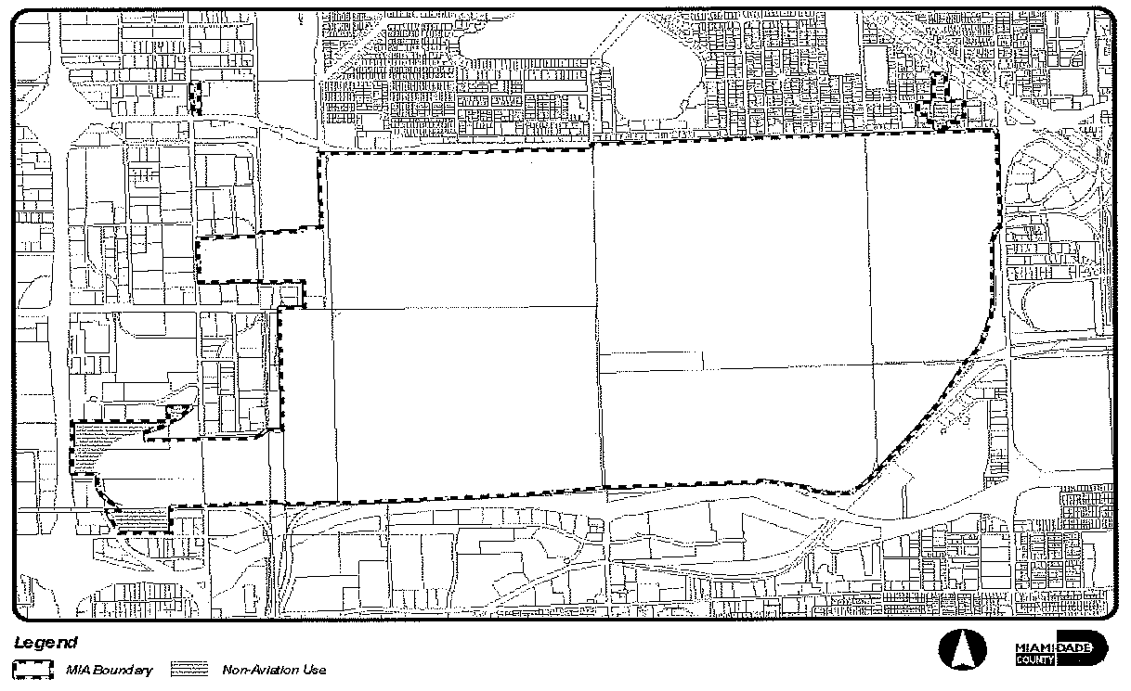

*Figure 1 - Miami International Airport*

(3) The Director of the Miami-Dade Aviation Department shall monitor the allocation of non-aviation uses in all areas of MIA lands zoned GP in order to maintain compliance with the Aviation Subelement of the CDMP.

(Ord. No. 12-56, § 1, 7-3-12)

Sec. 33-337.2. Site plan review.

For all non-aviation uses, the Department shall review plans for compliance with zoning regulations and for compliance with the site plan review criteria prior to building permit. The purpose of the site plan review is to encourage logic, imagination, innovation and variety in the design process and encourage the congruity of the proposed development and its compatibility with the surrounding area. All plans submitted to the Department shall be reviewed and approved or denied within thirty (30) days from the date of submission. Denials shall be in writing and shall specifically set forth the grounds for denial. Receipt of applicant's plans for thirty (30) days without formal written denial shall constitute approval. Notwithstanding the provisions of [Section 33-314](../level3/PTIIICOOR_CH33ZO_ARTXXXVIZOPR.docx#PTIIICOOR_CH33ZO_ARTXXXVIZOPR_S33-314DIAPAPCOCO), if the site is located within unincorporated or incorporated Miami-Dade County and if the plan is disapproved, the applicant may appeal to the Board of County Commissioners. Appeals by the applicant shall be filed within thirty (30) days of the date the project was denied.

(A) *Compliance.* Each non-aviation use shall comply with applicable law, including, but not limited to, FAA regulations and the current airport layout plan on file with the Miami-Dade County Aviation Department governing permissible uses on the entire airport property. All development shall comply with the off-street parking requirements of [Chapter 33](../level2/PTIIICOOR_CH33ZO.docx#PTIIICOOR_CH33ZO), and with [Chapter 18A](../level2/PTIIICOOR_CH18AMIDECOLAOR.docx#PTIIICOOR_CH18AMIDECOLAOR)

(B) *Signage.* Non-aviation uses shall comply with the signage requirements of Article VI, except that entrance features are not required to comply with [Section 33-112](../level4/PTIIICOOR_CH33ZO_ARTVISI_DIV4ENFE.docx#PTIIICOOR_CH33ZO_ARTVISI_DIV4ENFE_S33-112PEFEDE)(a)(1), (g), (h) and (i).

(C) *Required exhibits.* The following exhibits shall be prepared by design professionals such as architects and landscape architects and submitted to the Department:

(1) Dimensioned site plan(s) indicating, as a minimum, the following information:

(a) Existing zoning on the site and on adjacent properties.

(b) The basic use, height, bulk and location of all buildings and other structures with setbacks.

(c) Vehicular and pedestrian circulation systems including connection(s) to existing or proposed roadway and sidewalk system and the layout of parking, service and loading areas.

(d) Graphics and/or notations indicating the site planning or structure design methods used to minimize the impact of those industrial activities that could have a negative impact on existing or proposed adjacent land uses.

(e) Sketches of design elements to be used for buffering surrounding uses.

(2) Elevation of the proposed buildings and other major design elements.

(3) Landscape plans: Landscaping and trees shall be provided in accordance with [Chapter 18A](../level2/PTIIICOOR_CH18AMIDECOLAOR.docx#PTIIICOOR_CH18AMIDECOLAOR) of this Code.

(4) Figures indicating the following:

(a) Proposed uses.

(b) Gross floor area: ____________/____________/____________ square feet.

(c) Land area:

Gross lot area: ____________ square feet ____________ acres.

Net lot area: ____________ square feet ____________ acres.

(d) Landscaped open space:

Required: ____________ square feet ____________% of net land area.

Provided: ____________ square feet ____________% of net land area.

(e) Tree required: ____________; Trees provided: ____________.

(f) Off-street parking spaces:

Required: ____________; Provided: ____________.

(D) *Criteria.* The following shall be considered in the plan review process:

(1) *Planning studies:* Planning studies approved by the Board of County Commissioners that include development patterns or environmental and other design criteria shall be considered in the plan review process.

(2) *Landscape:* Landscape shall be preserved in its natural state insofar as is practicable by minimizing removal of existing vegetation. Landscape shall be used to shade and cool, enhance architectural features, relate structure design to the site, visually screen noncompatible uses, and ameliorate the impact of noise.

(3) *Compatibility:* The architectural design and scale of the proposed structures shall be compatible with surrounding existing or proposed uses or shall be made compatible by the use of screening elements. Screening elements can include such devices as trees and shrubs, walls and fencing, berming or any combination of these elements. Visual buffering shall be provided between parking and service areas and adjacent noncommercial uses.

(4) *Emergency access:* Unobstructed on-site access for emergency equipment shall be considered.

(5) *Circulation:* Internal vehicular and pedestrian circulation systems shall be designed to function with existing and/or approved systems outside the development. Vehicular traffic generated from the industrial activity should be routed in such a manner as to minimize impact on residential development.

(6) *Energy conservation:* Applicants shall comply with the Energy Conservation Standards (Sections 553.951—553.975) of Florida Statutes Chapter 553.

(7) *Visual screening for decorative walls:* In an effort to prevent graffiti vandalism, the following options shall be utilized for walls abutting zoned or dedicated rights-of-way:

(a) *Wall with landscaping.* The wall shall be setback two and one-half (2½) feet from the right-of-way line and the resulting setback area shall contain a continuous extensively landscaped buffer which must be maintained in a good healthy condition by the property owner, or where applicable, by the condominium, homeowners or similar association. The landscape buffer shall contain one (1) or more of the following planting materials:

(1) *Shrubs.* Shrubs shall be a minimum of three (3) feet in height when measured immediately after planting and shall be planted and maintained to form a continuous, unbroken, solid, visual screen within one (1) year after time of planting.

(2) *Hedges.* Hedges shall be a minimum of three (3) feet in height when measured immediately after planting and shall be planted and maintained to form a continuous, unbroken, solid, visual screen within one (1) year after time of planting.

(3) *Vines.* Climbing vines shall be a minimum of thirty-six (36) inches in height immediately after planting.

(b) *Metal picket fence.* Where a metal picket fence abutting a zoned or dedicated right-of-way is constructed in lieu of a decorative wall, landscaping shall not be required.

(Ord. No. 12-56, § 2, 7-3-12)

Sec. 33-338. Airport land use zoning nonconforming uses, regulations not retroactive.

The regulations prescribed by this article or any amendment thereto shall not be construed to require the change or alteration of any permanent structure or use lawfully in existence not conforming to the land use regulations of this article, or otherwise interfere with the lawful continuance of any legal nonconforming use.

(Ord. No. 69-39, § 9, 7-9-69; Ord. No. 78-78, § 1, 11-7-78; Ord. No. 04-203, § 9, 11-30-04; Ord. No. 07-92, § 5, 7-10-07)

Sec. 33-339. Airport land use zoning administration and enforcement.

It shall be the duty of the Director of the Department of Planning and Zoning of Miami-Dade County, Florida, to administer the Airport Land Use Zoning regulations prescribed herein in accordance with [Section 2-105](../level3/PTIIICOOR_CH2AD_ARTXVDEPLDERE.docx#PTIIICOOR_CH2AD_ARTXVDEPLDERE_S2-105DIUT), Code of Miami-Dade County, Florida, within unincorporated Miami-Dade County. It shall be the duty of the Aviation Department to enforce these regulations within unincorporated Miami-Dade County. The appropriate municipal official shall administer and enforce these regulations for Miami-Dade County in the incorporated areas.

In the event of any violation of the regulations contained herein, the person responsible for such violation shall be given notice in writing by MDAD or the appropriate municipal administrative official. Such notice shall indicate the nature of the violation and the necessary action to correct or abate the violation. A copy of said notice shall be sent to the Director of the Miami-Dade County Aviation Department as well as the Director of the Department of Planning and Zoning. The Director of the Department of Planning and Zoning or the director of the appropriate municipal office or designee shall order discontinuance of use of land or buildings; removal of trees in their entirety to conform with height limitations set forth herein; removal of buildings, additions, alterations, structures, or objects; discontinuance of any work being done; or shall take any or all other action necessary to correct violations and obtain compliance with all the provisions of this article.

(Ord. No. 69-39, § 10, 7-9-69; Ord. No. 78-78, § 1, 11-7-78; Ord. No. 95-215, § 1, 12-5-95; Ord. No. 98-125, § 21, 9-3-98; Ord. No. 04-203, § 10, 11-30-04; Ord. No. 07-92, § 6, 7-10-07)

Sec. 33-340. Airport land use zoning permits.

Applications for development permits in incorporated areas of Miami-Dade County that are located within any airport zone or sub-zone established in [Section 33-336](../level3/PTIIICOOR_CH33ZO_ARTXXXVIIMIINAIWIFIZO.docx#PTIIICOOR_CH33ZO_ARTXXXVIIMIINAIWIFIZO_S33-336ESAILAUSZOMACRUSREMIINAISUZOSNE) shall be reviewed by the appropriate municipal board(s) or official(s) for the purpose of assuring compliance with the minimum airport land use zoning standards set forth in this article. Applications for development permits in the unincorporated areas of Miami-Dade County that are located within any airport zone or sub-zone shall be reviewed by the appropriate County board(s) or official(s) for the purpose of assuring compliance with the minimum airport land use zoning standards set forth in this article. In all such instances, whether in the incorporated or unincorporated areas, a copy of the application for development permit shall be provided to the Director of the Miami-Dade Aviation Department and the Director of the Miami-Dade Planning and Zoning Department at the time such application is submitted.

The directors of MDAD and the Planning and Zoning Department shall submit in writing, to the appropriate board or official, any objections they may have to an application for development permit regulated by this article. All permits for traditional public school facility projects will be issued through the Miami-Dade Public School Building Department. Written notice of such school facility projects shall be submitted to the Directors of MDAD and the Planning and Zoning Department in sufficiently reasonable time to allow them to file written objections prior to the issuance of any permit.

The Director of MDAD and the Director of the Planning and Zoning Department are authorized to appeal or otherwise legally contest decisions of any municipality or other governmental agency granting a development permit regulated by this article for failure to comply with the airport land use zoning standards of this article.

(Ord. No. 69-39, § 11, 7-9-69; Ord. No. 78-78, § 1, 11-7-78; Ord. No. 86-83, § 1, 10-28-86; Ord. No. 95-215, § 1, 12-5-95; Ord. No. 98-125, § 21, 9-3-98; Ord. No. 04-203, § 11, 11-30-04; Ord. No. 07-92, § 7, 7-10-07)

Sec. 33-341. Airport land use zoning: nonconforming uses abandoned or destroyed.

Whenever the appropriate building, zoning, or other County or municipal official determines that the airport land use zoning standards of this article will be violated by the reconstruction, substitution or replacement of an existing nonconforming use, structure or tree, no development permit shall be granted for such reconstruction, substitution or replacement, regardless of whether such nonconforming use could otherwise be reconstructed, substituted, or replaced pursuant to [Section 33-35](../level3/PTIIICOOR_CH33ZO_ARTIINGE.docx#PTIIICOOR_CH33ZO_ARTIINGE_S33-35NOUS) of this Chapter, or pursuant to any otherwise applicable law of the County or any municipality.

(Ord. No. 69-39, § 12, 7-9-69; Ord. No. 78-78, § 1, 11-7-78; Ord. No. 86-83, § 1, 10-28-86; Ord. No. 95-215, § 1, 12-5-95; Ord. No. 04-203, § 12, 11-30-04; Ord. No. 07-92, § 8, 7-10-07)

Sec. 33-342. Variances and exceptions limited.

(1) Any person desiring to use property not in accordance with the land use or any other regulations prescribed in this article, shall follow the procedures set forth below for a variance or exception from such regulations, except in such instances where this article expressly prohibits variances or exceptions from certain regulations.

(2) Applications expressly for variances, exceptions, or any other authorization for any structure or use not expressly authorized by this article shall be submitted and determined in accordance with the procedures provisions and requirements set forth herein and in Florida Statutes, Section 333.03 and Sections 333.07 through and including 333.11 (1998), as may be amended from time to time. Notwithstanding any other provisions of the Code of Miami-Dade County to the contrary, for the purpose of zoning applications within the incorporated and the unincorporated area filed under this Article, the Board of County Commissioners shall constitute the Board of adjustment pursuant to Florida Statutes, Section 333.10, and shall utilize the procedures for processing zoning applications pursuant to this article.

(3) Prior to filing any application for variance or exception, the applicant shall forward to the Florida Department of Transportation by certified mail, return receipt requested, a copy of the application for review and comment, if any, by the Florida Department of Transportation. Copies of the return receipt must be filed with the Director of the Department of Planning and Zoning at the time of filing the application. No public hearing on the application may commence less than forty-six (46) days after receipt of the application by the Florida Department of Transportation. Notwithstanding any other provision of this code, failure to comply with the requirements of this subsection shall be grounds for appeal as set forth in Section 333.07(2)(a), Florida Statutes.

The applicant shall submit with the application documentation showing compliance with the federal requirement for notification of the proposed construction and a valid aeronautical evaluation of the application.

(4) Approval of variances, when not specifically prohibited by this article, shall be limited to those cases in which it is duly found that a literal application or enforcement of the regulations would result in unnecessary hardship and the relief granted would not be contrary to the public interest but granting thereof would do substantial justice and be in accordance with the intent and purpose of this article. The intent and purpose of this article is to promote the health, safety and general welfare of the inhabitants of Miami-Dade County, Florida, by preventing the creation of an airport hazard or of a hazard to air navigation, thereby protecting the lives and property of users of Miami International Airport and of occupants of land in its vicinity and preventing destruction or impairment of the utility of the airport and the public investment therein. Any variance may be subject to any reasonable conditions necessary to effectuate the purposes of this Chapter.

(5) In determining whether the standard set forth in paragraph (4) above has been met, the following factors pertaining to the public interest shall be considered:

(a) the nature of the terrain and height of existing structures;

(b) public and private interest and investments;

(c) the character of flying operations and planned future development of Miami International Airport;

(d) federal airways as designated by the Federal Aviation Administration;

(e) whether the construction of the proposed structure would cause an increase in the minimum descent altitude or the decision height at Miami International Airport;

(f) technological advances;

(g) the safety of persons on the ground and in the air;

(h) land use density;

(i) safe and efficient use of navigable airspace; and

(j) the cumulative effects on navigable airspace of all existing structures, proposed structures identified in the Comprehensive Development Master Plan, and all other known proposed structures and uses in the area.

No variance shall be approved solely on the basis that the proposed structure or use will not exceed federal obstruction standards, or any other federal aviation regulation.

(6) Notwithstanding the foregoing provisions of this section, in granting any variances or any other authorization for any structure or use not expressly authorized herein, the Board of County Commissioners shall require the owner of the structure or tree for which such authorization is being sought to install, operate and maintain thereon, at the owner's sole expense, such marking and lighting as may be necessary to indicate to aircraft pilots the presence of an obstruction, such marking and lighting to conform to the specific standards established by rule of the Florida Department of Transportation.

(Ord. No. 69-39, § 13, 7-9-69; Ord. No. 78-78, § 1, 11-7-78; Ord. No. 04-203, § 13, 11-30-04; Ord. No. 07-92, § 9, 7-10-07)

Sec. 33-343. Conditions to site plan approvals, public hearing approvals and variances.

Any variance granted under this article may, if such action is deemed advisable to effectuate the purposes of this article and reasonable in the circumstances, be so conditioned as to require the owner of the structure or tree in question to install, operate, and maintain, at his or her expense, or to permit the Miami-Dade County Aviation Department to install, operate, and maintain thereon at the owner's expense, such marking, or marking and lighting, as may be necessary to indicate to aircraft pilots the presence of an airport hazard. Such other reasonable conditions may also be imposed as to ensure compliance with the intent of this article.

(Ord. No. 69-39, § 14, 7-9-69; Ord. No. 78-78, § 1, 11-7-78; Ord. No. 04-203, § 14, 11-30-04)

Sec. 33-343.1. Notice of airport proximity (airport land use zoning).

All approval of uses in the CA-A sub-zone, including, but not limited to, approvals of permits, site plans, exceptions and variances, shall include the following notice prominently displayed:

NOTIFICATION OF AIRPORT PROXIMITY

The property that is the subject of this zoning approval is located in proximity to Miami International Airport and is therefore subject to certain impacts as a result of such proximity. Among the potential impacts are increased noise levels associated with aircraft and airport operations, overhead aircraft flights at reduced altitudes, and frequent overhead aircraft flights throughout the day and night.

Application for and utilization of any approval under Article XXXVII of the Code of Miami-Dade County (Miami International Airport (Wilcox Field) Zoning), shall constitute acknowledgment of the above-described conditions, and acknowledgement that the owner of the property and successors in title are not entitled to any present or future relief or compensation from Miami-Dade County or any other party to mitigate or ameliorate such impacts.

Additionally, each approval of a new educational facility, or an expansion or modification of an existing educational facility, in the Critical Approach (CA) Zone shall contain notification that the facility is located within 5 miles of a Miami International Airport runway.

(Ord. No. 04-203, § 17, 11-30-04; Ord. No. 07-92, § 10, 7-10-07)

Sec. 33-344. Penalties and enforcement.

Each violation of this article or of any regulation, order, or ruling promulgated hereunder shall be punishable as provided by [Section 33-39](../level3/PTIIICOOR_CH33ZO_ARTIINGE.docx#PTIIICOOR_CH33ZO_ARTIINGE_S33-39PEVICH), Code of Miami-Dade County, Florida, or in any other manner allowed by law; and any violation of any height, land use or other regulation of this article may be remedied by Miami-Dade County in any manner and through any means allowed by law.

(Ord. No. 69-39, § 15, 7-9-69; Ord. No. 07-92, § 11, 7-10-07)

Sec. 33-345. Conflicting regulations.

Nothing contained in this article shall be interpreted to conflict with or supersede any federal regulation pertaining to the control of airport hazards, except in those instances in which this article imposes lower height limitations or more stringent restrictions upon the use of land or water than are imposed or required by other County ordinance or resolution, or federal rules or regulations, in any of which instances the provisions of this article shall govern.

(Ord. No. 69-39, § 16, 7-9-69; Ord. No. 78-78, §§ 2, 3, 11-7-78)

Sec. 33-346. Establishment of airport height zoning districts for airport obstruction analysis area.

The Board of County Commissioners hereby adopts, approves and ratifies the map entitled "Airport Height Zoning District Map Miami International Airport", dated September 20, 2006, ("MIA Height Map") reflecting the location and identifying Miami International Airport and other topographic data pertinent thereto depicting the boundaries of the airport height zoning districts. Such map establishes the boundaries of the airport height zoning districts, and the prohibitions, restrictions, and limitations on heights permitted thereon by this article.

The above defined map, which is on file in the Miami-Dade Aviation Department and the Department of Planning and Zoning, shall be the official height use zoning map for the Miami International Airport and surrounding area, shall evidence the boundaries of the districts depicted thereon, and shall be applicable to and controlling of height zoning for such districts.

(A) For the purpose of this article all of the airport height classification areas for Miami International Airport (Wilcox Field), as the same is created, established and described hereinbefore, is hereby divided into height zoning districts as follows:

(1) *L or Landing districts (Primary Surfaces).* A "landing district" is established for each instrument and non-instrument runway. A landing district for an instrument runway shall have a uniform width of one thousand (1,000) feet. A landing district for a non-instrument runway shall have a uniform width of five hundred (500) feet. All landing districts shall extend for the full length of such runway plus a distance of two hundred (200) feet beyond each end thereof and shall include such runway and be symmetrical about the centerline thereof. Each landing district shall embrace and include all of the land and water area lying vertically beneath an imaginary surface referred to as the "primary surface" which shall have an elevation equal to the elevation of the nearest point on the runway centerline.

(2) *IA or Instrument approach districts.* An "instrument approach district" is established for each end of each instrument runway for instrument landings and takeoffs, and it is further established that each instrument approach district shall embrace and include all of the land and water area lying vertically beneath an imaginary inclined surface which shall hereafter, for the purposes of this article, be referred to and described as the instrument approach surface.

The instrument approach surface shall begin on a base one thousand (1,000) feet wide, such base to be at a position two hundred (200) feet beyond the end of the runway and from such base the approach surface shall widen uniformly to sixteen thousand (16,000) feet at a horizontal distance of fifty thousand two hundred (50,200) feet beyond the end of the runway, the centerline of this surface being the extension of the centerline of the runway.

Within the high structure set-aside district, the imaginary inclined instrument approach surface shall terminate in its intersection with any of the HSA districts as defined in [Section 33-346](../level3/PTIIICOOR_CH33ZO_ARTXXXVIIMIINAIWIFIZO.docx#PTIIICOOR_CH33ZO_ARTXXXVIIMIINAIWIFIZO_S33-346ESAIHEZODIAIOBANAR)(6), subsections (a) through (e) hereinafter described under "high structure set-aside district." The HSA districts shall have precedence when they are in conflict or coincide with any of the instrument approach surfaces.

The instrument approach surface shall extend outward and upward from its one thousand-foot-wide base, the elevation of which base is ten (10) feet MSL.

(a) For runways 8R, 26L, 12 and 30, the approach surface shall slope upward one (1) foot vertically to sixty-five (65) feet horizontally for the first ten thousand (10,000) feet of its length, and from thence it shall slope upward one (1) foot vertically to forty (40) feet horizontally for the remaining forty thousand (40,000) feet.

(b) For runways 9 and 27, the approach surface shall slope upward one (1) foot vertically to fifty (50) feet horizontally for the first ten thousand (10,000) feet of its length, and from thence it shall slope upward one (1) foot vertically to forty (40) feet horizontally for the remaining forty thousand (40,000) feet.

(3) *HZ or Horizontal districts.* A "horizontal district" is established by swinging arcs of ten thousand (10,000) feet from the center of each end of the primary surface of each runway and connecting the adjacent arcs by lines tangent to those arcs. The horizontal district does not include the landing, instrument approach and transition districts. The surface of the horizontal district is a horizontal plane at an elevation of one hundred fifty (150) feet above the hereinbefore established airport elevation.

(4) *CN or Conical district.* A "conical district" is established commencing at the periphery of the horizontal district and extending outward for a horizontal distance of four thousand (4,000) feet. The surface of the conical district commences at the elevation of the surface of the horizontal district and extends outward and upward at a slope of one (1) foot vertically to twenty (20) feet horizontally. Within the high structure set-aside district, the imaginary inclined Conical surface shall terminate in its intersection with any of the HSA districts as defined in [Section 33-246](../level3/PTIIICOOR_CH33ZO_ARTXXVLIBUDI.docx#PTIIICOOR_CH33ZO_ARTXXVLIBUDI_S33-246PU) (6), subsections (a) through (e) hereinafter described under "high structure set-aside district." The HSA districts shall have precedence when they are in conflict or coincide with any of the conical surfaces.

(5) *DZ or Departure zone district.* A "departure zone district" is hereby established adjacent to each instrument runway, and it is further established that each departure zone district shall embrace and include all of the land and water area lying vertically beneath imaginary inclined surfaces which shall hereafter, for the purpose of this article, be referred to and described as departure zone surface 1 and departure zone surface 2 as depicted on the Airport Height Zoning Area Map for Miami International Airport as defined herein. The high structure set-aside district, which is hereinafter established and described, shall not be a part of and is hereby specifically excluded from the departure zone district.

(6) *HSA or High structure set-aside district.* A "high structure set-aside district" is established which identifies an area where tall buildings and other structures may be permitted with limited impact on the capacity and operation of Miami International Airport. When in conflict with any other imaginary surface specified within this article, the herein defined HSA districts shall be the prevailing height limitation. The high structure set-aside district embraces and includes all of the land and water lying within an area in the City of Miami, Florida bounded by the following five (5) sub-districts as follows:

(a) This district shall be known as the 1010-foot AMSL boundary district. It shall have a maximum allowable height of 1010 feet AMSL. This district shall be bounded by an imaginary polygon connecting the following six (6) NAD 83 Latitude and Longitude coordinates starting with the Northwest corner traversing in a clockwise manner and overlies all the land and water area bounded as follows:

Northwestern most corner: Point #10 Latitude: 25° 46' 47.5296" Longitude: 80° 11' 37.7784"  
Then east to Point #16 Latitude: 25° 46' 49.646" Longitude: 80° 11' 6.9859"  
Then east to Point #9 Latitude: 25° 46' 50.2126" Longitude: 80° 10' 56.2165"  
Then southeast to Point #8 Latitude: 25° 46' 31.6176" Longitude: 80° 10' 47.7207"  
Then southwest to Point #7 Latitude: 25° 45' 21.8290" Longitude: 80° 11' 08.4645"  
Then northwest to Point #6 Latitude: 25° 45' 32.3210" Longitude: 80° 11' 38.2714"  
Then northeast to Point #17 Latitude: 25° 45' 42.3695" Longitude: 80° 11' 35.448" Then north back to the first point.

(b) This district shall be known as 709-foot AMSL boundary district. It shall have a maximum allowable height of 709 feet AMSL. This district shall be bounded by an imaginary line connecting the following polygon consisting of seven (7) NAD 83 Latitude and Longitude coordinates starting with the Northwest corner traversing in a clockwise manner and overlies all the land and water area bounded as follows:

Northwestern most corner: Point #12 Latitude: 25° 47' 10.4625" Longitude: 80° 11'38.7278"  
Then easterly to Point #18 Latitude: 25° 47' 09.0115" Longitude: 80° 11' 24.5157"  
Then Northeast to Point #23 Latitude: 25° 47' 10.2132" Longitude: 80° 11' 19.4348"  
Then northeast to Point #19 Latitude: 25° 47' 13.4815" Longitude: 80° 11' 11.6725"  
Then east to Point #14 Latitude: 25° 47' 14.1187" Longitude: 80° 11 07.1561"  
Then south to Point #16 Latitude: 25° 46' 49.646" Longitude: 80° 11' 06.9859"  
Then west to Point #10 Latitude: 25° 46' 47.5296" Longitude: 80° 11' 37.7784"  
Then north back to the first point.

(c) This district shall be known as the 649-foot AMSL boundary district. It shall have a maximum allowable height of 649 feet AMSL. This district shall be bounded by an imaginary line connecting the following polygon consisting of eleven (11) NAD 83 Latitude and Longitude coordinates starting with the Northwest corner traversing in a clockwise manner and overlies all the land and water area bounded as follows:

Northwestern most corner: Point #11 Latitude: 25° 48' 41.4522" Longitude: 80° 11' 43.1295"  
Then east to Point #22 Latitude: 25° 48' 40.8496" Longitude: 80° 11' 15.5784"  
Then northeast to Point #24 Latitude: 25° 48' 41.4146" Longitude: 80° 11' 08.9165"  
Then northeast to Point #15 Latitude: 25° 48' 41.0436" Longitude: 80° 11' 07.1879"  
Then south to Point #14 Latitude: 25° 47' 14.1187" Longitude: 80° 11' 07.1561"  
Then west to Point #19 Latitude: 25° 47' 13.4815" Longitude: 80° 11' 11.6725"  
Then Northeast to Point #23 Latitude: 25° 47' 10.2132" Longitude: 80° 11' 19.4348"  
Then southwest to Point #18 Latitude: 25° 47' 09.0115" Longitude: 80° 11' 24.5157"  
Then west to Point #12 Latitude: 25° 47' 10.4625" Longitude: 80° 11' 38.7278"  
Then north to Point #20 Latitude: 25° 47' 17.2495" Longitude: 80° 11' 39.0561"  
Then northwest to Point #21 Latitude: 25° 47' 18.5731" Longitude: 80° 11' 40.7420"  
Then north back to the first point.

(d) This district shall be known as the High Set-Aside Transitional District. Boundary end shall vary in its slope depending on the allowable heights that are adjacent to this district as set forth in this article. It shall have a maximum allowable height of 310 feet AMSL along some portions of the western boundary and increase to a maximum allowable height of 1010 feet AMSL along those areas that are adjacent to the 1010-foot boundary.

This district shall be bounded by an imaginary line connecting the following polygon consisting of eleven (11) NAD 83 Latitude and Longitude coordinates starting with the Northwest corner traversing in a clockwise manner and overlies all the land and water area bounded as follows:

Northwestern most corner: Point #1 Latitude: 25° 47' 37.6803" Longitude: 80° 12' 18.9273"  
Then east to Point #13 Latitude: 25° 47' 38.5695" Longitude: 80° 11' 41.318"  
Then south to Point #21 Latitude: 25° 47' 18.5731" Longitude: 80° 11' 40.7420"  
Then southeast to Point #20 Latitude: 25° 47' 17.2495" Longitude: 80° 11' 39.0561"  
Then south to Point #12 Latitude: 25° 47' 10.4625" Longitude: 80° 11' 38.7278"  
Then south to Point #10 Latitude: 25° 46' 47.5296" Longitude: 80° 11' 37.7784"  
Then south to Point #17 Latitude: 25° 45' 42.3695" Longitude: 80° 11' 35.448"  
Then southeast to Point # Latitude: 25° 45' 32.3210" Longitude: 80° 11' 38.2714"  
Then northwest to Point #5 Latitude: 25° 45' 43.2122" Longitude: 80° 11' 59.4724"  
Then north to Point #32 Latitude: 25° 46' 46.9187" Longitude: 80° 12' 01.4771"  
Then north to Point #2 Latitude: 25° 47' 02.6758" Longitude: 80° 12' 01.9730"  
Then back to the first point of this district.

(e) This district shall be known as 310-foot AMSL boundary district. It shall have a maximum allowable height of 310 feet AMSL. This district shall be bounded by an imaginary line connecting the following polygon consisting of twelve (12) NAD 83 Latitude and Longitude coordinates starting with the Northwest corner traversing in a clockwise manner and overlies all the land and water area bounded as follows:

Northwestern most corner: Point #3 Latitude: 25° 47′ 41.6854″ Longitude: 80° 13′ 40.3263″  
Then east to Point #25 Latitude: 25° 47′ 33.8427″ Longitude: 80° 12′ 17.0685″  
Then south to Point #2 Latitude: 25° 47′ 02.6758″ Longitude: 80° 12′ 01.9730″  
Then south to Point #32 Latitude: 25° 46′ 46.9187″ Longitude: 80° 12′ 01.4771″  
Then south to Point #5 Latitude: 25° 45′ 43.2122″ Longitude: 80° 11′ 59.4724″  
Then northwest to Point #4 Latitude: 25° 46′ 18.54″ Longitude: 80° 13′ 50.8037″  
Then northwest to Point #26 Latitude: 25° 46′ 31.8645″ Longitude: 80° 14′ 15.3849″  
Then northeast to Point #27 Latitude: 25° 46′ 29.9925″ Longitude: 80° 14′ 04.5838″  
Then north to Point #28 Latitude: 25° 46′ 53.1392″ Longitude: 80° 13′ 15.1815″  
Then northwest to Point #29 Latitude: 25° 46′ 55.9420″ Longitude: 80° 14′ 5.6983″  
Then northeast to Point #30 Latitude: 25° 46′ 56.6371″ Longitude: 80° 13′ 54.8079″  
Then north to Point #31 Latitude: 25° 47′ 19.8838″ Longitude: 80° 13′ 55.9731″  
Then back to the first point of this district.

(7) *TR or Transition districts.* "Transition districts" are hereby established adjacent to each landing and each instrument approach district.

Transition districts adjacent to landing districts embrace and include all of the land and water area lying vertically beneath an imaginary inclined surface symmetrically located on each side of such landing districts. For instrument runways such imaginary inclined surfaces extend outward and upward at right angles to the runway centerline and the runway centerline extended at a slope of one (1) foot vertically to seven (7) feet horizontally from the sides of the primary surface and from the side of the approach surface.

Transition districts adjacent to instrument approach districts embrace and include all of the land and water area lying vertically beneath imaginary inclined surfaces which extend outward and upward from the long sides of the instrument approach surfaces as hereinbefore described, with a slope of one (1) foot vertically to seven (7) feet horizontally.

Within horizontal districts, this imaginary inclined transition surface shall terminate when it reaches an elevation of one hundred sixty (160) feet AMSL. Within conical districts, the imaginary inclined transition surface shall terminate in its intersection with the conical surface as hereinbefore described under "conical district." Within the departure zone district, the imaginary inclined transition surface shall terminate in its intersection with the departure zone surface hereinbefore described under "departure zone district." Within the high structure set-aside district, the imaginary inclined transition surface shall terminate in its intersection with any of the HSA districts as defined in subsection (6)(a) through (e) of this article hereinbefore described under "high structure set-aside district." The HSA districts shall have precedence when they are in conflict or coincide with any of the transitional surfaces.

(8) *NA or Non-instrument approach districts.* A "non-instrument approach district" is established for each end of each non-instrument runway for non-instrument landings and take-offs and it is further established that each such non-instrument approach district shall embrace and include all of the land and water area lying vertically beneath an imaginary inclined surface which shall hereafter, for the purposes of this article, be referred to and described as the non-instrument approach surface.

The non-instrument approach surface shall begin, and shall have a base five hundred (500) feet wide, at a distance of two hundred (200) feet beyond the end of the runway, widening thereafter uniformly to a width of three thousand five hundred (3,500) feet at a horizontal distance of ten thousand two hundred (10,200) feet beyond the end of the runway, the centerline of this surface being the continuation of the centerline of the runway.

The non-instrument approach surface shall extend outward and upward from its five hundred-foot-wide base, the elevation of which is base is ten (10) feet AMSL.

For Runways 8L and 26R, the approach surface shall slope upward one (1) foot vertically to thirty-four (34) feet horizontally for its entire length.

(B) Criteria included in the Miami-Dade County Comprehensive Development Plan shall be utilized in the review of land use and zoning modifications which are requested in the hereinbefore established airport zoning area.

(Ord. No. 07-92, § 12, 7-10-07)

Sec. 33-347. Establishment of height limitations for height zoning districts in the airport zoning area.

Except as otherwise provided elsewhere in this article, no structure or object shall be erected or altered and no tree shall be allowed to grow or be maintained in any height zoning district created and established by this article to a height in excess of the height limits herein established for such district, as depicted by the MIA Height Map. In applying the provisions of this article, such height limitations shall be corrected to elevations referred to the heretofore established mean sea level datum plane, by adding such height limitations to the mean sea level elevation of the point, line or plane to which such height limitation is referenced, or to the airport elevation, as the context of this article requires. An area, structure, or tree located in more than one (1) of the described districts is considered to be only in the district with the more restrictive height limitation.

The MIA Height Map adopted in [Section 33-346](../level3/PTIIICOOR_CH33ZO_ARTXXXVIIMIINAIWIFIZO.docx#PTIIICOOR_CH33ZO_ARTXXXVIIMIINAIWIFIZO_S33-346ESAIHEZODIAIOBANAR) of this article shall be the official height zoning map for the Miami International Airport, shall establish the maximum height of structures and trees and shall be applicable to and controlling of such height limitations established herein.

Height limitations are hereby established for the districts of the MIA Height Map as follows:

(1) *Instrument Approach Districts:*

(a) For Runways 8R, 26L, 12 and 30: One (1) foot vertically for each sixty-five (65) feet horizontally beginning at a point two hundred (200) feet from the end of each instrument runway and extending for a distance of ten thousand two hundred (10,200) feet from the end of each runway; thence one (1) foot vertically for each forty (40) feet horizontally for a distance of forty thousand (40,000) feet to a point fifty thousand two hundred (50,200) feet from the end of each runway. Within the high structure set-aside district, this imaginary inclined surface shall terminate in its intersection with any of the HSA districts as defined in [Section 33-346](../level3/PTIIICOOR_CH33ZO_ARTXXXVIIMIINAIWIFIZO.docx#PTIIICOOR_CH33ZO_ARTXXXVIIMIINAIWIFIZO_S33-346ESAIHEZODIAIOBANAR)(6), subsections (a) through (e) hereinbefore described under "high structure set-aside district." The HSA districts shall have precedence when they are in conflict or coincide with any of these surfaces.

(b) For Runways 9 and 27, one (1) foot vertically for each fifty (50) feet horizontally beginning at a point two hundred (200) feet from the end of these instrument runways and extending for a distance of ten thousand two hundred (10,200) feet from the end of each runway; thence one (1) foot vertically for each forty (40) feet horizontally for a distance of forty thousand (40,000) feet to a point fifty thousand two hundred (50,200) feet from the end of each runway. Within the high structure set-aside district, this imaginary inclined surface shall terminate in its intersection with any of the HSA districts as defined in [Section 33-346](../level3/PTIIICOOR_CH33ZO_ARTXXXVIIMIINAIWIFIZO.docx#PTIIICOOR_CH33ZO_ARTXXXVIIMIINAIWIFIZO_S33-346ESAIHEZODIAIOBANAR)(6), subsections (a) through (e) hereinbefore described under "high structure set-aside district." The HSA districts shall have precedence when they are in conflict or coincide with any of these surfaces.

(2) *Horizontal district:* One hundred fifty (150) feet above the hereinbefore established airport elevation.

(3) *Conical district:* One (1) foot vertically to twenty (20) feet horizontally beginning at the periphery of the hereinbefore described horizontal district for a horizontal distance of four thousand (4,000) feet. Within the high structure set-aside district, the imaginary inclined Conical surface shall terminate in its intersection with any of the HSA districts as defined in [Section 33-346](../level3/PTIIICOOR_CH33ZO_ARTXXXVIIMIINAIWIFIZO.docx#PTIIICOOR_CH33ZO_ARTXXXVIIMIINAIWIFIZO_S33-346ESAIHEZODIAIOBANAR)(6), subsections (a) through (e) hereinbefore described under "high structure set-aside district." The HSA districts shall have precedence when they are in conflict or coincide with any of the conical surfaces.

(4) *Departure zone district:* For departure zone surface 1, one (1) foot vertically to forty (40) feet horizontally beginning at the departure end of each runway at an elevation of forty-five (45) feet AMSL and extending outward a distance of two (2) nautical miles (12,152 feet) from the end of the runway. For departure zone surface 2, one (1) foot vertically to forty (40) feet horizontally beginning at the edge of each runway and the edge of the departure zone surface 1, and at an elevation of three hundred forty-nine (349) feet AMSL, which is the elevation at the high end of the departure zone 1 surface, then extending until an elevation of one thousand five hundred ten (1,510) feet AMSL is reached. The one thousand five hundred ten-foot elevation continues outward from the airport as a horizontal plane to the boundaries of the airport zoning area. The height restrictions in the departure zone district do not apply within the high structure set-aside district.

(5) *HSA or High structure set-aside district:* A "high structure set-aside district" is established which identifies an area where tall buildings and other structures may be permitted with limited impact on the capacity and operation of Miami International Airport. When in conflict with any other imaginary surface specified within this article, the herein defined HSA sub-districts shall be the prevailing height limitation. The high structure set-aside district embraces and includes all of the land and water lying within an area in the City of Miami, Florida bounded by the following five (5) sub-districts as follows:

(a) This sub-district shall be known as the 1010-foot AMSL boundary district. It shall have a maximum allowable height of 1010 feet. This sub-district shall be bounded by an imaginary polygon connecting the following six (6) NAD 83 Latitude and Longitude coordinates starting with the Northwest corner traversing in a clockwise manner and overlies all the land and water area bounded as follows:

Northwestern most corner: Point #10 Latitude: 25° 46′ 47.5296″ Longitude: 80° 11′ 37.7784″  
Then east to Point #16 Latitude: 25° 46′ 49.646″ Longitude: 80° 11′ 6.9859″  
Then east to Point #9 Latitude: 25° 46′ 50.2126″ Longitude: 80° 10′ 56.2165″  
Then southeast to Point #8 Latitude: 25° 46′ 31.6176″ Longitude: 80° 10′ 47.7207″  
Then southwest to Point #7 Latitude: 25° 45′ 21.8290″ Longitude: 80° 11′ 08.4645″  
Then northwest to Point #6 Latitude: 25° 45′ 32.3210″ Longitude: 80° 11′ 38.2714″  
Then northeast to Point #17 Latitude: 25° 45′ 42.3695″ Longitude: 80° 11′ 35.448″  
Then north back to the first point.

(b) This sub-district shall be known as 709-foot AMSL boundary district. It shall have a maximum allowable height of 709 feet. This sub-district shall be bounded by an imaginary line connecting the following polygon consisting of seven (7) NAD 83 Latitude and Longitude coordinates starting with the Northwest corner traversing in a clockwise manner and overlies all the land and water area bounded as follows:

Northwestern most corner: Point #12 Latitude: 25° 47′ 10.4625″ Longitude: 80° 11′ 38.7278″  
Then easterly to Point #18 Latitude: 25° 47′ 09.0115″ Longitude: 80° 11′ 24.5157″  
Then Northeast to Point #23 Latitude: 25° 47′ 10.2132″ Longitude: 80° 11′ 19.4348″  
Then northeast to Point #19 Latitude: 25° 47′ 13.4815″ Longitude: 80° 11′ 11.6725″  
Then east to Point #14 Latitude: 25° 47′ 14.1187″ Longitude: 80° 11 07.1561″  
Then south to Point #16 Latitude: 25° 46′ 49.646″ Longitude: 80° 11′ 06.9859″  
Then west to Point #10 Latitude: 25° 46′ 47.5296″ Longitude: 80° 11′ 37.7784″  
Then north back to the first point.

(c) This sub-district shall be known as the 649-foot AMSL boundary district. It shall have a maximum allowable height of 649 feet. This sub-district shall be bounded by an imaginary line connecting the following polygon consisting of eleven (11) NAD 83 Latitude and Longitude coordinates starting with the Northwest corner traversing in a clockwise manner and overlies all the land and water area bounded as follows:

Northwestern most corner: Point #11 Latitude: 25° 48′ 41.4522″ Longitude: 80° 11′ 43.1295″  
Then east to Point #22 Latitude: 25° 48′ 40.8496″ Longitude: 80° 11′ 15.5784″  
Then northeast to Point #24 Latitude: 25° 48′ 41.4146″ Longitude: 80° 11′ 08.9165″  
Then northeast to Point #15 Latitude: 25° 48′ 41.0436″ Longitude: 80° 11′ 07.1879″  
Then south to Point #14 Latitude: 25° 47′ 14.1187″ Longitude: 80° 11′ 07.1561″  
Then west to Point #19 Latitude: 25° 47′ 13.4815″ Longitude: 80° 11′ 11.6725″  
Then Northeast to Point #23 Latitude: 25° 47′ 10.2132″ Longitude: 80° 11′ 19.4348″  
Then southwest to Point #18 Latitude: 25° 47′ 09.0115″ Longitude: 80° 11′ 24.5157″  
Then west to Point #12 Latitude: 25° 47′ 10.4625″ Longitude: 80° 11′ 38.7278″  
Then north to Point #20 Latitude: 25° 47′ 17.2495″ Longitude: 80° 11′ 39.0561″  
Then northwest to Point #21 Latitude: 25° 47′ 18.5731″ Longitude: 80° 11′ 40.7420″  
Then north back to the first point.

(d) This sub-district shall be known as the High-Set Aside Transitional District. Boundary end shall vary in its slope depending on the allowable heights that are adjacent to this sub-district as set forth in this article. It shall have a maximum allowable height of 310 feet AMSL along some portions of the western boundary and increase to a maximum allowable height of 1010 feet AMSL along those areas that are adjacent to the 1010-foot boundary. This sub-district shall be bounded by an imaginary line connecting the following polygon consisting of eleven (11) NAD 83 Latitude and Longitude coordinates starting with the Northwest corner traversing in a clockwise manner and overlies all the land and water area bounded as follows:

Northwestern most corner: Point #1 Latitude: 25° 47′ 37.6803″ Longitude: 80° 12′ 18.9273″  
Then east to Point #13 Latitude: 25° 47′ 38.5695″ Longitude: 80° 11′ 41.318″  
Then south to Point #21 Latitude: 25° 47′ 18.5731″ Longitude: 80° 11′ 40.7420″  
Then southeast to Point #20 Latitude: 25° 47′ 17.2495″ Longitude: 80° 11′ 39.0561″  
Then south to Point #12 Latitude: 25° 47′ 10.4625″ Longitude: 80° 11′ 38.7278″  
Then south to Point #10 Latitude: 25° 46′ 47.5296″ Longitude: 80° 11′ 37.7784″  
Then south to Point #17 Latitude: 25° 45′ 42.3695″ Longitude: 80° 11′ 35.448″  
Then southeast to Point #6 Latitude: 25° 45′ 32.3210″ Longitude: 80° 11′ 38.2714″  
Then northwest to Point #5 Latitude: 25° 45′ 43.2122″ Longitude: 80° 11′ 59.4724″  
Then north to Point #32 Latitude: 25° 46′ 46.9187″ Longitude: 80° 12′ 01.4771″  
Then north to Point #2 Latitude: 25° 47′ 02.6758″ Longitude: 80° 12′ 01.9730″  
Then back to the first point of this district.

(e) This sub-district shall be known as 310-foot AMSL boundary district. It shall have a maximum allowable height of 310 feet. This sub-district shall be bounded by an imaginary line connecting the following polygon consisting of twelve (12) NAD 83 Latitude and Longitude coordinates starting with the Northwest corner traversing in a clockwise manner and overlies all the land and water area bounded as follows:

Northwestern most corner: Point #3 Latitude: 25° 47′ 41.6854″ Longitude: 80° 13′ 40.3263″  
Then east to Point #25 Latitude: 25° 47′ 33.8427″ Longitude: 80° 12′ 17.0685″  
Then south to Point #2 Latitude: 25° 47′ 02.6758″ Longitude: 80° 12′ 01.9730″  
Then south to Point #32 Latitude: 25° 46′ 46.9187″ Longitude: 80° 12′ 01.4771″  
Then south to Point #5 Latitude: 25° 45′ 43.2122″ Longitude: 80° 11′ 59.4724″  
Then northwest to Point #4 Latitude: 25° 46′ 18.54″ Longitude: 80° 13′ 50.8037″  
Then northwest to Point #26 Latitude: 25° 46′ 31.8645″ Longitude: 80° 14′ 15.3849″  
Then northeast to Point #27 Latitude: 25° 46′ 29.9925″ Longitude: 80° 14′ 04.5838″  
Then north to Point #28 Latitude: 25° 46′ 53.1392″ Longitude: 80° 13′ 15.1815″  
Then northwest to Point #29 Latitude: 25° 46′ 55.9420″ Longitude: 80° 14′ 5.6983″  
Then northeast to Point #30 Latitude: 25° 46′ 56.6371″ Longitude: 80° 13′ 54.8079″  
Then north to Point #31 Latitude: 25° 47′ 19.8838″ Longitude: 80° 13′ 55.9731″  
Then back to the first point of this district.

(6) *Transition district:* One (1) foot vertically for each seven (7) feet horizontally from the sides of the primary surfaces and from the sides of the approach surfaces (instrument or non-instrument). Transition surfaces extend from the primary surfaces to the horizontal surface, and from the approach surfaces to the adjacent horizontal surface, conical surface or departure zone surface. Within the high structure set-aside district, the imaginary inclined transition, conical, and approach surfaces shall terminate in its intersection with any of the HSA districts as defined in subsection (6)(a) through (e) of this article hereinbefore described under "high structure set-aside district." The HSA districts shall have precedence when they are in conflict or coincide with any of the approach, conical, or transitional surfaces.

(7) *Non-Instrument approach districts:* For Runways 8L and 26R, the non-instrument approach surface shall extend outward and upward from its base, the elevation of which shall be the same as that of the runway end adjacent thereto, with a slope of one (1) foot vertically to thirty-four (34) feet horizontally for its entire length.

(Ord. No. 07-92, § 13, 7-10-07)

Sec. 33-348. Administration and enforcement of airport height zoning.

Notwithstanding any other provision of this chapter or Code to the contrary, it shall be the duty of the Director of the Miami-Dade Aviation Department (MDAD), to administer and enforce the regulations prescribed herein relating to height zoning within unincorporated Miami-Dade County and all incorporated municipalities therein.

In the event of any violation of the regulations contained herein, the Aviation Department shall provide notice of such violation to the appropriate administrative official, with a copy to the owner of the property where such violation occurred. Such notice shall indicate the nature of the violation and the necessary action to correct or abate the violation. A copy of said notice shall be sent to the Director of the Department of Planning and Zoning. The Director of the Miami-Dade Aviation Department or the director of the appropriate municipal office or designee shall order discontinuance of use of land or buildings; removal of structures or trees to conform with height limitations set forth herein; removal of buildings, additions, alterations, or structures; discontinuance of any work being done; or shall take any or all other action necessary to correct violations and obtain compliance with all the provisions of this article.

(Ord. No. 07-92, § 14, 7-10-07)

Sec. 33-349. Airspace approvals.

No permanent structure may be erected, constructed, located or otherwise established within the MIA Airport Zoning Area unless it has been issued an appropriate development permit(s) by Miami-Dade County or the municipality in which it is located. Except as provided for hereunder, no development permit for any structure or tree (whether permanent or temporary, natural or man made) to be erected, planted, located or otherwise established, within the MIA Airport Zoning Area shall be issued by the county or any municipality unless such development permit has been approved in writing by MDAD and meets the review criteria created pursuant to this article.

For permanent structures or trees, such approval is required for (1) all structures or trees on property located within or bifurcated by the all objects review boundary; (2) for all structures or trees greater than or equal to 35 feet AMSL on property located within or bifurcated by the 35 foot AMSL review boundary; and for all structures or trees greater than or equal to 200 feet AMSL on property located within or partially within the MIA airport zoning area but outside the 35 foot AMSL review boundary. For temporary cranes or other temporary structures, such approval is required if such structures meet either the crane review criteria or the events review criteria set forth in this section.

In all instances, whether in the incorporated or unincorporated areas of Miami-Dade County, a copy of any application for a development permit that requires approval by MDAD pursuant to this [Section 33-349](../level3/PTIIICOOR_CH33ZO_ARTXXXVIIMIINAIWIFIZO.docx#PTIIICOOR_CH33ZO_ARTXXXVIIMIINAIWIFIZO_S33-349AIAP) must be submitted to MDAD for review prior to the issuance of any development permit based on such application. Each such application for a development permit shall indicate the height (AMSL) of all applied-for structures. Any development permit subject to the review and approval process of this [Section 33-349](../level3/PTIIICOOR_CH33ZO_ARTXXXVIIMIINAIWIFIZO.docx#PTIIICOOR_CH33ZO_ARTXXXVIIMIINAIWIFIZO_S33-349AIAP) that is issued without the written approval of MDAD shall be voidable through an original action by a court of competent jurisdiction regardless of the expiration of any otherwise applicable appeal period for the challenge of such development permit.

Temporary cranes or other temporary structures, which meet the crane review criteria of this article, but which do not require a development permit for their erection, installation, siting, operation, or use, shall receive written approval from MDAD prior to their erection, installation, siting, operation or use if so erected, installed, sited, operated or used anywhere within the MIA airport zoning area. Temporary events, which meet the temporary events review criteria of this article, but which do not require a development permit for their installation, siting, operation or use, shall receive written approval from MDAD prior to their installation, siting, operation or use if so installed, sited, operated or used anywhere within the MIA airport zoning area.

In addition, neither Miami-Dade County nor any municipality or other entity shall issue any development permit, or allow the use of a crane, or otherwise allow any other structure to be erected, located or otherwise established within the airport zoning area unless such structure has been reviewed and approved by the FAA if the structure meets FAA notification criteria set forth in Title 14 of the Code of Federal Regulations, Part 77, as amended.

Notwithstanding any provisions of this chapter, in approving any permit under this article, the Director of the Miami-Dade Aviation Department shall require the owner of the structure for which a permit is being sought, to install, operate and maintain thereon at the owner's sole expense, such marking and lighting as may be necessary to indicate to aircraft pilots the presence of a structure, such marking and lighting to conform to the specific standard established by rule of the Department of Transportation and Federal Aviation Administration Advisory Circular 70/7460-1k change 1, or most recent update.

In order to comply with Federal Aviation Regulations, the Director of the Miami-Dade Aviation Department shall have the right to order structure or tree heights to be lower than the height limitations established in this article. For the sake of aviation safety and airport viability, there shall be no variances from or exceptions to the height zoning limitations of this article.

The Director of the Miami-Dade Aviation Department or designee is authorized to appeal or otherwise legally contest decisions of a municipality granting development permits that are subject to compliance with this article, for failure to comply with the airport height zoning standards of this article.

Applicant shall pay any applicable review fees to MDAD for its reviews performed in accordance with this article. Review shall not commence until the appropriate fees are paid to MDAD.

(A) *Permanent structures or trees.*

(1) Review process for permanent structures or trees shall be as follows:

(a) Applicant shall provide the Latitude and Longitude coordinates in NAD 83 (in degrees, minutes, and seconds format and to an accuracy of three decimal places for the seconds), job site address, height to tallest point of structures and trees, name of structures and trees, folio number(s), site location sheet and profile sheet (both 11×17 inch format) indicating the maximum height AMSL of the structures and trees. If any structure or tree meets the FAA notification criteria set forth in Title 14 of the Code of Federal Regulations, Part 77, a valid "Determination of No Hazard" issued by the FAA must be submitted to MDAD at the same time.

(b) Upon receipt of the required information, MDAD shall initiate the review process. Should MDAD require more information, MDAD shall notify the applicant of this deficiency and place the review process on hold until receipt of the requested information.

(c) For permanent structures or trees, MDAD shall issue a letter indicating if the proposed structure or tree height does or does not conform to the criteria established within this article. The letter shall also indicate whether the applicant needs to submit their information to the FAA for their own evaluation. No building permit or other development permit shall be issued by any incorporated municipality or Miami-Dade County unless the applicant can provide a valid "Determination of No Hazard" issued by the FAA, if the project meets FAA notification criteria as stated in Title 14 of the Code of Federal Regulations, Part 77. No building permit or other development permit shall be issued for, and no structure or tree shall be allowed to a height greater than the lower of (1) that height stated on a valid "Determination of No Hazard" issued by the FAA, or (2) that height allowed by the regulations set forth in this article.

(2) Certificate of Use and Certificate of Occupancy requirements for permanent structures. Upon completion of any project, no certificate of occupancy or certificate of use shall be issued by a municipality or Miami-Dade County until approval is obtained from MDAD certifying that the structure was built no higher than the height approved by MDAD in compliance with this article. This approval shall be issued by MDAD after submittal by applicant of the required information including as-built elevations certified and prepared, signed and sealed by a State of Florida licensed surveyor, architect or engineer. Such elevation as-built certification shall be 8.5" × 11" in size and contain an elevation view of as-built construction with Latitude and Longitude coordinates in NAD 83 (in degrees, minutes, seconds format with at least 2 decimal places accuracy for the seconds number) noted for the height of the structure and the height of any appurtenances thereto. The height shall also be indicated for the point closest to Miami International Airport.

(B) *Temporary Cranes and Other Temporary Structures.*

(1) Crane review criteria. Any crane or other temporary structure shall be reviewed if its height may at any time exceed an imaginary surface extending outward and upward at a slope of 100 to 1 from the nearest point of the nearest runway at MIA, or if its height may at any time equal or exceed 200 feet AMSL.

(2) No temporary crane or other temporary structure meeting the crane review criteria above shall be erected, installed, sited, operated or used unless it has been approved in writing by MDAD.

(3) Review and approval process for temporary cranes and other temporary structures shall be as follows:

(a) Applicant shall provide to the Aviation Department the Latitude and Longitude coordinates in NAD 83 (in degrees, minutes, and seconds format and to an accuracy of three decimal places for the seconds), job site address, height to tallest point of crane or structure, dates and times of operation, whether nighttime operation is requested, applicant's name, phone number, email, fax number, and the crane or structure operator's 24 hour phone number. This information should be provided to the MDAD, Aviation Planning Division, using MDAD's "Permissible Crane Height Determination" form. If the structure meets FAA notification criteria as stated in Title 14 of the Code of Federal Regulations, Part 77, a valid "Determination of No Hazard" as issued by the FAA must be submitted at the same time.

(b) Upon receipt of the required information, MDAD shall process the application. Should MDAD require more information, MDAD shall notify the applicant of this deficiency and place the review process on hold until receipt of the requested information.

(c) MDAD shall indicate on the "Permissible Crane Height Determination" form the allowable crane or structure height. MDAD shall not approve an application unless a valid FAA "Determination of No Hazard" has been attached, if the crane or structure meets FAA notification criteria set forth in Title 14 of the Code of Federal Regulations, Part 77.

(4) Crane lighting. Any crane or other temporary construction equipment shall comply with FAA Advisory Circular 70/7460-1K "Obstruction Marking and Lighting", as amended.

(C) *Temporary Events Affecting Navigable Airspace.*

(1) Temporary events review criteria. A temporary event that could affect navigable airspace shall be reviewed by MDAD if its height may at any time exceed an imaginary surface extending outward and upward at a slope of 100 to 1 from the nearest point of the nearest runway at MIA, or if its height may at any time equal or exceed 200 feet AMSL.

(a) Balloons, kites, unmanned rockets and unmanned free balloons shall be reviewed, operated, and marked in accordance with [Title 14](../level2/PTIIICOOR_CH14FIPR.docx#PTIIICOOR_CH14FIPR) of the Code of Federal Regulations, Part 101, as amended.

(b) Fireworks shall be reviewed and operated in accordance with [Title 14](../level2/PTIIICOOR_CH14FIPR.docx#PTIIICOOR_CH14FIPR) of the Code of Federal Regulations, Part 101, as amended.

(c) Outdoor laser operations shall be reviewed in accordance with FAA Advisory Circular 70-1, as amended.

(d) Radio controlled aircraft or other radio controlled objects shall be operated in accordance with FAA Advisory Circular 91-57, as amended.

(2) Review and approval process for temporary events impacting airspace shall be as follows:

(a) Applicant shall provide a written request to MDAD indicating the nature of the temporary event and any other pertinent details including the Latitude and Longitude coordinates in NAD 83 (in degrees, minutes, and seconds format and to an accuracy of three decimal places for the seconds), address where the temporary event will be located, operated, sited, installed, launched or otherwise used, height to tallest reasonably anticipated point of the temporary event, dates and times of operation, whether nighttime operation is requested, applicant's name, phone number, email, fax number, and the temporary event operator's 24 hour phone number. This information should be provided to MDAD, Aviation Planning Division, using MDAD's "Permissible Crane Height Determination" form. If the temporary event meets FAA notification criteria as stated in Title 14 of the Code of Federal Regulations, Part 77, a valid "Determination of No Hazard" as issued by the FAA must be submitted at the same time.

(b) Upon receipt of the required information, MDAD shall process the application. Should MDAD require more information, MDAD shall notify the applicant of this deficiency and place the review process on hold until receipt of the requested information.

(c) MDAD shall respond in writing stating whether the temporary event will be allowed to be used, operated or installed, and, if allowed, the allowable maximum height of the temporary event. MDAD shall not approve an application unless a valid FAA "Determination of No Hazard" has been attached, if the temporary event meets FAA notification criteria set forth in Title 14 of the Code of Federal Regulations, Part 77.

(d) In addition, the following temporary events shall meet and comply with the following criteria prior to approval from MDAD:

1. Lasers. Outdoor laser operations must receive and submit to MDAD a letter of non-objection from the FAA and be operated in accordance with FAA Advisory Circular 70-1.

2. Fireworks. Fireworks operations shall receive and submit to MDAD an acknowledgement letter from the FAA indicating that the operation meets the criteria of FAR [Title 14](../level2/PTIIICOOR_CH14FIPR.docx#PTIIICOOR_CH14FIPR), Part 101. Operations shall abide by all conditions prescribed in such FAA-issued acknowledgement letter.

3. Balloons, kites, unmanned rockets, and unmanned free balloons. These operations shall receive and submit to MDAD a waiver issued by the FAA as specified in FAR Title 14, Part 101.

(D) *Violations.* In addition to any other remedies or penalties set forth in this article or elsewhere in this code for violations of the provisions of this article, any structure, tree, temporary crane or structure, or temporary event that violates the provisions of this article is subject to a stop work order issued by MDAD or other appropriate county or municipal official, and is also subject to an order to lower, remove, or cease the operation or use of the structure, tree, temporary crane or structure, or temporary event that is in violation of the provisions of this article.

(Ord. No. 07-92, § 15, 7-10-07)

Sec. 33-350. Airport height zoning: nonconforming uses abandoned or destroyed.

Whenever the appropriate building, zoning, or other County or municipal official determines that the height limits of this article will be violated by the reconstruction, substitution or replacement of an existing legal nonconforming use, structure or tree, no permit shall be granted for such reconstruction, substitution or replacement, regardless of whether such nonconforming use could otherwise be reconstructed, substituted, or replaced pursuant to [Section 33-35](../level3/PTIIICOOR_CH33ZO_ARTIINGE.docx#PTIIICOOR_CH33ZO_ARTIINGE_S33-35NOUS) of this Chapter or pursuant to any otherwise applicable law of the County or any municipality. Notwithstanding any other provision of this Code or otherwise applicable municipal law, an appropriate County or municipal official may require the owner of a nonconforming structure or tree to allow the Miami-Dade Aviation Department, at the owner's expense to lower, remove, or mark, or mark and light, such structure or tree as may be necessary to conform such structure or tree to the height regulations of this article, or to give visual warning of such structures or trees that do not conform to the height regulations of this article. No development permit shall be granted that would allow the establishment or creation of an airport hazard or would permit a nonconforming structure or tree or nonconforming use to be made or become higher or to become a greater hazard to air navigation that it was when this ordinance was adopted or than when the application for permit was made.

(Ord. No. 07-92, § 16, 7-10-07)

Secs. 33-351—33-355. Reserved.

FOOTNOTE(S):

--- (**55**) ---

**Editor's note—** Article XXXVII, §§ 33-330—33-345, is derived from Ord. No. 69-39, §§ 1—16, enacted July 9, 1969. Section 2 of said ordinance authorized codification of such ordinance as a part of this Code. Section 19 of said ordinance repealed conflicting ordinances, therefore the editors deleted former §§ 33-330—33-345, derived from Ord. No. 61-29, §§ 1—16, enacted June 27, 1961, pertaining to similar subject matter and codified in lieu thereof, the provisions of Ord. No. 69-39 herein set out. (Back)

### ARTICLE XXXVIII. OPA LOCKA AIRPORT ZONING [56]

Sec. 33-356. Short title.

Sec. 33-357. Provisions hereof established as minimum standards governing zoning.

Sec. 33-358. Definitions.

Sec. 33-359. Establishment of airport zoning area for Opa Locka Airport.

Sec. 33-360. Establishment of zone classification district for airport zoning area.

Sec. 33-361. Establishment of height limitations for zone classification districts in the airport zoning area.

Sec. 33-362. Zone classification district boundary map for the airport zoning area.

Sec. 33-363. Use restrictions.

Sec. 33-363.1. Uses permitted on Opa-locka Airport lands in the GP Governmental Property zoning district.

Sec. 33-363.2. Site plan review.

Sec. 33-364. Nonconforming uses, regulations not retroactive.

Sec. 33-365. Administration and enforcement.

Sec. 33-366. Permits.

Sec. 33-367. Nonconforming uses abandoned or destroyed.

Sec. 33-368. Variances.

Sec. 33-369. Hazard marking and lighting.

Sec. 33-370. Penalties and enforcement.

Sec. 33-371. Conflicting regulations.

Sec. 33-356. Short title.

This article shall be known and may be cited as the "Opa Locka Airport Zoning Ordinance."

(Ord. No. 69-37, § 1, 7-9-69)

Sec. 33-357. Provisions hereof established as minimum standards governing zoning.

It is established that the airport zoning area for Opa Locka Airport, the zone classification districts therein and the height limitation applicable to such districts, as the same are hereinafter set forth, shall be incorporated with all other minimum standards governing zoning heretofore or hereinafter adopted pursuant to Section 4.07 of the Home Rules Charter for Miami-Dade County, Florida.

(Ord. No. 69-37, § 2, 7-9-69)

Sec. 33-358. Definitions.

In construing the provisions hereof and each and every word, term, phrase or part thereof, where the context will permit, the definitions provided in Section 1.01 F.S. and Section 33-1 and Section 33-302 of the Code of Miami-Dade County, Florida, and the following definitions shall apply:

(1) *Airport* means Opa Locka Airport.

(2) *Airport elevation* means the established elevation of the highest point on the usable landing area. The airport elevation for Opa Locka Airport is nine (9.0), mean sea level.

(3) *Airport hazard* means any structure or tree or use of land which obstructs the airspace required for or is otherwise hazardous to the flight of aircraft in landing or taking off at the airport.

(4) *Airport reference point* means the point established as the approximate geographic center of the landing area and so designated and identified. The positions of the airport reference point for Opa Locka Airport is described as follows:

Commence at the northeast corner of [Section 19](../level2/PTIIICOOR_CH19REPROWMEAC.docx#PTIIICOOR_CH19REPROWMEAC), Township 52 South, Range 41 East, Miami-Dade County, Florida, and run thence westward along the north line of said [Section 19](../level2/PTIIICOOR_CH19REPROWMEAC.docx#PTIIICOOR_CH19REPROWMEAC) for a distance of 1099 feet; thence southerly and at right angles to the said north line of [Section 19](../level2/PTIIICOOR_CH19REPROWMEAC.docx#PTIIICOOR_CH19REPROWMEAC) for a distance of 1357 feet to the airport reference point.

(5) *Height* for the purpose of determining the height limits in all districts set forth in this article and shown on the boundary map for zone classification districts, the datum shall be mean sea level (MSL) elevation unless otherwise specified.

(6) *Instrument runway* means a runway equipped or to be equipped with electronic or visual air navigation aids adequate to permit the landing or take-off of aircraft under restricted visibility conditions. The instrument runway at Opa Locka Airport is designated as Runway 9L/27R and its centerline is described as follows:

(a) *Runway 9L/27R;* Commencing at the southwest corner of [Section 18](../level2/PTIIICOOR_CH18IMSPRPDI.docx#PTIIICOOR_CH18IMSPRPDI), Township 52 South, Range 41 East, Miami-Dade County, Florida; thence northward along the west line of said [Section 18](../level2/PTIIICOOR_CH18IMSPRPDI.docx#PTIIICOOR_CH18IMSPRPDI) a distance of 791.18 feet; thence north 88° 27′ 52″ East a distance of 1362.54 feet to the west end of the runway and the point of beginning; thence continue north 88° 27′ 52″ East a distance of 8000 feet to the east end of the runway.

(7) *Landing area* means the area of the airport used or intended to be used for landing, take-off, or taxiing of aircraft.

(8) *Nonconforming use* means any structure, tree or use of land lawfully in existence on the effective date hereof which does not conform to a regulation prescribed in this article or any amendment thereto, as of the effective date of such regulations.

(9) *Non-instrument runway* means a runway other than an instrument runway. The non-instrument runways at Opa Locka Airport are designated as Runway 9R/27L, Runway 9C-27C, Runway 18R/36L and Runway 18L/36R and their centerlines are described as follow:

(a) *Runway 9R/27L:* Commencing at the southwest corner of [Section 18](../level2/PTIIICOOR_CH18IMSPRPDI.docx#PTIIICOOR_CH18IMSPRPDI), Township 52 South, Range 41 East, Miami-Dade County, Florida; thence northward along the west line of said [Section 18](../level2/PTIIICOOR_CH18IMSPRPDI.docx#PTIIICOOR_CH18IMSPRPDI) a distanced of 791.18 feet; thence north 88° 27′ 52″ East a distance of 4546.26 feet; thence south 01° 50′ 07″ West a distance of 5008.69 feet; thence south 88° 27′ 52″ West a distance of 2001.21 feet to the west end of the runway and the point of beginning; thence north 88° 27′ 52″ East a distance of 5000 feet to the end of the runway.

(b) *Runway 9C-27C:* Commencing at the southwest corner of [Section 18](../level2/PTIIICOOR_CH18IMSPRPDI.docx#PTIIICOOR_CH18IMSPRPDI), Township 52 South, Range 41 East, Miami-Dade County, Florida; thence northward along the west line of said [Section 18](../level2/PTIIICOOR_CH18IMSPRPDI.docx#PTIIICOOR_CH18IMSPRPDI) a distance of 791.18 feet; thence north 88° 27′ 52″ East a distance of 4546.26 feet; thence south 01° 50′ 07″ West a distance of 2653.15 feet; thence north 88° 10′ 12″ West a distance of 300.00 feet to the east end of the runway and the point of beginning; thence continue north 88° 10′ 12″ West a distance of 3000 feet to the west end of the runway.

(c) *Runway 18R/36L:* Commencing at the southwest corner of [Section 18](../level2/PTIIICOOR_CH18IMSPRPDI.docx#PTIIICOOR_CH18IMSPRPDI), Township 52 South, Range 41 East, Miami-Dade County, Florida; thence northward along the west line of said [Section 18](../level2/PTIIICOOR_CH18IMSPRPDI.docx#PTIIICOOR_CH18IMSPRPDI) a distance of 791.18 feet; thence north 88° 27′ 52″ East a distance of 3845.05 feet; thence south 01° 50′ 07″ West a distance of 658.67 feet to the north end of the runway and the point of beginning; thence continue south 01° 50′ 07″ west a distance of 4400 feet to the south end of the runway.

(d) *Runway 18L/36R:* Commencing at the southwest corner of [Section 18](../level2/PTIIICOOR_CH18IMSPRPDI.docx#PTIIICOOR_CH18IMSPRPDI), Township 52 South, Range 41 East, Miami-Dade County, Florida; thence northward along the west line of said [Section 18](../level2/PTIIICOOR_CH18IMSPRPDI.docx#PTIIICOOR_CH18IMSPRPDI) a distance of 791.18 feet; thence N 88° 27′ 52″ East a distance of 4546.25 feet; thence south 01° 50′ 07″ West 658.67 feet to the north end of the runway and the point of beginning; thence continue south 01° 50′ 07″ West a distance of 4400 feet to the south end of the runway.

(10) *Person* means an individual, firm, co-partnership, corporation, company, association, joint stock association or body politic, and includes any trustee, receiver, assignee, administrator, executor, guardian or other similar representative thereof.

(11) *Runway* means the paved surface of an airport landing strip.

(12) *Structure* means an object constructed or installed by man including, but without being limited to, buildings, derricks, draglines, cranes and other boom-equipped machinery, towers, signs, smokestacks, utility poles, or overhead transmission lines.

(13) *Tree* means any object of natural growth.

(Ord. No. 69-37, § 3, 7-9-69)

Sec. 33-359. Establishment of airport zoning area for Opa Locka Airport.

For the purpose of this article there is hereby created and established the airport zoning area for Opa Locka Airport and it is hereby ordained that such area shall include, and that the provisions of this article shall be applicable to and embrace all of the unincorporated and the incorporated land and water area lying, situate and being in those certain portions of Miami-Dade County, Florida, described as follows, to wit:

(1) In Township 52 South, Range 39 East, all of Sections 10 to 15, inclusive; 22 to 27, inclusive; 34 to 36, inclusive, and the east one-half (½) of Sections 9, 16, 21, 28 and 33.

(2) In Township 53 South, Range 39 East, all of Sections 1 to 3, inclusive, and the east one-half (½) of Section 4.

(3) In Township 52 South, Range 40 East, all of Sections 1 to 3, inclusive, and all of Sections 7 to 36 inclusive.

(4) In Township 53 South, Range 40 East, all of Sections 1 to 6, inclusive, and the north one-half (½) of the north one-half (½) of [Section 12](../level2/PTIIICOOR_CH12EL.docx#PTIIICOOR_CH12EL)

(5) In Township 51 South, Range 41 East, all of Sections 31 to 33, inclusive.

(6) All of Township 52 South, Range 41 East.

(7) In Township 53 South, Range 41 East, all of Sections 3 to 6, inclusive, and the north one-half (½) of the north one-half (½) of Sections 7 and 8.

(8) All of Township 52 South, Range 42 East.

(Ord. No. 69-37, § 4, 7-9-69)

Sec. 33-360. Establishment of zone classification district for airport zoning area.

For the purpose of this article all of the airport zoning area for Opa Locka Airport, as the same is created, established and described hereinbefore, is hereby divided into zone classification districts as follows:

(1) *L or Landing districts.* A "landing district" is established for each instrument runway for instrument landings and take-offs and for each non-instrument runway for non-instrument landings and take-offs.

A landing district for an instrument runway shall have a uniform width of one thousand (1,000) feet, shall extend for the full length of such instrument runway plus a distance of two hundred (200) feet beyond each end thereof and shall include such runway and be symmetrical about the centerline thereof.

A landing district for non-instrument runway shall have a uniform width of five hundred (500) feet, shall extend for the full length of such non-instrument runway plus a distance of two hundred (200) feet beyond each end thereof and shall include such runway and be symmetrical about the centerline thereof.

(2) *IA or Instrument approach districts.* An "instrument approach district" is established for each end of each instrument runway for instrument landings and take-offs and it is further established that each such instrument approach district shall embrace and include all of the land and water area lying vertically beneath an imaginary inclined surface which shall hereafter, for the purposes of this article, be referred to and described as the instrument approach surface.

The instrument approach surface shall begin, and shall have a base one thousand (1,000) feet wide, at a distance of two hundred (200) feet beyond the end of the runway, widening thereafter uniformly to a width of sixteen thousand (16,000) feet at a horizontal distance of fifty thousand two hundred (50,200) feet beyond the end of the runway, the centerline of this surface being the continuation of the centerline of the runway. The instrument approach surface shall extend outward and upward from its base, the elevation of which shall be the same as that of the runway end adjacent thereto, with a slope of one (1) foot vertically to fifty (50) feet horizontally for the first ten thousand (10,000) feet of its length and thence with a slope of one (1) foot vertically to forty (40) feet horizontally for the remainder.

(3) *NA or Non-instrument approach districts.* A "non-instrument approach district" is established for each end of each non-instrument runway for non-instrument landings and take-offs and it is further established that each such non-instrument approach district shall embrace and include all of the land and water area lying vertically beneath an imaginary inclined surface which shall hereafter, for the purposes of this article, be referred to and described as the non-instrument approach surface.

The non-instrument approach surface shall begin, and shall have a base five hundred (500) feet wide, at a distance of two hundred (200) feet beyond the end of the runway, widening thereafter uniformly to a width of two thousand five hundred (2,500) feet at a horizontal distance of ten thousand two hundred (10,200) feet beyond the end of the runway, the centerline of this surface being the continuation of the centerline of the runway. The non-instrument approach surface shall extend outward and upward from its base, the elevation of which shall be the same as that of the runway end adjacent thereto, with a slope of one (1) foot vertically to forty (40) feet horizontally for its entire length.

(4) *TR or Transition districts.* "Transition districts" are hereby established adjacent to each landing, instrument approach and non-instrument approach district.

Transition districts adjacent to runways embrace and include all of the land and water area lying vertically beneath an imaginary inclined surface symmetrically located on each side of each runway. For instrument runways such imaginary inclined surfaces extend outward from lines parallel to and five hundred (500) feet on either side of the centerline of the runway, upward with a slope of one (1) foot vertically to seven (7) feet horizontally and terminating at an elevation one hundred fifty (150) feet above the hereinbefore established airport elevation. For non-instrument runways such imaginary inclined surface extend outward from lines parallel to and two hundred fifty (250) feet on either side of the centerline of the runway, upward with a slope of one (1) foot vertically to seven (7) feet horizontally and terminating at an elevation one hundred fifty (150) feet above the hereinbefore established airport elevation.

Transition districts adjacent to non-instrument approach districts embrace and include all of the land and water area lying vertically beneath imaginary inclined surfaces which extend outward and upward from the long sides of the non-instrument approach surfaces, as hereinbefore described, with a slope of one (1) foot vertically to seven (7) feet horizontally terminating at an elevation one hundred fifty (150) feet above the hereinbefore established airport elevation.

Transition districts adjacent to instrument approach districts embrace and include all of the land and water area lying vertically beneath imaginary inclined surfaces which extend outward and upward from the long sides of the instrument approach surfaces as hereinbefore described, with a slope of one (1) foot vertically to seven (7) feet horizontally.

Within horizontal districts, which are hereafter established and described, this imaginary inclined plane shall terminate when it reaches an elevation one hundred fifty (150) feet above the hereinbefore established airport elevation. Within conical districts, which are also hereafter established and described, this imaginary inclined surface shall terminate in its intersection with the conical surface which, for the purposes of this article, is described hereinbelow. Outward from the limits of such conical surface, this imaginary inclined surface shall terminate five thousand (5,000) feet from the long sides of the hereinbefore described instrument approach surfaces, such five thousand (5,000) feet being measured horizontally and at right angles to the continuation of the centerline of the runway.

For the purposes of this article, the horizontal surface is established as a horizontal circular surface which has a radius of thirteen thousand (13,000) feet centered vertically above the airport reference point at an elevation one hundred fifty (150) feet above the heretofore established airport elevation.

For the purposes of this article, the conical surface is established as the outer surface of right angled section of an inverted cone, the horizontal circular base of which has a radius of thirteen thousand (13,000) feet centered vertically above the airport reference point at an elevation one hundred fifty (150) feet above the heretofore established airport elevation and the horizontal circular top of which has a radius of twenty thousand (20,000) feet at an elevation five hundred (500) feet above the hereinbefore established airport elevation.

(5) *T or Horizontal districts.* A "horizontal district" is established as the area within a circle having its center at the airport reference point and thirteen thousand (13,000) feet as its radius. The horizontal district does not include the landing, instrument approach, non-instrument approach and transition districts.

(6) *TI or Conical district.* A "conical district" is established commencing at the periphery of the horizontal district and extending to a periphery twenty thousand (20,000) feet from the airport reference point. The conical district does not include the instrument approach, non-instrument approach and transition districts.

(7) *NZ or Non-zoned districts.* Those portions of the airport zoning area not embraced and included in landing, instrument approach, non-instrument approach, transition, horizontal and conical districts, as the same are established and described elsewhere herein, are hereby designated as non-zoned districts.

(Ord. No. 69-37, § 5, 7-9-69)

Sec. 33-361. Establishment of height limitations for zone classification districts in the airport zoning area.

Except as otherwise provided elsewhere in this article, no structure shall be erected or altered and no tree shall be allowed to grow or be maintained in any district created and established by this article to a height in excess of the height limits herein established for such district. Such height limitations will, in applying the provisions of this article, be corrected to elevations referred to the heretofore established mean sea level datum plan, by adding such height limitations to the mean sea level elevation of the point, line or plane to which such height limitation is referenced, or to the airport elevation, as the context of this article requires. Such limitations are hereby established for the districts as follows:

(1) *Landing districts:* Structures and trees will not be permitted in landing districts except as required, necessary and pertinent to the operation and maintenance of Opa Locka Airport and then only to the extent permitted or authorized by applicable rule or regulation promulgated by the Federal Aviation Administration, or its successor counterpart.

(2) *Instrument approach districts:* One (1) foot in height for each fifty (50) feet in horizontal distance beginning at a point two hundred (200) feet from the end of the instrument runway and extending to a distance of ten thousand two hundred (10,200) feet from the end of the runway; thence one (1) foot in height for each forty (40) feet in horizontal distance to a point fifty thousand two hundred (50,200) feet from the end of the runway.

(3) *Non-instrument approach districts:* One (1) foot in height for each forty (40) feet in horizontal distance beginning at a point two hundred (200) feet from the end of the non-instrument runway and extending to a point ten thousand two hundred (10,200) feet from the end of the runway.

(4) *Transition districts:* One (1) foot in height for each seven (7) feet in horizontal distance beginning at a point two hundred fifty (250) feet from the centerline of non-instrument runways and five hundred (500) feet from the centerline of instrument runways, measured at right angles to the longitudinal centerline of the runway and extending upward to a maximum height of one hundred fifty (150) feet above the airport elevation as established elsewhere herein.

In addition to the foregoing, there are established height limits of one (1) foot vertical height for each seven (7) feet horizontal distance measured from the edges of all instrument approach surfaces and non-instrument approach surfaces upward and outward to an intersection with the hereinbefore described horizontal and conical surfaces. Further, where the instrument approach surface projects beyond, or through and beyond the conical surface, the height limit of one (1) foot for each seven (7) feet of horizontal distance shall be maintained, beginning at the edge of the instrument approach surface and extending a distance of five thousand (5,000) feet from the edge of the instrument approach surface, such five thousand (5,000) feet being measured horizontally and at right angles to the continuation of the centerline of the runway.

(5) *Horizontal district:* One hundred fifty (150) feet above the hereinbefore established airport elevation.

(6) *Conical district:* One (1) foot in height for each twenty (20) feet of horizontal distance beginning at the periphery of the hereinbefore described horizontal surface and measured in a vertical plane passing through the airport reference point.

(7) *Non-zoned districts:* The height limitations as well as land use requirement in non-zoned districts shall, for the purposes of this article, be identical with requirements as set forth in [Chapter 33](../level2/PTIIICOOR_CH33ZO.docx#PTIIICOOR_CH33ZO) of the Code of Miami-Dade County, Florida, or, as the same may be set forth in the general zoning ordinances of the various municipalities where the property is located within a municipality.

Where the hereinbefore described imaginary inclined or horizontal surfaces for one (1) district overlap, merge or intersect with those of any other district, the imaginary inclined or horizontal surface that prescribes the most restrictive height limitation shall obtain and shall govern.

Notwithstanding any other provisions of this article to the contrary, the height limits prescribed by this article shall not establish for any particular parcel of privately owned land at any particular point within such a parcel, a height limit of less than thirty-nine (39) feet above mean sea level at that point.

(Ord. No. 69-37, § 6, 7-9-69)

Sec. 33-362. Zone classification district boundary map for the airport zoning area.

The Board of County Commissioners shall, by resolution, adopt, approve and ratify a drawing which shall be entitled "Airport Zoning Area for Opa Locka Airport, Boundary Map, Zone Classification Districts." Such drawing shall locate and identify Opa Locka Airport and other topographic data pertinent thereto and to the purposes of this article and it shall also truly and faithfully depict the boundary of the airport zoning area and the boundaries; and by contour lines, the height limitations, for the several zone classification districts therein as the same are established herein and as the same may be changed, varied, amended or supplemented by resolution as provided and prescribed in [Chapter 33](../level2/PTIIICOOR_CH33ZO.docx#PTIIICOOR_CH33ZO) of the Code of Miami-Dade County, Florida. Copies or prints of such drawing shall be maintained and kept on file in the offices of the Miami-Dade County Port Authority and the Department and shall be prima facie evidence of the boundaries of the zone classification districts and the height limitations applicable thereto and therein.

(Ord. No. 69-37, § 7, 7-9-69; Ord. No. 95-215, § 1, 12-5-95)

Sec. 33-363. Use restrictions.

Except as otherwise provided in this article, it shall be unlawful to put any land or water located within L, T, and NA Districts and within TR Districts adjoining L and NA Districts and within the inner ten thousand (10,000) feet of IA Districts and the adjoining portions of TR Districts to any of the following prohibited uses:

*Prohibited uses:*

(1) Establishments or uses that emit smoke, gases, or dust in quantities or densities sufficient to jeopardize the safe use of the airport.

(2) Notwithstanding any other provisions of this article, no use may be made of land or water within the airport zoning area in such a manner as to create electrical interference with radio communications between the airport and aircraft; make it difficult for aircraft pilots and tower control operators to distinguish between airport lights, aircraft and others; result in glare in the eyes of aircraft pilots using the airport, or tower control operators; impair visibility in the vicinity of the airport; or otherwise endanger the landing, taking off or maneuvering of aircraft.

(Ord. No. 69-37, § 8, 7-9-69; Ord. No. 98-125, § 21, 9-3-98)

Sec. 33-363.1. Uses permitted on Opa-locka Airport lands in the GP Governmental Property zoning district.

The following public airport uses shall be permitted on those lands at Opa-locka Airport zoning area that are in the GP Governmental Property zoning district, provided that such uses comply with the requirements of the Future Aviation Facilities Section of the Aviation Subelement, are compatible with and not disruptive of airport operations occurring on such lands, and comply with all applicable regulations of the Federal Aviation Administration and other applicable law.

(1) The portion of the airport designated in the Comprehensive Development Master Plan for aviation uses, shall be deemed to consist of all portions of the airport where general public access is restricted (but not including terminal concourses), and shall be limited to aviation uses, including, but not limited to, airfield uses such as runways, taxiways, aprons, clear zones, landing areas, and support and maintenance facilities such as control towers, flight service stations, access roads, fire stations, storage and aircraft maintenance and repair facilities and hangars, aircraft and aircraft parts manufacturing and storage, fixed base operators, air cargo operations, specialized aircraft service operations, and fuel farms. Where not otherwise prohibited by law, open space and interim or existing agricultural uses and zoning may also be permitted in the portions of these airports designated for aviation use, subject to such conditions and requirements as may be imposed to ensure public health and safety.

(2) The portion of the airport designated in the Comprehensive Development Master Plan for aviation-related and non-aviation uses, shall be deemed to consist of all portions of the airport where general public access is not restricted, and may be developed with aviation uses, aviation-related uses and non-aviation uses that are compatible with airport operations and consistent with applicable law.

(a) Aviation uses where general public access is allowed may include existing uses and the following or substantially similar uses:

1. Terminal area for general aviation passenger traffic, such as private or corporate aircraft passenger traffic, which may include non-aviation related uses designed to serve the traveling public and on-site employees, such as offices, personal services, retail activities, restaurants, auto rental businesses, and lodging establishments,

2. Parking garages and lots serving the airport,

3. Access roadways serving the airport,

4. Offices of aviation industry companies and the Miami-Dade County Aviation Department,

5. Facilities of fixed base operators,

6. Hangar rentals and tie downs,

7. Ground transportation services,

8. General aviation aircraft, such as private and corporate jets or other aircraft, and automobile rental establishments,

9. Aviation-related educational uses such as flight schools, simulator training facilities, helicopter and aerobatics training and other educational facilities providing aviation courses,

10. Aviation-related governmental agency facilities,

11. Flying club facilities,

12. Aviation-related entertainment uses such as museums and sightseeing services,

13. Aviation-related retail uses such as general aviation aircraft sales, electronic and instrument sales and pilot stores,

14. Storage and aircraft maintenance and repair facilities and hangars,

15. Aircraft and aircraft parts manufacturing and storage,

16. Air cargo operations, and

17. Specialized aircraft service operations.

(b) Aviation-related uses, which shall include, but not be limited to, manufacturing, storage, office, service or similar uses ancillary to or supportive of aviation uses may be approved in the aviation-related and non-aviation areas of the airport.

(c) Subject to the restrictions contained herein, the following non-aviation uses may be approved in the aviation-related and non-aviation areas of the Opa-locka Airport:

1. lodgings such as hotels and motels,

2. Office buildings (except in terminal concourses),

3. Industrial uses such as distribution, storage, manufacturing research and development and machine shops (except in terminal concourses),

4. Agricultural uses, and

5. Retail, restaurants, and personal service establishments.

Such non-aviation uses shall be limited as follows:

The distribution, range, intensity and types of such non-aviation uses shall vary by location as a function of the availability of public services, height restrictions, Comprehensive Development Master Plan (CDMP) intensity ceiling for the Urban Infill Area (FAR of 2.0 not counting parking structures), impact on roadways, access and compatibility with neighboring development. Freestanding retail uses and shopping centers shall front on major access roads preferably near major intersections, where practical, and have limited access to major roadways.

Each non-aviation use shall comply with applicable law, including, but not limited to, FAA regulations and [[any]] the current airport layout plan on file with the Miami-Dade County Aviation Department governing permissible uses on the entire airport property. Warehouses, storage showrooms, printing shops and any other industrial use shall be subject to the site development standards of the IU-1 zoning district. Office buildings, retail sales, hotels and motels, restaurants, personal service establishments, and any other similar uses, shall be subject to the standards of the BU-2 district. Agricultural uses shall be subject to the site development standards of the AU district. All development shall comply with the off-street parking regulations of [Chapter 33](../level2/PTIIICOOR_CH33ZO.docx#PTIIICOOR_CH33ZO), and with [Chapter 18A](../level2/PTIIICOOR_CH18AMIDECOLAOR.docx#PTIIICOOR_CH18AMIDECOLAOR) (Landscaping). All non-aviation uses shall be subject to the site plan review standards of [Section 33-363.2](../level3/PTIIICOOR_CH33ZO_ARTXXXVIIIOPLOAIZO.docx#PTIIICOOR_CH33ZO_ARTXXXVIIIOPLOAIZO_S33-363.2SIPLRE) of this code.

(3) The airport shall consist of three development zones as depicted on the Opa-locka Executive Airport Development Zone Map where non-aviation uses may be developed. The minimum and maximum land area devoted to non-aviation uses within each development zone shall be limited as follows. The location and intensity of non-aviation uses within each development zone shall further be limited by the Comprehensive Development Master Plan's Airport Land Use Master Plan map and interpretive text.

(a) Zone One (153.4 Acres)

|  |  |  |
| --- | --- | --- |
|  | Minimum (acres) | Maximum (acres) |
| Commercial | 7.7 | 38.4 |
| Office | 7.7 | 38.4 |
| Hotel or Motel | 0 | 15.3 |
| Institutional | 0 | 30.7 |
| Industrial | 76.7 | 130.4 |

(b) Zone Two (100.23 acres)

|  |  |  |
| --- | --- | --- |
|  | Minimum (acres) | Maximum (acres) |
| Commercial | 5.0 | 25.1 |
| Office | 5.0 | 25.1 |
| Hotel or Motel | 0 | 10.0 |
| Institutional | 0 | 20.0 |
| Industrial | 50.1 | 85.2 |

(c) Zone Three (132 Acres)

|  |  |  |
| --- | --- | --- |
|  | Minimum (acres) | Maximum (acres) |
| Commercial | 6.6 | 33.0 |
| Office | 6.6 | 33.0 |
| Hotel or Motel | 0 | 13.2 |
| Institutional | 0 | 26.4 |
| Industrial | 66 | 112.2 |

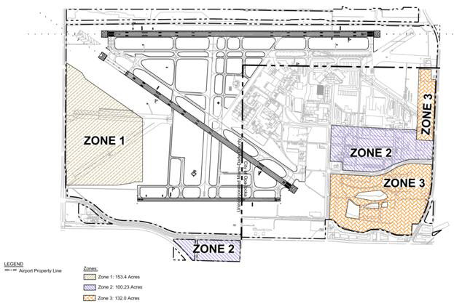

Opa-locka Executive Airport Development Zone Map

(Ord. No. 06-20, § 2, 2-7-06; Ord. No. 08-73, § 2, 6-3-08; Ord. No. 09-33, § 1, 5-5-09; Ord. No. 11-07, § 1, 2-1-11)

Sec. 33-363.2. Site plan review.

(A) For all non-aviation uses, the Department shall review plans for compliance with zoning regulations and for compliance with the site plan review criteria. The purpose of the site plan review is to encourage logic, imagination, innovation and variety in the design process and encourage the congruity of the proposed development and its compatibility with the surrounding area. All plans submitted to the Department shall be reviewed and approved or denied within fifteen (15) days from the date of submission. Denials shall be in writing and shall specifically set forth the grounds for denial. Receipt of applicant's plans for fifteen (15) days without formal written denial shall constitute approval. Notwithstanding the provisions of [33-314](../level3/PTIIICOOR_CH33ZO_ARTXXXVIZOPR.docx#PTIIICOOR_CH33ZO_ARTXXXVIZOPR_S33-314DIAPAPCOCO), if the site is located within unincorporated or incorporated Miami-Dade County and if the plan is disapproved, the applicant may appeal to the Board of County Commissioners. Appeals by the applicant shall be filed within thirty (30) days of the date the project was denied.

(B) Required exhibits. The following exhibits shall be prepared by design professionals such as architects and landscape architects and submitted to the Department:

(1) Dimensioned site plan(s) indicating, as a minimum, the following information:

(a) Existing zoning on the site and on adjacent properties.

(b) The basic use, height, bulk and location of all buildings and other structures with setbacks.

(c) Vehicular and pedestrian circulation systems including connection(s) to existing or proposed roadway and sidewalk system and the layout of parking, service and loading areas.

(d) Graphics and/or notations indicating the site planning or structure design methods used to minimize the impact of those industrial activities that could have a negative impact on existing or proposed adjacent land uses.

(e) Sketches of design elements to be used for buffering surrounding uses.

(2) Elevation of the proposed buildings and other major design elements.

(3) Landscape plans: Landscaping and trees shall be provided in accordance with [Chapter 18A](../level2/PTIIICOOR_CH18AMIDECOLAOR.docx#PTIIICOOR_CH18AMIDECOLAOR) of this Code.

(4) Figures indicating the following:

(a) Proposed uses.

(b) Gross floor area: ____________ square feet

(c) Land area:

Gross lot area: ____________ square feet  
____________ acres

Net lot area: ____________ square feet  
____________ acres

(d) Landscaped open space:

Required: ____________ square feet ____________ % of net land area

Provided: ____________ square feet ____________ % of net land area

(e) Tree Required: ____________

Trees Provided: ____________

(f) Off-street parking spaces:

Required: ____________

Provided: ____________

(C) Criteria. The following shall be considered in the plan review process:

(1) *Planning studies:* Planning studies approved by the Board of County Commissioners that include development patterns or environmental and other design criteria shall be considered in the plan review process.

(2) *Landscape:* Landscape shall be preserved in its natural state insofar as is practicable by minimizing removal of existing vegetation. Landscape shall be used to shade and cool, enhance architectural features, relate structure design to the site, visually screen noncompatible uses, and ameliorate the impact of noise.

(3) *Compatibility:* The architectural design and scale of the proposed structures shall be compatible with surrounding existing or proposed uses or shall be made compatible by the use of screening elements. Screening elements can include such devices as trees and shrubs, walls and fencing, berming or any combination of these elements. Visual buffering shall be provided between parking and service areas and adjacent non-commercial uses.

(4) *Emergency access:* Unobstructed on-site access for emergency equipment shall be considered.

(5) *Circulation:* Internal vehicular and pedestrian circulation systems shall be designed to function with existing and/or approved systems outside the development. Vehicular traffic generated from the industrial activity should be routed in such a manner as to minimize impact on residential development.

(6) *Energy conservation:* Applicants are advised to consider requirements of Florida Statutes Chapter 553 (Energy Code).

(7) *Visual screening for decorative walls:* In an effort to prevent graffiti vandalism, the following options shall be utilized for walls abutting zoned or dedicated rights-of-way:

(a) *Wall with landscaping.* The wall shall be setback two and one-half (2½) feet from the right-of-way line and the resulting setback area shall contain a continuous extensively landscaped buffer which must be maintained in a good healthy condition by the property owner, or where applicable, by the condominium, homeowners or similar association. The landscape buffer shall contain one (1) or more of the following planting materials:

(1) *Shrubs.* Shrubs shall be a minimum of three (3) feet in height when measured immediately after planting and shall be planted and maintained to form a continuous, unbroken, solid, visual screen within one (1) year after time of planting.

(2) *Hedges.* Hedges shall be a minimum of three (3) feet in height when measured immediately after planting and shall be planted and maintained to form a continuous, unbroken, solid, visual screen within one (1) year after time of planting.

(3) *Vines.* Climbing vines shall be a minimum of thirty-six (36) inches in height immediately after planting.

(b) *Metal picket fence.* Where a metal picket fence abutting a zoned or dedicated right-of-way is constructed in lieu of a decorative wall, landscaping shall not be required.

(Ord. No. 09-33, § 2, 5-5-09)

Sec. 33-364. Nonconforming uses, regulations not retroactive.

The regulations prescribed by this article or any amendment thereto shall not be construed to require the removal, lowering, or other change or alteration of any structure or tree or use of land lawfully in existence not conforming to the regulations as of the effective date hereof, or otherwise interfere with the continuance of any nonconforming use. After effective date hereof, property owners shall not be permitted to grow or maintain trees to heights in excess of those provided herein. Nothing herein contained shall require any change in the construction, alteration, or intended use of any structure, the construction or alteration of which was lawfully begun prior to the effective date of this article, and is diligently prosecuted and completed within the time limit as prescribed by the South Florida Building Code. Notwithstanding the preceding provisions of this article, the owner of any such nonconforming structure or tree is hereby required to permit the installation, operation and maintenance thereon of such marking, or marking and lighting, as shall be deemed necessary by the Director of the Miami-Dade County Port Authority, to indicate to the operators of aircraft in the vicinity of the airport the presence of such airport hazard. Such marking, or marking and lighting, and the installation, operation and maintenance thereof, or such disposition of the hazard as may be agreed upon by and between the owner and the Director of the Miami-Dade County Port Authority in lieu of such marking, or marking and lighting, shall be at the expense of the Miami-Dade County Port Authority.

(Ord. No. 69-37, § 9, 7-9-69)

Sec. 33-365. Administration and enforcement.

It shall be the duty of the Director to administer the regulations prescribed herein in accordance with [Section 2-105](../level3/PTIIICOOR_CH2AD_ARTXVDEPLDERE.docx#PTIIICOOR_CH2AD_ARTXVDEPLDERE_S2-105DIUT), Code of Miami-Dade County, Florida. It shall be the duty of Team Metro to enforce these regulations.

In the event of any violation of the regulations contained herein, the person responsible for such violation shall be given notice in writing by Team Metro. Such notice shall indicate the nature of the violation and the necessary action to correct or abate the violation. A copy of said notice shall be sent to the Director of the Miami-Dade County Port authority. A Department administrative official shall order discontinuance of use of land or buildings; removal of trees to conform with height limitations set forth herein; removal of buildings, additions, alterations, or structures; discontinuance of any work being done; or shall take any or all other action necessary to correct violations and obtain compliance with all the provisions of this article.

(Ord. No. 69-37, § 10, 7-9-69; Ord. No. 95-215, § 1, 12-5-95; Ord. No. 98-125, § 21, 9-3-98)

Sec. 33-366. Permits.

Applications for permits under this article shall be obtained from the appropriate Building and Zoning Department or agency.

Applications for permits for all construction, for adding height to any existing structures, and for all alterations, repairs, or additions that will change the use of the structure from the existing use to any commercial or industrial use in any airport zone classification district lying within unincorporated areas of Miami-Dade County, shall be obtained from the Director and from the Building Department.

All applications for permits made to appropriate municipal Building and Zoning Departments or agencies for all construction or for adding height to any existing structure, and for all alterations, repairs, or additions that will change the use of structure from the existing use to any commercial or industrial use in any airport zone classification district lying within a municipality for which airport zone classification district boundaries have been established herein, shall be approved by the Director and the Building Official or by their duly authorized representatives prior to issuance of the permit by any municipal Building and Zoning Department or agency for the purpose of assuring compliance with the minimum standards governing zoning as set forth in this article; provided however, no approval by the Director and Building Official will be required for building and use permits from municipalities which have adopted by ordinance effective airport zoning regulations, the minimum standards of which are at least as restrictive as the minimum standards prescribed herein as such apply to the areas covered by this article; no approval by the Director and Building Official will be required for building and use permits from municipalities which have adopted by ordinance effective general zoning regulations, the minimum standards of which are at least as restrictive as the minimum standards prescribed herein as such apply to the areas covered by this ordinance; provided, however, that no municipality may grant any variance to said general zoning regulations which would make said minimum standards less restrictive than the minimum standards prescribed herein.

Permits will be approved by the Director and Building Official or their duly authorized representatives unless the proposal fails to meet the requirements of all applicable zoning regulations and building codes including the provisions of this article.

Permits, when issued to applicants intending to use derricks, draglines, cranes and other boom-equipped machinery for such construction, reconstruction or alteration as is consistent with the provisions hereof, shall when the boom operating height exceeds the height limitations imposed by this article, require applicant to mark, or mark and light, the highest point on the boom to reflect conformity with the Federal Aviation Administration's standards for marking and lighting obstructions, and in such cases the applicant shall notify the Director of the Miami-Dade County Port Authority at least twenty-four (24) hours prior to the time that such use is to begin.

Any decision of the Director may be appealed as provided and prescribed under Article XXXVI, of [Chapter 33](../level2/PTIIICOOR_CH33ZO.docx#PTIIICOOR_CH33ZO), Code of Miami-Dade County, Florida.

(Ord. No. 69-37, § 11, 7-9-69; Ord. No. 95-215, § 1, 12-5-95; Ord. No. 98-125, § 21, 9-3-98)

Sec. 33-367. Nonconforming uses abandoned or destroyed.

Whenever the Director determines that a nonconforming use, structure or tree has been abandoned or is more than fifty (50) percent burned, torn down, physically deteriorated, or decayed, no permit shall be granted for reconstruction that would permit such structure or tree to violate height limits or use standards of this article. Whether application is made for a permit under this paragraph or not, the Director may, by appropriate action, require the owner of the nonconforming structure or tree to permit the Miami-Dade County Port Authority at its expense to lower, remove, or mark, or mark and light such object as may be necessary to conform to these regulations.

(Ord. No. 69-37, § 12, 7-9-69; Ord. No. 95-215, § 1, 12-5-95)

Sec. 33-368. Variances.

Any person desiring to erect or increase the height of any structure, or permit the growth of any tree or otherwise use his property not in accordance with the regulations prescribed in this article may apply to the appropriate zoning board for a variance from such regulations as provided and prescribed under Article XXXVI of [Chapter 33](../level2/PTIIICOOR_CH33ZO.docx#PTIIICOOR_CH33ZO), Code of Miami-Dade County, Florida. Such variances shall be allowed where it is duly found that a literal application or enforcement of the regulations would result in practical difficulty or unnecessary hardship and the relief granted would not be contrary to the public interest but will do substantial justice and be in accordance with the spirit of this article, and such zoning board is hereby admonished that the intent and purpose of this article is to promote the health, safety and general welfare of the inhabitants of Miami-Dade County, Florida, by preventing the creation or establishment of airport hazards, thereby protecting the lives and property of users of the Opa Locka Airport and of occupants of land in its vicinity and preventing destruction or impairment of the utility of the airport and the public investment therein.

(Ord. No. 69-37, § 13, 7-9-69)

Sec. 33-369. Hazard marking and lighting.

Any permit or variance granted under this article may, if such action is deemed advisable to effectuate the purposes of this article and reasonable in the circumstances, be so conditioned as to require the owner of the structure or tree in question to install, operate, and maintain, or to permit the Miami-Dade County Port Authority to install, operate, and maintain thereon at the owner's expense such marking, or marking and lighting, as may be necessary to indicate to aircraft pilots the presence of an airport hazard.

(Ord. No. 69-37, § 14, 7-9-69)

Sec. 33-370. Penalties and enforcement.

Each violation of this article or of any regulation, order, or ruling promulgated hereunder shall be punishable as provided by [Section 33-39](../level3/PTIIICOOR_CH33ZO_ARTIINGE.docx#PTIIICOOR_CH33ZO_ARTIINGE_S33-39PEVICH), Code of Miami-Dade County, Florida.

(Ord. No. 69-37, § 15, 7-9-69)

Sec. 33-371. Conflicting regulations.

Where this article imposes lower height limitations or more stringent restrictions upon the use of land or water than are imposed or required by any other ordinance or resolution, the provisions of this article shall govern. Nothing contained in this article shall, however, be interpreted to conflict with or supersede any federal regulations pertaining to the control of airport hazards.

(Ord. No. 69-37, § 16, 7-9-69)

FOOTNOTE(S):

--- (**56**) ---

**Editor's note—** Article XXXVIII, §§ 33-356—33-371, is derived from Ord. No. 69-37, §§ 1—16, enacted July 9, 1969. Said ordinance repealed all conflicting ordinances and authorized inclusion of said ordinance as a part of this Code; therefore, the editors deleted the former provisions of §§ 33-356—33-371, pertaining to similar subject matter, derived from Ord. No. 63-51, §§ 1—16, enacted Nov. 19, 1963, and codified in lieu thereof the provisions of Ord. No. 69-37 herein set out. (Back)

### ARTICLE XXXIX. HOMESTEAD GENERAL AVIATION AIRPORT ZONING [57]

Sec. 33-372. Short title.

Sec. 33-373. Provisions hereof established as minimum standards governing zoning.

Sec. 33-374. Definitions.

Sec. 33-375. Establishment of airport zoning area for Homestead General Aviation Airport.

Sec. 33-376. Establishment of zone classification districts for airport zoning area.

Sec. 33-377. Establishment of height limitations for zone classification districts in the airport zoning area.

Sec. 33-378. Zone classification district boundary map for the airport zoning area.

Sec. 33-379. Use restrictions.

Sec. 33-380. Nonconforming uses, regulations not retroactive.

Sec. 33-381. Administration and enforcement.

Sec. 33-382. Permits.

Sec. 33-383. Nonconforming uses abandoned or destroyed.

Sec. 33-384. Variances.

Sec. 33-385. Hazard marking and lighting.

Sec. 33-386. Penalties and enforcement.

Sec. 33-387. Conflicting regulations.

Sec. 33-372. Short title.

This article shall be known and may be cited as the "Homestead General Aviation Airport Zoning Ordinance."

(Ord. No. 69-38, § 1, 7-9-69)

Sec. 33-373. Provisions hereof established as minimum standards governing zoning.

It is established that the airport zoning area for Homestead General Aviation Airport, the zone classification districts therein and the height limitation applicable to such districts, as the same are hereinafter set forth, shall be incorporated with all other minimum standards governing zoning heretofore or hereinafter adopted pursuant to Section 4.07 of the Home Rule Charter for Miami-Dade County, Florida.

(Ord. No. 69-38, § 2, 7-9-69)

Sec. 33-374. Definitions.

In construing the provisions hereof and each and every word, term, phrase or part thereof, where the context will permit, the definitions provided in Section 1.01 F.S. and Section 33-1 and Section 33-302 of the Code of Miami-Dade County, Florida, and the following definitions shall apply:

(1) *Airport* means Homestead General Aviation Airport.

(2) *Airport elevation* means the established elevation of the highest point on the usable landing area. The airport elevation for Homestead General Aviation Airport is eight and five-tenths (8.5) feet mean sea level.

(3) *Airport hazard* means any structure or tree or use of land which obstructs the airspace required for or is otherwise hazardous to the flight of aircraft in landing or taking off at the airport.

(4) *Airport reference point* means the point established as the approximate geographic center of the landing area and so designated and identified. The position of the airport reference point for Homestead General Aviation Airport is described as follows:

Commence at the southwest corner of Section 5, Township 57 South, Range 38 East, Miami-Dade County, Florida, and run thence northward along the west line of said Section 5 at a bearing of North 00° 42′ 33″ West for a distance of two thousand five hundred fifty-five (2,555) feet; thence eastward at right angles to the said west line of Section 5 at a bearing of North 89° 17′ 27″ East for a distance of five hundred seventy-six (576) feet to the airport reference point.

(5) *Height* for the purpose of determining the height limits in all districts set forth in this article and shown on the boundary map for zone classification districts, the datum shall be mean sea level (MSL) elevation unless otherwise specified.

(6) *Instrument runway* means a runway equipped or to be equipped with electronic or visual air navigation aids adequate to permit the landing or take-off of aircraft under restricted visibility conditions. The instrument runway at Homestead General Aviation Airport will be designated as Runway 9L/27R, the centerline of which is described as follows:

*Runway 9L/27R:* Commencing at the northeast corner of Section 5, Township 57 South, Range 38 East, Miami-Dade County, Florida; thence South 00° 29′ 23″ East along the east line of said Section 5 a distance of 758.10 feet; thence South 89° 29′ 21″ West a distance of 1160 feet to the east end of the runway and the point of beginning; thence South 89° 29′ 21″ West a distance of 6500 feet to the west end of the runway.

(7) *Landing area* means the area of the airport used or intended to be used for landing, take-off, or taxiing of aircraft.

(8) *Nonconforming use* means any structure, tree or use of land lawfully in existence on the effective date hereof which does not conform to a regulation prescribed in this article or any amendment thereto, as of the effective date of such regulations.

(9) *Non-instrument runway* means a runway other than an instrument runway. The non-instrument runways at Homestead General Aviation are designated as Runways 18L/36R, Runway 18R/36L, and Runway 9R/27L and their centerlines are described as follow:

(a) *Runway 18L/36R:* Commencing at the northwest corner of Section 5, Township 57 South, Range 38 East, Miami-Dade County, Florida; thence South 00° 42′ 37″ East along the west line of said Section 5 a distance of 1388.10 feet; thence North 89° 29′ 21″ East a distance of 500 feet to the north end of the runway and the point of beginning; thence South 00° 42′ 37″ East a distance of 4000 feet to the south end of the runway.

(b) *Runway 18R/36L:* Beginning at the northeast corner of Section 6, Township 57 South, Range 38 East, Miami-Dade County, Florida, thence South 00° 42′ 37″ East along the east line of said Section 6 a distance of 683.10 feet; thence South 89° 29′ 21″ West a distance of 200 feet to the north end of the runway and the point of beginning; thence South 00° 42′ 37″ East a distance of 5000 feet to the south end of the runway.

(c) *Runway 9R/27L:* Beginning at the southeast corner of Section 5, Township 57 South, Range 38 East, Miami-Dade County, Florida, thence North 00° 09′ 23″ West along the east line of said Section 5 a distance of 500.13 feet; thence South 89° 29′ 21″ West a distance of 2175 feet to the east end of the runway and the point of beginning; thence continue South 89° 29′ 21″ West a distance of 4000 feet to the west end of the runway.

(10) *Person* means an individual, firm, co-partnership, corporation, company, association, joint stock association or body politic, and includes any trustee, receiver, assignee, administrator, executor, guardian or other similar representative thereof.

(11) *Runway* means the paved surface of an airport landing strip.

(12) *Structure* means an object constructed or installed by man, including, but without being limited to, buildings, derricks, draglines, cranes and other boom-equipped machinery towers, signs, smokestacks, utility poles, or overhead transmission lines.

(13) *Tree* means any object of natural growth.

(Ord. No. 69-38, § 3, 7-9-69)

Sec. 33-375. Establishment of airport zoning area for Homestead General Aviation Airport.

For the purpose of this article there is hereby created and established the airport zoning area for Homestead General Aviation Airport and it is hereby ordained that such area shall include, and that the provisions of this article shall be applicable to and embrace all of the unincorporated and the incorporated land and water area lying situate and being in those certain portions of Miami-Dade County, Florida, described as follows, to wit:

(1) In Township 57 South, Range 36 East, all of Sections 1, 2, 11 to 14 inclusive, 23 to 26 inclusive, the east one-half (½) of Sections 3, 10, 15, 22 and 27, the northeast one-quarter (¼) of Section 34, and the north one-half (½) of Sections 35 and 36.

(2) All of that portion of Range 36½ East, Miami-Dade County, Florida, which lies north of the prolongation west of the south line of [Section 18](../level2/PTIIICOOR_CH18IMSPRPDI.docx#PTIIICOOR_CH18IMSPRPDI), Township 57 South, Range 37 East, Miami-Dade County, Florida, and south of the prolongation west of the north line of the south half of [Section 19](../level2/PTIIICOOR_CH19REPROWMEAC.docx#PTIIICOOR_CH19REPROWMEAC), Township 56 South, Range 37 East, Miami-Dade County, Florida.

(3) In Township 56 South, Range 37 East, the south one-half (½) of Sections 19 to 23 inclusive, the northeast one-quarter (¼) of [Section 23](../level2/PTIIICOOR_CH23PE.docx#PTIIICOOR_CH23PE) and all of Sections 24 to 36 inclusive.

(4) In Township 57 South, Range 37 East, all of Sections 1 to 18 inclusive, the east one-half (½) of [Section 23](../level2/PTIIICOOR_CH23PE.docx#PTIIICOOR_CH23PE), and all of [Section 24](../level2/PTIIICOOR_CH24ENPRBIBAENDEAQPACOARBIBAENENTRFUENENLAPR.docx#PTIIICOOR_CH24ENPRBIBAENDEAQPACOARBIBAENENTRFUENENLAPR)

(5) In Township 56 South, Range 38 East, all of Sections 19 to 21 inclusive, 25 to 36 inclusive, and the south one-half (½) of Sections 22 to 24 inclusive.

(6) In Township 57 South, Range 38 East, all of Sections 1 to 22 inclusive.

(7) In Township 56 South, Range 39 East, the south one-half (½) of Sections 19 to 23 inclusive, the southwest one-quarter (¼) of [Section 24](../level2/PTIIICOOR_CH24ENPRBIBAENDEAQPACOARBIBAENENTRFUENENLAPR.docx#PTIIICOOR_CH24ENPRBIBAENDEAQPACOARBIBAENENTRFUENENLAPR), the west one-half (½) of Sections 25 and 36, and all of Sections 26 to 35 inclusive.

(8) In Township 57 South, Range 39 East, all of Sections 2 to 11 inclusive, all of Sections 14 to 18 inclusive, and the west one-half (½) of Sections 1, 12 and 13.

(Ord. No. 69-38, § 4, 7-9-69)

Sec. 33-376. Establishment of zone classification districts for airport zoning area.

For the purpose of this article all of the airport zoning area for Homestead General Aviation Airport, as the same is created, established and described hereinbefore, is hereby divided into zone classification districts as follows:

(1) *L or Landing districts.* A "landing district" is established for each instrument runway for instrument landings and take-offs and for each non-instrument runway for non-instrument landings and take-offs.

A landing district for an instrument runway shall have a uniform width of one thousand (1,000) feet, shall extend for the full length of such instrument runway plus a distance of two hundred (200) feet beyond each end thereof and shall include such runway and be symmetrical about the centerline thereof.

A landing district for non-instrument runway shall have a uniform width of five hundred (500) feet, shall extend for the full length of such non-instrument runway plus a distance of two hundred (200) feet beyond each end thereof and shall include such runway and be symmetrical about the centerline thereof.

(2) *IA or Instrument approach districts.* An "instrument approach district" is established for each end of each instrument runway for instrument landings and take-offs and it is further established that each such instrument approach district shall embrace and include all of the land and water area lying vertically beneath an imaginary inclined surface which shall hereafter, for the purposes of this article, be referred to and described as the instrument approach surface.

The instrument approach surface shall begin, and shall have a base one thousand (1,000) feet wide, at a distance of two hundred (200) feet beyond the end of the runway, widening thereafter uniformly to a width of sixteen thousand (16,000) feet at a horizontal distance of fifty thousand two hundred (50,200) feet beyond the end of the runway, the centerline of this surface being the continuation of the centerline of the runway. The instrument approach surface shall extend outward and upward from its base, the elevation of which shall be the same as that of the runway end adjacent thereto, with a slope of one (1) foot vertically to fifty (50) feet horizontally for the first ten thousand (10,000) feet of its length and thence with a slope of one (1) foot vertically to forty (40) feet horizontally for the remainder.

(3) *NA or Non-instrument approach districts.* A "non-instrument approach district" is established for each end of each non-instrument runway for non-instrument landings and take-offs and it is further established that each such non-instrument approach district shall embrace and include all of the land and water area lying vertically beneath an imaginary inclined surface which shall hereafter, for the purposes of this article be referred to and described as the non-instrument approach surface.

The non-instrument approach surface shall begin, and shall have a base five hundred (500) feet wide, at a distance of two hundred (200) feet beyond the end of the runway, widening thereafter uniformly to a width of two thousand five hundred (2,500) feet at a horizontal distance of ten thousand two hundred (10,200) feet beyond the end of the runway, the centerline of this surface being the continuation of the centerline of the runway. The non-instrument approach surface shall extend outward and upward from its base, the elevation of which shall be the same as that of the runway end adjacent thereto, with a slope of one (1) foot vertically to forty (40) feet horizontally for its entire length.

(4) *TR or Transition districts.* "Transition districts" are hereby established adjacent to each landing, instrument approach and non-instrument approach district.

Transition districts adjacent to runways embrace and include all of the land and water area lying vertically beneath an imaginary inclined surface symmetrically located on each side of each runway. For instrument runways such imaginary inclined surfaces extend outward from lines parallel to and five hundred (500) feet on either side of the centerline of the runway, upward with a slope of one (1) foot vertically to seven (7) feet horizontally and terminating at an elevation one hundred fifty (150) feet above the hereinbefore established airport elevation. For non-instrument runways such imaginary inclined surfaces extend outward from lines parallel to and two hundred fifty (250) feet on either side of the centerline of the runway, upward with a slope of one (1) foot vertically to seven (7) feet horizontally and terminating at an elevation one hundred fifty (150) feet above the hereinbefore established airport elevation.

Transition districts adjacent to non-instrument approach districts embrace and include all of the land and water area lying vertically beneath imaginary inclined surfaces which extend outward and upward from the long sides of the non-instrument approach surfaces, as hereinbefore described, with a slope of one (1) foot vertically to seven (7) feet horizontally terminating at an elevation one hundred fifty (150) feet above the hereinbefore established airport elevation.

Transition districts adjacent to instrument approach districts embrace and include all of the land and water area lying vertically beneath imaginary inclined surfaces which extend outward and upward from the long sides of the instrument approach surfaces as hereinbefore described, with a slope of one (1) foot vertically to seven (7) feet horizontally.

Within horizontal districts, which are hereafter established and described, this imaginary inclined plane shall terminate when it reaches an elevation one hundred fifty (150) feet above the hereinbefore established airport elevation. Within conical districts, which are also hereafter established and described, this imaginary inclined surface shall terminate in its intersection with the conical surface which, for the purposes of this article is described hereinbelow. Outward from the limits of such conical surface, this imaginary inclined surface shall terminate five thousand (5,000) feet from the long sides of the hereinbefore described instrument approach surfaces, such five thousand (5,000) feet being measured horizontally and at right angles to the continuation of the centerline of the runway.

For the purposes of this article, the horizontal surface is established as a horizontal circular surface which has a radius of eleven thousand five hundred (11,500) feet centered vertically above the airport reference point at an elevation one hundred fifty (150) feet above the heretofore established airport elevation.

For the purposes of this article, the conical surface is established as the outer surface of right angled section of an inverted cone, the horizontal circular base of which has a radius of eleven thousand five hundred (11,500) feet centered vertically above the airport reference point at an elevation one hundred fifty (150) feet above the heretofore established airport elevation and the horizontal circular top of which has a radius of eighteen thousand five hundred (18,500) feet at an elevation five hundred (500) feet above the hereinbefore established airport elevation.

(5) *T or Horizontal districts.* A "horizontal district" is established as the area within a circle having its center at the airport reference point and eleven thousand five hundred (11,500) feet as its radius. The horizontal district does not include the landing, instrument approach, non-instrument approach and transition districts.

(6) *TI or Conical district.* A "conical district" is established commencing at the periphery of the horizontal district and extending to a periphery eighteen thousand five hundred (18,500) feet from the airport reference point. The conical district does not include the instrument approach, non-instrument approach and transition districts.

(7) *NZ or Non-zoned districts.* Those portions of the airport zoning area not embraced and included in landing, instrument approach, non-instrument approach, transition, horizontal and conical districts, as the same are established and described elsewhere herein, are hereby designated as non-zoned districts.

(Ord. No. 69-38, § 5, 7-9-69)

Sec. 33-377. Establishment of height limitations for zone classification districts in the airport zoning area.

Except as otherwise provided elsewhere in this article, no structure shall be erected or altered and no tree shall be allowed to grow or be maintained in any district created and established by this article to a height in excess of the height limits herein established for such district. Such height limitations will, in applying the provisions of this article, be corrected to elevations referred to the heretofore established mean sea level datum plane, by adding such height limitations to the mean sea level elevation of the point, line or plane to which such height limitation is referenced, or to the airport elevation, as the context of this article requires. Such limitations are hereby established for the districts as follows:

(1) *Landing districts:* Structures and trees will not be permitted in landing districts except as required, necessary and pertinent to the operation and maintenance of Homestead General Aviation Airport and then only to the extent permitted or authorized by applicable rule or regulation promulgated by the Federal Aviation Administration, or its successor counterpart.

(2) *Instrument approach districts:* One (1) foot in height for each fifty (50) feet in horizontal distance beginning at a point two hundred (200) feet from the end of the instrument runway and extending to a distance of ten thousand two hundred (10,200) feet from the end of the runway; thence one (1) foot in height for each forty (40) feet in horizontal distance to a point fifty thousand two hundred (50,200) feet from the end of the runway.

(3) *Non-instrument approach districts:* One (1) foot in height for each forty (40) feet in horizontal distance beginning at a point two hundred (200) feet from the end of the non-instrument runway and extending to a point ten thousand two hundred (10,200) feet from the end of the runway.

(4) *Transition districts:* One (1) foot in height for each seven (7) feet in horizontal distance beginning at a point two hundred fifty (250) feet from the centerline of non-instrument runways and five hundred (500) feet from the centerline of instrument runways, measured at right angles to the longitudinal centerline of the runway and extending upward to a maximum height of one hundred fifty (150) feet above the airport elevation as established elsewhere herein.

In addition to the foregoing, there are established height limits of one (1) foot vertical height for each seven (7) feet horizontal distance measured from the edges of all instrument approach surfaces and non-instrument approach surfaces upward and outward to an intersection with the hereinbefore described horizontal and conical surfaces. Further, where the instrument approach surface projects beyond, or through and beyond the conical surface, the height limit of one (1) foot for each seven (7) feet of horizontal distance shall be maintained, beginning at the edge of the instrument approach surface and extending a distance of five thousand (5,000) feet from the edge of the instrument approach surface, such five thousand (5,000) feet being measured horizontally and at right angles to the continuation of the centerline of the runway.

(5) *Horizontal district:* One hundred fifty (150) feet above the hereinbefore established airport elevation.

(6) *Conical district:* One (1) foot in height for each twenty (20) feet of horizontal distance beginning at the periphery of the hereinbefore described horizontal surface and measured in a vertical plane passing through the airport reference point.

(7) *Non-zoned districts:* The height limitations as well as land use requirement in non-zoned districts, shall, for the purposes of this article, be identical with requirements as set forth in [Chapter 33](../level2/PTIIICOOR_CH33ZO.docx#PTIIICOOR_CH33ZO) of the Code of Miami-Dade County, Florida, or, as the same may be set forth in the general zoning ordinances of the various municipalities where the property is located within a municipality.

Where the hereinbefore described imaginary inclined or horizontal surfaces for one (1) district overlap, merge, or intersect with those of any other district, the imaginary inclined or horizontal surface that prescribes the most restrictive height limitation shall obtain and shall govern.

Notwithstanding any other provisions of this article to the contrary, the height limits prescribed by this article shall not establish for any particular parcel of privately owned land at any particular point within such a parcel, a height limit of less than thirty-eight and five-tenths (38.5) feet above the mean sea level at that point.

(Ord. No. 69-38, § 6, 7-9-69)

Sec. 33-378. Zone classification district boundary map for the airport zoning area.

The Board of County Commissioners shall, by resolution, adopt, approve and ratify a drawing which shall be entitled "Airport Zoning Area for Homestead General Aviation Airport, Boundary Map, Zone Classification Districts." Such drawing shall locate and identify Homestead General Aviation Airport and other topographic data pertinent thereto and to the purposes of this article and it shall also truly and faithfully depict the boundary of the airport zoning area and the boundaries; and by contour lines, the height limitations, for the several zone classification districts therein as the same are established herein and as the same may be changed, varied, amended or supplemented by resolution as provided and prescribed in [Chapter 33](../level2/PTIIICOOR_CH33ZO.docx#PTIIICOOR_CH33ZO) of the Code of Miami-Dade County, Florida. Copies or prints of such drawing shall be maintained and kept on file in the offices of the Miami-Dade County Port Authority and the Department and shall be prima facie evidence of the boundaries of the zone classification districts and the height limitations applicable thereto and therein.

(Ord. No. 69-38, § 7, 7-9-69; Ord. No. 95-215, § 1, 12-5-95)

Sec. 33-379. Use restrictions.

Except as otherwise provided in this article, it shall be unlawful to put any land or water located within L, T, and NA Districts and within TR Districts adjoining L and NA Districts and within the inner ten thousand (10,000) feet of IA Districts and the adjoining portions of TR Districts to any of the following prohibited uses:

*Prohibited uses:*

(1) Establishments or uses that emit smoke, gases, or dust in quantities or densities sufficient to jeopardize the safe use of the airport.

(2) Notwithstanding any other provisions of this article, no use may be made of land or water within the airport zoning area in such a manner as to create electrical interference with radio communications between the airport and aircraft; make it difficult for aircraft pilots and tower control operators to distinguish between airport lights, aircraft and others; result in glare in the eyes of aircraft pilots using the airport, or tower control operators; impair visibility in the vicinity of the airport or otherwise endanger the landing, taking off or maneuvering of aircraft.

(Ord. No. 69-38, § 8, 7-9-69)

Sec. 33-380. Nonconforming uses, regulations not retroactive.

The regulations prescribed by this article or any amendment thereto shall not be construed to require the removal, lowering, or other change or alteration of any structure or tree or use of land lawfully in existence not conforming to the regulations as of the effective date hereof, or otherwise interfere with the continuance of any nonconforming use. After effective date hereof, property owners shall not be permitted to grow or maintain trees to heights in excess of those provided herein. Nothing herein contained shall require any change in the construction, alteration, or intended use of any structure, the construction or alteration of which was lawfully begun prior to the effective date of this article, and is diligently prosecuted and completed within the time limit as prescribed by the South Florida Building Code. Notwithstanding the preceding provisions of this article, the owner of any such nonconforming structure or tree is hereby required to permit the installation, operation and maintenance thereon of such marking, or marking and lighting, as shall be deemed necessary by the Director of the Miami-Dade County Port Authority, to indicate to the operators of aircraft in the vicinity of the airport the presence of such airport hazard. Such marking, or marking and lighting, and the installation, operation and maintenance thereof, or such disposition of the hazard as may be agreed upon by and between the owner and the Director of the Miami-Dade County Port Authority in lieu of such marking, or marking and lighting, shall be at the expense of the Miami-Dade County Port Authority.

(Ord. No. 69-38, § 9, 7-9-69)

Sec. 33-381. Administration and enforcement.

It shall be the duty of the Director to administer the regulations prescribed herein in accordance with [Section 2-105](../level3/PTIIICOOR_CH2AD_ARTXVDEPLDERE.docx#PTIIICOOR_CH2AD_ARTXVDEPLDERE_S2-105DIUT), Code of Miami-Dade County, Florida. It shall be the duty of Team Metro to enforce these regulations.

In the event of any violation of the regulations contained herein, the person responsible for such violation shall be given notice in writing by Team Metro. Such notice shall indicate the nature of the violation and the necessary action to correct or abate the violation. A copy of said notice shall be sent to the Director of the Miami-Dade County Port Authority. A Department administrative official shall order discontinuance of use of land or buildings; removal of trees to conform with height limitations set forth herein; removal of buildings, additions, alteration, or structures; discontinuance of any work being done; or shall take any or all other action necessary to correct violations and obtain compliance with all the provisions of this article.

(Ord. No. 69-38, § 10, 7-9-69; Ord. No. 95-215, § 1, 12-5-95; Ord. No. 98-125, § 21, 9-3-98)

Sec. 33-382. Permits.

Applications for permits under this article shall be obtained from the appropriate Building and Zoning Department or agency.

Applications for permits for all construction, for adding height to any existing structures, and for all alterations, repairs, or additions that will change the use of the structure from the existing use to any commercial or industrial use in any airport zone classification district lying within unincorporated areas of Miami-Dade County, shall be obtained from the Director and the Building Department.

All applications for permits made to appropriate municipal Building and Zoning Departments or agencies for all construction or for adding height to any existing structure, and for all alterations, repairs, or additions that will change the use of structure from the existing use to any commercial or industrial use in any airport zone classification district lying within a municipality for which airport zone classification district boundaries have been established herein, shall be approved by the Director and Building Official or by their duly authorized representatives prior to issuance of the permit by any municipal Building and Zoning Department or agency for the purpose of assuring compliance with the minimum standards governing zoning as set forth in this article; provided, however, no approval by the Director and Building Official will be required for building and use permits from municipalities which have adopted by ordinance effective airport zoning regulations, the minimum standards of which are at least as restrictive as the minimum standards prescribed herein as such apply to the areas covered by this article; no approval by the Director and Building Official will be required for building and use permits from municipalities which have adopted by ordinance effective general zoning regulations, the minimum standards of which are at least as restrictive as the minimum standards prescribed herein as such apply to the areas covered by this article; provided, however, that no municipality may grant any variance to said general zoning regulations which would make said minimum standards less restrictive than the minimum standards prescribed herein.

Permits will be approved by the Director and Building Official or their duly authorized representatives unless the proposal fails to meet the requirements of all applicable zoning regulations and building codes including the provisions of this article.

Permits when issued to applicants intending to use derricks, draglines, cranes and other boom-equipped machinery for such construction, reconstruction or alteration as is consistent with the provisions hereof, shall, when the boom operating height exceeds the height limitations imposed by this article require applicant to mark, or mark and light, the highest point on the boom to reflect conformity with the Federal Aviation Administration's standards for marking and lighting obstructions, and in such cases the applicant shall notify the Director of the Miami-Dade County Port Authority at least twenty-four (24) hours prior to the time that such use is to begin.

Any decision of the Director may be appealed as provided and prescribed under Article XXXVI, of [Chapter 33](../level2/PTIIICOOR_CH33ZO.docx#PTIIICOOR_CH33ZO), Code of Miami-Dade County, Florida.

(Ord. No. 69-38, § 11, 7-9-69; Ord. No. 95-215, § 1, 12-5-95; Ord. No. 98-125, § 21, 9-3-98)

Sec. 33-383. Nonconforming uses abandoned or destroyed.

Whenever the Director determines that a nonconforming use, structure or tree has been abandoned or is more than fifty (50) percent burned, torn down, physically deteriorated, or decayed, no permit shall be granted for reconstruction that would permit such structure or tree to violate height limits or use standards of this article. Whether application is made for a permit under this paragraph or not, the Director, may, by appropriate action, require the owner of the nonconforming structure or tree to permit the Miami-Dade County Port Authority at its expense to lower, remove, or mark, or mark and light such object as may be necessary to conform to these regulations.

(Ord. No. 69-38, § 12, 7-9-69; Ord. No. 95-215, § 1, 12-5-95)

Sec. 33-384. Variances.

Any person desiring to erect or increase the height of any structure, or permit the growth of any tree or otherwise use his property not in accordance with the regulations prescribed in this article may apply to the appropriate zoning board for a variance from such regulations as provided and prescribed under Article XXXVI of [Chapter 33](../level2/PTIIICOOR_CH33ZO.docx#PTIIICOOR_CH33ZO), Code of Miami-Dade County, Florida. Such variances shall be allowed where it is duly found that a literal application or enforcement of the regulations would result in practical difficulty or unnecessary hardship and the relief granted would not be contrary to the public interest but will do substantial justice and be in accordance with the spirit of this article, and such zoning board is hereby admonished that the intent and purpose of this ordinance is to promote the health, safety and general welfare of the inhabitants of Miami-Dade County, Florida, by preventing the creation or establishment of airport hazards, thereby protecting the lives and property of users of the Homestead General Aviation Airport and of occupants of land in its vicinity and preventing destruction or impairment of the utility of the airport and the public investment therein.

(Ord. No. 69-38, § 13, 7-9-69)

Sec. 33-385. Hazard marking and lighting.

Any permit or variance granted under this article may, if such action is deemed advisable to effectuate the purposes of this article and reasonable in the circumstance, be so conditioned as to require the owner of the structure or tree in question to install, operate, and maintained, or to permit the Miami-Dade County Port Authority to install, operate, and maintain thereon at the owner's expense such marking, or marking and lighting, as may be necessary to indicate to aircraft pilots the presence of an airport hazard.

(Ord. No. 69-38, § 14, 7-9-69)

Sec. 33-386. Penalties and enforcement.

Each violation of this article or of any regulation, order, or ruling promulgated hereunder shall be punishable as provided by [Section 33-39](../level3/PTIIICOOR_CH33ZO_ARTIINGE.docx#PTIIICOOR_CH33ZO_ARTIINGE_S33-39PEVICH), Code of Miami-Dade County, Florida.

(Ord. No. 69-38, § 15, 7-9-69)

Sec. 33-387. Conflicting regulations.

Where this article imposes lower height limitations or more stringent restrictions upon the use of land or water than are imposed or required by any other ordinance or resolution, the provisions of this article shall govern. Nothing contained in this article shall, however, be interpreted to conflict with or supersede any federal regulations pertaining to the control of airport hazards.

(Ord. No. 69-38, § 16, 7-9-69)

FOOTNOTE(S):

--- (**57**) ---

**Editor's note—** Article XXXIX, §§ 33-372—33-387, is derived from Ord. No. 69-38, §§ 1—16, enacted July 9, 1969. Section 17 of said ordinance authorized inclusion of the ordinance in this Code, as a new article of Chapter 33 (Back)

### ARTICLE XL. KENDALL TAMIAMI EXECUTIVE AIRPORT ZONING [58]

Sec. 33-388. Short title.

Sec. 33-389. Provisions hereof established as minimum standards governing zoning.

Sec. 33-390. Definitions.

Sec. 33-391. Establishment of airport zoning area for Kendall Tamiami Executive Airport.

Sec. 33-392. Establishment of zone classification districts for airport zoning area.

Sec. 33-393. Establishment of height limitations for zone classification districts in the airport zoning area.

Sec. 33-394. Establishment of land use zoning criteria for airports.

Sec. 33-395. Land use zoning classifications for airports.

Sec. 33-396. Land use and height zoning maps for the airport zoning area.

Sec. 33-396.1 Uses permitted on Kendall Tamiami Executive Airport lands in the GP Governmental Property zoning district.

Sec. 33-396.2. Site plan review.

Sec. 33-397. Nonconforming uses, regulations not retroactive.

Sec. 33-398. Reserved.

Sec. 33-399. Administration and enforcement.

Sec. 33-400. Permits.

Sec. 33-401. Nonconforming uses abandoned or destroyed.

Sec. 33-402. Variances.

Sec. 33-403. Conditions to variances.

Sec. 33-404. Penalties and enforcement.

Sec. 33-405. Conflicting regulations.

Secs. 33-406—33-419. Reserved.

Sec. 33-388. Short title.

This article shall be known and may be cited as the "Kendall Tamiami Executive Airport Zoning Ordinance."

(Ord. No. 69-40, § 1, 7-9-69; Ord. No. 99-118, § 1, 9-21-99)

Sec. 33-389. Provisions hereof established as minimum standards governing zoning.

It is established that the airport zoning area for Kendall Tamiami Executive Airport, the zone classification districts therein and the height limitation applicable to such districts, as the same are hereinafter set forth, shall be incorporated with all other minimum standards governing zoning heretofore or hereinafter adopted pursuant to Section 4.07 of the Home Rule charter for Miami-Dade County, Florida.

(Ord. No. 69-40, § 2, 7-9-69; Ord. No. 99-118, § 1, 9-21-99)

Sec. 33-390. Definitions.

In construing the provisions hereof and each and every word, term, phrase or part thereof, where the context will permit, the definitions provided in Section 1.01 F.S. and Section 33-1 and Section 33-302 of the Code of Miami-Dade County, Florida, and the following definitions shall apply:

(1) *Airport* means Kendall Tamiami Executive Airport.

(2) *Airport elevation* means the established elevation of the highest point on the usable landing area. The airport elevation for Kendall Tamiami Executive Airport is ten (10.0) feet mean sea level.

(3) *Airport reference point* means the point established as the approximate geographic center of the landing area and so designated and identified. The position of the airport reference point for Kendall Tamiami Executive Airport is described as follows:

Commence at the northeast corner of [Section 16](../level2/PTIIICOOR_CH16GEOBBO.docx#PTIIICOOR_CH16GEOBBO), Township 55 South, Range 39 East, Miami-Dade County, Florida, and run thence southward along the east line of said [Section 16](../level2/PTIIICOOR_CH16GEOBBO.docx#PTIIICOOR_CH16GEOBBO) at a bearing of South 02° 22′ 40″ East a distance of 2734.47 feet; thence westward at right angles to the said east line of [Section 16](../level2/PTIIICOOR_CH16GEOBBO.docx#PTIIICOOR_CH16GEOBBO) at a bearing of South 87° 37′ 20″ West for a distanced of 334.45 feet to the airport reference point.

(4) *Aviation schools* shall mean any educational facility that primarily provides education or training in the science and art of flight, including, but not limited to: the operation and construction of aircraft, aircraft power plants and accessories, including the repair, packing and maintenance of parachutes; the design, establishment, construction, extension, operations, improvement, repair or maintenance of airports or other air navigation facilities, and instruction in flying or ground subjects pertaining thereto.

(5) *Educational facilities* shall mean those facilities as defined by Chapter 235, Florida Statutes, as amended, and the Code of Miami-Dade County.

(6) *Hazard to Air Navigation* is an obstruction determined by the Federal Aviation Administration to have a substantial adverse effect on the safe and efficient utilization of the navigable airspace.

(7) *Height* for the purpose of determining the height limits in all districts set forth in this article and shown on the boundary map for zone classification districts, the datum shall be mean sea level (MSL) elevation unless otherwise specified.

(8) *Instrument runway* means a runway equipped or to be equipped with electronic or visual air navigation aids adequate to permit the landing or take-off of aircraft under restricted visibility conditions. The instrument runways at Kendall Tamiami Executive Airport are designated as Runway 9L/27R and Runway 9R/27L and their centerlines are described as follows:

(a) *Runway 9L/27R:* Commencing at the northeast corner of [Section 15](../level2/PTIIICOOR_CH15SOWAMA.docx#PTIIICOOR_CH15SOWAMA), Township 55 South, Range 39 East, Miami-Dade County, Florida; thence south 03° 53′ 36″ East along the east line of said [Section 15](../level2/PTIIICOOR_CH15SOWAMA.docx#PTIIICOOR_CH15SOWAMA) a distance of 945.03 feet; thence south 87° 04′ 03″ West a distance of 2606.21 feet to the east end of the runway and the point of beginning; thence continue south 87° 04′ 03″ West a distance of 5000 feet to the west end of the runway.

(b) *Runway 9R/27L:* Commencing at the southeast corner of [Section 15](../level2/PTIIICOOR_CH15SOWAMA.docx#PTIIICOOR_CH15SOWAMA), Township 55 South, Range 39 East, Miami-Dade County, Florida; thence north 04° 35′ 16″ West along the east line of said [Section 15](../level2/PTIIICOOR_CH15SOWAMA.docx#PTIIICOOR_CH15SOWAMA) a distance of 1068.16 feet; thence south 87° 04′ 03″ West a distance of 2684.19 feet to the east end of the runway and the point of beginning; thence continue south 87° 04′ 03″ West a distance of 5000 feet to the west end of the runway.

(8.5) *Landing area* means the area of the airport used or intended to be used for landing, take-off, or taxiing of aircraft.

(9) *Nonconforming use* means any structure, tree or use of land lawfully in existence on the effective date hereof which does not conform to a regulation prescribed in this article or any amendment thereto, as of the effective date of such regulations.

(10) *Non-instrument runway* means a runway other than an instrument runway. The non-instrument runway at Kendall Tamiami Executive Airport is designated as Runway 13/31 and its centerline is described as follows:

(a) *Runway 13/31:* Commencing at the northeast corner of [Section 15](../level2/PTIIICOOR_CH15SOWAMA.docx#PTIIICOOR_CH15SOWAMA), Township 55 South, Range 39 East, Miami-Dade County, Florida; thence south 03° 53′ 36″ East along the east line of said [Section 15](../level2/PTIIICOOR_CH15SOWAMA.docx#PTIIICOOR_CH15SOWAMA) a distance of 945.03 feet; thence south 87° 04′ 03″ West a distance of 9254.87 feet; thence south 52° 54′ 00″ East a distance of 1148.67 feet to the northwest end of the runway and the point of beginning; thence continue south 52° 54′ 00″ East a distance of 4000 feet to the southeast end of the runway.

(11) *Person* means an individual, firm, co-partnership, corporation, company, association, joint stock association or body politic, and includes any trustee, receiver, assignee, administrator, executor, guardian or other similar representative thereof.

(12) *Runway* means the defined area on an airport prepared for landing and take-off of aircraft along its length.

(13) *Structure* means an object constructed or installed by man, including, but without being limited to, buildings, derricks, draglines, cranes and other boom-equipped machinery, towers, signs, smokestacks, utility poles, or overhead transmission lines.

(14) *Tree* means any object of natural growth.

(15) *Obstruction* means any structure, growth, or other object, including a mobile object, which exceeds the height limitations as set forth herein.

(16) *Airport hazard* means any structure or tree or use of land which would exceed the federal obstruction standards as contained in 14 C.F.R. §§ 77.21, 77.23, 77.25, 77.28, and 77.29 and which obstructs the airspace required for the flight of aircraft in taking off, maneuvering, or landing or is otherwise hazardous to such taking off, maneuvering, or landing of aircraft.

(Ord. No. 69-40, § 3, 7-9-69; Ord. No. 99-118, § 1, 9-21-99)

Sec. 33-391. Establishment of airport zoning area for Kendall Tamiami Executive Airport.

For the purpose of this article there is hereby created and established the airport zoning area for Kendall Tamiami Executive Airport and it is hereby ordained that such area shall include, and the provisions of this article shall be applicable to and embrace all of the unincorporated and the incorporated land and water area lying, situate and being in those certain portions of Miami-Dade County, Florida, described as follows, to wit:

(1) In Township 55 South, Range 37 East, all of Sections 1, 12, 13, 24, 25 and 36.

(2) In Township 55 South, Range 38 East, all of Section 1 to 32 inclusive.

(3) In Township 55 South, Range 39 East, all of Sections 1 to 30 inclusive.

(4) In Township 55 South, Range 40 East, all of Sections 1 to 30 inclusive, and the north one-half (½) of Section 36.

(5) In Township 55 South, Range 41 East, all of Sections 6, 7, 18, 19, 30, and the north one-half (½) of [Section 31](../level2/PTIIICOOR_CH31VEHI.docx#PTIIICOOR_CH31VEHI)

(6) In Township 54 South, Range 40 East, the south one-half (½) of Sections 35 and 36.

(7) In Township 54 South, Range 41 East, the south one-half (½) of [Section 31](../level2/PTIIICOOR_CH31VEHI.docx#PTIIICOOR_CH31VEHI)

(8) All of Lot 1 as the same lies between Township 54 South, Range 37 East and Township 55 South, Range 37 East.

(9) All of Lot 6 as the same lies between Township 54 South, Range 38 East and Township 55 South, Range 38 East.

(Ord. No. 69-40, § 4, 7-9-69; Ord. No. 99-118, § 1, 9-21-99)

Sec. 33-392. Establishment of zone classification districts for airport zoning area.

For the purpose of this article all of the Airport Zoning Area for Kendall Tamiami Executive Airport, as the same is created, established and described hereinbefore, is hereby divided into zone classification districts as follows:

(1) *L or Landing districts (Primary Surfaces).* A "landing district" is established for each instrument runway for instrument landings and take-offs and for each non-instrument runway for non-instrument landings and take-offs.

A landing district for an instrument runway shall have a uniform width of one thousand (1,000) feet, shall extend for the full length of such instrument runway plus a distance of two hundred (200) feet beyond each end thereof and shall include such runway and be symmetrical about the centerline thereof.

A landing district for non-instrument runway shall have a uniform width of five hundred (500) feet, shall extend for the full length of such non-instrument runway plus a distance of two hundred (200) feet beyond each end thereof and shall include such runway and be symmetrical about the centerline thereof.

(2) *IA or Instrument approach districts.* An "instrument approach district" is established for each end of each instrument runway for instrument landings and take-offs and it is further established that each such instrument approach district shall embrace and include all of the land and water area lying vertically beneath an imaginary inclined surface which shall hereafter, for the purposes of this article, be referred to and described as the instrument approach surface.

The instrument approach surface shall begin, and shall have a base one thousand (1,000) feet wide, at a distance of two hundred (200) feet beyond the end of the runway, widening thereafter uniformly to a width of sixteen thousand (16,000) feet at a horizontal distance of fifty thousand two hundred (50,200) feet beyond the end of the runway, the centerline of this surface being the continuation of the centerline of the runway. The instrument approach surface shall extend outward and upward from its base, the elevation of which shall be the same as that of the runway end adjacent thereto, with a slope of one (1) foot vertically to fifty (50) feet horizontally for the first ten thousand (10,000) feet of its length and thence with a slope of one (1) foot vertically to forty (40) feet horizontally for the remainder.

(3) *NA or Non-instrument approach districts.* A "non-instrument approach district" is established for each end of each non-instrument runway for non-instrument landings and take-offs and it is further established that each such non-instrument approach district shall embrace and include all of the land and water area lying vertically beneath an imaginary inclined surface which shall hereafter, for the purposes of this article be referred to and described as the non-instrument approach surface.

The non-instrument approach surface shall begin, and shall have a base five hundred (500) feet wide, at a distance of two hundred (200) feet beyond the end of the runway, widening thereafter uniformly to a width of three thousand five hundred (3,500) feet at a horizontal distance of ten thousand two hundred (10,200) feet beyond the end of the runway, the centerline of this surface being the continuation of the centerline of the runway. The non-instrument approach surface shall extend outward and upward from its base, the elevation of which shall be the same as that of the runway end adjacent thereto, with a slope of one (1) foot vertically to thirty-four (34) feet horizontally for its entire length.

(4) *TR or Transitional districts.* "Transitional districts" are hereby established adjacent to each landing, instrument approach and non-instrument approach district.

Transitional districts adjacent to runways embrace and include all of the land and water area lying vertically beneath an imaginary inclined surface symmetrically located on each side of each runway. For instrument runways such imaginary inclined surfaces extend outward from lines parallel to and five hundred (500) feet on either side of the centerline of the runway, upward with a slope of one (1) foot vertically to seven (7) feet horizontally and terminating at an elevation one hundred fifty (150) feet above the hereinbefore established airport elevation. For non-instrument runways such imaginary inclined surfaces extend outward from lines parallel to and two hundred fifty (250) feet on either side of the centerline of the runway, upward with a slope of one (1) foot vertically to seven (7) feet horizontally and terminating at an elevation one hundred fifty (150) feet above the hereinbefore established airport elevation.

Transitional districts adjacent to non-instrument approach districts embrace and include all of the land and water area lying vertically beneath imaginary inclined surfaces which extend outward and upward from the long sides of the non-instrument approach surfaces, as hereinbefore described, at right angles to the centerline of the runway, with a slope of one (1) foot vertically to seven (7) feet horizontally terminating at an elevation one hundred fifty (150) feet above the hereinbefore established airport elevation.

Transitional districts adjacent to instrument approach districts embrace and include all of the land and water area lying vertically beneath imaginary inclined surfaces which extend outward and upward from the long sides of the instrument approach surfaces as hereinbefore described, at right angles to the centerline of the runway with a slope of one (1) foot vertically to seven (7) feet horizontally.

Within horizontal districts, which are hereafter established and described, this imaginary inclined plane shall terminate when it reaches an elevation one hundred fifty (150) feet above the hereinbefore established airport elevation. Within conical districts, which are also hereafter established and described, this imaginary inclined surface shall terminate in its intersection with the conical surface which, for the purposes of this article, is described hereinbelow. Outward from the limits of such conical surface, this imaginary inclined surface shall terminate five thousand (5,000) feet from the long sides of the hereinbefore described instrument approach surfaces, such five thousand (5,000) feet being measured horizontally and at right angles to the continuation of the centerline of the runway.

For the purposes of this subsection, the horizontal surface is established one hundred fifty (150) feet above the heretofore established airport elevation by swinging arcs of 10,000 feet radii for all runways from the center of each end of the primary surface of each runway and connecting the adjacent arcs by lines tangent to those arcs.

For the purposes of this article, the conical surface is established at the outer edge of the horizontal surface base which has a radius of thirteen thousand two hundred and fifty (13,250) feet centered vertically above the airport reference point at an elevation one hundred fifty (150) feet above the heretofore established airport elevation and the horizontal circular top of which has a radius of seventeen thousand two hundred and fifty (17,250) feet at an elevation three hundred and fifty (350) feet above the hereinbefore established airport elevation by extending outward and upward from the periphery of the horizontal surface at a slope of 20 to 1 for a horizontal distance of 4,000 feet.

(5) *T or Horizontal districts.* A "horizontal district" is established as the area within the oblique circle having its center at the airport reference point and thirteen thousand two hundred and fifty (13,250) feet as its radius is created by swinging arcs of 10,000 feet for all runways from the center of each end of the primary surface of each runway and connecting the adjacent arcs by drawing lines tangent to those arcs. The horizontal district does not include the landing, instrument approach, non-instrument approach, transitional or conical districts.

(6) *TI or Conical districts.* A "conical district" is established commencing at the periphery of the horizontal district and extending to a periphery seventeen thousand two hundred and fifty (17,250) feet from the airport reference point therefrom a horizontal distance of 4,000 feet. The conical district does not include the landing instrument approach, non-instrument approach and transitional or horizontal districts.

(7) *NZ or Non-zoned districts.* Those portions of the airport zoning area not embraced and included in landing, instrument approach, non-instrument approach, transitional, horizontal and conical districts, as the same are established and described elsewhere herein, are hereby designated as non-zoned districts.

(Ord. No. 69-40, § 5, 7-9-69; Ord. No. 99-118, § 1, 9-21-99)

Sec. 33-393. Establishment of height limitations for zone classification districts in the airport zoning area.

Except as otherwise provided elsewhere in this article, no structure shall be erected or altered and no tree shall be allowed to grow or be maintained in any district created and established by this article to a height in excess of the height limits herein established for such district. Such height limitations will, in applying the provisions of this article, be corrected to elevations referred to the heretofore established mean sea level datum plane, by adding such height limitations to the mean sea level elevation of the point, line or plane to which such height limitation is referenced, or to the airport elevation, as the context of this article requires. Such limitations are hereby established for the districts as follow:

(1) *Landing districts:* Structures and trees will not be permitted in landing districts except as required, necessary and pertinent to the operation and maintenance of Kendall Tamiami Executive Airport and then only to the extent permitted or authorized by applicable rule or regulation promulgated by the Federal Aviation Administration, or its successor counterpart.

(2) *Instrument approach districts:* One (1) foot in height for each fifty (50) feet in horizontal distance beginning at a point two hundred (200) feet from the end of the instrument runway and extending to a distance of ten thousand two hundred (10,200) feet from the end of the runway; thence one (1) foot in height for each forty (40) feet in horizontal distance to a point fifty thousand two hundred (50,200) feet from the end of the runway.

(3) *Non-instrument approach districts:* One (1) foot in height for each thirty-four (34) feet in horizontal distance beginning at a point two hundred (200) feet from the end of the non-instrument runway and extending to a point ten thousand two hundred (10,200) feet from the end of the runway.

(4) *Transitional districts:* One (1) foot in height for each seven (7) feet in horizontal distance beginning at a point two hundred fifty (250) feet from the centerline of non-instrument runways and five hundred (500) feet from the centerline of instrument runways, measured at right angles to the longitudinal centerline of the runway and extending upward to a maximum height of one hundred fifty (150) feet above the airport elevation as established elsewhere herein.

In addition to the foregoing, there are established height limits of one (1) foot vertical height for each seven (7) feet horizontal distance measured from the edges of all instrument approach surfaces, all non-instrument approach surfaces and the long sides of all primary surfaces upward and outward to an intersection with hereinbefore described horizontal and conical surfaces. Further, where the instrument approach surface projects beyond, or through and beyond the conical surface, the height limit of one (1) foot for each seven (7) feet of horizontal distance shall be maintained, beginning at the edge of the instrument approach surface and extending a distance of five thousand (5,000) feet from the edge of the instrument approach surface, such five thousand (5,000) feet being measured horizontally and at right angles to the continuation of the centerline of the runway.

(5) *Horizontal district:* One hundred fifty (150) feet above the hereinbefore established airport elevation.

(6) *Conical district:* One (1) foot in height for each twenty (20) feet of horizontal distance beginning at the periphery of the hereinbefore described horizontal surface and extending to a height of 350 feet above the airport elevation.

(7) *Non-zoned districts:* The height limitations as well as land use requirement in non-zoned districts shall, for the purposes of this article, be identical with requirements as set forth in [Chapter 33](../level2/PTIIICOOR_CH33ZO.docx#PTIIICOOR_CH33ZO) of the Code of Miami-Dade County, Florida, or, as the same may be set forth in the general zoning ordinances of the various municipalities where the property is located within a municipality.

Where the hereinbefore described imaginary inclined or horizontal surfaces for one (1) district overlap, merge or intersect with those of any other district, the imaginary inclined or horizontal surface that prescribes the most restrictive height limitation shall obtain and shall govern.

Notwithstanding any other provisions of this article to the contrary, the height limits prescribed by this article shall not establish for any particular parcel of privately owned land at any particular point within such a parcel, a height limit of less than forty (40) feet above mean sea level at that point.

The drawing entitled "Airport Height Zoning Area Map for Kendall-Tamiami Executive Airport" as prepared by the Miami-Dade Aviation Department, dated March 26, 2002, reflecting the above-defined height limitations, which is on file in the Office of the Miami-Dade County Planning and Zoning Department, shall be the official height zoning map for the Kendall-Tamiami Executive Airport, shall be prima facie evidence of the height of the structures and shall be applicable to and controlling of such height limitations established herein.

(Ord. No. 69-40, § 6, 7-9-69; Ord. No. 99-118, § 1, 9-21-99; Ord. No. 02-169, § 1, 9-24-02)

Sec. 33-394. Establishment of land use zoning criteria for airports.

For the purpose of this article all of the land use zoning criteria for Kendall-Tamiami Executive Airport and the surrounding area, as the same is created, established and described hereinbefore, is hereby divided into classifications as follows:

(1) *Inner District (ILZ).* An ILZ covers an area measured as one-half the length of the longest runway at the airport on either side and at the end of each runway centerline at the airport.

(2) *Outer District (OLZ).* The OLZ at an airport is based on VFR traffic pattern criteria and predominant type of aircraft utilizing the airport. For Kendall-Tamiami Executive Airport "Category A" is used due to the predominant type of aircraft having an approach speed less than 91 knots and aircraft weighing less than 30,001 pounds. The mathematical formula for determining the limits of the OLZ are found in Federal Aviation Administration (FAA) Advisory Circular 7400.2C.

(3) *No School Zone (NSZ).* An NSZ for each runway covers an area that extends five statute miles from the end of a runway in a direct line along the centerline of the runway, and has a width measuring one-half the length of the longest runway at the airport.

(4) *Inner Safety Zone (ISZ).* Also referred to as the Runway Protection Zone (RPZ). For Kendall-Tamiami Executive Airport the ISZ is defined as an area which is centered about the extended runway centerline and begins 200 feet beyond the end of the area usable for take-off or landing. The ISZ dimension for Runway 13/31 begins at a width of 500 feet and extends 1,000 feet to a width of 700 feet. The ISZ dimension for Runway 9R/27L and Runway 9L/27R begin at a width of 1,000 feet and extends 2,500 feet to a width of 1,750 feet.

(5) *Outer Safety Zone (OSZ).* The OSZ is described as an area that extends outward from the ISZ to a point 5,000 feet from a runway end. The OSZ dimension for Runway 13/31 begins at a width of 700 feet and extends 3,800 feet to a width of 1,460 feet. The OSZ dimensions for Runway 9R/27L and Runway 9L/27R begin at a width of 1,750 feet and extend 2,300 feet to a width of 2,440 feet.

The drawing entitled "Airport Land Use Zoning Map for Kendall-Tamiami Executive Airport and Surrounding Area," as prepared by the Miami-Dade Aviation Department, dated September 13, 2001, reflecting the above defined classifications, which is on file in the Office of the Miami-Dade County Planning and Zoning Department, shall be the official land use zoning map for the Kendall-Tamiami Executive Airport, shall be prima facie evidence of the boundaries of the zones and districts dipicted thereon, and shall be applicable to and controlling of zoning for such zones and districts.

(Ord. No. 99-118, § 1, 9-21-99; Ord. No. 02-169, § 1, 9-24-02)

Sec. 33-395. Land use zoning classifications for airports.

(A) Except as otherwise provided in this article, limitations on development of land, structures, and utilization of land within areas designated herein as being restricted due to non-compatibility with aircraft operations are in effect. In situations where land is beneath more than one land use classification the most restrictive shall apply. Restrictions to insure land use compatibility around Kendall-Tamiami Executive Airport are hereby established as follows:

(1) *Inner District (ILZ).* New residential construction and educational facilities, excluding aviation, are not permitted within this land use classification.

(2) *Outer District (OLZ).* New residential construction and educational facilities excluding aviation, within this land use classification are required to incorporate at least a 25 db Noise Level Reduction (NLR) into the design/construction of the structure.

(3) *No School Zone (NSZ).* New educational facilities, excluding aviation schools, are not permitted within this land use classification.

(4) *Inner Safety Zone (ISZ).* New residential construction, educational facilities (excluding aviation schools), churches and places of public assembly are not permitted within this land use classification.

(5) *Outer Safety Zone (OSZ).* Residential units are limited to less than two per acre. Educational facilities (excluding aviation schools) and places of public assembly are not permitted.

(B) Except as otherwise provided in this article, it shall be unlawful to put any land or water located within L, T, and NA Districts and within TR Districts adjoining L and NA Districts and within the inner ten thousand (10,000) feet of IA Districts and the adjoining portions of TR Districts to any of the following prohibited uses:

*Prohibited uses:*

(1) Establishments or uses that emit smoke, gases, or dust in quantities or densities sufficient to jeopardize the safe use of the airport.

(2) Notwithstanding any other provisions of this article, no use may be made of land or water within the airport zoning area in such a manner as to create electrical interference with radio communications between the airport and aircraft; make it difficult for aircraft pilots and tower control operators to distinguish between airport lights, aircraft and others; result in glare in the eyes of aircraft pilots using the airport, or tower control operators; impair visibility in the vicinity of the airport; or otherwise endanger the landing, taking off or maneuvering of aircraft.

(3) Neither residential construction nor any educational facility as defined in Chapter 235, Florida Statutes, and the Code of Miami-Dade County, with the exception of aviation school facilities, shall be permitted within an area contiguous to the airport measuring one-half the length of the longest runway on either side of and at the end of each runway centerline.

(4) Nothing contained herein shall be construed to require the removal, alteration, sound conditioning, or other change, or to interfere with the continued use or adjacent expansion of any educational structure or site in existence on July 1, 1993, or be construed to prohibit the construction of any new structure for which a site has been determined as provided in Section 235.19, Florida Statues, as of July 1, 1993.

(5) Land fills and associated uses that emit smoke, gases, dust or attract birds shall not be permitted within 10,000 feet of any runway.

(Ord. No. 69-40, § 8, 7-9-69; Ord. No. 99-118, § 1, 9-21-99)

Sec. 33-396. Land use and height zoning maps for the airport zoning area.

The Board of County Commissioners shall, by ordinance, adopt, approve and ratify drawings which shall be entitled "Airport Land Use Zoning Map for Kendall-Tamiami Executive Airport and Surrounding Area, and "Airport Height Zoning Map for Kendall-Tamiami Executive Airport." Such drawings shall locate and identify Kendall-Tamiami Executive Airport, the affected surrounding area, and other topographic data pertinent thereto and to the purposes of this article and they shall also truly and faithfully depict the airport zoning area and the boundaries; and by contour lines, the height limitations, and zone classification districts therein as the same are established herein and as the same may be changed, varied, amended or supplemented by ordinance as provided and prescribed in [Chapter 33](../level2/PTIIICOOR_CH33ZO.docx#PTIIICOOR_CH33ZO) of the Code of Miami-Dade County, Florida. Copies or prints of such drawings shall be maintained and kept on file in the office of the Miami-Dade County Planning and Zoning Department and shall be prima facie evidence of the boundaries of the zone classification districts and the height limitations applicable thereto and therein.

(Ord. No. 69-40, § 7, 7-9-69; Ord. No. 95-215, § 1, 12-5-95; Ord. No. 99-118, § 1, 9-21-99; Ord. No. 02-169, § 1, 9-24-02)

Sec. 33-396.1 Uses permitted on Kendall Tamiami Executive Airport lands in the GP Governmental Property zoning district.

The following public airport uses shall be permitted on those lands at Kendall Tamiami Executive Airport zoning area that are in the GP Governmental Property zoning district, provided that such uses comply with the requirements of the Future Aviation Facilities Section of the Aviation Subelement, are compatible with and not disruptive of airport operations occurring on such lands, and comply with all applicable regulations of the Federal Aviation Administration and other applicable law.

(A) *Aviation Uses:* The portion of the airport designated in the Comprehensive Development Master Plan (CDMP) for aviation uses, shall be deemed to consist of all portions of the airport where general public access is restricted (but not including terminal concourses).

(1) Areas designated for aviation uses shall be limited to aviation uses, including, but not limited to:

a) Airfield uses such as runways, taxiways, aprons, runway protection zones, safety areas, landing areas, and support and maintenance facilities such as control towers, flight service stations, access roads, fire stations, storage and aircraft maintenance and repair facilities and hangars,

b) Aircraft and aircraft parts manufacturing and storage,

c) Fixed base operators,

d) Air cargo operations,

e) Specialized aircraft service operations,

f) Fuel farms,

g) Where not otherwise prohibited by law, open space and interim or existing agricultural uses and zoning may also be permitted in the portions of the airport designated for aviation use, subject to such conditions and requirements as may be imposed to ensure public health and safety.

(B) *Aviation-Related and Non-Aviation Uses:* The portion of the airport designated in the Comprehensive Development Master Plan for aviation-related and non-aviation uses, shall be deemed to consist of all portions of the airport where general public access is not restricted, and may be developed with aviation uses (aviation facilities), aviation-related uses and non-aviation uses that are compatible with airport operations and consistent with applicable law.

(1) *Aviation-related uses:*

a) Facilities where general public access is allowed may include existing uses and the following or substantially similar uses:

(1) Fixed Base Operator's lounge areas for aviation passenger traffic, including private or corporate aircraft passenger traffic, which may include non-aviation uses designated to serve the traveling public and on-site employees, such as offices, personal services, retail activities, restaurants, auto rental businesses, and lodging establishments,

(2) Parking garages and lots serving the airport,

(3) Access roadways serving the airport,

(4) Offices of aviation industry companies and the Miami-Dade Aviation Department,

(5) Hangar rentals and tie-downs,

(6) Ground transportation services,

(7) General aviation aircraft, such as private and corporate jets or other aircraft, and automobile rental establishments,

(8) Aviation-related educational uses such as flight schools, simulator training facilities, helicopter and aerobatics training and other educational facilities providing aviation courses,

(9) Aviation-related governmental agency facilities,

(10) Flying club facilities,

(11) Aviation-related entertainment uses such as museums and sightseeing services,

(12) Aviation-related retail uses such as general aviation aircraft sales, electronic and instrument sales and pilot stores,

(13) Storage and aircraft maintenance and repair facilities and hangars,

(14) Aircraft and aircraft parts manufacturing and storage,

(15) Air cargo operations, and

(16) Specialized aircraft service operations.

(2) *Non-aviation uses:*

a) Subject to the restrictions contained herein, the following non-aviation uses may be approved in the aviation-related and non-aviation areas of the airport:

(1) Lodgings such as hotels and motels,

(2) Office buildings,

(3) Industrial uses such as distribution, storage, manufacturing research and development and machine shops,

(4) Agricultural uses, and

(5) Retail, restaurants, and personal service establishments.

b) Such non-aviation uses shall be limited as follows:

(1) The distribution, range, intensity and types of such non-aviation uses shall vary by location as a function of the availability of public services, height restrictions, Comprehensive Development Master Plan (CDMP) intensity ceiling for the Urbanizing Area (FAR of 1.25 not counting parking structures), impact on roadways, access and compatibility with neighboring development.

(2) Freestanding retail uses and shopping centers shall front on major access roads preferably near major intersections, where practical, and have limited access to major roadways.

(3) Each non-aviation use shall comply with applicable law, including, but not limited to, FAA regulations and the current airport layout plan on file with the Miami-Dade County Aviation Department governing permissible uses on the entire airport property.

(4) Warehouses, storage showrooms, printing shops and any other industrial use shall be subject to the site development standards of the IU-1 zoning district. Office buildings, retail sales, hotels and motels, restaurants, personal service establishments, and any other similar uses shall be subject to the standards of the BU-2 district.

(5) All development shall comply with the off-street parking regulations of [Chapter 33](../level2/PTIIICOOR_CH33ZO.docx#PTIIICOOR_CH33ZO) and with [Chapter 18A](../level2/PTIIICOOR_CH18AMIDECOLAOR.docx#PTIIICOOR_CH18AMIDECOLAOR) (Landscaping) of this code. All non-aviation uses shall be subject to the site plan review standards of [Section 33-396.2](../level3/PTIIICOOR_CH33ZO_ARTXLKETAEXAIZO.docx#PTIIICOOR_CH33ZO_ARTXLKETAEXAIZO_S33-396.2SIPLRE) of this code.

(6) The development of the 8.2 acre (973.52 ft × 363 ft) parcel for non-aviation uses at the southwest corner of SW 137 Avenue and theoretical SW 124 Street shall be limited to access roads, open space, parking and drainage facilities.

(7) The minimum and maximum land area devoted to non-aviation uses shall be limited as follows:

Non-Aviation Uses Area  
(±43 Acres)

|  |  |  |
| --- | --- | --- |
| Use | Minimum (acres) | Maximum (acres) |
| Industrial | 0 | 37 |
| Commercial | 0 | 43 |
| Office | 0 | 11 |
| Hotels/Motels | 0 | 4 |
| Institutional | 0 | 9 |

(C) *Airport Area Map:* The following map depicts the airport's areas where aviation, aviation-related and non-aviation uses are permitted in accordance with the Comprehensive Development Master Plan.

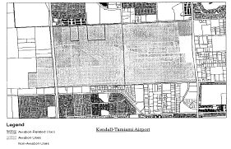

(Ord. No. 11-66, § 1, 8-2-11)

Sec. 33-396.2. Site plan review.

(A) *For all non-aviation uses,* the Department shall review plans for compliance with zoning regulations and for compliance with the site plan review criteria. The purpose of the site plan review is to encourage logic, imagination, innovation and variety in the design process and encourage the congruity of the proposed development and its compatibility with the surrounding area. All plans submitted to the Department shall be reviewed and approved or denied within fifteen (15) days from the date of submission. Denials shall be in writing and shall specifically set forth the grounds for denial. Receipt of applicant's plans for fifteen (15) days without formal written denial shall constitute approval. Notwithstanding the provisions of [33-314](../level3/PTIIICOOR_CH33ZO_ARTXXXVIZOPR.docx#PTIIICOOR_CH33ZO_ARTXXXVIZOPR_S33-314DIAPAPCOCO), if the site is located within unincorporated or incorporated Miami-Dade County and if the plan is disapproved, the applicant may appeal to the Board of County Commissioners. Appeals by the applicant shall be filed within thirty (30) days of the date the project was denied.

(B) *Required exhibits.* The following exhibits shall be prepared by design professionals such as architects and landscape architects and submitted to the Department:

(1) Dimensioned site plan(s) indicating, as a minimum, the following information:

a) Existing zoning on the site and on adjacent properties.

b) The basic use, height, bulk and location of all buildings and other structures with setbacks.

c) Vehicular and pedestrian circulation systems including connection(s) to existing or proposed roadway and sidewalk system and the layout of parking, service and loading areas.

d) Graphics and/or notations indicating the site planning or structure design methods used to minimize the impact of those industrial activities that could have a negative impact on existing or proposed adjacent land uses.

e) Sketches of design elements to be used for buffering surrounding uses.

(2) Elevation of the proposed buildings and other major design elements.

(3) Landscape plans: Landscaping and trees shall be provided in accordance with [Chapter 18A](../level2/PTIIICOOR_CH18AMIDECOLAOR.docx#PTIIICOOR_CH18AMIDECOLAOR) of this Code.

(4) Figures indicating the following:

a) Proposed uses.

b) Gross floor area: ____________ square feet

c) Land area:

Gross lot area: ____________ square feet ____________ acres

Net lot area: ____________ square feet ____________ acres

d) Landscaped open space:

Required: ____________ square feet ____________% of net land area

Provided: ____________ square feet ____________% of net land area

e) Tree Required: ____________ Trees Provided: ____________

f) Off-street parking spaces: Required: ____________ Provided: ____________

(C) *Criteria.* The following shall be considered in the plan review process:

(1) *Planning studies:* Planning studies approved by the Board of County Commissioners that include development patterns or environmental and other design criteria shall be considered in the plan review process.

(2) *Landscape:* Landscape shall be preserved in its natural state insofar as is practicable by minimizing removal of existing vegetation. Landscape shall be used to shade and cool, enhance architectural features, relate structure design to the site, visually screen noncompatible uses, and ameliorate the impact of noise.

(3) *Compatibility:* The architectural design and scale of the proposed structures shall be compatible with surrounding existing or proposed uses or shall be made compatible by the use of screening elements. Screening elements can include such devices as trees and shrubs, walls and fencing, berming or any combination of these elements. Visual buffering shall be provided between parking and service areas and adjacent non-commercial uses.

(4) *Emergency access:* Unobstructed on-site access for emergency equipment shall be considered.

(5) *Circulation:* Internal vehicular and pedestrian circulation systems shall be designed to function with existing and/or approved systems outside the development. Vehicular traffic generated from the industrial activity should be routed in such a manner as to minimize impact on residential development.

(6) *Energy conservation:* Applicants are advised to consider requirements of Florida Statutes Chapter 553 (Energy Code).

(7) *Visual screening for decorative walls:* In an effort to prevent graffiti vandalism, the following options shall be utilized for walls abutting zoned or dedicated rights-of-way:

a) *Wall with landscaping.* The wall shall be set back two and one-half (2½) feet from the right-of-way line and the resulting setback area shall contain a continuous extensively landscaped buffer which must be maintained in a good healthy condition by the property owner, or where applicable, by the condominium, homeowners or similar association. The landscape buffer shall contain one (1) or more of the following planting materials:

1) *Shrubs.* Shrubs shall be a minimum of three (3) feet in height when measured immediately after planting and shall be planted and maintained to form a continuous, unbroken, solid, visual screen within one (1) year after time of planting.

2) *Hedges.* Hedges shall be a minimum of three (3) feet in height when measured immediately after planting and shall be planted and maintained to form a continuous, unbroken, solid, visual screen within one (1) year after time of planting.

3) *Vines.* Climbing vines shall be a minimum of thirty-six (36) inches in height immediately after planting.

b) *Metal picket fence.* Where a metal picket fence abutting a zoned or dedicated right-of-way is constructed in lieu of a decorative wall, landscaping shall not be required.

(Ord. No. 11-66, § 2, 8-2-11)

Sec. 33-397. Nonconforming uses, regulations not retroactive.

The regulations prescribed by this article or any amendment thereto shall not be construed to require the removal, lowering, or other change or alteration of any structure or tree or use of land lawfully in existence not conforming to the regulations as of July 19, 1969, or otherwise interfere with the continuance of any nonconforming use. Between July 19, 1969 and the effective date of this ordinance property owners shall not be permitted to erect any structure or to grow or maintain trees to heights in excess of those provided in Ordinance No. 69-40. After July 19, 1969, property owners shall not be permitted to erect any structure or to grow or maintain trees to heights in excess of those provided herein. Notwithstanding the preceding provisions of this article, the owner of any such nonconforming structure or tree is hereby required to permit the installation, operation and maintenance thereon of such marking, or marking and lighting, as shall be deemed necessary by the Director of the Aviation Department, to indicate to the operators of aircraft in the vicinity of the airport the presence of such airport hazard. Such marking and lighting, and the installation, operation and maintenance thereof, or such disposition of the hazard as may be agreed upon by and between the owner and the Director of the Miami-Dade County Aviation Department in lieu of such marking, or marking and lighting, shall be at the expense of the Miami-Dade County Aviation Department.

For the purposes of determining what shall constitute a nonconforming use, nothing contained herein shall be construed to prohibit or to require the removal of any lawful residential construction existing on the effective date of this ordinance or the approval of new residential construction either (a) on land located inside a residential zoning district, (b) on land designated or considered as "Residential Communities" on the Comprehensive Development Master Plan Land Use Plan Map, or (c) on land designated as "Agriculture" or "Open Land" on the Land Use Plan Map that was surrounded on three or more sides within ¼ mile by land designated as "Residential Communities" on the Land Use Plan Map on the effective date of this ordinance. Any new residential construction on land identified in this paragraph is required to incorporate at least a 25 db Noise Level Reduction (NLR) into the design/construction of the structure.

For the purposes of determining what shall constitute a non-conforming use, nothing contained herein shall be construed to prohibit the construction of educational facilities previously approved by Zoning Resolution of the Community Zoning Appeals Board or Board of County Commissioners within twelve (12) months prior to the effective date of this ordinance.

(Ord. No. 69-40, § 9, 7-9-69; Ord. No. 99-118, § 1, 9-21-99)

Sec. 33-398. Reserved.

**Editor's note—**

Ord. No. 99-118, § 1, adopted Sept. 21, 1999 renumbered former [Section 33-398](../level3/PTIIICOOR_CH33ZO_ARTXLKETAEXAIZO.docx#PTIIICOOR_CH33ZO_ARTXLKETAEXAIZO_S33-398RE), entitled "Permits" as [Section 33-400](../level3/PTIIICOOR_CH33ZO_ARTXLKETAEXAIZO.docx#PTIIICOOR_CH33ZO_ARTXLKETAEXAIZO_S33-400PE)

Sec. 33-399. Administration and enforcement.

It shall be the duty of the Director of the Department of Planning and Zoning of Miami-Dade County, Florida, to administer the regulations prescribed herein in accordance with [Section 2-105](../level3/PTIIICOOR_CH2AD_ARTXVDEPLDERE.docx#PTIIICOOR_CH2AD_ARTXVDEPLDERE_S2-105DIUT), Code of Miami-Dade County, Florida. It shall be the duty of Team Metro to enforce these regulations.

In the event of any violation of the regulations contained herein, the person responsible for such violation shall be given notice in writing by Team Metro. Such notice shall indicate the nature of the violation and the necessary action to correct or abate the violation. A copy of said notice shall be sent to the Director of the Aviation Department and Team Metro of Miami-Dade County. A Planning and Zoning Department administrative official shall order discontinuance of use of land or buildings; removal of trees to conform with height limitations set forth herein; removal of buildings, additions, alteration, or structures; discontinuance of any work being done; or shall take any or all other action necessary to correct violations and obtain compliance with all the provisions of this article.

(Ord. No. 69-40, § 10, 7-9-69; Ord. No. 95-215, § 1, 12-5-95; Ord. No. 98-125, § 21, 9-3-98; Ord. No. 99-118, § 1, 9-21-99)

Sec. 33-400. Permits.

Applications for permits under this article shall be obtained from the appropriate planning and zoning department or agency.

Approval of applications for permits for all construction, for adding height to any existing structures, and for all alterations, repairs, or additions that will change the use of the structure from the existing use to any commercial, industrial educational facility or residential use in any airport zone classification district lying within unincorporated and incorporated areas of Miami-Dade County, shall be obtained from the Director of the Department of Planning and Zoning, such application for permits shall include the height and location of derricks, draglines, cranes and other boom-equipped machinery, if such machinery is to be used during construction. No person shall operate such equipment until approval is obtained from the Director of the Aviation Department and Building Department.

All applications for permits made to appropriate municipal Planning and Zoning Departments or agencies for all construction or for adding height to any existing structure, and for all alterations, repairs, or additions that will change the use of structure from the existing use to any commercial, industrial educational facility or residential use in any airport zone classification district lying within a municipality for which airport zone classification district boundaries have been established herein, shall be approved by the Director of the Miami-Dade County Planning and Zoning Department and Building Official or by their duly authorized representatives prior to issuance of the permit by any municipal Planning and Zoning Department or agency for the purpose of assuring compliance with the minimum standards governing zoning as set forth in this article; provided, however, no approval by the Director and Building Official will be required for building and use permits from municipalities which have adopted by ordinance effective airport zoning regulations, the minimum standards of which are at least as restrictive as the minimum standards prescribed herein as such apply to the areas covered by this article. No approval by the Director of the Miami-Dade County Planning and Zoning Department and Building Official will be required for building and use permits from municipalities which have adopted by ordinance effective general zoning regulations, the minimum standards of which are at least as restrictive as the minimum standards prescribed herein as such apply to the areas covered by this article; providing, however, that no municipality may grant any variance to said general zoning regulations which would make said minimum standards less restrictive than the minimum standards prescribed herein.

Permits will be approved by the Director of the Miami-Dade County Planning and Zoning Department and Building Official or their duly authorized representatives unless the proposal fails to meet the requirements of all applicable zoning regulations and building codes including the provisions of this article.

Permits when applied for by applicants intending to use derricks, draglines, cranes and other boom-equipped machinery for such construction, reconstruction or alteration of any commercial, industrial, educational facility or residential use as is consistent with the provisions hereof, shall, when the boom operating height exceeds the height limitations imposed by this article, require applicant to mark, or mark and light, the machinery to reflect conformity with the Federal Aviation Administration's or the Miami-Dade County Aviation Department standards for marking and lighting obstructions, whichever is the more restrictive, and shall require the applicant in such cases to obtain approval from the Director of the Miami-Dade County Aviation Department for the location, height and time of operation for such construction equipment use prior to the issuance of a construction permit to the applicant.

Notwithstanding any provision of this ordinance, in granting any permit or variance under this article, the Director or the appropriate board shall require the owner of the structure or tree for which a permit or variance is being sought, to install, operate and maintain thereon, at the owners sole expense, such marking and lighting as may be necessary to indicate to aircraft pilots the presence of an obstruction, such marking and lighting to conform to the specific standards established by rule of the Department of Transportation.

Any decision of the Director of the Planning and Zoning Department of Miami-Dade County may be appealed as provided and prescribed under Article XXXVI, of [Chapter 33](../level2/PTIIICOOR_CH33ZO.docx#PTIIICOOR_CH33ZO), Code of Miami-Dade County, Florida.

(Ord. No. 69-40, § 11, 7-9-69; Ord. No. 95-215, § 1, 12-5-95; Ord. No. 98-125, § 21, 9-3-98; Ord. No. 99-118, § 1, 9-21-99)

Sec. 33-401. Nonconforming uses abandoned or destroyed.

Whenever the Director of Planning and Zoning Department of Miami-Dade County determines that the height limits or use standards of this article will be violated by the reconstruction, substitution or replacement of an existing nonconforming use, structure or tree, no permit shall be granted for such reconstruction substitution or replacement.

Whether application is made for a permit under this paragraph or not, the Director of the Planning and Zoning Department of Miami-Dade County may by appropriate action require the owner of the nonconforming structure or tree to permit the Miami-Dade County Aviation Department at its expense to lower, remove, or mark, or mark and light such object as may be necessary to conform to these regulations.

(Ord. No. 69-40, § 12, 7-9-69; Ord. No. 95-215, § 1, 12-5-95; Ord. No. 99-118, § 1, 9-21-99)

Sec. 33-402. Variances.

(1) Any person desiring to erect or increase the height of any structure, or permit the growth of any tree or otherwise use his property not in accordance with the regulations prescribed in this article may apply to the appropriate zoning board for a variance from such regulations as provided and prescribed under Article XXXVI of [Chapter 33](../level2/PTIIICOOR_CH33ZO.docx#PTIIICOOR_CH33ZO), Code of Miami-Dade County, Florida. Applications for variances or any other authorization for any construction or use not authorized by Sections [33-392](../level3/PTIIICOOR_CH33ZO_ARTXLKETAEXAIZO.docx#PTIIICOOR_CH33ZO_ARTXLKETAEXAIZO_S33-392ESZOCLDIAIZOAR), [33-393](../level3/PTIIICOOR_CH33ZO_ARTXLKETAEXAIZO.docx#PTIIICOOR_CH33ZO_ARTXLKETAEXAIZO_S33-393ESHELIZOCLDIAIZOAR), [33-394](../level3/PTIIICOOR_CH33ZO_ARTXLKETAEXAIZO.docx#PTIIICOOR_CH33ZO_ARTXLKETAEXAIZO_S33-394ESLAUSZOCRAI), [33-395](../level3/PTIIICOOR_CH33ZO_ARTXLKETAEXAIZO.docx#PTIIICOOR_CH33ZO_ARTXLKETAEXAIZO_S33-395LAUSZOCLAI), [33-396](../level3/PTIIICOOR_CH33ZO_ARTXLKETAEXAIZO.docx#PTIIICOOR_CH33ZO_ARTXLKETAEXAIZO_S33-396LAUSHEZOMAAIZOAR) or [33-397](../level3/PTIIICOOR_CH33ZO_ARTXLKETAEXAIZO.docx#PTIIICOOR_CH33ZO_ARTXLKETAEXAIZO_S33-397NOUSRENORE) shall be submitted and determined in accordance with the procedures, provisions and requirements set forth in Florida Statutes, Section 333.03 and Sections 333.07 through and including 333.11 (1998) or successor legislation. For the purpose of zoning applications filed under this chapter, the appropriate Community Zoning Appeals Board shall constitute the board of adjustment pursuant to Florida Statutes, Section 333.10, subject to all procedures applicable to community zoning appeals boards.

(2) At the time of filing the application, the applicant shall forward to the Florida Department of Transportation by certified mail, return receipt requested, a copy of the application for the Department's review and comment, if any. A copy of the return receipt must be filed with the Director of the Miami-Dade County Department of Planning and Zoning at the time of filing the application. No public hearing on the application may commence less than forty-six (46) days after receipt of the application by the Department of Transportation. Notwithstanding any provision of the Code of Miami-Dade County, failure to comply with the requirements of this subsection shall be grounds for appeal of a decision rendered by the community zoning appeals board by an applicant, governing body of any municipality, if affected, or any aggrieved party as defined in [Section 33-313](../level3/PTIIICOOR_CH33ZO_ARTXXXVIZOPR.docx#PTIIICOOR_CH33ZO_ARTXXXVIZOPR_S33-313APBOCOCO), Code of Miami-Dade County, the Director or the County Manager to the Board of County Commissioners. The provisions of [Section 33-313](../level3/PTIIICOOR_CH33ZO_ARTXXXVIZOPR.docx#PTIIICOOR_CH33ZO_ARTXXXVIZOPR_S33-313APBOCOCO) shall govern all appeals brought under this subsection.

(3) No application shall be considered unless a written evaluation and recommendation of the director of the aviation department of his or her designee has been provided to the applicable board. For purposes of applications brought under this section, the procedures of this section shall be in addition to any procedures set forth elsewhere in the Code of Miami-Dade County.

(4) Approval of such variances shall be limited to those cases in which it is duly found that a literal application or enforcement of the regulations would result in practical difficulty or unnecessary hardship and the relief granted would not be contrary to the public interest but would do substantial justice and be in accordance with the spirit of this article, and such zoning board is hereby admonished that the intent and purpose of this article is to promote the health, safety and general welfare of the inhabitants of Miami-Dade County, Florida, by preventing the creation of an airport hazard or of a hazard to air navigation, thereby protecting the lives and property of users of Kendall Tamiami Executive Airport and of occupants of land in its vicinity and preventing destruction or impairment of the utility of the airport and the public investment therein.

(5) Construction of any educational facility is prohibited at either end of a runway of Kendall-Tamiami Executive Airport within an area which extends 5 miles in a direct line along the centerline of the runway, and which has a width measuring one-half the length of the runway. In addition to any findings required in this chapter, variances approving construction of an educational facility within the delineated area shall only be granted when the appropriate zoning board makes specific findings detailing how the public policy reasons for allowing construction outweigh health and safety concerns prohibiting such a location.

(6) Notwithstanding the foregoing provisions of this section, in granting any permit or variance under this article, the Director or the appropriate board shall require the owner of the structure or tree for which a permit or variance is being sought, to install, operate and maintain thereon, at the owners sole expense, such marking and lighting as may be necessary to indicate to aircraft pilots the presence of an obstruction, such marking and lighting to conform to the specific standards established by rule of the Department of Transportation.

(7) Notwithstanding any provision contained in any section of this Code, the Board of County Commissioners shall have jurisdiction over any appeal filed by the County Manager from a decision of a Community Zoning Appeals Board rendered pursuant to this section where it is the opinion of the County Manager that a Community Zoning Appeals Board's resolution is incompatible with aviation activity or aviation safety.

(Ord. No. 69-40, § 13, 7-9-69; Ord. No. 99-118, § 1, 9-21-99)

Sec. 33-403. Conditions to variances.

Any variance granted under this article may, if such action is deemed advisable to effectuate the purposes of this article and reasonable in the circumstance, be so conditioned as to require the owner of the structure or tree in question to install, operate, and maintain, at his expense, or to permit the Miami-Dade County Aviation Department to install, operate, and maintain thereon at the owner's expense such marking, or marking and lighting, as may be necessary to indicate to aircraft pilots the presence of an airport hazard or hazard to air navigation.

(Ord. No. 69-40, § 14, 7-9-69; Ord. No. 99-118, § 1, 9-21-99)

Sec. 33-404. Penalties and enforcement.

Each violation of this article or of any regulation, order, or ruling promulgated hereunder shall be punishable as provided by [Section 33-39](../level3/PTIIICOOR_CH33ZO_ARTIINGE.docx#PTIIICOOR_CH33ZO_ARTIINGE_S33-39PEVICH), Code of Miami-Dade County, Florida.

(Ord. No. 69-40, § 15, 7-9-69; Ord. No. 99-118, § 1, 9-21-99)

Sec. 33-405. Conflicting regulations.

Nothing contained in this article shall be interpreted to conflict with or supersede any federal regulation pertaining to the control of hazards to air navigation; provided however, where this article imposes lower height limitations or more stringent restrictions upon the use of land or water than are imposed or required by other County ordinance or resolution, or federal rules or regulations the provisions of this article shall govern.

(Ord. No. 69-40, § 16, 7-9-69; Ord. No. 99-118, § 1, 9-21-99)

Secs. 33-406—33-419. Reserved.

FOOTNOTE(S):

--- (**58**) ---

**Editor's note—** Article XL, §§ 33-388—33-403, is derived from Ord. No. 69-40, §§ 1—16, enacted July 9, 1969. Section 17 of said ordinance provides that the ordinance provisions be included in the Code of Ordinances as a new article of Chapter 33 (Back)

### ARTICLE XLI. ROCKMINING OVERLAY ZONING AREA (ROZA) [59]

Sec. 33-420. Definitions.

Sec. 33-421. Districts and Locations Where Rockmining Uses Are Permitted.

Sec. 33-422. Uses Permitted by This Article.

Sec. 33-423. Control of Rockmining Uses.

Sec. 33-424. Minimum Landscaped Open Space, Mitigation Areas and Littoral Zones.

Sec. 33-425. Zoned Rights-of-Way.

Sec. 33-420. Definitions.

The following words and phrases when used in this Article shall have the meaning ascribed to them in this Section:

*Asphalt plant* shall mean a facility used for the manufacture of asphalt paving products by combining crushed limestone, sand or screening with a heated petroleum binder in a kiln. An asphalt plant includes parking spaces needed for trucks, materials handling equipment, and administrative, control and office buildings. The asphalt manufactured at an asphalt plant consists of more than 80% limestone quarry products, which asphalt is primarily used in highway and parking area paving.

*Cement plant* shall mean a facility used for the manufacture of cement and mortar products. The products are manufactured by grinding limestone to a fine consistency and mixing it with certain additives such as silicates, aluminates, and iron oxides and then heating it in kilns to temperatures in excess of 2000° Fahrenheit. This process produces clinker, which is ground by mills with other ingredients such as gypsum to make specific types of cement and mortar products used in concrete manufacturing and masonry/brick construction. A cement plant includes parking spaces needed for trucks, materials handling equipment, and administrative, control and office buildings. The cement manufactured at a cement plant consists of more than 90% limestone quarry products.

*Concrete batching plant or ready mixed concrete plant* shall mean a facility used for the delivery of limestone aggregate, sand or screenings, cement and water into mixer trucks as part of the concrete manufacturing process. This facility may contain a system of conveyor belts, chutes, storage silos, stockpile areas, water and air systems, and weight scales and meters for the accurate dispensing of the raw materials to produce the desired strength and type of concrete. A concrete batching plant or ready mixed concrete plant facility includes parking spaces needed for trucks, materials handling equipment, and administrative, control and office buildings. The concrete manufactured at a concrete batching plant or ready mixed concrete plant consists of more than 90% limestone quarry products.

*Concrete block plant* shall mean a facility used for the manufacture of concrete block and contains sufficient ground and/or covered storage for curing the blocks once removed from their molds, as well as materials batching equipment with automated systems for placing the concrete into block molds and transporting the blocks to curing racks and stockpile areas. A concrete block plant includes parking spaces needed for trucks, materials handling equipment, and administrative, control or office buildings. The concrete blocks manufactured at a concrete block plant consist of more than 90% limestone quarry products.

*DERM* shall mean the Miami-Dade County Department of Environmental Resources Management.

*Director of DERM* shall mean the Director of DERM or the Director's designee.

*Prestressed and precast concrete production plant* shall mean a facility used for the manufacture of various concrete products and includes the equipment necessary to deliver concrete into molds and the materials needed to add strength to the final product such as steel reinforcement bars, strands or mesh, or, in the case of prestressed concrete, wire strands in tension. A prestressed and precast concrete production plant manufactures such things as concrete pipe, vaults, and bridge and highway components, requires a large outside storage area for finished product inventory, and includes parking spaces needed for trucks, materials handling equipment, and administrative, control and office buildings. The products produced at a prestressed and precast concrete production plant consist of more than 95% limestone quarry products, excluding the steel reinforcement material.

*Rockmining Overlay Zoning Area (ROZA)* shall mean that area described as follows: All of Section 6; that part of Section 4, lying northwesterly of the Florida Turnpike and west of Interstate 75, and those parts of Sections 5, 7, 8, 18 and 19 lying northwesterly of the Florida Turnpike, all lying in Township 52 South, Range 40 East; and all of Sections 1 and 2, the east ½ of Section 3, Section 10 less northwest ¼ thereof, and all of Sections 11, 12, 13, 14, 15, 21, 22, 23, 24, 25, 26, 27, 28, 33, 34, 35 and 36, all lying in Township 52 South, Range 39 East; all of Sections 1, 2, 3, 4, 9, 10, the west ½ of [Section 13](../level2/PTIIICOOR_CH13EX.docx#PTIIICOOR_CH13EX), all of Sections 15, 16, 21, 22, 23, the west ½ of [Section 24](../level2/PTIIICOOR_CH24ENPRBIBAENDEAQPACOARBIBAENENTRFUENENLAPR.docx#PTIIICOOR_CH24ENPRBIBAENDEAQPACOARBIBAENENTRFUENENLAPR), the west ½ of [Section 25](../level2/PTIIICOOR_CH25AVDERURE.docx#PTIIICOOR_CH25AVDERURE), all of Sections 26, 27, 28, 33, 34, 35 and the west ½ of Section 36, less the Northwest Wellfield area consisting of all lands within a 2,500 ft. distance from each of the wells, all lying in Township 53 South, Range 39 East; and Government Lots 3 and 4 lying between Township 53 South and Township 54 South; and that part of Section 3 and that part of Section 4 lying north of the Tamiami Trail, SR. 90 (U.S. 41) lying in Township 54 South, Range 39 East; and the East ½ of [Section 13](../level2/PTIIICOOR_CH13EX.docx#PTIIICOOR_CH13EX), all of [Section 24](../level2/PTIIICOOR_CH24ENPRBIBAENDEAQPACOARBIBAENENTRFUENENLAPR.docx#PTIIICOOR_CH24ENPRBIBAENDEAQPACOARBIBAENENTRFUENENLAPR) and the North ½ of [Section 25](../level2/PTIIICOOR_CH25AVDERURE.docx#PTIIICOOR_CH25AVDERURE) of Township 54 South, Range 38 East.

*Rock crushing and screening plant* shall mean a facility comprised of systems used for the automated conveying, crushing, segregation and blending of crushed rock in order to manufacture the basic materials used in construction such as concrete, concrete block, cement, asphalt, road base and many other rock products. A rock crushing and screening plant facility includes portable crushing facilities used primarily for the processing of road base material and parking spaces for trucks, materials handling equipment, and administrative, control and office buildings.

*Rockmining* shall mean the dredging or excavation of an area for the purpose of extracting subsurface materials. Rockmining shall also include ancillary property uses necessary for the extracting and processing of subsurface materials.

(Ord. No. 04-163, § 2, 9-9-04)

Sec. 33-421. Districts and Locations Where Rockmining Uses Are Permitted.

(1) The boundaries of the ROZA are defined in [Section 33-420](../level3/PTIIICOOR_CH33ZO_ARTXLIROOVZOARRO.docx#PTIIICOOR_CH33ZO_ARTXLIROOVZOARRO_S33-420DE)

(2) Rockmining uses are permitted in all zoning districts within the ROZA without a public hearing, upon approval of plans by the Department that are in compliance with the specified criteria of this Article, particularly the lake excavation plan criteria enumerated in [Section 33-423](../level3/PTIIICOOR_CH33ZO_ARTXLIROOVZOARRO.docx#PTIIICOOR_CH33ZO_ARTXLIROOVZOARRO_S33-423COROUS)(5) and [Chapter 24](../level2/PTIIICOOR_CH24ENPRBIBAENDEAQPACOARBIBAENENTRFUENENLAPR.docx#PTIIICOOR_CH24ENPRBIBAENDEAQPACOARBIBAENENTRFUENENLAPR) of the Code.

(3) All of the regulations of the underlying zoning districts apply within the ROZA except:

(a) Height restrictions. Notwithstanding the existing height restrictions within the underlying zoning districts imposed by this Chapter, and due to the nature of the uses permitted by this Article and the requirements imposed thereby, none of the height restrictions of the underlying zoning districts apply.

(b) Setback regulations. Within the ROZA, all buildings, structures and equipment shall be setback a minimum of 25 feet from all property lines under different ownership, except that no setback regulation is imposed upon conveyor belts and/or other systems or equipment used for the transportation of raw materials permitted below by [Section 33-422](../level3/PTIIICOOR_CH33ZO_ARTXLIROOVZOARRO.docx#PTIIICOOR_CH33ZO_ARTXLIROOVZOARRO_S33-422USPEAR)(1)(b)(i), provided; however, that such conveyor belt and/or systems or equipment for transportation of raw materials shall not extend across property boundaries without the consent of the adjacent property owner(s).

(c) Off-street parking regulations. Notwithstanding the existing parking regulations within the underlying zoning districts imposed by this chapter and due to the nature of the uses permitted by this Article, the off-street parking area requirements of [Section 33-126](../level3/PTIIICOOR_CH33ZO_ARTVIIOREPA.docx#PTIIICOOR_CH33ZO_ARTVIIOREPA_S33-126SUPAAR) of this Code do not apply.

(4) Rockmining uses shall not be permitted in any other area of unincorporated Miami-Dade County, Florida, other than as described in [Section 33-421](../level3/PTIIICOOR_CH33ZO_ARTXLIROOVZOARRO.docx#PTIIICOOR_CH33ZO_ARTXLIROOVZOARRO_S33-421DILOWHROUSARPE)(1) and (2) of this Article, unless approved after public hearing pursuant to [Section 33-13](../level3/PTIIICOOR_CH33ZO_ARTIINGE.docx#PTIIICOOR_CH33ZO_ARTIINGE_S33-13UNUS) of this Code.

(Ord. No. 04-163, § 2, 9-9-04)

Sec. 33-422. Uses Permitted by This Article.

(1) The rockmining uses permitted by this Article include:

(a) All rockmining, including lake excavations; quarrying of raw materials; rock crushing and screening; filling of excavations with rockmining tailings; the erection, maintenance and operation of all types of equipment necessary for the quarrying of raw materials; administrative offices, equipment and tool buildings, and watchman's prefabricated modular buildings necessary for the rockmining uses permitted by this Article.

(b) Uses ancillary to *bona fide* rockmining, provided that the rockmining uses and uses ancillary thereto are under common property ownership, which, for purposes of this Article, shall consist of fee-simple title or a lease of 25 years or more.

(i) the erection, maintenance and operation of cement plants; concrete batching plants or ready mixed concrete plants; concrete block plants; prestressed and precast concrete production plants; rock crushing and screening plants; asphalt plants but only in areas located outside any wellfield protection area as defined by [Chapter 24](../level2/PTIIICOOR_CH24ENPRBIBAENDEAQPACOARBIBAENENTRFUENENLAPR.docx#PTIIICOOR_CH24ENPRBIBAENDEAQPACOARBIBAENENTRFUENENLAPR) of this Code and in areas, as of the date of filing of an application for a certificate of use for such asphalt plant, more than two miles from any RU or EU zoning district boundary; office, control and laboratory buildings attendant to the uses set forth herein; operation of storage facilities for all equipment used in rock mining on premises attendant to the uses set forth herein; conveyor belt and/or other systems or equipment for the transportation of raw materials, repair facilities for the service of all equipment used on the premises and necessary for the service and operation of equipment used in connection with rockmining uses permitted by this Article; and the storage of fuel, oil, and lubricants necessary for the service and operation of equipment used in connection with rockmining uses permitted by this Article and to the extent authorized by [Chapter 24](../level2/PTIIICOOR_CH24ENPRBIBAENDEAQPACOARBIBAENENTRFUENENLAPR.docx#PTIIICOOR_CH24ENPRBIBAENDEAQPACOARBIBAENENTRFUENENLAPR) of this Code; and office, control and laboratory buildings required for the operation of the facilities described above.

The 2-mile distance requirement for asphalt plants shall be measured by following a straight line from the nearest structure of the asphalt plant to the nearest point of an EU or RU district boundary, as depicted on a survey prepared and sealed by a Florida-licensed surveyor and/or professional engineer.

(ii) the outdoor storage of vehicles and lake excavation equipment required for the rockmining uses permitted by this Article, subject to the following conditions: the vehicles and equipment shall be maintained in operable condition at all times, except as otherwise provided herein, and further provided that such vehicle and equipment storage areas shall be setback a minimum of 25 feet from all property lines under different ownership and rights-of-way; and the maintenance, repairs or overhaul performed on equipment or vehicles required by the rockmining uses permitted by this article shall be in accordance with best management practices as approved by DERM.

(c) Uses ancillary to rockmining requiring approval after public hearing provided; however, that such application for public hearing shall be made directly to the Board of County Commissioners pursuant to [Section 33-314](../level3/PTIIICOOR_CH33ZO_ARTXXXVIZOPR.docx#PTIIICOOR_CH33ZO_ARTXXXVIZOPR_S33-314DIAPAPCOCO)(C) of this code:

(i) the erection, maintenance and operation of tile and other concrete products processing and fabrication plants;

(ii) the erection, maintenance and operation of asphalt plants located within any wellfield protection area as defined by [Chapter 24](../level2/PTIIICOOR_CH24ENPRBIBAENDEAQPACOARBIBAENENTRFUENENLAPR.docx#PTIIICOOR_CH24ENPRBIBAENDEAQPACOARBIBAENENTRFUENENLAPR) of this Code or within two miles of any RU or EU zoning district boundary in existence as of the date of filing of an application for certificate of use for such asphalt plant.

(2) Nothing in this article shall be construed to prohibit uses within the ROZA that are otherwise permitted by this chapter or permitted by zoning action.

(3) For the purposes of this article, "bona fide rockmining" means the commercial extraction of limestone and sand suitable for production of construction aggregates, sand, cement and road base materials for shipment offsite by any person or company primarily engaged in the commercial mining of any such natural resources.

(Ord. No. 04-163, § 2, 9-9-04; Ord. No. 10-09, § 2, 2-2-10)

Sec. 33-423. Control of Rockmining Uses.

(1) Nothing in this article shall be construed to modify, amend or supersede any of the provisions of [Chapter 24](../level2/PTIIICOOR_CH24ENPRBIBAENDEAQPACOARBIBAENENTRFUENENLAPR.docx#PTIIICOOR_CH24ENPRBIBAENDEAQPACOARBIBAENENTRFUENENLAPR) of this Code.

(2) Rockmining is permitted hereunder after a 10-year rockmining certificate of use issued by Director upon compliance with the terms and conditions of the Plan, as defined in Subsection (3) below, subject to cancellation upon violation of any of the terms and conditions of the certificate of use.

(3) Application for a 10-year rockmining certificate of use shall be made by submittal of at least 3 sets of a 10-year lake excavation plan (the "Plan"), prepared and sealed by a Florida-licensed professional engineer, to the Director. The Plan shall indicate the extent of proposed lake excavation including any lake excavation phase lines, setbacks from property lines and zoned or dedicated rights-of-way, minimum and maximum lake depths, lakes slopes, ancillary uses, as well as any littoral shelves or other mitigation areas.

(4) Upon review and evaluation of the Plan, DERM shall issue to the Director a recommendation stating whether the Plan complies with [Chapter 24](../level2/PTIIICOOR_CH24ENPRBIBAENDEAQPACOARBIBAENENTRFUENENLAPR.docx#PTIIICOOR_CH24ENPRBIBAENDEAQPACOARBIBAENENTRFUENENLAPR) of this Code and all conditions included in any permits required by DERM.

(5) Upon review and evaluation of the Plan and the recommendation from DERM, the Director shall issue the 10-year rockmining certificate of use if the Director determines that the Plan is in compliance with the criteria enumerated in this section, this article, [Chapter 24](../level2/PTIIICOOR_CH24ENPRBIBAENDEAQPACOARBIBAENENTRFUENENLAPR.docx#PTIIICOOR_CH24ENPRBIBAENDEAQPACOARBIBAENENTRFUENENLAPR), and all conditions included in any permits required by DERM. It is provided, however, that a notice of intent to issue a rockmining certificate of use shall be advertised in a newspaper of general circulation no less than thirty (30) days prior to the issuance of the rockmining certificate of use. Notwithstanding anything in the Code to the contrary, within fifteen (15) days after the issuance of a rockmining certificate of use, notice of the Director's decision shall be published in a newspaper of general circulation. Any aggrieved person may only appeal the Director's decision to the Board of County Commissioners within thirty (30) days after the date of the newspaper publication. Upon issuance, the 10-year rockmining certificate shall allow the uses permitted by this Article and shall be promptly renewed with the Department, upon compliance with all terms and conditions, the same subject to cancellation upon violation of any of the terms and conditions. On an annual basis from the date of issuance of the 10-year rockmining certificate of use, a plan prepared and sealed by a Florida-licensed professional engineer shall be submitted to the Director, which plan shall depict the extent of rockmining conducted in the preceding 12 months. Failure to commence the excavation project within 6 months of the date of the original certificate of use issuance shall result in an abandonment of the excavation project.

(a) The construction of the perimeter littoral restoration areas and lake slopes shall be performed as approved by the Director of DERM. In accordance with this requirement, "as built" surveys prepared and sealed by a Florida-licensed surveyor and/or professional engineer shall be submitted to the Department within 180 days of completion of the littoral shelf restoration.

(b) The lake excavation site shall be suitably staked as approved by the Director and Director of DERM; stakes shall be maintained in proper position so that the limits of excavation, slopes, and grade levels may be easily determined.

(c) Access to the lake excavation site shall be restricted and the property shall be suitably posted to meet with the approval of the Director and the Director of DERM; said postings shall denote the rockmining operation and warn the public concerning possible hazards prior to commencement and for the duration of the excavation.

(d) If the lake excavation operation is discontinued, abandoned or time expires under the 10-year rockmining certificate of use, the excavation shall immediately be restored by the construction of the littoral area around the perimeter of the excavated lake, as required by DERM.

(e) No positive drainage of storm water from roads or other source will be allowed to enter the excavation except as allowed under a Class II permit issued by DERM. Retention of pollutants is one criterion for issuance of such a Class II permit.

(f) There shall be no direct connection between a lake excavation and a drainage canal. A system to allow overflows from lakes to canals for flood control purposes may be constructed subject to the approval of the Director and Director of DERM and upon the issuance of all required permits.

(g) To ensure compliance with all terms and conditions imposed, a joint cash or joint surety bond or substantially equivalent instrument as approved by the Director shall be posted with the Department, payable to Miami-Dade County, in an amount as may be determined by the Director. The bond or equivalent instrument shall be in recordable form so that it may be recorded in the public records of Miami-Dade County and the instrument shall be executed by the property owner and any and all parties who may have an interest in the land, such as mortgagees. The bond amount shall be based on the estimated costs to create the approved perimeter littoral areas and slopes depicted on the submitted Plan and shall satisfy the requirements of the Department.

(h) Upon completion of the lake excavation activities, the property shall be restored and left in a condition acceptable to the Director and the Director of DERM or their respective designee.

(i) If, in the opinion of the Director, the excavation is hazardous to the surrounding area, the hazardous area shall be fenced in, or otherwise protected, by the applicant in a manner acceptable to the Director.

(j) The perimeter of an excavated lake shall be consistent with the littoral shelf requirements of the approved Plan and the Class IV permits issued by DERM.

(k) If a lake excavation is proposed to be excavated in phases, a separate phase plan shall be submitted with the initial Plan. The phase plan shall delineate the area to be excavated in each phase and the time frame projected to close out each phase of the excavation project.

(l) Grading, leveling, and sloping of banks and perimeter littoral shelves shall occur on a progressive basis as the project develops and excavation progresses.

(Ord. No. 04-163, § 2, 9-9-04)

Sec. 33-424. Minimum Landscaped Open Space, Mitigation Areas and Littoral Zones.

Notwithstanding any provisions of [Chapter 33](../level2/PTIIICOOR_CH33ZO.docx#PTIIICOOR_CH33ZO) or [Chapter 18A](../level2/PTIIICOOR_CH18AMIDECOLAOR.docx#PTIIICOOR_CH18AMIDECOLAOR) (Landscaping Code) of the Code and due to the nature of the uses authorized by this Article and the requirements for these uses set forth in [Chapter 24](../level2/PTIIICOOR_CH24ENPRBIBAENDEAQPACOARBIBAENENTRFUENENLAPR.docx#PTIIICOOR_CH24ENPRBIBAENDEAQPACOARBIBAENENTRFUENENLAPR) and by other state, regional, and federal agencies, the mitigation areas and littoral zones provided for under all of the foregoing shall be deemed to constitute compliance with the landscaped open space requirements for the uses authorized by this Article. The timing of the installation of any required mitigation and littoral areas shall be governed by the permits issued by DERM pursuant to [Chapter 24](../level2/PTIIICOOR_CH24ENPRBIBAENDEAQPACOARBIBAENENTRFUENENLAPR.docx#PTIIICOOR_CH24ENPRBIBAENDEAQPACOARBIBAENENTRFUENENLAPR) of this Code.

(Ord. No. 04-163, § 2, 9-9-04)

Sec. 33-425. Zoned Rights-of-Way.

Notwithstanding any provisions of [Section 33-133](../level3/PTIIICOOR_CH33ZO_ARTVIIIRI-WPLMIWI.docx#PTIIICOOR_CH33ZO_ARTVIIIRI-WPLMIWI_S33-133RI-WPLMIWISTWA), upon approval of the Director and the Director of the Public Works Department, rights-of-way within the areas described by [Section 33-421](../level3/PTIIICOOR_CH33ZO_ARTXLIROOVZOARRO.docx#PTIIICOOR_CH33ZO_ARTXLIROOVZOARRO_S33-421DILOWHROUSARPE) may be waived and/or a dedication shall not be required, as long as the affected properties are utilized for the uses permitted under [Section 33-422](../level3/PTIIICOOR_CH33ZO_ARTXLIROOVZOARRO.docx#PTIIICOOR_CH33ZO_ARTXLIROOVZOARRO_S33-422USPEAR) of this Article and are not needed for access to non-rockmining properties that are otherwise landlocked. Previously dedicated rights-of-way may be abandoned in accordance with the procedures set forth pursuant to [Chapter 28](../level2/PTIIICOOR_CH28SU.docx#PTIIICOOR_CH28SU) of this Code.

(Ord. No. 04-163, § 2, 9-9-04)

FOOTNOTE(S):

--- (**59**) ---

**Editor's note—** Ord. No. 04-163, § 2, adopted Sept. 9, 2004, amended the Code with the addition of a new article XI, sections 33-152—33-157. In order to avoid duplication of article and section numbers, the provisions of said ordinance have been included herein as article XLI, sections 33-420—33-425, at the direction of the county. (Back)